Additional file 1

Supplementary methods tables and figures
Ultrasound Deep Learning for Distinguishing Benign Reactive from Hematologic Malignancy-Associated Cervical Lymphadenopathy in Children: Development and Validation
BMC Medical Imaging

Supplementary methods
Ultrasound regions centered on the consensus lesion contour were resized to 384 x 384 pixels. A binary lesion mask was supplied as a fourth input channel to an ImageNet-pretrained EfficientNetV2-S network. Model selection, probability calibration, and operating-threshold selection were performed within the development data of each outer iteration. Related images were kept in the same fold. The manually agreed consensus masks were used during both training and outer-fold inference; automatic segmentation was not evaluated.

Table S1. Outer-fold sample composition and model performance
Outer fold | Model | Image groups | Malignant  (n) | Benign  (n) | ROC AUC | Refit epochs
1 | Base | 112 | 63 | 49 | 0.916 | 3
2 | Base | 112 | 63 | 49 | 0.883 | 3
3 | Label-smoothed | 112 | 61 | 51 | 0.873 | 4
4 | Label-smoothed | 112 | 61 | 51 | 0.801 | 7
5 | Label-smoothed | 111 | 61 | 50 | 0.845 | 5
ROC AUC, area under the receiver operating characteristic curve. Image groups, rather than patients, were the unit of analysis.

Table S2. Fold-specific calibration and operating thresholds
Outer fold | Platt slope | Platt intercept | Youden threshold | Higher-sensitivity threshold | Test-time  augmentation
1 | 1.171 | -0.035 | 0.432 | 0.432 | None
2 | 1.092 | -0.132 | 0.579 | 0.442 | None
3 | 1.035 | 0.071 | 0.529 | 0.482 | None
4 | 0.998 | -0.021 | 0.489 | 0.559 | None
5 | 1.036 | 0.178 | 0.549 | 0.507 | None
Calibration parameters and thresholds were estimated from the corresponding outer-fold development data and then applied without adjustment to the held-out outer test fold.

Table S3. Performance across the four underlying diagnoses
Malignant diagnosis | Benign diagnosis | Image groups | ROC AUC
Acute lymphoblastic leukemia | EBV-associated lymphadenitis | 260 | 0.839
Acute lymphoblastic leukemia | Nonspecific reactive hyperplasia | 294 | 0.852
Lymphoma | EBV-associated lymphadenitis | 265 | 0.876
Lymphoma | Nonspecific reactive hyperplasia | 299 | 0.883
These diagnosis-pair analyses were descriptive. EBV, Epstein-Barr virus.
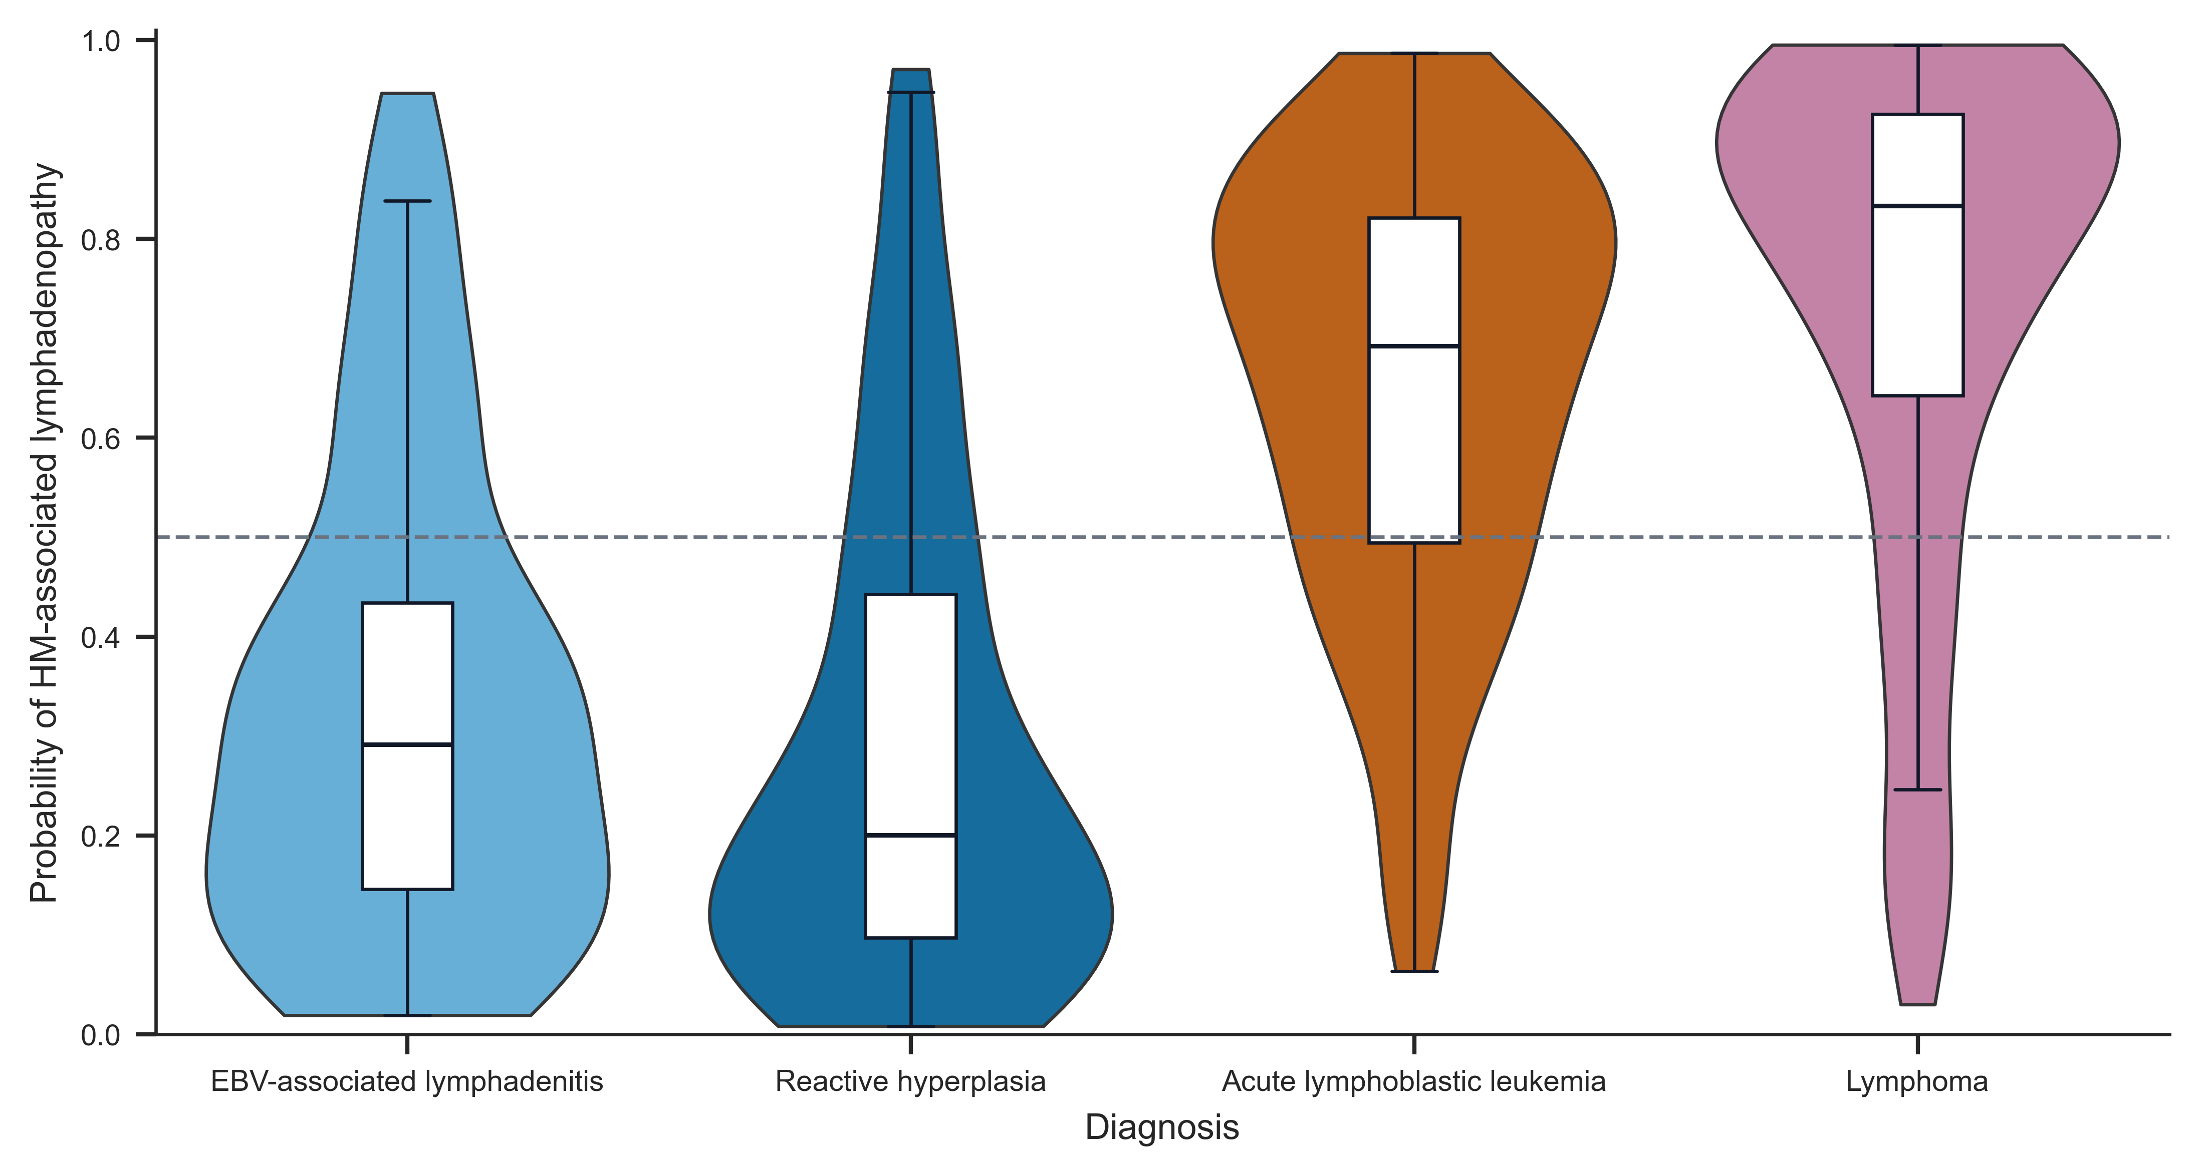
Figure S1. Distribution of calibrated model probabilities across the four underlying diagnoses. EBV, Epstein-Barr virus; HM, hematologic malignancy.
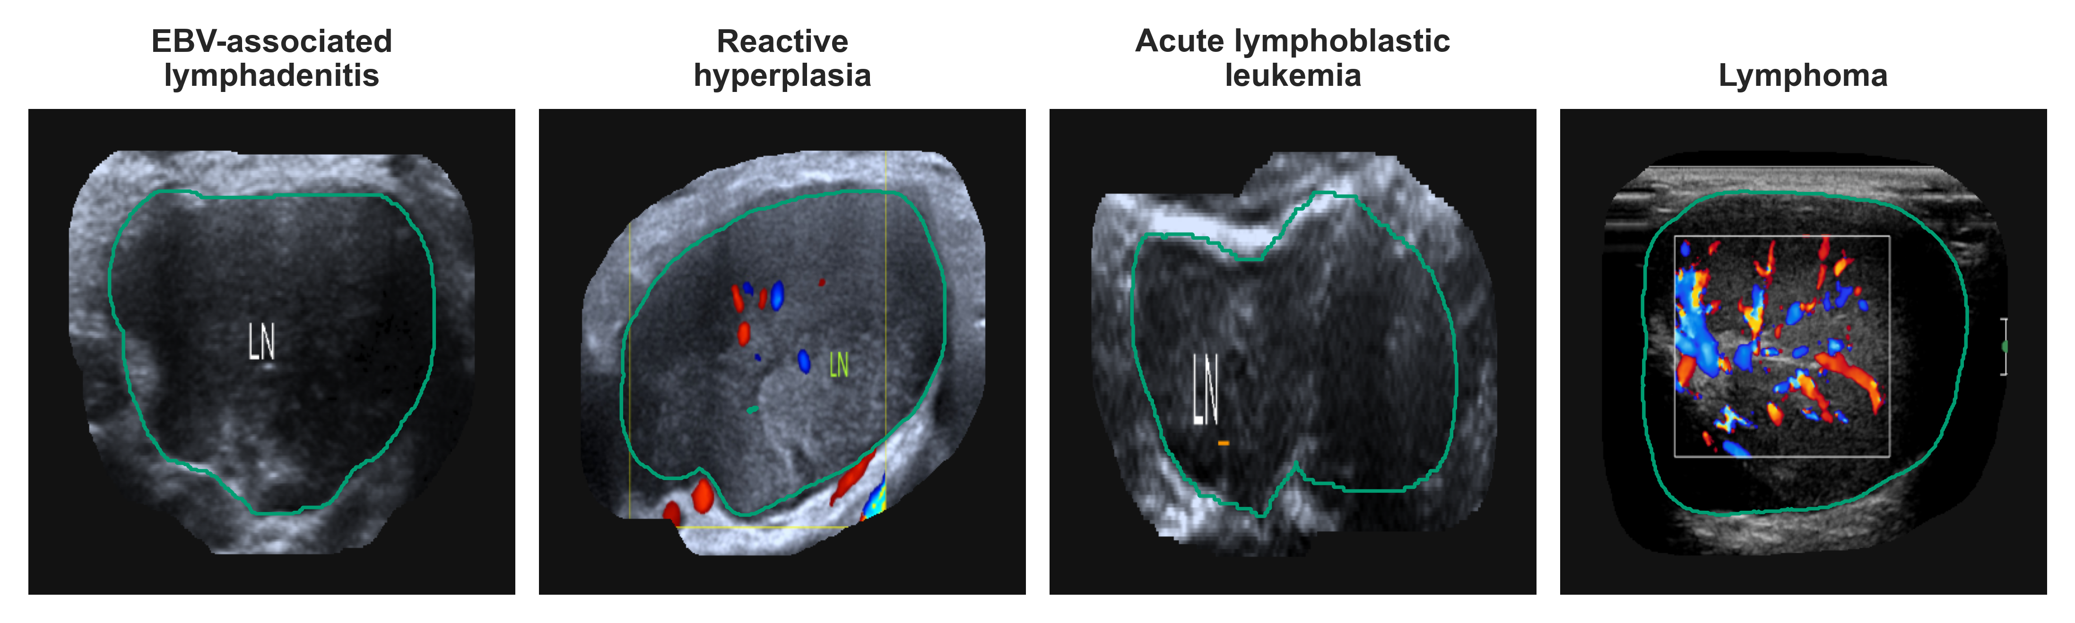
Figure S2. De-identified wider-field ultrasound images corresponding to the representative examples in Figure 2. Identifying screen text was removed before assembly. LN, lymph node.

