Exiguobacterium sargassi sp. nov., a novel seaweed-associated bacterium isolated from Sargassum henslowianum with a glycoside-hydrolase-enriched CAZyme repertoire
Ho Le Han ^{1*}, Tien Quang Vuong ², Thi Dong Phuong Nguyen ¹, Song-Gun Kim ^{3,4} , Nhat Minh Dang ¹* .
1 The University of Danang, University of Science and Technology, Danang, Vietnam.
2 GeneStory JSC, Hanoi, Vietnam
3 Biological Resource Center/Korean Collection for Type Cultures (KCTC), Korea Research Institute of Bioscience and Biotechnology, 181 Ipsingil, Jeongeup, Jeonbuk 56212, Korea
4 University of Science and Technology (UST), 217 Gajeong-ro, Yuseong, Daejeon 34113, Korea
*Corresponding author:
Professor. Dr. Nhat Minh Dang (dmnhat@dut.udn.vn)
The University of Danang, University of Science and Technology, Danang, Vietnam.

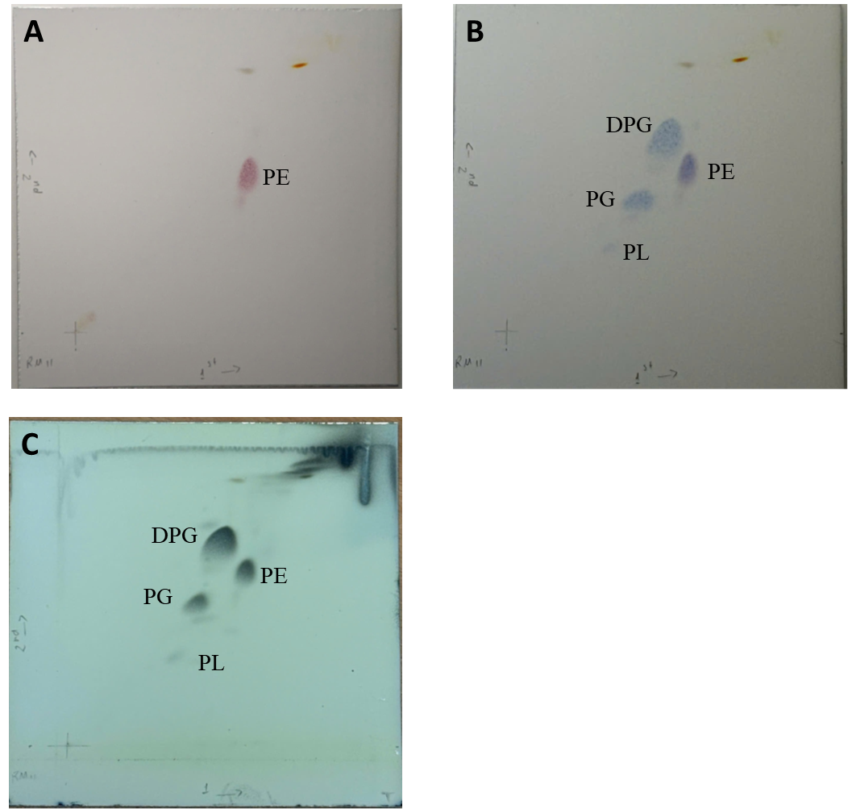
Fig. S1. Two-dimensional thin-layer chromatography showing the polar lipids profile of RM11^{T}. The solvent systems were used as chloroform-methanol-water (65:25:4, v/v/v) for the first dimension and chloroform-acetic acid-methanol-water (80:18:12:4, v/v/v/v) for the second dimension. The following spray reagents were used for the detection of polar lipids
A: ninhydrin for aminolipid
B: molybdenum blue for phospholipid
C: molybdatophosphoric acid for total lipid
Diphosphatidylglycerol (DPG), phosphatidylethanolamine (PE), Phosphatidyl glycerol (PG) unknown Phospho lipid (PL).

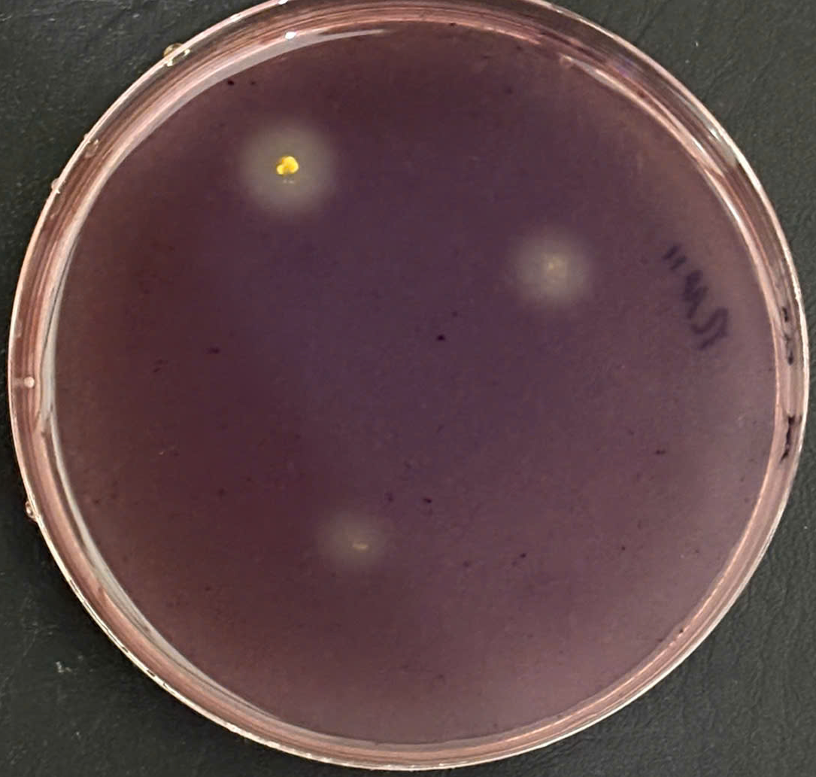

Fig S2. The novel strain RM11 grew on sodium alginate 1%, staining by Lugol's solution.
Table S1. Average nucleotide identity (ANI) and digital DNA–DNA hybridization (dDDH) values between strain RM11^{T} and the type strains of validly named Exiguobacterium species.
Type strain | Genome accession | ANI(%) | dDDH
Exiguobacterium aestuarii TF-16^{T} | GCF_025234735.1 | 90.92 | 41.7
Exiguobacterium marinum DSM 16307^{T} | GCF_000620845.1 | 87.65 | 33.3
Exiguobacterium profundum 10C^{T} | GCF_025234635.1 | 87.87 | 33.1
Exiguobacterium qingdaonense S82^{T} | GCF_018617855.1 | 86.46 | 30.5
Exiguobacterium algae S126^{T} | GCF_018617875.1 | 80.61 | 22.9
Exiguobacterium mexicanum 8N^{T} | GCF_025234665.1 | 78.13 | 21.1
Exiguobacterium aurantiacum DSM 6208^{T} | GCF_000702585.1 | 78.48 | 21.7
Exiguobacterium aquaticum IMTB-3094^{T} | GCF_025234795.1 | 78.23 | 21.1
Exiguobacterium acetylicum DSM 20416^{T} | GCF_000702605.1 | 70.47 | 21.7
Exiguobacterium oxidotolerans JCM 12280^{T} | GCF_000702625.1 | 70.28 | 21.2
Exiguobacterium artemiae 9AN^{T} | GCF_000019905.1 | 69.75 | 22.6
Exiguobacterium antarcticum DSM 14480^{T} | GCF_000685865.1 | 70.31 | 21.6
Exiguobacterium undae DSM 14481^{T} | GCF_000620805.1 | 69.94 | 21.7
Exiguobacterium flavidum HF60^{T} | GCF_003344535.1 | 70.21 | 22.3
Exiguobacterium indicum HHS31^{T} | GCF_001939065.1 | 69.97 | 20.6

