Supplementary Information

Chemically Reconfigurable Neuromorphic Electronics for Neurochemical Homeostasis

Shijie Peng^{1,4}, Qian Xu^{2,4}, Haochen Zou^{1,4}, Zhiwei Chen², Gang Song¹, Fan Zhang³, Lv
Xia¹, Rongyan Zhou¹, Weimin Hao¹, Zhuoye Tang¹, Ting Li¹, Xiao Zhao¹, Li Gao¹, Lixing Weng¹, Jianlong Ji³, Ming Wang^{2*}, Lianhui Wang^{1*}, Ting Wang^{1*}

¹State Key Laboratory of Flexible Electronics (LoFE) & Jiangsu Key Laboratory of Smart Biomaterials and Theranostic Technology, Institute of Advanced Materials (IAM), Nanjing University of Posts and Telecommunications, Nanjing 210023, P. R. China.
²State Key Laboratory of Integrated Chips and Systems, Frontier Institute of Chip and System, College of Integrated Circuits and Micro-Nano Electronics, Fudan University, Shanghai 200433, P. R. China.
³College of Integrated Circuits, Taiyuan University of Technology, Taiyuan 030600, P. R. China.
⁴These authors contributed equally to this work.
*Corresponding author. E-mail: Ming Wang: wang_ming@fudan.edu.cn, Lianhui Wang: iamlhwang@njupt.edu.cn, Ting Wang: iamtingwang@njupt.edu.cn

Table of Contents:
I: Supplementary Note
II: Supplementary Figures and Captions
III: Supplementary Table
IV: Supplementary References

I: Supplementary Note
- Calculation of μ_{h}, G and ∫OD
The calculation of hole mobility (μ_{h}) conductance (G) and integrated optical density (∫OD). We note that the hole mobility measurement using the current pulse technique¹, five consecutive voltage pulses of V_{G} = 0.7 V are input at the gate, with the V_{D} kept constant at -0.1 V. The dI_{D} / dt is calculated at the peak moment of the gate circuit of the fifth pulse.
The calculation of hole mobility is as follows:
$${\text{µ}}_{h}\text{= }\frac{\text{∂}{\text{I}}_{\text{D}}}{\text{∂}\text{t}} \text{×} \frac{{\text{L}}^{\text{2}}}{{\text{V}}_{\text{D}} \text{×} {\text{I}}_{\text{G}}}$$ | (1)
Where, μ_{h} represents the hole mobility, with units of cm² V⁻¹ s⁻¹; t is the test time, with units of s; L is the channel length (L = 150 μm); and I_{G} is the gate current, with units of μA.
The calculation of conductance change is as follows:
$$\text{∆}\text{G} \text{=} \frac{\text{∆}\text{PSC}}{{\text{V}}_{\text{D}}}$$ | (2)
Where post-synaptic current change ∆PSC = I_{D} – I_{D, baseline}, I_{D} represents the source-drain current, I_{D, baseline} represents the baseline I_{D} (without V_{G} pulses) and V_{D} represents the source-drain voltage.
Time-resolved UV–vis spectroscopy is capable of characterizing the kinetics of ions entering the channel thin film and extracting the UV absorption region in the vicinity of 550-650 nm. For the purpose of standardizing the optical readout, a fiber optic is utilized to record the light beam passing through the channel. Prior to the measurement, baseline calibration must be carried out in a dark environment where the LED light is turned off. The channel section of the OECT is positioned between the UV light source and the photometer. The incident UV light traverses through the electrolyte and the channel layer before reaching the photometer. Apply six consecutive square pulses each lasting 4 seconds with a 2-second interval, and simultaneously record the ultraviolet absorption values in the range of 550 to 650 nm. Calculate the normalized difference using the lowest absorption value as the baseline. We chose the ultraviolet absorption region of the PEDOT:PSS channel at wavelengths ranging from 550 to 650 nm for the calculation of ∫OD integration. The change in ultraviolet absorption within this region reflects the ion injection kinetics driven by the gate voltage. At a gate voltage of 0 V, the corresponding state is the neutral state. As the gate voltage increases along the rising edge up to 0.7 V, it transforms into the de-doped state, which is associated with the lowest unoccupied molecular orbital of PEDOT ². The region for optical density integration was selected to be in the range of 550-650 nm, and the calculation is carried out as per the following equation:
$$\text{∫}\text{OD} \text{=} \int_{\text{550}}^{\text{650}}{\left[\text{Delta }\text{Norm. Abs.}\right]\text{dλ}}$$ | (3)
$$\text{Delta }\text{Norm. Abs.}\text{ = }\text{Norm. Abs.} \left(\text{0.7 V}\right)\text{-Norm. Abs.} \left(\text{0 V}\right)$$ | (4)
Where, Norm. Abs. (0.7 V) denotes the normalized absorption of in-situ UV-vis spectrum value at the instant when the gate voltage is 0.7 V, which corresponds to the de-doped state. Norm. Abs. (0 V) represents the absorption value prior to the application of the gate voltage (i.e., the absorption value at the initial moment), corresponding to the neutral state.

- An elaboration on the chemical reconfiguration mechanism of the CR-
NeuroHealer
Based on our electrical characterization results, we propose that the CR-NeuroHealer’s reconfigurable properties arise from chemical modulation of the PEDOT:PSS channel’s oxidation states. The device exhibits three distinct operational modes governed by the electrolyte composition.
Healthy State (DA + Na⁺): DA undergoes electrochemical oxidation with positive V_{G}:
DA → DAQ + 2e⁻ + 2H⁺ (5)
The electrons released from DA transfer to the PEDOT:PSS channel, reducing PEDOT while cations (Cat⁺, donates Na⁺ and H⁺) migrate into the channel to compensate PSS⁻ charge:
PEDOT⁺:PSS⁻ + e⁻ + Cat⁺ → PEDOT⁰ + PSS⁻:Cat⁺ (6)
This electron transfer and ionic compensation mechanism enables long-term conductance modulation characteristic of synaptic plasticity, as evidenced by the sustained conductance changes observed with 1 mM DA + 100 mM Na⁺ electrolyte.
Pathological State (DA + Na⁺ + Fe³⁺): Fe³⁺ forms complexes with DA:
DA + Fe³⁺ → DA-Fe³⁺ (7)
Within this complex, intramolecular electron transfer occurs:
DA-Fe³⁺ + e⁻ → DA-Fe²⁺ (8)
The overall reaction:
DA + 2Fe³⁺ → DAQ-2Fe²⁺ + 2H⁺ (9)
This electron sequestration by Fe³⁺ inhibits PEDOT reduction (Equation 6), preventing sustained dedoping and converting LTP to short-term responses, as observed with 1 mM DA + 100 mM Na⁺ + 100 μM Fe³⁺.
Therapeutic State (DA + Na⁺ + Fe³⁺ + DFP): DFP’s superior chelation affinity for Fe³⁺ drives competitive displacement:
DA-Fe³⁺ + DFP → DFP-Fe³⁺ + DA (10)
This liberates DA from Fe³⁺ complexation, restoring its availability for electrochemical oxidation (Equation 5) and subsequent PEDOT reduction (Equation 6). The reestablishment of normal electron transfer pathways recovers long term conductance modulation, as demonstrated by the restored electrical properties with 1 mM DA + 100 mM Na⁺ + 100 μM Fe³⁺ + 1 mM DFP.
This molecular mechanism explains how chemical inputs directly control synaptic plasticity through competitive redox and chelation reactions, enabling autonomous reconfiguration between distinct functional states without external programming.
- Preparation procedures of PCM-NPs
In order to meet the requirements of thermal controlled release, PCM-NPs have been selected for use in the implantable release device for nano drug encapsulation³. This choice is based on their thermal controlled release characteristics with a controllable melting point and the stable drug encapsulation properties at room temperature. We elected to use PCM-NPs to embed DA and DFP to align with the thermal controlled release strategy. The melting point of PCM-NPs can be precisely regulated by adjusting the ratio of lauric acid to stearic acid. Anticipating that a melting point of 39 ºC would be appropriate, we set the ratio of lauric acid to stearic acid at 4:1. These two substances were separately heated and stirred in 5 mL and 9 mL of methanol, respectively, to prepare an oil phase with a pre-dissolution concentration of 4 mg/mL. To improve biocompatibility and the stability of the embedding process, the terminal groups were modified with polyethylene glycol-2000 (PEG-2000). PEG-2000 and lecithin were dissolved in 4% ethanol at a ratio of 1:3 to formulate an aqueous phase with a concentration of 1 mg/mL. Subsequently, to satisfy the release expectations of more than 1 mM for both DA and DFP, a concentration ratio of 1:10 was selected. Either 10 mM DA or 10 mM DFP was then mixed with the oil phase and the aqueous phase pre-heated to 50 ºC. The mixture was subjected to ultrasonic agitation for 10 minutes. After rapid cooling, two consecutive rounds of ultrafiltration centrifugation were carried out.
- Optimization of thermal control resistor parameters.
The role of the thermal control is to convert the PSC of the OECT into an appropriate output voltage, thereby meeting the requirements for the release of DA and DFP. Thus, our approach involves determining the method of weight extraction based on the characteristics of the thermally controlled resistor. Given that the release melting point of PCM-NPs is set at 39 ºC, we adjusted the resistance value and Joule effect in accordance with the length to width ratio (L/W) of the resistor. After careful consideration, a resistance value of 130 Ω was selected as appropriate. In light of the resistor’s characteristics, it is necessary to accommodate an input voltage within the range of 0-5.5 V.
- Supplementary Method. Detailed protocols for the 6-OHDA model and behavioral tests.
6-OHDA-induced Parkinsonian mouse model
Adult male and female C57BL/6J mice (18-20 g, 8-12 weeks) were used. To establish the Parkinsonian model, 6-OHDA hydrobromide (Sigma-Aldrich, 162957) was freshly dissolved in sterile saline at 4 μg/μl. Thirty minutes before surgery, mice were pretreated with desipramine (25 mg/kg) and pargyline (5 mg/kg) via i.p. injection to protect noradrenergic neurons. Under deep anesthesia, 1 μl of the 6-OHDA solution was injected into the right medial forebrain bundle (MFB) using a microsyringe pump at the coordinates (relative to bregma): AP -1.2 mm, ML -1.3 mm, DV -4.75 mm. The needle remained in place for an additional 5 min to ensure optimal diffusion. Subsequently, an equal volume (1 μl) of sterile saline was injected into the contralateral MFB at the symmetric coordinates as an internal control. Post-operatively, mice were kept on a heating pad to prevent hypothermia and received daily i.p. saline injections. For the first week after surgery, mice were provided with glucose aqueous solution ad libitum to ensure adequate hydration and nutrition
Behavioral assessments
Spontaneous locomotor activity was assessed using the open-field test. Each mouse was gently placed in the center of a square arena (50 cm × 50 cm) and allowed to explore freely for 10 minutes, recorded by an overhead camera. The total movement distance and velocity were tracked and analyzed using Fiji software (ImageJ, National Institutes of Health). Motor balance and coordination were assessed using the rotarod test. An accelerating protocol was applied, increasing the rotation speed from 5 to 45 rpm over 5 minutes. Each mouse underwent three trials on the same day with a 20-minute interval between trials, without prior training. The latency to fall was recorded for each trial, and the data were expressed as the average of the two best trials. For the AMPH-treated groups, the tests were performed at 2 h post-i.p. AMPH injection. For the 6-OHDA–induced Parkinsonian model groups and DFP-treated groups, the tests were conducted at the designated endpoints (e.g., 2 weeks post-lesioning for the 6-OHDA model, and after the 5-day DFP therapy and 1-week recovery).
Immunohistochemistry and TH immunofluorescence staining
Mice were deeply anesthetized using isoflurane and transcardially perfused with cold PBS followed by cold 4% PFA in PBS (pH 7.4). Brains were post-fixed in 4% PFA at 4 ºC for an additional 2 hours, equilibrated in 30% sucrose solution for 2 days, and rapidly frozen in embedding freezing medium (Thermo Fisher Scientific). Coronal slices of the striatum and SNc with a thickness of 30 μm were obtained using a cryostat (Epredia, NX50).
For immunofluorescence staining, the frozen sections were air-dried and baked in an oven at 37 ºC for 10 to 20 min. The slices were then fixed with methanol (Sinopharm Chemical Reagent Co., Ltd., 100141092) for 30 min and rinsed with PBS (pH 7.4, Servicebio, G0002) on a decolorizing shaker (Servicebio, SYC-Z100) three times for 5 min each. Heat-mediated antigen retrieval was subsequently performed for 30 min using an antigen retrieval apparatus (Servicebio, ARI-4). After natural cooling, the sections were washed with PBS three times for 5 min each. Next, the sections were blocked with 3% bovine serum albumin (Servicebio, GC305010) for 30 min at room temperature. The sections were then incubated overnight at 4 ºC with rabbit anti-TH primary antibody (Servicebio, GB11181) diluted 1:500 in blocking buffer. After washing with PBS three times for 5 min each, the sections were incubated with Alexa Fluor 488-conjugated goat anti-rabbit IgG secondary antibody (Servicebio) for 50 min at room temperature in the dark. Following another washing step, the cell nuclei were counterstained with DAPI (Servicebio, G1012) for 10 min at room temperature in the dark. After PBS washes, autofluorescence was quenched using an autofluorescence quencher (Servicebio, G1221) for 5 min, followed by a 10-min rinse under running water. Finally, the sections were mounted with an antifade mounting medium (Servicebio, G1401).
Fluorescence images were acquired using a digital tissue slide scanner (Servicebio, LG-FS80). The excitation and emission wavelengths were set as follows: DAPI (330-380 nm / 420 nm), Alexa Fluor 488 (465-495 nm / 515-555 nm), CY3 (510-560 nm / 590 nm), and CY5 (608-648 nm / 672-712 nm).

II: Supplementary Figures and Captions

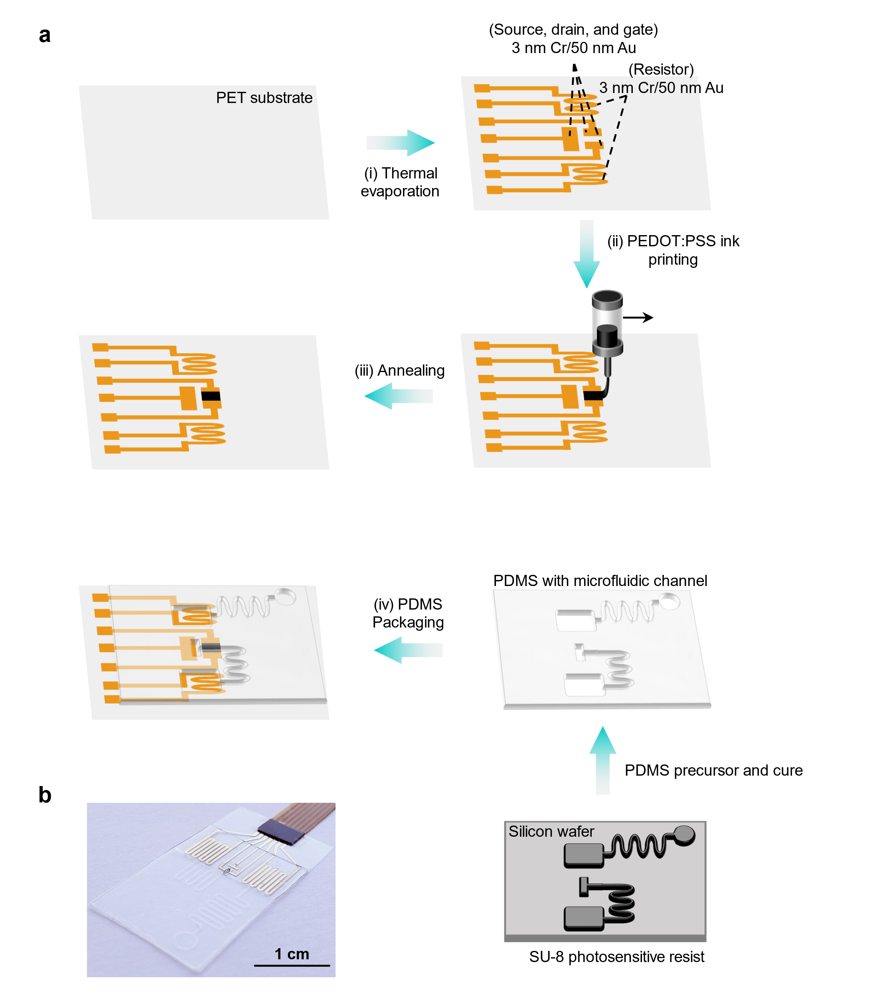
Supplementary Figure 1 Fabrication process and device architecture of CR-NeuroHealer. (a) Layer-by-layer fabrication process: (i) Thermal evaporation deposits source, drain, and gate electrodes (3 nm Cr/50 nm Au) on flexible PET substrate, with additional 3 nm Cr/50 nm Au resistor patterns for heating elements; (ii) PEDOT:PSS ink printing creates the active channel layer using inkjet deposition; (iii) Annealing at 120 ºC for 30 min enhances film conductivity and adhesion; (iv) PDMS packaging provides device protection while maintaining microfluidic channel access; (v) Final PDMS packaging integrates microfluidic channels for molecular delivery; (vi) Complete device assembly shows electrical connections to processing circuitry and dual thermally-controlled release modules. Bottom inset illustrates the photolithography process using SU-8 photosensitive resist on silicon wafer to create microfluidic channel molds, which are subsequently cast with PDMS precursor and cured. (b) Photograph of the fabricated CR-NeuroHealer showing the transparent flexible substrate, visible electrode arrays, and integrated microfluidic channels. Scale bar: 1 cm.

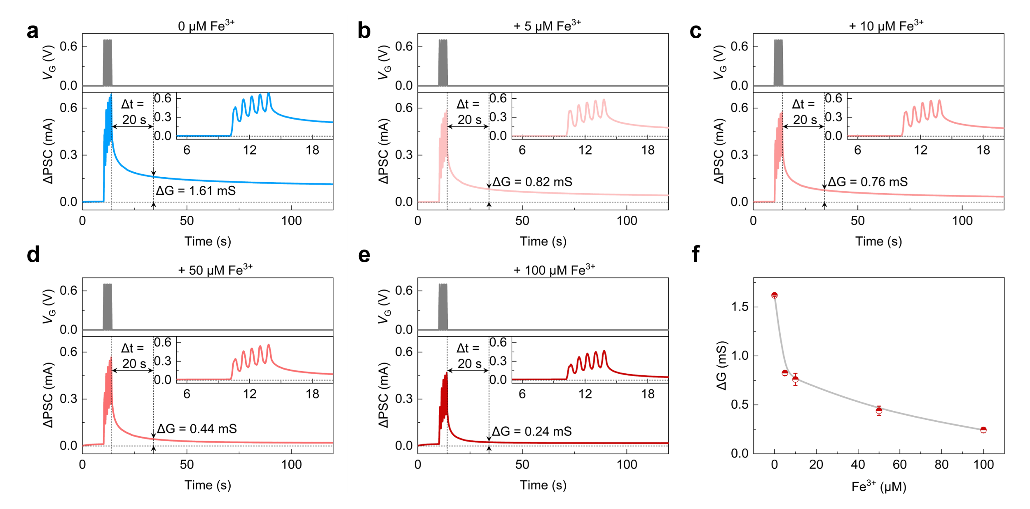
Supplementary Figure 2 Concentration dependent synaptic plasticity degradation in neuromorphic OECT. (a to e) ΔPSC responses and ΔG following five consecutive 0.7 V gate pulses (1.2 Hz, t_{w} = 550 ms) with increasing Fe³⁺ concentrations in base electrolyte (1 mM DA + 100 mM NaCl). V_{DS} = -0.1 V. (a) Control (0 μM Fe³⁺): robust ΔPSC response with ΔG = 1.61 mS indicating strong LTP. (b) 5 μM Fe³⁺: slightly reduced ΔG = 0.82 mS. (c) 10 μM Fe³⁺: ΔG decreases to 0.76 mS. (d) 50 μM Fe³⁺: significant plasticity loss with ΔG = 0.44 mS. (e) 100 μM Fe³⁺: severe impairment with ΔG = 0.24 mS, approaching STP. (f) Summary showing ΔG measured 20 s post-stimulation decreases linearly with Fe³⁺ concentration, demonstrating progressive transition from strong LTP to waken LTP. Error bars represent: mean ± SD of ΔG across n = 5 devices.

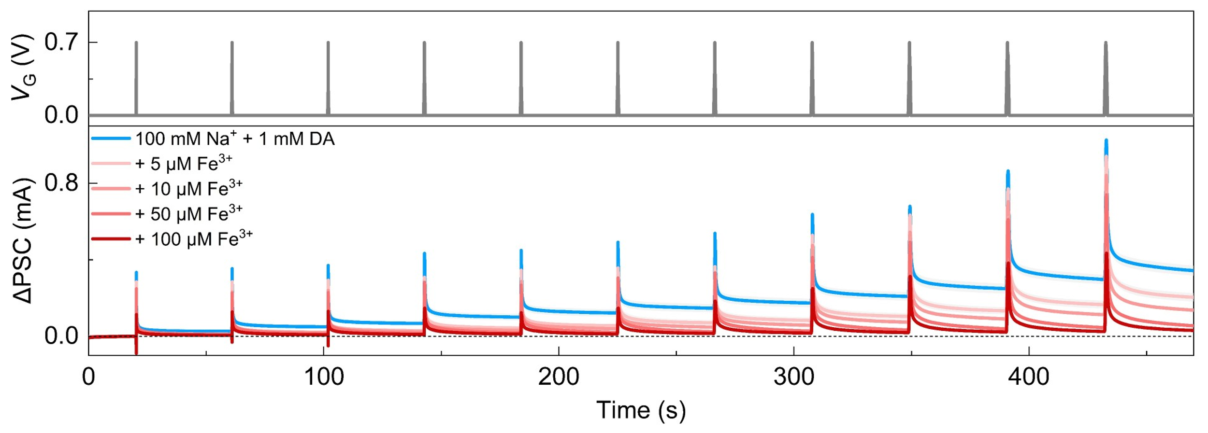
Supplementary Figure 3 The PSC output of neuromorphic OECT under different pulse duration conditions. When applying a 0.7 V gate pulse stimulation, the PSC output of neuromorphic OECT was measured in electrolyte environments of 100 mM Na⁺ + 1 mM DA and 5-100 μM Fe³⁺, respectively. Error bars represent: mean ± SD of ΔG across n = 5 devices.

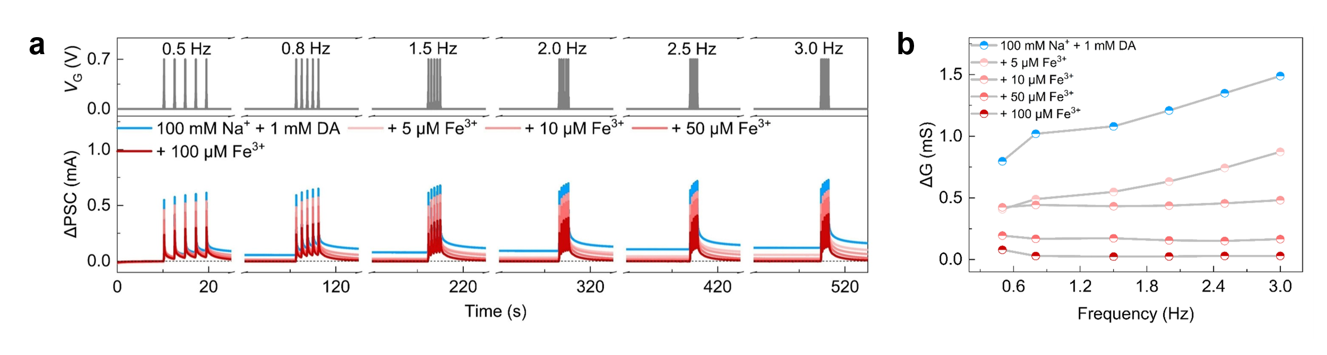
Supplementary Figure 4 The PSC output of neuromorphic OECT under different pulse frequency conditions. (a) When applying 0.5-3.0 Hz, 0.7 V gate pulse stimulation, the PSC output of neuromorphic OECT in the electrolyte environments of 100 mM Na⁺ + 1 mM DA and 5-100 μM Fe³⁺ were measured respectively. (b) The ΔG was separately extracted and statistically analyzed after each frequency of pulse stimulation. The time node for statistics was set at 20 s after the end of the last pulse.

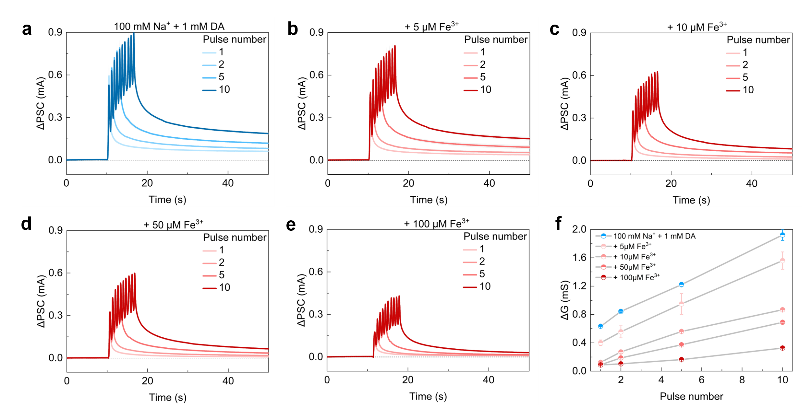
Supplementary Figure 5 The PSC output of neuromorphic OECT under different pulse duration conditions. (a to e) Applying 1-10 times of 0.7 V gate pulse stimulation (1.2 Hz, t_{w} = 550 ms), the PSC output of neuromorphic OECT in the electrolyte environments of 100 mM Na⁺ + 1 mM DA and 5-100 μM Fe³⁺ respectively. (f) The ΔG was separately extracted after each frequency of pulse stimulation. The statistical time node was set at 20 s after the end of the last pulse. Error bars represent: mean ± SD of ΔG across n = 5 devices.

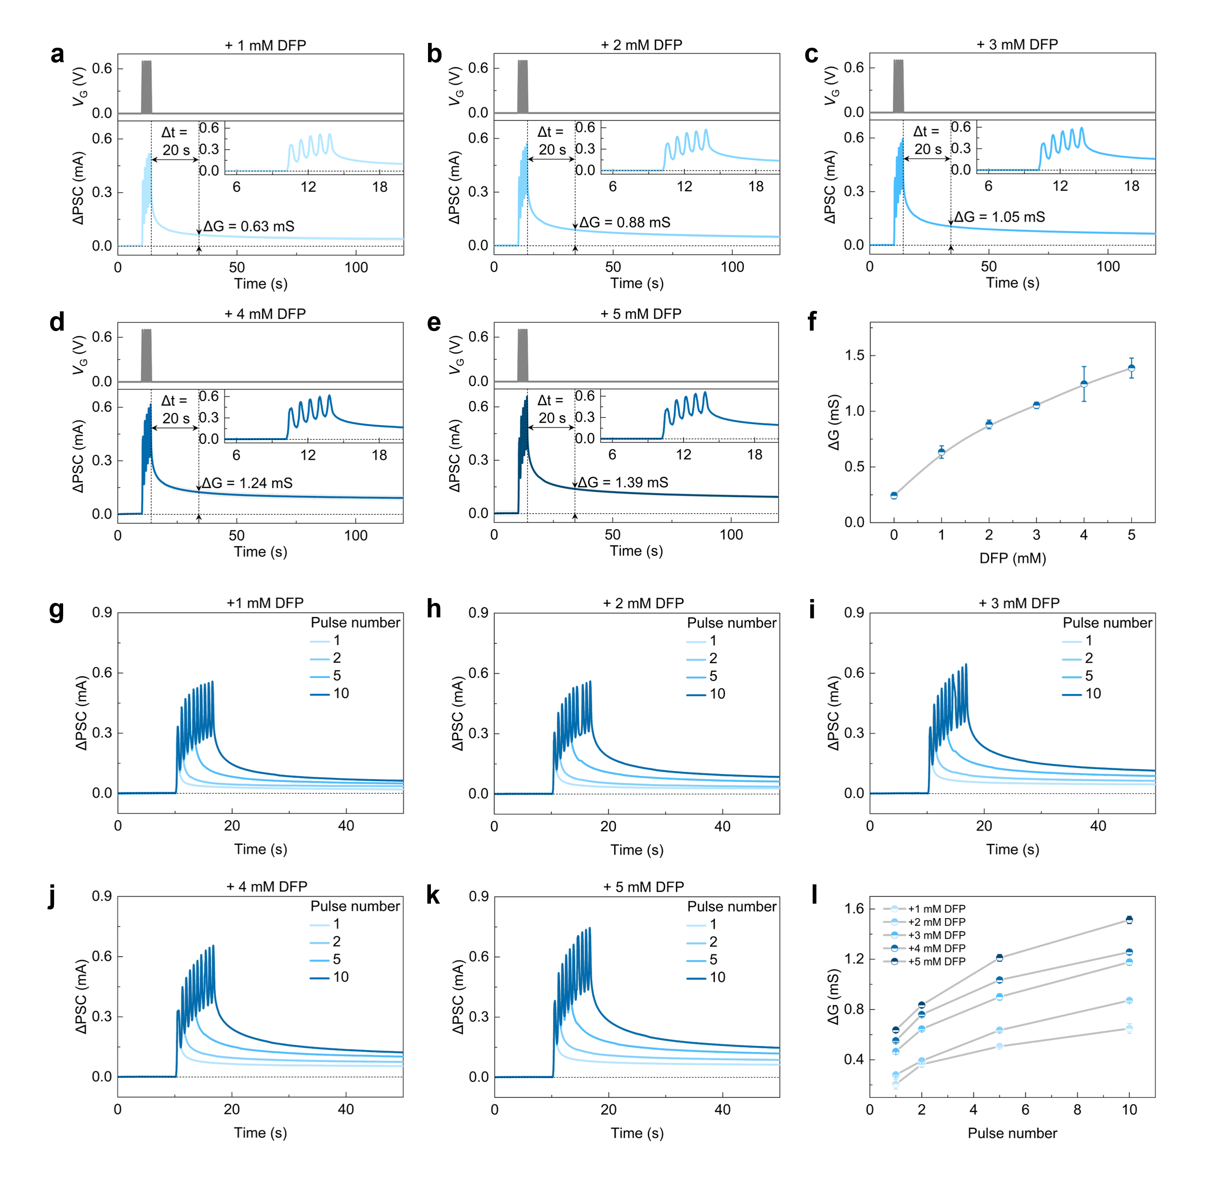
Supplementary Figure 6 DFP mediated recovery of synaptic plasticity in Fe³⁺ loaded neuromorphic OECT. (a to e) ΔPSC responses and ΔG following five consecutive 0.7 V gate pulses (1.2 Hz, t_{w} = 550 ms) with increasing DFP concentrations added to Fe³⁺ loaded system (100 μM Fe³⁺ + 1 mM DA + 100 mM NaCl). V_{DS} = -0.1 V. (a) 1 mM DFP: partial recovery with ΔG = 0.63 mS. (b) 2 mM DFP: ΔG = 0.88 mS. (c) 3 mM DFP: ΔG = 1.05 mS. (d) 4 mM DFP: ΔG = 1.24 mS. (e) 5 mM DFP: near complete recovery with ΔG = 1.39 mS, approaching healthy state LTP. (f) Summary showing dose dependent restoration of synaptic plasticity, with ΔG measured 20 s post-stimulation increasing from 0.63 to 1.39 mS across 1-5 mM DFP range. (g to k) Pulse dependent plasticity measurements at varying DFP concentrations (1-5 mM). Progressive enhancement of conductance with increasing pulse number (1, 2, 5, 10 pulses shown in gradient blue), demonstrating both LTP and concentration dependent amplification of synaptic responses over 50 s recording windows. (l) Comprehensive analysis of pulse dependent plasticity across all DFP concentrations. ΔG increases with both pulse number (1-10, t_{w} = 550 ms) and DFP concentration (1-5 mM), revealing synergistic enhancement of synaptic plasticity, with 1 mM DFP achieving 0.65 mS at 10 pulses compared to 1.51 mS at 5 mM DFP. The statistical time node was set at 20 s after the end of the last pulse. Error bars represent: mean ± SD of ΔG across n = 5 devices.

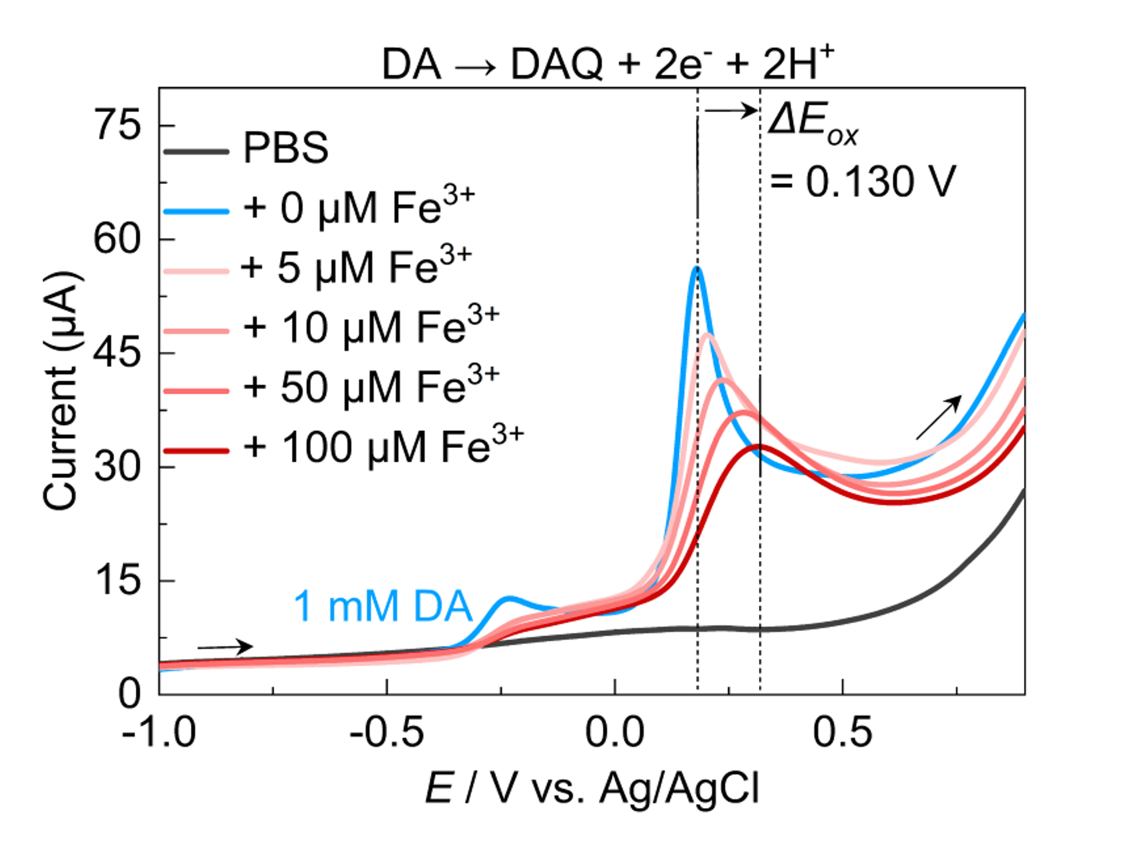
Supplementary Figure 7 Electrochemical evidence of [Fe(DA)]²⁺ complexation inhibiting DA oxidation. Linear sweep voltammetry curves obtained using Au working electrode show systematic changes in DA oxidation with increasing Fe³⁺ concentration. PBS buffer baseline (black), 1 mM DA alone exhibits clear oxidation peak at 0.178 V (blue), while addition of Fe³⁺ (5-100 μM, light to dark red) causes progressive positive shifts in oxidation potential and decreased peak currents. The rightward shift indicates that [Fe(DA)]²⁺ complexes are more thermodynamically stable than free DA, requiring higher potentials for oxidation. This enhanced stability of [Fe(DA)]²⁺ complexes reduces free DA available for oxidation, supporting the proposed mechanism where Fe³⁺ sequestration of DA inhibits electron transfer to the PEDOT:PSS channel. All solutions were degassed by N₂ bubbling for >15 minutes to eliminate O₂ effects on DA oxidation. Scan parameters: -1.0 to 0.8 V vs. Ag/AgCl at 50 mV/s.

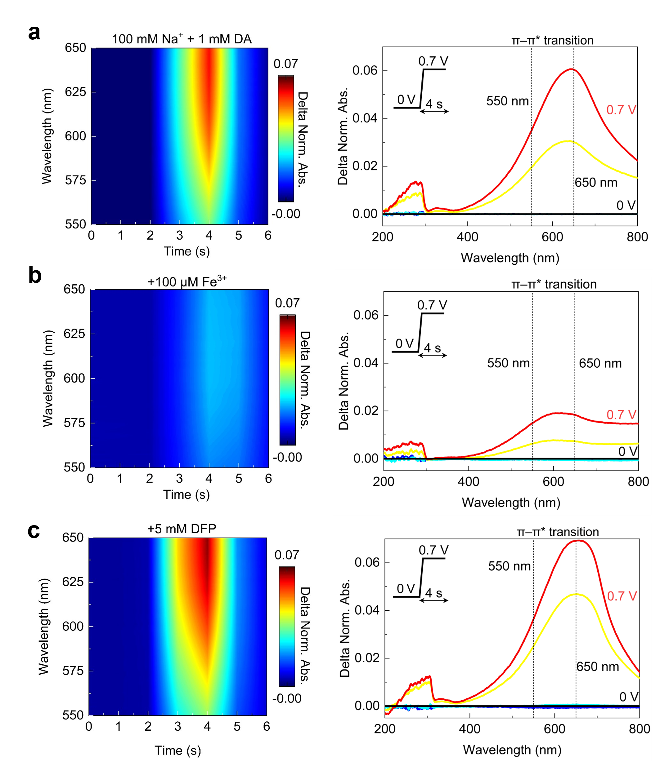
Supplementary Figure 8 Time-resolved UV–vis spectra spectroscopic characterization reveals gate induced PEDOT:PSS doping state transitions. Time resolved absorption spectra (550-650 nm) and full spectral analysis (200-800 nm) during application of six consecutive 0.7 V gate pulses (4 s ON and 2 s OFF) with V_{DS} = -0.1 V. Left panels show 2D spectral maps tracking absorption changes over time; right panels display extracted spectra at 0 V (baseline) and 0.7 V (pulsed) states, highlighting π-π* transitions at 550 nm and 650 nm, Delta Norm. Abs. denotes the different between the normalized absorbance at doping potential and 0 V. (a) DA mediated dedoping (1 mM DA + 100 mM Na⁺): Strong absorption decrease at 550-650 nm during pulses indicates efficient PSS⁻ dedoping and PEDOT oxidation state modulation, recovering after each pulse. (b) Fe³⁺ inhibited dedoping (+100 μM Fe³⁺): Minimal absorption changes demonstrate suppressed dedoping due to [Fe(DA)]²⁺ complexation reducing available protons for channel modulation. (c) DFP-restored dedoping (+5 mM DFP): Recovery of absorption modulation confirms DFP chelation of Fe³⁺ restores normal dopamine oxidation and channel dedoping dynamics, approaching the response observed in panel (a).

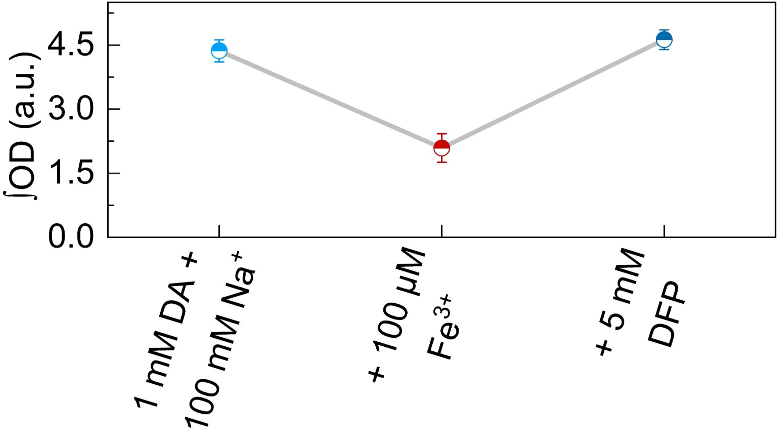
Supplementary Figure 9 The calculation result of the optical density. Error bars represent: mean ± SD of ΔG across n = 5 devices.

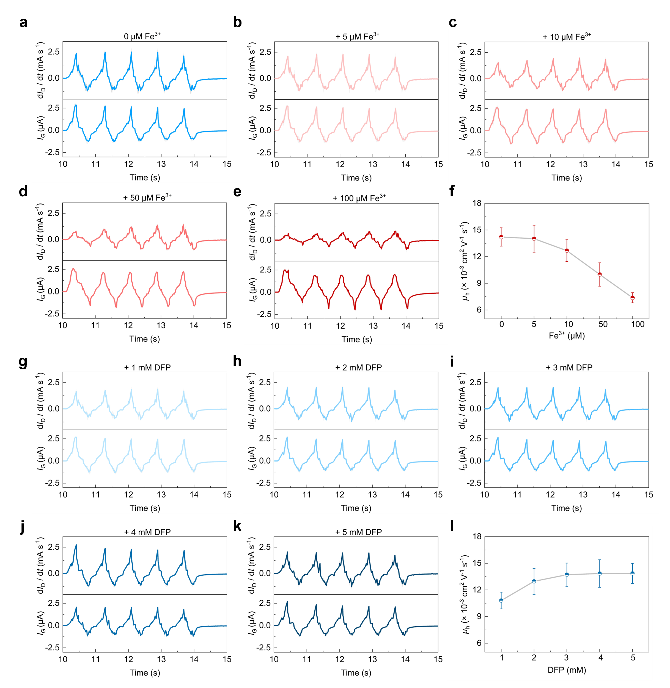
Supplementary Figure 10 Transient hole mobility measurements reveal concentration dependent modulation by Fe³⁺ and DFP. μ_{h} calculated from drain current derivatives (dI_{D} / dt) and I_{G} during the fifth gate pulse (0.7 V, V_{DS} = -0.1 V). Upper traces show corresponding dI_{D} / dt; lower traces display corresponding I_{G}. (a to e) Progressive Fe³⁺ addition demonstrates concentration dependent mobility suppression: (a) Control (0 μM Fe³⁺): μ_{h} = 14.218 × 10⁻³ cm² V⁻¹ s⁻¹. (b) 5 μM Fe³⁺: μ_{h} = 14.020 × 10⁻³ cm² V⁻¹ s⁻¹. (c) 10 μM Fe³⁺: μ_{h} = 12.677 × 10⁻³ cm² V⁻¹ s⁻¹. (d) 50 μM Fe³⁺: μ_{h} = 9.994 × 10⁻³ cm² V⁻¹ s⁻¹. (e) 100 μM Fe³⁺: μ_{h} = 7.369 × 10⁻³ cm² V⁻¹ s⁻¹. (f) Summary showing 51.8% mobility reduction at 100 μM Fe³⁺. (g to k) DFP mediated recovery in Fe³⁺ loaded system (100 μM Fe³⁺): (g) 1 mM DFP: μ_{h} = 10.808 × 10⁻³ cm² V⁻¹ s⁻¹. (h) 2 mM DFP: μ_{h} = 12.964 × 10⁻³ cm² V⁻¹ s⁻¹. (i) 3 mM DFP: μ_{h} = 13.717 × 10⁻³ cm² V⁻¹ s⁻¹. (j) 4 mM DFP: μ_{h} = 13.844 × 10⁻³ cm² V⁻¹ s⁻¹. (k) 5 mM DFP: μ_{h} = 13.860 × 10⁻³ cm² V⁻¹ s⁻¹. (l) Dose dependent mobility recovery 97.5% of control, confirming DFP restoration of charge transport.

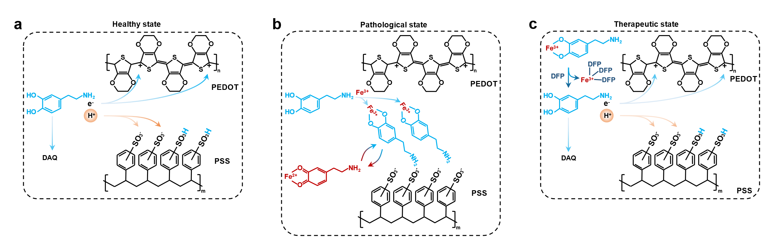
Supplementary Figure 11 Molecular mechanism of chemical reconfiguration in neuromorphic OECT through competitive redox and chelation reactions. (a) Healthy state (DA electrolyte): DA oxidation at the gate electrode generates DAQ, releasing electrons and protons. Protons migrate into the PEDOT:PSS channel where they protonate PSS⁻ groups, causing dedoping and increasing PEDOT⁺ oxidation state. This sustained dedoping creates long-term conductance changes characteristic of LTP. (b) Pathological state (DA + Fe³⁺ electrolyte): Fe³⁺ forms stable complexes with DA through catechol coordination, preventing DA oxidation. The [Fe(DA)]²⁺ complex undergoes intramolecular electron transfer (Fe³⁺ → Fe²⁺), diverting electrons from the PEDOT channel. Reduced proton generation limits PSS⁻ dedoping, maintaining PEDOT in its doped state and resulting in diminished synaptic plasticity. (c) Therapeutic state (DA + Fe³⁺ + DFP electrolyte): DFP’ s superior chelation affinity competitively displaces DA from Fe³⁺ complexes, forming stable Fe-DFP complexes. This liberates free DA to undergo normal oxidation, restoring proton generation and PSS⁻ dedoping. The reestablished dedoping mechanism recovers LTP, completing the chemical reconfiguration cycle from pathological to healthy synaptic function.

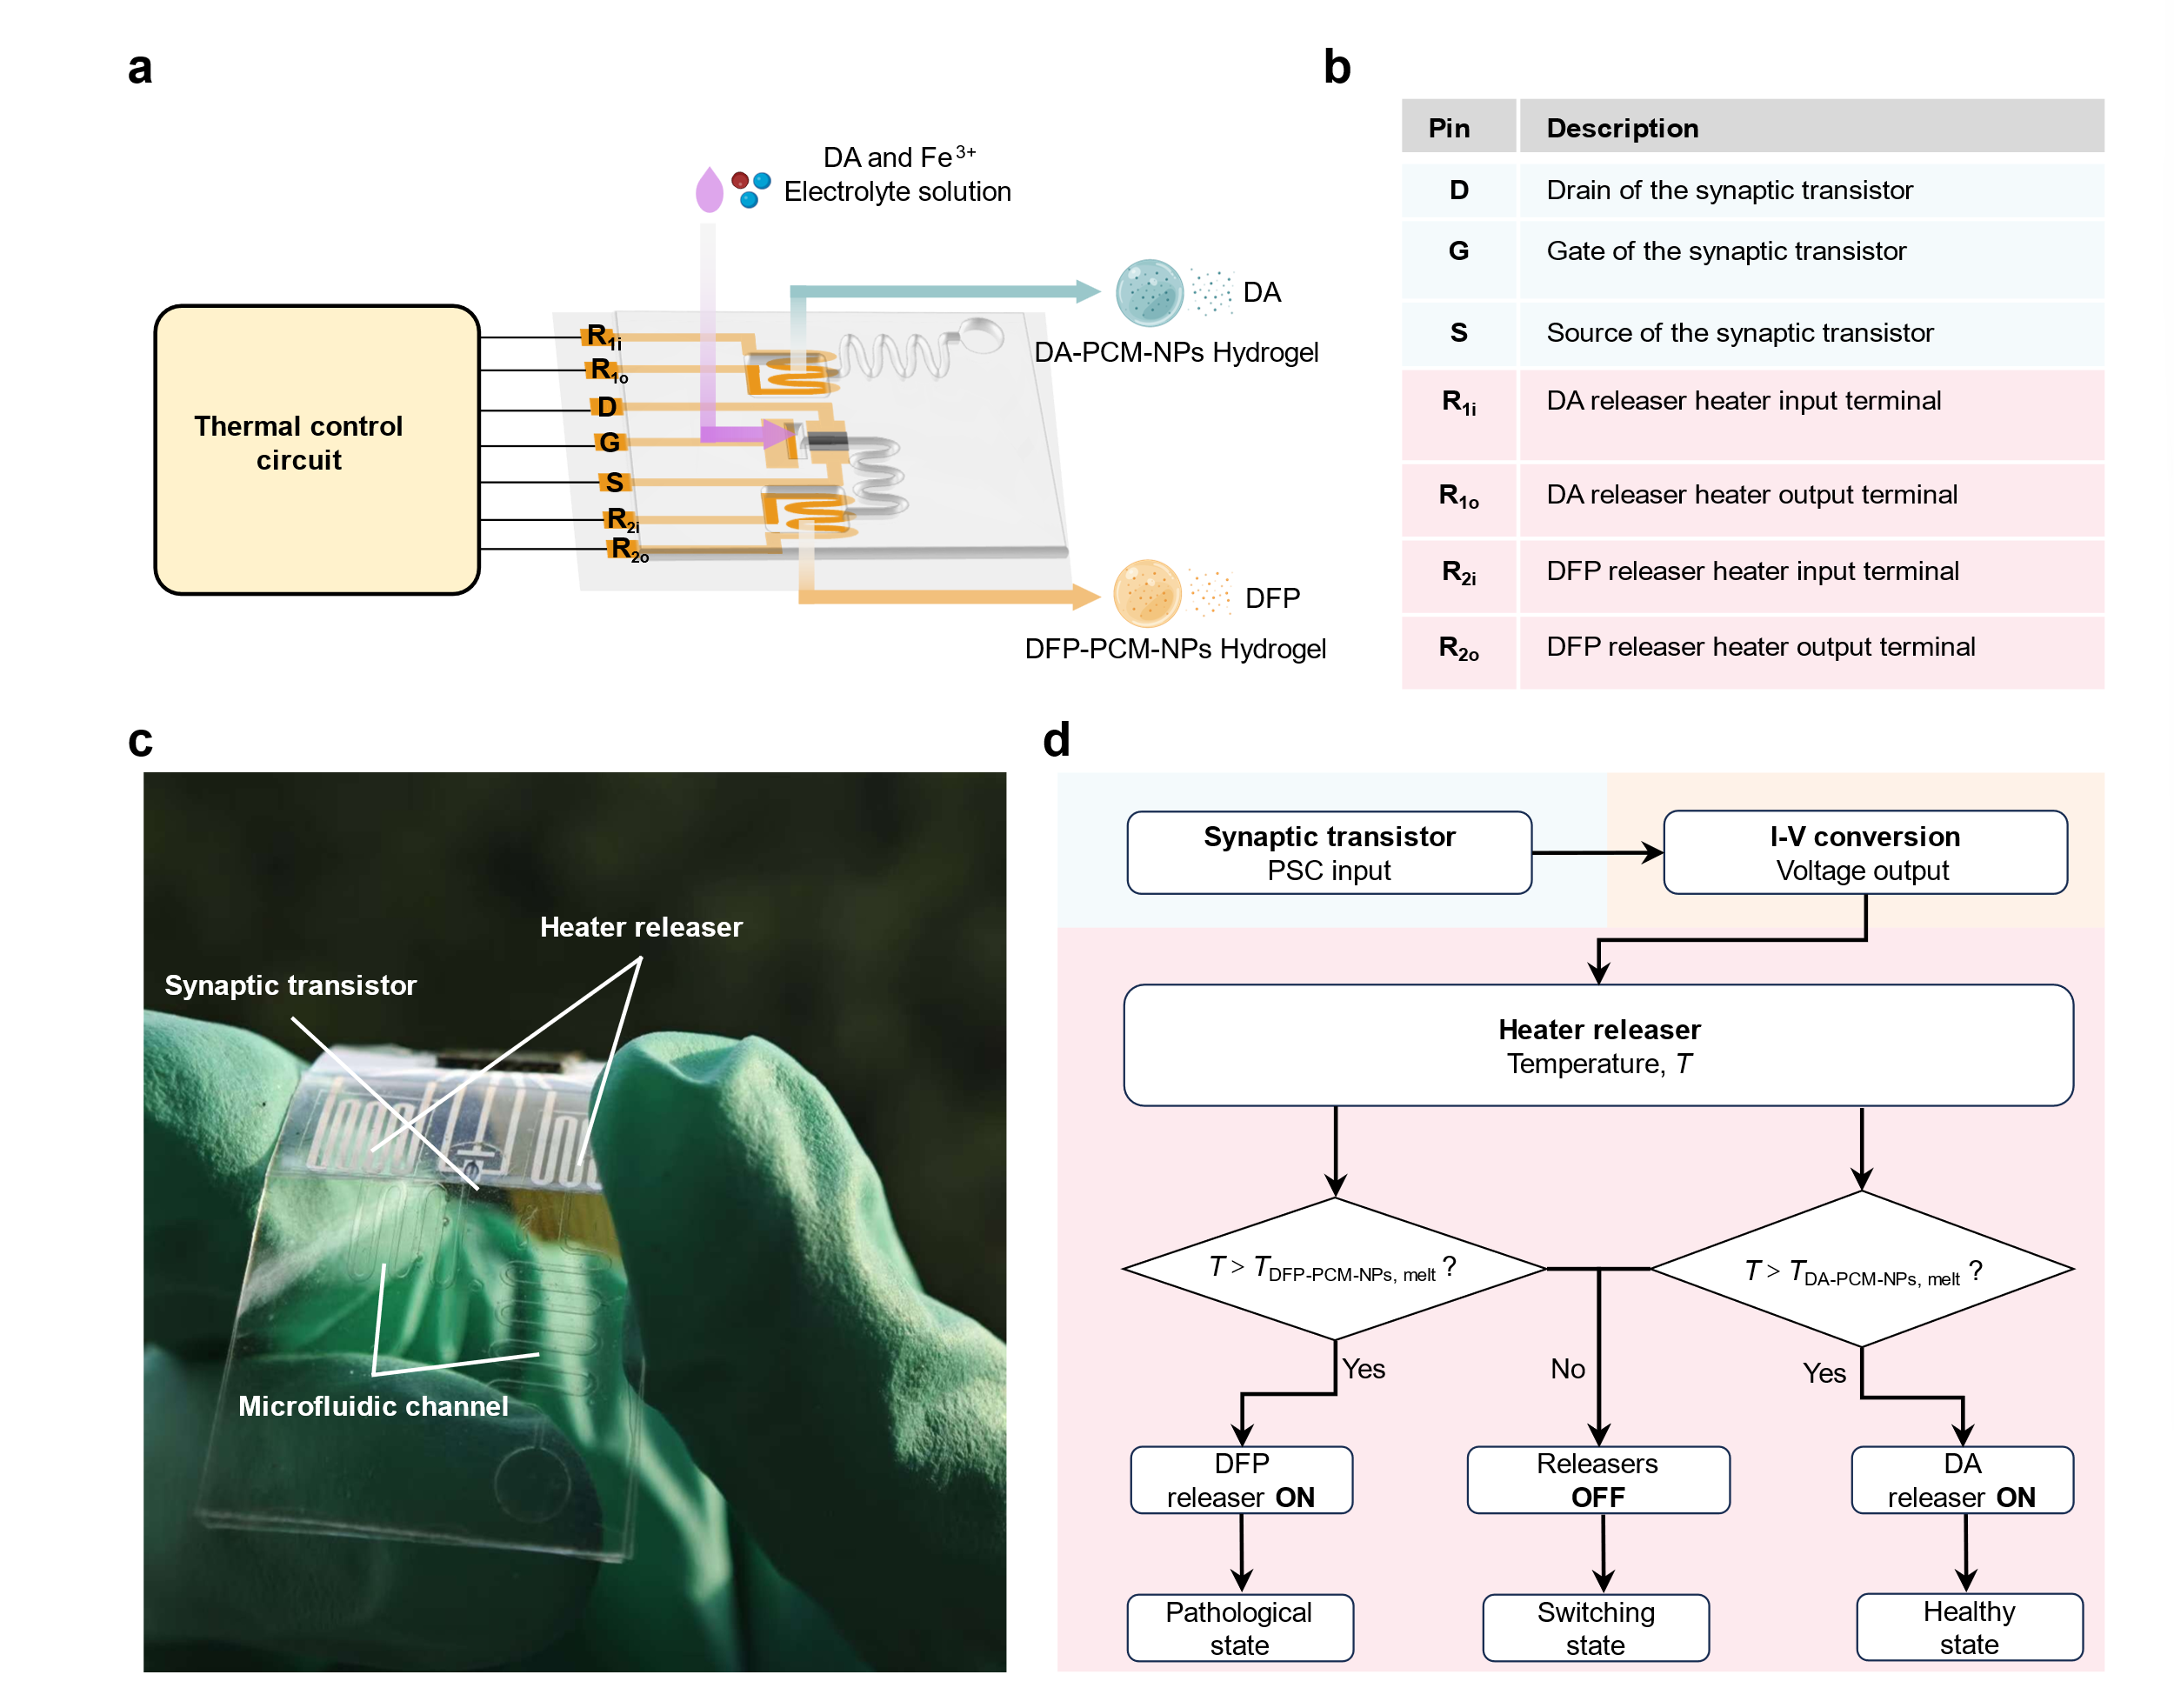
Supplementary Figure 12 System architecture and operational logic of the integrated CR-NeuroHealer. (a) Device architecture showing the multi-layer integration of functional components. The system comprises: (i) OECT for chemical perception of DA and Fe³⁺, (ii) resistive heaters for thermal control, (iii) dual microfluidic channels containing DFP (upper) and DA (lower) flows, and (iv) flexible substrate integration. Photograph shows the assembled device demonstrating mechanical flexibility for biocompatible applications. (b) Pin assignment and functional description Table. (c) Physical prototype photograph of CR-NeuroHealer. (d) Operational flowchart illustrating the autonomous decision making process. Chemical perception of iron levels triggers current to voltage mapping, which determines the thermal release pathway based on melting point of DA-PCM-NPs and DFP-PCM-NPs (T_{DA-PCM-NPs,melt} or T_{DFP-PCM-NPs,melt}). In healthy conditions (T < T_{DFP-PCM-NPs,melt} and T > T_{DA-PCM-NPs,melt}), DA is released to maintain synaptic function; in pathological conditions (T > T_{DFP-PCM-NPs,melt} and T < T_{DA-PCM-NPs,melt}), DFP is released for therapeutic iron chelation. This closed loop system enables real time homeostatic regulation without external control.

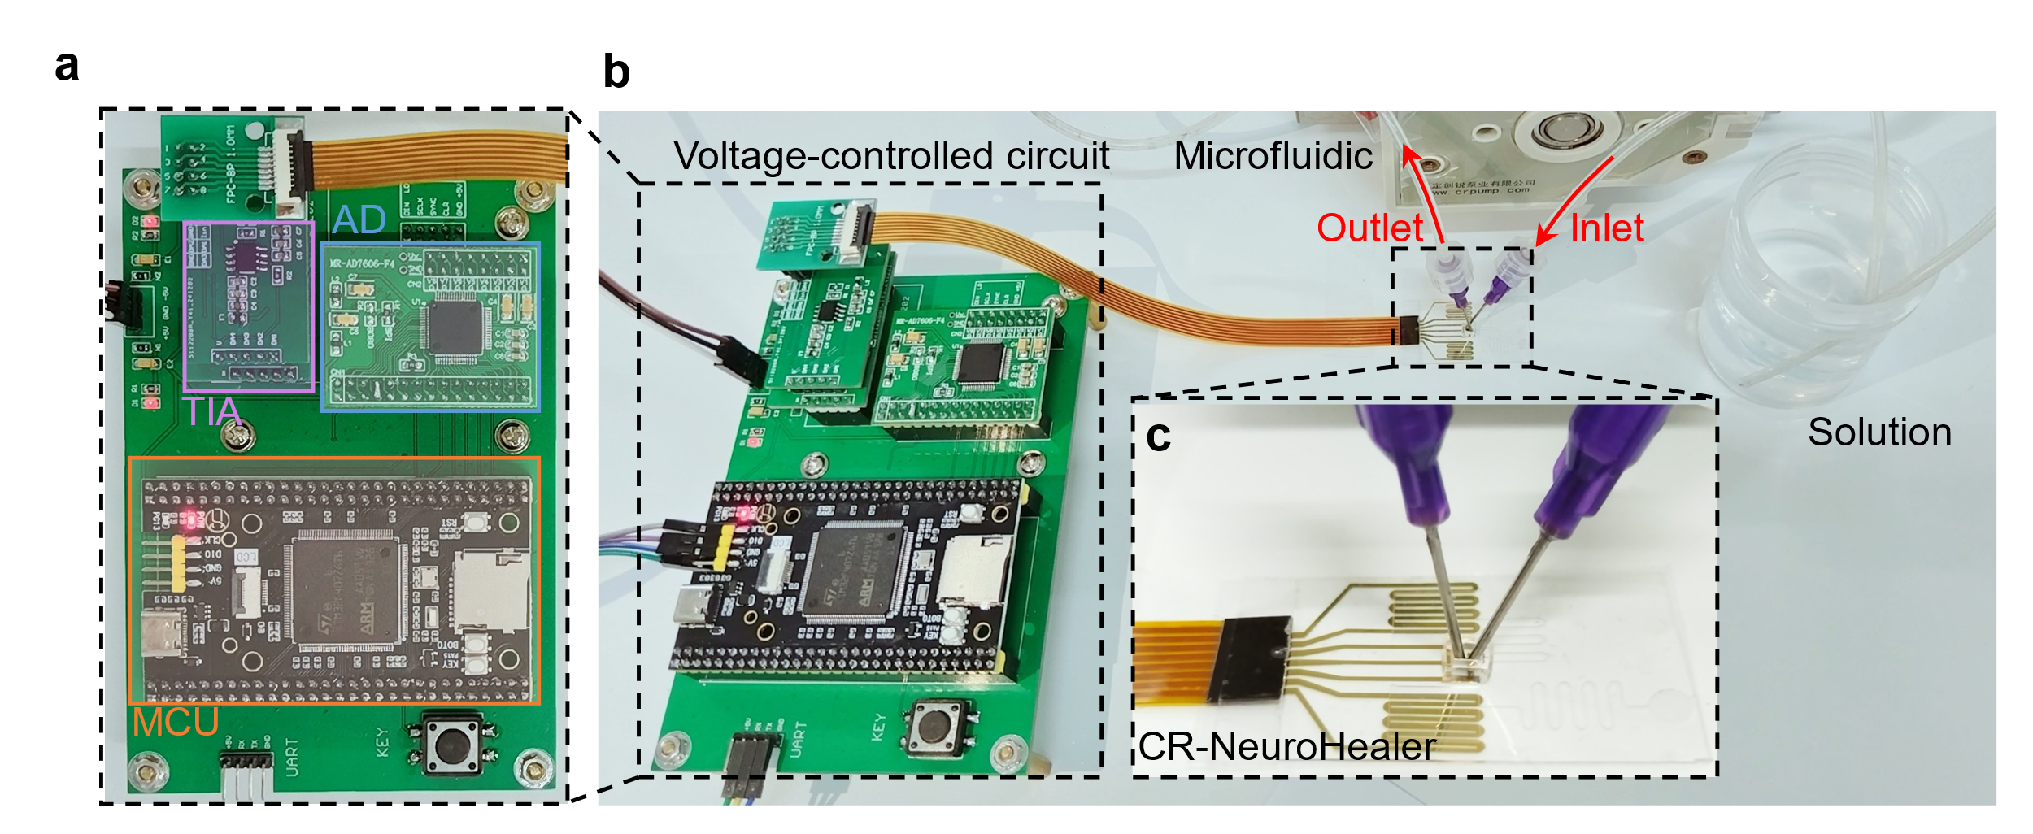
Supplementary Figure 13 Integrated CR-NeuroHealer system assembly and testing setup. (a) Voltage control module with a MCU, AD/DA converters, and TIA. (b) Complete system showing control electronics interfaced with CR-NeuroHealer device and microfluidic connections for solution delivery via peristaltic pump. (c) Magnified view of device with microfluidic inlet/outlet ports enabling real-time chemical perception and molecular release control.

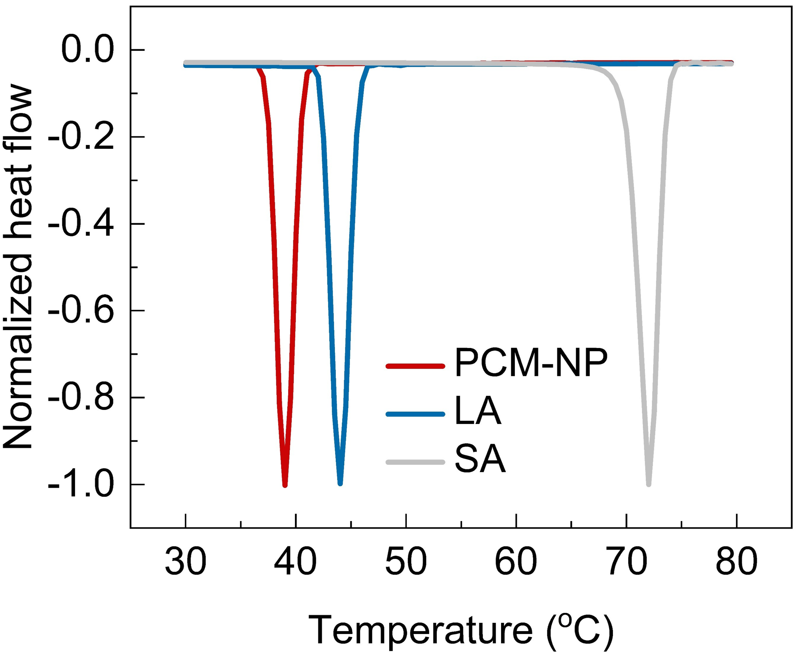
Supplementary Figure 14 Differential scanning calorimetry characterization of PCM-NPs. Normalized heat flow curves showing melting transitions for pure lauric acid (LA, blue curve, T_{m} = 43 ºC), pure stearic acid (SA, gray curve, T_{m} = 69 ºC), and optimized PCM-NP formulation with 4:1 LA:SA ratio (red curve, T_{m} = 39 ºC). The tailored melting point at 39 ºC enables precise thermally triggered molecular release in the CR-NeuroHealer system.

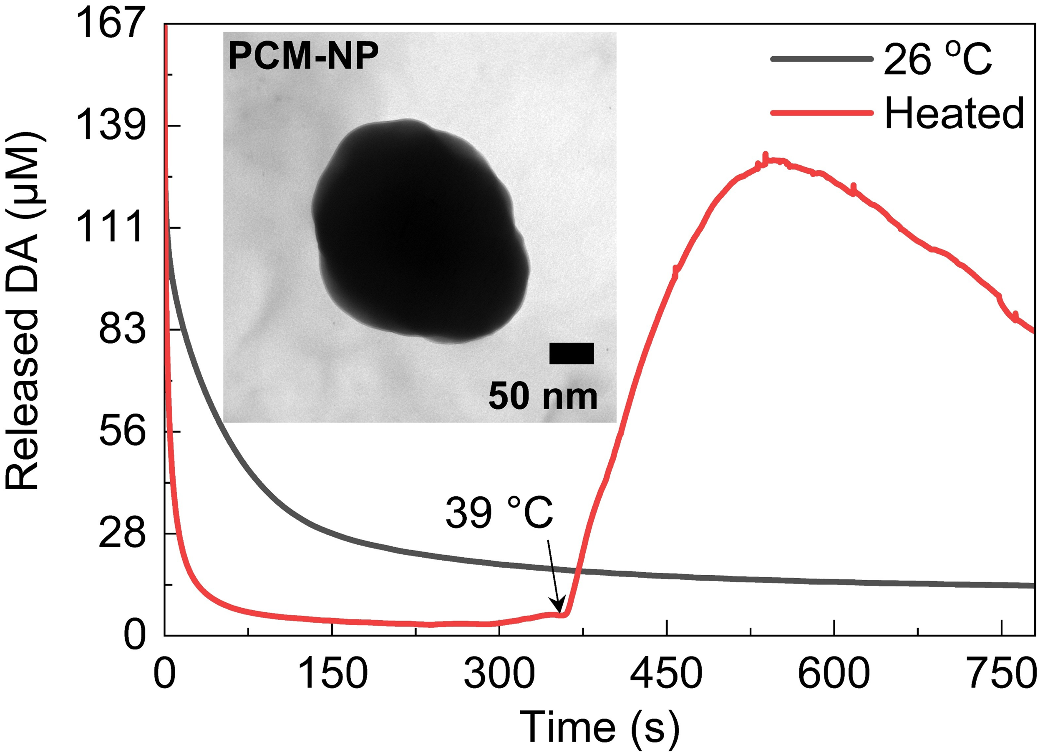
Supplementary Figure 15 Characterization of Thermally controlled DA release and a typical transmission electron microscope image of the PCM-NP. Thermally controlled release kinetic curves obtained by applying step wise temperatures ranging from 26 ºC to 39 ºC using the electrochemical current time mode. Quantitative characterization of DA concentration via electrochemical linear sweep voltammetry scans.

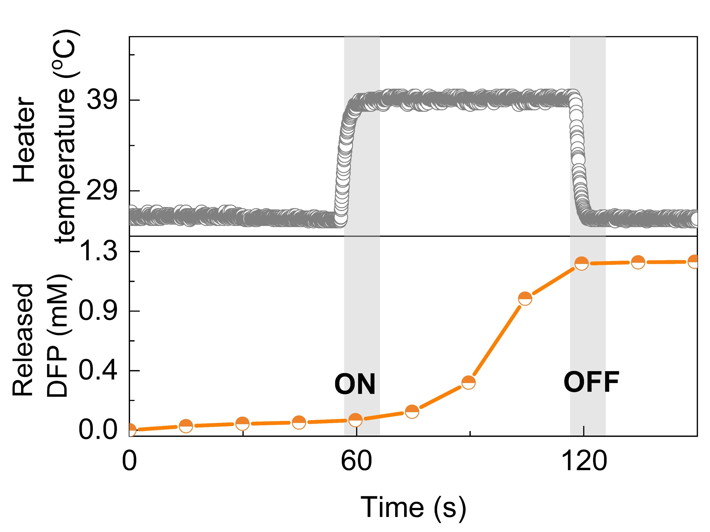
Supplementary Figure 16 Temperature controlled DFP release demonstrates precise ON/OFF switching. Real time monitoring of heater temperature (upper panel, gray trace) and corresponding DFP release (lower panel, orange trace) over a single thermal cycle. Temperature elevation from 27 ºC to 40 ºC at t = 60 s triggers rapid molecular release, with DFP concentration reaching 1.3 mM within 1 minute of heating. Upon cooling below the 39 ºC threshold at t = 120 s, release immediately ceases, maintaining stable concentration. The sharp transitions between ON and OFF states confirm precise thermal control of therapeutic molecule delivery, essential for autonomous homeostatic regulation in the CR-NeuroHealer system.

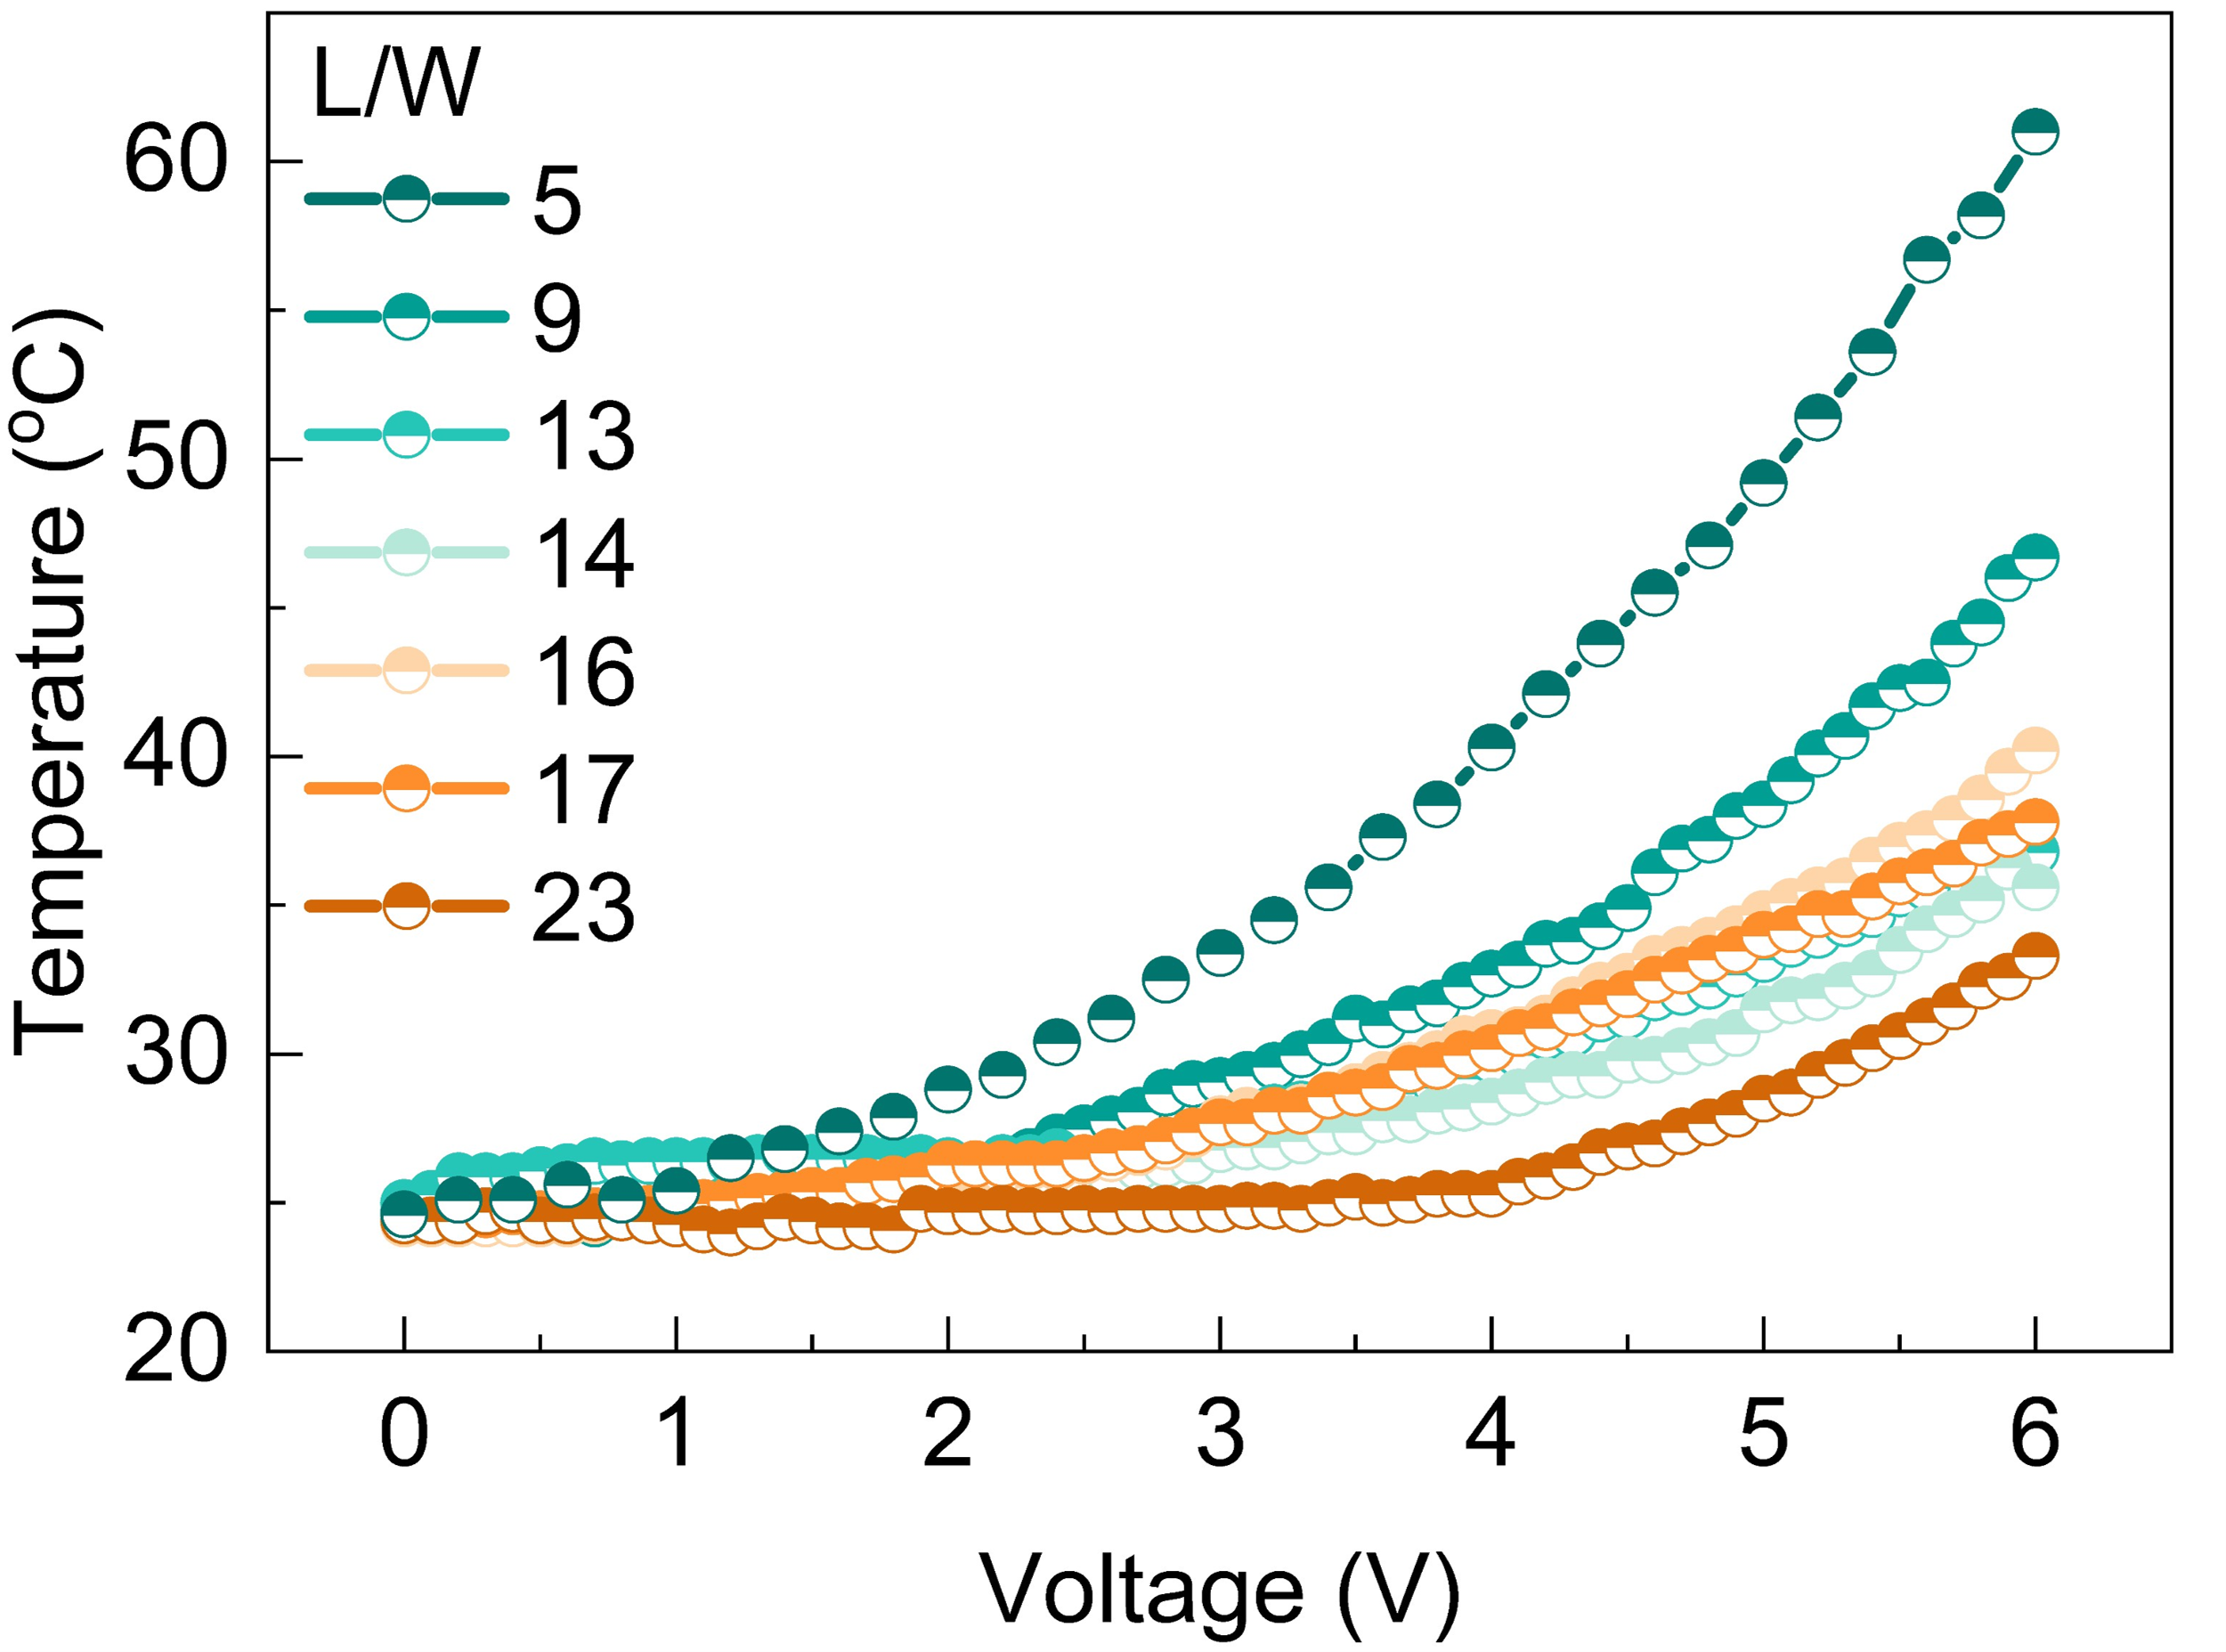
Supplementary Figure 17 Joule heating characteristics and thermal imaging of resistive heaters for PCM phase transition control. Temperature voltage relationships for resistive heaters with different length to width ratios (L/W: 5-23)

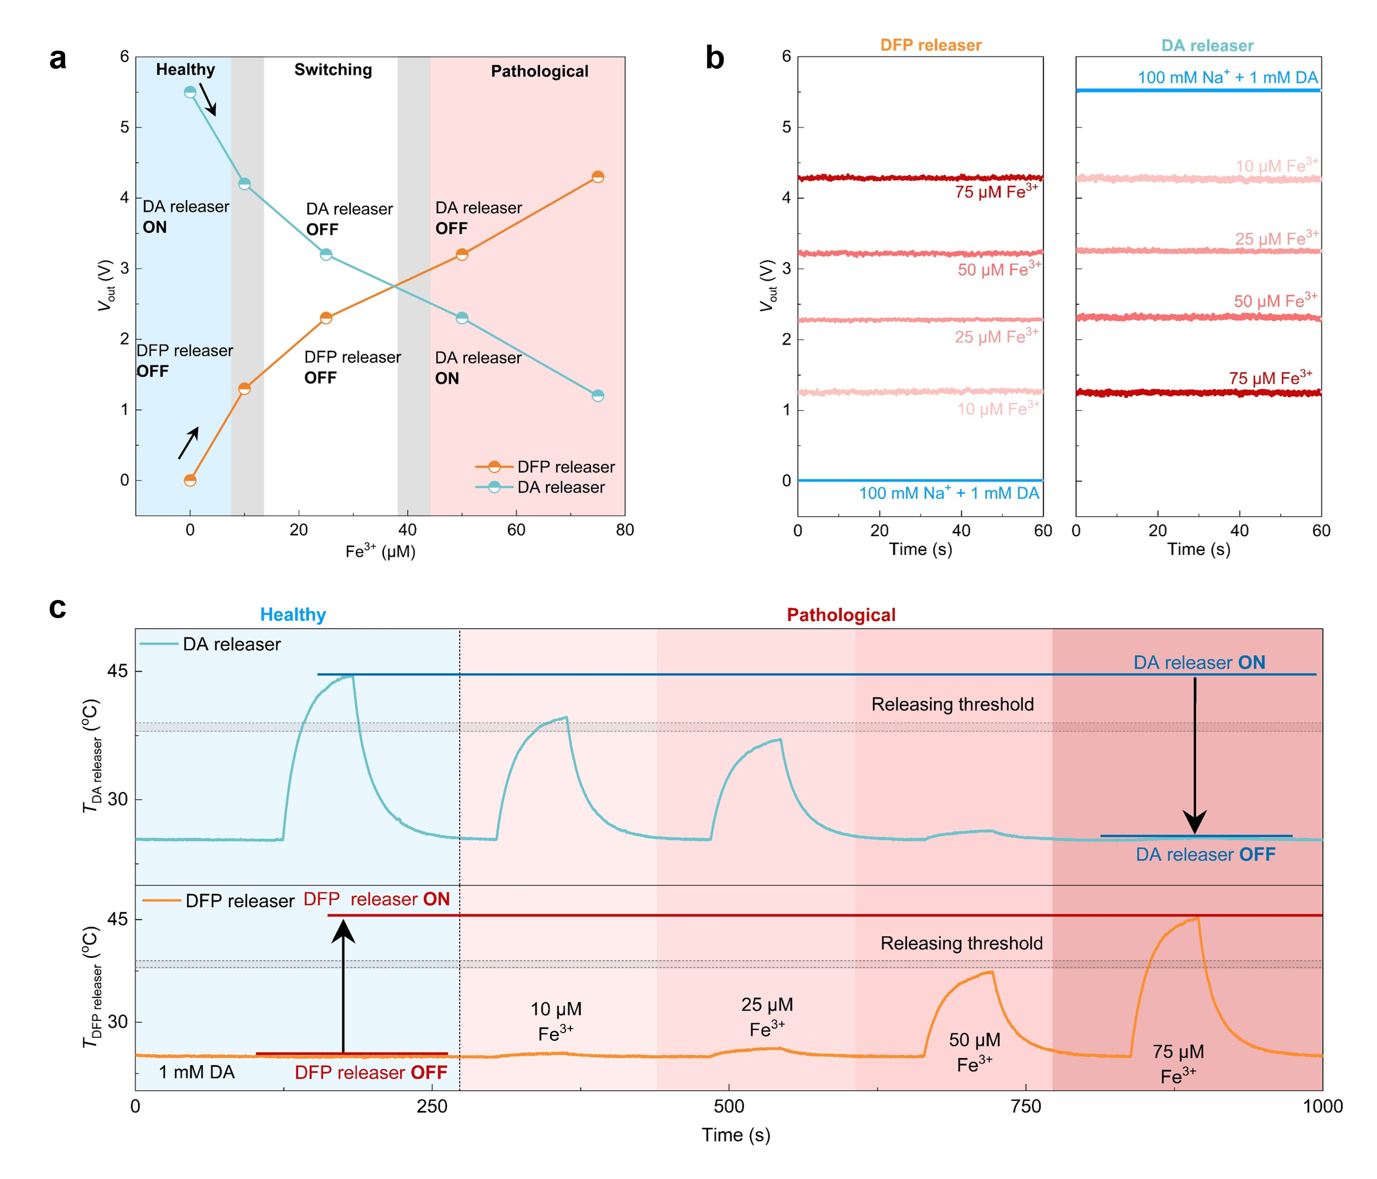
Supplementary Figure 18 Concentration dependent switching behavior and dual drug release dynamics of the CR-NeuroHealer system. (a) State dependent drug release profiles showing three operational phases as a function of Fe³⁺ concentration (0-75 μM). Healthy state (blue, 0-10 μM): DA releaser active (ON), DFP releaser inactive (OFF). Switching region (gray, 10-15 μM): transitional crossover behavior at ~40 μM Fe³⁺. Pathological state (red, 50-75 μM): complete functional inversion with DA releaser OFF and DFP releaser ON, establishing adaptive therapeutic response. (b) Concentration dependent voltage outputs over 120 second intervals. Left: DFP releaser demonstrates graded activation from baseline (0 μM) to maximum response (75 μM Fe³⁺), with pronounced activation at pathological concentrations. Right: DA releaser shows inverse suppression pattern in 100 mM Na⁺ + 1 mM DA medium, with output progressively decreasing from 0 to 75 μM Fe³⁺. (c) Complete therapeutic cycle monitored over 1000 seconds showing reciprocal thermal activation patterns. Top trace: DA releaser maintains pulsatile peaks (~45 ºC) above release threshold during healthy phase (Healthy state baseline), with progressive attenuation upon Fe³⁺ exposure (vertical dashed line at 270 s), ultimately falling below threshold (arrow) to cease operation. Bottom trace: DFP releaser remains inactive until pathological Fe³⁺ concentrations (10, 25, 50, 75 μM additions) trigger sequential thermal responses, with only 50-75 μM Fe³⁺ exceeding release threshold to initiate therapeutic iron chelation. This antagonistic control ensures targeted intervention during pathological states while preserving normal dopaminergic function in healthy conditions.

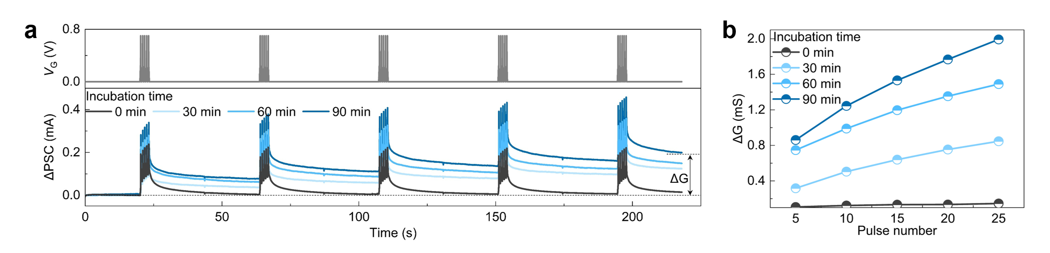
Supplementary Figure 19 PC-12 cell-device interaction reveals time-dependent enhancement of DA perception. (a) Real-time synaptic responses to 25 consecutive gate pulses (0.7 V, gray bars) at different KCl incubation times. PC-12 cells were stimulated with 120 mM KCl to induce DA release, which was detected by the CR-NeuroHealer as increasing ΔPSC amplitudes. Longer incubation periods (0-90 min) result in progressively stronger responses due to enhanced cellular DA secretion, with ΔPSC amplitude rising from 0.22 mA (0 min) to 0.45 mA (90 min). Each 5 pulses cycle demonstrates sustained ΔG characteristic of DA mediated LTP. (b) Quantitative analysis of synaptic plasticity showing relationship between pulse number (5-25) and ΔG at different incubation times. The ΔG increases with incubation duration—from 0.15 mS at 0 min to 1.99 mS at 90 min—confirming that prolonged KCl stimulation enhances cellular DA production and subsequent device response. This time-dependent potentiation validates the CR-NeuroHealer’s ability to detect and quantify endogenous neurotransmitter release from living neurons, establishing functional bio-hybrid synaptic connections essential for homeostatic regulation.

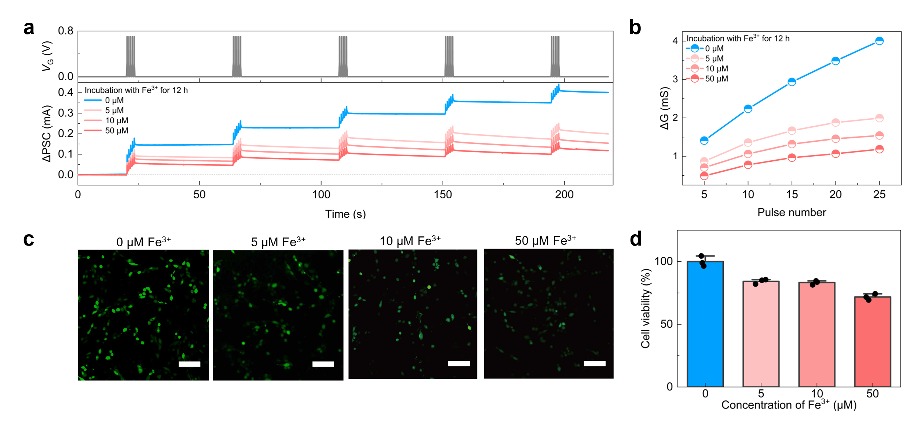
Supplementary Figure 20 Fe³⁺ concentration-dependent cellular dysfunction and CR-NeuroHealer mediated synaptic monitoring. (a) Real-time synaptic responses of CR-NeuroHealer to PC-12 cells exposed to increasing Fe³⁺ concentrations (0-50 μM) over 12 h incubation. Five consecutive gate pulses (0.7 V, gray bars) reveal progressive degradation of ΔPSC amplitude: from 0.45 mA (0 μM) to 0.16 mA (50 μM Fe³⁺), demonstrating the CR-NeuroHealer’s ability to quantitatively monitor cellular iron toxicity through synaptic signals. (b) Quantitative analysis of ΔG versus pulse number shows Fe³⁺ concentration dependent suppression of synaptic plasticity. Healthy cells (0 μM) exhibit robust plasticity with ΔG increasing to 4.01 mS after 25 pulses, while pathological Fe³⁺ levels progressively impair this response: 5 μM (1.99 mS), 10 μM (1.54 mS) and 50 μM (1.18 mS). (c) Assessment of cell viability under different Fe³⁺ treatment. Representative images of calcium staining (green) in cells treated with Fe³⁺ (0-50 μM). Scale bars: 100 μm. (d) Quantitative analysis of relative fluorescence intensity normalized to the control (0 μM). Error bars represent: mean ± SD, n = 3 per group.

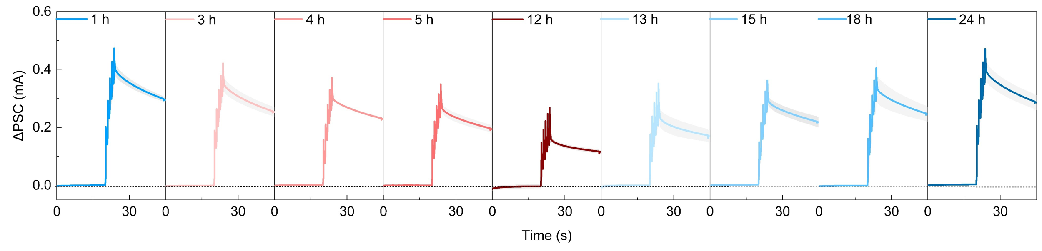
Supplementary Figure 21 Temporal dynamics of CR-NeuroHealer-mediated therapeutic intervention and neuroprotective efficacy of DFP release. Evolution of ΔPSC responses over 24 hours following pathological iron exposure and subsequent therapeutic intervention. Time course panels show the transition from healthy state (1 h, blue) through pathological decline (3-12 h, red gradient indicating iron accumulation) to therapeutic recovery (13-24 h, blue gradient indicating restoration). Peak amplitudes decrease from 0.48 mA to 0.36 mA during pathological progression (0-12 h), then gradually recover to near-baseline levels (0.47 mA) following automated deferiprone release initiated at 13 h. Error bars represent: mean ± SD, n = 3 per group.

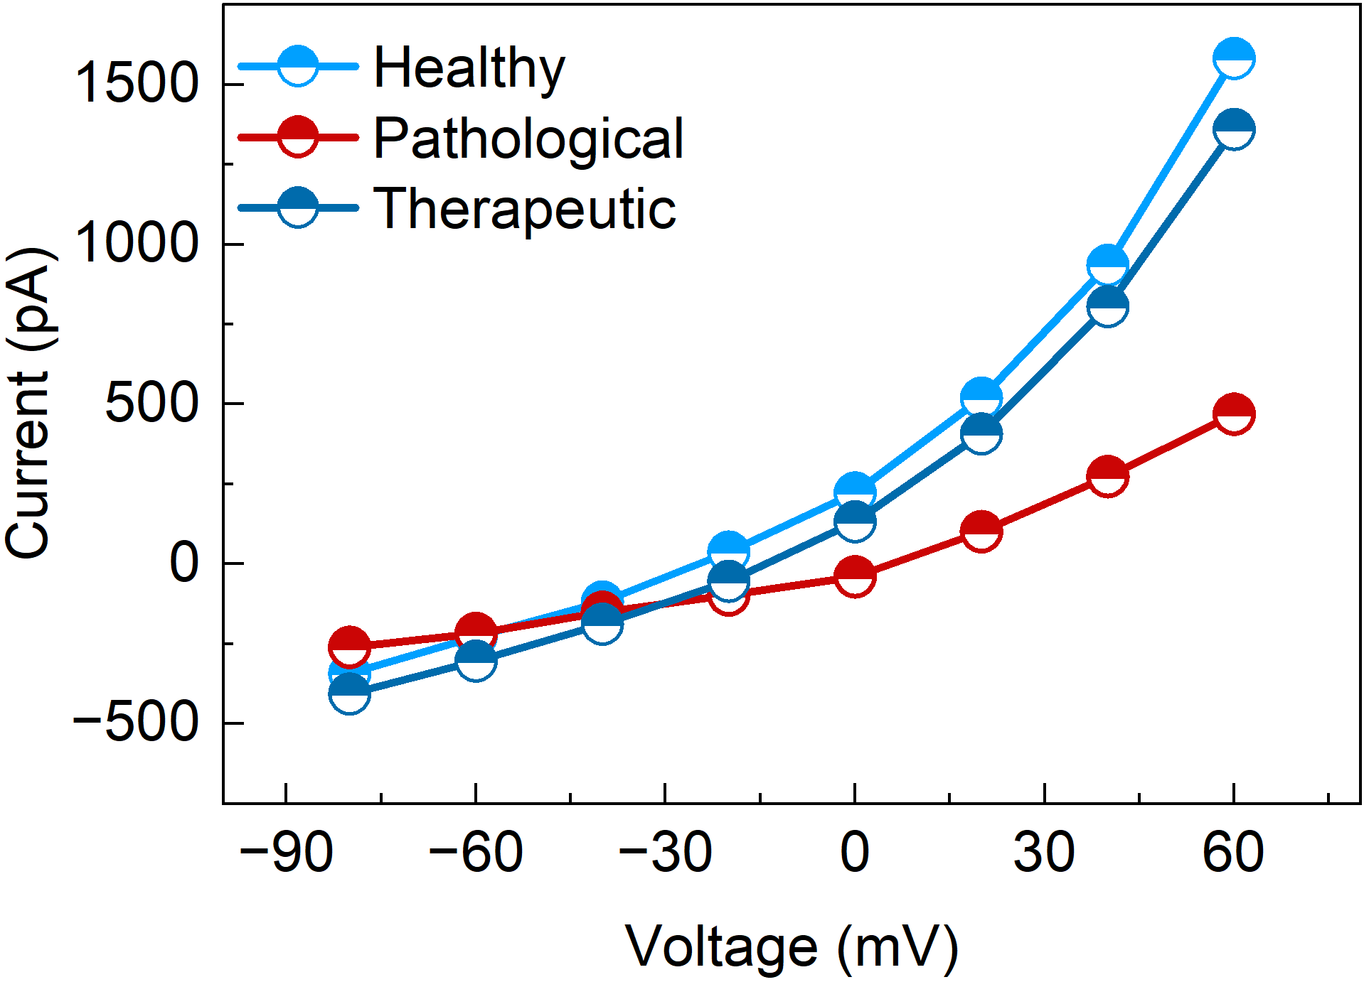
Supplementary Figure 22 Patch-clamp recordings demonstrate CR-NeuroHealer-mediated functional recovery of calcium channel activity in PC-12 cells. Current-voltage relationships of calcium currents measured in PC-12 cells across three experimental conditions. Healthy cells (blue) exhibit robust voltage-gated calcium currents reaching 1600 pA at +60 mV. Pathological state induced by 100 μM Fe³⁺ exposure (red) shows severely suppressed calcium channel function with maximum current of only 469 pA, indicating ~70% reduction in channel activity. Therapeutic intervention through device initiated DFP release (dark blue) restores calcium currents to near healthy levels (~1400 pA), demonstrating successful functional recovery. The overlapping current voltage curves between healthy and therapeutic states confirm that CR-NeuroHealer effectively reverses Fe³⁺ induced calcium channel dysfunction at the single cell electrophysiological level. Recordings performed using whole cell configuration with voltage steps from -80 to +60 mV.

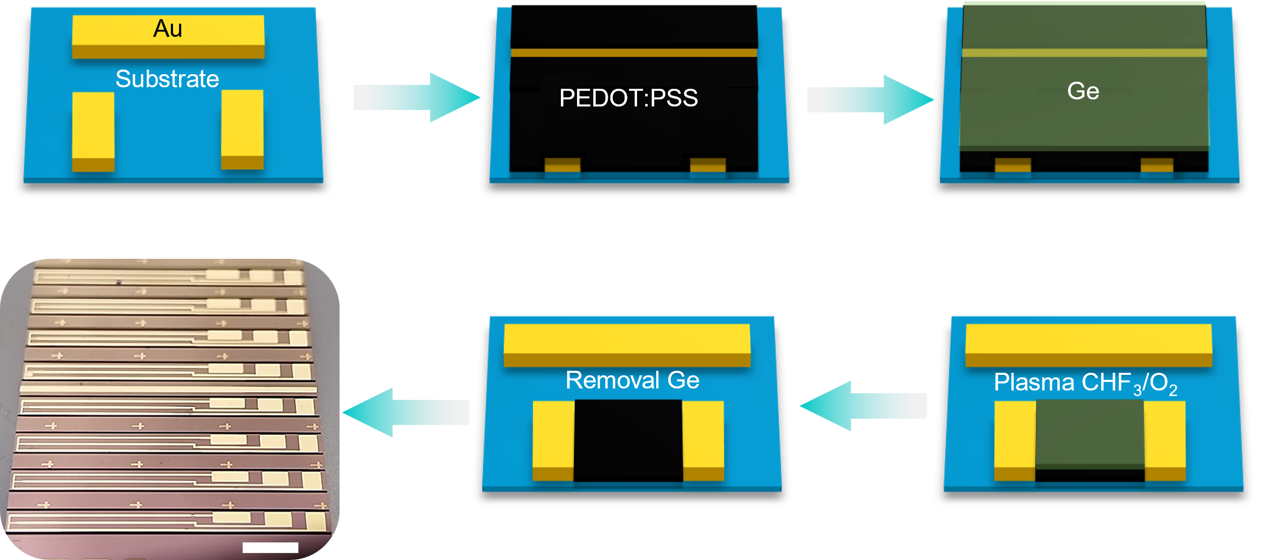
Supplementary Figure 23 Fabrication process of the miniaturized synaptic OECT devices Schematic illustration of the fabrication steps on a Si/SiO₂ substrate. (1) The source, drain, and planar gate electrodes were defined by depositing 5/40 nm of Cr/Au, with a patterned channel length of 10 μm and width of 100 μm, respectively. (2) A PEDOT:PSS (Clevios PH1000) aqueous solution, mixed with ethylene glycol, dodecylbenzene sulfonic acid, and (3-glycidyloxypropyl) trimethoxysilane, was spin-coated onto the substrate and annealed at 120 ºC. (3) A 100 nm germanium (Ge) sacrificial layer was deposited via electron-beam evaporation to protect the underlying PEDOT:PSS film. (4) Reactive ion etching using CHF₃/O₂ plasma was employed to pattern the channel region. (5) The Ge sacrificial layer was subsequently removed by immersing the device in deionized water for 8 h, exposing the final patterned PEDOT:PSS active channel. (6) Representative optical micrograph of the final fabricated device array. The individual devices were finally diced into strips measuring 1.5 × 17 mm for subsequent in vivo implantation. Scale bar: 3 mm.

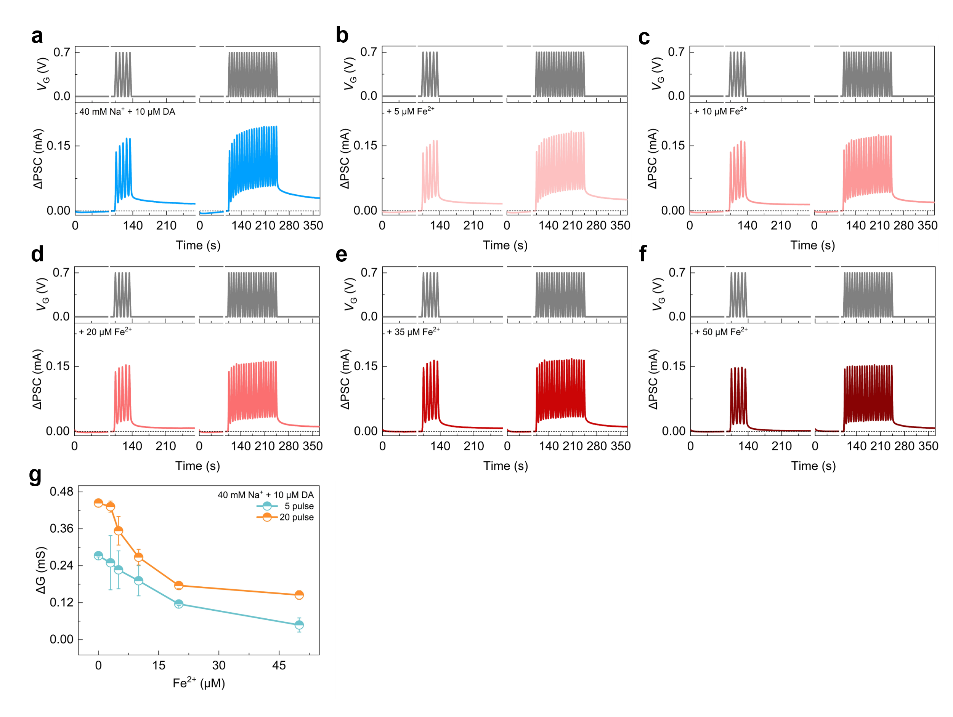
Supplementary Figure 24 In vitro synaptic responses of the miniaturized device with a 10-μm channel length under varying Fe²⁺ concentrations to mimic the brain microenvironment. (a) Representative ΔPSC traces of the device in response to continuous gate voltage pulse trains (5 and 20 pulses) under healthy-state conditions (containing 40 mM Na⁺ and 10 μM DA). (b to f) ΔPSC responses of the device upon the addition of increasing concentrations of Fe²⁺ (5, 10, 20, 35, and 50 μM, respectively) in the presence of constant Na⁺ and DA levels. A dose-dependent attenuation of ΔPSC amplitude is clearly observed with progressively increasing Fe²⁺ concentrations. These in vitro results effectively mimic the pathological synaptic impairment induced by iron overload in the brain microenvironment. (g) ΔG as a function of Fe²⁺ concentration in the presence of DA and Na⁺, under 5 and 20 pulse stimuli. Error bars represent: mean ± SD, n = 3 per group.

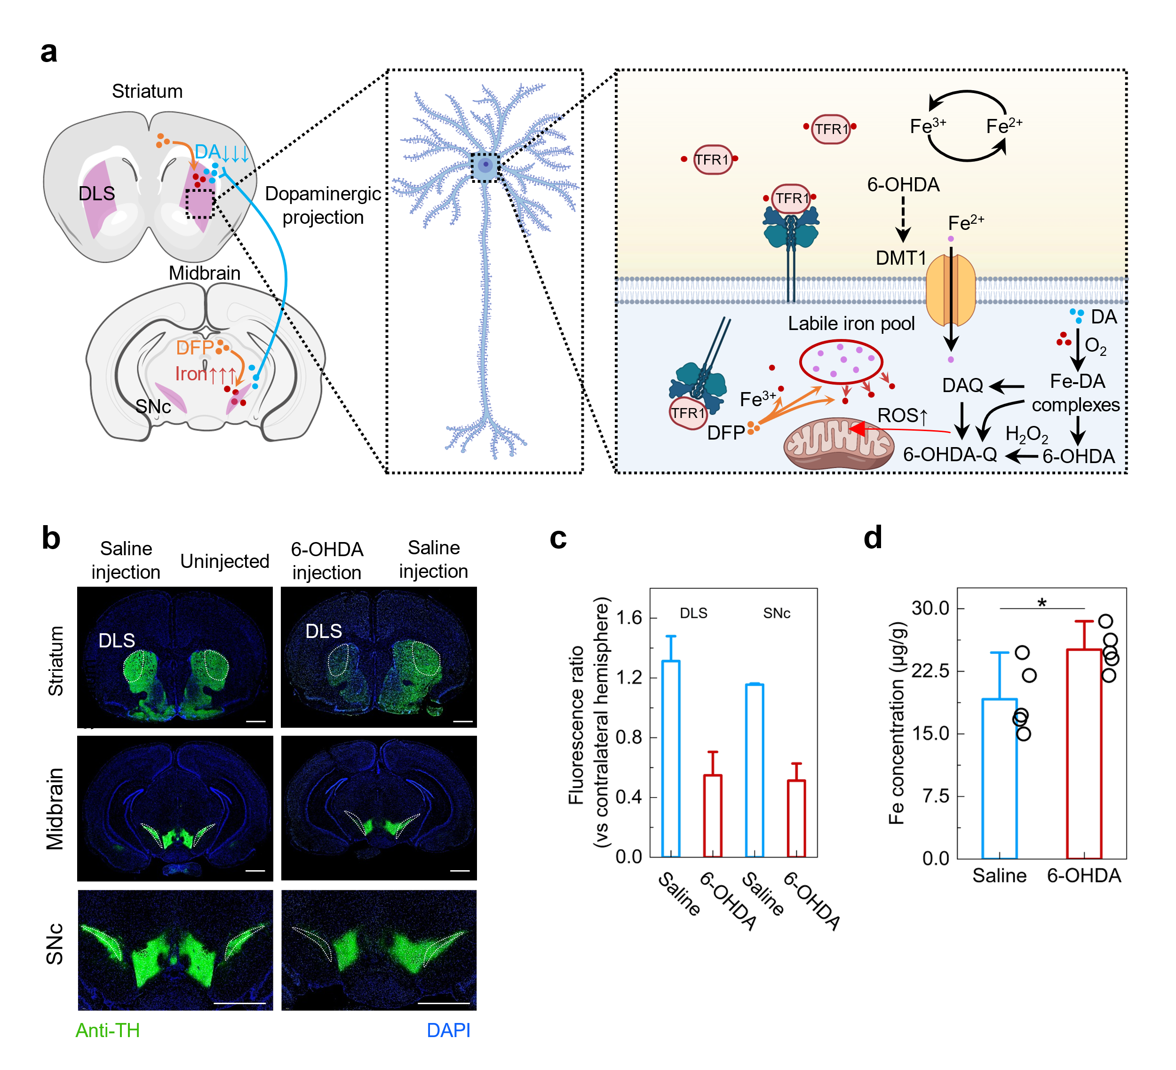
Supplementary Figure 25 Validation of the 6-OHDA lesion model, schematic of the brain implantation procedure, and postoperative recovery. (a) Schematic illustration of the nigrostriatal dopaminergic projection and the cellular mechanism of 6-OHDA-induced iron overload. At the cellular level, 6-OHDA stimulates Fe²⁺ influx via divalent metal transporter 1 (DMT1), promoting the formation of a labile iron pool and facilitating DA oxidation. This cascade generates Fe-DA complexes, reactive oxygen species (ROS), and toxic quinones. The therapeutic iron chelator DFP intervenes by chelating excess Fe³⁺ to restore neuronal homeostasis. (b) Representative immunofluorescence images of TH (green) and DAPI (blue) staining, with the left hemisphere representing the saline-injected side and the right hemisphere representing the uninjected side. Dashed white lines outline the DLS and SNc regions. Scale bars: 1 mm. (c) Quantitative analysis of TH fluorescence intensity in the DLS and SNc, normalized to the contralateral hemisphere. The significant reduction in the 6-OHDA group validates the efficacy of the unilateral dopaminergic lesion model. (d) Quantification of iron concentration (μg/g) in the midbrain tissue (containing the SNc) determined by ICP-OES. The iron content in the 6-OHDA group was significantly higher than that in the Saline group (P < 0.05). Data are presented as means ± SEM (n = 5 mice per group for c and d). Statistical significance was determined by two-tailed Student’s t-test (P < 0.05).

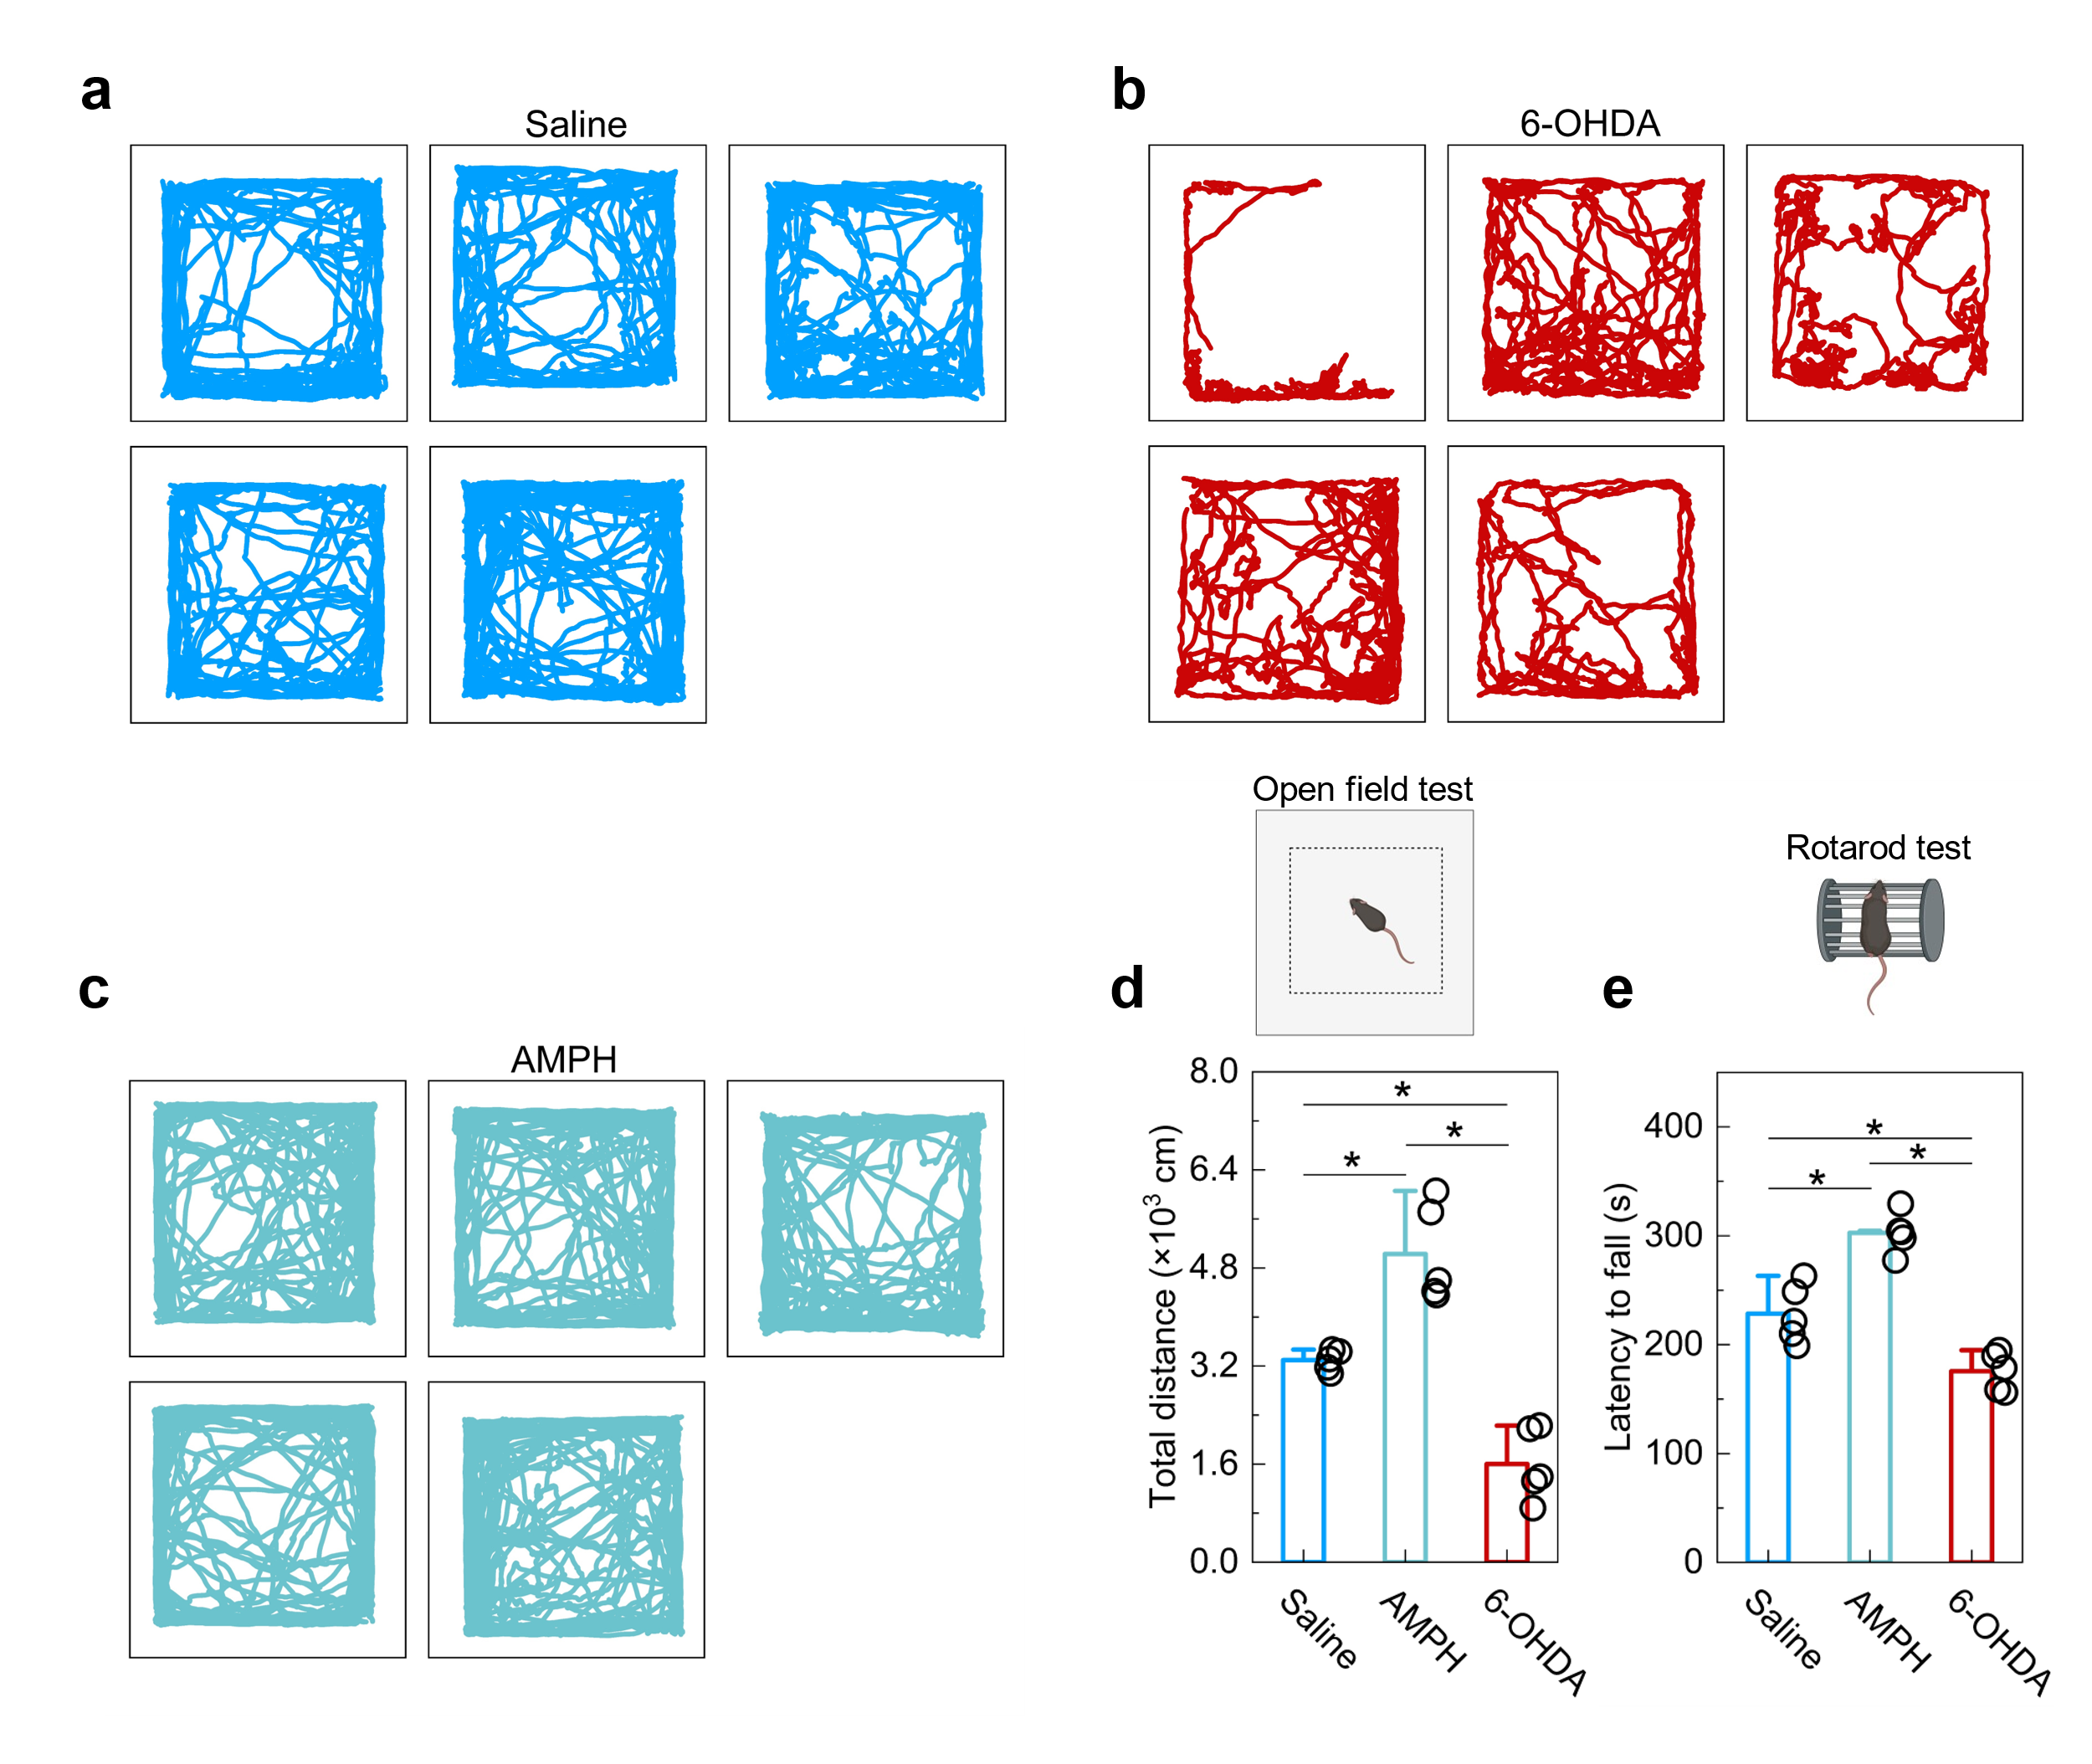
Supplementary Figure 26 Supplementary open-field locomotion traces for behavioral characterization. (a to c) Representative trajectory maps (n = 5 mice per group) recorded during the open-field test for the Saline control group (a), AMPH treated group (b), and 6-OHDA induced Parkinsonian model group (c), visually demonstrating the distinct locomotor activity and exploration patterns induced by AMPH and 6-OHDA. (d) Representative open-field locomotion traces for Saline, AMPH, and 6-OHDA groups. (d and e) Quantitative behavioral analysis of total movement distance (d) and rotarod fall latency (e) across the three groups. Data are presented as means ± SEM. Statistical significance was determined by one-way ANOVA with post hoc tests (*P < 0.05, compared with the indicated groups).

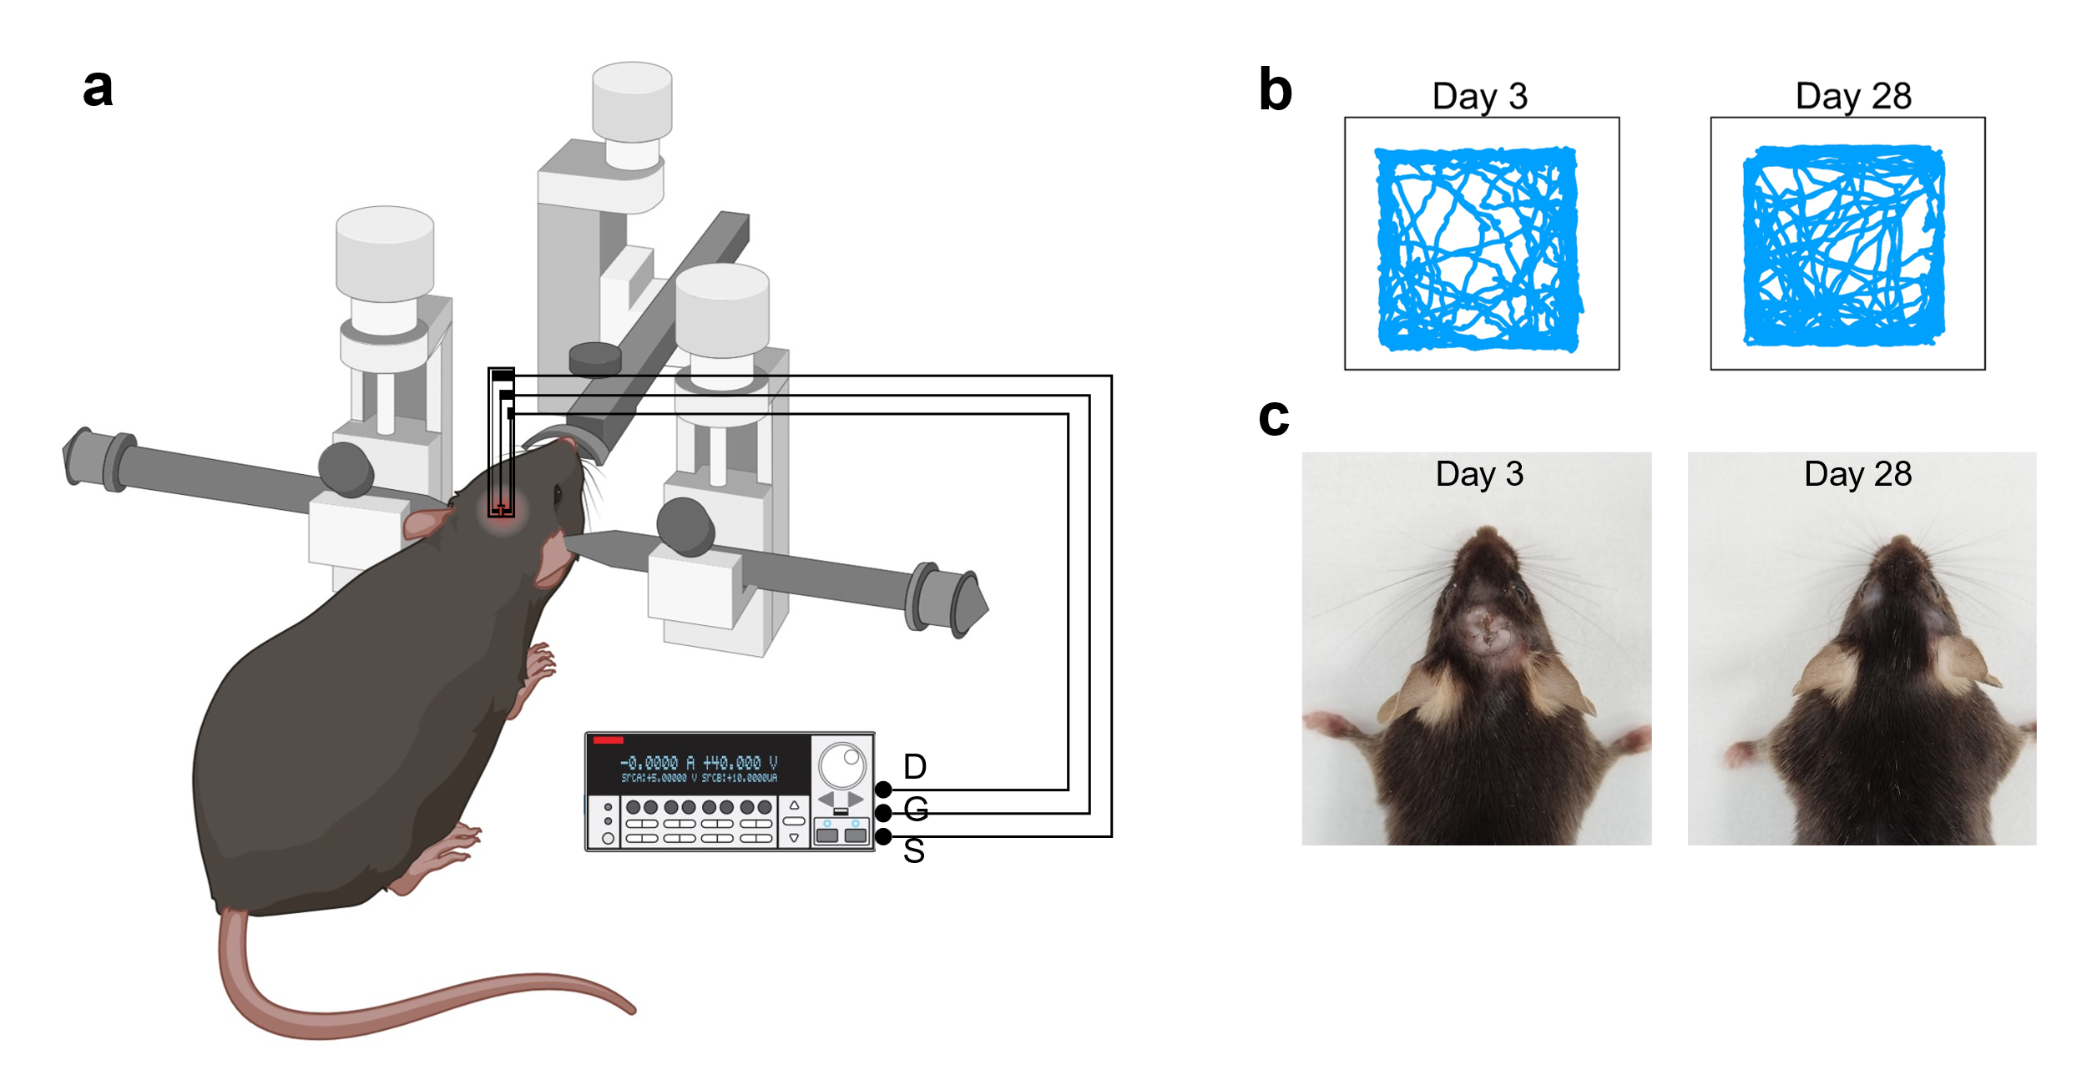
Supplementary Figure 27 In vivo surgical setup and postoperative evaluation. (a) Schematic illustration of the stereotaxic surgical setup for brain implantation and real-time device response recording with a source meter. (b) Representative open-field locomotion traces recorded at day 3 and day 28, confirming normal motor behavior and full recovery post-surgery. (c) Representative photographs showing wound healing at day 3 and day 28 post-surgery.

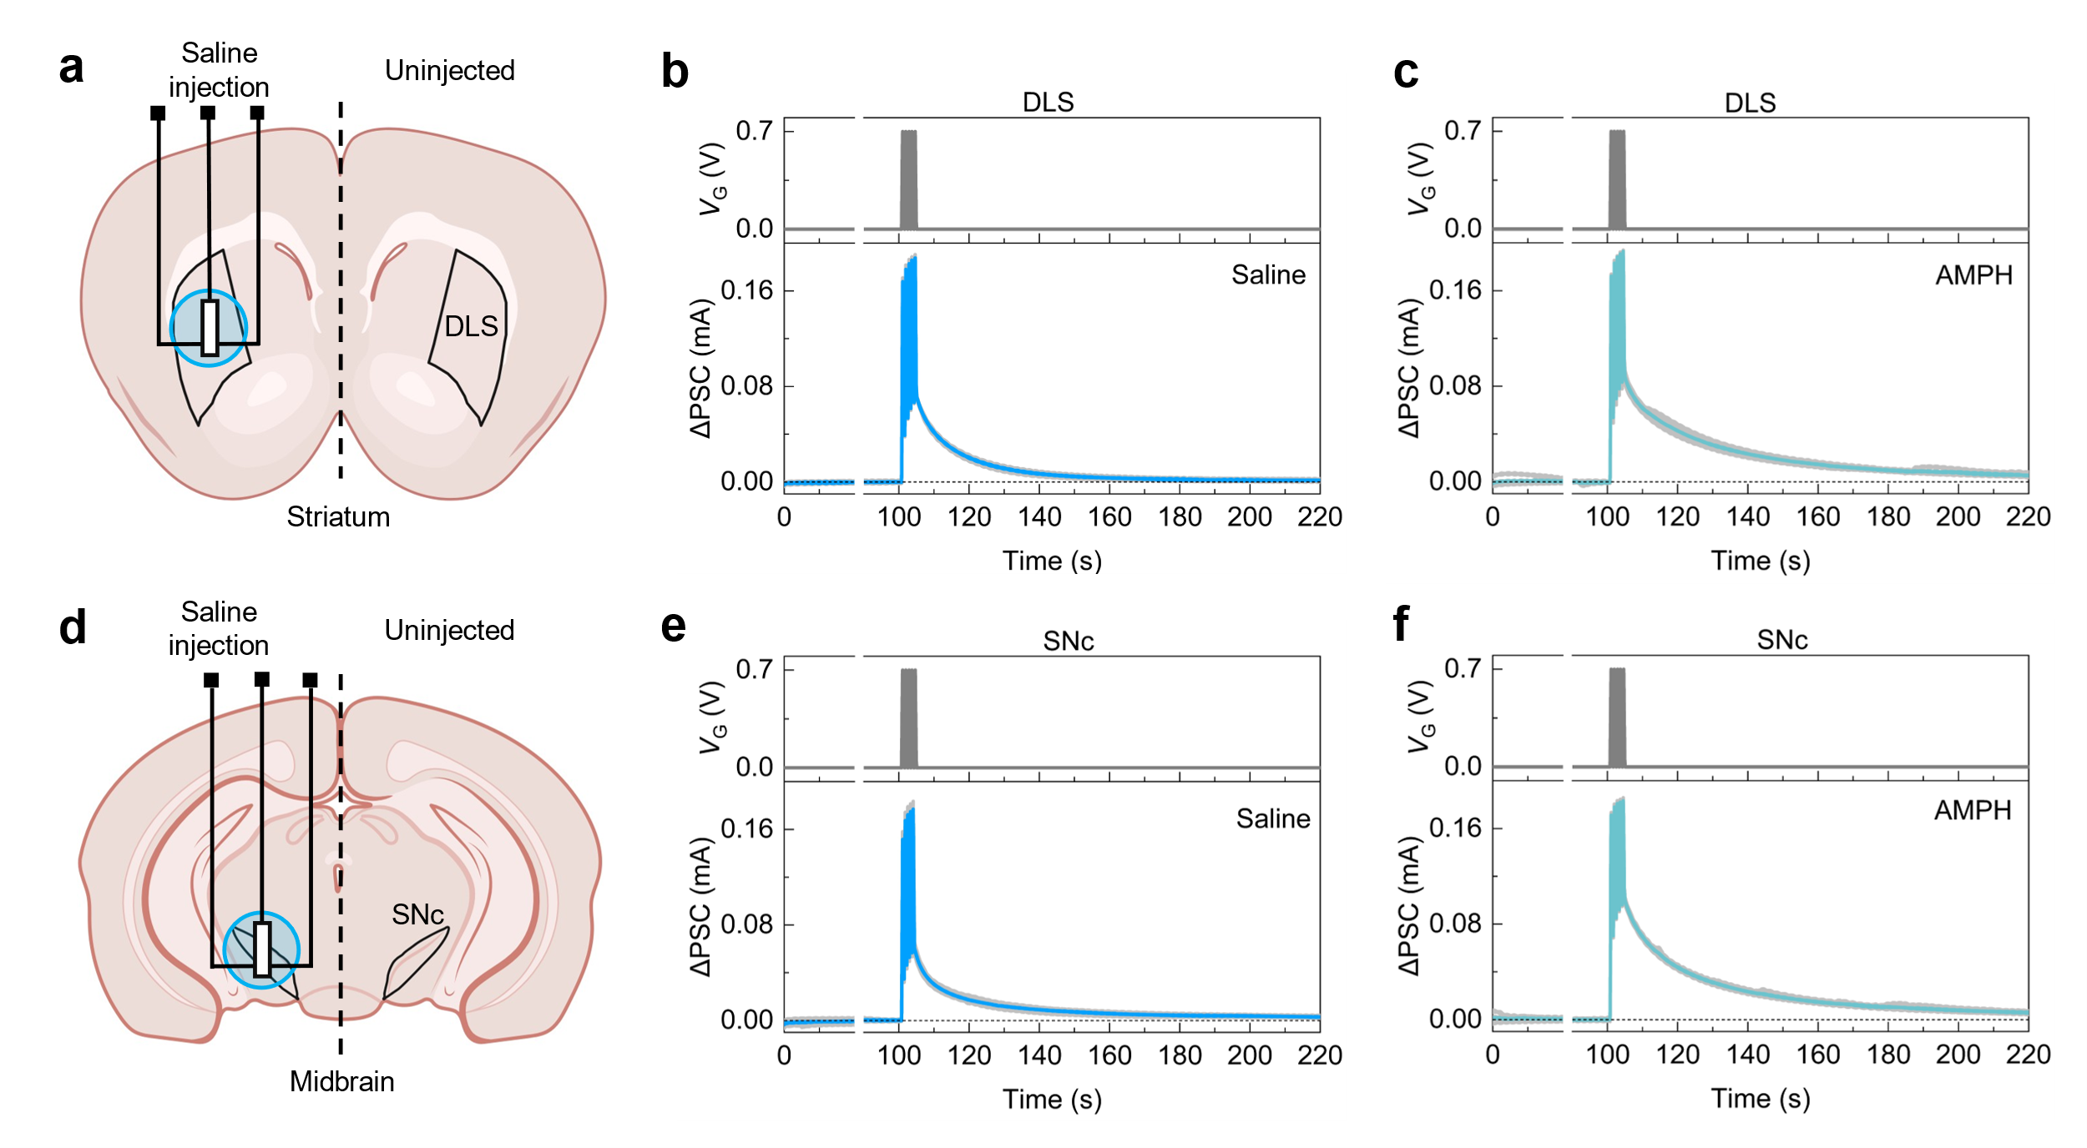
Supplementary Figure 28 In vivo device responses of the brain implanted device tested at 1.5 hours post-AMPH administration. (a and d) Schematic illustration of the unilateral electrode implantation. The device was implanted into the left hemisphere of the (DLS, a) and (SNc, d), which corresponds to the side of local saline injection. (b and e) Representative ΔPSC traces recorded from the implanted left hemisphere in response to a single gate voltage pulse under the baseline condition (MFB saline injection + intraperitoneal saline administration, indicated by the mouse icon). (c and f) Corresponding ΔPSC traces recorded from the same implanted left hemisphere at 1.5 h post-intraperitoneal AMPH administration (labeled as Saline + AMPH, with the mouse icon indicating the intraperitoneal injection route). The results demonstrate that the device effectively perceives induced by systemic AMPH administration. All data were obtained from a single animal. The bold colored lines represent the average responses from 5 consecutive measurements, while the gray shaded regions indicate the distribution of the individual recordings.

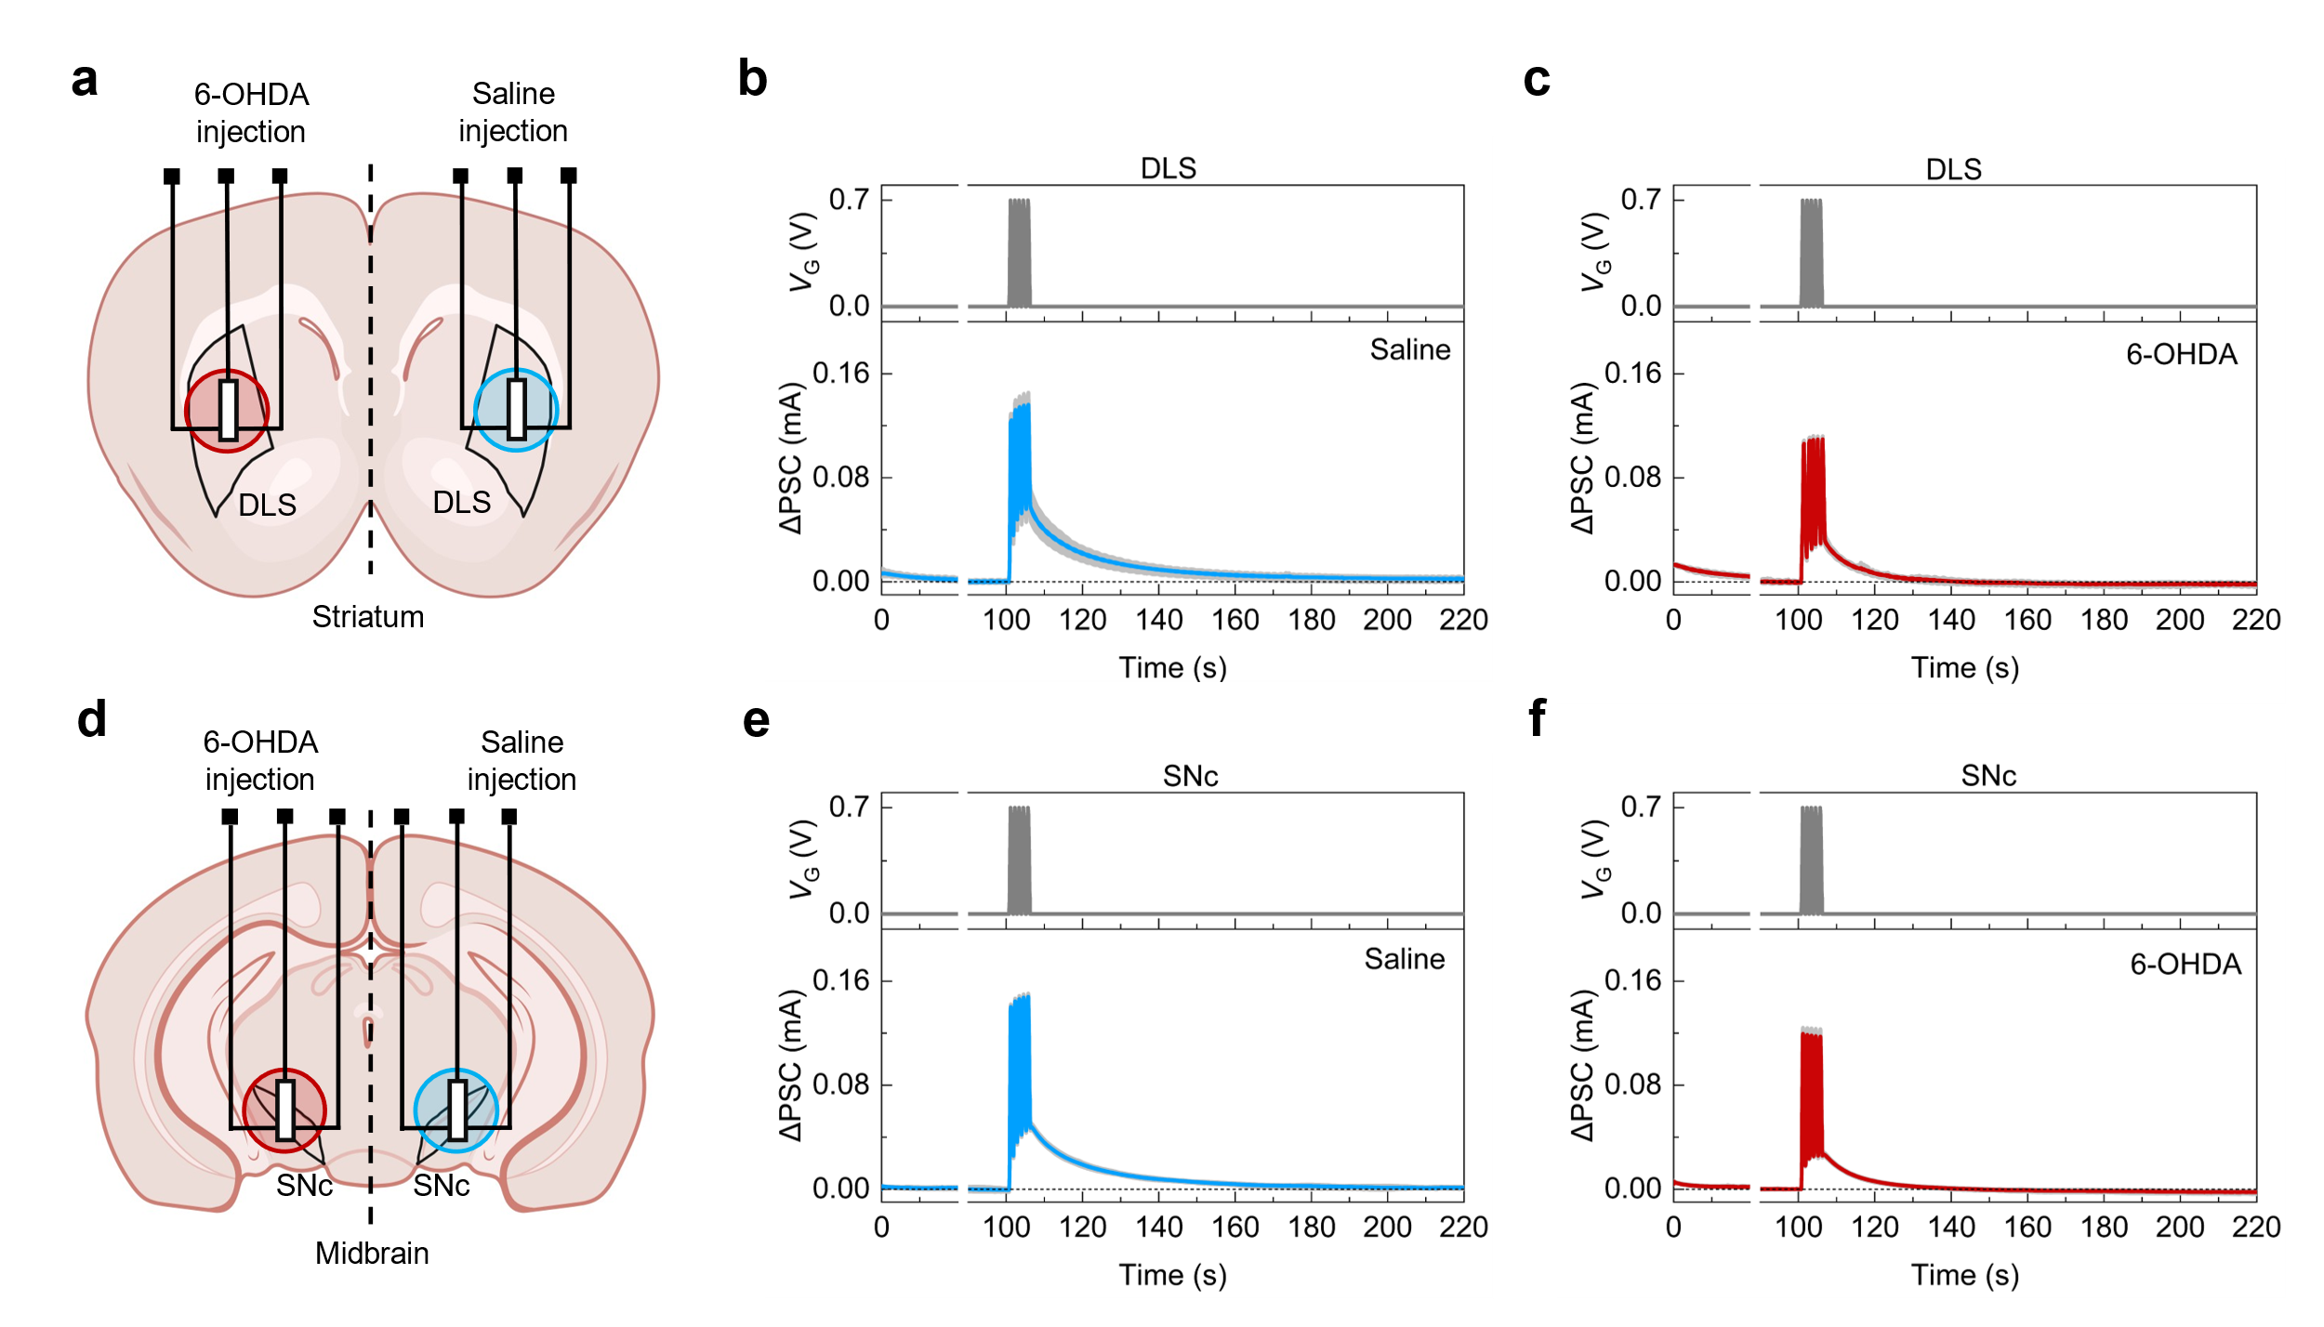
Supplementary Figure 29 In vivo synaptic-like responses of the implanted synaptic OECT tested at two weeks post 6-OHDA injection. (a and d) Schematic illustration of bilateral electrode implantation. The devices were implanted into the left (6-OHDA + Saline injection) and right (Saline injection) hemispheres of the (DLS, a) and (SNc, d). The neurotoxin 6-OHDA and an equal volume of saline were respectively injected into the MFB of the left and right hemispheres to establish a unilateral lesion model with an internal contralateral control. (b and e) Representative ΔPSC traces recorded from the DLS (b) and SNc (e) of the right hemisphere (Saline control) in response to a single gate voltage pulse. (c and f) Representative ΔPSC traces recorded from the DLS (c) and SNc (f) of the left hemisphere (6-OHDA lesioned side). The results demonstrate a drastic attenuation of synaptic-like responses in the lesioned hemisphere compared with the Saline control side. All data were obtained from a single animal. The bold colored lines represent the average responses from 5 consecutive measurements, while the gray shaded regions indicate the distribution of the individual recordings.
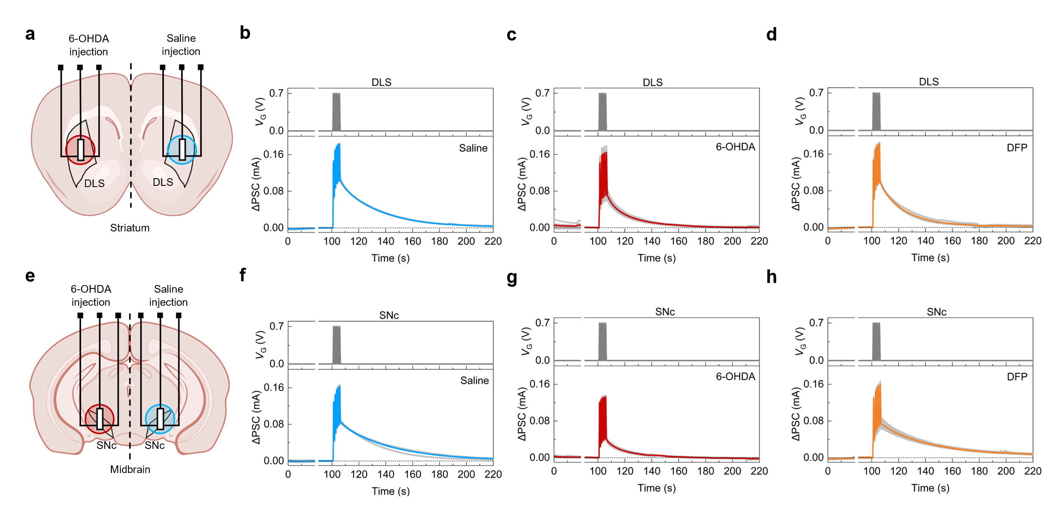
Supplementary Figure 30 In vivo device responses of the implanted synaptic OECT following DFP intervention. (a and e) Schematic illustration of bilateral electrode implantation. The devices were implanted into the left hemisphere (Saline + 6-OHDA injection, lesioned side) and the right hemisphere (Saline injection, contralateral control) of the (DLS, a) and (SNc, e). The neurotoxin 6-OHDA and an equal volume of saline were respectively injected into the MFB of the left and right hemispheres. (b and f) Representative ΔPSC traces recorded from the right hemisphere (Saline control) of the DLS (b) and SNc (f) in response to a single gate voltage pulse. (c and g) Representative ΔPSC traces recorded from the left hemisphere (6-OHDA lesioned side), demonstrating a drastic attenuation of the device responses compared with the contralateral control. (d and h) Corresponding ΔPSC traces recorded from the left hemisphere after DFP feedback therapy, showing a robust recovery of the previously weakened synaptic-like responses. All data were obtained from a single animal. The bold colored lines represent the average responses from 5 consecutive measurements, while the gray shaded regions indicate the distribution of the individual recordings.

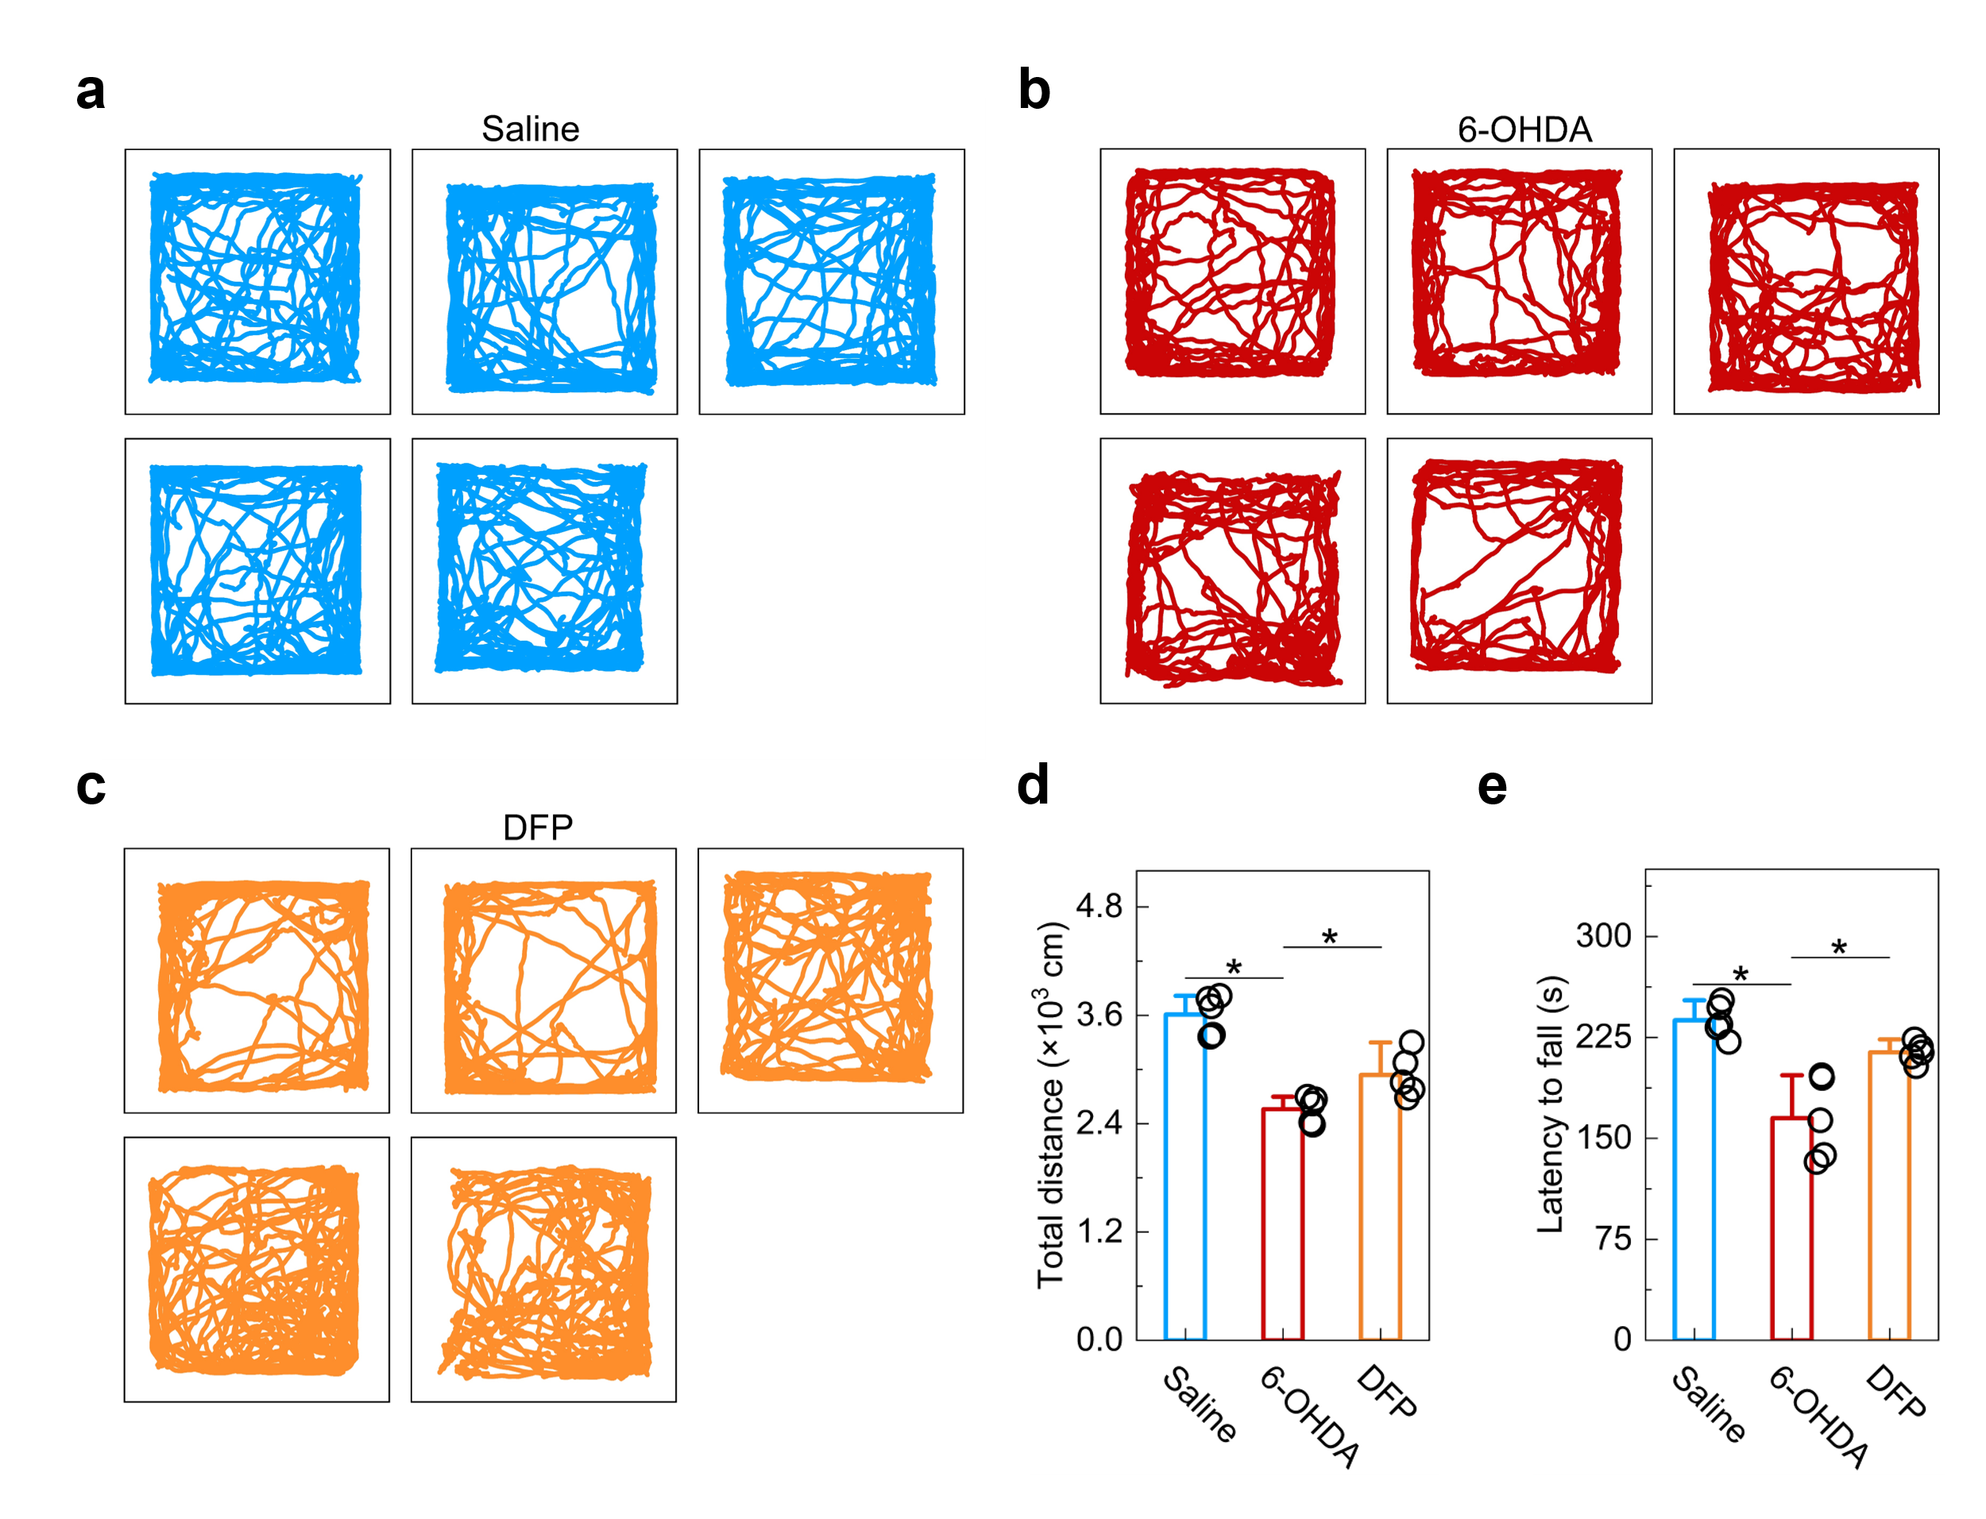
Supplementary Figure 31 Supplementary behavioral evaluations after DFP intervention. (a to c) Representative open-field locomotion traces (n = 5 mice per group) for the saline control group (a), the 6-OHDA induced PD model group (b), and the DFP-treated group (c). (d and e) Quantitative assessments of the latency to fall in the rotarod test (d) and total movement distance in the open-field test (e). The results demonstrate that DFP feedback therapy effectively rescues motor function in the Parkinsonian model, with significant restoration observed in both spontaneous locomotor activity and motor coordination. Data are presented as means ± SEM. Statistical significance was determined by one-way ANOVA with post hoc tests (*P < 0.05, compared with the indicated groups).

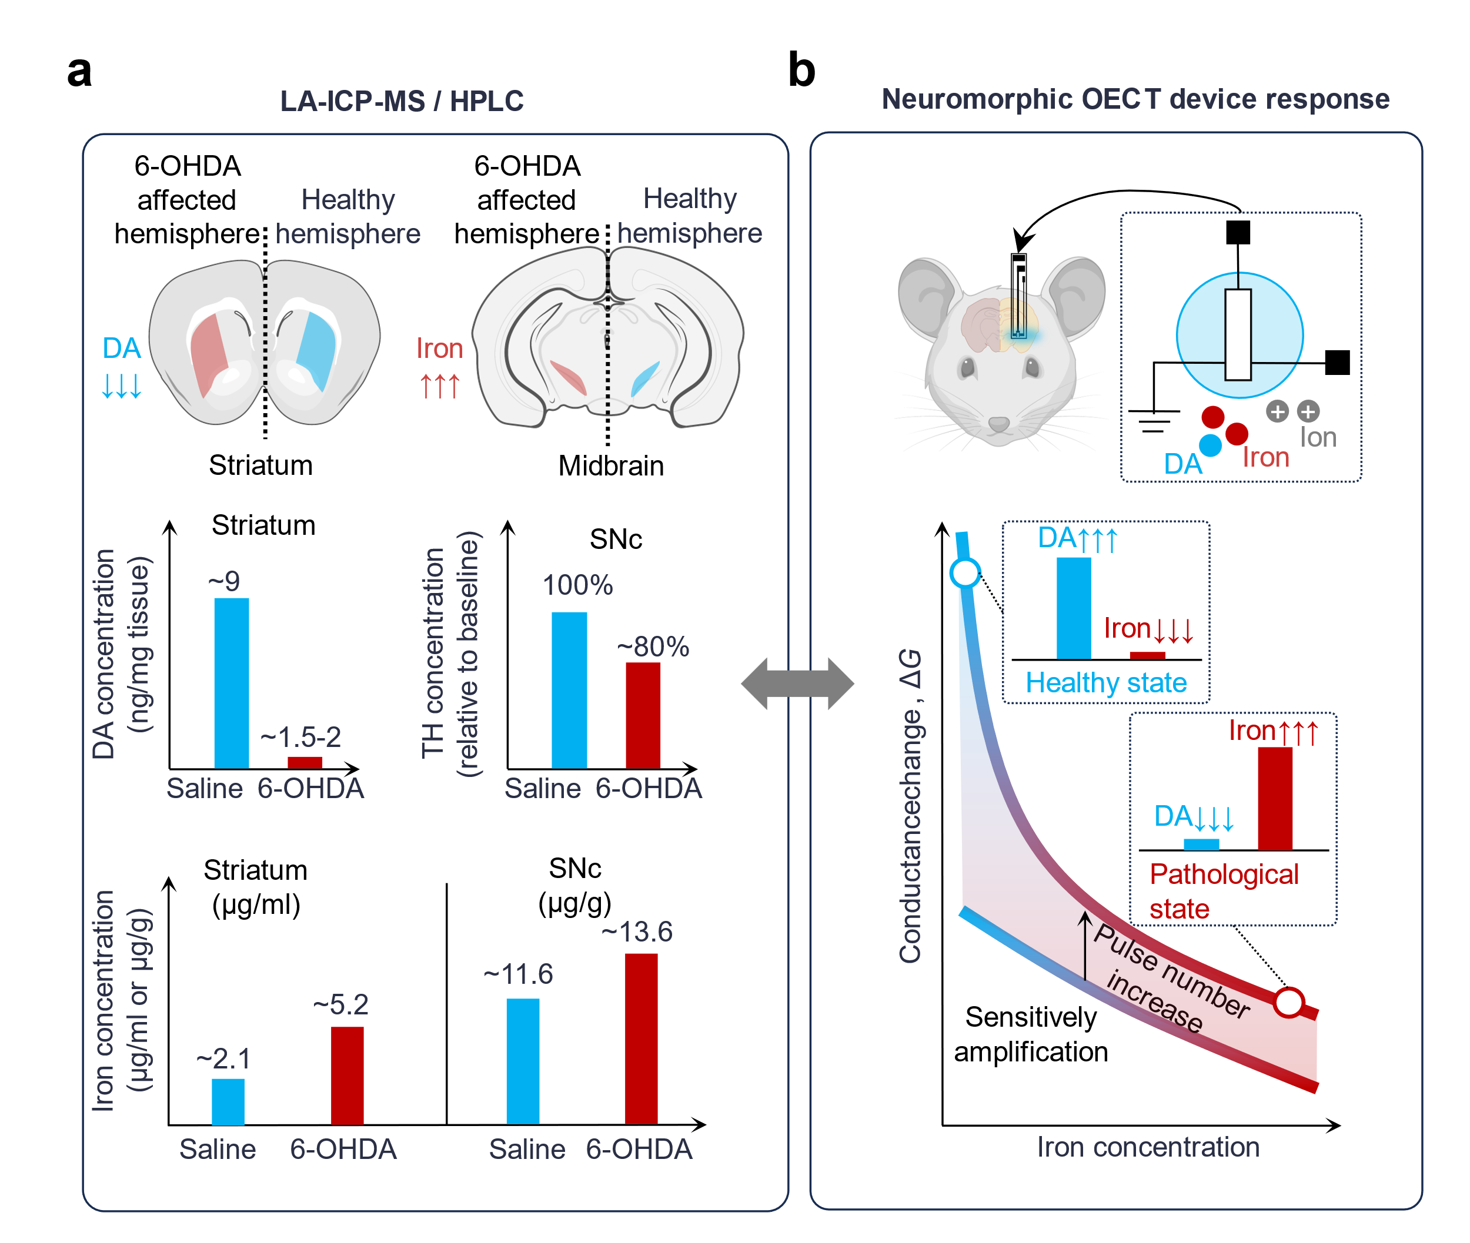
Supplementary Figure 32 Correlation between 6-OHDA–associated neurochemical changes and the corresponding device responses. (a) Schematic summary of the neurochemical alterations associated with unilateral 6-OHDA lesioning. Previous studies have reported decreased striatal DA levels and TH-positive dopaminergic neurons, accompanied by increased iron accumulation in the striatum and SNc ⁴⁻⁶. The values shown are representative literature-reported values and are presented to illustrate the overall trends rather than for direct quantitative comparison with the present study. (b) Corresponding responses of the neuromorphic OECT device to DA/iron-associated chemical states. Increasing iron levels attenuate ΔG, while accumulated gate-pulse stimulation enhances the contrast between the healthy-like state (high DA/low iron) and the pathological-like state (low DA/high iron).

III: Supplementary Table
Supplementary Table S1. Comparison of typical neuromorphic devices or systems
Neuromorphic system | Device | Stimulat-ion  Type (s) | Neuromorphic  functions | Bio hybrid functions | Brain implant validation
Neuromorphic efferent nerve ⁷ | Transistor | Strain | Synaptic plasticity | Control the displacement and maximum force of the mouse’s leg | ×
Neuromorphic sensorimotor loop ⁸ | Transistor | Pressure | Synaptic plasticity, pulse train encoding | A live rat model of biological perception actuation loop | ×
Artificial spiking afferent nerve ⁹ | Transistor | Pressure | Spiking behavior | Hybrid monosynaptic reflex arc | ×
Organic electrochemical neurons and synapses ¹⁰ | Transistor | Na⁺ | Synaptic plasticity, Axon action potential | To modulate the plant’s electrophysiology | ×
Artificial chemically neuron ¹¹ | Sensor and memristor | DA | Synaptic plasticity, DA release | Chemically communication between the PC-12 cells | ×
Organic electrochemical neuron ¹² | Transistor | NH₄Cl, CaCl₂,  KCl,  NaCl | Stochastic response | Neuromorphic sensing the Na⁺/Cl⁻ concentration of the mouse’s Vagus nerve | ×
Organic electrochemical device ¹³ | Transistor | Na⁺,  Cl⁻,  DA | Spiking behavior | Bio interfacing of epithelial biomembrane | ×
This work | Transistor | DA,  Fe³⁺ | Synaptic plasticity | Self-adaptive regulating neuronal iron homeostasis | √

IV: Supplementary References
1. Keene ST, et al. Enhancement-Mode PEDOT:PSS Organic Electrochemical Transistors Using Molecular De-Doping. Adv. Mater. 32, 2000270 (2020).
2. Matrone GM, et al. Electrical and optical modulation of a PEDOT:PSS‐based electrochemical transistor for multiple neurotransmitter‐mediated artificial synapses. Adv. Mater. Technol. 8, 2201911 (2023).
3. Zhu CL, et al. A eutectic mixture of natural fatty acids can serve as the gating material for near‐infrared‐triggered drug release. Adv. Mater. 29, 1703702 (2017).
4. Youdim MBH, et al. Ironing Iron Out in Parkinson’s Disease and Other Neurodegenerative Diseases with Iron Chelators: A Lesson from 6-Hydroxydopamine and Iron Chelators, Desferal and VK-28. Ann. N. Y. Acad. Sci. 1012, 306–325 (2004).
5. Hare DJ, et al. An iron–dopamine index predicts risk of parkinsonian neurodegeneration in the substantia nigra pars compacta. Chemical Science 5, 2160–2169 (2014).
6. Idrissi SE, et al. Restraint Stress Exacerbates Apoptosis in a 6-OHDA Animal Model of Parkinson Disease. Neurotox. Res. 41, 166–176 (2023).
7. Lee Y, et al. Author Correction: A low-power stretchable neuromorphic nerve with proprioceptive feedback. Nat. Biomed. Eng. 6, 1085 (2022).
8. Wang W, et al. Neuromorphic sensorimotor loop embodied by monolithically integrated, low-voltage, soft e-skin. Science 380, 735–742 (2023).
9. Kim Y, et al. A bioinspired flexible organic artificial afferent nerve. Science 360, 998–1003 (2018).
10. Harikesh PC, et al. Organic electrochemical neurons and synapses with ion mediated spiking. Nat. Commun. 13, 901 (2022).
11. Wang T, et al. A chemically mediated artificial neuron. Nat. Electron. 5, 586–595 (2022).
12. Harikesh PC, et al. Ion-tunable antiambipolarity in mixed ion-electron conducting polymers enables biorealistic organic electrochemical neurons. Nat. Mater. 22, 242–248 (2023).
13. Sarkar T, et al. An organic artificial spiking neuron for in situ neuromorphic sensing and biointerfacing. Nat. Electron. 5, 774–783 (2022).

