Supplementary figures
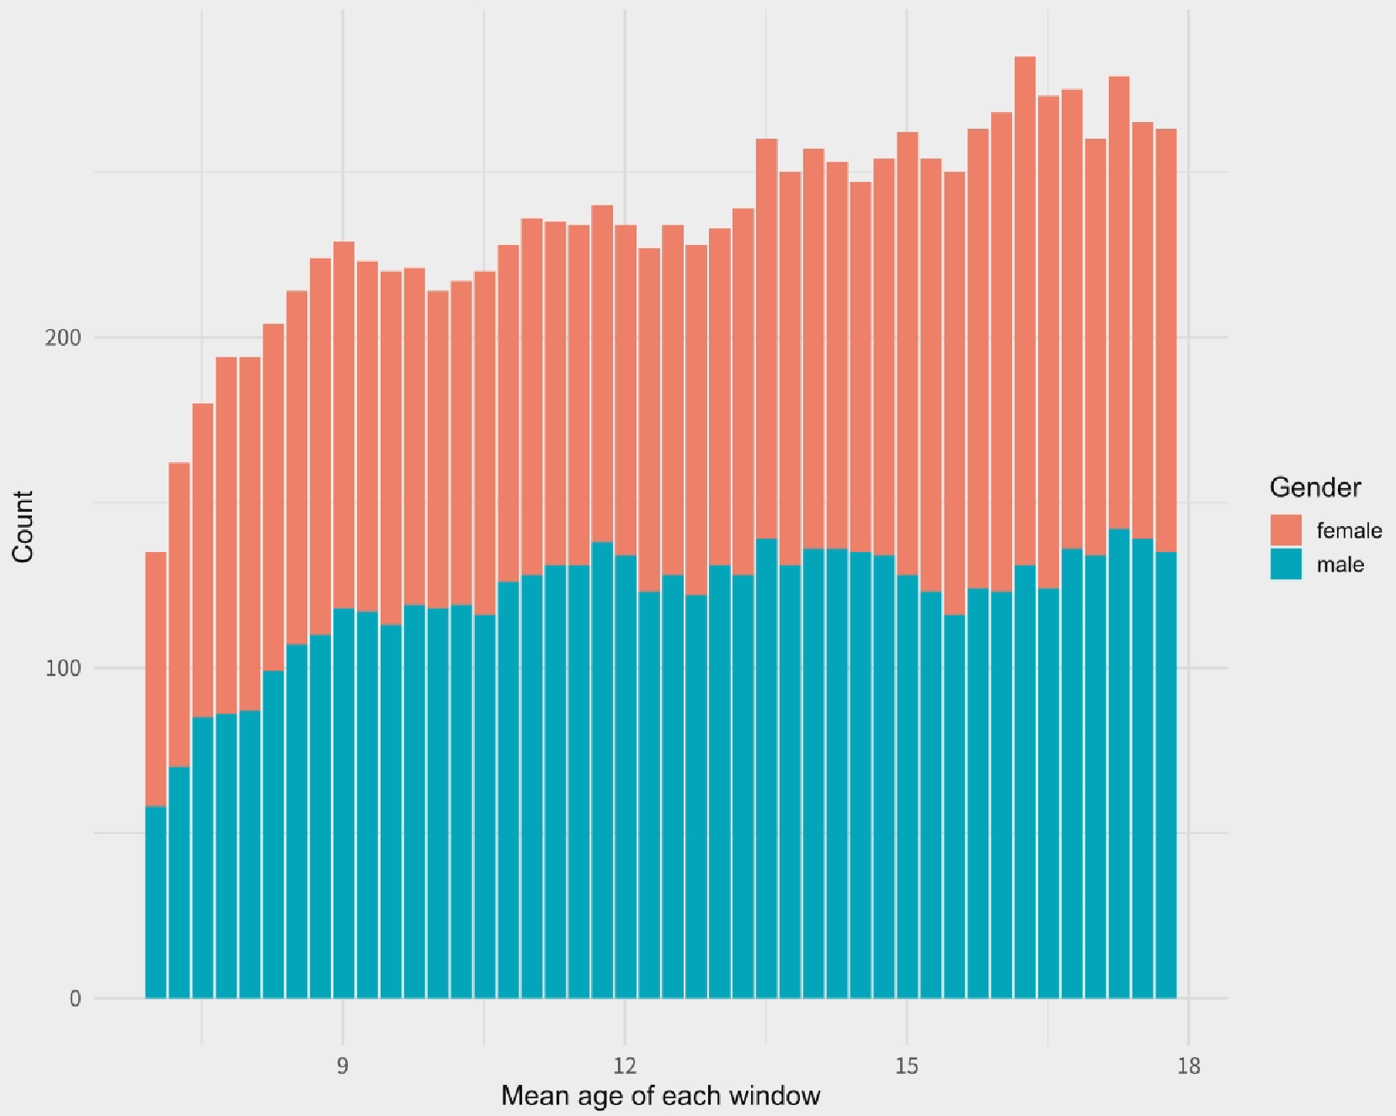
Figure S1. Sample size and gender ratio in each sliding window.

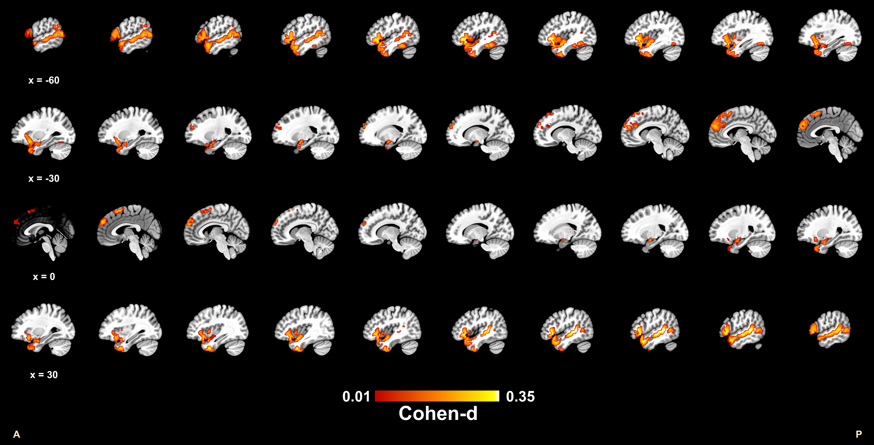
Figure S2. Group activation contrast map of emotion generation.

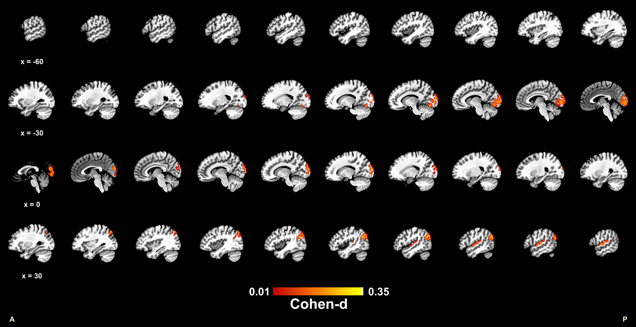
Figure S3. Group deactivation contrast map of emotion regulation.

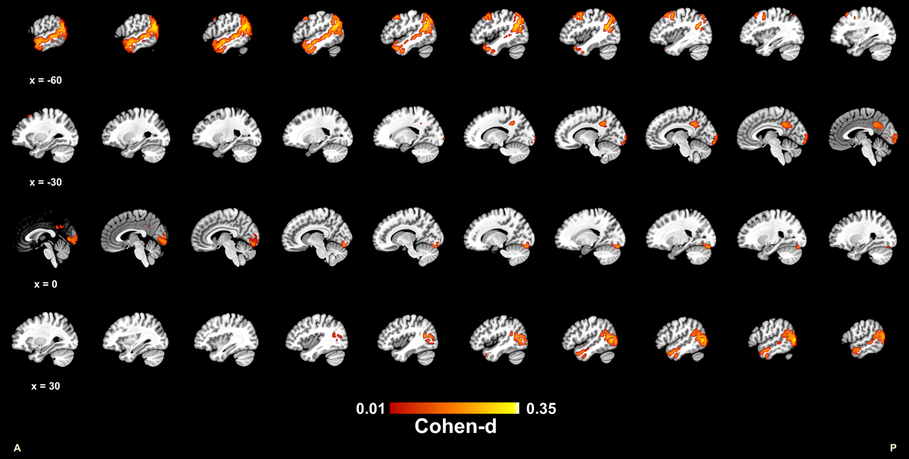
Figure S4. Group activation contrast map of emotion regulation.

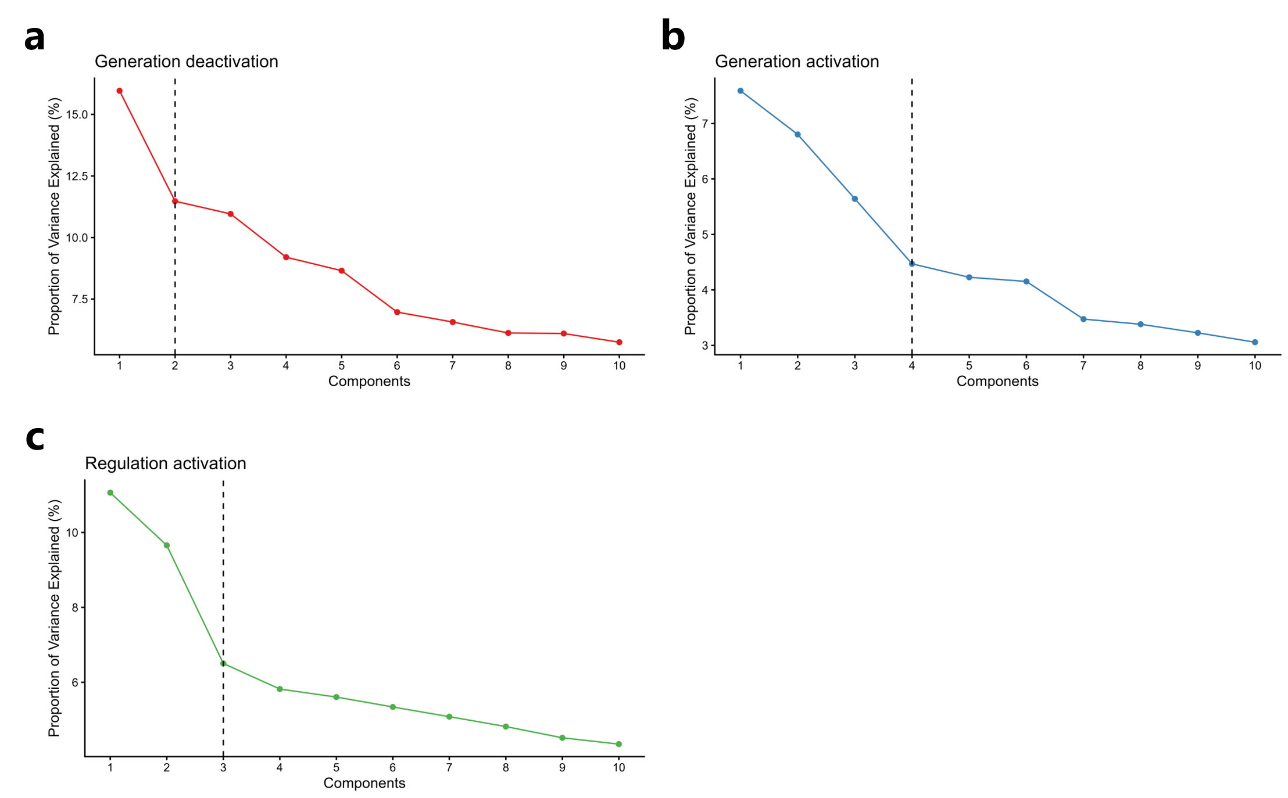
Figure S5. Residual of PCA. a: Proportion of valence explained of generation deactivation map. b: Proportion of valence explained of generation activation map. c: Proportion of valence explained of regulation deactivation map.
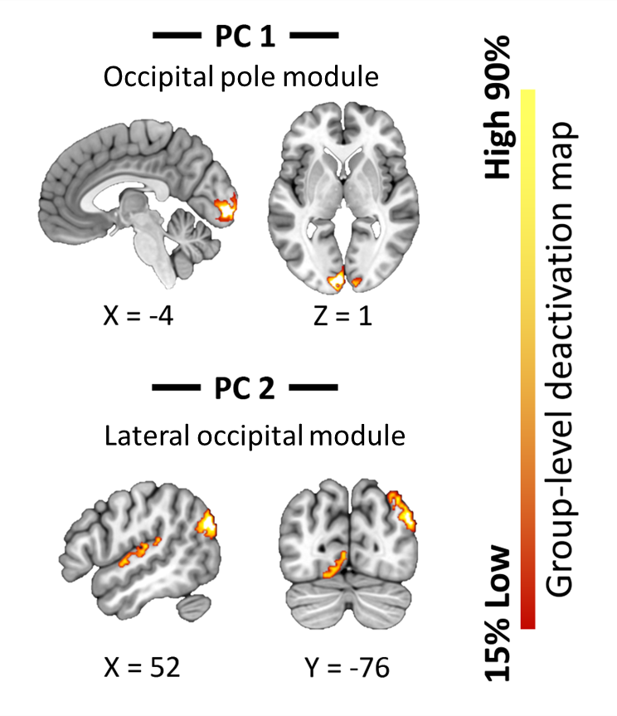
Figure S6. Deactivation map of the deactivation PCs of emotion generation.

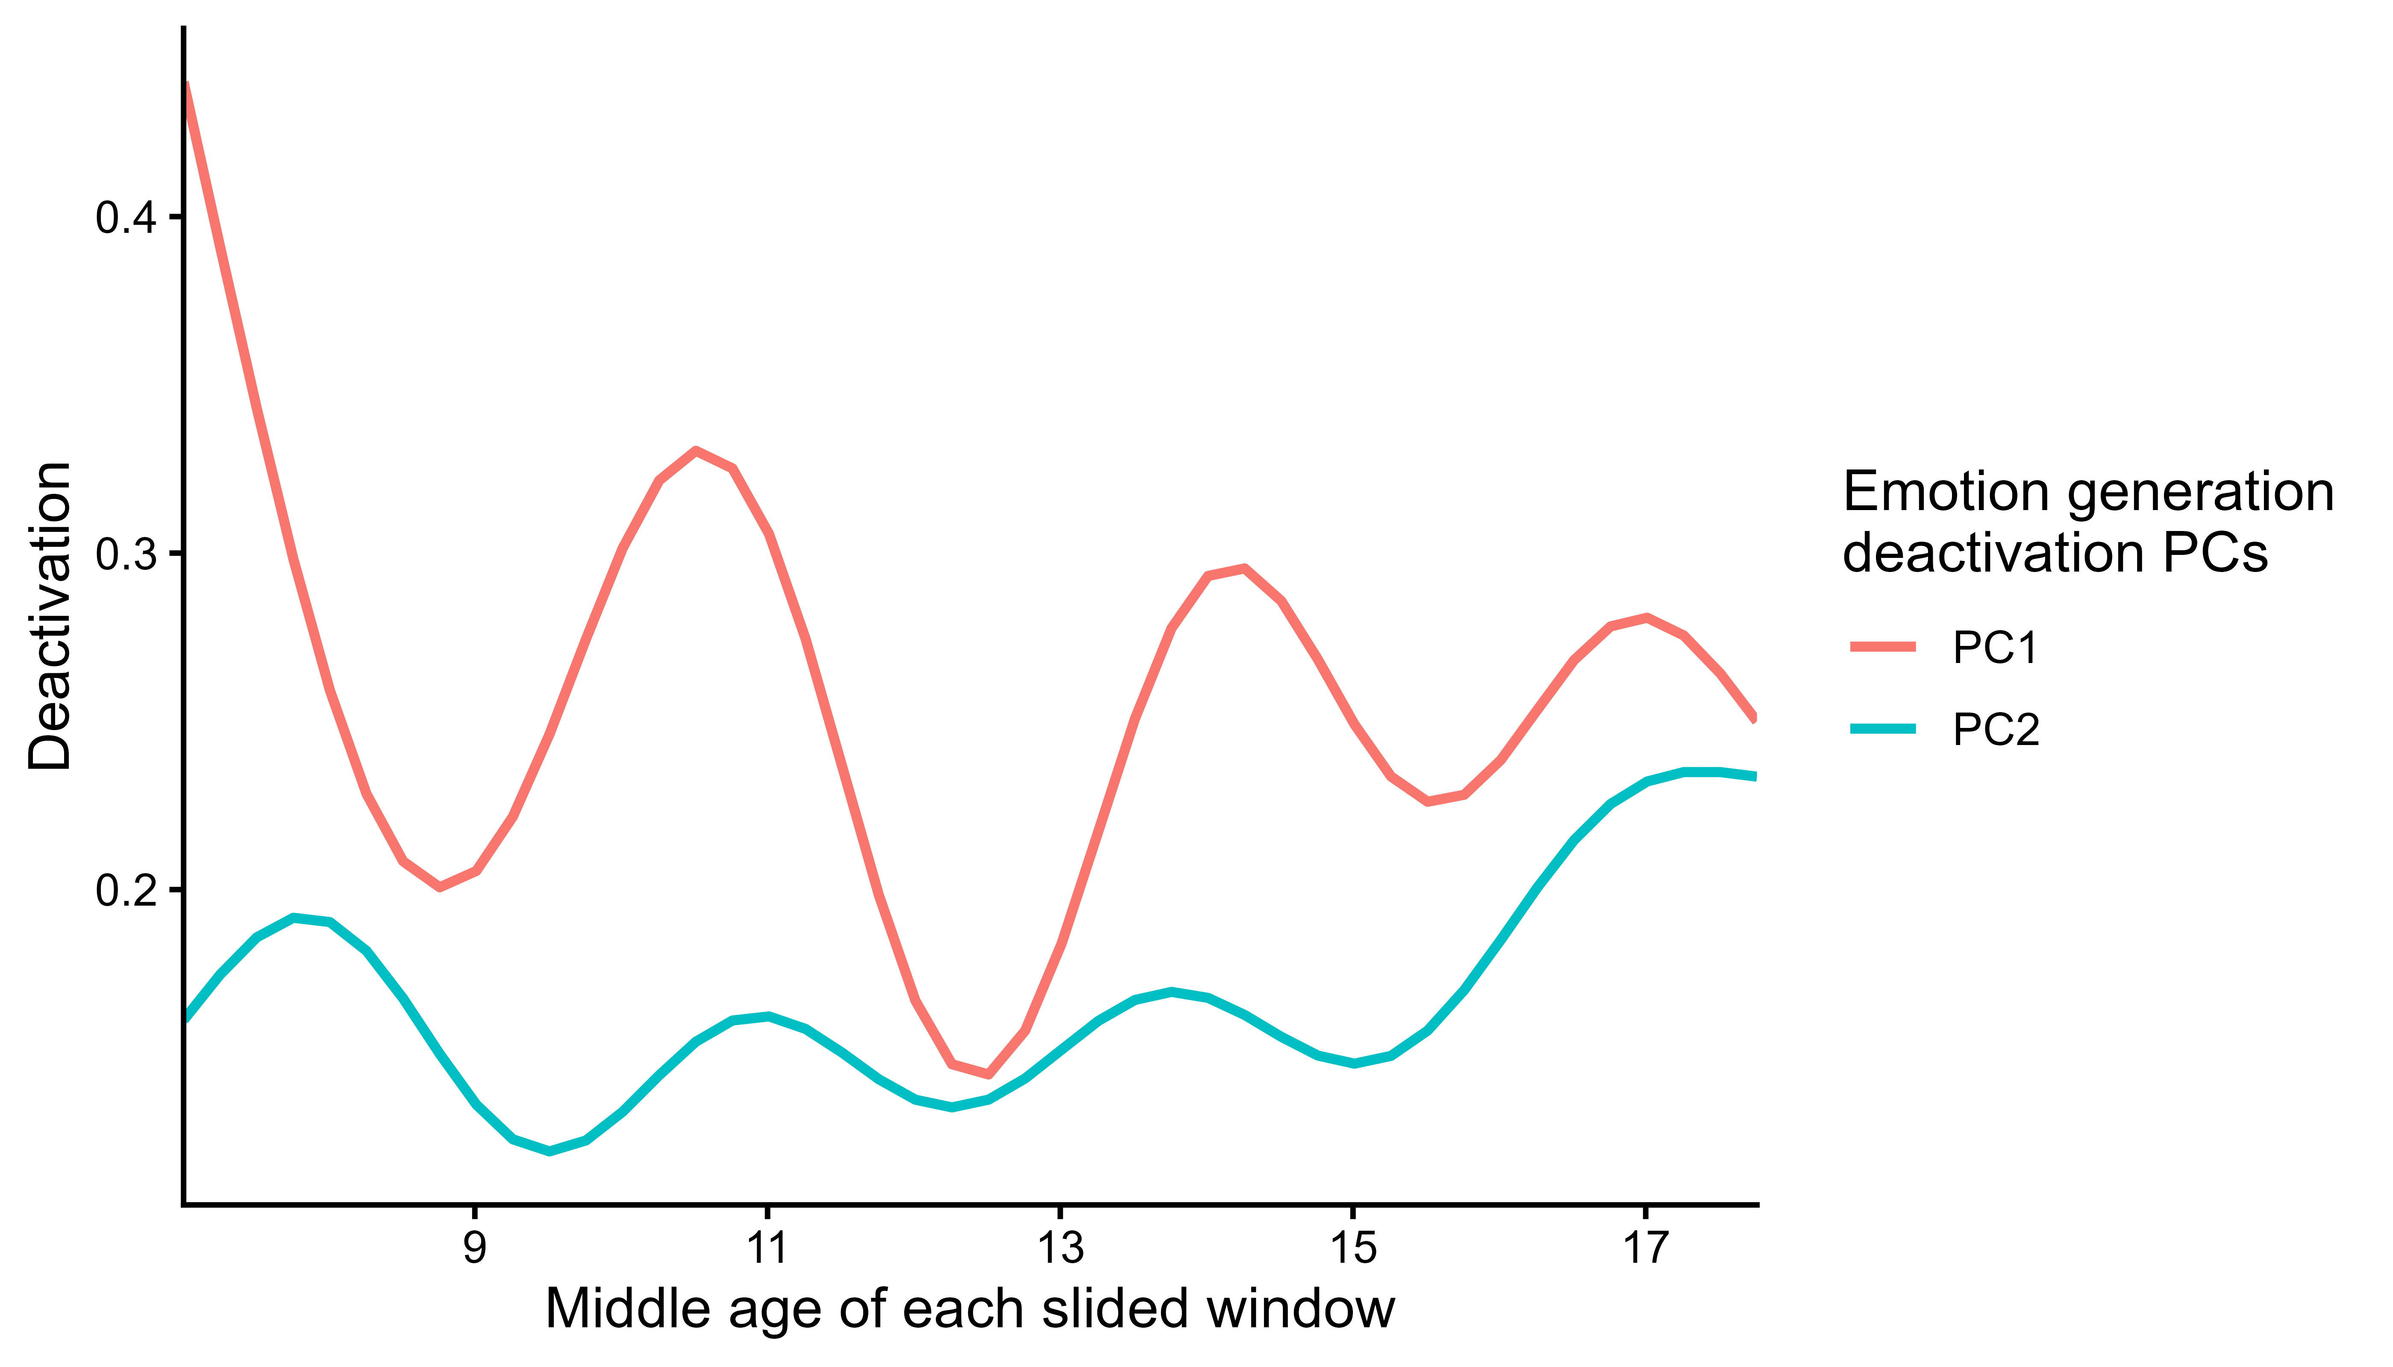
Figure S7. Longitudinal changes in the mean activation of the deactivation PCs of emotion generation. The x-axis represents the midpoint age of each sliding window.

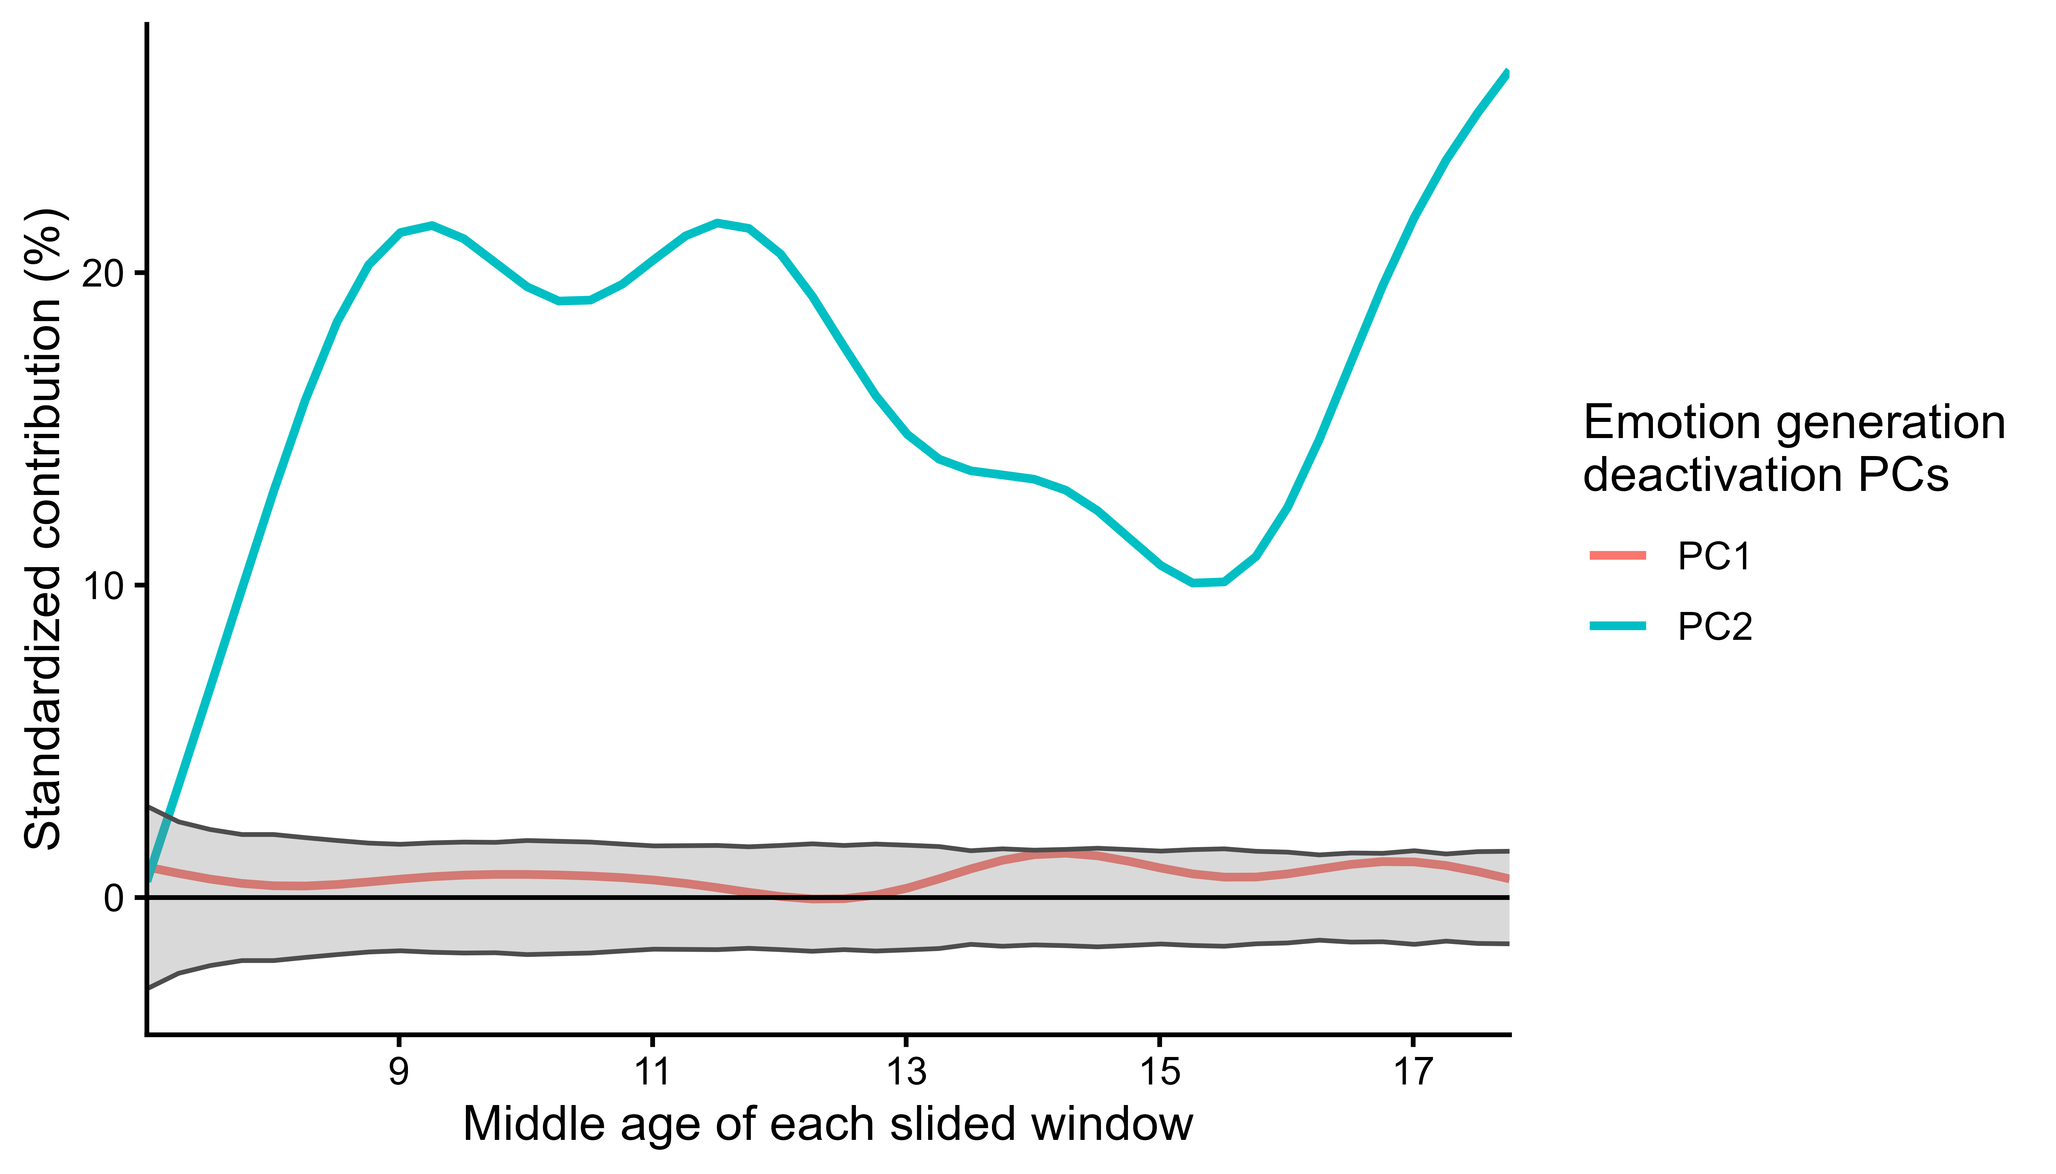
Figure S8. Longitudinal changes in the contribution of deactivation neural modules to emotion generation effect. The x-axis represents the midpoint age of each sliding window. The y-axis represents the standardized contribution (%) of each PC. The gray shaded area represents the significance threshold, and curves extending beyond this area indicate statistically significant contributions. FD, MRI scanner model and gender were included as covariates in the model.

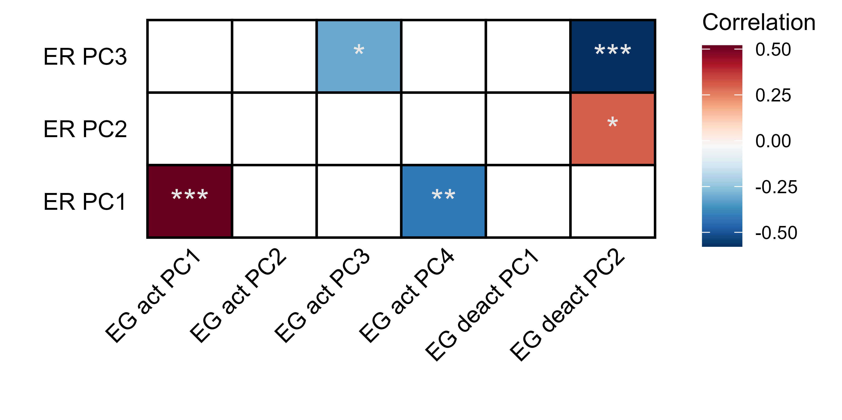
Figure S9. Correlation between the contribution of neural modules from emotion generation and regulation. ER: emotion regulation. EG: emotion generation. act: activation map. deact: deactivation map.

Figure S10. Linear and quadratic relationship between deactivation neural modules and other emotion-related variables. FD, MRI scanner model and gender were included as covariates. Blue or red color represented the significant positive or negative standardized β value of the linear or quadratic term. The white color denotes the nonsignificant relations.

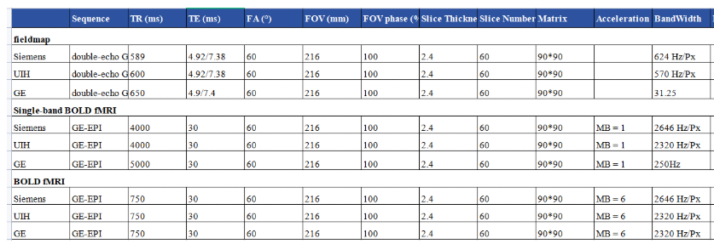
Figure S11. Parameters of three scanners. TR: repetition time. TE: echo time. FA: flip angle. FOV: field of view.

Supplementary tables
Age group | Neural module | emmean | SE | .group | rank
6-7 | Generation activation PC4 | 0.127 | 0.048 | a | 1
6-7 | Generation activation PC3 | 0.127 | 0.048 | a | 2
6-7 | Generation activation PC1 | 0.091 | 0.048 | a | 3
6-7 | Generation activation PC2 | 0.085 | 0.048 | a | 4
8-9 | Generation activation PC4 | 0.184 | 0.034 | a | 1
8-9 | Generation activation PC2 | 0.136 | 0.034 | ab | 2
8-9 | Generation activation PC3 | 0.13 | 0.034 | ab | 3
8-9 | Generation activation PC1 | 0.111 | 0.034 | b | 4
10-11 | Generation activation PC4 | 0.188 | 0.033 | a | 1
10-11 | Generation activation PC2 | 0.156 | 0.033 | ab | 2
10-11 | Generation activation PC3 | 0.124 | 0.033 | b | 3
10-11 | Generation activation PC1 | 0.103 | 0.033 | b | 4
12-13 | Generation activation PC4 | 0.211 | 0.031 | a | 1
12-13 | Generation activation PC2 | 0.193 | 0.031 | a | 2
12-13 | Generation activation PC3 | 0.178 | 0.031 | a | 3
12-13 | Generation activation PC1 | 0.089 | 0.031 | b | 4
14-15 | Generation activation PC4 | 0.162 | 0.031 | a | 1
14-15 | Generation activation PC3 | 0.14 | 0.031 | a | 2
14-15 | Generation activation PC2 | 0.135 | 0.031 | a | 3
14-15 | Generation activation PC1 | 0.069 | 0.031 | b | 4
16-17 | Generation activation PC4 | 0.217 | 0.03 | a | 1
16-17 | Generation activation PC2 | 0.171 | 0.03 | ab | 2
16-17 | Generation activation PC3 | 0.135 | 0.03 | bc | 3
16-17 | Generation activation PC1 | 0.083 | 0.03 | c | 4
18-19 | Generation activation PC4 | 0.139 | 0.035 | a | 1
18-19 | Generation activation PC2 | 0.117 | 0.035 | ab | 2
18-19 | Generation activation PC3 | 0.087 | 0.035 | ab | 3
18-19 | Generation activation PC1 | 0.054 | 0.035 | b | 4
Table S1. Relative activation ranking of emotion generation neural modules across age groups. Values are estimated marginal means (EMMs) from a linear mixed model (Activation ~ Age group * Neural module), adjusted for MRI equipment, gender, and mean framewise displacement. Components sharing a common letter do not differ significantly within the same age group (Tukey-adjusted pairwise comparisons, p < 0.05). Letters are assigned in decreasing order: a = highest, b = next, ab = not significantly different from either a or b alone, bc = not significantly different from either b or c alone, c = lowest.

Region Index (HOA) | Region | Hemi | Volume (mm^3) | Percentage of this PC
Emotion generation activation
PC1
0 | background | L | 1365 | 6.29
102 | insular cortex | L | 2712 | 12.49
106 | inferior frontal gyrus/pars opercularis | L | 52 | 0.24
107 | precentral gyrus | L | 12 | 0.06
108 | temporal pole | L | 3192 | 14.70
114 | inferior temporal gyrus/anterior division | L | 307 | 1.41
115 | inferior temporal gyrus/posterior division | L | 627 | 2.89
116 | inferior temporal gyrus/temporooccipital part | L | 402 | 1.85
133 | frontal orbital cortex | L | 233 | 1.07
134 | parahippocampal gyrus | L | 165 | 0.76
137 | temporal fusiform cortex/anterior division | L | 264 | 1.22
138 | temporal fusiform cortex/posterior division | L | 518 | 2.39
139 | temporal occipital fusiform cortex | L | 445 | 2.05
141 | frontal operculum cortex | L | 695 | 3.20
142 | central opercular cortex | L | 76 | 0.35
144 | planum polare | L | 457 | 2.11
153 | hippocampus | L | 43 | 0.20
154 | amygdala | L | 1146 | 5.28
202 | insular cortex | R | 851 | 3.92
208 | temporal pole | R | 3402 | 15.67
209 | superior temporal gyrus | R | 24 | 0.11
213 | middle temporal gyrus/temporooccipital part | R | 1270 | 5.85
214 | middle temporal gyrus/anterior division | R | 826 | 3.81
223 | lateral occipital cortex | R | 879 | 4.05
237 | temporal fusiform cortex | R | 140 | 0.64
244 | planum temporal | R | 473 | 2.18
253 | hippocampus | R | 46 | 0.21
254 | amygdala | R | 1086 | 5.00
PC2
0 | background | L | 583 | 3.35
101 | frontal pole | L | 457 | 2.62
102 | insular cortex | L | 1148 | 6.59
103 | superior frontal gyrus | L | 2988 | 17.15
105 | inferior frontal gyrus/pars triangularis | L | 2488 | 14.28
106 | inferior frontal gyrus/pars opercularis | L | 1341 | 7.70
108 | temporal pole | L | 234 | 1.34
126 | juxtaposotional lobule cortex | L | 53 | 0.30
128 | paracingulate gyrus | L | 1693 | 9.72
129 | anterior cingulate gyrus | L | 11 | 0.06
133 | frontal orbital cortex | L | 3461 | 19.86
141 | frontal operculum cortex | L | 822 | 4.72
202 | insular cortex | R | 457 | 2.62
203 | superior frontal gyrus | R | 311 | 1.78
228 | paracingulate gyrus | R | 6 | 0.03
233 | frontal orbital cortex | R | 1350 | 7.75
241 | frontal operculum cortex | R | 22 | 0.13
PC3
0 | background | \ | 1669 | 10.93
108 | temporal pole | L | 4647 | 30.45
109 | superior temporal gyrus/anterior division | L | 425 | 2.78
110 | superior temporal gyrus/posterior division | L | 1087 | 7.12
111 | middle temporal gyrus/anterior division | L | 90 | 0.59
112 | middle temporal gyrus/posterior division | L | 1975 | 12.94
113 | middle temporal gyrus/temporoccipital part | L | 1941 | 12.72
114 | inferior temporal gyrus/anterior division | L | 131 | 0.86
120 | supramarginal gyrus/posterior division | L | 631 | 4.13
121 | angular gyrus | L | 1762 | 11.54
122 | lateral occipital cortex/superior division | L | 195 | 1.28
123 | lateral occipital cortex/inferior division | L | 289 | 1.89
133 | frontal orbital cortex | L | 421 | 2.76
PC4
0 | background | \ | 2071 | 10.64
201 | frontal pole | R | 864 | 4.44
203 | superior frontal gyrus | R | 850 | 4.37
205 | inferior frontal gyrus/pars triangularis | R | 2867 | 14.73
206 | inferior frontal gyrus/pars opercularis | R | 726 | 3.73
208 | temporal pole | R | 2031 | 10.43
209 | superior temporal gyrus/anterior division | R | 534 | 2.74
210 | superior temporal gyrus/posterior division | R | 1440 | 7.40
211 | middle temporal gyrus/anterior division | R | 17 | 0.09
212 | middle temporal gyrus/posterior division | R | 2278 | 11.70
213 | middle temporal gyrus/temporooccipital part | R | 2097 | 10.77
220 | Supramarginal Gyrus/posterior division | R | 1434 | 7.37
221 | Angular Gyrus | R | 577 | 2.96
223 | Lateral Occipital Cortex/inferior division | R | 54 | 0.28
228 | Paracingulate Gyrus | R | 42 | 0.22
233 | Frontal Orbital Cortex | R | 1124 | 5.77
241 | Frontal Operculum Cortex | R | 458 | 2.35
Table S2. Regions presented in Figure 2. HOA: Havard – Oxford atlas.

Neural module | beta_age | SE | t_value | p_value | p_fdr | significant
Generation activation PC1 | -0.0026 | 0.0021 | -1.246 | 0.2128 | 0.8512 | ns
Generation activation PC2 | 0.0007 | 0.0043 | 0.167 | 0.8675 | 0.9502 | ns
Generation activation PC3 | -0.0022 | 0.0045 | -0.486 | 0.6271 | 0.9502 | ns
Generation activation PC4 | -0.0003 | 0.0045 | -0.063 | 0.9502 | 0.9502 | ns
Generation deactivation PC1 | -0.0087 | 0.0084 | -1.042 | 0.2975 | 0.2975 | ns
Generation deactivation PC2 | 0.0106 | 0.0054 | 1.985 | 0.0473 | 0.0946 | ns
Regulation activation PC1 | 0.0175 | 0.0059 | 2.971 | 0.003 | 0.009 | *
Regulation activation PC2 | 0.0053 | 0.0034 | 1.563 | 0.1182 | 0.1773 | ns
Regulation activation PC3 | -0.0016 | 0.0051 | -0.318 | 0.7506 | 0.7506 | ns
Table S3. Linear associations between age and neural module activation. Beta coefficients from separate linear models controlling for MRI equipment, gender, and mean framewise displacement. Raw and FDR-adjusted p-values (Benjamini-Hochberg) are reported. * = p_{FDR} < 0.05.

Region Index (HOA) | Region | Hemi | Volume (mm^3) | Percentage of this PC
Emotion regulation activation
PC1
0 | background | \ | 696 | 3.21
103 | Superior Frontal Gyrus | L | 4 | 0.02
104 | Middle Frontal Gyrus | L | 2891 | 13.32
107 | Precentral Gyrus | L | 12 | 0.06
108 | Temporal Pole | L | 108 | 0.50
110 | Superior Temporal Gyrus/posterior division | L | 457 | 2.10
111 | Middle Temporal Gyrus/anterior division | L | 1486 | 6.84
112 | Middle Temporal Gyrus/posterior division | L | 5618 | 25.88
113 | Middle Temporal Gyrus/temporooccipital part | L | 407 | 1.87
114 | Inferior Temporal Gyrus/anterior division | L | 47 | 0.22
115 | Inferior Temporal Gyrus/posterior division | L | 3 | 0.01
120 | Supramarginal Gyrus/posterior division | L | 132 | 0.61
121 | Angular Gyrus | L | 3721 | 17.14
122 | Lateral Occipital Cortex/superior division | L | 4027 | 18.55
130 | Cingulate Gyrus/posterior division | L | 1007 | 4.64
131 | Precuneous Cortex | L | 1062 | 4.89
230 | Cingulate Gyrus/posterior division | R | 10 | 0.05
231 | Precuneous Cortex | R | 23 | 0.11
PC2
0 | background | \ | 3074 | 12.39
108 | Temporal Pole | L | 4628 | 18.65
109 | Superior Temporal Gyrus/anterior division | L | 1485 | 5.98
110 | Superior Temporal Gyrus/posterior division | L | 711 | 2.86
111 | Middle Temporal Gyrus/anterior division | L | 1085 | 4.37
112 | Middle Temporal Gyrus/posterior division | L | 820 | 3.30
113 | Middle Temporal Gyrus/temporooccipital part | L | 2266 | 9.13
114 | Inferior Temporal Gyrus/anterior division | L | 928 | 3.74
115 | Inferior Temporal Gyrus/posterior division | L | 20 | 0.08
120 | Supramarginal Gyrus/posterior division | L | 1022 | 4.12
121 | Angular Gyrus | L | 1404 | 5.66
122 | Lateral Occipital Cortex/superior division | L | 316 | 1.27
123 | Lateral Occipital Cortex/inferior division | L | 477 | 1.92
144 | Planum Polare | L | 2 | 0.01
208 | Temporal Pole | R | 1107 | 4.46
209 | Superior Temporal Gyrus/anterior division | R | 547 | 2.20
211 | Middle Temporal Gyrus/anterior division | R | 716 | 2.89
212 | Middle Temporal Gyrus/posterior division | R | 478 | 1.93
213 | Middle Temporal Gyrus/temporooccipital part | R | 1222 | 4.92
220 | Supramarginal Gyrus/posterior division | R | 466 | 1.88
221 | Angular Gyrus | R | 520 | 2.10
222 | Lateral Occipital Cortex/superior division | R | 81 | 0.33
223 | Lateral Occipital Cortex/inferior division | R | 1443 | 5.81
PC3
0 | background | \ | 944 | 5.01
113 | Middle Temporal Gyrus/temporooccipital part | L | 930 | 4.94
121 | Angular Gyrus | L | 1211 | 6.43
122 | Lateral Occipital Cortex/superior division | L | 2424 | 12.87
123 | Lateral Occipital Cortex/inferior division | L | 1479 | 7.85
136 | Lingual Gyrus | L | 32 | 0.17
210 | Superior Temporal Gyrus/posterior division | R | 10 | 0.05
212 | Middle Temporal Gyrus/posterior division | R | 68 | 0.36
213 | Middle Temporal Gyrus/temporooccipital part | R | 1527 | 8.10
220 | Supramarginal Gyrus/posterior division | R | 159 | 0.84
221 | Angular Gyrus | R | 2505 | 13.30
222 | Lateral Occipital Cortex/superior division | R | 1372 | 7.28
223 | Lateral Occipital Cortex/inferior division | R | 4028 | 21.38
224 | Intracalcarine Cortex | R | 30 | 0.16
236 | Lingual Gyrus | R | 1261 | 6.69
240 | Occipital Fusiform Gyrus | R | 821 | 4.36
248 | Occipital Pole | R | 40 | 0.21
Table S4. Regions presented in Figure 3. HOA: Havard – Oxford atlas.

Age group | Neural module | emmean | SE | .group | rank
6-7 | Regulation activation PC3 | 0.223 | 0.059 | a | 1
6-7 | Regulation activation PC2 | 0.086 | 0.059 | b | 2
6-7 | Regulation activation PC1 | 0.031 | 0.059 | b | 3
8-9 | Regulation activation PC3 | 0.168 | 0.042 | a | 1
8-9 | Regulation activation PC1 | 0.128 | 0.042 | ab | 2
8-9 | Regulation activation PC2 | 0.084 | 0.042 | b | 3
10-11 | Regulation activation PC3 | 0.18 | 0.04 | a | 1
10-11 | Regulation activation PC1 | 0.135 | 0.04 | ab | 2
10-11 | Regulation activation PC2 | 0.093 | 0.04 | b | 3
12-13 | Regulation activation PC1 | 0.209 | 0.038 | a | 1
12-13 | Regulation activation PC3 | 0.183 | 0.038 | ab | 2
12-13 | Regulation activation PC2 | 0.128 | 0.038 | b | 3
14-15 | Regulation activation PC1 | 0.217 | 0.038 | a | 1
14-15 | Regulation activation PC3 | 0.191 | 0.038 | ab | 2
14-15 | Regulation activation PC2 | 0.124 | 0.038 | b | 3
16-17 | Regulation activation PC1 | 0.193 | 0.037 | a | 1
16-17 | Regulation activation PC3 | 0.151 | 0.037 | ab | 2
16-17 | Regulation activation PC2 | 0.122 | 0.037 | b | 3
18-19 | Regulation activation PC1 | 0.264 | 0.043 | a | 1
18-19 | Regulation activation PC3 | 0.185 | 0.043 | ab | 2
18-19 | Regulation activation PC2 | 0.15 | 0.043 | b | 3
Table S5. Relative activation ranking of emotion regulation neural modules across age groups. Values are estimated marginal means (EMMs) from a linear mixed model (Activation ~ Age group * Neural module), adjusted for MRI equipment, gender, and mean framewise displacement. Components sharing a common letter do not differ significantly within the same age group (Tukey-adjusted pairwise comparisons, p < 0.05). Letters are assigned in decreasing order: a = highest, b = next, ab = not significantly different from either a or b alone.

Region Index (HOA) | Region | Hemi | Volume (mm^3) | Percentage of this PC
Emotion generation deactivation
PC1
0 | background | \ | 767 | 5.64
124 | Intracalcarine Cortex | L | 1306 | 9.60
132 | Cuneal Cortex | L | 319 | 2.34
136 | Lingual Gyrus | L | 634 | 4.66
147 | Supracalcarine Cortex | L | 358 | 2.63
148 | Occipital Pole | L | 5168 | 37.98
222 | Lateral Occipital Cortex | R | 5 | 0.04
224 | Intracalcarine Cortex | R | 15 | 0.11
232 | Cuneal Cortex | R | 387 | 2.84
236 | Lingual Gyrus | R | 209 | 1.54
247 | Supracalcarine Cortex | R | 216 | 1.59
248 | Occipital Pole | R | 4224 | 31.04
PC2
0 | background | / | 3031 | 12.26
122 | Lateral Occipital Cortex/superior division | L | 110 | 0.45
124 | Intracalcarine Cortex | L | 474 | 1.92
132 | Cuneal Cortex | L | 273 | 1.10
136 | Lingual Gyrus | L | 3011 | 12.18
140 | Occipital Fusiform Gyrus | L | 284 | 1.15
147 | Supracalcarine Cortex | L | 105 | 0.42
148 | Occipital Pole | L | 1596 | 6.46
209 | Superior Temporal Gyrus/anterior division | R | 152 | 0.62
210 | Superior Temporal Gyrus/posterior division | R | 613 | 2.48
217 | Postcentral Gyrus | R | 93 | 0.38
221 | Angular Gyrus | R | 469 | 1.90
222 | Lateral Occipital Cortex/superior division | R | 7313 | 29.59
224 | Intracalcarine Cortex | R | 35 | 0.14
232 | Cuneal Cortex | R | 249 | 1.01
236 | Lingual Gyrus | R | 47 | 0.19
242 | Central Opercular Cortex | R | 1272 | 5.15
243 | Parietal Operculum Cortex | R | 215 | 0.87
244 | Planum Polare | R | 634 | 2.57
245 | Heschls Gyrus (includes H1 and H2) | R | 937 | 3.79
246 | Planum Temporale | R | 2437 | 9.86
247 | Supracalcarine Cortex | R | 43 | 0.17
248 | Occipital Pole | R | 1322 | 5.35
Table S6. Regions in PCs from the emotion generation deactivation map. HOA: Havard – Oxford atlas.

Age group | Neural module | emmean | SE | .group | rank
6-7 | Generation deactivation PC1 | 0.471 | 0.084 | a | 1
6-7 | Generation deactivation PC2 | 0.058 | 0.084 | b | 2
8-9 | Generation deactivation PC1 | 0.169 | 0.059 | a | 1
8-9 | Generation deactivation PC2 | 0.132 | 0.059 | a | 2
10-11 | Generation deactivation PC1 | 0.3 | 0.057 | a | 1
10-11 | Generation deactivation PC2 | 0.127 | 0.057 | b | 2
12-13 | Generation deactivation PC1 | 0.13 | 0.055 | a | 1
12-13 | Generation deactivation PC2 | 0.11 | 0.055 | a | 2
14-15 | Generation deactivation PC1 | 0.26 | 0.054 | a | 1
14-15 | Generation deactivation PC2 | 0.132 | 0.054 | b | 2
16-17 | Generation deactivation PC1 | 0.252 | 0.053 | a | 1
16-17 | Generation deactivation PC2 | 0.181 | 0.053 | a | 2
18-19 | Generation deactivation PC2 | 0.186 | 0.062 | a | 1
18-19 | Generation deactivation PC1 | 0.169 | 0.062 | a | 2
Table S7. Relative deactivation ranking of emotion generation neural modules across age groups. Values are estimated marginal means (EMMs) from a linear mixed model (Activation ~ Age group * Neural module), adjusted for MRI equipment, gender, and mean framewise displacement. Components sharing a common letter do not differ significantly within the same age group (Tukey-adjusted pairwise comparisons, p < 0.05). Letters are assigned in decreasing order: a = higher, b = lower.

 | Emotion generation
 | Deactivation map |  | Activation map
Topic | PC1 | PC2 | PC1 | PC2 | PC3 | PC4
0_stimulation_somatosensory_tms | 0.00 | 0.18 | 0.00 | 0.08 | 0.00 | 0.01
13_cognitive_control_performance | 0.00 | 0.00 | 0.00 | 0.00 | 0.00 | 0.00
14_wm_imagery_mental | 0.03 | 0.15 | 0.02 | 0.02 | 0.00 | 0.00
15_reading_words_language | 0.01 | 0.11 | 0.12 | 0.26 | 0.30 | 0.12
17_social_empathy_participants | 0.00 | 0.04 | 0.05 | 0.33 | 0.22 | 0.30
20_semantic_words_word | 0.00 | 0.02 | 0.19 | 0.39 | 0.31 | 0.00
21_context_gaze_cues | 0.00 | 0.00 | 0.00 | 0.12 | 0.00 | 0.13
22_depression_mdd_patients | 0.00 | 0.00 | 0.53 | 0.00 | 0.00 | 0.00
23_acupuncture_creative_stimulation | 0.07 | 0.04 | 0.20 | 0.04 | 0.04 | 0.04
24_memory_encoding_retrieval | 0.01 | 0.02 | 0.13 | 0.15 | 0.04 | 0.03
25_inhibition_response_control | 0.00 | 0.03 | 0.10 | 0.27 | 0.04 | 0.21
2_smokers_users_smoking | 0.00 | 0.00 | 0.00 | 0.00 | 0.00 | 0.00
30_ms_patients_global | 0.00 | 0.00 | 0.23 | 0.00 | 0.00 | 0.00
32_verbs_verb_nouns | 0.00 | 0.00 | 0.07 | 0.56 | 0.48 | 0.05
34_decision_choice_decisions | 0.00 | 0.03 | 0.05 | 0.19 | 0.00 | 0.00
40_action_actions_observation | 0.05 | 0.08 | 0.18 | 0.03 | 0.11 | 0.13
46_hearing_deaf_tinnitus | 0.00 | 0.24 | 0.24 | 0.00 | 0.07 | 0.33
49_conflict_interference_control | 0.00 | 0.00 | 0.09 | 0.24 | 0.00 | 0.13
4_stress_ptsd_exposure | 0.00 | 0.00 | 0.47 | 0.00 | 0.00 | 0.00
51_sequences_timing_bimanual | 0.00 | 0.14 | 0.01 | 0.04 | 0.00 | 0.04
52_sleep_number_numerical | 0.00 | 0.23 | 0.00 | 0.00 | 0.00 | 0.00
56_events_memory_autobiographical | 0.02 | 0.01 | 0.10 | 0.13 | 0.12 | 0.08
58_switching_set_rule | 0.03 | 0.00 | 0.08 | 0.10 | 0.00 | 0.00
5_disease_patients_ad | 0.00 | 0.00 | 0.21 | 0.06 | 0.13 | 0.02
60_emotional_negative_emotion | 0.00 | 0.04 | 0.42 | 0.21 | 0.10 | 0.22
61_pain_painful_stimulation | 0.00 | 0.10 | 0.20 | 0.07 | 0.00 | 0.02
62_adhd_asd_autism | 0.00 | 0.00 | 0.00 | 0.00 | 0.00 | 0.00
65_faces_face_facial | 0.01 | 0.00 | 0.42 | 0.04 | 0.04 | 0.18
66_women_sex_gender | 0.00 | 0.00 | 0.20 | 0.18 | 0.00 | 0.00
67_personality_ocd_trait | 0.00 | 0.00 | 0.21 | 0.00 | 0.00 | 0.00
68_memory_working_task | 0.01 | 0.07 | 0.05 | 0.14 | 0.02 | 0.01
6_object_objects_visual | 0.14 | 0.06 | 0.14 | 0.00 | 0.02 | 0.00
70_body_bodies_images | 0.00 | 0.00 | 0.29 | 0.00 | 0.00 | 0.00
72_force_motor_muscle | 0.00 | 0.03 | 0.03 | 0.00 | 0.00 | 0.00
75_spatial_space_location | 0.06 | 0.20 | 0.02 | 0.01 | 0.00 | 0.01
77_reasoning_judgments_moral | 0.00 | 0.00 | 0.00 | 0.49 | 0.07 | 0.13
7_phase_rate_cycle | 0.00 | 0.00 | 0.17 | 0.00 | 0.00 | 0.00
81_alcohol_ds_alcoholics | 0.00 | 0.00 | 0.20 | 0.00 | 0.00 | 0.00
82_trials_response_trial | 0.00 | 0.05 | 0.03 | 0.13 | 0.00 | 0.00
85_feedback_error_errors | 0.00 | 0.00 | 0.09 | 0.36 | 0.00 | 0.05
86_speech_auditory_sounds | 0.00 | 0.39 | 0.01 | 0.04 | 0.22 | 0.28
87_sentences_language_comprehension | 0.00 | 0.09 | 0.10 | 0.38 | 0.48 | 0.27
88_motion_perception_visual | 0.06 | 0.07 | 0.26 | 0.00 | 0.04 | 0.11
90_familiar_recognition_false | 0.00 | 0.00 | 0.09 | 0.15 | 0.07 | 0.00
93_eye_eyes_movements | 0.09 | 0.11 | 0.09 | 0.01 | 0.00 | 0.00
95_motor_movement_movements | 0.01 | 0.12 | 0.08 | 0.08 | 0.03 | 0.02
97_fear_threat_conditioning | 0.00 | 0.02 | 0.48 | 0.05 | 0.00 | 0.06
98_food_taste_weight | 0.00 | 0.00 | 0.24 | 0.11 | 0.00 | 0.09
99_reward_anticipation_monetary | 0.00 | 0.00 | 0.08 | 0.06 | 0.02 | 0.00
9_attention_attentional_visual | 0.08 | 0.13 | 0.04 | 0.02 | 0.00 | 0.14
Table S8. Spatial Correlation between emotion generation PCs and Neurosynth topics.

 | Emotion regulation
 | Activation map
Topic | PC1 | PC2 | PC1
0_stimulation_somatosensory_tms | 0.04 | 0.01 | 0.00
13_cognitive_control_performance | 0.00 | 0.07 | 0.00
14_wm_imagery_mental | 0.02 | 0.02 | 0.00
15_reading_words_language | 0.18 | 0.28 | 0.04
17_social_empathy_participants | 0.21 | 0.33 | 0.30
20_semantic_words_word | 0.19 | 0.27 | 0.07
21_context_gaze_cues | 0.00 | 0.13 | 0.00
22_depression_mdd_patients | 0.00 | 0.00 | 0.00
23_acupuncture_creative_stimulation | 0.05 | 0.08 | 0.04
24_memory_encoding_retrieval | 0.12 | 0.07 | 0.04
25_inhibition_response_control | 0.09 | 0.05 | 0.08
2_smokers_users_smoking | 0.00 | 0.00 | 0.00
30_ms_patients_global | 0.00 | 0.00 | 0.00
32_verbs_verb_nouns | 0.24 | 0.51 | 0.04
34_decision_choice_decisions | 0.00 | 0.00 | 0.02
40_action_actions_observation | 0.03 | 0.27 | 0.30
46_hearing_deaf_tinnitus | 0.12 | 0.19 | 0.16
49_conflict_interference_control | 0.00 | 0.00 | 0.00
4_stress_ptsd_exposure | 0.00 | 0.19 | 0.00
51_sequences_timing_bimanual | 0.01 | 0.01 | 0.00
52_sleep_number_numerical | 0.00 | 0.00 | 0.00
56_events_memory_autobiographical | 0.25 | 0.23 | 0.13
58_switching_set_rule | 0.03 | 0.00 | 0.00
5_disease_patients_ad | 0.07 | 0.16 | 0.00
60_emotional_negative_emotion | 0.02 | 0.09 | 0.06
61_pain_painful_stimulation | 0.01 | 0.00 | 0.00
62_adhd_asd_autism | 0.00 | 0.44 | 0.00
65_faces_face_facial | 0.00 | 0.11 | 0.14
66_women_sex_gender | 0.00 | 0.14 | 0.00
67_personality_ocd_trait | 0.00 | 0.00 | 0.00
68_memory_working_task | 0.04 | 0.02 | 0.00
6_object_objects_visual | 0.00 | 0.15 | 0.19
70_body_bodies_images | 0.00 | 0.29 | 0.53
72_force_motor_muscle | 0.00 | 0.01 | 0.00
75_spatial_space_location | 0.00 | 0.09 | 0.10
77_reasoning_judgments_moral | 0.25 | 0.18 | 0.11
7_phase_rate_cycle | 0.07 | 0.00 | 0.00
81_alcohol_ds_alcoholics | 0.00 | 0.00 | 0.00
82_trials_response_trial | 0.00 | 0.00 | 0.00
85_feedback_error_errors | 0.00 | 0.02 | 0.00
86_speech_auditory_sounds | 0.13 | 0.25 | 0.01
87_sentences_language_comprehension | 0.25 | 0.53 | 0.09
88_motion_perception_visual | 0.00 | 0.43 | 0.42
90_familiar_recognition_false | 0.20 | 0.08 | 0.18
93_eye_eyes_movements | 0.01 | 0.13 | 0.16
95_motor_movement_movements | 0.04 | 0.03 | 0.02
97_fear_threat_conditioning | 0.00 | 0.00 | 0.00
98_food_taste_weight | 0.00 | 0.00 | 0.00
99_reward_anticipation_monetary | 0.00 | 0.02 | 0.00
9_attention_attentional_visual | 0.03 | 0.16 | 0.11
Table S9. Spatial Correlation between emotion regulation PCs and Neurosynth topics.

Module | Dependent Variable | Model Term | β (Standardized) | Std. Error | t | p
Generation PC1 | Happy threshold | Linear | 0.115 | 0.041 | 2.79 | 0.005
 | CBCL Social problems | Linear | 0.091 | 0.041 | 2.21 | 0.027
 | Non-social negative emotion | Quadratic | -0.049 | 0.020 | -2.43 | 0.015
 | Non-social negative self-esteem | Quadratic | -0.039 | 0.020 | -1.98 | 0.048
Generation PC2 | CBCL Thought problems | Linear | -0.098 | 0.044 | -2.21 | 0.027
 | Angry RT | Quadratic | 0.047 | 0.022 | 2.13 | 0.033
 | Cognitive reappraisal | Quadratic | 0.045 | 0.022 | 2.02 | 0.043
Generation PC3 | Happy threshold | Linear | -0.119 | 0.048 | -2.49 | 0.013
 | Social positive self-esteem | Linear | 0.125 | 0.048 | 2.62 | 0.009
 | Non-social positive self-esteem | Linear | 0.133 | 0.048 | 2.81 | 0.005
 | Social positive emotion | Linear | 0.105 | 0.048 | 2.20 | 0.028
 | PANAS negative emotion | Linear | 0.095 | 0.048 | 1.99 | 0.047
 | CBCL Internalizing problems | Linear | 0.097 | 0.048 | 2.03 | 0.042
 | CBCL Withdraw & depression | Linear | 0.101 | 0.048 | 2.11 | 0.035
 | RPAQ-Reactive aggression | Linear | 0.136 | 0.048 | 2.87 | 0.004
 | Expression suppression | Quadratic | 0.049 | 0.022 | 2.26 | 0.024
 | PHQ-9 depression | Quadratic | 0.067 | 0.022 | 3.06 | 0.002
 | CBCL Social problems | Quadratic | -0.047 | 0.022 | -2.15 | 0.032
Generation PC4 | Non-social negative self-esteem | Linear | 0.104 | 0.052 | 2.01 | 0.045
 | GAD-7 anxiety | Quadratic | -0.053 | 0.023 | -2.26 | 0.024
 | PHQ-9 depression | Quadratic | -0.068 | 0.023 | -2.96 | 0.003
Regulation PC1 | PANAS negative emotion | Linear | 0.119 | 0.039 | 3.06 | 0.002
 | Social negative self-esteem | Quadratic | -0.042 | 0.020 | -2.31 | 0.021
 | CBCL Internalizing problems | Quadratic | -0.037 | 0.018 | -2.03 | 0.042
Regulation PC2 | GAD-7 anxiety | Linear | -0.129 | 0.048 | -2.69 | 0.007
 | PHQ-9 depression | Linear | -0.114 | 0.048 | -2.38 | 0.018
 | PANAS negative emotion | Linear | -0.153 | 0.048 | -3.21 | 0.001
 | Happy RT | Quadratic | 0.040 | 0.020 | 1.98 | 0.048
 | Angry RT | Quadratic | 0.042 | 0.020 | 2.08 | 0.038
 | CBCL Attention problems | Quadratic | -0.042 | 0.020 | -2.05 | 0.041
 | CBCL Social problems | Quadratic | -0.046 | 0.020 | -2.28 | 0.023
Regulation PC3 | Social negative self-esteem | Quadratic | 0.042 | 0.017 | 2.47 | 0.014
 | Expression suppression | Quadratic | 0.051 | 0.017 | 2.99 | 0.002
Table S10. Statistical information of Figure 4. For each dependent variable, all PCs derived from a given phase were simultaneously included in the regression model to isolate the unique contribution of each neural module. FD, MRI scanner model and gender were included as covariates. Both dependent and independent variables in the scatterplots were standardized.

Module | Dependent Variable | Model Term | β (Standardized) | Std. Error | t | p
Deactivation Generation PC1 | Happy RT | Linear | 0.075 | 0.030 | 2.52 | 0.012
 | Social positive self-esteem | Linear | -0.069 | 0.030 | -2.34 | 0.019
 | Non-social positive self-esteem | Linear | -0.071 | 0.030 | -2.39 | 0.017
 | Happy threshold | Quadratic | -0.034 | 0.017 | -2.03 | 0.043
 | Expression Suppression | Quadratic | 0.040 | 0.017 | 2.34 | 0.020
 | Happy RT | Quadratic | -0.033 | 0.017 | -1.97 | 0.049
 | Angry RT | Quadratic | -0.037 | 0.017 | -2.20 | 0.028
Deactivation Generation PC2 | Happy RT | Linear | -0.068 | 0.030 | -2.27 | 0.023
 | Angry RT | Linear | -0.080 | 0.030 | -2.70 | 0.007
 | Social positive self-esteem | Quadratic | -0.036 | 0.016 | -2.17 | 0.030
 | Non-social positive self-esteem | Quadratic | -0.032 | 0.016 | -1.98 | 0.049
 | Social negative self-esteem | Quadratic | -0.037 | 0.016 | -2.26 | 0.024
 | Non-social negative self-esteem | Quadratic | -0.034 | 0.017 | -2.06 | 0.039
Table S11. Statistical information of Figure S10. For each dependent variable, all PCs derived from a given phase were simultaneously included in the regression model to isolate the unique contribution of each neural module. FD, MRI scanner model and gender were included as covariates. Both dependent and independent variables in the scatterplots were standardized.

