SUPPLEMENTARY INFORMATION

Improved Simulation of Volcanic Sulfur Dioxide Depletion and Transport Using a High-Resolution Volcanic Sulfur Dioxide Emissions Inventory
Xue Wu^{1,2}, Wenjing Zhang³, Lars Hoffmann⁴, Sabine Griessbach⁴, Bing Chen^{3*}, Ming Li^{1,2}
¹ Laboratory of Middle Atmosphere and Global Environment Observation, Institute of Atmospheric Physics, Chinese Academy of Sciences, Beijing, China
² University of Chinese Academy of Sciences, Beijing, China
³ Key Laboratory of Atmospheric Environment and Processes in the Boundary Layer over the Low‑Latitude Plateau Region, Department of Atmospheric Science, Yunnan University, Kunming, China
⁴ Jülich Supercomputing Centre, Forschungszentrum Jülich, Jülich, Germany
*Correspondence: chenbing@ynu.edu.cn

Contents of this file:
Supplementary Notes 1 to 2
Supplementary Figures 1 to 8

Supplementary Note 1: Construction of the Time- and Height-Resolved Inventory of Volcanic Emissions of SO₂ (THRIVE-SO₂)
Step 1: Identification of volcanic eruption events from the AIRS SO₂ index
To construct the THRIVE-SO₂, we first systematically screened AIRS observations since 2002 to identify candidate eruption events exhibiting significant SO₂ signals. The SO₂ index (SI) is computed as the brightness temperature difference between the two channels centered at 1412.87 cm⁻¹ and 1371.52 cm⁻¹. A detection threshold of SI > 20 K was applied to the global AIRS record to include significant volcanic SO₂ loading. All AIRS pixels exceeding this threshold were extracted, together with their corresponding observation time, latitude, and longitude.
Because a single eruption typically produces spatially and temporally clustered SI enhancements as the plume disperses over subsequent days, consecutive high-SI detections were grouped by spatial proximity and temporal continuity to associate them with a specific source volcano and eruption onset time. Specifically, clusters of SI > 20 K pixels occurring within a time period and located within a plausible transport distance of a known volcanic edifice (cross-referenced against the Global Volcanism Program database) were attributed to the same eruptive event. This procedure yielded a candidate list of discrete volcanic eruption events, each characterized by an approximate eruption date and source location, which was compiled into a reference table used as the basis for the subsequent emission reconstruction.
The current version includes 52 selected eruptions available at: https://datapub.fz-juelich.de/slcs/so2_inv/html/events.html, and additional events may be included in future versions.
Step 2: Reconstruction of altitude-resolved volcanic SO₂ emission time series
For each identified eruption event, the time series of SO₂ mass emission and injection height were reconstructed following the general approach of Hoffmann et al.¹, which combines AIRS SO₂ column measurements with backward trajectory calculations. Since AIRS provides only vertically integrated column density without altitude-resolved information, a vertical column of air parcels was initialized at each AIRS SO₂ detection location, spanning an altitude range of 0–30 km to encompass the plausible vertical extent of volcanic SO₂ dispersion.
A total of 100,000 air parcels were distributed across all columns associated with a given eruption, with the number of parcels allocated to each column scaled according to the local SI magnitude, and the vertical placement of parcels within each column following the mean averaging kernel of the AIRS SO₂ retrieval. To account for the AIRS footprint size (13.5–41 km depending on scan angle), parcels were horizontally scattered using a Gaussian distribution with a full width at half maximum (FWHM) of 30 km.
Backward trajectories were then computed for all initialized air parcels. We defined the volcano's source domain as a horizontal radius of 75 km around the vent and a vertical range of 0–30 km, encompassing the expected injection height. Trajectories with durations ranging from one to seven days were checked against this domain. If a trajectory passed through the source domain during this time window, it was attributed to the corresponding volcanic eruption. The associated air parcel was then counted as a volcanic SO₂ emission, recording its time and altitude at the moment it passed through the domain. This procedure was repeated for each identified eruption event in the candidate list. We obtained the altitude- and time-resolved SO₂ emission profiles for the full set of eruptions. The parameters governing this reconstruction (vertical column extent, horizontal scatter FWHM, trajectory duration, and volcano domain dimensions) were determined through sensitivity experiments designed to optimize agreement between simulated and observed SO₂ plume evolution.
This trajectory-based approach reconstructs the realistic spatiotemporal relative distribution of SO₂ emissions, but the absolute total mass of SO₂ released must be determined independently. We employed the fast infrared radiative transfer model (JURASSIC)² to forward-simulate the AIRS SI using the relative SO₂ distribution obtained from the MPTRAC trajectory reconstruction, together with co-located atmospheric fields of water vapor, pressure, and temperature. The simulated SI was then compared against the observed AIRS SI, and the total SO₂ mass was iteratively adjusted until the JURASSIC-simulated SI converged to the observed AIRS SI, thereby yielding a radiative-transfer-based estimate of the absolute SO₂ emission for each eruption. However, to enable a direct and consistent comparison with the SO₂ emissions database used in the WACCM model, the total SO₂ mass of THRIVE-SO₂ was instead scaled to match that of the WACCM database for the five eruptions examined in this study.
This trajectory-based reconstruction approach has been applied successfully to reconstruct SO₂ emission inventories for individual volcanic eruptions since 2002.

Supplementary Note 2: Description of the VolcanEESM global volcanic SO₂ emissions database
The volcanic SO₂ emission inventory commonly used in WACCM is the VolcanEESM global volcanic SO₂ emissions database³. The inventory includes volcanic eruptions from 1853 to 2015 and contains information on the mass of SO₂ emitted directly into the stratosphere and the upper troposphere.
The SO₂ signal was from satellites including Total Ozone Mapping Spectrometer (TOMS), Ozone Monitoring Instrument (OMI), Ozone Mapping Profile Suite (OMPS), Infrared Atmospheric Sounding Interferometer (IASI), Global Ozone Monitoring Experiment (GOME/2), Atmospheric Infrared Sounder (AIRS), Microwave Limb Sounder (MLS), Michelson Interferometer for Passive Atmospheric Sounding (MIPAS), and ground-based remote sensing or petrological methods.
The plume heights were compiled based on published estimates of the eruption source parameters and reports from the Smithsonian Global Volcanism Program (http://volcano.si.edu/), National Aeronautics and Space Administration (NASA)'s Global Sulfur Dioxide Monitoring website (http://so2.gsfc.nasa.gov/), and the Support to Aviation Control Service (http://sacs.aeronomie.be/).
Supplementary Fig. 1 compares the altitude ranges of volcanic SO₂ plumes from the THRIVE-SO₂ and the VolcanEESM database. It also clearly shows that the THRIVE-SO₂ includes more eruption cases than the VolcanEESM database.

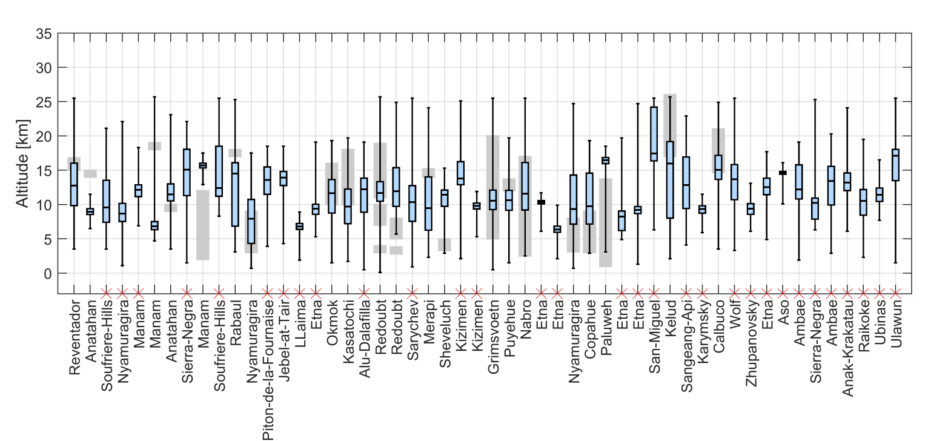

Supplementary Figure 1: Comparison of SO₂ plume altitude ranges between THRIVE-SO₂ and VolcanEESM. Box-and-whisker plots show THRIVE-SO₂ retrievals (whiskers: plume top/bottom; box: 25th–75th percentiles; line: median altitude of SO₂ mass). Gray bars show the VolcanEESM plume altitude range. Red crosses mark the eruptions that are present in the THRIVE-SO₂ but absent from the VolcanEESM database. The full list of the 52 volcanic eruptions in the THRIVE-SO₂ is at https://datapub.fz-juelich.de/slcs/so2_inv/html/events.html.
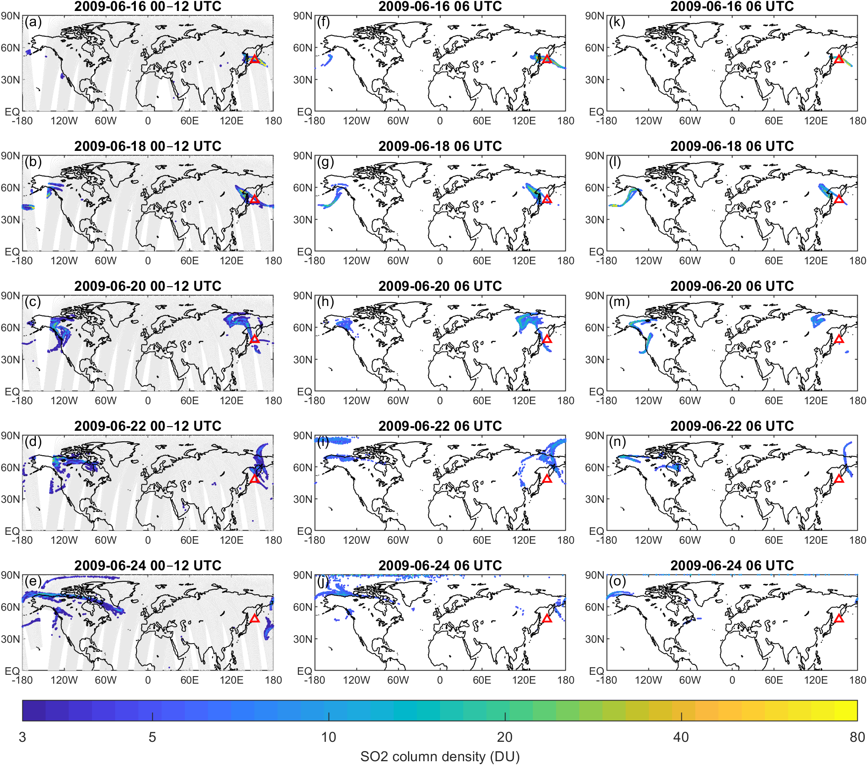

Supplementary Figure 2: Comparison of the simulated SO₂ column density evolution initialized by the THRIVE-SO₂ and the VolcanEESM against AIRS SO₂ column density observations for the Sarychev eruption from 16 to 24 June 2009. The MPTRAC SO₂ column densities are shown at 06:00 UTC on selected days, and AIRS data within ±6 h are shown. The red triangle denotes the location of the Sarychev volcano.
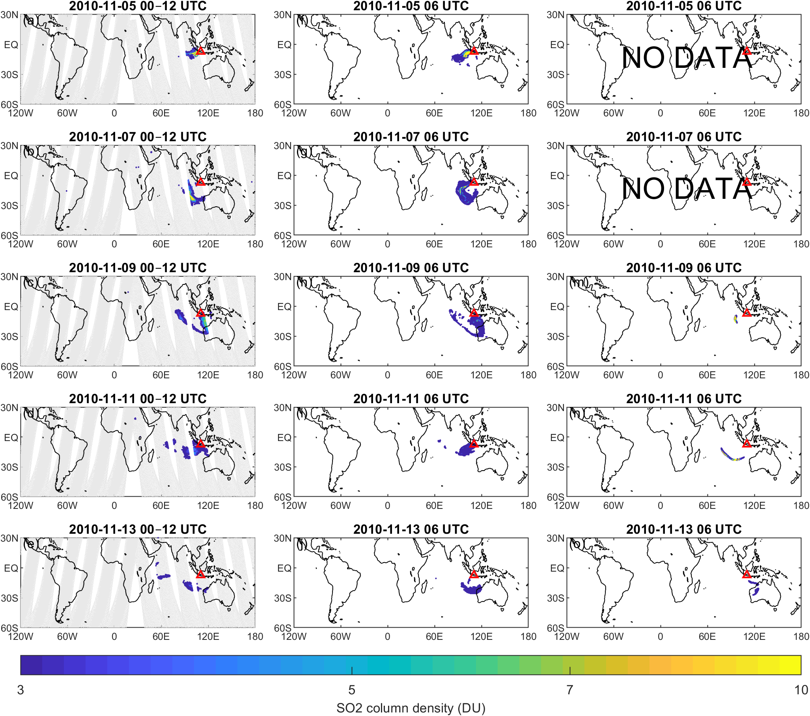

Supplementary Figure 3: Comparison of the simulated SO₂ column density evolution initialized by the THRIVE-SO₂ and the VolcanEESM against AIRS SO₂ column density observations for the Merapi eruption from 05 to 13 November 2010. The MPTRAC SO₂ column densities are shown at 06:00 UTC on selected days, and AIRS data within ±6 h are shown. The red triangle denotes the location of the Merapi volcano. The VolcanEESM provides SO₂ emissions only from 8 November 2010; hence, no SO₂ plume data are available before this date.

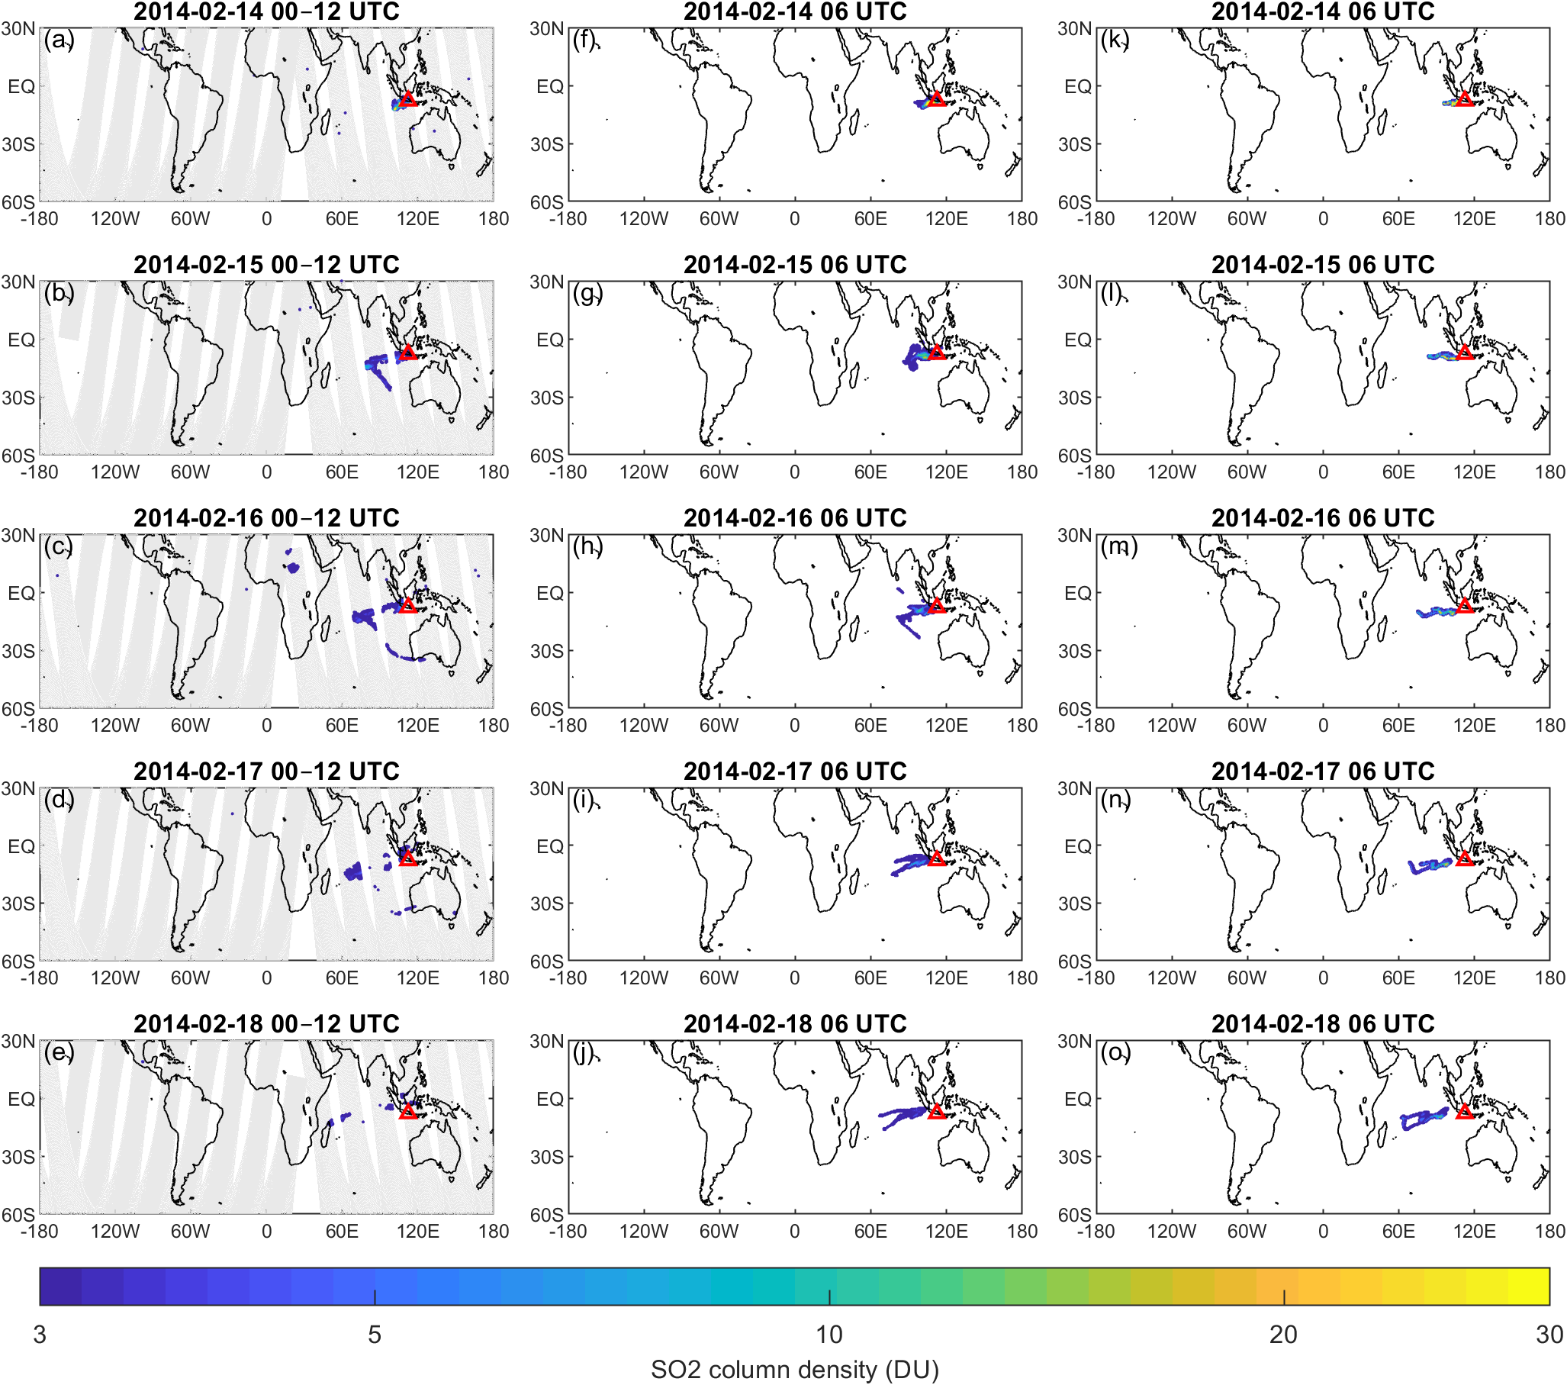

Supplementary Figure 4: Comparison of the simulated SO₂ column density evolution initialized by the THRIVE-SO₂ and the VolcanEESM against AIRS SO₂ column density observations for the Kelud eruption from 14 to 18 February 2014. The MPTRAC SO₂ column densities are shown at 06:00 UTC on selected days, and AIRS data within ±6 h are shown. The red triangle denotes the location of the Kelud volcano.

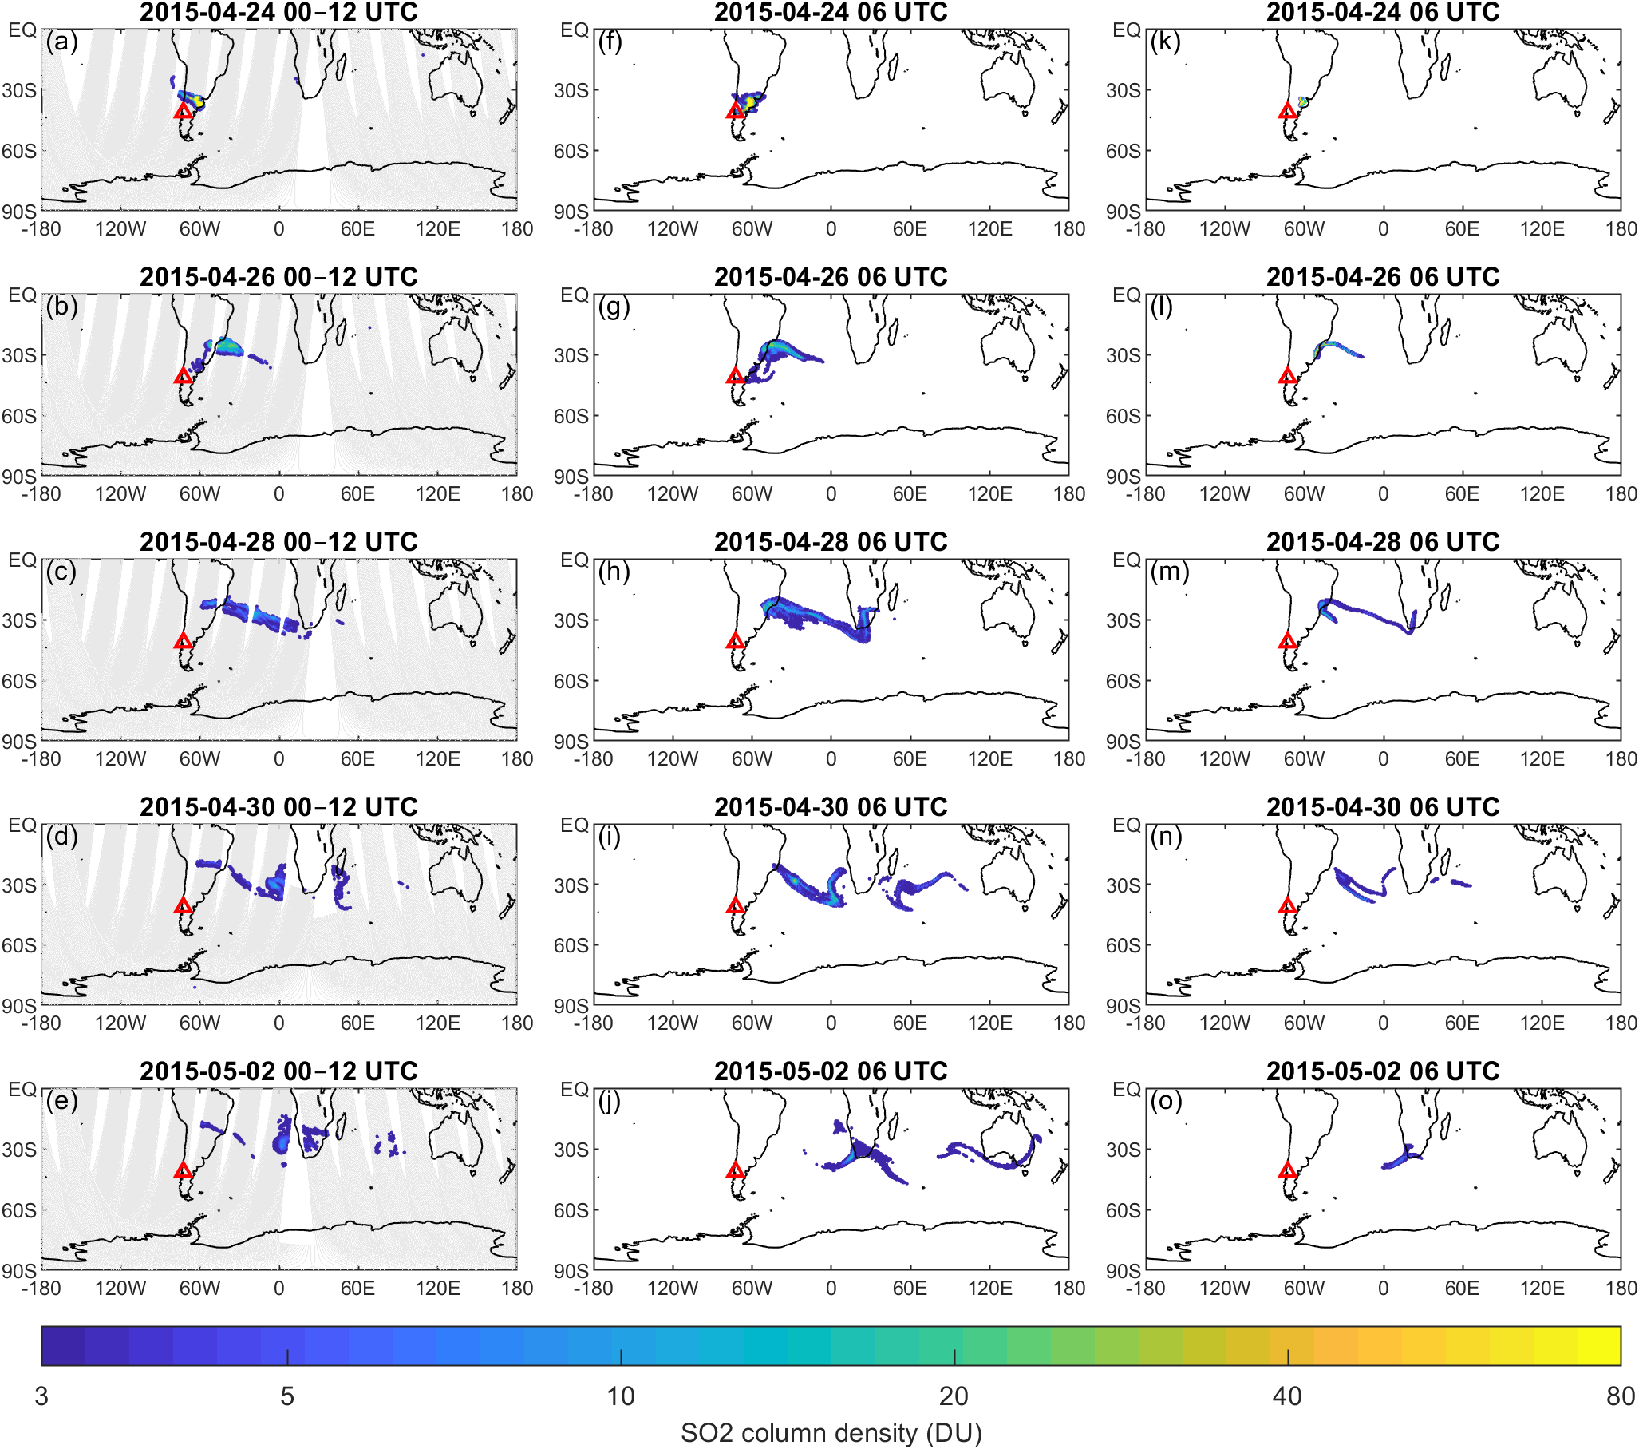

Supplementary Figure 5: Comparison of the simulated SO₂ column density evolution initialized by the THRIVE-SO₂ and the VolcanEESM against AIRS SO₂ column density observations for the Calbuco eruption from 24 April to 02 May 2015. The MPTRAC SO₂ column densities are shown at 06:00 UTC on selected days, and AIRS data within ±6 h are shown. The red triangle denotes the location of the Calbuco volcano.

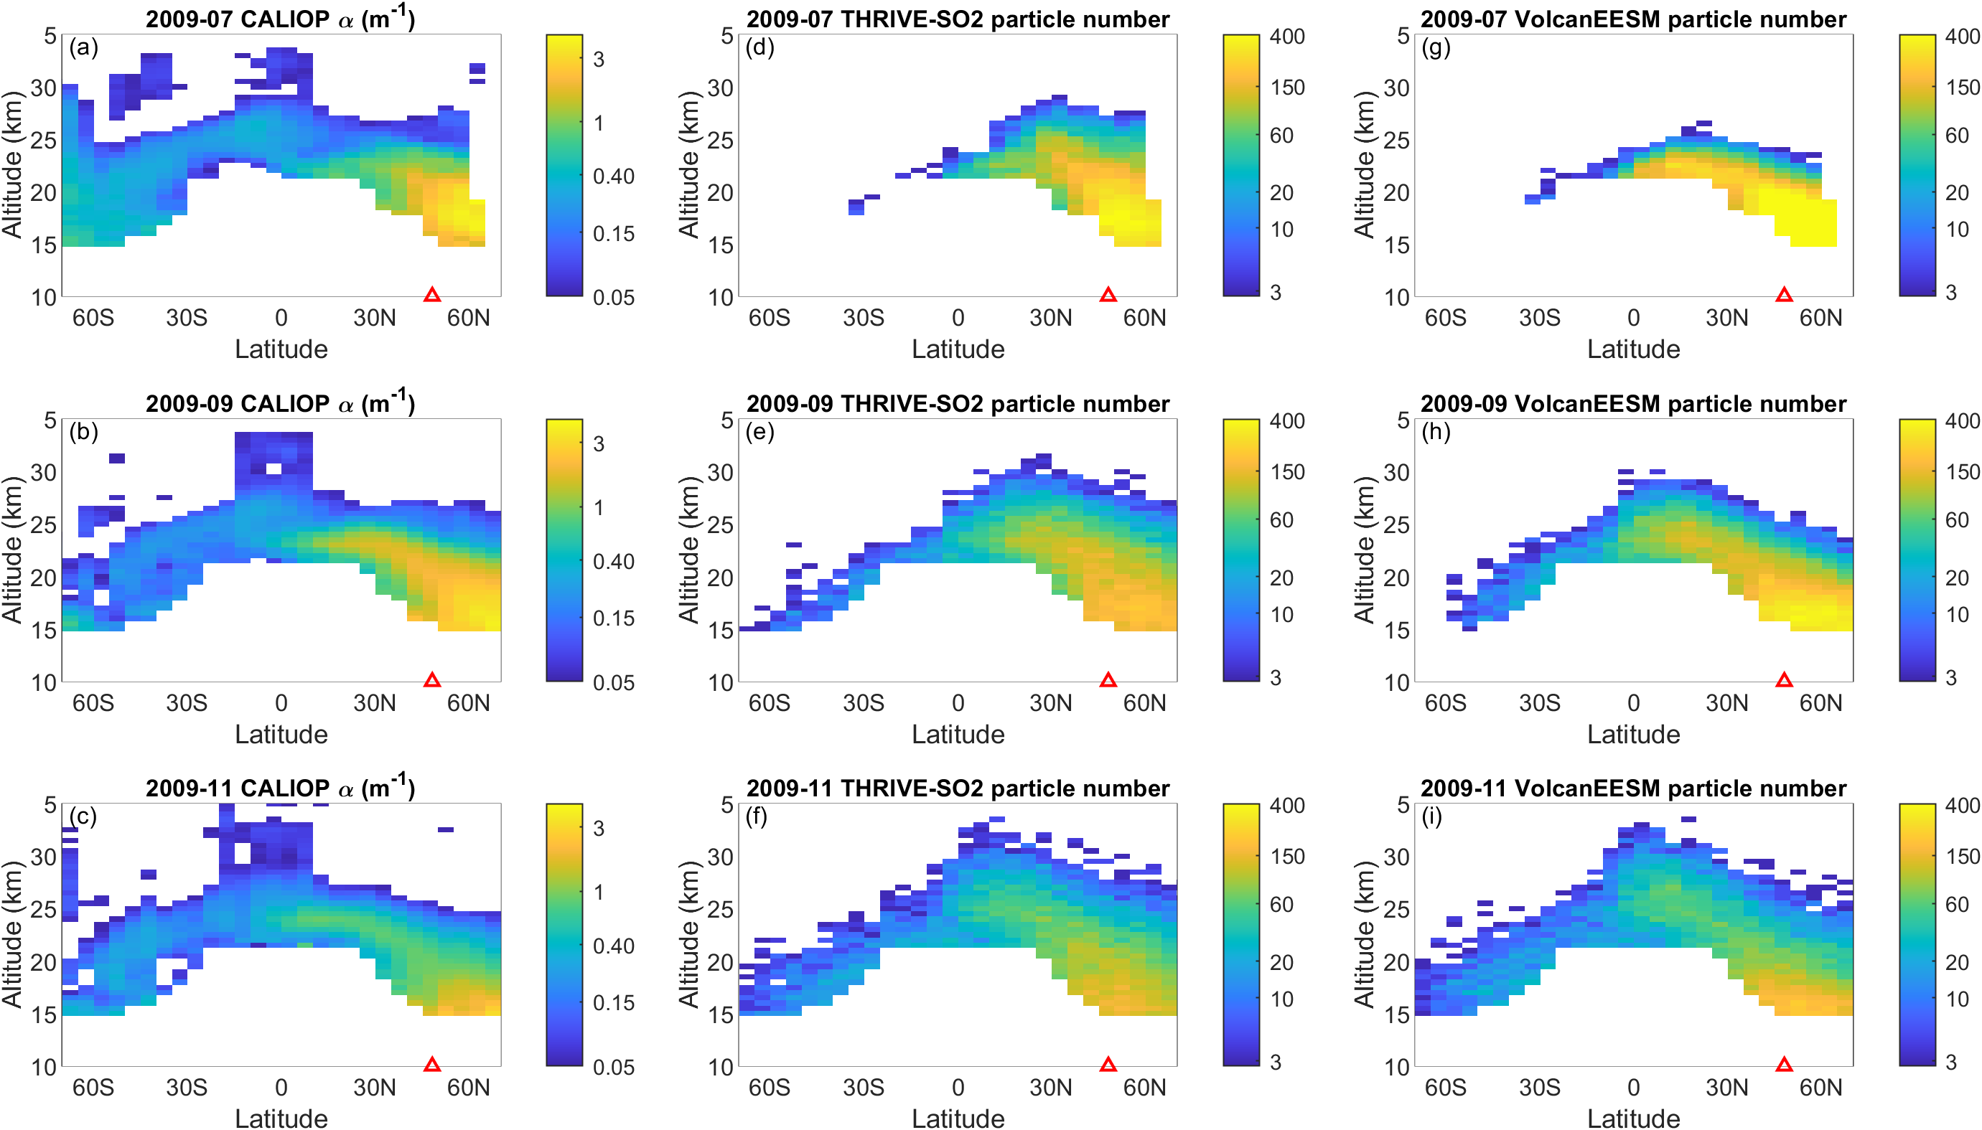

Supplementary Figure 6: Latitude-altitude cross-sections of aerosols from July to November 2009 following the Sarychev volcano eruption in June 2009. Left column: the 525 nm CALIOP aerosol extinction coefficients from the Global Space-based Stratospheric Aerosol Climatology (GloSSAC); Middle column: simulated aerosol particle count initialized by the THRIVE-SO₂; Right column: simulated aerosol particle count initialized by the VolcanEESM. The bin size is 5°×0.5 km. The red triangles indicate the latitude of Sarychev volcano. Regions with missing CALIOP data are masked in the simulations for better comparison.

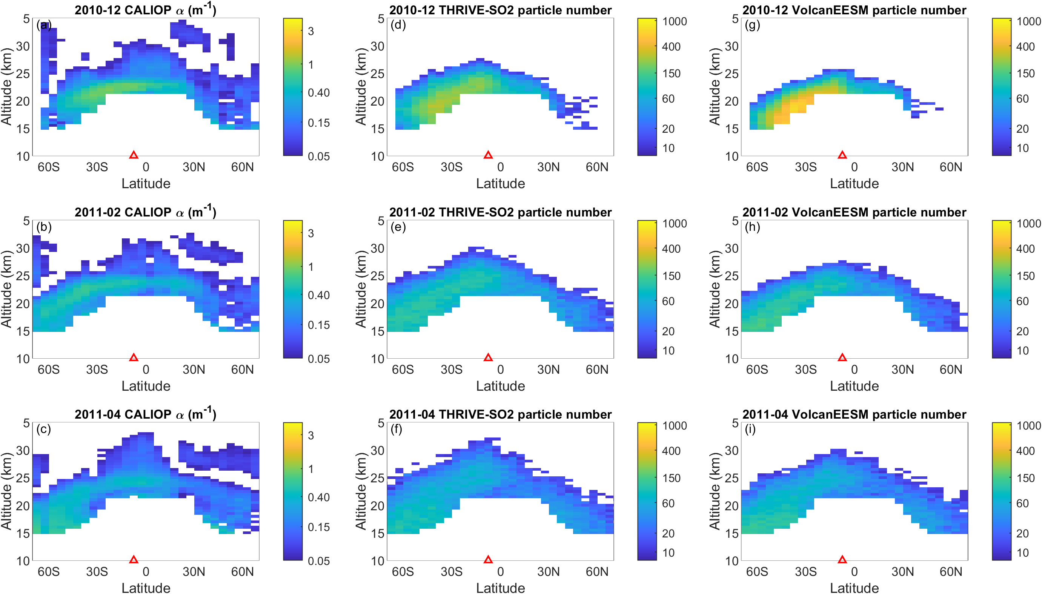

Supplementary Figure 7: Latitude-altitude cross-sections of aerosols from December 2010 to April 2011 following the Merapi volcano eruption in November 2010. Left column: the 525 nm CALIOP aerosol extinction coefficients from the Global Space-based Stratospheric Aerosol Climatology (GloSSAC); Middle column: simulated aerosol particle count initialized by the THRIVE-SO₂; Right column: simulated aerosol particle count initialized by the VolcanEESM. The bin size is 5°×0.5 km. The red triangles indicate the latitude of the Merapi volcano. Regions with missing CALIOP data are masked in the simulations for better comparison.

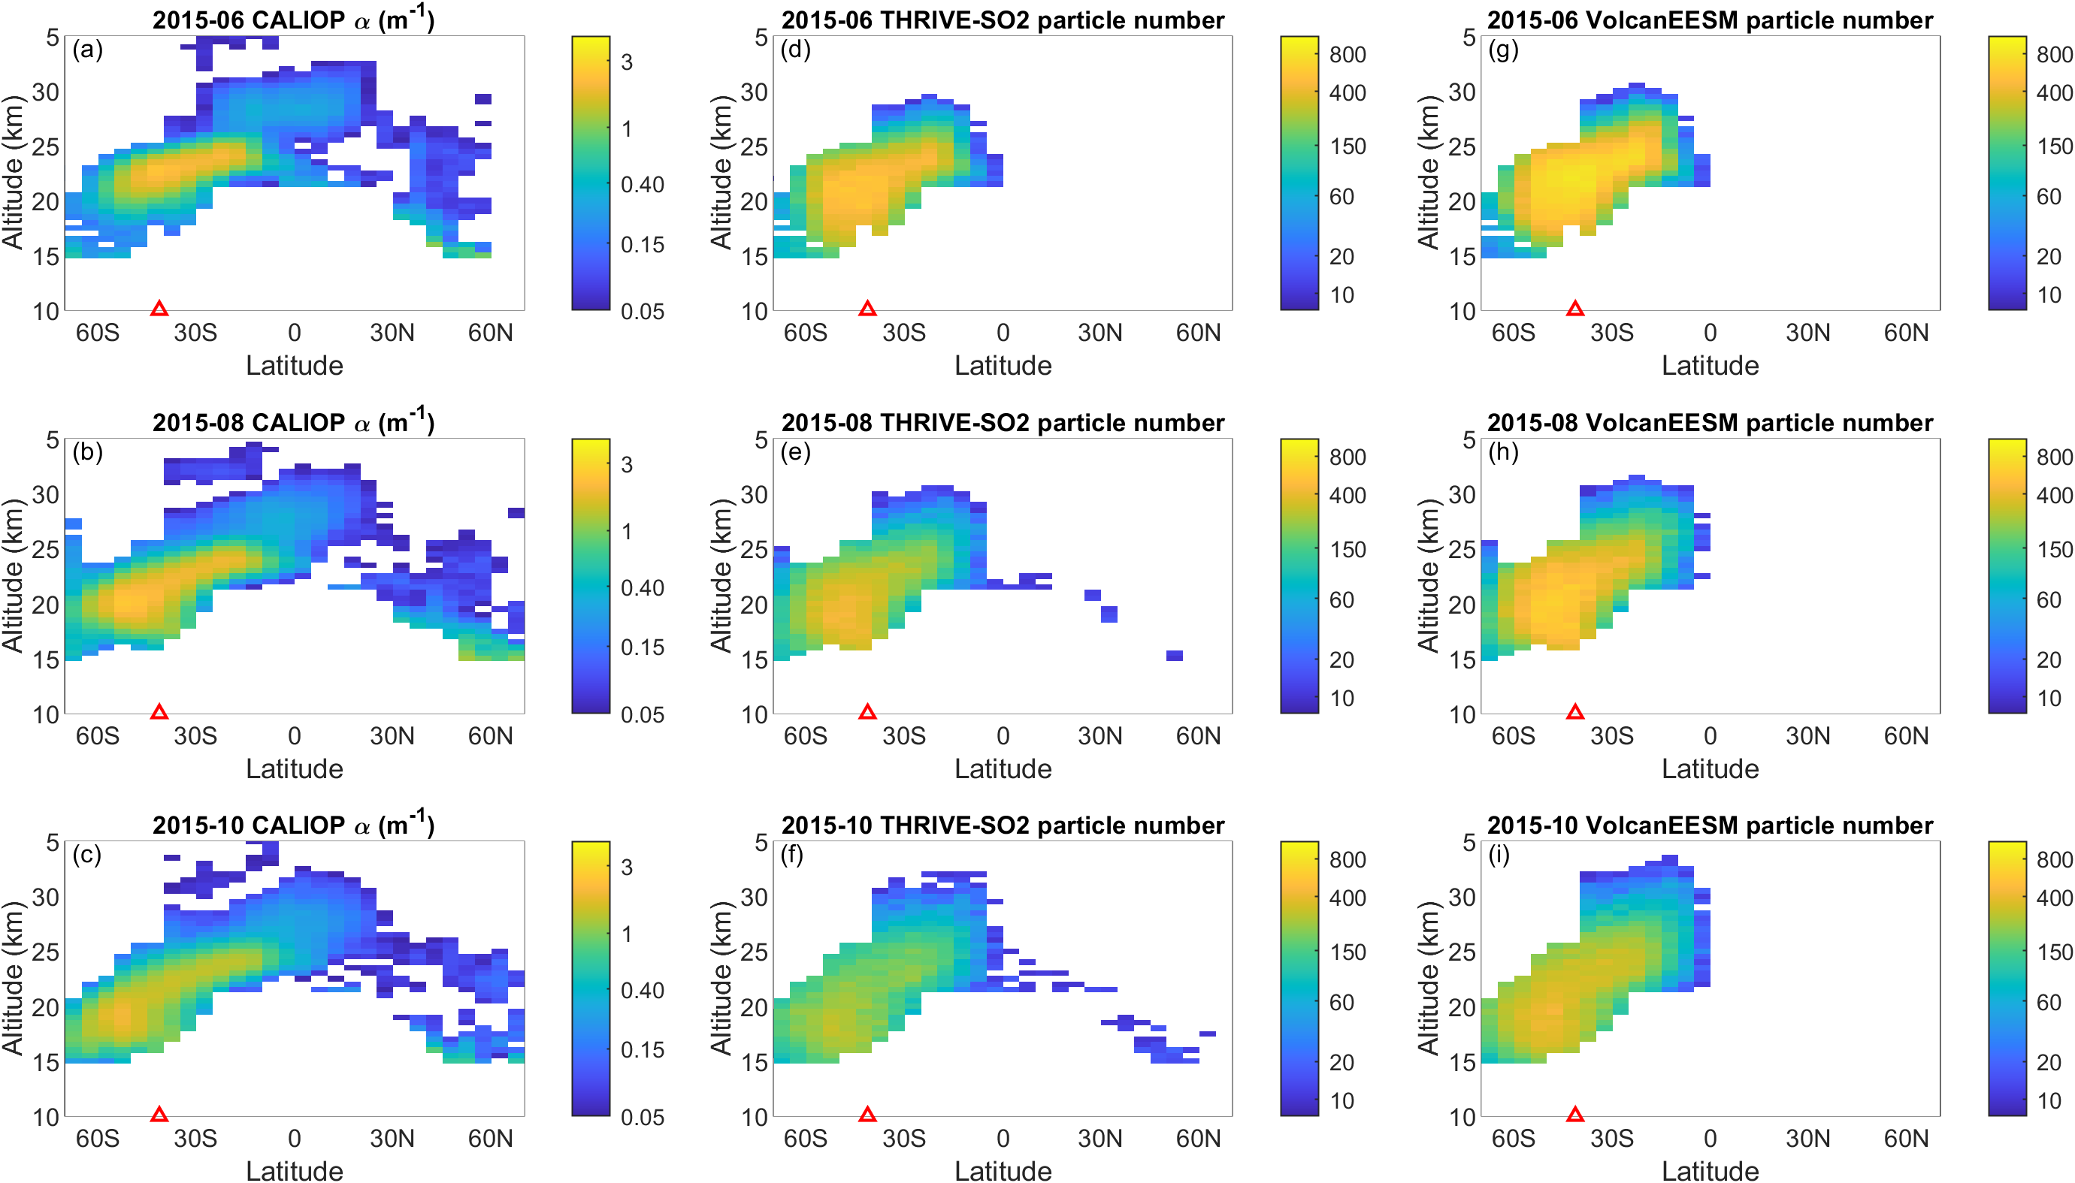
Supplementary Figure 8: Latitude-altitude cross-sections of aerosols from June 2015 to October 2015 following the Calbuco volcano eruption in April 2015. Left column: the 525 nm CALIOP aerosol extinction coefficients from the Global Space-based Stratospheric Aerosol Climatology (GloSSAC); Middle column: simulated aerosol particle count initialized by the THRIVE-SO₂; Right column: simulated aerosol particle count initialized by the VolcanEESM. The bin size is 5°×0.5 km. The red triangles indicate the latitude of the Calbuco volcano. Regions with missing CALIOP data are masked in the simulations for better comparison.

Supplementary References
- Hoffmann L, Rößler T, Griessbach S, Heng Y, Stein O. Lagrangian transport simulations of volcanic sulfur dioxide emissions: Impact of meteorological data products. J. Geophys. Res.-Atmos. 121, 4651-4673 (2016).
- Baumeister PF and Hoffmann L. Fast infrared radiative transfer calculations using graphics processing units: JURASSIC-GPU v2.0, Geosci. Model Dev., 15, 1855–1874 (2022).
- Neely RR, and Schmidt A. VolcanEESM: Global volcanic sulphur dioxide (SO2) emissions database from 1850 to present Version 1.0., Centre for Environmental Data Analysis (2016).

