Supplementary Tables & Figures

Diabetes Type 2 in the Berlin Aging Study II: Prevalence, Incidence and Severity over up to ten years of follow-up
Johanne Spieker, Valentin Max Vetter, Dominik Spira, Elisabeth Steinhagen-Thiessen, Vera Regitz-Zagrosek, Nikolaus Buchmann⁴, Ilja Demuth

Supplementary Table 1: DCSI variables applied to Berlin Aging Study II

Supplementary Table 2. Characteristics of BASE-II participants diagnosed with diabetes mellitus type 2 at baseline (N=209 of 1,671) and follow-up (N=185 of 1,083).

Variables | BASE-II baseline |  | BASE-II follow-up
 | Mean (SD) or % | Number of observations | Mean (SD) or % | Number of observations
Females | 37.3 | 78 | 41.1 | 76
Age (years) | 68.7 (3.7) | 209 | 75.6 (4.2) | 185
T2D new diagnosis (unaware of disease) | 24.9 | 52 | 22.2 | 41
Fasting glucose (mg/dl) | 129.0 (36.1) | 202 | 135.3 (33.0) | 185
2h-OGTT (mg/dl) | 213.3 (60.4) | 48 | 209.1 (36.0) | 39
HbA1c (%) | 6.6 (0.8) | 197 | 6.5 (0.8) | 184
Anamnestic history of T2D (self-report) | 72.8 | 150 | 70.8 | 131
Antidiabetic medication | 53.4 | 111 | 54.1 | 100
Smoking (packyears) | 14.5 (19.4) | 198 | 13.7 (21.6) | 169
Alcohol (4 times a week or more) | 29.0 | 60 | 24.3 | 45
RAPA score | 4.8 (1.6) | 200 | 4.6 (1.2) | 185
BMI | 29.6 (4.7) | 205 | 29.1 (4.2) | 184
Morbidity index* | 1.2 (1.3) | 191 | 1.7 (1.6) | 148
T2D = diabetes mellitus type 2; 2h-OGTT = oral glucose tolerance test (OGTT was only performed when T2D was not known); RAPA = rapid assessment of physical activity; BMI = body mass index; *modified version of the morbidity index originally described by Charlson (40), for details see (41).

Supplementary Table 3: Impact (in percent) and absolute score values of each DCSI category in BASE-II at baseline and follow-up (N=111).
DCSI category | Baseline % (absolute score value) | Follow-up % (absolute score value)
Retinopathy | 6.3 (7) | 9.0 (10)
Nephropathy | 21.6 (24) | 61.3 (68)
Neuropathy | 8.1 (9) | 26.1 (29)
Cerebrovascular | 1.8 (2) | 7.2 (8)
Cardiovascular | 43.2 (48) | 67.6 (75)
Peripheral vascular  disease | 27.9 (31) | 28.8 (32)

Supplementary Figure 1: Type 2 Diabetes diagnosis in women at follow-up (N=76).
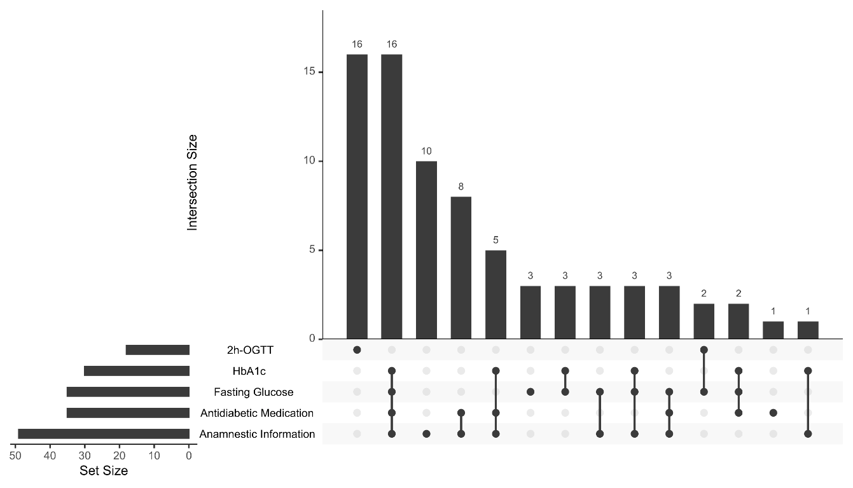Diabetes diagnosis criteria at follow-up and their combinations (OGTT was only performed when T2D was not known): Anamnestic information, fasting glucose, antidiabetic medication, HbA1c and 2h-OGTT. OGTT= oral glucose tolerance test.

Supplementary Figure 2: Type 2 Diabetes diagnosis in men at follow-up (N=109).
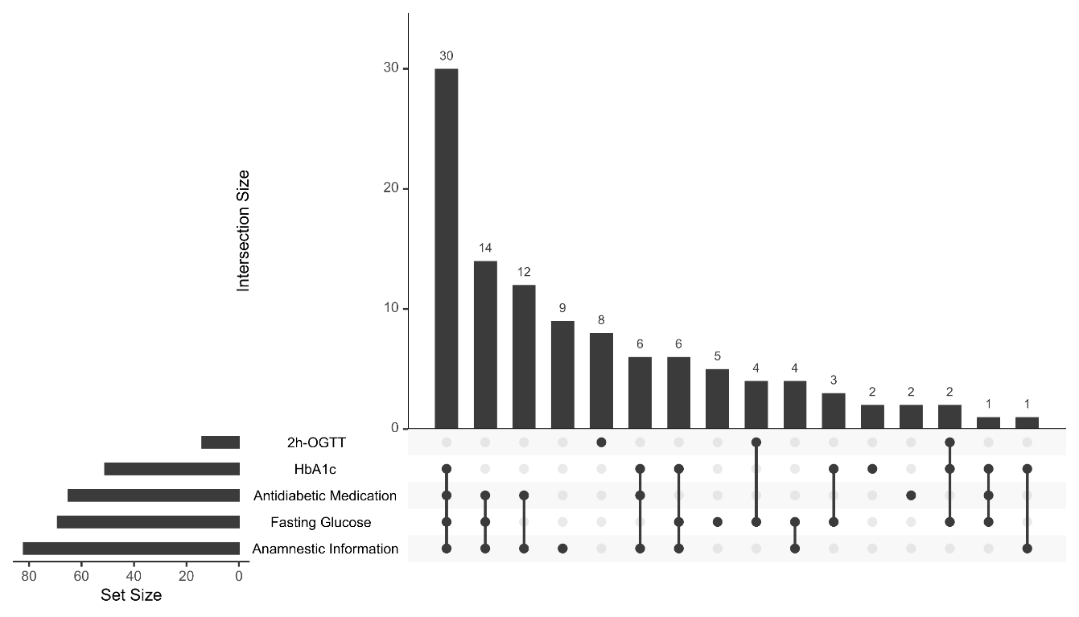
Diabetes diagnosis criteria at follow-up and their combinations (OGTT was only performed when T2D was not known): Anamnestic information, fasting glucose, antidiabetic medication, HbA1c and 2h-OGTT. OGTT= oral glucose tolerance test.

