Childbearing Transition in Pacific Island Countries and Territories, 1950–2023: Supplementary Material
This supplement accompanies “Childbearing Transition in Pacific Island Countries and Territories, 1950–2023: Timing, Progression, and Concentration.” The main text reports four decompositions over the full 1950–2023 window — of aggregate mean age at childbearing (MAC, §3.6), reproductive span (§3.7), aggregate age dispersion (§3.8) and higher-order postponement (§3.9) — and, in each of those sections, summarises how the balance between components differed between the earlier (1950–1990) and later (1990–2023) halves of that window using regional medians or means. Tables S1–S8 below report all four decompositions, split at the 1990 midpoint, for each of the 18 countries and territories individually. Country-level values reported here are the source of the regional summary statistics cited in the main text.
Figure S1, alongside Tables S7–S8, provides the country-level detail behind §3.9's decomposition of higher-order postponement: it shows the own (between-order) and inherited (first-birth) components at the level of each sub-period separately, the levels from which Figure 11's sub-period changes are computed. This supplement additionally reports, as Table S9, the birth-order composition of period TFR at each country's 1950, 1990 and 2023 schedules, and, under “Robustness checks” below, three further checks conducted in response to peer feedback: an internal-identity and small-territory-exclusion check, a bin-width sensitivity check on the entropy-based concentration measures of §3.5, a full accounting of the country-year sample sizes underlying the stage-by-period cells discussed in §3.10 (Table S10), and a supplementary figure propagating GBD 2023's published ASFR uncertainty intervals through to total fertility rate (Figure S2).

Table S1. Decomposition of the change in aggregate mean age at childbearing (MAC), 1950–1990
Within-order timing and parity-composition components. The two components sum exactly to the net change in MAC.
Country | Composition effect (years) | Timing effect (years) | Net change (years) | MAC start (years) | MAC end (years)
American Samoa | -1.20 | 0.50 | -0.70 | 29.32 | 28.62
Cook Islands | -2.67 | 1.62 | -1.05 | 28.88 | 27.83
Fiji | -2.74 | 1.69 | -1.05 | 28.47 | 27.42
Guam | -2.11 | -0.48 | -2.59 | 29.26 | 26.67
Kiribati | -1.64 | 1.79 | 0.16 | 28.88 | 29.04
Marshall Islands | -2.22 | 1.18 | -1.04 | 28.43 | 27.40
Micronesia (Federated States of) | -2.21 | 3.07 | 0.85 | 28.73 | 29.58
Nauru | -1.59 | 0.70 | -0.89 | 29.07 | 28.18
Niue | -3.29 | 3.07 | -0.22 | 28.99 | 28.78
Northern Mariana Islands | -3.65 | 3.22 | -0.43 | 28.30 | 27.87
Palau | -3.96 | 3.67 | -0.30 | 29.17 | 28.87
Papua New Guinea | -1.37 | 1.90 | 0.52 | 29.26 | 29.79
Samoa | -2.31 | 2.32 | 0.01 | 29.87 | 29.88
Solomon Islands | -1.14 | 0.92 | -0.22 | 29.59 | 29.37
Tokelau | -3.61 | 2.83 | -0.78 | 29.49 | 28.71
Tonga | -1.41 | 1.79 | 0.37 | 29.82 | 30.19
Tuvalu | -1.93 | 1.91 | -0.02 | 29.03 | 29.01
Vanuatu | -0.93 | 1.30 | 0.38 | 28.47 | 28.85

Table S2. Decomposition of the change in aggregate mean age at childbearing (MAC), 1990–2023
Within-order timing and parity-composition components. The two components sum exactly to the net change in MAC.
Country | Composition effect (years) | Timing effect (years) | Net change (years) | MAC start (years) | MAC end (years)
American Samoa | -2.47 | 2.96 | 0.49 | 28.62 | 29.11
Cook Islands | -1.43 | 2.23 | 0.80 | 27.82 | 28.62
Fiji | -0.39 | 1.41 | 1.02 | 27.42 | 28.44
Guam | -1.23 | 4.14 | 2.91 | 26.66 | 29.57
Kiribati | -1.43 | 1.70 | 0.27 | 29.04 | 29.31
Marshall Islands | -2.10 | 2.32 | 0.22 | 27.38 | 27.60
Micronesia (Federated States of) | -2.37 | 2.32 | -0.05 | 29.58 | 29.53
Nauru | -1.32 | 1.21 | -0.11 | 28.18 | 28.07
Niue | -1.21 | 2.09 | 0.87 | 28.77 | 29.65
Northern Mariana Islands | -1.08 | 2.67 | 1.58 | 27.87 | 29.46
Palau | -0.49 | 0.88 | 0.39 | 28.87 | 29.26
Papua New Guinea | -0.95 | 0.53 | -0.42 | 29.79 | 29.37
Samoa | -0.40 | 0.43 | 0.03 | 29.82 | 29.85
Solomon Islands | -2.45 | 2.01 | -0.43 | 29.33 | 28.90
Tokelau | -1.86 | 2.15 | 0.29 | 28.71 | 29.00
Tonga | -1.82 | 1.38 | -0.44 | 30.19 | 29.75
Tuvalu | -1.05 | 1.32 | 0.27 | 28.68 | 28.94
Vanuatu | -1.84 | 1.54 | -0.30 | 28.85 | 28.55

Table S3. Decomposition of the change in reproductive span, 1950–1990
Progression and spacing components. The two components sum exactly to the net change in reproductive span.
Country | Progression component (years) | Spacing component (years) | Net change (years) | Span start (years) | Span end (years)
American Samoa | -4.73 | 1.15 | -3.58 | 17.05 | 13.47
Cook Islands | -10.07 | 4.10 | -5.97 | 17.57 | 11.60
Fiji | -10.64 | 2.16 | -8.47 | 17.79 | 9.32
Guam | -7.91 | 1.85 | -6.06 | 16.65 | 10.59
Kiribati | -6.55 | 2.95 | -3.60 | 17.69 | 14.09
Marshall Islands | -8.67 | 3.14 | -5.53 | 19.78 | 14.25
Micronesia (Federated States of) | -8.90 | 5.06 | -3.84 | 18.88 | 15.04
Nauru | -6.30 | 2.51 | -3.79 | 18.30 | 14.51
Niue | -12.56 | 4.17 | -8.39 | 18.46 | 10.07
Northern Mariana Islands | -13.79 | 4.24 | -9.56 | 17.79 | 8.23
Palau | -14.91 | 4.10 | -10.81 | 18.13 | 7.32
Papua New Guinea | -5.46 | 3.48 | -1.98 | 19.97 | 17.99
Samoa | -8.78 | 3.51 | -5.27 | 20.75 | 15.48
Solomon Islands | -4.37 | 1.78 | -2.59 | 21.30 | 18.71
Tokelau | -14.00 | 5.16 | -8.84 | 19.61 | 10.77
Tonga | -5.44 | 1.96 | -3.48 | 18.08 | 14.60
Tuvalu | -7.83 | 3.53 | -4.30 | 17.50 | 13.20
Vanuatu | -3.78 | 2.13 | -1.65 | 18.44 | 16.79

Table S4. Decomposition of the change in reproductive span, 1990–2023
Progression and spacing components. The two components sum exactly to the net change in reproductive span.
Country | Progression component (years) | Spacing component (years) | Net change (years) | Span start (years) | Span end (years)
American Samoa | -9.01 | 2.34 | -6.67 | 13.47 | 6.80
Cook Islands | -5.10 | 0.13 | -4.97 | 11.59 | 6.62
Fiji | -1.40 | 0.13 | -1.27 | 9.32 | 8.05
Guam | -4.39 | 0.86 | -3.53 | 10.58 | 7.05
Kiribati | -5.32 | 1.00 | -4.32 | 14.09 | 9.77
Marshall Islands | -7.82 | 2.25 | -5.57 | 14.22 | 8.65
Micronesia (Federated States of) | -8.70 | 1.56 | -7.14 | 15.04 | 7.90
Nauru | -4.95 | 1.08 | -3.87 | 14.51 | 10.64
Niue | -4.22 | 0.50 | -3.72 | 10.06 | 6.35
Northern Mariana Islands | -3.57 | 0.32 | -3.25 | 8.23 | 4.99
Palau | -1.62 | 0.11 | -1.51 | 7.32 | 5.80
Papua New Guinea | -3.66 | 0.98 | -2.67 | 17.99 | 15.31
Samoa | -1.51 | -0.02 | -1.53 | 15.38 | 13.85
Solomon Islands | -9.19 | 3.23 | -5.96 | 18.64 | 12.68
Tokelau | -6.48 | 0.87 | -5.61 | 10.76 | 5.15
Tonga | -6.66 | 1.37 | -5.29 | 14.60 | 9.32
Tuvalu | -4.26 | 0.82 | -3.44 | 12.59 | 9.15
Vanuatu | -7.22 | 2.66 | -4.56 | 16.79 | 12.22

Table S5. Decomposition of the change in aggregate age variance, 1950–1990
Within-order and between-order components of variance in age at childbearing. The two components sum exactly to the net change in aggregate age variance.
Country | Within-order component (years²) | Between-order component (years²) | Net change (years²) | Variance start (years²) | Variance end (years²)
American Samoa | -0.65 | -6.67 | -7.32 | 47.78 | 40.46
Cook Islands | 8.74 | -6.95 | 1.79 | 51.03 | 52.82
Fiji | -0.07 | -12.49 | -12.56 | 53.81 | 41.25
Guam | 1.68 | -9.22 | -7.55 | 49.59 | 42.04
Kiribati | 3.87 | -7.33 | -3.45 | 52.37 | 48.92
Marshall Islands | 2.23 | -9.63 | -7.40 | 53.33 | 45.94
Micronesia (Federated States of) | 6.66 | -10.08 | -3.42 | 56.63 | 53.21
Nauru | 2.64 | -7.29 | -4.65 | 51.63 | 46.98
Niue | 6.40 | -11.31 | -4.91 | 51.09 | 46.18
Northern Mariana Islands | 8.44 | -12.70 | -4.27 | 51.46 | 47.19
Palau | 8.36 | -15.02 | -6.66 | 54.55 | 47.89
Papua New Guinea | 5.01 | -2.36 | 2.65 | 57.15 | 59.80
Samoa | 3.05 | -7.32 | -4.27 | 55.26 | 50.98
Solomon Islands | 0.99 | -4.25 | -3.26 | 58.36 | 55.10
Tokelau | 7.16 | -12.47 | -5.31 | 52.55 | 47.24
Tonga | 1.52 | -6.02 | -4.50 | 50.58 | 46.08
Tuvalu | 5.09 | -8.23 | -3.15 | 51.45 | 48.30
Vanuatu | 2.02 | -6.13 | -4.11 | 54.36 | 50.25

Table S6. Decomposition of the change in aggregate age variance, 1990–2023
Within-order and between-order components of variance in age at childbearing. The two components sum exactly to the net change in aggregate age variance.
Country | Within-order component (years²) | Between-order component (years²) | Net change (years²) | Variance start (years²) | Variance end (years²)
American Samoa | 6.89 | -6.41 | 0.48 | 40.46 | 40.94
Cook Islands | -2.79 | -7.92 | -10.71 | 52.82 | 42.12
Fiji | -0.84 | -1.43 | -2.27 | 41.25 | 38.98
Guam | 2.37 | -3.55 | -1.18 | 42.04 | 40.86
Kiribati | 0.74 | -5.24 | -4.50 | 48.92 | 44.42
Marshall Islands | 5.11 | -5.89 | -0.78 | 45.94 | 45.16
Micronesia (Federated States of) | 2.58 | -9.18 | -6.60 | 53.21 | 46.61
Nauru | 0.87 | -4.70 | -3.83 | 46.98 | 43.14
Niue | 1.21 | -4.57 | -3.36 | 46.18 | 42.82
Northern Mariana Islands | 1.55 | -4.26 | -2.71 | 47.19 | 44.48
Palau | 0.15 | -2.06 | -1.91 | 47.89 | 45.98
Papua New Guinea | 0.52 | -4.53 | -4.00 | 59.80 | 55.79
Samoa | -1.43 | -3.35 | -4.78 | 50.98 | 46.20
Solomon Islands | 4.62 | -8.31 | -3.69 | 55.10 | 51.42
Tokelau | 2.37 | -6.97 | -4.60 | 47.24 | 42.64
Tonga | 2.08 | -6.73 | -4.65 | 46.08 | 41.43
Tuvalu | 0.17 | -5.54 | -5.37 | 48.30 | 42.94
Vanuatu | 4.20 | -4.69 | -0.49 | 50.25 | 49.76

Supplementary Figure S1
The main text's Figure 11 shows, for each of the 18 countries and territories, the change between 1950–1990 and 1990–2023 in the own (between-order) and inherited (first-birth) components of higher-order postponement decomposed in §3.9. The four panels below show the underlying levels for each sub-period separately, from which those changes are computed: panels (a)–(b) show the own component at birth orders k = 2–6 for 1950–1990 and 1990–2023 respectively, on a shared colour scale; panels (c)–(d) show the inherited component, a single value per country and sub-period, on a shared horizontal scale with a zero reference line. All four panels follow the same country order as Figure 11 (sorted by the k=6 own-component change).
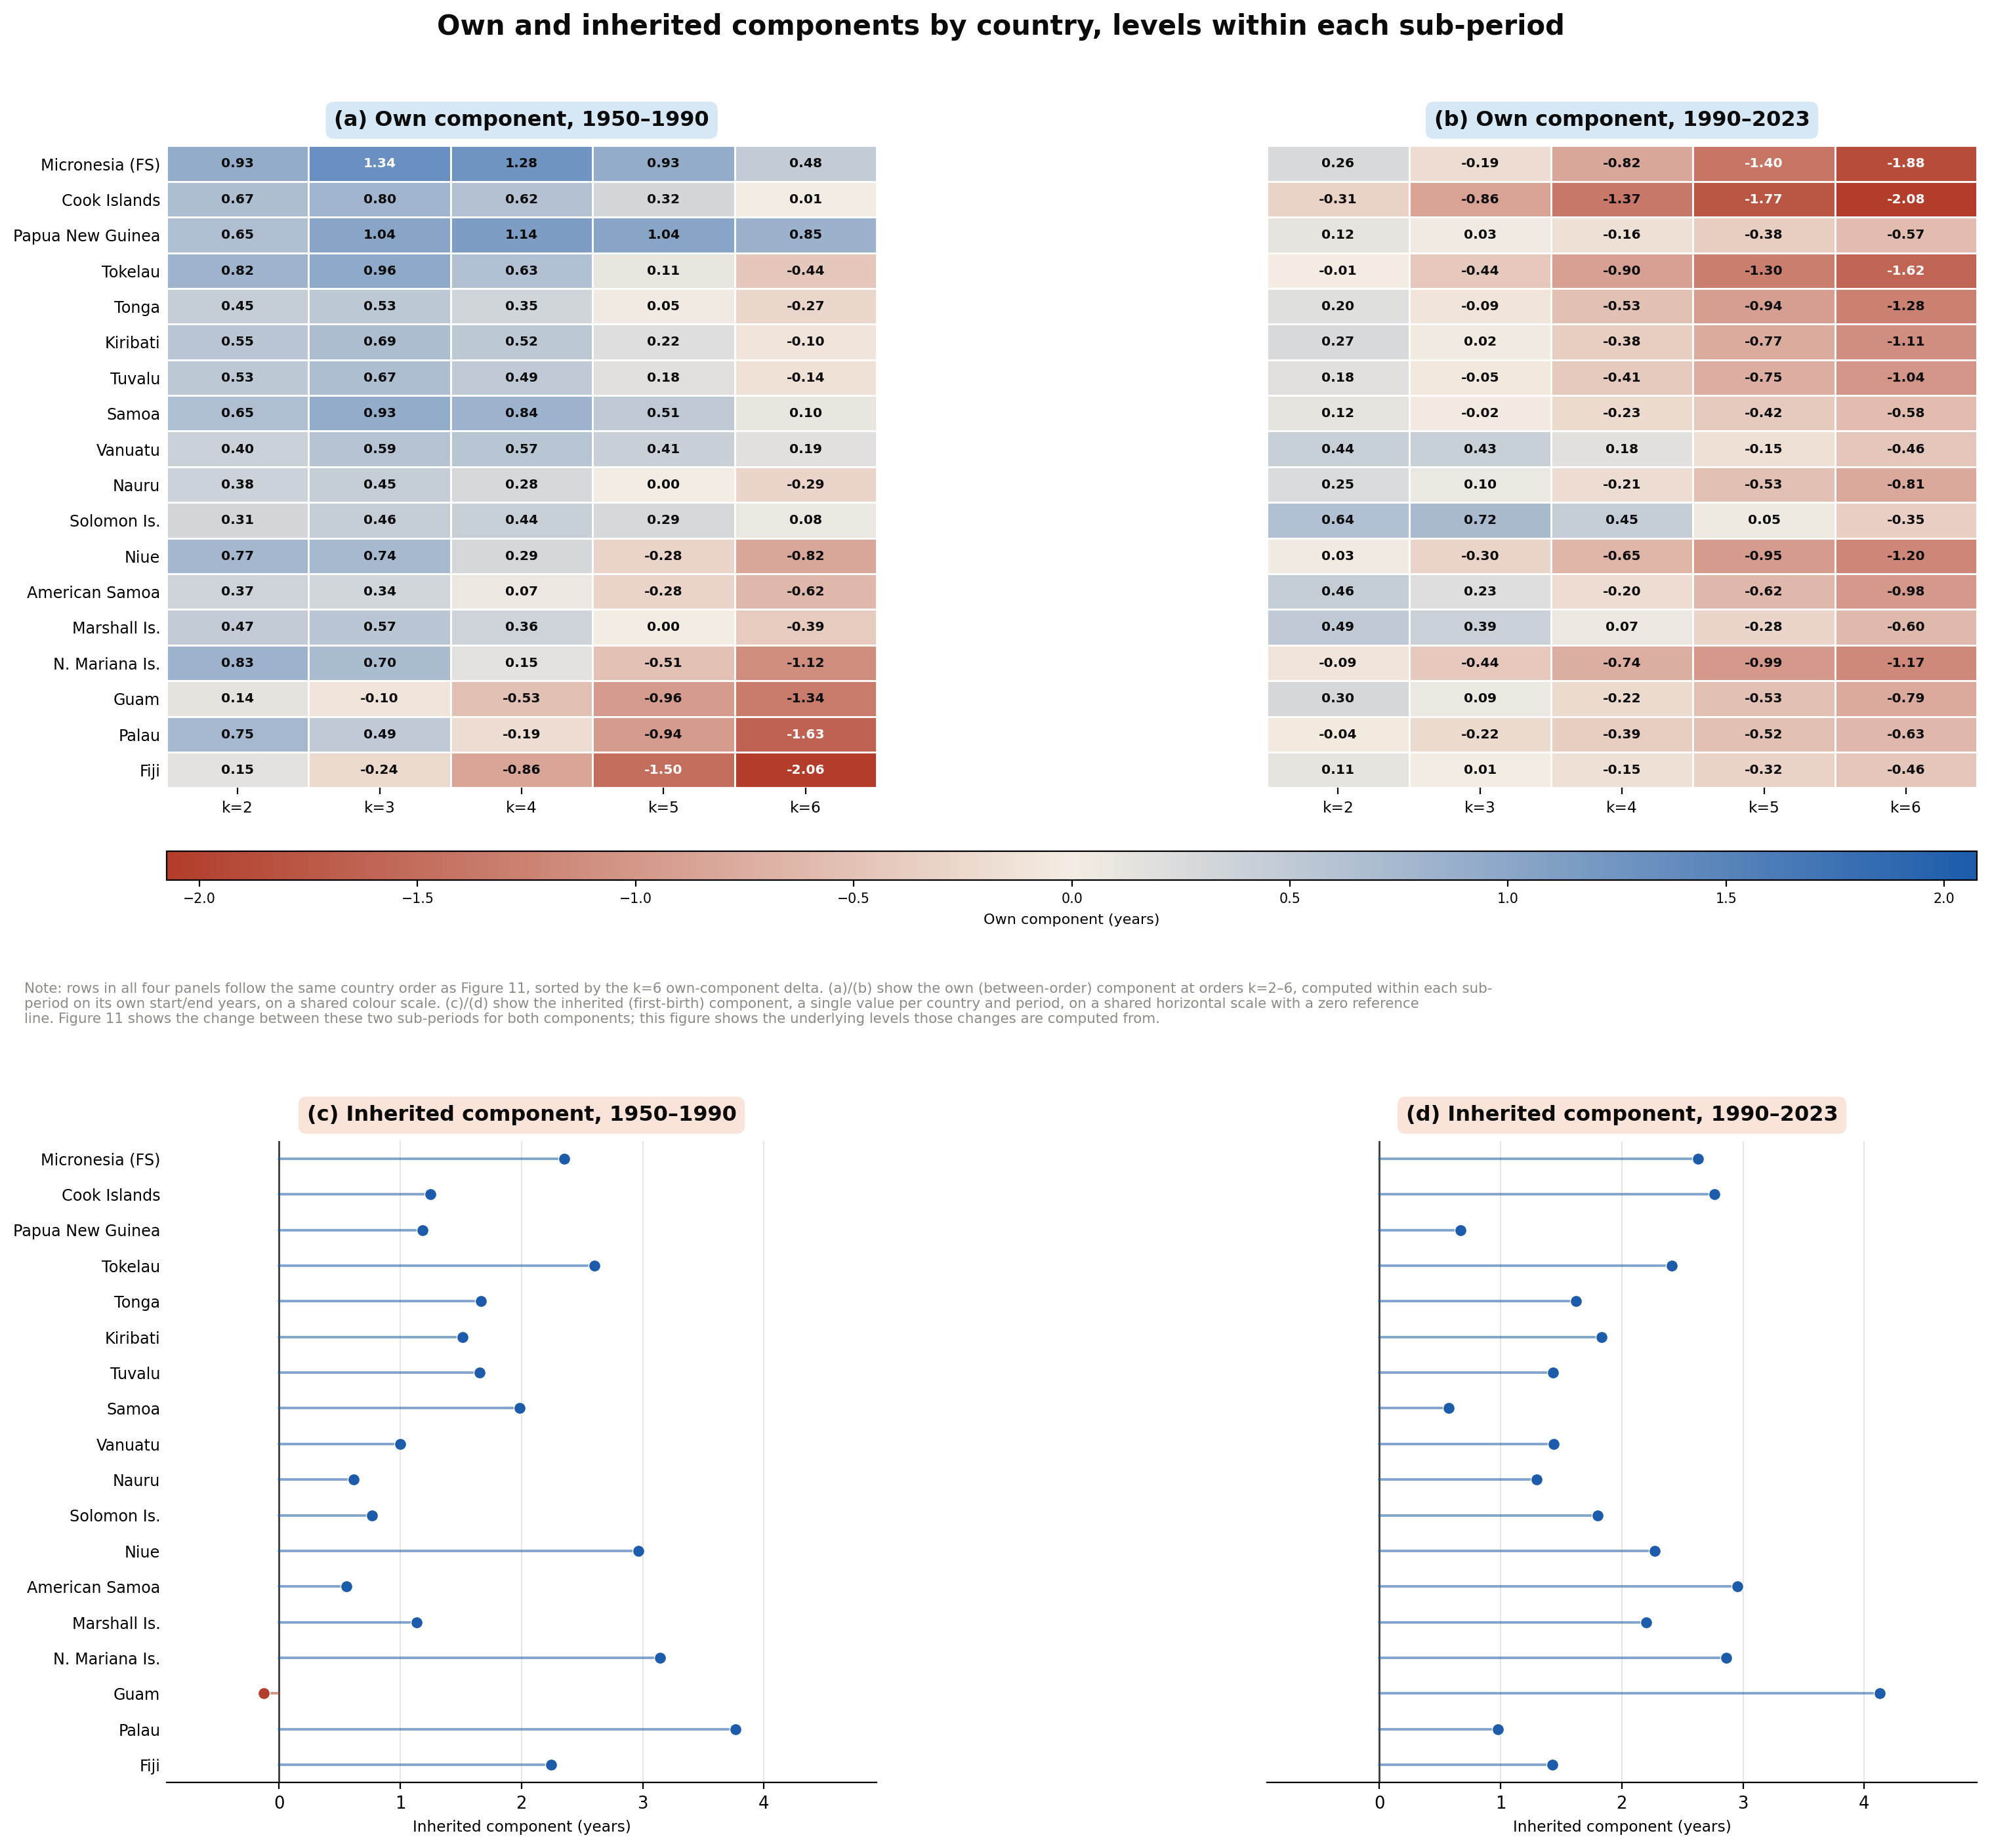
Supplementary Figure S1. Own and inherited components of higher-order postponement by country, levels within each sub-period (G0). (a)/(b) Own (between-order) component at orders k=2–6, 1950–1990 and 1990–2023 respectively. (c)/(d) Inherited (first-birth) component, 1950–1990 and 1990–2023 respectively. Figure 11 in the main text shows the change between these two sub-periods for both components; country-level values underlying both figures are given in Tables S7–S8.

Table S7. Sources of higher-order postponement, 1950–1990
Inherited component (the constant shift attributable to first-birth age, carried forward to every later birth) and the cumulative own between-order component at the third and sixth births. Inherited plus Own sum exactly to the Observed total change in mean age at that order.
Country | Inherited component (years) | Own component, k=3 (years) | Own component, k=6 (years) | Observed total, k=3 (years) | Observed total, k=6 (years)
American Samoa | 0.55 | 0.34 | -0.62 | 0.89 | -0.07
Cook Islands | 1.25 | 0.80 | 0.01 | 2.06 | 1.27
Fiji | 2.25 | -0.24 | -2.06 | 2.01 | 0.18
Guam | -0.12 | -0.10 | -1.34 | -0.22 | -1.46
Kiribati | 1.52 | 0.69 | -0.10 | 2.21 | 1.41
Marshall Islands | 1.14 | 0.57 | -0.39 | 1.70 | 0.75
Micronesia (Federated States of) | 2.35 | 1.34 | 0.48 | 3.69 | 2.84
Nauru | 0.61 | 0.45 | -0.29 | 1.06 | 0.33
Niue | 2.96 | 0.74 | -0.82 | 3.70 | 2.15
Northern Mariana Islands | 3.14 | 0.70 | -1.12 | 3.84 | 2.02
Palau | 3.76 | 0.49 | -1.63 | 4.26 | 2.13
Papua New Guinea | 1.18 | 1.04 | 0.85 | 2.22 | 2.03
Samoa | 1.99 | 0.93 | 0.10 | 2.92 | 2.09
Solomon Islands | 0.77 | 0.46 | 0.08 | 1.23 | 0.85
Tokelau | 2.60 | 0.96 | -0.44 | 3.56 | 2.16
Tonga | 1.66 | 0.53 | -0.27 | 2.20 | 1.39
Tuvalu | 1.65 | 0.67 | -0.14 | 2.32 | 1.51
Vanuatu | 1.00 | 0.59 | 0.19 | 1.59 | 1.19

Table S8. Sources of higher-order postponement, 1990–2023
Inherited component (the constant shift attributable to first-birth age, carried forward to every later birth) and the cumulative own between-order component at the third and sixth births. Inherited plus Own sum exactly to the Observed total change in mean age at that order.
Country | Inherited component (years) | Own component, k=3 (years) | Own component, k=6 (years) | Observed total, k=3 (years) | Observed total, k=6 (years)
American Samoa | 2.96 | 0.23 | -0.98 | 3.18 | 1.97
Cook Islands | 2.77 | -0.86 | -2.08 | 1.90 | 0.69
Fiji | 1.43 | 0.01 | -0.46 | 1.44 | 0.97
Guam | 4.13 | 0.09 | -0.79 | 4.22 | 3.34
Kiribati | 1.83 | 0.02 | -1.11 | 1.86 | 0.73
Marshall Islands | 2.20 | 0.39 | -0.60 | 2.59 | 1.59
Micronesia (Federated States of) | 2.63 | -0.19 | -1.88 | 2.44 | 0.75
Nauru | 1.30 | 0.10 | -0.81 | 1.40 | 0.49
Niue | 2.27 | -0.30 | -1.20 | 1.97 | 1.07
Northern Mariana Islands | 2.86 | -0.44 | -1.17 | 2.42 | 1.69
Palau | 0.98 | -0.22 | -0.63 | 0.76 | 0.35
Papua New Guinea | 0.67 | 0.03 | -0.57 | 0.71 | 0.10
Samoa | 0.57 | -0.02 | -0.58 | 0.55 | -0.01
Solomon Islands | 1.80 | 0.72 | -0.35 | 2.53 | 1.45
Tokelau | 2.41 | -0.44 | -1.62 | 1.97 | 0.79
Tonga | 1.62 | -0.09 | -1.28 | 1.53 | 0.34
Tuvalu | 1.43 | -0.05 | -1.04 | 1.38 | 0.40
Vanuatu | 1.44 | 0.43 | -0.46 | 1.87 | 0.98

Table S9. Birth-order composition of period TFR, 1950, 1990 and 2023
Percentage of period TFR contributed by births of order k (k = 1, 2, 3, 4, 5+), by country and year. Because the reconstruction assumes completed parity follows a Poisson distribution with mean TFR (Appendix A2.1), these shares are a deterministic transform of the scalar TFR value alone — they do not depend on the age schedule and carry no information beyond what is already shown by TFR (Table 1) and the parity-progression ratios (Figures 2–3). They are reported here as a reference/lookup table rather than as a new empirical finding.
Country | Year | TFR | Order 1 (%) | Order 2 (%) | Order 3 (%) | Order 4 (%) | Order 5+ (%)
American Samoa | 1950 | 5.96 | 16.7 | 16.5 | 15.7 | 14.2 | 36.9
American Samoa | 1990 | 4.48 | 22.1 | 20.9 | 18.4 | 14.6 | 24.0
American Samoa | 2023 | 2.16 | 40.9 | 29.4 | 17.0 | 8.0 | 4.7
Cook Islands | 1950 | 5.71 | 17.5 | 17.1 | 16.2 | 14.4 | 34.9
Cook Islands | 1990 | 3.21 | 29.9 | 25.9 | 19.4 | 12.4 | 12.4
Cook Islands | 2023 | 2.10 | 41.8 | 29.5 | 16.7 | 7.7 | 4.3
Fiji | 1950 | 5.66 | 17.6 | 17.3 | 16.3 | 14.4 | 34.4
Fiji | 1990 | 2.90 | 32.5 | 27.1 | 19.1 | 11.4 | 9.9
Fiji | 2023 | 2.57 | 35.9 | 28.3 | 18.5 | 10.0 | 7.4
Guam | 1950 | 5.33 | 18.7 | 18.2 | 16.9 | 14.6 | 31.7
Guam | 1990 | 3.28 | 29.4 | 25.6 | 19.4 | 12.6 | 13.0
Guam | 2023 | 2.23 | 40.0 | 29.3 | 17.3 | 8.4 | 5.1
Kiribati | 1950 | 6.39 | 15.6 | 15.5 | 14.9 | 13.8 | 40.2
Kiribati | 1990 | 4.25 | 23.2 | 21.8 | 18.7 | 14.4 | 21.8
Kiribati | 2023 | 2.92 | 32.4 | 27.0 | 19.1 | 11.5 | 10.0
Marshall Islands | 1950 | 6.98 | 14.3 | 14.2 | 13.9 | 13.1 | 44.4
Marshall Islands | 1990 | 4.46 | 22.2 | 21.0 | 18.4 | 14.6 | 23.8
Marshall Islands | 2023 | 2.58 | 35.8 | 28.3 | 18.5 | 10.1 | 7.4
Micronesia (Federated States of) | 1950 | 7.85 | 12.7 | 12.7 | 12.5 | 12.1 | 49.9
Micronesia (Federated States of) | 1990 | 4.40 | 22.4 | 21.2 | 18.5 | 14.6 | 23.3
Micronesia (Federated States of) | 2023 | 2.34 | 38.6 | 29.0 | 17.7 | 8.9 | 5.7
Nauru | 1950 | 6.48 | 15.4 | 15.3 | 14.8 | 13.7 | 40.9
Nauru | 1990 | 4.51 | 21.9 | 20.8 | 18.3 | 14.6 | 24.3
Nauru | 2023 | 3.24 | 29.6 | 25.7 | 19.4 | 12.6 | 12.7
Niue | 1950 | 6.34 | 15.7 | 15.6 | 15.0 | 13.8 | 39.9
Niue | 1990 | 2.96 | 32.0 | 26.9 | 19.2 | 11.6 | 10.3
Niue | 2023 | 2.01 | 43.1 | 29.7 | 16.2 | 7.2 | 3.8
Northern Mariana Islands | 1950 | 6.06 | 16.5 | 16.2 | 15.5 | 14.1 | 37.7
Northern Mariana Islands | 1990 | 2.41 | 37.8 | 28.8 | 18.0 | 9.3 | 6.2
Northern Mariana Islands | 2023 | 1.64 | 49.2 | 29.7 | 13.8 | 5.1 | 2.1
Palau | 1950 | 5.95 | 16.8 | 16.5 | 15.7 | 14.2 | 36.8
Palau | 1990 | 2.16 | 41.0 | 29.4 | 17.0 | 8.0 | 4.6
Palau | 2023 | 1.82 | 46.1 | 29.8 | 15.1 | 6.1 | 2.9
Papua New Guinea | 1950 | 7.07 | 14.1 | 14.0 | 13.7 | 13.0 | 45.1
Papua New Guinea | 1990 | 5.29 | 18.8 | 18.3 | 17.0 | 14.6 | 31.3
Papua New Guinea | 2023 | 4.35 | 22.7 | 21.4 | 18.6 | 14.5 | 22.8
Samoa | 1950 | 7.31 | 13.7 | 13.6 | 13.4 | 12.8 | 46.6
Samoa | 1990 | 4.68 | 21.2 | 20.2 | 18.1 | 14.7 | 25.8
Samoa | 2023 | 4.27 | 23.1 | 21.7 | 18.7 | 14.5 | 22.0
Solomon Islands | 1950 | 7.26 | 13.8 | 13.7 | 13.4 | 12.8 | 46.3
Solomon Islands | 1990 | 5.96 | 16.7 | 16.5 | 15.7 | 14.2 | 36.9
Solomon Islands | 2023 | 3.60 | 27.1 | 24.3 | 19.4 | 13.5 | 15.8
Tokelau | 1950 | 6.94 | 14.4 | 14.3 | 14.0 | 13.2 | 44.1
Tokelau | 1990 | 3.15 | 30.4 | 26.1 | 19.3 | 12.2 | 11.9
Tokelau | 2023 | 1.71 | 48.0 | 29.8 | 14.3 | 5.5 | 2.4
Tonga | 1950 | 6.36 | 15.7 | 15.5 | 15.0 | 13.8 | 40.0
Tonga | 1990 | 4.61 | 21.5 | 20.5 | 18.2 | 14.7 | 25.2
Tonga | 2023 | 2.88 | 32.8 | 27.2 | 19.1 | 11.3 | 9.6
Tuvalu | 1950 | 6.39 | 15.6 | 15.4 | 14.9 | 13.8 | 40.2
Tuvalu | 1990 | 3.94 | 24.9 | 23.0 | 19.1 | 14.1 | 18.9
Tuvalu | 2023 | 2.81 | 33.5 | 27.4 | 19.0 | 11.0 | 9.1
Vanuatu | 1950 | 7.06 | 14.2 | 14.1 | 13.8 | 13.0 | 45.0
Vanuatu | 1990 | 5.51 | 18.1 | 17.7 | 16.5 | 14.5 | 33.2
Vanuatu | 2023 | 3.53 | 27.5 | 24.6 | 19.4 | 13.3 | 15.2

Robustness checks
This section reports three checks conducted in response to peer feedback, referenced from the Discussion (§4).

Internal identities and small-territory exclusion
Every two-term decomposition reported in this paper and in Tables S1–S8 above sums exactly to its reported net change; the maximum discrepancy across all reported decompositions, all 18 countries, and both sub-period windows is on the order of 10⁻¹⁴, consistent with floating-point rounding rather than any computational error. Separately, every claim in this paper phrased as holding unanimously or as a majority across the 18 countries and territories (for example, a component that is “positive in all 18” or a count of the form “X of 18”) was re-evaluated after excluding the four smallest populations by 2023 reproductive-age population — Tokelau, Niue, Tuvalu and Nauru. No such claim reverses under this exclusion.

Entropy bin-width sensitivity
The entropy-based concentration measures reported in §3.5 (first-birth timing entropy, order-specific timing entropy for orders 1–6, last-birth timing entropy, and reproductive-span-length entropy) are computed from age or interval distributions grouped into 1-year bins. Re-aggregating each of these distributions into 2-year bins before computing normalised entropy reproduces every headline “X of 18” claim in §3.5 with no reversals: first-birth entropy still rises in 18 of 18 countries, second-order timing entropy in 18 of 18, third-order in 17 of 18, and reproductive-span-length entropy still falls in 12 of 18. The turning point at the fourth birth order (entropy rising in 9 of 18 countries) is also unchanged. Two order-specific counts shift by exactly one country each: the fifth-order decline count changes from 16 of 18 to 15 of 18 (Solomon Islands reclassified), and the sixth-order decline count from 18 of 18 to 17 of 18 (Papua New Guinea reclassified). Absolute entropy levels are lower under the coarser 2-year bins, as expected for a bin-count-dependent normalised entropy measure, but no direction, turning point, or “majority/all” claim reported in the main text depends on the specific 1-year bin width.

Table S10. Stage-by-period sample sizes underlying §3.10
Number of country-year observations and number of distinct countries and territories contributing to each fertility-stage × calendar-period cell reported in Figures 12–13 and discussed in §3.10. Cells with very few contributing countries — Below replacement × 1980–1994 (3 country-years, all from Guam), Middle transition × 1950–1964 (12 country-years, 2 countries), and Late transition × 1965–1979 (10 country-years, 2 countries) — should be read as illustrative of those specific countries' early experience rather than as regional medians; by contrast, the best-populated cells (e.g. High fertility × 1950–1964, spanning all 18 countries and territories) are far more solid. Cells with 0 observations are empty in Figures 12–13 and are marked “0 (empty)” here.
Fertility stage | Calendar period | Country-years (n) | Distinct countries (n)
High fertility | 1950-1964 | 258 | 18
High fertility | 1965-1979 | 173 | 15
High fertility | 1980-1994 | 69 | 8
High fertility | 1995-2009 | 12 | 2
High fertility | 2010-2023 | 0 (empty) | —
Middle transition | 1950-1964 | 12 | 2
Middle transition | 1965-1979 | 87 | 10
Middle transition | 1980-1994 | 151 | 13
Middle transition | 1995-2009 | 158 | 13
Middle transition | 2010-2023 | 104 | 10
Late transition | 1950-1964 | 0 (empty) | —
Late transition | 1965-1979 | 10 | 2
Late transition | 1980-1994 | 47 | 6
Late transition | 1995-2009 | 69 | 7
Late transition | 2010-2023 | 95 | 11
Below replacement | 1950-1964 | 0 (empty) | —
Below replacement | 1965-1979 | 0 (empty) | —
Below replacement | 1980-1994 | 3 | 1
Below replacement | 1995-2009 | 31 | 3
Below replacement | 2010-2023 | 53 | 5

Supplementary Figure S2
The main text's Limitations paragraph (§4) notes that GBD 2023 publishes 95% uncertainty intervals around each ASFR, and that these are propagated through the reconstruction here only for total fertility rate — the one indicator identified directly from the ASFR schedule itself, without further modelling assumptions. The panel below shows the resulting central-estimate TFR trajectory together with the lower/upper-bound band for every country and territory, reconstructed by applying the same procedure to GBD's published lower and upper ASFR bounds respectively.
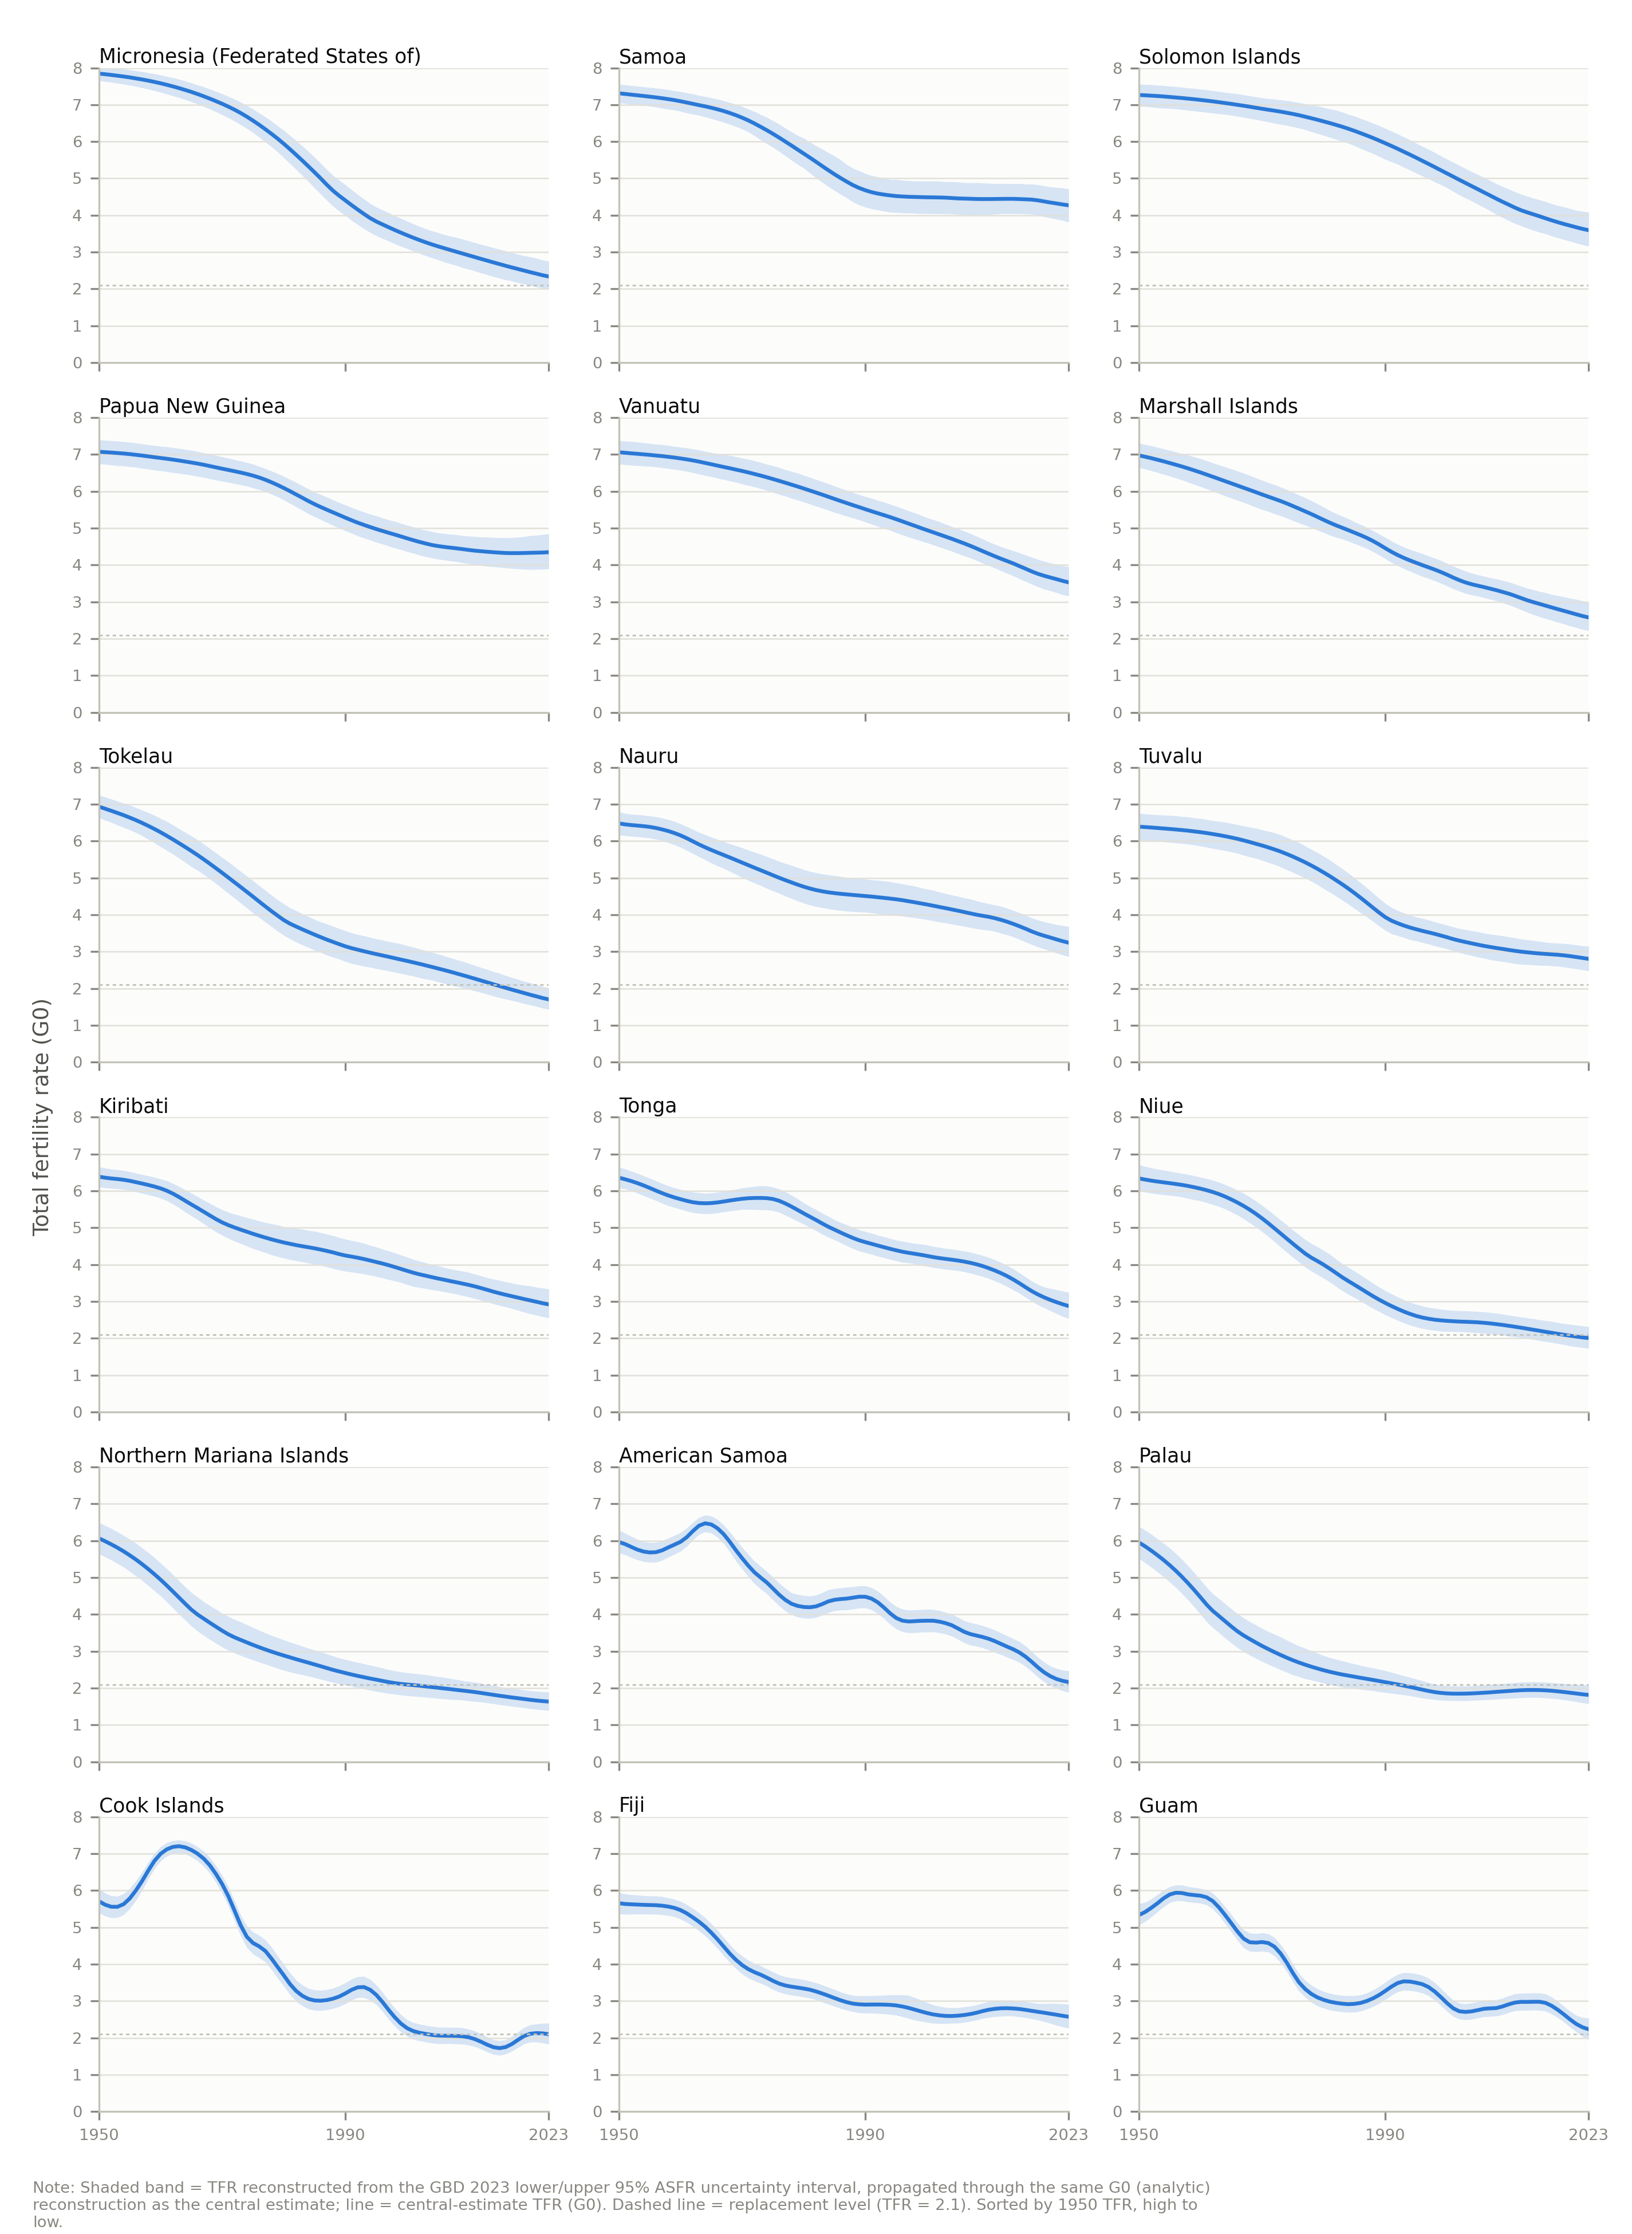
Supplementary Figure S2. Total fertility rate with GBD 2023 95% uncertainty interval, 1950–2023, 18 Pacific countries and territories individually. Shaded band = TFR reconstructed from the GBD 2023 lower/upper 95% ASFR uncertainty interval; line = central-estimate TFR. Dashed line = replacement level (TFR = 2.1). Sorted by 1950 TFR, high to low. Uncertainty intervals for years before 1990 come from GBD's extended demographic series rather than standard GBD 2023 estimates, a characteristic shared with the point-estimate ASFRs used throughout this paper for the same years.

External Validation Against MICS and DHS Birth-History Data (Tier 2)
We compare the G0 reconstruction with independent birth-history evidence from eight country-rounds drawn from two survey programs — the UNICEF Multiple Indicator Cluster Surveys (MICS, seven rounds) and the Demographic and Health Surveys (DHS, one round: Papua New Guinea). This comparison is intended as an external plausibility and cross-source consistency assessment, not as definitive validation against a gold-standard dataset. Age-parity-specific vital-registration data would provide the strongest benchmark for the reconstructed birth-order quantities, but such data are unavailable for the Pacific populations studied here. MICS and DHS birth histories are themselves subject to recall and date-reporting error, age misreporting (including birth displacement and age heaping), incomplete histories, sampling error, small-sample uncertainty, partly imputed rather than directly reported birth dates for records with incomplete day/month information, and cohort–period differences relative to synthetic-period G0 quantities; Papua New Guinea's DHS round has a higher share of imputed birth dates than is documented for the MICS rounds (about 7%, 2,370 of 34,561 birth records, per DHS's own completeness-of-information flag), and DHS is a related but methodologically distinct data-collection program from MICS, with its own instrument, fieldwork, and processing conventions. The comparisons therefore inform the plausibility, approximate magnitude, directional consistency, and model sensitivity of the reconstructed indicators rather than testing exact equality between the two sources. The subset of Pacific countries with available survey microdata is Fiji (2021, MICS), Kiribati (2018–19, MICS), Nauru (2023, MICS), Papua New Guinea (2016–18, DHS), Tonga (2024, MICS), Tuvalu (2019–20, MICS), Vanuatu (2023, MICS), and Samoa (2019–20, MICS) — one round per country; all comparisons are against the paper's own G0 model only.
Survey estimates carry particularly substantial sampling uncertainty for the smaller-population surveys (Nauru, Tuvalu); Papua New Guinea's much larger DHS sample carries comparatively little sampling uncertainty by contrast, though the data-quality differences noted above still apply. The main text (§4, Limitations) reports only the directional reading of these comparisons; this section reports the full numeric detail behind it.
All survey-side point estimates use each country's own sampling weights. All survey-side confidence intervals use a design-based (Taylor-linearization, ultimate-cluster) variance estimator that accounts for stratification and clustering, using each survey's own sampling-error design variables (PSU_SE/stratum_SE where provided, or the underlying PSU/stratum variables where a survey provides no _SE variant). Sample sizes (n) reported throughout are unweighted respondent counts; MICS sampling weights are normalized so that the weighted total approximates the unweighted total (a relative, not population-scale, weighting). For the Papua New Guinea DHS round, the same design-based approach is applied using DHS's own primary-sampling-unit and stratum variables (v021, v022) in place of MICS's PSU_SE/stratum_SE, and DHS's standard sampling weight (v005), rescaled by its documented factor of 1,000,000, in place of MICS's wmweight.

Supplementary Figure S3
For each survey, we compare (Panel A) the age-specific fertility rate schedule across all birth orders, in 5-year age bands, and (Panel B) the shape of the age-at-first-birth distribution, in single-year bins, against the corresponding G0 output. Survey points use each woman's own 36-month pre-interview window (births in [interview date − 36 months, interview date)); G0 curves use the input ASFR schedule graduated to a smooth continuous curve (monotone-cubic interpolation, preserving each 5-year band's total births) before order decomposition, pooled across the calendar years each survey's window touches (weighted by woman-months of window exposure). Panel B curves are renormalized to sum to 1 for shape comparability; Panel A is on the natural ASFR scale.
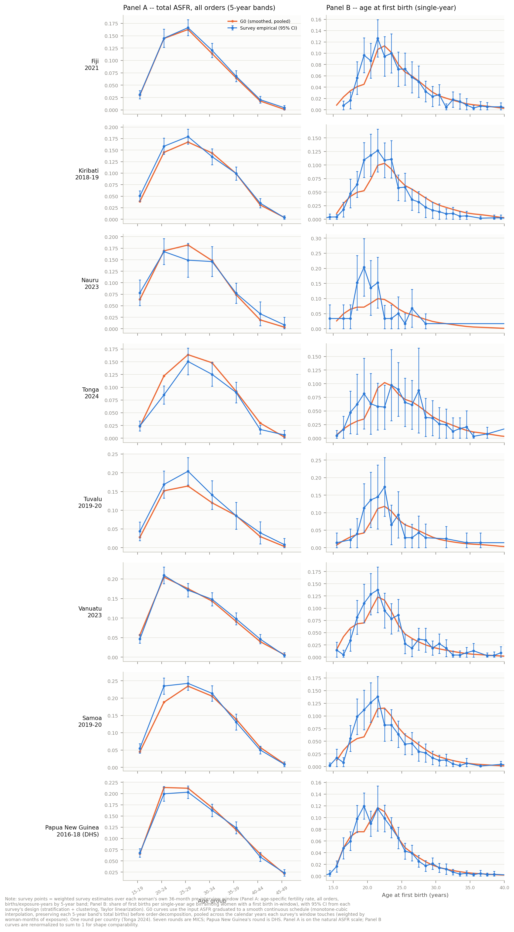
Supplementary Figure S3. Panel A (total ASFR, all orders, 5-year bands, left column) and Panel B (age-at-first-birth shape, single-year, right column) for each of the 8 country-rounds (seven MICS, one DHS: Papua New Guinea). Orange = G0; blue with error bars = survey empirical estimate with 95% design-based CI.

Table S11. Wald goodness-of-fit test, Panel A (total ASFR, 5-year bands)
To formally test whether the G0 and survey shapes are statistically distinguishable (beyond counting how many individual bins' CIs contain the G0 value), we constructed design-based Wald goodness-of-fit tests using the full design-based covariance matrix across bins (not just per-bin variances), via ultimate-cluster linearization generalized to cross-bin covariances. 2 of 8 rounds reject the null of no difference at α = 0.05 (Tonga, Samoa); the total fertility schedule G0 implies otherwise agrees well with the survey data.
Country | Round | χ² statistic | df | p-value
Fiji | 2021 | 4.53 | 7 | 0.717
Kiribati | 2018–19 | 10.99 | 7 | 0.139
Nauru | 2023 | 5.80 | 7 | 0.564
Tonga | 2024 | 20.31 | 7 | 0.005
Tuvalu | 2019–20 | 8.74 | 7 | 0.272
Vanuatu | 2023 | 6.09 | 7 | 0.529
Samoa | 2019–20 | 29.18 | 7 | <0.001
Papua New Guinea | 2016–18 (DHS) | 7.19 | 7 | 0.409

Table S12. Wald goodness-of-fit test, Panel B (age-at-first-birth shape, 3-year bands)
6 of 8 rounds reject the null at α = 0.05, including Papua New Guinea: the age-at-first-birth shape is statistically distinguishable between G0 and the survey data in most countries.
Country | Round | n | χ² statistic | df | p-value
Fiji | 2021 | 346 | 34.44 | 10 | <0.001
Kiribati | 2018–19 | 366 | 77.75 | 8 | <0.001
Nauru | 2023 | 57 | 45.80 | 6 | <0.001
Tonga | 2024 | 139 | 13.53 | 8 | 0.095
Tuvalu | 2019–20 | 75 | 15.29 | 8 | 0.054
Vanuatu | 2023 | 262 | 29.68 | 8 | <0.001
Samoa | 2019–20 | 366 | 83.84 | 8 | <0.001
Papua New Guinea | 2016–18 (DHS) | 1395 | 22.82 | 8 | 0.004

Table S13. Mean age at first birth (MAFB)
Empirical MAFB is the weighted mean age at first birth among first births falling in each woman's own 36-month pre-interview window; the design-based SE and 95% CI use the same ultimate-cluster estimator as elsewhere in this section. G0's value is pooled across the calendar years the survey's windows touch, weighted by window-months of exposure (as in Panel A/B above). Both the original (piecewise-constant input ASFR) and a smoothed (monotone-cubic-graduated input ASFR) version of G0's order-1 mean age are reported, to confirm the empirical-vs-G0 gap is not an artifact of the piecewise-constant representation. 3 of 8 rounds are in CI under either G0 representation; every miss, including Papua New Guinea's DHS round, shows G0 older than the survey estimate (no misses in the other direction).
Country | Round | Empirical MAFB | 95% CI | G0 (original) | In CI? | G0 (smoothed) | In CI?
Fiji | 2021 | 24.108 | [23.481, 24.735] | 24.224 | Yes | 24.436 | Yes
Kiribati | 2018–19 | 22.753 | [22.301, 23.204] | 24.117 | No | 24.342 | No
Nauru | 2023 | 21.347 | [20.035, 22.660] | 22.838 | No | 23.059 | No
Tonga | 2024 | 24.539 | [23.502, 25.577] | 25.080 | Yes | 25.299 | Yes
Tuvalu | 2019–20 | 23.031 | [22.040, 24.022] | 24.352 | No | 24.571 | No
Vanuatu | 2023 | 23.050 | [22.478, 23.621] | 22.781 | Yes | 23.034 | Yes
Samoa | 2019–20 | 22.348 | [21.858, 22.838] | 23.215 | No | 23.505 | No
Papua New Guinea | 2016–18 (DHS) | 22.112 | [21.788, 22.436] | 22.453 | No | 22.734 | No

Table S14. Progression ratio to first parity (PR1)
Following Pandey and Suchindran's (1997) completed-cohort approach to parity progression ratios, PR1 is the proportion of women who ever have a first birth. The empirical estimate restricts to women aged 45–49 (a near-complete real cohort), taking the weighted proportion with at least one recorded birth; G0's value is its entry_probability for the survey year itself (or nearest available year ≤ 2023). This is a period-synthetic-vs-most-recently-completed-real-cohort comparison, the same kind classical demography uses to compare a period measure (e.g. TFR) against a completed cohort's actual experience. 4 of 8 rounds are in CI; all 4 misses (Kiribati, Tonga, Samoa, Papua New Guinea) show G0 higher than the survey estimate — no misses in the other direction.
Country | Round | n (45–49) | Empirical PR1 | 95% CI | G0 PR1 | In CI?
Fiji | 2021 | 578 | 0.934 | [0.912, 0.956] | 0.928 | Yes
Kiribati | 2018–19 | 384 | 0.901 | [0.872, 0.930] | 0.955 | No
Nauru | 2023 | 57 | 0.930 | [0.864, 0.996] | 0.961 | Yes
Tonga | 2024 | 270 | 0.864 | [0.815, 0.913] | 0.944 | No
Tuvalu | 2019–20 | 60 | 0.883 | [0.800, 0.965] | 0.945 | Yes
Vanuatu | 2023 | 286 | 0.964 | [0.939, 0.988] | 0.971 | Yes
Samoa | 2019–20 | 476 | 0.933 | [0.910, 0.955] | 0.987 | No
Papua New Guinea | 2016–18 (DHS) | 1229 | 0.933 | [0.915, 0.952] | 0.987 | No

Table S15. First birth interval (1→2)
Empirical intervals use a window-based (not cohort-restricted) design: any woman of any current age with a recorded pair of births at the relevant orders, where the LATER birth of the pair falls in her own 36-month pre-interview window — a completed interval is fully observed once both endpoint births are recorded, regardless of the woman's current age, so no age restriction or censoring adjustment is needed. G0's value is its mean_interval_years for the relevant transition, pooled across the calendar years the window touches (weighted by window-months of exposure, as above). For Tonga (survey year 2024, beyond G0's 2023 cutoff), the window is fixed at the 36 months ending December 2023 (2021–2023) on both the empirical and G0 sides, rather than using the survey's true 2024 interview dates on one side only. 0 of 8 rounds are in CI; G0 is wider than the survey estimate in all 8 rounds.
Country | Round | n | Empirical (yrs) | 95% CI | G0 pooled (yrs) | Years pooled | In CI?
Fiji | 2021 | 325 | 3.826 | [3.475, 4.177] | 5.398 | 2018–2021 | No
Kiribati | 2018–19 | 312 | 4.040 | [3.713, 4.367] | 5.604 | 2015–2018 | No
Nauru | 2023 | 48 | 3.979 | [3.318, 4.641] | 5.313 | 2020–2023 | No
Tonga | 2024 | 123 | 3.144 | [2.752, 3.536] | 5.529 | 2021–2023* | No
Tuvalu | 2019–20 | 63 | 3.375 | [2.707, 4.043] | 5.505 | 2016–2020 | No
Vanuatu | 2023 | 270 | 4.013 | [3.726, 4.300] | 5.250 | 2020–2023 | No
Samoa | 2019–20 | 305 | 3.031 | [2.760, 3.302] | 4.922 | 2016–2020 | No
Papua New Guinea | 2016–18 (DHS) | 1224 | 3.396 | [3.248, 3.544] | 5.122 | 2013–2018 | No
*Tonga's window is fixed at 2021–2023 on both sides (2024 censored) — see method note above.

Table S16. Second birth interval (2→3)
Same window-based design as Table S15, shifted one parity order (order-3, not order-2, birth's own timing defines the window), using BHLN for order identification. 3 of 8 rounds are in CI (Nauru, Tonga, Vanuatu); G0 is wider than the survey estimate in all 8 rounds — same direction as 1→2.
Country | Round | n | Empirical (yrs) | 95% CI | G0 pooled (yrs) | In CI?
Fiji | 2021 | 245 | 4.130 | [3.732, 4.527] | 4.650 | No
Kiribati | 2018–19 | 227 | 3.820 | [3.480, 4.160] | 4.756 | No
Nauru | 2023 | 32 | 3.661 | [2.665, 4.658] | 4.537 | Yes
Tonga | 2024 | 96 | 3.967 | [3.179, 4.755] | 4.619 | Yes
Tuvalu | 2019–20 | 68 | 3.694 | [2.987, 4.400] | 4.827 | No
Vanuatu | 2023 | 257 | 4.378 | [4.027, 4.730] | 4.729 | Yes
Samoa | 2019–20 | 280 | 2.913 | [2.657, 3.168] | 4.234 | No
Papua New Guinea | 2016–18 (DHS) | 1003 | 3.473 | [3.303, 3.644] | 4.630 | No

Table S17. Last closed birth interval (four empirical scenarios)
The last closed birth interval is the birth-to-birth gap immediately preceding a woman's actual last (highest-order) recorded birth — a standard demographic device for approximating completed spacing without needing a full parity ladder. On the G0 side this is a weighted average, over all possible final parities i ≥ 2, of the model's interval into order i conditional on i being the final parity, weighted by the probability that parity i is a woman's final parity (both already computed by the underlying model; i = 1 is excluded, since a woman whose only birth is her first has no preceding birth to close an interval against). The same G0 value is used across all four empirical scenarios below — only the empirical population/definition changes. Four scenarios were run: (a) women aged 45–49 with parity ≥ 2, using only genuinely closed birth-to-birth intervals; (b) the same closed-interval definition, without the age restriction; (c) women aged 45–49, closed intervals as in (a) plus “open” intervals — the elapsed time since a woman's only birth, for women of parity 1 whose only birth was at least 60 months before interview — capped at exactly 60 months; and (d) the same open-interval addition as (c), without the age restriction. G0 is wider than the empirical estimate in every country under every scenario (32 of 32); only Nauru's (a)/(c) fall within the CI (small n, wide interval). Adding the 60-month open-interval supplement (c vs. a, d vs. b) makes little difference to the empirical mean; the all-ages scenarios (b/d) sit consistently lower than the 45–49-restricted ones (a/c) in every country.
Country | G0 last-closed interval (yrs)
Fiji | 6.028
Kiribati | 6.096
Nauru | 5.923
Tonga | 5.920
Tuvalu | 6.263
Vanuatu | 6.360
Samoa | 5.634
Papua New Guinea (DHS) | 6.420
(a) 45–49, closed intervals only
Country | n | Empirical (yrs) | 95% CI | In CI?
Fiji | 474 | 4.550 | [4.262, 4.839] | No
Kiribati | 318 | 5.004 | [4.597, 5.410] | No
Nauru | 48 | 5.245 | [4.010, 6.479] | Yes
Tonga | 211 | 3.972 | [3.455, 4.489] | No
Tuvalu | 48 | 5.054 | [4.027, 6.080] | No
Vanuatu | 253 | 5.493 | [4.984, 6.003] | No
Samoa | 412 | 4.712 | [4.339, 5.085] | No
Papua New Guinea (DHS) | 1073 | 4.286 | [4.067, 4.505] | No
(b) all ages, closed intervals only
Country | n | Empirical (yrs) | 95% CI | In CI?
Fiji | 2539 | 4.031 | [3.914, 4.149] | No
Kiribati | 2053 | 4.003 | [3.876, 4.130] | No
Nauru | 366 | 3.707 | [3.385, 4.029] | No
Tonga | 1071 | 3.586 | [3.397, 3.774] | No
Tuvalu | 392 | 3.393 | [3.142, 3.645] | No
Vanuatu | 2012 | 4.287 | [4.158, 4.417] | No
Samoa | 2147 | 3.488 | [3.365, 3.612] | No
Papua New Guinea (DHS) | 8225 | 3.536 | [3.446, 3.626] | No
(c) 45–49, closed + open capped at 60 months
Country | n | Empirical (yrs) | 95% CI | In CI?
Fiji | 541 | 4.607 | [4.355, 4.859] | No
Kiribati | 348 | 5.003 | [4.635, 5.372] | No
Nauru | 52 | 5.226 | [4.086, 6.366] | Yes
Tonga | 238 | 4.078 | [3.620, 4.536] | No
Tuvalu | 53 | 5.049 | [4.116, 5.982] | No
Vanuatu | 275 | 5.455 | [4.984, 5.926] | No
Samoa | 444 | 4.732 | [4.385, 5.079] | No
Papua New Guinea (DHS) | 1137 | 4.320 | [4.112, 4.528] | No
(d) all ages, closed + open capped at 60 months
Country | n | Empirical (yrs) | 95% CI | In CI?
Fiji | 2922 | 4.162 | [4.059, 4.265] | No
Kiribati | 2298 | 4.113 | [3.997, 4.228] | No
Nauru | 421 | 3.876 | [3.598, 4.153] | No
Tonga | 1231 | 3.787 | [3.625, 3.948] | No
Tuvalu | 440 | 3.568 | [3.340, 3.795] | No
Vanuatu | 2212 | 4.353 | [4.234, 4.472] | No
Samoa | 2314 | 3.590 | [3.472, 3.707] | No
Papua New Guinea (DHS) | 8801 | 3.639 | [3.552, 3.726] | No

Table S18. Mean age at last birth (MALB)
Empirical MALB is the weighted mean age at each woman's most recent recorded birth, among women aged 45–49 (the same near-complete cohort as PR1); this uses only the maximum recorded birth date per woman and does not depend on the birth-order variable at all. G0's value is its mean_age_last_birth for the survey year itself (or nearest available year ≤ 2023), already part of the model's standard summary output. 5 of 8 rounds are in CI — markedly closer agreement than the other indicators above; all three misses (Fiji, Samoa, Papua New Guinea) show G0 older than the survey estimate, the same direction as elsewhere, but the gap is small and inconsistent across countries.
Country | Round | n (45–49) | Empirical MALB | 95% CI | G0 MALB | In CI?
Fiji | 2021 | 544 | 31.351 | [30.731, 31.972] | 32.813 | No
Kiribati | 2018–19 | 348 | 34.831 | [34.164, 35.499] | 34.692 | Yes
Nauru | 2023 | 53 | 34.286 | [32.910, 35.662] | 33.496 | Yes
Tonga | 2024 | 239 | 35.127 | [34.357, 35.896] | 34.554 | Yes
Tuvalu | 2019–20 | 53 | 32.950 | [31.231, 34.670] | 34.154 | Yes
Vanuatu | 2023 | 275 | 34.477 | [33.757, 35.198] | 34.905 | Yes
Samoa | 2019–20 | 444 | 36.377 | [35.843, 36.911] | 36.980 | No
Papua New Guinea | 2016–18 (DHS) | 1138 | 35.795 | [35.040, 36.550] | 37.362 | No

Table S19. Summary of directional findings
Across all indicators tested, deviations between G0 and the survey estimates (MICS and DHS) point in a single, coherent direction: G0 implies somewhat higher lifetime childbearing progression, a somewhat older age at first birth, appreciably wider spacing between successive births, and (weakly, inconsistently) a somewhat older age at a woman's last birth, relative to the same real cohorts' survey-reported experience.
Indicator | Direction of G0 deviation | Consistency across countries
Total ASFR shape (Panel A) | Good agreement | 2 of 8 rounds statistically distinguishable
Age-at-first-birth shape (Panel B) | Under-concentrated at peak teenage ages | 6 of 8 rounds statistically distinguishable
Mean age at first birth (MAFB) | G0 older | 5 of 8 rounds outside empirical 95% CI, all same direction
Progression to first parity (PR1) | G0 higher | 4 of 8 rounds outside empirical 95% CI, all same direction
First birth interval (1→2) | G0 wider | 8 of 8 rounds outside empirical 95% CI, all same direction
Second birth interval (2→3) | G0 wider | 5 of 8 rounds outside empirical 95% CI, all same direction
Last closed birth interval (4 scenarios) | G0 wider | 30 of 32 country×scenario combos outside CI, all same direction
Mean age at last birth (MALB) | G0 older | 3 of 8 rounds outside empirical 95% CI, all same direction

Table S20. Cross-country ranking check: age-at-first-birth vs. 2023 total fertility rate
§3.3 reports that, relative to a cross-country linear regression of age at first birth on 2023 TFR across all 18 Pacific Island Countries and Territories, entry was unusually early relative to fertility level in the Marshall Islands, Nauru and Vanuatu, and unusually late in Samoa and Tonga (among others). Four of these five countries — Nauru, Vanuatu, Samoa and Tonga — are in the MICS validation set above (the Marshall Islands is not, and cannot be checked this way). Because this is a deviation-from-regression claim rather than a raw ranking, and age-at-first-birth-vs.-TFR is exactly the quantity the mean age at first birth (MAFB) validation above targets, we tested directly whether substituting each country's survey-based MAFB for its G0 value, holding that country's actual 2023 TFR fixed, changes its classification relative to the regression line.
The regression was first reconstructed from G0's own 2023 values across all 18 countries and territories (mean age at first birth = 28.43 − 1.42 × TFR, r = −0.885); the resulting residuals reproduce the deviations reported in §3.3 almost exactly (e.g. Nauru −0.89 years vs. the reported 0.9; Samoa +1.04 vs. 1.0; Tonga +0.76 vs. 0.8), confirming this is the regression the text refers to. Substituting survey MAFB preserves the reported classification for Nauru, Vanuatu and Tonga. For Samoa, the survey-based residual is close to zero rather than clearly positive — a technical change in sign, but to a near-null value rather than a reversal to “unusually early.” Samoa's MICS round (2019–20) is several years further from 2023 than the other three (Nauru and Vanuatu 2023, Tonga 2024), and age at first birth rose across the study period in every country, so an estimate anchored to c.2017–2019 is expected to understate the 2023 value; this timing mismatch, rather than a genuine disagreement about direction, is the more likely explanation.
Country | 2023 TFR | G0 age at first birth | G0 residual (yrs) | Classification (G0) | Survey MAFB | Survey residual (yrs) | Classification (survey)
Nauru | 3.243 | 22.941 | −0.894 | early | 21.347 | −2.488 | early
Vanuatu | 3.529 | 22.864 | −0.564 | early | 23.050 | −0.378 | early
Tonga | 2.877 | 25.116 | +0.762 | late | 24.539 | +0.185 | late
Samoa | 4.270 | 23.416 | +1.038 | late | 22.348 | −0.030 | borderline (near-null)
Papua New Guinea was checked against this same regression and excluded from the table above: its G0-based residual (+0.19 years) falls well inside the range treated as unflagged in §3.3, so no reclassification question arises for this country.

