Supplementary Information
Selective CO-to-acetate electroproduction via intermediate adsorption tuning on ordered Cu-Pd sites

Yali Ji^{1,4}, Zheng Chen^{1,4}, Chao Yang¹, Yuhang Wang¹, Jie Xu², Anxiang Guan¹, Jiatang Chen³, Tsun-Kong Sham³, Jun Luo², Xin Xu^{1,}*, and Gengfeng Zheng^{1,}*

¹Department of Chemistry, Laboratory of Advanced Materials, Shanghai Key Laboratory of Molecular Catalysis and Innovative Materials, Collaborative Innovation Centre of Chemistry for Energy Materials, Fudan University, Shanghai 200438, China
² Institute for New Energy Materials & Low-Carbon Technologies and Tianjin Key Lab of Photoelectric Materials & Devices, School of Materials Science and Engineering, Tianjin University of Technology, Tianjin 300384, China.
³Department of Chemistry, University of Western Ontario, London, Ontario N6A5B7, Canada.
⁴These authors contributed equally to this work.
*Email: Correspondence should be addressed to: xxchem@fudan.edu.cn (X.X.) and gfzheng@fudan.edu.cn (G.Z.)

Table of contents:
Supplementary Methods
Supplementary Figures 1-16
Supplementary Tables 1-11
Supplementary Methods
Experimental Section
Materials: Copper(II) acetate (98.0‒102.0%), sodium borohydride (≥98.0), potassium hydroxide (≥85.0), ethylene glycol ethyl ether (≥99%), acetone (≥99.5), and isopropanol (≥99.7) were purchased from the Sinopharm Chemical Reagent Company. Palladium(II) acetate (99.9% metal basis) , IrO₂ nanoparticles (99% metal basis) were purchased from Macklin Reagent. Ethanol (≥99.7%) was purchased from General Reagent. The Nafion solution (Dupont, D-520 dispersion, 5% w/w in water and 1-propanol) were purchased from Alfa Aesar. Freudenberg gas diffusion layer was purchased from Fuel Cell Store. A hydroxide exchange membrane FAB-PK-130 was purchased from Fumatech.
Synthesis of Cu nanoparticles: Copper(II) acetate (3 mmol) was dissolved into 250 mL ethylene glycol ethyl ether solution and vigorous stirred with bubbling Ar for 30 min. Afterwards, 20 mL of aqueous solution of NaBH₄ (30 mmol) was added into the mixture solution dropwise. After stirring the mixed solution for 5 min at room temperature, the crude sample was collected by centrifugation, and purified by washing with water for 5 times, ethanol twice, and then dried under vacuum.
Synthesis of Pd nanoparticles: Palladium(II) acetate (3 mmol) was dissolved into a mixture solution of 30 mL of acetone, 250 mL of ethylene glycol ethyl ether, and 30 mL of aqueous solution of NaBH₄ (30 mmol). After stirring the mixed solution for 5 min at room temperature, the crude sample was collected by centrifugation, and purified by washing with water for 10 times, ethanol for twice, and then dried under vacuum.
Synthesis of disordered Cu−Pd alloys: The Cu−Pd alloys were synthesized from the reduction of palladium(II) acetate and copper(II) acetate in solution with sodium borohydride, in which the atomic ratios of Cu to Pd were controlled by adjusting the concentrations of Pd and Cu precursors. For disordered CuPd alloy, 10 mL of acetone solution of palladium acetate (1.5 mmol) was mixed with 250 mL of ethylene glycol ethyl ether solution of copper acetate (1.5mmol). The blue-green mixture was stirred vigorously for 30 min at room temperature. Afterwards, 30 mL of aqueous solution of NaBH₄ (40 mmol) was then added into the mixture solution dropwise. The crude sample was collected by centrifugation, and purified by washing with water for 10 times, ethanol for twice, and then dried under vacuum. Cu₃Pd and CuPd₃ alloys were obtained in the same way, using a solution containing metal species with concentrations corresponding to the final compositions.
Synthesis of ordered CuPd-IC: The resulted disordered CuPd alloy was heated in a tube furnace under flowing 5 vol% hydrogen/argon at 573 K for 3 h to accelerate atomic displacement and yield atomically ordered CuPd-IC.
Preparation of electrodes: Gas-diffusion-electrodes (GDEs) were prepared via spraying catalysts onto a H14C9 gas-diffusion-layer (GDL, Freudenberg) by an airbrush technique. To prepare the cathode electrode, a well-dispersed catalyst slurry comprising 20 mg of catalyst, 3 mL of isopropanol, and 30 μl of Nafion ionomer solution was mixed. Next, the catalyst slurry was slowly sprayed onto a GDL to attain a catalyst loading of ~ 0.5 mg·cm⁻². The actual loading was determined by weighing the GDL before and after spraying. A similar procedure was used for IrO₂ nanoparticles (99% metal basis, Macklin) to prepare the anode electrode.
Flow-cell CO electrolysis: Electroreduction was performed in a flow cell configuration consisting of a catalyst-sprayed GDE as the working electrode, an IrO₂-sprayed GDE as the anode, and an anion exchange membrane (Fumatech FAB-PK-130) to separate the cathode and anode chambers. Alkaline electrolytes (1 M KOH) were flown through both cathodic and anodic compartments cell at 0.5 mL·min⁻¹ using a peristaltic pump. CO gas was flowed into the gas chamber at a constant flow rate of 40 sccm using a mass flow controller (DSN MFC-700, Designtech). All the electrochemical experiments were conducted using an electrochemical workstation (Autolab PGSTAT302N) with an Ag/AgCl reference electrode. Electrode potentials were rescaled to the RHE reference by:
E (vs. RHE) = E (vs. Ag / AgCl) + 0.197 V + 0.0591 × pH (S1)
The electrode potentials were corrected using the following formula:
E_{catal} = E_{applied} – 0.9 I_{total}R_{cell} (S2)
where E_{catal} is the corrected potential at the cathode, E_{applied} is the applied potential, I_{total} is the total current, and R_{cell} is the measured cell resistance which was 1 Ω here.
Product detection: Products were quantified over a period of 300 s at each potential. The gas-phase products were analyzed using Shanghai Ramiin GC 2060 online gas chromatograph equipped with a thermal conductivity detector and a flame ionization detector. Liquid products were quantified by ¹H nuclear magnetic resonance (NMR) spectroscopy (Bruker AVANCEAV III HD 500) and pre-saturation method was used to suppress water peak.
CO electrolysis in membrane electrode assembly (MEA): For tests in a MEA electrolyzer, the experimental set-up used was a commercial MEA electrolyser (Dioxide Materials, 5 cm² active area). The MEA consisted of a cathode electrode, Nafion 115 membrane and anode electrode (IrO₂–Ti mesh). The anode electrode was prepared by following a methodology similar to that described in the previous report¹. The resulting cathode and anode electrodes were then mounted on their respective flow fields, separated from each other via the cation-exchange membrane and assembled in the MEA electrolyser; CO was then supplied with a flow rate of 40 sccm through the flow channels in the cathode flow field, whereas 0.5 M KHCO₃ was fed into the anode flow channels with a flow rate of 20 mL·min⁻¹. The electrochemical stability tests were performed at a constant full cell potential of −3.6 V.

Computational details
The Vienna ab initio simulation package (VASP)²⁻⁴ was used for all density functional theory (DFT) calculations. The 1s electron in hydrogen, the 2s, 2p electrons in carbon and oxygen, and the 3d, 4p electrons in copper were treated as valence electrons, while the kinetic energy cutoff for the plane-wave basis sets was set to be 450 eV. The remaining core electrons were described by the projector augmented-wave (PAW) method⁵. The Monkhorst–Pack meshes⁶ of 2 × 2 × 1 and 3 × 3 × 3 k-point sampling in the Brillouin zone were employed for the slab model and the bulk model, respectively. For bulk optimization, all atoms and the lattice constants were all relaxed. For the pristine Cu(111) and Pd(111), a 4 × 4 supercell consisting of 2 fixed bottom layers and 2 relaxed top layers was used. For the pristine CuPd(110), a 4 × 2 supercell (12.1 Å × 8.5 Å) consisting of 2 fixed bottom layers and 2 relaxed top layers was used. When the convergence criterion for optimizations was met, the largest remaining force on each atom was less than 0.02 eV·Å⁻¹. For all calculations, the generalized gradient approximation (GGA) of the Perdew–Burke–Ernzerhof (PBE) functional was used⁷.
It is known that the adsorption energy and the preferred site of CO adsorption on metals cannot be reliably predicted by DFT at the generalized gradient approximation (GGA). Mason et. al.⁸ showed that a simple first-principles correction based on the difference between the singlet-triplet CO excitation energy values obtained by DFT-GGA and high-level quantum chemistry methods could yield accurate CO adsorption properties on a variety of metal surfaces. According to their results, to obtain more reasonable CO binding energies, the correction energies for Cu(111)-top site, Cu(111)-bridge site, Cu(111)-hollow site were 0.125, 0.246 and 0.279 eV, respectively⁸. The correction energies for Pd(111)-top site, Pd(111)-bridge site, Pd(111)-hollow site were 0.138, 0.297 and 0.360 eV, respectively⁸. For CuPd(110) surface, considering that the CO binding energies on bridge and hollow sites including Pd atom(s) are closer to those of Pd(111) than Cu(111) surface, the corresponding correction energies on Pd(111) are used.
For CO reduction mechanism, there are proton-coupled electron transfer (PCET) steps. The Gibbs free energy change (ΔG) was calculated by using the standard hydrogen electrode (SHE) model^{9, 10}, which uses one-half of the chemical potential of hydrogen as the chemical potential of proton-electron pair. Accordingly, the ΔG value was determined as^{9, 10}:
ΔG = ΔH - TΔS + ΔG_{U} + ΔG_{pH} , (S3)
where ΔH and ΔS were the enthalpy change and the entropy change, respectively. ΔG_{U} was the free energy contribution related to the electrode potential U. T is the absolute temperature. ΔG_{pH} was the concentration correction to the H⁺ free energy, which was calculated as
ΔG_{pH} = 2.303 × k_{B} × pH, (S4)
where k_{B} is the Boltzmann constant. As the theoretical overpotential was independent of the pH or the potential value U¹¹, the analysis for the free energy changes was performed at standard conditions (pH 0, 298.15 K, 1 atm) and U = 0. During calculations, for convenience, we assumed the chemical potential of the water in solution was equal to 3.169 kPa, the same as pure liquid water at room temperature.
We assumed that in addition to the total electronic energies, the translation and rotation contributions of the gas phase were significant while other parts were ignored. Assuming the gas phase to be an ideal gas, the partition functions of translation and rotation were calculated as¹²:
, (S5)
(linear), (nonlinear), (S6)
where P and m are the pressure and the molecular mass, respectively, k_{B} is the Boltzmann constant, and T (298.15 K) is the absolute temperature. is the volume of the system, $σ$$σ$ is the symmetry factor, A^{rot}, B^{rot}, C^{rot} are rotational constants, and h is the Plank’s constant.

Supplementary Figures

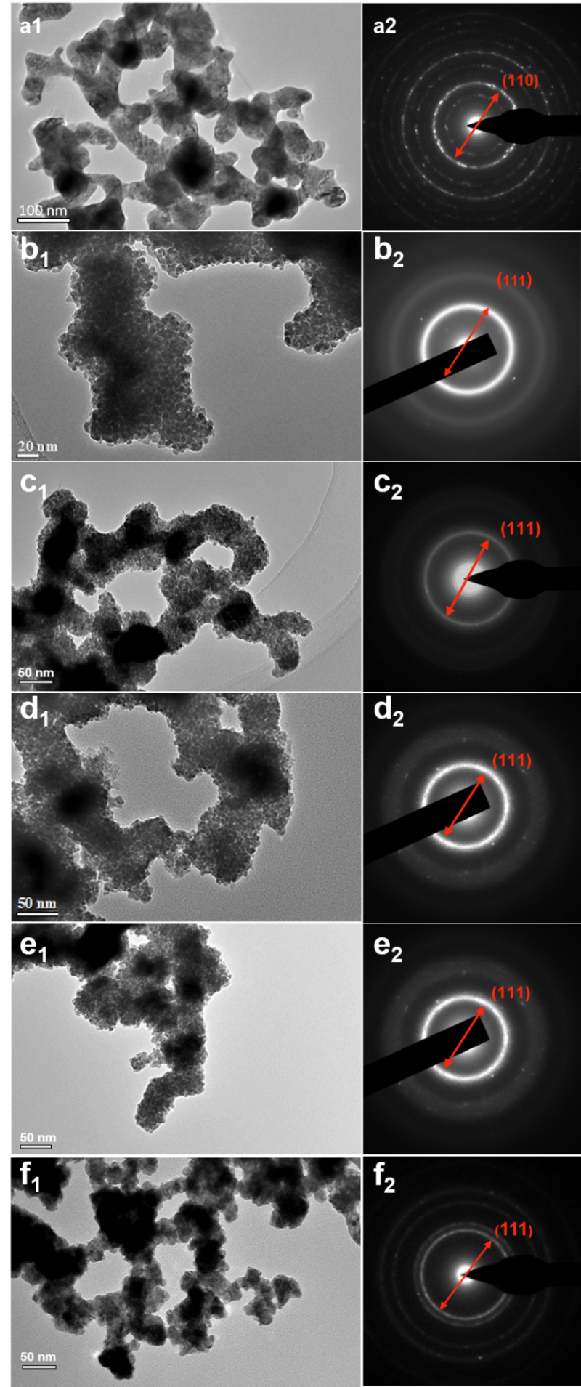
Supplementary Figure 1. TEM images (a₁‒f₁) and corresponding selective area electron diffraction (SAED) patterns (a₂‒f₂) of (a) ordered CuPd, (b) Cu nanoparticles, (c) Cu₃Pd, (d) CuPd, (e) CuPd₃, and (f) Pd nanoparticles, respectively.

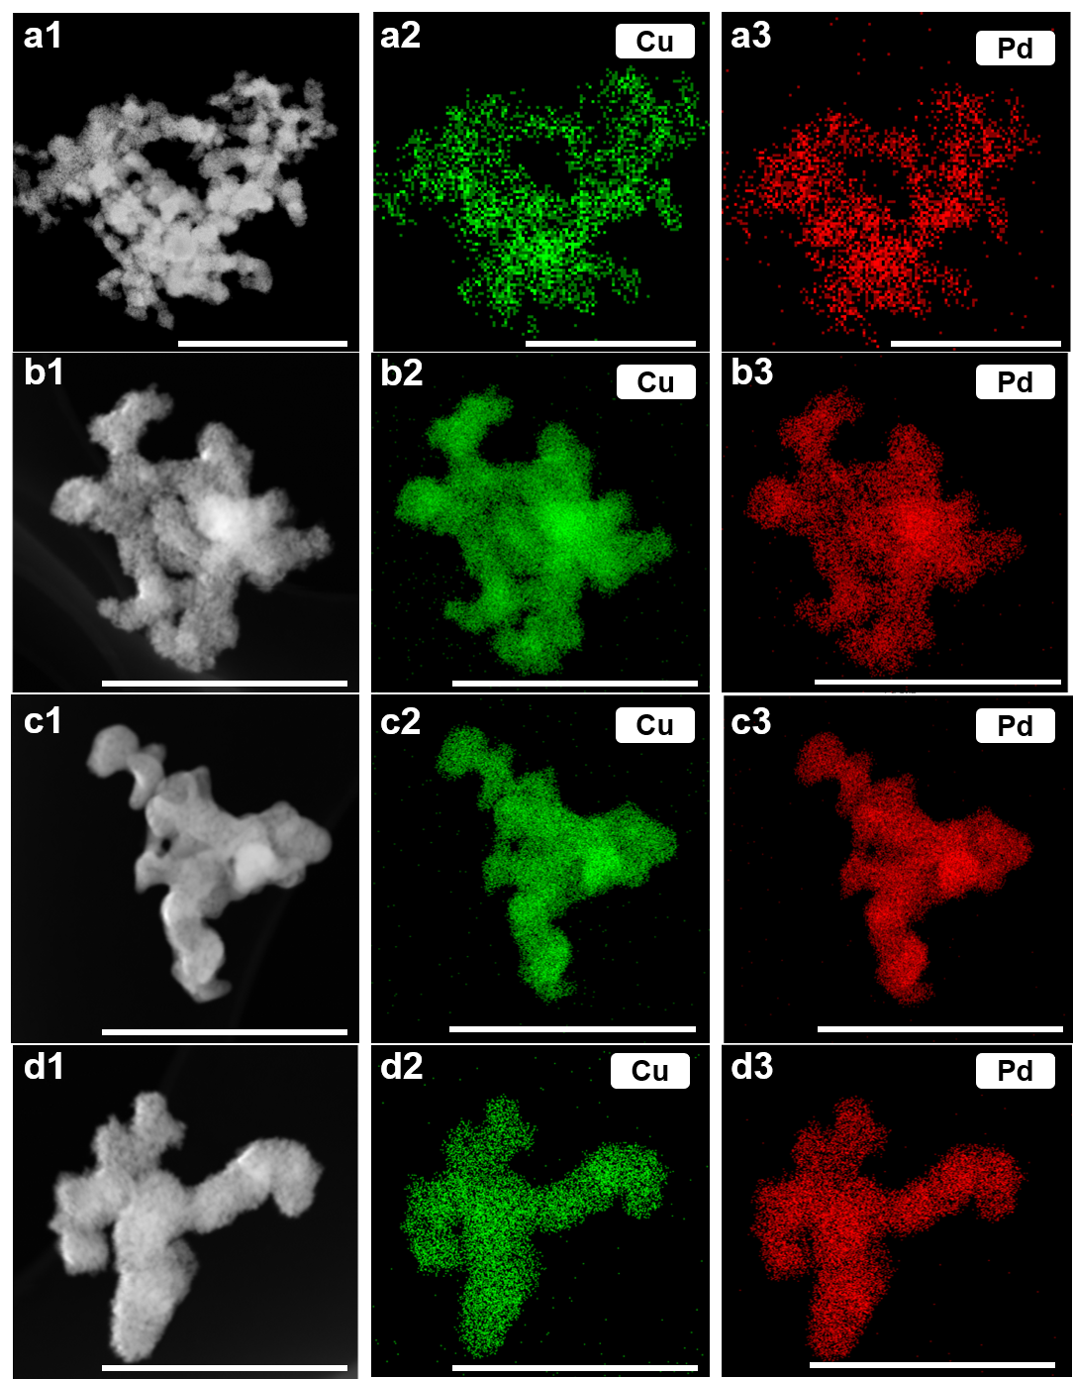
Supplementary Figure 2. STEM images and corresponding energy-dispersive X-ray spectroscopy (EDS) elemental mapping images of (a1‒a3) CuPd-IC, (b1‒b3) Cu₃Pd, (c1‒c3) d-CuPd, and (d1‒d3) CuPd₃. Scale bars: 500 nm in a, 250 nm in b, c, d. Green and red colors represent Cu and Pd elements, respectively.

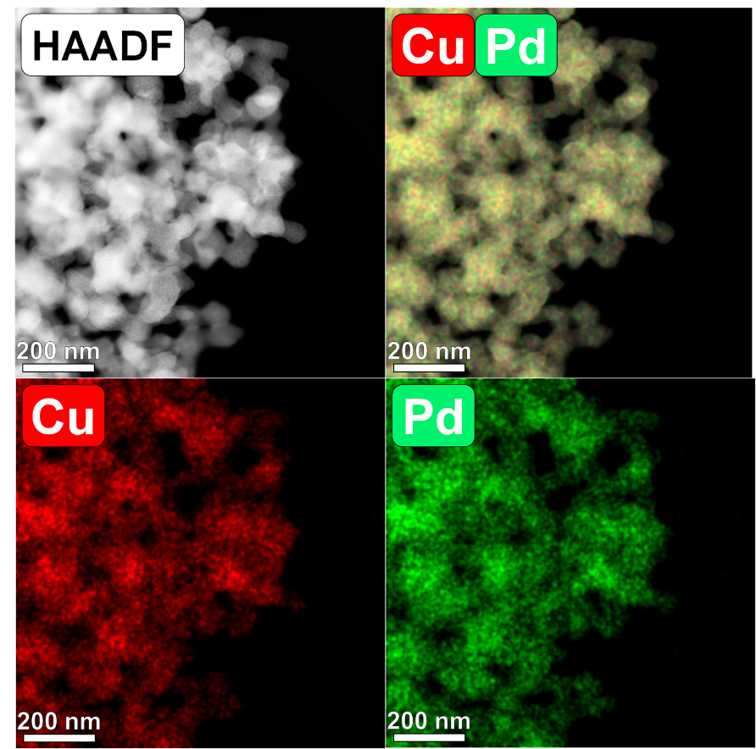
Supplementary Figure 3. The HAADF-STEM images and corresponding EDS elemental mappings of the CuPd-IC.

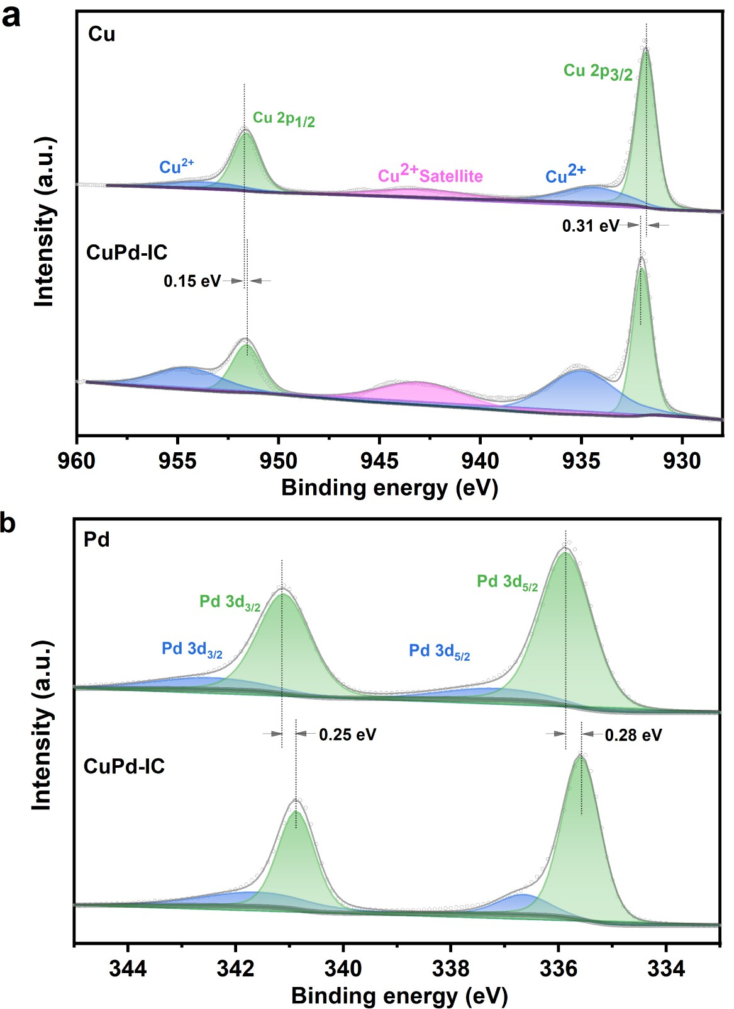
Supplementary Figure 4. XPS spectra of (a) Cu 2p and (b) Pd 3d for the Cu, Pd, and CuPd-IC catalysts.

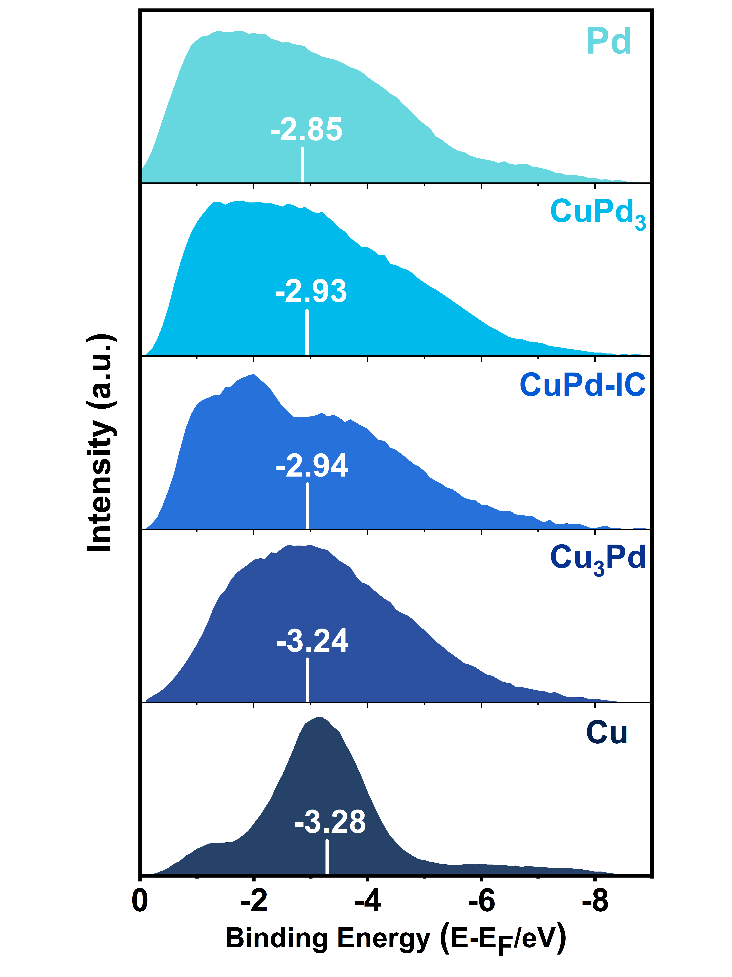
Supplementary Figure 5. Surface valence band photoemission spectra of Cu–Pd alloys. All the spectra were background corrected. The white bar indicates their centers of gravity. For comparison, the upper limit of integration was ﬁxed to ‒9.0 eV in binding energy.

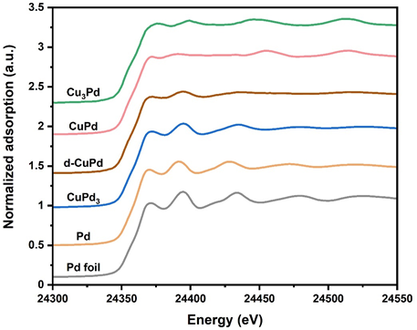
Supplementary Figure 6. Pd K-edge XANES spectra of the Cu-Pd alloys and Pd nanoparticles, in reference of Pd foil.

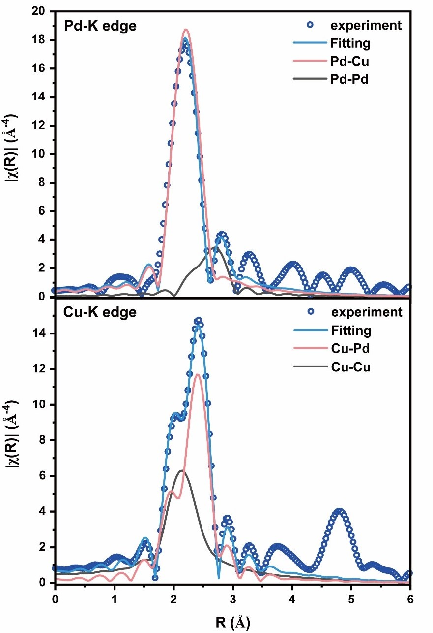
Supplementary Figure 7. FT-EXAFS spectra and fitting results of the CuPd-IC at Pd K-edge (upper panel) and Pd K-edge (lower panel), respectively.

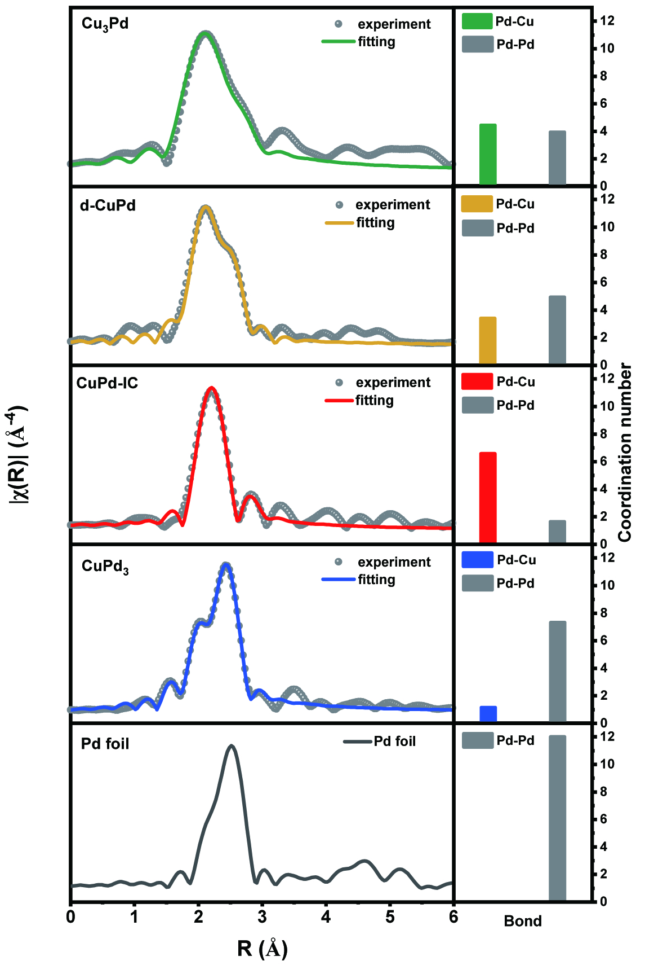
Supplementary Figure 8. FT-EXAFS spectra fitting results (left panels) and coordination numbers (right panels) of the Cu-Pd alloys at Pd K-edge.

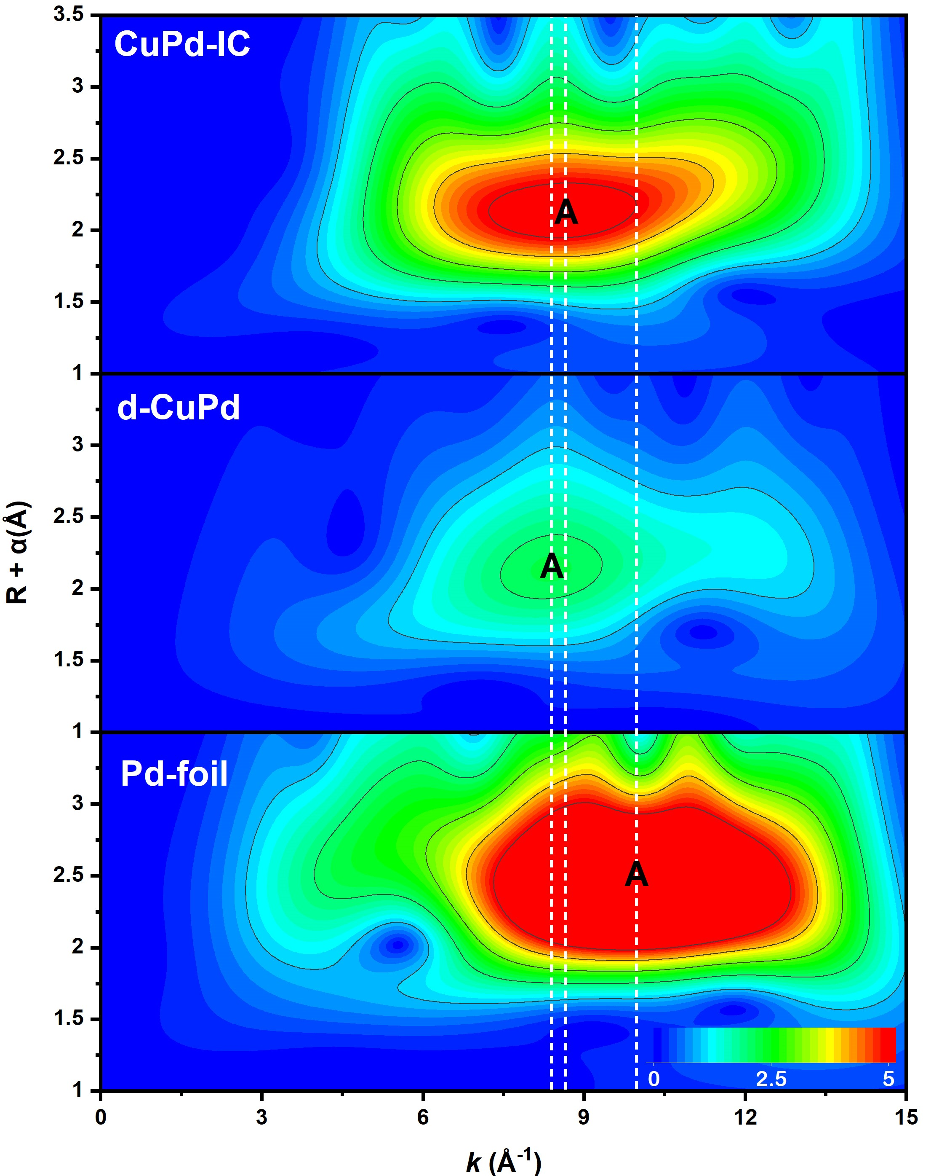
Supplementary Figure 9. WT-EXAFS spectra of the CuPd-IC, d-CuPd alloy and Pd foil at Pd K-edge. The location of the maximum A shifted from 8.62 Å⁻¹ (for CuPd-IC) to 8.39 Å⁻¹ (for the d-CuPd alloy). The WT maximum at k-value was 9.86 Å⁻¹ for pure Pd foil.

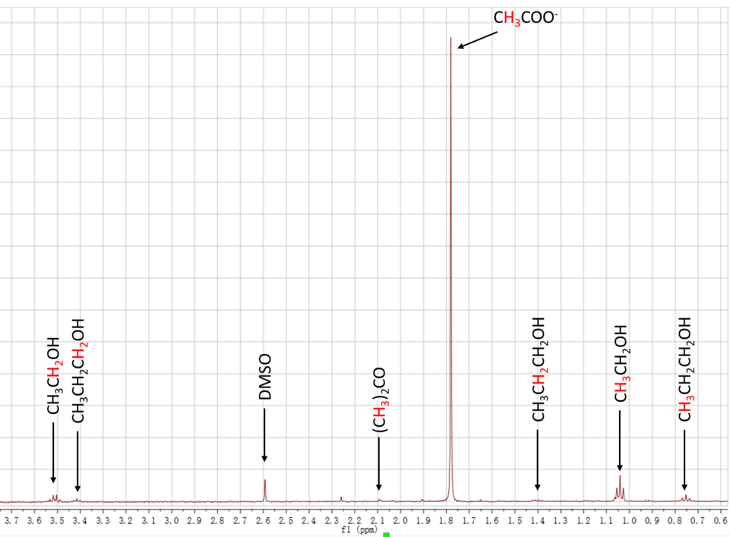
Supplementary Figure 10. A representative H-NMR spectrum of the electrolyte after electrochemical CO reduction, analyzing the liquid products from CO electroreduction.

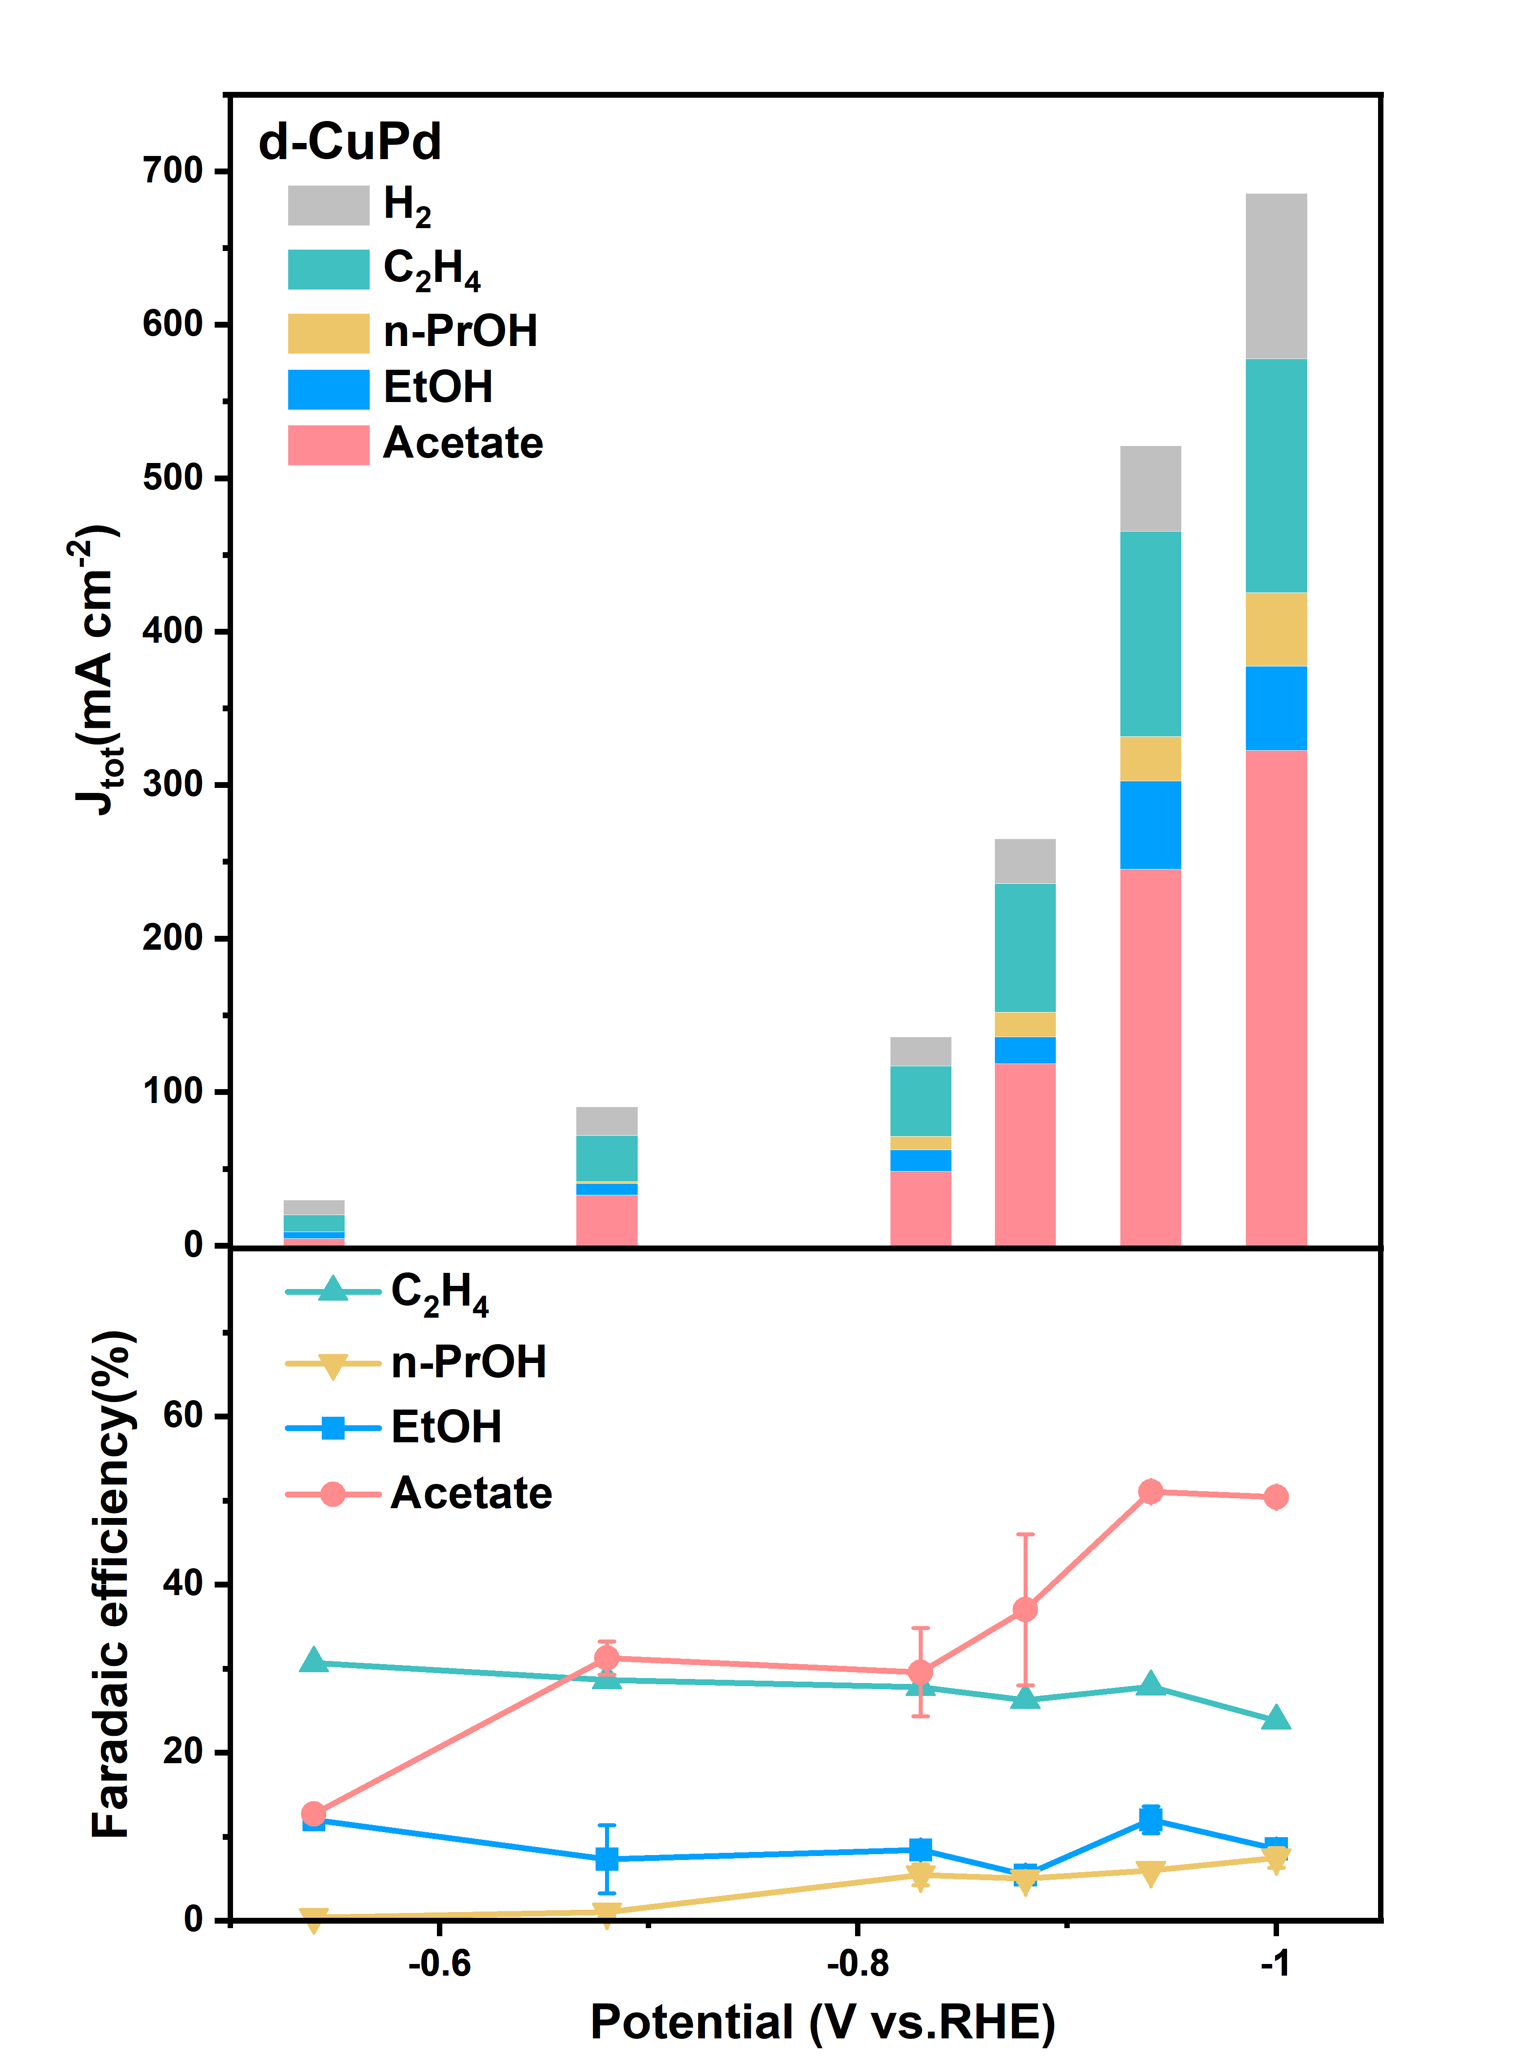
Supplementary Figure 11. Partial current densities for each CORR product and H₂ (upper panel), and corresponding Faradaic efficiencies for each CORR product (lower panel), as a function of applied potentials of d-CuPd in 1 M KOH.

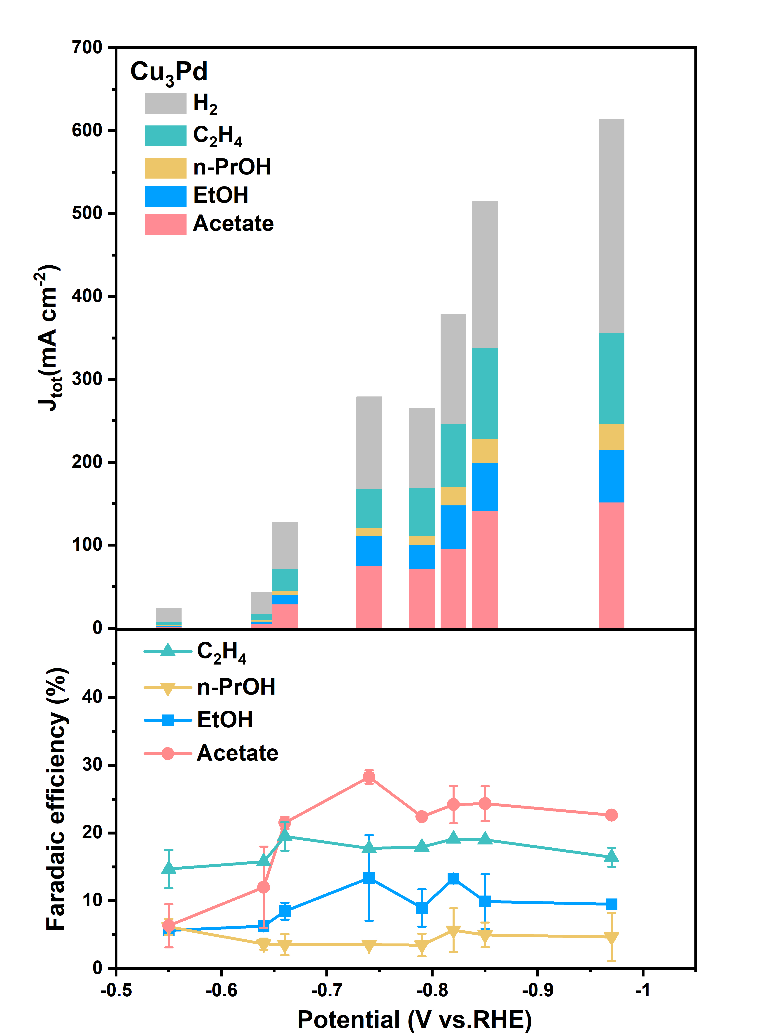
Supplementary Figure 12. Partial current densities for each CORR product and H₂ (upper panel), and corresponding Faradaic efficiencies for each CORR product (lower panel), as a function of applied potentials for the Cu₃Pd alloy in 1 M KOH.

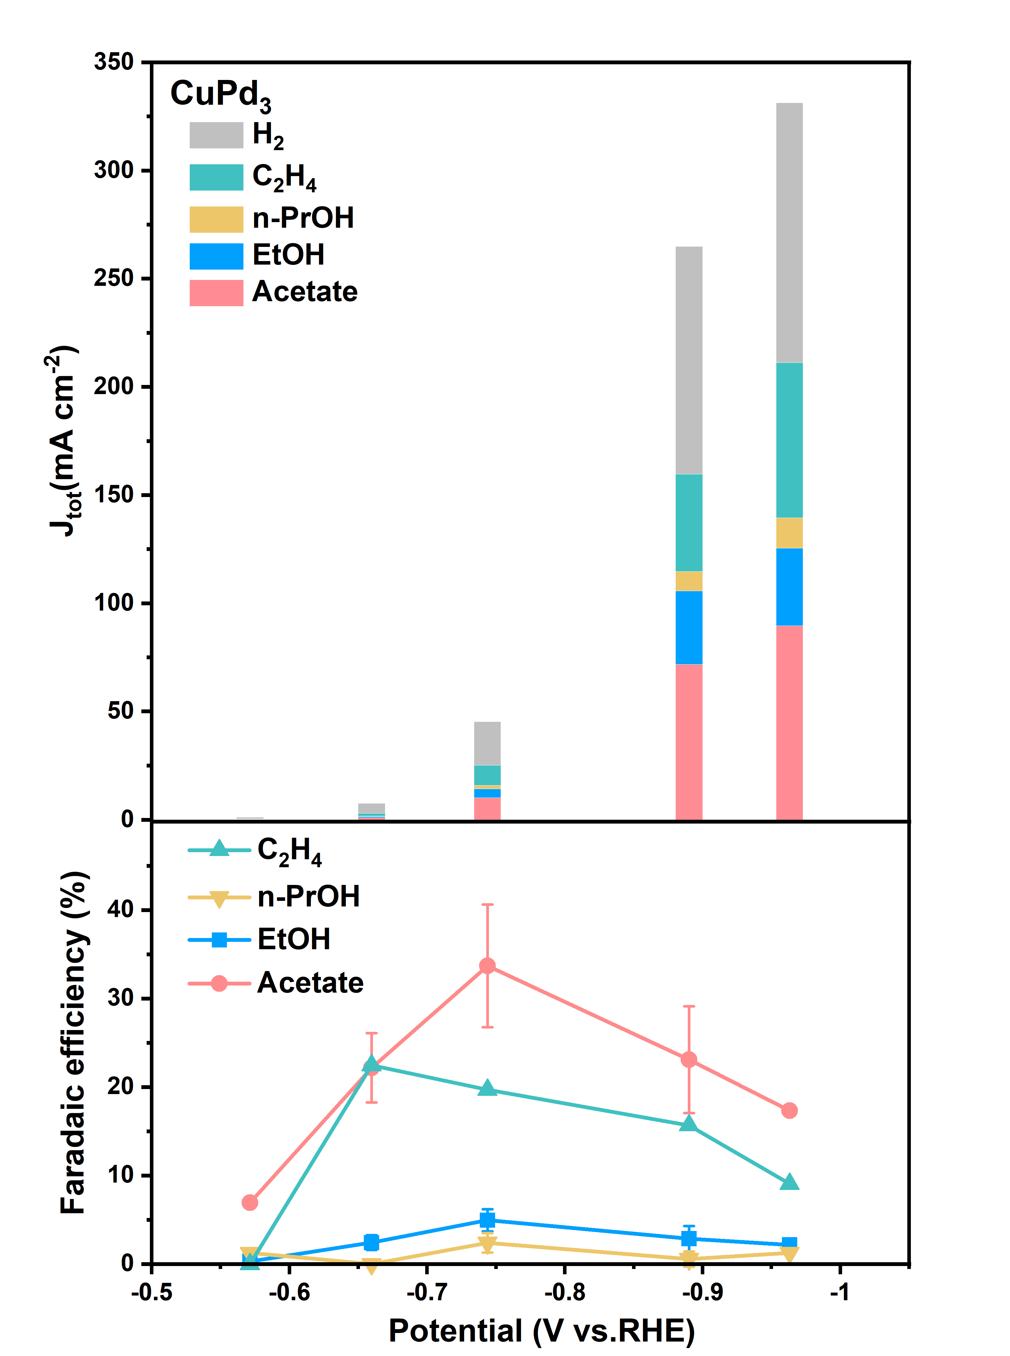
Supplementary Figure 13. Partial current densities for each CORR product and H₂ (upper panel), and corresponding Faradaic efficiencies for each CORR product (lower panel), as a function of applied potentials for the CuPd₃ alloy in 1 M KOH.

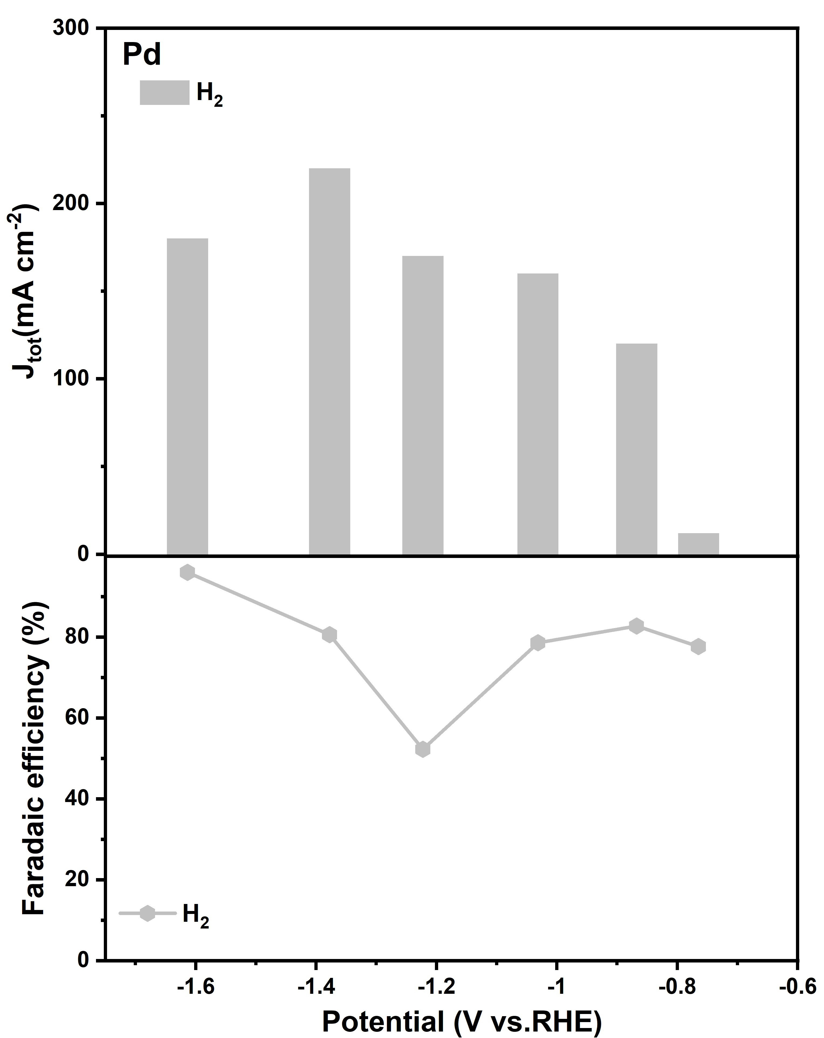
Supplementary Figure 14. Partial current densities for each CORR product and H₂ (upper panel), and corresponding Faradaic efficiencies for each CORR product (lower panel), as a function of applied potentials for the Pd nanoparticles in 1 M KOH. Here no CO electroreduction products were detected.

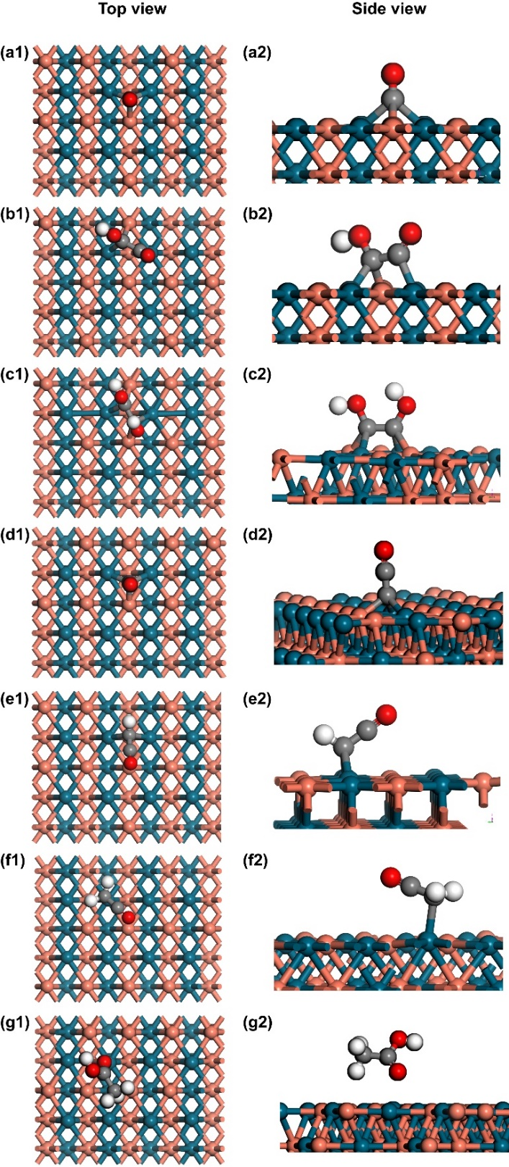
Supplementary Figure 15. Adsorption configuration of C₂ intermediates on the ordered CuPd(110) surface at low CO coverage. (a1‒g1): Top views of absorption configurations for (a1) CO*, (b1) *CO‒COH, (c1) *COH‒COH, (d1) *C‒CO, (e1) *CH‒CO, (f1) CH₂CO, (g1) CH₃COOH. (a2‒g2): Side views of absorption configurations for (a2) CO*, (b2) *CO‒COH, (c2) *COH‒COH, (d2) *C‒CO, (e2) *CH‒CO, (f2) CH₂CO, (g2) CH₃COOH. The orange, blue, red, grey and light grey balls represent copper, palladium, oxygen, carbon, and hydrogen atoms, respectively.
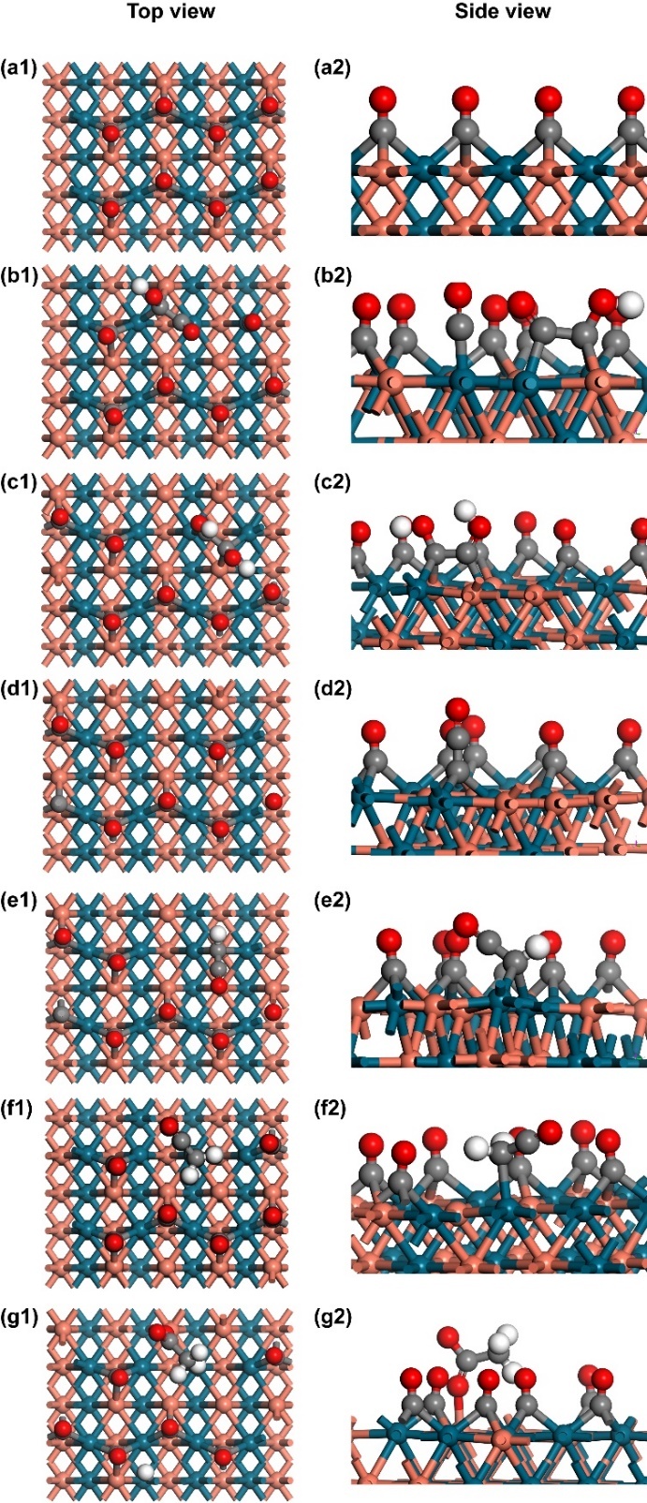
Supplementary Figure 16. Adsorption configuration of C₂ intermediates on the ordered CuPd(110) surface at high CO coverage. (a1‒g1), top views of absorption configurations for (a1) CO*, (b1) *CO‒COH, (c1) *COH‒COH, (d1) *C‒CO, (e1) *CH‒CO, (f1) CH₂CO, (g1) CH₃COOH. (a2‒g2), side views of absorption configurations for (a2) CO*, (b2) *CO‒COH, (c2) *COH‒COH, (d2) *C‒CO, (e2) *CH‒CO, (f2) CH₂CO, (g2) CH₃COOH. The orange, blue, red, grey and light grey balls represent copper, palladium, oxygen, carbon, and hydrogen atoms, respectively.
Supplementary Tables

Supplementary Table 1: SEM EDS results of Cu₃Pd, d-CuPd, CuPd₃ alloys, and CuPd-IC.

Sample | Element | Weight ratio | Atom ratio | Total
CuPd | Cu K | 37.17 | 49.77 | 100
CuPd | Pd L | 62.83 | 50.23 | 100
Cu₃Pd | Cu K | 64.5 | 75.27 | 100
Cu₃Pd | Pd L | 35.5 | 24.73 | 100
d-CuPd | Cu K | 37.17 | 49.77 | 100
d-CuPd | Pd L | 62.83 | 50.23 | 100
CuPd₃ | Cu K | 16.61 | 25.02 | 100
CuPd₃ | Pd L | 83.39 | 74.98 | 100

Supplementary Table 2: Fitting results of Cu and Pd K-edge EXAFS Data of Cu foil, Pd foil and different Cu-Pd alloys.

Sample | EXAFS | bond | CN | R (Å) | σ²(10⁻³ Å²)
Cu foil | Cu K | Cu-Cu | 12 | 2.54 | 11.04
CuPd-IC | Cu K | Cu-Pd | 7.2 | 2.54 | 4.98
 |  | Cu-Cu | 0.5 | 2.43 | 0.34
 | Pd K | Pd-Cu | 6.6 | 2.56 | 5.52
 |  | Pd-Pd | 1.6 | 2.92 | 1.38
d-CuPd | Cu K | Cu-Pd | 4.8 | 2.56 | 3.52
 |  | Cu-Cu | 3.1 | 2.48 | 2.27
 | Pd k | Pd-Cu | 3.4 | 2.56 | 2.86
 |  | Pd-Pd | 4.9 | 2.68 | 4.14
Cu₃Pd | Cu K | Cu-Pd | 2.2 | 2.59 | 2.03
 |  | Cu-Cu | 5.7 | 2.53 | 5.16
 |  | Cu-O | 0.5 | 1.84 | 0.44
 | Pd K | Pd-Cu | 4.4 | 2.56 | 0.01
 |  | Pd-Pd | 3.9 | 2.68 | 0.02
CuPd₃ | Cu K | Cu-Pd | 6.6 | 2.63 | 6.1
 |  | Cu-Cu | 1.9 | 2.59 | 1.71
 | Pd K | Pd-Cu | 1.1 | 2.6 | 1.26
 |  | Pd-Pd | 7.3 | 2.69 | 8.06
Pd foil | Pd K | Pd-Pd | 12 | 2.74 | 9.49

Supplementary Table 3: Faradaic efficiencies for all products on CuPd-IC in 1 M KOH.

Potential | Faradaic efficiency (%)
(V vs. RHE) | H₂ | C₂H₄ | Acetate | EtOH | n-PrOH | Total
‒0.56 | 92±3 | 3 | 8±3 | 4±1 | 1±1 | ~108
‒0.65 | 75±2 | 13±1 | 12±3 | 3 | 2±2 | ~105
‒0.72 | 31 | 23 | 34±3 | 12 | 4±4 | ~104
‒0.79 | 15±6 | 21 | 51±1 | 10±6 | 5±5 | ~102
‒0.84 | 15±3 | 18±2 | 54±2 | 8±6 | 5±5 | ~100
‒0.91 | 18±2 | 17 | 61±3 | 9±4 | 4±4 | ~109
‒1.03 | 14±5 | 16±3 | 70±5 | 6±4 | 3±3 | ~110

Supplementary Table 4: Faradaic efficiencies for all products on Cu nanoparticles in 1 M KOH.

Potential | Faradaic efficiency (%)
(V vs. RHE) | H₂ | C₂H₄ | Acetate | EtOH | n-PrOH | Total
‒0.51 | 18 | 36±3 | 9±3 | 25±6 | 18 | ~106
‒0.57 | 20 | 38±1 | 11 | 28±1 | 11±2 | ~98
‒0.62 | 14 | 41±3 | 10±1 | 23±3 | 14±2 | ~102
‒0.67 | 13 | 40±3 | 10±2 | 27±3 | 12±1 | ~102
‒0.73 | 16 | 41 | 15±1 | 25±3 | 10 | ~107
‒0.77 | 14 | 42±2 | 11±1 | 25±3 | 11±1 | ~103
‒0.88 | 14 | 43±2 | 11±1 | 27±3 | 11±1 | ~106

Supplementary Table 5: Faradaic efficiencies for all products on d-CuPd alloy in 1 M KOH.

Potential | Faradaic efficiency (%)
(V vs. RHE) | H₂ | C₂H₄ | Acetate | EtOH | n-PrOH | Total
‒0.54 | 27 | 31 | 13 | 12 | 0.4 | ~83
‒0.68 | 18 | 29 | 31±2 | 7±4 | 1±1 | ~86
‒0.83 | 12 | 28 | 30±5 | 8 | 5±1 | ~83
‒0.88 | 9 | 26 | 37±9 | 5 | 5 | ~82
‒0.94 | 12 | 28 | 51±1 | 12±2 | 6 | ~109
‒1.00 | 17 | 24 | 50±1 | 9 | 7±1 | ~107

Supplementary Table 6: Faradaic efficiencies for all products on the Cu₃Pd alloy in 1 M KOH.

Potential | Faradaic efficiency (%)
(V vs. RHE) | H₂ | C₂H₄ | Acetate | EtOH | n-PrOH | Total
‒0.55 | 67±3 | 15±3 | 6±3 | 6 | 6±1 | ~100
‒0.64 | 58 | 16 | 12±6 | 6±1 | 4±1 | ~96
‒0.66 | 42 | 20±2 | 22±1 | 8±1 | 4±2 | ~96
‒0.74 | 42 | 18 | 28±1 | 13±6 | 4 | ~105
‒0.79 | 30 | 18 | 22 | 9±3 | 3±2 | ~82
‒0.82 | 34 | 20 | 24±3 | 13 | 6±3 | ~96
‒0.85 | 30 | 19 | 24±3 | 10±4 | 5±2 | ~88
‒0.97 | 38 | 16±1 | 23 | 10 | 4±4 | ~91

Supplementary Table 7: Faradaic efficiencies for all products on the CuPd₃ alloy in 1 M KOH.
Potential | Faradaic efficiency (%)
(V vs. RHE) | H₂ | C₂H₄ | Acetate | EtOH | n-PrOH | Total
‒0.57 | 90 | 0 | 7 | 0.3 | 1±1 | ~98
‒0.66 | 51 | 22 | 22±4 | 2±1 | 0 | ~97
‒0.74 | 27 | 20 | 34±7 | 5±1 | 2±2 | ~88
‒0.89 | 34 | 16 | 23±6 | 3±1 | 1±1 | ~77
‒0.96 | 43 | 9 | 17 | 2 | 1±1 | ~72

Supplementary Table 8: The electronic energies (ΔE) and free energies (ΔG) (under 298.15 K and 105 kPa CO pressure) of CO adsorption on Cu(111), CuPd(110) and Pd(111). Unit: eV
Surface and CO coverage | ΔE | ΔG
Cu(111)-0.06 ML | ‒0.67 | ‒0.06
Cu(111)-0.50 ML | ‒0.59 | 0.02
CuPd(110)-0.06 ML | ‒1.39 | ‒0.78
CuPd(110)-0.50 ML | ‒1.1 | ‒0.49
Pd(111)-0.06ML | ‒1.62 | ‒1.01

Supplementary Table 9: The free energy evolution for acetic acid formation on CuPd(110) at 0 V (versus RHE) at high coverage (HC) and at low coverage (LC). Unit:
eV.
Intermediate | Low coverage | High coverage
*CO*CO | 0.00 | 0.00
*CO‒COH | 1.53 | 0.87
*COH‒COH | 1.44 | 0.67
*C‒CO | 0.78 | 0.05
*CH‒CO | 0.54 | ‒0.31
CH₂CO | 0.32 | ‒0.92
CH₃COOH | ‒0.83 | ‒2.27

Supplementary Table 10: The free energy evolution for acetic acid formation on CuPd(110) and Cu(111) at 0 V (vs. RHE) low coverage (LC). Unit: eV

Intermediate | CuPd(110) | Cu(111)
*CO‒COH | ‒0.04 | 0.61
*COH‒COH | ‒0.13 | 0.11
*C‒CO | ‒0.79 | ‒0.89
*CH‒CO | ‒1.03 | ‒0.94
CH₂CO | ‒1.25 | ‒0.90
CH₃COOH | ‒1.90 | ‒1.91

Supplementary Table 11: The free energies (ΔG) (under 298.15 K and 105 kPa H₂ pressure) of H* on CuPd(110) and Pd(111) surfaces with high CO coverage. Unit: eV

Surface and CO coverage | ΔG
CuPd(111)-0.50 ML | 0.32
Pd(111)-0.69 ML | 0.16

Supplementary References
1. Luc, W., Rosen, J. & Jiao, F. An Ir-based anode for a practical CO₂ electrolyzer. Catal. Today 288, 79-84 (2017).
2. Kresse, G. & Hafner, J. Ab initio molecular dynamics for open-shell transition metals. Phys. Rev. B 48, 13115-13118 (1993).
3. Kresse, G. & Furthmüller, J. Efficiency of ab initio total energy calculations for metals and semiconductors using a plane-wave basis set. Comput. Mater. Sci. 6, 15–50 (1996).
4. Kresse, G. & Furthmüller, J. Efficient iterative schemes for ab initio total-energy calculations using a plane-wave basis set. Phys. Rev. B. 54, 11169–11186 (1996).
5. Blochl, P.E. Projector augmented-wave method. Phys. Rev. B. 50, 17953-17979 (1994).
6. Monkhorst, H.J. & Pack, J.D. Special points for Brillouin-zone integrations. Phys. Rev. B. 13, 5188-5192 (1976).
7. Perdew, J. P., Burke, K. & Ernzerhof, M. Generalized gradient approximation made simple. Phys. Rev. Lett. 77, 3865–3868 (1996).
8. Mason, S.E., Grinberg, I. & Rappe, A.M. First-principles extrapolation method for accurate CO adsorption energies on metal surfaces. Phys. Rev. B. 69, 161401 (2004).
9. Nørskov, J. K. et al. Origin of the overpotential for oxygen reduction at a fuel-cell cathode. J. Phys. Chem. B. 108, 17886–17892 (2004).
10. Peterson, A. A.; Abild-Pedersen, F.; Studt, F.; Rossmeisl, J. & Nørskov, J. K. How copper catalyzes the electroreduction of carbon dioxide into hydrocarbon fuels. Energy Environ. Sci. 3, 1311–1315 (2010).
11. Calle-Vallejo, F. & Koper, M.T.M. First-principles computational electrochemistry: Achievements and challenges. Electrochimica Acta 84, 3-11 (2012).
12. Chorkendorff, I. & Niemantsverdriet, J. W. Concepts of Modern Catalysis and Kinetics. (Wiley-VCH, Weinheim, 2003).

