Vapor-liquid-solid epitaxy of wafer-scale perovskite single crystals
Yuan Chen^{1,5,6*}, Guijia Hu^{1, 6}, Jianmei Chen^{2,6}, Wei Zhang¹, Yongshu Wang,¹ Hongcao Shi,¹ Jinchuan Cao,¹ Guoxiang Zhao,³ Chen Wang,³ Peipei Ma,³ Hao Wang^{4*}, Shan Cong,^{3*} and Guifu Zou^{3,5*}
¹College of Mechanical and Electronic Engineering, Shandong University of Science and Technology, Qingdao 266590, China
²College of Electronic and Optical Engineering & College of Flexible Electronics (Future Technology), Nanjing University of Posts & Telecommunications, Nanjing 210023, China
³School of Energy, Soochow University, Suzhou 215000, P. R. China.
⁴Research Institute of Superconductor Electronics, Nanjing University, Nanjing 210023, China
⁵School of Advanced Energy, Sun Yat-sen University, Shenzhen 518107, China
⁶These authors contributed equally to this work
*Correspondence to: chenyuan@sdust.edu.cn; wanghao91@nju.edu.cn; congshan1352@suda.edu.cn; zougf3@mail.sysu.edu.cn.

Supplementary Note 1: Adaptive supersaturation in the liquid phase region.
The permeability of the solution boiling point rise was express as:^{[1]}
$$∆T_{b}=T_{b}-T_{b}^{0}=iK_{b}m_{B}$$
$$K_{b}=\frac{R{\left(T_{b}^{0}\right)}^{2}M_{A}}{{∆H}_{vap}}$$
Where, $∆T_{b}$is the value at which the boiling point of a solution increases compared to a pure solvent, $T_{b}$ is boiling point of solution, $T_{b}^{0}$ is boiling point of pure solvent. $m_{B}$ is molar concentration of solute mass, $i$is Van't Hoff factor, $K_{b}$ is the boiling point rise constant of solvent. $R$ is molar gas constant (8.314 J mol⁻¹ K ⁻¹), $M_{A}$ is molar mass of solvent, ${∆H}_{vap}$ is molar enthalpy of vaporization of pure solvents.
Based on the above relationship, it can be explained that as the bromine mixture with metal halide (CsBr, PbBr₂), it can exist above 500 ℃.
On the other hand, according to the: $∆T_{b}=iK_{b}m_{B}$, due to the $∆T_{b}$ is constant in experiment, the $m_{B}$ is always constant. Therefore, although the vapor-phase condensation, metal salt dissolution, and thin film crystal growth were dynamic processes. They can still maintain a constant overall metal salt concentration by changing the volume percentage of bromine and the total volume of droplets.

Supplementary Note 2: The nucleation energy barrier, rate, and diffusion length for vapor phase growth.
- The nucleation energy barrier for vapor phase growth process
The nucleation energy barrier during CVD process for thin film epitaxial on substrate is described as:^{[2]}
$$\begin{aligned}∆G_{hetero}=\frac{16π{γ_{fv}}^{3}}{3{\left(∆G_{V}\right)}^{2}}∙\frac{\left(2+\cos{θ}\right){\left(1-\cos{θ}\right)}^{2}}{4}\#\left(1\right)\end{aligned}$$
$$\begin{aligned}∆G_{V}= -\frac{∆μ}{V_{m}} = \frac{1}{V_{m}}\left(μ_{gas}-μ_{solid}\right)\#\left(2\right)\end{aligned}$$
Where, $γ_{fv}$ is the interface energy of thin film/vapor phase, $θ$ is the contact angle of crystal nucleus on substrate, $∆G_{V}$ is the unit volume phase transition driving force, determined by supersaturation ($∆μ$，chemical potential difference) among vapor and solid phase, $V_{m}$ is the molar volume of CsPbBr₃.
The relationship between interface energy and contact angle is described by the Young's equation:
$$\begin{aligned}\cos{θ}= \frac{γ_{sv}-γ_{sf}}{γ_{fv}}\#\left(3\right)\end{aligned}$$
Where, $γ_{sv}$ is substrate/vapor phase surface energy, $γ_{sf}$ is substrate film interface energy.
Form the above relationship, the small contact angle ($θ$, high wettability), smaller supersaturation ($∆μ$) were beneficial for heterogeneous nucleation.

- The nucleation rate for vapor phase growth process
The corresponding nucleation rate is:
$\begin{aligned}J=N_{0}∙ν∙exp\left(-\frac{∆G_{hetero}}{k_{B}T}\right)\#\left(4\right)\end{aligned}$where $N_{0}$is the surface-active site density; $ν$ is the atomic surface diffusion attempt frequency. It suggests that the nucleation rate is dependent on the nucleation energy barrier ($∆G_{hetero}$), the high nucleation energy barrier result to large nucleation number. Therefore, reducing the nucleation energy barrier can decrease the number of nucleation sites.

- The vapor diffusion length for vapor phase growth process
The vapor diffusion length on substrate surface is:^{[3]}
$$\begin{aligned}L_{s}=\sqrt{4D_{s}τ}=aexp\left(\frac{E_{des}-E_{diff}}{{2k}_{B}T}\right)\#\left(5\right)\end{aligned}$$
Where, the $D_{s}$ is surface diffusion coefficient, $τ$ is average residence time of adsorbed molecules on the surface, $E_{des}$ is desorption activation energy, $E_{diff}$ is surface diffusion barrier.
As $L_{s}≫d_{step}$, adsorbed atoms easily reach the step and merge into the lattice, resulting in a smooth surface. The crystal grows in a step flow manner (layered, Frank van der Merwe).
As $L_{s}≪d_{step}$, the supersaturation on the steps increases, resulting in two-dimensional nucleation, roughness, and island shaped crystal growth (Volmer-Weber).
As $L_{s}\sim d_{step}$, the layered first and then island shaped, driven by strain energy, resulting in mixed growth of crystals (Stranski-Krastanov).

Supplementary Note 3: The fitting of transient absorption spectrum
Transient absorption (TA) spectroscopy was employed to probe the excited-state dynamics. The sample exhibited an emission maximum at 521 nm. TA kinetics were recorded at probe wavelengths of 490, 520, 550, and 700 nm. Each kinetic trace was fitted independently using a tri-exponential decay model:^{[4]}
ΔA(t) = A₁exp(−t/τ₁) + A₂exp(−t/τ₂) + A₃exp(−t/τ₃) + A₀ (6)
where Aᵢ and τᵢ are the amplitude and time constant of the i-th component, and A₀ accounts for a long-lived offset. The fitting was performed by nonlinear least-squares analysis, convolving the model with the instrument response function (IRF) to account for the finite temporal resolution. The goodness of fit was assessed by residual plots and R² values. This tri-exponential model adequately described the complex relaxation pathways, including fast trapping, intermediate recombination, and slow charge-separation or relaxation processes. The fitted amplitudes were used to compare spectral contributions, and the intensity-weighted average lifetime was calculated where appropriate. All fits were conducted under consistent conditions to ensure comparability.

Supplementary Note 4: The calculation of carrier mobility and trap density
The carrier mobility (μ) of CsPbBr₃ perovskite single crystal film was measured through space charge limited current method, with planner structure device configuration, and the μ could be calculated using the Mott-Gurney equation:^{[5]}
$$\begin{aligned}μ= \frac{8JL^{3}}{9εε_{0}V^{2}}\#\left(7\right)\end{aligned}$$
where J is current density, V is applied voltage, ε is the dielectric constant of perovskite CsPbBr₃, and the ε₀ is the vacuum dielectric constant.
The trap density (n_{trap}) could be obtained from the:
$$\begin{aligned}V_{TFL}=\frac{en_{trap}L^{2}}{2εε_{0}}\#\left(8\right)\end{aligned}$$
where e is elementary charge and L is the film thickness.

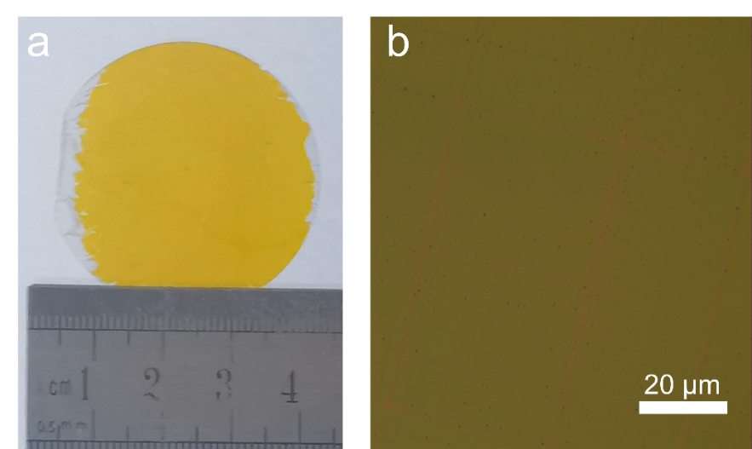
Figure S1. (a, b) The photograph and optical microscopy image of CsPbBr₃ that was grown on a mica wafer.

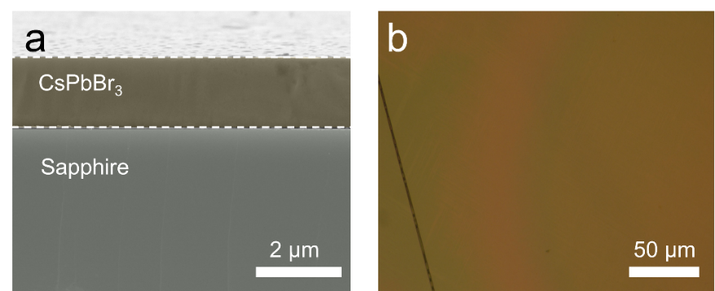
Figure S2. The cross-section SEM image (a) and optical microscopy image (b) of CsPbBr₃ that was grown on a sapphire substrate.

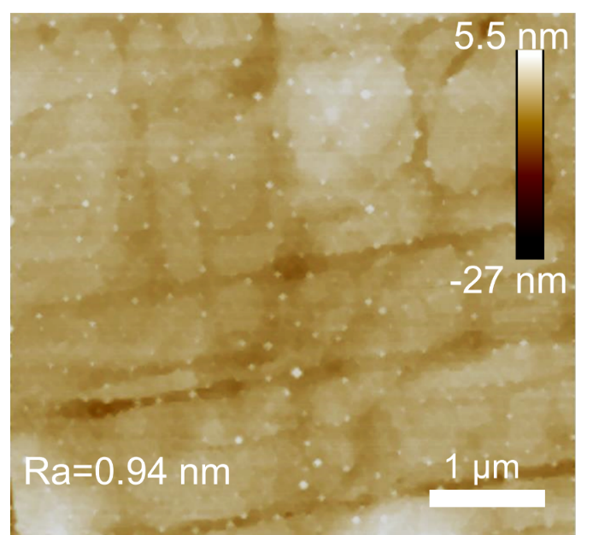
Figure S3. AFM image of the CsPbBr₃ wafer.

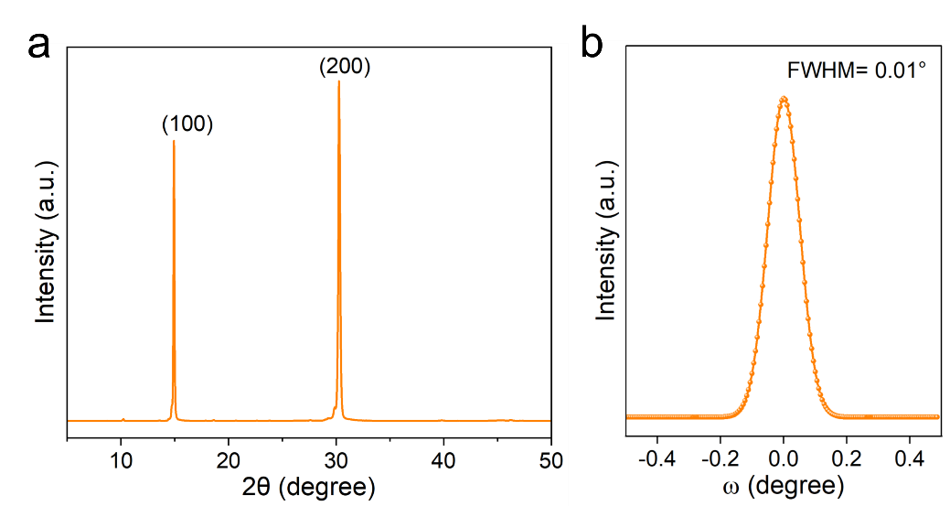
Figure S4. (a) The out-of-plane XRD of CsPbBr₃ film, (b) The XRD ω-scan rocking curve of CsPbBr₃ film.

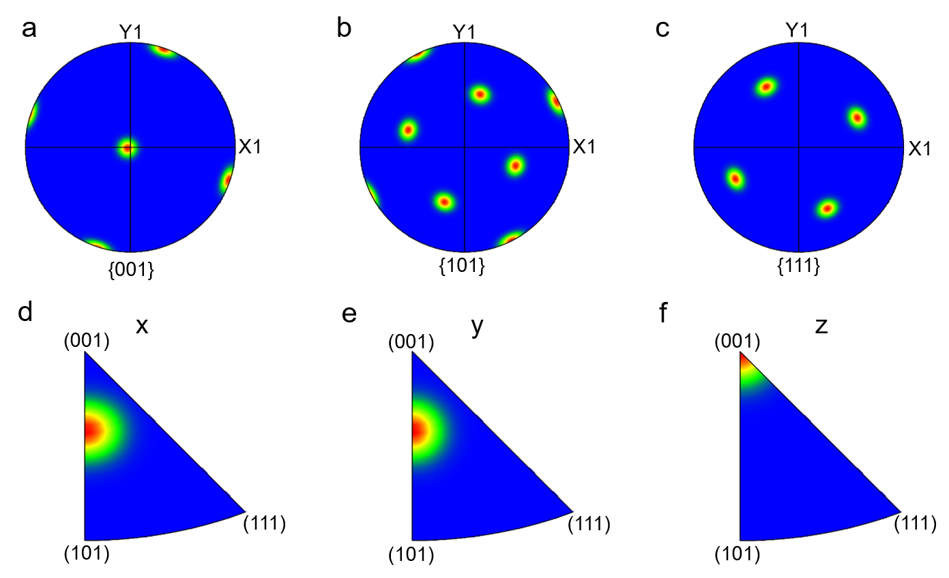
Figure S5. (a-c) EBSD pole image of CsPbBr₃ film with the projection along. (d-f) EBSD inverse pole image of CsPbBr₃ film with the projection along x, y, and z axis.

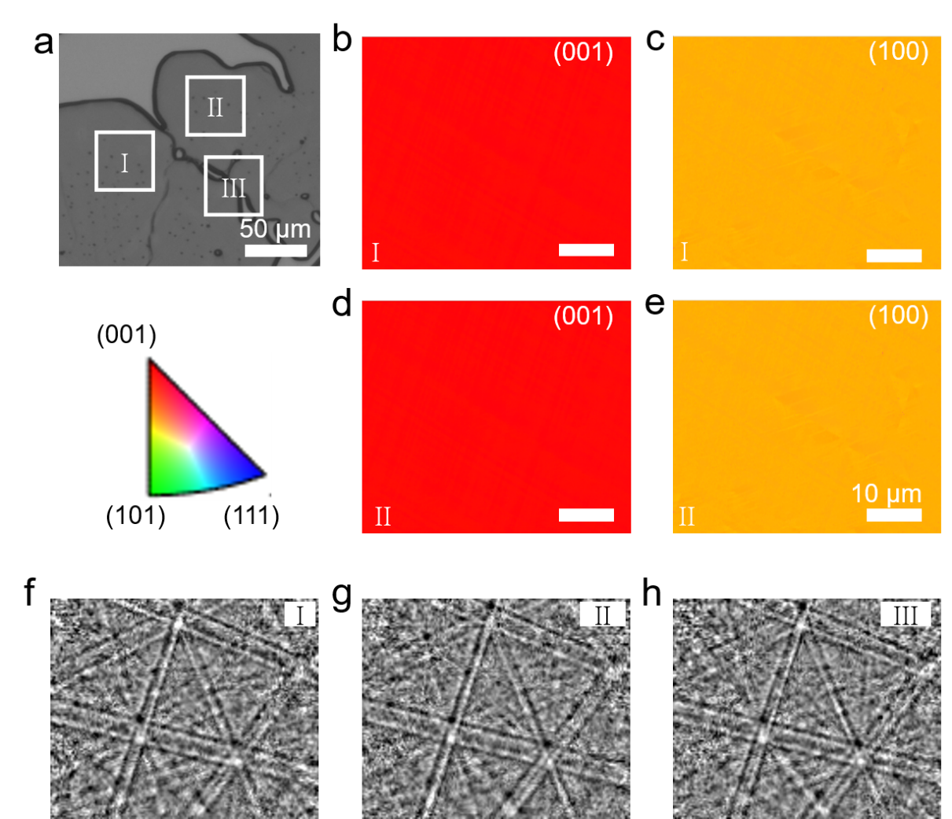
Figure S6. (b, c) EBSD mapping image of CsPbBr₃ film along (001) and (100).

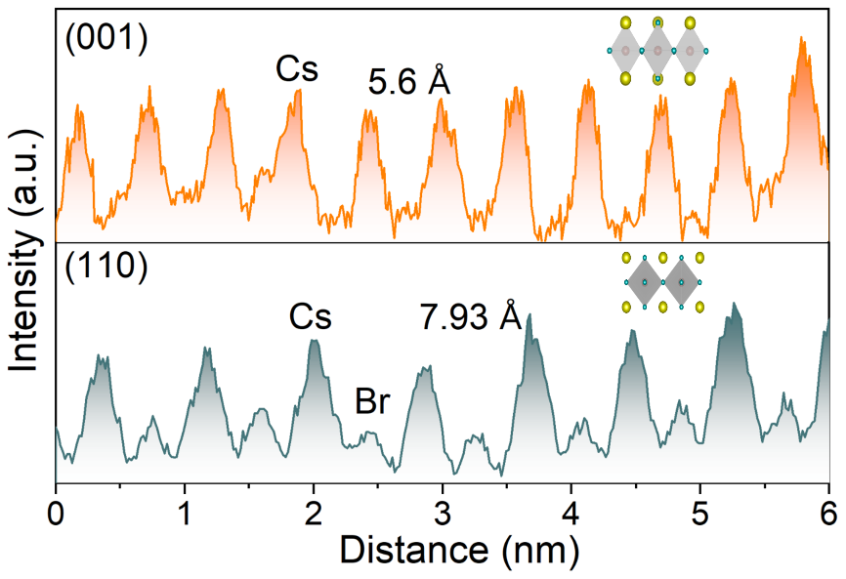
Figure S7. TEM profile images of the CsPbBr₃ single crystal film.

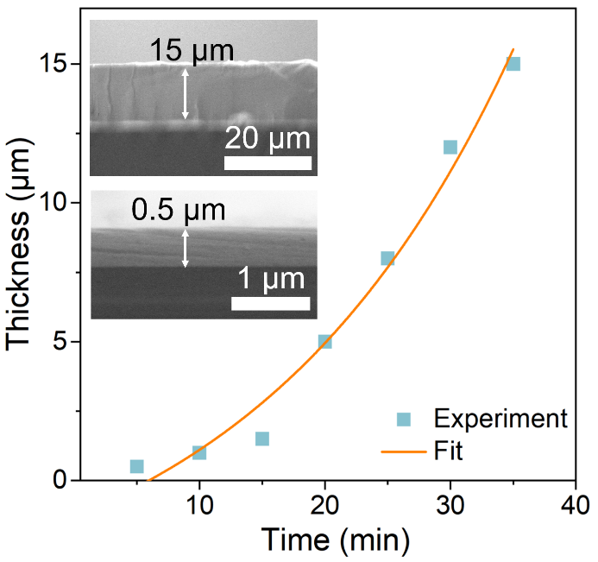
Figure S8. The thickness statistics and fitting of the film grown over a time range from 5 to 35 minutes, the insert is the SEM cross-section image of the film.
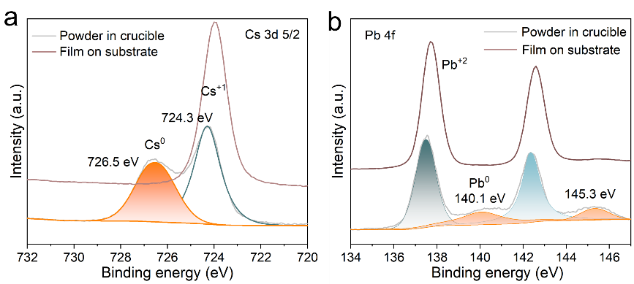
Figure S9. XPS spectrum images of the quenched film on the substrate and precursor powder in the crucible.

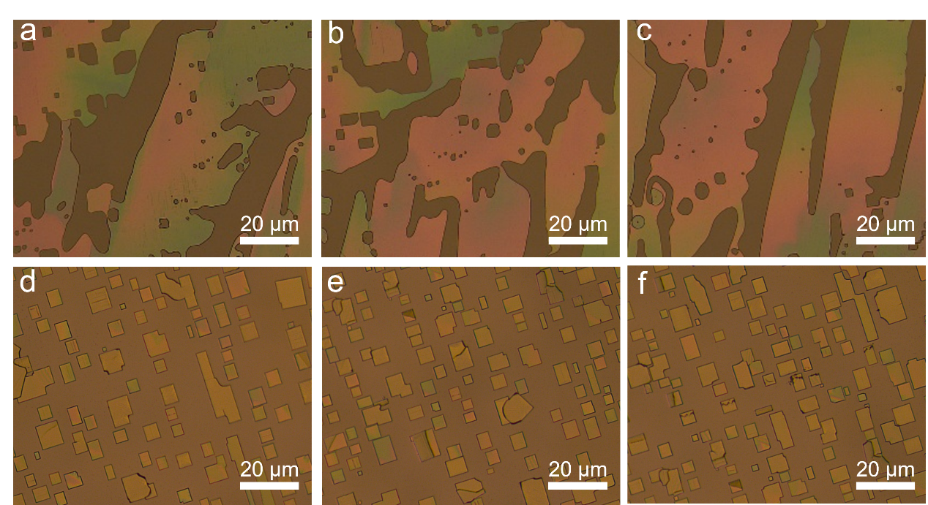
Figure S10. Optical microscopy images of substrates at different positions during the nucleation stage: (a-c) vapor-liquid-solid pathway, (d-f) vapor-solid pathway.

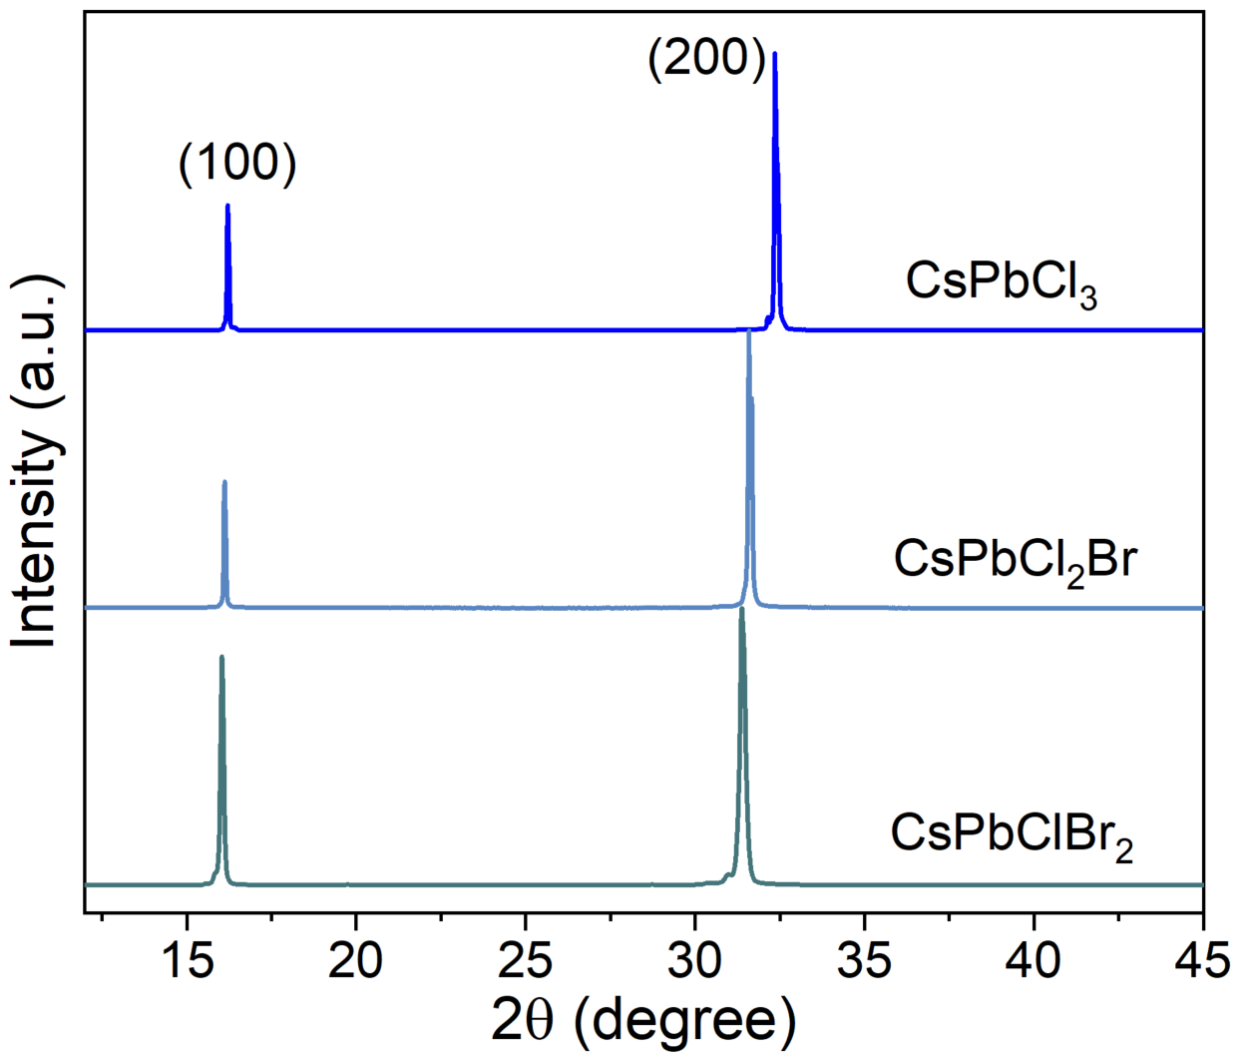
Figure S11. XRD patterns of the CsPbCl₃, CsPbCl₂Br, and CsPbClBr₂ single crystal wafers.

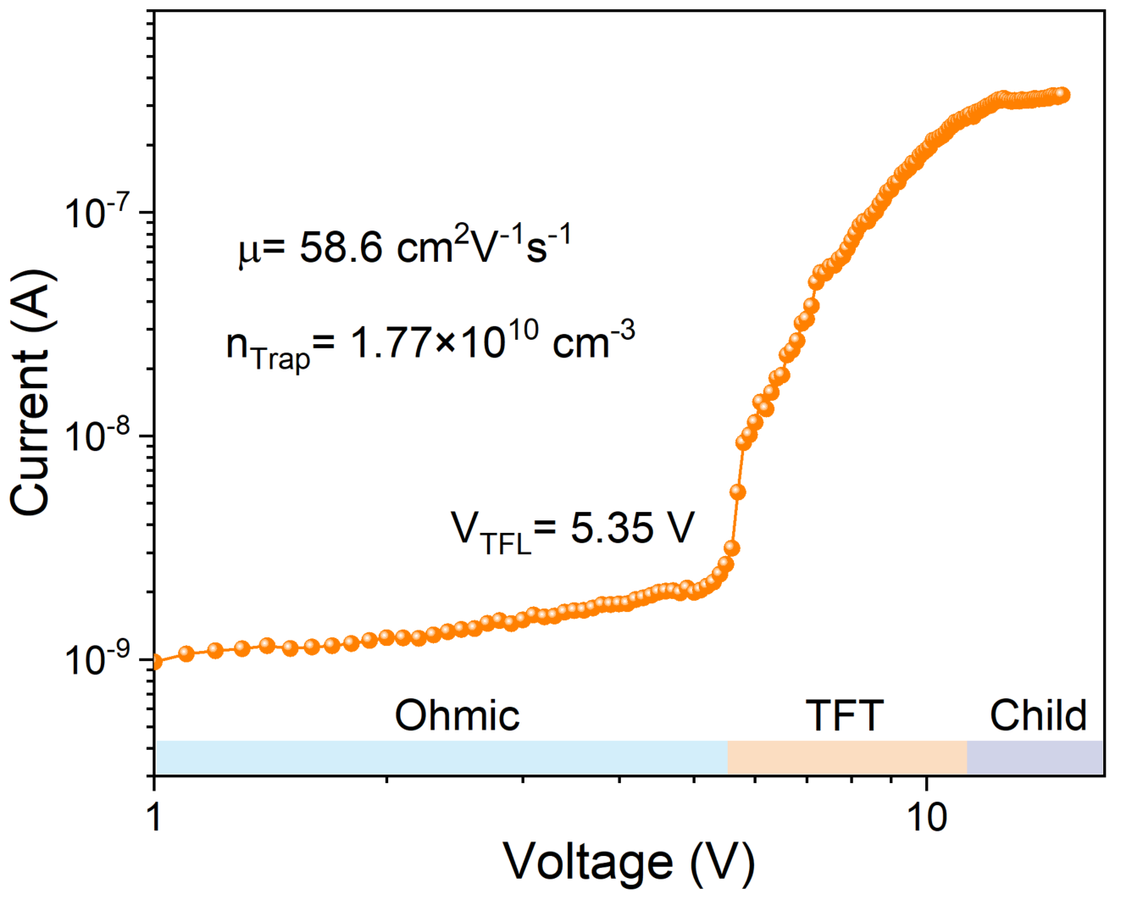
Figure S12. SCLC current-voltage characteristic curve of perovskite with the Au/CsPbBr₃/Au lateral structure devices.

Wavelength | τ₁ | τ₂ | τ₃
490 nm | 20.36 | 119.84 | 1458.67
520 nm | 3.83 | 49.84 | 721.35
550 nm | 127.88 | 21.75 | 1239.60
700 nm | 799.42 | 53.78 | 8.42
Table S1. The triple-exponential fitting of the transient absorption lifetime at different wavelengths.

References
[1] J. H. v. t. Hoff. The role of osmotic pressure in the analogy between solutions and gases. J. Membr. Sci. 1995, 100: 39-44.
[2] C. Li; R. Signorell. Understanding vapor nucleation on the molecular level: A review. J. Aerosol Sci. 2021, 153: 105676.
[3] H. Suzuki; R. Hashimoto; M. Misawa; Y. Liu; M. Kishibuchi; K. Ishimura; K. Tsuruta; Y. Miyata; Y. Hayashi. Surface Diffusion-Limited Growth of Large and High-Quality Monolayer Transition Metal Dichalcogenides in Confined Space of Microreactor. ACS nano 2022, 16: 11360-11373.
[4] S. Yuan; L. Dai; Y. Sun; F. Auras; Y.-H. Zhou; R.-Z. An; Y. Liu; C. Ding; C. Cassidy; X. Tang; S.-C. Dong; H.-B. Kang; K. Chen; X. Liu; Z.-F. Ye; Y. Zhao; C. Adachi; L.-S. Liao; N. C. Greenham; Y. Qi; S. D. Stranks; L.-S. Cui; R. H. Friend. Efficient blue electroluminescence from reduced-dimensional perovskites. Nat. Photon. 2024, 18: 425-431.
[5] D. Shi; V. Adinolfi; R. Comin; M. J. Yuan; E. Alarousu; A. Buin; Y. Chen; S. H. Rothenberger; K. Katsiev; Y. Losovyj; X. Zhang; P. A. Dowben; O. F. Mohammed; E. H. Sargent; O. M. Bakr. Low trap-state density and long carrier diffusion in organolead trihalide perovskite single crystals. Science 2015, 347: 519-522.

