SUPPLEMENTARY MATERIAL S1. Sampling completeness and model diagnostics
Supplementary Information
Article title: Resource and landscape-scale habitat availability shape insectivorous bat assemblages in a high-altitude Andean city
Journal: Urban Ecosystems
Authors: Stephanie Torrico-Paz, Isabel Moya, Luis F. Aguirre, and Luis F. Pacheco
Corresponding author: Stephanie Torrico-Paz
Affiliation: Carrera de Biología, Facultad de Ciencias Puras y Naturales, Universidad Mayor de San Andrés, La Paz, Bolivia
Email: s.torrico.paz92@gmail.com

S1.1 Sampling completeness
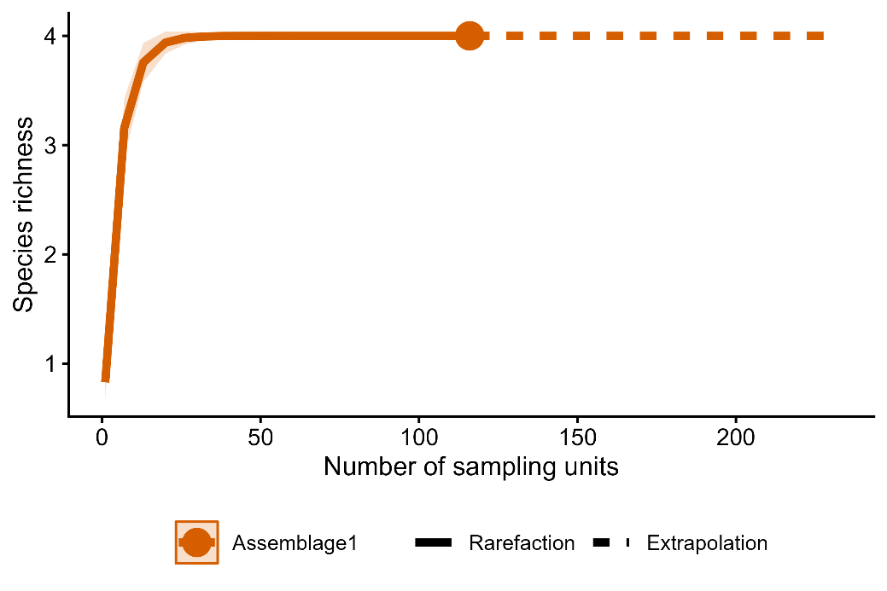
Fig. S1.1 Incidence-based rarefaction and extrapolation curve for the acoustically detectable insectivorous bat assemblage in La Paz. The solid line represents rarefaction based on incidence data, the dashed line represents extrapolation to twice the observed sampling effort, and the shaded area indicates the 95% confidence interval. The filled circle represents the observed sampling effort (116 sampling units). Sample coverage reached 1.00 at the observed effort and remained unchanged under extrapolation, indicating high completeness of the assemblage detectable under the survey protocol.

S1.2 Bat richness models
S1.2.1 Habitat availability scale-selection diagnostics
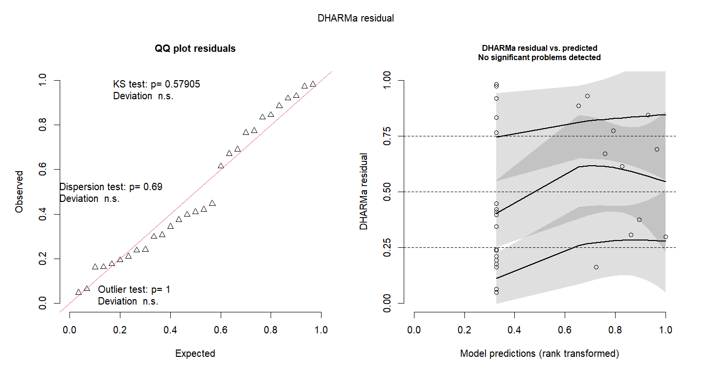
Fig. S1.2.1a Residual diagnostic plots for the habitat-availability scale-selection models for species richness. Models represent habitat availability within the local 4-ha sampling site. Diagnostic plots show DHARMa quantile residuals and residuals against model predictions.

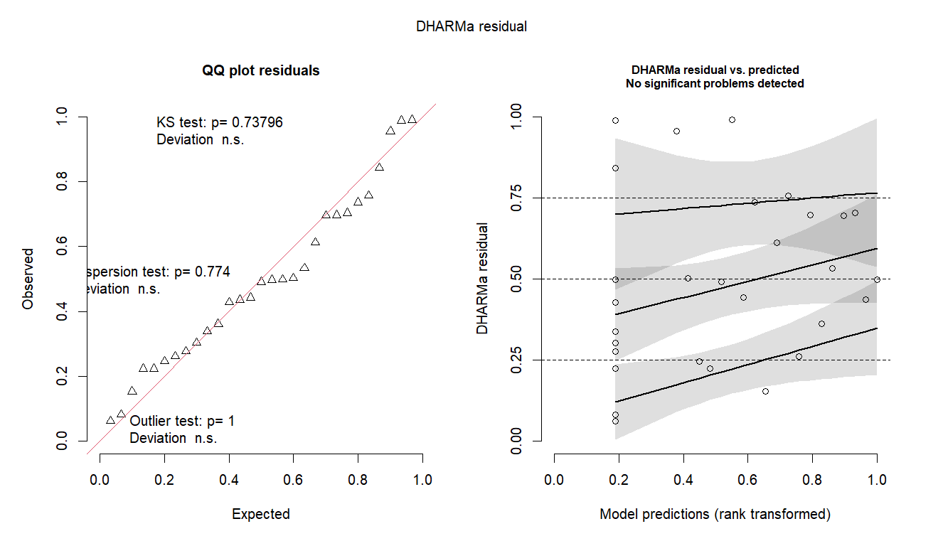 Fig. S1.2.1b Residual diagnostic plots for the habitat-availability scale-selection models for species richness. Models represent habitat within 200-m landscape buffers. Diagnostic plots show DHARMa quantile residuals and residuals against model predictions.

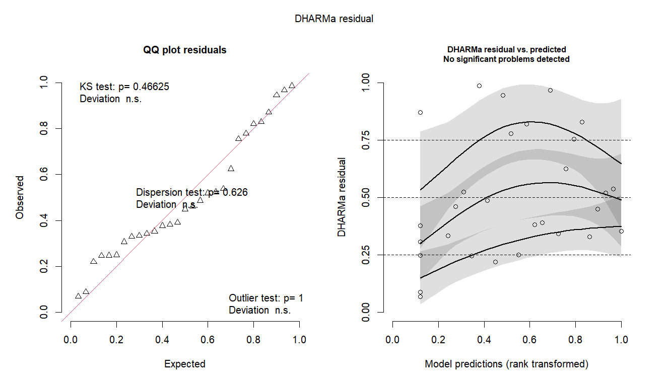
Fig S1.2.1c Residual diagnostic plots for the habitat-availability scale-selection models for species richness. Models represent habitat availability within 500-m landscape buffers. Diagnostic plots show DHARMa quantile residuals and residuals against model predictions.

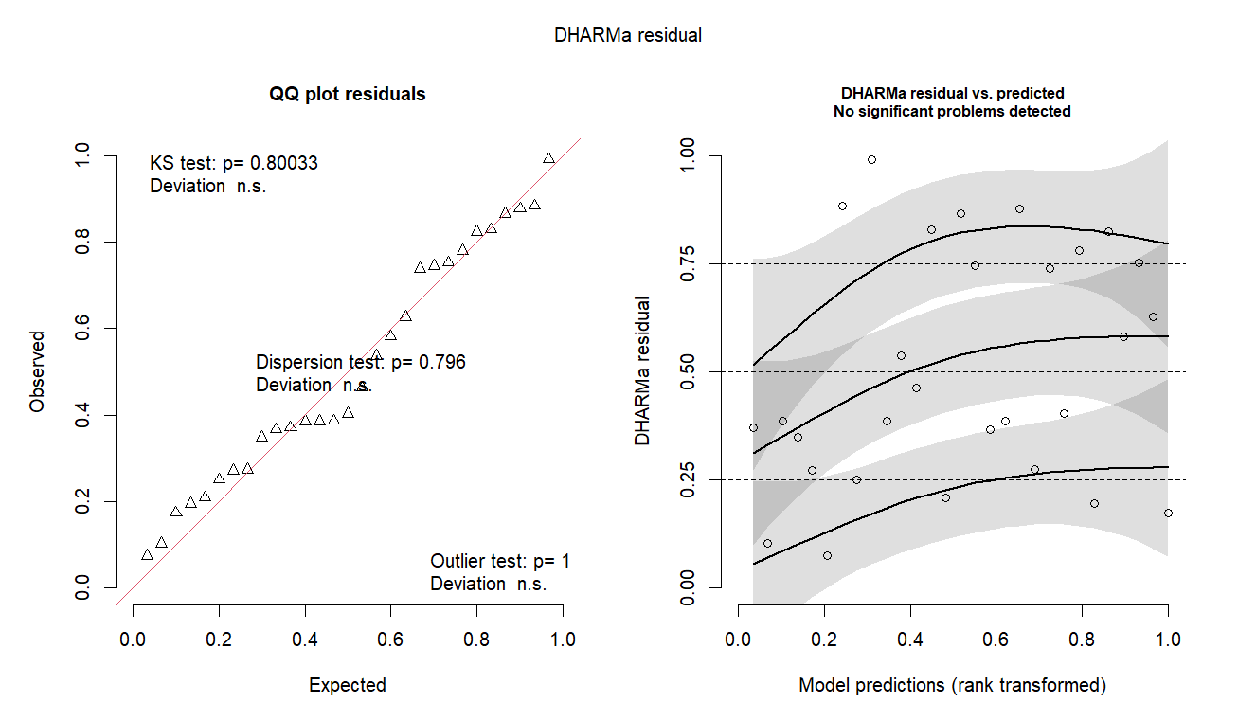
Fig S1.2.1d Residual diagnostic plots for the habitat-availability scale-selection models for species richness. Models represent habitat availability within 1,000-m landscape buffers. Diagnostic plots show DHARMa quantile residuals and residuals against model predictions.
Table S1.2.1 DHARMa residual diagnostics for the scale selection model for bat richness. Reported diagnostics include the Kolmogorov–Smirnov statistic (KS D) and p-value (KS p), dispersion ratio and dispersion p-value, and zero ratio and zero-inflation p-value. Models were evaluated at the local scale and at 200, 500, and 1,000 m spatial scales.
Response | Scale | KS D | KS p | Dispersion ratio | Dispersion p | Zero ratio | Zero-inflation p
Richness | Local | 0.139 | 0.579 | 1.080 | 0.690 | 1.374 | 0.370
Richness | 200 m | 0.122 | 0.738 | 0.864 | 0.774 | 1.229 | 0.572
Richness | 500 m | 0.152 | 0.466 | 0.808 | 0.626 | 1.175 | 0.708
Richness | 1,000 m | 0.115 | 0.800 | 0.873 | 0.796 | 1.157 | 0.744

S1.2.2 Hypothesis-model diagnostics
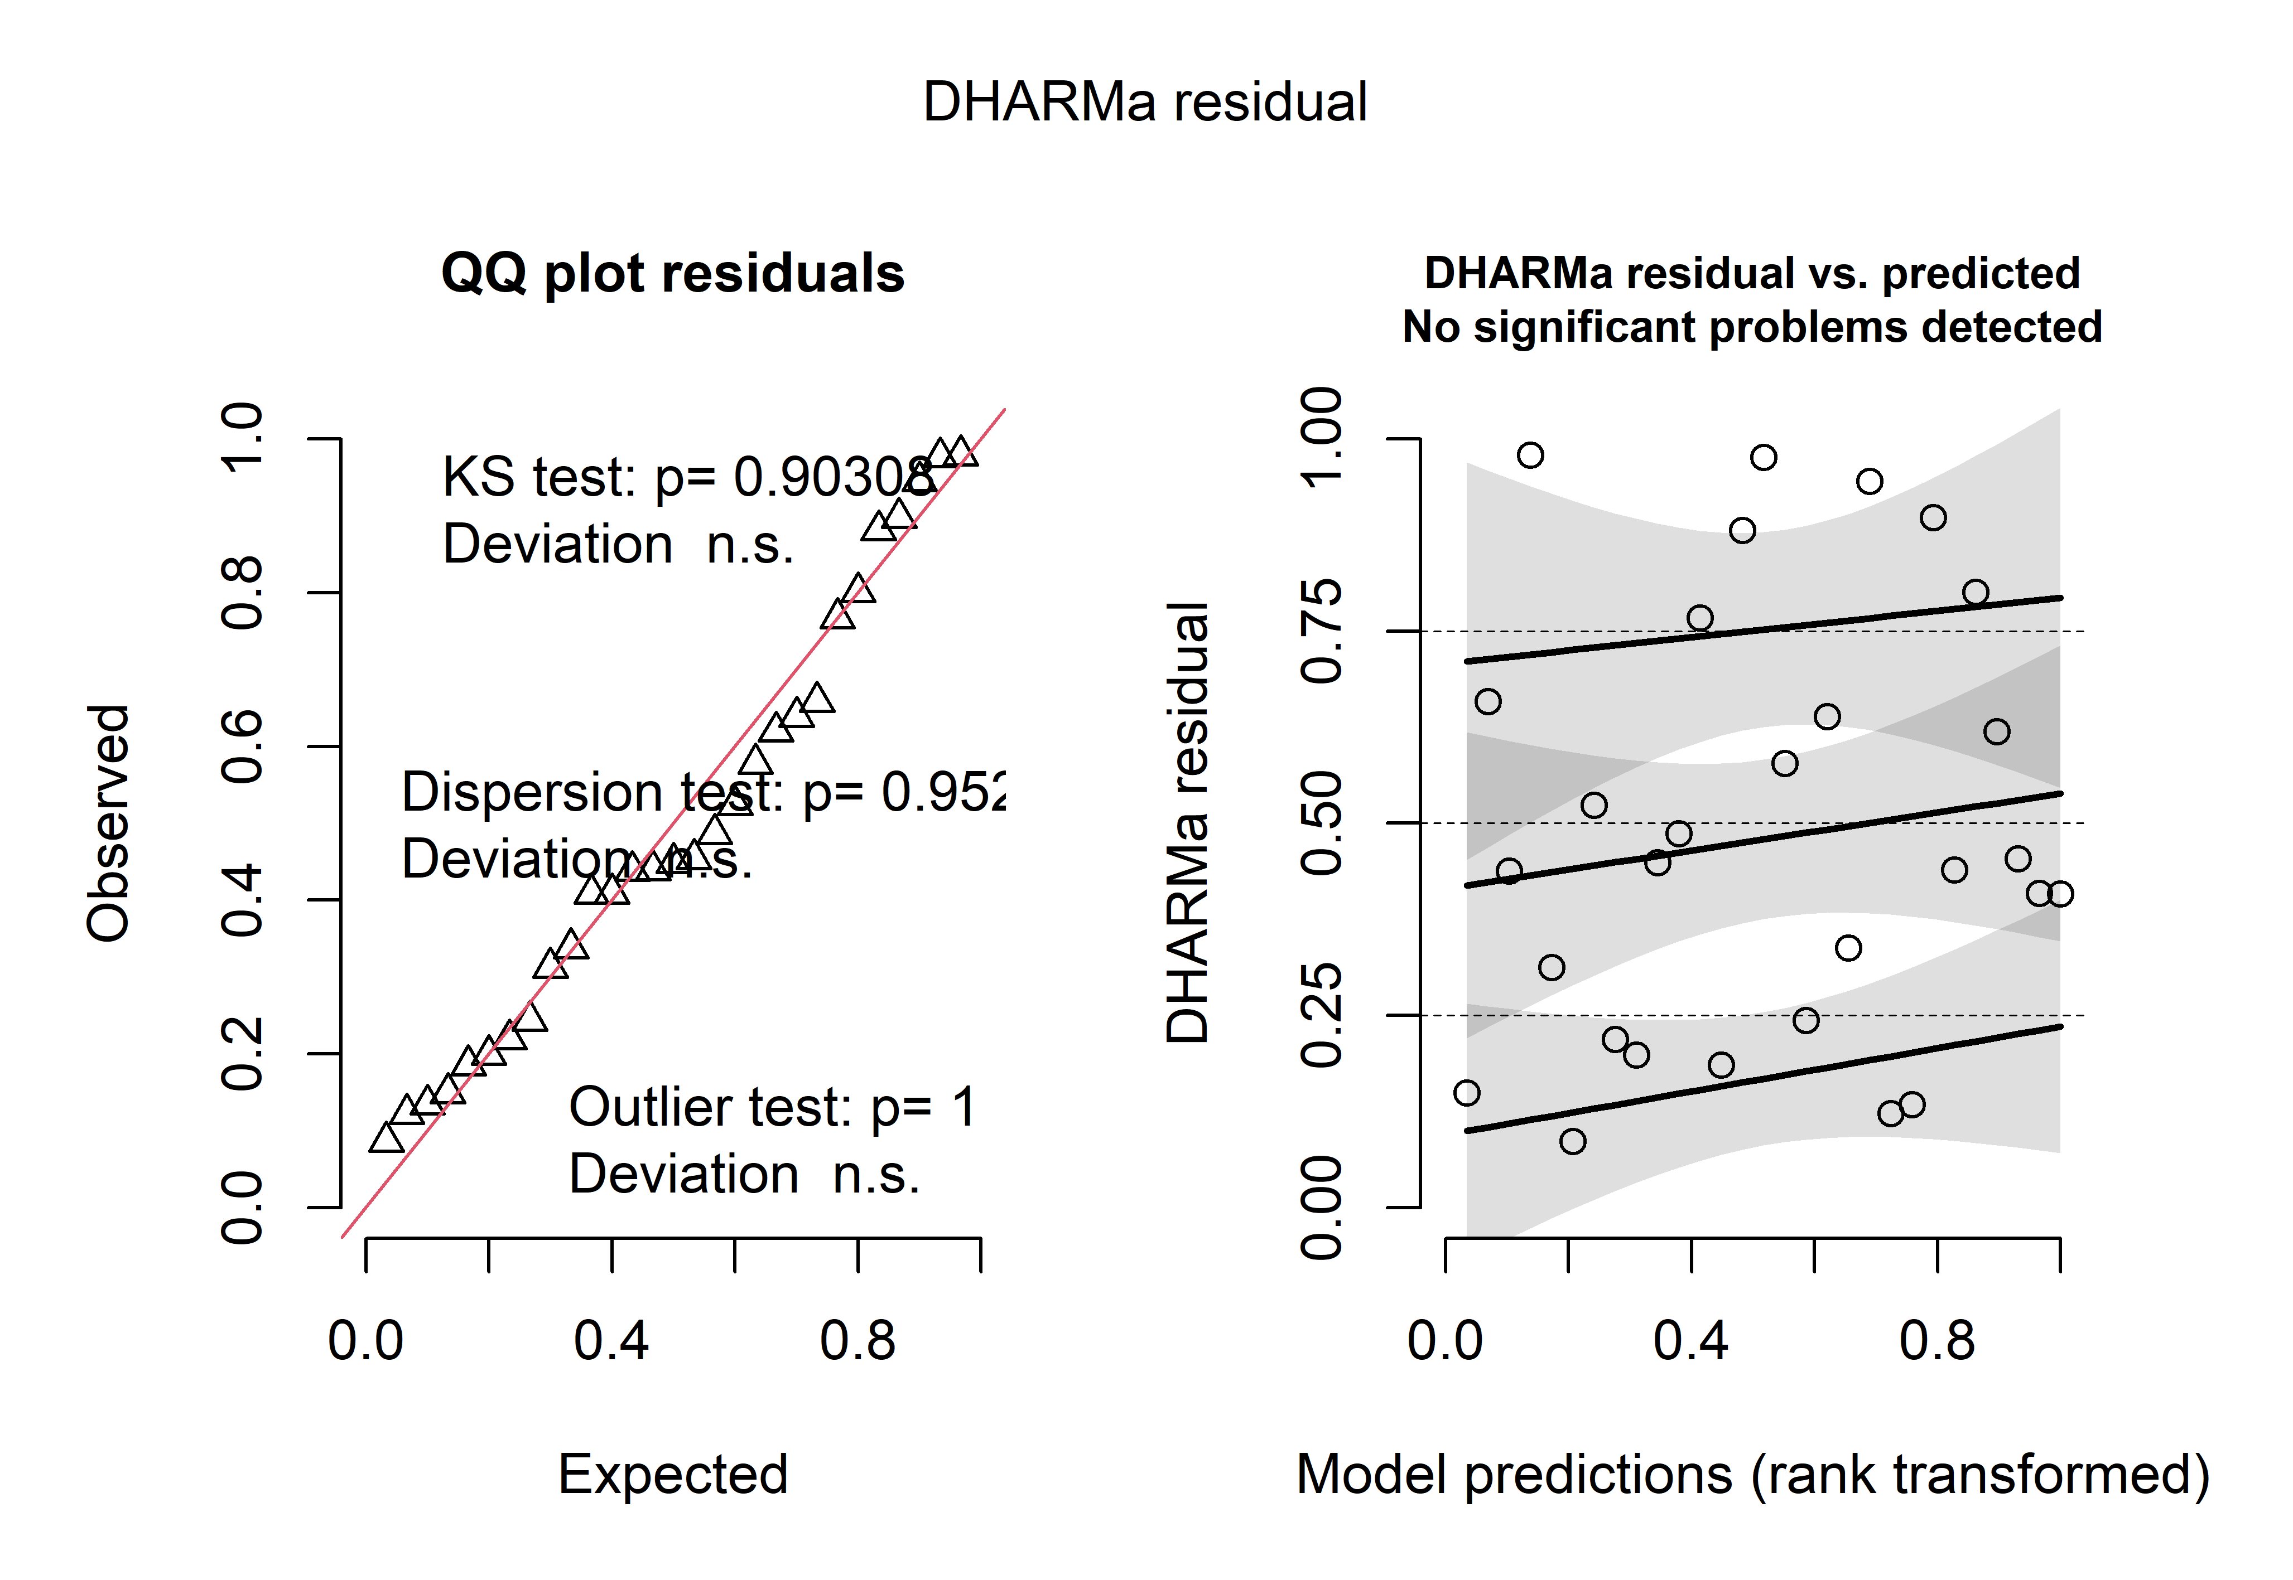 Fig. S1.2.2a. DHARMa residual diagnostics for the richness Local model. The left panel shows the quantile–quantile plot of simulated residuals, including tests for uniformity, dispersion, and outliers. The right panel shows residuals against model predictions to assess potential systematic patterns in residual distribution.

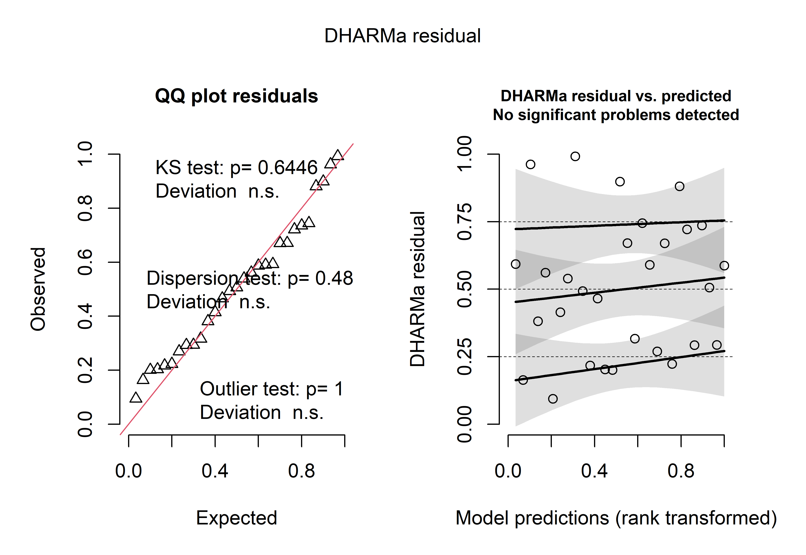 Fig. S1.2.2b. DHARMa residual diagnostics for the richness Landscape model. The left panel shows the quantile–quantile plot of simulated residuals, including tests for uniformity, dispersion, and outliers. The right panel shows residuals against model predictions to assess potential systematic patterns in residual distribution.

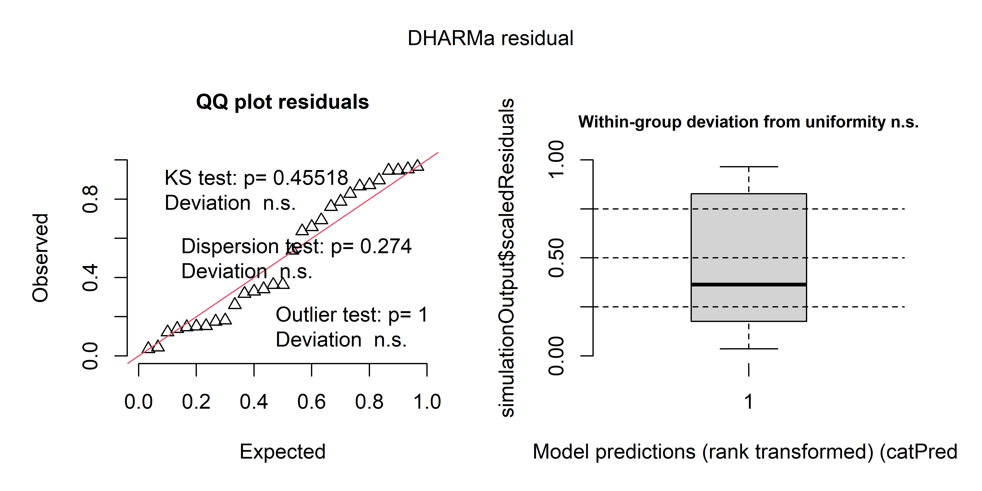 Fig. S1.2.2c DHARMa residual diagnostics for the richness Null model. The left panel shows the quantile–quantile plot of simulated residuals, including tests for uniformity, dispersion, and outliers. The right panel shows residuals against model predictions to assess potential systematic patterns in residual distribution.

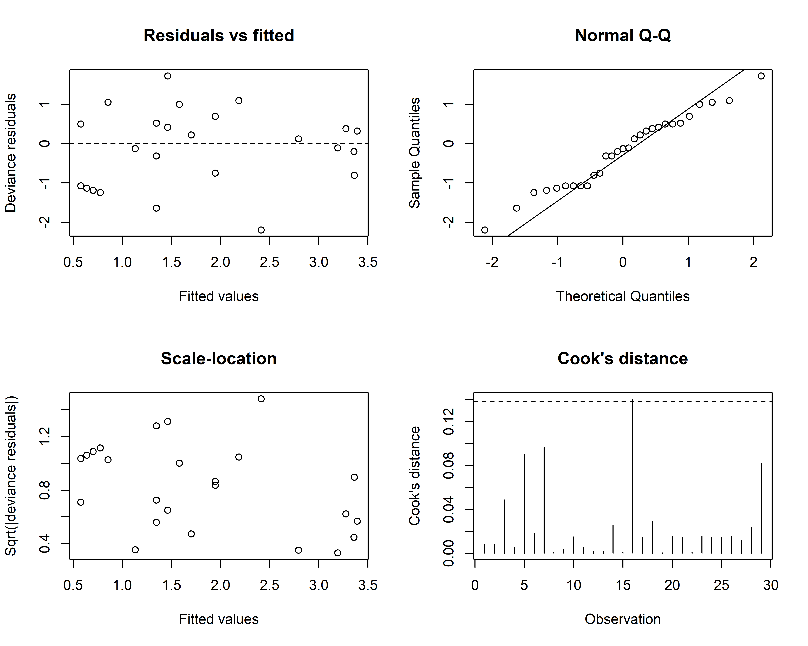
Fig. S1.2.2d Diagnostic plots for the richness GAM under the Resource model. Panels show deviance residuals versus fitted values, a Q–Q plot, a scale–location plot, and Cook’s distance. The dashed line indicates the exploratory Cook’s distance threshold (4/n).

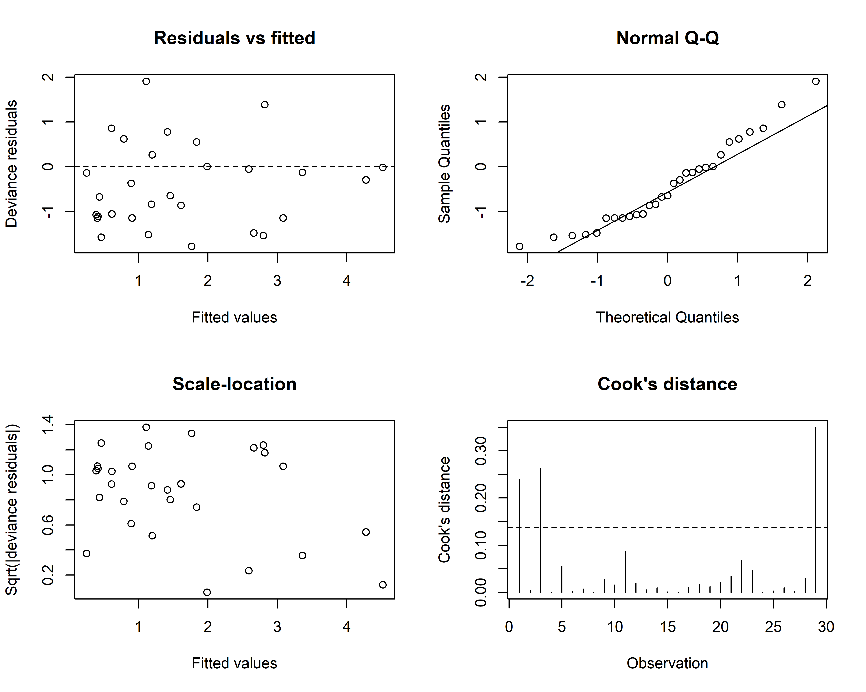
Fig S1.2.2e Diagnostic plots for the richness GAM under the Complete model. Panels show deviance residuals versus fitted values, a Q–Q plot, a scale–location plot, and Cook’s distance. The dashed line indicates the exploratory Cook’s distance threshold (4/n).

Table S1.2.2a. Residual diagnostics for the richness Local, Landscape, and Null models. Diagnostic metrics include the Pearson dispersion ratio and overdispersion test, DHARMa residual uniformity (Kolmogorov–Smirnov test), DHARMa dispersion, zero inflation, and outlier tests. Potentially influential observations were identified using Cook’s distance, with values greater than 4/n considered potentially influential.
Model | Pearson dispersion ratio | Overdispersion p | DHARMa  KS D | KS p | DHARMa dispersion ratio | DHARMa dispersion p | Zero ratio | Zero-inflation p | Outlier p | Influential observations (Cook > 4/n)
Local | 1.160 | 0.261 | 0.101 | 0.903 | 0.941 | 0.952 | 1.190 | 0.666 | 1.000 | Strongest (0.578)
Landscape | 1.136 | 0.287 | 0.132 | 0.645 | 0.746 | 0.480 | 1.068 | 0.962 | 1.000 | Codavisa (0.223); Aranjuez (0.191); Callapa (0.239)
Null | 1.296 | 0.135 | 0.154 | 0.455 | 1.316 | 0.274 | 1.561 | 0.220 | 1.000 | None

Table S 1.2.2b Model diagnostic statistics for the Resource and Complete richness models. Effective degrees of freedom (edf), basis-dimension diagnostic (k-index and associated p-value), Pearson dispersion ratio, and Cook’s distance diagnostics are shown for each model. The Cook’s distance threshold was calculated as 4/n; observations exceeding this threshold are listed together with their Cook’s distance values.
Model | edf | k-index | k-check p | Pearson dispersion ratio | Cook threshold | Influential observations (Cook > 4/n)
Resource | 2.17 | 0.87 | 0.260 | 0.783 | 0.138 | Lipari (0.141)
Complete | 1.91 | 0.70 | 0.065 | 0.842 | 0.138 | Strongest (0.165); Callapa (0.176)

S1.3. Total acoustic activity models
S1.3.1 Habitat availability scale-selection diagnostics
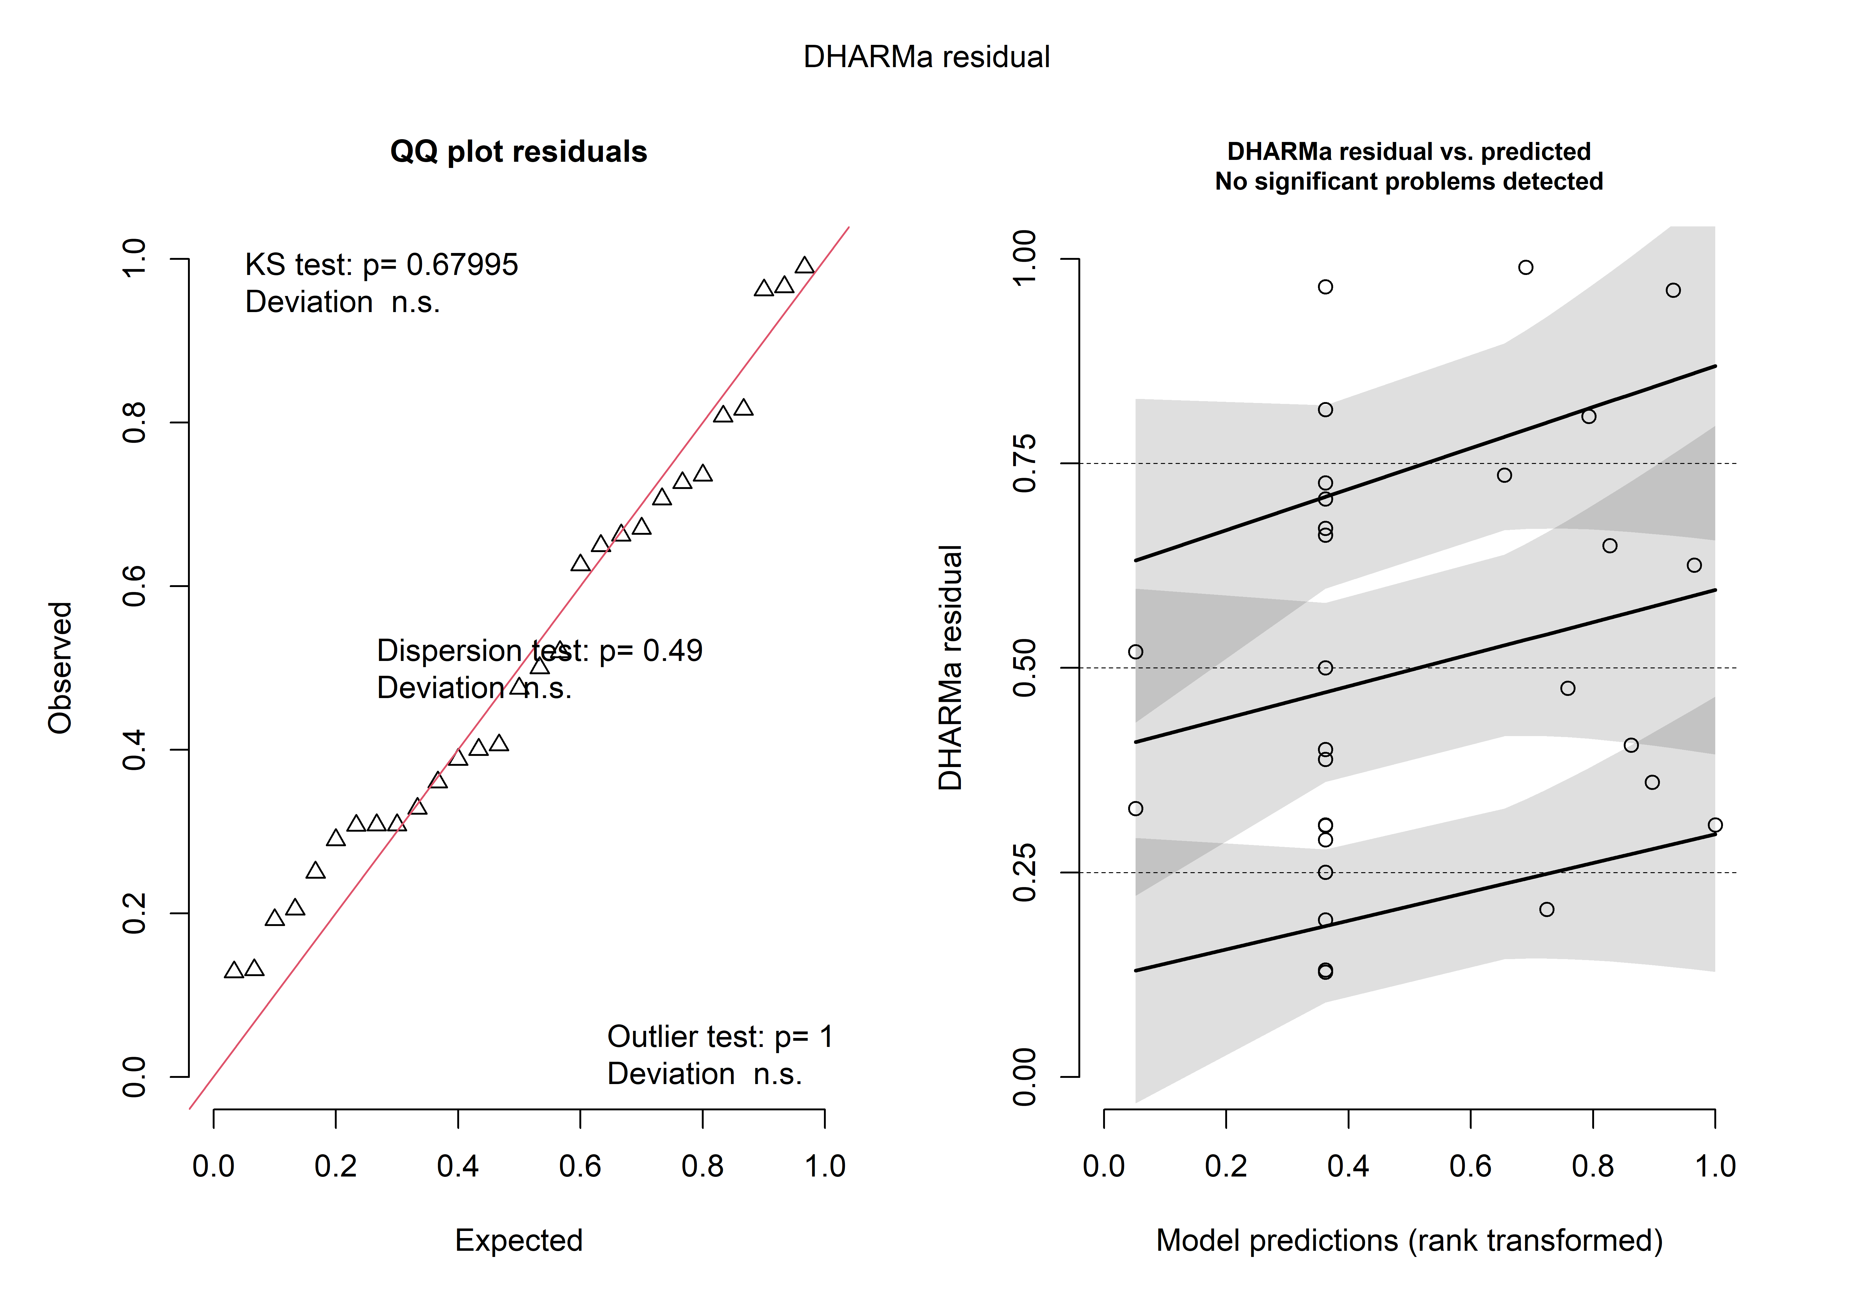
Fig. S1.3.1a DHARMa residual diagnostics for the habitat local-scale negative binomial model of total acoustic activity. The left panel shows the quantile–quantile plot of simulated residuals, including tests of residual uniformity, dispersion, and outliers. The right panel shows simulated residuals against model-predicted values.
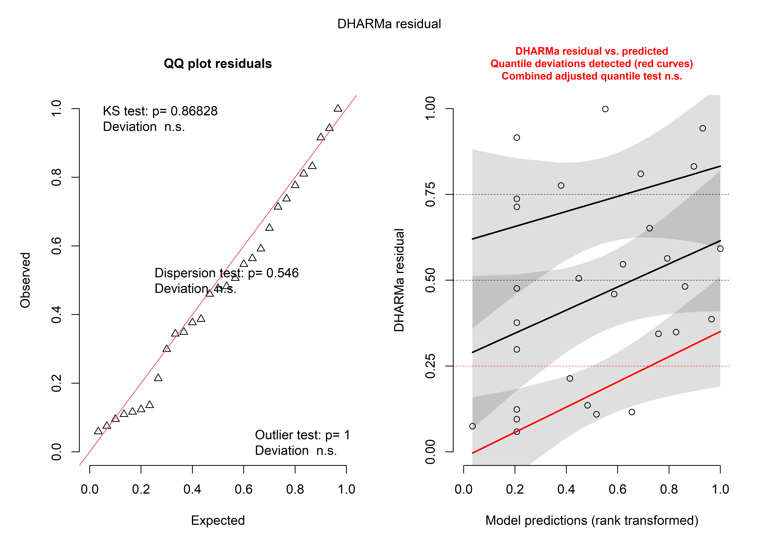
Fig.S1.3.1b DHARMa residual diagnostics for the 200 m habitat-scale negative binomial model of total acoustic activity. The left panel shows the quantile–quantile plot of simulated residuals, including tests of residual uniformity, dispersion, and outliers. The right panel shows simulated residuals against model-predicted values.

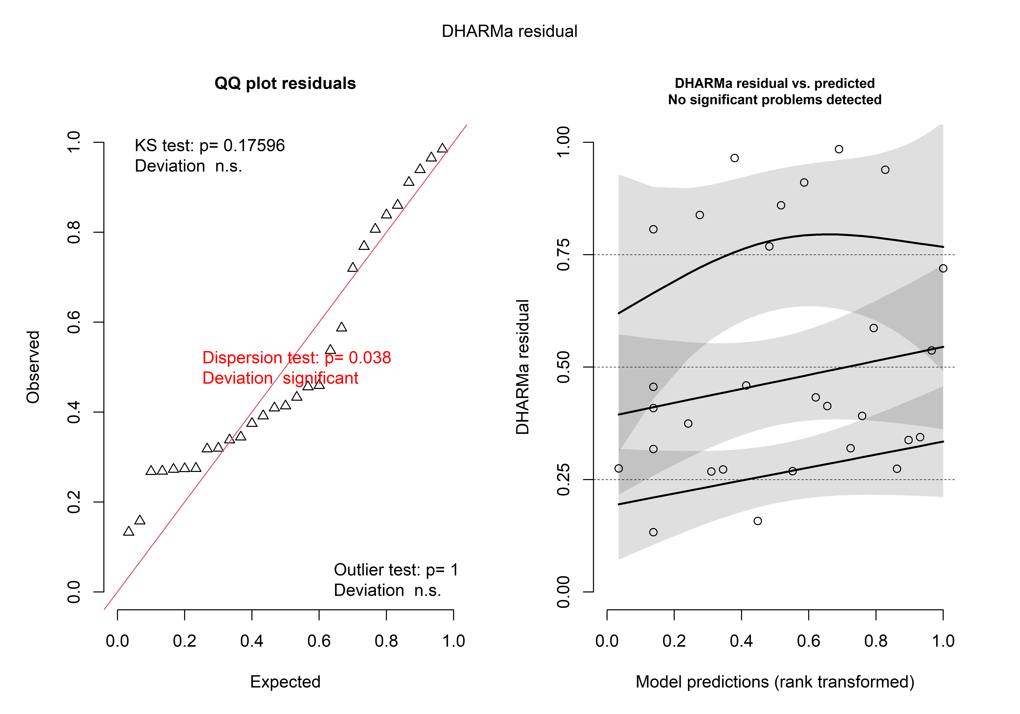
Fig.S1.3.1c DHARMa residual diagnostics for the 500 m habitat-scale negative binomial model of total acoustic activity. The left panel shows the quantile–quantile plot of simulated residuals, including tests of residual uniformity, dispersion, and outliers. The right panel shows simulated residuals against model-predicted values.
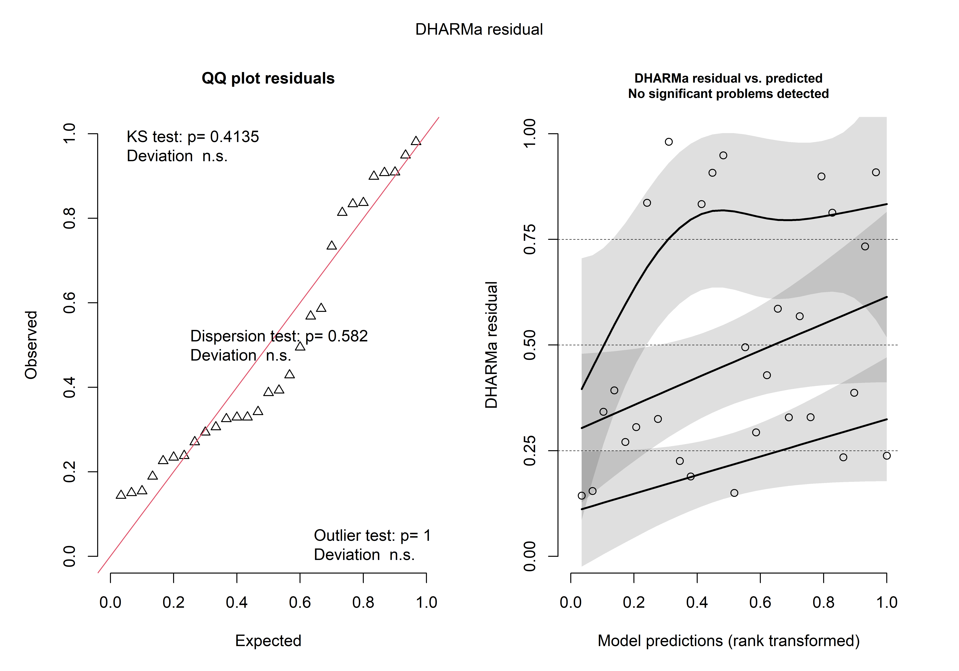 Fig.S1.3.1d DHARMa residual diagnostics for the 1,000 m habitat-scale negative binomial model of total acoustic activity. The left panel shows the quantile–quantile plot of simulated residuals, including tests of residual uniformity, dispersion, and outliers. The right panel shows simulated residuals against model-predicted values.
Table S1.3.1. Residual and influence diagnostics for the habitat-availability scale-selection models of total acoustic activity. The table summarizes overdispersion diagnostics, DHARMa residual uniformity (Kolmogorov–Smirnov test), DHARMa dispersion, zero-inflation and outlier tests, Pearson dispersion ratio, and potentially influential observations identified using Cook’s distance. Observations exceeding the threshold of 4/n are listed with their corresponding Cook’s distance values. The 500 m model showed evidence of underdispersion in both the overdispersion check and DHARMa dispersion test; therefore, the 1,000 m habitat-availability model was retained for subsequent analyses.
Scale | Overdispersion ratio | Overdispersion p | KS D | KS p | DHARMa dispersion ratio | DHARMa dispersion p | Zero ratio | Zero-inflation p | Outlier p | Pearson dispersion ratio | Influential observations (Cook > 4/n)
Local | 0.166 | 0.424 | 0.128 | 0.680 | 0.205 | 0.490 | 0.968 | 1.000 | 1.000 | 1.090 | Ciudadela (0.249); Auquisamana (0.178); Zoo (0.220); Lipari (0.300)
200 m | 0.618 | 0.568 | 0.106 | 0.868 | 0.675 | 0.546 | 1.018 | 1.000 | 1.000 | 1.583 | Ciudadela (0.877); Lipari (0.341)
500 m | 0.040 | 0.032 | 0.199 | 0.176 | 0.035 | 0.038 | 1.081 | 0.906 | 1.000 | 0.916 | Ciudadela (0.188)
1,000 m | 0.597 | 0.568 | 0.159 | 0.414 | 0.527 | 0.582 | 1.066 | 0.940 | 1.000 | 0.896 | Lipari (0.168); Callapa (0.307)

S1.3.2 Hypothesis-model diagnostics

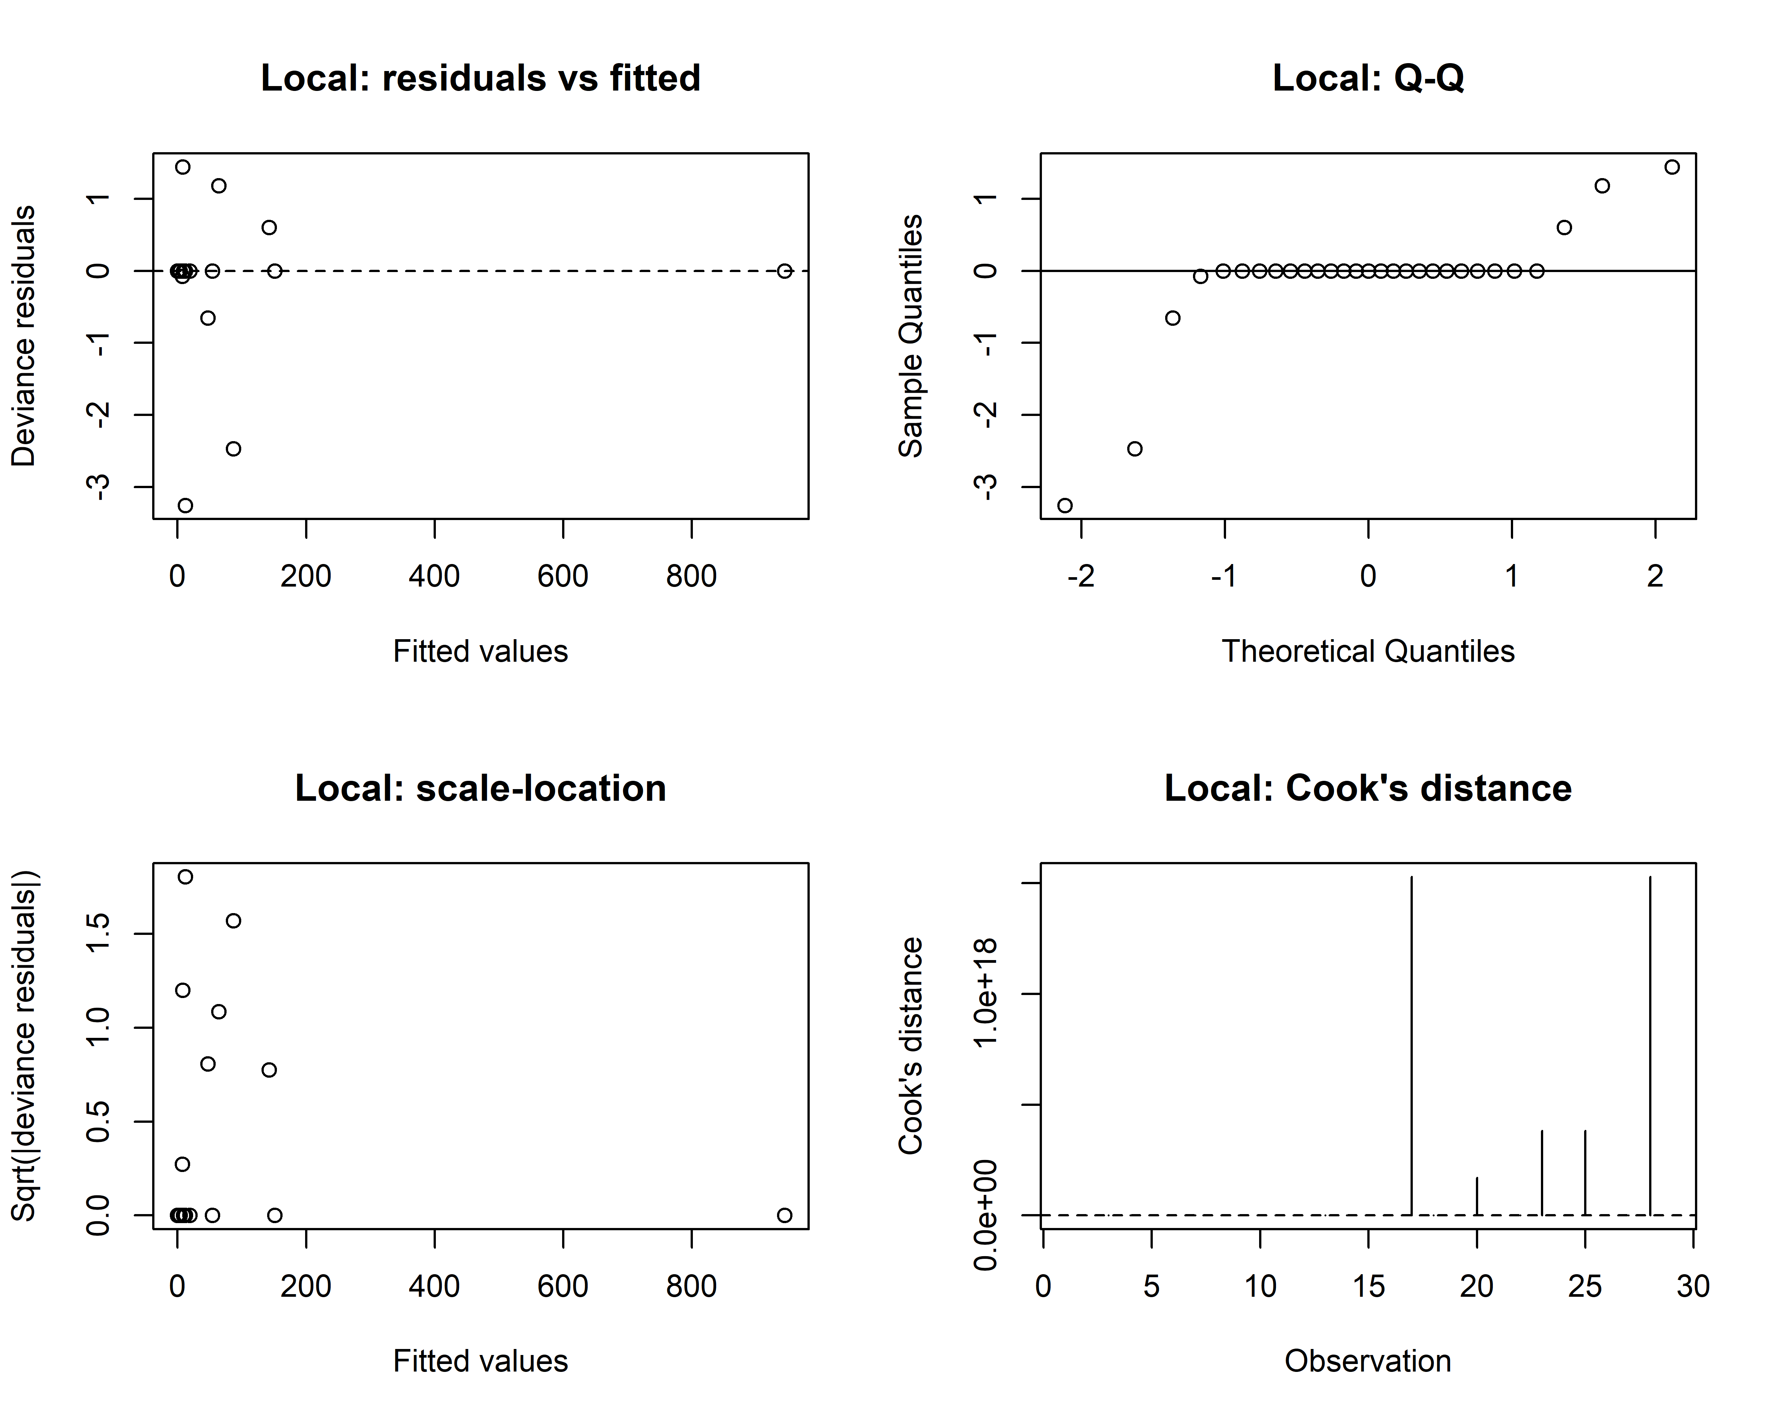 Fig. S1.3.2a. Diagnostic plots for the local-model negative binomial model of total acoustic activity. Residuals versus fitted values, normal Q–Q plot, scale–location plot, and Cook’s distance are shown to assess model fit, residual structure, heteroscedasticity, and influential observations.

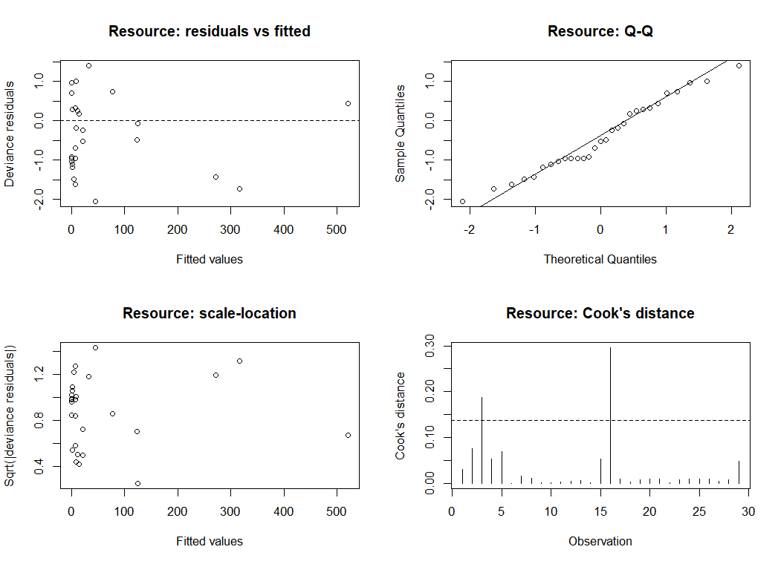
Fig. S1.3.2b. Diagnostic plots for the Resource negative binomial model of total acoustic activity. Residuals versus fitted values, normal Q–Q plot, scale–location plot, and Cook’s distance are shown to assess model fit, residual structure, heteroscedasticity, and influential observations.

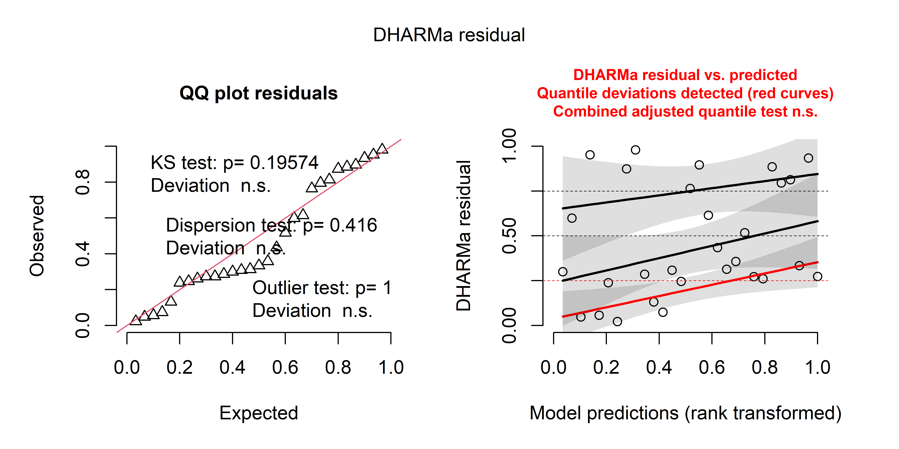
Fig. S1.3.2c DHARMa residual diagnostics for the landscape-scale model of total acoustic activity. The left panel shows the quantile–quantile plot of simulated residuals, including tests of residual uniformity, dispersion, and outliers. The right panel shows simulated residuals against model-predicted values, including quantile regression curves and the combined adjusted quantile test.

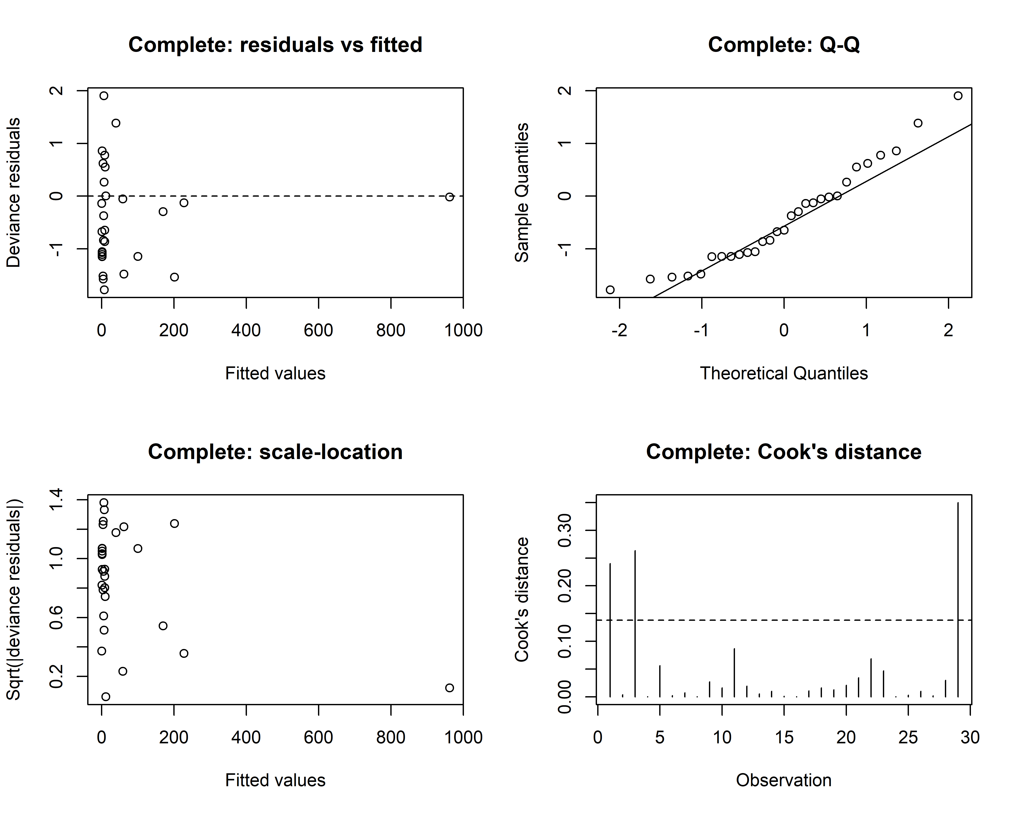
Fig. S1.3.2d. Diagnostic plots for the Complete negative binomial model of total acoustic activity. Residuals versus fitted values, normal Q–Q plot, scale–location plot, and Cook’s distance are shown to assess model fit, residual structure, heteroscedasticity, and influential observations.

Fig. S1.3.2e DHARMa residual diagnostics for the null model of total acoustic activity. The left panel shows the quantile–quantile plot of simulated residuals, including tests of residual uniformity, dispersion, and outliers. The right panel shows simulated residuals against model-predicted values, including quantile regression curves and the combined adjusted quantile test.
Model | Overdispersion ratio | Overdispersion p | DHARMa KS D | KS p | DHARMa dispersion ratio | DHARMa dispersion p | Zero ratio / expected zeros | Zero-inflation p | Outlier p | Influential observations (Cook > 4/n)
Landscape | 1.019 | 0.384 | 0.194 | 0.196 | 0.965 | 0.416 | 1.073 | 0.922 | 1.000 | Codavisa (0.211); Lipari (0.168); Callapa (0.246)
Null | 1.889 | 0.256 | 0.128 | 0.678 | 1.751 | 0.290 | 0.925 | 0.916 | 1.000 | Lipari (1.562)
Table S1.3.2a Diagnostic statistics for the landscape and null negative binomial models of total acoustic activity. The table summarizes overdispersion diagnostics, DHARMa residual uniformity (Kolmogorov–Smirnov test), dispersion, zero-inflation, and outlier tests, together with influential observations identified using Cook’s distance. Observations exceeding the threshold of 4/n are listed with their corresponding Cook’s distance values.

Table S1.3.2b. Model adequacy diagnostics for the local, resource, and complete models of total acoustic activity. The table summarizes smooth-term basis-dimension diagnostics (effective degrees of freedom, k-index, and k-check p-value), Pearson dispersion ratio, concurvity, and potentially influential observations identified using Cook’s distance. Observations exceeding the threshold of 4/n are listed with their corresponding Cook’s distance values. Dashes indicate diagnostics not applicable to models without smooth terms.
Model | edf | k-index | k-check p | Pearson dispersion ratio | Concurvity | Influential observations (Cook > 4/n)
Local | — | — | — | 1.654 | — | Strongest (0.394); Lipari (0.787)
Resource | 2.18 | 0.89 | 0.590 | 0.730 | Negligible | Ciudadela (0.188); Lipari (0.295)
Complete | 1.00 | 0.66 | 0.120 | 1.251 | High for parametric component; lower for smooth | Achumani (0.240); Ciudadela (0.263); Callapa (0.350)

S1.4. Myotis oxyotus models
S1.4.1 Habitat availability scale-selection diagnostics
Fig. S1.4.1a Diagnostic plots for the local-scale model of Myotis oxyotus acoustic activity. The panels show deviance residuals versus fitted values, a normal Q–Q plot of residuals, a scale–location plot, and Cook’s distance for individual observations. These diagnostics were used to evaluate residual structure, variance patterns, departures from normality, and potentially influential observations.
Fig. S1.4.1b Diagnostic plots for the 200 m-scale model of Myotis oxyotus acoustic activity. The panels show deviance residuals versus fitted values, a normal Q–Q plot of residuals, a scale–location plot, and Cook’s distance for individual observations. These diagnostics were used to evaluate residual structure, variance patterns, departures from normality, and potentially influential observations.

Fig. S1.4.1c Diagnostic plots for the 500 m-scale model of Myotis oxyotus acoustic activity. The panels show deviance residuals versus fitted values, a normal Q–Q plot of residuals, a scale–location plot, and Cook’s distance for individual observations. These diagnostics were used to evaluate residual structure, variance patterns, departures from normality, and potentially influential observations.
Fig. S1.4.1d Diagnostic plots for the 1,000 m-scale model of Myotis oxyotus acoustic activity. The panels show deviance residuals versus fitted values, a normal Q–Q plot of residuals, a scale–location plot, and Cook’s distance for individual observations. These diagnostics were used to evaluate residual structure, variance patterns, departures from normality, and potentially influential observations.
Table S1.4.1 Diagnostic summary for habitat-scale models of Myotis oxyotus acoustic activity. The table reports Pearson dispersion, observed zero counts, mean simulated zeros with 95% simulation intervals, and potentially influential observations identified using Cook’s distance (>4/n) for the local, 200 m, 500 m, and 1,000 m models.
Scale | Pearson dispersion | Observed zeros | Mean simulated zeros | 95% simulation interval | Influential observations (Cook > 4/n)
Local | 0.736 | 18 | 18.201 | 13–23 | Zoo (0.303)
200 m | 0.831 | 18 | 17.882 | 13–23 | Ciudadela (0.408); Lipari (0.165)
500 m | 1.014 | 18 | 17.930 | 13–23 | Cotacota (0.416)
1,000 m | 1.306 | 18 | 17.953 | 13–22 | Cotacota (0.629)

S1.4.2 Hypothesis-model diagnostics

Fig. S1.4.2a Diagnostic plots for the resource + space model of Myotis oxyotus acoustic activity. The panels show deviance residuals versus fitted values, a normal Q–Q plot, a scale–location plot, and Cook’s distance for individual observations. These diagnostics were used to evaluate residual structure, variance patterns, departures from normality, and potentially influential observations. The dashed horizontal line in the Cook’s distance panel indicates the 4/n threshold used to identify influential observations.

Fig. S1.4.2b Diagnostic plots for the local + space model of Myotis oxyotus acoustic activity. The panels show deviance residuals versus fitted values, a normal Q–Q plot, a scale–location plot, and Cook’s distance for individual observations. These diagnostics were used to evaluate residual structure, variance patterns, departures from normality, and potentially influential observations. The dashed horizontal line in the Cook’s distance panel indicates the 4/n threshold used to identify influential observations.

Fig. S1.4.2c Diagnostic plots for the landscape + space model of Myotis oxyotus acoustic activity. The panels show deviance residuals versus fitted values, a normal Q–Q plot, a scale–location plot, and Cook’s distance for individual observations. These diagnostics were used to evaluate residual structure, variance patterns, departures from normality, and potentially influential observations. The dashed horizontal line in the Cook’s distance panel indicates the 4/n threshold used to identify influential observations.

Fig. S1.4.2d Diagnostic plots for the complete + space model of Myotis oxyotus acoustic activity. The panels show deviance residuals versus fitted values, a normal Q–Q plot, a scale–location plot, and Cook’s distance for individual observations. These diagnostics were used to evaluate residual structure, variance patterns, departures from normality, and potentially influential observations. The dashed horizontal line in the Cook’s distance panel indicates the 4/n threshold used to identify influential observations.

Fig.S1.4.2e Diagnostic plots for the spatial baseline model of Myotis oxyotus acoustic activity. The panels show deviance residuals versus fitted values, a normal Q–Q plot, a scale–location plot, and Cook’s distance for individual observations. These diagnostics were used to evaluate residual structure, variance patterns, departures from normality, and potentially influential observations. The dashed horizontal line in the Cook’s distance panel indicates the 4/n threshold used to identify influential observations.
Table S1.4.2a Diagnostic statistics for spatial models of Myotis oxyotus acoustic activity. Reported diagnostics include convergence and model rank, spatial smooth basis adequacy (edf, k-index, and k-check p-value), Pearson dispersion, observed and expected zero counts with 95% simulation intervals, influential observations based on Cook’s distance (>4/n), and concurvity or model-specific diagnostic notes. Rank-deficient models are indicated explicitly.
Model | Convergence / rank | Spatial smooth: edf | Spatial k-index | Spatial k-check p | Pearson dispersion | Observed zeros | Expected zeros (mean; 95% interval) | Influential observations (Cook > 4/n) | Concurvity / diagnostic note
Local + space | Full; 29/29 | 2.00 | 0.96 | 0.41 | 1.417 | 18 | 18.183 (16–21) | 23 observations | Very high concurvity
Resource + space | Full; 10/10 | 2.00 | 0.83 | 0.68 | 0.580 | 18 | 17.854 (14–22) | Zoo (0.159); Callapa (0.171) | Moderate shared concurvity between insect and spatial smooths
Landscape + space | Full; 8/8 | 2.00 | 0.89 | 0.74 | 0.769 | 18 | 17.515 (13–21.025) | Codavisa (0.141); Zoo (0.250); Callapa (0.333) | Moderate concurvity
Spatial baseline | Full; 6/6 | 2.00 | 0.73 | 0.33 | 0.528 | 18 | 17.919 (14–22) | Bolognia (0.164) | Negligible concurvity
Complete + space | Full numerical convergence; 32/35 | 2.00 | 0.83 | 0.12 | 1.33 × 10⁻¹⁵ | 18 | 18.967 (18–21) | 23 observations; several Cook values infinite | Rank deficient / severe instability; diagnostic results unreliable

S1.5 Tadarida brasiliensis models
S1.5.1 Habitat availability scale-selection diagnostics
Fig. S1.5.1a. Diagnostic plots for the local-scale model of Tadarida brasiliensis acoustic activity. The panels show deviance residuals versus fitted values, a normal Q–Q plot, a scale–location plot, and Cook’s distance for individual observations. These diagnostics were used to evaluate residual structure, variance patterns, departures from normality, and potentially influential observations. The dashed horizontal line in the Cook’s distance panel indicates the 4/n threshold used to identify influential observations.

Fig. S1.5.1b. Diagnostic plots for the 200 m-scale model of Tadarida brasiliensis acoustic activity. The panels show deviance residuals versus fitted values, a normal Q–Q plot, a scale–location plot, and Cook’s distance for individual observations. These diagnostics were used to evaluate residual structure, variance patterns, departures from normality, and potentially influential observations. The dashed horizontal line in the Cook’s distance panel indicates the 4/n threshold used to identify influential observations.

Fig S1.5.1c Diagnostic plots for the 500 m-scale model of Tadarida brasiliensis acoustic activity. The panels show deviance residuals versus fitted values, a normal Q–Q plot, a scale–location plot, and Cook’s distance for individual observations. These diagnostics were used to evaluate residual structure, variance patterns, departures from normality, and potentially influential observations. The dashed horizontal line in the Cook’s distance panel indicates the 4/n threshold used to identify influential observations.

Fig S1.5.1d Diagnostic plots for the 1,000 m-scale model of Tadarida brasiliensis acoustic activity. The panels show deviance residuals versus fitted values, a normal Q–Q plot, a scale–location plot, and Cook’s distance for individual observations. These diagnostics were used to evaluate residual structure, variance patterns, departures from normality, and potentially influential observations. The dashed horizontal line in the Cook’s distance panel indicates the 4/n threshold used to identify influential observations.
Table S1.5.1 Diagnostic summary for habitat-scale models of Tadarida brasiliensis acoustic activity. For each spatial scale, the table reports model convergence and rank, Pearson dispersion ratio, observed number of zeros, mean number of zeros obtained from simulations with the corresponding 95% simulation interval, and potentially influential observations identified using Cook’s distance (>4/n).
Scale | Convergence | Pearson dispersion | Observed zeros | Mean simulated zeros | 95% simulation interval | Influential observations (Cook > 4/n)
Local | Full; rank 2/2 | 0.944 | 12 | 12.698 | 8–18 | Auquisamana (0.221); Zoo (0.224); Lipari (0.487)
200 m | Full; rank 2/2 | 0.975 | 12 | 11.994 | 7–17 | Ciudadela (0.230); Lipari (0.565)
500 m | Full; rank 2/2 | 1.058 | 12 | 11.567 | 7–16 | Codavisa (0.138); Zoo (0.144); Chasquipampa (0.315)
1,000 m | Full; rank 2/2 | 1.316 | 12 | 11.893 | 7–17 | Codavisa (0.309); Lipari (0.392); Chasquipampa (0.460)

S1.5.2 Hypothesis-model diagnostics

Fig. S1.5.2a Diagnostic plots for the local + space model of Tadarida brasiliensis acoustic activity. The panels show deviance residuals versus fitted values, a normal Q–Q plot, a scale–location plot, and Cook’s distance for individual observations. These diagnostics were used to evaluate residual structure, variance patterns, departures from normality, and potentially influential observations. The dashed horizontal line in the Cook’s distance panel indicates the 4/n threshold used to identify influential observations.
Fig. S1.5.2b Diagnostic plots for the resource + space model of Tadarida brasiliensis acoustic activity. The panels show deviance residuals versus fitted values, a normal Q–Q plot, a scale–location plot, and Cook’s distance for individual observations. These diagnostics were used to evaluate residual structure, variance patterns, departures from normality, and potentially influential observations. The dashed horizontal line in the Cook’s distance panel indicates the 4/n threshold used to identify influential observations.

Fig. S1.5.2c Diagnostic plots for the landscape + space model of Tadarida brasiliensis acoustic activity. The panels show deviance residuals versus fitted values, a normal Q–Q plot, a scale–location plot, and Cook’s distance for individual observations. These diagnostics were used to evaluate residual structure, variance patterns, departures from normality, and potentially influential observations. The dashed horizontal line in the Cook’s distance panel indicates the 4/n threshold used to identify influential observations.
Fig. S1.5.2d Diagnostic plots for the complete + space model of Tadarida brasiliensis acoustic activity. The panels show deviance residuals versus fitted values, a normal Q–Q plot, a scale–location plot, and Cook’s distance for individual observations. These diagnostics were used to evaluate residual structure, variance patterns, departures from normality, and potentially influential observations. The dashed horizontal line in the Cook’s distance panel indicates the 4/n threshold used to identify influential observations.

Fig. S1.5.2e Diagnostic plots for the space model of Tadarida brasiliensis acoustic activity. The panels show deviance residuals versus fitted values, a normal Q–Q plot, a scale–location plot, and Cook’s distance for individual observations. These diagnostics were used to evaluate residual structure, variance patterns, departures from normality, and potentially influential observations. The dashed horizontal line in the Cook’s distance panel indicates the 4/n threshold used to identify influential observations.

Table S 1.5.2 Diagnostic summary for spatially explicit models of Tadarida brasiliensis acoustic activity. The table reports model convergence and rank, effective degrees of freedom and basis-dimension diagnostics for the spatial smooth, Pearson dispersion ratio, observed and simulation-expected numbers of zeros with 95% simulation intervals, potentially influential observations identified using Cook’s distance (>4/n), and model-specific diagnostic notes on basis adequacy, concurvity, and numerical stability.
Model | Convergence / rank | Spatial smooth edf | Spatial k-index | Spatial k-check p | Pearson dispersion | Observed zeros | Expected zeros (mean; 95% interval) | Influential observations (Cook > 4/n) | Diagnostic note
Local + space | Full; 8/8 | 4.35 | 0.97 | 0.50 | 0.698 | 12 | 12.141 (10–15) | Ciudadela (0.303); Mallasilla (0.361); Zoo (0.300); Lipari (3.271) | Acceptable basis-dimension check; moderate concurvity
Resource + space | Full; 10/10 | 4.29 | 1.05 | 0.66 | 0.759 | 12 | 12.159 (9–15) | Ciudadela (0.490); IrpaviII (0.142); Lipari (3.759) | Acceptable basis-dimension check; moderate shared concurvity
Landscape + space | Full; 8/8 | 2.00 | 0.90 | 0.42 | 0.915 | 12 | 12.197 (9–16) | Ciudadela (0.531); Codavisa (0.241); Mallasilla (0.208); Zoo (0.263); Lipari (0.151) | Acceptable basis-dimension check; moderate concurvity
Complete + space | Full; 14/14 | 2.00 | 0.89 | 0.37 | 1.040 | 12 | 12.172 (9–16) | Ciudadela (0.410); Cotacota (0.182); Codavisa (0.202); Mallasilla (0.286); Zoo (0.498); Lipari (1.414) | Numerically stable; moderate-to-high concurvity
Spatial baseline | Full; 6/6 | 4.42 | 1.01 | 0.62 | 0.710 | 12 | 12.128 (9–15) | Ciudadela (0.400); IrpaviII (0.174); Zoo (0.171); Lipari (4.595) | Good basis-dimension check; negligible concurvity

S1.6 Histiotus montanus models
S1.6.1 Habitat availability scale-selection diagnostics

Fig. S1.6.1a Diagnostic plots for the local-scale model of Histiotus montanus acoustic activity. The panels show deviance residuals versus fitted values, a normal Q–Q plot, a scale–location plot, and Cook’s distance for individual observations. These diagnostics were used to evaluate residual structure, variance patterns, departures from normality, and potentially influential observations. The dashed horizontal line in the Cook’s distance panel indicates the 4/n threshold used to identify influential observations.

Fig. S1.6.1b Diagnostic plots for the 200 m scale model of Histiotus montanus acoustic activity. The panels show deviance residuals versus fitted values, a normal Q–Q plot, a scale–location plot, and Cook’s distance for individual observations. These diagnostics were used to evaluate residual structure, variance patterns, departures from normality, and potentially influential observations. The dashed horizontal line in the Cook’s distance panel indicates the 4/n threshold used to identify influential observations.

Fig.S1.6.1c Diagnostic plots for the 500 m scale model of Histiotus montanus acoustic activity. The panels show deviance residuals versus fitted values, a normal Q–Q plot, a scale–location plot, and Cook’s distance for individual observations. These diagnostics were used to evaluate residual structure, variance patterns, departures from normality, and potentially influential observations. The dashed horizontal line in the Cook’s distance panel indicates the 4/n threshold used to identify influential observations.

Fig. S1.6.1d Diagnostic plots for the 1,000 m scale model of Histiotus montanus acoustic activity. The panels show deviance residuals versus fitted values, a normal Q–Q plot, a scale–location plot, and Cook’s distance for individual observations. These diagnostics were used to evaluate residual structure, variance patterns, departures from normality, and potentially influential observations. The dashed horizontal line in the Cook’s distance panel indicates the 4/n threshold used to identify influential observations.
Table S1.6.1 Diagnostic summary for habitat-scale models of Histiotus montanus acoustic activity. For each spatial scale, the table reports model convergence and rank, Pearson dispersion ratio, observed number of zeros, mean number of zeros obtained from simulations with the corresponding 95% simulation interval, and potentially influential observations identified using Cook’s distance (>4/n).
Scale | Convergence | Pearson dispersion | Observed zeros | Mean simulated zeros | 95% simulation interval | Influential observations (Cook > 4/n)
Local | Full; rank 2/2 | 0.857 | 18 | 17.936 | 12.975–23 | Ciudadela (0.371)
200 m | Full; rank 2/2 | 1.184 | 18 | 17.786 | 12–23 | Ciudadela (0.726)
500 m | Full; rank 2/2 | 1.135 | 18 | 17.782 | 13–23 | Ciudadela (0.372); Callapa (0.214)
1,000 m | Full; rank 2/2 | 1.205 | 18 | 17.409 | 12–22 | Callapa (0.854)

S1.6.2 Hypothesis-model diagnostics

Fig.S1.6.2a Diagnostic plots for the local model of Histiotus montanus acoustic activity. The panels show deviance residuals versus fitted values, a normal Q–Q plot, a scale–location plot, and Cook’s distance for individual observations. These diagnostics were used to evaluate residual structure, variance patterns, departures from normality, and potentially influential observations. The dashed horizontal line in the Cook’s distance panel indicates the 4/n threshold used to identify influential observations.
Fig. S1.6.2b Diagnostic plots for the resource model of Histiotus montanus acoustic activity. The panels show deviance residuals versus fitted values, a normal Q–Q plot, a scale–location plot, and Cook’s distance for individual observations. These diagnostics were used to evaluate residual structure, variance patterns, departures from normality, and potentially influential observations. The dashed horizontal line in the Cook’s distance panel indicates the 4/n threshold used to identify influential observations.
Fig. S1.6.2c Diagnostic plots for the landscape model of Histiotus montanus acoustic activity. The panels show deviance residuals versus fitted values, a normal Q–Q plot, a scale–location plot, and Cook’s distance for individual observations. These diagnostics were used to evaluate residual structure, variance patterns, departures from normality, and potentially influential observations. The dashed horizontal line in the Cook’s distance panel indicates the 4/n threshold used to identify influential observations.

Fig. S1.6.2d Diagnostic plots for the complete model of Histiotus montanus acoustic activity. The panels show deviance residuals versus fitted values, a normal Q–Q plot, a scale–location plot, and Cook’s distance for individual observations. These diagnostics were used to evaluate residual structure, variance patterns, departures from normality, and potentially influential observations. The dashed horizontal line in the Cook’s distance panel indicates the 4/n threshold used to identify influential observations.

Fig. S1.6.2e Diagnostic plots for the null model of Histiotus montanus acoustic activity. The panels show deviance residuals versus fitted values, a normal Q–Q plot, a scale–location plot, and Cook’s distance for individual observations. These diagnostics were used to evaluate residual structure, variance patterns, departures from normality, and potentially influential observations. The dashed horizontal line in the Cook’s distance panel indicates the 4/n threshold used to identify influential observations.
Table S1.6.2a Diagnostic summary for the local, landscape, and null models of Histiotus montanus acoustic activity. The table reports model convergence and rank, Pearson dispersion ratio, observed and simulation-expected numbers of zeros with their corresponding 95% simulation intervals, and potentially influential observations identified using Cook’s distance (>4/n).
Model | Convergence / rank | Pearson dispersion | Observed zeros | Expected zeros | 95% simulation interval | Influential observations (Cook > 4/n)
Local | Full; 3/3 | 1.181 | 18 | 17.732 | 13–22.025 | Ciudadela (0.435); Strongest (0.281)
Landscape | Full; 3/3 | 1.345 | 18 | 17.520 | 12–22 | Ciudadela (0.158); Callapa (0.684)
Null | Full; 1/1 | 0.592 | 18 | 17.937 | 12–23 | Ciudadela (0.309)

Table S1.6.2b Diagnostic summary for the resource and complete models of Histiotus montanus acoustic activity. The table reports model convergence and rank, effective degrees of freedom and basis-dimension diagnostics (k-index and k-check p-value), Pearson dispersion ratio, observed and simulation-expected numbers of zeros with their corresponding 95% simulation intervals, concurvity, and potentially influential observations identified using Cook’s distance (>4/n).
Model | Convergence / rank | edf | k-index | k-check p | Pearson dispersion | Observed zeros | Expected zeros | 95% simulation interval | Concurvity | Influential observations (Cook > 4/n)
Resource | Full; 5/5 | 2.33 | 1.02 | 0.99 | 0.641 | 18 | 18.094 | 14–22 | Negligible | Ciudadela (0.196)
Complete | Full; 9/9 | 1.96 | 0.98 | 0.90 | 0.712 | 18 | 17.493 | 13–22 | Moderate for smooth; high parametric component | Ciudadela (0.249); Strongest (1.095); Lipari (0.195); Callapa (0.314)

