Extended Data
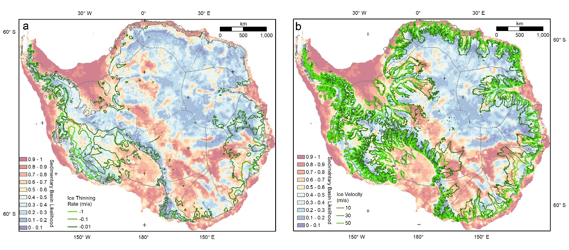
Extended Data Fig. 1: Relationship between sedimentary basin likelihood with the current ice thining rate and ice velocity in Antarctica. a, Sedimentary basin likelihood overlying ice thinning rate as estimated by satellite laser altimetry data²⁰. b, Sedimentary basin likelihood overlying the fast ice flow region.

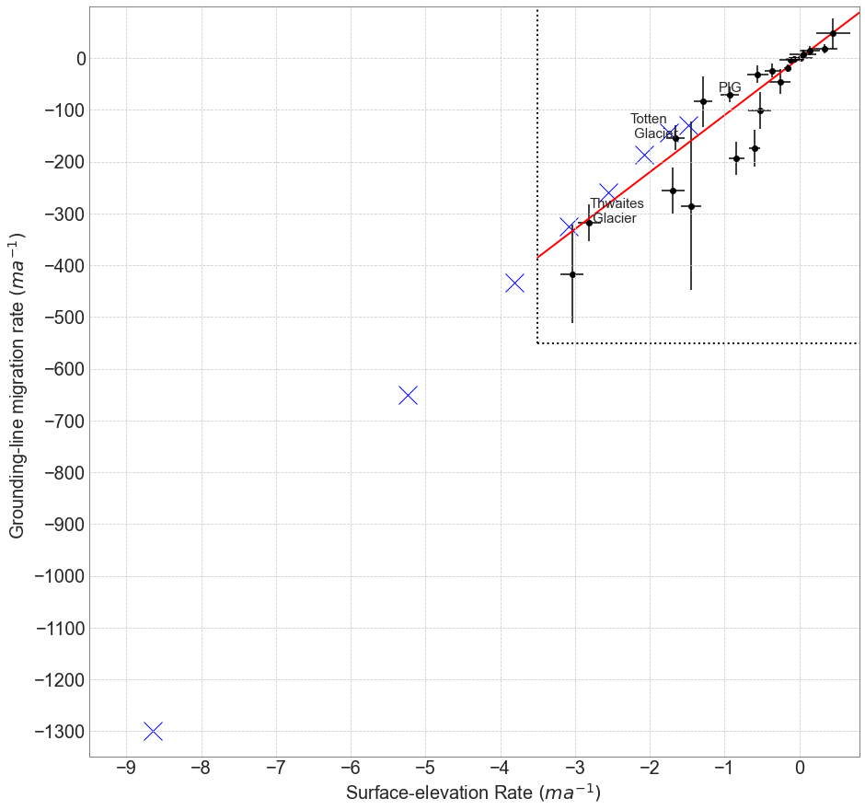
Extended Data Fig. 2: Rate of grounding-line migration rate versus rate of ice thinning. The dash box and black dot show the estimated continental wide grounding-line retreat rate versus ice thinning rate⁴³. The blue cross mark shows the grounding-line retreat rate that we used in hydro-mechanical modelling. Detail of the estimation of groundline-line migration and ice thinning rate are shown in Supplementary Information 2.1.2.

