Supporting materials for
Global optimization workflow with compact graph neural networks for comprehensive transition-state mapping
Difan Zhang,ª Roger Rousseau,ª Vassiliki-Alexandra Glezakou^{a,*}
- Chemical Sciences Division, Oak Ridge National Laboratory, Oak Ridge, Tennessee 37830, United States
* To whom correspondence should be addressed: glezakouva@ornl.gov (V.-A.G.)

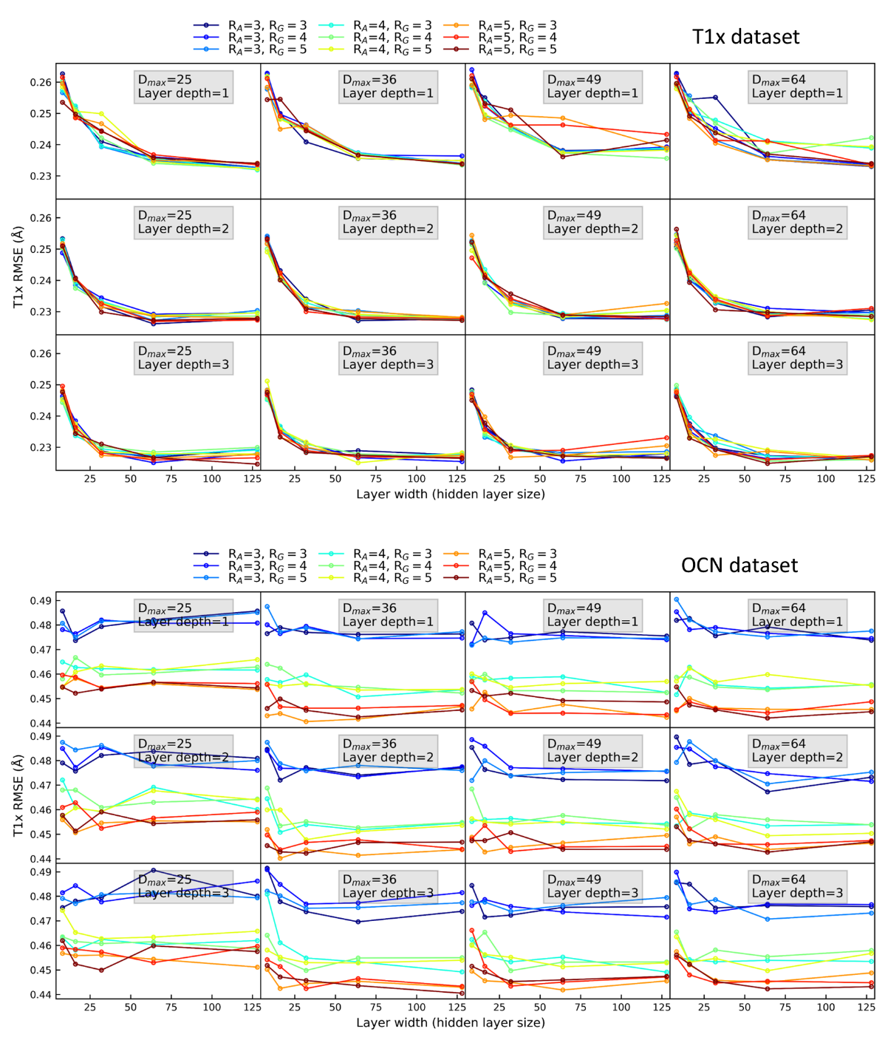
Figure S1. Predictive performance of different graph feature settings and graph neural networks hyperparameters.

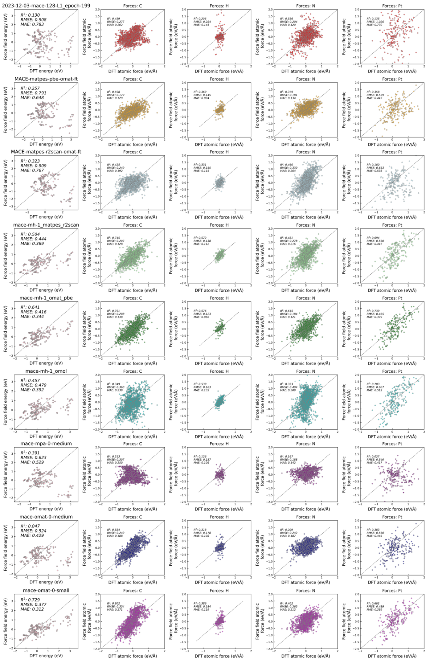
Figure S2. Benchmark of MACE force fields against DFT calculations from CP2K.

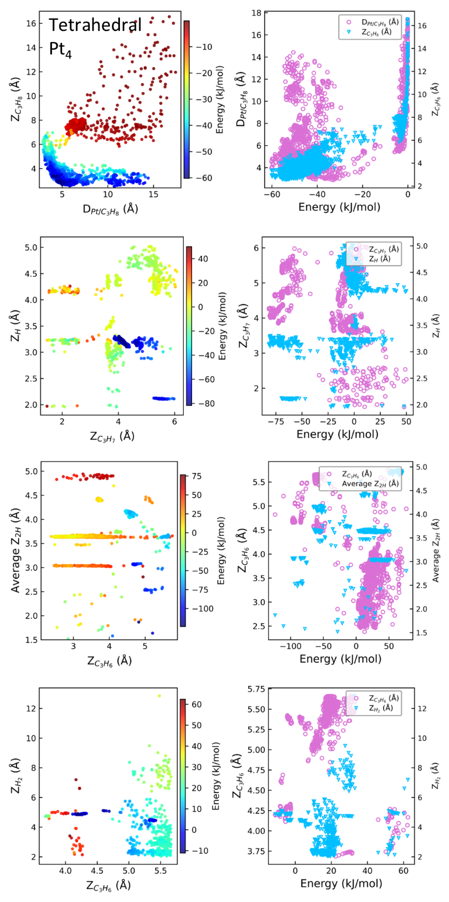
Figure S3. Two-dimensional map of the structures in different states of the propane dehydrogenation reactions on tetrahedral cluster.
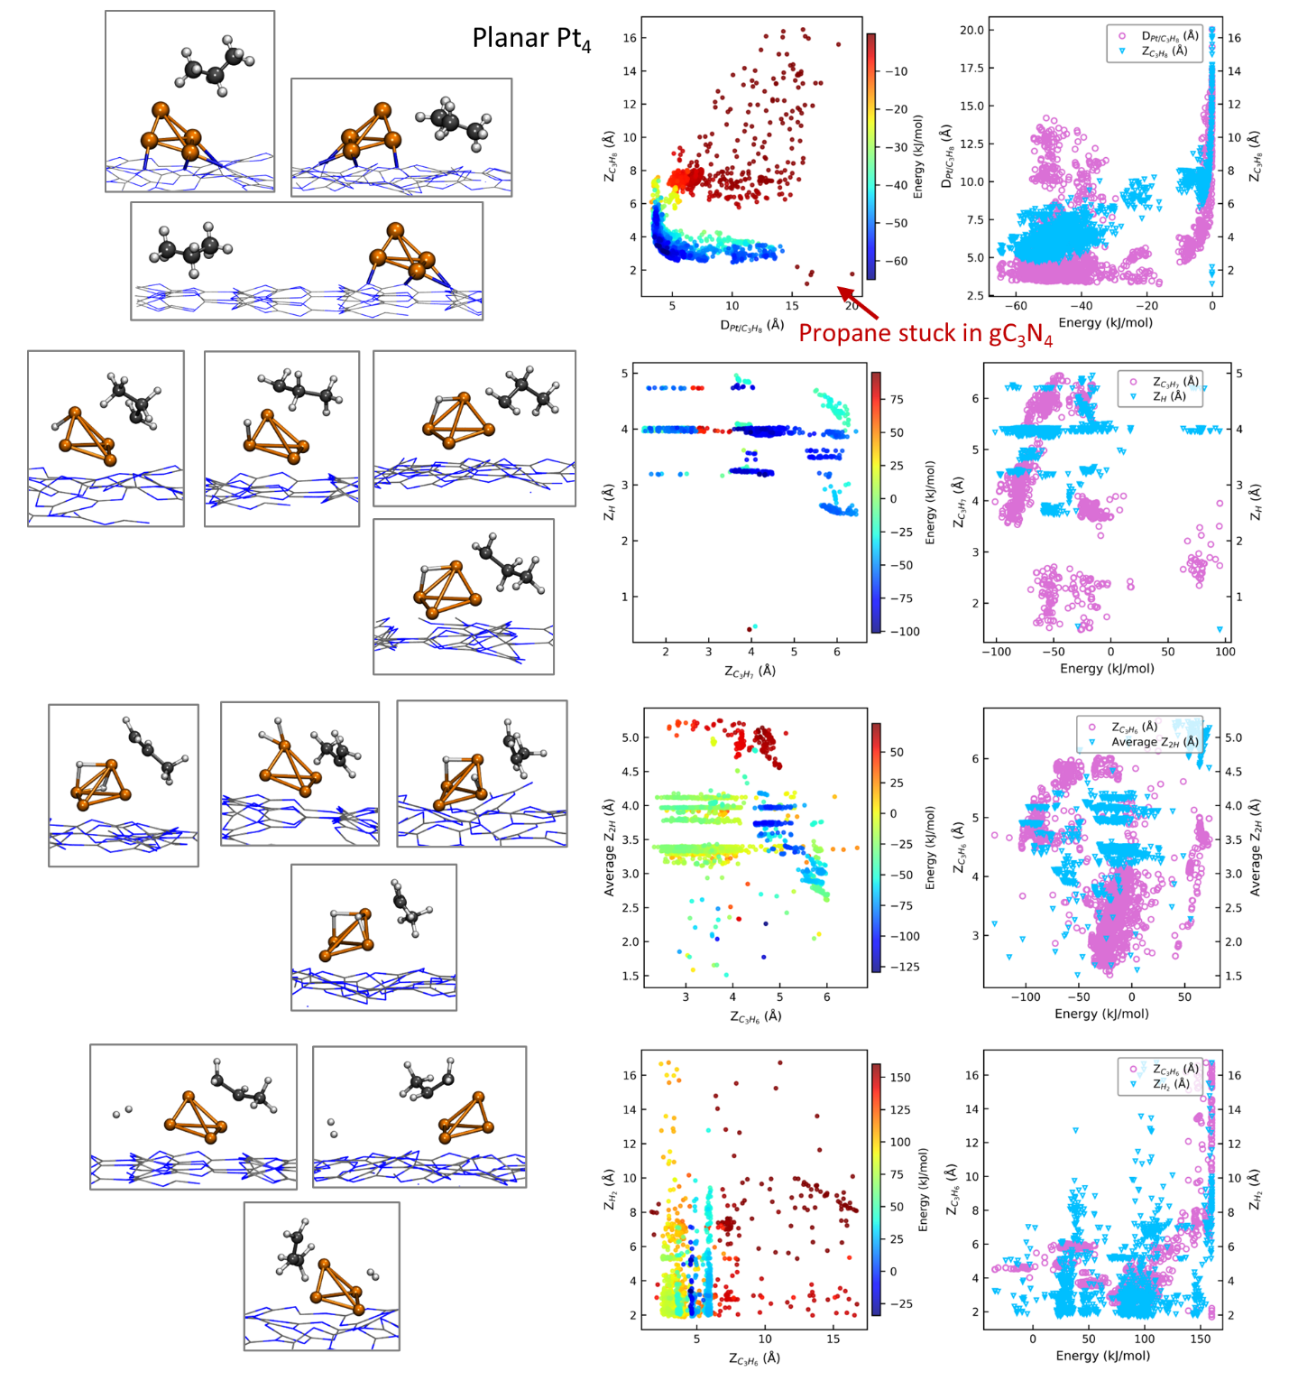
Figure S4. Two-dimensional map of the structures in different states of propane dehydrogenation reactions on planar cluster. C, H, and Pt atoms are shown in gray, white, and orange, respectively, in the representative structure snapshots on the left side.

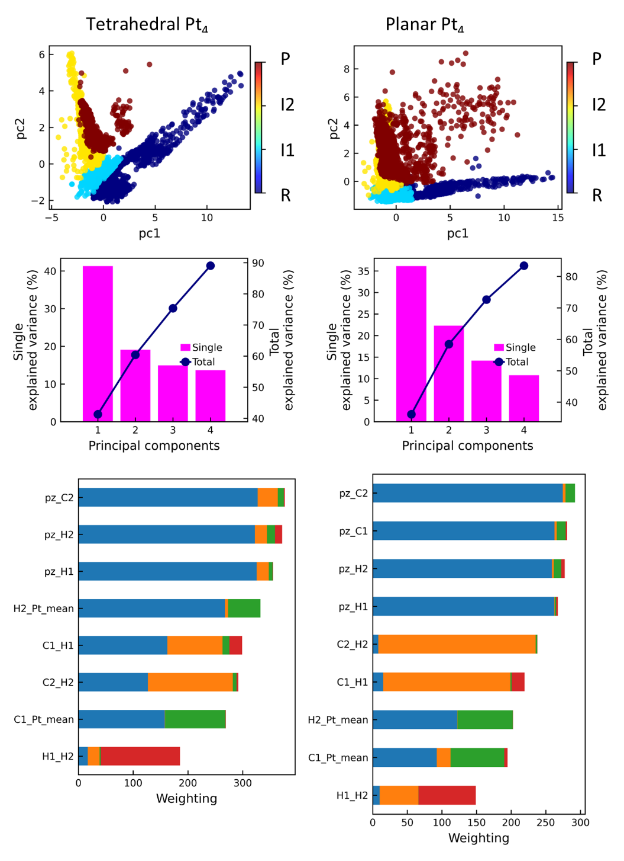
Figure S5. PCA results for the structures from different states with tetrahedral and planar clusters.

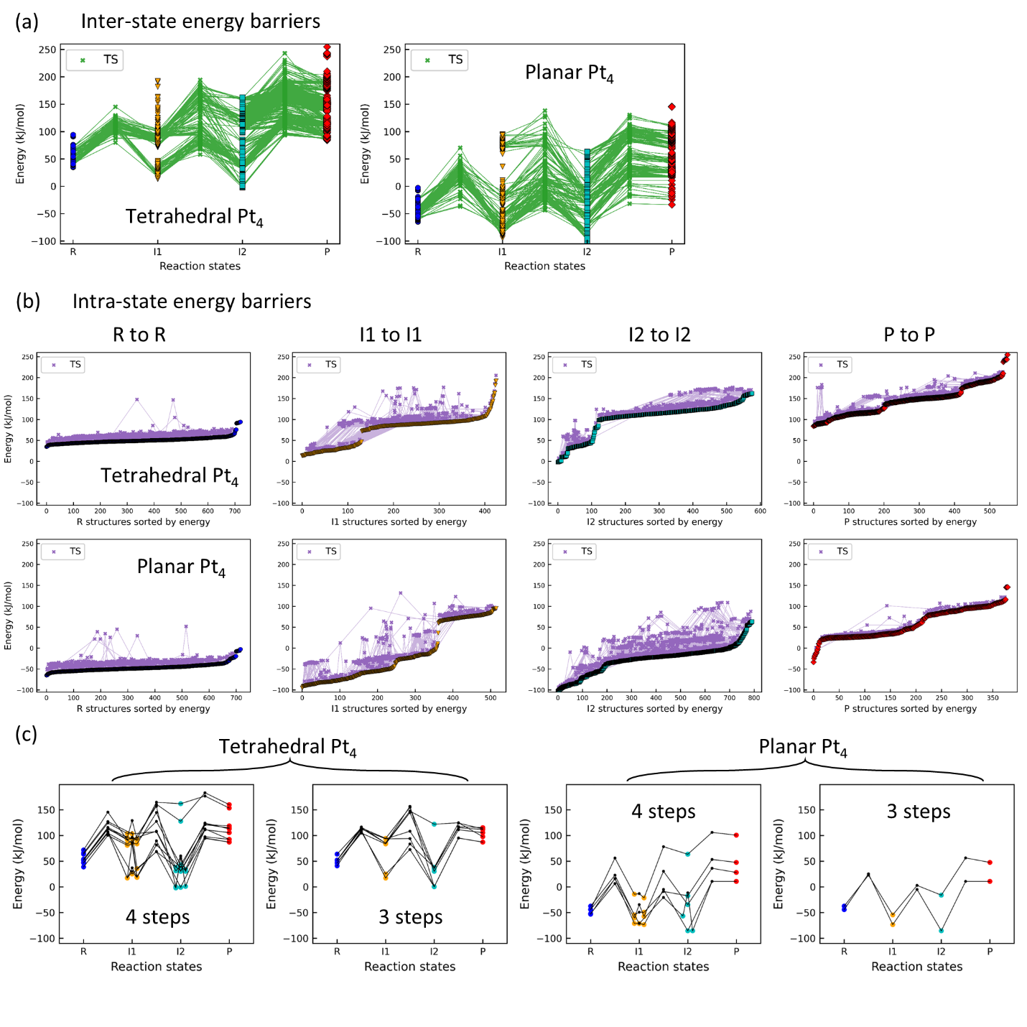
Figure S6. The identified reaction transition states and their energy landscapes on tetrahedral and planar clusters during (a) inter-state conversion and (b) intra-state transformation. (c) The fully connected reaction pathways obtained from connected segments in (a) and (b) for tetrahedral and planar clusters, respectively.

