Supplementary Information
Ultrasound-detected hepatic steatosis in psoriatic disease: prevalence, cardiometabolic correlates and biochemical discordance
Supplementary Table S1. Ultrasound availability
Population | n (%) | Comparison
Complete cohort | 572 | —
Ultrasound available | 534 (93.4%) | —
Ultrasound unavailable | 38 (6.6%) | —
Unavailable in psoriasis without PsA | 16/401 (4.0%) | —
Unavailable in PsA | 22/171 (12.9%) | p<0.001
The ultrasound outcome was not imputed.

Supplementary Table S2. Contemporary SLD-compatible classification
Category | n | % of steatosis
MASLD-compatible: metabolic criterion and alcohol below MetALD threshold | 88 | 68.2%
MetALD-compatible | 1 | 0.8%
Metabolic phenotype, alcohol amount unknown | 31 | 24.0%
Metabolic phenotype, alcohol status unknown | 1 | 0.8%
No reconstructed cardiometabolic criterion | 8 | 6.2%
Total | 129 | 100.0%
Classification among 129 ultrasound-confirmed cases. Categories are phenotype-compatible because alternative causes were not systematically adjudicated.

Supplementary Table S3. Liver enzyme patterns
Pattern | n | %
ALT, AST and GGT normal | 9 | 7.1%
Isolated GGT elevation | 28 | 22.0%
Isolated ALT elevation | 32 | 25.2%
Isolated AST elevation | 4 | 3.1%
ALT and GGT elevated | 20 | 15.7%
AST and GGT elevated | 2 | 1.6%
ALT and AST elevated | 10 | 7.9%
ALT, AST and GGT elevated | 22 | 17.3%
Total with all enzymes available | 127 | 100.0%
Restricted to 127 steatosis cases with AST, ALT and GGT available; sex-specific upper limits were used.

Supplementary Table S4. Sensitivity analyses for GGT
Population | N | Steatosis | Sensitivity | Specificity | PPV | NPV | AUC (95% CI)
Overall normal AST/ALT | 408 | 37 | 75.7% | 98.7% | 84.8% | 97.6% | 0.989 (0.980–0.996)
Abstainers | 301 | 20 | 70.0% | 98.6% | 77.8% | 97.9% | 0.987 (0.975–0.996)
Psoriasis without PsA | 300 | 26 | 73.1% | 98.9% | 86.4% | 97.5% | 0.990 (0.980–0.998)
PsA | 108 | 11 | 81.8% | 97.9% | 81.8% | 97.9% | 0.988 (0.963–1.000)
PASI <10 | 204 | 16 | 81.3% | 99.5% | 92.9% | 98.4% | 0.996 (0.988–1.000)
Performance of sex-specific GGT elevation among patients with normal AST and ALT; AUC is based on GGT/ULN.

Supplementary Table S5. Exploratory incremental discrimination from adding elevated GGT among patients with normal AST and ALT
Model | N / events | Mean CV AUC | Mean delta AUC | 2.5th-97.5th percentile delta AUC
Clinical + waist circumference | 389 / 37 | 0.719 | - | -
Clinical + waist circumference + elevated GGT | 389 / 37 | 0.945 | 0.226 | 0.201-0.253
Clinical + BMI | 396 / 37 | 0.713 | - | -
Clinical + BMI + elevated GGT | 396 / 37 | 0.936 | 0.223 | 0.198-0.248
Ridge-penalized logistic regression with 100 repetitions of stratified five-fold cross-validation. Ranges are empirical distributions, not external-validation confidence intervals.

Supplementary Table S6. Exploratory principal component analysis of continuous cardiometabolic measures
Measure | PC1 loading | PC2 loading
Waist circumference | 0.87 | -0.31
BMI | 0.82 | -0.38
Log triglycerides | 0.68 | 0.34
HDL cholesterol | -0.62 | -0.02
Log fasting glucose | 0.45 | 0.75
Variance explained | 49.5% | 18.4%
Cumulative variance | 49.5% | 67.9%
Complete-case PCA included 490 patients (120 with steatosis). OR per 1-SD higher PC1: 1.99 (bootstrap 95% CI 1.59-2.60); AUC 0.681 (95% CI 0.627-0.734).

Supplementary Table S7. Sensitivity analysis adding systemic treatment to waist-based multivariable models
Complete-case estimates are shown on the same 491 participants (120 with steatosis). The clinical-waist model included PsA, age, sex, current alcohol consumption, PASI ≥10 and waist circumference. The fully adjusted model additionally included dysglycaemia/diabetes, atherogenic lipid phenotype and hypertension. Values are adjusted OR (95% CI).
Variable | Clinical-waist model | Clinical-waist + systemic treatment | Fully adjusted + systemic treatment
Psoriatic arthritis | 1.40 (0.83–2.34) | 1.38 (0.82–2.33) | 1.37 (0.81–2.31)
Age, per 10 years | 1.13 (0.96–1.32) | 1.12 (0.96–1.32) | 1.15 (0.96–1.39)
Female sex | 0.39 (0.23–0.66) | 0.39 (0.23–0.66) | 0.40 (0.23–0.67)
Current alcohol consumption | 2.28 (1.42–3.65) | 2.29 (1.43–3.67) | 2.39 (1.48–3.86)
PASI ≥10 | 1.02 (0.65–1.60) | 0.96 (0.55–1.70) | 0.93 (0.53–1.66)
Waist circumference, per 10 cm | 1.38 (1.14–1.66) | 1.38 (1.14–1.67) | 1.35 (1.10–1.64)
Dysglycemia/diabetes | — | — | 1.14 (0.69–1.89)
Atherogenic lipid phenotype | — | — | 1.44 (0.89–2.32)
Hypertension | — | — | 0.70 (0.38–1.31)
Systemic treatment | — | 1.09 (0.61–1.98); p=0.765 | 1.13 (0.62–2.05); p=0.684
N / events | 491 / 120 | 491 / 120 | 491 / 120

Supplementary Figure S1
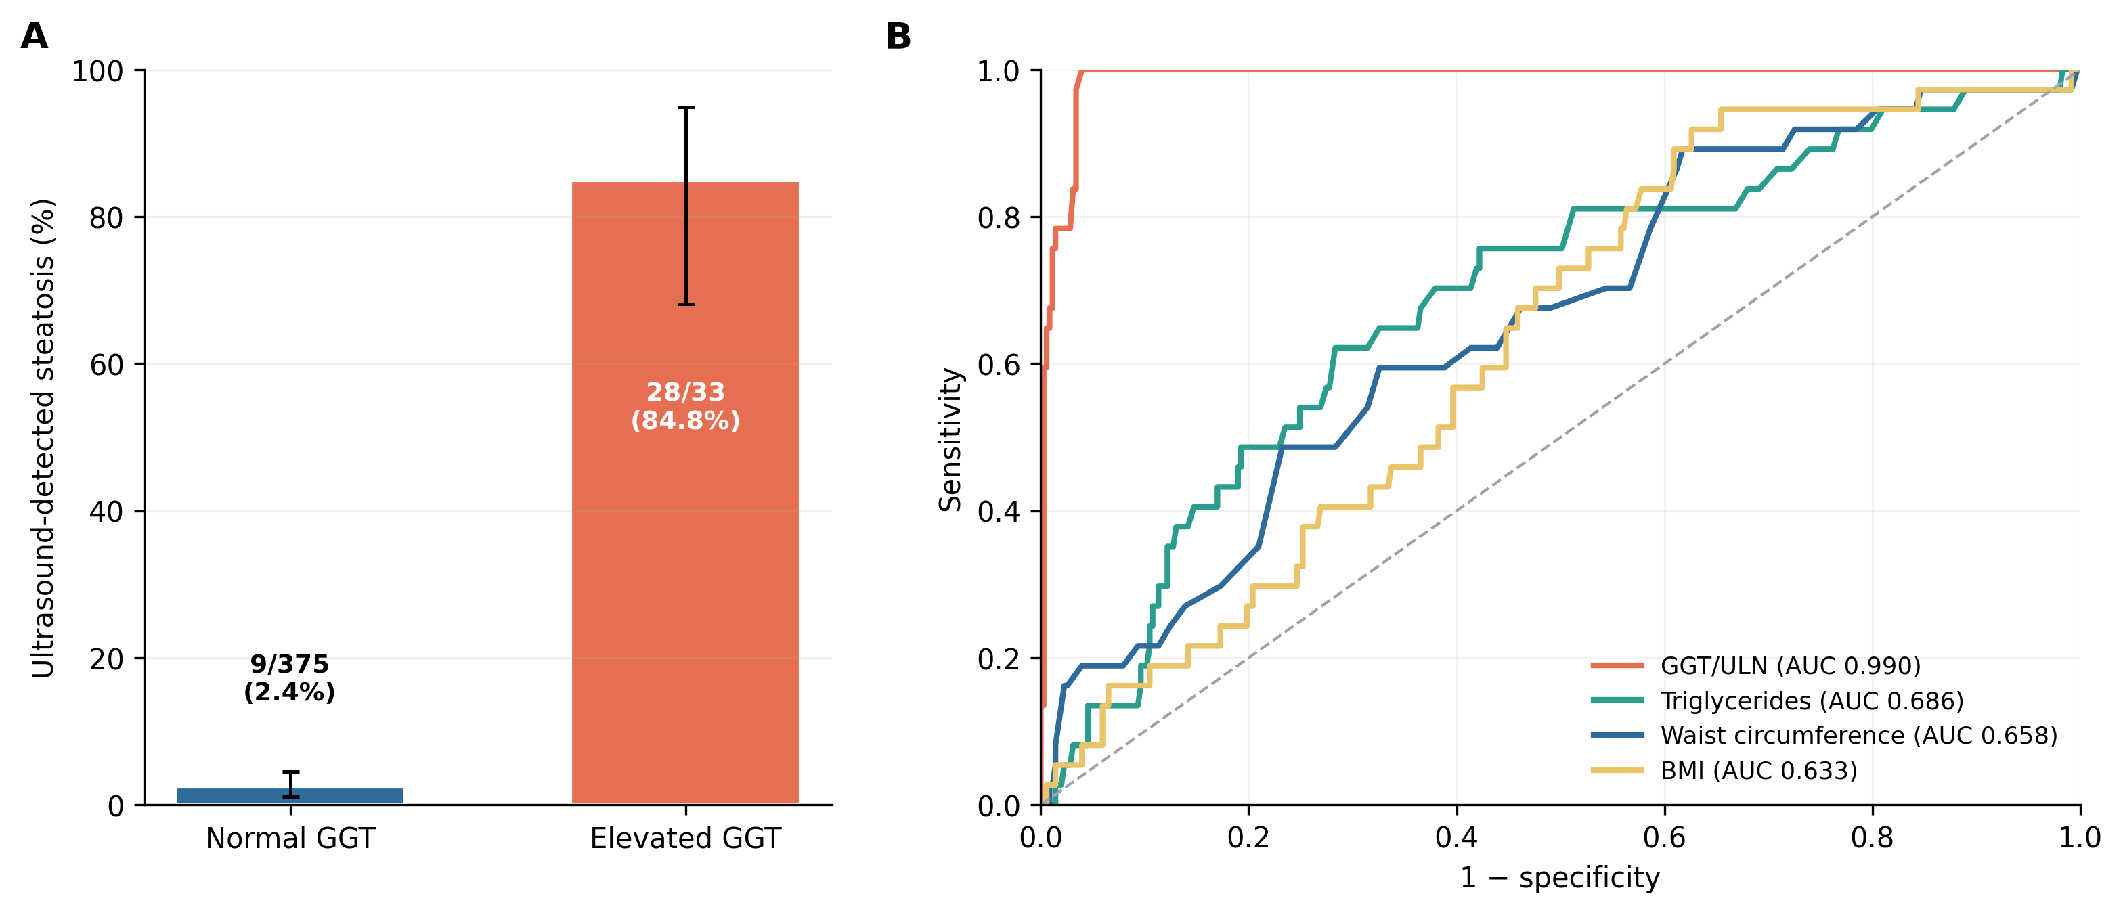
Supplementary Figure S1. GGT performance among patients with normal AST and ALT. Panel A shows the prevalence of ultrasound-detected steatosis according to sex-specific GGT status, with exact 95% confidence intervals. Panel B compares receiver operating characteristic curves for GGT relative to its sex-specific upper limit of normal, triglycerides, waist circumference and BMI. Estimates are internally derived and do not represent external diagnostic validation.

