Supplementary Datasets

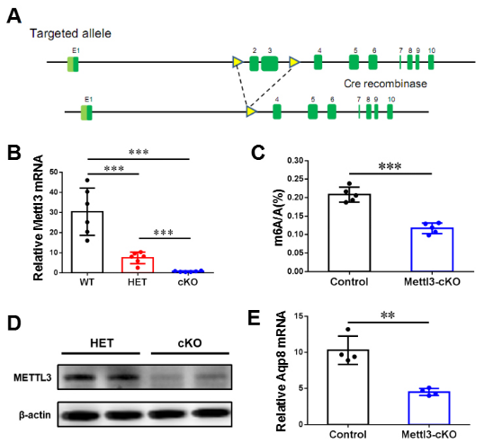
Supplementary Figure 1-related to Figure 2. Generation of hepatocyte-specific Mettl3 knockout mice.
(A) Schematic diagram of strategy to construct flox mouse. (B) qRT-PCR assay of Mettl3 mRNA level in indicated genotypes. (C) The levels of m6A mRNA were analysis in control and KO mouse livers. (D) Western blotting assay of Mettl3 protein level in control and KO mouse livers. (E) qRT-PCR assay of Aqp8 mRNA level in different genotypes. Data are representative of at least three independent experiments and shown as mean ± SEM. (**, p < 0.01; ***, p < 0.001.)

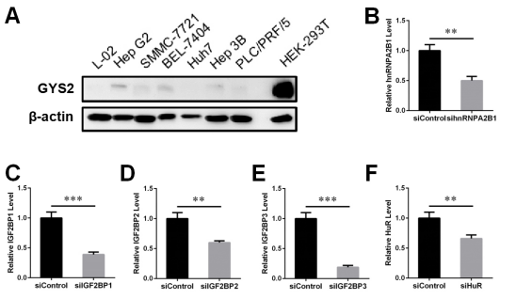
Supplementary Figure 2- related to Figure 4. Identification of Gys2 associated m6A readers using HEK-293T cells.
(A) Western blotting assay of GYS2 in different cell lines. (B-F) qRT-PCR assay of indicated genes’ relative mRNA level in siControl and sihnRNPA2B1 (B), siIGF2BP1 (C), siIGF2BP2 (D), siIGF2BP3 (E), siHuR (F).
Data are representative of at least three independent experiments and shown as mean ± SEM. (**, p < 0.01; ***, p < 0.001.)

Supplementary Table 1. Primers used for genotyping analysis.
Target | Forward Primer | Reverse Primer
Mettl3 loxP | AAAAGGCAATGTGCTTCTATGCCCG | TGCACGATGATAAAAGCCACTGTAAC
Albumin-Cre | TGGCAAACATACGCAAGGG | CGGCAAACGGACAGAAGCA

Supplementary Table 2. Primers used for real-time PCR analysis.
Target | Forward Primer | Reverse Primer
Gys2 (mouse) | ACCAAGGCCAAAACGACAG | GGGCTCACATTGTTCTACTTGA
Mettl3 (mouse) | CTGGGCACTTGGATTTAAGGAA | TGAGAGGTGGTGTAGCAACTT
β-actin  (mouse) | GAGACCTTCAACACCCCAGC | ATGTCACGCACGATTTCCC
Mettl3  (rat) | CTGGGCACTTGGACTTAAGGAA | TGAGAGGTGGTGTAGCAACTT
Gys2  (rat) | CGCACGTGTTTACCACAGTGT | CAGGCTTCCTCTTCAGCATGT
Igf2bp2  (rat) | TGGCTGAGTATGGGACGGTA | CCTCGAACTGATGCCCACTT
β-actin  (rat) | CCCATCTATGAGGGTTACGC | TTTAATGTCACGCACGATTTC
hnRNPA2B1 (human) | ATTGATGGGAGAGTAGTTGAGCC | AATTCCGCCAACAAACAGCTT
IGF2BP1 (human) | GCGGCCAGTTCTTGGTCAA | TTGGGCACCGAATGTTCAATC
IGF2BP2 (human) | AGCTAAGCGGGCATCAGTTTG | CCGCAGCGGGAAATCAATCT
IGF2BP3 (human) | ACGAAATATCCCGCCTCATTTAC | GCAGTTTCCGAGTCAGTGTTCA
HuR (human) | GGGTGACATCGGGAGAACG | CTGAACAGGCTTCGTAACTCAT
Gys2 (human) | TGAAGTTGCTTGGGAAGTGAC | AGGTTCACACTGTTCCACCTG
β-actin (human) | TGACGTGGACATCCGCAAAG | CTGGAAGGTGGACAGCGAGG

Supplementary Table 3. siRNA used in this study.
Target | Sense (5' to 3')
siControl | UUCUCCGAACGUGUCACGUTT
hnRNPA2B1 #1 | GCUGUUUGUUGGCGGAAUUTT
hnRNPA2B1 #2 | CCAUACCAUCAAUGGUCAUTT
IGF2BP1 #1 | GCGAUGAAGGCCAUCGAAATT
IGF2BP1 #2 | GCUCCCUAUAGCUCCUUUATT
IGF2BP2 #1 | GCUGUUAACCAACAAGCCATT
IGF2BP2 #2 | GCGAAAGGAUGGUCAUCAUTT
IGF2BP2 #3 | CAGUUUGAGAACUACUCCUTT
IGF2BP2 #4 | GAAACAGGGACCAAGAUAATT
IGF2BP3 #1 | CCUUGAAAGUAGCCUAUAUTT
IGF2BP3 #2 | GCUGGAGCUUCAAUUAAGATT
HuR(ELAVL1) #1 | GAACGAAUUUGAUCGUCAATT
HuR(ELAVL1) #2 | GGUUUGGGCGGAUCAUCAATT

