Supplementary Information
Sample-to-answer automated centrifugal microfluidics with computer-vision readout for point-of-care molecular diagnostics
Ahmad S. Akhtar ª; Noa Lapins ª; João M. Moura ^{c}; Luis Paula ^{c}; Adriano Pedro ^{c}; Fabio Martins ^{c}; Duarte Mota ^{c}; Inês F. Pinto ª; Marco Martins ^{c}; Aman Russom ^{a, b, *}
ª KTH Royal Institute of Technology, Division of Nanobiotechnology, Department of Protein Science, Science for Life Laboratory, Solna, Sweden
^{b}AIMES - Center for the Advancement of Integrated Medical and Engineering Sciences at Karolinska Institutet and KTH Royal Institute of Technology, Stockholm, Sweden
^{c} INL – International Iberian Nanotechnology Laboratory, Braga, Portugal

* Contact author:
aman@kth.se (A. Russom)

Table of Contents
Screenshots of the Graphical User Interface 2
Screenshots of computer vision-based detection 3
Bead-based signal enhancement using 1 time flow through beads 4

Screenshots of the Graphical User Interface

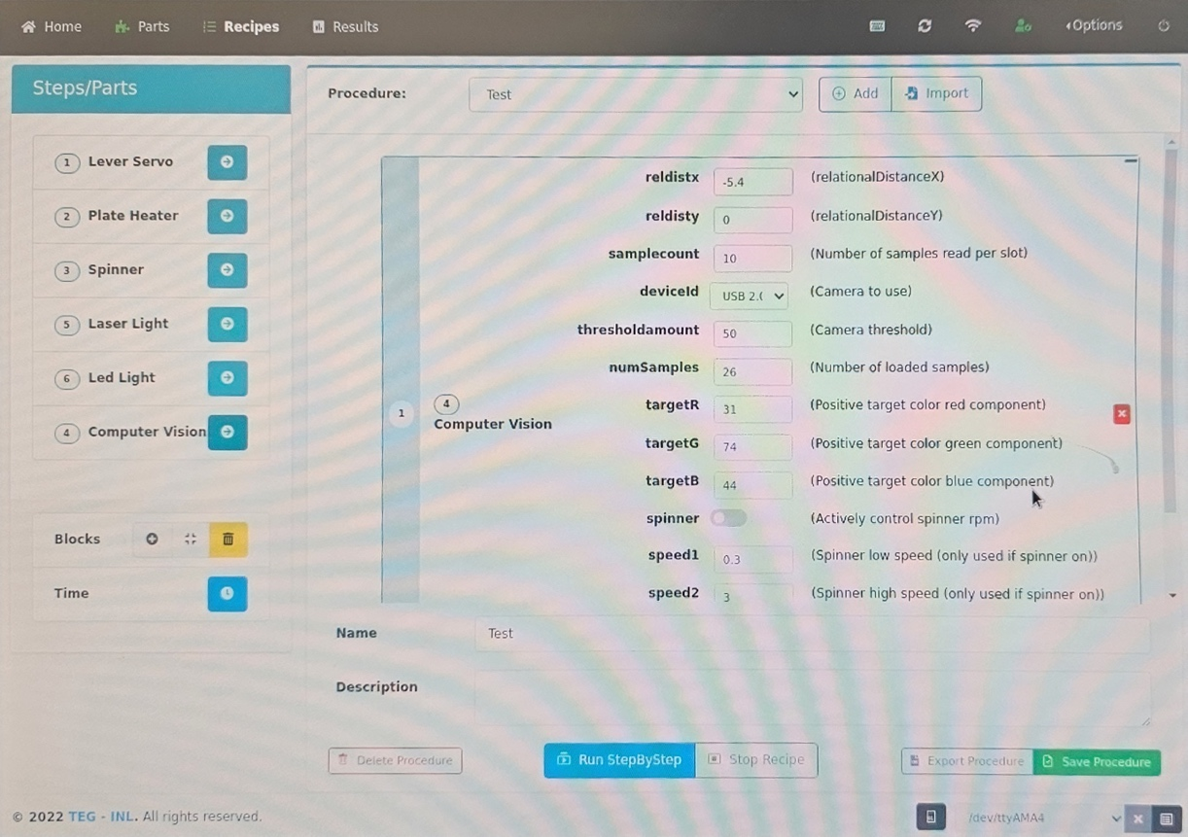
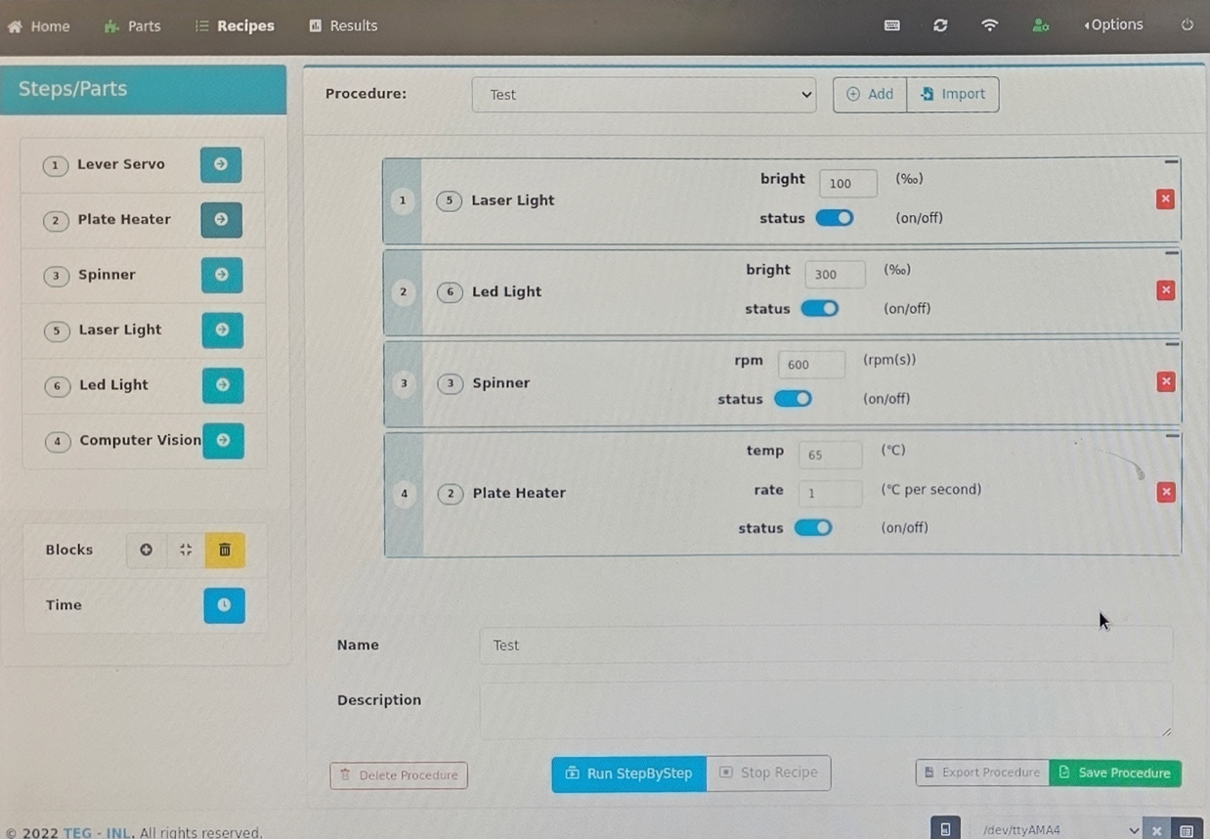
Figure S1: Images of the graphical user interface of for configuration of different modules of the device such as computer vision algorithm (top) and laser, LED, motor and heater (below).

Screenshots of computer vision-based detection
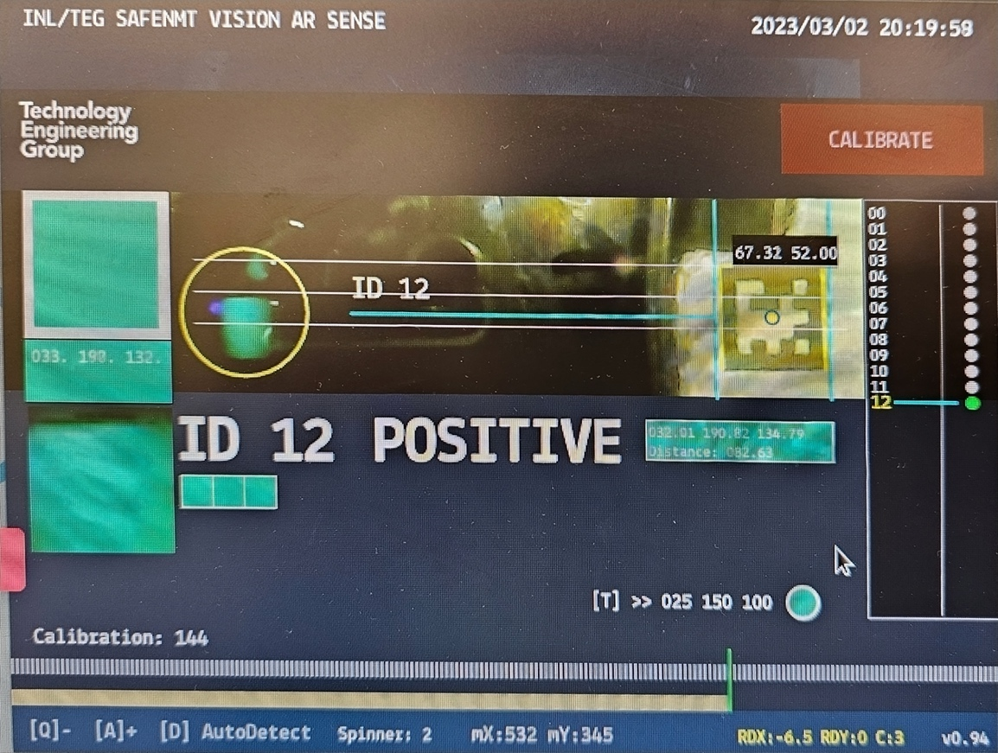
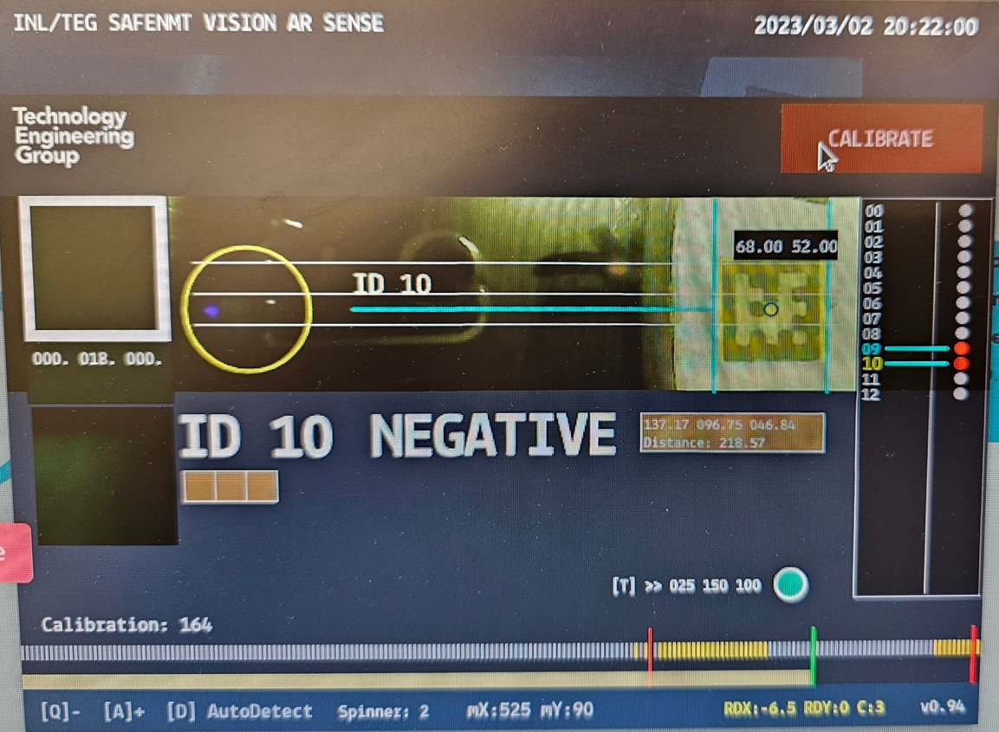
Figure S2: Images of the graphical user interface demonstrating the computer vision algorithm detecting a positive (top) and a negative (bottom) signal.

Bead-based signal enhancement using 1 time flow through beads

Figure S3: Images of the pre-amplified LAMP master mixes incubated at 65 °C for 30 min in MIC PCR thermocycler in the presence (positive) or absence (negative) of 10⁴ SARS-CoV-2 RNA fragment copies. The images were taken after loading the samples on to the disc and using the integrated platform to visualize the signal. The “Before” pictures refer to images before processing the pre-amplified samples using NBNM beads packed on the disc and “After” pictures refer to samples that have passed through the packed NBNM beads.

