Supplementary material
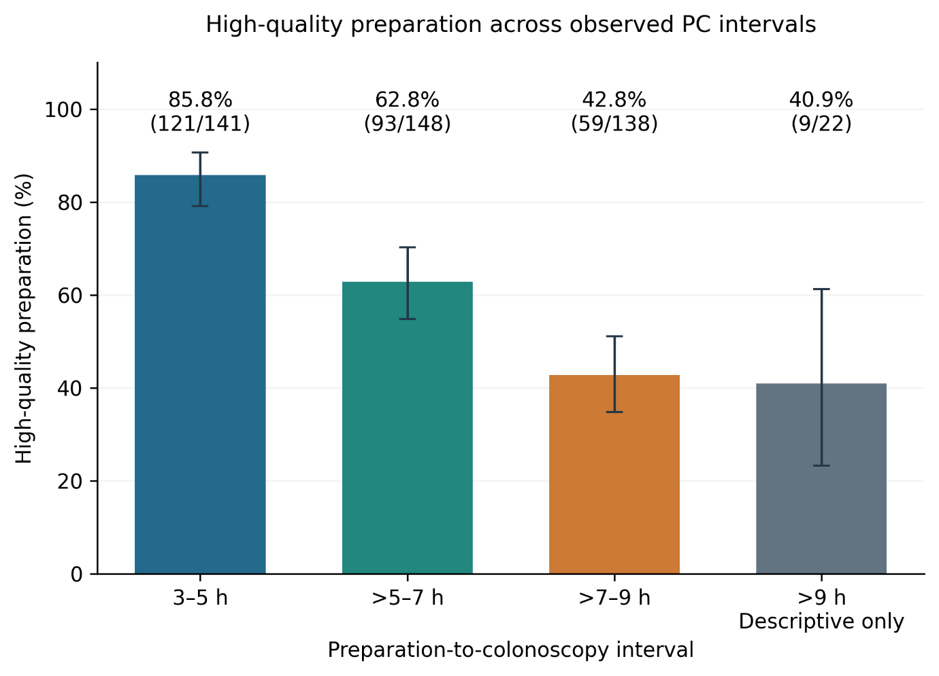
Figure S1. High-quality preparation across the observed intervals, including the >9-h extension cohort. Error bars indicate Wilson 95% CIs. The >9-h results are descriptive; no overall four-group hypothesis test was performed.
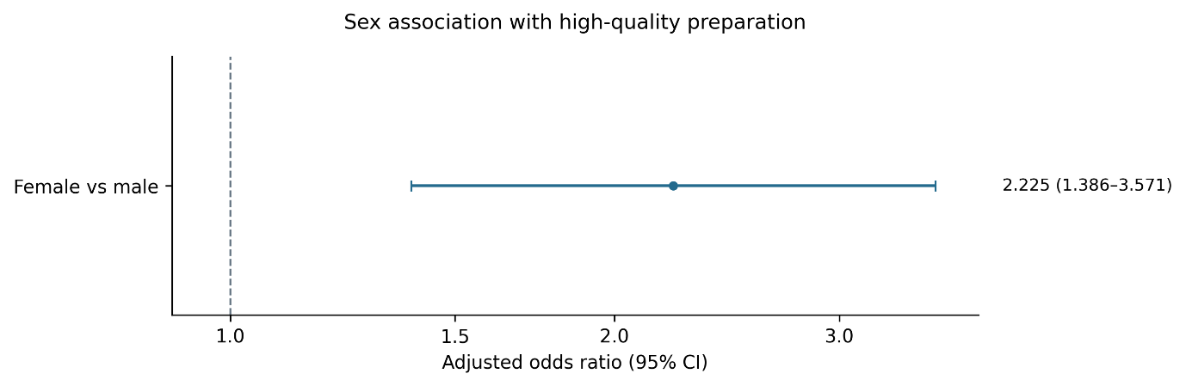
Figure S2. Adjusted association between female sex and high-quality preparation. The estimate and 95% CI are from the model in Table 3.
Table S1. Center effect modification and stratified analyses
Model / center | n | High quality, n (%) | PC aOR (95% CI) | P value
Primary cohort | 427 | 273 (63.9) | 0.580 (0.498–0.675) | <0.001
Shuixiang center | 165 | 111 (67.3) | 0.461 (0.351–0.606) | <0.001
Main center | 262 | 162 (61.8) | 0.643 (0.529–0.781) | <0.001
Center × PC interaction | 427 | — | Likelihood-ratio test | 0.037
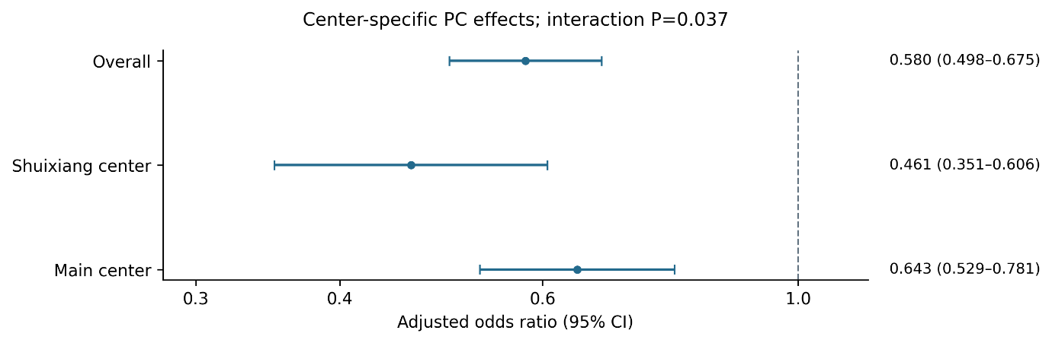
Figure S3. Center-specific PC associations. The exploratory interaction yielded P=0.037 without adjustment for multiple comparisons.
Table S2. Participant-clustered logistic model for a segment BBPS score of 3
Colonic segment | PC coefficient β | Robust SE | OR (95% CI)
Left colon | -0.383 | 0.078 | 0.682 (0.586–0.794)
Transverse colon | -0.504 | 0.088 | 0.604 (0.508–0.718)
Right colon | -0.554 | 0.074 | 0.575 (0.497–0.664)
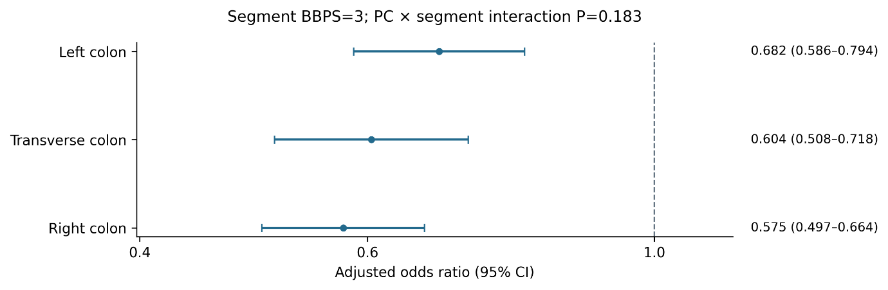
Figure S4. Segment-specific ORs per additional PC hour for a BBPS score of 3. The overall PC-by-segment interaction yielded P=0.183.
Table S3. Restricted cubic spline nonlinearity tests
RCS model | Knots (h) | Nonlinearity LR | df | P value
3 knots | 3.717, 6.000, 8.133 | 0.00005 | 1 | 0.994
4 knots | 3.717, 5.102, 6.915, 8.133 | 0.64095 | 2 | 0.726
Both models used the same covariates as the high-quality preparation model. Likelihood-ratio tests assessed nonlinear terms for the same binary outcome. Knot number was not selected according to the smallest P value.
Appendix S4. Interpretation of the segmented fit
Location and slope intervals are reported in Table 4. In the observed sample, the curve changed from increasing to decreasing at 3.75 h, which is described as the fitted peak. Join-point selection was repeated in every bootstrap sample, and resampled fits were not required to retain a peak shape. The location interval therefore reflects uncertainty in the selected join point, rather than precision around an established population peak. The wild-bootstrap test repeated the complete search under a single-line null model. An ordinary coefficient P value conditional on the selected location was not used to establish a breakpoint. R² and AIC were used only to compare fit.
Table S5. Descriptive preparation-process variables
Measure | Overall | 3–5 h | >5–7 h | >7–9 h | P value
Stool frequency | 11.48±4.21 | 10.87±3.48 | 11.56±4.26 | 12.02±4.74 | 0.396
Last drink to insertion (h; valid records) | 3.90±1.80 | 2.55±0.67 | 3.77±1.38 | 5.42±1.84 | <0.001
Clear final stool | 167 (39.1) | 81 (57.4) | 51 (34.5) | 35 (25.4) | <0.001
Stool frequency and final appearance were available for 427 participants. Last-drink-to-insertion intervals were summarized for 423 records satisfying 0<interval≤24 h. Four anomalous original values were retained in the audit records without correction. These are preparation-process variables rather than baseline characteristics; comparisons are exploratory.

