Online Resource 3
Preoperative Machine-Learning Models for Predicting Postoperative Morbidity after Anterior Clinoidal Meningioma Surgery: Development and External Validation
Journal of Neuro-Oncology
¹Noa Ben Dor, MD; ¹Gal Ziv, BA; ¹Filippo Friso, MD; ¹Carlo Bortolotti, MD; ^{1,2}Diego Mazzatenta, MD, PhD; ^{1,2}Matteo Zoli, MD, PhD; ¹Matteo Martinoni, MD; ¹Filippo Badaloni, MD; ¹Giulia Casulli, MD; ¹Vittoria Rosetti, MD; ¹Luca Zanuttini, MD; ²Lorenzo Faccin, MD; ³Francesco Travaglini, MD; ³Luigino Tosatto, MD; ⁴He-ming Wu, MD; ⁵Catherine Elizabeth Gilkes, MD; ⁵Cathal John Hannan, PhD; ^{5,6}Michael D. Jenkinson, MD, PhD; ³Marcello D'Andrea, MD; ^{1,2}Alfredo Conti, MD, PhD.

1 Department of Neurosurgery; IRCCS Institute of Neurological Sciences of Bologna (ISNB), Bologna, Italy
2 Department of Biomedical and Neuromotor Sciences (DIBINEM), Alma Mater Studiorum – University of Bologna, Bologna, Italy
3 Department of Neurosurgery, Maurizio Bufalini Hospital, AUSL Romagna, Cesena, Italy
4 Department of Neurosurgery, Nanjing First Hospital, Nanjing Medical University, Nanjing, Jiangsu, China
5 Department of Neurosurgery, The Walton Centre NHS Foundation Trust, Liverpool L9 7LJ, UK
6 Institute of Systems, Molecular and Integrative Biology, University of Liverpool, Liverpool, UK

Corresponding author:
Noa Ben Dor, MD
Department of Neurosurgery, IRCCS Institute of Neurological Sciences (ISNB), Bologna, Italy
Via Altura 3, 40139 Bologna, Italy
E-mail: noa.bendorziv@studio.unibo.it
ORCID: 0009-0009-8608-6418
Supplementary results: performance of all ridge-penalized and gradient-boosting models, internal–external cross-validation, thresholds, model equations, neurological endpoints, the cognitive-decline model and sensitivity analyses (Tables S9–S16, Figs. S2 and S3)

This document reports the results summarized in the main text: the performance of the ridge-penalized models for every endpoint, internal–external cross-validation, operating characteristics and net benefit, the model equations implemented in the online calculator, gradient boosting, the neurological endpoints, the cognitive-decline model and the pre-specified medical model including ASA physical status. Methods and the modelling population are described in Online Resource 1.
Endpoint definitions
Following the neurological, regional and systemic classification of craniotomy morbidity (Sawaya et al., 1998), the ten recorded non-neurological complication types were assigned as follows: medical (systemic) = systemic infection, deep vein thrombosis, acute respiratory insufficiency, heart failure; surgical (regional) = postoperative hematoma, seizure, wound infection, CSF leak, hydrocephalus; new ischemic stroke = neurological domain; death = severity grade. The non-neurological composite (any of the ten types) was analyzed as a sensitivity endpoint; it comprised 50 events (20.7% of 241; 21.6% of 231). All endpoints were derived from the per-type complication records.
Event counts (n = 241): medical 36 (systemic infection 21, deep vein thrombosis 17, acute respiratory insufficiency 4, heart failure 4); surgical 21 (hematoma 10, seizure 8, wound infection 4, CSF leak 3, hydrocephalus 2); new ischemic stroke 7; non-neurological composite 50; any new neurological deficit 68 (motor 30, cognitive 28, visual 19, psychiatric 3). Patients may have more than one complication.
Ridge-penalized models: performance for all endpoints
Every endpoint was modelled with the same pipeline: standardization of the predictors, L2-penalized logistic regression with the penalty selected within each training fold by five-fold cross-validated log-loss over a grid of eleven values (10⁻³ to 10²), nested 10-fold cross-validation repeated five times (the reported internal AUC is the mean over repeats, with a 95% percentile bootstrap interval from the out-of-fold predictions averaged over repeats), 200-replicate bootstrap optimism correction of the apparent AUC, internal–external cross-validation and the geographical split. The systemic predictor set (age, Charlson Comorbidity Index, cardiorespiratory comorbidity, preoperative KPS, maximum axial tumor diameter, vessel encasement grade, ACA/MCA/PCA involvement; ASA class, part of the pre-specified set, was removed as described below and in Table S16) was used for the non-neurological endpoints and the neurological set (age, Charlson index, KPS, preoperative motor symptoms, diameter, vessel encasement grade, ICA/carotid siphon involvement, cavernous sinus involvement) for the neurological endpoints.

Table S9 Ridge-penalized model performance for all endpoints, modelling population (n = 231) and full cohort (n = 241)
Endpoint | Population | Events (%) | Internal CV AUC (95% CI) | Optimism-corrected AUC | Calibration slope | Brier (null) | IECV pooled AUC (95% CI) | Held-out range | External AUC (95% CI)
Medical complication | n = 231 | 36 (15.6) | 0.755 (0.667–0.838) | 0.772 | 1.04 | 0.115 (0.132) | 0.768 (0.665–0.846) | 0.728–0.847 | 0.847 (0.641–0.972)
Medical complication | n = 241 | 36 (14.9) | 0.769 (0.682–0.849) | 0.775 | 1.08 | 0.110 (0.127) | 0.769 (0.667–0.847) | 0.731–0.861 | 0.866 (0.699–0.982)
Surgical complication | n = 231 | 21 (9.1) | 0.659 (0.526–0.783) | 0.675 | 1.04 | 0.081 (0.083) | 0.686 (0.518–0.816) | 0.565–0.759 | 0.710 (0.496–0.885)
Surgical complication | n = 241 | 21 (8.7) | 0.667 (0.531–0.780) | 0.684 | 0.94 | 0.078 (0.080) | 0.694 (0.530–0.821) | 0.589–0.761 | 0.760 (0.588–0.920)
Non-neurological composite | n = 231 | 50 (21.6) | 0.707 (0.624–0.784) | 0.725 | 1.01 | 0.153 (0.170) | 0.700 (0.608–0.778) | 0.644–0.767 | 0.767 (0.608–0.906)
Non-neurological composite | n = 241 | 50 (20.7) | 0.720 (0.643–0.795) | 0.727 | 1.09 | 0.148 (0.164) | 0.697 (0.604–0.776) | 0.644–0.784 | 0.799 (0.655–0.927)
New or worsened motor deficit | n = 231 | 30 (13.0) | 0.729 (0.639–0.805) | 0.740 | 1.07 | 0.107 (0.113) | 0.711 (0.596–0.803) | 0.684–0.720 | 0.684 (0.481–0.865)
New or worsened motor deficit | n = 241 | 30 (12.4) | 0.744 (0.661–0.828) | 0.755 | 1.16 | 0.102 (0.109) | 0.728 (0.616–0.816) | 0.684–0.742 | 0.731 (0.549–0.889)
Any neurological deficit or ischemic stroke | n = 231 | 71 (30.7) | 0.712 (0.633–0.790) | 0.721 | 1.02 | 0.178 (0.213) | 0.694 (0.558–0.804) | 0.632–0.827 | 0.827 (0.684–0.943)
Any neurological deficit or ischemic stroke | n = 241 | 71 (29.5) | 0.728 (0.652–0.806) | 0.732 | 1.02 | 0.170 (0.208) | 0.699 (0.579–0.797) | 0.647–0.820 | 0.861 (0.738–0.959)
Any new or worsened neurological deficit | n = 231 | 68 (29.4) | 0.696 (0.614–0.776) | 0.707 | 1.04 | 0.178 (0.208) | 0.682 (0.522–0.807) | 0.596–0.834 | 0.834 (0.699–0.947)
Visual deterioration | n = 231 | 19 (8.2) | 0.420 (0.265–0.497) | 0.535 | −8.95 | 0.076 (0.075) | 0.478 (0.312–0.649) | 0.454–0.581 | 0.581 (0.280–0.914)
Motor deficit, motor-symptom predictor removed | n = 231 | 30 (13.0) | 0.709 (0.620–0.793) | 0.731 | 1.02 | 0.107 (0.113) | 0.710 (0.601–0.799) | 0.708–0.711 | 0.708 (0.512–0.882)
Medical complication, pre-specified set with ASA | n = 231 | 36 (15.6) | 0.773 (0.685–0.856) | 0.788 | 1.03 | 0.114 (0.132) | 0.749 (0.646–0.831) | 0.739–0.822 | 0.822 (0.607–0.969)
CV, cross-validation (nested 10-fold, five repeats; AUC = mean over repeats); IECV, internal–external cross-validation (each center held out in turn; DerSimonian–Laird random-effects pooling of per-center AUCs on the logit scale); held-out range = lowest to highest per-center AUC among centers with at least five events and five non-events; external = development in Bologna + Cesena (n = 183; with the ten excluded patients added to the development cohort for the n = 241 rows), validation in Liverpool (n = 48). In the full cohort the excluded center (no events) cannot contribute a held-out AUC. The row ‘any neurological deficit or ischemic stroke’ (71 events) is shown for completeness; the neurological components are detailed in Table S14 and cognitive decline, which was not recorded in Cesena, in Table S15. Calibration slope and Brier score refer to the internal out-of-fold predictions. The last row is the pre-specified medical model with ASA class (Table S16).

Internal–external cross-validation
Each center was held out in turn, the model was refitted on the remaining centers with the penalty re-selected, and discrimination and calibration were assessed in the held-out center. Per-center AUCs were pooled on the logit scale by DerSimonian–Laird random-effects meta-analysis, with standard errors derived from 1000-replicate percentile bootstrap intervals; a held-out estimate required at least five events and five non-events. Because only three centers contribute, the between-center variance τ² is estimated with little precision and τ² = 0 should not be read as evidence of homogeneity. Calibration was summarized by the calibration slope (logistic recalibration of the held-out linear predictor) and by calibration-in-the-large (intercept with the slope fixed at 1; negative values indicate over-prediction). The AUC of the held-out predictions pooled across centers, which is additionally sensitive to between-center differences in baseline risk, was 0.741 for the medical endpoint, 0.696 for the composite, 0.596 for the surgical endpoint and 0.707 for motor deficit (Table S10; Fig. S2a). The held-out Liverpool estimate of the internal–external cross-validation is, by construction, the same model as the geographical external validation reported in the main text.
Table S10 Internal–external cross-validation by held-out center, ridge-penalized models (modelling population)
Endpoint | Held-out center | n | Events | AUC (95% CI) | Calibration slope | Calibration-in-the-large | Mean predicted / observed (%)
Medical complication | Bologna | 115 | 22 | 0.760 (0.653–0.853) | 1.42 | 0.59 | 12.0 / 19.1
Medical complication | Cesena | 68 | 7 | 0.728 (0.441–0.968) | 1.09 | −0.46 | 14.9 / 10.3
Medical complication | Liverpool | 48 | 7 | 0.847 (0.637–0.977) | 1.25 | −0.74 | 23.7 / 14.6
Medical complication | Pooled (random effects) | 231 | 36 | 0.768 (0.665–0.846); τ² = 0.000 | 0.91 | 0.03 | pooled-prediction AUC 0.741
Surgical complication | Bologna | 115 | 7 | 0.565 (0.289–0.853) | 1.30 | −0.80 | 12.5 / 6.1
Surgical complication | Cesena | 68 | 8 | 0.759 (0.540–0.949) | 3.73 | 0.52 | 7.4 / 11.8
Surgical complication | Liverpool | 48 | 6 | 0.710 (0.497–0.891) | 1.97 | 0.27 | 9.9 / 12.5
Surgical complication | Pooled (random effects) | 231 | 21 | 0.686 (0.518–0.816); τ² = 0.000 | 0.93 | −0.16 | pooled-prediction AUC 0.596
Non-neurological composite | Bologna | 115 | 26 | 0.699 (0.578–0.805) | 1.16 | 0.20 | 19.5 / 22.6
Non-neurological composite | Cesena | 68 | 13 | 0.644 (0.462–0.811) | 0.69 | −0.01 | 19.3 / 19.1
Non-neurological composite | Liverpool | 48 | 11 | 0.767 (0.604–0.906) | 0.98 | −0.47 | 30.4 / 22.9
Non-neurological composite | Pooled (random effects) | 231 | 50 | 0.700 (0.608–0.778); τ² = 0.000 | 0.85 | −0.01 | pooled-prediction AUC 0.696
New or worsened motor deficit | Bologna | 115 | 17 | 0.720 (0.600–0.832) | 1.34 | 0.37 | 10.8 / 14.8
New or worsened motor deficit | Cesena | 68 | 3 | not reported (<5 events)
New or worsened motor deficit | Liverpool | 48 | 10 | 0.684 (0.481–0.867) | 0.85 | 0.52 | 14.0 / 20.8
New or worsened motor deficit | Pooled (random effects) | 231 | 30 | 0.711 (0.596–0.803); τ² = 0.000 | 1.21 | 0.07 | pooled-prediction AUC 0.707
Any new or worsened neurological deficit | Bologna | 115 | 37 | 0.623 (0.504–0.741) | 0.53 | 0.10 | 30.2 / 32.2
Any new or worsened neurological deficit | Cesena | 68 | 11 | 0.596 (0.360–0.817) | 0.71 | −0.92 | 30.2 / 16.2
Any new or worsened neurological deficit | Liverpool | 48 | 20 | 0.834 (0.693–0.947) | 2.39 | 0.53 | 30.6 / 41.7
Any new or worsened neurological deficit | Pooled (random effects) | 231 | 68 | 0.682 (0.522–0.807); τ² = 0.174 | 0.79 | −0.05 | pooled-prediction AUC 0.666
Visual deterioration | Bologna | 115 | 8 | 0.454 (0.196–0.722) | 0.96 | −0.34 | 9.5 / 7.0
Visual deterioration | Cesena | 68 | 6 | 0.462 (0.242–0.704) | 0.82 | 0.12 | 7.9 / 8.8
Visual deterioration | Liverpool | 48 | 5 | 0.581 (0.284–0.932) | 0.74 | 0.34 | 7.7 / 10.4
Visual deterioration | Pooled (random effects) | 231 | 19 | 0.478 (0.312–0.649); τ² = 0.000 | −1.64 | −0.06 | pooled-prediction AUC 0.443
Calibration slope and calibration-in-the-large are computed in the held-out center (pooled row: on all held-out predictions). Motor deficit had three events in Cesena; that center contributes held-out predictions to the pooled-prediction AUC but no per-center estimate. Cognitive decline, which was not recorded in Cesena, is reported in Table S15.
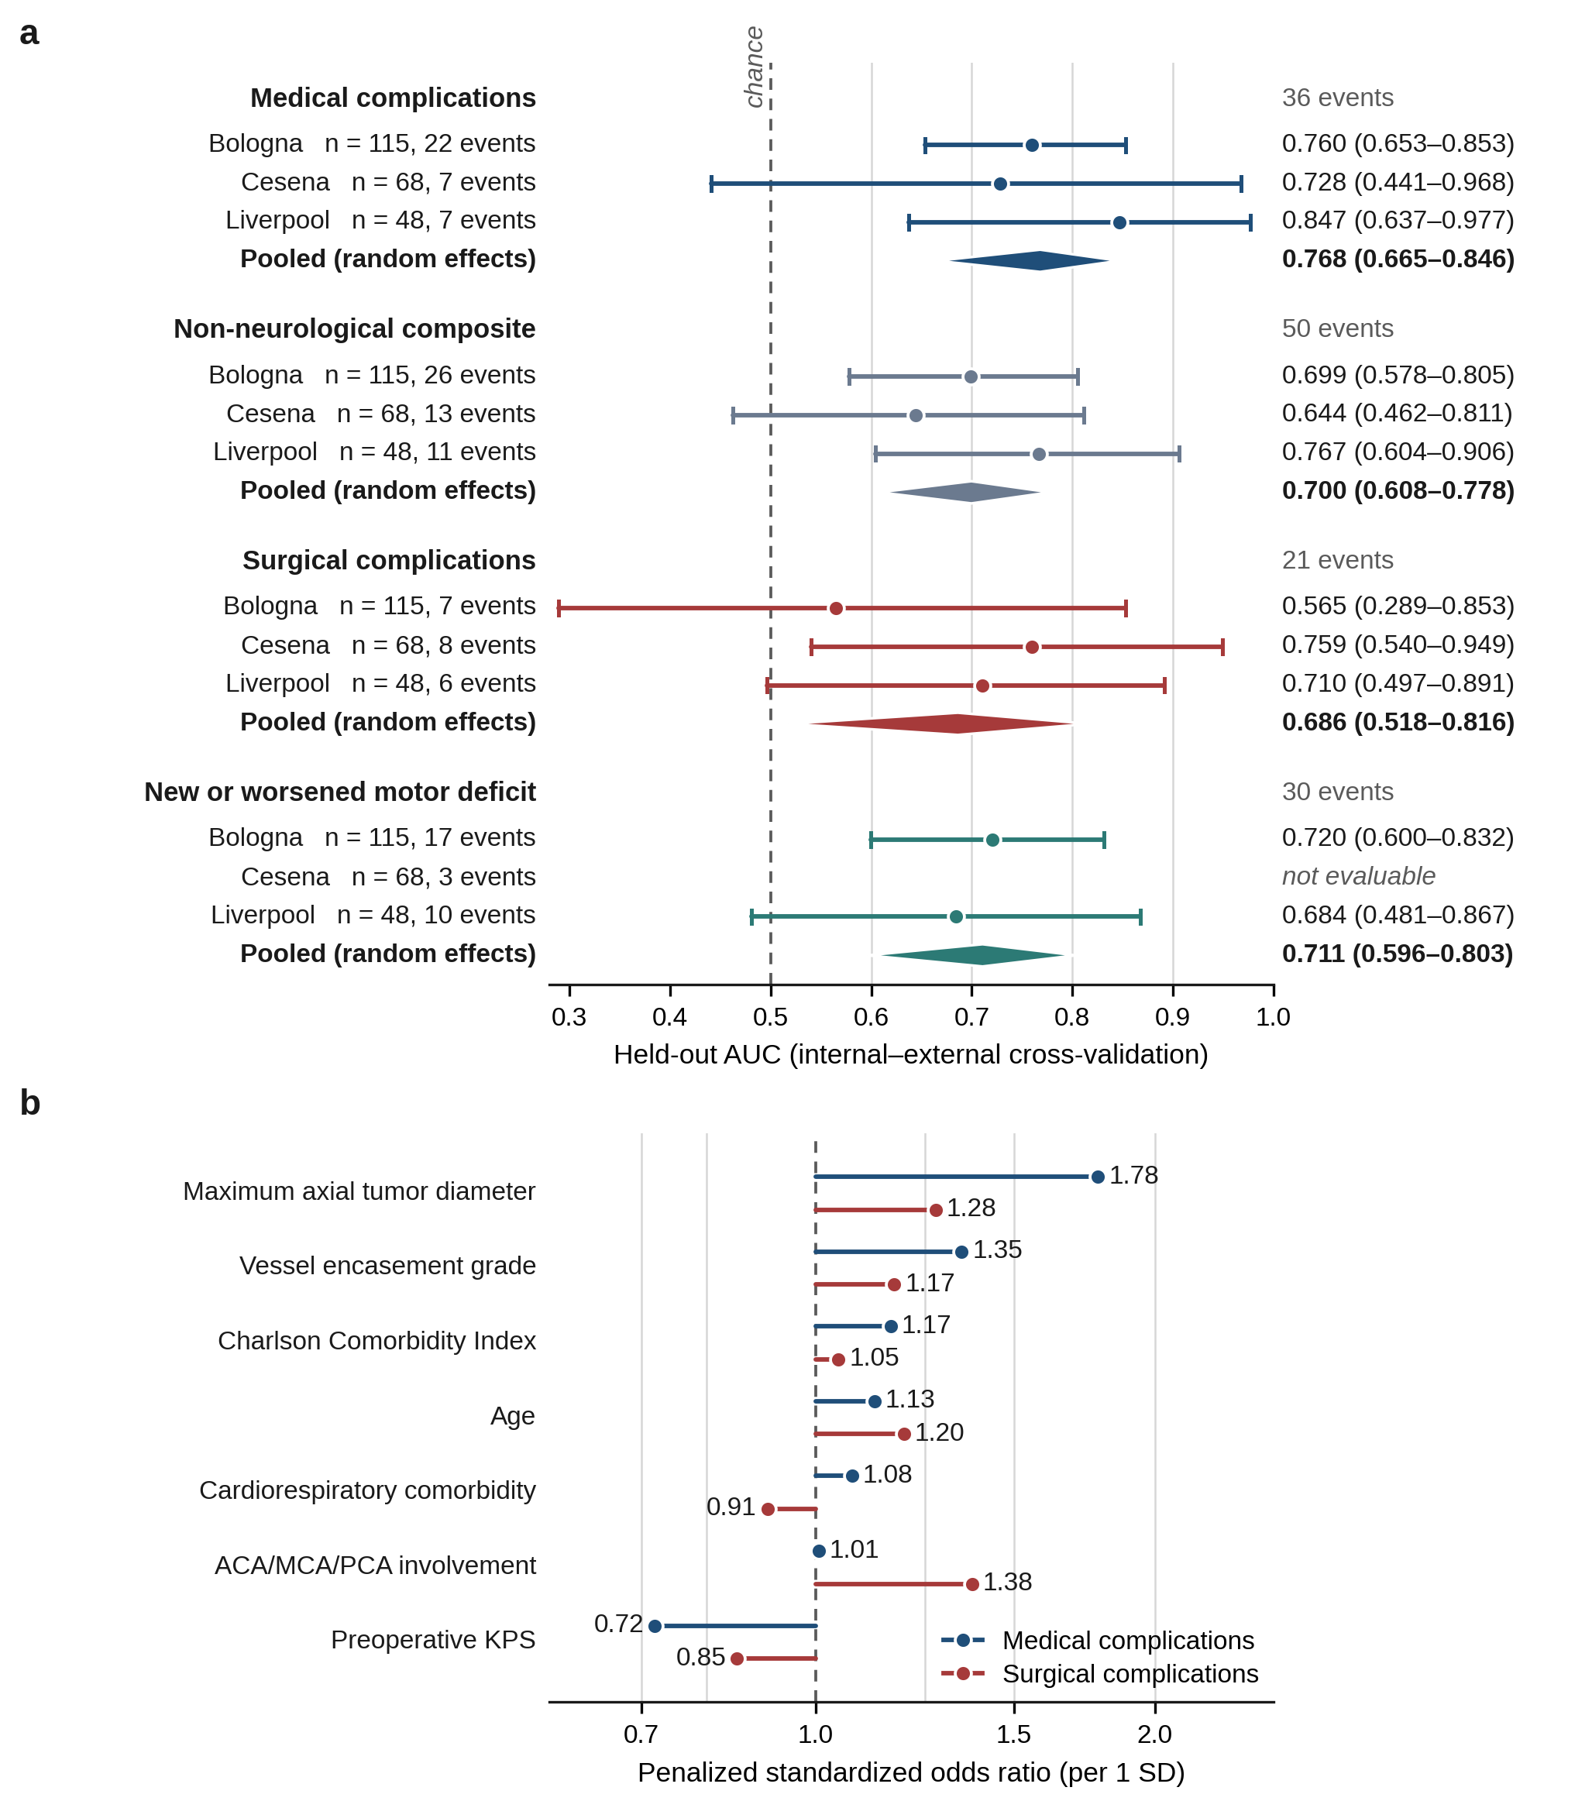
Fig. S2 Internal–external cross-validation by center and endpoint decomposition. a, Held-out areas under the curve from internal–external cross-validation: each center was withheld in turn, and the model was refitted on the remaining centers, with per-center estimates and DerSimonian–Laird random-effects pooled estimates (diamonds) for each candidate endpoint; horizontal bars are 95% percentile bootstrap confidence intervals (1,000 replicates; the Liverpool intervals in Figs. 2 and 3 and in the main text use 2,000, hence differences in the third decimal) and the dashed line marks chance. The Cesena cohort contributed three motor events and was not evaluable for that endpoint. b, Ridge-penalized standardized odds ratios per 1-SD increase for the medical and surgical endpoints on a logarithmic scale; the dashed line marks unity. Estimates are penalized and therefore shrunk toward 1; confidence intervals are not shown because penalized coefficients have no valid closed-form standard errors. AUC, area under the receiver operating characteristic curve; KPS, Karnofsky Performance Status.
Threshold and decision-curve analysis
Operating characteristics were computed from the held-out predictions of the internal–external cross-validation (every patient predicted by a model that had not seen his or her center), which use all 231 patients and 36 medical (30 motor) events and are therefore more stable than the 48-patient geographical split. Net benefit is (true positives − false positives × threshold/(1 − threshold))/n; the model is useful at a given threshold when its net benefit exceeds both the treat-all and the treat-none (0) strategies.
Table S11 Operating characteristics and net benefit of the held-out predictions across probability thresholds
Model | Threshold (%) | Sensitivity (%) | Specificity (%) | PPV (%) | NPV (%) | Flagged (%) | Net benefit, model | Net benefit, treat all
Medical complication | 5 | 97.2 | 19.5 | 18.2 | 97.4 | 83.1 | 0.116 | 0.111
Medical complication | 10 | 77.8 | 50.3 | 22.4 | 92.5 | 54.1 | 0.075 | 0.062
Medical complication | 15 | 66.7 | 69.2 | 28.6 | 91.8 | 36.4 | 0.058 | 0.007
Medical complication | 20 | 47.2 | 83.1 | 34.0 | 89.5 | 21.6 | 0.038 | −0.055
Medical complication | 30 | 30.6 | 91.3 | 39.3 | 87.7 | 12.1 | 0.016 | −0.206
Medical complication | 40 | 22.2 | 96.4 | 53.3 | 87.0 | 6.5 | 0.014 | −0.407
New or worsened motor deficit | 5 | 96.7 | 13.9 | 14.4 | 96.6 | 87.4 | 0.086 | 0.084
New or worsened motor deficit | 10 | 83.3 | 49.3 | 19.7 | 95.2 | 55.0 | 0.059 | 0.033
New or worsened motor deficit | 15 | 56.7 | 76.1 | 26.2 | 92.2 | 28.1 | 0.037 | −0.024
New or worsened motor deficit | 20 | 33.3 | 89.6 | 32.3 | 90.0 | 13.4 | 0.021 | −0.088
New or worsened motor deficit | 30 | 3.3 | 98.0 | 20.0 | 87.2 | 2.2 | −0.003 | −0.243
Base rates: medical 15.6% (NPV of a null model 84.4%), motor 13.0% (87.0%). Observed event rates across tertiles of held-out predicted risk: medical 3/77 (3.9%), 10/77 (13.0%) and 23/77 (29.9%); motor 4/77 (5.2%), 9/77 (11.7%) and 17/77 (22.1%); non-neurological composite 5/77 (6.5%), 20/77 (26.0%) and 25/77 (32.5%). NPV, negative predictive value; PPV, positive predictive value.
Model coefficients and equations
The retained models were fitted on all 231 patients with the penalty selected by five-fold cross-validated log-loss (medical model C = 0.1; motor model C = 0.032, scikit-learn parameterization). Coefficients are given on the standardized scale (per 1 SD, as plotted in Figs. 2 and 3 of the main text) and on the raw scale, so that the predicted probability can be computed directly: logit(p) = intercept + Σ (raw coefficient × predictor value); p = 1/(1 + exp(−logit)). Vessel encasement is coded 0–4 (0 none, 1 <90°, 2 90–<180°, 3 180–270°, 4 >270°), binary predictors 0/1, KPS 0–100, diameter in mm, age in years. The online calculator implements these equations.
Table S12 Coefficients of the retained ridge-penalized models (n = 231)
Model | Predictor | Mean | SD | Standardized coefficient | Standardized OR per 1 SD | Raw-scale coefficient
Medical complication | Age | 60.563 | 12.274 | 0.1202 | 1.128 | 0.00979
Medical complication | Charlson Comorbidity Index | 2.481 | 1.611 | 0.1537 | 1.166 | 0.09538
Medical complication | Cardiorespiratory comorbidity | 0.381 | 0.486 | 0.0741 | 1.077 | 0.15266
Medical complication | Preoperative KPS | 80.866 | 11.325 | −0.3294 | 0.719 | −0.02909
Medical complication | Maximum axial tumor diameter | 36.152 | 14.134 | 0.5772 | 1.781 | 0.04084
Medical complication | Vessel encasement grade | 1.805 | 1.424 | 0.2983 | 1.348 | 0.20956
Medical complication | ACA/MCA/PCA involvement | 0.593 | 0.491 | 0.0063 | 1.006 | 0.01281
Medical complication | Intercept (raw scale) |  |  | −1.9934 (standardized-scale intercept) |  | −2.39135
New or worsened motor deficit | Age | 60.563 | 12.274 | 0.0365 | 1.037 | 0.00298
New or worsened motor deficit | Charlson Comorbidity Index | 2.481 | 1.611 | 0.0047 | 1.005 | 0.00292
New or worsened motor deficit | Preoperative KPS | 80.866 | 11.325 | −0.2428 | 0.784 | −0.02144
New or worsened motor deficit | Preoperative motor symptoms | 0.242 | 0.429 | 0.1641 | 1.178 | 0.38285
New or worsened motor deficit | Maximum axial tumor diameter | 36.152 | 14.134 | 0.2473 | 1.281 | 0.01749
New or worsened motor deficit | Vessel encasement grade | 1.805 | 1.424 | 0.0853 | 1.089 | 0.05991
New or worsened motor deficit | ICA/carotid siphon involvement | 0.567 | 0.495 | 0.1679 | 1.183 | 0.33877
New or worsened motor deficit | Cavernous sinus involvement | 0.195 | 0.396 | 0.1261 | 1.134 | 0.31835
New or worsened motor deficit | Intercept (raw scale) |  |  | −2.0461 (standardized-scale intercept) |  | −1.58704
Worked example (medical model): a 65−year−old patient, Charlson index 3, cardiorespiratory comorbidity present, KPS 80, 45−mm tumor, vessel encasement grade 3, ACA/MCA/PCA involvement present: logit = −1.164, predicted probability 23.8%. Standardized coefficients apply to (value − mean)/SD. Penalized coefficients have no valid closed-form standard errors and are shrunk toward zero.

Gradient boosting
Histogram gradient boosting was applied to each endpoint in the same modelling population, with the 25 candidate variables of Online Resource 1, Table S2, encoded to 39 inputs (one-hot encoding of sex, ASA class, tumor side and vessel-encasement category, each with an explicit missing-category indicator), scikit-learn default settings (learning rate 0.1, up to 100 iterations, 31 leaves, minimum 20 samples per leaf, no L2 regularization) and early stopping on a 10% internal validation split (10 iterations without improvement of the log-loss). Internal performance is the mean AUC over five repeats of stratified five-fold cross-validation in all 231 patients; internal–external cross-validation and the geographical split follow the ridge analysis. The high-sensitivity operating threshold was the largest threshold reaching ≥ 90% sensitivity in repeated cross-validation within the development cohort, frozen and applied to the external predictions. Because a single boosted model depends on the random early-stopping split, the external AUC was also recomputed over 20 seeds.
Table S13 Histogram gradient boosting for all endpoints (modelling population, n = 231)
Endpoint | Events | Internal CV AUC (95% CI) | Calibration slope | IECV pooled AUC (95% CI) | Held-out AUC Bologna / Cesena / Liverpool | External AUC (95% CI) | External calibration slope | External AUC over 20 seeds, median (range)
Medical complication | 36 | 0.728 (0.644–0.829) | 0.72 | 0.722 (0.601–0.817) | 0.684 / 0.792 / 0.834 | 0.834 (0.650–0.967) | 1.29 | 0.829 (0.749–0.909)
Surgical complication | 21 | 0.624 (0.495–0.789) | 0.74 | 0.601 (0.420–0.758) | 0.497 / 0.566 / 0.726 | 0.726 (0.466–0.925) | 0.96 | 0.699 (0.550–0.762)
Non-neurological composite | 50 | 0.697 (0.623–0.800) | 0.84 | 0.674 (0.569–0.764) | 0.651 / 0.600 / 0.794 | 0.794 (0.639–0.926) | 0.98 | 0.783 (0.730–0.860)
New or worsened motor deficit | 30 | 0.676 (0.594–0.800) | 0.83 | 0.639 (0.520–0.743) | 0.644 / n.e. / 0.625 | 0.625 (0.422–0.822) | 0.42 | 0.587 (0.474–0.642)
Any new or worsened neurological deficit | 68 | 0.652 (0.583–0.736) | 0.93 | 0.586 (0.446–0.714) | 0.510 / 0.551 / 0.718 | 0.718 (0.556–0.852) | 1.14
Table S13 (continued) High-sensitivity operating threshold of the gradient-boosting models
Endpoint | Development-cohort CV AUC | Frozen threshold (%) | Internal sensitivity / specificity (%) | External sensitivity / specificity (%) | External PPV / NPV (%) | External patients flagged
Medical complication | 0.693 | 6 | 93.1 / 37.0 | 100.0 / 9.8 | 15.9 / 100.0 | 44 of 48 (7 events)
Non-neurological composite | 0.684 | 9 | 92.3 / 23.6 | 100.0 / 37.8 | 32.4 / 100.0 | 34 of 48 (11 events)
New or worsened motor deficit | 0.657 | 4 | 90.0 / 21.5 | 80.0 / 39.5 | 25.8 / 88.2 | 31 of 48 (10 events)
n.e., not evaluable (fewer than five events or non-events in the held-out center). Gradient boosting reproduced the ordering of the ridge analysis (medical > composite > surgical; composite neurological endpoint poorly transportable) with slightly lower internal discrimination for the medical endpoint and a comparable external estimate; its external results vary appreciably with the random seed because the development cohort is small (183 patients, 29 medical events).
Neurological endpoints in the modelling population
The composite neurological endpoint (any new or worsened motor, cognitive, visual or psychiatric deficit at discharge) and its components were modelled with the fixed neurological predictor set on the same 231 patients. Held-out performance of the composite was heterogeneous (τ² = 0.174) and its apparently good Liverpool estimate was poorly calibrated (slope 2.39); visual deterioration was ranked in the opposite direction from motor deficit (AUC below 0.5), so pooling the components cancels rather than accumulates signal. Cognitive decline was not recorded in Cesena (0 of 68 patients); an estimate on all 231 patients would treat those 68 patients as event-free and is therefore not reported here. The cognitive model was developed in Bologna and validated in Liverpool (Table S15). Removing preoperative motor symptoms from the motor model changed discrimination little (0.729 to 0.709 internally; 0.711 to 0.710 across centers). Psychiatric syndromes (three events) were not modelled.
Table S14 Neurological endpoints: ridge-penalized models with the fixed neurological predictor set (n = 231)
Endpoint | Events | Internal CV AUC (95% CI) | Optimism-corrected | IECV pooled AUC (95% CI) | Held-out AUC Bologna / Cesena / Liverpool | External AUC (95% CI) | External calibration slope | Gradient boosting: internal / IECV / external
Any new or worsened neurological deficit | 68 | 0.696 (0.614–0.776) | 0.707 | 0.682 (0.522–0.807) | 0.623 / 0.596 / 0.834 | 0.834 (0.699–0.947) | 2.39 | 0.652 / 0.586 / 0.718
New or worsened motor deficit | 30 | 0.729 (0.639–0.805) | 0.740 | 0.711 (0.596–0.803) | 0.720 / n.e. / 0.684 | 0.684 (0.481–0.865) | 0.85 | 0.676 / 0.639 / 0.625
Visual deterioration | 19 | 0.420 (0.265–0.497) | 0.535 | 0.478 (0.312–0.649) | 0.454 / 0.462 / 0.581 | 0.581 (0.280–0.914) | 0.74
Motor deficit, motor-symptom predictor removed | 30 | 0.709 (0.620–0.793) | 0.731 | 0.710 (0.601–0.799) | 0.711 / n.e. / 0.708 | 0.708 (0.512–0.882) | 0.62
n.e., not evaluable. The motor-symptom sensitivity analysis uses the neurological set without the preoperative motor symptom predictor (seven predictors). Cognitive decline is reported in Table S15 (development Bologna, validation Liverpool).
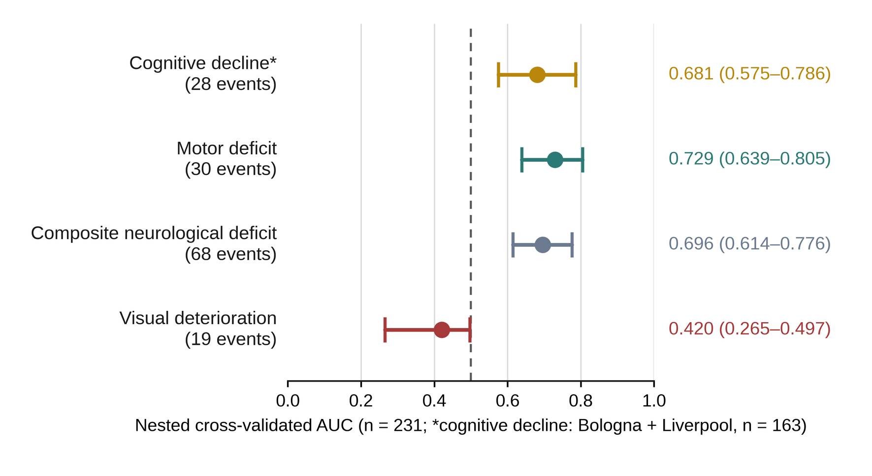
Fig. S3 Heterogeneity of neurological endpoints. Nested cross-validated AUC obtained with the fixed neurological predictor set for the composite endpoint and its components, with 95% percentile bootstrap confidence intervals. The composite, motor and visual endpoints were evaluated in the modelling population (n = 231); cognitive decline was evaluated in the two centers that recorded it (Bologna and Liverpool, n = 163), and the development–validation performance of the cognitive model is reported in the main text and in Table S15. Event counts are those of the respective populations. Visual outcome coding was verified, and an AUC below 0.5 indicated that the fixed score ranked visual deterioration in the opposite direction from the motor deficit. New psychiatric syndromes were not modelled because only three events occurred. AUC, area under the receiver operating characteristic curve.
Cognitive decline: development in Bologna, external validation in Liverpool
Cognitive decline at discharge was recorded in Bologna (16 of 115, 13.9%) and Liverpool (12 of 48, 25.0%) but not in Cesena (0 of 68). The model was therefore developed in Bologna with the fixed neurological predictor set and the ridge pipeline of the other models (penalty selected within each training fold by log-loss; nested 10-fold cross-validation repeated five times; 200-replicate bootstrap optimism correction) and tested once in Liverpool. With 16 events for eight predictors (events per variable 2.0), the selected penalty was strong (C = 0.01) and all standardized odds ratios lie close to unity; the model ranks patients but its absolute risks are compressed. Internal discrimination was modest (nested cross-validated AUC 0.592, 95% CI 0.424–0.757; apparent 0.756, optimism 0.103, optimism-corrected 0.653). In Liverpool the AUC was 0.731 (95% CI 0.572–0.871), with a calibration slope of 4.03 and calibration-in-the-large of 0.71 (mean predicted risk 14.2% versus observed 25.0%; Brier 0.193 versus a null Brier of 0.188): predictions were under-dispersed and, on average, too low. Across tertiles of predicted risk in Liverpool, 0 of 16, 6 of 16 and 6 of 16 patients declined. Gradient boosting with the 25 candidate variables reached 0.579 (95% CI 0.402–0.749) on repeated five-fold cross-validation in Bologna and 0.632 (95% CI 0.433–0.822) in Liverpool (median 0.653, range 0.513–0.676 over 20 random seeds). Sensitivity analyses: replacing preoperative motor symptoms by preoperative cognitive or psychiatric symptoms gave 0.547 internally and 0.711 externally; pooling the two centers that recorded the outcome (163 patients, 28 events) gave a nested cross-validated AUC of 0.681 (95% CI 0.575–0.786; calibration slope 0.84); the reverse direction (development Liverpool, test Bologna) gave 0.580 (95% CI 0.423–0.719). For comparison, the same Bologna-to-Liverpool split gave 0.679 for the motor endpoint and 0.819 for the medical endpoint. The cognitive model is implemented in the online calculator as an exploratory model.
Table S15 Cognitive decline: model developed in Bologna (n = 115, 16 events) and validated in Liverpool (n = 48, 12 events)
Model | Internal CV AUC (95% CI) | Optimism-corrected | Internal calibration slope | External AUC, Liverpool (95% CI) | External calibration slope / in-the-large | External Brier (null)
Ridge, fixed neurological set (8 predictors) | 0.592 (0.424–0.757) | 0.653 | 0.24 | 0.731 (0.572–0.871) | 4.03 / 0.71 | 0.193 (0.188)
Ridge, cognitive or psychiatric symptoms in place of motor symptoms | 0.547 (0.370–0.713) | 0.597 | – | 0.711 (0.551–0.853) | 27.71 / – | –
Gradient boosting, 25 candidate variables | 0.579 (0.402–0.749) | – | 0.22 | 0.632 (0.433–0.822) | 0.51 / – | 0.183 (0.188)
Ridge, Bologna + Liverpool pooled (n = 163, 28 events), nested CV | 0.681 (0.575–0.786) | – | 0.84 | – | – | –
Internal validation: nested 10-fold cross-validation repeated five times (ridge) or repeated stratified 5-fold cross-validation (gradient boosting) within Bologna. External validation: single fit on Bologna applied to Liverpool. The internal calibration slope of the ridge model (0.24) and the external slope (4.03) both reflect the strong penalty selected with 16 events.
Table S15 (continued) Coefficients of the cognitive-decline model (Bologna fit) and univariable associations in the two centers that recorded the outcome
Predictor | Mean | SD | Standardized coefficient | Standardized OR per 1 SD | Raw-scale coefficient | Univariable standardized OR (n = 163)
Age | 60.97 | 12.60 | 0.0576 | 1.059 | 0.0046 | 2.08
Charlson Comorbidity Index | 2.82 | 1.67 | 0.0305 | 1.031 | 0.0183 | 1.40
Preoperative KPS | 78.96 | 11.60 | −0.0718 | 0.931 | −0.0062 | 0.56
Preoperative motor symptoms | 0.28 | 0.45 | 0.0648 | 1.067 | 0.1446 | 1.48
Maximum axial tumor diameter | 33.71 | 12.41 | 0.0387 | 1.039 | 0.0031 | 1.50
Vessel encasement grade | 1.87 | 1.33 | −0.0003 | 1.000 | −0.0002 | 1.32
ICA/carotid siphon involvement | 0.72 | 0.45 | 0.0065 | 1.007 | 0.0145 | 1.66
Cavernous sinus involvement | 0.17 | 0.38 | 0.0314 | 1.032 | 0.0829 | 1.54
Intercept (raw scale) |  |  | −1.8321 |  | −1.8432
Means and SDs are those of the Bologna development cohort (standardization constants). logit = intercept + Σ raw coefficient × raw value; p = 1 / (1 + exp(−logit)). Univariable standardized odds ratios are descriptive (unpenalized, Bologna + Liverpool) and are not part of the model.
Table S15 (continued) Operating characteristics of the cognitive-decline model in Liverpool (n = 48, 12 events)
Threshold | Flagged | Sensitivity (%) | Specificity (%) | PPV (%) | NPV (%) | Missed events
5.0% | 48 | 100.0 | 0.0 | 25.0 | – | 0
7.5% | 48 | 100.0 | 0.0 | 25.0 | – | 0
10.0% | 47 | 100.0 | 2.8 | 25.5 | 100.0 | 0
12.5% | 32 | 100.0 | 44.4 | 37.5 | 100.0 | 0
15.0% | 18 | 50.0 | 66.7 | 33.3 | 80.0 | 6
20.0% | 1 | 8.3 | 100.0 | 100.0 | 76.6 | 11
25.0% | 0 | 0.0 | 100.0 | – | 75.0 | 12
30.0% | 0 | 0.0 | 100.0 | – | 75.0 | 12
Because the predictions are compressed (all between roughly 10% and 20%), the useful thresholds are narrow; at 12.5% the model flagged 32 of 48 patients and missed none of the 12 events.
ASA physical status: removed from the systemic predictor set
ASA class was part of the pre-specified systemic set. In the medical model it received an inverse coefficient (standardized OR 0.69 per SD in the ridge model; unpenalized OR 0.51 per class, 95% CI 0.27–0.96, adjusted for the other seven predictors), which would lower the predicted risk as the ASA class rises and is clinically implausible. The data explain the sign. The observed medical complication rate did not rise with ASA class (class I 23.5% (4/17); class II 17.0% (16/94); class III 11.9% (13/109); class IV 27.3% (3/11)), and ASA had no association on its own (OR 0.83 per class, 95% CI 0.50–1.38, p = 0.48). It overlapped with age and the Charlson index (Spearman ρ 0.41 and 0.39; mean Charlson index 0.9 in class I and 3.8 in class IV), so that once these were in the model the remaining ASA signal ran in the opposite direction. Grading also differed between centers (class III–IV in 43.5% of Bologna, 80.9% of Cesena and 31.2% of Liverpool patients; class IV only in Cesena and Liverpool), and three Bologna patients coded ASA I had cardiorespiratory disease recorded. Adjustment for center did not remove the inverse association (OR 0.53 per class, 95% CI 0.26–1.08). ASA was therefore removed from the systemic set; the medical, surgical and composite models in the main text and in Tables S9–S12 use the remaining seven predictors. The pre-specified eight-variable medical model is reported in Table S16 as a sensitivity analysis: without ASA, internal discrimination was slightly lower (0.755 versus 0.773) and discrimination across centers and in Liverpool slightly higher (0.768 versus 0.749; 0.847 versus 0.822).
Table S16 Medical model: final seven-variable set versus the pre-specified set with ASA (n = 231)
Model | Internal CV AUC (95% CI) | Optimism-corrected | Calibration slope | IECV pooled AUC (95% CI) | Held-out AUC Bologna / Cesena / Liverpool | External AUC (95% CI) | External calibration slope
Pre-specified set with ASA (8 predictors; sensitivity analysis) | 0.773 (0.685–0.856) | 0.788 | 1.03 | 0.749 (0.646–0.831) | 0.739 / 0.752 / 0.822 | 0.822 (0.607–0.969) | 1.08
Final set without ASA (7 predictors) | 0.755 (0.667–0.838) | 0.772 | 1.04 | 0.768 (0.665–0.846) | 0.760 / 0.728 / 0.847 | 0.847 (0.641–0.972) | 1.25

