Supplementary file

Supplementary Figure 1. Manhattan-, QQ- and Locus Zoom plots for the GWASs

  - Any infection, MAICS
    - Manhattanplot
The GWAS for any infection in MAICS did not give any genome-wide significant loci.
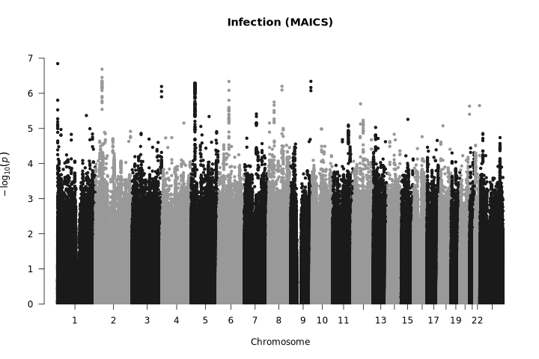
    - QQ-plot
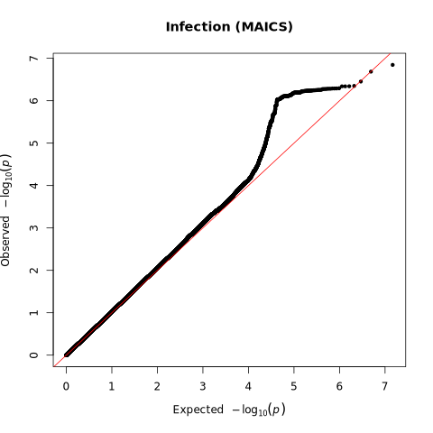
  - Infection related mortality, MAiCS
    - Manhattanplot

The GWAS for infection related mortality in MAICS did not give any genome-wide significant loci.

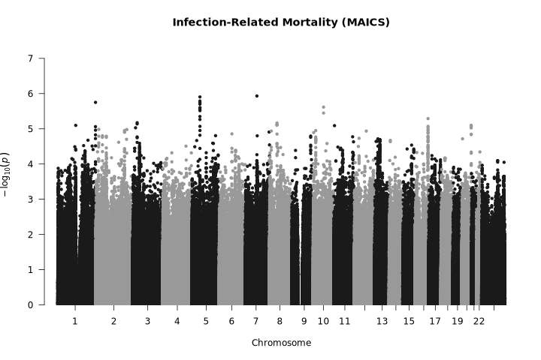
    - QQ-plot
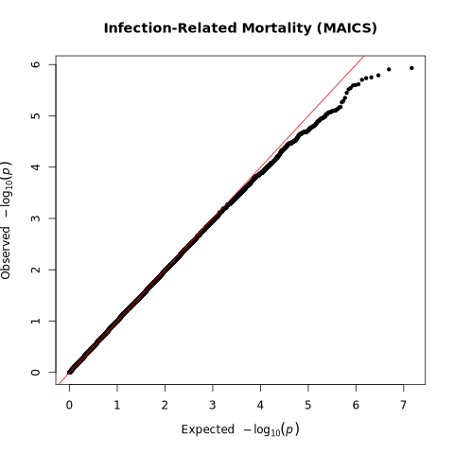
  - Pneumonia, MAICS
    - Manhattanplot

The GWAS for pneumonia in MAICS did not give any genome-wide significant loci.

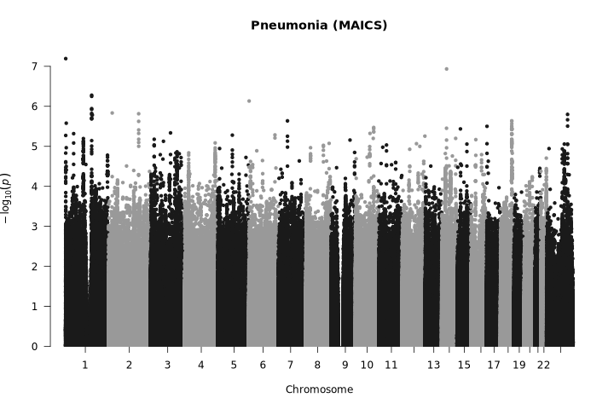
    - QQ-plot
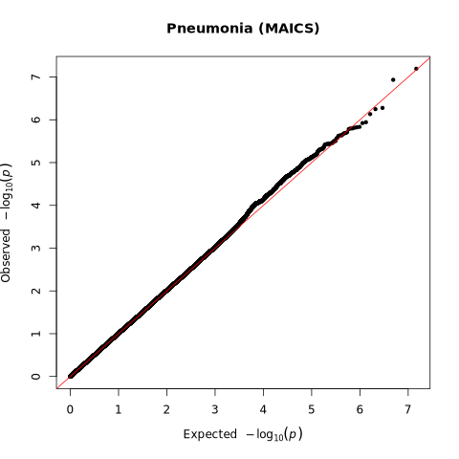
  - UTI, MAICS
    - Manhattanplot

The GWAS for UTI in MAICS did not give any genome-wide significant loci.

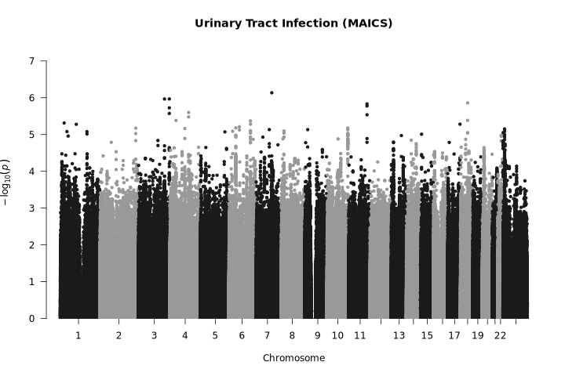
    - QQ-plot
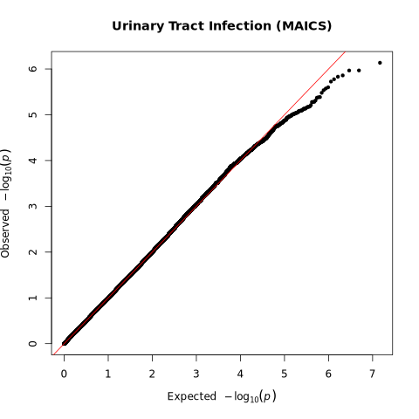

  - Any infection, UKBB
    - Manhattanplot
the GWAS of any infection identified 273 independent loci in UKBB.
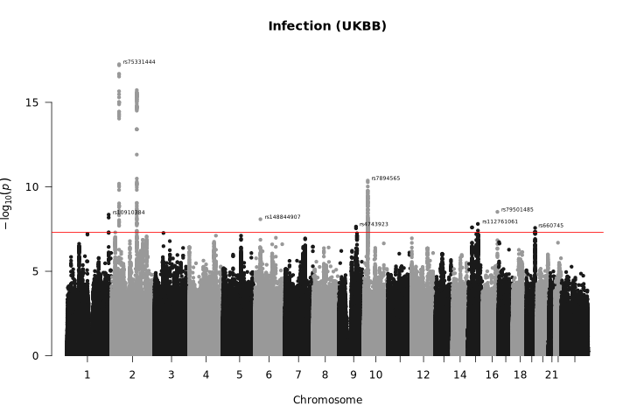
    - QQ-plot
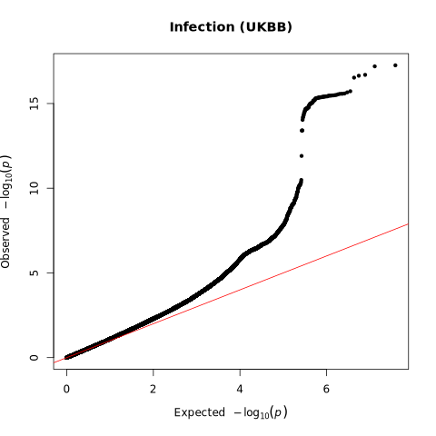
    - Locus Zoom
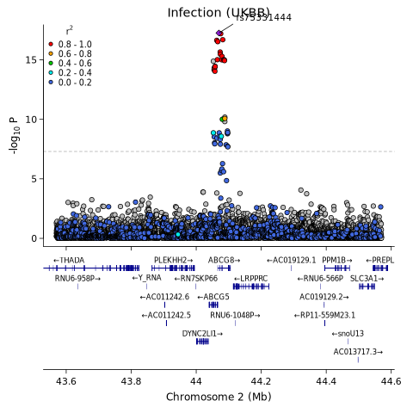
LocusZoom for the chromosome 2p21 locus associated with any infection in UK Biobank. The locus overlaps the ABCG5/ABCG8 gene region. The lead variant, rs5331444, lies within a region harbouring genes involved in sterol transport and lipid metabolism.

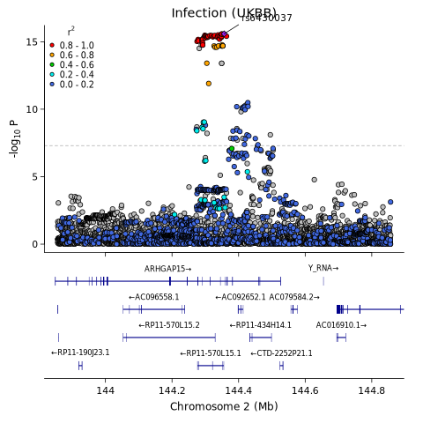
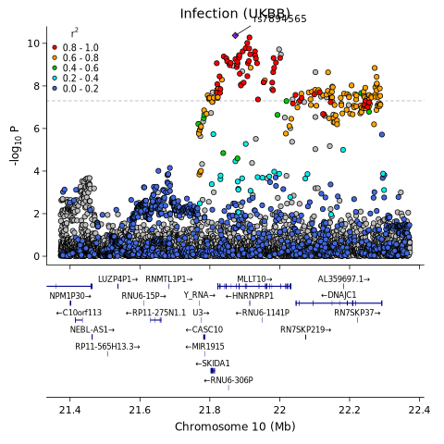

  - Infection related mortality, UKBB
    - Manhattanplot

the GWAS of infection related mortality did not identify any genome-wide significant loci in UKBB.

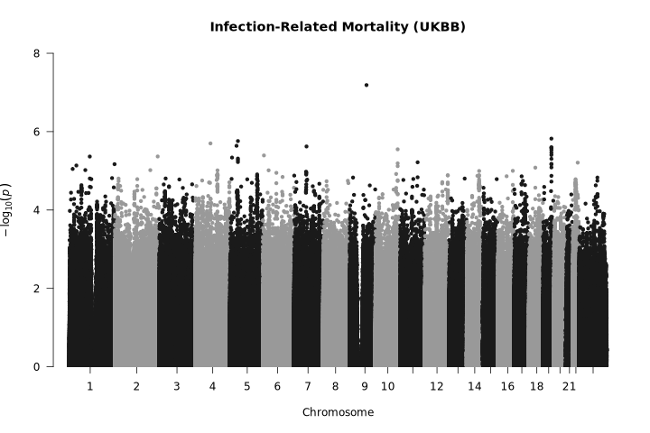
    - QQ-plot
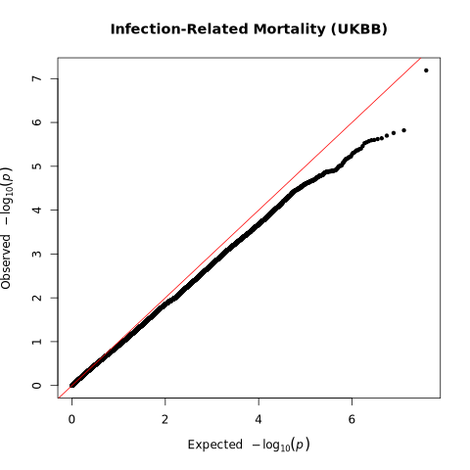
  - Pneumonia, UKBB
    - Manhattanplot

the GWAS of pneumonia identified 61 independent loci in UKBB.

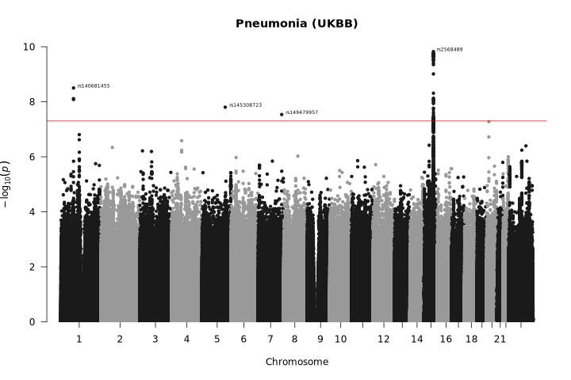
    - QQ-plot
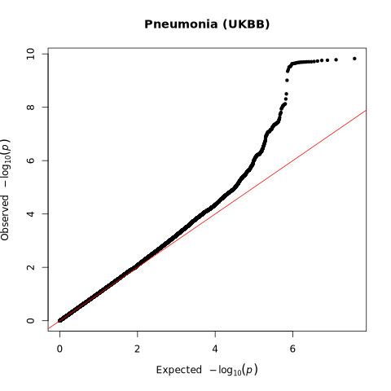
    - Locus Zoom
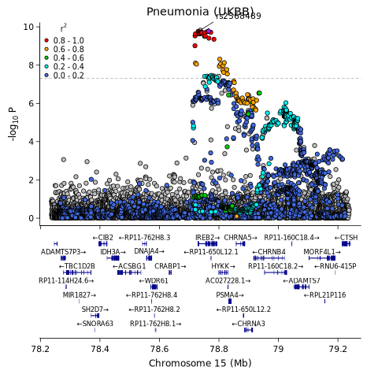
  - UTI, UKBB
    - Manhattanplot

the GWAS of UTI identified 7 independent loci in UKBB.
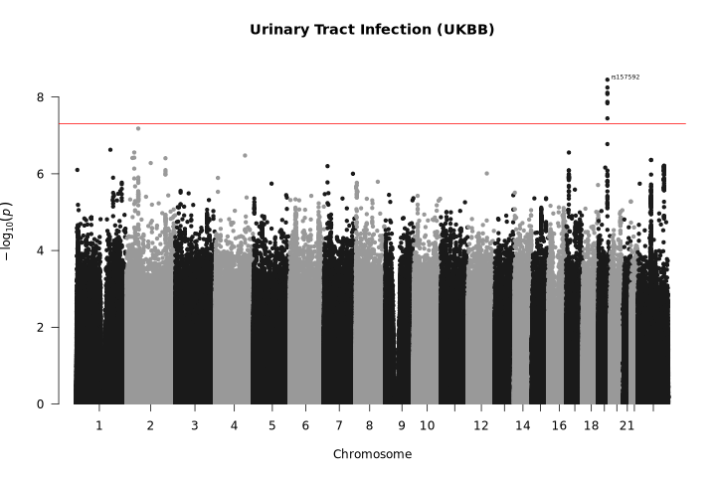
    - QQ-plot
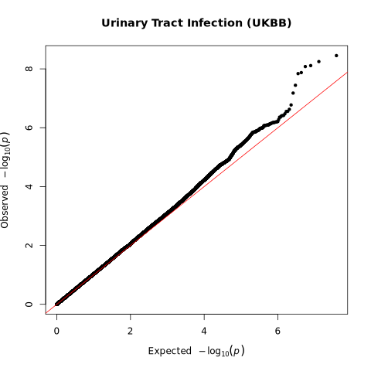
    - Locus Zoom
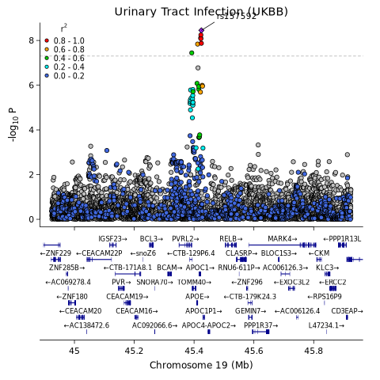

Manhattan-, QQ- and Locus Zoom plots for the GWASs on A) any infection in MAICS B) infection related mortality in MAICS C) pneumonia in MAICS D) UTI in MAICS E) any infection in UKBB F) infection related mortality in UKBB G) pneumonia in UKBB H) UTI in UKBB.

Supplementary Figure 2. Scatter plot of MR analyses for the association between sedentary behaviour on risk of infectious outcomes.
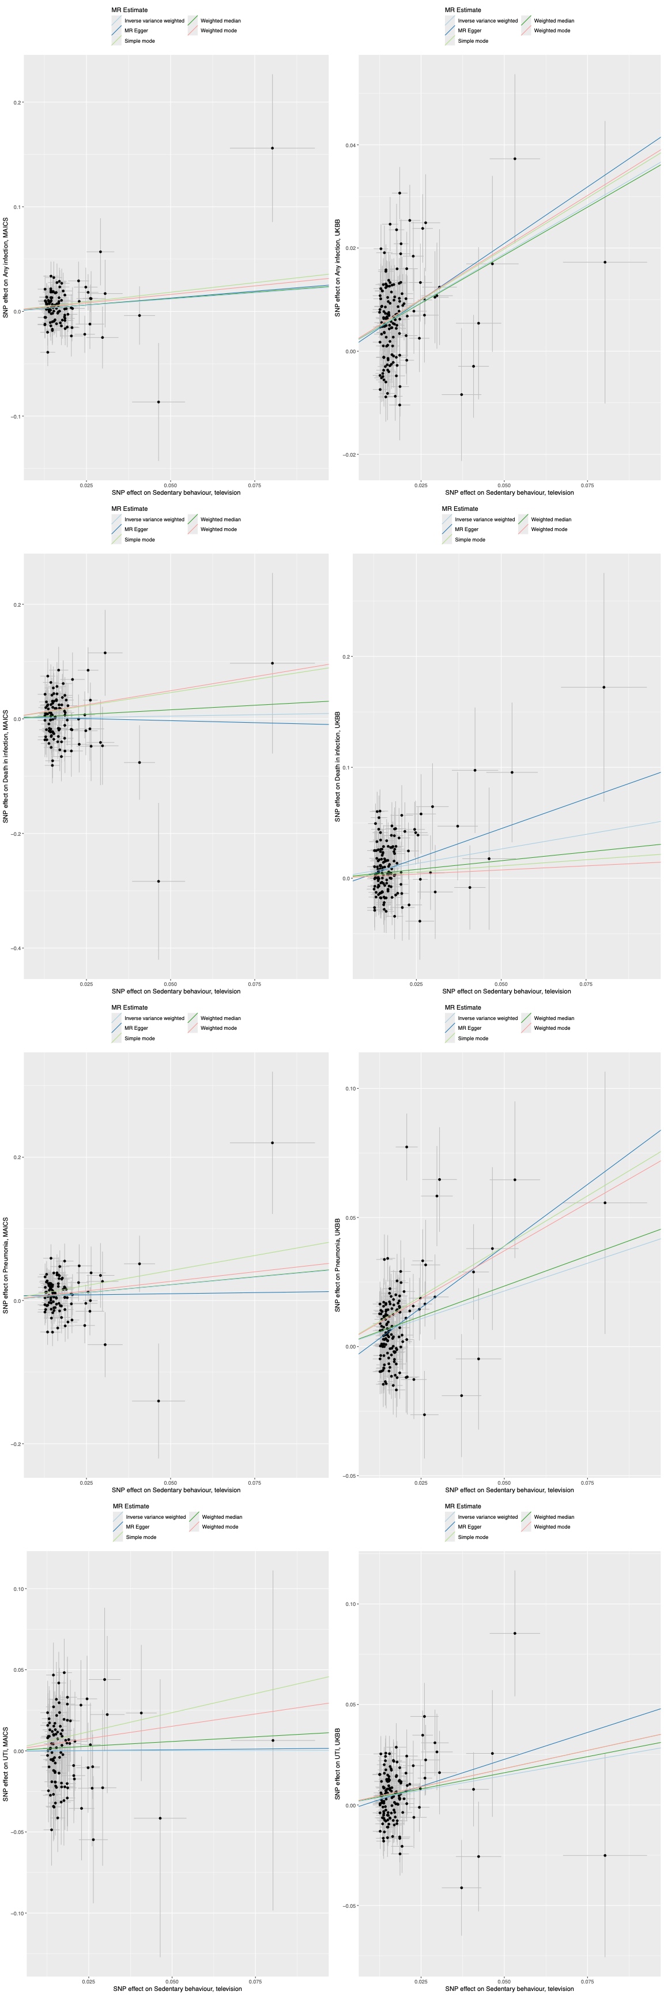
Scatter plot of MR analyses for the association between sedentary behaviour (television watching) on risk of infectious outcomes in MAICS and UKBB. Each dot represents a genetic instrumental variable, effect size of SNP on sedentary behaviour (x-axis, SD units) and on the infectious outcome (y-axis, log OR). Error bars represent 95 % Cis
Supplementary Figure 3. Leave-one-out sensitivity analysis.
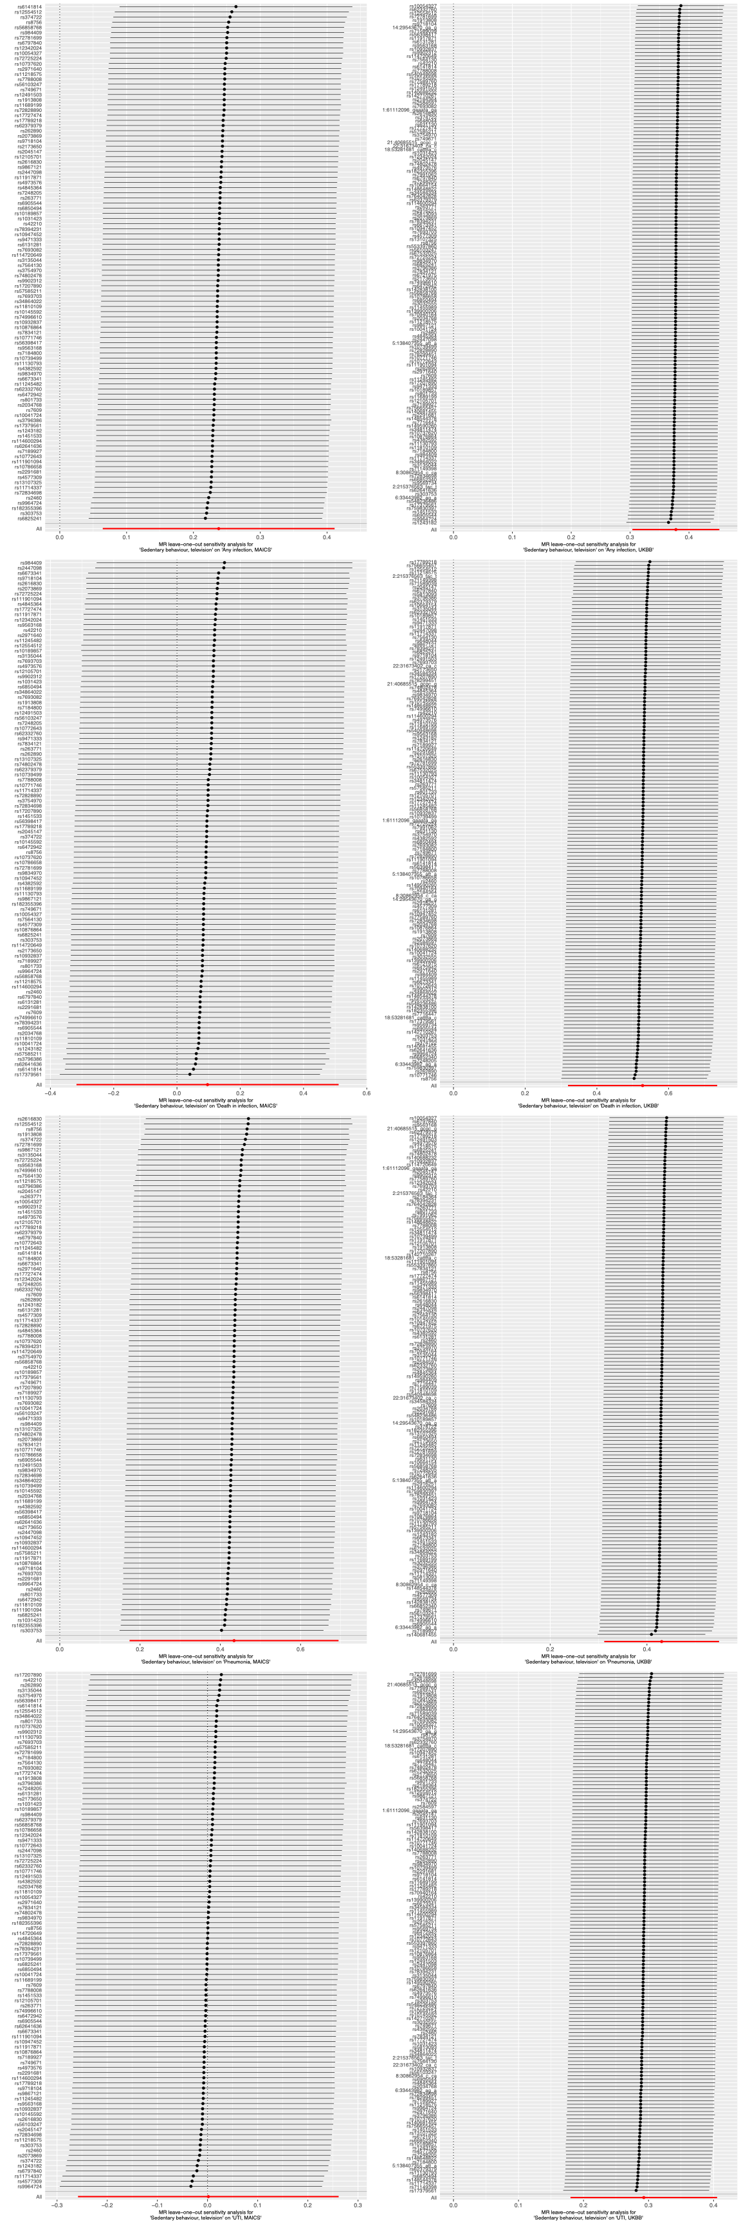
Leave-one-out sensitivity analysis. Each black point represents the IVW MR method applied to estimate the causal effect of sedentary behaviour (television watching) on risk of infectious outcomes in MAICS and UKBB excluding that particular variant from the analysis. The red point depicts the IVW estimate using all SNPs. MR estimate on x-axis in log odds per SD, bars indicating 95 % Cis.
Supplementary Figure 4. Scatter plot of MR analyses for the association between moderate-to-vigorous physical activity on risk of infectious outcomes.
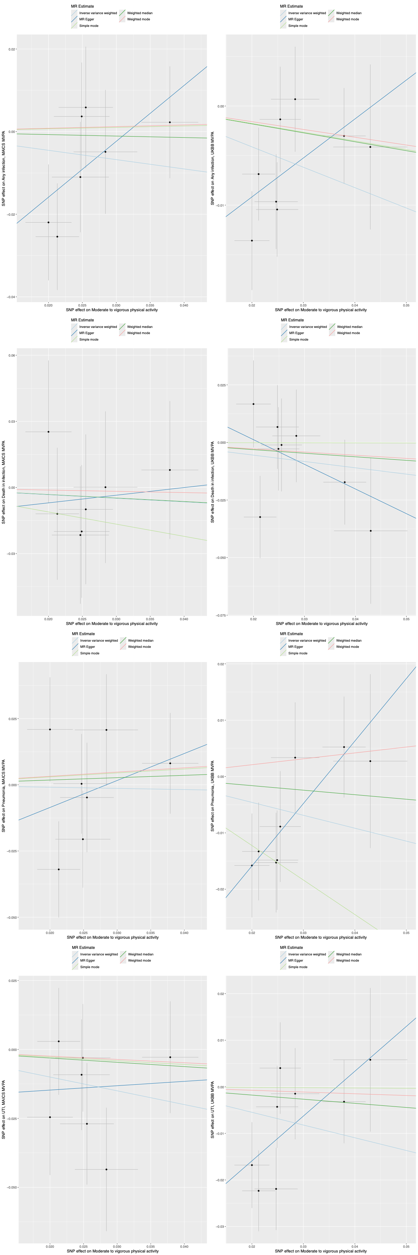
Scatter plot of MR analyses for the association between moderate-to-vigorous physical activity on risk of infectious outcomes in MAICS and UKBB. Each dot represents a genetic instrumental variable, effect size of SNP on moderate-to-vigorous physical activity (x-axis, SD units) and on the infectious outcome (y-axis, log OR). Error bars represent 95 % CIs.
Supplementary Figure 5. Leave-one-out sensitivity analysis.
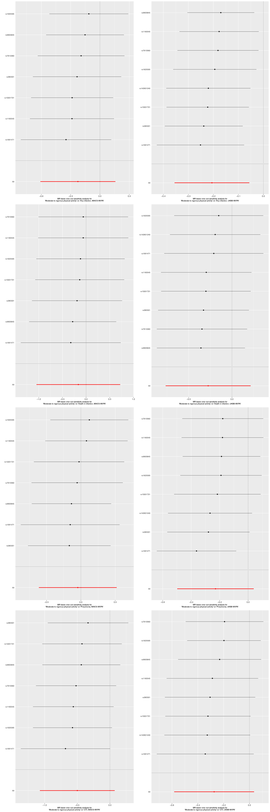
Leave-one-out sensitivity analysis. Each black point represents the IVW MR method applied to estimate the causal effect of moderate-to-vigorous physical activity on risk of infectious outcomes in MAICS and UKBB excluding that particular variant from the analysis. The red point depicts the IVW estimate using all SNPs. MR estimate on x-axis in log odds per SD, bars indicating 95 % CIs.

Supplementary Table 1. Infectious diseases by ICD-group

Group | Disease | ICD 10 | ICD 9
Other sepsis | Streptococcal sepsis | A40. | 0380
 | Other sepsis | A41. | 0381  0382  0383  0384  0388  0389
 | Listeriosis | A32 | 0270
 | Bacterial infection of unspecified site | A49 | 0410  0411  0412  0413  0414  0415  0416  0417  0418  0419  7907
 | Other bacterial diseases | A48. | 0400  0408  0401  0403
 | Streptococcus, staphylococcus, enterococcus | B95. | 0410  0411
 | Other bacterial agents as the cause of disease classified elsewhere | B96. | 0413  0414  0415  0416  0417  0418
 | Disseminated intravascular coagulation | D65. | 2866
 | Infection following infusion, transfusion or therapeutic injection | T802 | 9993
 | Systemic inflammatory response syndrome | R65.1
 | Septic shock | R57.2
Abdominal | Appendicitis | K35 | 5400  5401  5409  541  542
 | Diverticular disease with perforation or abscess | K57.0 | 5620
 |  | K57.2 | 5621
 |  | K57.4 | 5620  5621
 |  | K57.8 | 5621
 | Abscess of intestine | K63.0 | 5695
 | Perforation of intestine (nontraumatic) | K63.1 | 5694  5698
 | Peritonitis | K65 | 5400  5671  5672  5679  5778
 | Calculus of gallbladder with cholecystitis | K80.0 | 5740
 |  | K80.1 | 5741
 |  | K80.3 | 5743  5744
 |  | K80.4 | 5743  5744
 | Cholecystitis | K81 | 5750  5751
 | Cholangitis | K83.0 | 5761
 | Pancreatitis | K85 | 5770
Urogenital | Acute tubulo-interstitial nephritis | N10 | 5901  5902  5903  5909
 | Tubulo-interstitial nephritis, not classified as acute or chronic | N12 | 5908
 | Pyonephrosis | N13.6 | 5908
 | Acute salpingitis and oophoritis | N70 | 6140  6141  6142
 | Urinary tract infection, site not specified | N39.0 | 5990
Soft tissue | Septic arthritis | M00 | 7110  7119
 |  | M01 | 7114  7270  730  7115  7116  7117  7118
 | Necrotizing fasciitis | M72.6
 | Erysipelas | A46 | 035
Pneumonia | Penumonia due to Streptococcus pneumoniae | J13 | 481  0382
 | Pneumonia due to Haemophilus pneumoniae | J14 | 4822
 | Bacterial pneumonia | J15 | 4820  4821  4822  4823  4824  4828  4829  483
 | Pneumonia due to other organisms | J16 | 483
 | Bronchopneumonia, unspecified | J18 | 485  486
 | Abscess of lung | J85 | 5130  5131
 | Pyothorax | J86 | 510  5111
Endocarditis | Endocarditis | I33 | 4210  4219
 |  | I39 | 4249  421
Tuberculosis | Tuberculosis | A15 | 010  0101  0108  0109  0100  0113  0119  0120  0121  0122  0123  0128
 |  | A16 | 0100  0101  0108  0109  0110  0111  0112  0113  0114  0115  0116  0117  0118  0119  0120  0121  0123  0128
 |  | A17 | 0130  0138  0178  0139
 |  | A18 | 014  015  016  017
 |  | A19 | 018
CNS | Meningococcemia | A39 | 036
 | Bacterial meningitis | G00 | 320
 |  | G01 | 320
 |  | G02
 |  | G03.9
 |  | G05.0 | 320
 | Intracranial/intraspinal abscess | G06 | 324  320
 |  | G07.9

Supplementary table 2. Associations with previous infectious disease GWASs.
Chr | Our lead SNP (UKBB) | Our phenotype | Tängdén lead SNP | Tängdén phenotype | R² | Tängdén SNP in our GWAS | Relationship
1 | rs10910384 (1:234353053:A:C) | Any infection | rs4333882 (1:234352899:G:A) | Abdominal | 0.6648 | Significant (EAF 0.193, P 6.6×10⁻⁹) | Correlated; our signal modest rather than a clean peak
2 | rs1559068778 (position TBC) | Any infection | rs6717024 (2:144308780:C:G) | Abdominal | 0.8185 | Significant (EAF 0.820, P 3.9×10⁻¹⁶) | Correlated (strong)
6 | rs148844907 (6:31628397:T:A) | Any infection | rs28752520 (6:32584739:C:T) | Respiratory | LE | — | Independent (linkage equilibrium)
6 | rs148844907 (6:31628397:T:A) | Any infection | rs570640158 (6:32517793:C:T) | Abdominal | LE | — | Independent (linkage equilibrium)
10 | rs7894565 (position TBC) | Any infection | — | — | — | — | Not reported by Tängdén
15 | rs112761061 (15:76851548:T:A) | Any infection | rs77438700 (15:78906637:G:A) | Bacterial pneumonia | LE | Not significant | Independent (linkage equilibrium)
15 | rs2568489 (15:78737483:T:A) | Pneumonia | rs77438700 (15:78906637:G:A) | Bacterial pneumonia | NA | — | Proximal; LD not calculable (rs2568489 absent from 1000G panel)
16 | rs79501485 (16:84939983:G:C) | Any infection | rs4782673 (16:84884072:T:G) | Abdominal | 0.2175 | — | Weakly correlated; our variant weakly significant

