Online Resource 1
Hugo RAS versus da Vinci Xi for robot-assisted simple hysterectomy in endometrial cancer: a concurrent-period comparison of operative efficiency, cost structure, and the cost of early adoption
Journal Journal of Robotic Surgery
Authors Ikuko Sakamoto; Takahiro Nozaki; Naoki Fukada; Yoshihiko Ito; Keiko Kagami
Corresponding author Ikuko Sakamoto
Department of Obstetrics and Gynecology, Yamanashi Central Hospital, 1-1-1 Fujimi, Kofu, Yamanashi 400-0027, Japan
E-mail: I-nagata@ych.pref.yamanashi.jp

S1 Supplementary methods

S1.1 Small-sample inference
The concurrent cohort comprises 67 cases with nine model parameters. Because surgeon D contributed no case to either group in this cohort, the surgeon fixed effect requires two dummy variables, leaving 58 residual degrees of freedom. At this scale, applying normal reference values to HC3 heteroscedasticity-robust standard errors can be anti-conservative. Every estimate was therefore accompanied by three intervals:
HC3 normal interval — HC3 standard error with normal critical values.
HC3-t(n − k) interval — HC3 standard error with t critical values on the residual degrees of freedom.
Stratified case bootstrap interval — 2000 replicates, resampling cases within platform strata, percentile method.
Outcomes for which the three intervals disagree on significance at the 0.05 level are flagged explicitly in the main text. Non-console time was the only such outcome (Table S3).

S1.2 Overlap weighting
Overlap weighting was applied to the full-period cohort of 218 cases (one case excluded for missing uterine weight). Propensity scores were estimated by logistic regression, and weights were 1 − e in the treated group and e in the control group, where e is the estimated propensity score. Overlap weights are bounded in [0, 1] by construction, and the estimand is the average treatment effect in the overlap population (ATO). Because the weights carry the balancing, the outcome model contained only the platform indicator (weighted least squares, HC3).
Two propensity score specifications were used:
PS-A (case mix only) — age, body mass index (BMI), previous abdominal surgery, log(uterine weight + 1), and surgeon.
PS-B (case mix plus calendar) — PS-A plus the calendar-month index.
Surgeon D contributed three da Vinci Xi cases and no Hugo RAS case, producing quasi-complete separation. Surgeon was therefore collapsed to “A versus other” in the propensity score model only; the unweighted full-period outcome models retained the full surgeon factor. The primary overlap-weighted outcome models included only the platform indicator. Effective sample size (ESS) per group is reported as (Σw)² / Σw². Weighted covariate balance was assessed by weighted standardised mean difference (SMD), using the unweighted pooled within-group variance in the denominator so that weighted and unweighted columns share a denominator. Symmetric propensity score trimming at 0.05 and 0.10 was applied as a sensitivity analysis, with the propensity score model re-estimated after trimming.

S1.3 Sensitivity analyses of the covariate specification
In addition to the primary six-covariate model, the following were fitted to total operative time: (a) calendar-month index removed; (b) a reduced model retaining only age, BMI, and log(uterine weight + 1); (c) restriction to surgeon A, with the surgeon fixed effect dropped as it becomes a single level; (d) exclusion of the first ten Hugo RAS cases; (e) addition of the extent of adnexal surgery as a covariate; (f) Huber M-estimation; (g) median (quantile) regression; and (h) the standardised absolute difference from a log-link gamma model. Results appear in Table 3 of the main text.

S1.4 Sensitivity analysis for discordant pathology records
Two cases (both Hugo RAS) carried endometrial cancer in the structured final pathology field but a conflicting free-text note (“postoperative pathology EIN” and “no residual cancer”). Both were retained in the primary analysis under the prespecified rule that the structured field governs. Excluding them changed the adjusted mean difference in total operative time from +16.31 min (95 % CI 6.04–26.58; p = 0.0018, n = 67) to +17.03 min (95 % CI 6.12–27.93; p = 0.0022, n = 65). The primary conclusion is unaffected.

S1.5 Definition of operative cost
Operative cost as recorded in the hospital accounting database is the sum of four components: labour, consumables, drugs, and overhead expenses. Across all 61 cases in the concurrent cost cohort, the sum of these four components reconciled with the recorded operative cost total to within ¥0. Mean component values in the concurrent cohort were:

Table S1 Components of operative cost in the concurrent cohort
Component | da Vinci Xi (n = 36) | Hugo RAS (n = 25) | Difference (Hugo − da Vinci)
Consumables | ¥266,942 | ¥213,141 | −¥53,801
Labour | ¥57,752 | ¥69,923 | +¥12,170
Drugs | ¥18,964 | ¥19,755 | +¥791
Overhead | ¥21,982 | ¥25,800 | +¥3,817
Operative cost (total) | ¥365,641 | ¥328,618 | −¥37,022
Values are unadjusted means; rounding may cause small discrepancies between component sums, total costs, and differences of displayed means. Non-consumable cost (labour + drugs + overhead expenses) was approximately ¥98,699 with the da Vinci Xi and ¥115,477 with the Hugo RAS. Capital items such as depreciation of acquisition cost and maintenance contracts do not appear as separate components of operative cost, so this analysis cannot establish total cost of ownership.

S2 Supplementary tables

Table S2a Overlap-weighted analysis of total operative time
PS model | Trim | n (dV/Hugo) | ESS (dV/Hugo) | Effect (min) | 95% CI | p
PS-A | None | 218 (188/30) | 170.6/29.9 | -3.54 | −12.67 to 5.59 | 0.448
PS-B | None | 218 (188/30) | 31.0/23.1 | +15.86 | 3.23 to 28.48 | 0.014
PS-B | 0.05 | 71 (42/29) | 31.0/24.0 | +16.31 | 3.94 to 28.67 | 0.010
PS-B | 0.10 | 65 (36/29) | 30.0/24.7 | +16.53 | 4.22 to 28.84 | 0.009
PS propensity score; dV da Vinci Xi; ESS effective sample size; CI confidence interval. PS-A includes case mix; PS-B also includes calendar month. Trimming uses both tails, and the propensity model is re-estimated after trimming.

Table S2b Selected covariate balance before and after weighting
Covariate | Unweighted | PS-A | PS-B | Included in PS-A / PS-B
Age | 0.004 | 0.000 | 0.000 | Yes / Yes
BMI | 0.167 | 0.000 | 0.000 | Yes / Yes
log(uterine weight + 1) | 0.022 | 0.000 | 0.000 | Yes / Yes
Previous abdominal surgery | 0.340 | 0.000 | 0.000 | Yes / Yes
Calendar-month index | 2.097 | 2.107 | 0.000 | No / Yes
Platform-specific cumulative case number | 2.023 | 2.015 | 4.092 | No / No
FIGO stage II | 0.278 | 0.228 | 0.519 | No / No
The estimand is the average treatment effect in the overlap population (ATO). Weights are 1 − e in the treated group and e in the control group, bounded in [0, 1] by construction. The outcome model contains only the platform indicator (weighted least squares, HC3). ESS = (Σw)² / Σw². The propensity score model was re-estimated after trimming. PS-B balances calendar month exactly but doubles the imbalance in platform-specific cumulative case number, and SMD increased by more than 0.01 on eight variables. ESS effective sample size, SMD standardised mean difference

Table S3 Small-sample inference in the concurrent cohort
Outcome | n | Residual df | Estimate | HC3 normal | HC3 t | Bootstrap
Total operative time, min | 67 | 58 | 16.31 | 6.04 to 26.58 | 5.82 to 26.80 | 7.54 to 25.23
Console time, min | 66 | 57 | 9.96 | 3.99 to 15.92 | 3.86 to 16.05 | 4.46 to 15.25
Non-console time, min | 66 | 57 | 6.54 | 0.12 to 12.96 | −0.02 to 13.10 | 0.80 to 12.34
Incision-to-console time, min | 66 | 57 | 4.38 | 1.03 to 7.74 | 0.95 to 7.82 | 0.80 to 7.31
Patient-in-room time, min | 63 | 54 | 20.32 | 8.53 to 32.11 | 8.26 to 32.38 | 8.58 to 31.09
Operative cost (ratio) | 61 | 52 | 0.923 | 0.857 to 0.993 | 0.856 to 0.994 | 0.861 to 0.990
Consumable cost (ratio) | 61 | 52 | 0.808 | 0.730 to 0.895 | 0.728 to 0.897 | 0.740 to 0.907
Reimbursement (ratio) | 61 | 52 | 1.013 | 0.987 to 1.041 | 0.986 to 1.041 | 0.988 to 1.039
Profit (ratio) | 61 | 52 | 1.076 | 1.005 to 1.151 | 1.004 to 1.153 | 1.006 to 1.144
Profit margin (percentage points) | 61 | 52 | 3.70 | 0.48 to 6.92 | 0.40 to 7.00 | 0.68 to 6.57
The bootstrap is a platform-stratified case bootstrap (2000 replicates, percentile method). Non-console time is the only outcome for which the three intervals disagree on significance. HC3 heteroscedasticity-consistent type 3; df degrees of freedom. All intervals are 95% confidence intervals.

Table S4 Descriptive oncologic outcomes in the full-period cohort
Measure | da Vinci Xi (n = 189) | Hugo RAS (n = 30)
Recorded recurrences, n | 18 | 2
Median follow-up (reverse Kaplan–Meier), months | 47.2 | 14.8
Maximum follow-up, months | 83.7 | 31.1
Estimated RFS at 12 months, % (95 % CI) | 93.0 (88.2–95.9) | 96.4 (77.2–99.5)
Estimated RFS at 24 months, % (95 % CI) | 91.9 (86.9–95.0) | 90.0 (63.8–97.6)
Estimated RFS at 36 months, % (95 % CI) | 91.2 (86.0–94.5) | Not estimable
Number at risk at 12 / 24 / 36 months | 171 / 147 / 121 | 18 / 5 / 0
No between-group test was performed because follow-up differs substantially between the groups. This table is descriptive and does not evaluate oncologic equivalence or non-inferiority. The concurrent cohort contained four recurrences in the da Vinci Xi group and two in the Hugo RAS group, so no time-to-event analysis was performed in that cohort. RFS recurrence-free survival

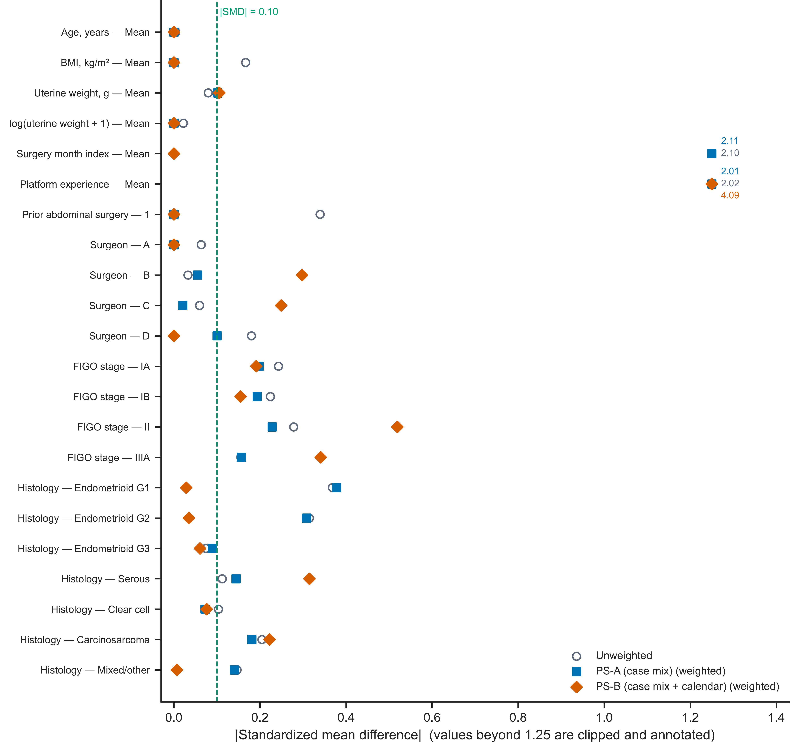
Fig. S1 Covariate balance before and after overlap weighting (Love plot). Open circles show unweighted absolute standardised differences, squares PS-A (case mix only), and diamonds PS-B (case mix plus calendar month). The dashed line marks |SMD| = 0.10. The calendar-month index and platform-specific cumulative case number exceed 1.25 and are annotated with their observed values

Fig. S2 Propensity-score distributions and overlap-weight diagnostics
a PS-A (case mix only)
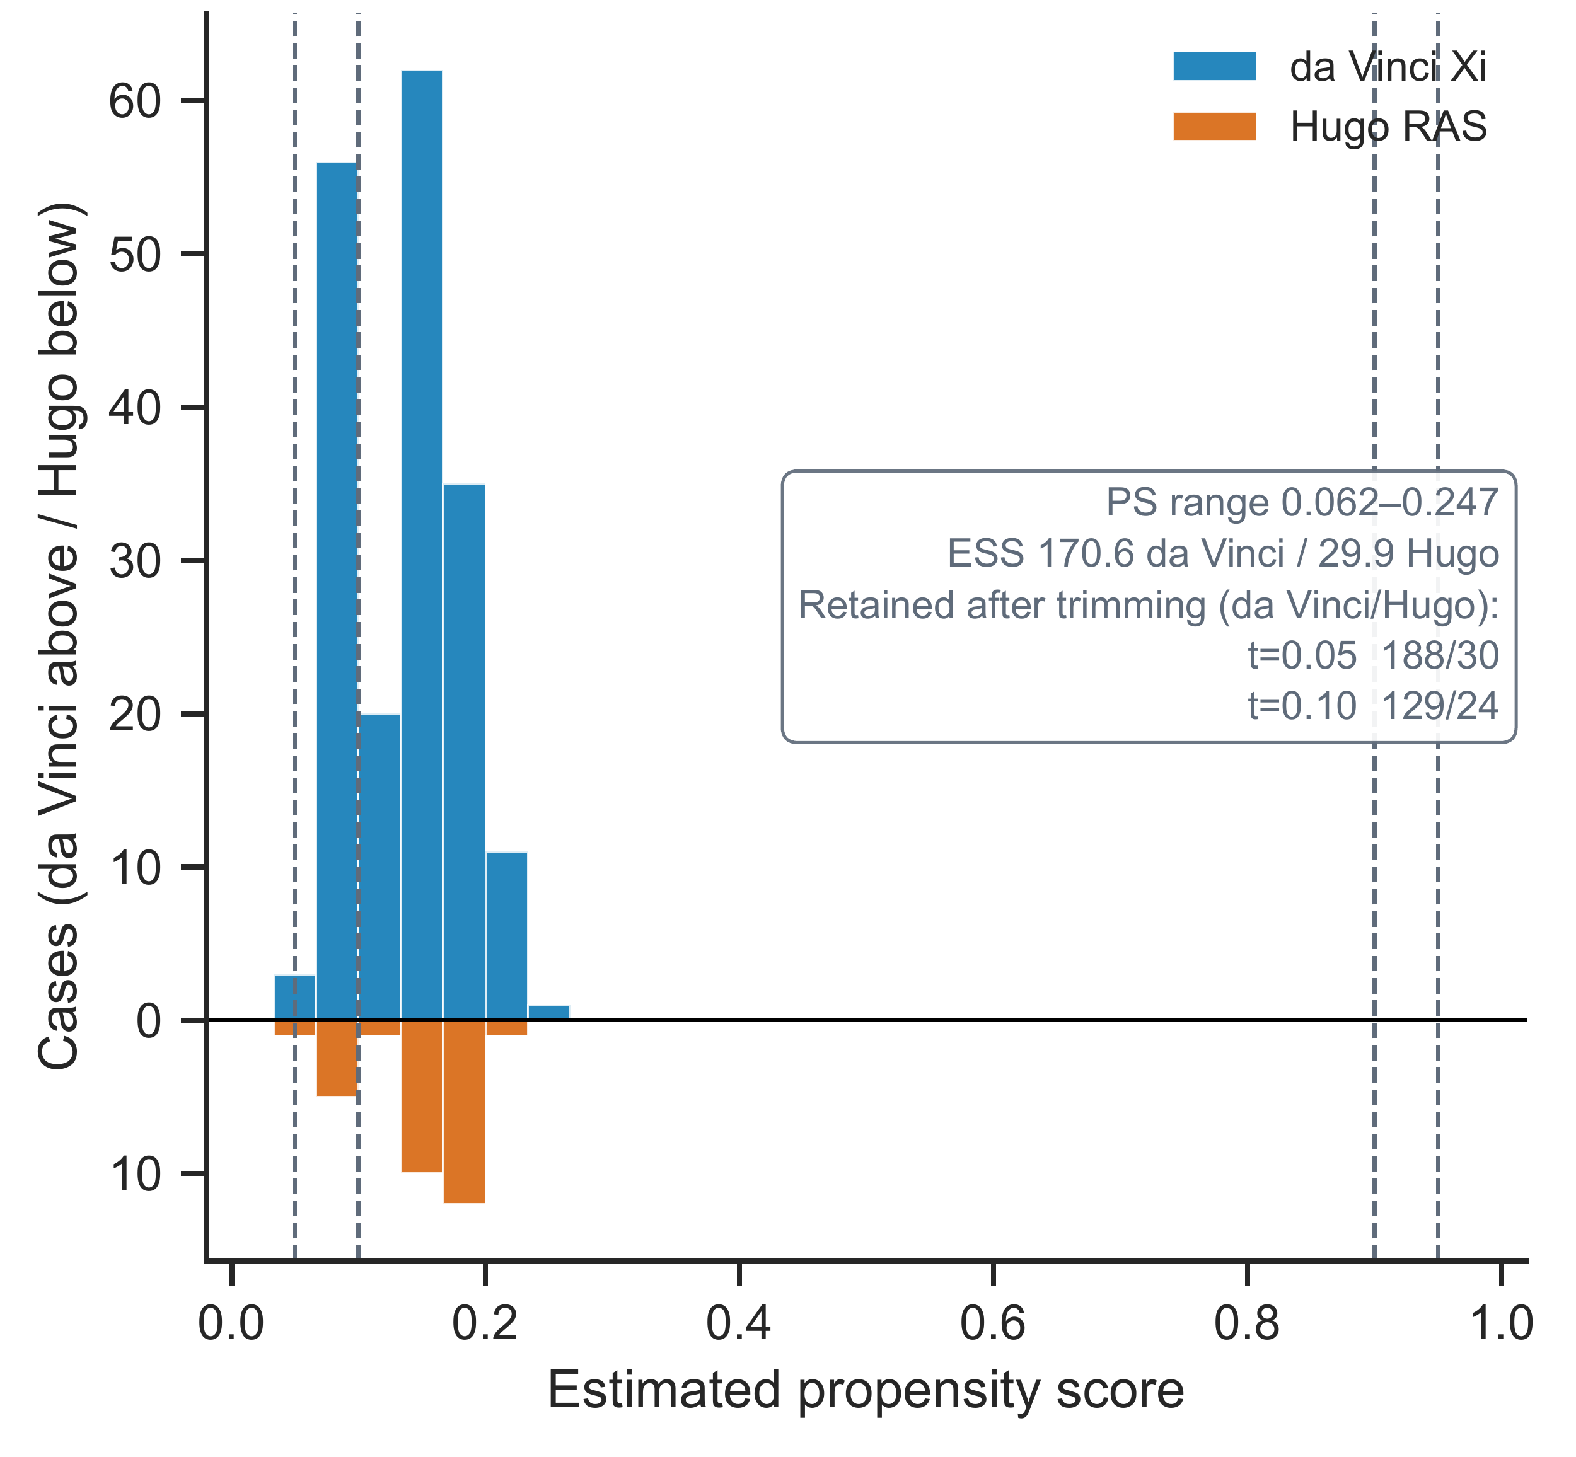
Panel a Back-to-back propensity-score histogram; da Vinci Xi above and Hugo RAS below. ESS effective sample size; PS propensity score

Fig. S2 continued
b PS-B (case mix plus calendar month)
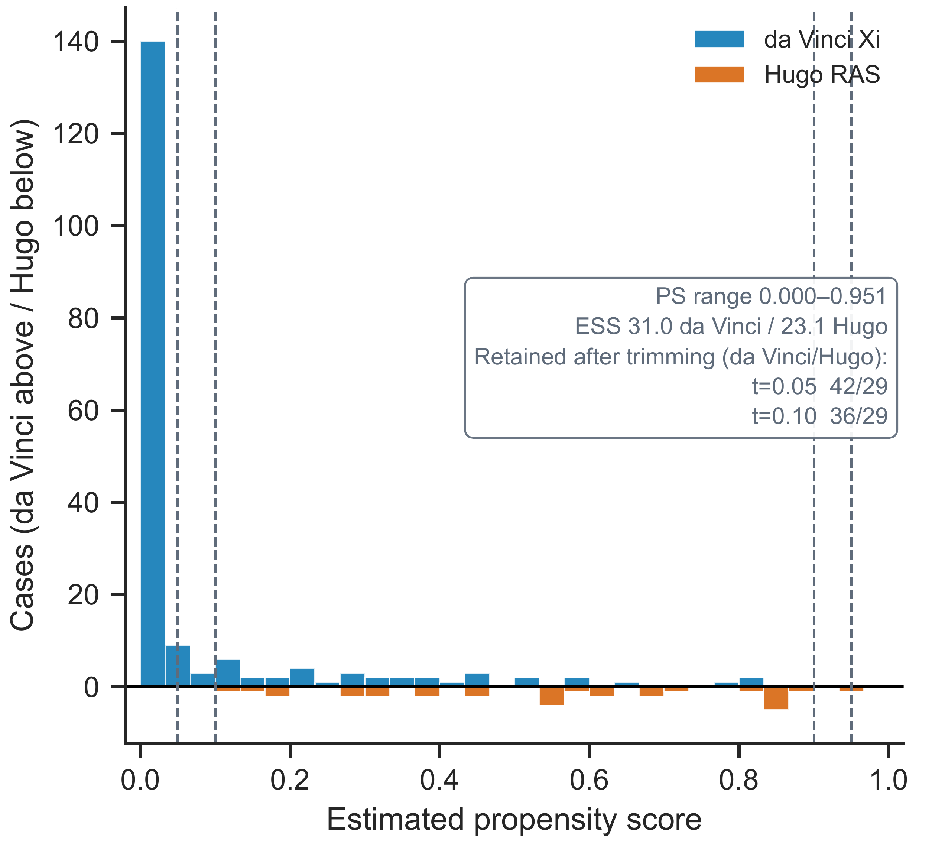
Panel b Dashed lines mark symmetric trimming thresholds of 0.05 and 0.10

Fig. S2 continued
c Overlap weights under PS-B
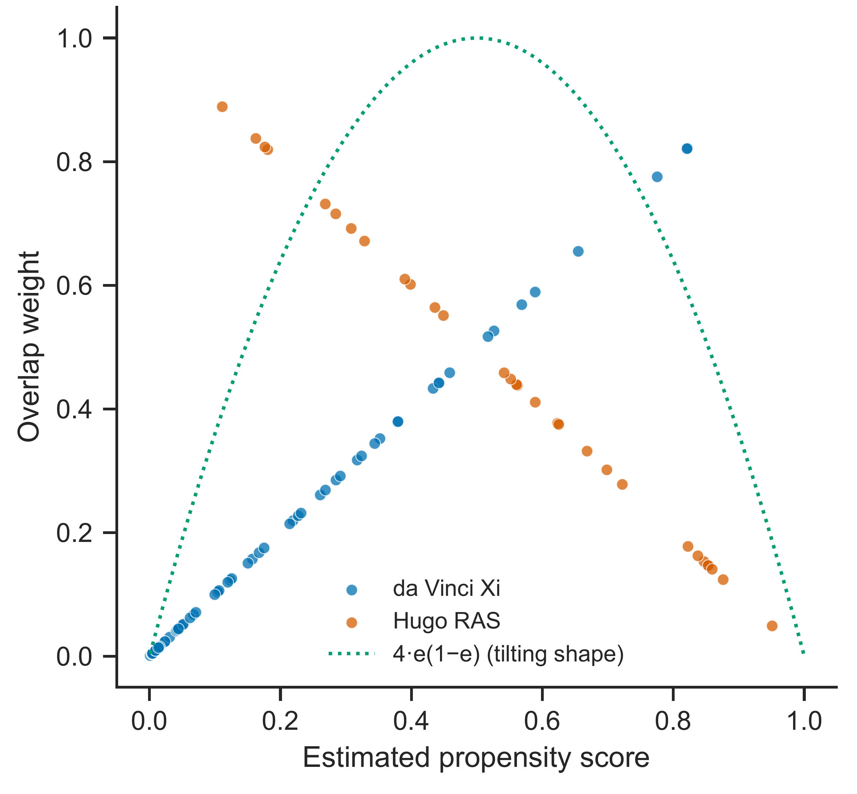
Panel c The dotted curve is 4e(1 − e), a scaled target-density tilting function rather than the individual treatment-specific weight; individual weights are e for da Vinci Xi and 1 − e for Hugo RAS

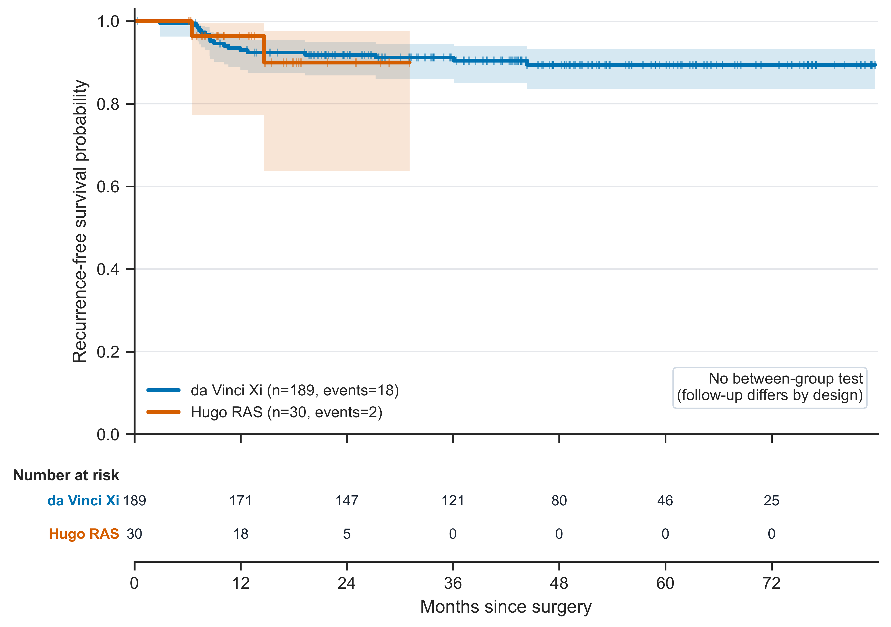
Fig. S3 Kaplan–Meier estimates of recurrence-free survival in the full-period cohort. Recurrences recorded in the medical record were treated as events, and patients without recurrence were censored at the last follow-up date. No between-group test was performed because follow-up differs substantially between the groups. Shading denotes 95% confidence intervals; tick marks denote censoring. Numbers at risk are displayed beneath the curves

