Supplementary Material
The experiments related to HFD mice have been analyzed in detail by our group in published articles（DOI: 10.1002/oby.22590）, so these studies have not been put back in this article, and the results and methods are as follows.
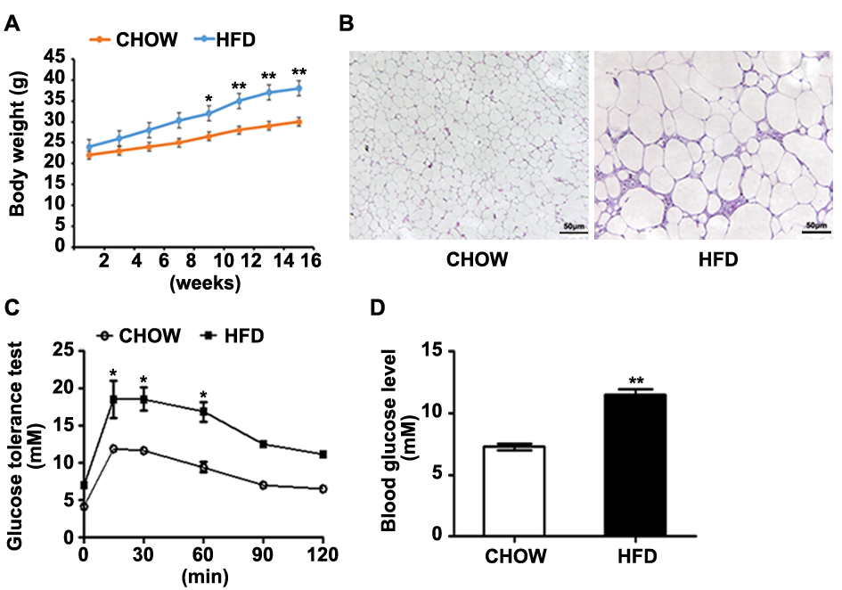
Figure S1: Pathological changes in chow and HFD mice about obesity and T2DM. (A) Body weight. (B) Representative images of the H&E-stained adipose tissue of the mice. (C) GTT. (D) Fast glucose level of HFD and CHOW groups mice. The values in bar graphs are means ± SD. ∗p < 0.05.

Animal model
Male C57BL/6J mice (8 weeks old) were purchased from Guangdong Medical Laboratory Animal Center (Guangdong, China). All procedures related to mouse care were carried out according to the guidelines of the Ethics Committee for Animal Research, Shenzhen Institutes of Advanced Technology, Chinese Academy of Sciences. After one-week adaptation, the mice were randomly divided into two groups: the chow group (n=3) and the HFD group (n=3). Mice were fed high-fat diet (45% fat, Research diet D12451, New Jersey) or chow diet ad libitum for 15 weeks until the symptoms of the mice are characteristic for IR. Body weight was measured fortnightly.
Hematoxylin and Eosin (H&E) staining
The adipose tissue of the epididymis of mice were fixed in 4% paraformaldehyde (pH7.4) for 24 h and embedded in paraffin. The tissues were sliced and stained with H&E (Sigma-Aldrich Corp, Missouri). All sections were observed with microscope (OlympusIX71, Japan).
Glucose tolerance test (GTT) and fast glucose measurement
In brief, GTT was performed after 16 hours fasting of the mice. Glucose (2 g/kg) was administrated intraperitoneally and snipping tail vein blood glucose of each mouse was measured by AccuCheck glucometer (Roche, Switzerland). Blood glucose levels were measured at 0-, 30-, 60-, and 120-minutes post-injection of glucose. For fast blood glucose measuring, the mice were fasted for 5 hours instead of overnight.
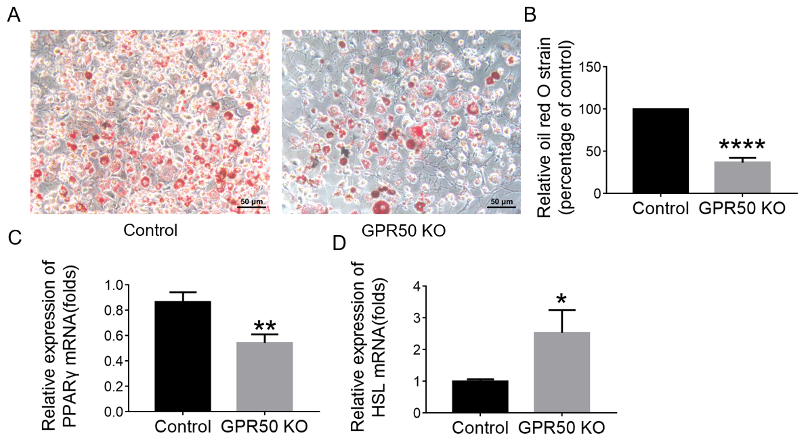
Figure.S2： Effect of GPR50 on lipid accumulation in 3T3-L1 adipocytes. 3T3-L1 and GPR50-knockout 3T3L1 cell line differentiation was examined on day 10 by oil red O staining (A) and quantification of droplet (B). The relative mRNA expressions of PPAR-γ (C) and HSL (D) were analyzed by Q-PCR. The values are expressed as mean ± standard deviation of independent experiments performed in triplicate. Data were analyzed by t test. ****: p <0.0001, **: p <0.01, *: p <0.05 compared to Control.
Data Availability Statement: Microarray and sample annotation data were deposited in Gene Expression Omnibus under accession number GSE100028. Direct link to the deposited data is available at https://www.ncbi.nlm.nih.gov/geo/query/acc.cgi?acc=GSE100028.

