Table A. Search Keywords’ Details for Database Searching

Social Media Keywords | Review Keywords | Platform Keywords | Population Keywords | Search Date
"social media" OR "social media use*" OR "social media platform*" OR "social network" OR "social network site*" | "meta-analy*" OR "meta analy*" OR "review" OR "quantitative synthesis" OR "systematic review" | "internet" OR "online" OR "chat" OR "electronic" OR "mobile" OR "social network" OR "media" OR "Facebook" OR "Twitter" OR "blog*" OR "YouTube" OR "Tumblr" OR "Discord" OR "Reddit" OR "Instagram" OR "TikTok" OR "Snapchat" OR "Pinterest" OR "LinkedIn" | "child*" OR "adolescent*" OR "student*" OR "teen*" OR "youth" | 8th, February, 2025

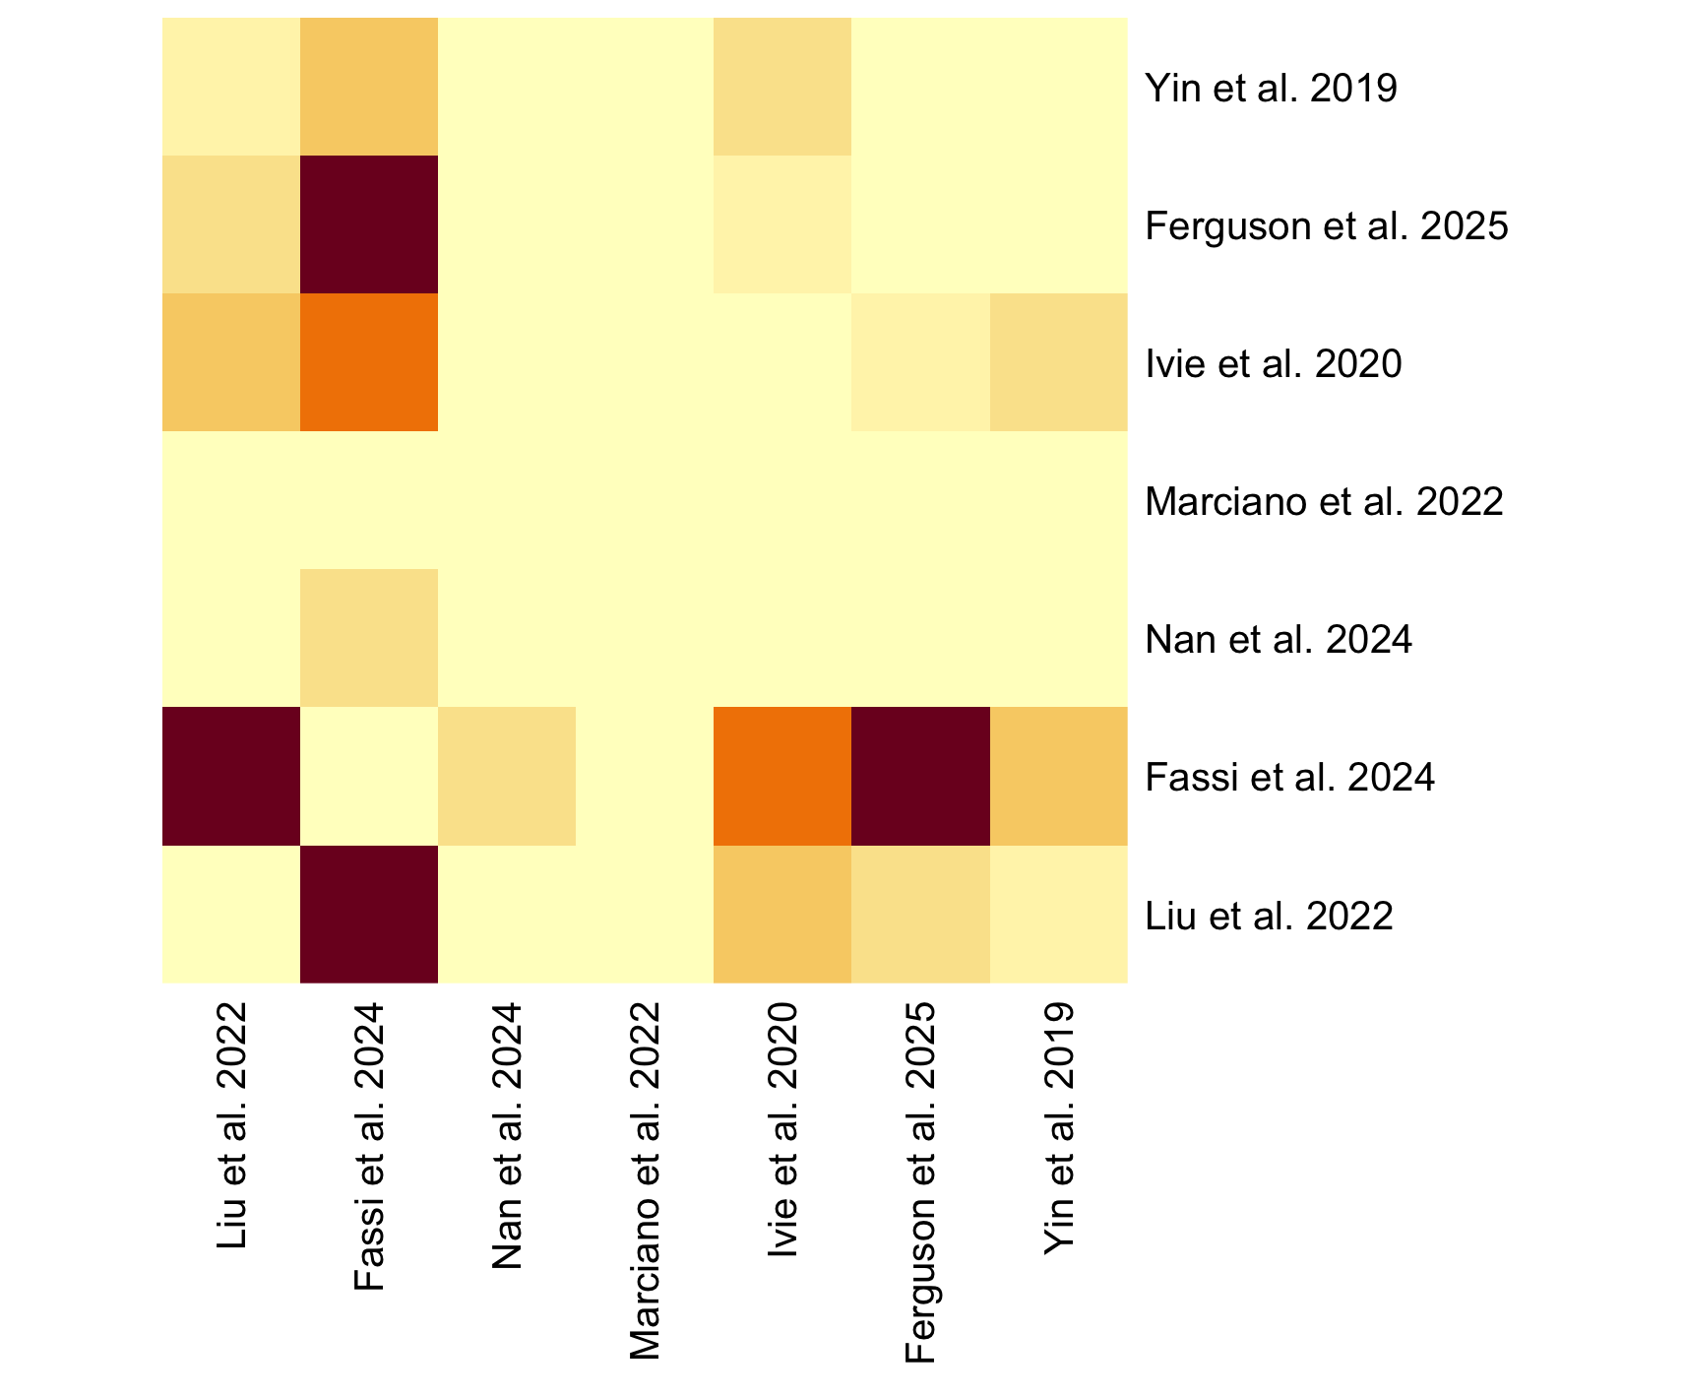
Figure A. Pairwise overlap of primary studies across reviews to assess corrected covered areas in meta-meta-analysis

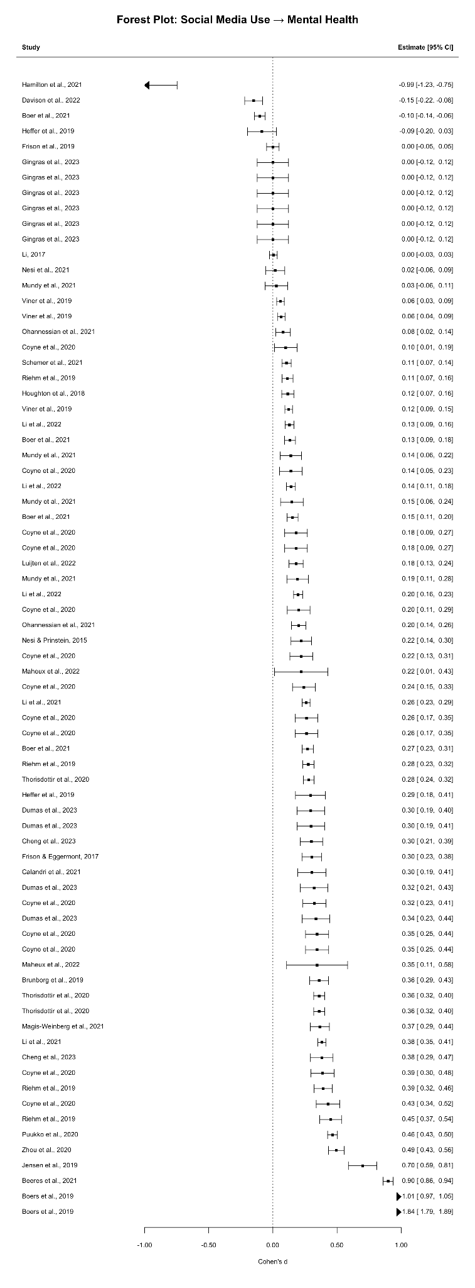

Figure B. Forest plot in forward direction (social media -> mental health) in the mini-meta-analysis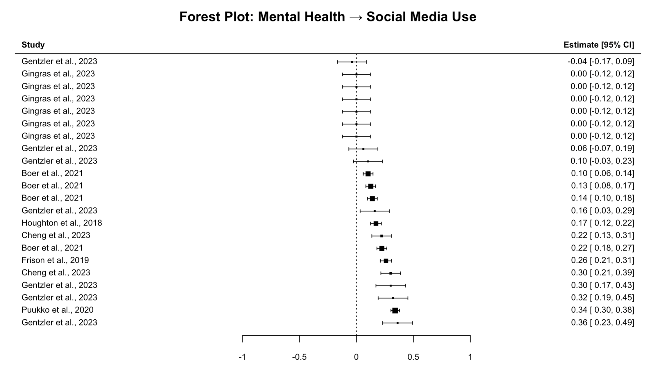
Figure C. Forest plot in reverse direction (mental health -> social media) in the mini-meta-analysis
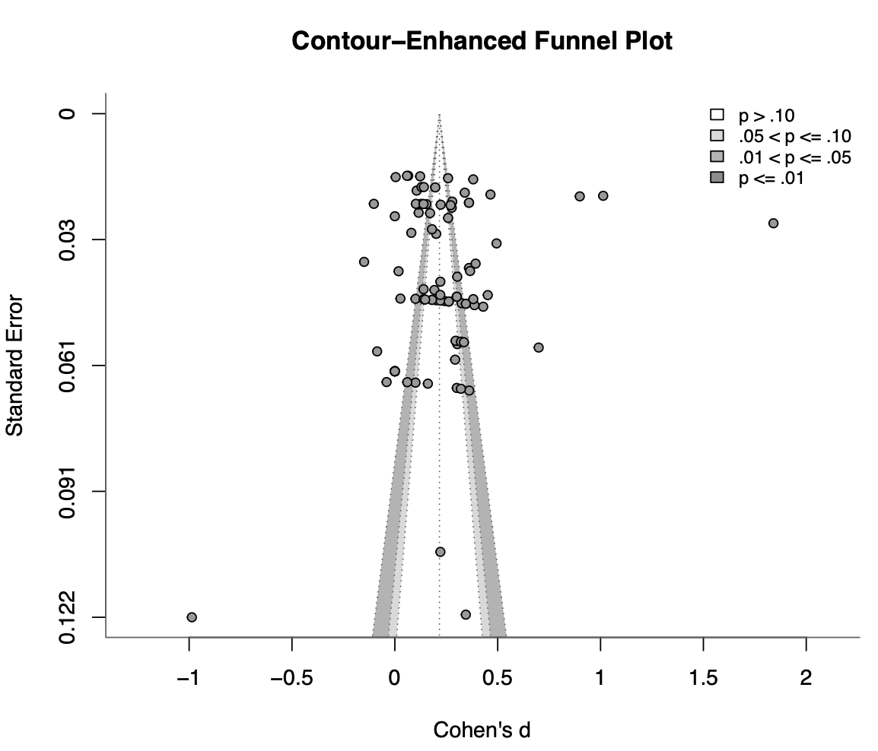
Figure D. Contour-enhanced funnel plot for the mini-meta-analysis. This funnel plot was used as descriptive diagnostics, while formal assessment of selective reporting relied primarily on selection models.

Section A. Search string details recorded for database searching

Pubmed (1094): ((((Social media[Title/Abstract]) OR (social media us*[Title/Abstract]) OR (social media platform*[Title/Abstract]) OR (social network[Title/Abstract]) OR (social network site*[Title/Abstract])) AND ((Meta-analy*[Title/Abstract]) OR (meta analy*[Title/Abstract]) OR (review[Title/Abstract]) OR (quantitative synthesis[Title/Abstract]) OR (systematic review[Title/Abstract]))) AND ((internet[Title/Abstract] OR net[Title/Abstract] OR online[Title/Abstract] OR chat[Title/Abstract] OR electronic[Title/Abstract] OR mobile[Title/Abstract] OR ‘social network’[Title/Abstract] OR media[Title/Abstract] OR Facebook[Title/Abstract] OR Twitter[Title/Abstract] OR Blog*[Title/Abstract] OR Youtube[Title/Abstract] OR Tumblr[Title/Abstract] OR Discord[Title/Abstract] OR Reddit[Title/Abstract] OR Instagram[Title/Abstract] OR Tiktok[Title/Abstract] OR Snapchat[Title/Abstract] OR Pinterest[Title/Abstract] OR LinkedIn[Title/Abstract]))) AND ((child*[Title/Abstract]) OR (adolescent*[Title/Abstract]) OR (student*[Title/Abstract]) OR (teen*[Title/Abstract]) OR (youth[Title/Abstract]))

Scopus (3195): ( TITLE ( "social media" OR "social media use*" OR "social media platform*" OR "social network" OR "social network site*" ) OR ABS ( "social media" OR "social media use*" OR "social media platform*" OR "social network" OR "social network site*" ) ) AND ( TITLE ( "meta-analy*" OR "meta analy*" OR "review" OR "quantitative synthesis" OR "systematic review" ) OR ABS ( "meta-analy*" OR "meta analy*" OR "review" OR "quantitative synthesis" OR "systematic review" ) ) AND ( TITLE ( "internet" OR "net" OR "online" OR "chat" OR "electronic" OR "mobile" OR "social network" OR "media" OR "Facebook" OR "Twitter" OR "blog*" OR "YouTube" OR "Tumblr" OR "Discord" OR "Reddit" OR "Instagram" OR "TikTok" OR "Snapchat" OR "Pinterest" OR "LinkedIn" ) OR ABS ( "internet" OR "net" OR "online" OR "chat" OR "electronic" OR "mobile" OR "social network" OR "media" OR "Facebook" OR "Twitter" OR "blog*" OR "YouTube" OR "Tumblr" OR "Discord" OR "Reddit" OR "Instagram" OR "TikTok" OR "Snapchat" OR "Pinterest" OR "LinkedIn" ) ) AND ( TITLE ( "child*" OR "adolescent*" OR "student*" OR "teen*" OR "youth" ) OR ABS ( "child*" OR "adolescent*" OR "student*" OR "teen*" OR "youth" ) )

PsycInfo (774): (("social media" or "social media use*" or "social media platform*" or "social network" or "social network site*").ab,ti.and ("meta-analy*" or "meta analy*" or "review" or "quantitative synthesis" or "systematic review").ab,ti.and ("internet" or "net" or "online" or "chat" or "electronic" or "mobile" or "social network" or "media" or "Facebook" or "Twitter" or "blog*" or "YouTube" or "Tumblr" or "Discord" or "Reddit" or "Instagram" or "TikTok" or "Snapchat" or "Pinterest" or "LinkedIn").ab,ti.) and ("child*" or "adolescent*" or "student*" or "teen*" or "youth").ab,ti.

EBSCOhost (CINAHL Complete, Communication and Mass Media Complete, Social Science Abstracts (H.W. Wilson) (1368): (TI "social media" OR TI "social media use*" OR TI "social media platform*" OR TI "social network" OR TI "social network site*" OR AB "social media" OR AB "social media use*" OR AB "social media platform*" OR AB "social network" OR AB "social network site*") AND (TI "meta-analy*" OR TI "meta analy*" OR TI "review" OR TI "quantitative synthesis" OR TI "systematic review" OR AB "meta-analy*" OR AB "meta analy*" OR AB "review" OR AB "quantitative synthesis" OR AB "systematic review") AND (TI "internet" OR TI "net" OR TI "online" OR TI "chat" OR TI "electronic" OR TI "mobile" OR TI "social network" OR TI "media" OR TI "Facebook" OR TI "Twitter" OR TI "blog*" OR TI "YouTube" OR TI "Tumblr" OR TI "Discord" OR TI "Reddit" OR TI "Instagram" OR TI "TikTok" OR TI "Snapchat" OR TI "Pinterest" OR TI "LinkedIn" OR AB "internet" OR AB "net" OR AB "online" OR AB "chat" OR AB "electronic" OR AB "mobile" OR AB "social network" OR AB "media" OR AB "Facebook" OR AB "Twitter" OR AB "blog*" OR AB "YouTube" OR AB "Tumblr" OR AB "Discord" OR AB "Reddit" OR AB "Instagram" OR AB "TikTok" OR AB "Snapchat" OR AB "Pinterest" OR AB "LinkedIn") AND (TI "child*" OR TI "adolescent*" OR TI "student*" OR TI "teen*" OR TI "youth" OR AB "child*" OR AB "adolescent*" OR AB "student*" OR AB "teen*" OR AB "youth")

ERIC (237): (title("social media" OR "social media use*" OR "social media platform*" OR "social network" OR "social network site*") OR abstract("social media" OR "social media use*" OR "social media platform*" OR "social network" OR "social network site*")) AND (title("meta-analy*" OR "meta analy*" OR "review" OR "quantitative synthesis" OR "systematic review") OR abstract("meta-analy*" OR "meta analy*" OR "review" OR "quantitative synthesis" OR "systematic review")) AND (title("internet" OR "net" OR "online" OR "chat" OR "electronic" OR "mobile" OR "social network" OR "media" OR "Facebook" OR "Twitter" OR "blog*" OR "YouTube" OR "Tumblr" OR "Discord" OR "Reddit" OR "Instagram" OR "TikTok" OR "Snapchat" OR "Pinterest" OR "LinkedIn") OR abstract("internet" OR "net" OR "online" OR "chat" OR "electronic" OR "mobile" OR "social network" OR "media" OR "Facebook" OR "Twitter" OR "blog*" OR "YouTube" OR "Tumblr" OR "Discord" OR "Reddit" OR "Instagram" OR "TikTok" OR "Snapchat" OR "Pinterest" OR "LinkedIn")) AND (title("child*" OR "adolescent*" OR "student*" OR "teen*" OR "youth") OR abstract("child*" OR "adolescent*" OR "student*" OR "teen*" OR "youth"))

Proquest Dissertations and Thesis Global (427): (title("social media" OR "social media use*" OR "social media platform*" OR "social network" OR "social network site*")
OR abstract("social media" OR "social media use*" OR "social media platform*" OR "social network" OR "social network site*")) AND
(title("meta-analy*" OR "meta analy*" OR "review" OR "quantitative synthesis" OR "systematic review") OR abstract("meta-analy*" OR "meta analy*" OR "review" OR "quantitative synthesis" OR "systematic review")) AND (title("internet" OR "net" OR "online" OR "chat" OR "electronic" OR "mobile" OR "social network" OR "media" OR "Facebook" OR "Twitter" OR "blog*" OR "YouTube" OR "Tumblr" OR "Discord" OR "Reddit" OR "Instagram" OR "TikTok" OR "Snapchat" OR "Pinterest" OR "LinkedIn") OR abstract("internet" OR "net" OR "online" OR "chat" OR "electronic" OR "mobile" OR "social network" OR "media" OR "Facebook" OR "Twitter" OR "blog*" OR "YouTube" OR "Tumblr" OR "Discord" OR "Reddit" OR "Instagram" OR "TikTok" OR "Snapchat" OR "Pinterest" OR "LinkedIn")) AND (title("child*" OR "adolescent*" OR "student*" OR "teen*" OR "youth") OR abstract("child*" OR "adolescent*" OR "student*" OR "teen*" OR "youth"))

Web of Science (1685) - Exported in two batches (1-1000, 1001-1685): (TI=("social media" OR "social media use*" OR "social media platform*" OR "social network" OR "social network site*") OR AB=("social media" OR "social media use*" OR "social media platform*" OR "social network" OR "social network site*")) AND (TI=("meta-analy*" OR "meta analy*" OR "review" OR "quantitative synthesis" OR "systematic review") OR AB=("meta-analy*" OR "meta analy*" OR "review" OR "quantitative synthesis" OR "systematic review")) AND (TI=("internet" OR "net" OR "online" OR "chat" OR "electronic" OR "mobile" OR "social network" OR "media" OR "Facebook" OR "Twitter" OR "blog*" OR "YouTube" OR "Tumblr" OR "Discord" OR "Reddit" OR "Instagram" OR "TikTok" OR "Snapchat" OR "Pinterest" OR "LinkedIn") OR AB=("internet" OR "net" OR "online" OR "chat" OR "electronic" OR "mobile" OR "social network" OR "media" OR "Facebook" OR "Twitter" OR "blog*" OR "YouTube" OR "Tumblr" OR "Discord" OR "Reddit" OR "Instagram" OR "TikTok" OR "Snapchat" OR "Pinterest" OR "LinkedIn")) AND (TI=("child*" OR "adolescent*" OR "student*" OR "teen*" OR "youth") OR AB=("child*" OR "adolescent*" OR "student*" OR "teen*" OR "youth"))

References for Longitudinal Studies Included in the Mini-meta-analysis

Beeres, D. T., Andersson, F., Vossen, H. G. M. & Galanti, M. R. Social Media and Mental Health Among Early Adolescents in Sweden: A Longitudinal Study With 2-Year Follow-Up (KUPOL Study). J Adolesc Health 68, 953–960 (2021).
Boer, M., Stevens, G. W. J. M., Finkenauer, C., de Looze, M. E. & van den Eijnden, R. J. J. M. Social media use intensity, social media use problems, and mental health among adolescents: Investigating directionality and mediating processes. Computers in Human Behavior 116, (2021).
Boers, E., Afzali, M. H., Newton, N. & Conrod, P. Association of Screen Time and Depression in Adolescence. JAMA Pediatr 173, 853–859 (2019).
Brunborg, G. S. & Burdzovic Andreas, J. Increase in time spent on social media is associated with modest increase in depression, conduct problems, and episodic heavy drinking. J Adolesc 74, 201–209 (2019).
Calandri, E., Graziano, F. & Rollé, L. Social Media, Depressive Symptoms and Well-Being in Early Adolescence. The Moderating Role of Emotional Self-Efficacy and Gender. Front. Psychol. 12, (2021).
Cheng, W., Nguyen, D. N. & Nguyen, P. N. T. The association between passive social network usage and depression/negative emotions with envy as a mediator. Sci Rep 13, 10097 (2023).
Coyne, S. M., Rogers, A. A., Zurcher, J. D., Stockdale, L. & Booth, M. Does time spent using social media impact mental health?: An eight year longitudinal study. Computers in Human Behavior 104, 106160 (2020).
Davison, J. et al. Less Screen Time, More Frequent Fruit and Vegetable Intake and Physical Activity are Associated with Greater Mental Wellbeing in Adolescents. Child Ind Res 15, 1339–1361 (2022).
Dumas, T. M., Tremblay, P. F., Ellis, W., Millett, G. & Maxwell-Smith, M. A. Does pressure to gain social media attention have consequences for adolescents’ friendship closeness and mental health? A longitudinal examination of within-person cross-lagged relations. Computers in Human Behavior 140, 107591 (2023).
Frison, E., Bastin, M., Bijttebier, P. & Eggermont, S. Helpful or Harmful? The Different Relationships Between Private Facebook Interactions and Adolescents’ Depressive Symptoms. Media Psychology 22, 244–272 (2019).
Frison, E. & Eggermont, S. Browsing, Posting, and Liking on Instagram: The Reciprocal Relationships Between Different Types of Instagram Use and Adolescents’ Depressed Mood. Cyberpsychol Behav Soc Netw 20, 603–609 (2017).
Gentzler, A. L., Hughes, J. L., Johnston, M. & Alderson, J. E. Which social media platforms matter and for whom? Examining moderators of links between adolescents’ social media use and depressive symptoms. Journal of Adolescence 95, 1725–1748 (2023).
Gingras, M.-P. et al. Adolescents and Social Media: Longitudinal Links Between Types of Use, Problematic Use and Internalizing Symptoms. Res Child Adolesc Psychopathol 51, 1641–1655 (2023).
Hamilton, J. L. et al. Social media use and prospective suicidal thoughts and behaviors among adolescents at high risk for suicide. Suicide &amp; Life Threat Behav 51, 1203–1212 (2021).
Heffer, T., Good, M., Daly, O., MacDonell, E. & Willoughby, T. The Longitudinal Association Between Social-Media Use and Depressive Symptoms Among Adolescents and Young Adults: An Empirical Reply to Twenge et al. (2018). Clinical Psychological Science 7, 462–470 (2019).
Houghton, S. et al. Reciprocal Relationships between Trajectories of Depressive Symptoms and Screen Media Use during Adolescence. J Youth Adolesc 47, 2453–2467 (2018).
Jensen, M., George, M. J., Russell, M. R. & Odgers, C. L. Young Adolescents’ Digital Technology Use and Mental Health Symptoms: Little Evidence of Longitudinal or Daily Linkages. Clinical Psychological Science 7, 1416–1433 (2019).
Li, J.-B. et al. Roles of Psychosocial Factors on the Association Between Online Social Networking Use Intensity and Depressive Symptoms Among Adolescents: Prospective Cohort Study. J Med Internet Res 23, e21316 (2021).
Li, J.-B. et al. Associations of intensity and emotional connection related to online social networking use on the risk of incident depression among Chinese adolescents: A prospective cohort study. J Affect Disord 308, 116–122 (2022).
Li, J. Effects of online social networking use on inter-personal and psychological well-being among students in China: A longitudinal study. Dissertations & Theses of The Chinese University of Hong Kong (Hong Kong). (2017).
Luijten, C. C., van de Bongardt, D. & Nieboer, A. P. The Roles of Social Media Use and Friendship Quality in Adolescents’ Internalizing Problems and Well-being. J Happiness Stud 23, 3161–3178 (2022).
Magis‐Weinberg, L., Gys, C. L., Berger, E. L., Domoff, S. E. & Dahl, R. E. Positive and Negative Online Experiences and Loneliness in Peruvian Adolescents During the COVID‐19 Lockdown. J of Research on Adolesc 31, 717–733 (2021).
Maheux, A. J., Roberts, S. R., Nesi, J., Widman, L. & Choukas-Bradley, S. Longitudinal associations between appearance-related social media consciousness and adolescents’ depressive symptoms. J Adolesc 94, 264–269 (2022).
Mundy, L. K. et al. Social networking and symptoms of depression and anxiety in early adolescence. Depression and Anxiety 38, 563–570 (2021).
Nesi, J. & Prinstein, M. J. Using Social Media for Social Comparison and Feedback-Seeking: Gender and Popularity Moderate Associations with Depressive Symptoms. J Abnorm Child Psychol 43, 1427–1438 (2015).
Nesi, J. et al. Emotional Responses to Social Media Experiences Among Adolescents: Longitudinal Associations with Depressive Symptoms. Journal of Clinical Child & Adolescent Psychology 51, 907–922 (2022).
Ohannessian, C. M., Fagle, T. & Salafia, C. Social media use and internalizing symptoms during early adolescence: The role of co-rumination. J Affect Disord 280, 85–88 (2021).
Puukko, K., Hietajärvi, L., Maksniemi, E., Alho, K. & Salmela-Aro, K. Social Media Use and Depressive Symptoms—A Longitudinal Study from Early to Late Adolescence. Int J Environ Res Public Health 17, 5921 (2020).
Riehm, K. E. et al. Associations Between Time Spent Using Social Media and Internalizing and Externalizing Problems Among US Youth. JAMA Psychiatry 76, 1266–1273 (2019).
Schemer, C., Masur, P. K., Geiß, S., Müller, P. & Schäfer, S. The impact of internet and social media use on well-being: A longitudinal analysis of adolescents across nine years. Journal of Computer-Mediated Communication 26, 1–21 (2021).
Thorisdottir, I. E. et al. Longitudinal association between social media use and psychological distress among adolescents. Prev Med 141, 106270 (2020).
Viner, R. M. et al. Roles of cyberbullying, sleep, and physical activity in mediating the effects of social media use on mental health and wellbeing among young people in England: a secondary analysis of longitudinal data. The Lancet Child & Adolescent Health 3, 685–696 (2019).
Zhou, M., Li, F., Wang, Y., Chen, S. & Wang, K. Compensatory Social Networking Site Use, Family Support, and Depression Among College Freshman: Three-Wave Panel Study. J Med Internet Res 22, e18458 (2020).

