Supplementary Information

Phonon-selective control of trimeron charge order in magnetite

Rupali Rakshit¹, Azusa N. Hattori¹, Masaya Nagai², Ai I. Osaka¹,
Kunihiko Yamauchi³, Tamio Oguchi³, & Hidekazu Tanaka¹

¹ SANKEN, The University of Osaka, Ibaraki, Osaka, Japan
²Graduate School of Engineering Science, The University of Osaka, Toyonaka, Osaka 560-8531 Japan
³Center for Spintronics Research Network (CSRN), The University of Osaka, Toyonaka, Osaka, Japan

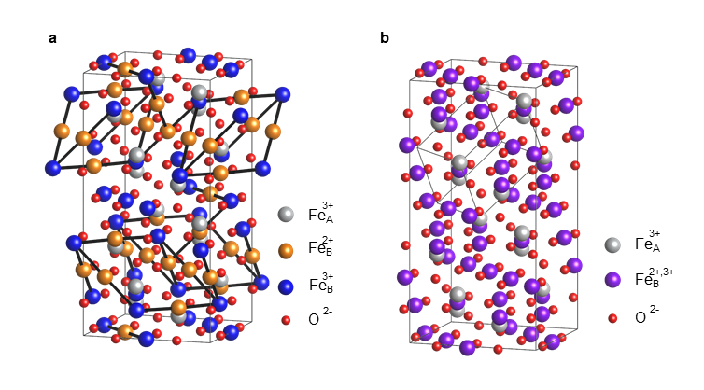

Figure S1| Crystal structures of magnetite. a Atomic arrangement of Fe₃O₄ crystal in the Cc monoclinic phase. Green bars show trimeron formation. The gray frame represents the unit cell of this structure. b Atomic arrangement of Fe₃O₄ in the cubic phase. The gray frame represents the unit cell of the cubic $Fd\overline{3}m$ structure.

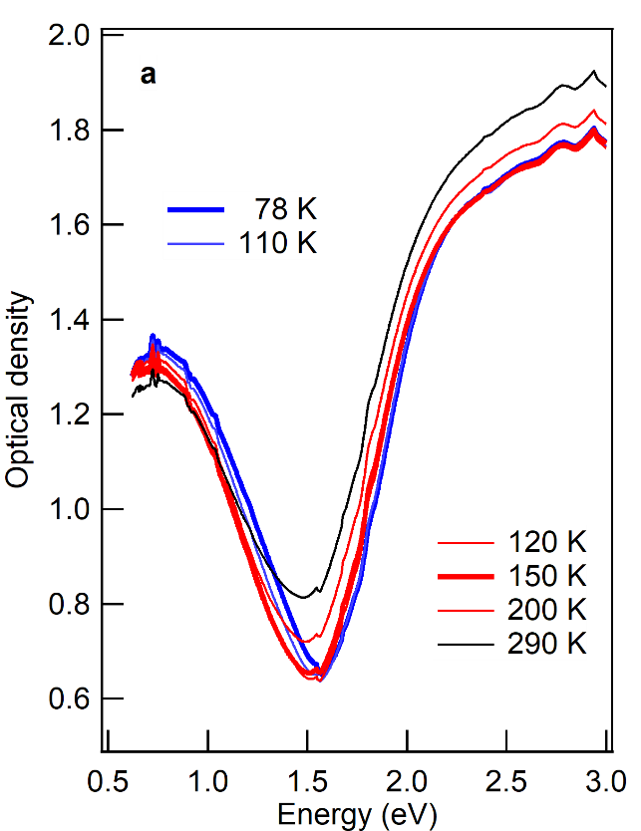
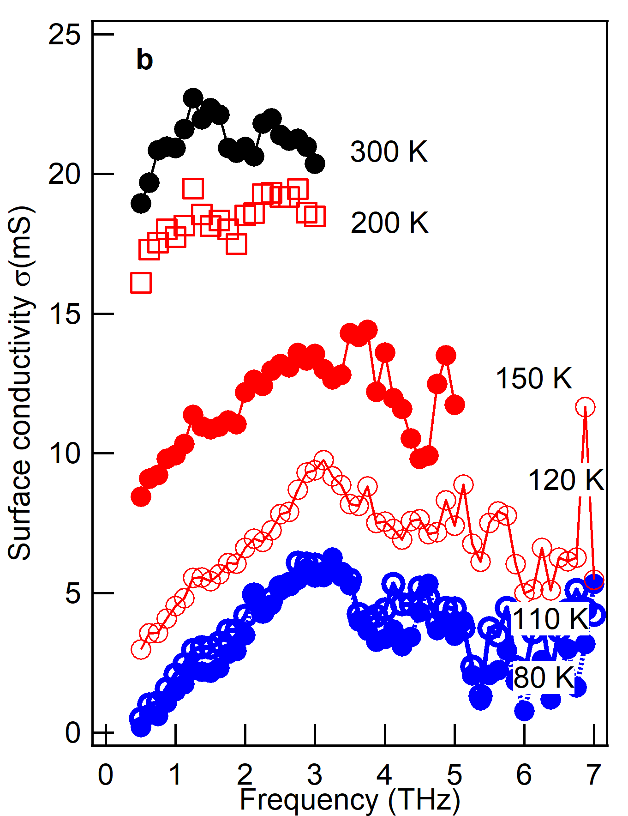

Figure S2| Optical properties of the magnetite thin films. a Temperature-dependent optical density of a 0.3 μm-thick Fe₃O₄ thin film on a MgO substrate, measured at 80, 110, 120, 150, 200, and 300 K. b THz surface conductivity of a 1.1 μm-thick Fe₃O₄ thin film on a MgO substrate, measured at 80, 110, 120, 150, 200, and 300 K.

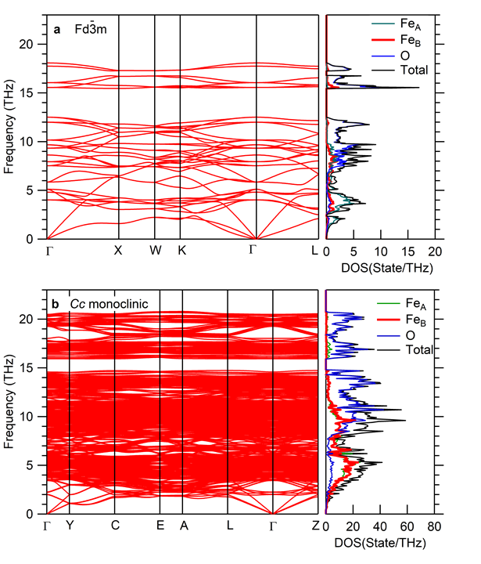
Figure S3| Phonon dispersions of magnetite. a Calculated phonon dispersion (left) and phonon pDOS (right) for high-temperature Fe₃O₄ with the $Fd\overline{3}m$ cubic structure. b Calculated phonon dispersion (left) and phonon pDOS (right) for low-temperature Fe₃O₄ with the Cc monoclinic structure.

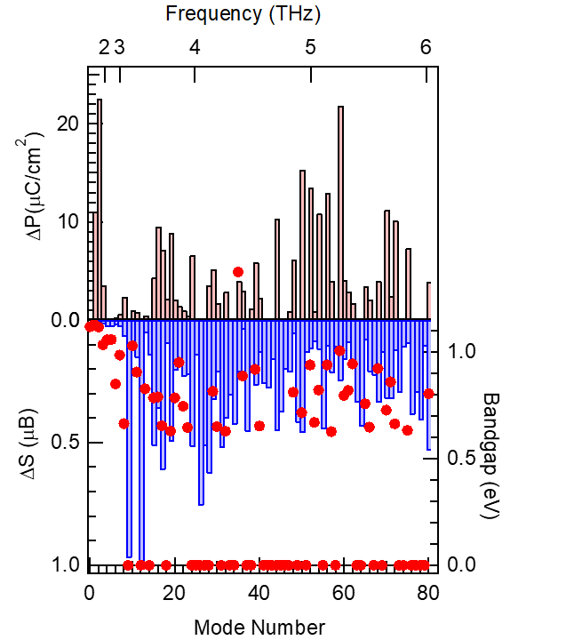

Figure S4| Modulation of Physical Properties by Phonon-Induced Atomic Displacements. Changes in polarization (ΔP; upper bars), bandgap (filled circles), and spin (ΔS; lower bars) induced by atomic displacements with an amplitude of 0.2 Å applied to 80 low-frequency phonon modes in Fe₃O₄ with the Cc monoclinic structure.

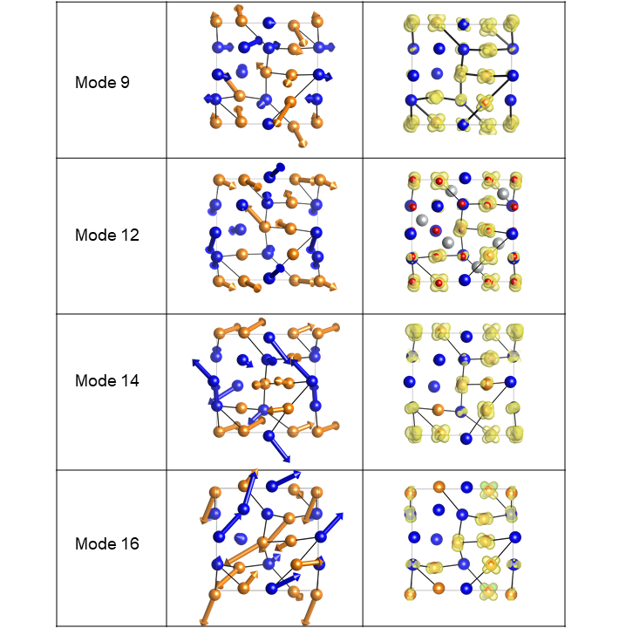
Figure S5| Changes in physical properties induced by specific phonon atomic displacements. The left panel shows atomic displacement vectors corresponding to modes 9, 12, 14, and 16 of Fe₃O₄ in the Cc monoclinic structure. This is a top-down view of the top half of Fig. 1a, with the grey bonds representing trimerons. The right panels show the corresponding $Fe_{B}^{2+}$ t_{2g↓} orbital charge distributions for structures with a static 0.2 Å displacement applied along these modes.

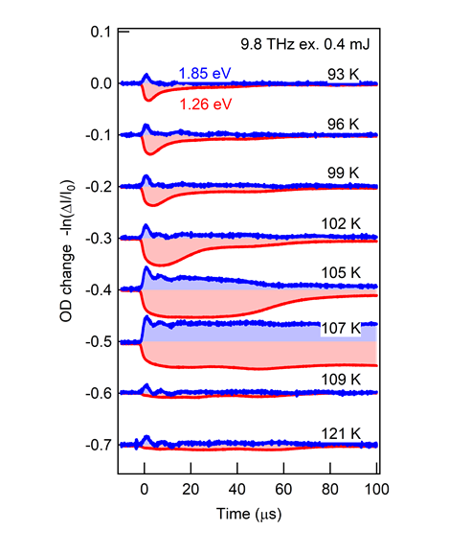
Figure S6| Temperature dependence of optical density changes in a magnetite thin film under 9.8 THz excitation. Optical density changes in Fe₃O₄ thin films under THz-FEL excitation, measured across different temperatures to evaluate THz-induced responses. At 107 K, close to the phase transition temperature, the signal at 1.85 eV also changes significantly due to thermal effects, but at lower temperatures, it exhibits the same behaviour as shown in Fig. 5.
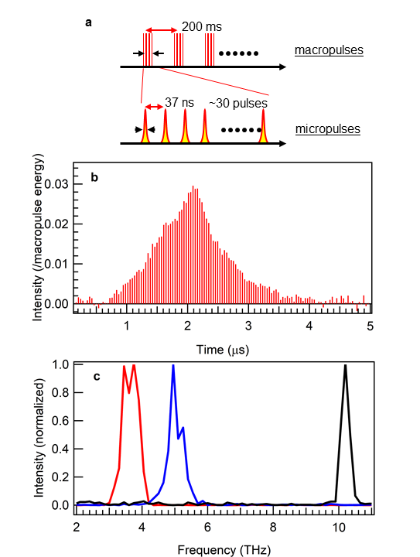
Figure S7| The profile of the THz-FEL. a The schematic of the THz-FEL pulse structure. b Temporal profile of the micropulse train measured using a pyroelectric detector. To improve the signal-to-noise ratio, we extract the peak signals from the detected data. Each micropulse's peak intensity was normalized by the sum of the peak intensities of all micropulses. c Typical spectra of the THz-FEL evaluated using the Michelson interferometer. The black curve corresponds to a wiggler magnet gap of 50 mm and an 18-MeV electron beam, yielding a center frequency of 10.2 THz. For the present experiment, the wiggler magnet gap was set to 49 mm to achieve sufficient light intensity, corresponding to a center frequency of 9.8 THz.

