Appendix

Probability of Tuberculosis Infection Calculations

To estimate future changes in ARI, we used Equation 1 below, representing 200 status quo ARI trajectories per country in which historically observed trends were assumed to continue into the future.
$$\left(1\right) {ARI}_{year}={ARI}_{2021}* {(1-average rate of decline) }^{\left(year-2021\right)}$$
Equation 1: Status quo scenario annual risk of tuberculosis infection
To simulate improvements in overseas TB epidemiology in the reduction scenarios, additional annual reductions of 1%, 2%, 3%, and 4% supplemented the underlying declines starting in 2025. For instance, if ARI was decreasing at an average rate of –2% per year between 2001 and 2021, the same rate of –2% per year would apply until 2025, at which point adjusted rates of–3%, –4%, –5%, and –6% per year would be applied until 2050 in the 1%, 2%, 3%, and 4% reduction scenarios, respectively. These ARI trajectories were calculated using Equation 2.

$$\left(2\right) {ARI}_{year}={ARI}_{2025}* {(1-adjusted rate of decline) }^{\left(year-2025\right)}$$
Equation 2: Reduction scenario annual risk of tuberculosis infection

The calculated ARI trajectories were then used to determine cumulative risk of infection (CRI). CRI was calculated by birth year, country of origin, and year of arrival among foreign-born individuals arriving in Canada from China, India, the Philippines, and Vietnam between 2001 and 2050. As shown in Equation 3, this was done by summing the log-scale ARI from each year a particular group of individuals spent in their country of origin prior to immigration to Canada with the log-scale ARI among foreign-born permanent residents in Canada for the particular year of arrival. Birth and immigration were both assumed to occur mid-year. Therefore, the risk of infection for the year of birth was halved, and the risk of infection for the year of arrival in Canada reflected a six-month period in the country of origin and a six-month period in Canada. In other words, individuals were assumed to be born halfway through their given birth year, at which point their CRI began accumulating. CRI then increased according to the logarithm of the ARI in their country of origin for each year they lived there prior to immigration. Immigration to Canada was also assumed to occur midway through the year. Therefore, in the year of arrival, CRI reflected a six-month period in an individual’s country of origin and a six-month period in Canada.
CRI post-arrival in Canada increased according to the logarithm of the ARI among Canada’s foreign-born population, as shown below in Equation 4. ARI among foreign-born individuals living in Canada was determined by combining IRCC and Canadian TB case notification data—the number of individuals estimated to have acquired TBI that year was divided by the total number of individuals in the subgroup in that same year. The background probability of acquiring TBI from Canadian-born individuals was also incorporated using an average background incidence of 4.7 TB disease cases per 100,000 population and an effective contact rate of 1.3.⁵⁹ All CRI estimates were subsequently converted to TBI probability estimates using Equation 5.
$$\left(3\right) {CRI}_{arrival}=\sum_{i=b+1}^{a-1}{{log⁡(ARI}_{io})}+\frac{1}{2}{log⁡(ARI}_{bo})+\frac{1}{2}{log⁡(ARI}_{ao})+\frac{1}{2}{log⁡(ARI}_{ac})$$
Equation 3: Cumulative risk of tuberculosis infection upon arrival in Canada
$$\left(4\right) {CRI}_{post-arrival}={CRI}_{arrival}+\sum_{i=a+1}^{year}{{\log{(}ARI}_{ic})}$$

Equation 4: Cumulative risk of tuberculosis infection post-arrival in Canada
$$\left(5\right) Probability of TBI {}_{year}= 1-e^{-CRI_{year}}$$

$$where a=year of arrival, b=year of birth, c=Canada, and o=country of origin$$
Equation 5: Probability of tuberculosis infection
The resulting TBI probability estimates were then aggregated into five age groups: 0-14, 15-34, 35-54, 55-65, and 65+ years of age. This resulted in 200 TBI probability estimates per scenario for each unique combination of age group, country of origin, and year from 2001 to 2050. Each group of 200 TBI probability estimates was then summarized to obtain the 25th percentile, median, and 75th percentile TBI probability estimates.
To parameterize TBI probability within the model, the newly generated 25th percentile, median, and 75th percentile probability estimates were used to construct separate beta probability distributions using Equations 6–9 for each unique combination of age group, country of origin, and year of arrival for all five scenarios between 2001 and 2050. During deterministic analysis, the model determines the probability of TBI within a specific subgroup upon arrival to Canada using the median TBI probability estimates, whereas during probabilistic analyses, the model uses the alpha and beta parameters to construct beta probability distributions, from which specific probabilities are randomly selected each trial.

$$\left(6\right) variance={\left(\frac{P75-P25 }{1.349}\right)}^{2}$$

Equation 6: Probability of tuberculosis infection variance
$$\left(7\right) precision=\frac{μ \left(1-μ\right)}{variance-1}$$

Equation 7: Probability of tuberculosis infection precision
$$\left(8\right) α=μ* precision$$

Equation 8: Beta probability distribution alpha parameter
$$\left(9\right) β=\left(1-μ\right)*precision$$
Equation 9: Beta probability distribution beta parameter

$$where μ=median estimate, P25={25}^{th} percentile estimate, and P75= {75}^{th}percentile estimate$$

Tuberculosis Infection Prevalence in 2001 (%, 95% UR)
Tuberculosis Disease in Country of Origin per 100,000 persons | Age at Immigration <15 | Age at Immigration 15-34 | Age at Immigration 35-54 | Age at Immigration 55-74 | Age at Immigration  ≥75 | All
0-9 | 6 (2-24) | 16 (8-34) | 22 (13-42) | 27 (13-53) | 33 (15-58) | 14 (7-30)
10-49 | 8 (4-17) | 24 (14-41) | 39 (25-56) | 51 (35-67) | 53 (37-72) | 24 (14-38)
50-99 | 8 (4-15) | 26 (13-45) | 46 (23-68) | 72 (31-89) | 77 (36-92) | 31 (16-45)
100-199 | 16 (8-32) | 52 (25-76) | 71 (39-89) | 84 (36-98) | 88 (46-98) | 47 (23-66)
200+ | 13 (10-19) | 40 (29-54) | 59 (42-72) | 72 (52-89) | 79 (59-94) | 40 (30-51)
All | 8 (6-18) | 25 (19-37) | 41 (33-50) | 59 (45-70) | 66 (51-76) | 25 (20-35)
Tuberculosis Infection Prevalence in 2006 (%, 95% UR)
Tuberculosis Disease in Country of Origin per 100,000 persons | Age at Immigration <15 | Age at Immigration 15-34 | Age at Immigration 35-54 | Age at Immigration 55-74 | Age at Immigration  ≥75 | All
0-9 | 6 (3-22) | 16 (8-32) | 20 (11-35) | 25 (13-44) | 33 (15-55) | 13 (7-27)
10-49 | 6 (4-14) | 22 (13-35) | 37 (25-50) | 49 (34-64) | 54 (37-72) | 22 (14-33)
50-99 | 7 (4-12) | 24 (13-38) | 44 (23-64) | 69 (31-88) | 76 (34-91) | 29 (16-41)
100-199 | 15 (8-30) | 48 (25-69) | 67 (41-83) | 83 (41-97) | 85 (56-97) | 44 (24-61)
200+ | 12 (10-16) | 38 (29-50) | 57 (43-69) | 71 (54-88) | 79 (62-93) | 39 (30-49)
All | 8 (6-16) | 25 (19-34) | 40 (33-49) | 59 (47-69) | 67 (54-75) | 24 (20-33)
Tuberculosis Infection Prevalence in 2011 (%, 95% UR)
Tuberculosis Disease in Country of Origin per 100,000 persons | Age at Immigration <15 | Age at Immigration 15-34 | Age at Immigration 35-54 | Age at Immigration 55-74 | Age at Immigration  ≥75 | All
0-9 | 7 (3-26) | 13 (7-25) | 16 (9-28) | 23 (12-38) | 27 (12-49) | 11 (6-25)
10-49 | 7 (4-16) | 18 (13-26) | 32 (24-43) | 44 (32-60) | 49 (34-67) | 19 (14-27)
50-99 | 7 (4-13) | 21 (12-31) | 39 (22-56) | 63 (30-83) | 73 (33-91) | 25 (14-35)
100-199 | 15 (8-27) | 43 (25-61) | 62 (42-77) | 80 (45-94) | 83 (56-97) | 39 (24-54)
200+ | 12 (10-15) | 36 (29-46) | 56 (44-68) | 69 (54-84) | 78 (63-92) | 37 (30-46)
All | 8 (6-18) | 23 (19-29) | 39 (33-46) | 57 (46-66) | 64 (52-73) | 23 (19-30)
Tuberculosis Infection Prevalence in 2016 (%, 95% UR)
Tuberculosis Disease in Country of Origin per 100,000 persons | Age at Immigration <15 | Age at Immigration 15-34 | Age at Immigration 35-54 | Age at Immigration 55-74 | Age at Immigration  ≥75 | All
0-9 | 6 (2-21) | 11 (6-22) | 14 (8-23) | 20 (9-34) | 25 (11-47) | 10 (5-21)
10-49 | 7 (4-15) | 16 (12-25) | 28 (21-37) | 41 (30-56) | 45 (30-64) | 17 (13-25)
50-99 | 7 (4-13) | 20 (12-29) | 36 (22-53) | 59 (30-82) | 74 (32-92) | 23 (14-33)
100-199 | 15 (8-26) | 40 (25-54) | 59 (41-72) | 77 (51-91) | 81 (58-95) | 37 (23-49)
200+ | 12 (9-15) | 35 (30-42) | 54 (44-65) | 68 (54-83) | 75 (62-90) | 35 (30-43)
All | 8 (6-16) | 22 (19-26) | 37 (31-43) | 55 (45-63) | 65 (50-74) | 22 (19-28)
Tuberculosis Infection Prevalence in 2021 (%, 95% UR)
Tuberculosis Disease in Country of Origin per 100,000 persons | Age at Immigration <15 | Age at Immigration 15-34 | Age at Immigration 35-54 | Age at Immigration 55-74 | Age at Immigration  ≥75 | All
0-9 | 5 (2-18) | 9 (5-17) | 10 (6-16) | 18 (9-32) | 23 (10-47) | 8 (4-17)
10-49 | 6 (4-13) | 15 (11-22) | 23 (18-31) | 37 (27-52) | 43 (27-62) | 16 (12-22)
50-99 | 6 (4-11) | 20 (12-29) | 34 (21-49) | 56 (29-78) | 70 (32-91) | 23 (14-33)
100-199 | 13 (7-23) | 40 (24-55) | 55 (40-67) | 73 (53-87) | 78 (58-92) | 37 (24-49)
200+ | 10 (8-13) | 34 (29-40) | 51 (43-60) | 66 (55-80) | 74 (62-88) | 35 (30-42)
All | 8 (6-16) | 22 (19-26) | 37 (31-43) | 55 (45-63) | 65 (50-74) | 22 (19-27)
Table A1: Estimated tuberculosis infection prevalence upon arrival in Canada among
foreign-born individuals by age group and tuberculosis incidence in country of origin
during census years 2001 to 2021
Table A2: Additional countries of origin included in weighted ARI and TBI prevalence calculations. The countries included in the weighted ARI and TBI prevalence calculations among new immigrants in Canada from countries other than China, India, the Philippines, and Vietnam are shown below by WHO region, with the African Region being subdivided into African Region High and African Region Low based on HIV prevenance. Countries excluded from the analysis due to a lack of data availability include American Samoa, Federated States of Micronesia, Curacao, Niue, Palau, Palestine, Serbia, South Sudan, Tokelau, Tuvalu, United States Virgin Islands, Northern Mariana Islands, Sint Maarten, and Bonaire, Sint Eustatius, and Saba.

African Region –High
Botswana | Burundi | Cameroon | Central African Republic | Congo DRC
Congo | Cote d'Ivoire | Ethiopia | Gabon | Kenya
Lesotho | Malawi | Mozambique | Namibia | Nigeria
Rwanda | Republic of South Africa | Swaziland | Uganda | Zambia
Zimbabwe
African Region – Low
Algeria | Angola | Benin | Burkina Faso | Cabo Verde
Chad | Comoros | Equatorial Guinea | Eritrea | Gambia
Ghana | Guinea | Guinea-Bissau | Liberia | Madagascar
Mali | Mauritania | Mauritius | Niger | Sao Tome and Principe
Senegal | Seychelles | Sierra Leone | Tanzania | Togo
Region of the Americas
Anguilla | Antigua and Barbuda | Argentina | Aruba | Bahamas
Barbados | Belize | Bermuda | Bolivia | Brazil
Cayman Islands | Chile | Colombia | Costa Rica | Cuba
Dominica | Dominican Republic | Ecuador | El Salvador | Greenland
Grenada | Guatemala | Guyana | Haiti | Honduras
Jamaica | Mexico | Montserrat | Nicaragua | Panama
Paraguay | Peru | Puerto Rico | Saint Kitts and Nevis | Saint Lucia
Saint Vincent and the Grenadines | Suriname | Trinidad and Tobago | Turks and Caicos Islands | United States
Uruguay | Venezuela | British Virgin Islands
Eastern Mediterranean Region
Afghanistan | Bahrain | Djibouti | Egypt | Iran
Iraq | Jordan | Kuwait | Lebanon | Libya
Morocco | Oman | Pakistan | Qatar | Saudi Arabia
Somalia | Sudan | Syria | Tunisia | United Arab Emirates
Yemen
European Region
Albania | Andorra | Armenia | Austria | Azerbaijan
Belarus | Belgium | Bosnia and Herzegovina | Bulgaria | Croatia
Cyprus | Czech Republic | Denmark | Estonia | Finland
France | Georgia | Germany | Greece | Hungary
Iceland | Ireland | Israel | Italy | Kazakhstan
Kyrgyzstan | Latvia | Lithuania | Luxembourg | North Macedonia
Malta | Moldova | Monaco | Netherlands | Norway
Poland | Portugal | Romania | Russian Federation | Slovakia
Slovenia | Spain | Sweden | Switzerland | Tajikistan
Turkey | Turkmenistan | Ukraine | United Kingdom | Uzbekistan
Southeast Asia Region
Bangladesh | Bhutan | Myanmar | Thailand | Indonesia
North Korea | Maldives | Nepal | Sri Lanka
Western Pacific Region
Australia | Brunei Darussalam | Cambodia | Vanuatu | Cook Islands
Fiji | French Polynesia | Guam | Hong Kong | Japan
Kiribati | South Korea | Laos | Macau | Malaysia
Marshall Islands | Mongolia | Nauru | New Caledonia | New Zealand
Papua New Guinea | Tonga | Samoa | Singapore | Solomon Islands
Timor-Leste | Wallis and Futuna
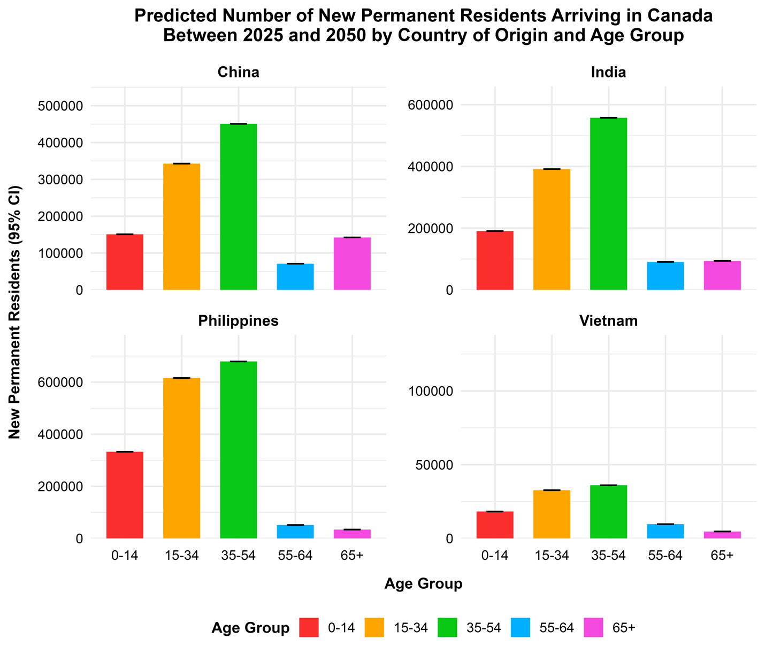
Figure 10: Incremental cost vs incremental quality-adjusted life years gained between 2025 and 2050 per 100,000 foreign-born Canadians from country of origin
Figure A1: Predicted number of new permanent residents arriving in Canada between 2025 and 2050 by country of origin and group. The number and age of new permanent residents arriving per country of origin between 2025 and 2050 was predicted using source data from Immigration, Refugees, and Citizenship Canada. Immigration trends observed between 2001 and 2021 were assumed to continue until 2050. The number and age group of new immigrants from each country are shown above, with age group denoted by colour.

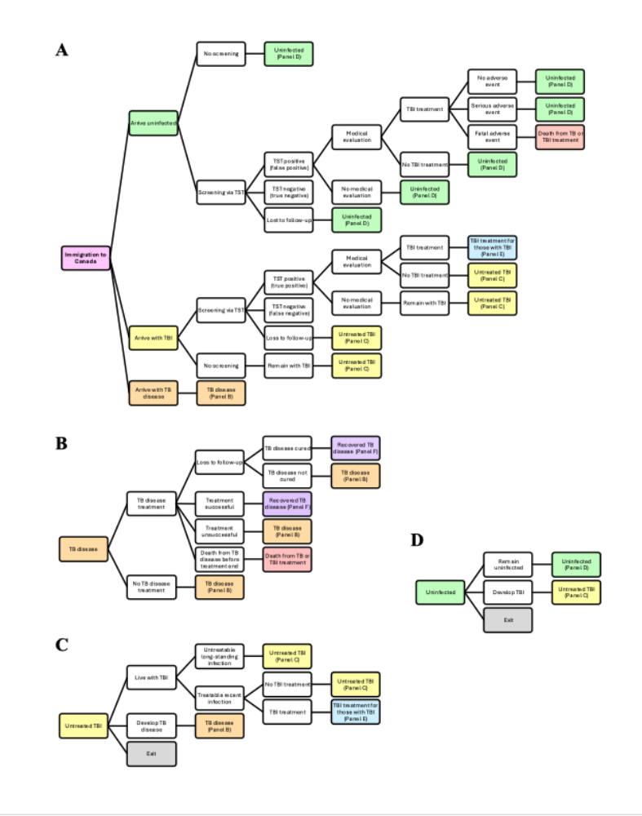

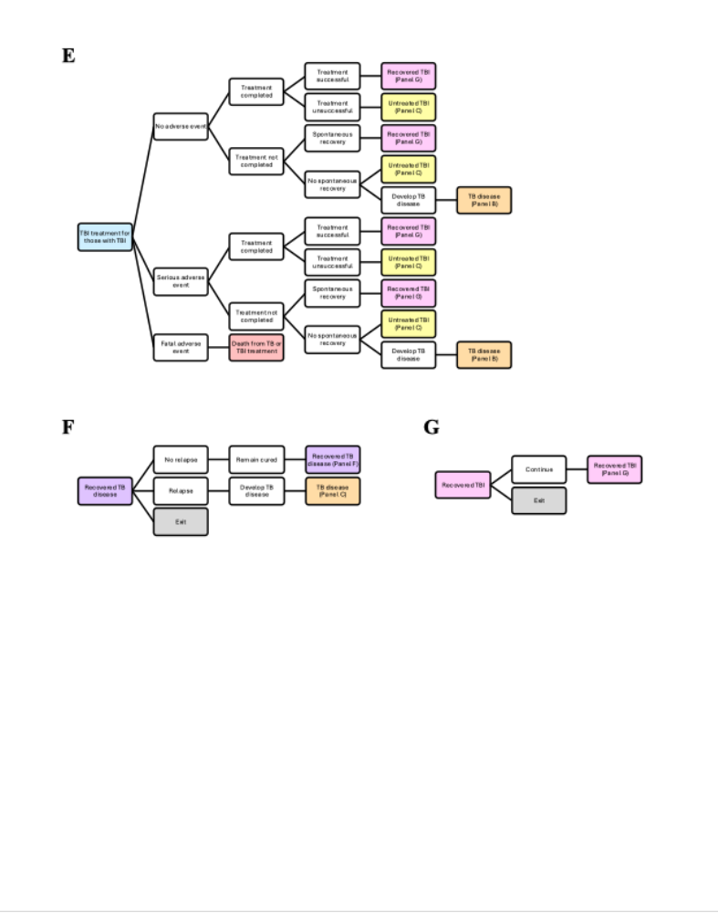
Figure A2: Overview of the Markov decision analysis model. An overview of the Markov decision analysis model used in this analysis is shown. Individuals enter the model upon immigration to Canada and exit upon death or emigration. While in the model, individuals move between mutually exclusive health states, indicated by different coloured boxes. Several sub-trees are shown to depict the key processes and disease states, including (A) immigration to Canada, (B) TB disease, (C) untreated TBI, (D) uninfected, (E) TBI treatment for those with TBI, (F) recovered TB disease, and (G) recovered TBI.

Table A3: Key Epidemiological Parameters Related to TBI Screening and Treatment. An open-cohort Markov decision analysis model was used to simulate TB epidemiology among foreign-born Canadians between 2001 and 2050. The key epidemiological parameters related to TBI screening and treatment are shown below with 95% URs.

Parameter | Value | Reference
TST sensitivity | 77% | 60
TST specificity | 97% | 60
Probability of starting TBI treatment after positive TST | 64% | 61
Probability of completing TBI treatment (age ≤50) | 81% | 62
Probability of completing TBI treatment (age >50) | 82% | 62
Complete TBI treatment efficacy | 90% | 20-22
Incomplete TBI treatment efficacy | 21% | 20-22
Probability of major adverse event during TBI treatment (age ≤50) | 2.2% | 38, 63, 64
Probability of major adverse event during TBI treatment (age >50) | 4.0% | 38, 63, 64
Probability of fatal adverse event during TBI treatment (all ages) | 0.001% | 65
Cost of medical evaluation | $219 | 26
Cost of TBI screening using TST | $25 | 26
Cost of complete TBI treatment | $468 | 26
Cost of incomplete TBI treatment | $111 | 26

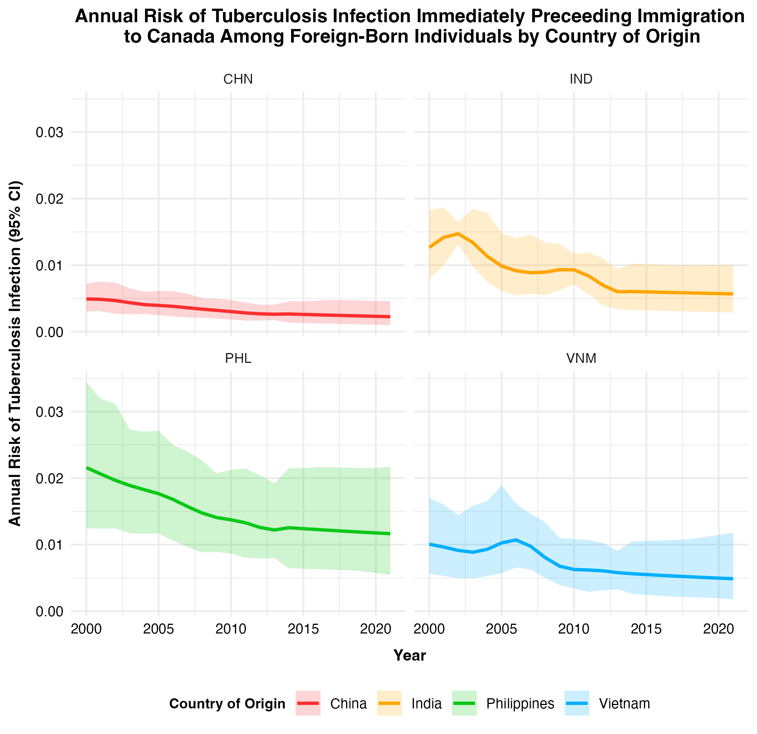
Figure A3: Annual risk of tuberculosis infection immediately preceding migration to Canada among foreign-born individuals by country of origin. Historical annual risk of TBI data from Dodd and Houben were combined with Canadian immigration data to estimate the probability of TBI upon arrival to Canada among specific immigrant groups. This was repeated 200 times for each foreign-born group from China, India, the Philippines, and Vietnam. The mean estimated probability of TBI upon arrival to Canada for each of the four countries is denoted with a solid line, while the 95% is shown by the shaded region. Country of origin is indicated by colour.

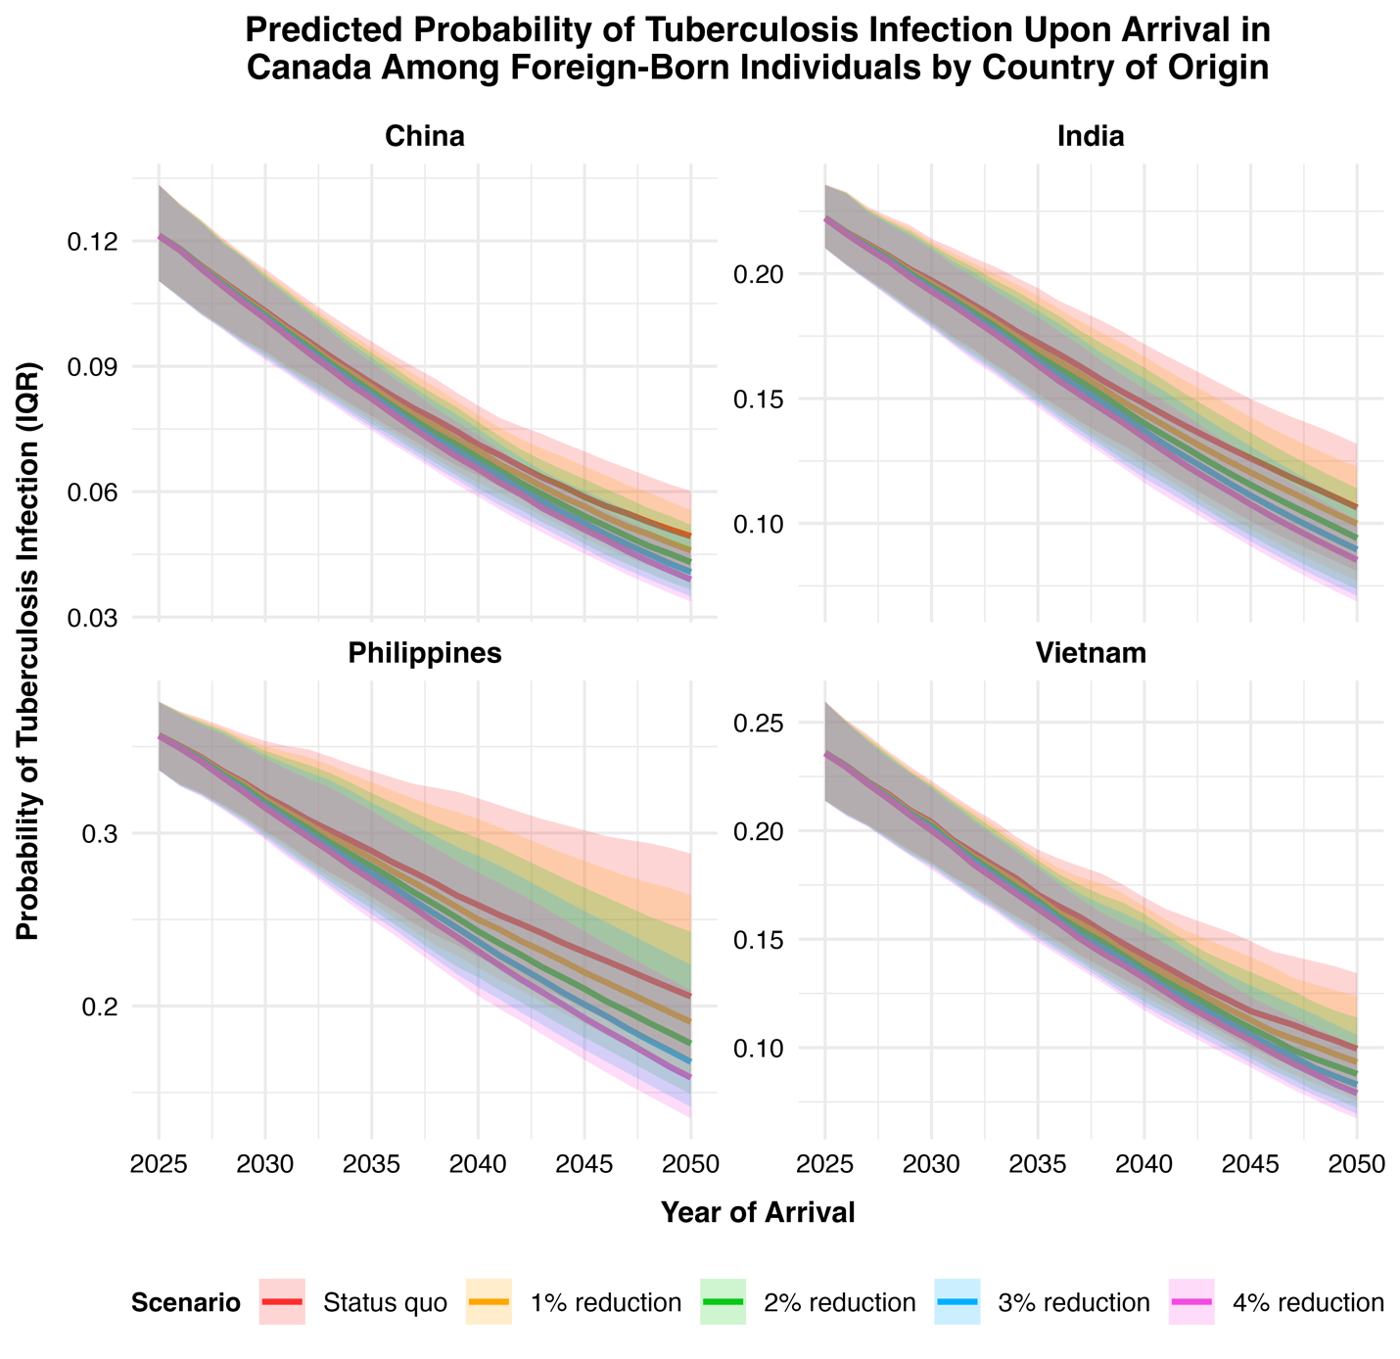
Figure A4: Predicted probability of tuberculosis infection upon arrival in Canada among foreign-born individuals by country of origin. The probability of TBI upon arrival to Canada was predicted among foreign-born individuals from China, India, the Philippines, and Vietnam between 2025 and 2050. This was repeated for the status quo, 1%, 2%, 3%, and 4% reduction scenarios, as indicated with five separate colours above. The median probability of TBI upon arrival to Canada is denoted with a solid line, while the IQR is shown by the shaded region. The same figure is shown in the main text without the IQR for readability.

Table A4: Predicted tuberculosis-related outcomes among foreign-born Canadians between 2025 and 2050 by country of origin. TB-related outcomes were predicted among foreign-born Canadians from China, India, the Philippines, and Vietnam between 2025 and 2050. This was repeated for the status quo scenario as well as the 1%, 2%, 3%, and 4% reduction scenarios. The predicted outcomes, which include costs, TBI cases, TB disease cases, TB deaths, and QALYs lived, are shown below with 95% URs.
 | Scenario | Healthcare System Costs (95% UR) | TB Infections  (95% UR) | TB Disease  Cases  (95% UR) | TB Deaths (95% UR) | QALYs  (95% UR)
China | Status Quo | $39,240,746  ($12,576,994–  $85,654,274) | 152,931  (145,177–161,067) | 1,711  (1,617–1,806) | 141  (133–149) | 16,470,908  (13,942,029–18,418,526)
China | 1% Reduction | $38,973,853  ($12,489,124–$85,104,801) | 150,617  (142,952–158,611) | 1,698  (1,603–1,792) | 140  (132–148) | 16,470,912  (13,942,033–18,418,531)
China | 2% Reduction | $38,740,989  ($12,412,944–$84,626,338) | 148,643  (140,909–156,669) | 1,686  (1,591–1,780) | 139  (131–147) | 16,470,917  (13,942,037–18,418,536)
China | 3% Reduction | $38,534,322  ($12,345,387–$84,202,069) | 146,936  (139,220–154,925) | 1,676  (1,581–1,770) | 138  (130–147) | 16,470,921  (13,942,040–18,418,540)
China | 4% Reduction | $38,348,026  ($12,284,884–$83,819,880) | 145,432  (137,783–153,380) | 1,666  (1,572–1,760) | 138  (130–146) | 16,470,925  (13,942,043–18,418,544)
India | Status Quo | $156,747,385  ($49,527,446–$343,005,476) | 284,998  (273,898–295,417) | 6,911  (6,702–7,124) | 565  (549–582) | 18,710,118  (15,836,321–20,921,487)
India | 1% Reduction | $155,399,495  ($49,105,458–$339,982,398) | 279,938  (269,275–290,143) | 6,843  (6,637–7,054) | 560  (544–577) | 18,710,138  (15,836,337–20,921,509)
India | 2% Reduction | $154,190,814  ($48,726,995–$337,273,139) | 275,479  (265,212–285,588) | 6,783  (6,580–6,991) | 556  (539–572) | 18,710,158  (15,836,353–20,921,529)
India | 3% Reduction | $153,121,642  ($48,393,038–$334,878,540) | 271,595  (261,745–281,542) | 6,729  (6,527–6,936) | 552  (536–568) | 18,710,175  (15,836,367–20,921,548)
India | 4% Reduction | $152,161,970  ($48,092,593–$332,726,623) | 268,182  (258,574–277,958) | 6,681  (6,481–6,885) | 549  (533–564) | 18,710,192  (15,836,380–20,921,565)
Philippines | Status Quo | $121,333,493  ($39,097,748–$265,151,280) | 498,161  (472,726–524,775) | 5,329  (5,138–5,513) | 437  (423–452) | 23,880,995  (20,212,950–26,703,451)
Philippines | 1% Reduction | $119,896,954  ($38,634,879–$261,814,635) | 486,142  (461,893–511,236) | 5,257  (5,070–5,435) | 432  (418–446) | 23,881,005  (20,212,958–26,703,461)
Philippines | 2% Reduction | $118,613,961  ($38,220,841–$258,842,698) | 475,584  (452,400–499,538) | 5,192  (5,011–5,367) | 427  (413–441) | 23,881,015  (20,212,965–26,703,471)
Philippines | 3% Reduction | $117,458,345  ($37,847,095–$256,174,389) | 466,222  (444,114–489,273) | 5,134  (4,956–5,309) | 423  (409–437) | 23,881,024  (20,212,973–26,703,480)
Philippines | 4% Reduction | $116,433,797  ($37,515,226–$254,005,185) | 458,028  (436,867–480,254) | 5,083  (4,907–5,255) | 419  (406–433) | 23,881,033  (20,212,980–26,703,490)
Vietnam | Status Quo | $5,483,991  ($1,778,571–$11,890,787) | 20,711  (19,684–21,816) | 240  (227–253) | 20  (19–21) | 1,485,763  (1,257,745–1,661,218)
Vietnam | 1% Reduction | $5,440,313  ($1,764,147–$11,792,937) | 20,355  (19,352–21,414) | 238  (224–250) | 20  (18–21) | 1,485,764  (1,257,746–1,661,218)
Vietnam | 2% Reduction | $5,401,510  ($1,751,371–$11,706,125) | 20,042  (19,063–21,075) | 236  (222–248) | 19  (18–21) | 1,485,764  (1,257,746–1,661,219)
Vietnam | 3% Reduction | $5,367,194  ($1,740,076–$11,629,218) | 19,769  (18,807–20,779) | 234  (221–247) | 19  (18–20) | 1,485,765  (1,257,746–1,661,219)
Vietnam | 4% Reduction | $5,336,343  ($1,729,946–$11,560,354) | 19,528  (18,583–20,525) | 232  (219–245) | 19  (18–20) | 1,485,765  (1,257,746–1,661,220)

Table A5: Tuberculosis-related outcomes among foreign-born Canadians between 2025 and 2050 by country of origin. TB-related outcomes were predicted among foreign-born Canadians between 2025 and 2050. This was done for the status quo scenario as well as all four reduction scenarios, The predicted number of TB infections and deaths averted are shown below with 95% URs shown in brackets.
Table 2: Tuberculosis-related outcomes among foreign-born Canadians between 2025 and 2050 by country of origin
 | Scenario | Tuberculosis Infections  Averted (95% UR) | Tuberculosis Deaths Averted (95% UR)
China | 1% Reduction | 2,314  (2,160–2,469) | 1.0  (0.9–1.0)
China | 2% Reduction | 4,289  (4,009–4,578) | 1.8  (1.7–1.9)
China | 3% Reduction | 5,995  (5,608–6,399) | 2.6  (2.4–2.7)
China | 4% Reduction | 7,500  (7,023–8,000) | 3.2  (3.1–3.4)
India | 1% Reduction | 5,060  (4,576–5,560) | 4.9  (4.6–5.3)
India | 2% Reduction | 9,519  (8,632–10,441) | 9.3  (8.7–10.0)
India | 3% Reduction | 13403  (12174–14701) | 13.2  (12.3–14.1)
India | 4% Reduction | 16,816  (15,286–18,433) | 16.7  (15.5–17.9)
Philippines | 1% Reduction | 12,019  (10,550–13,681) | 5.2  (4.7–5.8)
Philippines | 2% Reduction | 22,578  (19,834–25,691) | 9.9  (9.0–10.9)
Philippines | 3% Reduction | 31,940  (28,110–36,334) | 14.1  (12.8–15.5)
Philippines | 4% Reduction | 40,133  (35,340–45,583) | 17.8  (16.1–19.6)
Vietnam | 1% Reduction | 356  (317–398) | 0.2  (0.1–0.2)
Vietnam | 2% Reduction | 669  (596–746) | 0.3  (0.3–0.3)
Vietnam | 3% Reduction | 942  (838–1,050) | 0.4  (0.4–0.5)
Vietnam | 4% Reduction | 1,184  (1,053–1,317) | 0.5  (0.5–0.6)

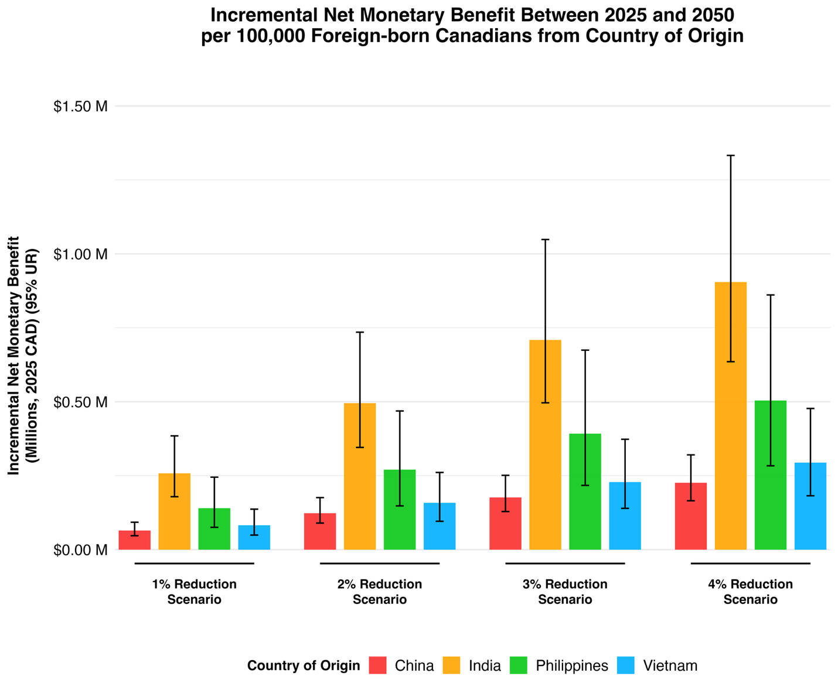
Figure A5: Incremental net monetary benefit between 2025 and 2050 normalized per 100,000 foreign-born Canadians from country of origin. The INMB between 2025 and 2050 was calculated for foreign-born individuals from China, India, the Philippines, and Vietnam and normalized per 100,000 individuals. This was done using the predicted incremental costs averted and a WTP threshold of $100,000 per QALY gained. The four different countries are denoted by colour, with a 95% UR shown with error bars. The largest incremental net monetary benefit in each scenario was predicted among individuals from the Philippines, followed by those from India, Vietnam, and China.

