Supplementary Information for
Regional synchrony amplifies the fire signal in global CO₂ growth rate
Sudhanshu Pandey^{1,*}, Kevin W. Bowman¹, Jeongmin Yun¹, Junjie Liu¹, A. Anthony Bloom¹, James T. Randerson²
¹NASA Jet Propulsion Laboratory, California Institute of Technology, Pasadena, CA 91109, USA
²Department of Earth System Science, University of California, Irvine, CA 92697, USA
*Correspondence: sudhanshu.pandey@jpl.nasa.gov

Supplementary Note 1 | Robustness of regional fire synchronization
The main result uses annual carbon emissions from the Global Fire Emissions Database (GFED), so these tests ask how far it depends on that choice: they vary the time over which emissions are aggregated, replace modelled carbon with the burned area it is derived from, and repeat the comparison in an alternative emissions product. Cross-region reinforcement appears in all three.

1A. Seasonal timing of the cross-region covariance
Synchronization is measured here from annual totals, even though the 14 regions burn in different months: an annual total carries the covariance between emissions that occur in different months, which a same-month comparison leaves out, so fire seasons that never overlap can still reinforce one another within a year. Repeating the two-window variance decomposition on monthly emissions and on emissions summed over meteorological seasons (DJF, MAM, JJA and SON) shows how much this matters. The covariance contribution to the increase in global fire variance is largest for annual sums, 84%, and smaller at the seasonal and monthly scales (Supplementary Fig. 1a); coherence, the mean pairwise cross-region correlation (Methods), likewise increases most for annual sums, from −0.03 to +0.15 (Supplementary Fig. 1b).
A second calculation asks how the recent cross-region covariance is distributed in time. Regions whose fire seasons barely overlap can still covary strongly in their annual totals: Boreal Asia burns mainly in April–July and Southeast Asia in January–April (Supplementary Table 2), yet their annual anomalies reinforced one another in 2015–2024 (r = +0.75, against −0.34 in 2001–2010). Across all region pairs, emissions in the same month supply 5.8% of the covariance of calendar-year totals; in December–November totals, which assign December to the following year’s DJF, emissions in the same meteorological season supply 31% and emissions in different seasons the remaining 69%. The two shares rest on different annual bases, and a region pair can contribute to both the same-season and the different-season term. The exact shares depend on how the monthly and seasonal series are detrended: detrending each calendar month or season separately, which also reproduces the annual covariance exactly, gives 1.2% and 19%, but emissions in different seasons still supply most of the covariance. Regional fire synchronization is therefore same-year reinforcement among seasonally separated fires rather than globally simultaneous burning.
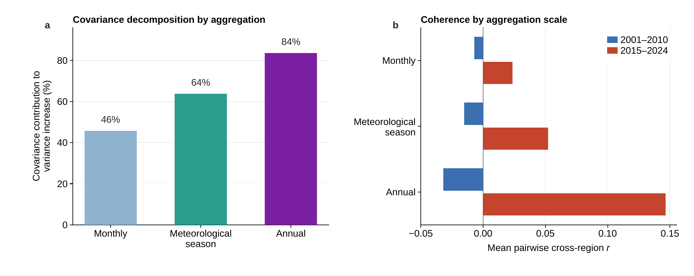
Supplementary Fig. 1 | Synchronization across aggregation scales. a, Covariance contribution to the change in global fire variance between 2001–2010 and 2015–2024 when regional emissions are aggregated monthly, to fixed meteorological seasons (DJF, MAM, JJA and SON) or annually. b, Coherence (mean pairwise cross-region correlation) of within-window detrended anomalies at the three aggregation scales; blue bars, 2001–2010; red bars, 2015–2024. Seasonal values use December–November years, with December assigned to the following year’s DJF; monthly and annual values use calendar years.

1B. Sensitivity to using burned area instead of fire carbon
In GFED, fire-carbon emissions are burned area multiplied by modelled fuel consumption. Repeating the analysis on the burned area alone tests whether the synchronization is already present in the extent of burning, before that conversion. The coherence of burned area rose by about as much as that of fire carbon (Supplementary Fig. 2a), and global burned area declined between the windows while its year-to-year variability rose (Supplementary Fig. 2b). The synchronization therefore appears in the extent of burning itself rather than in the modelling that converts it to carbon, although the amplification of variability was stronger for carbon than for burned area (Supplementary Table 4).
Regional annual burned area is the GFED5.1 ecosystem burned-area field¹ summed over each basis region for 2002–2022, with GFED5NRT^{2,3} for 2023–2024 and the GFED5 archive⁴ for 2001 rescaled to GFED5.1 by region-specific factors from the 2002–2020 overlap; all factors are within 5% of one, and the rescaling moves the early-window coherence by 0.002.
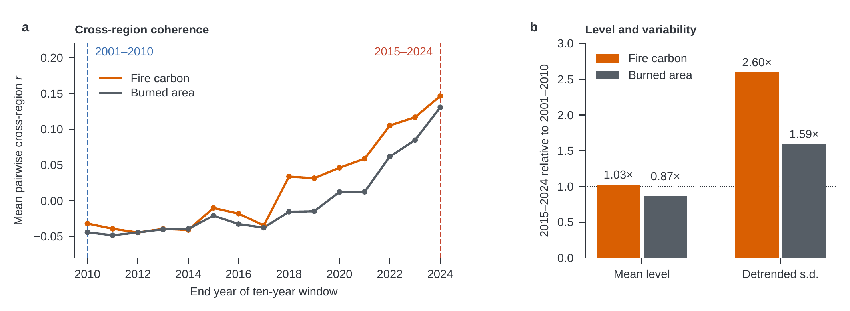
Supplementary Fig. 2 | Regional synchronization in GFED burned area and fire carbon. a, Coherence (mean pairwise cross-region correlation) of within-window detrended annual anomalies in trailing ten-year windows ending 2010–2024, for burned area (grey) and fire-carbon emissions (orange); dashed lines mark the windows ending in 2010 and 2024. b, Ratio of the 2015–2024 to the 2001–2010 value for the mean global level and for the detrended standard deviation of the global total; the dotted line marks no change.

1C. Sensitivity to the emissions product
The Global Fire Assimilation System (GFAS) estimates emissions from satellite fire radiative power rather than from GFED’s fuel and combustion modelling¹, and so tests whether the reinforcement depends on how emissions are derived; its conversion factors were calibrated against an earlier GFED version⁵. Over its available comparison windows, 2003–2010 and 2015–2024, GFAS reproduces the change from negative to positive cross-region covariance (−0.024 to +0.020 PgC² yr⁻²) and a similar covariance share of the change in global fire variance (Supplementary Fig. 3c); GFED restricted to finalized years, 2001–2010 against 2015–2022, retains the same sign change (Supplementary Fig. 3c,d). GFAS coherence, which weights all region pairs equally, remains −0.01 in both windows.
The reinforcement that carries the main result is therefore reproduced by GFAS, whereas the broader rise in pairwise coherence is not: in GFAS the reinforcement is concentrated in the high-variance regions rather than spread across all pairs. Both products draw on active-fire information from the Moderate Resolution Imaging Spectroradiometer (MODIS), so this comparison does not independently test satellite fire detection.
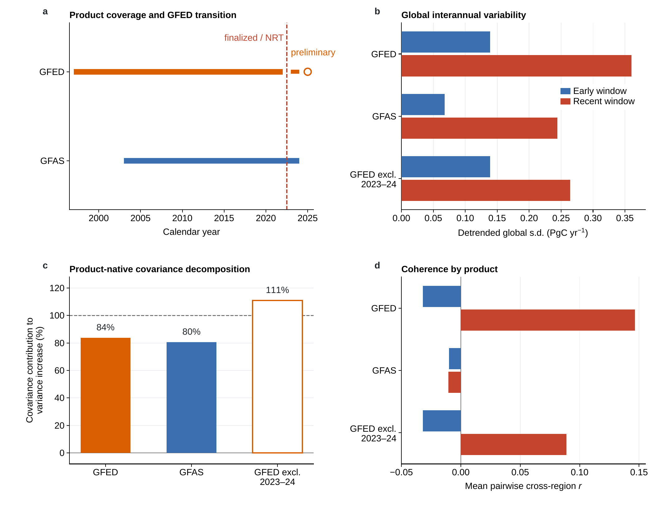
Supplementary Fig. 3 | Fire-product and sensor-transition sensitivity. a, Product coverage; the dashed line separates finalized GFED through 2022 from the near-real-time (NRT) extension, and the open symbol marks the preliminary full-year 2025 GFED5NRT value. b, Early and recent global fire interannual variability; blue bars, early window; red bars, recent window. c, Cross-region covariance contribution over each product’s available comparison windows; the dashed line marks 100%, where the covariance term alone would account for the entire change in global variance. d, Coherence (mean pairwise cross-region correlation); colours as in b. GFED uses 2001–2010 versus 2015–2024, GFAS 2003–2010 versus 2015–2024, and “GFED excl. 2023–24” compares 2001–2010 with 2015–2022, excluding the near-real-time years informed by the Visible Infrared Imaging Radiometer Suite (VIIRS)².

Supplementary Note 2 | Atmospheric constraints and the fire–CO₂ association

2A. CO-constrained fire estimates and alternative growth-rate records
Atmospheric carbon monoxide (CO) constrains fire emissions without depending on fuel-consumption modelling. For 2019–2024, fire-CO₂ estimates constrained by CO from the TROPOspheric Monitoring Instrument (TROPOMI)⁶ reproduce GFED’s regional anomaly structure (Supplementary Fig. 4b) together with its recent cross-region coherence and covariance share, whether the inversion starts from the Quick Fire Emissions Dataset (QFED) or the GFAS fire prior (Supplementary Table 3A). Both priors take their year-to-year variation from satellite fire radiative power rather than from GFED burned area, so the priors’ anomaly timing comes from satellite fire detections rather than from GFED, although GFED’s 2023–2024 near-real-time values also draw on active-fire detections. These comparisons are of timing rather than of absolute emissions, which the products do not share; the estimates retain some dependence on their priors and on the CO-to-CO₂ conversion (Methods), and six years test the recent synchronized state rather than the change from the early decade. GFED and GFAS track one another year by year (Supplementary Fig. 5).
The recent fire–growth association is likewise a property of the atmospheric record rather than of one inversion or one observing system (Supplementary Fig. 4a). It holds for each of the six fixed Global Carbon Budget 2025 in situ inversions (CarboScope, NISMON-insitu, CarbonTracker, CarbonTracker Europe, MIROC4-ACTM and the University of Edinburgh inversion)⁷, for their median and for the satellite-derived estimates of Growth Rate Estimation from Satellite Observations (GRESO; Supplementary Table 3A)^{8,9}, and for the marine-boundary-layer estimate of the National Oceanic and Atmospheric Administration (NOAA; Supplementary Fig. 4a).
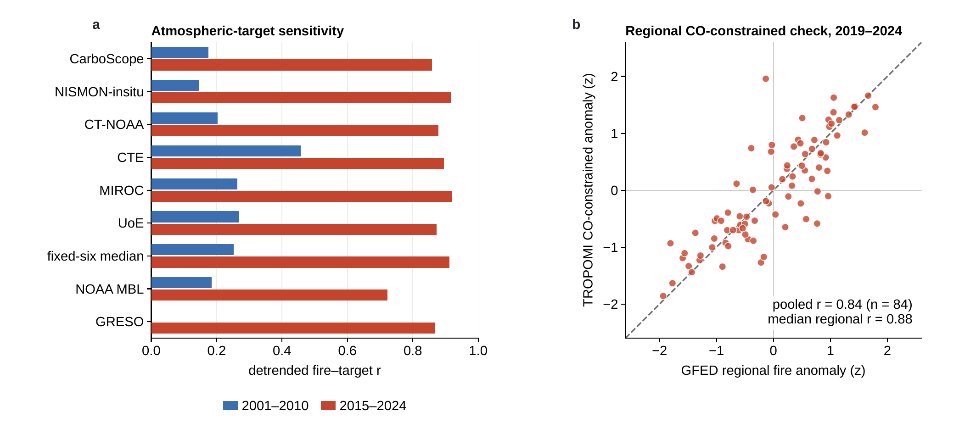
Supplementary Fig. 4 | Atmospheric targets and the CO-constrained fire check. a, Early and recent detrended fire–target correlations for the six fixed inversion members, their median, the NOAA marine-boundary-layer (MBL) growth target and the satellite growth rate from the Orbiting Carbon Observatory-2 alone (OCO-2 v11.3r; labelled GRESO), available only for the recent window; the GRESO series of main Fig. 3 is the mean of OCO-2 and the Greenhouse gases Observing SATellite (GOSAT). b, Standardized detrended regional fire anomalies from GFED and from the TROPOMI CO inversions (mean of the QFED- and GFAS-prior runs), 14 regions over 2019–2024, each series detrended over 2019–2024 and divided by its own standard deviation; dashed line, 1:1.
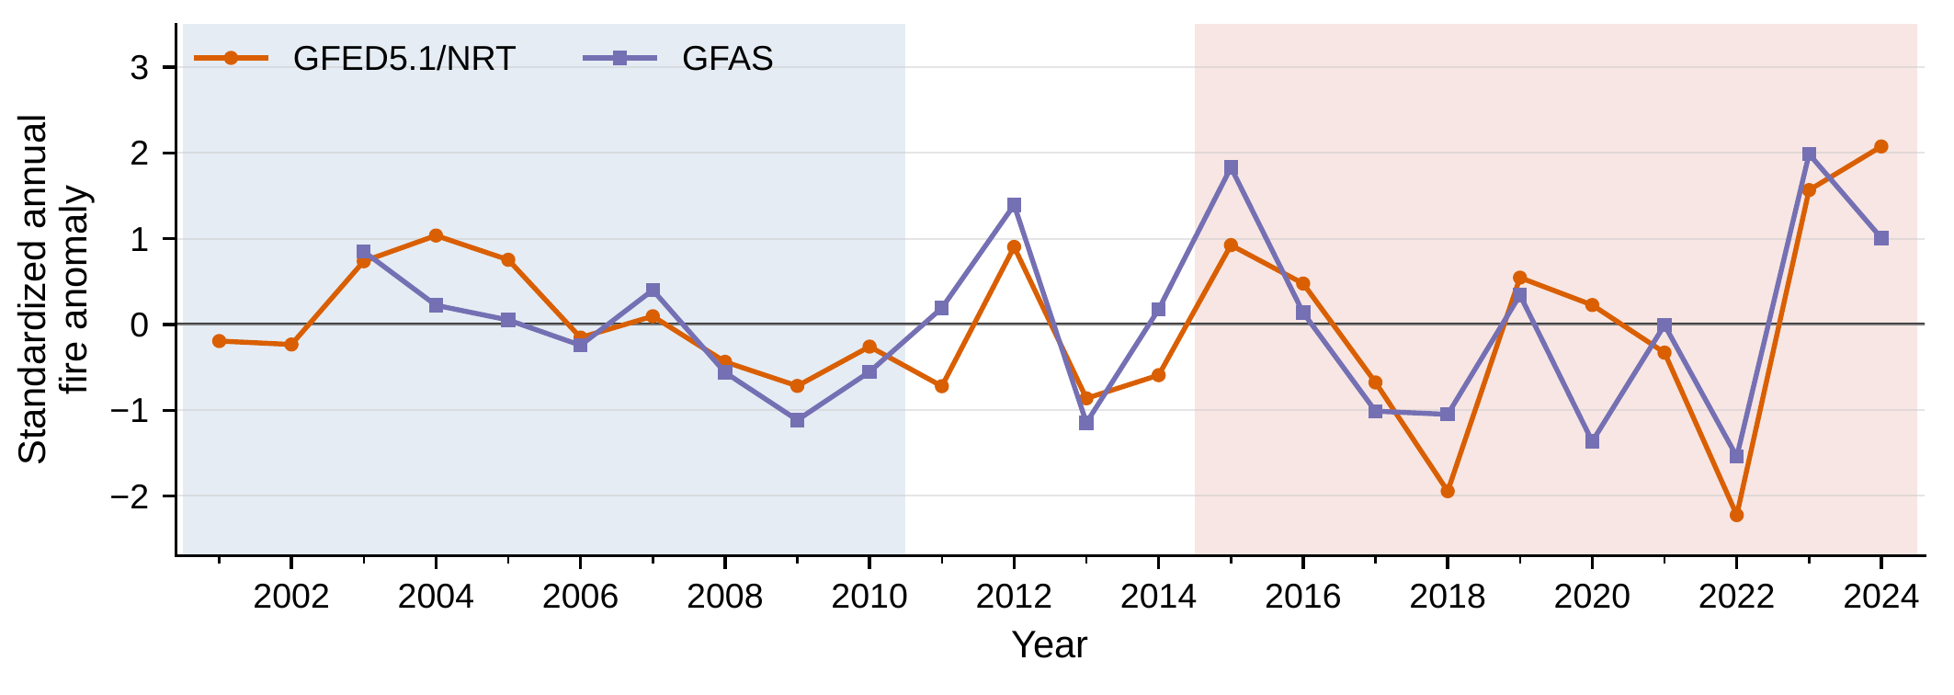
Supplementary Fig. 5 | Standardized global fire anomalies from two inventories. Annual anomalies for GFED5.1 with its near-real-time extension (orange circles) and GFAS (purple squares). Each series is detrended over its available years within 2001–2024 and divided by its own detrended standard deviation; GFAS begins in 2003. Blue and red shading marks 2001–2010 and 2015–2024. The comparison is of timing, not of absolute emissions.

2B. Decomposition of the change in growth-rate variance
Subtracting the fire flux from CO₂ growth lowers the recent growth variance by far more than fire’s own share of that variance (main Fig. 3d). Let F be the detrended GFED fire anomaly, G the detrended growth anomaly from the median of the six fixed inversions and N = G − F the remainder. Fire and the remainder covaried in 2015–2024 (r = 0.78) but not in 2001–2010 (r = 0.07), so the subtraction removes both fire’s own variance and its covariance with the remainder. It is an arithmetic diagnostic of these three detrended series: N does not reconstruct an atmosphere in which fire did not occur, and the reduction is not an estimate of fire’s causal contribution.
Of the 0.22 PgC² yr⁻² increase in growth-rate variance between the windows, fire’s own variance supplies +0.11 and the remainder’s variance −0.20, while the fire–remainder covariance, which enters the total twice, supplies +0.31. Within 2015–2024 the subtraction reduces growth-rate variance by 57% (95% bootstrap interval, 42–65%), against 6% in 2001–2010 (−18 to 23%), a difference of 51 percentage points (28–75); the early-to-recent change in the remainder’s own variability is not statistically resolved (Supplementary Table 3B).
Relative to a single linear trend fitted over 2001–2024, the 2024 growth anomaly is +1.33 PgC yr⁻¹, the largest of 2001–2024, and the fire anomaly +0.55, so the remainder is +0.78 PgC yr⁻¹, the fourth largest, after 2002 (+1.09), 2015 (+0.91) and 2005 (+0.80).

Supplementary Note 3 | Sensitivity to the comparison windows and to individual years
These tests vary the comparison windows, remove individual years and blocks of years, and test the record’s endpoints. Each window holds ten or fewer years and all are drawn from one overlapping record, so the tests can establish how robust the recent reinforcing state is but cannot date its onset or establish a monotonic trend.

3A. Sensitivity to window length and position
Both the length and the position of the comparison windows were varied. The covariance-amplification factor A=Var(r​Fr)/r​Var(Fr) exceeds one for every 6-, 8- and 10-year window of the 1997–2024 record ending in 2018 or later, and fire coherence in trailing ten-year windows is greater towards the end of the record (Supplementary Fig. 2a). The ten-year window ending in 2022, before the GFED5NRT years, gives A = 1.6, against 0.4 for 2001–2010 and 1.8 for 2015–2024.
Comparisons between pairs of windows are less uniform. The record permits five comparisons of ten-year windows separated by four omitted years, with recent windows starting in 2011–2015. Those whose recent window starts in 2013–2015 give positive changes in coherence (+0.15 to +0.18); the two using 1997–2006 and 1998–2007 as early baselines give small negative changes (−0.02 and −0.03), and those baselines include years before direct MODIS burned-area observations (Methods). Because the largest of the five changes was selected after seeing all five, it was compared with the largest change obtained from resampled records rather than with a single-comparison threshold, giving a one-sided P = 0.07 (Methods). The analysis therefore supports a recent reinforcing state, but neither a steady trend towards it nor a particular year at which it began.

3B. Omission of single years and blocks of years
Neither principal result rests on one influential year. Omitting any single year from 2015–2024 leaves the covariance contribution to the increase in global fire variance between 71% and 96% (all-year value, 84%) and the fire–CO₂ R² between 0.74 and 0.91, and excluding prespecified blocks of years (2015–2016, 2018, 2022 or 2023–2024) retains the direction of both results. The recent decade did contain larger detrended global fire anomalies in both directions than 2001–2010, from −0.66 to +0.42 PgC yr⁻¹ against −0.17 to +0.22 PgC yr⁻¹, each decade against its own fitted trend. The 2022 minimum was widespread: 13 of the 14 regions burned below trend, and the largest single regional deficit, in Boreal Asia (−0.15 PgC yr⁻¹), supplied 22% of it.

3C. Near-real-time 2023 and preliminary 2025 data
The recent window ends with two near-real-time years, so we tested whether 2023 produced the boreal–tropical reinforcement. Under the original 2015–2024 trends, 2023 supplied only 3.4% of the positive recent boreal–tropical covariance and 2.8% of its change from the early period, and removing it raised the correlation from 0.48 to 0.64 while leaving the covariance positive with a similar share of the cross-region covariance increase (Supplementary Table 1).
Preliminary 2025 values are consistent with the recent state but do not test it. Adding 2025 to the recent decade, or using the matched 2016–2025 window, leaves the boreal–tropical covariance positive, because boreal and tropical emissions were both below their fitted trends in that year; and the preliminary 2025 GFED5NRT/GRESO pair, placed relative to trends fitted only through 2024, falls close to the recent fire–growth regression (main Fig. 3c). These values enter no main result and no fitted fire–CO₂ regression: they are an out-of-window consistency check, not evidence that the recent association persists.

Supplementary Note 4 | Climate coherence and regional fire seasons

4A. Coherence of regional temperature and VPD
These comparisons test whether regional fire synchronization was accompanied by greater coherence in regional climate; they do not resolve its cause. Temperature coherence changes little when climate is restricted to each region’s fire season (+0.09 to +0.10) but rises over that season and the eight months before it (+0.12 to +0.33), close to its annual-mean change (+0.13 to +0.36). Vapour pressure deficit (VPD) coherence rises from 0.00 to +0.07 in annual means, stays near +0.05 under twelve-month sampling and rises only from +0.02 to +0.05 within fire seasons, while fire coherence rises under fire-season as well as annual sampling (−0.04 to +0.11 within fire seasons; main Fig. 4b). Temperature and relative humidity are from the National Centers for Environmental Prediction–National Center for Atmospheric Research (NCEP–NCAR) reanalysis (Reanalysis 1)¹⁰, and VPD follows the saturation vapour pressure formulation of Bolton¹¹ (Methods).
The 95% moving-block bootstrap intervals for the changes in temperature and VPD coherence include zero under all three sampling choices, so these are estimated differences in the climate accompanying regional fire synchronization rather than statistically resolved changes; the interval for the annual change in fire coherence (+0.03 to +0.35) excludes zero. The twelve-month window also contains the fire season together with the preceding eight months (Methods), so it does not isolate antecedent climate from conditions during burning. Main Fig. 4 therefore describes a plausible climate context for the regional fire synchronization rather than identifying a shared mechanism.

4B. Fire-season definitions
Supplementary Table 2 lists the fixed four-month fire season of each region (Methods). Where two windows tie for the largest climatological emissions over 1999–2011, the window containing the climatological peak month is chosen, and then the earliest start month. The season year is the calendar year of the anchor month, the largest climatological month inside the selected window, and the twelve-month sampling window ends with the season’s final month.

Supplementary Tables
Supplementary Table 1 | Endpoint sensitivity of boreal–tropical fire reinforcement.
Test | Years (n) | Correlation, r | Covariance term | Share of full change
Early window | 2001–2010 (10) | −0.23 | −0.0077 | —
Recent baseline | 2015–2024 (10) | 0.48 | 0.033 | 44%
Exclude 2023 | 2015–2022, 2024 (9) | 0.64 | 0.035 | 41%
Include 2025 | 2015–2025 (11) | 0.56 | 0.041 | 48%
Matched 10-year | 2016–2025 (10) | 0.57 | 0.044 | 45%
Positive covariance means the two groups tended to be high or low in the same years; negative covariance means they tended to cancel. Values are in PgC² yr⁻² and are doubled because the boreal–tropical pair enters the variance of the global sum twice, once in each direction. The percentage is the boreal–tropical change divided by the full 14-region change from the 2001–2010 reference; each row has its own fitted trends.
Supplementary Table 2 | Fixed fire-season definitions for the 14 GFED basis regions.
Region | Abbreviation | Fire season | Anchor month
Boreal North America | BONA | May–Aug | July
Temperate North America | TENA | Jul–Oct | August
Central America | CEAM | Mar–Jun | May
Northern Hemisphere South America | NHSA | Jan–Apr | February
Southern Hemisphere South America | SHSA | Aug–Nov | September
Europe | EURO | Jul–Oct | August
Middle East | MIDE | Jun–Sep | August
Northern Hemisphere Africa | NHAF | Nov–Feb | January
Southern Hemisphere Africa | SHAF | Jun–Sep | August
Boreal Asia | BOAS | Apr–Jul | July
Central Asia | CEAS | Jul–Oct | August
Southeast Asia | SEAS | Jan–Apr | March
Equatorial Asia | EQAS | Jul–Oct | September
Australia and New Zealand | AUST | Sep–Dec | October
Seasons are held fixed for all years. Northern Hemisphere Africa is the only region whose season crosses the calendar boundary: anchored in January, it draws its November and December from the preceding calendar year. For Central Asia the largest climatological month of the full year is April, outside the selected July–October window, so the season year is anchored on August, the largest month inside it.
Supplementary Table 3 | Atmospheric constraints and decomposition of growth-rate variance.
A — Atmospheric and product consistency
Comparison | Result
TROPOMI-derived fire CO₂ versus GFED regional anomalies | Pooled region–year r = 0.84; median regional r = 0.88
Coherence (mean pairwise cross-region r) | TROPOMI: 0.18–0.23; GFED: 0.24
Cross-region covariance as a share of global fire variance | TROPOMI: 61–63%; GFED: 57%
Fire versus each fixed inversion’s growth rate | R² = 0.74–0.85
Fire versus the six-inversion median growth rate | R² = 0.83; slope = 2.3
Fire versus satellite-derived growth rate | OCO-2/GOSAT mean: R² = 0.77, slope = 2.4; OCO-2 alone: R² = 0.75; GOSAT alone: R² = 0.77
B — Fire–growth variance accounting
Quantity | 2001–2010 | 2015–2024
Standard deviation of fire anomaly, F | 0.14 | 0.36
Standard deviation of growth anomaly, G | 0.76 | 0.90
Standard deviation of growth minus fire, N | 0.74 | 0.59
Squared fire–growth correlation, Corr(F, G)² | 0.06 | 0.83
Fire variance relative to growth variance, a = Var(F)/Var(G) | 3.3% | 16%
Fire share of growth variance by covariance, s = Cov(F, G)/Var(G) | 4.6% | 37%
Variance reduction after subtraction, 1 − Var(N)/Var(G) | 5.9% | 57%
Standard-deviation reduction after subtraction, 1 − SD(N)/SD(G) | 3.0% | 35%
Early and recent denote 2001–2010 and 2015–2024. Panel A: regional comparisons use 2019–2024 and all 14 GFED regions, TROPOMI ranges span the QFED- and GFAS-prior estimates, and the pooled comparison uses within-region standardized anomalies; growth-rate comparisons use GFED fire for 2015–2024, with slopes in PgC of growth per PgC of fire; main Fig. 3b uses the OCO-2/GOSAT mean and Supplementary Fig. 4a OCO-2 alone. Panel B: standard deviations are in PgC yr⁻¹, ten annual values per window, and the variance budget quoted in the text is computed from the unrounded series, so squaring the rounded standard deviations here does not reproduce it exactly; s contains fire variance plus one share of the fire–remainder covariance whereas the subtraction contains two, and standard deviation is the square root of variance, so the two fractional reductions differ. The 95% bootstrap intervals of the recent/early standard-deviation ratios are 1.4–5.0 for F (two-sided F test with 8 and 8 degrees of freedom, P = 0.014), 0.7–1.5 for G (P = 0.66) and 0.48–1.04 for N (P = 0.53); the remainder was more variable in the recent window than in the early one in 4% of replicates. These measures describe the same detrended records without estimating fire’s causal contribution.
Supplementary Table 4 | Comparison of synchronization in burned area and fire carbon.
Quantity | Burned area | Fire carbon
Coherence (mean pairwise cross-region r) | −0.04 → +0.13 | −0.03 → +0.15
Global variance / summed regional variances | 0.67 → 1.95 | 0.36 → 1.81
Recent/early detrended standard deviation | 1.6 | 2.6
Arrows compare 2001–2010 with 2015–2024. In the second row, a ratio above one means that regional anomalies reinforce rather than cancel in the global total. Mean global burned area declined from 821 to 714 Mha yr⁻¹, while its detrended standard deviation rose from 28 to 44 Mha yr⁻¹. The larger amplification in carbon variability additionally depends on carbon released per area burned and on where the burning occurred.

Supplementary references
- van der Werf, G. R. et al. Landscape fire emissions from the 5th version of the Global Fire Emissions Database (GFED5). Scientific Data 12, 1870 (2025). doi:10.1038/s41597-025-06127-w.
- Chen, Y. et al. Tracking recent extremes and interannual variability of global fire emissions using a near-real-time extension to the Global Fire Emissions Database. Earth System Science Data Discussions (2026). doi:10.5194/essd-2026-158. Preprint, in review.
- Chen, Y. et al. GFED5NRT: Global Fire Emissions Database Near-Real-Time Extension, version 5.1. Zenodo (2026). doi:10.5281/zenodo.18702700. Dataset accompanying ref. 2.
- Chen, Y. et al. Multi-decadal trends and variability in burned area from the fifth version of the Global Fire Emissions Database (GFED5). Earth System Science Data 15, 5227–5259 (2023). doi:10.5194/essd-15-5227-2023.
- Kaiser, J. W. et al. Biomass burning emissions estimated with a global fire assimilation system based on observed fire radiative power. Biogeosciences 9, 527–554 (2012). doi:10.5194/bg-9-527-2012.
- Yun, J., Pandey, S., Bowman, K., Miyazaki, K. & Liu, J. Unprecedented role of Amazon fires in the record atmospheric CO₂ growth in 2024. ESS Open Archive (2025). doi:10.22541/essoar.175874118.83695562/v1. Preprint, version 1; not peer reviewed.
- Friedlingstein, P. et al. Global Carbon Budget 2025. Earth System Science Data 18, 3211–3288 (2026). doi:10.5194/essd-18-3211-2026.
- Pandey, S. et al. Toward low-latency estimation of atmospheric CO₂ growth rates using satellite observations: evaluating sampling errors of satellite and in situ observing approaches. AGU Advances 5, e2023AV001145 (2024). doi:10.1029/2023AV001145.
- Pandey, S. et al. Time-varying errors in the atmospheric CO₂ growth rate. Research Square (2026). doi:10.21203/rs.3.rs-9854768/v1. Preprint, version 1; not peer reviewed.
- Kalnay, E. et al. The NCEP/NCAR 40-year reanalysis project. Bulletin of the American Meteorological Society 77, 437–472 (1996). doi:10.1175/1520-0477(1996)077<0437:TNYRP>2.0.CO;2.
- Bolton, D. The computation of equivalent potential temperature. Monthly Weather Review 108, 1046–1053 (1980). doi:10.1175/1520-0493(1980)108<1046:TCOEPT>2.0.CO;2.

