Human osteoblast-like cells exhibit anabolic attenuation and catabolic phenotypic signals after exposure to polystyrene microplastics

Table S1 shows the primary antibodies used: anti-β-catenin (9582S), anti-p-β-catenin (9561S), anti-NF-κB (4764S), anti-p-SMAD4 (46535S), anti-p-SMAD3 (9523S), anti-SMAD3 (9561), and anti-p-SMAD1/5/9 (13820S). Anti-GAPDH (glyceraldehyde-3-phosphate dehydrogenase, 5174) was used as an intra-experimental control (housekeeping) for data normalization. All antibodies are from Cell Signaling Technology (CST - Massachusetts, USA) and were diluted in 0.1% TBST. In sequence, secondary incubation was performed with horseradish peroxidase (HRP)-conjugated anti-rabbit Cell Signaling 5174 diluted 1:10,000 in 5% BSA, for 1 h at room temperature.

Table S1. Proteins tested using the Western blot technique.
Primary Antibody | Reactivity | Molecular weight (kDA) | Dilution | Secondary antibody
β-catenin | Human | 92 | 1:1000 | Anti-rabbit
p-β-catenin | Human | 92 | 1:1000 | Anti-rabbit
p-SMAD4 | Human | 70 | 1:1000 | Anti-rabbit
p-SMAD1/5/9 | Human | 60 | 1:1000 | Anti-rabbit
SMAD3 | Human | 52 | 1:1000 | Anti-rabbit
p-SMAD3 | Human | 52 | 1:1000 | Anti-rabbit
NF-KappaB | Human | 65 | 1:1000 | Anti-rabbit
GAPDH | Human | 37 | 1:1000 | Anti-rabbit

Table 2. Information on the intra-experiment control primer (YWHAZ) and target primers
Gene | Acession number | Product length | Foward | Reverse
YWHAZ (16) | NM_145690.3 | 245 | ACTTTTGGTACATTGCTTCAA | CCGCCAGGACAAACCAGTAT
ALPL | NM_000478.4 | 137 | GACCTCCTCGGAAGACACTC | TGAAGGGCTTCTTGTCTGTG
BGLAP | NM_199173.6 | 114 | TCACACTCCTCGCCCTATT | CCTCCTGCTTGGACACAAA
TNFRSF11B | NM_002546.4 | 95 | GATGTCCAGATGGGTTCTTCTC | CTGAGTTAGCAGGAGACCAAAG
CTNNB1 | NM_001438871.1 | 99 | CTGCTGTTTTGTTCCGAATGTC | CCATTGGCTCTGTTCTGAAGAGA
IL-1B | NM_000576.3 | 145 | TGAAATGATGGCTTATTACAGTGG | GTAGTGGTGGTCGGAGATTCGTAG
DKK1 | NM_012242.4 | 115 | TGGAACTCCCCTGTGATTGC | AATAGGCAGTGCAGCACCTT
BMP4 | NM_001347916.1 | 277 | TGTGACACGGTGGGAAACT | CCGCTGTGAGTGATGCTTAG
TGFB | NM_001407430.1 | 235 | CATTTTTCCCAAGTGCCAGT | ACACCCCTAAGCATGTGGAG
NF-kB-p65 | NM_021975.4 | 123 | TGTGAAGAAGCGGGACCTGGAG | AAGCAGAGCCGCACAGCATTC
Primers: Tyrosine 3-Monooxygenase/Tryptophan 5-Monooxygenase Activation Protein Zeta (YWHAZ); Runt-related transcription factor 2 (RUNX2); Alkaline phosphatase (ALPL); Bone Gamma-Carboxyglutamate Protein (BGLAP, osteocalcina); TNF Receptor Superfamily Member 11b (TNFRSF11B, osteoprotegerina); Catenin Beta 1 (CTBNN1), Interleucin 1 beta (IL-1β); Dickkopf Wnt Signaling Pathway Inhibitor 1 (DKK1); Bone Morphogenetic Protein 4 (BMP4); Transforming Growth Factor Beta 1 (TGFβ); NF-kappa-B transcription complex (NFkB) subunit p65 (NF-kB-p65).

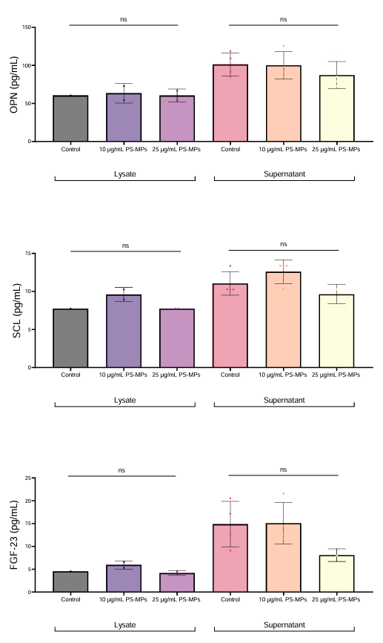
Figure S1. Quantification of bone-related proteins in cell lysates and supernatants using the Milliplex™ Bone Panel after exposure to PS-MPs (10 and 25 µg/mL). Osteopontin (OPN), sclerostin (SCL) and fibroblast growth factor 23 (FGF-23) concentrations remained unchanged across treatments in both cell lysates and supernatants. Data are presented as fold-change related to the control, representing three independent biological and two technical replicates (n = 4), and were analyzed using GraphPad Prism 10.1.1 (v. 323). The significance level of p < 0.05 was considered.
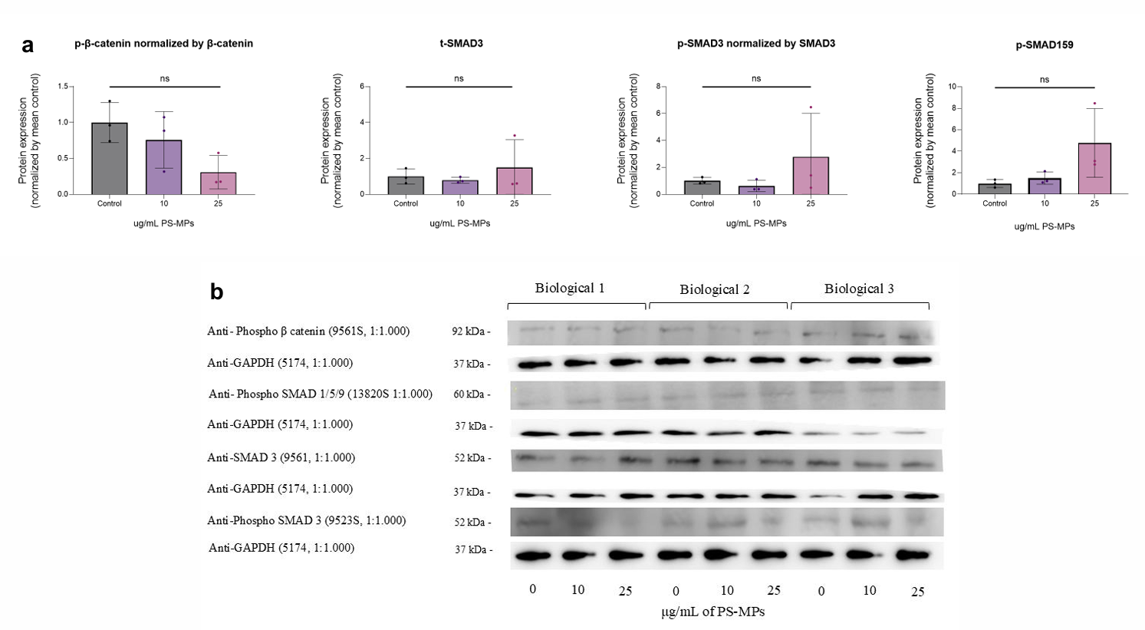
Figure S2. Representation of the densitometric analysis of Western blot data of non-altered proteins from cells treated with 10 and 25 µg/mL polystyrene microplastics (PS-MPs) (a) and Representative Western blot images corresponding to the quantified proteins. Protein expression levels were normalized to GAPDH and expressed relative to control cells (b). Band quantification was performed using the ImageJ gel analysis tool, based on the area under the curve, and normalized to the internal loading control (GAPDH). Molecular weights (kDa) are indicated for each protein according to the molecular weight marker. Statistical analysis was performed using one-way ANOVA or Kruskal-Wallis followed by Dunnett’s multiple comparisons test. Data are presented as fold-change related to the control, representing three independent biological and two technical replicates (n = 6), and were analyzed using GraphPad Prism 10.1.1 (v. 323). The significance level of p < 0.05 was considered.

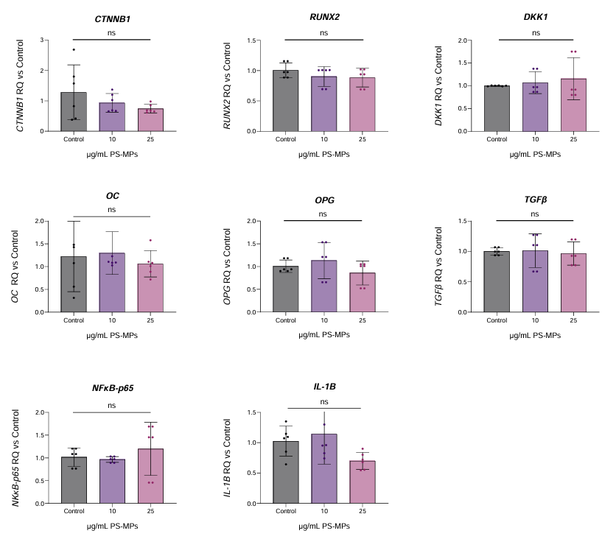
Figure S3. Relative gene expression in MG-63 cells exposed to polystyrene microplastics (PS-MPs) for 7 days. Gene expression was assessed by RT-qPCR (QuantStudio 3) and normalized using the YWHAZ reference gene. Osteogenic and inflammatory signaling genes were not altered. Statistical analysis was performed using one-way ANOVA or Kruskal-Wallis followed by Dunnett’s multiple comparisons test. Data are presented as fold-change related to the control, representing three independent biological and two technical replicates (n = 6), and were analyzed using GraphPad Prism 10.1.1 (v. 323). The significance level of p < 0.05 was considered.

