Carbon composites from iron-chelating pyridine nitrogen-rich coordinated nanosheets for oxygen reduction

Bing Zhang ¹, Hele Guo ¹, Longsheng Zhang ², Xu Zhang ^{1,}*, Chao Zhang ¹, Tianxi Liu ^{1,2,}*

¹ State Key Laboratory for Modification of Chemical Fibers and Polymer Materials, College of Materials Science and Engineering, Innovation Center for Textile Science and Technology, Donghua University, Shanghai 201620, People’s Republic of China.

² Key Laboratory of Synthetic and Biological Colloids, Ministry of Education, School of Chemical and Material Engineering, International Joint Research Laboratory for Nano Energy Composites, Jiangnan University, Wuxi, Jiangsu 214122, People’s Republic of China.

* Corresponding authors.
E-mail address: xuzhang@dhu.edu.cn (Xu Zhang), txliu@dhu.edu.cn (Tianxi Liu)

Supporting Information
S1. Supplementary figures

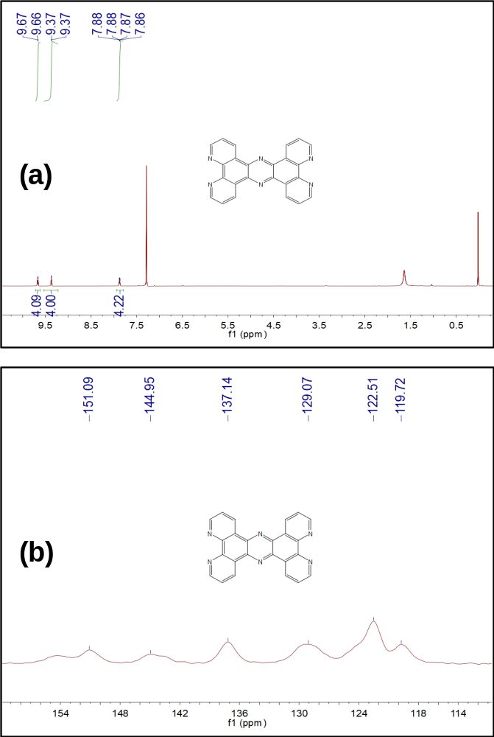
Figure S1. (a) ¹H NMR spectra of the TP (CDCl₃, 600 MHz) and (b) ¹³C NMR spectra of the TP (100 MHz).

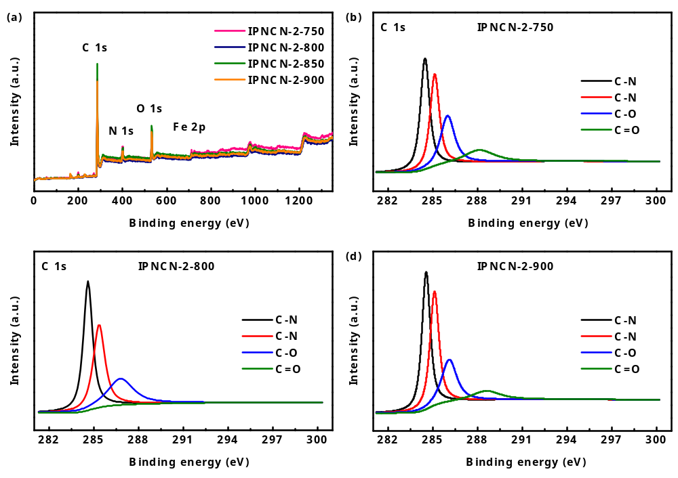
Figure S2. (a) XPS survey spectra of the IPNCN-2 compoaites calcined at 750 °C, 800 °C, 850 °C, and 900 °C. The C 1s spectra of the IPNCN-2 compoaites caclined at (b) 750 °C, (c) 800 °C, and (d) 900 °C.

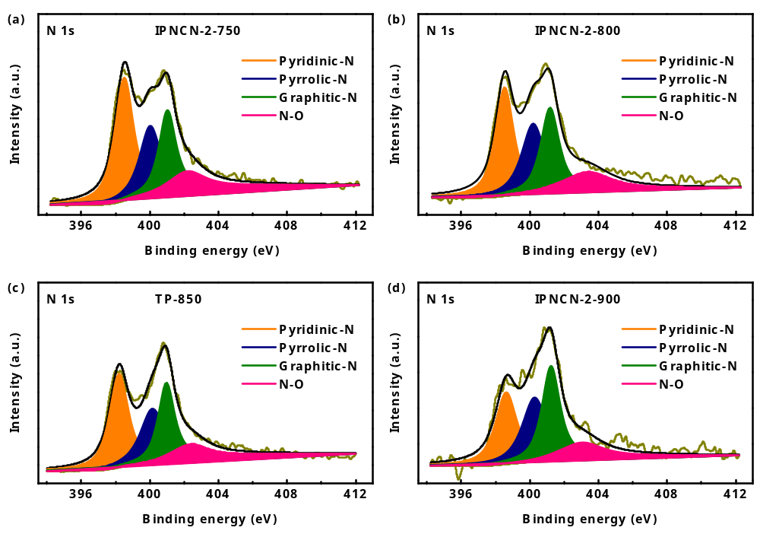
Figure S3. (a) N 1s spectra of the TP-850 catalysts. (b-d) N 1s spectra of the IPNCN-2 composites prepared at different pyrolytic temperatures.

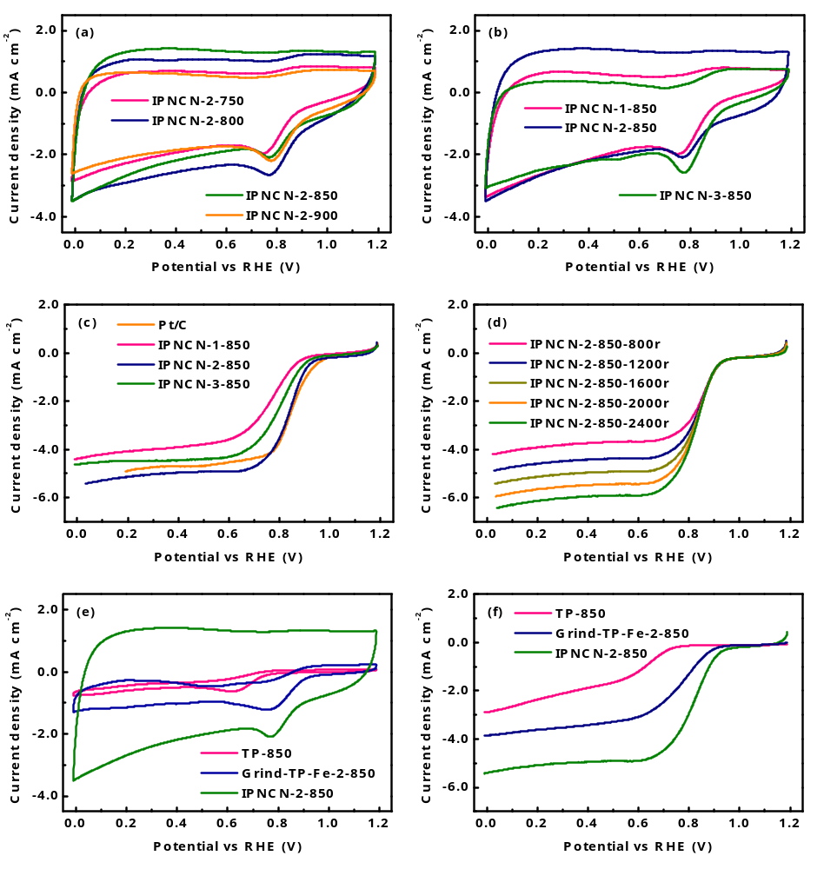
Figure S4. (a) CV curves of the IPNCN-2 composite catalysts prepared at different pyrolytic temperatures in the O₂-saturated 0.1 mol/L aqueous KOH electrolyte solution. (b) CV curves of the IPNCN composite catalysts calcined at 850 °C with different mole ratios in the O₂-saturated 0.1 mol/L aqueous KOH electrolyte solution. (c) LSV curves of the IPNCN composite catalysts prepared at different mole ratios and the commercial Pt/C catalysts at 1600 rpm rotation rate in the O₂-saturated 0.1 mol/L KOH solution. (d) LSV curves of the IPNCN-2-850 composite catalysts at various rotation speeds. (e) CV curves of the IPNCN-2-850 composite, TP-850, and Grind-TP-Fe-2-850 catalysts in the O₂-saturated 0.1 mol/L aqueous KOH electrolyte solution. (f) LSV curves of the IPNCN-850 composite , TP and Grind-TP-Fe-2-850 catalysts at 1600 rpm rotation rate in the O₂-saturated 0.1 mol/L KOH solution.
S2. Gaussian calculations
All the structures were optimized at the B3LYP level of the density functional theory without any constraints [S1]. In addition, the frequency calculations were performed at the same level of the theory to confirm that all the stationary points were minima (no imaginary frequency). The effective core potentials (ECPs) of Hay and Wadt with double-ζ valence basis set (LanL2DZ) were used to describe the Fe atoms [S2], whereas the 6-311+G(d) [S3] basis sets were used for C, H, and N atoms. The polarization functions were also added for Fe (ζ(f) = 2.462) [S4]. All the calculations were performed with the Gaussian 16 [S5] software package at 298K.

Cartesian coordinates and electronic energies for all the complexes calculated in the present study
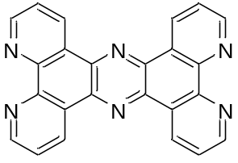
E = -1250.6185249 a.u.
C 2.45120100 -2.84165000 -0.00073700
C 2.41170100 -1.43716100 -0.00032900
C 1.14747300 -0.71093200 -0.00009100
C 1.14747500 0.71094100 0.00002100
C -1.14748300 -0.71093400 0.00002400
C -1.14748200 0.71093400 -0.00016700
C -2.41171100 1.43716500 -0.00041100
C -3.64070900 0.73660300 -0.00004500
C -3.64071700 -0.73659400 0.00032900
C -2.41171200 -1.43716400 0.00026400
C -2.45121000 -2.84165700 0.00037700
C 3.64071000 -0.73659000 -0.00017300
C 3.64071200 0.73659000 0.00020200
C 2.41170500 1.43716500 0.00032800
C 2.45122100 2.84165000 0.00078000
C -2.45120800 2.84165700 -0.00100000
N -0.00000800 1.39295700 -0.00009200
N -0.00000400 -1.39295300 -0.00000400
C 3.67383000 3.48111700 0.00097200
C 3.67380900 -3.48113000 -0.00081200
C 4.83509200 -2.69352800 -0.00062000
C -4.83508200 2.69354800 -0.00057300
C -3.67381800 -3.48113500 0.00072300
C -4.83509600 -2.69353200 0.00079700
C 4.83510500 2.69350600 0.00073500
C -3.67379700 3.48112200 -0.00112800
N -4.82738000 1.37027900 -0.00006000
N -4.82737500 -1.37027100 0.00063900
N 4.82737200 1.37026000 0.00044200
N 4.82737200 -1.37026800 -0.00035500
H -5.81575100 3.16443200 -0.00054900
H -3.74478300 4.56334600 -0.00154500
H -1.52005500 3.39443600 -0.00134200
H -1.52005800 -3.39444100 0.00022500
H -3.74481400 -4.56336000 0.00102400
H -5.81578700 -3.16437100 0.00120700
H 1.52007500 3.39444400 0.00091900
H 3.74482900 4.56333900 0.00128000
H 5.81580000 3.16433800 0.00082400
H 1.52004400 -3.39442500 -0.00086900
H 3.74480900 -4.56335200 -0.00113000
H 5.81578500 -3.16436700 -0.00081900

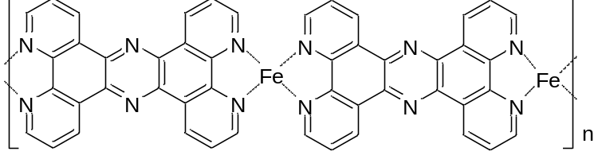
E = -3997.8888472 a.u.
C 8.91017700 0.39150900 2.80817000
C 9.35502400 0.10378300 1.51618000
C 10.60864000 0.61040200 0.95492400
C 11.01934100 0.24023000 -0.36699600
C 12.52930600 1.85362600 1.19232300
C 12.94426400 1.47093300 -0.11387200
C 14.21680500 1.94966300 -0.64175100
C 15.04109300 2.80040900 0.13583800
C 14.60607600 3.20570800 1.48377600
C 13.37054900 2.73501300 1.99342100
C 12.98619100 3.14295000 3.28409400
C 8.56106200 -0.72977400 0.69942400
C 8.94182900 -1.04384800 -0.62920200
C 10.16918000 -0.61927000 -1.18373700
C 10.49526100 -1.05218800 -2.47355600
C 14.66307500 1.58484000 -1.92516200
N 12.17981100 0.67404400 -0.87040700
N 11.37229300 1.41340400 1.70232700
C 9.60089800 -1.88525700 -3.15067900
C 7.68756800 -0.16347100 3.22222300
C 6.96165500 -0.98295400 2.37366200
C 16.62101100 2.90111300 -1.52626000
C 13.81988600 3.98029000 4.00160600
C 15.02496400 4.38979000 3.40479000
C 8.38742200 -2.22629200 -2.54828300
C 15.87881900 2.06352800 -2.37690500
N 16.22558000 3.26285400 -0.31299000
N 15.41340600 4.02180800 2.19111900
N 8.03162600 -1.80619300 -1.32316500
N 7.36625300 -1.30266700 1.11124800
H 17.58340500 3.29493800 -1.85164500
H 16.25795100 1.80423300 -3.36089100
H 14.04146900 0.93465000 -2.53076100
H 12.04245100 2.79071700 3.68555500
H 13.55845500 4.31777800 5.00006300
H 15.70435400 5.04957400 3.94356400
H 11.43290400 -0.74118600 -2.92010800
H 9.82522700 -2.25409000 -4.14606800
H 7.65521700 -2.83855300 -3.06801300
H 9.50090200 1.02512800 3.45821600
H 7.30279600 0.03330800 4.21827900
H 6.02252600 -1.42138800 2.69037500
C -14.26047300 0.15330800 3.00276800
C -14.12050500 1.01555500 1.89868800
C -12.96426700 0.93827700 1.01657800
C -12.85495500 1.82423700 -0.08683000
C -10.95544200 -0.02670500 0.45021100
C -10.84664500 0.86585800 -0.66715300
C -9.70778200 0.75954300 -1.57649800
C -8.63271400 -0.08665500 -1.20772000
C -8.73988400 -0.97012200 -0.09445900
C -9.92464800 -1.03571200 0.67963500
C -10.06175600 -2.10710800 1.56687800
C -15.14123000 1.97157400 1.66474100
C -15.02636500 2.89232000 0.52297800
C -13.89762200 2.81118600 -0.33156400
C -13.81849700 3.71031700 -1.41199000
C -9.64376600 1.38419100 -2.82517600
N -11.79884900 1.76821400 -0.91643100
N -12.01298100 0.02181600 1.26397900
C -14.83362400 4.62900400 -1.60003800
C -15.37701900 0.26681400 3.80913500
C -16.33232300 1.24787500 3.48879600
C -7.52379500 0.28911200 -3.20621900
C -9.05644000 -3.07637100 1.61603700
C -7.90141900 -2.91534800 0.84683500
C -15.91032600 4.62563400 -0.69539700
C -8.55957500 1.10790400 -3.66197900
N -7.50586300 -0.25969800 -1.97970500
N -7.69872300 -1.85863700 0.04221100
N -16.01246600 3.79262900 0.33122800
N -16.22771300 2.07489500 2.45769900
H -6.67143900 0.06755100 -3.83887700
H -8.50910300 1.52134000 -4.66388700
H -10.45509500 2.03088000 -3.14029000
H -10.96161900 -2.19106400 2.16605200
H -9.15828900 -3.95349300 2.24657500
H -7.10144800 -3.64707100 0.88049900
H -12.95898700 3.66105900 -2.07129700
H -14.80825800 5.33904700 -2.42136600
H -16.72662600 5.33732900 -0.81584700
H -13.48548200 -0.58037200 3.19509300
H -15.52072300 -0.37970300 4.66980000
H -17.22393500 1.36290600 4.10456500
C -2.59051300 -2.70704400 1.90982700
C -2.40041000 -2.00809200 0.71068200
C -1.08759000 -1.76937100 0.11834200
C -0.95998300 -0.93791800 -1.03469900
C 1.18833900 -2.08386200 0.14335300
C 1.31694900 -1.25985400 -1.02156600
C 2.62880200 -1.02350000 -1.62694800
C 3.75278400 -1.60828500 -1.00507600
C 3.62649200 -2.37736200 0.17883800
C 2.37303700 -2.67320500 0.75735900
C 2.34411200 -3.51338800 1.87578000
C -3.52753400 -1.47217800 0.05947800
C -3.40003300 -0.63418400 -1.08427200
C -2.13992000 -0.31126500 -1.62300300
C -2.07680800 0.62306600 -2.66507000
C 2.82587800 -0.26111100 -2.78034700
N 0.23874700 -0.69974300 -1.57996600
N -0.01022900 -2.32129300 0.68772000
C -3.26758400 1.22526800 -3.06816500
C -3.88592000 -2.78470900 2.41859400
C -4.95136900 -2.23474100 1.70949500
C 5.19905300 -0.72051700 -2.59999200
C 3.54881600 -4.02447700 2.36521500
C 4.75156000 -3.64886100 1.76164800
C -4.47598800 0.84967100 -2.48654200
C 4.14015500 -0.11209500 -3.25398400
N 5.04981100 -1.48720600 -1.48252200
N 4.81615800 -2.82322500 0.70425600
N -4.59046200 -0.12088700 -1.54727000
N -4.81969400 -1.63495500 0.50185700
H 6.21436300 -0.61563700 -2.96421000
H 4.34071800 0.47257100 -4.14664200
H 1.98073600 0.19494800 -3.28115800
H 1.39314000 -3.75667600 2.33597300
H 3.56618800 -4.69155100 3.22072800
H 5.70620700 -3.99657700 2.14744400
H -1.11926400 0.88550200 -3.09829600
H -3.26922700 2.00039900 -3.82843600
H -5.39339000 1.34475200 -2.77258500
H -1.73884900 -3.12979300 2.42901600
H -4.08110600 -3.26397700 3.37304700
H -5.95235100 -2.26888800 2.11738400
Fe 6.38235500 -2.14095600 -0.28762000
Fe -6.17308000 -0.93247300 -0.72690200

References
- (a) Becke, A. D. J. Chem. Phys. 1993, 98, 5648-5652. (b) Miehlich, B.; Savin, A.; Stoll, H.; Preuss, H. Chem. Phys. Lett. 1989, 157, 200-206. (c) Lee, C.; Yang, W. T.; Parr, R. G. Phys. Rev. B. 1988, 37, 785-789. (d) Stephens, P. J.; Devlin, F. J.; Chabalowski, C. F.; Frisch, M. J. J. Phys. Chem. 1994, 98, 11623-11627.
- Hay, P. J.; Wadt, W. R. J. Chem. Phys. 1985, 82, 299-310.
- Clark, T.; Chandrashakar, J.; Spitznagel, G. W.; Schleyer, P. V. R. J. Comput. Chem. 1983, 4, 294-301.

