Supplementary Information
Protonation-induced site and field reconstruction for ultrafast adsorptive desulfurization over Cu-N-C
Table of Content
Experimental Section
Reagent
Preparation of Cu-N-C
Preparation of Cu-N-C-800*
Preparation of CuTPP@CB
Desulfurization experiment
Flow adsorption experiment
Evaluation of adsorptive desulfurization performance
Calculation of maximum adsorption capacity
Computational details
Characterizations
Supplementary Figure
Morphology and physic-chemical characterizations of Cu-N-C-800
Figure S1 XRD patterns of different samples
Figure S2 SEM images
Figure S3 TEM images
Figure S4 HAADF-STEM images
Figure S5 XRD pattern
Figure S6 Cu 2p XPS spectrum
Figure S7 N 1s XPS spectrum
Figure S8 Langmuir isotherm model fitting
Adsorption desulfurization activity evaluation and comparison
Figure S9 Calculated breakthrough adsorption capacity of Cu-N-C-800 according to the flow adsorption experiment
Figure S10 Pseudo-second-order model of Cu-N-C-800 and other adsorbents
Figure S11 Sulfur removal rate and adsorption selectivity of Cu-N-C-800
Figure S12 Competitive adsorption capacity of Cu-N-C for DBT in the model oil with toluene as the interfering substances
Figure S13 S2p XPS spectra of Cu-N-C-800 before and after adsorption
Figure S14 SCN⁻ poisoning experiment of Cu-N-C-800
Figure S15 Density of states of Cu 4s, 3d and S 3p
Figure S16 DBT adsorption energy of π-π interaction
Effect of protonation and deprotonation on desulfurization capability
Figure S17 1st derivative of N K-edge XANES spectra
Figure S18 Cu2p XPS spectra of Cu-N-C-800*
Figure S19 Protonation effect of Cu-N-C on adsorption and desorption capacities.
Supplementary Tables
Table S1 EXAFS fitting parameters at the Cu K-edge for various samples
Table S2 Adsorption performances of different adsorbents for DBT
Table S3 Pseudo-second-order model with a rate constant (K₂) of Cu-N-C-800 and other contrasting adsorbents.

Experimental Section
Reagent:
The copric chloride dihydrate (CuCl₂•2H₂O, 99%), 1-butyl-3- methylimidazolium bromide (C₈H₁₅BrN₂, 99.5%), copper (II) meso- tetraphenylporphine (CuTPP, 95%), carbon black (CB), dibenzothiophene (DBT, 98%), 4, 6-dibenzothiophene (4, 6-DMDBT, 97%), thiophene (Th, 99%), nitric acid (HNO₃), n-octane (98%), toluene (99%) and other chemicals or solvents used were all purchased from commercial sources and were of highest purity available. All listed chemicals in this study were used without further puriﬁcation. The ultrapure water (18.2 MΩ•cm) was supplied by water purification system (Qingdao FLOM Technology Co., Ltd.).
Preparation of Cu-N-C:
The preparation method was similar to our previous report.^{[1]} In a typical experiment, CuCl₂•2H₂O (6.99 g) in 150 mL ethanol was added into the mixture of 1-butyl-3-methylimidazolium bromide (8.99 g) and 50 mL ethanol. The formed mixture was stirred at 25 ºC for 8 h, and the ethanol was removed via the rotary evaporation (70 ºC, 90 rpm). The obtained mulberry liquid was washed by diethyl ether for three times to yield product, which was dried in the vacuum at 80 ºC for 8 h. This Cu-based precursor was calcinated at different temperature for 1 h under the N₂ atmosphere (150 mL/min) with the ramp rate of 10 ºC/min. The obtained samples were leached by concentrated nitric acid at room temperature for 8 h to protonate pyridinic-N sites and remove the excess Cu-related clusters or particles. The final product Cu-N-C-800) was washed by ultrapure water for several times until the pH of solution approached 7, which was dried in the vacuum at 80 ºC for 8 h.
Preparation of Cu-N-C-800* (i.e., deprotonated Cu-N-C-800)
50 mg Cu-N-C-800 was firstly washed by NaOH solution (1 M, 50 mL) to eliminate the proton of pyridinic-NH⁺, then washed by ultrapure water several times until the pH of solution approached 7. The obtained sample was further dried in the vacuum at 80 ºC for 8 h. The final product was denoted as Cu-N-C-800*.
Preparation of CuTPP@CB
The CB (0.5 g) was added into this solution of meso-tetraphenylporphine (CopperTPP, 44.0 mg) dissolved in 20 mL toluene. The mixture was stirred at 25 ºC for 8 h, then filtered and dried in the vacuum at 80 ºC for 8 h. The final product was named as CuTPP@CB.
Desulfurization experiment
The desulfurization experiments were conducted at 25 ºC in the static situation. Taking Cu-N-C-800 as an example, 50 mg Cu-N-C-800 was added into 5 mL n-octane solution containing 300 ppm DBT. During adsorption, ~0.3 mL mixture was removed and filtrated. The obtained filtrate was collected to determine the sulfur content.
Flow adsorption experiment
At room temperature, Cu-N-C-800 (0.1 g) was used in the flow adsorption experiment conducted in a fixed bed column (6 mm i.d. × 500 mm length) with the flow rate of 8.88 mL/h controlled via a peristaltic pump (Model oil: n-octane containing 300 ppm DBT).
Desorption and recyclability experiment
After adsorption, the adsorbent was washed by n-octane for several times and dried in the vacuum at 80 ºC for 8 h. The dried adsorbent was introduced into the Soxhlet apparatus with 60 mL toluene to desorb organosulfur at 145 ºC for 8 h. The regenerated adsorbent was dried in the vacuum overnight for recycling.
Evaluation of adsorptive desulfurization performance
The sulfur content in the solution was determined by REK-20S Ultraviolet fluorescence sulfur determination instrument (Taizhou Ruike Analytical Instrument, Co., Ltd.). The desulfurization performance was evaluated using desulfurization rate (%) and adsorption capacity (Q_{t}, mg S/g), which were determined according to the following two equations:
 | $$\text{Desulfurization rate }\left(\text{\%}\right)\text{=}\frac{{\text{C}}_{\text{0}}\text{-} {\text{C}}_{\text{t}}}{{\text{C}}_{\text{0}}}\text{×100}$$ | (1)
 | $${\text{Q}}_{\text{t}}\text{ (mg S/g)= }\frac{{\text{(C}}_{\text{0}}\text{-}{ \text{C}}_{\text{t}}\text{)×}{\text{V}}_{\text{oil}}}{\text{m}}$$ | (2)
Wherein, C₀ (ppm: mg S/L) and C_{t} (ppm) represented the sulfur contents of model oil before and after adsorption, V_{oil} (mL) was the volume of model oil, m (g) represented the Cu-N-C dosage.
Calculation of maximum adsorption capacity
The Langmuir isotherm model was used to calculate the maximum adsorption capacity of different adsorbents. The equation was given below:
 | $$\frac{{\text{C}}_{\text{e}}}{{\text{Q}}_{\text{e}}}\text{=}\frac{\text{1}}{{\text{Q}}_{\text{m}}\text{×}{\text{K}}_{\text{L}}}\text{+}\frac{{\text{C}}_{\text{e}}}{{\text{Q}}_{\text{m}}}$$ | (3)
Wherein, C_{e} (ppm) was the sulfur content of n-octane when the adsorption reached equilibrium; Q_{e} (mg S/g) represented the adsorption capacity; Q_{m} (mg S/g) meant the maximum adsorption capacity and K_{L} was the Langmuir parameter at 25 ºC.
Computational details:
The density functional theory (DFT) calculations with B3LYP functional were performed by Gaussian 09 software package. The basis set of H, C, N and S atoms was set as 6-31G (d, p) level, and the Cu atom was described by the effective core potentials (ECPs) with the LanL2DZ double-valence basis set. Considering the basis set superposition error, the relative energy of all optimized configurations along the adsorption path was the zero-point energy correction at the same optimization level. Geometric optimization didn’t impose symmetry constraints. SMD (Solvation Model Based on Density) implicit solvent model was used to investigate the adsorption behavior of DBT in the presence of toluene. We also calculated adsorption energy (E_{ads}) during the study, which was defined as follows:
 | $${\text{E}}_{\text{ads}}\text{=}{\text{ E}}_{\text{ads-state}}\text{- (}{\text{E}}_{\text{S}}\text{+}{\text{ E}}_{Cu\text{-N-C}}\text{)}$$ | (4)
The E_{ads-state} was the whole energy of the system that sulfide was adsorbed on the adsorbent. Furthermore, E_{S} and E_{Cu-N-C} are the energy of the isolated sulfide and Cu-N-C, respectively. The density of states (DOS) analysis was performed by Multiwfn program.
Characterizations
The nitrogen adsorption/desorption isotherm was tested at 77 K with Micromeritics ASAP 2460 (USA). The Nicolet AVATAR 360 instrument (USA) was used to record Fourier-transform infrared (FT-IR) spectra of samples. The powder X-ray diffraction (XRD) pattern was collected using Bruker advanced D8 X-ray diffractometer (Germany) with Cu K_{α} irradiation (λ=1.5406 Å, 40 kV, 40 mA). The X-ray photoelectron spectroscopy (XPS) spectra was performed on a thermo ESCALAB 250XI (650 μm, 16 kV, 14.9 mA, USA). The spherical aberration corrected transmission electron microscopy (STEM, FEI Themis Z, USA), transmission electron microscopy (TEM, FEI Talos S-FEG, USA) and scanning electron microscopy (SEM, Zeiss Sigma 300, Germany) were used to confirm the texture of Cu-N-C. The Cu content was tested on an Agilent 7800 Inductively Coupled Plasma-Mass Spectrometry (ICP-MS, USA). The elementary analysis (EA) was conducted using elementar vario MICRO cube (Germany). The Raman spectra was recorded by Bruker Senterra (Germany). The Ultraviolet Photoelectron Spectroscopy (UPS) was tested by PHI5000 VersaProbe III (Scanning ESCA Microprobe) SCA (Spherical Analyzer) (Japan). The X-ray absorption spectra (XAS) including X-ray absorption near-edge structure (XANES) and extended X-ray absorption fine structure (EXAFS) of the samples (410 eV were collected at the Singapore Synchrotron Light Source (SSLS) center, where a pair of channel-cut Si (111) crystals was used in the monochromator. The storage ring was working at the energy of 2.5 GeV with average electron current of below 200mA. The X-ray absorption spectra of Cu K-edge were measured at beamline 4B9A of Beijing Synchrotron Radiation Facility (BSRF) in transmission mode.

Figure S1 XRD patterns of different pyrolysis temperature samples.
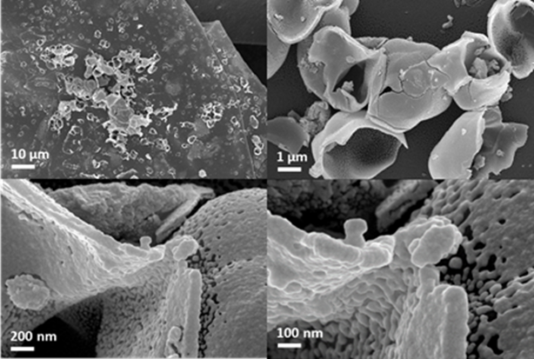
Figure S2 SEM image of Cu-N-C-800

(a) (b)
Figure S3 TEM image of Cu-N-C-800

(a)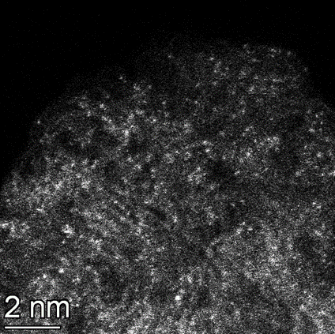(b)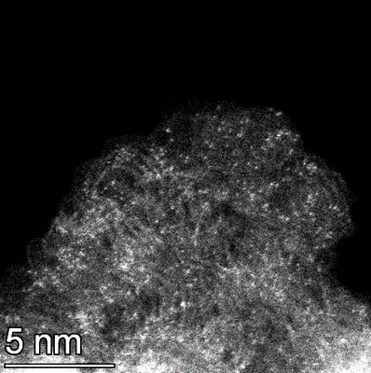
(c)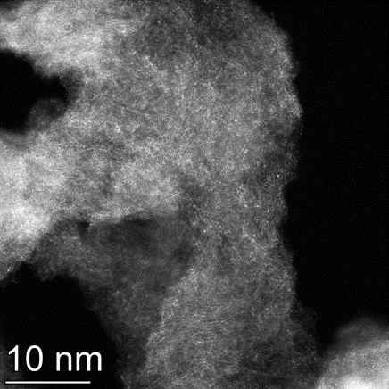(d)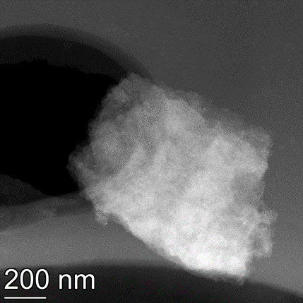
Figure S4 HAADF-STEM image of Cu-N-C-800

Figure S5 XRD pattern of Cu-N-C-800
Figure S6 Cu 2p XPS spectra of Cu-N-C-800
Figure S7 N 1s XPS spectra of Cu-N-C-800
Figure S8 Langmuir isotherm model fitting of Cu-N-C-800
Figure S9 Calculated breakthrough adsorption capacity of Cu-N-C-800 according to the flow adsorption experiment

Figure S10 Pseudo-second-order model of Cu-N-C-800 and other adsorbents
Figure S11 Sulfur removal rate and adsorption selectivity of Cu-N-C-800
Figure S12 Competitive adsorption capacity of Cu-N-C-800 for DBT in the model oil with toluene as the interfering substances.
Figure S13 S 2p XPS spectra of Cu-N-C-800 before and after adsorption

Figure S14 SCN⁻ poisoning experiment of Cu-N-C-800
Figure S15 Density of states of Cu 4s, 3d and S 3p
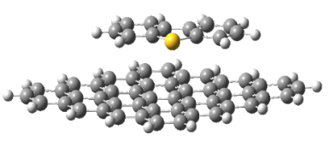
E_{a} (π-π interaction) = -32.51 kcal/mol
Figure S16 DBT adsorption energies of π-π interaction

Figure S17 1st derivative of N K-edge XANES spectra

Figure S18 Cu2p XPS spectra of Cu-N-C-800* before and after adsorption.

Figure S19 Protonation effect of Cu-N-C on adsorption and desorption capacities.

Table S1 EXAFS fitting parameters at the Cu K-edge for various samples (Ѕ₀²=0.846).
Sample | Shell | CNª | R(Å)^{b} | σ²(Å²)^{c} | ΔE₀(eV)^{d} | R factor
Cu K-edge
Cu foil | Cu-Cu | 12* | 2.54±0.01 | 0.0085±0.0004 | 4.3±0.5 | 0.0034
CuPc | Cu-N | 4.0 | 1.95±0.01 | 0.0031±0.0016 | 8.3±2.8 | 0.0079
CuO | Cu-O | 4.0 | 1.96±0.01 | 0.0041±0.0008 | 7.6±1.2 | 0.0071
Cu-N-C-800 | Cu-N | 4.4±0.6 | 1.97±0.01 | 0.0055±0.0012 | -0.3±1.6 | 0.0148
Cu-N-C-800* | Cu-N | 4.6±0.5 | 1.96±0.01 | 0.0063±0.0009 | -0.1±1.2 | 0.0079
ªCN, coordination number; ^{b}R, distance between absorber and backscatter atoms; ^{c}σ², Debye-Waller factor to account for both thermal and structural disorders; ^{d}ΔE₀, inner potential correction; R factor indicates the goodness of the fit. S₀² was fixed to 0.846, according to the experimental EXAFS fit of foil by fixing CN as the known crystallographic value. Fitting range: 3.0 ≤ k (/Å) ≤ 12.0 and 1.0 ≤ R (Å) ≤ 3.0 (Cu Foil, CuPc and CuO); 2.0 ≤ k (/Å) ≤ 12.0 and 1.0 ≤ R (Å) ≤ ~2.5 (Cu-N-C-800 and Cu-N-C-800*). A reasonable range of EXAFS fitting parameters: 0.700 < Ѕ₀² < 1.000; CN > 0; σ² > 0 Å²; ΔE₀ < 10 eV; R factor < 0.02.
Table S2 Adsorption performance of different adsorbents for DBT.
Adsorbents | Pseudo-second-order |  |  | Stability (5 cycle) | Adsorption capacity (mg S/g, 298K) |  | Ref.
Adsorbents | K₂ (g/mg/min) |  |  | Stability (5 cycle) |  |  | Ref.
TMU-11 |  | 0.00034 |  |  |  | 143.54 | [2]
PCMSs |  | 0.00083 | 9.2%(10) |  |  | 118.03 | [3]
SMIP/HCMS |  | 0.00108 | 16%(8) |  |  | 61.55 | [4]
Ag/Zn/Ni/Cu-BTC |  | 0.0021 | 8% |  |  | 92.59 | [5]
MSU-S |  | 0.00225 |  |  |  | 15.923 | [6]
Fe₃O₄@mSiO₂@DT-MIP |  | 0.0028 |  |  |  | 18.14 | [7]
N-G4 |  | 0.0031 | 16.3%(3) |  |  | 12.77 | [8]
Zn/Co@C-800 |  | 0.0042 |  |  |  | 40.6 | [9]
CuZn@C-0.05 |  | 0.0046 | 14%(4) |  |  | 60.0 | [10]
BN-ZIF |  | 0.0059 |  |  |  | 35.6 | [11]
Fe-OMC |  | 0.0101 | 21.4% |  |  | 19.33 | [12]
Fe-N-C |  | 0.0176 | No reduction |  |  | 34.03 | [1]
BCN-50 |  | 0.02765 |  |  |  | 27.43 | [13]
CN-900 |  | 0.028 | ≈20%(6) |  |  | 37.28(373K) | [14]
C-BN |  | 0.0234 | 22.7%(3) |  |  | 35.39 | [15]
Ag-Al₂O₃ |  | 0.0318 |  |  |  | 4.668 | [16]
ZIF-8-derived |  | 0.0329 |  |  |  | 26.7 | [17]
Ce-BN |  | 0.036 |  |  |  | 48.54 | [18]
BN-24 |  | 0.0441 |  |  |  | 20.12 | [19]
Cu-N-C-800 |  | 0.1054 | Almost no reduction |  |  | 35.32 | This work
C-2 |  | 0.330 | 22%(2) |  |  | 41.5 | [20]
AC/Ce/Fe |  | 0.394 |  |  |  | 16.52 | [21]
Fe₃O₄@C-650 |  |  | 33% |  |  | 9.99 | [22]
Ce/AC |  |  | 15.2% (3) |  |  | 11.2 | [23]
Carbon aerogels |  |  |  |  |  | 15.1 | [24]
AC |  |  |  |  |  | 16.36 | [25]
AC Spheres |  |  |  |  |  | 17.6 | [26]
DA-rGO-6h |  |  |  |  |  | 18 | [27]
MY-0.5C-0.35T-0.9B |  |  |  |  |  | 27.8 | [28]
AgNO₃/MCM-41 |  |  |  |  |  | 27.90 | [25]
MIL-53(Cr) with HF |  |  | 6% |  |  | 40.11 | [29]
Cu(I)-Y zeolite |  |  |  |  |  | 41.69 | [25]
3D BN |  |  | 29.6%(4) |  |  | 43.2 | [30]
CHAS-1 |  |  | 11%(2) |  |  | 44.7 | [31]
HPA/IL@MOF |  |  | 10% (3) |  |  | 47.51 | [32]
C-700 |  |  | 19%(1) |  |  | 49.1 | [33]
BN Nanowires |  |  | 15.8% |  |  | 65.4 | [34]

Table S3 Pseudo-second-order model with a rate constant (K₂) of different Cu-N-C-800 and other contrasting adsorbents.
Adsorbents | Experimental q_{e} (mg/g) |  | Pseudo second order
Adsorbents |  |  | K₂(g/mg/min) | Calculated q_{e} |  | R²
CuTPP | 11.52 | 0.0678 |  |  | 11.38 |  | 0.9897
CB | 12.92 | 0.0588 |  |  | 12.92 |  | 0.9990
CuTPP@CB | 11.79 | 0.1221 |  |  | 11.69 |  | 0.9985
Cu-N-C-800 | 27.50 | 0.1054 |  |  | 27.60 |  | 0.9999

References
[1] Y. Tong, J. Li, J. Peng, D. Dong, F. He, M. Zhu, C. Huang, Chem. Eng. J., 2022, 430.
[2] M. Bagheri, M. Y. Masoomi, A. Morsali, J. Hazard. Mater., 2017, 331, 142-149.
[3] L. Qin, X. Jia, Y. Yang, X. Liu, Ind. Eng. Chem. Res., 2016, 55, 1710-1719.
[4] S. Hua, L. Zhao, L. Cao, X. Wang, J. Gao, C. Xu, Chem. Eng. J., 2018, 345, 414-424.
[5] Y. Gao, J. Wu, X. Xiong, N. Yan, N. Ma, W. Dai, Ind. Eng. Chem. Res., 2020, 59, 7849-7856.
[6] M. Ahmadi, M. Mohammadian, M. R. Khosravi-Nikou, A. Baghban, J. Hazard. Mater., 2019, 374, 129-139.
[7] J. Wang, J. Wei, J. Mater. Chem. A, 2017, 5, 4651-4659.
[8] S. S. Meshkat, A. Rashidi, Z. H. Dastgerdi, M. D. Esrafili, Ecotoxicol. Environ. Saf., 2019, 172, 89-96.
[9] Q. Huo, J. Li, G. Liu, X. Qi, X. Zhang, Y. Ning, B. Zhang, Y. Fu, S. Liu, Chem. Eng. J., 2019, 362, 287-297.
[10] Q. Huo, J. Li, X. Qi, G. Liu, X. Zhang, B. Zhang, Y. Ning, Y. Fu, J. Liu, S. Liu, Chem. Eng. J., 2019, 378.
[11] L. Mu, J. Luo, C. Wang, J. Liu, Y. Zou, X. Li, Y. Huang, P. Wu, H. Ji, W. Zhu, Fuel 2021, 288.
[12] N. Farzin Nejad, E. Shams, M. K. Amini, J. Magn. Magn. Mater., 2015, 390, 1-7.
[13] H. Li, S. Zhu, M. Zhang, P. Wu, J. Pang, W. Zhu, W. Jiang, H. Li, ACS Omega, 2017, 2, 5385-5394.
[14] C. Deng, M. Zhu, Energy & Fuels 2020, 34, 9320-9327.
[15] J. Xiong, W. Zhu, H. Li, L. Yang, Y. Chao, P. Wu, S. Xun, W. Jiang, M. Zhang, H. Li, J. Mater. Chem. A, 2015, 3, 12738-12747.
[16] R. Neubauer, M. Husmann, C. Weinlaender, N. Kienzl, E. Leitner, C. Hochenauer, Chem. Eng. J., 2017, 309, 840-849.
[17] Y. Shi, X. Zhang, L. Wang, G. Liu, AIChE J., 2014, 60, 2747-2751.
[18] J. Luo, Y. Chao, Z. Tang, M. Hua, X. Li, Y. Wei, H. Ji, J. Xiong, W. Zhu, H. Li, Ind. Eng. Chem. Res., 2019, 58, 13303-13312.
[19] J. Xiong, W. Zhu, H. Li, W. Ding, Y. Chao, P. Wu, S. Xun, M. Zhang, H. Li, Green Chem., 2015, 17, 1647-1656.
[20] Y. Shi, X. Zhang, G. Liu, ACS Sustain. Chem. Eng., 2015, 3, 2237-2246.
[21] G. I. Danmaliki, T. A. Saleh, Chem. Eng. J., 2017, 307, 914-927.
[22] C. Wang, H. Zhong, W. Wu, C. Pan, X. Wei, G. Zhou, F. Yang, ACS Omega 2019, 4, 1652-1661.
[23] L. Xiong, F.-X. Chen, X.-M. Yan, P. Mei, J. Porous Mat., 2011, 19, 713-719.
[24] S. Haji, C. Erkey, Ind. Eng. Chem. Res., 2003, 42, 6933-6937.
[25] L. Wang, B. Sun, F. H. Yang, R. T. Yang, Chem. Eng. Sci., 2012, 73, 208-217.
[26] C. M. Zhang, W. Song, G. H. Sun, L. J. Xie, L. Wan, J. L. Wang, K. X. Li, Ind. Eng. Chem. Res., 2014, 53, 4271-4276.
[27] P. Zhang, X. Y. Mao, B. L. Yang, Ind. Eng. Chem. Res., 2019, 58, 10589-10598.
[28] W. Zhou, Y. Zhou, Q. Wei, S. Ding, S. Jiang, Q. Zhang, M. Liu, Chem. Eng. J., 2017, 330, 605-615.
[29] D. M. Kabtamu, Y.-n. Wu, Q. Chen, L. Zheng, K.-i. Otake, L. Matović, F. Li, ACS Sustain. Chem. Eng., 2020, 8, 12443-12452.
[30] J. Xiong, J. Luo, J. Di, X. Li, Y. Chao, M. Zhang, W. Zhu, H. Li, Fuel, 2020, 261.
[31] T. Di, Y. Xia, B. Pei, T. Zhu, T. Zhao, T. Li, L. Li, Langmuir, 2020, 36, 11117-11124.
[32] N. A. Khan, B. N. Bhadra, S. H. Jhung, Chem. Eng. J., 2018, 334, 2215-2221.
[33] Y. Shi, G. Liu, L. Wang, X. Zhang, Chem. Eng. J., 2015, 259, 771-778.
[34] J. Xiong, L. Yang, Y. Chao, J. Pang, M. Zhang, W. Zhu, H. Li, ACS Sustain. Chem. Eng., 2016, 4, 4457-4464.

