Evaluating CMAQ Representation of Wildfire PM₂.₅ in California (2008–2018): Regime-Dependent Performance and Nonlinear Error Structure
Eimy X. Bonilla¹, Jose Perez-Chavez¹, Daja Elum¹, Olutoyosi Oyelowo¹, Samuel Kane¹, Rachel E. Connolly², Miriam E. Marlier², Jihoon Jung³, Mohammad Al-Hamdan⁴, Claire L. Schollaert², John C. Flunker⁵, Huikyo Lee⁶, Sambit Bhattacharya⁷, Osinachi Ajoku¹, Christopher Blaszczak-Boxe¹, and Joseph L. Wilkins¹
¹ Department of Earth, Environment, and Equity, Howard University Graduate Program in Atmospheric Sciences, Howard University, Washington, DC, USA
² Fielding School of Public Health, Department of Environmental Health Sciences, University of California, Los Angeles, Los Angeles, CA, USA
³ Department of City and Regional Planning, University of North Carolina at Chapel Hill, Chapel Hill, NC, USA
⁴ National Center for Computational Hydroscience and Engineering, School of Engineering, University of Mississippi, Oxford, MS, USA
⁵ Department of Epidemiology, University of Iowa, Iowa City, IA, USA
⁶ NASA’s Jet Propulsion Laboratory, Pasadena, CA, USA
⁷ Department of Mathematics and Computer Science, Fayetteville State University, Fayetteville, NC, USA
Corresponding author: Eimy X. Bonilla; exbonilla12@gmail.com

Supplementary Information

Supplementary Methods
Whole-day lag sensitivity paired CMAQ total PM₂.₅ on day t with observations from the same site at t−3 through t+3 days. Positive lags indicate that the modeled value preceded the observation. Pearson r, MAE, RMSE, and F1 scores at 12 and 35 µg m⁻³ were recalculated for available pairs.
All descriptive, event-detection, case-study, and regime summaries were regenerated from the frozen paired CMAQ–AQS dataset containing 304 unique AQS site identifiers. The primary quality-control (QC) population required finite observed and CMAQ total PM₂.₅ values, observed PM₂.₅ from 0 to 557 µg m⁻³ inclusive, and CMAQ total PM₂.₅ ≤557 µg m⁻³. Values were not capped or winsorized. Eighteen otherwise-valid site-days with CMAQ total PM₂.₅ >557 µg m⁻³ were quarantined from the primary analysis, leaving 187,051 pairs; the full 187,069-pair population was retained only for labeled sensitivity analyses. CMAQ error was defined as CMAQ total minus observed PM₂.₅.
Observed PM₂.₅ defined background (<12 µg m⁻³), moderate (12 to <35 µg m⁻³), and high (≥35 µg m⁻³) descriptive regimes. The 12 µg m⁻³ cut point is descriptive and reflects the former annual primary standard; it is not a daily standard. The 35 µg m⁻³ level is the current 24-hour standard, while formal attainment uses a three-year design value. The current 9 µg m⁻³ annual standard was not applied to daily observations or incomplete-year fire-season means. An observed or modeled threshold event occurred when the corresponding concentration met or exceeded the specified level on a paired site-day. Pearson r and r² are reported separately; r² in descriptive tables is Pearson r squared. Normalized mean bias and normalized mean error use the sum of observations as denominator.
The leakage-resistant Random Forest predicted CMAQ total PM₂.₅ error from CMAQ fire-only PM₂.₅, latitude, longitude, year, month, day of year, geometric distance to the recorded fire origin, a missing-distance indicator, and observation-record count. Observed PM₂.₅, CMAQ total PM₂.₅, CMAQ no-fire PM₂.₅, observed-regime labels, fire name, and fire-window tags were excluded from the primary feature matrix. No fire radiative power or direct fire-intensity predictor was available. Site-year groups were assigned to an untouched 20% test partition (428 of 2,139 groups), with five-fold grouped cross-validation confined to the remaining groups. Cross-validation quantified out-of-group performance and variability and was not used for hyperparameter optimization. The forest settings were fixed before evaluation rather than selected through grid or randomized search: 160 trees, maximum depth 24, minimum leaf size 10, 0.7 of predictors considered per split, and random seed 20260905. The same settings were used in every cross-validation fold and in the final development-partition fit; the untouched test partition was used only for final evaluation.
Permutation importance was calculated on a fixed 20,000-observation sample from the untouched test partition using 10 repeated permutations. Accumulated local effects used 20 equal-frequency bins on the same sample. Regime labels were introduced only after prediction for stratified evaluation. Analyses used Python 3.12.14 with pinned package versions listed in Table S8. The executable notebook, fold assignments, untouched-test predictions, metric files, figures, requirements, and run manifest are archived in the public reproducibility package (version 1.0.0; https://doi.org/10.5281/zenodo.22677978).
Table S1 Annual and full-period performance for daily paired CMAQ total and AQS-observed PM₂.₅ during California fire seasons (June–October), 2008–2018, after primary QC. Panel A reports concentrations and conventional agreement metrics; Panel B reports absolute and normalized errors. No values were capped or winsorized
Panel A. Concentrations and agreement metrics
Year | n | Observed mean | CMAQ mean | Pearson r | r² | RMSE | MB
2008 | 10,140 | 15.05 | 17.73 | 0.711 | 0.505 | 13.17 | 2.68
2009 | 12,392 | 10.92 | 9.84 | 0.525 | 0.276 | 7.04 | -1.09
2010 | 15,125 | 10.42 | 10.01 | 0.446 | 0.199 | 7.38 | -0.41
2011 | 16,360 | 11.51 | 6.94 | 0.587 | 0.344 | 7.58 | -4.57
2012 | 17,977 | 9.84 | 6.73 | 0.521 | 0.272 | 6.34 | -3.11
2013 | 19,015 | 9.81 | 6.27 | 0.454 | 0.206 | 7.21 | -3.54
2014 | 17,098 | 9.64 | 7.33 | 0.381 | 0.145 | 8.46 | -2.31
2015 | 18,580 | 9.42 | 7.43 | 0.571 | 0.326 | 6.45 | -1.99
2016 | 19,711 | 9.44 | 7.79 | 0.311 | 0.097 | 9.85 | -1.65
2017 | 19,758 | 11.46 | 12.61 | 0.453 | 0.205 | 16.81 | 1.15
2018 | 20,895 | 11.94 | 12.65 | 0.503 | 0.253 | 12.37 | 0.71
All years | 187,051 | 10.69 | 9.29 | 0.502 | 0.252 | 9.96 | -1.40
Note. Concentration and error metrics are in µg m⁻³. MB = mean bias; RMSE = root mean square error.
Panel B. Absolute and normalized errors
Year | MAE | NMB (%) | NME (%) | Overestimated (%) | Underestimated (%)
2008 | 7.82 | 17.81 | 51.95 | 53.9 | 46.1
2009 | 4.81 | -9.95 | 44.03 | 40.2 | 59.8
2010 | 5.06 | -3.89 | 48.61 | 43.9 | 56.1
2011 | 5.50 | -39.69 | 47.82 | 16.8 | 83.2
2012 | 4.52 | -31.60 | 45.98 | 23.1 | 76.9
2013 | 4.98 | -36.08 | 50.77 | 19.8 | 80.2
2014 | 4.33 | -23.96 | 44.97 | 27.4 | 72.6
2015 | 4.06 | -21.09 | 43.14 | 28.9 | 71.1
2016 | 4.44 | -17.47 | 47.04 | 28.8 | 71.2
2017 | 6.30 | 10.02 | 54.99 | 41.7 | 58.3
2018 | 5.85 | 5.93 | 48.95 | 47.6 | 52.4
All years | 5.16 | -13.09 | 48.29 | 33.0 | 67.0
Note. MAE = mean absolute error; NMB = normalized mean bias; NME = normalized mean error.
Table S2 CMAQ performance in the specified Klamath (2008) and Rim (2013) fire windows after primary QC. The recalculation uses the frozen fire-window tags in the paired dataset and does not cap concentrations
Metric | Klamath Fire | Rim Fire
Paired observations, n | 958 | 3,611
Monitoring sites, n | 21 | 77
Observed mean (µg m⁻³) | 18.84 | 8.26
CMAQ total mean (µg m⁻³) | 27.40 | 7.33
Pearson r | 0.814 | 0.645
r² | 0.663 | 0.416
MAE (µg m⁻³) | 12.67 | 3.88
RMSE (µg m⁻³) | 23.33 | 6.57
MB (µg m⁻³) | 8.56 | -0.93
NMB (%) | 45.46 | -11.25
NME (%) | 67.28 | 46.93
Table S3 Primary-QC CMAQ total PM₂.₅ error by observed concentration regime. Error is CMAQ total minus observed PM₂.₅. Regimes were used only for stratified evaluation, not as model predictors
Regime | n | Observed mean | CMAQ mean | Mean error | Median error | MAE | RMSE
Background (<12) | 127,256 | 7.08 | 6.79 | -0.29 | -1.08 | 3.43 | 6.07
Moderate (12 to <35) | 57,644 | 17.03 | 13.50 | -3.54 | -5.34 | 7.98 | 11.98
High (≥35) | 2,151 | 53.93 | 44.14 | -9.79 | -17.69 | 31.94 | 50.88
Directional and normalized error metrics
Regime | NMB (%) | NME (%) | Overestimated (%) | Underestimated (%)
Background (<12) | -4.08 | 48.42 | 37.2 | 62.8
Moderate (12 to <35) | -20.76 | 46.88 | 24.0 | 76.0
High (≥35) | -18.16 | 59.23 | 25.7 | 74.3
Note. Concentrations and unnormalized errors are in µg m⁻³. High-regime sensitivity including quarantined extreme CMAQ values is reported in the QC audit, not mixed with the primary table.
Table S4 Overall paired-site-day event detection by CMAQ total PM₂.₅ at 12 and 35 µg m⁻³ after primary QC. For this diagnostic, an event is a concentration at or above the specified threshold
Threshold | n | Observed events | Modeled events | TP | FN | FP | TN
12 | 187,051 | 59,795 | 41,071 | 27,159 | 32,636 | 13,912 | 113,344
35 | 187,051 | 2,151 | 3,310 | 878 | 1,273 | 2,432 | 182,468
Detection scores
Threshold | Sensitivity | Specificity | Precision | Balanced accuracy | F1 | CSI | Frequency bias
12 | 0.454 | 0.891 | 0.661 | 0.672 | 0.539 | 0.368 | 0.687
35 | 0.408 | 0.987 | 0.265 | 0.698 | 0.322 | 0.192 | 1.539
Note. TP = true positive; FN = false negative; FP = false positive; TN = true negative; CSI = critical success index.
Table S5 Annual paired-site-day event-detection counts and scores at 12 and 35 µg m⁻³ after primary QC. Panel A gives contingency counts; Panel B gives selected detection scores
Panel A. Event and contingency counts
Year | Threshold | n | Observed events | Modeled events | TP | FN | FP
2008 | 12 | 10,140 | 5,279 | 5,540 | 4,146 | 1,133 | 1,394
2008 | 35 | 10,140 | 504 | 832 | 301 | 203 | 531
2009 | 12 | 12,392 | 4,453 | 3,580 | 2,364 | 2,089 | 1,216
2009 | 35 | 12,392 | 110 | 114 | 9 | 101 | 105
2010 | 12 | 15,125 | 4,902 | 4,566 | 2,684 | 2,218 | 1,882
2010 | 35 | 15,125 | 88 | 127 | 8 | 80 | 119
2011 | 12 | 16,360 | 5,985 | 2,257 | 1,799 | 4,186 | 458
2011 | 35 | 16,360 | 218 | 26 | 14 | 204 | 12
2012 | 12 | 17,977 | 5,118 | 2,344 | 1,520 | 3,598 | 824
2012 | 35 | 17,977 | 52 | 25 | 10 | 42 | 15
2013 | 12 | 19,015 | 5,130 | 1,840 | 1,110 | 4,020 | 730
2013 | 35 | 19,015 | 109 | 82 | 5 | 104 | 77
2014 | 12 | 17,098 | 4,645 | 2,049 | 1,379 | 3,266 | 670
2014 | 35 | 17,098 | 55 | 78 | 12 | 43 | 66
2015 | 12 | 18,580 | 4,601 | 2,410 | 1,519 | 3,082 | 891
2015 | 35 | 18,580 | 82 | 111 | 30 | 52 | 81
2016 | 12 | 19,711 | 5,150 | 2,806 | 1,697 | 3,453 | 1,109
2016 | 35 | 19,711 | 52 | 154 | 8 | 44 | 146
2017 | 12 | 19,758 | 7,203 | 6,108 | 4,100 | 3,103 | 2,008
2017 | 35 | 19,758 | 321 | 917 | 199 | 122 | 718
2018 | 12 | 20,895 | 7,329 | 7,571 | 4,841 | 2,488 | 2,730
2018 | 35 | 20,895 | 560 | 844 | 282 | 278 | 562
Panel B. Event-detection scores
Year | Threshold | Sensitivity | Specificity | Precision | F1 | CSI | Frequency bias
2008 | 12 | 0.785 | 0.713 | 0.748 | 0.766 | 0.621 | 1.049
2008 | 35 | 0.597 | 0.945 | 0.362 | 0.451 | 0.291 | 1.651
2009 | 12 | 0.531 | 0.847 | 0.660 | 0.589 | 0.417 | 0.804
2009 | 35 | 0.082 | 0.991 | 0.079 | 0.080 | 0.042 | 1.036
2010 | 12 | 0.548 | 0.816 | 0.588 | 0.567 | 0.396 | 0.931
2010 | 35 | 0.091 | 0.992 | 0.063 | 0.074 | 0.039 | 1.443
2011 | 12 | 0.301 | 0.956 | 0.797 | 0.437 | 0.279 | 0.377
2011 | 35 | 0.064 | 0.999 | 0.538 | 0.115 | 0.061 | 0.119
2012 | 12 | 0.297 | 0.936 | 0.648 | 0.407 | 0.256 | 0.458
2012 | 35 | 0.192 | 0.999 | 0.400 | 0.260 | 0.149 | 0.481
2013 | 12 | 0.216 | 0.947 | 0.603 | 0.319 | 0.189 | 0.359
2013 | 35 | 0.046 | 0.996 | 0.061 | 0.052 | 0.027 | 0.752
2014 | 12 | 0.297 | 0.946 | 0.673 | 0.412 | 0.259 | 0.441
2014 | 35 | 0.218 | 0.996 | 0.154 | 0.180 | 0.099 | 1.418
2015 | 12 | 0.330 | 0.936 | 0.630 | 0.433 | 0.277 | 0.524
2015 | 35 | 0.366 | 0.996 | 0.270 | 0.311 | 0.184 | 1.354
2016 | 12 | 0.330 | 0.924 | 0.605 | 0.427 | 0.271 | 0.545
2016 | 35 | 0.154 | 0.993 | 0.052 | 0.078 | 0.040 | 2.962
2017 | 12 | 0.569 | 0.840 | 0.671 | 0.616 | 0.445 | 0.848
2017 | 35 | 0.620 | 0.963 | 0.217 | 0.321 | 0.192 | 2.857
2018 | 12 | 0.661 | 0.799 | 0.639 | 0.650 | 0.481 | 1.033
2018 | 35 | 0.504 | 0.972 | 0.334 | 0.402 | 0.251 | 1.507
Table S6 Untouched site-year test-partition performance for the primary leakage-resistant Random Forest, baselines, and prespecified sensitivity models. R² is the coefficient of determination; Pearson r is reported separately
Model | n | R² | Pearson r | RMSE | MAE | Mean residual
Primary leakage-resistant RF | 37,430 | 0.711 | 0.844 | 5.82 | 3.44 | 0.17
Training-mean baseline | 37,430 | 0.000 | 0.000 | 10.83 | 4.99 | -0.01
Linear regression | 37,430 | 0.600 | 0.778 | 6.85 | 4.29 | 0.13
Fire-only RF | 37,430 | 0.592 | 0.770 | 6.92 | 4.32 | 0.10
No-fire sensitivity RF | 37,430 | 0.335 | 0.581 | 8.83 | 3.78 | 0.03
RF including quarantined extremes | 37,433 | 0.381 | 0.828 | 9.44 | 3.51 | 0.32
Note. Five-fold grouped cross-validation for the primary RF yielded mean (SD) R² 0.581 (0.081), RMSE 6.19 (0.63) µg m⁻³, and MAE 3.41 (0.07) µg m⁻³. Mean residual is predicted minus observed target error, in µg m⁻³.
Table S7 Performance of the primary leakage-resistant Random Forest in the untouched test partition, stratified post hoc by observed PM₂.₅ regime. Regime labels were not supplied to the model
Regime | n | R² | Pearson r | RMSE | MAE | Mean residual
All | 37,430 | 0.711 | 0.844 | 5.82 | 3.44 | 0.17
Background (<12) | 25,242 | 0.670 | 0.838 | 3.71 | 2.50 | -1.15
Moderate (12 to <35) | 11,715 | 0.730 | 0.880 | 6.65 | 4.74 | 2.33
High (≥35) | 473 | 0.695 | 0.897 | 29.23 | 21.06 | 16.97
Table S8 Pinned software environment for the leakage-resistant Random Forest rerun
Component | Version
Python | 3.12.14
NumPy | 2.5.2
pandas | 3.0.1
SciPy | 1.18.1
scikit-learn | 1.9.0
Matplotlib | 3.11.1
nbformat | 5.11.1
nbclient | 0.11.0
ipykernel | 7.3.0
Table S9 Whole-day lag sensitivity for paired CMAQ total and AQS-observed PM₂.₅. Positive lags indicate that the modeled value preceded the observation; lag 0 is same-day pairing
Lag (days) | n | Pearson r | MAE | RMSE | F1 at 12 | F1 at 35
-3 | 167,403 | 0.286 | 6.19 | 11.58 | 0.436 | 0.183
-2 | 145,347 | 0.318 | 6.16 | 11.45 | 0.451 | 0.215
-1 | 147,238 | 0.390 | 5.76 | 10.79 | 0.490 | 0.257
0 | 187,051 | 0.502 | 5.16 | 9.96 | 0.539 | 0.322
+1 | 147,238 | 0.420 | 5.69 | 10.55 | 0.495 | 0.264
+2 | 145,347 | 0.342 | 6.13 | 11.21 | 0.452 | 0.196
+3 | 167,403 | 0.298 | 6.21 | 11.55 | 0.431 | 0.166
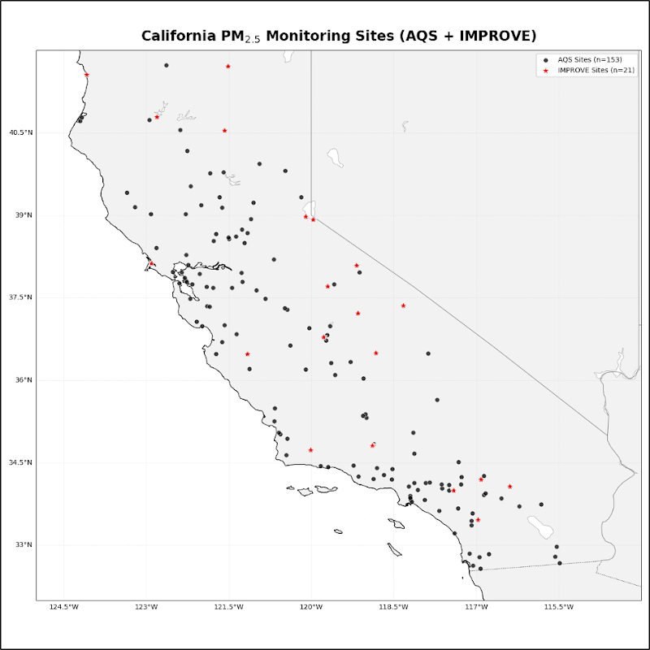
Fig. S1 Spatial distribution of AQS and IMPROVE monitoring sites across California used in this study. AQS observation sites are shown as black filled circles, and IMPROVE sites are shown as red filled symbols. These monitoring locations provide the in-situ PM₂.₅ and carbonaceous aerosol measurements used for model evaluation
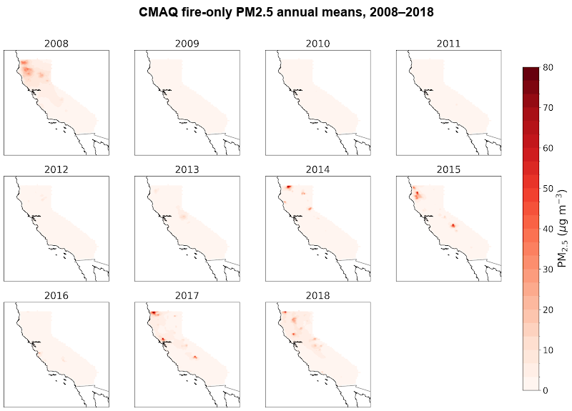
Fig. S2 Interannual variability in CMAQ-simulated wildfire-attributable PM₂.₅ across California for 2008–2018. Each panel shows annual mean fire-only PM₂.₅ for the corresponding year. Concentrations are reported in µg m⁻³, and the color scale is consistent across panels with a maximum value of 80 µg m⁻³
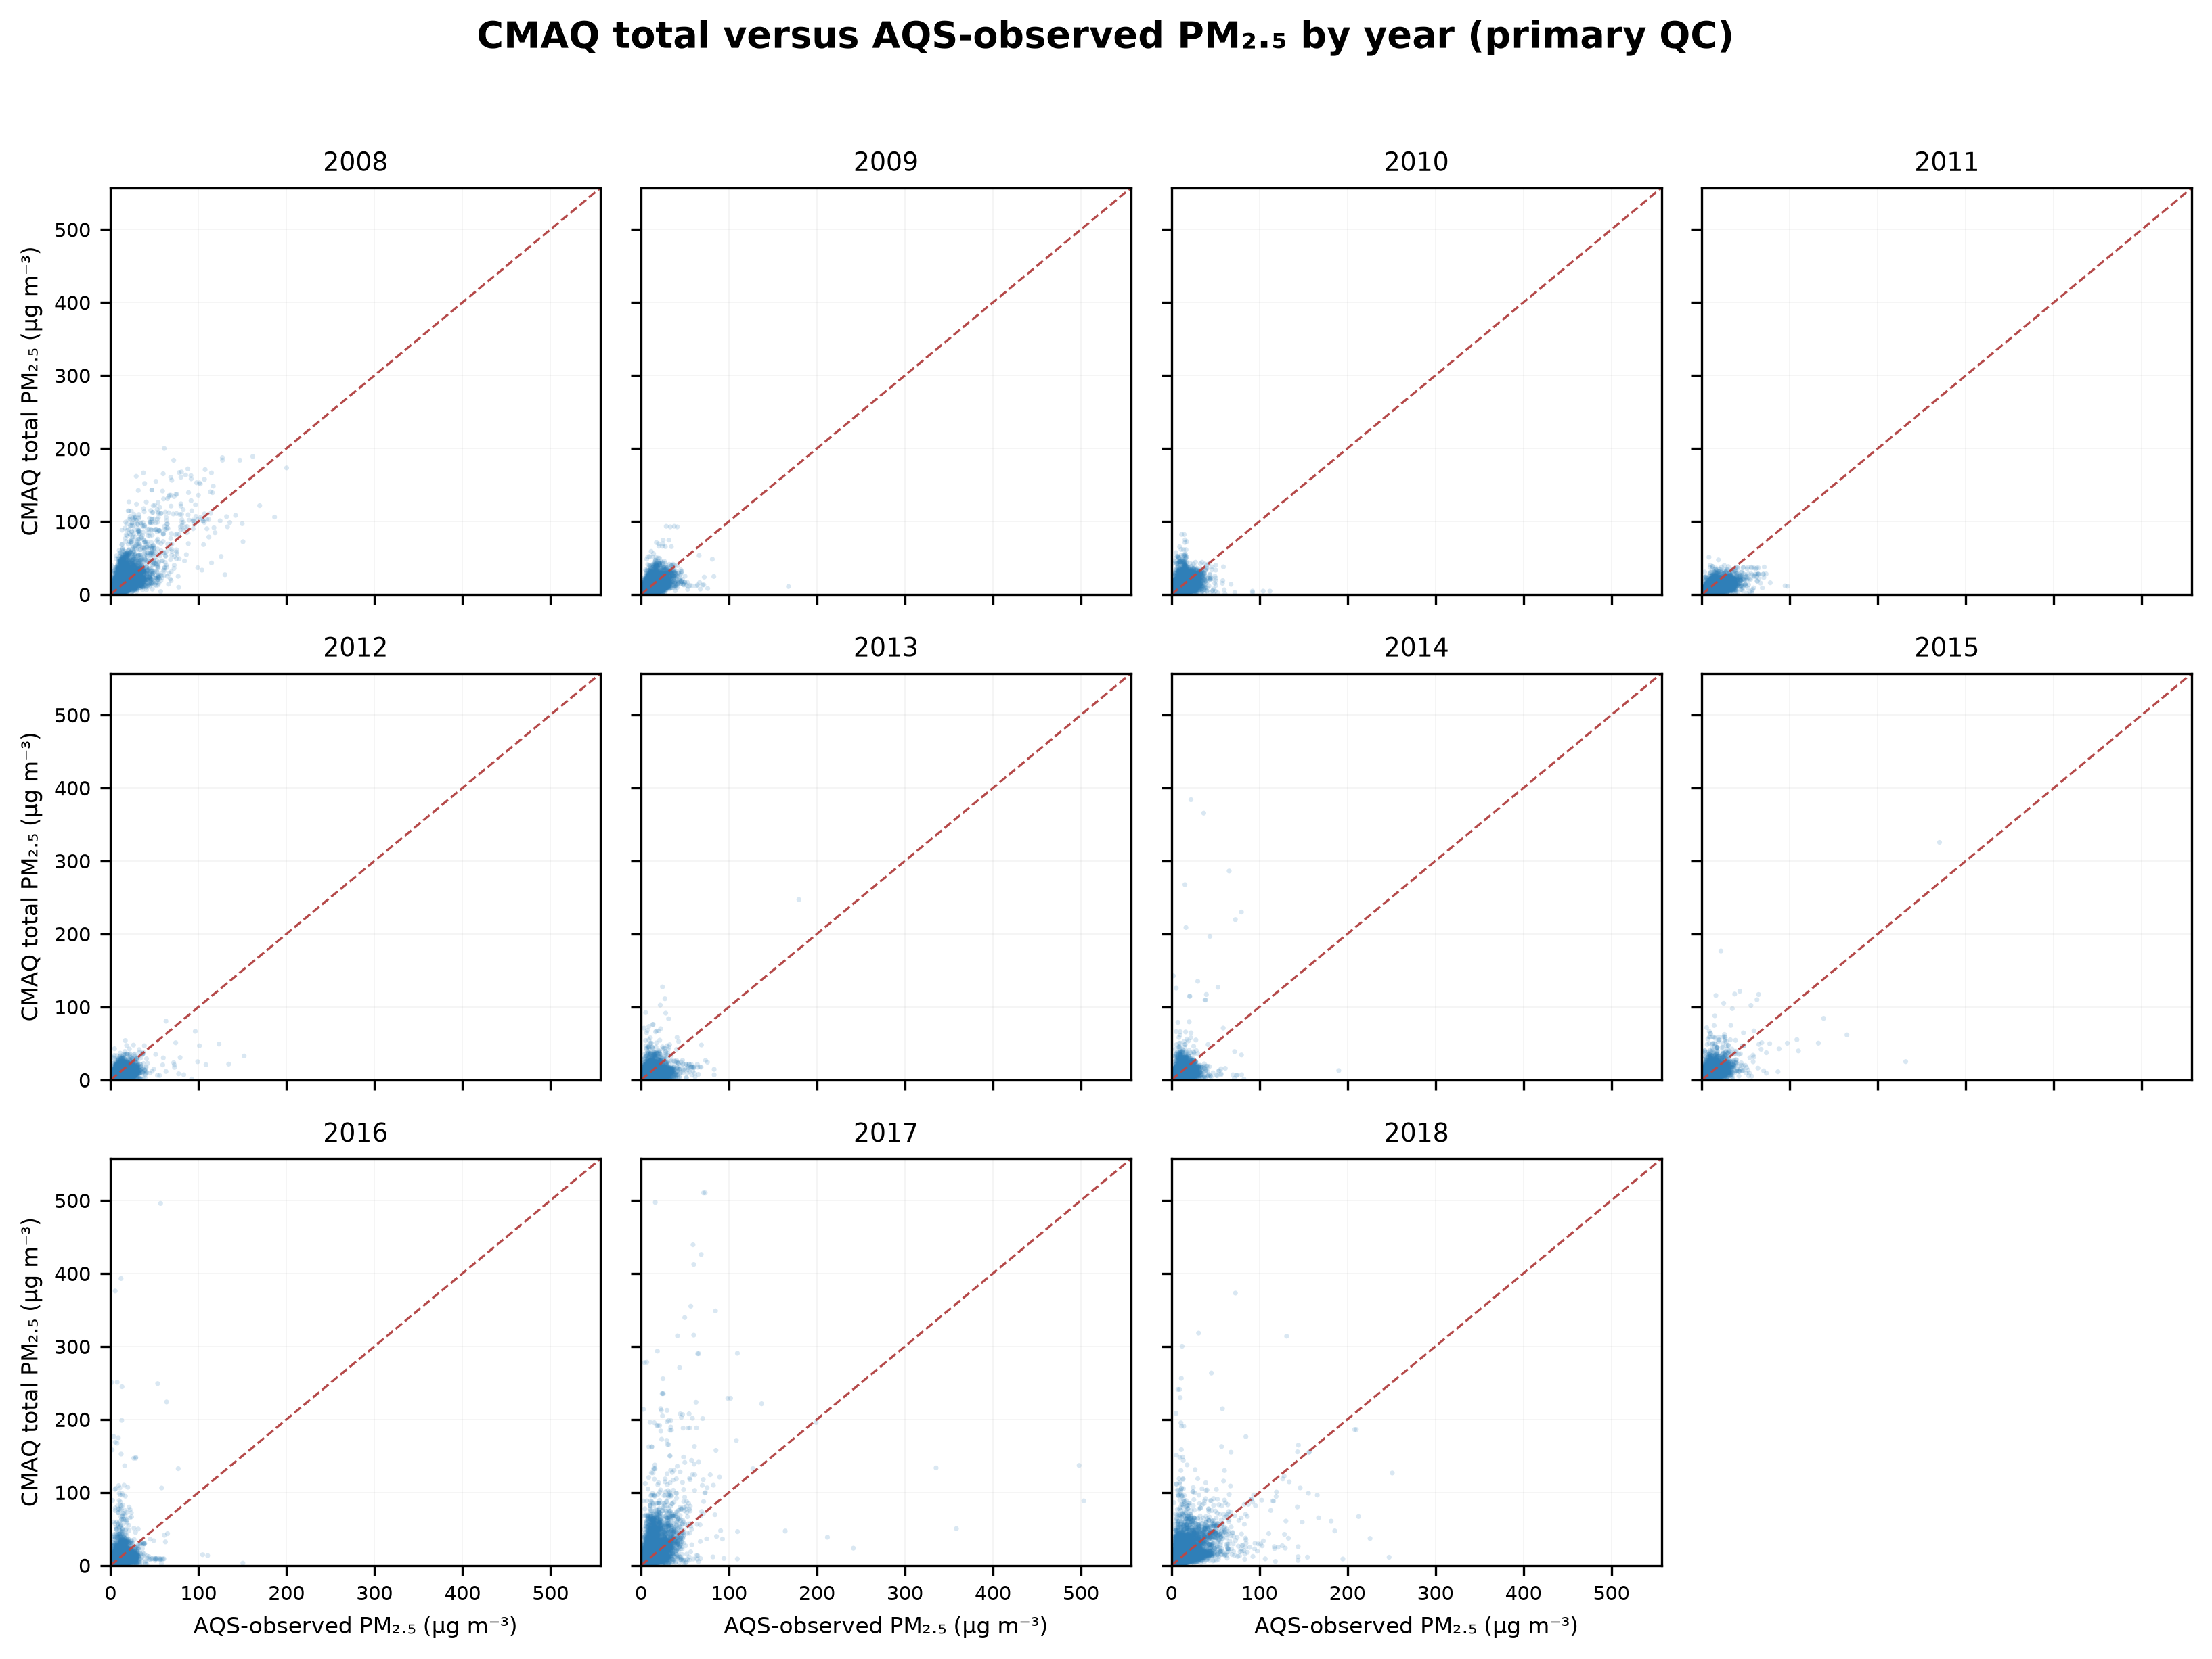
Fig. S3 Scatter plots comparing CMAQ-simulated total PM₂.₅ and paired AQS observations during California fire seasons for 2008–2018 after primary QC. The x-axis shows AQS-observed PM₂.₅ and the y-axis shows CMAQ total PM₂.₅. The red dashed line is the 1:1 identity line. Values were not capped or winsorized
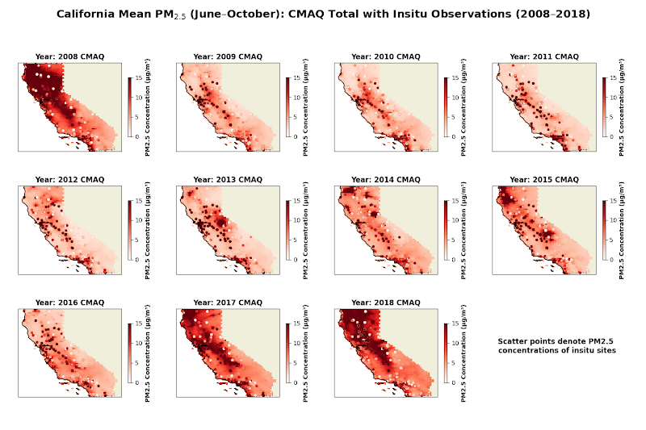
Fig. S4 Spatial comparison of CMAQ-simulated and observed PM₂.₅ across California during fire seasons for 2008–2018. Gridded fields show CMAQ total PM₂.₅, and overlaid circles show AQS observations. The common color scale is capped at 15 µg m⁻³ for visualization only; analysis values were not capped
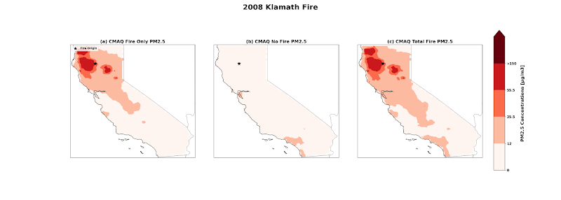
Fig. S5 Spatial distribution of CMAQ-simulated PM₂.₅ during the 2008 Klamath Fire window. Panel (a) shows fire-only PM₂.₅, panel (b) the no-fire simulation, and panel (c) total PM₂.₅. The black star indicates the approximate fire origin
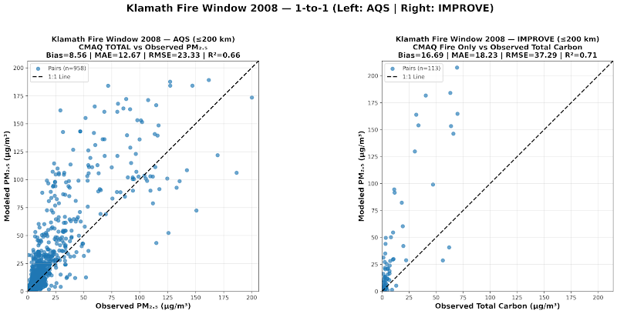
Fig. S6 Correlation plots for the 2008 Klamath Fire window comparing CMAQ-simulated PM₂.₅ with in-situ observations. The left panel compares CMAQ total PM₂.₅ with AQS PM₂.₅; the right compares CMAQ fire-only PM₂.₅ with IMPROVE total carbon. The dashed line is the 1:1 relation
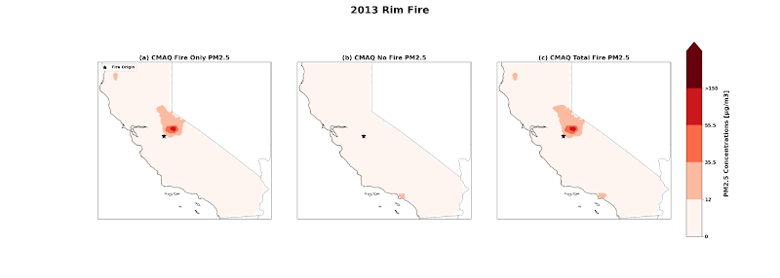
Fig. S7 Spatial distribution of CMAQ-simulated PM₂.₅ during the 2013 Rim Fire window. Panel (a) shows fire-only PM₂.₅, panel (b) the no-fire simulation, and panel (c) total PM₂.₅. The black star indicates the approximate fire origin
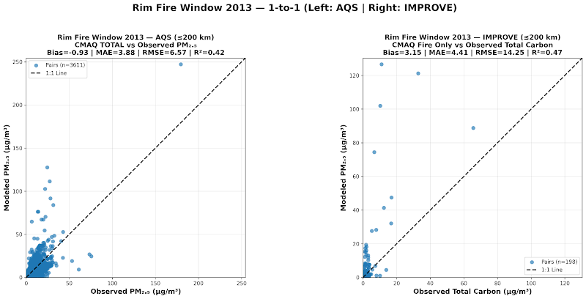
Fig. S8 Correlation plots for the 2013 Rim Fire window comparing CMAQ-simulated PM₂.₅ with in-situ observations. The left panel compares CMAQ total PM₂.₅ with AQS PM₂.₅; the right compares CMAQ fire-only PM₂.₅ with IMPROVE total carbon. The dashed line is the 1:1 relation
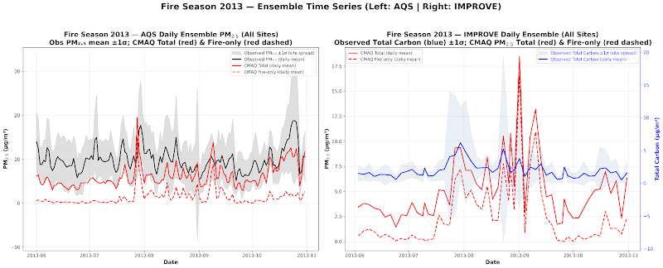
Fig. S9 Fire-season-wide ensemble time series for 2013. The left panel shows the daily across-site mean AQS-observed PM₂.₅ (black), with variability shading, together with CMAQ total PM₂.₅ (solid red) and fire-only PM₂.₅ (dashed red). The right panel shows IMPROVE total carbon (blue), CMAQ total PM₂.₅ (solid red), and fire-only PM₂.₅ (dashed red)
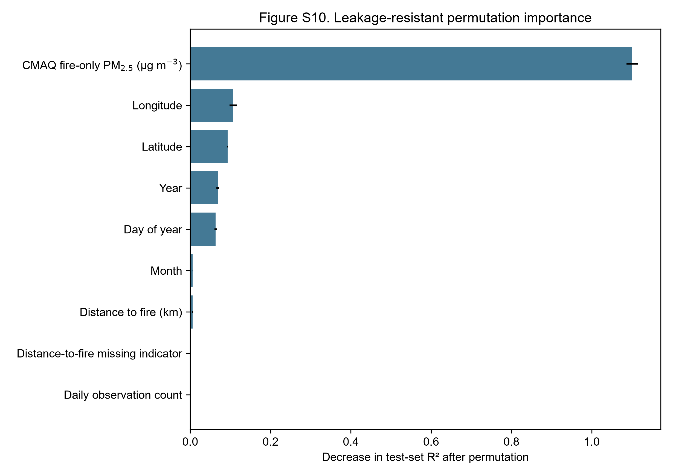
Fig. S10 Permutation importance for the leakage-resistant Random Forest, calculated on a fixed random sample of 20,000 observations from the untouched site-year test partition with 10 repeated permutations. Importance is the decrease in test-set coefficient of determination (R²); error bars denote the standard deviation across repeats. Observed PM₂.₅, total CMAQ PM₂.₅, no-fire CMAQ PM₂.₅, and observed-regime labels were excluded from the primary feature matrix
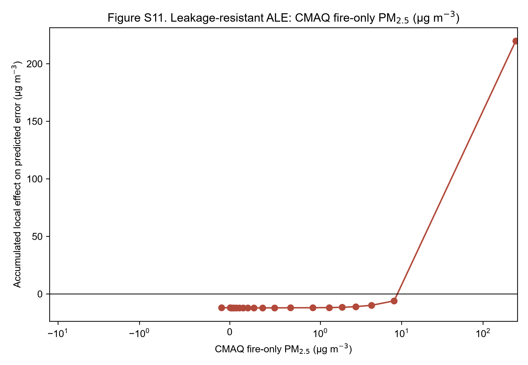
Fig. S11 One-dimensional accumulated local effect (ALE) of CMAQ fire-only PM₂.₅ on predicted CMAQ total PM₂.₅ error in the leakage-resistant model. ALE was estimated from 20 equal-frequency bins in a fixed 20,000-row sample of the untouched test partition and centered at zero. A symmetric logarithmic x-axis displays the strongly right-skewed fire-only distribution; the uppermost bin spans the sparse extreme tail and should be interpreted cautiously
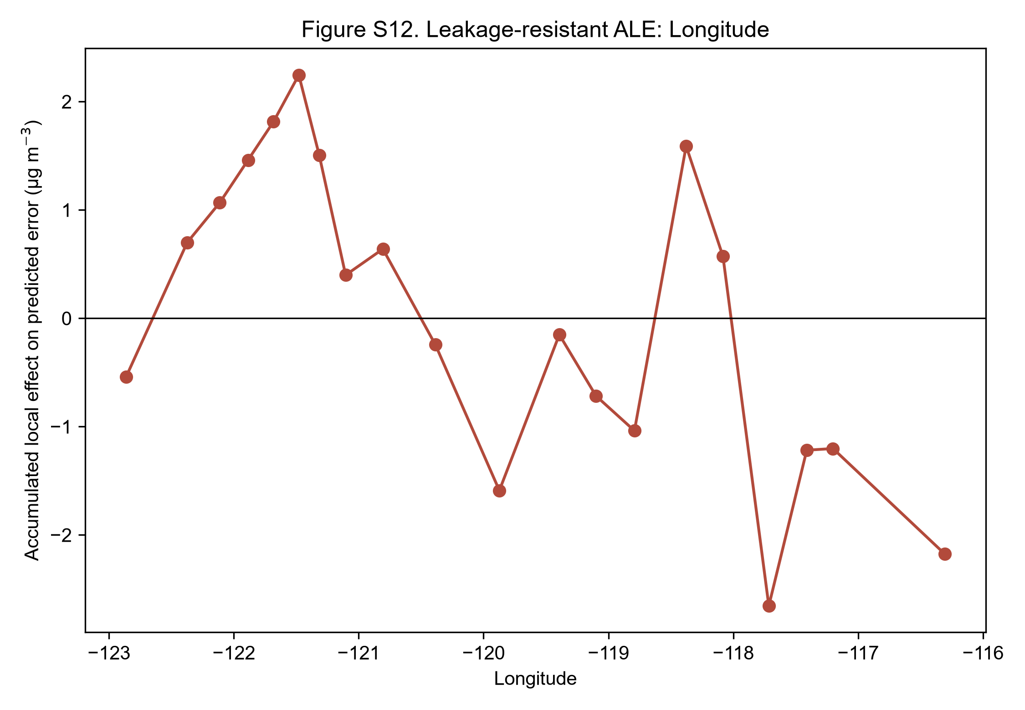
Fig. S12 One-dimensional accumulated local effect (ALE) of longitude, the next most influential contextual predictor after fire-only PM₂.₅ in test-set permutation analysis. ALE was estimated from 20 equal-frequency bins in a fixed 20,000-row sample of the untouched test partition and centered at zero. This diagnostic describes model behavior and should not be interpreted causally
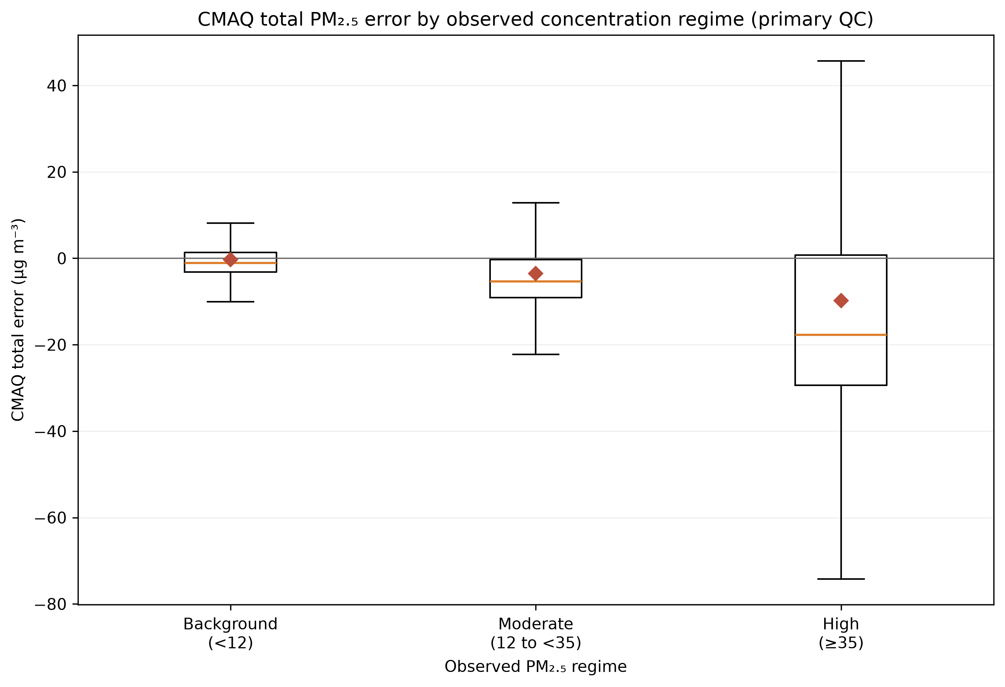
Fig. S13 Distribution of CMAQ total PM₂.₅ error (CMAQ minus observed) by observed concentration regime after application of the primary QC rule. Boxes show the interquartile range and median, whiskers extend to 1.5 times the interquartile range, and diamonds show means. Observed-regime labels were used only for descriptive evaluation, not model training

