Target bacteria/gene | Target gene |  | Sequence (5`-3`) | Product size  (bp) | Annealing temperature (°C) | Reference
E. coli | uspA | Forward | F-CCG ATA CGC TGC CAA TCA GT | 884 | 56 | [1]
E. coli | uspA | Reverse | R-ACG CAG ACC GTA GGC CAG AT | 884 | 56 | [1]
Sul-1 | Sul-1 | Forward | F-CGG CGT GGG CTA CCT GAA CG | 433 | 66 | [2]
Sul-1 | Sul-1 | Reverse | R-GCC GAT CGC GTG AAG TTC CG | 433 | 66 | [2]
Sul-3 | Sul-3 | Forward | F-CAACGGAAGTGGGCGTTGTGGA | 244 | 66˚C | [2]
Sul-3 | Sul-3 | Reverse | R-GCT GCA CCA ATT CGC TGAACG | 244 | 66˚C | [2]
blaOxa-1 | Oxa-1 | Forward | F-AGCCGTTAAAATTAAGCCC | 882 | 56˚C | [3]
 | Oxa-1 | Reverse | R-CTTGATTGAAGGGTTGGGCG
Supplementary table S1. Primers used in this study

[1].Grakh, K., Mittal, D., Prakash, A., Kumar, R., & Jindal, N. (2023). uspA gene-based phylogenetic analysis and antigenic epitope prediction for Escherichia coli strains of avian origin. Frontiers in Veterinary Science, 10, 1183048. https://doi.org/10.3389/fvets.2023.1183048

[2] G. K. Kozak, P. Boerlin, N. Janecko, R. J. Reid-Smith, and C. Jardine, “Antimicrobial Resistance in Escherichia coli Isolates from Swine and Wild Small Mammals in the Proximity of Swine Farms and in Natural Environments in Ontario, Canada,” Appl Environ Microbiol, vol. 75, no. 3, pp. 559–566, Feb. 2009, doi: 10.1128/AEM.01821-08.

[3]. Poirel L, Walsh TR, Cuvillier V, Nordmann P. Multiplex PCR for detection of acquired carbapenemase genes. Diagnostic microbiology and infectious disease. 2011 May 1;70(1):119-23.

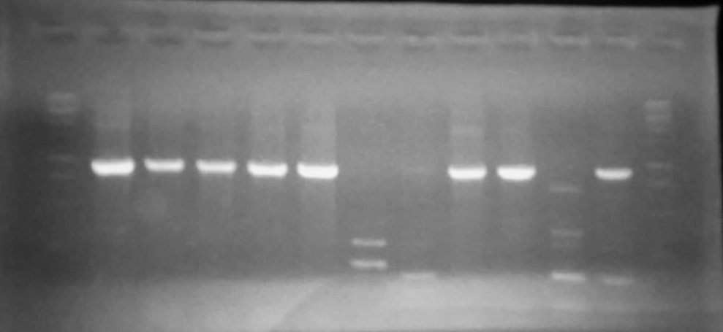
Figure: Oxa-1
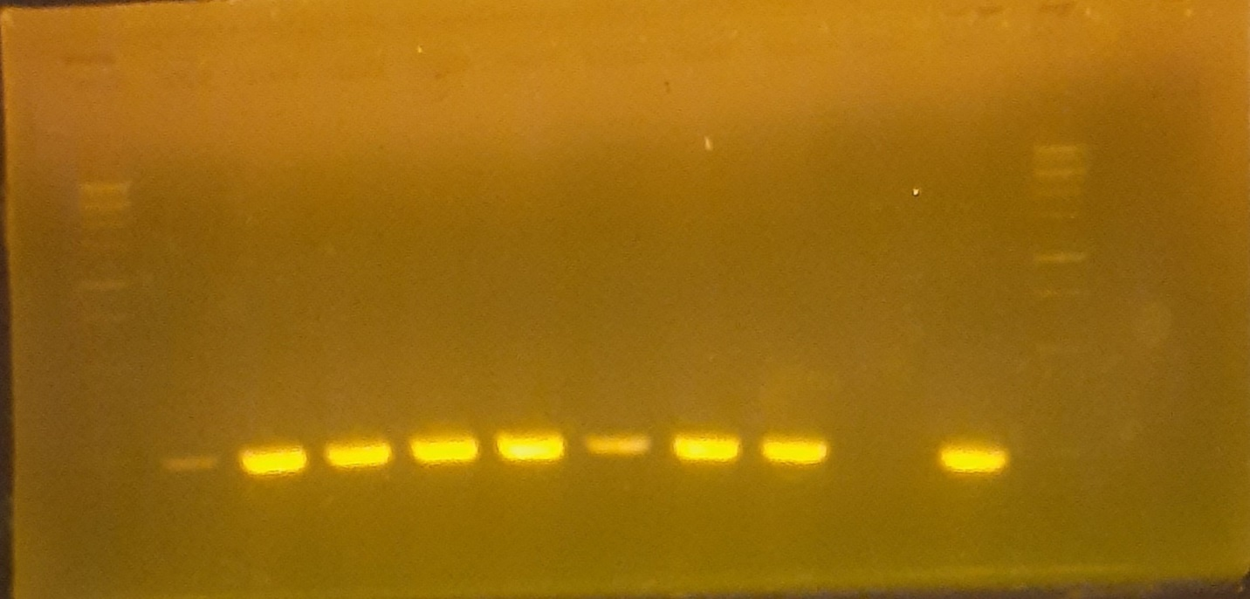
Figure: Sul-3
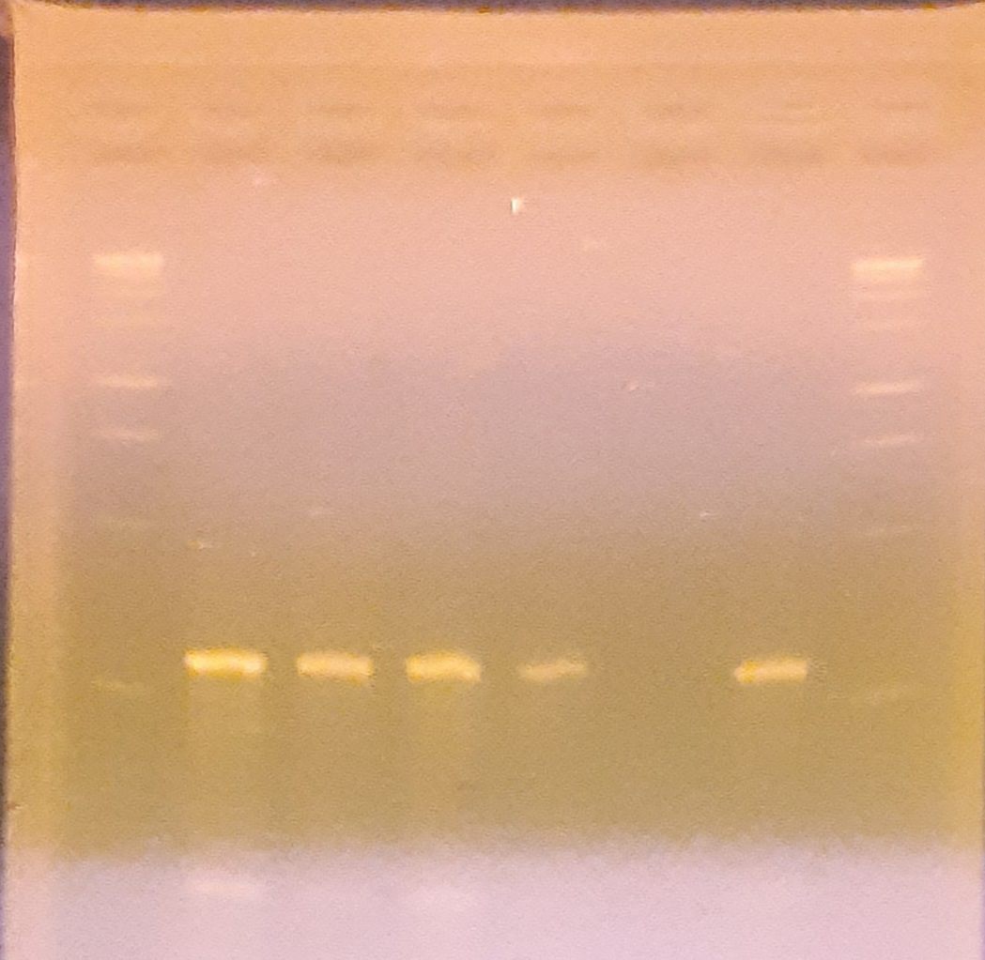
Figure: Sul-1

