SUPPLEMENTAL FILE

PTS/OTS SURVEY
Instructions:
Please answer the following questions based on your experience implementing exercise programs for frail older adults in your Skilled Nursing Facility (SNF). Your responses will remain confidential.

Frailty Identification Guide
Before completing this survey, please review the FRAIL-NH Scale below. This tool is used to classify patients as frail based on specific criteria. Use this scale to identify a frail patient in your caseload, and answer the survey questions based on how you would treat them.

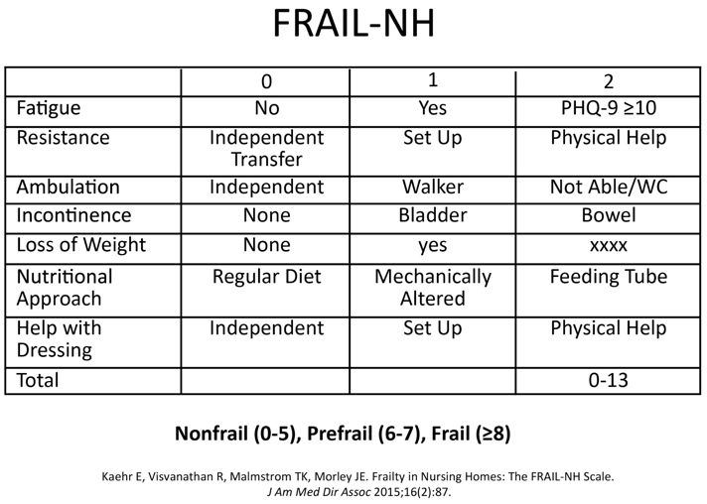

Section 1: Demographics

What is your age?
o 18–29 years
o 30–39 years
o 40–49 years
o 50–59 years
o 60+ years

What is your current profession?
o Physical Therapist
o Occupational Therapist

How many years have you been practicing in your current profession?
o 0–5 years
o 6–10 years
o 11–15 years
o 16–20 years
o 21+ years

What is your highest level of education?
o Associate Degree
o Bachelor’s Degree
o Master’s Degree
o Doctorate

Section 2: Perceptions of Frailty

How do you define frailty in the patients you treat? (Select all that apply)
o Reduced physical strength
o Decreased endurance or fatigue
o Cognitive decline
o Increased vulnerability to stressors
o Dependence on assistance for daily activities
o Other: ___________

What frailty levels do you typically work with?
o Mildly frail
o Moderately frail
o Severely frail

Section 3: Clinical Reasoning in Practice

When designing an exercise program for a frail patient, what factors are most important in your decision-making? (Select all that apply)
o Patient's current frailty level
o Patient's health history and comorbidities
o Patient's goals and preferences
o Available resources and equipment
o Collaboration with other healthcare professionals
o Evidence-based guidelines or protocols
o Other: ________

How do you decide when to modify an exercise program?
o Based on changes in patient performance or feedback
o Following a decline in frailty level
o Upon observing safety concerns during exercise
o After consultation with other professionals
o Other: ________

What reasoning guides your selection of specific exercises for frail patients? (Select all that apply)
o Focus on improving strength and balance to prevent falls
o Addressing specific functional deficits (e.g., mobility, endurance)
o Promoting overall health and resilience to stressors
o Aligning with patient preferences and capabilities
o Following standardized protocols or guidelines
o Other: ________

Section 4: Resources and Challenges

Do you feel you have adequate resources to implement exercise programs effectively?
o Yes
o No

What challenges do you encounter when implementing exercise programs? (Select all that apply)
o Lack of patient motivation
o Physical limitations of the patient
o Time constraints
o Limited equipment
o Lack of support from healthcare providers
o Other: ________

Section 5: Outcomes

How do you measure success in frail older adults' exercise programs? (Select all that apply)
o Improvement in mobility
o Reduction in falls
o Increased strength or endurance
o Enhanced functional independence
o Patient-reported quality of life
o Improvement in cognition
o Other: ________

In your experience, what is the most significant impact of exercise programs on frailty-related outcomes?
o Improved resilience to health stressors (e.g., fewer falls)
o Increased physical endurance
o Enhanced ability to perform daily activities independently
o Improved cognition
o Other: ________

Section 6: Open-Ended Insights

How do you approach clinical reasoning when working with frail patients? Describe any strategies or considerations you prioritize.
________

What do you think is the most effective component of an exercise program for frail older adults? Examples might include progressive resistance training, balance exercises to reduce fall risk, or activities aimed at improving functional independence. Please provide specific examples to support your response.

