Supplementary Information

Hidden antibiotic exposures: A scoping review of residues detected in humans without recent, intentional use
Yoon Han, Tianyi Zhou, Nabiah Bhatti, Shenita R. Peterson, Ashley Styczynski, Maya L. Nadimpalli

Supplementary Tables and Figures
Table S1. Search strategy for this review.
Search string
(antibiotic*[ti] OR Anti-bacterial[ti] OR antimicrobial*[ti] OR anti-microbial*[ti])
AND
(residu*[tiab] OR exposure[tiab] OR exposome[tiab] OR contamin*[tiab])
AND
("Biological Monitoring"[Mesh] OR "Blood"[Mesh] OR "Milk, Human"[Mesh] OR "Feces"[Mesh] OR "Follicular Fluid"[Mesh] OR "Gastrointestinal Tract"[Mesh] OR "Plasma"[Mesh] OR "Semen"[Mesh] OR "Tissues"[Mesh] OR "Urine"[Mesh] OR "Urinalysis"[Mesh] OR "Bodily Secretions"[Mesh:NoExp] OR biomonitoring[tiab] OR "biological monitoring"[tiab] OR blood[tiab] OR "breast milk"[tiab] OR "breastmilk"[tiab] OR "human milk"[tiab] OR Feces[tiab] OR Faeces[tiab] OR fecal[tiab] OR stool[tiab] OR "follicular fluid"[tiab] OR gut[tiab] OR plasma[tiab] OR semen[tiab] OR tissue[tiab] OR urin*[tiab] OR mucus[tiab] OR sput*[tiab] OR sweat[tiab] OR tears[tiab])
AND
(detect*[tiab] OR occur*[tiab] OR "Mass Spectrometry"[Mesh] OR "Mass Spectrometry"[tiab] OR "Chromatography, Liquid"[Mesh] OR "liquid chromatography"[tiab])
AND
("english"[Language] OR "french"[Language] OR "spanish"[Language])
AND
("1990"[Date - Publication] : "2025"[Date - Publication])
AND
("Journal Article" [Publication Type:NoExp] NOT ("Review" [Publication Type] OR "systematic review*"[ti] OR "meta analys*"[ti]))
AND
"humans"[MeSH Terms]

Table S2. Antibiotic classifications used for residues measured among the 32 studies included in this review.
Residue | Class
novobiocin | aminocoumarins
apramycin | aminoglycosides
gentamycin | aminoglycosides
hygromycin | aminoglycosides
kanamycin | aminoglycosides
neomycin | aminoglycosides
spectinomycin | aminoglycosides
streptomycin | aminoglycosides
tobramycin | aminoglycosides
faropenem | carbapenems
meropenem | carbapenems
cefaclor | cephalosporins
cefalexin | cephalosporins
cefalomium | cephalosporins
cefapirin | cephalosporins
cefdinir | cephalosporins
cefoperazone | cephalosporins
cefotaxime | cephalosporins
cefotaxime sodium | cephalosporins
cefpirome | cephalosporins
cefquinome | cephalosporins
cefquinome sulfate | cephalosporins
ceftiofur | cephalosporins
ceftriaxone | cephalosporins
cefuroxime | cephalosporins
cephalothin | cephalosporins
antofloxacin | fluoroquinolones
ciprofloxacin | fluoroquinolones
danofloxacin | fluoroquinolones
difloxacin | fluoroquinolones
enoxacin | fluoroquinolones
enrofloxacin | fluoroquinolones
fleroxacin | fluoroquinolones
flumequine | fluoroquinolones
levofloxacin | fluoroquinolones
lomefloxacin | fluoroquinolones
lomefloxacin hydrochloride | fluoroquinolones
marbofloxacin | fluoroquinolones
nadifloxacin | fluoroquinolones
norfloxacin | fluoroquinolones
ofloxacin | fluoroquinolones
oxolinic acid | fluoroquinolones
pefloxacin | fluoroquinolones
quinolones | fluoroquinolones
quinolones (including enrofloxacin, ciprofloxacin, danofloxacin, difloxacin, marbofloaxacin, oxolinic acid and flumequine) | fluoroquinolones
sarafloxacin | fluoroquinolones
sparfloxacin | fluoroquinolones
vancomycin | glycopeptides
lincomycin | lincosamides
lincomycin hydrochloride | lincosamides
lincosamides | lincosamides
pirlimycin | lincosamides
3-o-acetyltylosin | macrolides
acetylisovalarytylosin | macrolides
azithromycin | macrolides
clarithromycin | macrolides
erythromycin | macrolides
josamycin | macrolides
kitasamycin | macrolides
roxithromycin | macrolides
spiramycin | macrolides
tilmicosin | macrolides
tylosin | macrolides
furazolidone | nitrofurans
dimetridazole | nitroimidazoles
hydroxy metronidazole | nitroimidazoles
metronidazole | nitroimidazoles
amoxicillin | penicillins
amoxicillin trihydrate | penicillins
ampicillin | penicillins
benzylpenicillin | penicillins
beta lactams (including penicillin (penicillin g, ampicillin, dicloxacillin, amoxicillin, cloxacillin, nafcillin and penicillin v) and cephalosporin (cefalonium, ceforperazone, cefapirin cefquinome, ceftiofur, cefacetril and cefazolin) groups) | penicillins
clavulanic acid | penicillins
cloxacillin | penicillins
flucloxacillin | penicillins
oxacillin | penicillins
penicillin | penicillins
penicillin g | penicillins
penicillin v | penicillins
penicillin-g sodium salt | penicillins
β-lactams | penicillins
amide alcohol antibiotics | phenicols
amphenicol | phenicols
chloramphenicol | phenicols
florfenicol | phenicols
florfenicol amine | phenicols
thiamphenicol | phenicols
tiamulin | pleuromutilins
valnemulin | pleuromutilins
colistin A | polymyxins
colistin B | polymyxins
polymyxin | polymyxins
bacitracin | polypeptides
cyadox | quinoxalines
olaquindox | quinoxalines
quinocetone | quinoxalines
rifaximin | rifamycins
virginiamycin | streptogramins
acetylated sulfadiazine | sulfonamide_metabolites
acetylated sulfamethazine | sulfonamide_metabolites
acetylated sulfamethoxazole | sulfonamide_metabolites
n4-acetylsulfamonomethoxine | sulfonamide_metabolites
phthalysulfathiazole | sulfonamides
sulfabenzamide | sulfonamides
sulfacetamide | sulfonamides
sulfachloropyridazine | sulfonamides
sulfachlorpyridazine | sulfonamides
sulfaclozine | sulfonamides
sulfaclozine sodium monohydrate | sulfonamides
sulfadiazine | sulfonamides
sulfadimethoxine | sulfonamides
sulfadimethoxypyrimidine | sulfonamides
sulfadimidine | sulfonamides
sulfadimidine (sulfamethazine) | sulfonamides
sulfadoxine | sulfonamides
sulfaguanidine | sulfonamides
sulfalozine | sulfonamides
sulfamerazine | sulfonamides
sulfameter | sulfonamides
sulfamethazine | sulfonamides
sulfamethazine-n4-acetyl | sulfonamides
sulfamethizole | sulfonamides
sulfamethoxazole | sulfonamides
sulfamethoxazole/trimethoprim | sulfonamides
sulfamethoxypyridazine | sulfonamides
sulfametoxydiazine | sulfonamides
sulfamonomethioxine | sulfonamides
sulfamonomethoxine e | sulfonamides
sulfamoxol | sulfonamides
sulfaphenazole | sulfonamides
sulfapyridine | sulfonamides
sulfaquinoxaline | sulfonamides
sulfathiazole | sulfonamides
sulfisomidine | sulfonamides
sulfisoxazole | sulfonamides
sulfonamides | sulfonamides
sulphamethoxazole | sulfonamides
sulphaquinoxaline | sulfonamides
dapsone | sulfones
chlortetracycline | tetracyclines
deoxytetracycline | tetracyclines
doxycycline | tetracyclines
doxycycline hyclate | tetracyclines
doxycycline hydrochloride | tetracyclines
oxytetracycline | tetracyclines
tetracycline | tetracyclines
tetracycline hydrochloride | tetracyclines
baquiloprim | trimethoprims
diaveridine | trimethoprims
trimethoprim | trimethoprims
trimethoprime d | trimethoprims

Table S3. Summary table of studies included in the review.
Authors | Title | Published Year | City | Country | Study Period | Antibiotic-Free Period (mon.) | Specimen (Category) | Analytical Approach Category
Smadi et al. | Assessment Of Antibiotic And Pesticides Residues In Breast Milk Of Syrian Refugee Lactating Mothers | 2019 | Akkar | Lebanon | Dec. 2018-Feb. 2019 | At least 9 months (9) | Breast milk | LC-MS/MS
Lotto et al. | Prevalence And Predictors Of Residual Antibiotics In Children'S Blood In Community Settings In Tanzania. | 2024 | Mbeya City Council (CC) and Mbeya District Council (DC) in Mbeya, and Mlimba DC, Ulanga DC, and Ifakara Town Council (TC) in Morogoro | Tanzania | Feb.-Mar. 2021 | 2 weeks (0.46) | Dried Blood Spot (Blood) | LC-MS
Wang et al. | Occurrence And Distribution Of Clinical And Veterinary Antibiotics In The Faeces Of A Chinese Population. | 2020 | Changzhou City, Shenyang City, and Taibai County | China | May-Jul. 2017 | Nearly 3 months (3) | Faeces (Stool) | LC-MS/MS
Yu et al. | Antibiotic Azithromycin Inhibits Brown/Beige Fat Functionality And Promotes Obesity In Human And Rodents. | 2022 | Wenzhou and Shanghai | China | NA | 1 year (12) | Fat | LC-MS
Duan et al. | Gut Resistomes, Microbiota And Antibiotic Residues In Chinese Patients Undergoing Antibiotic Administration And Healthy Individuals. | 2020 | Changzhou of Jiangsu Province, Shenyang of Liaoning Province, and Taibai of Gansu Province | China | Apr. 2016-Jan. 2018 | Nearly 6 months (6) | Feces (Stool) | LC-MS/MS
Zhang et al. | Occurrence And Risk Assessment Of Antibiotics In Feces Of Elderly Individuals In Shenzhen. | 2023 | Shenzhen | China | Jun. 2018-Jan. 2019 | 3 months (3) | Feces (Stool) | LC-MS/MS
Dinleyici et al. | Human Milk Antibiotic Residue Levels And Their Relationship With Delivery Mode, Maternal Antibiotic Use And Maternal Dietary Habits. | 2018 | Eskisehir | Turkey | NA | At least 9 months (9) | Human milk (Breast milk) | Other
Catalano et al. | Comparison Between Parental Report And Results Of Microbiologic Agar Assay For Presence Of Antibiotic In Urine Of Argentinian Children With Acute Lower Respiratory Tract Infection | 1990 | Buenos Aires | Argentina | NA | 2 weeks (0.46) | Urine | Bioassay
Donkor et al. | A Cross-Sectional Study On The Prevalence Of Antibiotic Use Prior To Laboratory Tests At Two Ghanaian Hospitals | 2019 | Ashanti Region and Eastern Region | Ghana | Mar.-Apr. 2017 | "Before a hospital visit" (NA) | Urine | Bioassay
Khennavong et al. | Urine Antibiotic Activity In Patients Presenting To Hospitals In Laos: Implications For Worsening Antibiotic Resistance | 2011 | Vientiane | Laos | Mar.-Jul. 2005 | 48 hours (0.06) | Urine | Bioassay
Skovbjerg et al. | Urine Bioassay Optimisation To Assess The Association Between Antimicrobial Exposure, Pneumococcal Carriage And Antimicrobial Resistance Among Hospitalised Children In Malawi | 2025 | Blantyre | Malawi | Nov. 2016-Jul. 2019 | 1 week (0.23) | Urine | Bioassay
Chu et al. | Urinary Antibiotics And Dietary Determinants In Adults In Xinjiang, West China. | 2022 | Langan Township, Sarbulak Township, and Luchaogou Township, Huocheng County, Ili | China | NA | 1 month (1) | Urine | LC-MS
Jin et al. | The Association Between Urinary Antibiotics Levels And The Risk Of Adolescent Depression. | 2025 | Nantong | China | May-Sep. 2022 | 4 weeks (0.92) | Urine | LC-MS
Lin et al. | Association Between Prenatal Antibiotics Exposure And Measures Of Fetal Growth: A Repeated-Measure Study. | 2022 | Shanghai | China | NA | At least six weeks (1.38) | Urine | LC-MS
Xu et al. | Association Between New Onset Type 1 Diabetes And Real-World Antibiotics And Neonicotinoids' Exposure-Related Gut Microbiota Perturbation. | 2022 | 8 Cities: Fuzhou, Nanchang, Shanghai, Suzhou, Jinan, Taiyuan, Changchun, And Zhengzhou | China | Jan. 2019-Mar. 2020 | 1 month (1) | Urine | LC-MS
Zhang et al. | The Exposure Levels And Health Risk Assessment Of Antibiotics In Urine And Its Association With Platelet Mitochondrial Dna Methylation In Adults From Tianjin, China: A Preliminary Study. | 2022 | Tianjin | China | Oct. 2015 - Feb. 2016 | NA (NA) | Urine | LC-MS
Zhong et al. | Antibiotics In Urine From General Adults In Shenzhen, China: Demographic-Related Difference In Exposure Levels. | 2022 | Shenzhen | China | May-Dec. 2017 | 3 months (3) | Urine | LC-MS
Bekoe et al. | Detection And Quantification Of Antibiotic Residues In Urine Samples Of Healthy Individuals From Rural And Urban Communities In Ghana Using A Validated Spe-Lc-Ms/Ms Method | 2020 | Kumasi; Awenare | Ghana | Jul.-Oct. 2012 | 2 weeks (0.46) | Urine | LC-MS/MS
Sun et al. | Metabolic Alterations Of Short-Chain Organic Acids In The Elderly Link Antibiotic Exposure With The Risk For Depression | 2024 | West Anhui | China | NA | 1 month (1) | Urine | LC-MS/MS
Lerbech et al. | Antibiotic Exposure In A Low-Income Country: Screening Urine Samples For Presence Of Antibiotics And Antibiotic Resistance In Coagulase Negative Staphylococcal Contaminants. | 2014 | Na | Ghana | Feb.-Apr. 2012 | 14 days (0.47) | Urine | LC-MS/MS
Liu et al. | Exposure To Veterinary Antibiotics Via Food Chain Disrupts Gut Microbiota And Drives Increased Escherichia Coli Virulence And Drug Resistance In Young Adults | 2022 | Anhui Province | China | Dec. 2020-Nov. 2021 | 1 year (12) | Urine | LC-MS/MS
Ji et al. | Influence Of A Five-Day Vegetarian Diet On Urinary Levels Of Antibiotics And Phthalate Metabolites: A Pilot Study With "Temple Stay" Participants. | 2010 | Gimje | Korea | Aug. 2007 | 30 days (1) | Urine | LC-MS/MS
Ji et al. | Influence Of Water And Food Consumption On Inadvertent Antibiotics Intake Among General Population. | 2010 | Han and Nakdong River Basins | Korea | NA | 30 days (1) | Urine | LC-MS/MS
Zhou et al. | Detection Of Antibiotics In The Urine Of Children And Pregnant Women In Jiangsu, China. | 2021 | Jiangsu Province | China | Jul.-Aug. 2019 | 1 month (1) | Urine | LC-MS/MS
Huang et al. | Antibiotic Burden Of School Children From Tibetan, Hui, And Han Groups In The Qinghai-Tibetan Plateau. | 2020 | Xiahe County | China | Oct. 2017 | 3 months (3) | Urine | LC-MS/MS
Bekoe et al. | Reservoir Of Antibiotic Residues And Resistant Coagulase Negative Staphylococci In A Healthy Population In The Greater Accra Region, Ghana | 2022 | Korle-Gonno; Dodowa | Ghana | NA | 2 weeks (0.46) | Urine | LC-MS/MS
Fan et al. | Urinary Antibiotics Concentrations, Their Related Affecting Factors And Infant Growth In The First 6 Months Of Life: A Prospective Cohort Study | 2023 | Shanghai | China | Jul. 2018-Jul. 2019 | 3 days; 42 days; 6 months (0.10; 1.38; 6) | Urine | LC-MS/MS
Liu et al. | Antibiotics In Urine Of The General Population: Exposure, Health Risk Assessment, And Food Factors. | 2022 | Shanghai | China | Na | 30 days (1) | Urine | LC-MS/MS
Sun et al. | Antibiotic Exposure And Risk Of Overweight/Obesity In Children: A Biomonitoring-Based Study From Eastern Jiangsu, China. | 2024 | Nantong | China | Jun.-Jul. 2022 | 30 days (1) | Urine | LC-MS/MS
Zeng et al. | Maternal Antibiotic Concentrations In Pregnant Women In Shanghai And Their Determinants: A Biomonitoring-Based Prospective Study. | 2020 | Shangahi | China | Jun. 2012 - Nov. 2013 | Weeks 29-41 of pregnancy (2.77) | Urine | LC-MS/MS
Alexandrova et al. | Identification Of Widespread Antibiotic Exposure In Patients With Cholera Correlates With Clinically Relevant Microbiota Changes. | 2019 | Netrokona | Bangladesh | Sep.-Dec. 2015 | NA (NA) | Urine; Stool | LC-MS; bioassay
Su et al. | Effect Of Exposure To Antibiotics On The Gut Microbiome And Biochemical Indexes Of Pregnant Women. | 2021 | Shanghai | China | Sep. 2019-Jun. 2020 | "No prescribed antibiotics" (NA) | Venous blood (Blood) | Other

Table S4. Maximum stool and breast milk antibiotic concentrations among participants without prior, intentional antibiotic use
Antibiotic | Specimen | Studies with maximum concentrations reported | Antibiotic concentrations (μg/kg)ª
Amoxicillin | Stool | Wang et al. | 43.72
Ampicillin | Stool | Wang et al. | 49.52
Azithromycin | Stool | Zhang et al. 2023 | 1676.7
Cefalexin | Stool | Wang et al. | 49.35
Cephalothin | Stool | Zhang et al. 2023 | 7.1
Chlortetracycline | Stool | Wang et al. | 36.63
Ciprofloxacin | Stool | Wang et al., Zhang et al. 2023 | 37.48, 645.1
Doxycycline | Stool | Wang et al., Zhang et al. 2023 | 39.35, 58.3
Enoxacin | Stool | Zhang et al. 2023 | 15.3
Enrofloxacin | Stool | Zhang et al. 2023, Wang et al. | 5.2, 29.23
Erythromycin | Stool | Wang et al. | 36.79
Flumequine | Stool | Zhang et al. 2023 | 9.3
Norfloxacin | Stool | Zhang et al. 2023 | 5099.8
Ofloxacin | Stool | Wang et al., Zhang et al. 2023 | 35.39, 604.7
Oxytetracycline | Stool | Wang et al., Zhang et al. 2023 | 29.52, 5532.8
Roxithromycin | Stool | Zhang et al. 2023, Wang et al. | 1.8, 34.73
Sarafloxacin | Stool | Zhang et al. 2023 | 17.8
Spiramycin | Stool | Zhang et al. 2023 | 9.8
Sulfachlorpyridazine | Stool | Wang et al. | 26.12
Sulfadiazine | Stool | Wang et al. | 41.5
Sulfadimethoxine | Stool | Wang et al. | 16.78
Sulfadimidine | Stool | Wang et al. | 41.72
Sulfamethazine | Stool | Zhang et al. 2023 | 92
Sulfamethizole | Stool | Zhang et al. 2023 | 206.7
Sulfamethoxazole | Stool | Wang et al. | 45.4
Tetracycline | Stool | Wang et al., Zhang et al. 2023 | 38.65, 53.7
Tilmicosin | Stool | Zhang et al. 2023 | 376
Trimethoprim | Stool | Wang et al. | 38.33
Tylosin | Stool | Zhang et al. 2023, Wang et al. | 7.6, 23.73
Oxytetracycline | Breast milk | Smadi et al. | 6*
ª For the one study reporting maximum antibiotic residue concentrations in breast milk, the units are µg/L.

Supplementary Figures

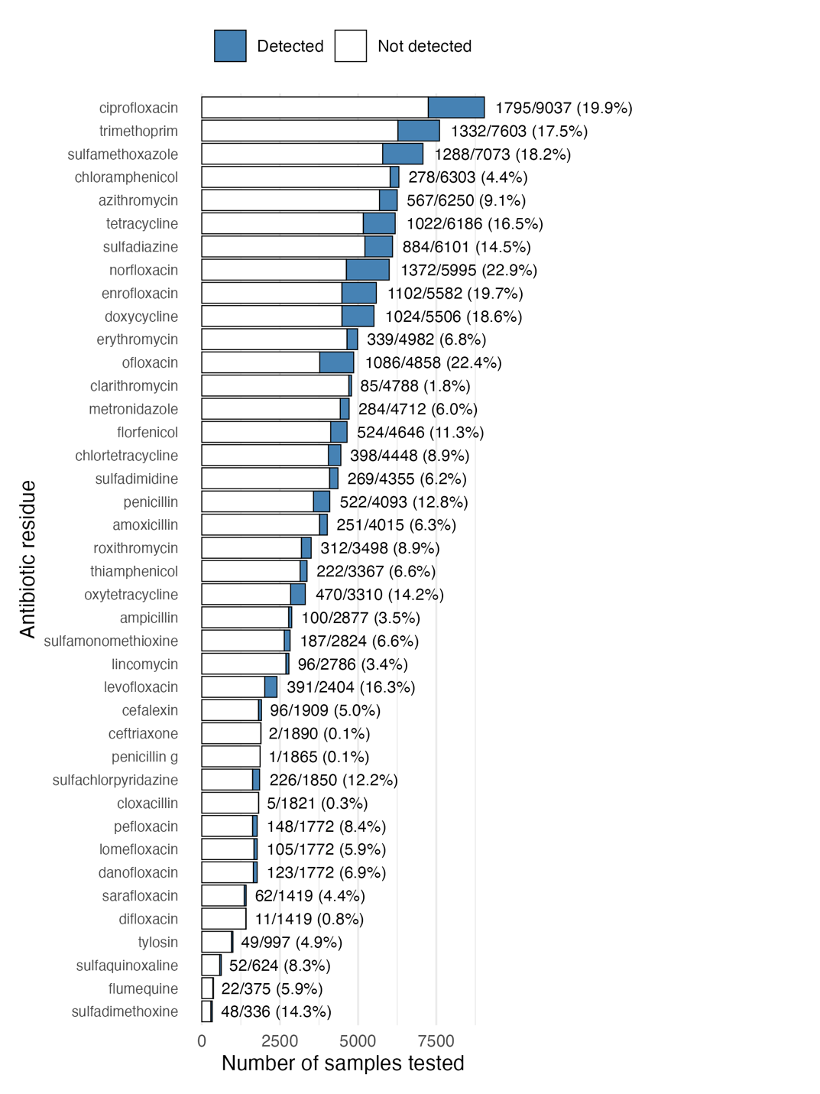
Figure S1. Proportion of human samples with detectable antibiotic residues among 10,126 persons with no recent antibiotic use reported.
Residues assessed in fewer than 3 studies are not depicted. Bar length corresponds to the number of samples that were tested for a given antibiotic. White indicates a sample was negative for the given antibiotic; blue indicates it was positive.

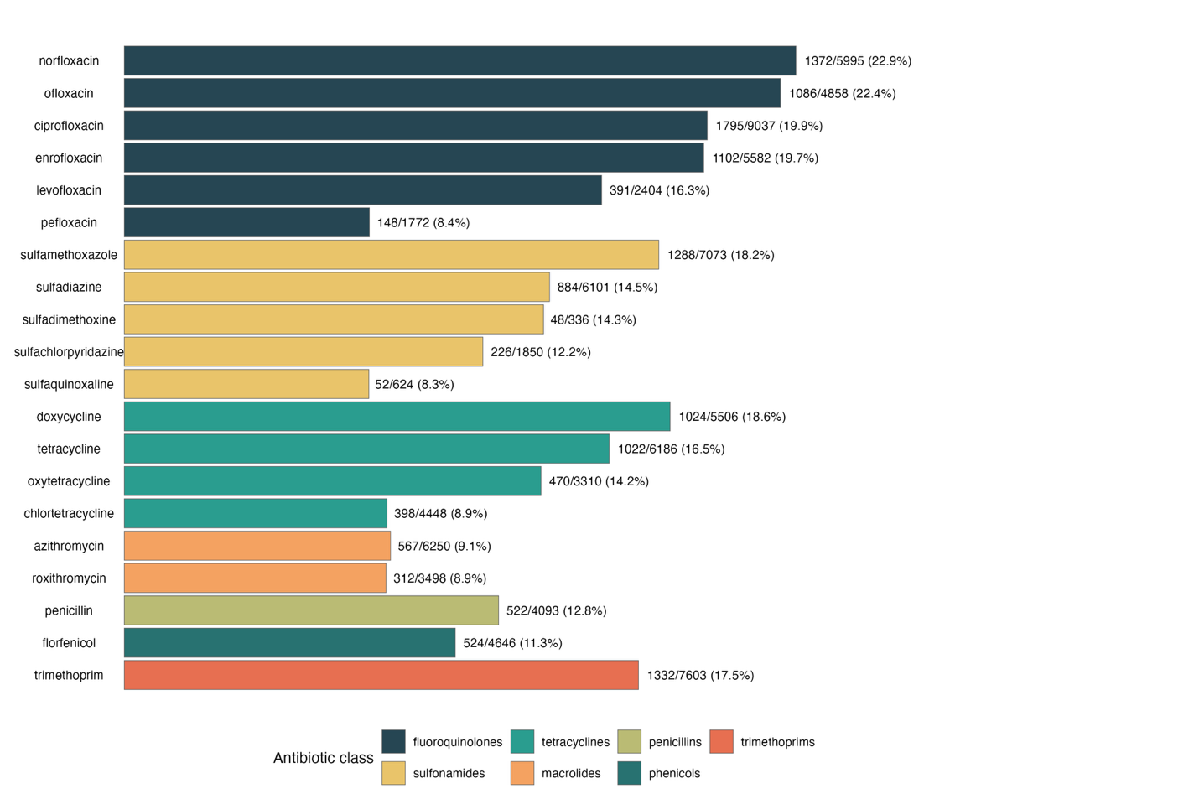Figure S2. Frequency of antibiotic residue detection among participants with no recent antibiotic use reported, stratified by antibiotic class.
Results include the 20 most common antibiotic residues identified in the blood, urine, stool, breast milk, or fat of 10,126 unique persons with no recent, intentional antibiotic use. Bar coloring corresponds to antibiotic class.

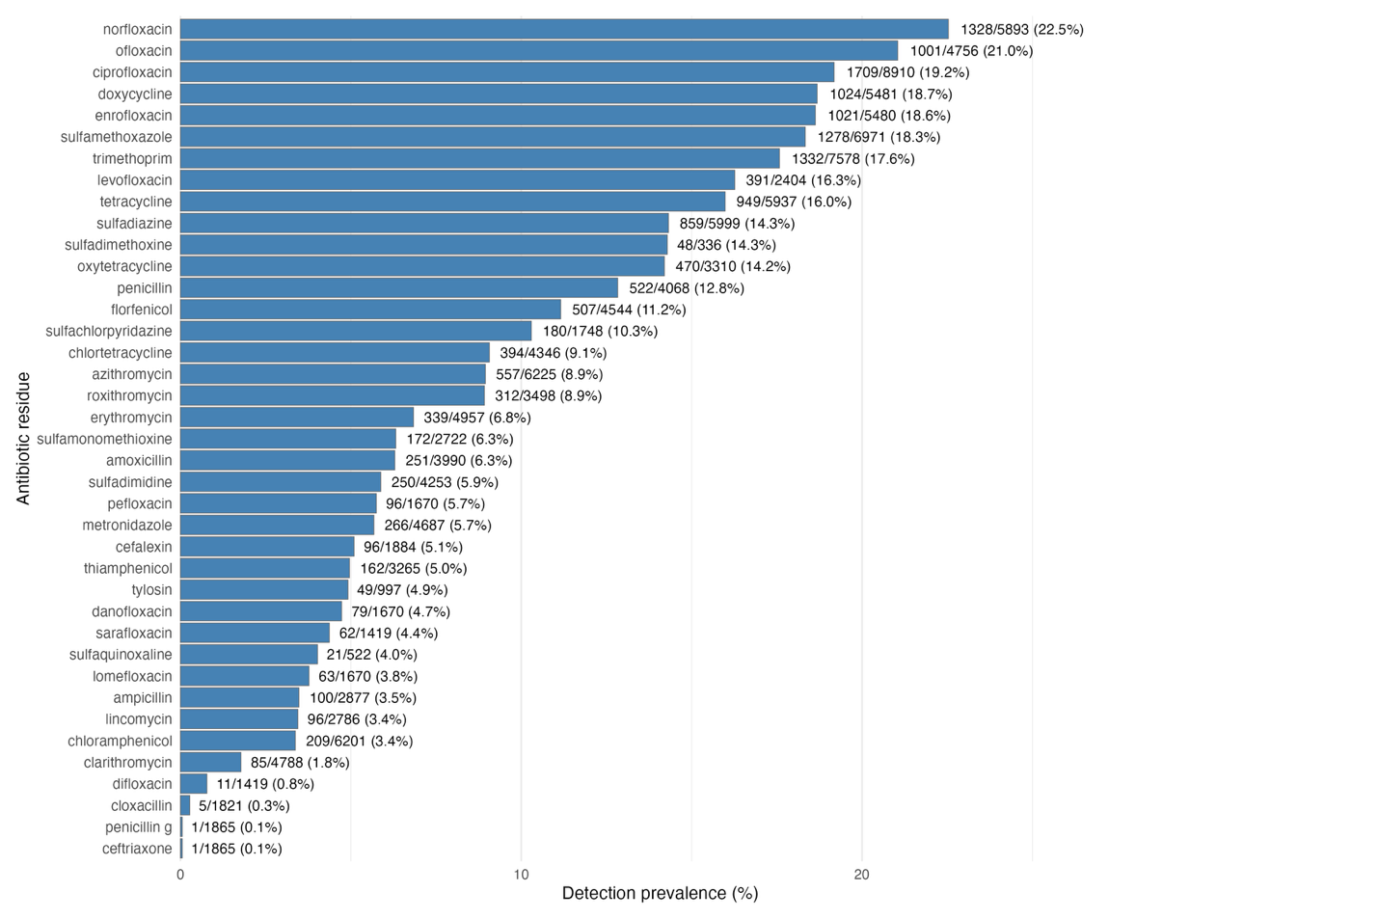
Figure S3. Frequency of detection of 40 antibiotic residues examined in the blood, urine, stool, breast milk, or fat of up to 9,877 unique persons with a minimum reported antibiotic abstention time of two weeks.
Residues assessed in fewer than 3 studies are not depicted.
Note: To avoid double-counting data from the same participants, only results from the 42-day timepoint were retained for Fan et al. 2023.

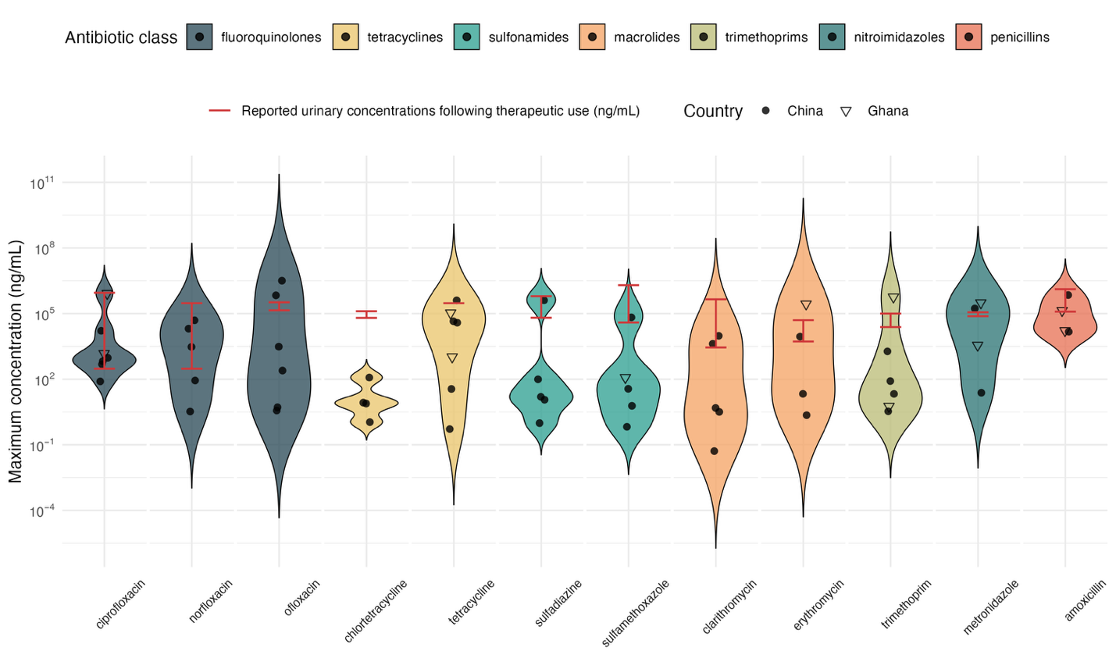
Figure S4. Maximum urinary antibiotic concentrations among participants with a minimum reported antibiotic abstention time of two weeks, relative to concentrations expected following therapeutic use.
Only antibiotics for which at least 3 studies reported maximum antibiotic concentrations are depicted. Each point represents results from a unique study. References are provided in Table 2.

Preferred Reporting Items for Systematic reviews and Meta-Analyses extension for Scoping Reviews (PRISMA-ScR) Checklist
SECTION | ITEM | PRISMA-ScR CHECKLIST ITEM | REPORTED ON PAGE #
TITLE
Title | 1 | Identify the report as a scoping review. | 1
ABSTRACT
Structured summary | 2 | Provide a structured summary that includes (as applicable): background, objectives, eligibility criteria, sources of evidence, charting methods, results, and conclusions that relate to the review questions and objectives. | 2-3
INTRODUCTION
Rationale | 3 | Describe the rationale for the review in the context of what is already known. Explain why the review questions/objectives lend themselves to a scoping review approach. | 4-5
Objectives | 4 | Provide an explicit statement of the questions and objectives being addressed with reference to their key elements (e.g., population or participants, concepts, and context) or other relevant key elements used to conceptualize the review questions and/or objectives. | 5
METHODS
Protocol and registration | 5 | Indicate whether a review protocol exists; state if and where it can be accessed (e.g., a Web address); and if available, provide registration information, including the registration number. | NA
Eligibility criteria | 6 | Specify characteristics of the sources of evidence used as eligibility criteria (e.g., years considered, language, and publication status), and provide a rationale. | 6
Information sources* | 7 | Describe all information sources in the search (e.g., databases with dates of coverage and contact with authors to identify additional sources), as well as the date the most recent search was executed. | 6
Search | 8 | Present the full electronic search strategy for at least 1 database, including any limits used, such that it could be repeated. | Supplementary Material: Table 1
Selection of sources of evidence† | 9 | State the process for selecting sources of evidence (i.e., screening and eligibility) included in the scoping review. | 6-7
Data charting process‡ | 10 | Describe the methods of charting data from the included sources of evidence (e.g., calibrated forms or forms that have been tested by the team before their use, and whether data charting was done independently or in duplicate) and any processes for obtaining and confirming data from investigators. | 6-7
Data items | 11 | List and define all variables for which data were sought and any assumptions and simplifications made. | 7
Critical appraisal of individual sources of evidence§ | 12 | If done, provide a rationale for conducting a critical appraisal of included sources of evidence; describe the methods used and how this information was used in any data synthesis (if appropriate). | NA
Synthesis of results | 13 | Describe the methods of handling and summarizing the data that were charted. | 7
RESULTS
Selection of sources of evidence | 14 | Give numbers of sources of evidence screened, assessed for eligibility, and included in the review, with reasons for exclusions at each stage, ideally using a flow diagram. | 8,33
Characteristics of sources of evidence | 15 | For each source of evidence, present characteristics for which data were charted and provide the citations. | 8, Supplementary Material: Table 3
Critical appraisal within sources of evidence | 16 | If done, present data on critical appraisal of included sources of evidence (see item 12). | NA
Results of individual sources of evidence | 17 | For each included source of evidence, present the relevant data that were charted that relate to the review questions and objectives. | 8-11
Synthesis of results | 18 | Summarize and/or present the charting results as they relate to the review questions and objectives. | 8-11, Tables 1-2, Figures 3 & 4
DISCUSSION
Summary of evidence | 19 | Summarize the main results (including an overview of concepts, themes, and types of evidence available), link to the review questions and objectives, and consider the relevance to key groups. | 11-17
Limitations | 20 | Discuss the limitations of the scoping review process. | 16
Conclusions | 21 | Provide a general interpretation of the results with respect to the review questions and objectives, as well as potential implications and/or next steps. | 16-17
FUNDING
Funding | 22 | Describe sources of funding for the included sources of evidence, as well as sources of funding for the scoping review. Describe the role of the funders of the scoping review. | 17
JBI = Joanna Briggs Institute; PRISMA-ScR = Preferred Reporting Items for Systematic reviews and Meta-Analyses extension for Scoping Reviews.
* Where sources of evidence (see second footnote) are compiled from, such as bibliographic databases, social media platforms, and Web sites.
† A more inclusive/heterogeneous term used to account for the different types of evidence or data sources (e.g., quantitative and/or qualitative research, expert opinion, and policy documents) that may be eligible in a scoping review as opposed to only studies. This is not to be confused with information sources (see first footnote).
‡ The frameworks by Arksey and O’Malley (6) and Levac and colleagues (7) and the JBI guidance (4, 5) refer to the process of data extraction in a scoping review as data charting.
§ The process of systematically examining research evidence to assess its validity, results, and relevance before using it to inform a decision. This term is used for items 12 and 19 instead of "risk of bias" (which is more applicable to systematic reviews of interventions) to include and acknowledge the various sources of evidence that may be used in a scoping review (e.g., quantitative and/or qualitative research, expert opinion, and policy document).

From: Tricco AC, Lillie E, Zarin W, O'Brien KK, Colquhoun H, Levac D, et al. PRISMA Extension for Scoping Reviews (PRISMAScR): Checklist and Explanation. Ann Intern Med. 2018;169:467–473. doi: 10.7326/M18-0850.

