Supplementary Table 1. Linear regression models for TabCAT test outcomes and demographic predictors in the development sample of PWoH
 |  |  | Unstandardized $β$ coefficients  (95% CI) |  |  | Standardized coefficients
TabCAT test | n | Intercept | Age (yrs) | Education (yrs) | Male sex | Effect size, $β$ | R²
Birdwatch Total Correct | 155 | 30.25  (28.90, 31.59) | -0.43  (-0.53, -0.33) | 0.79  (0.28, 1.29) | NA | age = -0.56; edu = 0.20 | 0.37
Match Total Correct | 162 | 47.42  (46.42, 48.42) | -0.42  (-0.50, -0.35) | 0.97  (0.60, 1.35) | NA | age = -0.65; edu = 0.28 | 0.52
Rapid Naming Total Correct | 162 | 30.88  (29.88, 31.88) | -0.14  (-0.22, -0.07) | 0.81  (0.43, 1.18) | NA | age = -0.29; edu = 0.30 | 0.19
Set Shifting Total Score | 162 | 6.67  (6.51, 6.82) | -0.03  (-0.04, -0.02) | 0.07  (0.01, 0.13) | NA | age = -0.42; edu = 0.16 | 0.21
Dot Counting Total Score | 162 | 12.67  (11.85, 13.48) | -0.10  (-0.14, -0.06) | 0.39  (0.17, 0.62) | 1.31  (0.12, 2.49) | age = -0.34; edu = 0.24;  sex = 0.15 | 0.21
Favorites All Trials Total Correct | 162 | 13.95  (13.16, 14.73) | -0.17  (-0.23, -0.12) | 0.53  (0.23, 0.83) | NA | age = -0.42; edu = 0.24 | 0.25
Flanker Total Score | 158 | 8.14  (8.01, 8.27) | -0.04  (-0.05, -0.03) | 0.11  (0.06, 0.16) | NA | age = -0.52; edu = 0.27 | 0.36
Line Length Threshold Score | 162 | 4.77  (4.23, 5.32) | NA | -0.11  (-0.26, 0.04) | -0.54  (-1.34, 0.26) | sex = -0.10;  edu = -0.11 | 0.02
Line Orientation Threshold Score | 162 | 12.60  (11.55, 13.65) | 0.08  (0.01, 0.15) | -0.77  (-1.16, -0.37) | NA | age = 0.16; edu = -0.29 | 0.11
Quick Tap primary measure | 162 | 4.31  (3.58, 5.04) | -0.04  (-0.08, -0.00) | NA | 1.87  (0.81, 2.94) | age = -0.16; sex = 0.26 | 0.10
Tempo primary measure | 162 | 1.36 (1.14, 1.58) | 0.02 (0.01, 0.03) | NA | -0.10 (-0.42, 0.22) | age = 0.25; sex = -0.05 | 0.07
Unstandardized coefficients are reported with 95% confidence intervals; standardized coefficients and R² are also shown. NA indicates a predictor was not retained. At least two demographic predictors were retained (even if p>0.05), so some confidence intervals include zero. The sample size varies by test.
Supplementary Table 2. Adjusted odds ratios for reference HAND classification in development PWH using the four-test TabCAT battery
Predictor | OR (95% CI) | p-value
Birdwatch Total | 0.76 (0.45, 1.26) | 0.304
Match Total | 0.46 (0.23, 0.86) | 0.019
Set Shifting Total | 0.86 (0.46, 1.60) | 0.639
Rapid Naming Total | 0.49 (0.27, 0.82) | 0.009
Predictors are demographically adjusted z-scores. Each odds ratio is per 1-SD increase in the predictor, adjusted for the other three measures. OR = exp(beta). For OR < 1, the relative reduction in odds is 100 × (1 − OR)%.
Supplementary Table 3. Adjusted odds ratios for reference HAND classification in validation PWH using the four-test TabCAT battery
Predictor | OR (95% CI) | p-value
Birdwatch Total | 0.47 (0.26, 0.81) | 0.009
Match Total | 0.56 (0.33, 0.93) | 0.028
Set Shifting Total | 0.53 (0.31, 0.88) | 0.017
Rapid Naming Total | 0.89 (0.53, 1.47) | 0.651
Predictors are demographically adjusted z-scores. Each odds ratio is per 1-SD increase in the predictor, adjusted for the other three measures.
Supplementary Table 4. Pearson and Spearman correlations between selected TabCAT and related reference tests across both samples
Comparison | n | Pearson's r | Pearson p-value | Spearman’s ρ | Spearman p-value
TabCAT Birdwatch: Benson Delayed Recall | 429 | 0.428 | <0.0001 | 0.423 | <0.0001
TabCAT Birdwatch: HVLT-R Delayed Recall | 428 | 0.506 | <0.0001 | 0.513 | <0.0001
TabCAT Set Shifting: Color Trails 1 | 447 | -0.408 | <0.0001 | -0.423 | <0.0001
TabCAT Set Shifting: Color Trails 2 | 447 | -0.449 | <0.0001 | -0.482 | <0.0001
TabCAT Match: Color Trails 1 | 454 | -0.594 | <0.0001 | -0.604 | <0.0001
TabCAT Match: Color Trails 2 | 454 | -0.606 | <0.0001 | -0.681 | <0.0001
TabCAT Rapid Naming: Animal Fluency | 455 | 0.499 | <0.0001 | 0.485 | <0.0001
TabCAT Rapid Naming: Letter Fluency | 455 | 0.485 | <0.0001 | 0.519 | <0.0001
Supplementary Figure 1. Correlations between selected TabCAT and related reference tests across both samples.
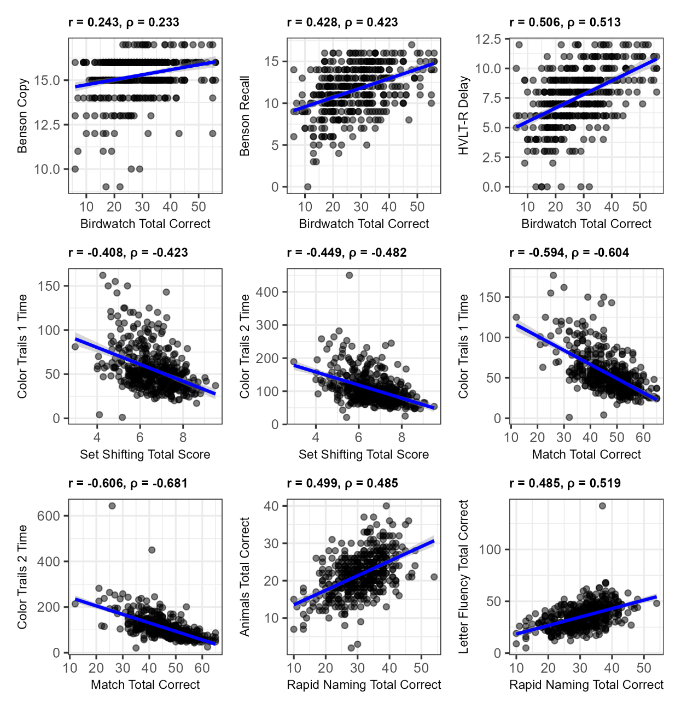
Panels display Pearson r and Spearman rho; pairwise sample sizes appear in Supplementary Table 4.
Supplementary Table 5. Estimated administration time for the selected four-test battery
Test | Primary cognitive processes | Minutes
Birdwatch | Associative learning and memory | 7
Match | Processing speed, attention and working memory | 2
Set Shifting | Executive task switching | 4
Rapid Naming | Speeded confrontation naming | 1
Total | Sum of the test descriptions | 14
Durations are estimates from the candidate-test descriptions, not observed completion times.

