Graphical Abstract- Leaf-amendment-driven restructuring of bacterial–fungal communities during PAH bioremediation.
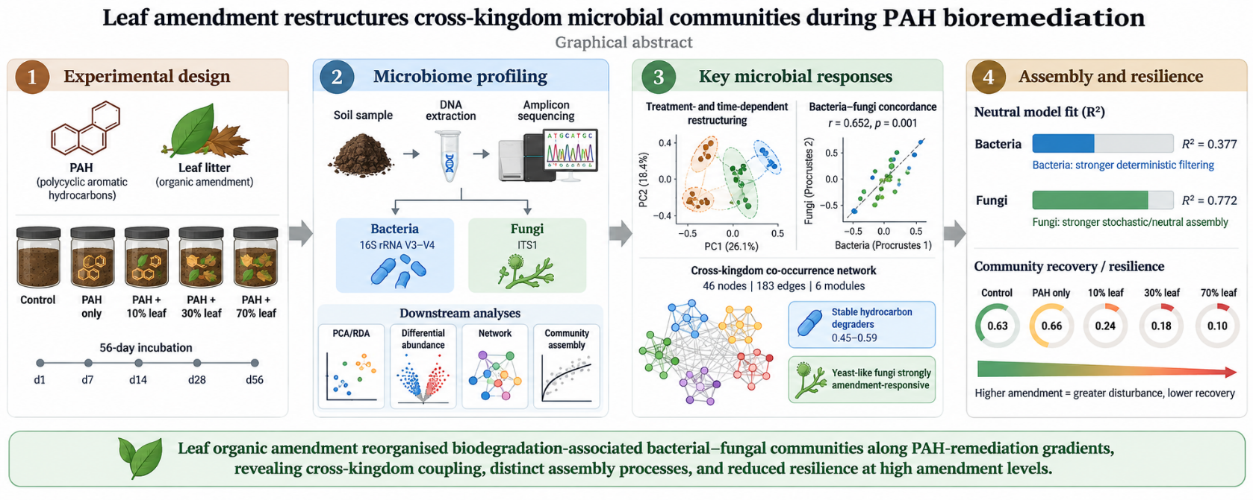
Fig. 1 Graphical abstract sketch of leaf-amendment-driven bacterial–fungal reassembly during PAH bioremediation
The graphical abstract summarises the experimental workflow and major ecological outcomes of organic amendment-assisted PAH bioremediation in soil microcosms. PAH-contaminated soils were amended with graded leaf organic matter at 10%, 30%, and 70% (w/w) and incubated for 56 days, with samples collected across five time points. Bacterial 16S rRNA V3–V4 and fungal ITS1 amplicon sequencing were used to profile microbial community dynamics, followed by ordination, differential abundance, co-occurrence network, community assembly, and stability analyses. Leaf amendment induced treatment- and time-dependent bacterial–fungal community restructuring, with significant cross-kingdom concordance (Procrustes r = 0.652, p = 0.001) and a modular co-occurrence network comprising 46 nodes, 183 edges and six modules. Functional inference revealed stable hydrocarbon-degrading bacterial profiles (0.45–0.59), whereas yeast-like fungi were strongly responsive to the amendment. Neutral modelling indicated stronger stochastic/neutral assembly in fungi (R² = 0.772) than bacteria (R² = 0.377), while recovery indices declined with increasing amendment intensity, reaching the lowest value under 70% leaf amendment (0.10). Hence, leaf organic amendment reorganised biodegradation-associated bacterial–fungal communities along PAH-remediation gradients, revealing cross-kingdom coupling, distinct assembly processes and reduced resilience at high amendment levels.

