Additional file 1

Supplementary Figure 1:
A. Rarefaction plot showing the asymptotic stabilization or the curves at the read count threshold selected for the rarefaction and colouring the curves based on their HIV and MAFLD conditions. Curves present 250 subsampling points (which represent the mean of 10 iterations) in a range from 1 to 75000 counts. B. Taxonomic composition of the top 15 most abundant genera. Each bar represents one study subject, and each graph represents a different study group indicated at the top of the graph.
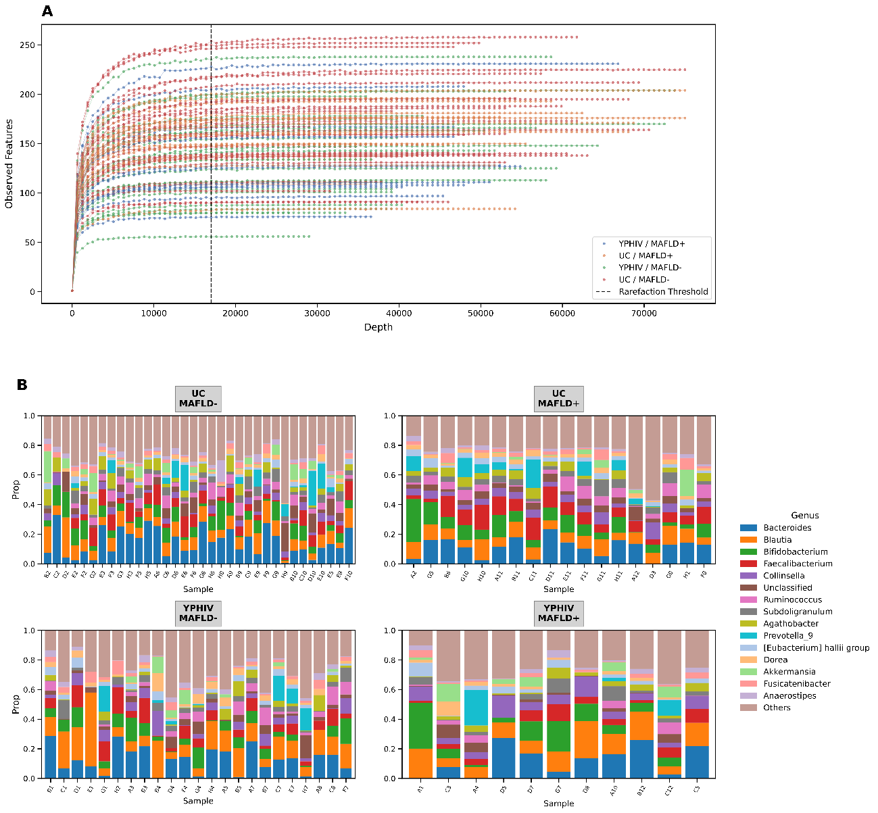

Supplementary Table 1:

Variable | YPHIV MAFLD+ (N=11,  32% of YPHIV) | YPHIV MAFLD− (N=23,  68% of YPHIV) | UC MAFLD+  (N=18,  35% of UC) | UC MAFLD-  (N=34,  65% of UC) | Overall (N=86,  100%) | p-value MAFLD+ vs MAFLD- in YPHIV | p-value MAFLD+ vs MAFLD- in UC | p-value YPHIV vs UC in MAFLD+ | p-value YPHIV vs UC in MAFLD-
Age (years) |  |  |  |  |  | 0.246 | 0.001  ** | 0.041  * | 0.095
Mean (SD) | 22.0 (9.14) | 18.6 (6.28) | 14.5 (3.98) | 21.4 (7.60) | 19.3 (7.30)
Sex |  |  |  |  |  | 0.812 | 0.041  * | 0.295 | 0.276
Female | 6 (54.5%) | 10 (43.5%) | 5 (27.8%) | 21 (61.8%) | 42 (48.8%)
Male | 5 (45.5%) | 13 (56.5%) | 13 (72.2%) | 13 (38.2%) | 44 (51.2%)
Ethnicity |  |  |  |  |  | 0.162 | 0.500 | 0.517 | 0.008  **
Caucasian | 9 (81.8%) | 13 (56.5%) | 15 (83.3%) | 28 (82.4%) | 65 (75.6%)
Latin American | 2 (18.2%) | 2 (8.7%) | 1 (5.6%) | 4 (11.8%) | 9  (10.5%)
African Sub-Saharian | 0 (0%) | 7 (30.4%) | 1 (5.6%) | 0 (0%) | 8  (9.3%)
Other | 0 (0%) | 1 (4.3%) | 1 (5.6%) | 2 (5.9%) | 4  (4.7%)
BMI (kg/m2) |  |  |  |  |  | 0.060 | < 0.001  *** | 0.009  ** | 0.038  *
Mean (SD) | 24.2 (6.89) | 20.3 (2.97) | 29.7 (6.80) | 21.8 (3.12) | 23.4  (5.73)
Median [Min, Max] | 23.3 [17.6, 43.3] | 19.4 [15.0, 25.9] | 28.1 [20.5, 42.8] | 22.1 [14.3, 28.9] | 22.3  [14.3, 43.3]
BMI category |  |  |  |  |  | 0.178 | < 0.001  *** | 0.034  * | 0.704
Healthy | 7 (63.6%) | 20 (87.0%) | 3 (16.7%) | 27 (79.4%) | 57  (66.3%)
Overweight | 3 (27.3%) | 3 (13.0%) | 10 (55.6%) | 7 (20.6%) | 23  (26.7%)
Obesity | 1 (9.1%) | 0 (0%) | 5 (27.8%) | 0 (0%) | 6 (7.0%)
Overweight |  |  |  |  |  | 0.263 | < 0.001  *** | 0.029  * | 0.704
no | 7 (63.6%) | 20 (87.0%) | 3 (16.7%) | 27 (79.4%) | 57 (66.3%)
yes | 4 (36.4%) | 3 (13.0%) | 15 (83.3%) | 7 (20.6%) | 29 (33.7%)
CD4 nadir (cells/uL) |  |  |  |  |  | 0.373 | - | - | -
Mean (SD) | 309 (138) | 384 (255) | - | - | 359 (223)
Median [Min, Max] | 297 [158, 639] | 374 [32.0, 990] | - | - | 333  [32.0, 990]
Missing | 1 (9.1%) | 3 (13.0%) | - | - | 56  (65.1%)
TAR Families |  |  |  |  |  | 0.068 | - | - | -
II | 2 (18.2%) | 12 (52.2%) | - | - | 14 (16.3%)
Unknown | 4 (36.4%) | 2 (8.7%) | - | - | 6 (7.0%)
Other | 4 (36.4%) | 4 (17.4%) | - | - | 8 (9.3%)
PI | 1 (9.1%) | 5 (21.7%) | - | - | 6 (7.0%)
Missing | 0 (0%) | 0 (0%) | - | - | 52  (60.5%)

Supplementary Table 2:
- Alpha diversity ANCOVA analysis in all patients (N=86). Rows indicate the variables tested, while columns represent the sum of squares (SUM SQ), degrees of freedom (DF), F-statistic (F), and p-value (PR(>F)).
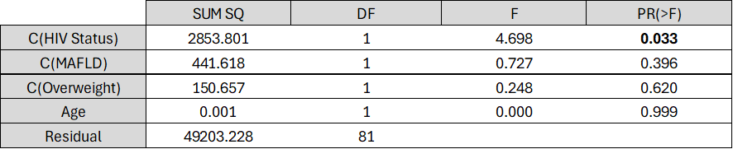
- Alpha diversity ANCOVA analysis in YPHIV patients (N=34). Rows indicate the variables tested, while columns represent the sum of squares (SUM SQ), degrees of freedom (DF), F-statistic (F), and p-value(PR(>F)).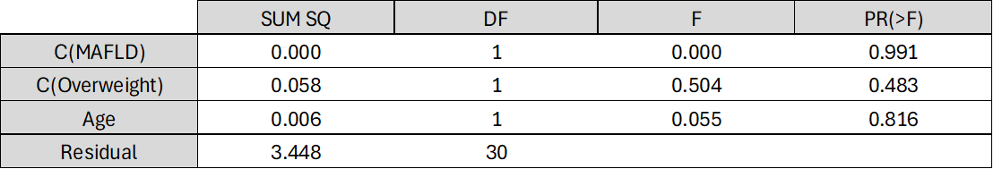
- Alpha diversity ANCOVA analysis in MAFLD+ patients (N=29). Rows indicate the variables tested, while columns represent the sum of squares (SUM SQ), degrees of freedom (DF), F-statistic (F), and p-value (PR(>F)).
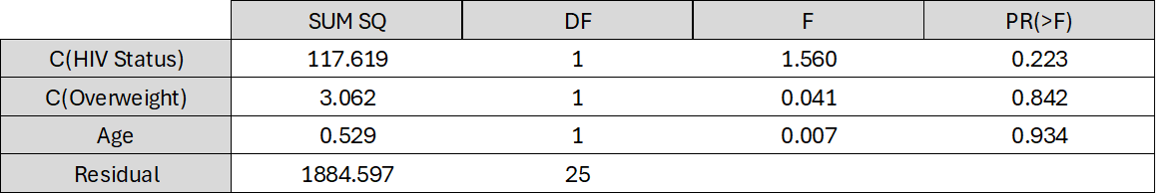
- Alpha diversity ANCOVA analysis in MAFLD+ and YPHIV patients (N=11). Rows indicate the variables tested, while columns represent the sum of squares (SUM SQ), degrees of freedom (DF), F-statistic (F), and p-value (PR(>F)).
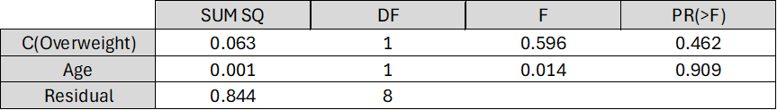

Supplementary Figure 2
A. Boxplot showing the age-adjusted distribution of alpha diversity measured by the Shannon index among the MAFLD+ YPHIV patients (N = 11, ANCOVA, P = 0.46). B. Principal coordinate analysis (PCoA) of the Bray-Curtis resemblance matrix. Orange color indicates overweight, and gray represents non-overweight patients. The proportion of variance explained by each principal coordinate (PCo) is indicated on the corresponding axis. C. Volcano plot of the differential abundance analysis using ANCOM-BC2 to compare different statuses regarding overweight status (while correcting for age) among MAFLD+ YPHIV patients (N=11), using the non-overweight status as the reference. The y-axis represents the negative log10-transformed q-value, while the x-axis shows the natural logarithm of the fold change (LogFC). Significance thresholds are indicated by dotted lines (q-value threshold = 0.1; LogFC threshold = ±1). Significantly increased taxa are colored in red, while blue dots represent a significant decrease in taxa abundance.
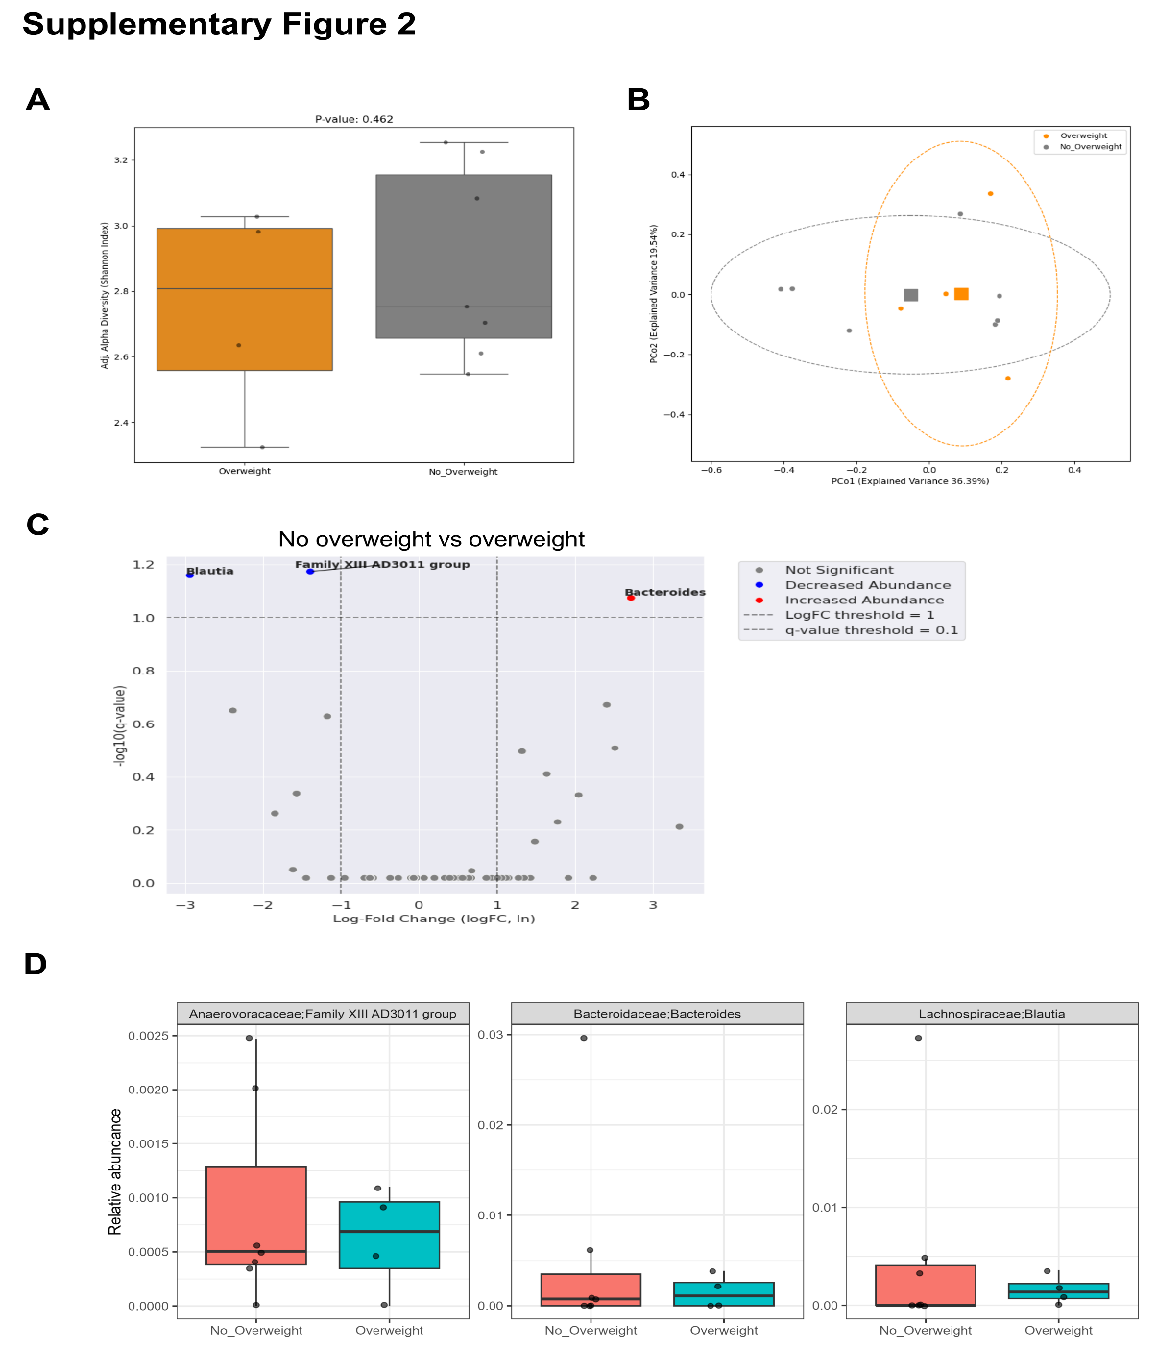
Supplementary Table 3:
Full results of the PICRUSt2-predicted KEGG Orthology (KO) differential abundance analysis (ANCOM-BC2), presented across four sheets, one per comparison. The "HIV ALL" sheet reports KOs differentially abundant according to HIV status in the overall cohort (N=86), adjusted for MAFLD, overweight and age; "MAFLD ALL" reports KOs differentially abundant according to MAFLD status in the overall cohort; "HIV in MAFLD+" reports KOs differentially abundant according to HIV status among participants with MAFLD; and "MAFLD+ in HIV" reports KOs differentially abundant according to MAFLD status among YPHIV. Only KOs reaching statistical significance after false discovery rate correction are shown. Columns indicate the KO identifier, the log fold change (lfc) for the tested condition, the negative log10-transformed q-value, the direction of regulation, a brief description of the corresponding gene product, and the BaseMean (mean normalized abundance across all samples).
HIVALL:
taxon | lfc_HIV.StatusHIV+ | -log10(q_value) | Regulation | Significant | description | BaseMean
K00728 | -1.2969544567556 | 1.5104160163636808 | Decreased Abundance | True | POMT, pmt; dolichyl-phosphate-mannose-protein mannosyltransferase [EC:2.4.1.109] | 6.202197802197803
K18230 | 1.2380708069153 | 2.0582545795401845 | Increased Abundance | True | tylC, oleB, carA, srmB; macrolide transport system ATP-binding/permease protein | 2.30956043956044
K16146 | 1.5332332163787 | 3.1791149929546383 | Increased Abundance | True | pep2 | maltokinase [EC:2.7.1.175]
K17489 | 1.56844232598597 | 3.4280736709359485 | Increased Abundance | True | E2.1.3.1-12S | methylmalonyl-CoA carboxyltransferase 12S subunit [EC:2.1.3.1]
K10232 | 2.00264724406856 | 1.7050483974161845 | Increased Abundance | True | aglE, ggtB; alpha-glucoside transport system substrate-binding protein | 2.043956043956044

MAFDL ALL:
taxon | lfc_MAFLD+ | -log10(q_value) | Regulation | Significant | description | BaseMean
K06945 | -2.36677078047734 | 3.555152983653174 | Decreased Abundance | True | K06945 | uncharacterized protein
K09000 | -1.44316929460333 | 3.665166657918912 | Decreased Abundance | True | cmr4 | CRISPR-associated protein Cmr4
MAFDL+ IN HIV:
taxon | lfc_HIV.StatusHIV+ | -log10(q_value) | Regulation | Significant | description | BaseMean
K03795 | 3.2811338595616 | 1.109806298223932 | Increased Abundance | True | cbiX | sirohydrochlorin cobaltochelatase [EC:4.99.1.3]
K10747 | 4.46117382352568 | 1.2721677615830953 | Increased Abundance | True | LIG1 | DNA ligase 1 [EC:6.5.1.1 6.5.1.6 6.5.1.7]

HIV IN MAFDL+:
taxon | lfc_MAFLD+ | -log10(q_value) | Regulation | Significant | description | BaseMean
K15331 | 2.05710194731961 | 1.1025626458452193 | Increased Abundance | True | TRMT2B, TRM2; tRNA (uracil-5-)-methyltransferase [EC:2.1.1.35] | 368.29681318681304
K06988 | 2.92385507900448 | 1.2790763828190024 | Increased Abundance | True | fno | 8-hydroxy-5-deazaflavin:NADPH oxidoreductase [EC:1.5.1.40]

