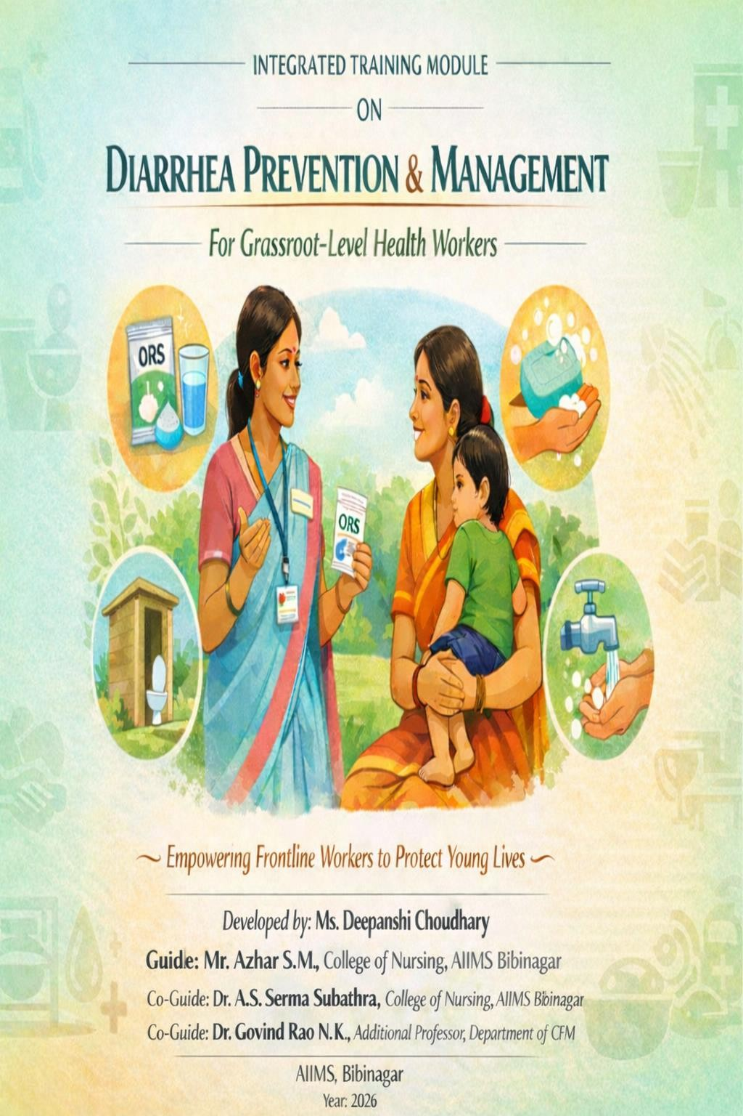
STRUCTURED TEACHING PROGRAMME MODULE

“Clean Water, Zinc & ORS – The Triple Shield for Child Survival.”

DISCLAIMER

This training module has been developed for academic and capacity-building purposes to strengthen the knowledge and competencies of grassroots-level health workers in the prevention and management of diarrheal diseases among under-five children.

The content of this module is based on national guidelines issued by the Ministry of Health and Family Welfare (MoHFW), Government of India, World Health Organization (WHO) recommendations, UNICEF frameworks, and other standard public health references. Every effort has been made to ensure that the information presented is accurate, evidence-based, and contextually appropriate at the time of development.

This module is intended for training and educational use only. It does not replace clinical judgment, institutional protocols, or official government guidelines. In case of updates to national or international recommendations, users are advised to refer to the latest guidelines.

The responsibility for the interpretation and application of the content rests with the user.

2

DEVELOPER: MS. DEEPANSHI CHOUDHARY

ACKNOWLEDGEMENT

This training module has been developed as part of an academic and practical effort to strengthen the knowledge, skills, and competencies of grassroots-level health workers in the prevention and management of diarrheal diseases among under-five children.

I express my sincere gratitude to my research guide and faculty members for their continuous guidance, valuable suggestions, and academic support throughout the development of this module. Their expert inputs ensured that the content is evidence-based, context-specific, and aligned with national and global guidelines.

I also acknowledge the contribution of community health workers, ASHAs, ANMs, and Anganwadi Workers whose field experiences, challenges, and insights helped shape the practical and locally relevant components of this module.

Special appreciation is extended to the Ministry of Health and Family Welfare, Government of India, WHO, UNICEF, and other global public health agencies whose guidelines and frameworks informed the scientific foundation of this training program.

This module is dedicated to all grassroots-level health workers who serve as the first line of defense in safeguarding child health and preventing avoidable deaths due to diarrheal diseases.

3

PREFACE

Diarrheal diseases remain one of the leading causes of morbidity and mortality among children under five years of age worldwide. Despite being preventable and treatable, diarrhea continues to pose a significant public health challenge, particularly in low- and middle-income countries.

In India, diarrheal diseases account for a considerable proportion of under-five deaths. Although mortality has declined due to improved ORS availability, zinc supplementation, vaccination programs, and public health initiatives, morbidity remains high. Seasonal outbreaks, unsafe drinking water, poor sanitation, malnutrition, and persistent myths contribute to continued disease burden.

Grassroot level workers such as ASHAs, ANMs, and anganwadi workers play a pivotal role in early identification, prevention, counseling, and referral of diarrhea cases. However, gaps in knowledge, confidence, communication skills, and problem-solving capacity often limit effective management at the community level.

This structured training module has been developed to address these gaps through a systematic, evidence-based, and participatory approach. It integrates national guidelines, WHO recommendations, adult learning principles, and locally contextualized strategies.
The purpose of this module is to:

- Enhance understanding of diarrheal disease burden

4

- Strengthen assessment and classification skills

- Improve ORS and zinc counseling practices

- Build communication and behavior change competencies

5

- Address local barriers and myths

- Promote community engagement and referral mechanisms

The module emphasizes practical learning through case scenarios, demonstrations, role-plays, group discussions, and IEC/BCC activities. It aims not only to impart knowledge but also to develop confidence, leadership, and problem-solving skills among grassroots-level workers.

By strengthening frontline capacity, this module aspires to contribute to reduced diarrheal morbidity and mortality and improved child survival outcomes.

RIGHTS-BASED PERSPECTIVE

This training module is grounded in a child rights and public health framework that recognizes the fundamental right of every child to survival, health, and development.

The right to health is enshrined under Article 24 of the United Nations Convention on the Rights of the Child (UNCRC), which affirms every child’s right to the highest attainable standard of health and access to healthcare services. Preventable deaths due to diarrheal dehydration represent a violation of this fundamental right.

Children from economically disadvantaged, rural, and marginalized communities often face disproportionate risk due to inadequate sanitation, unsafe water, poor access to health services, and limited awareness. Addressing diarrheal disease, therefore, is not merely a clinical responsibility but also a social and ethical obligation.

This module adopts the following rights-based principles:

- Non-discrimination: Every child, regardless of socio-economic status, deserves timely and effective care.
- Best interest of the child: Early identification and correct management prioritize child survival.
- Right to survival and development: Preventing dehydration directly contributes to survival and healthy growth.
- Community participation: Empowering families and health workers strengthens collective responsibility.

By strengthening the competencies of grassroots-level workers, this module contributes to safeguarding children’s right to life and health.

6

INSTRUCTIONS FOR USE OF THIS MODULE

This training module has been designed as a structured Training of Trainers (ToT) resource for building the capacity of grassroots-level health workers involved in diarrhea prevention and management. It is intended to be conducted as a three-day consecutive training program; however, the duration may be adjusted based on local needs and participant availability. The module follows participatory and adult learning principles to ensure that learning is interactive, practical, and experience-based rather than lecture-oriented.

Training Duration

The module is structured as a three-day training program. However, it may be adapted into shorter or non-consecutive sessions depending on local feasibility and participant availability.

Training Approach

The module follows adult learning principles and emphasizes participatory methodology rather than didactic teaching. Sessions incorporate:

- Case-based discussions
- Role-plays
- Demonstrations (ORS and zinc preparation)
- Group exercises
- Practical skill drills
- Problem-solving activities
- IEC/BCC planning exercises

Target Audience

7

- ASHAs
- ANMs

- Anganwadi Workers
- Other frontline health workers Recommended batch size: 20–25 participants. Facilitator Preparation
Facilitators should:

- Review all sessions thoroughly prior to training.
- Arrange required materials (ORS packets, measuring spoons, flipcharts, markers).
- Adapt case scenarios to reflect local district-level data.
- Use local language for improved comprehension.

Session Flow

Each session includes:

- Learning objectives
- Core content
- Practical activities
- Facilitator notes
- Annexures
- Competency statement
- Session summary

Assessment

Pre- and post-training assessments may be conducted to evaluate improvement in knowledge and skills. Observational assessment during role-plays and demonstrations is recommended to evaluate competency attainment.

8

Adaptation

Examples, statistics, and referral pathways should be customized based on district-level HMIS data and seasonal patterns.

Expected Outcome

Upon completion of this module, grassroots-level workers should be able to:

- Assess and classify diarrhea correctly
- Initiate appropriate management (Plan A, B, or C)
- Demonstrate ORS and zinc preparation
- Identify danger signs and refer timely
- Promote at least five preventive WASH practices
- Address local myths and harmful practices effectively

Facilitators are encouraged to carefully review the entire module before conducting the training to understand the flow of sessions and learning objectives. Each session includes suggested time allocations, which should ideally be followed to maintain participant engagement and ensure completion of all planned activities. A variation of ±5 minutes per session is acceptable; however, excessive deviation should be avoided to prevent participant fatigue or loss of interest.

The module incorporates multiple teaching methodologies such as case studies, group discussions, demonstrations (particularly ORS and zinc preparation), role-plays, problem-solving exercises, visual aids, and IEC/BCC planning activities. Facilitators should actively encourage participation, create a safe environment for discussion, and allow participants to share their field experiences. Linking session content to real-life local situations will enhance relevance and retention.

The recommended batch size is 20–25 participants to allow effective interaction and group work.

Seating should ideally be arranged in a semi-circle or U-shape to promote visibility and
9

engagement. Essential materials such as flipcharts, markers, dehydration classification charts, ORS demonstration kits, and audiovisual equipment should be arranged in advance.

10

Facilitators should adapt examples, case scenarios, and referral pathways to reflect local data, district-level HMIS reports, seasonal patterns, and community-specific challenges. Using local language during discussions and demonstrations is strongly encouraged to improve comprehension and future field application.

At the beginning of each session, facilitators should clearly explain the learning objectives and briefly outline what participants can expect. At the end of each session, key messages should be summarized, and practical take-home points should be reinforced. Where possible, pre- and post-training assessments may be conducted to evaluate improvement in knowledge and skills.

Overall, this module is intended to strengthen the knowledge, practical competencies, communication skills, and confidence of grassroots-level workers so that they can effectively prevent, identify, manage, and refer cases of diarrhea in under-five children, thereby contributing to reduced morbidity and mortality in their communities.

CONTENTS

11

SESSION  NO. | SESSION TITLE | PAGE  NO.
1 | Introduction to the Training & Understanding the Role | 14-20
2 | Understanding the Burden of Diarrhea – Global, National & Local Context | 21-30
3 | Essential Concepts of Diarrhea – Causes, Transmission & Risk Factors | 31-44
4 | Assessment, Classification & Management of Diarrhea | 45-62
5 | Prevention of Diarrhea – Local Strategies & Practical Solutions | 63-77
6 | Issues & Challenges in Diarrhea Prevention and Treatment | 78-88
7 | WHO-UNICEF 7-Point Plan for Comprehensive Diarrhea Control | 89-97
8 | Effective Communication – Tailoring Messages for Communities and IEC/BCC Activities – Designing & Delivering Local Campaigns | 98-125
9 | Community engagement, health system structures and social mobilization for diarrhea control | 126-139
Appendix
I | Indian standards of drinking water | 140-141
II | Water quality management | 142-144
III | Methods of excreta disposal | 145-146
IV | National immunization schedule | 147-150
V | Rotavirus vaccination | 151-153
VI | Training feedback form | 154 - 155

AGENDA OF STRUCTURED TEACHING PROGRAMME

12

AGENDA: DAY 1

TIME | SESSION | TOPIC
9:00–9:30 AM |  | Registration
9:30–10:00 AM | 1 | Introduction to the Training & Understanding the Role
10:00–11:00 AM | 2 | Understanding the Burden of Diarrhea – Global, National &  Local Context
11:00–11:15 AM |  | TEA BREAK
11:15–12:30 PM | 3 | Essential Concepts of Diarrhea – Causes, Transmission &  Risk Factors
12:30–1:15 PM | 4 | Assessment of Diarrhea – Look, Feel, Ask Approach
1:15–2:00 PM |  | LUNCH
2:00–3:00 PM | 4 | Classification of Dehydration & Treatment Plans (A, B & C)
3:00–3:15 PM |  | TEA BREAK
3:15–4:15 PM | 4 | ORS & Zinc Administration – Demonstration & Practice
4:15–5:00 PM |  | Reflection, Q&A & Day 1 Wrap-up

AGENDA: DAY 2

TIME | SESSION | TOPIC
9:00–9:30 AM |  | Welcome & Recap of Day 1
9:30–10:30 AM | 5 | Prevention of Diarrhea – Local Strategies & Practical Solutions
10:30–11:15 AM | 6 | Issues & Challenges in Diarrhea Prevention and Treatment
11:15–11:30 AM |  | TEA BREAK
11:30–12:15 PM | 7 | WHO–UNICEF 7-Point Plan for Comprehensive Diarrhea Control
12:15–1:00 PM | 8 | Effective Communication – Principles & Tailoring Messages

1:00–2:00 PM |  | LUNCH
2:00–3:00 PM | 8 | IEC/BCC Activities – Designing & Delivering Local Campaigns
3:00–3:15 PM |  | TEA BREAK
3:15–4:15 PM |  | Documentation & Reporting of IEC/BCC Activities
4:15–5:00 PM |  | Group Activity & Day 2 Wrap-up

13

AGENDA: DAY 3

TIME | SESSION | TOPIC
9:00–9:30 AM |  | Welcome & Recap of Day 2
9:30–10:30 AM | 9 | Community Engagement, Health System Structures &  Referral Linkages
10:30–11:15 AM | 9 | Social Mobilization & Reaching the Unreached
11:15–11:30 AM |  | TEA BREAK
11:30–12:30 PM |  | Group Work: Developing Micro-Action Plans for Villages
12:30–1:00 PM |  | Presentation of Action Plans
1:00–2:00 PM |  | LUNCH
2:00–3:00 PM |  | Mock Session 1 – ORS & Zinc Demonstration (Feedback)
3:00–3:15 PM |  | TEA BREAK
3:15–4:00 PM |  | Mock Session 2 – Counseling & Dehydration Classification
4:00–4:45 PM |  | Post-Training Assessment & Evaluation
4:45–5:00 PM |  | Valedictory & Feedback

SESSION 1: INTRODUCTION TO THE TRAINING AND UNDERSTANDING
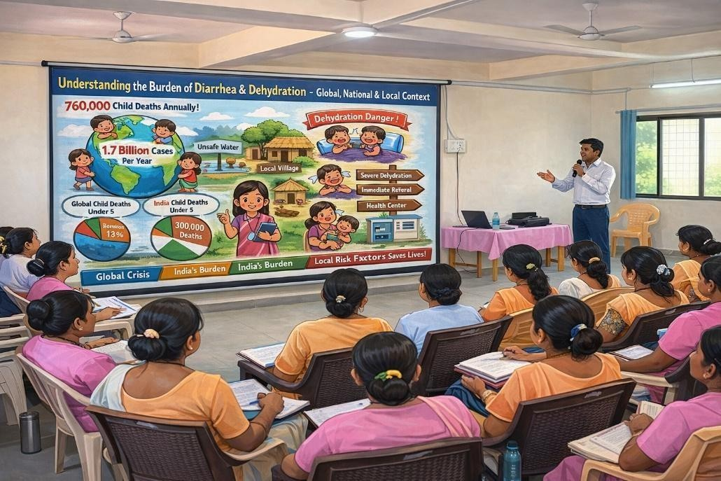

PURPOSE OF THIS SESSION

This session helps health workers understand why this training is important, reflect on their current knowledge and challenges, and prepare for active participation in the upcoming sessions.

LEARNING OBJECTIVES

By the end of this session, you will be able to:

- Understand the purpose of this training program
- Recognize the seriousness of diarrhea among under-five children
- Reflect on your own experiences and challenges in managing diarrhea
- Identify areas where you want to improve your knowledge and skills

14

WHY THIS TRAINING MATTERS

Diarrhea is one of the leading causes of illness and death in children under five years of age in India. Most deaths can be prevented with early recognition, correct use of ORS and zinc, continued feeding, and timely referral.

As a frontline health worker, grassroot level workers are the first and most trusted contact for families in the community. Grassroot level workers actions can save lives.

ROLE AS A GRASSROOT LEVEL WORKERS

- Identifying diarrhea early
- Teaching families how to prepare and give ORS
- Ensuring zinc is given for 14 days
- Encouraging continued breastfeeding and feeding
- Recognizing danger signs and referring on time
- Correcting myths and misconceptions

BASELINE SELF-ASSESSMENT

Before starting the training, it is important to think about:

- What do I already know about diarrhea management?
- What confuses me most?
- What problems do I face in the field?

This helps grassroot level workers focus better during the training.

COMMITMENT AS A GRASSROOT LEVEL WORKERS

15

During this training, grassroot level workers are encouraged to:

- Share your experiences openly

- Ask questions without hesitation
- Participate actively in discussions and activities
- Apply what you learn in your community

WHAT WILL BE COVERED IN THIS TRAINING

In the upcoming sessions, you will learn about:

- Burden of diarrhea and dehydration
- Causes and transmission
- Assessment and classification
- ORS and zinc preparation and use
- Prevention strategies
- Communication and counseling skills
- Community education (IEC/BCC)
- Solving local challenges

KEY MESSAGE

- The participants will get to know and learn from each other
- The participants will build upon the expertise they and others have in the group.
- They will set the ground rules of the workshop and will have a brief overview of the
- workshop.
COMPETENCY ACHIEVED: Grassroot level workers develop role clarity, self-awareness, and readiness to strengthen their knowledge and skills in diarrhea prevention and management.

16

FACILITATOR NOTES AND ACTIVITIES
ACTIVITY 2: BASELINE KNOWLEDGE QUIZ (10 MINUTES)

PURPOSE: To assess pre-training knowledge and identify gaps.

INSTRUCTIONS:

1. Distribute Pre-training quiz (Annexure I-A).
17

OPENING & WELCOME (5 MINUTES)

- Welcome participants and introduce yourself and co-facilitators.
- Briefly explain the Stop Diarrhoea Initiative (SDI) and its goals.
- State the purpose of today’s session: to get to know each other and understand our starting point.

ACTIVITY 1: ICEBREAKER – “FIND YOUR MATCH” (10 MINUTES)

PURPOSE: To break the ice and encourage interaction.

INSTRUCTIONS:

- Prepare paired cards with related terms (e.g., “ORS” – “Zinc,” “Dehydration” – “Sunken Eyes,” “Rotavirus” – “Vaccine”).
- Distribute one card to each participant.
- Ask them to find their partner by matching the terms.
- Once paired, partners share:
  - Name
  - Role
  - One challenge they face in diarrhea management
- Each pair introduces the other to the whole group.

DEBRIEF: Highlight the variety of roles and experiences in the room.

- Give 5 minutes to complete.
ANNEXURE I-A: PRE-TRAINING QUIZ

Name (Optional): Date:
1. Diarrhea is defined as or more loose stools per day in a child.
18
- Collect responses (anonymous).
- Briefly discuss 2–3 key questions to gauge understanding.

SAMPLE QUIZ QUESTIONS:

- How many loose stools per day define diarrhea in a child?
- Name two signs of severe dehydration.
- True or False: You should stop breastfeeding if a child has diarrhea.
- What is the correct ratio of salt, sugar, and water for homemade ORS?

ACTIVITY 3: SHARING FIELD CHALLENGES (10 MINUTES)

PURPOSE: To surface real barriers faced by health workers.

INSTRUCTIONS:

- Distribute challenge cards (Annexure I-B).
- Ask each participant to write one major challenge they face in diarrhea management.
- Collect and cluster cards on a flipchart under themes:
  - Knowledge gaps
  - Community resistance
  - Supply issues
  - Systemic barriers
- Briefly discuss top 3 challenges.

- List two signs of severe dehydration:
a.
b.
- True or False: Giving fluids during diarrhea can make it worse.
- How many days should zinc be given to a child with diarrhea? days.
- What are the three main ingredients in homemade ORS?
, ,

- Name one common myth about diarrhea in your community:

ANNEXURE I-B: CHALLENGE CARD

Write ONE big challenge you face when managing diarrhea in children:

This could be related to:
- Knowledge
- Supplies
- Community beliefs
- Transport
- Documentation
19

- Other:

20

SESSION SUMMARY

This introductory session establishes the foundation for the entire training program. It highlights the seriousness of diarrheal diseases among under-five children and emphasizes that most deaths are preventable with timely and correct management.

Participants reflect on their current knowledge, field experiences, and challenges in managing diarrhea cases. The session clarifies the critical role of grassroots-level workers in early identification, ORS and zinc promotion, continued feeding, myth correction, and timely referral.

By encouraging active participation, open discussion, and self-assessment, this session prepares participants mentally and professionally for deeper learning in subsequent sessions. It builds motivation, ownership, and commitment toward improving child survival in their communities.

SESSION 2: UNDERSTANDING THE BURDEN OF DIARRHEA & DEHYDRATION GLOBAL, NATIONAL & LOCAL CONTEXT

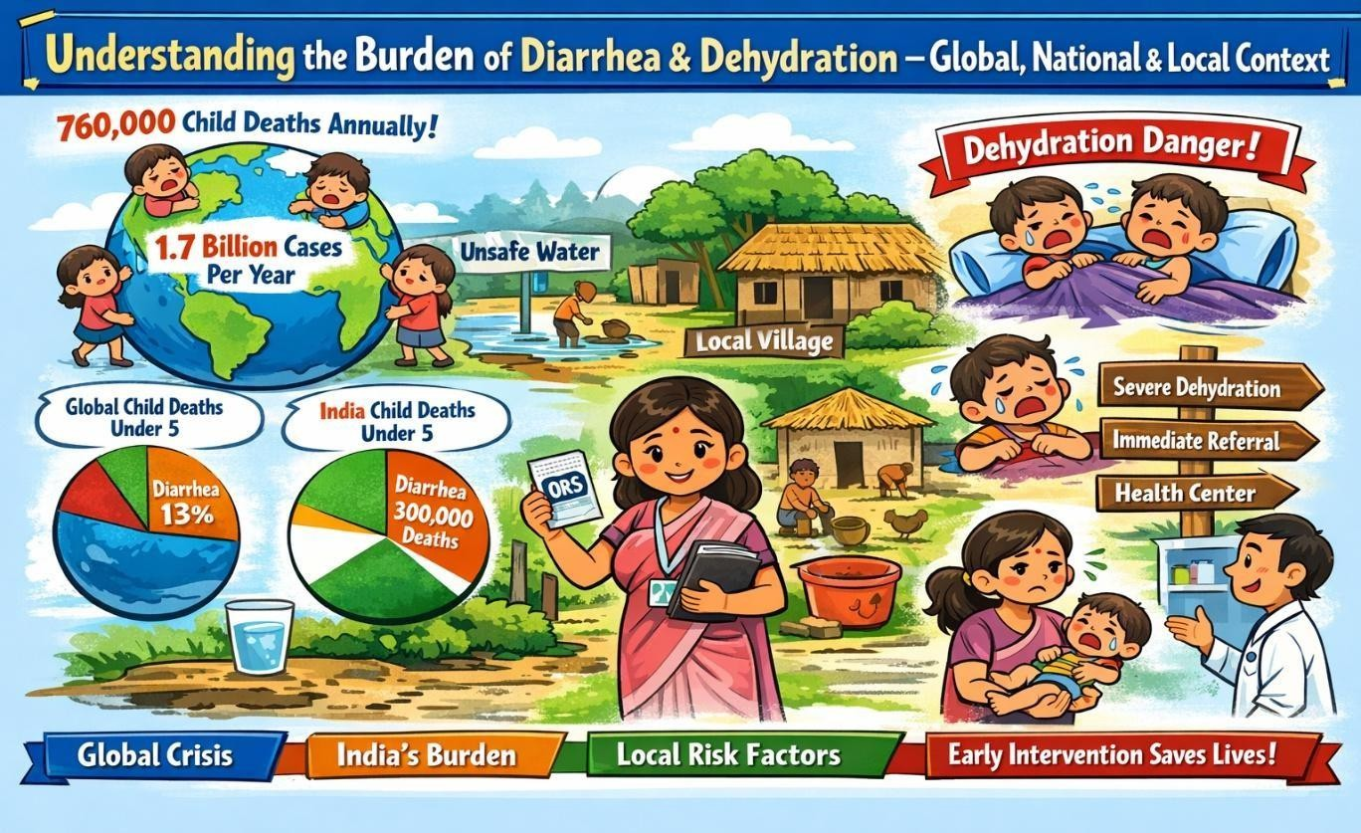

LEARNING OBJECTIVES

By the end of this session, you will be able to:

- Understand how serious diarrheal diseases are at global, national, and local levels
- Recognize why diarrhea remains a major cause of illness and death in under-five children

BURDEN OF DIARRHEA – WHY WE MUST ACT GLOBAL SITUATION
Diarrheal disease is the second leading cause of death in children under five years globally, responsible for approximately 760,000 deaths annually. It accounts for nearly 1 in 9 child deaths worldwide. Globally, there are an estimated 1.7 billion episodes of diarrheal disease each year.

21

Recent Global Burden of Disease (GBD) estimates indicate that although mortality has declined due to improved ORS and vaccination coverage, diarrhea still remains among the top five causes of under-five mortality in low- and middle-income countries.

Africa and South Asia together account for more than 80% of global child deaths due to diarrhea, with India contributing a significant proportion of this burden.
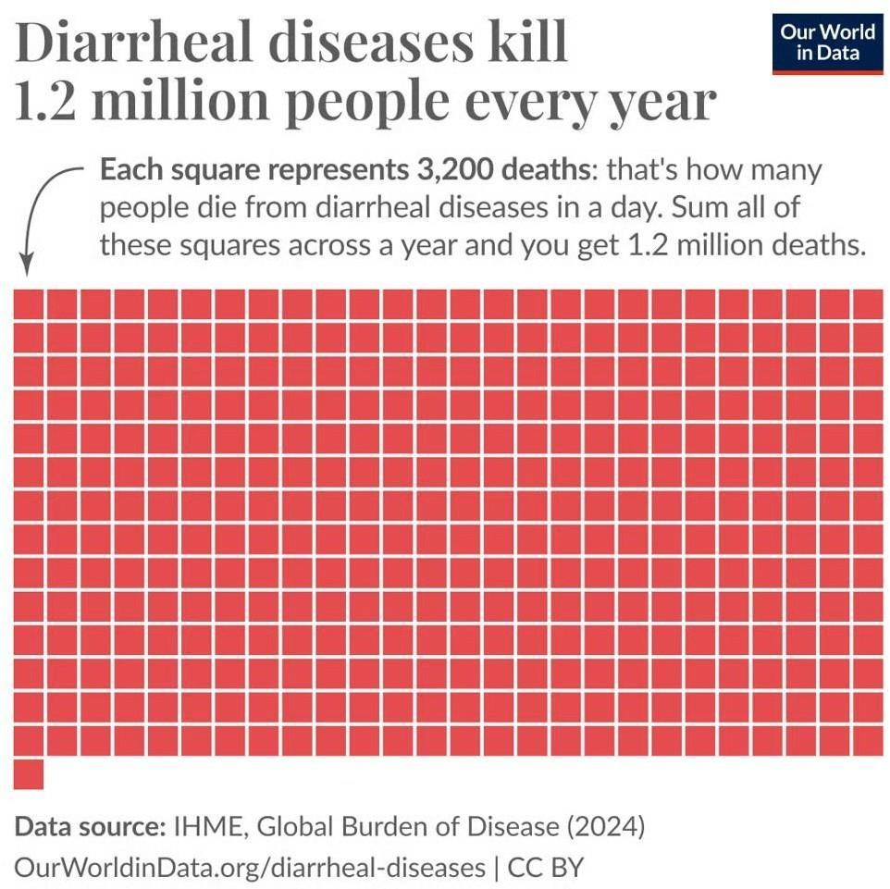

NATIONAL BURDEN IN INDIA

In India, diarrhea remains a significant cause of under-five mortality. According to estimates from the World Health Organization and the Centers for Disease Control and Prevention, diarrheal diseases continue to contribute substantially to preventable child deaths, particularly in low- and middle-income settings like India.
22

In India, diarrhea continues to be a leading contributor to under-five mortality. It accounts for approximately 13% of deaths in children under five years.

An estimated 300,000 children die annually due to diarrhea in India, though mortality has declined compared to previous decades due to programs such as:

- Integrated Management of Neonatal and Childhood Illness (IMNCI)
- Intensified Diarrhea Control Fortnight (IDCF)
- Rotavirus vaccination under UIP

According to the Million Death Study, diarrhea accounted for:

- 8.9 per 1000 live births among boys
- 13.4 per 1000 live births among girls

The burden is disproportionately higher in low-income and rural states, with regional variation observed across India.

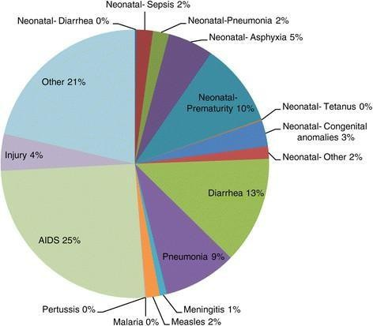
The average incidence of diarrhea among children aged 0–6 years is approximately:

23

- 1.71 episodes per child per year in rural areas
- 1.09 episodes per child per year in urban areas

Despite availability of ORS and zinc, delayed recognition, improper usage, and myths continue to contribute to preventable deaths.

SITUATION IN TELANGANA

Telangana, like many other states in India, experiences seasonal peaks of diarrheal diseases, especially during:

- Monsoon season
- Summer months

According to NFHS-5 (2019–21):

- Approximately 7–9% of under-five children in Telangana had diarrhea in the two weeks preceding the survey.
- ORS use has improved but remains suboptimal in certain rural districts.
- Zinc supplementation coverage is still inconsistent.

Rural and tribal districts report higher incidence due to:

- Unsafe drinking water sources
- Seasonal contamination of bore wells and ponds
- Open defecation in some pockets
- Poor household water storage practices
- Low awareness regarding continued breastfeeding during illness

District-level HMIS data often shows spikes in diarrhea cases during monsoon outbreaks, particularly in areas with water stagnation and inadequate sanitation infrastructure.

Although mortality rates have reduced, morbidity remains high, leading to:

- Recurrent illness
24

- Malnutrition
- Increased healthcare expenditure
- School absenteeism
- Reduced productivity of caregivers

Thus, diarrhea remains not only a medical problem but a significant public health and socio-economic challenge in Telangana.

KEY MESSAGES:
- Diarrheal disease is globally the second leading cause of death in children under five years old.
- The number of child deaths from pneumonia and diarrhea is almost equal to the number of child deaths from all other causes.
- Africa and South Asia are home to more than 80 percent of child deaths due to diarrhea.
- India is leading in accounting for child deaths due to diarrhea (almost 13%).

COMPETENCY ACHIEVED: Grassroot level workers developed the competency to understand the public health burden of diarrhea.

FACILITATOR NOTES AND ACTIVITIES

PART 1: GLOBAL & NATIONAL BURDEN (10 MINS)

  - Use slides to show global data (WHO, UNICEF).
  - Highlight India’s position: 300,000 under-5 deaths annually.
  - Transition to NFHS/DLHS data for your state.
  - Ask: “Why do you think diarrhea is still so common here?”
25

PART 2: LOCAL BURDEN – OUR DISTRICT’S STORY (15 MINS) ACTIVITY: LOCAL DATA MAPPING
26
  - Share district/block-level diarrhea prevalence (from HMIS or local surveys).
  - Use a map of the district to show high-burden villages.
  - Ask participants: “Which villages in your area see the most diarrhea cases? Why?”
  - Cluster responses on flipchart: Water source, sanitation, myths, access.

PART 3: RECOGNIZING & CLASSIFYING DEHYDRATION (15 MINS) VISUAL AID ACTIVITY:
- Display laminated dehydration chart (no dehydration / some / severe).
- Show photos of real children (with permission) or drawings showing:
  - Sunken eyes
  - Skin pinch test
  - Lethargy vs. alertness
- Group Exercise: Give 3 case scenarios – ask groups to classify.

PART 4: REFERRAL PATHWAYS – LOCAL CONTACTS (5 MINS)

- Show referral flowchart poster.
- Walk through local contacts:
  - Ambulance numbers
  - Nearest PHC/CHC contacts
  - ASHA/ANM on-call protocol
- Role-play: “Calling the PHC for a severe dehydration referral.”

VISUAL DEHYDRATION CHART
Year:
27

Signs | No Dehydration | Some Dehydration | Severe Dehydration
Eyes | Normal | Sunken | Very sunken
Skin Pinch | Goes back quickly | Goes back slowly | Goes back very slowly
Child’s State | Alert | Restless/irritable | Lethargic/unconscious
Thirst/Drinking | Drinks normally | Drinks eagerly | Cannot drink
ACTION | Plan A: Home care | Plan B: ORS at clinic | REFER URGENTLY

LOCAL REFERRAL FLOWCHART

Child with Diarrhea
↓
Assess for Dehydration → Use Visual Chart
↓
SEVERE? → Call [Local Ambulance No.] / [PHC Contact]
↓
Escort to [Nearest CHC/FRU]
↓
Follow up in 24 hrs

ANNEXURE II-A: DISTRICT DIARRHEA BURDEN SNAPSHOT

District:

Block | Under-5 Diarrhea Cases (Last 1 Year) | Top Risk Factor | ORS Coverage

Block A | 1,250 | Open defecation | 40%
Block B | 980 | Unsafe water storage | 55%
Block C | 1,500 | Myth: “Stop breastfeeding” | 30%
Your Block | [Insert Your Data] | [Your Observation] | [Your Data]
You can get these numbers from:

- ASHA diaries
- VHND (Village Health Nutrition Day) reports
- Household surveys you’ve conducted
28

EXAMPLE OF HOW TO FILL IT WITH REAL DATA (FROM YOUR WORK):

District: Banda, Uttar Pradesh
Year: 2023

Block | Under-5 Diarrhea Cases | Top Risk Factor | ORS Coverage
Naraini | 1,842 | Open defecation near water sources | 42% (HMIS  2023)
Baberu | 1,550 | Unsafe drinking water (wells) | 38% (IDCF 2023)
Your Block | Your actual number | Your observed risk factor | Your actual %

HOW TO CALCULATE ORS COVERAGE YOURSELF (ROUGH ESTIMATE):
ORS Coverage % =
No. of children with diarrhea who received ORS
Total diarrhea cases in under-5 children
× 100

ANNEXURE II-B: CASE SCENARIOS FOR CLASSIFICATION

CASE 1:
2-year-old Rani, 6 loose stools in 12 hours. Eyes normal, skin pinch quick, drinking well.
Classification: Action:

CASE 2:
18-month-old Aarav, 10 watery stools since morning. Eyes sunken, skin pinch slow, restless, drinks eagerly.
Classification: Action:

CASE 3:
3-year-old Priya, 12 stools, vomiting, eyes deeply sunken, skin pinch very slow, unconscious.
Classification: Action:

SESSION SUMMARY

Diarrheal disease continues to be a major global and national public health concern, particularly among children under five years of age. Despite significant reductions in mortality due to improved access to ORS, zinc supplementation, vaccination, and child health programs, diarrhea remains one of the leading causes of preventable child deaths worldwide. Africa and South Asia carry the greatest burden, with India contributing a substantial proportion of cases and deaths.

In India, although initiatives such as IMNCI, IDCF, and rotavirus vaccination have reduced mortality, morbidity remains high, especially in rural and low-income settings. Telangana also experiences seasonal peaks in diarrheal diseases, particularly during monsoon and summer months, with rural and tribal areas facing higher risk due to unsafe water, sanitation gaps, and persistent myths.

Dehydration is the most dangerous complication of diarrhea and the primary cause of mortality. Early recognition of dehydration signs and accurate classification into no, some, or severe
29

dehydration are essential to guide appropriate management—Plan A (home care), Plan B (ORS at facility), or Plan C (urgent referral).

Grassroot level workers play a critical role in:

- Recognizing early warning signs
- Classifying dehydration correctly
- Initiating timely ORS therapy
- Ensuring immediate referral when required
- Addressing local risk factors and myths

Understanding the burden at global, national, and local levels strengthens the urgency of action and empowers health workers to respond effectively. Early identification, proper classification, and timely referral can prevent almost all deaths due to diarrheal dehydration.

REFERENCES

- World Health Organization. Diarrhoeal disease [Internet]. Geneva: WHO; 2023.
- UNICEF. The state of the world’s children 2023. New York: UNICEF; 2023.
- Global Burden of Disease Collaborative Network. Global burden of diarrheal diseases 2019.
- International Institute for Population Sciences (IIPS). NFHS-5, Telangana Fact Sheet; 2021.
- Ministry of Health and Family Welfare. Health Management Information System (HMIS) reports; 2023.

30

SESSION 3: ESSENTIAL CONCEPTS OF DIARRHEA – CAUSES, TRANSMISSION & LOCAL RISK FACTORS
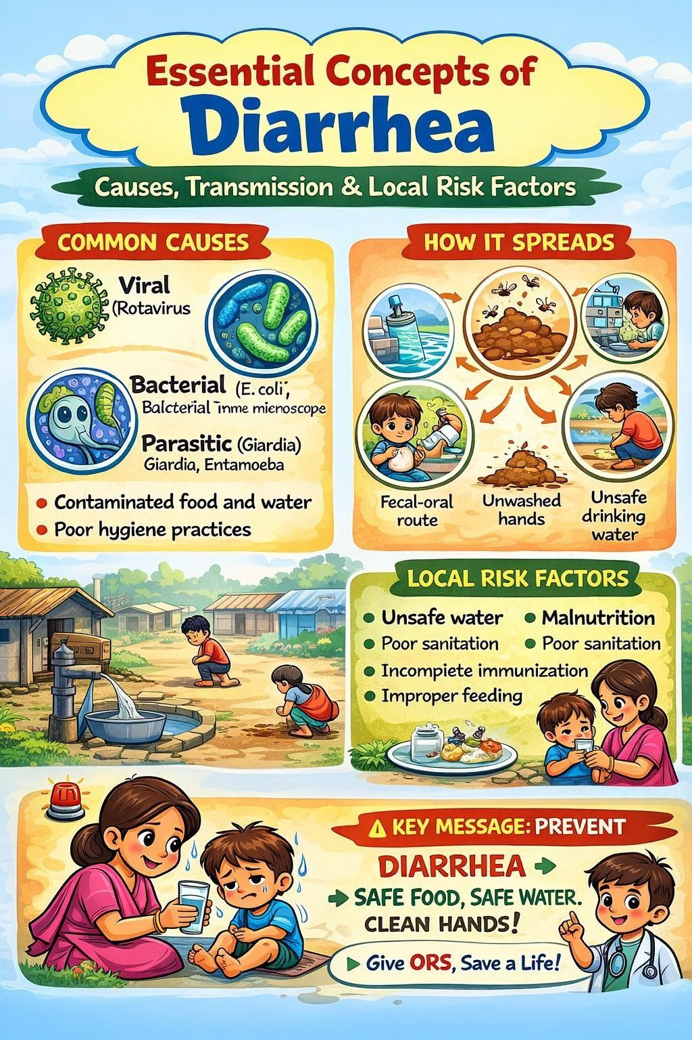

LEARNING OBJECTIVES

By the end of this session, you will be able to:

31

  - Define diarrhea clearly
  - Identify different types of diarrhea
  - Understand how diarrhea spreads in the community

  - Recognize local risk factors that increase diarrhea in children
  - Identify myths and harmful practices related to diarrhea

WHAT IS DIARRHEA?
Diarrhea is defined as the passage of three or more loose or liquid stools per day. However, it is the consistency of the stools rather than number that is more important.
Diarrhea is usually a symptom of an infection in the intestinal tract, which can be caused by a variety of bacterial, viral and parasitic organisms.

- Frequent passing of
formed stools.
- “Pasty” stools passed by babies who are breastfed.
What is not diarrhea?

WHAT ARE VARIOUS TYPES OF DIARRHEA?
There are three clinical types of diarrhea:

    - Acute watery diarrhea – lasts several days, and includes cholera;
    - Acute bloody diarrhea – also called dysentery; and
    - Persistent diarrhea – lasts 14 days or longer.

COMPLICATIONS OF DIARRHEA
The main danger associated with acute watery diarrhea is dehydration. Weight loss may also occur if feeding is not continued. Damage of intestinal mucosa, sepsis and malnutrition may additionally occur in acute bloody diarrhea. Persistent diarrhea may lead to malnutrition.
Dehydration may also occur sometimes.

DIARRHEA ASSOCIATED WITH DEHYDRATION
During a diarrheal episode, water and electrolytes (sodium, chloride, potassium and bicarbonate) are lost through liquid stools, vomit, sweat, urine and breathing. Dehydration occurs when these losses are not replaced.
The degree of dehydration is graded according to signs and symptoms that reflect the amount of fluid lost:
    - Early stages of dehydration-no signs and symptoms
32

    - Moderate dehydration-thirst, restless or irritable behavior, decreased skin turgor, sunken eyes and sunken fontanelle (in infants)
    - Severe dehydration- shock, with diminished consciousness, lack of urine output, cool, moist extremities, a rapid and feeble pulse, low or undetectable blood pressure, and pale skin.
(Show a video of a dehydrated child with diarrhea).

Death can follow severe dehydration if body fluids and electrolytes are not replenished.

WHAT ARE CAUSES OF DIARRHEA?
Infectious agents are by far the most common cause for sporadic or endemic episodes of acute diarrhea in children.
Infectious causes include:

Viruses
    - Rotavirus
    - Norovirus
    - Calcivirus
    - Astrovirus
    - Enteric type adenovirus

Bacteria
    - Campylobacter Jejuni
    - Salmonella
    - E coli
    - Shigella Clostridium difficile
    - Vibrio parahaemolyticus
    - Vibrio cholera

33
    - Aeromonas hydrophila

Parasites
    - Cryptodporidium

    - Giardia lamblia
Besides, there are other non-infectious causes of diarrhea as well. These include: drug induced, food allergies or intolerances, malabsorption disorders, chemotherapy or radiation induced enteritis, heavy metal ingestion, vitamin deficiencies.

MODES OF TRANSMISSION OF DIARRHEA
Most pathogens that cause diarrhea share a similar mode of transmission – from the stool of one person to the mouth of another. This is known as faecal-oral transmission. Acute diarrhea usually occurs by ingestion of contaminated food or water. Infection is more common when there is a shortage of adequate sanitation and hygiene and safe water for drinking, cooking and cleaning.
Food is another major cause of diarrhea when it is prepared or stored in unhygienic conditions. Water can contaminate food during irrigation.3 Fish and seafood from polluted water may also contribute to the disease.

VULNERABILITY TO CHILDHOOD DIARRHEA
- Various studies across the world indicate that low level of maternal education, working status of mother, absence of toilet facility, lack of hand washing before feeding, inadequate breastfeeding, improper child stool disposal methods, not improved source of drinking water, poor socio-economic status, having more than two under five children, higher birth order and the age of the child are some of the risk factors associated with childhood diarrhea. Incidence of diarrheal diseases is observed to be maximum during the summer months followed by rainy or winter months.

HOW DOES DIARRHEA SPREAD?

Diarrhea spreads mainly through the fecal–oral route.

Common Routes of Transmission

- Drinking contaminated water

34
- Eating contaminated food
- Dirty hands feeding the child
- Flies sitting on food

- Open defecation near water sources

35

Anything that carries germs from stool to mouth can cause diarrhea.

DIARRHEA TRANSMISSION CYCLE (LOCAL CONTEXT)

- Open defecation contaminates soil and water
- Rainwater carries germs into wells and ponds
- Germs enter household drinking water
- Family members consume contaminated water or food
- Children develop diarrhea

WHO IS MOST AT RISK?

Children at higher risk include:

- Children under 2 years of age
- Non-breastfed infants
- Malnourished children
- Children from households without toilets
- Children drinking unsafe water

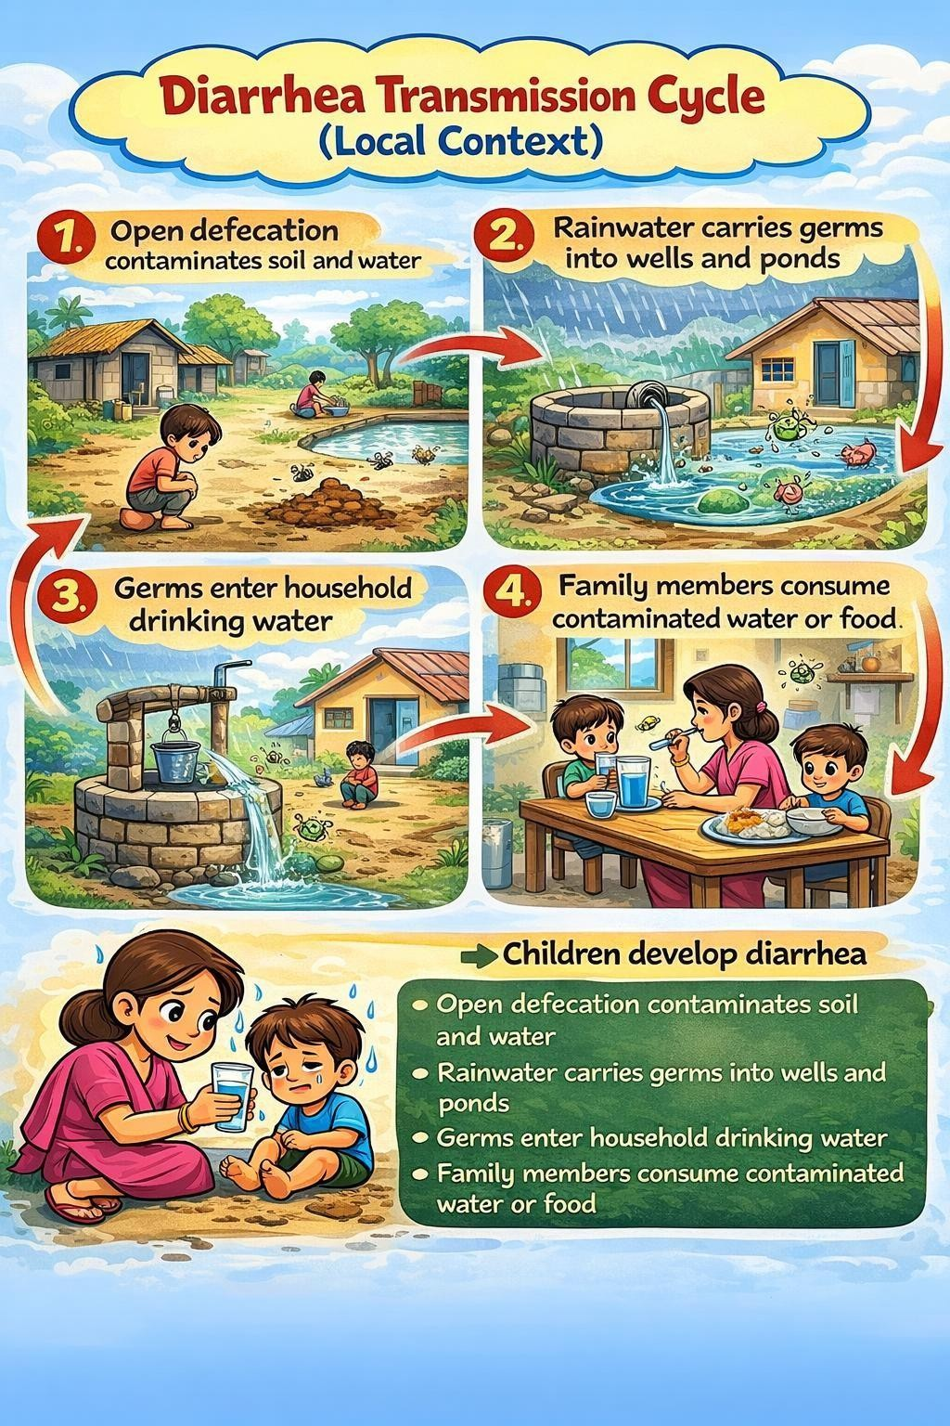
Breaking this cycle is key to prevention.

LOCAL RISK FACTORS COMMONLY SEEN

In many communities, diarrhea is linked to:

36

- Unsafe water storage in open containers
- Not washing hands before feeding children
- Stopping breastfeeding early

- Food kept uncovered
- Belief that ORS is “hospital medicine only”

As a health worker, identifying these risks helps in targeted counseling.

MYTHS AND MISCONCEPTIONS ABOUT DIARRHEA

Some common harmful beliefs include:

- “Breastfeeding should be stopped during diarrhea”
- “ORS increases loose motions”
- “Diarrhea is caused by teething or hot foods only”
- “Home remedies are enough; medical care is not needed” These myths delay proper treatment and increase risk. CORRECT FACTS YOU MUST SHARE
- Breastfeeding should continue during diarrhea
- ORS does not stop diarrhea, but prevents dehydration
- Zinc helps in faster recovery and prevents future episodes
- Clean water, sanitation, and hygiene reduce diarrhea

ROLE OF GRASSROOT LEVEL WORKERS IN PREVENTION OF DIARRHEA

Grassroot level workers can reduce diarrhea by:

- Educating families on handwashing
- Promoting toilet use
- Encouraging safe water practices
- Correcting myths respectfully

37
- Demonstrating ORS preparation

CASE EXAMPLE (LOCAL CONTEXT)

38
COMPETENCY ACHIEVED: Grassroot level workers developed the ability to understand, analyze, and explain the causes, transmission, risk factors, and prevention of diarrhea, enabling them to identify and address community-level determinants effectively

A 2-year-old child has diarrhea. The mother stops milk and gives only rice water. Water is stored in an open pot, and there is no toilet at home.

RISK FACTORS PRESENT:

- Stopping breastfeeding
- Unsafe water storage
- Poor sanitation

GRASSROOT LEVEL WORKERS ROLE:
Correct myths, promote ORS and zinc, encourage hygiene.

KEY MESSAGES TO REMEMBER

- Diarrhea spreads through dirty water, food, and hands
- Children under two years are most vulnerable
- Local practices strongly influence risk
- Myths can increase danger
- Prevention starts at household level
- Diarrhea is defined as the passage of three or more loose or watery stools per day.
- There are three clinical types of diarrhea: acute watery, acute bloody and persistent diarrhea
- During a diarrheal episode, water and electrolytes (sodium, chloride, potassium and bicarbonate) are lost which can cause dehydration.
- Diarrhea is transmitted by faeco-oral route.
- Diarrhoea is caused by both infectious and non-infectious agents.
- Viral diarrhea is more common in childhood.

FACILITATION NOTES AND ACTIVITIES

EXERCISE
Q1. A 1month old child on breast milk is passing pasty stools 3-4 times a day in last 2 days. The mother says that he has history of passage of such stools. What is your diagnosis?
Ans.
Q2. A 4month old is passing loose watery stools for last 3 days. The child is not being breastfed. The child is top-fed and taking water also since birth. The child is 5 birth order living in a family of seven. There is no toilet in the house. The mother is illiterate. But she works as housemaid in neighbouring colonies. Kindly enlist the risk factors in the history for this child.
Ans.
Q3. A 3 year old child is passing loose watery stools for last 1 day. The child openly defecates near the house and does not wash hands before eating food. Describe the mode of transmission of infection in this case.
Ans.

PART 1: WHAT IS DIARRHEA? (10 MINS)

Use slide with local language terms for diarrhea (e.g., Diarrhea, Dysentery, Loose stools)

- Show 3 clinical types with local examples:
  - Acute watery – common in summer/rainy season here.
  - Dysentery (bloody) – seen after eating roadside food in town.
  - Persistent diarrhea – common in malnourished children in our AWC.

39

EXAMPLE:

“Last monsoon in [Village BRM], 15 children had watery diarrhea after the well was flooded. That’s acute watery diarrhea.”

PART 2: LOCAL CAUSES & TRANSMISSION (20 MINS) ACTIVITY: TRANSMISSION MAPPING
- Draw a child in the center of flipchart.
- Ask: “How does diarrhea reach our children here?”
- Use photo cards to build the map:
  - Contaminated hand → child’s mouth
  - Dirty water → drinking
  - Flies on food → child eats
  - Open defecation → water source

INSIGHTS:

“In our area, the biggest cause is hand contamination after farming – parents come home and feed children without washing.”
“During weddings, food left outside causes outbreaks.”

PART 3: VULNERABILITY – WHO IS MOST AT RISK? (15 MINS) RISK FACTOR CARD GAME:
- Distribute risk factor cards (local examples):
  - Child under 2 years
- Not breastfed
- No toilet at home
- Mother works outside
- Stored water in open pot
40

- Belief: “ORS is medicine only for hospitals”
- Water: Well water without boiling
- Sanitation: No toilet / toilet not used
- Handwashing: No soap at home
- Feeding: Early stop of breastfeeding
- Food: Food kept open for flies
41
- Ask participants to rank them by commonness in their village.
- Discuss: “Which of these can we change? How?”

PART 4: LOCAL MYTHS VS. FACTS (15 MINS) MYTH-BUSTING EXERCISE:
- Share 3 common local myths on slips.
- In groups, discuss why they’re harmful.
- Create a “Fact Response” in local language.

ANNEXURE III-A: LOCAL DIARRHEA TRANSMISSION CYCLE

Open Defecation → Flies → Food → Child eats → Diarrhea
↓ Rainwater runoff
↓
Well /Pond water
↓
Household drinking water
↓
Family members drink → Diarrhea

ANNEXURE III-B: LOCAL RISK FACTOR CHECKLIST

Tick the factors you see in your village:

  - Beliefs: ORS not trusted / not used
  - Seasonal: More diarrhea in month
  - Economic: Mother working far away

Most common in your area:

ANNEXURE III-C: CASE STUDY – LOCAL CONTEXT

CASE:
In [ Bomalaramaram Village], 2-year-old Mohan had 6 loose stools in a day. His mother gave him ghutty (rice starch) and stopped milk. She said, “Doodh se aur kharab hoga.” Mohan’s father works in the city, mother works in MGNREGA digging. They have a toilet but use it for storage. Water is from a handpump, stored in an open matka.

Questions for Group Discussion:

- What type of diarrhea is this?
- List 3 transmission risks in this home.
- What myth is affecting treatment?
- What would you advise the mother?

SESSION SUMMARY

This session provided participants with a comprehensive understanding of the essential concepts of diarrhea, including its definition, types, causes, modes of transmission, complications, and local risk factors. Participants learned that diarrhea is defined as the passage of three or more loose or watery stools per day, and that stool consistency is more important than frequency.
The session clarified the three clinical types of diarrhea—acute watery diarrhea, acute bloody diarrhea (dysentery), and persistent diarrhea—and emphasized dehydration as the most life-

42

threatening complication. Participants understood the pathophysiology of dehydration, including the loss of fluids and electrolytes, and recognized early, moderate, and severe signs of dehydration.

The discussion highlighted infectious causes (viral, bacterial, parasitic) as the most common etiologies in children, along with important non-infectious causes. Special focus was given to the fecal–oral route of transmission and the local transmission cycle involving unsafe water, poor sanitation, improper food handling, and inadequate hand hygiene.

Participants identified vulnerable groups, especially children under two years, malnourished children, and non-breastfed infants. Local risk factors and harmful myths were explored, reinforcing the importance of culturally sensitive counseling.

Overall, this session strengthened participants’ conceptual clarity and contextual understanding of diarrhea, enabling them to link clinical knowledge with community realities and preventive strategies.

REFERENCES

- World Health Organization. The treatment of diarrhoea: a manual for physicians and other senior health workers. 4th ed. Geneva: WHO; 2005.
- Lamberti LM, Fischer Walker CL, Black RE. Systematic review of diarrhea duration and severity in children and adults in low- and middle-income countries. BMC Public Health. 2012;12:276.
- Ministry of Health and Family Welfare, Government of India. Integrated management of neonatal and childhood illness (IMNCI) handbook. New Delhi: MoHFW; 2009.
- Das JK, Salam RA, Bhutta ZA. Global burden of childhood diarrhea and interventions.
Curr Opin Infect Dis. 2014;27(5):451–458.
- World Health Organization. Diarrhoeal disease [Internet]. Geneva: WHO; 2013 [cited 2026 Feb 22]. Available from: https://www.who.int/news-room/fact-sheets/detail/diarrhoeal-disease
43

- Medscape. Diarrhea clinical presentation [Internet]. 2015 [cited 2026 Feb 22]. Available from: https://emedicine.medscape.com/article/928598-clinical

44
- Mihrete TS, Alemie GA, Teferra AS. Determinants of childhood diarrhea among under-five children in Benishangul Gumuz Regional State, Northwest Ethiopia. BMC Pediatr. 2014;14:102.
- Mengistie B, Berhane Y, Worku A. Prevalence of diarrhea and associated risk factors among children under five years of age in Eastern Ethiopia: a cross-sectional study. Open J Prev Med. 2013;3(7):446–453.
- Lakshminarayanan S, Jayalakshmy R. Diarrheal diseases among children in India: current scenario and future perspectives. J Nat Sci Biol Med. 2015;6(1):24–28.

SESSION 4: ASSESSMENT, CLASSIFICATION & MANAGEMENT OF DIARRHEA
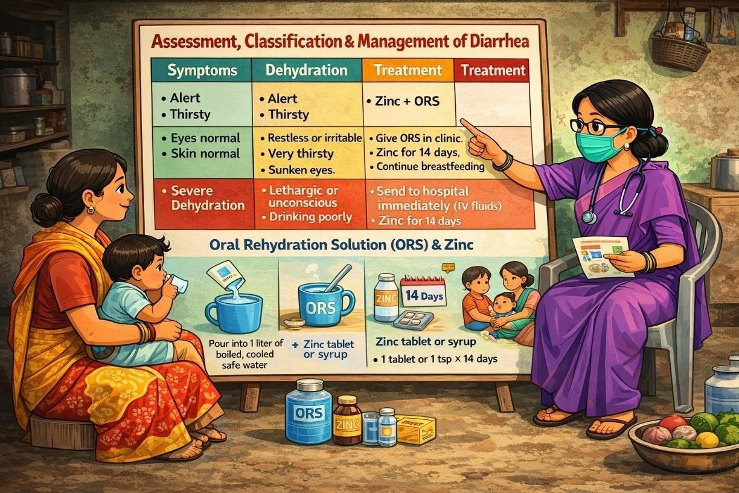

LEARNING OBJECTIVES

After this session, you will be able to:

  - Assess a child with diarrhea systematically
  - Classify dehydration correctly
  - Decide appropriate management (home care, clinic care, or referral)
  - Prepare and explain ORS and zinc administration

INTRODUCTION
A child with diarrhea should be assessed for dehydration, bloody diarrhea, persistent diarrhea, malnutrition, serious non-intestinal infections, so that an appropriate treatment plan can be developed and implemented without delay.

45

HISTORY

Ask the mother or caretaker about:
  - Age of the child
  - Duration of diarrhea
  - Frequency of diarrhea
  - Presence of blood in stool
  - Presence of fever, cough or other important problems (e.g. recent measles)
  - Presence and frequency of vomiting
  - Type and amount of fluids (including breast milk) food taken during illness
  - Immunization status
  - Drugs or other remedies taken

ASSESSMENT OF A CHILD WITH DIARRHEA

Assessment should be done using the Look – Feel – Ask method.

CLINICAL ASSESSMENT
Look for signs and symptoms of dehydration:
- Child’s general condition. Assess if the child is alert or lethargic or unconscious or restless/ irritable
- Are the eyes normal or sunken?
- Child’s reaction when offered to drink: When water or ORS solution is offered to drink, is it taken normally or refused, taken eagerly, or is the child unable to drink owing to lethargy or coma?
Feel the child to assess:
  - Elasticity of the skin: Check elasticity of skin using the skin pinch test. When released, the skin pinch goes back either very slowly (longer than 2 seconds) or slowly (skin stays up even for a brief instant), or immediately.
  - Then check for signs of other important problems.
46

  - Look for:
    - Does the child’s stool contain red blood?
    - Is the child malnourished? Check for visible severe wasting of the shoulders, arms, buttocks and legs, with ribs easily seen. Look at the child’s hips. They may look small when compared to chest and abdomen. This indicates presence of marasmus. Look at the child from the side to see if the fat of the buttocks is missing. When wasting is extreme, there are many folds of skin on the buttocks and thigh. However, the face of a child with visible severe wasting may still look normal. Look also for oedema of feet. If possible assess child’s weight for age using growth chart.
    - Is the child coughing? If so, count the respiratory rate to determine whether breathing is abnormally rapid and look for chest in drawing.
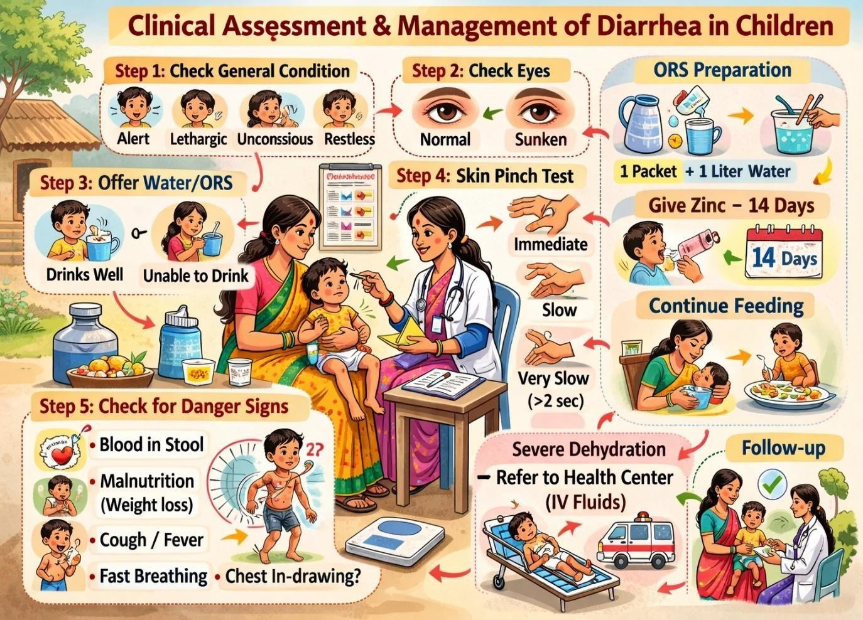
  - Take the child’s temperature
47

CLASSIFICATION OF DEHYDRATION

Based on a combination of the above clinical signs, children presenting with diarrhea are classified into 3 categories:
TABLE 1: ASSESSMENT OF DIARRHEA PATIENTS FOR DEHYDRATION

Categories | A | B | C
Look at:  - Condition  - Eyes  - Thirst | Well, alert Normal Drinks normally, not thirsty | Restless, irritable Sunken  Thirsty, drinks eagerly | Lethargic/unconscious Sunken  Drinks poorly, or not able to  drink
Feel: skin pinch | Goes back  quickly | Goes back slowly | Goes back very slowly
Decide | The patient has NO SIGNS OF DEHYDRATION | If the patient has two or more signs in B, there is SOME  DEHYDRATION | If the patient has two or more signs in C, there is SEVERE  DEHYDRATION
Treat | Use treatment plan A | Weigh the patient, and use treatment plan B | Weigh the patient, and use  treatment plan C URGENTLY
Note:
- Being lethargic and sleepy are not the same. A lethargic child is not simply asleep: the child’s mental state is dull and the child cannot be fully awakened; the child may appear to be drifting into unconsciousness.
- In some infants and children, the eyes normally appear somewhat sunken. It is helpful to ask the mother if the child’s eyes are normal or more sunken than usual.
- The skin pinch is less useful in infants or children with marasmus or kwashiorkor, or obese children.

CLASSIFICATION OF PERSISTENT DIARRHEA
All children with diarrhea for 14 days or more should be classified based on the presence or absence of any dehydration
- If dehydration is present, children are classified as having severe persistent diarrhea. Such children require special treatment and should not be managed at outpatient
48

health facility.
- If no signs of dehydration are present, children are classified as having persistent diarrhea. Such children can safely be managed at outpatient health facility.

CLASSIFICATION OF DYSENTERY
A child is classified as having dysentery if mother or caretaker reports blood in child’s stool. Bloody diarrhea is usually a sign of invasive enteric infection that carries a substantial risk of morbidity and death.

EXERCISE
Q1. Case: Fatima is 18 months old. She weighs 11.5 Kg. Her temperature is 37.5 degree Celsius. The mother brought the child to the physician and complained that the child is having diarrhea for 3 days. She said, “there was no blood in the stool.” The general condition of the child was poor. Child looked lethargic. Fatima’s eyes looked sunken. The physician asked “Do you notice anything different about Fatima’s eyes?” The mother said “Yes”. He gave the mother some clean water in a cup and asked her to offer it to Fatima. When offered the cup, Fatima would not drink. When pinched, the skin of Fatima’s abdomen went back slowly.
Classify the child with diarrhea

Ans.
Q2. Case: Jatin is 6 weeks old. He weighs 4.5 Kg. His temperature is 37 degree Celsius. The physician asks the mother about Jatin’s diarrhea, the mother replies that it began 3 days ago, there is no blood in the stool. Jatin is crying. He stopped once when his mother put him to the breast. He began crying again when she stopped breastfeeding. His eyes look normal, not sunken. When the skin of his abdomen is pinched, it goes back slowly.
Classify the child with diarrhea
Ans.

49

MANAGEMENT OF ACUTE DIARRHEA
The objectives of treatment are to:
- Prevent dehydration, if there are no signs of dehydration;
- Treat dehydration, when it is present;
- Prevent nutritional damage, by feeding and during diarrhea;
- Reduce the duration and severity of diarrhea and the occurrence of future episodes by giving supplemental zinc.

TREATMENT PLAN A: HOME THERAPY TO PREVENT DEHYDRATION AND MALNUTRITION
Children with no signs of dehydration need extra fluids and salt to replace their losses of water and electrolytes due to diarrhea. Mothers should be taught how to prevent dehydration at home by giving the child more fluid than usual, how to prevent malnutrition by continuing to feed the child, and why these actions are important. There are 4 rules of home treatment: give extra fluid, zinc supplement, continue feeding, when to return.
- Give extra fluid (as much as the child will take)
  - If the child is exclusively breastfed: Breastfeed frequently and for longer at each feed. If passing frequent watery stools:
    - For less than 6 months age give ORS (oral rehydration solution) and clean drinking water in addition to breast milk.
    - If 6 months or older give one or more of the home fluids in addition to breast milk.
  - If the child is not exclusively breastfed: Give one or more of the following home fluid: ORS solution, food based fluid (such as soup, rice water, and yoghurt drinks, coconut water) or clean water.
  - It is especially important to give ORS at home when:
    - The child has been treated with Plan B or Plan C during this visit.
    - The child cannot return to a clinic if the diarrhea gets worse.
  - Teach the mother how to mix and give ORS. Give the mother 2 packets of ORS to use at home.
50

  - Show the mother how much fluid to give in addition to the usual fluid intake:

Up to 2 years | 50-100 mL after each loose stool
2 years or more | 00 to 200 ml after each loose stool
  - Tell the mother to:
    - Give frequent small sips from a cup
    - If the child vomits, wait 10 minutes. Then continue, but more slowly.
    - Continue giving extra fluid until the diarrhea stops.

- Give Zinc (age 2 months upto 5 years)

  - Tell the mother how much zinc to give (20 mg tab):

2 months to 6 months | ½ tablet daily for 14 days
6 months or more | 1 tablet daily for 14 days
  - Show the mother how to give zinc supplements
    - Infants- dissolve tablet in a small amount of expressed breast milk, ORS or clean water in a cup.
    - Older children- tablets can be chewed or dissolved in a small amount of water.
- Continue feeding (exclusive breastfeeding if age less than 6 months)
- When to return: follow up in 5 days if not improving

TREATMENT PLAN B: ORAL REHYDRATION THERAPY FOR CHILDREN WITH SOME DEHYDRATION
Children with some dehydration should receive oral rehydration therapy (ORT) with ORS solution in a health facility following Treatment Plan B. Determine amount of ORS to give during first 4 hours

51

Weight | <6 Kg | 6-<10 Kg | 10-<12 Kg | 12-19 Kg
Age* | Upto 4 months | 4-12 months | 1-2 years | 2-5 years
In ml | 200-450 | 450-800 | 800-960 | 960-1600
*Use the child’s age only when you do not know the weight. The approximate amount of ORS required (in ml) can also be calculated by multiplying child’s weight (in Kg) times 75.
- If the child wants more ORS than shown, give more.
- For infants under 6 months who are not breastfed, also give 100-200 ml clean water during this period if you use standard ORS. This is not needed if you use low osmolarity ORS.
- Show the mother how to give ORS solution
  - Give frequent small sips from cup.
  - If the child vomits, wait 10 minutes. Then continue, but more slowly.
  - Continue breastfeeding whenever the child wants.
- After 4 hours:
  - Reassess the child and classify the child for dehydration
  - Select the appropriate plan to continue treatment.
  - Begin feeding the child in clinic
- If the mother must leave before completing the treatment:
  - Show her how to prepare ORS solution at home.
  - Show her how much ORS to give to finish 4-hour treatment at home.
  - Give her enough ORS packets to complete rehydration.
  - Explain her 4 rules of home treatment.

TREATMENT PLAN C: FOR PATIENTS WITH SEVERE DEHYDRATION
The preferred treatment for children with severe dehydration is rapid intravenous rehydration, following Treatment Plan C. If possible, the child should be admitted to hospital.

- Start IV fluid immediately. If the patient can drink, give ORS by mouth until the

52

drip is set up. Give 100 ml/Kg Ringer Lactate solution (or if not available, normal saline), divided as follows:

Age | First give 30 ml/kg in: | Then give 70 ml/kg in:
Infants (under 12 months) | 1 hour | 5 hours
Children (12 months upto 5 years) | 30 minutes | 2.5 hours

- Reassess the child every 1-2 hours. If hydration status is not improving, give the IV drip more rapidly.
- Also give ORS (about 5 ml/kg/hour) as soon as the child can drink: usually after 3-4 hours (infants) or 1-2 hours (children).
- Reassess an infant after 6 hours and a child after 3 hours. Classify dehydration. Then choose the appropriate plan (A, B or C) to continue treatment.
Exercise
Q1. For the above mentioned 2 cases, kindly discuss the suitable treatment plan in detail.
Ans.

DEMONSTRATION: WHO ORS
Preparing one litre Oral Rehydration Soultion (ORS): Take 5 cups of water (each cup of 200 mL). Boil the water and then cool it. Mix the WHO recommended low osmolarity solution in one litre of water. Keep giving this ORS at regular interval over 24-hour period.

53

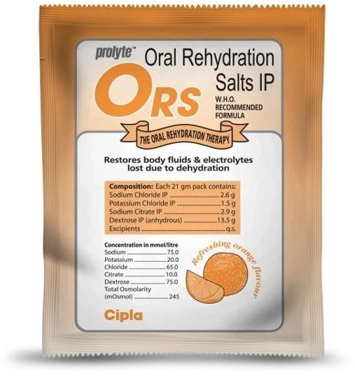

DEMONSTRATION: HOME-MADE ORS
Preparing one litre Oral Rehydration Solution (ORS) using salt, sugar and water at home. Mix an oral rehydration solution using one of the following recipes; depending on ingredients and container availability:
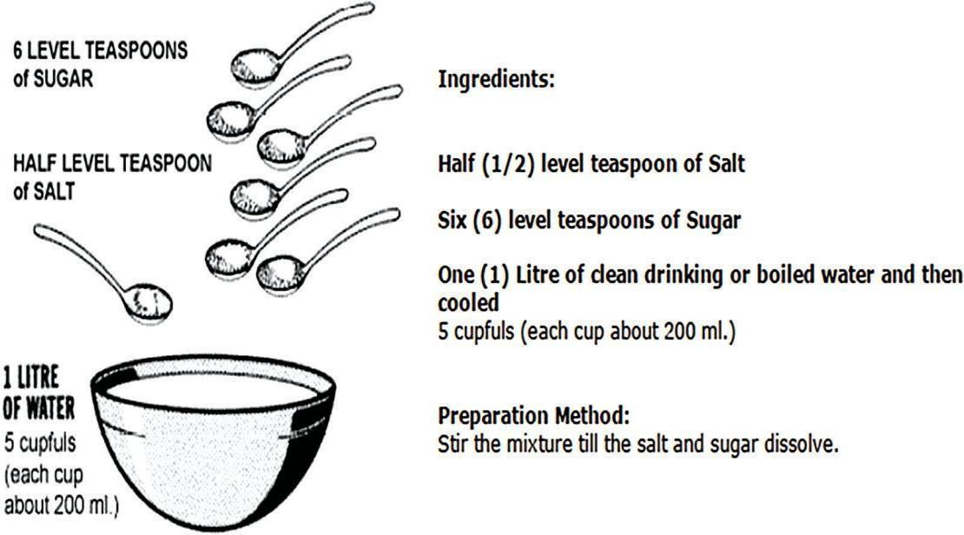

Note:

Antibiotics should not be used routinely for treatment of diarrhea. Most diarrheal episodes are caused by agents for which anti-microbials are not effective, e.g. viruses.
Anti-diarrheal drugs-including anti-motility agents (e.g. loperamide, diphenoxylate, codeine, tincture of opium), adsorbents (e.g. kaolin), live bacterial cultures (e.g. lactobacillus, streptococcus faecium), and charcoal-do not provide practical benefits for children with acute diarrhea.
54

BREASTFEEDING DURING DIARRHEA

- Continue breastfeeding
- Continue age-appropriate feeding
- Do not starve the child

INDICATIONS FOR REFERRAL

- Severe dehydration
- Persistent vomiting
- Blood in stool
- Child unconscious or unable to drink

KEY MESSAGES

- ORS saves lives
- Breastfeeding should never be stopped
- Zinc for 14 days is essential
- Correct classification prevents complications
- Early referral prevents death

- Ask, look and feel for relevant signs and symptoms related to diarrhea.
- Assessment of dehydration in a case of diarrhea is must.
- A case of diarrhea can be classified into 3 categories based on general condition, eyes, skin pinch and thirst.
- Treatment Plan A is given as home therapy to prevent dehydration; Treatment Plan B is for children with some dehydration whereas Treatment Plan C for children with severe dehydration and have to be managed in hospital inpatient department
- For a breastfed child, continue breastfeeding even during the episode of diarrhea.
- In absence of ORS, homemade ORS can also be given to child.
- Viral diarrhea is more common in childhood.

55

COMPETENCY ACHIEVED: Grassroot level workers independently assesses a child with diarrhea and initiates correct ORS, zinc, or referral based on classification.

FACILITATION NOTES AND ACTIVITIES

PART 1: HISTORY TAKING – ASKING THE RIGHT QUESTIONS (20 MINS) ACTIVITY: THE COMPLETE HISTORY
- Use a local case example to model questions:
*“Last Tuesday, Sita’s 18-month-old son had loose motions. What should we ask her?”
- Teach the HADFIB mnemonic (local adaptation):

  - H – How many stools? (How many times is the child passing stools in a day?)
  - A – Any blood? (Is there any blood in the stool?)
  - D – Duration? (Since when has the diarrhea started?)
  - F – Fever? (Does the child have fever?)
  - I – Intake? (What has the child eaten or drunk? Is the child able to drink fluids?)
  - B – Behavior? (How is the child behaving? Is the child active, lethargic, or irritable?)

LOCAL TOUCH:

“In our villages, always ask: ‘Does anyone defecate in the courtyard?’ – many children play there.”
“Ask if they’ve given ‘Home remedy’ like Jeera water– it affects treatment.”
PART 2: CLINICAL ASSESSMENT – LOOK, FEEL, ASK (25 MINS)

DEMONSTRATION: THE 3-MINUTE CHECK

1. LOOK – Show photo cards: sunken eyes, dry mouth, lethargic child.
56

- FEEL – Demonstrate skin pinch on doll. Ask: “If the skin pinch returns in more than 2 seconds.?”
- ASK – “Is the child thirsty? Is the child able to drink fluids?”

ROLE-PLAY ACTIVITY:

  - In pairs, one is health worker, one is mother.
  - Use role-play cards with local details:
“Child: 2 years, 8 loose stools, vomiting, drinks little, eyes look fine.”
  - Practice Look-Feel-Ask in 5 minutes.
  - Swap roles.

PART 3: CLASSIFICATION – USING OUR LOCAL CHART (25 MINS)

GROUP EXERCISE: CLASSIFY THESE CASES
Display 3 cases on flipchart (mix from local reports):

Case A: Ravi, 1 year, 5 watery stools, playing, drinking milk, eyes normal.
Case B: Anjali, 3 years, 10 stools, restless, eyes sunken, skin pinch slow.
Case C: Deepak, 18 months, 12 stools, unconscious, eyes deep sunken, skin pinch very slow.

STEPS:

- Groups discuss and classify (No/Some/Severe).
- Write action: Home/Clinic/Refer.
- Refer to local referral poster – who to call for Case C?

LOCAL INSIGHT:

“Most workers misclassify ‘some’ as ‘severe’ because they panic. Remember: If the child can
drink, it’s not severe yet.”
PART 4: MANAGEMENT & ORS PREPARATION (40 MINS)

A. MANAGEMENT PLANS – LOCAL ADAPTATIONS:
57

  - Plan A (Home): Home management – Give ORS, Zinc, and continue feeding.
  - Plan B (Clinic): Give ORS at the Primary Health Centre.
  - Plan C (Refer): Immediate hospital referral – Dial this number:

B. ORS PREPARATION – HANDS-ON DRILL:

- WHO ORS Demo: Show 1 packet + 1L clean water.
- Home-Made ORS Demo: Use local measures:

  - 1 teaspoon of sugar + 1 pinch of salt + 1 glass of water.
  - 1 handful of sugar + a three-finger pinch of salt + 1 liter of water.

- Common Mistakes Here:
- Too salty → show taste test
- Dirty hands → demonstrate handwash first
- Storing >24 hours → explain why not

C. ZINC DEMONSTRATION:

- Show correct dose: 20mg tablet for 14 days.
- Local tip: “Dissolve the tablet in milk so that the child can take it more easily.”

PART 5: WRAP-UP & Q&A (10 MINS)

- Quick quiz: “3 signs of severe dehydration?”
- Distribute Take-Home Cards with classification chart and ORS recipe.
- Remind: “If there is any suspicion of complications, refer the child immediately.”
ANNEXURE IV-A: DIARRHEA ASSESSMENT CHECKLIST (LOCAL
LANGUAGE) CHILD ASSESSMENT FORM
58

Child’s Name:
Age: Date:

Ask:

- Since when has the child had diarrhea?
- How many times per day?
- Is there blood in the stool? Yes / No
- Vomiting? Yes / No
- Fever? Yes / No
- What is the child drinking? Milk / Water / ORS / Nothing

Look:

- Are the eyes sunken? Yes / No
- Is the child lethargic or unconscious? Yes / No

Check:

- Skin pinch test – Returns immediately / Returns slowly / Returns very slowly

Decision:

- No dehydration → Treat at home
- Some dehydration → Give ORS at the clinic
- Severe dehydration → Refer immediately

Refer to: (Phone Number: )

ANNEXURE IV-B: LOCAL ORS PREPARATION GUIDE METHOD 1 – USING ORS PACKET:

59
- Take 1 liter of clean water.

- Add 1 ORS packet.
- Mix well.
- Use within 24 hours.

METHOD 2 – HOMEMADE ORS (IF PACKET IS NOT AVAILABLE):

- 1 liter of water
- 6 level teaspoons of sugar
- ½ level teaspoon of salt

Caution: Do not add extra salt. Too much salt can be harmful.

ANNEXURE IV-C: ROLE-PLAY CARDS CARD 1 – MOTHER:
“My child is 1 year old. Since morning, he has passed loose stools 4 times. He is playing and drinking milk.”

CARD 2 – HEALTH WORKER:

You need to:

- Ask 3 questions
- Check the eyes and perform the skin pinch test
- Decide and explain: What should be done?

SESSION SUMMARY

In this session, participants learned how to systematically assess a child with diarrhea using proper history taking and the Look–Feel–Ask approach. Early and accurate identification of dehydration signs is essential to prevent complications and reduce mortality.
Participants were trained to classify dehydration into No Dehydration, Some Dehydration, and Severe Dehydration, and to select the appropriate treatment plan (Plan A, B, or C) based on
60

clinical findings. Correct classification ensures timely management and prevents both under-treatment and unnecessary referrals.

The session emphasized that ORS and zinc are the cornerstone of diarrhea management. ORS prevents and treats dehydration, while zinc reduces the duration and severity of diarrhea and prevents recurrence. Continued breastfeeding and appropriate feeding during illness are critical to prevent malnutrition.

Participants also understood the importance of recognizing danger signs such as severe dehydration, persistent vomiting, blood in stool, and inability to drink, which require urgent referral.

Overall, this session strengthens the clinical decision-making capacity of grassroots-level health workers, enabling them to provide timely, evidence-based, and life-saving care for children with diarrhea at the community level.

REFERENCES

- World Health Organization. Pocket book of hospital care for children: guidelines for the management of common childhood illnesses. 2nd ed. Geneva: WHO; 2013.
- World Health Organization. Guidelines for the clinical management of diarrhoea. Geneva: WHO; 2004.
- Ministry of Health and Family Welfare, Government of India. National guidelines on management of childhood diarrhoea. New Delhi: MoHFW; 2014.
- Lazzerini M, Wanzira H. Oral zinc for treating diarrhoea in children. Cochrane Database Syst Rev. 2016;12:CD005436.
- Freedman SB, Ali S, Oleszczuk M, Gouin S, Hartling L. Treatment of acute gastroenteritis in children: an overview of systematic reviews of interventions commonly used in developed countries. Evid Based Child Health. 2013;8(4):1123–1371.
- World Health Organization. The treatment of diarrhoea: a manual for physicians and other senior health workers [Internet]. Geneva: WHO; 2005 [cited 2026 Feb 22]. Available from: https://apps.who.int/iris/handle/10665/43209

61

- Ministry of Health and Family Welfare, Government of India. Student’s handbook for Integrated Management of Neonatal and Childhood Illness (IMNCI). New Delhi: MoHFW; 2009.

62
- Rehydrate.org. Oral rehydration solutions: made at home [Internet]. 2012 [cited 2026 Feb 22]. Available from: http://rehydrate.org/solutions/homemade-ors.pdf

SESSION 5: PREVENTION OF DIARRHEA – LOCAL STRATEGIES & PRACTICAL SOLUTIONS
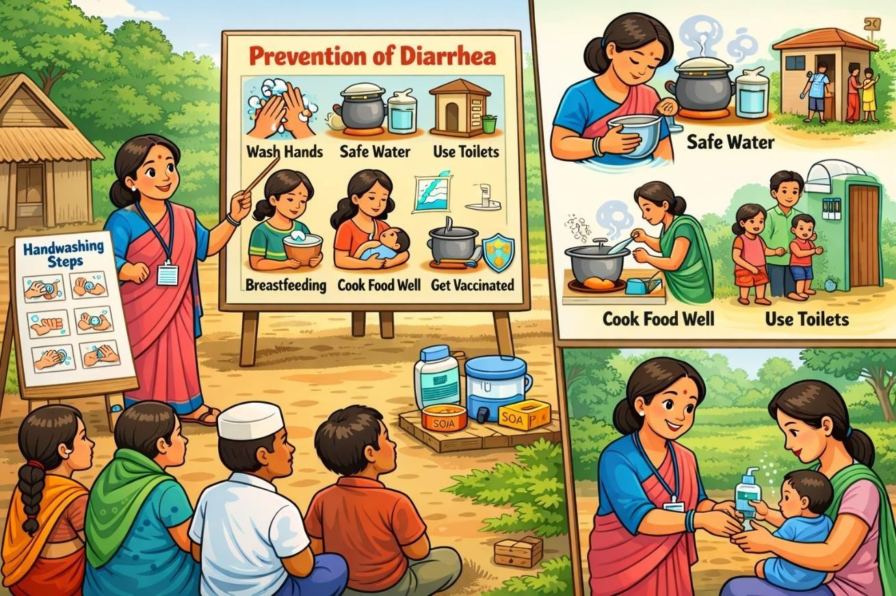

LEARNING OBJECTIVES

After this session, participants will be able to:

  - List key evidence-based measures to prevent diarrhea
  - Identify local behaviors that increase diarrhea risk
  - Demonstrate correct handwashing and safe water practices
  - Educate families on simple, low-cost prevention methods

INTRODUCTION
Proper treatment of diarrheal diseases is highly effective in preventing death, but has no impact on the incidence of diarrhea. However, there exists a range of preventive strategies for reducing the burden of morbidity associated with diarrhea. The key measures include:
63

    - Access to safe drinking water;
    - Use of improved sanitation;
    - Hand washing with soap at critical times
    - Exclusive breastfeeding for the first six months of life; and continued breastfeeding for two years.
    - Good personal and food hygiene;
    - Health education about how infections spread;
    - Measles and Rotavirus vaccination

ACCESS TO SAFE DRINKING WATER
Safe drinking water is water with microbial, chemical and physical characteristics that meet WHO guidelines or national standards on drinking water quality (Indian standards for drinking water IS 10500 See the Annexure I); and access to safe drinking water means that the source is less than 1 kilometer away from its place of use and that it is possible to reliably obtain at least 20 litres per member of a household per day (WHO). In India, as per Ministry of Drinking Water & Sanitation (MDWS), India, in rural context safe water requirement is 55 lpcd within the household premises or at a horizontal or vertical distance of not more than 100 metres from their household without barriers of social or financial discrimination (Purpose and quantity (in lpcd): Drinking -3, Cooking- 5, Bathing 15, Washing utensils and house 10, Ablution/Toilets 10 Washing of Clothes and other uses 12=Total
55). Interventions to improve water quality at the source, along with treatment of household water and safe storage systems, have been shown to reduce diarrhea incidence by as much as 47 per cent. Household water treatment options that are currently being promoted include chlorination, filtration, disinfection, boiling, and solar disinfection. (See Appendix I)

Further, families should:
- Collect water from the cleanest available source.
- Not allow bathing, washing, or defecation near the source. Latrines should be located more than 15 metres away and downhill.
- Keep animals away from protected water sources.
64

- Collect and store water in clean containers; empty and rinse out the containers every day; keep the storage container covered and take out water with a long handled laddle that is kept especially for the purpose so that hands do not touch the water.
- Use filtered and boiled water for drinking and making food for young children. Water needs only to be brought to a rolling boil.
- The amount of water available to families has as much impact on the incidence of diarrheal diseases as the quality of water. In simpler terms it means that if the amount of water is less, it will impact the personal as well as environmental hygiene, thereby leading to infections. Also if the quality of water is poor, it leads to diarrhea

USE OF IMPROVED SANITATION
In India, around 595 million people, which is nearly half the population of India, defecate in the open. Open defecation poses a serious threat to the health of children in India. The practice is the main reason India reports the highest number of diarrheal death of children
under-five in the world. Children weakened by frequent diarrhea episodes are more vulnerable to malnutrition, stunting, and opportunistic infections such as pneumonia. Improving sanitation facilities has been associated with an estimated median reduction in diarrhea incidence of 36 per cent. This is due to the fact that improved sanitation prevents the transmission of pathogens that cause diarrhea by preventing human faecal matter from contaminating environment. Every family needs access to a clean, functioning latrine.
(To accelerate the efforts to achieve universal sanitation coverage and to put focus on sanitation, the Prime Minister of India launched the Swachh Bharat Mission on 2nd October, 2014. The Mission Coordinator is Secretary, Ministry of Drinking Water and Sanitation (MDWS) with two Sub-Missions, the Swachh Bharat Mission (Gramin) and the Swachh Bharat Mission (Urban), which aims to achieve Swachh Bharat by 2019)

HAND WASHING WITH SOAP
All diarrheal disease agents can be spread by hands, that have been contaminated by fecal material. The risk of diarrhea is substantially reduced when family members practice regular hand washing. All family members should wash their hands thoroughly after defecation, after cleaning a child who has defecated, after disposing of a child’s stool, before preparing food, and before eating. Good hand washing requires the use of soap or a local substitute, and enough water to rinse the hands thoroughly.
65

DEMONSTRATE: 6 STEPS IN HAND WASHING
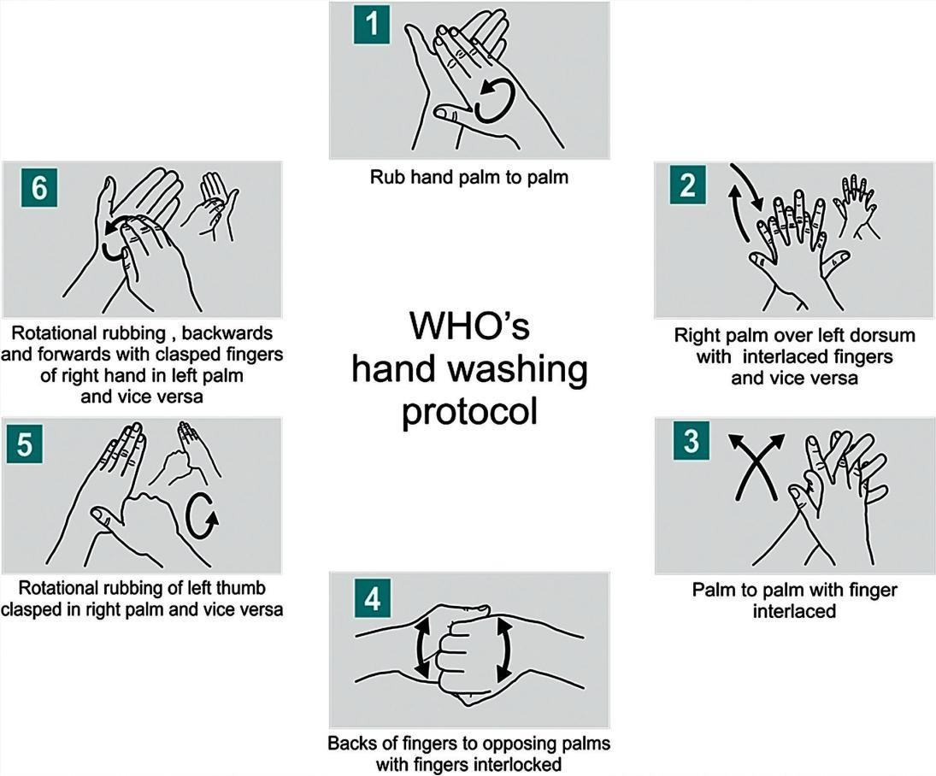

EXCLUSIVE BREASTFEEDING
During the first 6 months of life, infants should be exclusively breastfed. This means that the healthy baby should receive breast milk and no other foods or fluids, such as water, teas, juice, cereal drinks, animal milk or formula. Exclusively breastfed babies are much less likely to get diarrhea or to die from it than babies who are not breastfed or are partially breastfed. Breastfeeding also protects against the risk of allergy early in life, aids in child spacing and provides protection against infections other than diarrhea (e.g. pneumonia). Breastfeeding should continue until at least 2 years of age. The best way to establish the practice is to put the baby to the breast immediately after birth and not to give any other fluids.
If breastfeeding is not possible, cow’s milk (diluted with water if given to infants younger than 6 months as the digestive system of the child is not developed at that age) or milk formula should be given from a cup. This is possible even with very young infants. Feeding bottles and teats should not be used
66

because they are very difficult to clean and easily carry the organisms that cause diarrhea. Careful instructions should be given on the correct hygienic preparation of milk formula using water that has been boiled briefly before use.
Take home message: In cases where breast feeding is not possible (such as death of the mother, HIV positive mother, infection of the breast, thyroid disorders etc.), milk given from outside must be diluted with clean boiled water and for making milk formula also, clean water should be used.

GOOD PERSONAL AND FOOD HYGIENE
Personal hygiene requires the cleaning of all parts of the body (face, hair, body, legs and hands). The hands and finger nails have to be cleaned because the germs in between the fingers and finger nails cause contagious diseases such as diarrhea, worms, etc.
Food can be contaminated by diarrheal agents at all stages of production and preparation and storage. Following precautions should be taken to endure food safety:
- Do not eat raw food, except undamaged fruits and vegetables that are peeled and eaten immediately;
- Wash hands thoroughly with soap after defecation and before preparing or eating food;
- Cook food until it is hot throughout;
- Eat food while it is still hot, or reheat it thoroughly before eating;
- Wash and thoroughly dry all cooking and serving utensils after use;
- Keep cooked food and clean utensils separately from uncooked food and potentially contaminated utensils; and
- Protect food from flies by means of fly screens.

MEASLES AND ROTAVIRUS IMMUNIZATION
Immunizations help reduce deaths from diarrhea in two ways: by helping prevent infections that cause diarrhea directly, such as rotavirus, and by preventing infections that can lead to diarrhea as a complication of an illness, such as measles. (See Appendix IV)

67
For details of rotavirus (See Annexure V)

MICRONUTRIENT SUPPLEMENTATION
Adequate zinc intake among children is critical for normal growth and development. Recent supplementation trials have shown that adequate zinc leads to a substantial reduction in childhood diarrhea cases. It reduces the duration and severity of diarrhea episodes, decrease stool output, and lessen the need for hospitalization. It may also prevent future diarrhea for upto three months. It has been determined that the use of both zinc and ORS for diarrhea can dramatically reduce the need for unscheduled IV therapy and, more importantly, reduce the number of diarrheal disease-related deaths.

Vitamin A supplementation has also been shown to reduce the duration, severity and complications associated with diarrhea. Vitamin A maintains the physical and functional integrity of epithelial tissues that serve as a barrier against infection. Further, Vitamin A also plays a role in the production of cell glycoprotein and in the regulation of cell division in the intestine, which has a bearing on intestinal epithelial renewal during and after acute enteric infections and thereby on the absorption of water, electrolytes, and other nutrients

WHY PREVENTION IS IMPORTANT

  - Diarrhea is largely preventable
  - Most causes are related to water, sanitation, and hygiene
  - Simple household practices can reduce diarrhea by half

KEY STRATEGIES FOR PREVENTION

- Handwashing

Handwashing should be done:

  - Before preparing or feeding food
  - After defecation
  - After cleaning a child

68

Method:

  - Use soap and water

- Safe Drinking Water

  - Boil water before drinking (especially during monsoon)
  - Store water in covered containers
  - Use clean ladles for water retrieval

- Sanitation

  - Use toilets consistently
  - Dispose of child’s stool safely
  - Avoid open defecation near water sources

- Food Hygiene

  - Cook food thoroughly
  - Keep food covered
  - Avoid feeding stale or uncovered food

- Infant and Young Child Feeding

  - Exclusive breastfeeding for first 6 months
  - Continue breastfeeding up to 2 years and beyond
  - Continue feeding during illness

- Immunization

  - Timely vaccination (e.g., rotavirus, measles) reduces diarrhea severity

COMMON LOCAL MYTHS AND CORRECT FACTS

69

Myth | Correct Fact
Diarrhea is normal in children | It can be dangerous if untreated
ORS is medicine | ORS replaces lost fluids
Soap is costly | Ash works effectively

Toilets cause impurity | Toilets prevent disease

ROLE OF GRASSROOTS LEVEL WORKERS

  - Educate families using local language
  - Demonstrate handwashing and water treatment
  - Promote toilet use respectfully
  - Reinforce prevention messages during every visit

KEY MESSAGES

  - Prevention is better than cure
  - Handwashing saves lives
  - Safe water prevents disease
  - Breastfeeding protects children
  - Small changes make big differences

COMPETENCY ACHIEVED: Grassroot level workers promotes at least five preventive WASH practices tailored to local context.

FACILITATION NOTES AND ACTIVITIES

PART 1: WHAT REALLY PREVENTS DIARRHEA? (15 MINS) ACTIVITY: PREVENTION RANKING
List 7 prevention strategies (WHO/UNICEF 7-point plan):

- Safe water

70
- Sanitation
- Handwashing
- Breastfeeding

- Vaccination (Rotavirus, Measles)
- Nutrition (Zinc, Vitamin A)
- Food hygiene Ask participants:
  - “Which is most feasible in your village?”
  - “Which is most ignored?” Discuss local barriers for each. LOCAL INSIGHT:
  - “In our area, people know about handwashing, but soap is considered costly – however, ash works just as well.”
  - “Many families have toilets but do not use them – especially men and children.”

PART 2: LOCAL BELIEFS – HELPFUL OR HARMFUL? (15 MINS) MYTH-BUSTING DEBATE
Present 3 local beliefs (write on cards):

- “Diarrhea happens naturally in summer – nothing can be done.”
- “Do not give outside food to children – home food is always safe.” (Is this always true?)
- “Do not build a toilet inside the house – it will bring impurity into the home.” Divide participants into For and Against groups.
  - Debate for 5 minutes.
  - Facilitate a fact-based conclusion.

71

LOCAL EXAMPLES:

  - “In Village Malyala, people believe mango causes diarrhea – but actually it is unwashed mangoes eaten with dirty hands.”
  - “Some think having a toilet inside the house is impure – but open defecation spreads more disease.”

PART 3: HANDS-ON SKILLS HANDWASHING & WATER TREATMENT (20 MINS)

- HANDWASHING DRILL

  - Demonstrate the 6-step handwashing method with soap.
  - Show alternative: ash + water (if soap is not available).
  - Common local mistake: Only rinsing, without rubbing properly.
  - Practice: All participants wash hands correctly.

- WATER TREATMENT DEMONSTRATION

Show 4 local methods:

  - Boiling – Rolling boil for 1 minute.
  - Cloth filtration – For turbid (dirty) water.
  - Chlorination – Demonstrate correct drops per liter.
  - SODIS (Solar Disinfection) – Keep a plastic bottle in sunlight for 6 hours.

KEY LOCAL TIP:

“During the rainy season, always boil well water – floods bring contamination.”

PART 4: CREATING LOCAL PREVENTION MESSAGES (10 MINS) ACTIVITY: MESSAGE DESIGN FOR VILLAGE

72
In groups, create a one-sentence message on:

    - Handwashing
    - Toilet use

    - Safe water

Use local language, rhymes, and proverbs.

Example:
“Eating without washing hands invites disease.”

SAMPLE LOCAL SLOGANS:

    - “Use the toilet, keep diarrhea away from your home.”
    - “Boil water, prevent disease.”

ANNEXURE V-A: LOCAL PREVENTION CHECKLIST

Tick what is available in your village:

Water:

    - Tube well/Hand pump
    - Piped water
    - Covered well
    - Water treatment (boiling/filter/chlorine)

Sanitation:

    - Household toilets
    - Community toilets
    - No open defecation areas
    - Safe disposal of child feces

Hygiene:

73

    - Soap available in homes
    - Ash used for handwashing
    - Nails cut short

    - Food covered from flies

Feeding:

    - Exclusive breastfeeding (<6 months)
    - Continued breastfeeding (up to 2 years)
    - Zinc supplementation available
    - Vitamin A distribution

Biggest gap in your village:

ANNEXURE V-B: HANDWASHING STEPS (VISUAL GUIDE)

- Take water – wet your hands using a mug.
- Apply soap – rub on palms.
- Scrub – front and back of hands, between fingers, under nails.
- Rinse – with clean water.
- Dry – with a clean cloth.
- Turn off tap properly.

If soap is not available: Use ash – it is equally effective when used properly.

ANNEXURE V-C: HOME WATER TREATMENT – LOCAL METHODS

- Boiling:

  - Let water boil for at least 1 minute.
  - Cool and store in a covered container.

74

- Cloth Filtration:

  - Use a clean cotton cloth.

  - Filter water before use.
  - Wash the cloth daily.

- Chlorination:

  - 1 liter of water + 2 drops of bleaching solution.
  - Wait 30 minutes before drinking.

- Solar Disinfection (SODIS):

  - Fill a clean plastic bottle with water.
  - Keep in direct sunlight for 6 hours.
  - Cool in shade before drinking.

ANNEXURE V-D: CASE STUDY – LOCAL CONTEXT

The Sharma Family:

  - 5 members, including 2 children under 5 years.
  - Water from an open well, stored in a clay pot without a lid.
  - Toilet constructed but used as storage space.
  - Handwashing practiced only before prayers.
  - Belief: “We have always lived like this – illness is God’s will.”

Group Discussion:

- List 3 diarrhea risk factors in this home.
- What one change would you suggest first? Why?
- How would you convince them respectfully without offending their beliefs?

75

SESSION SUMMARY

This session focused on evidence-based, practical strategies for preventing diarrhoea among under-five children through simple, low-cost household measures. Participants learned that while treatment prevents deaths, prevention reduces the overall burden of disease. The foundation of diarrhoea prevention lies in safe drinking water, improved sanitation, handwashing with soap, exclusive breastfeeding, safe food practices, timely immunization, and adequate micronutrient supplementation.

The session emphasized that many diarrhoeal infections are linked to unsafe water, open defecation, poor hygiene, and inappropriate feeding practices. Demonstrating correct handwashing techniques, safe water storage, toilet use, and exclusive breastfeeding are essential roles of grassroots-level workers. Addressing common myths with respectful communication further strengthens prevention efforts.

In conclusion, diarrhoea is largely preventable through consistent WASH practices, proper infant feeding, and immunization. Grassroots-level workers act as key change agents by educating families, modeling healthy behaviors, and reinforcing prevention messages during every community interaction, ultimately reducing illness, malnutrition, and child mortality.

REFERENCES

- World Health Organization. Safer water, better health: costs, benefits and sustainability of interventions to protect and promote health. Geneva: WHO; 2008.
- Ejemot-Nwadiaro RI, Ehiri JE, Arikpo D, Meremikwu MM, Critchley JA. Hand washing promotion for preventing diarrhoea. Cochrane Database Syst Rev. 2021;12:CD004265.
- Ministry of Drinking Water and Sanitation. Swachh Bharat Mission (Gramin): guidelines. New Delhi: Government of India; 2017.
- Waddington H, Snilstveit B, White H, Fewtrell L. Water, sanitation and hygiene interventions to combat childhood diarrhoea in developing countries. New Delhi: International Initiative for Impact Evaluation; 2009.

76

- Curtis V, Cairncross S. Effect of washing hands with soap on diarrhoea risk in the community: a systematic review. Lancet Infect Dis. 2003;3(5):275–281.

77
- World Health Organization. The treatment of diarrhoea: a manual for physicians and other senior health workers [Internet]. Geneva: WHO; 2005 [cited 2016 Feb 2]. Available from: http://apps.who.int/iris/bitstream/10665/43209/1/9241593180.pdf
- World Health Organization. Diarrhoeal disease [Internet]. Geneva: WHO; 2013 [cited 2016 Feb 2]. Available from: http://www.who.int/mediacentre/factsheets/fs330/en/
- World Health Organization. Water, sanitation and health (WSH) [Internet]. Geneva: WHO; 2002 [cited 2016 Feb 10]. Available from: http://www.who.int/water_sanitation_health/mdg1/en/
- UNICEF, World Health Organization. Diarrhoea: why children are still dying and what can be done. Geneva: UNICEF/WHO; 2009.
- UNICEF. Eliminate open defecation [Internet]. 2015 [cited 2016 Mar 15]. Available from: http://unicef.in/Whatwedo/11/Eliminate-Open-Defecation
- World Health Organization. Hand hygiene: why, how and when? [Internet]. Geneva: WHO; 2009 [cited 2016 Feb 10]. Available from: http://www.who.int/gpsc/5may/Hand_Hygiene_Why_How_and_When_Brochure.pdf
- Center for Sustainable Development. Zinc & Vitamin A: mitigating diarrhea in children [Internet]. 2015 [cited 2016 Feb 17]. Available from: http://www.csd-i.org/zinc-vitamin-a-mitigating-dia/
- Bhan MK, Bhandari N. The role of zinc and vitamin A in persistent diarrhea among infants and young children. J Pediatr Gastroenterol Nutr. 1998;26(4):446–453.

SESSION 6: ISSUES & CHALLENGES IN DIARRHEA PREVENTION AND TREATMENT – LOCAL BARRIERS & PRACTICAL SOLUTIONS
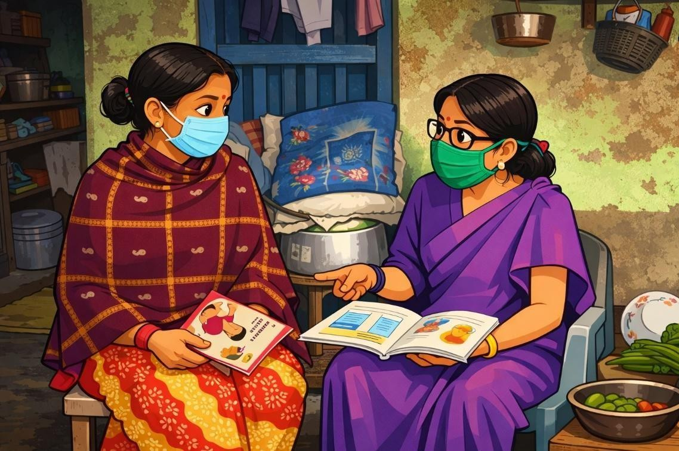

LEARNING OBJECTIVES

After this session, participants will be able to:

  - Identify common local challenges in diarrhea prevention and treatment
  - Understand root causes of these challenges
  - Apply practical, context-specific solutions
  - Advocate effectively for supplies and community support

ISSUES AND CHALLENGES IN PREVENTION OF DIARRHEA

Diarrhoeal diseases remain a major public health problem in India despite progress in child health. Globally, diarrhoea accounted for about 9% of deaths among children under five in 2021. In India, diarrhoea continues to contribute significantly to child morbidity and mortality, with national surveys showing a prevalence of around 9.2% among children under five in 2019–21.

78

Water, Sanitation, and Hygiene (WASH) Challenges:

Poor access to safe water and sanitation remains a key barrier to diarrhoeal disease control. Although national sanitation campaigns like the Swachh Bharat Mission have greatly increased toilet construction and reduced open defecation rates, India still bears a high disease burden linked to poor sanitation. Lack of adequate sanitation and hygiene contributes to faecal contamination of water and environments where children live and play, increasing diarrhoea risk. Hand-washing practices, which are crucial for preventing diarrhoea, are still not universal; many households lack sufficient water and soap for frequent hand-washing, even though these behaviours have a strong protective effect.

Breastfeeding and Infant Feeding:

Exclusive breastfeeding (EBF) protects infants from diarrhoeal infections, but uptake remains sub-optimal. National patterns indicate continued challenges in early initiation and continuation of EBF, influenced by lack of family and workplace support, socio-cultural beliefs, and limited awareness of its benefits.

Immunization Gaps:

Vaccination against measles and rotavirus is essential for diarrhoea prevention. While measles immunization coverage has improved in recent years, timely vaccination still varies across regions. Rotavirus vaccination has been increasingly introduced in many states and shown to reduce diarrhoeal incidence and severity, yet full nationwide coverage has taken time to scale up.

Behavioral and Socio-economic Factors:

Knowledge of ORS and zinc is relatively high in India, but there remains a gap between knowledge and correct practice, particularly in usage rates for childhood diarrhoea. Access to safe water, barriers in health-seeking behaviour, cultural beliefs, and household socioeconomic status influence uptake of preventive measures and treatment practices.
79

Overall, preventing diarrhoeal diseases in India requires addressing multi-sectoral challenges, including improving WASH infrastructure, promoting proper hand-washing and breastfeeding behaviours, strengthening immunization, and enhancing community-based healthcare delivery.

ISSUES AND CHALLENGES IN TREATMENT OF DIARRHEA

The Government of India recommends low-osmolarity ORS, zinc supplementation, and continued feeding including breastfeeding as the cornerstone of diarrhoea treatment. However, despite improved awareness, there is substantial under-use of these interventions in many regions. Studies based on NFHS-5 indicate that while ORS knowledge is widespread, its actual use during diarrhoeal episodes remains lower than ideal, and zinc use remains limited in many communities.

Inappropriate treatment practices are also reported, with over-reliance on antibiotics and other medications that are not recommended for acute diarrhoea, contributing to misuse of medicines and antimicrobial resistance.

COMMON CHALLENGES IN PREVENTION AND TREATMENT OF DIARRHEA

- Knowledge & Skills

  - Incorrect dehydration classification
  - Improper ORS preparation
  - Incomplete zinc course

Solution: Regular refresher training, on-the-spot demonstrations.

- Community Beliefs & Practices

  - Stopping breastfeeding during diarrhea
  - Belief that ORS increases stools
  - Preference for home remedies only

Solution: Respectful counseling, use of local language, stories, and demonstrations.

80

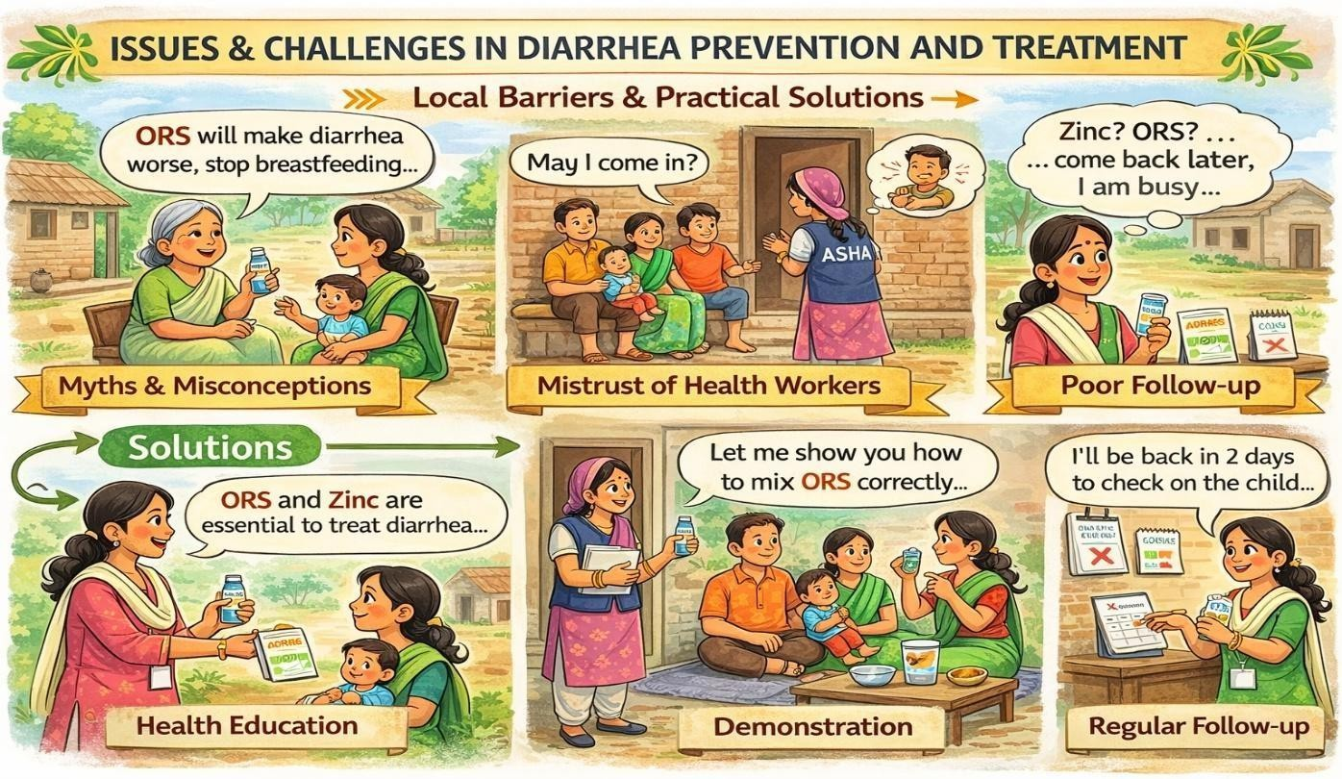
81
- Supply & Logistics

  - ORS/zinc stock-outs
  - Transport difficulties for referrals

Solution: Buffer stock at AWC/sub-center, timely indenting, coordination with PHC.

- System & Administrative Issues

  - Heavy paperwork reducing field time
  - Delayed incentives/supervision

Solution: Prioritization of visits, reporting issues to supervisors, teamwork.

ROOT CAUSE THINKING

Ask “Why?” repeatedly to move from the problem to the cause:

  - Problem: Low ORS use
  - Cause: Misconceptions + lack of home demonstration
  - Action: Home-based ORS demo + follow-up

Advocacy & Problem-Solving

  - Communicate needs clearly to supervisors
  - Use data (case numbers, stock days)
  - Involve community leaders for support
  - Collaborate with ASHA/ANM/AWW teams

KEY MESSAGES

  - Challenges in diarrhea prevention include- lack of proper sanitation and safe water supply, lack of knowledge about benefits of exclusive breastfeeding, socio-cultural, administrative barriers and logistics and supply chain related barriers for low coverage of measles
  - Challenges in diarrhea treatment- availability and correct use of ORS, compliance to zinc therapy and irrational use of antibiotics in childhood diarrhea.
  - Challenges are manageable, not failures
  - Community trust improves acceptance
  - Continuous supplies save lives
  - Teamwork strengthens outcomes

COMPETENCY ACHIEVED: Grassroot level workers identifies local barriers and proposes practical, field-based solutions within available resources.
82

SESSION SUMMARY
ACTIVITY: CHALLENGE MAPPING

- Present 4 challenge categories on flipcharts:
  - Knowledge & Skills (e.g., misclassification, poor ORS prep)
  - Community & Behavior (e.g., myths, refusal)
83

This session highlighted the major issues and challenges in the prevention and treatment of diarrhoea among under-five children, with special focus on local barriers and practical solutions. Despite improvements in sanitation, immunization, and child health services, diarrhoeal diseases continue to remain a significant public health concern due to gaps in WASH practices, sub-optimal exclusive breastfeeding, immunization delays, behavioral misconceptions, and socio-economic constraints.

Participants learned that prevention challenges include unsafe water, poor sanitation, inadequate hand-washing practices, low exclusive breastfeeding rates, and incomplete immunization coverage. In treatment, common problems include improper ORS preparation, incomplete zinc therapy, irrational use of antibiotics, stock-outs of essential supplies, and limited follow-up.

The session emphasized root-cause thinking—asking “why” repeatedly to identify the real cause behind low service uptake—and developing context-specific solutions such as refresher training, home demonstrations, respectful counseling, improved supply management, teamwork, and community involvement.

In conclusion, challenges in diarrhoea prevention and treatment are manageable through coordinated efforts, strong advocacy, continuous supplies, supportive supervision, and building community trust. Grassroots-level workers play a vital role in identifying barriers, applying practical solutions, and ensuring that every child receives timely and appropriate care.

FACILITATION NOTES AND ACTIVITIES

PART 1: IDENTIFYING LOCAL CHALLENGES (15 MINS)

- Supply & Logistics (e.g., stock-outs, transport)
- System & Administration (e.g., paperwork, incentives)
  - Distribute challenge cards – ask participants to place them under correct category.
  - Discuss: “Which category is biggest in your area?”

Example as Local Data:

*“Last year in [Block X], ORS stock-outs happened in 3 of 6 PHCs during monsoon.”
“In [Village Y], 70% of mothers believe zinc is ‘too strong’ for children.”

PART 2: ROOT CAUSE ANALYSIS – WHY DO THESE CHALLENGES EXIST? (20 MINS)
ACTIVITY: FISHBONE DIAGRAM

  - Pick one major local challenge (e.g., “Why is ORS not used correctly?”).
  - Draw a fishbone on flipchart.
  - Bones = categories:
    - People (knowledge, attitudes)
    - Process (training, supervision)
    - Supplies (stock, quality)
    - Environment (community norms, season)
  - Ask: “What is the root cause, not just the symptom?”

EXAMPLE FROM VILLAGE Y AREA:

Problem: Low ORS use in [Y District]
└─ People: Mothers think ORS is "medicine for hospitals only"
└─ Process: Health workers don't demonstrate ORS at home
└─ Supplies: ORS packets not given during VHND
└─ Environment: Local healers advise against ORS
PART 3: BRAINSTORMING LOCAL SOLUTIONS (15 MINS)
84

ACTIVITY: SOLUTION STORM
Challenge: Category: □ Knowledge/Skills □ Community □ Supply □ System
Why does this happen? (Ask ‘Why?’ 5 times):
85

  - In small groups, pick one challenge and brainstorm 3 practical solutions.
  - Use the “How might we…” format:
    - “How might we ensure ORS is always in stock?”
    - “How might we convince mothers to give zinc for 14 days?”
  - Write solutions on sticky notes, cluster by theme.

LOCAL SOLUTIONS:

“In [Block Z], we created a community ORS depot at the Anganwadi center.” “We trained local youth to transport severe cases on motorcycles during night.”

PART 4: ADVOCACY & ROLE-PLAY (10 MINS) ROLE-PLAY SCENARIOS:
- Convincing a resistant mother to give ORS.
- Requesting stock replenishment from a medical officer.
- Mobilizing community leaders to build a handwashing station.

Instructions:

  - In pairs, practice respectful persuasion.
  - Use local language, proverbs, analogies.
  - Feedback: “What worked? What could be better?”

ANNEXURE VI-A: ROOT CAUSE ANALYSIS WORKSHEET

1.
Card 4 – System:
“Paperwork takes 3 hours daily – less time for home visits.”
ANNEXURE VI-C: SOLUTION BRAINSTORMING TEMPLATE
86
2.
3.
4.
5.

Root Cause:

Who can help solve this?

  - Supervisor
  - Community leader
  - PHC staff
  - NGO partner
  - Self (with training)

One action I will take this month:

ANNEXURE VI-B: LOCAL CHALLENGE CARDS (EXAMPLES – CUSTOMIZE WITH YOURS)

Card 1 – Supply:
*“ORS packets out of stock at sub-center for 2 weeks during rains.”

Card 2 – Community:
“Mothers stop breastfeeding during diarrhea – belief that milk increases stools.”

Card 3 – Knowledge:
“Health workers classify all dehydration as ‘severe’ – leading to unnecessary referrals.”

Challenge | Short-Term Solution  (This Month) | Long-Term Solution  (This Year) | Who Will Lead?
ORS stock-out | Keep 10 packets at  AWC | Advocate for buffer stock  at block level | ASHA + ANM
Myths about  zinc | Demo zinc with local  food | Involve local healer in  training | Health worker +  Sarpanch
No transport at  night | List bike owners willing  to help | Link with 108 ambulance  service | Youth group

ANNEXURE VI-D: ADVOCACY ROLE-PLAY SCRIPT (LOCAL LANGUAGE) SCENARIO: REQUESTING ADDITIONAL ORS STOCK

You:
“Sir/Madam, ORS stock has run out at our sub-center. During the rainy season, diarrhea cases are increasing.”

Medical Officer:
“The indent has already been sent.”

You:
“Yes, but the supply has not arrived yet. Could you please arrange one box from the block immediately? Otherwise, children may be at risk.”

Medical Officer:
“Alright, I will send it by tomorrow.”

Key Phrases to Practice:

  - “We need support…”

87
  - “Immediate action is necessary…”
  - “We can work together to solve this…”

REFERENCES

- Rowe AK, Onikpo F, Lama M, Cokou F, Deming MS. Management of childhood illness at health facilities in Benin: problems and their causes. Am J Public Health. 2001;91(10):1625–1635.
- McQuestion M, Velasquez A. Evaluating health worker performance in Benin using the simulated client method. Int J Qual Health Care. 2009;21(6):421–428.
- Rowe AK, de Savigny D, Lanata CF, Victora CG. How can we achieve and maintain high-quality performance of health workers in low-resource settings? Lancet. 2005;366(9490):1026–1035.
- Ministry of Health and Family Welfare. Rural health statistics 2021–22. New Delhi: Government of India; 2022.
- Kumar GS, Kar SS, Jain A. Health and environmental sanitation in India: issues for prioritizing control strategies. Indian J Occup Environ Med. 2011;15(3):93–96.
- Lakshminarayanan S, Jayalakshmy R. Diarrheal diseases among children in India: current scenario and future perspectives. J Nat Sci Biol Med. 2015;6(1):24–28.
- UNICEF. The situation of children in India – A profile [Internet]. [cited 2016 Feb 11]. Available from: http://www.unicef.org/india/health.html
- Graeff JA, Elder JP, Booth EM. Communication for health and behavior change: a developing country perspective. San Francisco, CA: Jossey-Bass; 1993.
- International Institute for Population Sciences (IIPS) and Macro International. National Family Health Survey (NFHS-3), 2005–06: India. Volume I. Mumbai: IIPS; 2007.
- Suresh S, Sharma KK, Saksena M, Thukral A, Agarwal R, Vatsa M. Predictors of breastfeeding problems in the first postnatal week and its effect on exclusive breastfeeding rate at six months: experience in a tertiary care centre in Northern India. Indian J Public Health. 2014;58(4):270–273.
- Ram S, Shrivastava BL. Measles in India: challenges and recent developments. Infect Ecol Epidemiol. 2015;5:27784.
88

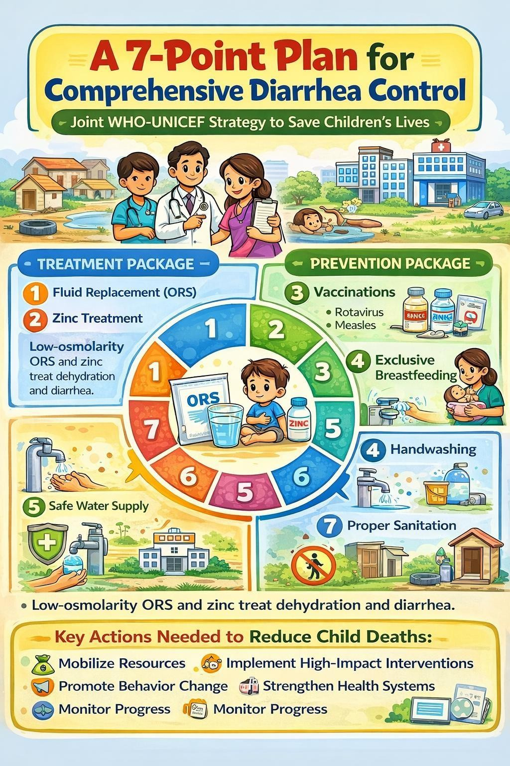
SESSION 7: A 7-POINT PLAN FOR COMPREHENSIVE DIARRHEA CONTROL
LEARNING OBJECTIVES

After this session, the participants will be able to:

  - Knows a 7-point plan for comprehensive diarrhea control
  - Know the action needed to reduce child deaths from diarrhea

INTRODUCTION
A plan for comprehensive diarrhea control-a 7 point plan has jointly been advocated by WHO
89

and UNICEF for improving child survival in developing countries in particular. The 7-point plan includes two treatment and five prevention strategies.

90

TREATMENT PACKAGE
The treatment package focuses on two main elements:

- Fluid replacement to prevent dehydration
- Zinc treatment.
Oral rehydration therapy is the cornerstone of fluid replacement. New elements of this approach include low-osmolarity ORS, which are more effective at replacing fluids than the previous ORS formulation, and zinc treatment, which decreases diarrhea severity and duration.

Comparison of standard and low osmolarity ORS solutions in terms of composition

ORS COMPOSITION

Composition | Standard ORS solution (mEq or mmol/l) | Reduced Osmolarity Solution (mEq or mmol/l)
Glucose | 111 | 75
Sodium | 90 | 75
Chloride | 80 | 65
Potassium | 20 | 20
Citrate | 10 | 10
Osmolarity | 311 | 245

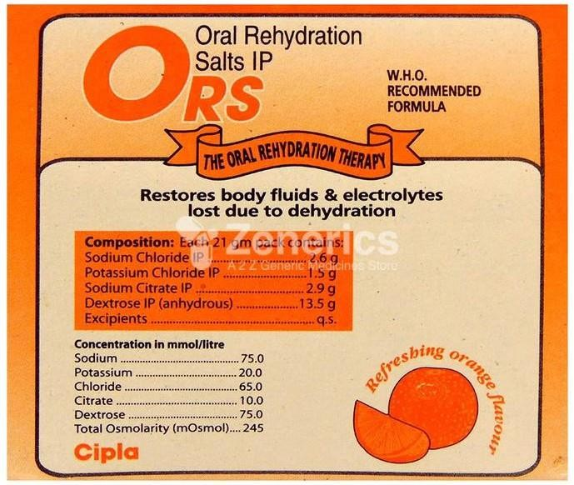

The original ORS was found to be hyperosmolar and may risk hypernatremia (high plasma sodium concentration) and increase in stool output especially in infants and young children. The low-osmolarity ORS reduce stool output by 25%, reduces vomiting by 30% and reduces the need for unscheduled intravenous therapy by more than 30%. Zinc is a vital micronutrient essential for protein synthesis, cell growth and differentiation, immune function, and intestinal transport of water and electrolytes. Zinc deficiency is associated with an increased risk of gastrointestinal infections, adverse effects on the structure and function of the gastrointestinal tract, and impaired immune function. Important additional components of the package
are continued feeding, including breastfeeding, during the diarrhea episode and use of appropriate fluids available in the home if ORS is not available.

Prevention Package
The prevention package focuses on five main elements to reduce diarrhea in the medium to long term:
- Rotavirus and measles vaccinations
- Promotion of early and exclusive breastfeeding and vitamin A supplementation
- Promotion of hand washing with soap.
- Improved water supply quantity and quality, including treatment and safe storage of household water
91

- Community-wide sanitation promotion.
It is important that implementation of the prevention package is approached in a concerted way, since single interventions alone are likely to result in lesser overall impact. For example, diarrhea caused by rotavirus cannot be prevented solely by improvements in water and sanitation. And rotavirus vaccine does not prevent other pathogens (such as E. coli and Shigella) from causing diarrhea. The package should be accompanied by clear, targeted and integrated behavior and social change communication strategies to improve uptake by families and communities.
EXERCISE
A 3 month child living in a village X has suffered from 3 episodes of diarrhea since his birth. He is not being exclusively breastfed. Many children in his village also suffer from similar illness. The village does not have a toilet facility and there is no supply of piped water. Kindly discuss the strategies to prevent and control diarrhea in this setting
Ans.

ACTION NEEDED NOW TO REDUCE CHILD DEATHS FROM DIARRHEA
  - Mobilize and allocate resources for diarrhea control: New resources for child survival must include funding for diarrhea prevention and treatment. And global initiatives must keep the management of diarrhea high on the list of priorities for public health resource allocation, including rotavirus vaccination. At the same time, national and district
health planners should include diarrhea control in program targeting childhood malaria, pneumonia and HIV, and ensure support to accelerate coverage of proven interventions.
  - Reinstate diarrhea prevention and treatment as a cornerstone of community-based primary health care: To effectively control diarrhea, treatment and prevention measures should be integrated into the training of health workers
  - Ensure that low-osmolarity ORS and zinc are adopted as policy in all countries: Clear policy guidance is needed to ensure that the latest recommendations for treating childhood diarrhea are adopted and promoted, using effective delivery strategies. One way of facilitating the delivery of
92

low-osmolarity ORS and zinc is by combining these life- saving remedies in a single treatment kit.
  - Reach every child with effective interventions: Community-based approaches are needed to ensure high coverage of health, nutrition and water and sanitation interventions, rather than relying solely on the public sector for these services.
  - Accelerate the provision of basic water and sanitation services: This can best be accomplished through partnerships between the health sector and other agencies responsible for water and sanitation, and the use of community-based approaches. Eliminating open defecation must be a priority, along with promoting the construction of basic sanitation facilities by households and providing safe water facilities close to people’s homes that can be operated and maintained by the community.
  - Use innovative strategies to increase the adoption of proven measures against diarrhea: All available options should be exploited to reach every household with a package of high- impact interventions against diarrhea which could include, for example, the development of flavoured ORS formulas or systems for treating and safely storing household water. Other types of innovations include alternative delivery strategies, such as Child Health Days, to reach a high proportion of the target group. Consumer research to improve packaging, marketing and product positioning will be essential for greater acceptance of ORS, soap and household water treatment.
    - Change behaviors through community involvement, education and health-promotion activities: Clear and targeted health promotion and behavior change communication programs must accompany the delivery of interventions to ensure that caregivers understand the simple actions they can take at home to prevent and manage diarrhea.
    - Make health systems work to control diarrhea: These include meeting the need for human resources, reducing staff turnover, improving training programs and seeking creative ways to motivate community health workers.
    - Monitor progress at all levels, and make the results count: As national programs accelerate their diarrhea control activities, it will become increasingly important for countries to collect, analyze and report quality data in a timely manner to monitor programs and increase accountability and performance.
93

EXERCISES:
Q1. Based on the above suggested measures, discuss in your respective groups what are the important actions that need to be taken in Indian settings?

KEY MESSAGES:
      - A 7- point plan consists of 2 treatment and 5 prevention strategies
      - Treatment package includes fluid replacement and zinc treatment.
      - Prevention package includes immunization, exclusive breastfeeding, handwashing, safe water supply, sanitation.
      - Action needed to control the disease involves:
        - Mobilizing resources;
        - Implementing high impact interventions
        - Social and behavior change communication
        - Monitoring progress
        - Strengthening health systems

COMPETENCY ACHIEVED: Grassroot level workers develop comprehensive program-level understanding of integrated diarrhea control strategies and system-based action planning.

FACILITATOR NOTES AND ACTIVITIES

To make this session more interactive and aligned with adult learning principles, the following activities:

94

ACTIVITY 1: BRAINSTORMING – “WHAT ARE WE ALREADY DOING?” (5 MINUTES)

METHOD: Whole group discussion Ask participants:
- Which of these 7 strategies are already being implemented in your village?
- Which ones are weak or missing?

Write responses under two columns:
✔ Strong
✖ Needs Improvement

This builds ownership and contextual understanding.

ACTIVITY 2: 7-POINT SORTING GAME (10 MINUTES)

METHOD: Small group activity

Provide participants with 7 printed cards (each containing one strategy). Ask them to:

- Separate them into Treatment and Prevention.
- Arrange them in order of impact (according to their opinion).

After 5 minutes, discuss:

  - Why did you rank them this way?
  - Is treatment alone enough?

This improves conceptual clarity.

95

ACTIVITY 3: CASE-BASED APPLICATION (10 MINUTES)

SCENARIO:
“In a village, ORS is available but handwashing is poor and open defecation is common. Rotavirus vaccination coverage is low.”

Ask groups:

  - Which components of the 7-point plan are weak?
  - What immediate and long-term actions would you take?

Each group presents briefly.

ACTIVITY 4: ACTION MAPPING EXERCISE (5 MINUTES)

Divide participants into 4 groups and assign:

Group 1 → Resource Mobilization
Group 2 → Behavior Change Communication Group 3 → Health System Strengthening Group 4 → Monitoring & Data

Ask each group to list 3 practical actions they can take at village/block level. This links theory to field-level implementation.

OPTIONAL SKILL DEMONSTRATION

Demonstrate a combined ORS + Zinc counseling kit and show how to counsel a mother using the 7-point framework.

SESSION SUMMARY

This session focused on the WHO–UNICEF 7-point plan for comprehensive diarrhea control, which integrates two treatment strategies and five prevention strategies to reduce diarrheal morbidity and mortality among under-five children. The treatment package emphasizes low-osmolarity ORS for effective fluid replacement and zinc supplementation to reduce duration,
96

severity, and recurrence of diarrhea. Continued feeding and breastfeeding are essential supportive components.

97

REFERENCES

- World Health Organization. The treatment of diarrhoea: a manual for physicians and other senior health workers. 4th ed. Geneva: WHO; 2005.
- United Nations Children’s Fund, World Health Organization. Diarrhoea: why children are still dying and what can be done. Geneva: WHO; 2009.
- United Nations Children’s Fund, World Health Organization. Ending preventable child deaths from pneumonia and diarrhoea by 2025: The integrated global action plan for pneumonia and diarrhoea (GAPPD). Geneva: WHO; 2013.
- Ministry of Health and Family Welfare. National guidelines on management of childhood diarrhoea. New Delhi: Government of India; 2014.
- Lazzerini M, Wanzira H. Oral zinc for treating diarrhoea in children. Cochrane Database Syst Rev. 2016;12:CD005436.
- Global Burden of Disease Collaborative Network. Global burden of diarrheal diseases 2019. Seattle: Institute for Health Metrics and Evaluation; 2020.
- UNICEF. The state of the world’s children 2023. New York: UNICEF; 2023.

SESSION 8: EFFECTIVE COMMUNICATION – TAILORING MESSAGES FOR LOCAL COMMUNITIES AND INFORMATION, EDUCATION & COMMUNICATION / BEHAVIOR CHANGE COMMUNICATION (IEC/BCC) – DESIGNING AND DELIVERING LOCAL CAMPAIGNS

LEARNING OBJECTIVES

After this session, participants will be able to:

  - Identify common communication barriers in the community
  - Communicate effectively using simple, local language
  - Build trust with caregivers
  - Counsel families on diarrhea prevention and management
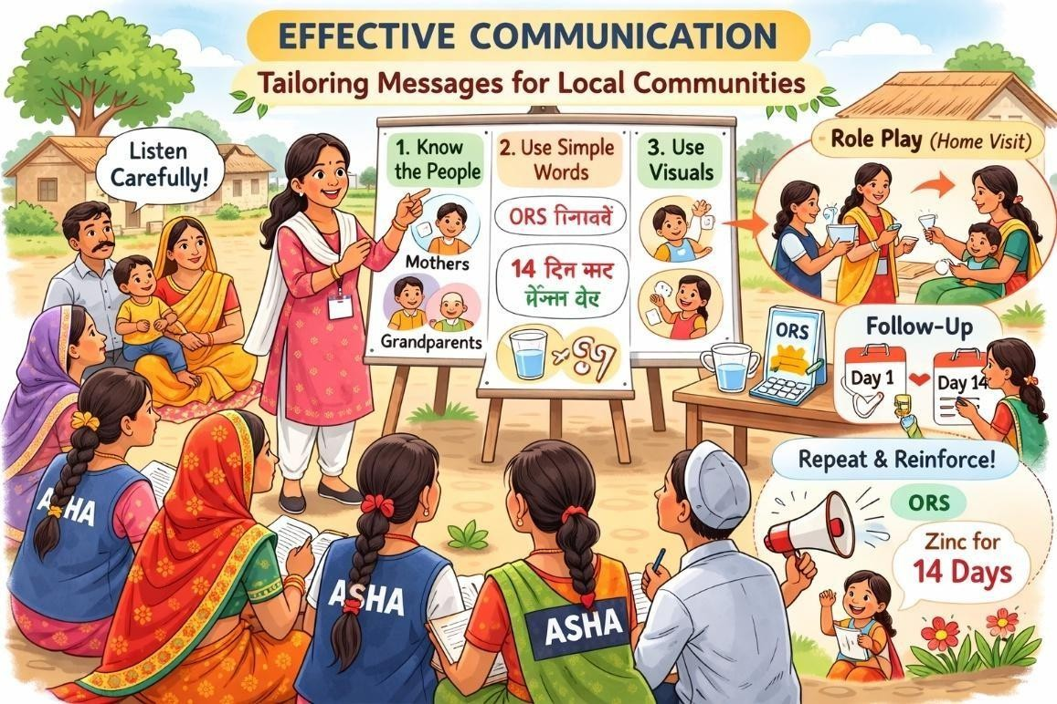

Communication is the art of expressing and exchanging ideas, thoughts and feelings in speech, writing and or by body language.1 It is the act of being understood. It is a process which involves sharing of information between people through a continuous activity of speaking, listening and understanding.

98

WHY COMMUNICATION MATTERS

  - Correct knowledge alone is not enough
  - Families act only when they trust and understand the message
  - Poor communication leads to non-compliance with ORS, zinc, and referral advice

COMMUNICATION PROCESS

: Communication process involves the following:

- Idea: Communication is a simple but very important process in the prevention and management of diarrhoea in under-five children. It begins with an idea, which means the information or thought that comes into the mind of the sender. For example, an ASHA worker may think that a child with diarrhoea needs ORS and zinc to prevent dehydration. This thought in her mind is the idea.
- Encoding: The next step is encoding, which means changing that idea into simple words, signs, or actions so that the mother can understand it. Instead of using medical terms, the worker explains in simple language, such as, “If your child passes loose stools, give ORS solution after every loose motion and continue breastfeeding.” She may also show the ORS packet and demonstrate how to prepare it. This process of explaining and demonstrating is encoding.
- The channel: After encoding, the message is sent through a channel, which is the method used to communicate. The worker may use home visits, mothers’ meetings, demonstrations, posters, or phone calls. Choosing the correct channel is very important. For example, if the mother cannot read, giving a written leaflet may not be effective. In such cases, verbal explanation and live demonstration are better methods.
- Decoding: The next step is decoding, which means the mother understands the message. Understanding depends on two things: content and context. Content refers to the actual words used, such as instructions on how to mix ORS correctly. Context refers to the situation or environment in which communication takes place. If the mother is busy, stressed, or if there is noise around, she may not understand properly. Therefore, the worker must ensure that the environment is suitable for communication.
- Feedback: Finally, there is feedback, which is the response given by the mother.
99

Feedback helps the worker know whether the message was understood correctly. For example, the worker may ask the mother to show how she will prepare ORS. If she mixes the whole packet in one litre of clean water correctly, it means communication was successful.

Thus, effective communication among grassroots-level workers ensures that mothers understand how to manage diarrhoea properly, continue feeding, recognize danger signs, and seek medical help when necessary. Clear communication can prevent dehydration, reduce complications, and help save the lives of under-five children.
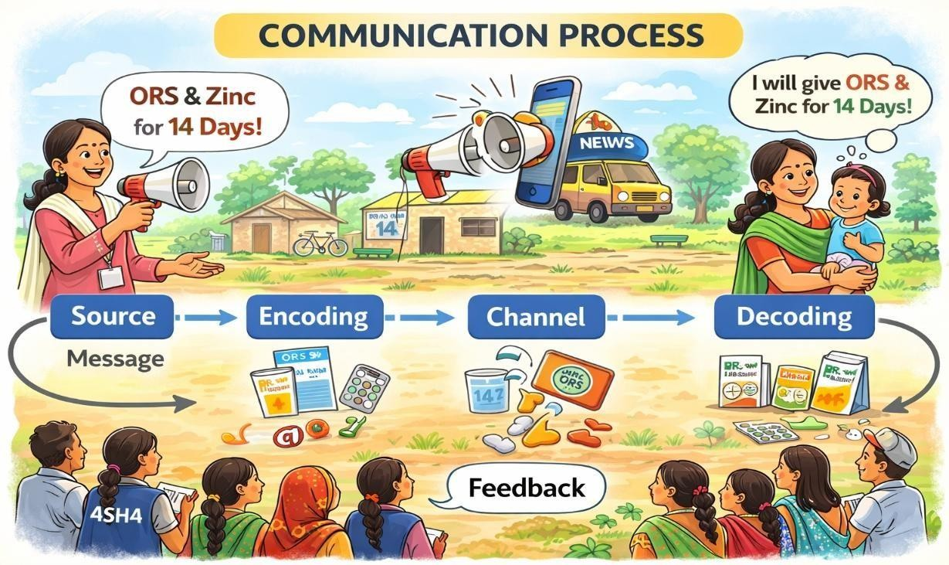

COMMON COMMUNICATION BARRIERS

In the process of communication, caution needs to be exercised as barriers to communication are either consciously or unconsciously erected by the sender or the receiver.

100
The barriers may be ;

- Physiological- difficulties in hearing, expression
- Psychological- emotional disturbances, neurosis, levels of intelligence, language or comprehension difficulties.
- Environmental-noise, visibility, congestion
- Cultural- illiteracy, levels of knowledge and understanding, customs, beliefs, religion, attitudes, economic and social class differences, language variations, cultural differences between foreigners and nationals, between urban education and rural population

PRINCIPLES OF EFFECTIVE COMMUNICATION

  - Listen patiently
  - Use simple, non-medical words
  - Respect beliefs while correcting myths
  - Use examples from daily life
  - Encourage questions

BUILDING TRUST (S.O.F.T.E.N. APPROACH)

  - S – Smile
  - O – Open posture
  - F – Forward lean
  - T – Touch (when culturally appropriate)
  - E – Eye contact
  - N – Nod to show understanding Trust improves acceptance of health advice.

101
Do’s | Don’ts
(S.O.F.T.E.N.) | Tap fingers, pens, pencils
Smile | Crossing arms
Open Posture-this means no crossed legs,  arms | Yawning or looking bored

Forward-lean forward… just a little | Leaning away from the client
Touch-shake hands or greet in warm &  friendly manner | Looking out of window or somewhere else
Eye Contact | Tapping feet
Nod

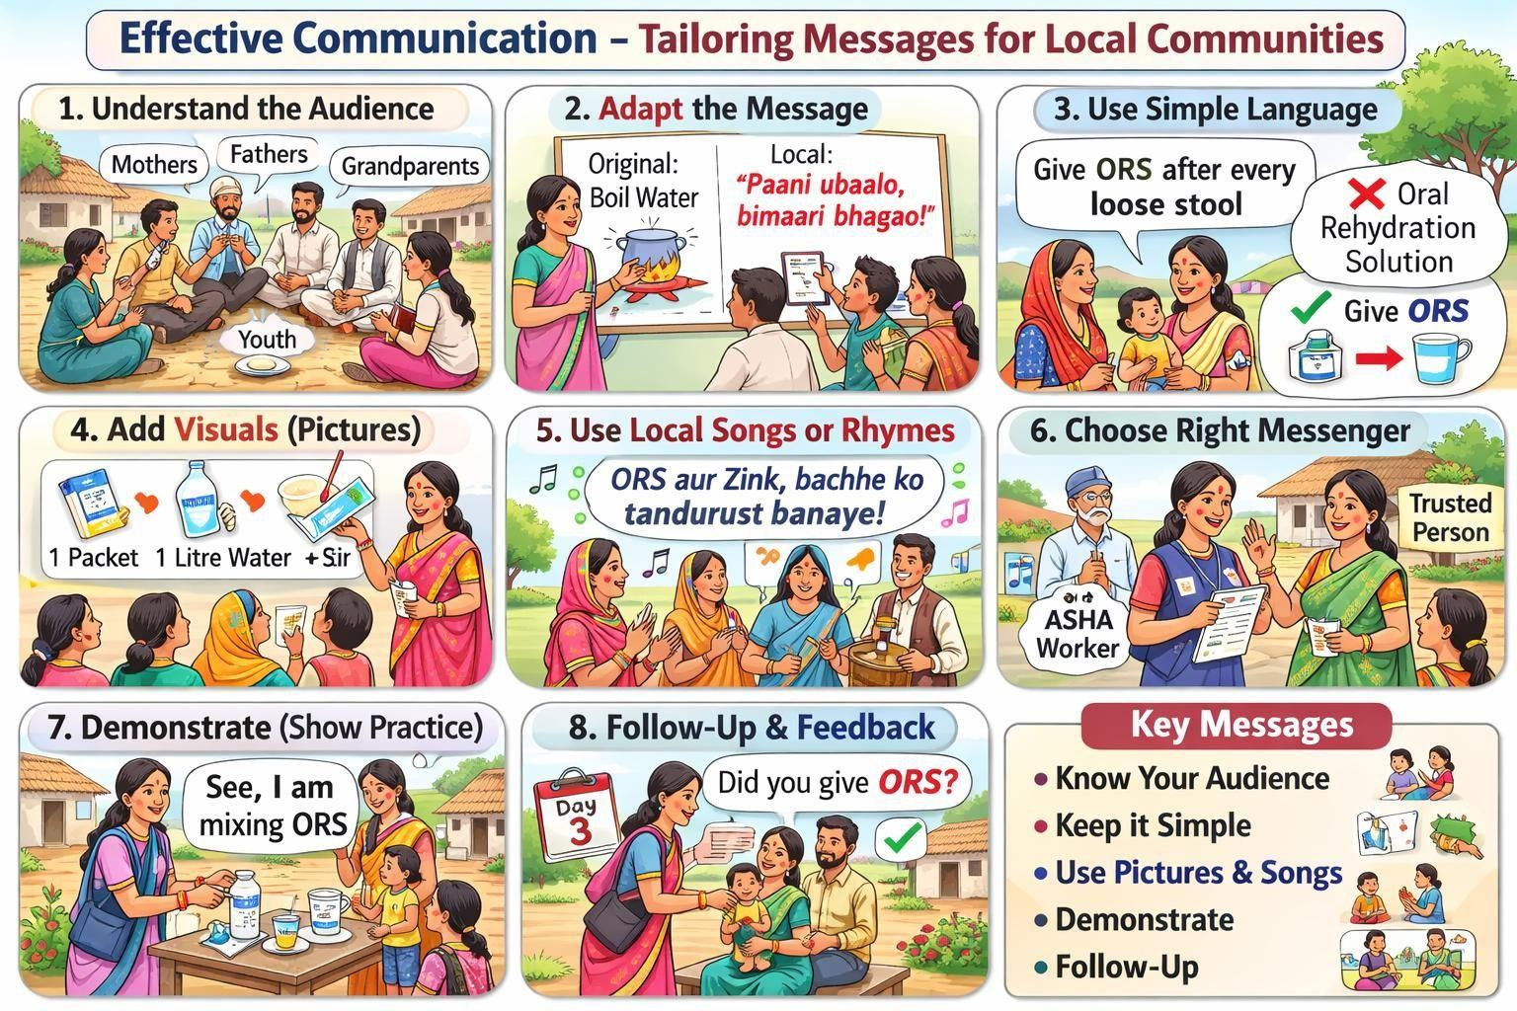
MODE OF DELIVERY OF KEY MESSAGES

We will discuss in detail the common mode of delivery of key messages in community settings.
102

They are as follows:

- Flip charts:
  - This consist of series of charts or posters about 25 by 30 cm or more, each with an illustration pertaining to talk to be given
  - Each chart is displayed before the group as the talk is being given.
  - The message on the chart must be brief and to the point
  - E.g. Flip chart can be used to stimulate community discussion about health sanitation issues. They can be used for large group of people.

- Posters:

  - The message to be communicated should be simple, easy to understand and artistic.
  - The title needs to be communicated from a distance of 5-10 m and text from 1.5 to 2 m. Block thick styles of letters no less than 23 mm for titles and 5 mm for text for legibility should be followed.
  - Posters should be changed frequently.
  - They are usually displayed in visible public areas.
  - E.g. Posters can be used to display any health promotion issue-such as hand washing can reduce diarrhea. They are meant for specific small groups.

- Handouts:

- It is a single piece of paper where information is printed on one or both sides to promote a product or service or to provide information about an event or a social issue.
- They carry detailed information about the health issue.
- They give the audience something to take away from your message or presentation.
- Make it simple, readable type.
- Organize and break out dense information into charts, graphs and other illustrations.

- E.g. Handouts on safe water supply/how to make water safe for drinking purposes. Handouts
103

can also be given as summary of the session on diarrhea prevention and control. They can distributed widely

- Pamphlets:

a. An unbound booklet without binding or a hardcover is also known as a pamphlet. These pamphlets are made by folding the few pages in half and saddle stapling them at the crease. E.g. Pamphlets on management of diarrhea-various treatment plans can be made. They can be distributed widely.

- Wall paintings:

- It is a tool for communicating to people through writing text and drawing pictures on the wall.
- They are easily readable
- They are a cheap medium
- People from all age groups can be given messages through wall paintings
- Size of the wall writing should be at least 6 x 4 feet.
- It should be clearly visible from 100 m distance.
- E.g. Wall paintings depicting safe water supply through pipes in a village. It reaches to large audience.

- Community talks:

- The talks cover basic health information and are delivered in easy-to-understand language, with plenty of time for questions and answers.
- They take place in community settings, such as places of worship, recreation centers, and libraries.
- E.g. community talks on importance of environmental sanitation in health. It also targets large audience

104

- Mother meetings:

- Regular meeting for mother of under-5 children in the community provide counseling opportunities regarding infant feeding and hygiene.
- It involves informal discussion and supportive environment.
- E.g. Mother meetings on importance of exclusive breastfeeding and immunization for young children are highly useful.
- Folk media:

a. It involves keerthan, katha, songs, dances and dramas which have roots in our culture
E.g. Folk media can be used for spreading the message of immunization for children.

ADAPTING MESSAGES FOR THE COMMUNITY

- Use local language and idioms
- Use stories instead of technical explanations
- Compare ORS to familiar daily practices
- Repeat key messages during each visit

COUNSELING FOR DIARRHEA (KEY FOCUS AREAS)

- Importance of ORS for every loose stool
- Zinc for 14 days
- Continue breastfeeding and feeding
- Recognize danger signs and seek care early

KEY MESSAGES

- Communication is a process which involves sharing of information between people through a continuous activity of speaking, listening and understanding.
- There are various types of communication: one way-two way; verbal-nonverbal; formal- informal; tele-communication
105

- There are various barriers which are needed to be overcome for effective communication-physiological, psychological, environmental and cultural
- Listening is different from hearing

COMPETENCY ACHIEVED: Grassroot level workers demonstrates effective counseling using S.O.F.T.E.N communication approach.

INFORMATION, EDUCATION & COMMUNICATION / BEHAVIOR CHANGE COMMUNICATION (IEC/BCC) – DESIGNING AND DELIVERING LOCAL CAMPAIGNS

LEARNING OBJECTIVES

After completing this session, participants will be able to:

- Differentiate between IEC and BCC
- Identify the stage of behavior change in the community
- Design simple, locally appropriate IEC/BCC activities
- Select suitable messengers and channels for communication
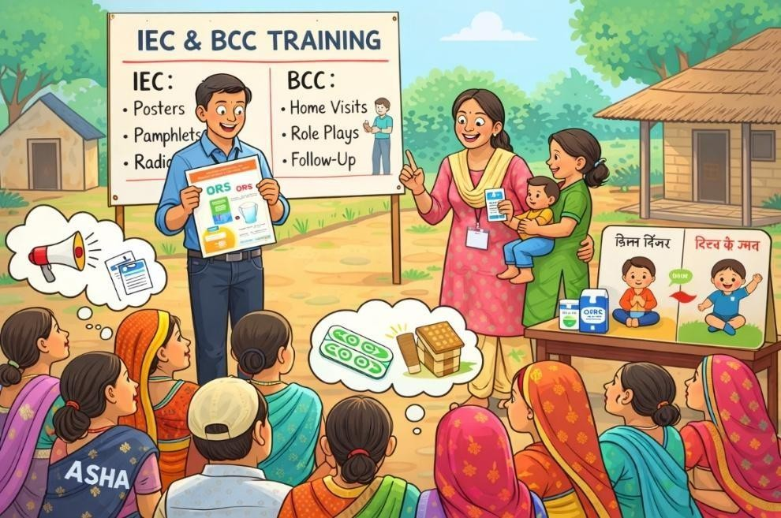
- Plan follow-up actions to sustain behavior change
106

“This session is guided by the Transtheoretical Model of Behavior Change and the National BCC Strategy (MoHFW, 2020), emphasizing stage-based communication and participatory engagement.”

UNDERSTANDING IEC AND BCC

INFORMATION, EDUCATION AND COMMUNICATION (IEC)

IEC is a process of working with individuals, communities and societies to develop communication strategies to promote positive behaviors which are appropriate to their settings.

IEC focuses on providing information and increasing awareness.

EXAMPLES:

- Posters on ORS preparation at PHC
- Pamphlets on handwashing
- Loudspeaker announcements on diarrhea prevention IEC helps people know what is right.

BEHAVIOR CHANGE COMMUNICATION (BCC)

BCC is a process of working with individuals, communities and societies to develop communication strategies to promote positive behaviors which are appropriate to their settings; and to provide a supportive environment which will enable people to initiate and sustain positive behaviors.

BCC focuses on changing behavior through interaction, trust, and follow-up.

EXAMPLES:

107

- Demonstrating ORS preparation at home
- Counseling a mother repeatedly to give zinc for 14 days
- Follow-up visits to ensure toilet use

BCC helps people do what is right.

IEC creates awareness; BCC creates action.

WHY IEC/BCC IS IMPORTANT IN DIARRHEA CONTROL

- Knowledge alone does not change behavior
- Many families know about ORS but do not use it correctly
- Cultural beliefs and fear prevent correct practices IEC/BCC helps to:
- Improve ORS and zinc usage
- Promote continued breastfeeding
- Encourage early care-seeking
- Reduce harmful traditional practices

STAGES OF BEHAVIOR CHANGE

People in the community may be at different stages:

Mass Media

Mass & Interpersonal Media

Interpersonal Communication
Enabling environment – social support, services, policies, commodities
Step-by-step action plan/information
Information on risks, benefits; effective Communication

Unaware

Contemplation

Decision/Determination
action

Maintenance/sustained behavior change
Channels of Communication
Enabling Factors
Stages of Behavior Change
Change Continuum
- Pre-contemplation (Unaware) – Not aware or not concerned
  - “Diarrhea happens normally in children.”
108

- Contemplation – Aware but unsure
  - “I have heard of ORS, but I’m not sure.”
- Preparation – Ready to act
  - “I will try ORS next time.”
- Action – Practicing the behavior
  - “I am giving ORS and zinc.”
- Maintenance – Sustained behavior
  - “We always use ORS now.”

➡ Health workers must match messages to the stage.
You cannot expect immediate action from someone who is unaware.

DESIGNING A SIMPLE IEC/BCC ACTIVITY

When planning an activity, consider:

- Health Problem

Example: Low zinc use during diarrhea

- Target Behavior

Example: Giving zinc for 14 days

- Barrier

Example: Belief that zinc is “too strong” for children

- Message (Local Language)

“Zinc supplementation strengthens the child and reduces the risk of recurrent diarrhea.”

- Messenger

  - ASHA / AWW
109

  - Trusted elder or community leader

- Channel

  - Home visit
  - Anganwadi meeting
  - Village gathering (chaupal)

- Follow-up

  - Next home visit to check zinc intake

SELECTING APPROPRIATE COMMUNICATION CHANNELS

Different groups need different channels:

Target Group | Effective Channel
Mothers | Home visits, AWC meetings
Fathers | Village meetings, workplace visits
Grandparents | Respectful home counseling
Children | School activities, songs

Local channels are often more effective than mass media.

ROLE OF GRASSROOTS LEVEL WORKERS IN IEC/BCC

Health workers act as:

  - Educators (IEC)
  - Counselors (BCC)
  - Motivators

110
  - Follow-up supporters

They ensure that information leads to real behavior change.

A sample format for documentation of event

111
- Use illustrations to reinforce the text
- Use bold or underline to emphasize the message
- Limit the number of concepts per material
- Avoid illustrating negative message
- Leave plenty of white space.
- The font of the message should be legible
- Consider the socio-cultural background of the audience also.
- Information should be presented in logical manner

Name of the district:
Date of submission of report:
PART-A | Activity Report (within 150 words)
PART-B | Photographs (insert soft copy of photos with caption) | 1.  2.  3.
PART-C | Paper clippings (insert soft copy with paper name and date of publication) | 1.  2.  3.
Reported submitted by: | Medical Officer-Primary Health Centre  (Name): | Signature:
Reported verified by: | Block Medical Officer:  (Name): | Signature:

- Message should be short, simple and scientifically accurate.
IEC MATERIAL DEVELOPMENT TIPS
- Message should be in local language, easily understandable by the target audience.

KEY MESSAGES TO REMEMBER

- IEC informs, BCC transforms behavior
- Understand the community’s readiness to change
- Use trusted messengers and local channels
- Follow-up is essential for sustained change

COMPETENCY ACHIEVED: Grassroot level workers able to designs a simple IEC/BCC activity suitable for her village.

FACILITATION NOTES AND ACTIVITIES – EFFECTIVE COMMUNICATION

- Sheela is a 4 year old girl who is brought to the Primary Health center by her mother with the complaints of loose stools for 4 days accompanied with blood and mucus. The medical officer calls the mother into his room and asks the mother about child’s complaint. He did not ask the mother to sit on a stool or chair and did not even look into her eyes while taking history. There is a lot of noise outside the clinic room. The mother tells that the child is passing loose stools, but she forgets to tell about passage of mucus and blood. An adult patient comes in to ask about how to take his medicines. The conversation between the mother and the doctor gets interrupted. The doctor then again turns towards mother and write the prescription without telling what he has prescribed. He then calls upon next patient.
  - what are the communication barriers in this case

Ans.

  - What could have been done to avoid or overcome these barriers?

Ans.

PART 1: LOCAL COMMUNICATION BARRIERS – WHY MESSAGES FAIL (15 MINS)

112

ACTIVITY: BARRIER MAPPING

Present common barriers:

- Language/Literacy – Use of technical terms, low reading ability
- Trust Issues – Outsider vs. insider perception, past negative experiences
- Cultural Beliefs – Myths, traditions, gender norms
- Timing & Setting – Wrong place or wrong time for communication Ask:
  - “Which barrier is strongest in your village?”

Encourage participants to share real stories of failed communication.

LOCAL EXAMPLES:

  - “In village X, using the word ‘dehydration’ confuses mothers – they understand ‘loss of body water’ better.”
  - “In village Y, men do not listen to female health workers – so we first involve the village head (pradhan).”

PART 2: BUILDING TRUST WITH S.O.F.T.E.N. (15 MINS) S.O.F.T.E.N. METHOD – LOCAL ADAPTATION
  - S – Smile
  - O – Open Posture (Keep body language open and welcoming)
  - F – Forward Lean (Lean slightly forward while speaking)
  - T – Touch (appropriate) – Gentle supportive touch if culturally acceptable
  - E – Eye Contact

113
  - N – Nod (Show understanding by nodding)

DEMONSTRATION & PRACTICE:

  - Facilitator demonstrates poor vs. good communication.
  - Participants practice in pairs: one explains ORS; the other applies S.O.F.T.E.N.
  - Feedback question: “How did it feel when they smiled or nodded?”

PART 3: ADAPTING MESSAGES – SPEAKING THEIR LANGUAGE (20 MINS) ACTIVITY: MESSAGE MAKEOVER
Technical message:
“ORS replenishes electrolytes and prevents dehydration.” Ask groups to adapt it using:
  - Local Idiom:
“Just like salt-sugar solution helps during heatstroke, ORS helps during diarrhea.”
  - Story:
“Like Radha gave ORS to her son and he recovered quickly…”
  - Analogy:
“Giving ORS is like watering a plant – strength returns.”

LOCAL ADAPTATIONS:

  - “In tribal areas, we compare ORS to ‘forest water’ – natural and strengthening.”
  - “For farmers: ‘Just like crops need water, children need ORS during diarrhea.’” PART 4: ROLE-PLAY – HANDLING RESISTANCE (10 MINS) SCENARIO CARDS:
- Mother: “The doctor told me to stop giving milk.”
- Father: “Zinc will make the child weak.”
- Grandmother: “We have always given lentil water – we don’t need this new medicine.”

INSTRUCTIONS:
114

  - Use S.O.F.T.E.N. + adapted messages.
  - Listen first, then respond respectfully.
  - Peer feedback: “What worked? What could be softer?”

ANNEXURE VIII-A: MESSAGE ADAPTATION WORKSHEET

ORIGINAL MESSAGE:
“ORS prevents dehydration by replacing lost fluids and electrolytes.”

Adapt for Low-Literacy Mothers:

(Use simple words, analogy, or story)

Adapt for Elderly Caregivers:

(Use tradition, respect, and comparison with local remedies)

Adapt for Men/Household Decision-Makers:

(Use economic or strength analogy; emphasize quick recovery)

Local Idiom to Use:
“ ”
(Example: “Just as oil keeps a lamp burning, ORS keeps a child strong.”) ANNEXURE VIII-B: S.O.F.T.E.N. CUE CARD REMEMBER – SOFTEN:
  - S – Smile
  - O – Open posture

115
  - F – Lean forward
  - T – Appropriate touch
  - E – Maintain eye contact
  - N – Nod to show understanding

Avoid These Mistakes:

116

  - Looking at your mobile phone while talking
  - Crossing arms while speaking
  - Interrupting or dismissing concerns ANNEXURE VIII-C: Role-Play Feedback Checklist Observer Notes:
  - Smiled appropriately
  - Maintained eye contact
  - Listened without interrupting
  - Used local words/examples
  - Responded to emotions, not just facts
  - Ended with a clear agreed next step

What went well: What to improve:

ANNEXURE VIII-D: LOCAL COMMUNICATION BARRIERS

Barrier  Type | Example from  Field Area | Root Cause | Proposed  Solution | Expected  Outcome
Language Barrier | Tribal dialect not understood by ASHA/ANM | Communication gap due to linguistic diversity | Train local youth volunteers as community  translators | Improved clarity of messages and better caregiver  compliance
Trust Deficit | “You are government staff – you lie.” | Mistrust of government system | Involve respected local healer or elder in awareness  sessions | Increased acceptance of ORS and zinc  counseling

Gender Barrier | Male caregivers unwilling to listen to female workers | Patriarchal norms limiting female authority | Engage village pradhan to formally introduce health worker during  meetings | Improved male participation in child health decisions
Timing Constraints | Home visits during farming hours | Occupational engagement during daytime | Conduct evening chaupal meetings and VHND-based  counseling | Higher attendance and engagement

FACILITATION NOTES AND ACTIVITIES – IEC

PART 1: IEC VS. BCC – WHAT’S THE DIFFERENCE HERE? (10 MINS) ACTIVITY: REAL-LIFE EXAMPLES
  - IEC Example: “A poster in the PHC about ORS.”
  - BCC Example: “An ASHA demonstrating ORS preparation at home and following up for 14 days.”

Ask participants:

  - “Which one is more common in your work?”
  - “Which one is harder to implement?”

LOCAL INSIGHT:

  - “In a village, we displayed IEC posters, but behavior did not change until we started BCC home visits involving local grandmothers.”
  - “In a village, a radio message (IEC) created awareness, but a street play (BCC) motivated people to use toilets.”

PART 2: STAGES OF BEHAVIOR CHANGE – WHERE IS YOUR COMMUNITY? (15 MINS)

STAGE CARDS ACTIVITY

- Pre-contemplation: “Diarrhea just happens – nothing can be done.”
- Contemplation: “Maybe ORS works… but I am unsure.”
- Preparation: “I will start giving ORS tomorrow – I have brought the packet.”
- Action: “I started giving ORS to my child today.”
- Maintenance: “For the past 3 months, we give ORS every time – the child recovers faster.”

GROUP TASK: Match local quotes to the correct stage.

FACILITATOR’S NOTE:

“Most mothers in our area are in Pre-contemplation or Contemplation – they have heard about ORS but do not fully trust it yet.”

PART 3: DESIGNING LOCAL IEC/BCC ACTIVITIES (20 MINS)

Scenario: Low zinc usage in Village X – mothers think it is ‘too strong.’ Groups design a BCC activity:
  - Target Stage: Contemplation → Preparation
  - Message: “Zinc stops diarrhea and gives strength to the child.”
  - Messenger: Trusted local Anganwadi Worker (AWW) or grandmother
  - Channel: Home demonstration + follow-up visit
  - Material: Visual card showing zinc tablet with local food Create a prototype on chart paper.

118

LOCAL EXAMPLE:

“We used a comparison card: one side – child without zinc (weak), other side – child with zinc (active and playing). It worked in village Z.”

PART 4: CHANNEL SELECTION – WHAT WORKS WHERE? (10 MINS) CHANNEL CHOICE GAME
Cards with local channels:

  - ASHA home visit
  - Village council (Chaupal) meeting
  - School parent-teacher meeting
  - Local market announcement
  - Mobile van with loudspeaker
  - Folk song at village fair Match channel to audience:
  - For elderly: Folk song at fair
  - For men: Chaupal meeting
  - For mothers: AWW home visit

Discussion: “Which channel is underused in your area?” PART 5: PRACTICE & FEEDBACK (5 MINS) PAIR ACTIVITY
  - Deliver your BCC message using your chosen channel.
  - Partner gives feedback using tokens:

119

    - ● Green: Clear, convincing, culturally appropriate
    - ● Yellow: Good but could be simpler/shorter
    - ● Red: Confusing, too technical, or disrespectful

ANNEXURE IX-A: IEC/BCC ACTIVITY DESIGN WORKSHEET

Health Issue: Target Behavior: Barrier:

STAGE OF TARGET AUDIENCE:

  - Pre-contemplation (unaware)
  - Contemplation (thinking)
  - Preparation (ready)
  - Action (doing)
  - Maintenance (continuing)

Key Message (in local language):

Messenger (Who will deliver?):

  - ASHA
  - AWW
  - Local leader
  - Youth volunteer
  - Other:

Channel:

  - Home visit
  - Group meeting
  - School

120
  - Market
  - Festival
  - Local radio

  - Other:

Materials Needed:

  - Poster
  - Flipchart
  - Demonstration kit
  - Song/drama
  - Video
  - Other:

Follow-up Plan:

ANNEXURE IX-B: STAGES OF CHANGE – LOCAL EXAMPLES

Stage | What They Say | What to Do
Pre-  contemplation | “Diarrhea is God’s will.” | Build awareness using local stories  and visuals.
Contemplation | “I’ve heard about ORS… but  how do I give it?” | Provide information, address fears,  give a simple demo.
Preparation | “I will start giving ORS  tomorrow.” | Provide materials and set a start date.
Action | “I started giving it today.” | Praise, support, troubleshoot problems.
Maintenance | “We give it every time – it has  become a habit.” | Recognize, reinforce, make it a social  norm.

ANNEXURE IX-C: LOCAL CHANNEL EFFECTIVENESS GRID

Channel | Best For | Limitations in Area
121

ASHA Home Visit | Personal counseling,  demonstrations | Time-consuming; some households  may not cooperate
Chaupal Meeting | Reaching men, building group  consensus | Usually evening only; seasonal due to  farming
School Event | Reaching children and parents | Only when school is open
Market  Announcement | Reaching many people quickly | Noisy; lacks personal interaction
Folk Song/Drama | Emotional connection, strong  recall | Requires skilled performers

Your Top 3 Channels:

1.
2.
3.

ANNEXURE IX-D: SAMPLE BCC SCRIPT – LOCAL DIALECT SCENARIO: CONVINCING A MOTHER TO GIVE ZINC FOR 14 DAYS
ASHA:
“Sister, just like crops need watering for many days, zinc must be given for 14 days.”

Mother:
“But the diarrhea stopped in 5 days.”

ASHA:
“Yes, but to prevent it from coming back in the next 2 months, completing 14 days is important. Zinc builds the child’s strength.”

122

Mother:
“Alright, I will continue giving it.”

ASHA:
“I will visit again tomorrow to see how you are giving the tablet.”

SESSION SUMMARY

This session emphasized the vital role of effective communication in improving diarrhea prevention and management among children under five. Participants understood that communication is a continuous process involving sharing information, ensuring understanding, and receiving feedback. Merely possessing knowledge is not sufficient—health workers must use simple, culturally appropriate language, select suitable communication methods, and build trust with caregivers.

The session also clarified the difference between Information, Education, and Communication (IEC) and Behavior Change Communication (BCC). While IEC focuses on creating awareness and providing essential information, BCC aims at bringing about sustained behavior change through counseling, relationship-building, and regular follow-up. Participants learned that behavior change occurs gradually and that messages must align with the community’s stage of readiness.

Common communication barriers were discussed along with practical strategies to overcome them. Special emphasis was placed on counseling families about correct ORS preparation, administering zinc for 14 days, continuing feeding during diarrhea, and recognizing early danger signs requiring referral.

In conclusion, clear, respectful, and stage-appropriate communication strengthens caregivers’ understanding and trust, encourages positive health behaviors, and ultimately helps prevent dehydration and save children’s lives.

REFERENCES

- World Health Organization. Health communication: a practical guide. Geneva: WHO; 2017.
123

- Schiavo R. Health communication: from theory to practice. 2nd ed. San Francisco: Jossey-Bass; 2013.
- Ministry of Health and Family Welfare. Facilitator's guide for communication skills training of health workers. New Delhi: Government of India; 2014.
- Wakefield MA, Loken B, Hornik RC. Use of mass media campaigns to change health behaviour. Lancet. 2010;376(9748):1261–1271.
- Grier S, Bryant CA. Social marketing in public health. Annu Rev Public Health. 2005;26:319–339.
- National Health Mission (NHM), Government of India. Facilitator’s guide: Orientation of medical officers for adolescent friendly health services. New Delhi: Government of India; 2014.
- Mberia HK. Communication training module. Int J Humanit Soc Sci. 2011;1(20):232–255.
- Park K. Park’s textbook of preventive and social medicine. 23rd ed. New Delhi: Banarasidas Bhanot Publishers; 2011.
- National Health Service (NHS). Introduction to communication skills: Student training module [Internet]. 2015 [cited 2016 Feb 15]. Available from: https://www.networks.nhs.uk/nhs-networks/medslearning/documents/communications-1
- Corcoran N. Theories and models in communicating health messages [Internet]. 2007 [cited 2016 Feb 15]. Available from: http://www.corwin.com/upm-data/13975_Corcoran_Chapter_1.pdf
- Davis M, Davis KJ, Wolf DC. Effective communication with poster displays. J Nat Resour Life Sci Educ. 1992;21(2):156–160.
- Introduction to Behavior Change Communication [Internet]. 2016 [cited 2016 Feb 2]. Available from:
http://www.seesac.org/sasp2/english/publications/5/1_Introduction_BCC.pdf
- USAID. Developing behavior change communication interventions for population, health and environment projects: Facilitator’s guide [Internet]. 2013 [cited 2016 Feb 16]. Available from:
https://www.k4health.org/sites/default/files/PHE%20IEC%20workshop_Facilitators%20 Guide_508.pdf
124

- McKee N, Manoncourt E, Yoon CS, Carnegie R. Involving people, evolving behaviour: the UNICEF experience. New York: UNICEF; 2000.

125
- Piotrow PT, Kincaid DL, Rimon JG, Rinehart W. Health communication: lessons from family planning and reproductive health. Baltimore: Johns Hopkins School of Public Health; 1997.
- Ministry of Health and Family Welfare. National behaviour change communication (BCC) strategy for health and nutrition. New Delhi: Government of India; 2020.
- Storey D, Figueroa ME. Toward a global theory of health behavior and social change. In: Obregon R, Waisbord S, editors. The handbook of global health communication. Chichester: Wiley-Blackwell; 2012. p. 70–94.
- Airhihenbuwa CO. Health and culture: beyond the western paradigm. Thousand Oaks: Sage Publications; 1995.
- United Nations Children’s Fund (UNICEF). Communication for development (C4D): strengthening communication approaches for health and development programmes [Internet]. New York: UNICEF; 2018 [cited 2026 Feb 22]. Available from: https://www.unicef.org/c4d

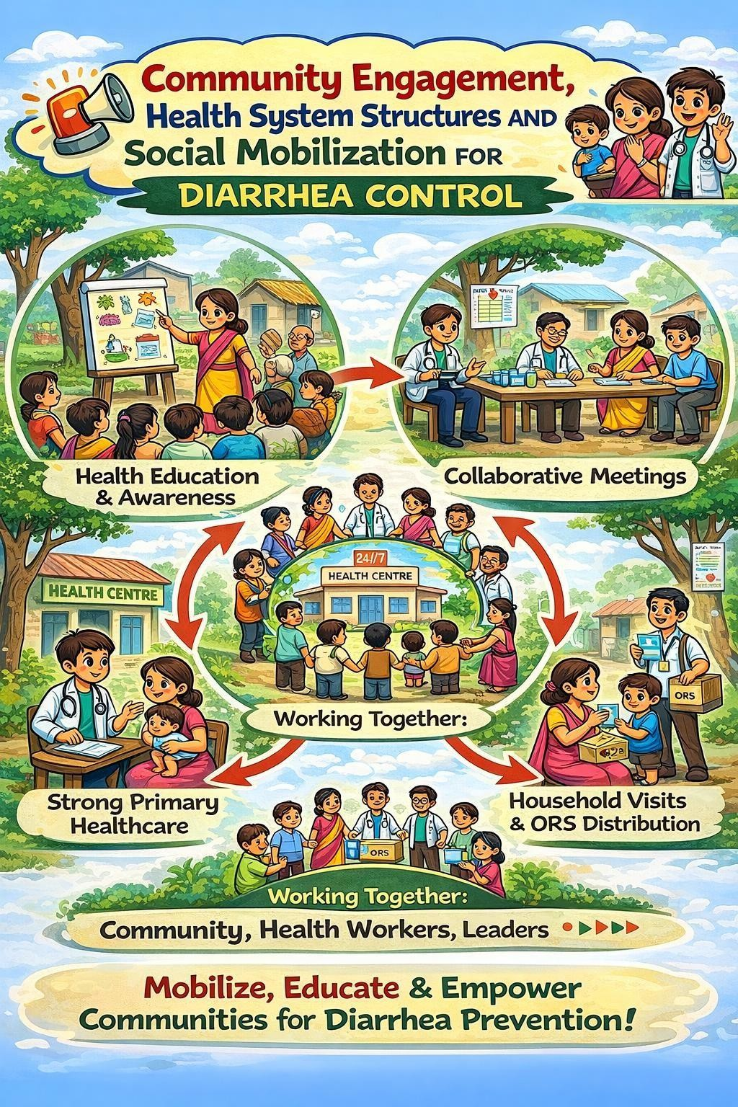
SESSION 9: COMMUNITY ENGAGEMENT, HEALTH SYSTEM STRUCTURES AND SOCIAL MOBILIZATION FOR DIARRHEA CONTROL

126

LEARNING OBJECTIVES

By the end of this session, the participants will be able to:

- Describe the key community-level health structures involved in diarrhea prevention and control.
- Explain the roles and responsibilities of ASHA, ANM, AWW, VHSNC, RKS, and VHND platforms.
- Understand the concept and process of social mobilization in public health.
- Identify strategies to reach underserved and vulnerable populations.
- Recognize the importance of community monitoring, advocacy, and inter-sectoral coordination in strengthening diarrhea control efforts.

SECTION I: COMMUNITY-LEVEL STRUCTURES IN DIARRHEA CONTROL

Effective diarrhea control depends on coordination of multiple community with launch of National Rural Health Mission in 2005, a strong focus has been on community engagement to ensure people’s participation in health and to enable action on the social determinants of health.1 The key instruments in this regard are the ASHA and the Village Health, Sanitation and Nutrition Committees (VHSNC).

The ASHA Program:
The ASHA program was introduced as a key component of the community processes intervention under NRHM in 2005. It has emerged as the largest community health worker program in the world, and is considered a critical contributor to enabling people’s participation in health.
Accredited Social Health Activist (ASHA) works as healthcare facilitator, a service provider and a health activist. ASHA is woman resident of the village, preferably married and aged 25-45 years. She has effective communication skills, leadership qualities and able to reach to the community. She should be a literate with formal education upto class eighth at least. One ASHA is for 1000 population.
Her roles and responsibilities are:

127

- ASHA will take steps to create awareness and provide information to the community on determinants of health such as nutrition, basic sanitation and hygienic practices, healthy living and working conditions, information on existing health services and the need for timely use of health services.
- She will counsel women and families on birth preparedness, importance of safe delivery, breastfeeding and complementary feeding, immunization, contraception and prevention of common infections including Reproductive Tract Infection/Sexually Transmitted Infection (RTIs/STIs) and care of the young child.
- ASHA will mobilize the community and facilitate people’s access to health and health related services available at the village/sub-centre/primary health centres, such as Immunization, Ante Natal Check-up (ANC), Post Natal Check-up (PNC), ICDS, sanitation and other services being provided by the government.
- She will work with the Village Health, Sanitation and Nutrition Committee to develop a comprehensive village health plan, and promote convergent action by the committee on social determinants of health. In support with VHSNC, ASHAs will assist and mobilize the community for action against gender based violence.
  - She will arrange escort/accompany pregnant women & children requiring treatment/ admission to the nearest pre- identified health facility i.e. Primary Health Centre/ Community Health Centre/First Referral Unit (PHC/CHC/FRU).
  - ASHA will provide community level curative care for minor ailments such as diarrhea, fevers, care for the normal and sick newborn, childhood illnesses and first aid. She will be a provider of Directly Observed Treatment Short-course (DOTS) under Revised National Tuberculosis Control Program. She will also act as a depot holder for essential health products appropriate to local community needs.
  - The ASHA will provide information on about the births and deaths in her village and any unusual health problems/disease outbreaks in the community to the Sub-Centres/Primary Health Centre. She will promote construction of household toilets under Total Sanitation Campaign. (Now under Swacch Bharat Mission for rural and urban area)
  - ASHA should promote attendance at the monthly Village Health and Nutrition Day by those

128

who need Aganwadi or Auxiliary Nurse Midwife (ANM) services and help with counseling, health education and access to services.

Village Health Sanitation and Nutrition Committee (VHSNC)
It is envisaged to- act as leadership platform for improving awareness and access of community for health services, support the ASHA, develop village health plans, specific to the local needs, and serve as a mechanism to promote community action for health, particularly for social determinants of health.
    - The VHSNC is to be formed at the level of revenue village. It should have minimum of about
15 members. Members of the committee are selected from: elected Gram Panchayat Members, ASHAs, frontline staff of government health related services such as ANM, AWW and the school teacher, pre-existing committees, representatives from community based organizations, service users.
    - Roles and responsibilities of VHSNC are as follows:

- Monitoring and Facilitating Access to Essential Public Services- and Correlating Such Access with Health Outcomes- other than health services the VHSNC also records access to related public services, including the access to work under MNREGA, rations from public distribution system, midday meals, anganwadi services, safe drinking water, access to toilets, etc-
- Organising Local Collective Action for Health Promotion- The VHSNC could motivate voluntarism by organization and serve as an inspiring village organization, or they could pay local village youth for the task, or contract labour for this purpose.
- Facilitating Service Delivery and Service Providers in the Village-
  - Organization of the Village Health and Nutrition Day and support to the organization of immunization sessions is key part of facilitating service access in the village.
  - VHSNCs need to allow outreach workers and community service providers to articulate their problems in these meetings. The meeting should identify those individuals whom the ANM, Anganwadi worker, the school teacher and the ASHA are unable to reach and should help these providers in reaching these sections.
129

  - Sometimes there are important amenities missing in the Anganwadi center or Sub- center or School. The VHSNC can help provide these amenities
  - The committee can organize local tie-ups with vehicle owners to transport a patient to the hospital in time of need.
  - One specific type of service for VHSNCs to focus on is the registration of births and deaths.

- Village Health Planning- One method of making a village health plan is to identify the problems in access to public services and close the gaps. This type of planning enables understanding on why some pockets or habitations have lower access and can suggest actions to close the gaps.
- Community Monitoring of Health Care Facilities- In many districts VHSNCs have been oriented towards community monitoring of health care services in primary and secondary health care facilities in their area.
- Monthly meetings (should be held once in a month)
- Management of Untied Village Health Fund- Every VHSNC is entitled to an annual untied grant of Rs. 10,000 from the National Rural Health Mission (NRHM). The untied grant
is a resource for community action at the local level. Nutrition, Education & Sanitation, Environmental Protection, Public Health Measures are key areas where these funds could be utilized
- Maintenance of records-record of meetings, record of approvals, cash back, public services monitoring register, birth and death register.

Auxiliary Nurse Midwife (ANM)
ANMs are regarded as the first contact person between people and organisation, between needs and services and between consumer and provider.2 ANM is expected to participate in Maternal Health, Child Health and Family Planning Services; Nutrition Education; Health
Education; Collaborative Service for Improvement of Environmental Sanitation; Immunisation for Control of Communicable Diseases; Treatment of Minor Ailments and First Aid in Emergencies and Disasters.
130

In addition to these duties, the ANM would perform the following functions in guiding and training the female Accredited Social Health Activist (ASHA), as envisaged in the Guidelines on ASHA, under NRHM:
- Holding weekly / fortnightly meeting with ASHA to discuss the activities undertaken during the week/fortnight.
- Acting as a resource person, along with Anganwadi Worker (AWW), for the training of ASHA.
- Informing ASHA about date and time of the outreach session and also guiding her to bring the prospective beneficiaries to the outreach session.
- Participating and guiding in organising Health Days at Anganwadi Centre
- Taking help of ASHA in updating eligible couples register of the village concerned.
- Utilizing ASHA in motivating the pregnant women for coming to Sub-Centre for initial check-ups.
- ASHA helps ANMs in bringing married couples to Sub-Centres for adopting family planning.
- Guiding ASHA in motivating pregnant women for taking full course of iron folic acid (IFA) tablets and TT injections, etc.
- Orienting ASHA on the dose schedule and side effects of oral pills.
- Educating ASHA on danger signs of pregnancy and labour so that she can identify and help beneficiary in getting further timely treatment.
- Informing ASHA about date, time and place for initial and periodic training schedule. ANM would also ensure that during the training ASHA gets the compensation for performance and also TA/DA for attending the training.

Anganwadi Worker
An Anganwadi is the focal point for the delivery of Integrated Child Development Services (ICDS) Scheme services to children and mothers. An Anganwadi normally covers a population of 400-800 in both rural and urban areas and 300-800 in tribal areas.
Services at Anganwadi center (AWC) are delivered by an Anganwadi Worker (AWW) who is a part-time honorary worker. She is a woman of same locality, chosen by the people,
131

educational qualification of middle school or matric or higher. She is assisted by a helper who is also a local woman and is paid honorarium. Being the functional unit of ICDS programme which involves different groups of beneficiaries, the AWW has to conduct various types of job responsibilities.
Role and responsibilities of AWW are as follows:

  - To elicit community support and participation in running the programme.
  - To weigh each child every month, record the weight graphically on the growth card, use referral card for referring cases of mothers/children to the sub-centers/Primary Health Centers (PHC) etc., and maintain child cards for children below 6 years and produce these cards before visiting medical and para-medical personnel
  - To carry out a quick survey of all the families, especially mothers and children in those families in their respective area of work once in a year.
  - To organise non-formal pre-school activities in the anganwadi of children in the age group 3-6 years of age and to help in designing and making of toys and play equipment of indigenous origin for use in anganwadi.
  - To organise supplementary nutrition feeding for children (0-6 years) and expectant and nursing mothers by planning the menu based on locally available food and local recipes.
  - To provide health and nutrition education and counseling on breastfeeding/Infant & young feeding practices to mothers. Anganwadi Workers, being close to the local community, can motivate married women to adopt family planning/birth control measures
  - AWWs shall share the information relating to births that took place during the month with the Panchayat Secretary/Gram Sabha Sewak/ANM whoever has been notified as Registrar/ Sub Registrar of Births & Deaths in her village.
Rogi Kalyan Samiti (RKS)
Rogi Kalyan Samiti (Patient Welfare Committee) / Hospital Management Society is a registered society, acts as a group of trustees for the hospitals to manage the affairs of the hospital.
It consists of members from local Panchayati Raj Institutions (PRIs), NGOs, local elected representatives and officials from Government sector who are responsible for proper
132

functioning and management of the hospital / Community Health Centre / First Referral Units (FRU’s). RKS / HMS is free to prescribe, generate and use the funds with it as per its best judgement for smooth functioning and maintaining the quality of services.4
The suggested composition of RKS / HMS is as follows:
- Peoples representatives MLA / MP
- Health officials (including an Ayush doctor)
- Local district officials
- Leading members of the community
- Local CHC/ FRU in-charge
- Representatives of the Indian Medical Association
- Members of the local bodies and Panchayati Raj representative
- Leading donors

Roles and responsibilities of RKS:

- Identifying the problems faced by the patients in CHC/PHC;
- Acquiring equipment, furniture, ambulance (through purchase, donation, rental or any other means, including loans from banks) for the hospital;
- Expanding the hospital building, in consultation with and subject to any Guidelines that may be laid down by the State Government;
- Making arrangements for the maintenance of hospital building (including residential buildings), vehicles and equipment available with the hospital;
- Improving boarding / lodging arrangements for the patients and their attendants;
- Entering into partnership arrangement with the private sector (including individuals) for the improvement of support services such as cleaning services, laundry services, diagnostic facilities and ambulatory services etc.;
- Developing / leasing out vacant land in the premises of the hospital for commercial purposes with a view to improve financial position of the Society;
133

- Encouraging community participation in the maintenance and upkeep of the hospital;
- Promoting measures for resource conservation through adoption of wards by institutions or individuals; and,
- Adopting sustainable and environmental friendly measures for the day-to-day management of the hospital, e.g. scientific hospital waste disposal system, solar lighting systems, solar refrigeration systems, water harvesting and water re-charging systems etc.

Village Health Nutrition Day
The VHND is to be organized once every month (preferably on Wednesdays, and for those villages that have been left out, on any other day of the same month) at the AWC in the village. This will ensure uniformity in organizing the VHND. The AWC is identified as the hub for service provision in the RCH-II, NHM, and also as a platform for inter-sectoral convergence. VHND is also to be seen as a platform for interfacing between the community and the health system.
On the appointed day, ASHAs, AWWs, and other will mobilize the villagers, especially women and children, to assemble at the nearest AWC. The ANM and other health personnel should be present on time On the VHND, the villagers can interact freely with the health personnel and obtain basic services and information. They can also learn about the preventive and promotive aspects of health care, which will encourage them to seek health care at proper facilities.

SECTION II: SOCIAL MOBILIZATION AND REACHING THE UNREACHED

What is Social Mobilization?
Social mobilization is a process that engages and motivates a wide range of partners and allies at national and local levels to raise awareness of and demand for a particular development objective through dialogue.1 Members of institutions, community networks, civic and religious groups and others work in a coordinated way to reach specific groups of people for dialogue with planned messages. In other words, it’s about people taking action and making change for the common good. The societal mobilization strategy calls for
134

partnership with all stake holders.

Steps to mobilize the community
When working with the community, it is advised to apply the Community Mobilization Cycle. This cycle is composed of 8 steps and can regularly be used when enabling the community to solve their own problems and initiate their own projects.

Reaching the unreached
It is suggested that the unreached may be considered in three categories.3

- First there are the under-served in geographically remote areas, sometimes referred to as the rural ghettos.
- Then there are the under-served in the urban ghettos who may or may not be in close proximity to every kind of health care resource but still do not get the care they need.
- And then there is a very large and generally overlooked group, the under-served among educated, economically self-sufficient persons who are quite capable of getting health care for themselves, but who; may feel they are perfectly healthy and not in need of care, or who for some other reason may not choose to avail themselves of it.

Social mobilization components
Health education:

Information Education Communication- Appropriate messages should be designed for a particular audience based on a particular problem. Use of various mechanisms and forms of communication-both one way and two-way communication.

135

Fig: Hierarchy of effects

Target Audience | Exposed to message | Correctly understand  the message | Agree with message | Intend to act | Act
 |  |  | 
100 persons | 80 persons | 60 persons | 40 persons | 20 persons | 3-7 persons

Training-

- Develop competencies of the community, health sector workers and those of the other sectors.
- In undertaking the identified tasks from resource sharing to provision of specific health procedures.
Community organizing:

- Build the community’s capability for problem-solving, decision making and collective action while developing and strengthening its own networks.
- Mobilization of communities should focus on building confidence, trust and respect, increasing knowledge base, and enabling community members to participate, and become
136

more proactive with regard to their own health behavior.
Advocacy

- Organization of information into arguments used to persuade or convince a specific group of people to take necessary action on a specific goal.
Involves the generation and utilization of reliable information to help national leaders, policy makers, and decision makers to help adopt necessary policies or programs

Monitoring and Evaluation
- Improve the implementer’s efficiency in advocating and mobilizing action (Monitoring)
- Determine the effectiveness of the program (Evaluation)

Social mobilization in diarrhea prevention and treatment⁴
- Improvement in care-seeking and child-rearing practices; health education and promotion; social accountability and advocacy have been identified as the core components of the community mobilization strategy
- Inter-sectoral collaboration within and outside the health sector
- Community-based workers have to be trained not only in counseling skills to improve child care and feeding and care-seeking practices but also in community development facilitating skills.
- Generating and presenting in the appropriate national and international forums the relevant data on the disease burden, the human and socioeconomic impacts arising from this burden and the available cost-effective interventions as a solution to this problem must be an integral part.
- Besides reducing excess mortality, morbidity and disability, especially in poor and marginalized populations, mobilizing a unified response from national and international partners would also assist in framing an enabling policy and creating an institutional environment for implementing the programme.

137
COMPETENCY ACHIEVED: Grassroot level workers demonstrate the ability to coordinate with community-level structures and apply social mobilization strategies to strengthen diarrhea prevention and control efforts.

Exercise
Q1. As a community health worker, how will you mobilize the community for prevention and control of diarrhea among children?
(ask the participants to work in group and put it on charts)

SESSION SUMMARY

This session emphasized the critical role of community engagement and decentralized health structures in effective diarrhea prevention and control. Participants gained an understanding of how the National Rural Health Mission strengthened community participation through key platforms such as ASHA, Village Health Sanitation and Nutrition Committees (VHSNC), Anganwadi Centres, Auxiliary Nurse Midwives, Rogi Kalyan Samitis, and Village Health and Nutrition Days.

The coordinated roles of frontline workers were discussed in detail, highlighting their contribution to awareness generation, service delivery, referral, monitoring, and community mobilization. The session further explored the concept of social mobilization as a participatory process that empowers communities to identify problems, plan interventions, and take collective action for health improvement.

Participants learned about the Community Mobilization Cycle and the importance of reaching underserved populations in geographically remote, economically disadvantaged, and cognitively unaware groups. The session reinforced that sustainable reduction in diarrhea-related morbidity and mortality requires not only medical interventions but also strong community systems, inter-sectoral collaboration, advocacy, and continuous monitoring.
Overall, the session highlighted that community ownership, accountability, and system strengthening are fundamental pillars for long-term diarrhea control.

138

REFERENCES:

139
- UNICEF. Communication for Development (C4D) [Internet] 2015 [Accessed on 2016, Feb 20]. Available from: http://www.unicef.org/cbsc/index_42347.html
- Handbook “Steps and methods to mobilize the community” [Internet] 2003 [Accessed on 2016, Feb 20]. Available from: http://siteresources.worldbank.org/
- Watts MS. Editorial: reaching the unreached with health care. West J Med 1974;121(3):230-31.
- WHO. Strategy for coordinated approach to prevention and control of acute diarrhea and respiratory infection in the South East Asia Region [Internet] 2010 [Accessed on 2016, Feb 15] Available from: http://www.searo.who.int/about/administration_structure/cds/Publication_SEA- CD-
212.pdf

APPENDIX I

140
INDIAN STANDARDS OF DRINKING WATER

. No. | Test Parameter | IS: 10500-2012 |  | Method of Test
 |  | Drinking Water Specification |  | (Indian Standard IS:3025 Methods of Sampling and Test for Water and Waste Water)
 |  | (Second Revision)
 |  | Requirement (Acceptable limit) | Permissible limit In the Absence of alternate source
1 | Odour | Agreeable | Agreeable | IS:3025 Part 5
2 | Taste | Agreeable | Agreeable | IS:3025 Part 8
3 | pH value | 6.5 – 8.5 | No relaxation | IS:3025 Part 11
4 | Turbidity, NTU, Max | 1 | 5 | IS:3025 Part 10
5 | Total dissolved solids (TDS), mg/l, Max | 500 | 2000 | IS:3025 Part 16
6 | Total alkalinity  as CaCO3, mg/l, Max | 200 | 600 | IS:3025 Part 23
7 | Total hardness as CaCO3, mg/l, Max | 200 | 600 | IS:3025 Part 21
8 | Calcium as Ca, mg/l,  max | 75 | 200 | IS:3025 Part 40
9 | Magnesium as Mg,  mg/l, Max | 30 | 100 | IS:3025 Part 46
10 | Chloride as Cl, mg/l,  Max | 250 | 1000 | IS:3025 Part 32
11 | Residual Free Chlorine, mg/l,  Min* | 0.2 | 1 | IS:3025 Part 26
12 | Sulphate as SO4, mg/l,  max | 200 | 400 | IS:3025 Part 24
13 | Nitrate Nitrogen as NO3, mg/l, Max | 45 | No relaxation | IS:3025 Part 34
14 | Fluoride as F, mg/l,  Max | 1 | 1.5 | IS:3025 Part 60
15 | Total Iron as Fe, mg/l,  Max | 0.3 | No relaxation | IS:3025 Part 53

16 | Coliform MPN/100 ml | Shall not be detectable in any 100 ml sample |  | Indian Standard IS:1622, Methods of Sampling and Microbiological  Examinationofwater.
17 | Faecal Coliform, Presence/Absence | Shall not be detectable in any 100 ml sample
18 | E.coli, Presence / Absence | Shall not be detectable in any 100 ml sample
*Applicable only when water is chlorinated

141

APPENDIX II

WATER QUALITY MANAGEMENT

Purification of water on a large scale
The method of treatment of water to be employed depends upon the nature of raw water, and the desired standards of water quality. For example, ground water (e.g. wells and springs) may need no treatment, other than disinfection. Surface water (e.g. river water) which tends to be turbid and polluted, requires extensive treatment
The components of a typical water purification system comprise one or more of the following measures:
- Storage
- Filtration
- Disinfection
Storage: Water is drawn out from source and impounded in reservoirs. Storage provides a reserve of water from which further pollution is excluded. About 90% of the suspended impurities settle down in 24 hours by gravity. The water becomes clearer. This allows penetration of light and reduces the work of filters. Also, certain chemical changes take place during storage. The aerobic bacteria oxidize the organic matter present in the water with aid of dissolved oxygen. Consequently, the content of free ammonia is reduced. It is found out that when river water is stored, the total bacterial count drops by as much as 90% in the first 5-7 days.
The optimum period of storage of river water is 10-14 days, after which there is likelihood of development of vegetable growths such as algae which impart bad smell and color to water.
Filtration: It is the second stage in purification of water. 98-99% of the bacteria are removed by filtration. Two types of filters are in use the “biological” or “slow sand” filters and the “rapid sand” or mechanical filters.

142

Disinfection: It is the last step in purification process. An agent or chemical can act as disinfectant if it is capable of destroying pathogenic organisms, does not leave any products of reaction, have ready and dependable availability, possess the property of leaving residual concentration to deal with small possible re-contamination and is amenable to detection by simple analytical techniques. Examples-chlorine and ozone.

Purification of water on a small scale
Three methods are generally available for purifying water on an individual or domestic scale. These methods are:
- Boiling
- Chemical disinfection
- Filtration
- Ultraviolet irradiation
- Multi-stage reverse osmosis purification of water
Boiling: It is a satisfying method of purifying water for household purposes. To be effective, the water must be brought to “rolling boil” for 10-20 minutes. It kills all bacteria, spores, cysts and ova and yields sterilized water. It also removes temporary hardness of water. However, it offers no “residual protection” against subsequent microbial contamination.
Chemical disinfection: Water is disinfected using bleaching powder, chlorine solution, hypochlorite solution, chlorine tablets, iodine.
Filtration: Water can be purified by filtering through ceramic filters such as Pastuer Chamberland filter, Berkefeld filter and “Katadyn” filter. The essential part of a filter is the “candle” which is either made of porcelain or infusorial earth. In the Katadyn filter, the surface of the filter is coated with silver catalyst so that bacteria coming in contact with the surface are killed. Filter candles of fine type usually remove bacteria found in drinking water, but not filter passing viruses.
Ultraviolet (UV) irradiation: UV irradiation is effective against most microorganisms known to contaminate water supplies like bacteria, yeast, viruses, fungi, algae, protozoa

143

etc. This method of disinfection involves exposure of a film of water, upto 120 mm thick, to one or several quartz mercury vapour arc lamps emitting UV. The advantages are that exposure is for short period, no foreign matter introduced and no taste or odour produced. Over exposure does not result in any harmful effects.

144
Multi-stage reverse osmosis purification of water: It is used to make water both chemically and microbiologically potable by reducing total dissolved solids, hardness, heavy metals, and disease causing bacteria, virus, protozoa and cysts.

APPENDIX III METHODS OF EXCRETA DISPOSAL
There are number of methods of excreta disposal. Some are applicable to unsewered areas and
some to sewered areas.

- Unsewered areas
  - Non service type latrines (sanitary latrine) A sanitary latrine is one where:
    - Excreta should not contaminate the ground or surface water.
    - Excreta should not pollute the soil.
    - Excreta should not be accessible to flies, rodents, animals, and other vehicle of transmission
    - Excreta should not create a nuisance due to odour or unsightly appearance. Some well-known type of sanitary latrines are as follows:
      - Bore hole latrine: The latrine consists of a circular hole 30-40 cm in diameter,
dug vertically into the ground to a depth of 4-8 m. A concrete squatting plate with central opening and footrests is place over the hole. For a family of 5-6 people, it serves well over a year.
      - Dug well latrine or pit latrine: A circular pit about 75 cm in diameter and 3-3.5 m deep is dug into the ground for reception of nightsoil. A concrete squatting plate with central opening and footrests is place over the hole. The pit latrine last for about 5 years for a family of 4-5 persons.
      - Water seal latrine or hand flushed “water seal” type: The squatting plate is fitted with water seal which prevents access by flies and odours and foul gases thereby eliminating the nuisance from smell. This type of latrine consists of pan that receives nightsoil, urine, and wash water. There is a uniform slope from front to back of the pan. It is connected to a trap which is bent pipe holding the water seal. A connecting pipe is required if the pit is dug away from the squat.
      - Septic tank: It is water tight masonry tank into which the household sewage is admitted for treatment. A capacity of 20-30 gallons per person is recommended for household septic tanks. The minimum capacity should 500 gallons. The depth of the tank is 1.5-2 m and
145

length is usually twice the breadth. The liquid depth should be 1.2 m. There should be minimum of 30 cm air space between the liquid in the tank and undersurface of the cover.
      - Aqua privy: The privy consists of water tight chamber filled with water. A short length of a drop pipe from latrine floor dips into the water. A capacity of one cubic ft. is recommended for small family, allowing 6 years or more for cleansing purposes
There is an inlet and outlet pipe and bottom is sloping towards inlet. Newly built septic tanks are first filled with water upto the outlet level and then seeded with ripe sludge drawn from another septic tank, to provide the right type of bacteria for decomposition Latrines suitable for camps and temporary use:
- Shallow trench latrine: The trench is 30 cm wide and 90-150 cm deep. Its length depends on the number of users: 3-3.5 m are necessary for 100 people. It is rudimentary arrangement for a short period (upto one week).
- Deep trench latrine: The trench is 1.8 to 2.5 m deep and 75-90 cm wide. This type of latrine is intended for camps of longer duration, from few weeks to a few months.
- Sewered areas
  - Water carriage system and sewage treatment: It implies collecting and transporting of human excreta and waste water from residential, commercial and industrial areas, by a network of underground pipes, called sewers to the place of ultimate disposal.
A water carriage system consists of the following elements:

- Household sanitary fittings (plumbing system of buildings)
- House sewers

- Street sewers

146

APPENDIX IV

147
NATIONAL IMMUNIZATION SCHEDULE

Age | Vaccines given
Birth | Bacillus Calmette Guerin (BCG), Oral Polio Vaccine (OPV)-0 dose, Hepatitis B birth dose
6 Weeks | OPV-1, Pentavalent-1, Rotavirus Vaccine (RVV)-1, Fractional dose of Inactivated Polio Vaccine (fIPV)-1, Pneumococcal Conjugate Vaccine (PCV) -1*
10 weeks | OPV-2, Pentavalent-2, RVV-2
14 weeks | OPV-3, Pentavalent-3, fIPV-2, RVV-3, PCV-2*
9-12 months | Measles & Rubella (MR)-1, JE-1** , PCV-Booster*
16-24  months | MR-2, JE-2**, Diphtheria, Pertussis & Tetanus (DPT)-Booster-1, OPV – Booster
5-6 years | DPT-Booster-2
10 years | Tetanus & adult Diphtheria (Td)
16 years | Td
Pregnant Mother | Td-1, Td-2 or Td-Booster***
* PCV in selected states/districts: Bihar, Himachal Pradesh, Madhya Pradesh, Uttar Pradesh (selected districts) and Rajasthan; in Haryana as state initiative
** JE in endemic districts only
*** One dose if previously vaccinated within 3 years

Vaccine | When to give | Dose | Route | Site
For Pregnant Women
Tetanus & adult Diphtheria (Td)-1 | Early in pregnancy | 0.5 ml | Intra-muscular | Upper Arm
Td-2 | 4 weeks after Td-1 | 0.5 ml | Intra-muscular | Upper Arm
Td- Booster | If received 2 TT/Td doses in a  pregnancy within the last 3 years* | 0.5 ml | Intra-muscular | Upper Arm
For Infants
Bacillus Calmette Guerin (BCG) | At birth or as early as possible till one year of  age | 0.1ml (0.05ml until 1 month age) | Intra-dermal | Left Upper Arm
Hepatitis B - Birth dose | At birth or as  early as possible within 24 hours | 0.5 ml | Intra-muscular | Antero-lateral  side of mid-thigh
Oral Polio Vaccine (OPV)-0 | At birth or as early as possible  within the first 15 days | 2 drops | Oral | Oral
OPV 1, 2 & 3 | At 6 weeks, 10  weeks & 14 weeks  (OPV can be given till 5 years  of age) | 2 drops | Oral | Oral
Pentavalent 1, 2 & 3 | At 6 weeks, 10  weeks & 14 weeks  (can be given till one year of age) | 0.5 ml | Intra-muscular | Antero-lateral side of mid-thigh
Pneumococcal Conjugate Vaccine(PCV) | Two primary doses at 6 and 14 weeks followed by Booster dose  at 9-12 months | 0.5 ml | Intra-muscular | Antero-lateral side of mid-thigh
Rotavirus (RVV) | At 6 weeks, 10  weeks & 14 weeks  (can be given till one year of age) | 5 drops (liquid vaccine)  2.5 ml (lyophilized  vaccine) | Oral | Oral

148

Inactivated Polio Vaccine (IPV) | Two fractional  dose at 6 and 14 weeks of age | 0.1 ml |  | Intra dermal two fractional dose | Intra-dermal: Right upper arm
Measles Rubella | 9 completed | 0.5 ml |  | Sub-cutaneous | Right upper Arm
(MR) 1st dose | months-12
 | months.
 | (Measles can be
 | given till 5 years
 | of age)
Vaccine | When to give | Dose |  | Route | Site
Japanese Encephalitis (JE)  - 1 | 9 completed months-12 months. | 0.5 ml |  | Sub-cutaneous (Live attenuated vaccine)  Intramuscular(Killed vaccine) | Left upper Arm (Live attenuated vaccine) Anterolateral aspect of mid thigh (Killed  vaccine)
Vitamin A (1st dose) | At 9 completed months with measles-Rubella | 1 ml  ( 1 lakh IU) |  | Oral | Oral
For Children
Diphtheria, | 16-24 months |  | 0.5 ml | Intra-muscular |  | Antero-lateral
Pertussis & |  |  |  |  |  | side of mid-thigh
Tetanus (DPT)
booster-1
MR 2nd dose | 16-24 months |  | 0.5 ml | Sub-cutaneous |  | Right upper Arm
OPV Booster | 16-24 months |  | 2 drops | Oral |  | Oral
JE-2 | 16-24 months |  | 0.5 ml | Sub-cutaneous (Live attenuated vaccine)  Intramuscular(Killed vaccine) |  | Left upper Arm (Live attenuated vaccine)
Anterolateral aspect of mid thigh (Killed
vaccine)

149

Vitamin A (2nd to 9th dose) | 16-18 months. Then one dose every 6 months  up to the age of 5 years. | 2 ml  (2 lakh IU) | Oral | Oral
DPT Booster-2 | 5-6 years | 0.5 ml. | Intra-muscular | Upper Arm
Td | 10 years & 16 years | 0.5 ml | Intra-muscular | Upper Arm
*One dose if previously vaccinated within 3 years Note:
- JE Vaccine is introduced in select endemic districts after the campaign.
- The 2nd to 9th doses of Vitamin A can be administered to children 1-5 years old during biannual rounds, in collaboration with ICDS.
- PCV in selected states/districts: Bihar, Himachal Pradesh, Madhya Pradesh, Rajasthan & Uttar Pradesh (selected districts), and in Haryana as state initiative

150

APPENDIX V ROTAVIRUS VACCINATION
Rotavirus is the leading cause of severe diarrhea in Indian children under 5, and has been projected to cause 457,000 to 884,000 hospitalizations, 2,000,000 outpatient visits, and 122,000–153,000 deaths annually. Findings from various studies support the introduction of rotavirus vaccine in India, particularly in states such as Bihar and Uttar Pradesh, where rotavirus-associated mortality rates are high.

Brief Description of Rotavirus

Rotaviruses belong to the family Reoviridae, genus Rotavirus. The virus measures 70 nm in diameter and has three shells — outer capsid, inner capsid, and core — which surround 11 segments of double-stranded RNA. The rotaviruses are divided into seven groups: A, B, C (human and animal viruses) and D, E, F, G (animal viruses). Group A rotaviruses are the most frequently identified pathogens.

Based on structural glycoprotein VP7, Group A rotaviruses are classified into 15 genotypes/serotypes, and based on protease-sensitive protein VP4, they are classified into more than 20 serotypes. In most studies from India, the most common G types reported were G1 and G2, and P types were P[4] and P[8].

A novel neonatal strain P type 11 human rotavirus (116E) was isolated from a newborn in a nursery of Delhi. The VP4 of this strain was closely related to that of the bovine serotype G10 P[11] strain B223. Another neonatal strain G10 P[11] was reported from Bangalore. These unusual rotavirus strains, which are natural reassortants of human and bovine rotaviruses, suggest that reassortment may be an important mechanism for generation of rotavirus strains in newborns.

Rotavirus Vaccine in India

India’s first indigenous rotavirus vaccine was launched in March 2016 under the Universal Immunization Programme (UIP). The vaccine was initially introduced in four states — Andhra

151

Pradesh, Haryana, Himachal Pradesh, and Odisha — and was later expanded to the entire country in a phased manner.

Rotavirus Vaccine — ROTAVAC (Live Attenuated, Oral) is a monovalent liquid frozen vaccine containing live rotavirus 116E strain [G9 P(11)] prepared in Vero cells for the prevention of rotavirus gastroenteritis. ROTAVAC should be administered as a 3-dose regimen, 4 weeks apart, beginning at 6 weeks of age, and should not be administered to children older than 8 months of age.

ROTAVAC has a shelf life of 5 years when stored at –20°C until the expiry date and can be stored for up to six months between 5°C ±3°C.

Advantages of ROTAVAC over other rotavirus vaccines include:
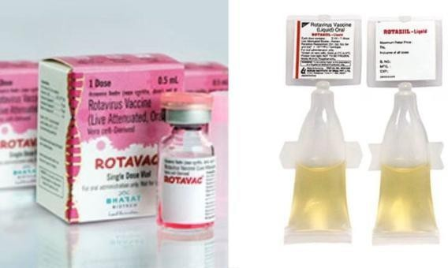

- Easy administration (<10 seconds)
- 0.5 mL (5 drops) per dose
- Requires less cold chain space
- Better compliance due to sweet taste
- Can be safely given with other UIP vaccines
- No interference with breast milk
- No vaccine-related intussusception reported

Rotavirus strain 116E, isolated from asymptomatic neonates born during 1986–88 at the All India Institute of Medical Sciences, New Delhi, was developed into ROTAVAC by Bharat Biotech in collaboration with national and international organizations.

152

The vaccine efficacy of ROTAVAC for severe non-vaccine rotavirus gastroenteritis was found to be 56.4% (95% CI: 36.6–70.1) in the first year of life, and 49% (95% CI: 17.5–68.4) in the second year of the same study.

153

APPENDIX VI

154

TRAINING FEEDBACK FORM (FOR MOCK SESSIONS)

Date of the session:
Name of the session:
Presenter’s/ Trainer’s name:

Instructions: Please indicate your level of agreement with statements listed below:

S.no. | Statements | Strongly agree | Agree | Neutral | Disagree | Strongly disagree
1. | The objectives of the training clearly defined
2. | Participation & interaction were encouraged
3. | The topics covered were relevant to me
4. | The content was organized and easy to follow
5. | The materials distributed were helpful
6. | The trainer was knowledgeable about training topics.
7. | The training objectives were met.
8. | The time allotted for training was sufficient
9. | The trainer was well prepared.
10. | The meeting room and facilities were adequate and comfortable

Q11. What aspect of training you liked the most?

155

Q12. What aspects of the training could be improved?

Other comments:

NOTES

156

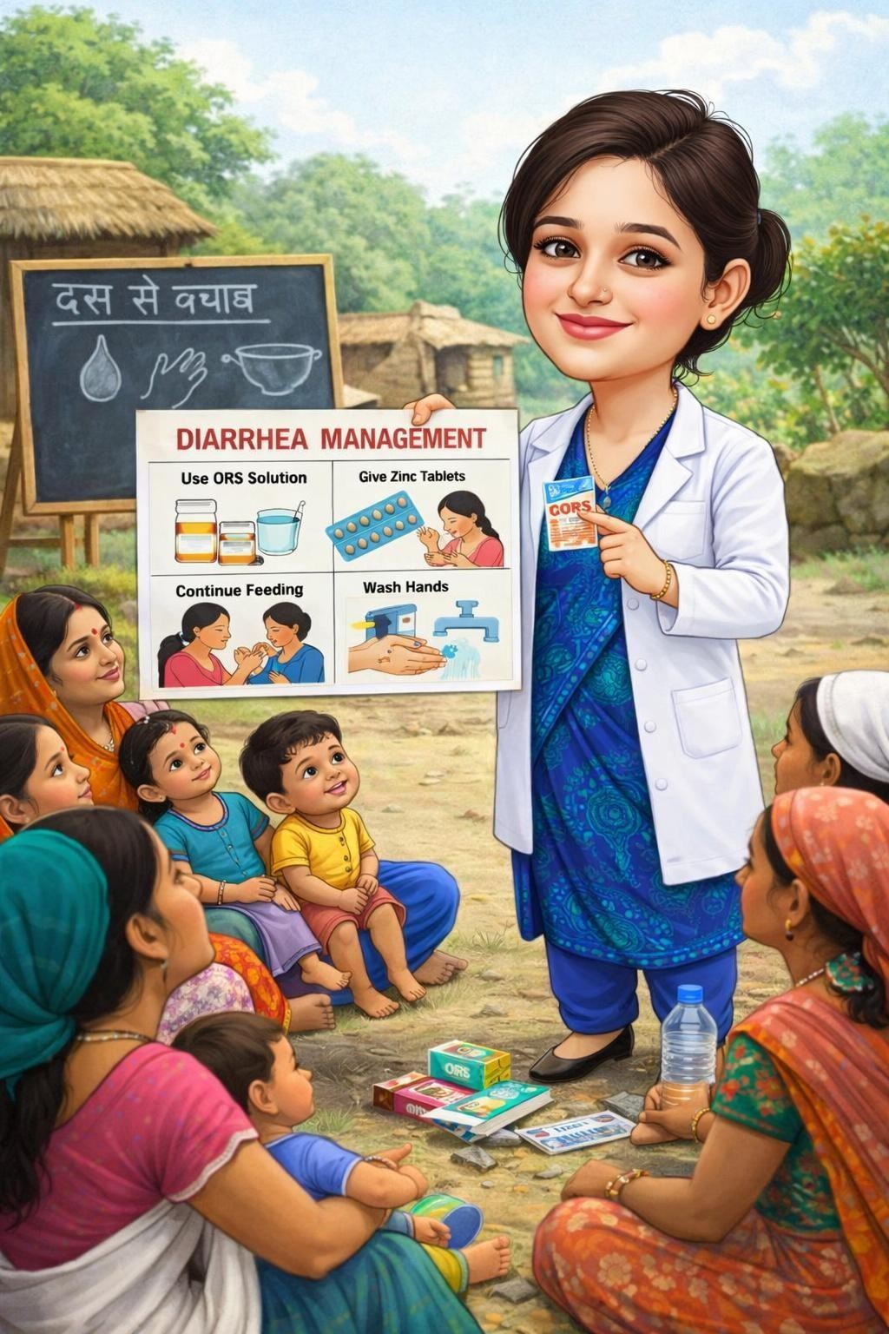
“Wash Hands, Use ORS, Give Zinc – Protect Every Child from Diarrhea.”

1

