CODING AND THEMATIC ANALYSIS

  - THEMATIC ANALYSIS

VERBATIM | CODE | SUB-THEME | THEME
THEME 1: KNOWLEDGE AND
PERCEPTION
"If it happens more than that
and there is a lot of water
loss, that is what is
diarrhea." (I₂AS₂)
"We consider it diarrhea if it
happens more than five
times." (F₂AS₂)
"Diarrhea means three or
more loose stools in a day." | Symptom
(F₁AN₂) | recognition
 |  | 1.1 Definition of
"Diarrhea means having |  | 1.1 Definition of
loose motions, madam. If a |  | diarrhea
child has loose motions
more than three or four |  |  | 1. Knowledge
times a day, we consider it |  |  | and perception
diarrhea." (I₅AN₂)
"Diarrhea in children is
when they pass watery stools
more than three or four
times a day." (I₆AN₃)
"Small children become
dehydrated fast, so we must
identify it early." (F₁AS₆)
"Their body water goes
down very quickly." (I₅AN₂)

"Dehydration comes very  fast." (I₆AN₃) | Water loss and
"The baby gets dehydrated  first." (I₂AS₂) | dehydration
"We explain dehydration signs like sunken eyes and  dry skin." (F₁AS₃) | dehydration
"Diarrhea means contaminated water... Because of contaminated water, there are motions and  vomiting." (I₁AS₁) | Awareness on contamination | 1.2 Etiology of diarrhea
"This is caused by a  contaminated environment and food." (I₄AS₃) | Awareness on contamination | 1.2 Etiology of diarrhea
"It is due to bacteria in contaminated food and  water." (F₂AS₆) | Awareness on contamination | 1.2 Etiology of diarrhea
"Contaminated food and  drinking water are main reasons." (F₂AS₄) | Awareness on contamination | 1.2 Etiology of diarrhea
"In local areas, lack of safe drinking water is a major reason for diarrhea."  (F₁AN₁) | Awareness on contamination | 1.2 Etiology of diarrhea
"Unsafe drinking water, poor sanitation, and poor handwashing practices together cause diarrhea."  (I₃AN₁) |  | 1.2 Etiology of diarrhea

"If hygiene is not maintained  before feeding children, they get diarrhea." (F₂AS₅) | Hygiene related causes
"Children playing in mud  and putting things in mouth causes diarrhea." (F₂AS₃) | Hygiene related causes
"It mainly happens due to lack of cleanliness, madam... Children play in the mud, and that also causes  diarrhea." (F₁AS₄) | Hygiene related causes
"Feeding bottles not cleaned
properly cause infections in infants." (F₂AN₃)
"Under five children have very low immunity, madam. (pause) When motions increase, their body strength  drops immediately." (I₅AN₂) | Vulnerability & Immunity | 1.3 Severity & Rationale for Prevention
"Under five children have low immunity, so prevention  is crucial." (F₂AN₁) | Vulnerability & Immunity | 1.3 Severity & Rationale for Prevention
"It’s because their immune system is weaker. Also, they don’t eat large quantities of  food." (I₅AN₂) | Vulnerability & Immunity | 1.3 Severity & Rationale for Prevention
"They play in the mud. They don’t clean themselves...  This can cause infection."  (F₂AS₁) | Vulnerability & Immunity | 1.3 Severity & Rationale for Prevention

"Adults get it too, but
children don’t know how to be careful." (I₁AS₁)
"In just one day they become weak... their eyes look sunken. They cannot tolerate it the way adults can."  (I₅AN₂) | Complications & Mortality
"Diarrhea can cause death in  small children." (F₂AS₃) | Complications & Mortality
"And since the death rate is higher among them, we concentrate more on them."  (I₁AS₁) | Complications & Mortality
"Preventing diarrhea reduces
infant mortality rate." (F₂AN₂)
"If dehydration becomes severe, it can lead to other
dangers." (I₅AN₂)
THEME 2: CASE MANAGEMENT
PRACTICES
"Their eyes roll back."
(I₁AS₁)
"We explain dehydration
signs like sunken eyes and dry skin." (F₁AS₃)
"The skin doesn’t return
quickly, and there are pits near the eyes." (I₅AN₂)

"When you hold their skin, it  seems stretched, right? That too." (I₂AS₂) | Signs & Symptoms | 2.1 Assessment & Identification | 2. Case Management  Practices  2. Case Management  Practices
"The child lies down tired...  the lips look dry." (I₄AS₃) | Signs & Symptoms | 2.1 Assessment & Identification | 2. Case Management  Practices  2. Case Management  Practices
"They don’t feel like drinking, and urine output  becomes very less." (I₆AN₃) | Signs & Symptoms | 2.1 Assessment & Identification | 2. Case Management  Practices  2. Case Management  Practices
"Passing less urine, being very thirsty — these are  danger signs." (F₁AN₃) | Signs & Symptoms | 2.1 Assessment & Identification | 2. Case Management  Practices  2. Case Management  Practices
"The child is not active."  (I₃AN₁) | Signs & Symptoms | 2.1 Assessment & Identification | 2. Case Management  Practices  2. Case Management  Practices
"They can’t eat or drink..."  (I₆AN₃) | Signs & Symptoms | 2.1 Assessment & Identification | 2. Case Management  Practices  2. Case Management  Practices
"We also check if they are using contaminated water. We explain prevention  simultaneously." (F₁AN₂) | Signs & Symptoms | 2.1 Assessment & Identification | 2. Case Management  Practices  2. Case Management  Practices
"We tell them to mix ORS in boiled and cooled water and give it to them to drink."  (I₁AS₂) | Use of ORS & Zinc |  | 2. Case Management  Practices  2. Case Management  Practices
"When we identify diarrhea, we provide ORS and advise them to take zinc tablets for  14 days." (F₂AS₂) | Use of ORS & Zinc |  | 2. Case Management  Practices  2. Case Management  Practices
"We give zinc tablets, madam. We believe zinc helps reduce the frequency  of loose motions and helps | Use of ORS & Zinc |  | 2. Case Management  Practices  2. Case Management  Practices

control the diarrhea."  (I₅AN₂) |  | 2.2 Management of Diarrhea
"Along with ORS, we also give zinc tablets. Zinc tablets help boost their  immunity." (I₄AS₃) |  | 2.2 Management of Diarrhea
"ORS should be given."  (F₁AS₃) |  | 2.2 Management of Diarrhea
"We tell them that giving sips of ORS frequently will help them tolerate the loose  motions better." (I₄AS₃) | Continued Feeding During Diarrhea | 2.2 Management of Diarrhea
"Then we explain that water should not be stopped... the child must drink fluids."  (F₁AS₇) | Continued Feeding During Diarrhea | 2.2 Management of Diarrhea
"We tell families to boil drinking water, keep utensils clean, and not stop  breastfeeding." (F₁AS₆) | Continued Feeding During Diarrhea | 2.2 Management of Diarrhea
"ORS and breastfeeding should be continued during
diarrhea." (F₂AS₃)
"We emphasize that rehydration is very
important." (F₁AS₅)
"If the situation is more severe, they might need to be taken to the hospital even
after starting ORS." (I₅AN₂)

"If vomiting is too much, we  tell them to take the child to the doctor." (F₁AS₁) | Action Based on Severity | 2.3 Escalation & Referral | 2. Case Management  Practices  2. Case Management  Practices
"If such signs appear, we tell  them to come to the PHC immediately." (F₁AS₃) | Action Based on Severity | 2.3 Escalation & Referral | 2. Case Management  Practices  2. Case Management  Practices
"If diarrhea becomes too frequent, we ask them to bring the child even at  night." (F₁AS₄) | Action Based on Severity | 2.3 Escalation & Referral | 2. Case Management  Practices  2. Case Management  Practices
"First, I tell them to start ORS, madam. I check the child for dehydration and if needed, I ask them to come  to the PHC." (I₆AN₃) | Referral System Awareness | 2.3 Escalation & Referral | 2. Case Management  Practices  2. Case Management  Practices
"From our sub-center, we first refer them to the PHC... So the first point of referral  is the PHC." (I₄AS₃) | Referral System Awareness | 2.3 Escalation & Referral | 2. Case Management  Practices  2. Case Management  Practices
"Then we refer  immediately." (F₁AN₃) | Referral System Awareness | 2.3 Escalation & Referral | 2. Case Management  Practices  2. Case Management  Practices
"We send them to the PHC, madam. We call the medical officer at the PHC and inform them about the  serious case." (I₅AN₂) | Referral System Awareness | 2.3 Escalation & Referral | 2. Case Management  Practices  2. Case Management  Practices
"We first refer them to the PHC. If the child’s condition doesn’t improve there, we refer them to the Bhonigiri  Area Hospital..." (I₆AN₃) | Referral System Awareness | 2.3 Escalation & Referral | 2. Case Management  Practices  2. Case Management  Practices

"We tell them to go to the
hospital. We first refer them to the PHC." (I₆AN₃)
THEME 3: CHALLENGES & BARRIERS IN
MANAGEMENT
"They believe drinking more water increases motions."  (I₄AS₃) | Beliefs about Management | 3.1  Misinformation & Myths | 3. Challenges & Barriers in Management
"Madam... they say, ‘If we give water, diarrhea increases’ (laughs)..."  (F₁AS₇) | Beliefs about Management | 3.1  Misinformation & Myths | 3. Challenges & Barriers in Management
"Many people say ‘Giving  more water increases diarrhea.’" (I₃AN₁) | Beliefs about Management | 3.1  Misinformation & Myths | 3. Challenges & Barriers in Management
"Some think using ORS will worsen loose motion."  (F₂AS₃) | Beliefs about Management | 3.1  Misinformation & Myths | 3. Challenges & Barriers in Management
"They think ORS increases  weakness." (F₁AS₇) | Beliefs about Management | 3.1  Misinformation & Myths | 3. Challenges & Barriers in Management
"Some say ‘cold water  causes diarrhea,’ madam." (I₅AN₂) | Beliefs about Management | 3.1  Misinformation & Myths | 3. Challenges & Barriers in Management
"Some believe diarrhea is  caused by teething." (F₂AS₁) | Beliefs about Management | 3.1  Misinformation & Myths | 3. Challenges & Barriers in Management
"There is a belief that
diarrhea comes only from old stored water." (I₆AN₃)

"They give soda, madam,  believing it is some kind of medicine." (F₁AS₃) | Use of  Inappropriate Remedies
"Convincing parents causes  the biggest delay." (I₃AN₁) | Lack of Seriousness | 3.2 Lack of Seriousness &  Resistance
"Even when dehydration signs appear, they say, ‘We’ll see tomorrow.’"  (F₁AN₂) | Lack of Seriousness | 3.2 Lack of Seriousness &  Resistance
"A baby was severely dehydrated. Parents refused referral and brought the  child too late." (I₁AS₂) | Lack of Seriousness | 3.2 Lack of Seriousness &  Resistance
"Family members fear the  hospital crowd." (I₂AS₂) | Lack of Seriousness | 3.2 Lack of Seriousness &  Resistance
"They underestimate it saying ‘It’s nothing, just some loose motions.’"  (F₁AS₃) | Lack of Seriousness | 3.2 Lack of Seriousness &  Resistance
"When we talk about bottle  feeding, they argue." (I₂AS₂) | Resistance to Advice | 3.2 Lack of Seriousness &  Resistance
"When we ask them to stop  bottle feeding, they argue and don’t listen." (F₁AS₅) | Resistance to Advice | 3.2 Lack of Seriousness &  Resistance
"Most mothers follow instructions but some ignore  advice." (F₂AS₂) | Resistance to Advice | 3.2 Lack of Seriousness &  Resistance
"Some people do not take  our advice seriously." (F₂AS₃) | Resistance to Advice | 3.2 Lack of Seriousness &  Resistance

"Mothers listen initially but  don’t follow in practice." (I₁AS₁) | Non-Adherence to Advice | 3.3 Non-  Adherence
"When we give zinc tablets, they stop after two days.  Completing the full course is  a challenge." (F₁AS₂) | Non-Adherence to Advice | 3.3 Non-  Adherence
"They might take the packets but may not prepare and drink the solution at home."  (I₆AN₃) | Non-Adherence to Advice | 3.3 Non-  Adherence
"If the child seems better temporarily, they stop medicines immediately."  (F₁AS₄) | Non-Adherence to Advice | 3.3 Non-  Adherence
"Many families need repeated counseling. They never follow advice the first  time." (F₁AN₃) | Non-Adherence to Advice | 3.3 Non-  Adherence
"They find ORS preparation difficult, so they avoid it."  (I₂AS₂) | ORS Preparation Issues | 3.4 Community Knowledge &  Skill Gaps
"Even after seeing ORS preparation once, they keep asking again and again how  to mix it." (F₂AS₃) | ORS Preparation Issues | 3.4 Community Knowledge &  Skill Gaps
"They do not prepare ORS correctly — too much water  or too little." (F₁AN₃) | ORS Preparation Issues | 3.4 Community Knowledge &  Skill Gaps
"We don’t have proper  measuring cups to | ORS Preparation Issues | 3.4 Community Knowledge &  Skill Gaps

demonstrate to mothers how
to prepare ORS." (F₁AS₆)
"Low education levels —  repeated counseling is needed." (I₃AN₁) | Low Health Literacy
"People want immediate results. ORS works slowly, so they don’t trust it."  (I₁AS₁) | Expectation of Quick Fix
"They want immediate results. ORS works slowly, so they don’t trust it."  (F₁AS₁) | Expectation of Quick Fix
"Mothers sometimes stop breastfeeding during  diarrhea." (F₂AS₄) | Fluid Restriction Misconception
"They reduce giving water,  fearing that it will increase diarrhea." (F₁AS₂) | Fluid Restriction Misconception
"Then we explain that water  should not be stopped." (F₁AS₇) | Fluid Restriction Misconception
"ORS stock sometimes  arrives late." (I₁AS₁) | Stock-Outs & Shortages | 3.5 Supply & Infrastructure  Barriers
"Zinc strips don’t come in  full supply." (I₂AS₂) | Stock-Outs & Shortages | 3.5 Supply & Infrastructure  Barriers
"Sometimes ORS packets are not in stock, madam. That becomes a big  problem." (F₁AS₁) | Stock-Outs & Shortages | 3.5 Supply & Infrastructure  Barriers
"Supply is irregular for zinc  supplements." (F₂AS₅) | Stock-Outs & Shortages | 3.5 Supply & Infrastructure  Barriers

"Stock outs occur during
rainy season." (F₂AS₂)
"There are errors in forecasting how many children might need the  medicine." (F₁AN₃) | Forecasting Challenges
"Sometimes overstocking  leads to expiry of medicines." (F₂AN₃) | Forecasting Challenges
"Inventory tracking is  difficult; manual records are time-consuming." (F₁AN₂) | Forecasting Challenges
"There is a transport  problem — autos aren’t available." (I₁AS₁) | Lack of Transport
"A severe case needed IV fluids, but transport was unavailable. Very  challenging." (I₃AN₁) | Lack of Transport
"At night time, it’s very difficult to get an ambulance... This is a very  big problem." (F₁AS₂) | Lack of Transport
"The lack of transport facilities to take patients to the hospital during emergencies is a major  problem." (F₁AS₄) | Lack of Transport
"Limited transport and poor  weather also reduce outreach." (F₂AN₁) | Lack of Transport

"Many homes do not have  soap or handwashing stations." (F₂AS₁) | Lack of Basic Amenities
"Water scarcity limits  handwashing." (F₂AS₂) | Lack of Basic Amenities
"Some households lack
proper toilets." (F₂AS₃)
"Poor drainage near homes
attracts flies." (F₂AS₄)
"Lack of safe drinking water at community level."
(F₂AN₁)
"It would be good if we had visual charts and  demonstration kits." (I₁AS₁) | IEC Material Shortage | 3.6 IEC &  Training Gaps
"The supply of printed  pamphlets is very low." (I₁AS₂) | IEC Material Shortage | 3.6 IEC &  Training Gaps
"We don’t have a mic or speaker during awareness meetings... people can’t hear  properly." (I₄AS₃) | IEC Material Shortage | 3.6 IEC &  Training Gaps
"We lack demo materials, madam — like bottle models and handwashing charts."  (I₅AN₂) | IEC Material Shortage | 3.6 IEC &  Training Gaps
"IEC material is very limited. Supplies reach the  PHC late." (I₆AN₃) | IEC Material Shortage | 3.6 IEC &  Training Gaps
"Only basic training was  given, madam... we didn’t |  | 3.6 IEC &  Training Gaps

receive extra materials or  refresher training." (I₄AS₃) | Lack of Training
"The training is sufficient, but if there were a refresher course every six months, the networking would be much  better." (F₁AS₂) | Lack of Training
"It has been many years since I attended that
training." (I₆AN₃)
"Sessions are short and not
practical enough." (F₂AS₂)
"Need periodic supervision
and evaluation." (F₂AN₂)
"Excessive documentation taking time away from  health education." (F₂AS₁) |  | 3.7 Administrative & Workload Challenges
"But after going door-to-door all day... there is no time to fill out so many  records and forms." (F₁AS₃) |  | 3.7 Administrative & Workload Challenges
"Record maintenance is also a challenge repeated cases, follow-up, daily reporting... the workload is heavy."  (F₁AN₂) |  | 3.7 Administrative & Workload Challenges
"Inventory tracking is difficult; manual records are  time-consuming." (F₁AN₂) |  | 3.7 Administrative & Workload Challenges
"Reduction of redundant  reporting work." (F₂AN₃) |  | 3.7 Administrative & Workload Challenges

"Yes madam, house visits,  VHND, surveys the workload is heavy." (I₁AS₁) | Heavy Workload
"The workload is heavy. There isn’t enough time to explain everything in detail  to each family." (I₄AS₃) | Heavy Workload
"The whole day goes in field work... I don’t have time to sit and educate separately."  (I₆AN₃) | Heavy Workload | 3.7 Administrative & Workload Challenges
"Sometimes we don’t get
enough time for diarrhea counseling." (I₂AS₂)
"ANC, PNC, deliveries — the workload makes focused counseling difficult."
(I₃AN₁)
"Community meetings are  often cancelled due to local events." (F₂AS₄) | Community Priorities vs.  Health Initiatives | 3.8 Community-Related  Behavioural Challenges
"Families prioritize other  work over health education." (F₂AS₅) | Economic vs. Health Priorities | 3.8 Community-Related  Behavioural Challenges
"Many mothers are busy with work and do not attend awareness sessions."  (F₂AS₁) | Economic vs. Health Priorities | 3.8 Community-Related  Behavioural Challenges
"They only tell us if we go to their house and ask; otherwise, they don’t report  it." (F₂AS₁) | Passive Health Reporting | 3.8 Community-Related  Behavioural Challenges

"When a child has diarrhea, parents often come in casually saying it’s just  loose motions." (I₅AN₂) | Normalization vs. Medicalization
"Families use home remedies and delay seeking  help." (F₂AS₂) | Delayed Formal Care Seeking
THEME 4: HEALTH SYSTEM NAVIGATION & COMMUNITY
ENGAGEMENT
"They trust what neighbors  say more than us." (F₁AS₃) | Peer Influence Over Professional Advice | 4.1 Community Trust & Influence | 4. Health System  Navigation & Community Engagement
"They follow neighbors’ advice and try home remedies. They give coconut water but forget ORS."  (F₁AS₄) | Peer Influence Over Professional Advice | 4.1 Community Trust & Influence | 4. Health System  Navigation & Community Engagement
"We get guidance from  ANM and MO during fieldwork." (F₂AS₁) | Guidance from Health Workers Guidance from Health Workers | 4.2 Guidance & Referral Pathways | 4. Health System  Navigation & Community Engagement
"Our ANM madam arranges a regular meeting for us once a month. There we can share our problems and learn  new guidelines." (F₁AS₁) | Guidance from Health Workers Guidance from Health Workers | 4.2 Guidance & Referral Pathways | 4. Health System  Navigation & Community Engagement
"From our sub-center, we first refer them to the PHC... So the first point of referral  is the PHC." (I₄AS₃) | Referral Pathway Clarity | 4.2 Guidance & Referral Pathways | 4. Health System  Navigation & Community Engagement
"We first refer them to the  PHC. If the child’s condition | Referral Pathway Clarity | 4.2 Guidance & Referral Pathways | 4. Health System  Navigation & Community Engagement

doesn’t improve there, we
refer them to the Bhonigiri Area Hospital..." (I₆AN₃)
"We explain these preventive measures in the village so people become more aware."  (I₅AN₂) | Community-Based Health Communication | 4.3  Communication & Outreach Strategies
"They should give us simple, eye-catching posters and folders. We can take them door-to-door and show  them." (F₁AS₃) | Community-Based Health Communication | 4.3  Communication & Outreach Strategies
THEME 5: CAPACITY &
CONFIDENCE
"I feel confident when  mothers listen about ORS and hygiene." (F₂AS₁) | High Confidence & Receptivity | 5.1 Self-Efficacy in Education | 5. Capacity & Confidence
"I know how to explain ORS  preparation clearly." (F₂AS₄) | High Confidence & Receptivity | 5.1 Self-Efficacy in Education | 5. Capacity & Confidence
"I am comfortable conducting awareness sessions with mothers’  groups." (F₂AN₂) | High Confidence & Receptivity | 5.1 Self-Efficacy in Education | 5. Capacity & Confidence
"My confidence improves with field experience and  observation." (F₂AN₃) | High Confidence & Receptivity | 5.1 Self-Efficacy in Education | 5. Capacity & Confidence
"We give them ORS, and they definitely take the packets... generally,  everyone takes it." (I₆AN₃) | Positive Receptivity | 5.1 Self-Efficacy in Education | 5. Capacity & Confidence
"To prevent it, we should  give the baby thin liquids, |  |  | 5. Capacity & Confidence

give ORS, wash hands  properly, and continue breastfeeding." (F₁AS₁) | Hygiene Education | 5.2 Skill & Knowledge Building
"We advise them to wash their hands with soap, especially after using the  toilet." (F₂AS₂) | Hygiene Education | 5.2 Skill & Knowledge Building
"We should wash hands after using the toilet and before  cooking." (F₁AS₃) | Hygiene Education | 5.2 Skill & Knowledge Building
"For prevention, we focus on handwashing and safe  storage." (F₁AN₂) | Hygiene Education | 5.2 Skill & Knowledge Building
"We explain these preventive measures in the village so people become more aware."
(I₅AN₂)
"They told us at what age children get diarrhea and how to prevent it after it occurs. How to mix ORS..."  (I₁AS₁) | Practical Training
"In the training, they practically showed how to make ORS. It was very  useful." (F₁AS₂) | Practical Training
"They taught us how to raise awareness in the community, which is making our work  much easier." (F₁AN₂) | Practical Training

"Learned about hygiene and
breastfeeding during VHND." (F₂AS₂)
"Demonstration on ORS
preparation was given." (F₂AS₅)
"We received training on identifying dehydration signs and giving correct  advice." (F₁AN₁) | Clinical Assessment Skills
"Basic training covered early identification signs."  (F₂AS₆) | Clinical Assessment Skills
"They told us whether we should treat them at home ourselves or refer them to a  hospital." (I₁AS₁) | Clinical Assessment Skills
"We ask about stool color, frequency, and child’s
lethargy." (F₁AN₂)
"For prevention, we discuss ORS and zinc in mothers’ meetings and explain how to identify severe dehydration."
(F₁AN₁)
"Our ANM madam arranges a regular meeting for us once a month. There we can share our problems and learn
new guidelines." (F₁AS₁)

"We get guidance from  ANM and MO during fieldwork." (F₂AS₁) | Regular Meetings & Guidance | 5.3 System Support
"Regular supply of ORS and  zinc packets is provided." (F₂AS₃) | Regular Meetings & Guidance | 5.3 System Support
"Refresher training comes  once a year." (I₃AN₁) | Regular Meetings & Guidance | 5.3 System Support
"There is a diarrhea program, and they conducted a training session before it  started." (I₅AN₂) | Regular Meetings & Guidance | 5.3 System Support
"There should be a helpline for real-time support. To get immediate guidance on problems being  encountered." (F₁AN₂) | Real-time Support Needs | 5.3 System Support
"They should give us simple, eye-catching posters and folders. We can take them door-to-door and show  them." (F₁AS₃) | Real-time Support Needs | 5.3 System Support
"More field-level  supervision." (F₂AS₂) | Real-time Support Needs | 5.3 System Support
"Supply of educational posters and leaflets."  (F₂AS₃) | Real-time Support Needs | 5.3 System Support
"Improved transport for  referrals." (F₂AS₄) | Real-time Support Needs | 5.3 System Support

  - CODEBOOK

S.NO. | CODE NAME | CONCEPTUAL DEFINITION | SUPPORTING  VERBATIM EXAMPLES
THEME 1: KNOWLEDGE & PERCEPTION
Sub-theme 1.1: Definition of Diarrhea
1 | Symptom Recognition | Defining diarrhea by the frequency and consistency of stools. | "Diarrhea means three or more loose stools in a day." (F1AN2)  "We consider it diarrhea if it happens more than five times." (F2AS2)  "If it happens more than that and there is a lot of water loss, that is what is diarrhea." (I2AS2) "Diarrhea means having loose motions, madam. If a child has loose motions more than three or four times a day, we consider  it diarrhea." (I5AN2)
2 | Water Loss & Dehydration | The immediate association of diarrhea with rapid fluid loss and the danger of dehydration, especially in children. | "Small children become dehydrated fast, so we must identify it early." (F1AS6)  "Their body water goes down very quickly." (I5AN2)  "Dehydration comes very  fast." (I6AN3)

"The baby gets dehydrated first." (I2AS2) "We explain dehydration signs like sunken eyes
and dry skin." (F1AS3)
Sub-theme 1.2: Etiology of Diarrhea
3 | Awareness on Contamination | The understanding that contaminated water and food are primary causes of diarrhea. | "Diarrhea means contaminated water... Because of contaminated water, there are motions and vomiting." (I1AS1) "This is caused by a contaminated environment and food." (I4AS3)  "It is due to bacteria in contaminated food and water." (F2AS6) "Contaminated food and drinking water are main reasons." (F2AS4)  "In local areas, lack of safe drinking water is a major reason for  diarrhea." (F1AN1)
4 | Hygiene Related Causes | The belief that poor hygiene practices are direct behavioral causes of diarrhea. | "Unsafe drinking water, poor sanitation, and poor handwashing practices together cause diarrhea." (I3AN1)  "If hygiene is not maintained before  feeding children, they get

diarrhea." (F2AS5) "Children playing in mud and putting things in mouth causes diarrhea." (F2AS3)
"It mainly happens due to lack of cleanliness...
Children play in the mud, and that also causes diarrhea." (F1AS4) "Feeding bottles not cleaned properly cause infections in infants."
(F2AN3)
Sub-theme 1.3: Severity & Rationale for Prevention
5 | Vulnerability & Immunity | The perception that children under five are particularly susceptible due to underdeveloped immune systems. | "Under five children have very low immunity, madam. When motions increase, their body strength drops immediately." (I5AN2) "Under five children have low immunity, so prevention is crucial." (F2AN1)  "It's because their immune system is weaker. Also, they don't eat large quantities of food." (I5AN2)  "They play in the mud.  They don't clean

themselves... This can cause infection." (F2AS1) "Adults get it too, but children don't know how
to be careful." (I1AS1)
6 | Complications & Mortality | The understanding that diarrhea can lead to severe physical decline and is a life-threatening condition for children. | "In just one day they become weak... their eyes look sunken. They cannot tolerate it the way adults can." (I5AN2)  "Diarrhea can cause death in small children." (F2AS3)  "And since the death rate is higher among them, we concentrate more on them." (I1AS1) "Preventing diarrhea reduces infant mortality rate." (F2AN2)  "If dehydration becomes severe, it can lead to  other dangers." (I5AN2)
THEME 2: CASE MANAGEMENT
PRACTICES
Sub-theme 2.1: Assessment & Identification
7 | Signs & Symptoms | Observable physical and behavioral cues used to identify dehydration in a  child. | "Their eyes roll back." (I1AS1)  "We explain dehydration signs like sunken eyes  and dry skin." (F1AS3)

"The skin doesn't return quickly, and there are pits near the eyes." (I5AN2)
"When you hold their skin, it seems stretched, right? That too." (I2AS2) "The child lies down tired... the lips look dry." (I4AS3)
"They don't feel like drinking, and urine output becomes very less." (I6AN3) "Passing less urine, being very thirsty —
these are danger signs." (F1AN3)
"The child is not active."
(I3AN1)
Sub-theme 2.2: Management of Diarrhea
8 | Use of ORS & Zinc | The administration of ORS and zinc tablets as the cornerstone of community-based treatment. | "We tell them to mix ORS in boiled and cooled water and give it to them to drink." (I1AS2)  "When we identify diarrhea, we provide ORS and advise them to take zinc tablets for 14 days." (F2AS2)  "We give zinc tablets,  madam. We believe zinc

helps reduce the frequency of loose motions and helps control the diarrhea." (I5AN2)
"Along with ORS, we also give zinc tablets. Zinc tablets help boost their immunity." (I4AS3) "ORS should be given." (F1AS3)
"We also check if they are using contaminated water. We explain prevention
simultaneously." (F1AN2)
9 | Continued Feeding During Diarrhea | Counseling to continue and encourage fluid intake and nutrition during diarrhea. | "We tell them that giving sips of ORS frequently will help them tolerate the loose motions better." (I4AS3)  "Then we explain that water should not be stopped... the child must drink fluids." (F1AS7) "We tell families to boil drinking water, keep utensils clean, and not stop breastfeeding." (F1AS6)  "ORS and breastfeeding should be continued during diarrhea."  (F2AS3)

"We emphasize that rehydration is very important." (F1AS5) "We also advise to give thin liquids like rice
water and coconut water
along with ORS." (F1AS4)
Sub-theme 2.3: Escalation & Referral
10 | Action Based on Severity | The decision to refer a child is triggered by specific danger signs or a failure to improve with initial treatment. | "If the situation is more severe, they might need to be taken to the hospital even after starting ORS." (I5AN2) "If vomiting is too much, we tell them to take the child to the doctor." (F1AS1)  "If such signs appear, we tell them to come to the PHC immediately." (F1AS3)  "If diarrhea becomes too frequent, we ask them to bring the child even at night." (F1AS4)  "First, I tell them to start ORS, madam. I check the child for dehydration and if needed, I ask them to come to the PHC."  (I6AN3)
11 | Referral System Awareness | The hierarchical process of referring a | "From our sub-center, we first refer them to the

 |  | child to a higher facility, typically beginning at the Primary Health Centre. | PHC... So the first point of referral is the PHC." (I4AS3)  "Then we refer immediately." (F1AN3) "We send them to the PHC, madam. We call the medical officer at the PHC and inform them about the serious case." (I5AN2)  "We first refer them to the PHC. If the child's condition doesn't improve there, we refer them to the Bhonigiri Area Hospital..." (I6AN3) "We tell them to go to the hospital. We first refer them to the PHC."  (I6AN3)
THEME 3: CHALLENGES & BARRIERS IN MANAGEMENT
Sub-theme 3.1: Misinformation &
Myths
12 | Beliefs about Management | Widespread and dangerous myths that fluid intake, including ORS, will worsen diarrhea. | "They believe drinking more water increases motions." (I4AS3) "Madam... they say, 'If we give water, diarrhea  increases' (laughs)..."

 |  |  | (F1AS7)
 |  |  | "Many people say
 |  |  | 'Giving more water
 |  |  | increases diarrhea.'"
 |  |  | (I3AN1)
 |  |  | "Some think using ORS
 |  |  | will worsen loose
 |  |  | motion." (F2AS3)
 |  |  | "They think ORS
 |  |  | increases weakness."
 |  |  | (F1AS7)
 |  |  | "Some believe ORS is
 |  |  | only for severe cases, not
 |  |  | for mild diarrhea."
 |  |  | (F2AS4)
13 | Beliefs about Causes | Incorrect beliefs held | "Some say 'cold water
 |  | by community | causes diarrhea,'
 |  | members regarding | madam." (I5AN2)
 |  | the origins of | "Some believe diarrhea is
 |  | diarrhea. | caused by teething."
 |  |  | (F2AS1)
 |  |  | "There is a belief that
 |  |  | diarrhea comes only
 |  |  | from old stored water."
 |  |  | (I6AN3)
 |  |  | "They say it is due to
 |  |  | money problems, but
 |  |  | many don't even know
 |  |  | ORS is free." (F1AS2)
 |  |  | "Some think it's because
 |  |  | of evil eye or black
 |  |  | magic." (I3AN1)
14 | Use of Inappropriate Remedies | A community attitude of minimizing the | "They give soda, madam, believing it is some kind

 |  | severity of diarrhea, relying on home remedies, and failing to proactively report cases. | of medicine." (F1AS3) "Families use home remedies and delay seeking help." (F2AS2) "They follow neighbors' advice and try home remedies. They give coconut water but forget ORS." (F1AS4)  "Some even increase bottle feeding, which makes the problem worse." (F1AS6)  "They give herbal teas instead of ORS, thinking it will stop diarrhea  faster." (I5AN2)
Sub-theme 3.2: Lack of Seriousness &
Resistance
15 | Lack of Seriousness | Families’ refusal or delay in accepting a referral to a health facility, often due to fear or minimization of the illness. | "Convincing parents causes the biggest delay." (I3AN1)  "Even when dehydration signs appear, they say, 'We'll see tomorrow.'" (F1AN2)  "A baby was severely dehydrated. Parents refused referral and brought the child too late." (I1AS2)  "Family members fear  the hospital crowd."

(I2AS2)
"They underestimate it saying 'It's nothing, just some loose motions.'" (F1AS3)
"Some think it will resolve on its own and avoid coming to us."
(I6AN3)
16 | Resistance to Advice | Direct argumentation or distrust when health workers’ advice challenges deep-seated practices or beliefs. | "When we talk about bottle feeding, they argue." (I2AS2) "When we ask them to  stop bottle feeding, they argue and don't listen." (F1AS5)  "Most mothers follow instructions but some ignore advice." (F2AS2) "Some people do not take our advice seriously." (F2AS3)  "They say, 'You are young, what do you know about raising children?'"  (F1AS3)
Sub-theme 3.3: Non-Adherence
17 | Non-Adherence to Advice | Failure to complete prescribed treatment courses or adhere to health advice, even when supplies are  accepted. | "Mothers listen initially but don't follow in practice." (I1AS1) "When we give zinc tablets, they stop after  two days. Completing the

full course is a challenge." (F1AS2) "They might take the packets but may not prepare and drink the solution at home." (I6AN3)
"If the child seems better temporarily, they stop medicines immediately." (F1AS4)
"Many families need repeated counseling. They never follow advice the first time." (F1AN3) "They forget to give ORS regularly, only when they
remember." (I4AS3)
Sub-theme 3.4: Community Knowledge & Skill
Gaps
18 | ORS Preparation Issues | Practical difficulties faced by families in correctly preparing ORS due to a lack of understanding, tools, or education. | "They find ORS preparation difficult, so they avoid it." (I2AS2) "Even after seeing ORS preparation once, they keep asking again and again how to mix it." (F2AS3)  "They do not prepare ORS correctly — too much water or too little."  (F1AN3)

"We don't have proper measuring cups to demonstrate to mothers how to prepare ORS." (F1AS6)
"Low education levels — repeated counseling is needed." (I3AN1)
"They mix ORS in unboiled water, which can worsen diarrhea."
(F2AS5)
19 | Low Health Literacy | The persistent practice of restricting fluids during diarrhea due to the belief it worsens the condition. | "Low education levels — repeated counseling is needed." (I3AN1)  "They don't understand why zinc is given for 14 days." (F1AS2)  "Many think ORS is only for severe cases." (I5AN2) "They don't know the signs of severe dehydration." (I6AN3) "They think diarrhea is normal in children and doesn't need treatment."  (F2AS1)
20 | Expectation of Quick Fix | People want immediate results, and ORS works slowly, leading to distrust. | "People want immediate results. ORS works slowly, so they don't trust it." (I1AS1)  "They want immediate results. ORS works  slowly, so they don't trust

it." (F1AS1)
"They stop ORS if the child doesn't improve in a day." (F2AS2)
"They expect medicines to stop diarrhea instantly, not just
rehydrate." (I4AS3)
21 | Fluid Restriction Misconception | The belief that restricting fluids during diarrhea will improve the condition. | "Mothers sometimes stop breastfeeding during diarrhea." (F2AS4) "They reduce giving water, fearing that it will increase diarrhea." (F1AS2)  "Then we explain that water should not be stopped." (F1AS7) "Some even reduce  breastfeeding, thinking it will worsen diarrhea." (I5AN2)  "They think giving less fluid will reduce stool  frequency." (I3AN1)
Sub-theme 3.5: Supply & Infrastructure
Barriers
22 | Stock-Outs & Shortages | Frequent and serious stock-outs of critical medical supplies, particularly ORS and zinc. | "ORS stock sometimes arrives late." (I1AS1) "Zinc strips don't come in full supply." (I2AS2)  "Sometimes ORS packets

are not in stock, madam. That becomes a big problem." (F1AS1) "Supply is irregular for zinc supplements." (F2AS5)
"Stock outs occur during rainy season." (F2AS2) "Sometimes we run out of measuring spoons for
ORS." (I4AS3)
23 | Forecasting Challenges | Inefficiencies in forecasting needs and inventory management, leading to either shortages or wastage of medicines. | "There are errors in forecasting how many children might need the medicine." (F1AN3) "Sometimes overstocking leads to expiry of medicines." (F2AN3) "Inventory tracking is difficult; manual records are time-consuming." (F1AN2)  "We don't have a proper system to track stock at sub-centers." (I6AN3) "Sometimes we order too much, sometimes too  little." (F2AS2)
24 | Lack of Transport | The unavailability of transportation, especially during emergencies and at night, which impedes | "There is a transport problem — autos aren't available." (I1AS1)  "A severe case needed IV fluids, but transport was  unavailable. Very

 |  | referral and service | challenging." (I3AN1)
 |  | delivery. | "At night time, it's very
 |  |  | difficult to get an
 |  |  | ambulance... This is a
 |  |  | very big problem."
 |  |  | (F1AS2)
 |  |  | "The lack of transport
 |  |  | facilities to take patients
 |  |  | to the hospital during
 |  |  | emergencies is a major
 |  |  | problem." (F1AS4)
 |  |  | "Limited transport and
 |  |  | poor weather also reduce
 |  |  | outreach." (F2AN1)
25 | Lack of Basic | A lack of essential | "Many homes do not
 | Amenities | household and | have soap or
 |  | community | handwashing stations."
 |  | infrastructure, such as | (F2AS1)
 |  | soap, water, and | "Water scarcity limits
 |  | sanitation, which | handwashing." (F2AS2)
 |  | hinders prevention. | "Some households lack
 |  |  | proper toilets." (F2AS3)
 |  |  | "Poor drainage near
 |  |  | homes attracts flies."
 |  |  | (F2AS4)
 |  |  | "Lack of safe drinking
 |  |  | water at community
 |  |  | level." (F2AN1)
 |  |  | "No proper waste
 |  |  | disposal system in
 |  |  | villages." (I5AN2)
Sub-theme 3.6: IEC & Training Gaps

26 | IEC Material Shortage | A shortage of essential educational tools and demonstration kits needed for effective counseling. | "It would be good if we had visual charts and demonstration kits." (I1AS1)  "The supply of printed pamphlets is very low." (I1AS2)  "We don't have a mic or speaker during awareness meetings... people can't hear properly." (I4AS3)  "We lack demo materials, madam — like bottle models and handwashing charts." (I5AN2)  "IEC material is very limited. Supplies reach  the PHC late." (I6AN3)
27 | Lack of Training | The absence of basic audio equipment that compromises the ability to conduct effective group awareness sessions. | "Only basic training was given, madam... we didn't receive extra materials or refresher training." (I4AS3)  "The training is sufficient, but if there were a refresher course every six months, the networking would be much better." (F1AS2) "It has been many years since I attended that training." (I6AN3)  "Sessions are short and

not practical enough." (F2AS2)
"Need periodic supervision and
evaluation." (F2AN2)
Sub-theme 3.7: Administrative & Workload Challenges
28 | Administrative Burden | The significant burden of manual, repetitive, and excessive paperwork that diverts time and energy away from direct patient care and education. | "Excessive documentation taking time away from health education." (F2AS1) "But after going door-to-door all day... there is no time to fill out so many records and forms." (F1AS3)  "Record maintenance is also a challenge — repeated cases, follow-up, daily reporting... the workload is heavy." (F1AN2)  "Inventory tracking is difficult; manual records are time-consuming." (F1AN2)  "Reduction of redundant  reporting work." (F2AN3)
29 | Heavy Workload | The overwhelming volume of work that leaves insufficient time for | "Yes madam, house visits, VHND, surveys — the workload is heavy." (I1AS1)  "The workload is heavy.

 |  | comprehensive counseling. | There isn't enough time to explain everything in detail to each family." (I4AS3)  "The whole day goes in field work... I don't have time to sit and educate separately." (I6AN3) "Sometimes we don't get enough time for diarrhea counseling." (I2AS2) "ANC, PNC, deliveries — the workload makes focused counseling  difficult." (I3AN1)
Sub-theme 3.8: Community-Related Behavioural
Challenges
30 | Community Priorities vs. Health Initiatives | Multiple health programs and community demands that force health workers to deprioritize diarrhea management. | "Community meetings are often cancelled due to local events." (F2AS4) "Families prioritize other work over health education." (F2AS5) "Many mothers are busy with work and do not attend awareness sessions." (F2AS1) "Sometimes local festivals or weddings take priority over health talks." (I5AN2)  "They say they have to go

 |  |  | to the field, no time for health meetings." (I4AS3)
31 | Economic vs. Health Priorities | Families prioritize other work over health education. | "Families prioritize other work over health education." (F2AS5) "Many mothers are busy with work and do not attend awareness sessions." (F2AS1)  "They say, 'We have to earn daily wages, we can't come for meetings.'" (I3AN1) "Health is not a priority when they are struggling  for food." (I6AN3)
32 | Passive Health Reporting | A community attitude of minimizing the severity of diarrhea, relying on home remedies, and failing to proactively report cases. | "They only tell us if we go to their house and ask; otherwise, they don't report it." (F2AS1) "When a child has diarrhea, parents often come in casually saying it's just loose motions." (I5AN2)  "Families use home remedies and delay seeking help." (F2AS2) "They think it's normal, so they don't report." (I4AS3)  "Only if the child becomes very weak, they  come to us." (F1AS3)

33 | Normalization vs. | Families | "When a child has
 | Medicalization | underestimate | diarrhea, parents often
 |  | diarrhea, saying it is | come in casually saying
 |  | just loose motions. | it's just loose motions."
 |  |  | (I5AN2)
 |  |  | "They underestimate it
 |  |  | saying 'It's nothing, just
 |  |  | some loose motions.'"
 |  |  | (F1AS3)
 |  |  | "They think every child
 |  |  | gets diarrhea, so why
 |  |  | bother?" (I6AN3)
 |  |  | "They say, 'It's just a
 |  |  | stomach bug, it will go
 |  |  | away.'" (F2AS2)
34 | Delayed Formal | Families delay | "Families use home
 | Care Seeking | seeking formal care, | remedies and delay
 |  | relying on home | seeking help." (F2AS2)
 |  | remedies. | "They wait for 2–3 days
 |  |  | before coming to us."
 |  |  | (I5AN2)
 |  |  | "By the time they bring
 |  |  | the child, dehydration is
 |  |  | severe." (I1AS2)
 |  |  | "They try everything at
 |  |  | home first, then come to
 |  |  | us as last resort." (F1AS4)
THEME 4: HEALTH SYSTEM NAVIGATION & COMMUNITY
ENGAGEMENT

Sub-theme 4.1: Community Trust &
Influence
35 | Peer Influence Over Professional Advice | Community members trust neighbors' advice more than health workers'. | "They trust what neighbors say more than us." (F1AS3)  "They follow neighbors' advice and try home remedies. They give coconut water but forget ORS." (F1AS4)  "They listen to elders in the village more than to us." (I5AN2)  "If one family says something worked, everyone follows."  (I4AS3)
Sub-theme 4.2:
Guidance & Referral Pathways
36 | Guidance from Health Workers | Existing support mechanisms, such as regular supervisory meetings and guidance from senior staff. | "We get guidance from ANM and MO during fieldwork." (F2AS1) "Our ANM madam arranges a regular meeting for us once a month. There we can share our problems and learn new guidelines." (F1AS1)  "Regular supply of ORS and zinc packets is  provided." (F2AS3)

"Refresher training comes once a year." (I3AN1)
"There is a diarrhea program, and they conducted a training session before it started."
(I5AN2)
37 | Referral Pathway Clarity | The hierarchical process of referring a child to a higher facility, typically beginning at the Primary Health Centre. | "From our sub-center, we first refer them to the PHC... So the first point of referral is the PHC." (I4AS3)  "We first refer them to the PHC. If the child's condition doesn't improve there, we refer them to the Bhonigiri Area Hospital..." (I6AN3) "We send them to the PHC, madam. We call the medical officer at the PHC and inform them about the serious case." (I5AN2)  "We tell them to go to the hospital. We first refer them to the PHC."  (I6AN3)
Sub-theme 4.3: Communication & Outreach Strategies

38 | Community-Based Health Communication | The ability to clearly articulate and deliver a comprehensive package of preventive hygiene measures to the community. | "We explain these preventive measures in the village so people become more aware." (I5AN2)  "They should give us simple, eye-catching posters and folders. We can take them door-to-door and show them." (F1AS3)  "We use local language and stories to explain." (I4AS3)  "We demonstrate handwashing with soap in group meetings."  (F2AS2)
THEME 5:
CAPACITY & CONFIDENCE
Sub-theme 5.1: Self-Efficacy in Education
39 | High Confidence & Receptivity | Health workers’ confidence in their ability to educate and the positive receptivity they perceive from the community when their advice is followed. | "I feel confident when mothers listen about ORS and hygiene." (F2AS1)  "I know how to explain ORS preparation clearly." (F2AS4)  "I am comfortable conducting awareness sessions with mothers' groups." (F2AN2)  "My confidence improves

with field experience and observation." (F2AN3) "We give them ORS, and they definitely take the packets... generally, everyone takes it."
(I6AN3)
Sub-theme 5.2: Skill & Knowledge Building
40 | Hygiene Education | The ability to clearly articulate and deliver a comprehensive package of preventive hygiene measures to the community. | "To prevent it, we should give the baby thin liquids, give ORS, wash hands properly, and continue breastfeeding." (F1AS1)  "We advise them to wash their hands with soap, especially after using the toilet." (F2AS2)  "We should wash hands after using the toilet and before cooking." (F1AS3) "For prevention, we focus on handwashing and safe storage." (F1AN2)  "We explain these preventive measures in the village so people become more aware."  (I5AN2)
41 | Practical Training | Foundational and practical training | "They told us at what age children get diarrhea and

 |  | sessions that provide hands-on skills, such as ORS preparation and community awareness. | how to prevent it after it occurs. How to mix ORS..." (I1AS1)  "In the training, they practically showed how to make ORS. It was very useful." (F1AS2)  "They taught us how to raise awareness in the community, which is making our work much easier." (F1AN2) "Learned about hygiene and breastfeeding during VHND." (F2AS2)  "Demonstration on ORS preparation was given."  (F2AS5)
42 | Clinical Assessment Skills | Training in identifying signs of dehydration and making critical decisions about home management versus referral. | "We received training on identifying dehydration signs and giving correct advice." (F1AN1)  "Basic training covered early identification signs." (F2AS6)  "They told us whether we should treat them at home ourselves or refer them to a hospital." (I1AS1)  "We ask about stool color, frequency, and child's lethargy." (F1AN2)  "For prevention, we

discuss ORS and zinc in mothers' meetings and explain how to identify severe dehydration."
(F1AN1)
Sub-theme 5.3: System Support
43 | Regular Meetings & Guidance | Existing support mechanisms, such as regular supervisory meetings and guidance from senior staff, which provide problem-solving and updates. | "Our ANM madam arranges a regular meeting for us once a month. There we can share our problems and learn new guidelines." (F1AS1)  "We get guidance from ANM and MO during fieldwork." (F2AS1) "Regular supply of ORS and zinc packets is provided." (F2AS3) "Refresher training comes once a year." (I3AN1)  "There is a diarrhea program, and they conducted a training session before it started."  (I5AN2)
44 | Real-time Support Needs | Suggestions for real-time, accessible support systems, such as helplines and improved materials,  to solve field-level | "There should be a helpline for real-time support. To get immediate guidance on problems being  encountered." (F1AN2)

 |  | problems immediately. | "They should give us simple, eye-catching posters and folders. We can take them door-to-door and show them." (F1AS3)  "More field-level supervision." (F2AS2) "Supply of educational posters and leaflets." (F2AS3)  "Improved transport for  referrals." (F2AS4)

ANNEXURE XXI: CODING AND THEMATIC ANALYSIS

- THEMES AND SUBTHEMES

S.NO. | CODE | S.NO. | SUB-THEME | S.NO. | THEME
1 | Symptom recognition | 1.1 | Definition of diarrhea | 1 | Knowledge and perception
2 | Water loss and dehydration
3 | Awareness on contamination | 1.2 | Etiology of diarrhea | 1 | Knowledge and perception
4 | Hygiene related causes
5 | Vulnerability and immunity | 1.3 | Severity and rationale for prevention | 1 | Knowledge and perception
6 | Complications and mortality
7 | Signs and symptoms | 2.1 | Assessment and Identification | 2 | Case management practices
8 | Use of ORS and zinc | 2.2 | Management of diarrhea | 2 | Case management practices
9 | Continued feeding during diarrhea
10 | Action based on severity | 2.3 | Escalation and referral | 2 | Case management practices
11 | Referral system awareness
12 | Beliefs about management | 3.1 | Misinformation and myths | 3 | Challenges and barriers in management
13 | Beliefs about causes
14 | Use of inappropriate  remedies

15 | Lack of seriousness | 3.2 | Lack of seriousness and resistance
16 | Resistance to advice
17 | Non-Adherence to advice | 3.3 | Non-Adherence
18 | ORS preparation issues | 3.4 | Community knowledge and skill gaps
19 | Low health literacy
20 | Expectation of quick fix
21 | Fluid restriction misconception
22 | Stock-outs and shortages | 3.5 | Supply & infrastructure barriers
23 | Forecasting challenges
24 | Lack of transport
25 | Lack of basic amenities
26 | IEC material shortage | 3.6 | IEC & training gaps
27 | Lack of training
28 | Administrative burden | 3.7 | Administrative and Workload Challenges
29 | Heavy workload
30 | Community Priorities vs.  Health Initiatives | 3.8 | Community-Related
31 | Economic vs. Health Priorities

32 | Passive Health Reporting |  | Behavioural Challenges
33 | Normalization vs. medicalization
34 | Delayed formal care seeking
35 | Peer influence over professional advice | 4.1 | Community trust and influence | 4 | Health system navigation and community engagement
36 | Guidance from health workers | 4.2 | Guidance and referral pathways | 4 | Health system navigation and community engagement
37 | Referral pathway clarity
38 | Community-based health communication | 4.3 | Communication and outreach strategies | 4 | Health system navigation and community engagement
39 | High confidence and receptivity | 5.1 | Self-efficacy in education | 5 | Capacity and confidence
40 | Hygiene education | 5.2 | Skill and knowledge building | 5 | Capacity and confidence
41 | Practical training
42 | Clinical assessment skills
43 | Regular meetings and guidance | 5.3 | System support | 5 | Capacity and confidence
44 | Real-time support needs

- CODING TREE
INDUCTIVE THEMATIC ANALYSIS PROCESS TO DEVELOP A CONCEPTUAL FRAMEWORK

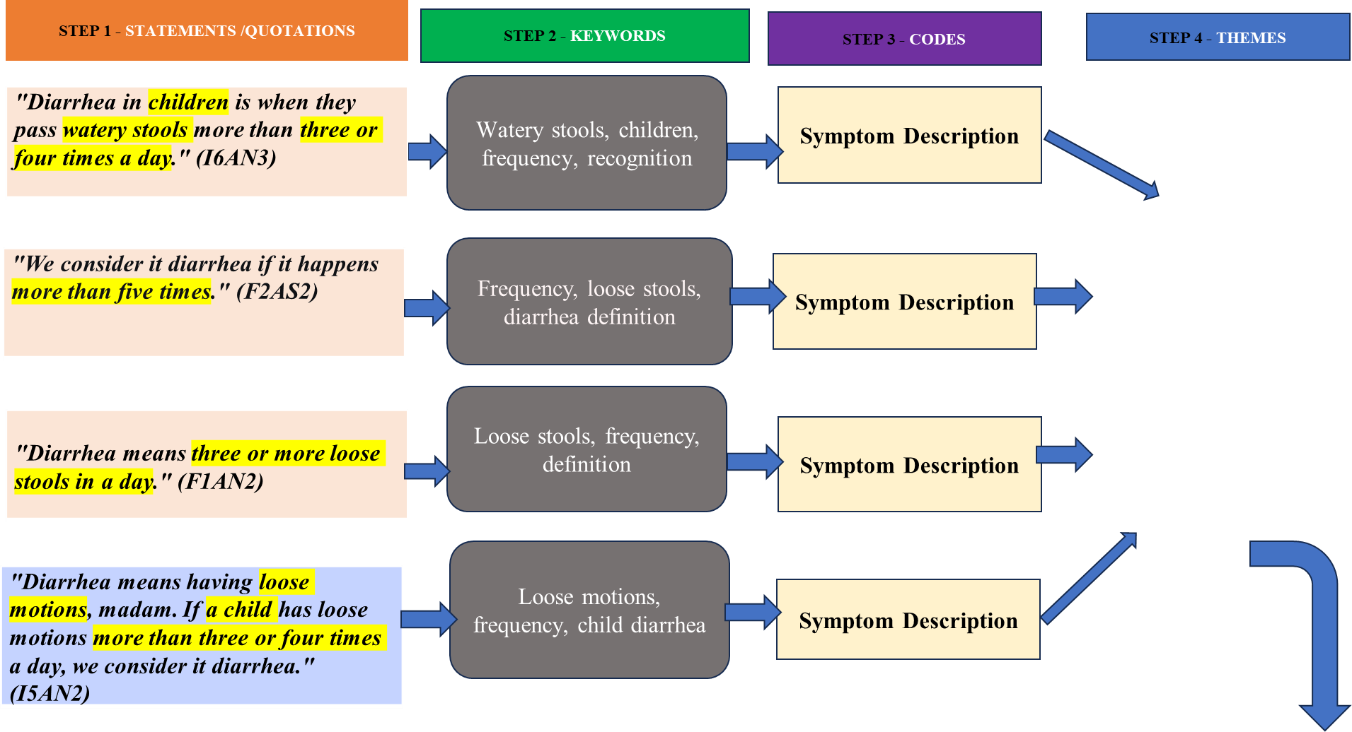
KNOWLEDGE AND PERCEPTION
  - Definition of Diarrhea

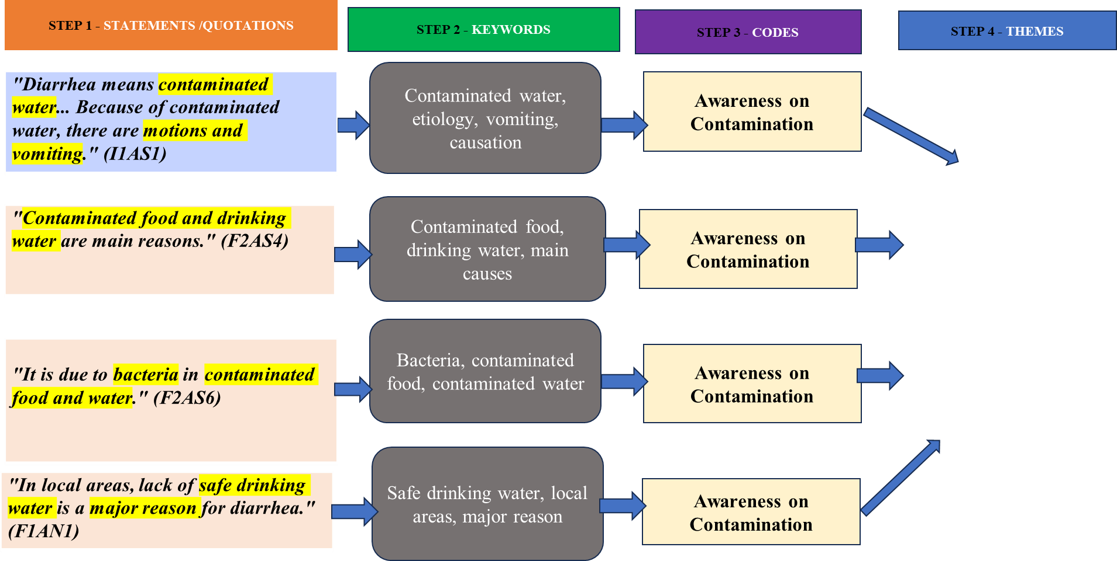
KNOWLEDGE
& PERCEPTION
  - Etiology of diarrhea

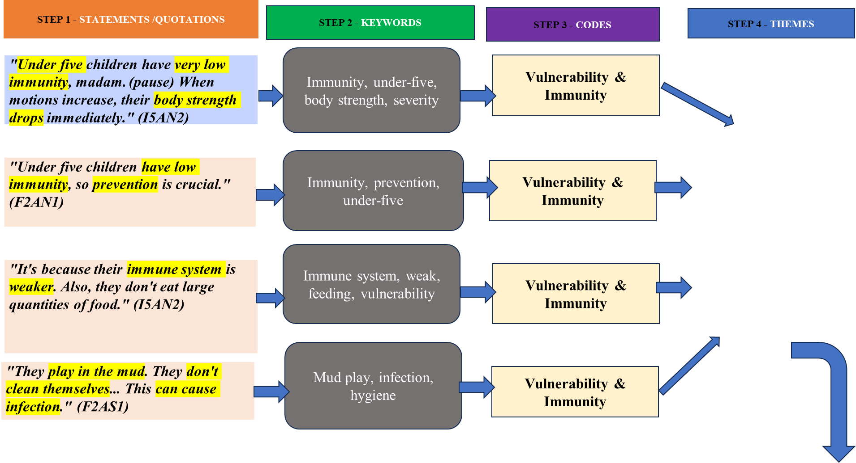
KNOWLEDGE AND
PERCEPTION
  - Severity and Rationale for Prevention

STEP 5 - CONCEPTUALIZATION
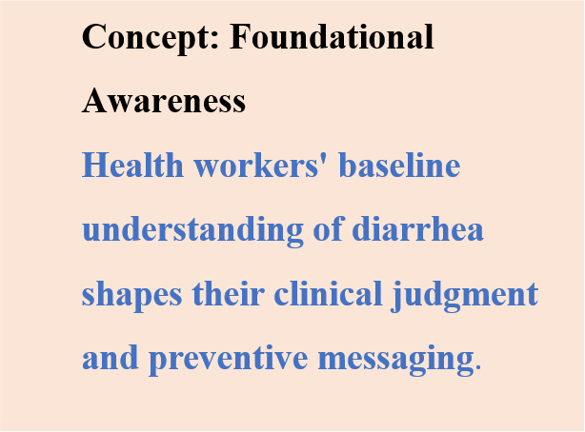
STEP 6 – DEVELOPMENT OF CONCEPTUAL MODEL

INDUCTIVE THEMATIC ANALYSIS PROCESS TO DEVELOP A CONCEPTUAL FRAMEWORK
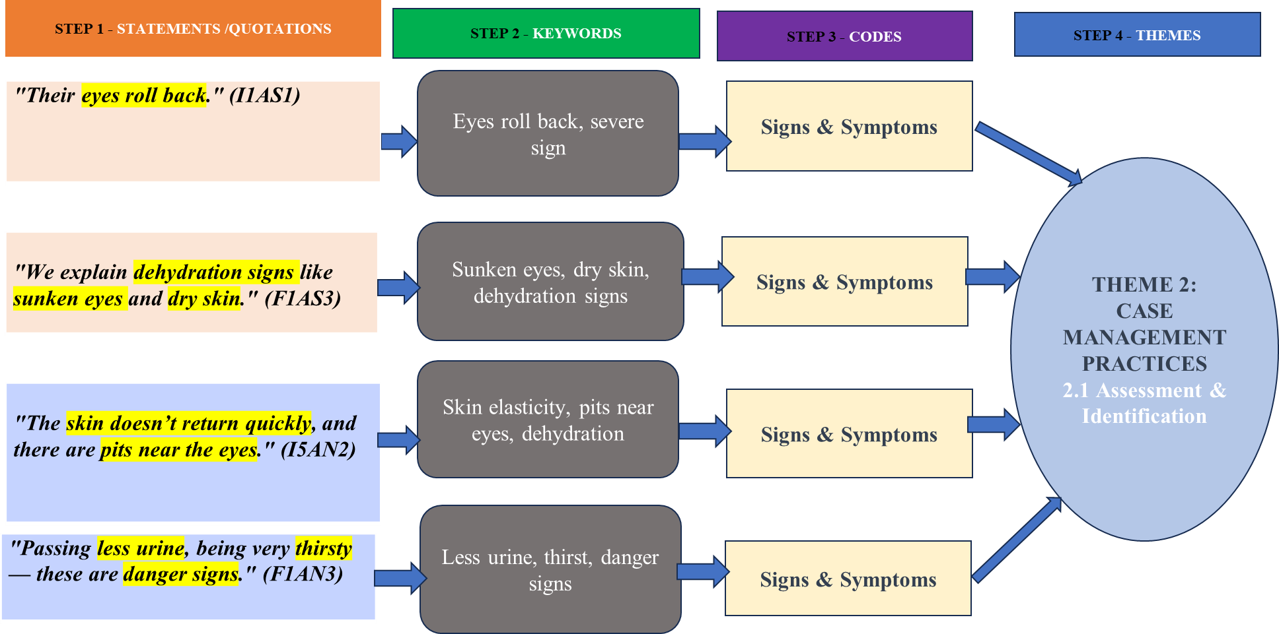

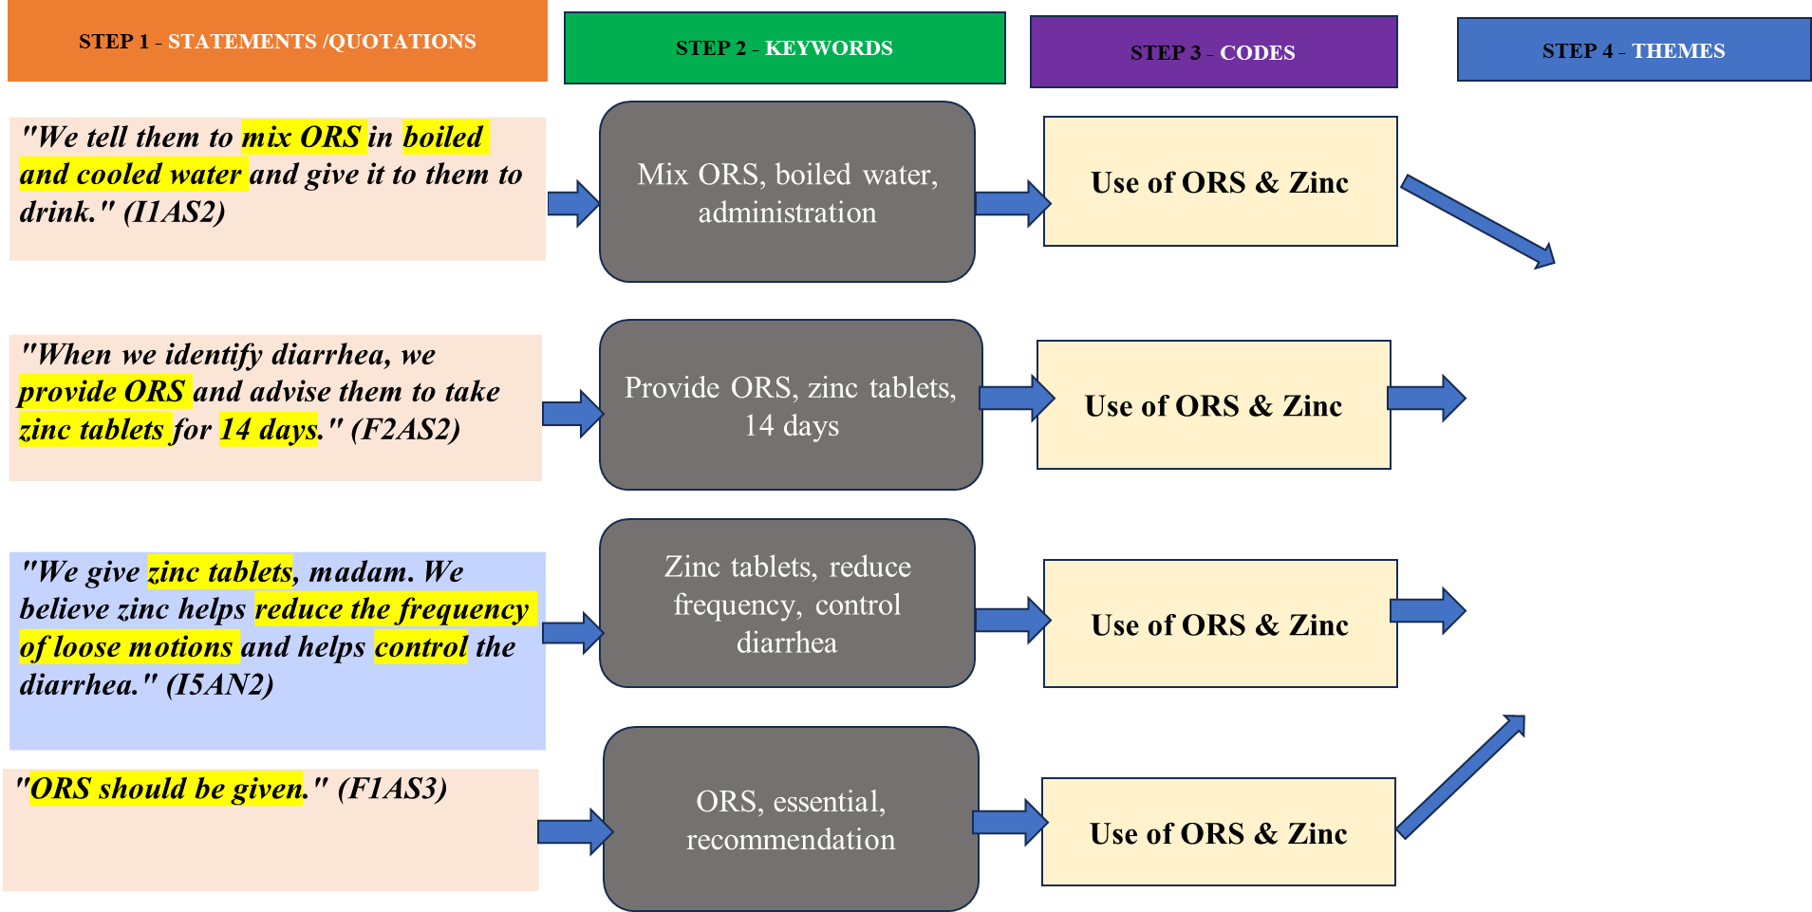
THEME 2: CASE MANAGEMENT PRACTICES
2.2Management of Diarrhea

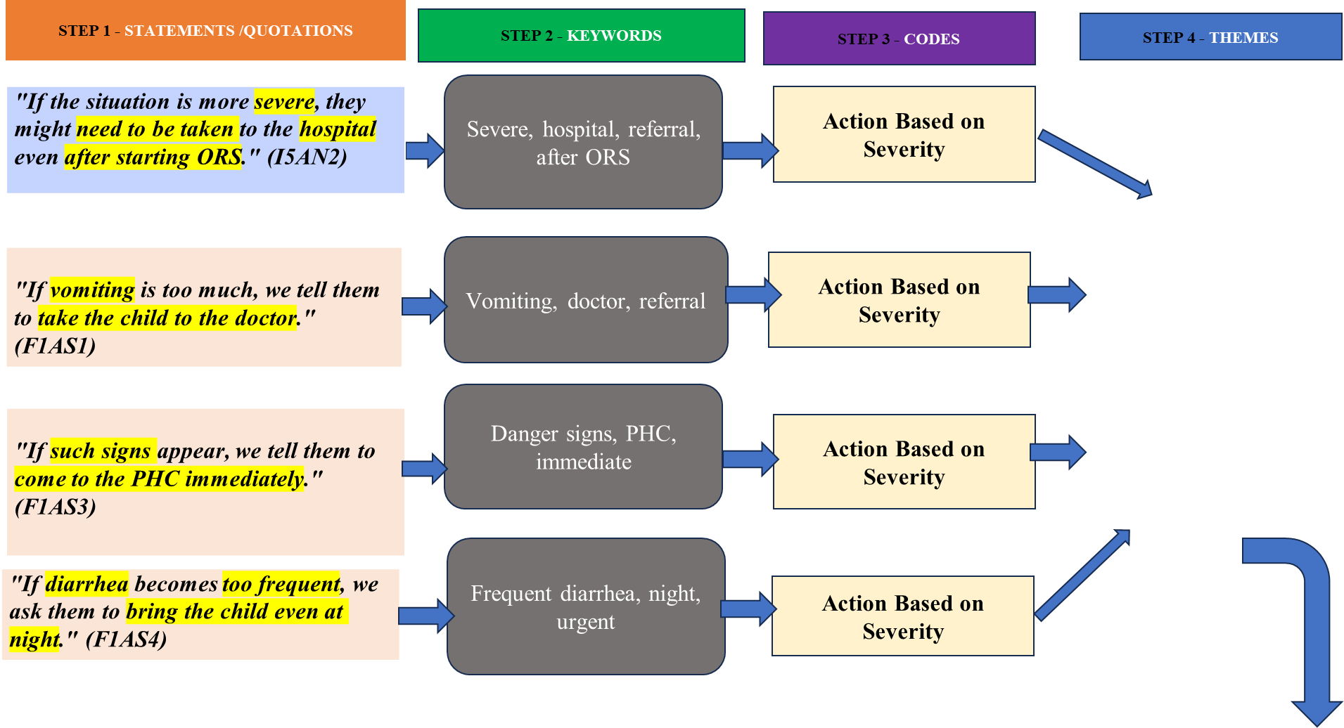
THEME 2: CASE MANAGEMENT PRACTICES

2.3 Escalation and Referral

STEP 5 - CONCEPTUALIZATION
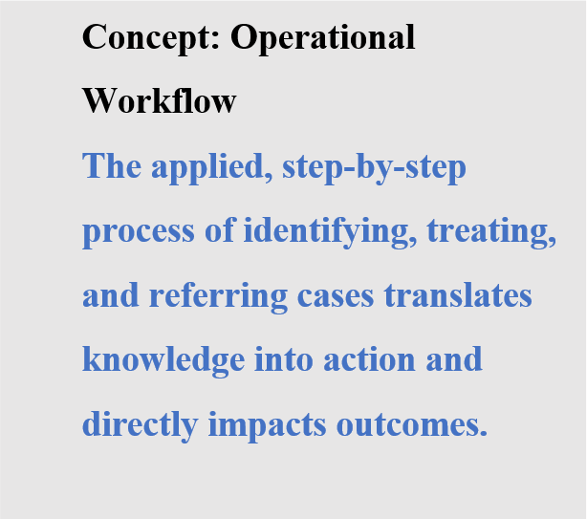

STEP 6 – DEVELOPMENT OF CONCEPTUAL MODEL

INDUCTIVE THEMATIC ANALYSIS PROCESS TO DEVELOP A CONCEPTUAL FRAMEWORK

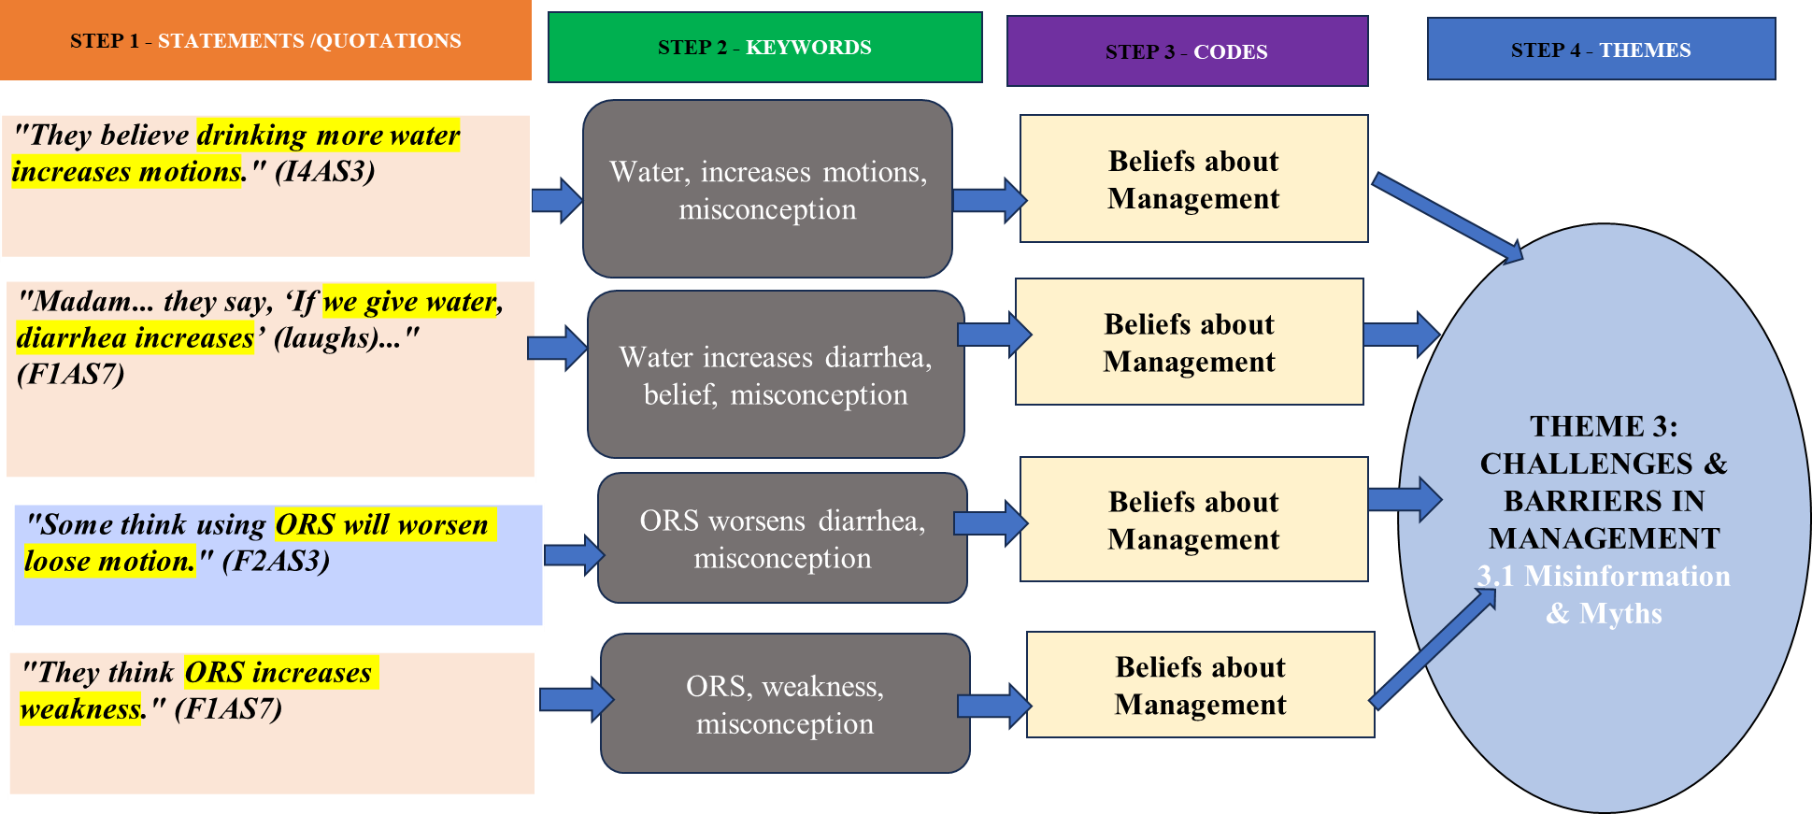

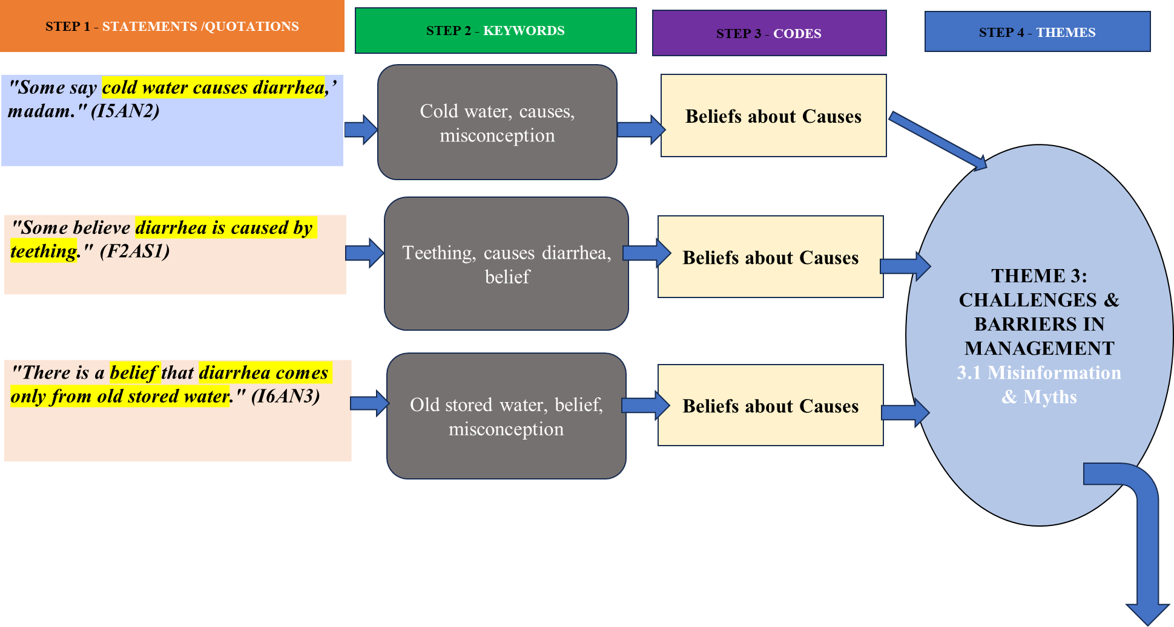

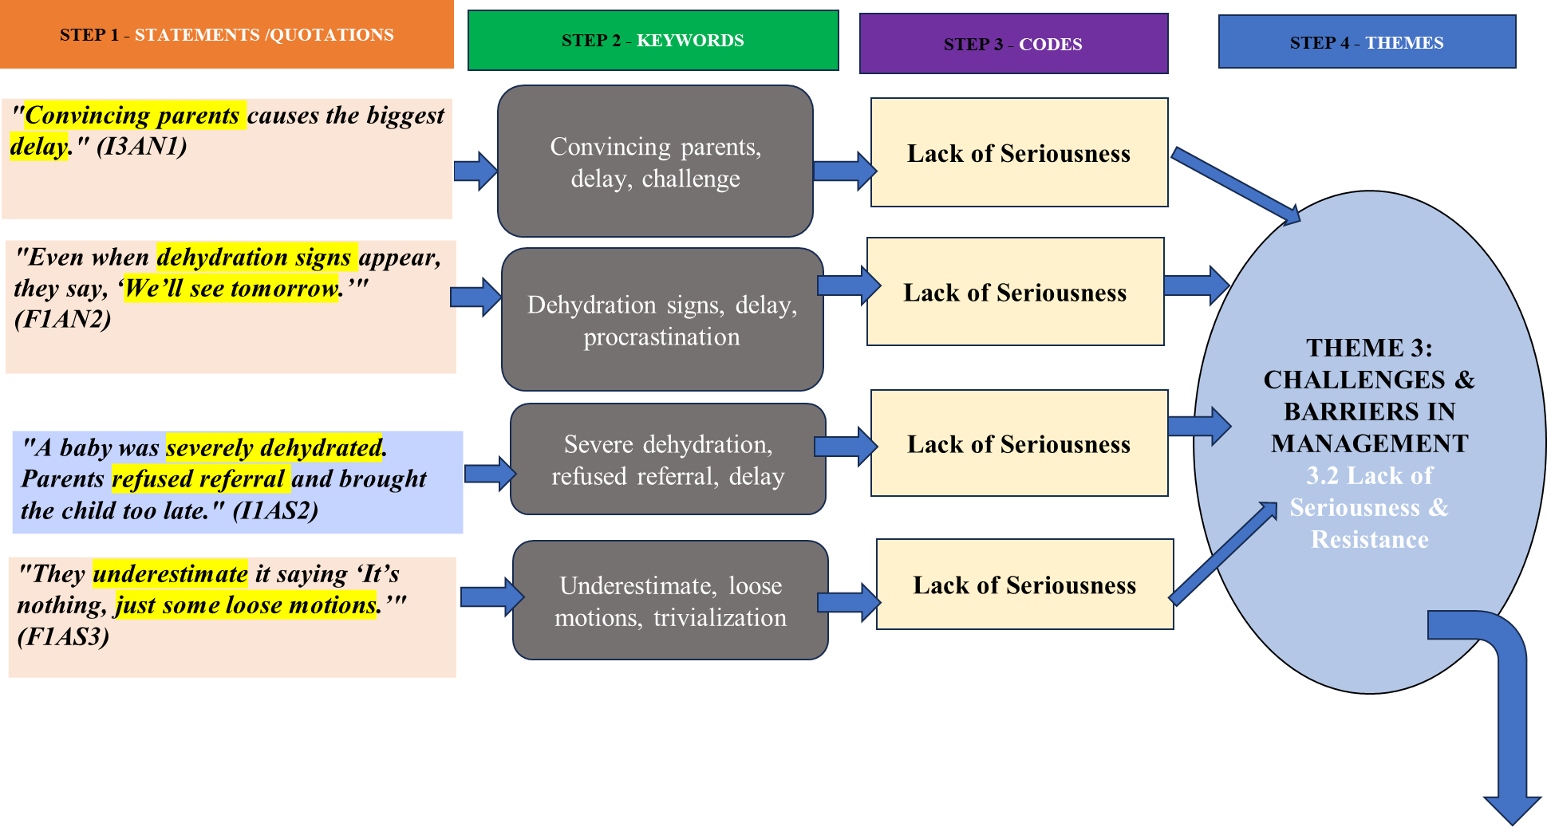

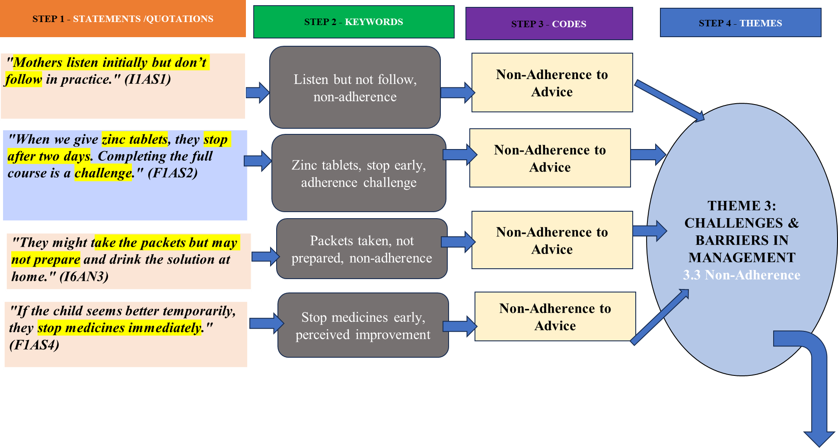

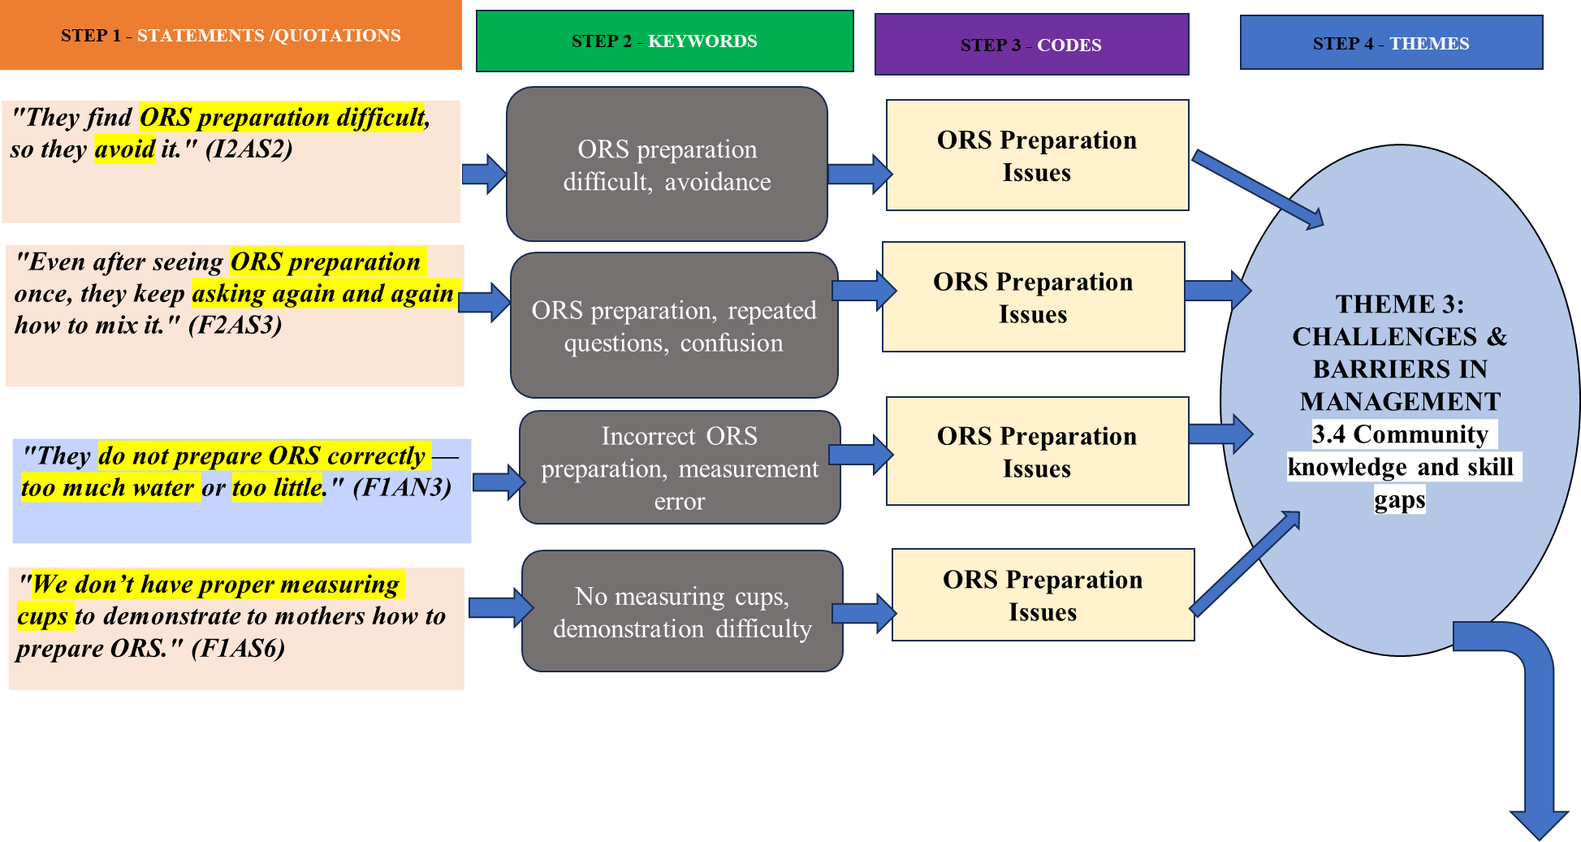

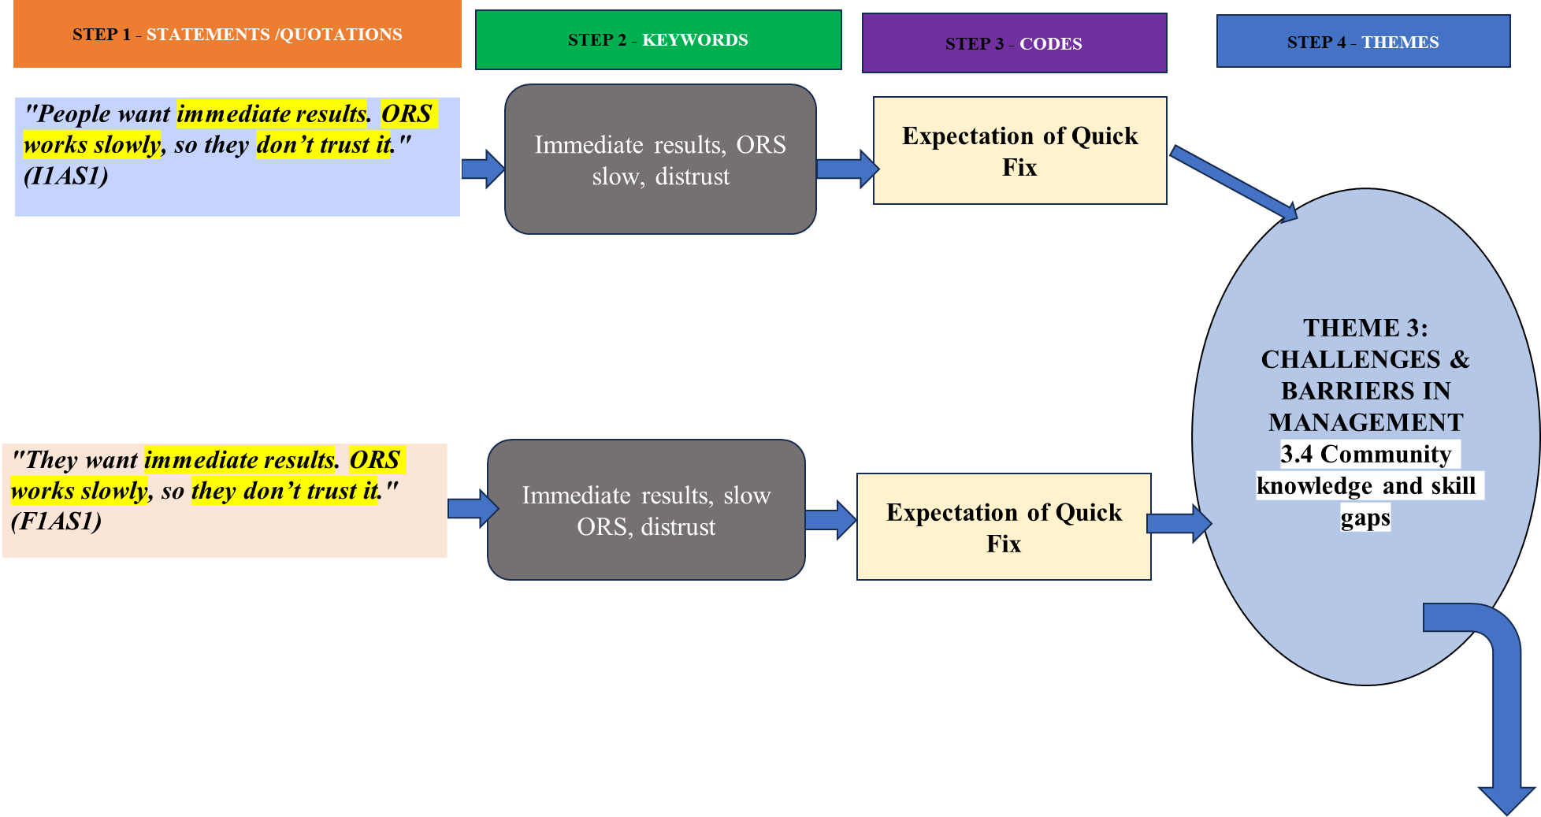

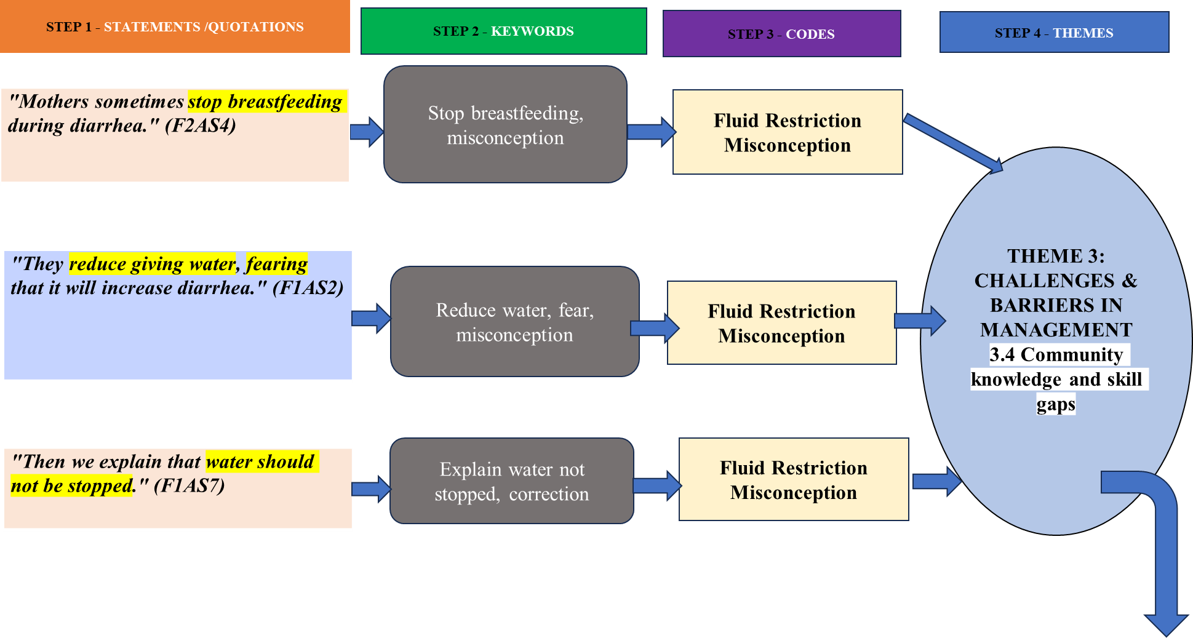

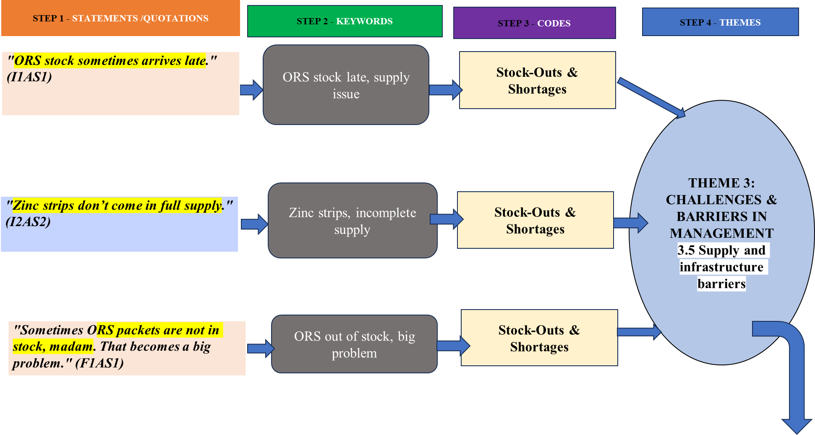

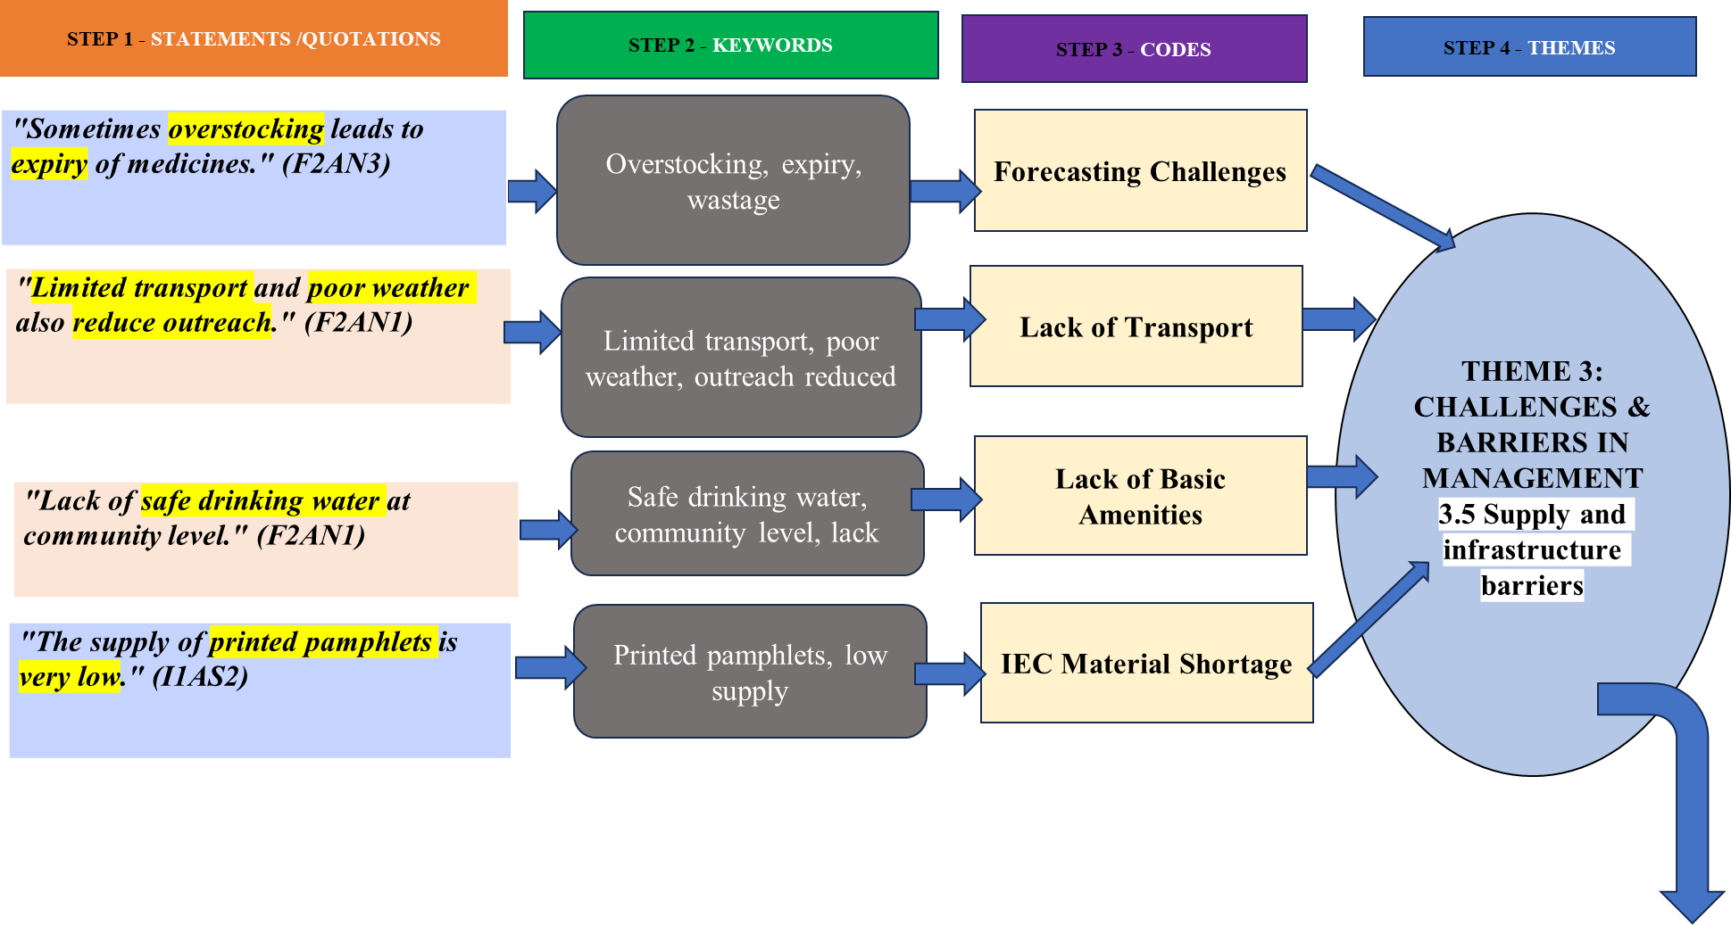

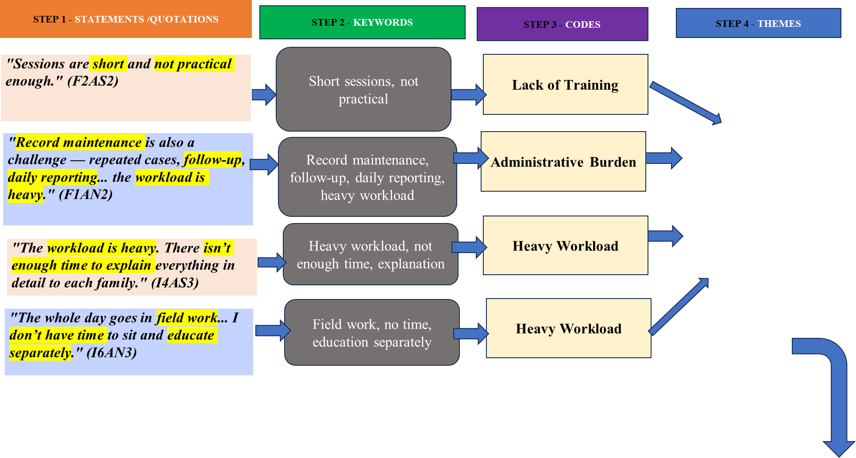
THEME 3: CHALLENGES & BARRIERS IN MANAGEMENT
3.4 Community knowledge and
skill gaps

STEP 5 - CONCEPTUALIZATION

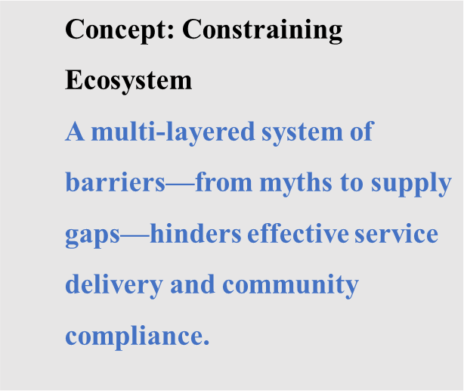
STEP 6 – DEVELOPMENT OF CONCEPTUAL MODEL

INDUCTIVE THEMATIC ANALYSIS PROCESS TO DEVELOP A CONCEPTUAL FRAMEWORK

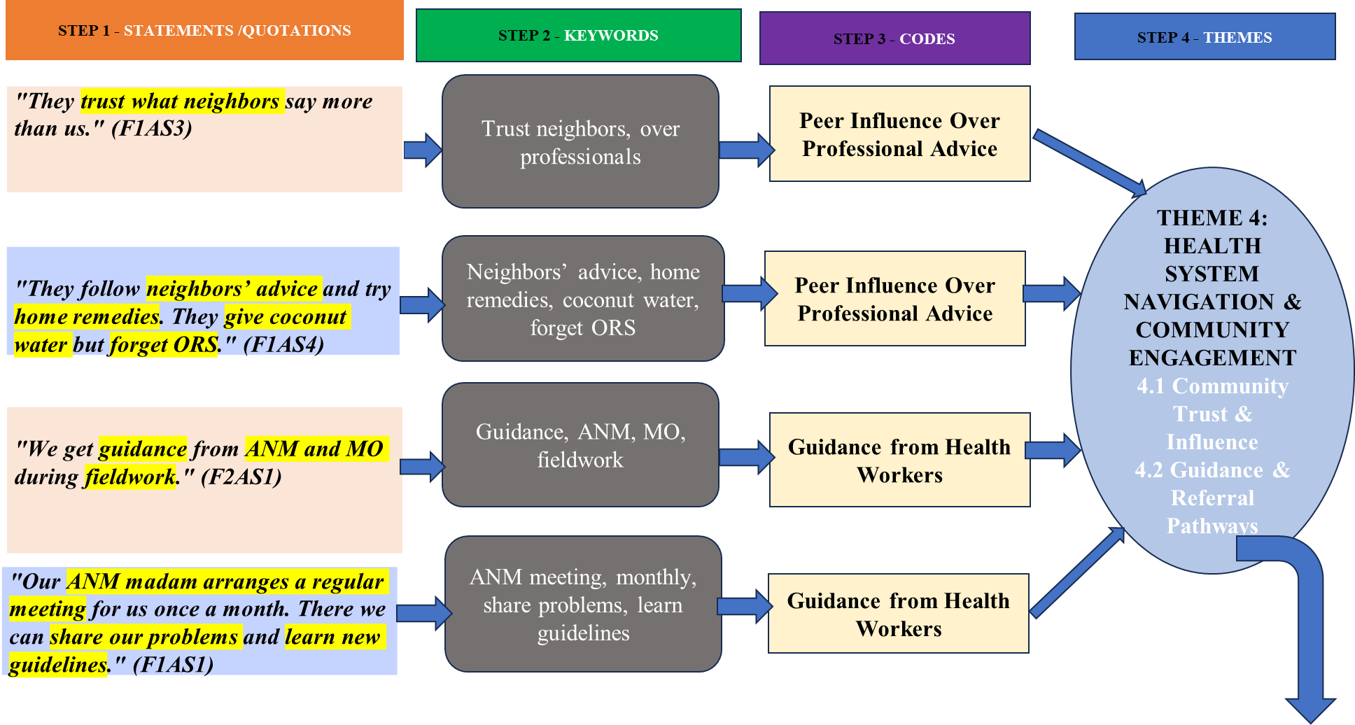

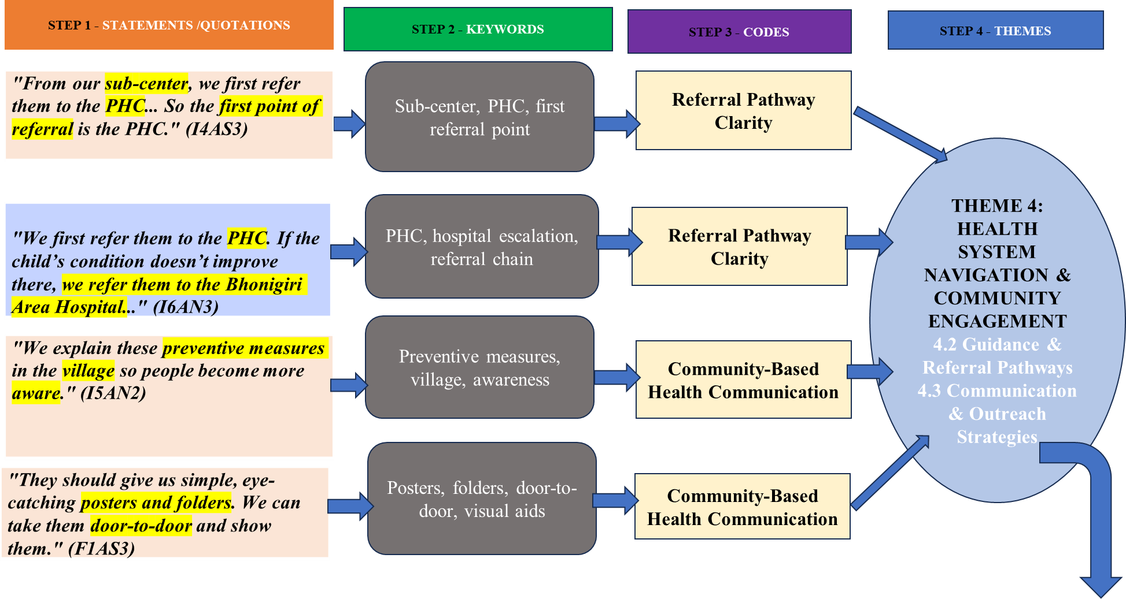

STEP 5 - CONCEPTUALIZATION
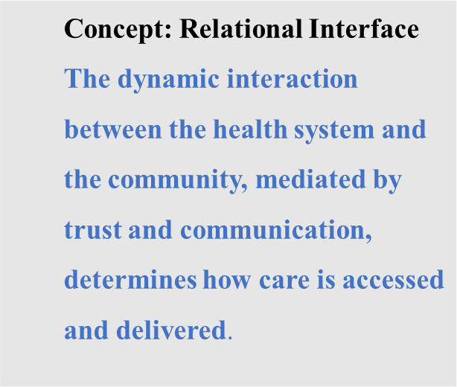
STEP 6 – DEVELOPMENT OF CONCEPTUAL MODEL

INDUCTIVE THEMATIC ANALYSIS PROCESS TO DEVELOP A CONCEPTUAL FRAMEWORK
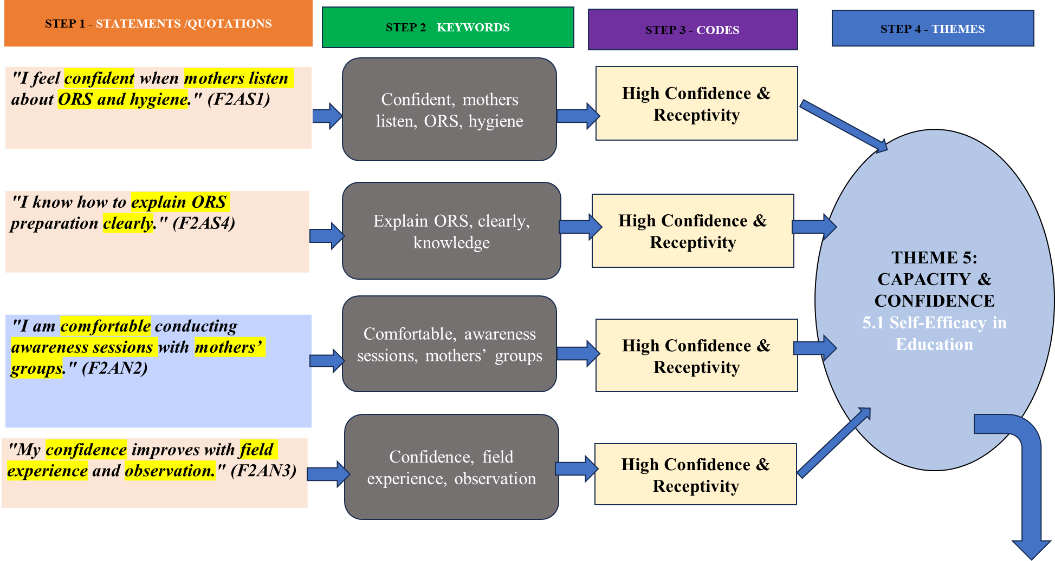

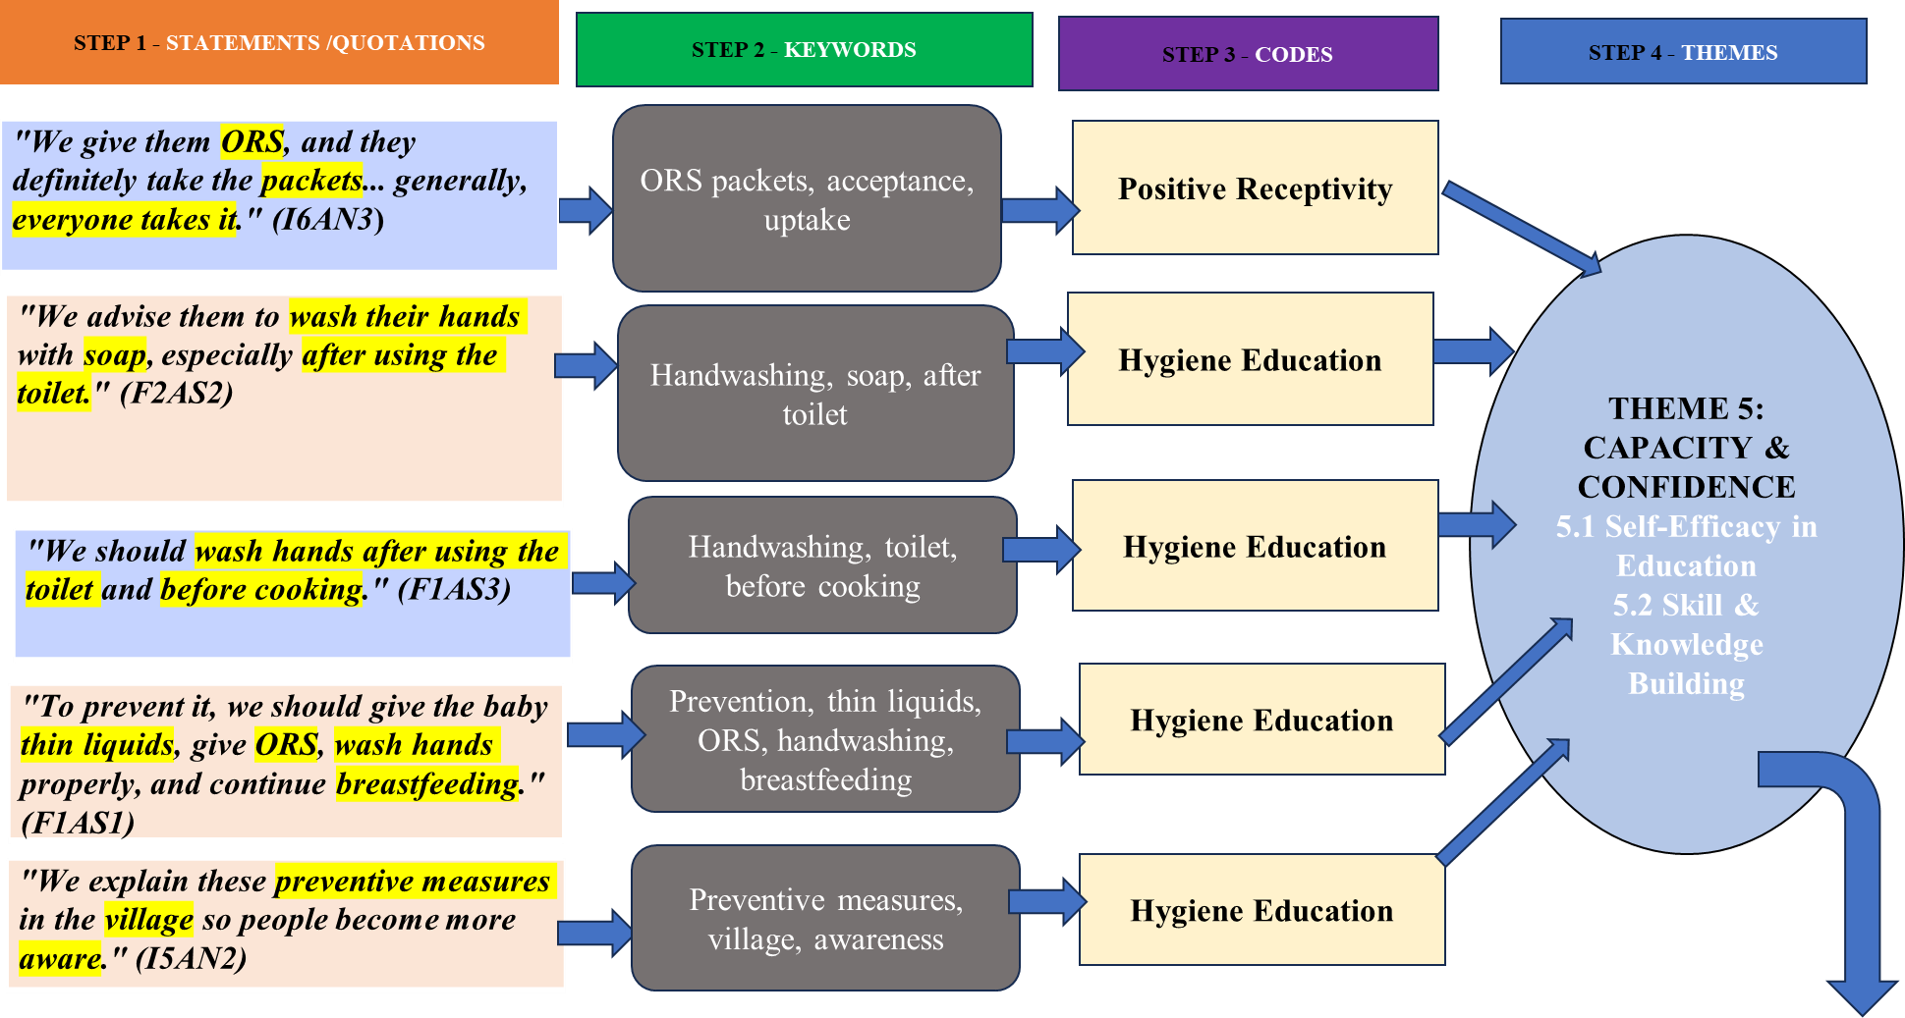

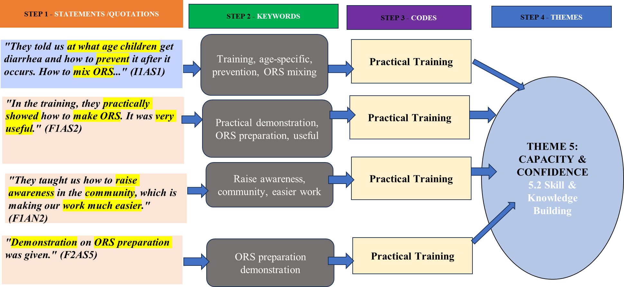

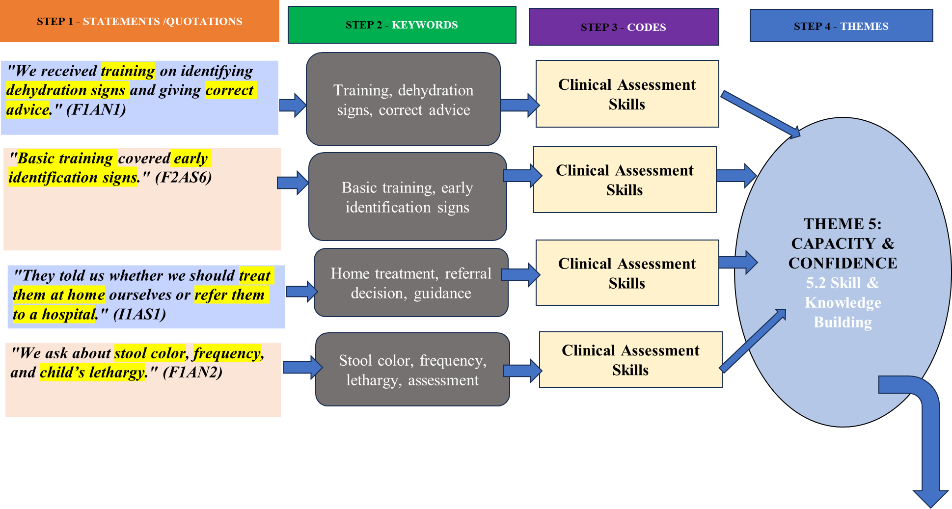

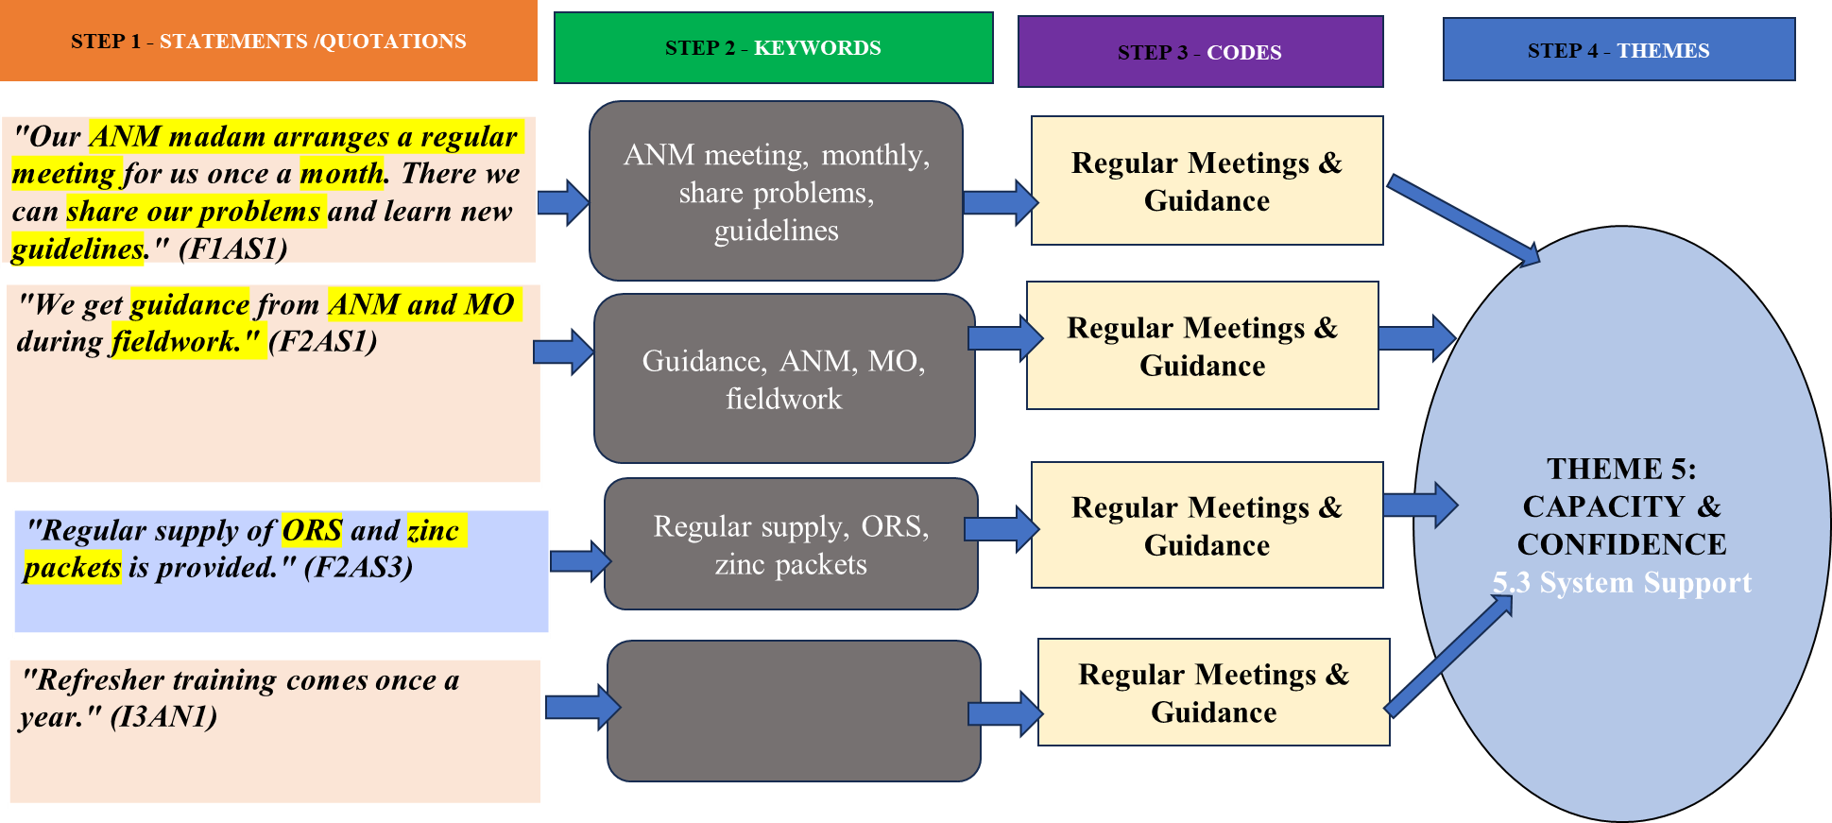

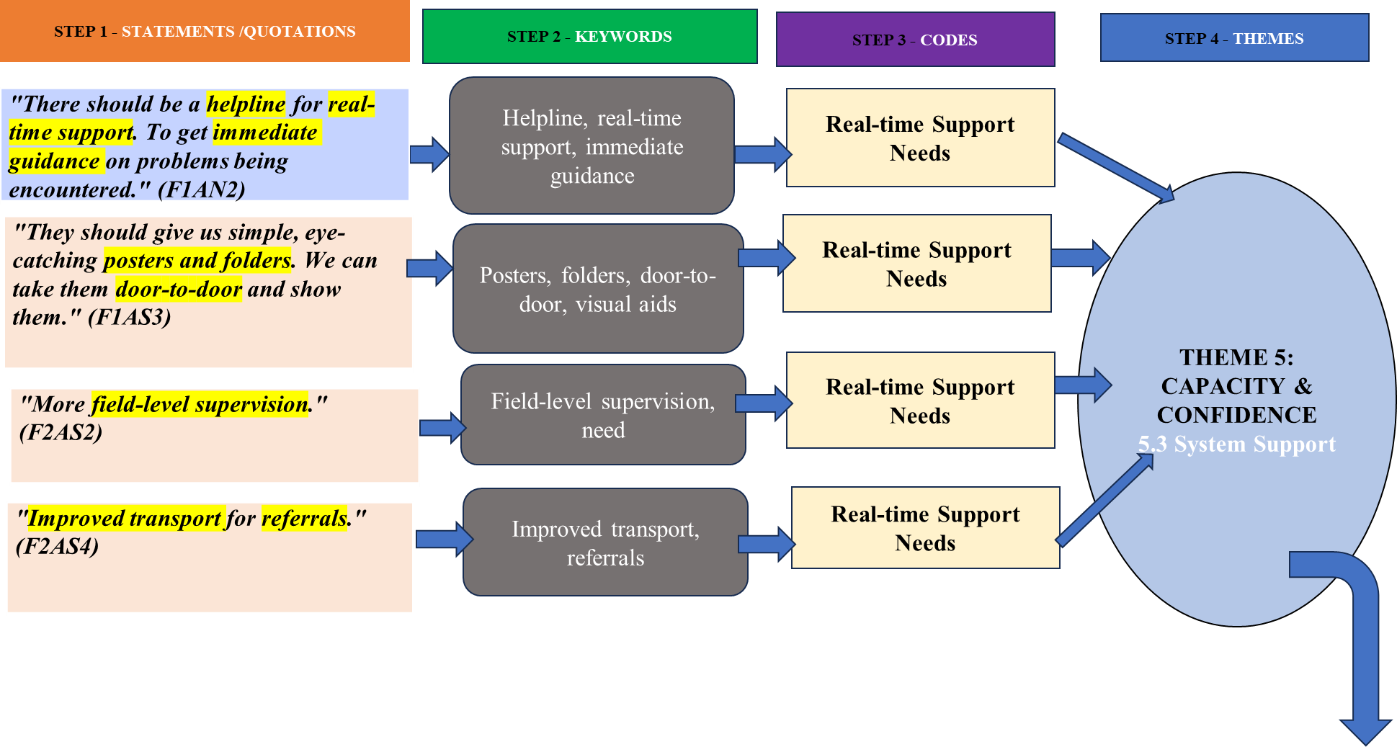

STEP 5 - CONCEPTUALIZATION
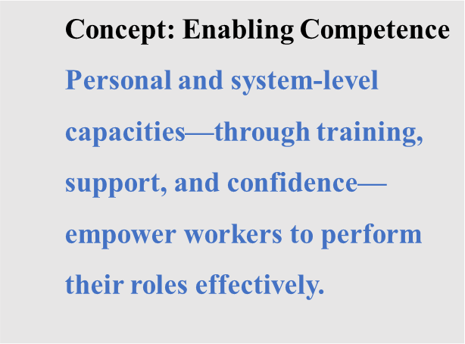
STEP 6 – DEVELOPMENT OF CONCEPTUAL MODEL

STEP 6 – DEVELOPMENT OF CONCEPTUAL MODEL

Affects 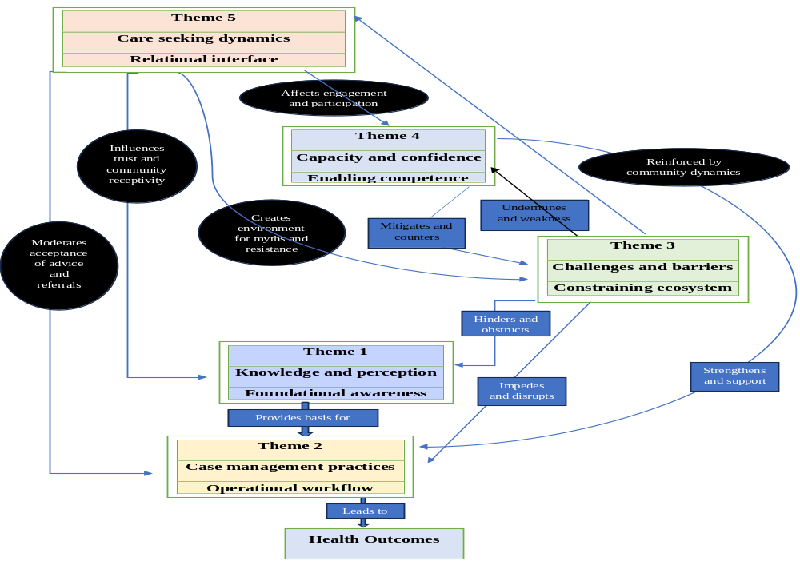 engagement and participation

Influences trust and community receptivity

