Supplement Information:
Reconfigurable Photonic Quasi-Unitary Computing Hardware for Optical Signal Processing

Section I: Design of PQU Devices
The proposed PQU device consists of two FPRs and arrayed waveguides, with a structural configuration similar to that of conventional arrayed waveguide gratings (AWGs). The FPR of PQU unit is universally designed with the Rowland circle architecture. As illustrated in Fig. S1 (a), the proposed input-output star coupler possesses a concave grating-like configuration. All ports of the arrayed waveguides are arranged on a large circle with a radius of R=2r, while the input and output waveguide ports are distributed on a small circle with a radius of r. This structure satisfies the second-order imaging condition and eliminates first-order and second-order aberrations for all operating wavelengths.
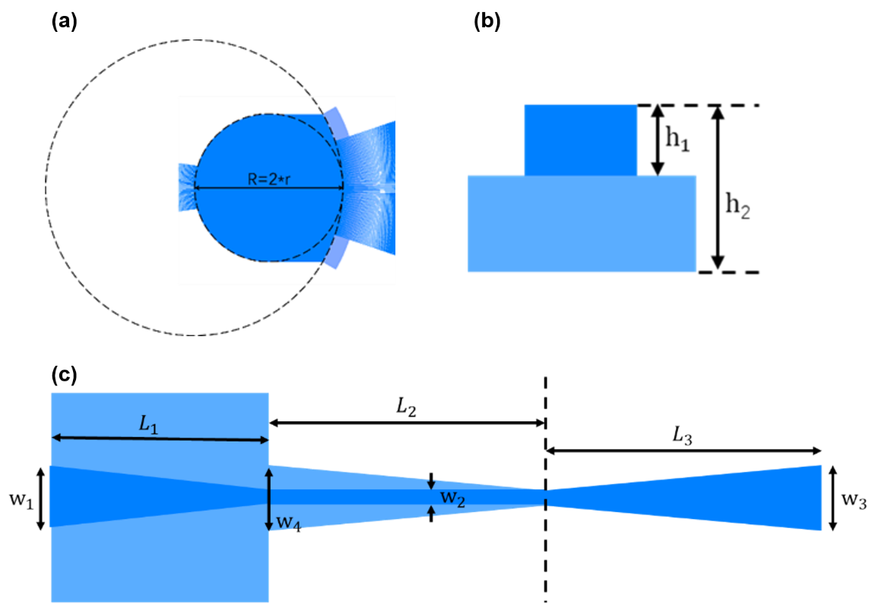
Fig. S1 | Structural schematic of the proposed PQU device and optimized shallow-etched transition waveguide structure. (a) Layout of the Rowland circle-based star coupler configuration of the PQU device. (b) Cross-sectional view of the optimized transition waveguide for high-order mode suppression and adiabatic mode conversion. (c) Schematic diagram of the double-layer shallow-etched transition waveguide structure deployed at arrayed waveguide ports.
To reduce optical loss, a double-layer waveguide structure consisting of shallow-etched and transition regions is deployed at arrayed waveguide ports as shown in Fig. S1(b) and Fig. S1(c). Based on standard SOI fabrication parameters of h1 = 220 nm and h2 = 70 nm, the geometric dimensions of the shallow-etched transition section, including w1, L1, and L2, are systematically optimized to suppress high-order mode excitation during mode conversion from FPRs to arrayed waveguides. The waveguide width is adiabatically tapered in the transition region to match the fixed arrayed waveguide width of w2 = 0.45 μm, enabling effective high-order mode filtering and smooth fundamental-mode energy transmission, which improves signal quality and mitigates system crosstalk. The segment lengths L₁, L₂, and L₃ are optimized via a genetic algorithm to maximize fundamental mode coupling efficiency. After systematic simulation and optimization under fabrication constraints, the optimal structural parameters are determined as w₁ = 1.4 μm, L₁ = 20 μm, and L₂ = 30 μm.
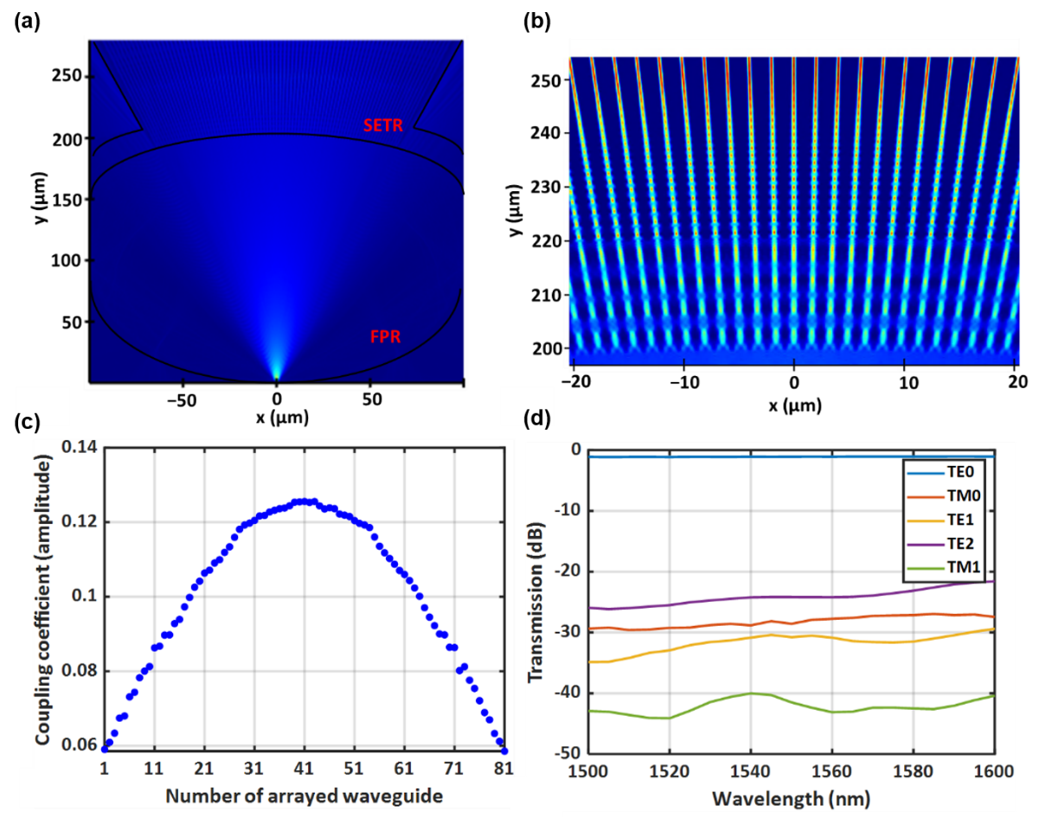
Fig. S2 | Simulated optical field characteristics and transmission performance of the proposed shallow-etched transition structure. (a) Optical field propagation within the FPR and shallow-etched transition region. (b) Detailed view of the optical field distribution in the arrayed waveguide section. (c) Coupling power ratio distribution of individual arrayed waveguides following a Gaussian profile. (d) Power ratios of different guided modes across the 1.5–1.6 μm operating band, demonstrating effective high-order mode suppression..
Fig. S2(a) shows the simulated optical field propagation in the designed FPR and shallow-etched transition region, and Fig. S2(b) provides a detailed view of the arrayed waveguide section. The optical propagation exhibits low scattering and negligible high-order mode excitation, verifying the excellent performance of the proposed shallow-etched transition structure. Figure 2(c) plots the calculated coupling power ratio of each individual arrayed waveguide, which follows the theoretically predicted Gaussian distribution. The total power statistics of all arrayed waveguides indicate that the additional loss introduced by the FPR-transition interface is approximately 0.5 dB. Furthermore, Fig. S2(d) illustrates the power ratios of all guided modes, including TE₀, TM₀, TE₁, TE₂, and TM₁. The results reveal effective suppression of high-order modes across the 1.5–1.6 μm operating band, with a high extinction ratio of over 25 dB. Overall, the numerical simulations validate the feasibility and superiority of the proposed device design, and further optimization can be implemented to improve the device performance in follow-up research.
Wider silicon waveguides can effectively suppress sidewall field perturbation and reduce the width sensitivity of modal effective refractive index, which greatly improves device fabrication tolerance. Based on this principle, the arrayed waveguides in this work are uniformly designed with a width of 2 μm to balance stable mode characteristics and excellent fabrication robustness.
The adopted 2-μm-wide arrayed waveguides exceed the single-mode condition, which easily excites high-order modes and induces severe modal crosstalk in bent waveguide segments. To address this issue and suppress unwanted mode interference under a compact device footprint, optimized Euler bends are deployed in this design. Numerical calculations verify that a bending radius of 2000 μm achieves a mode field distribution highly consistent with that of straight waveguides, which is therefore selected as the maximum radius R_{max} of the Euler bend. The minimum radius R_{min} is optimized by balancing structural compactness and optical performance, and is finally set to 20 μm, yielding an effective bending radius of 37.1 μm. Benefiting from the optimized structure, the proposed Euler bend achieves a TE₀ propagation loss below 0.01 dB and an inter-modal crosstalk lower than −27.1 dB across the 1500–1600 nm wavelength band.
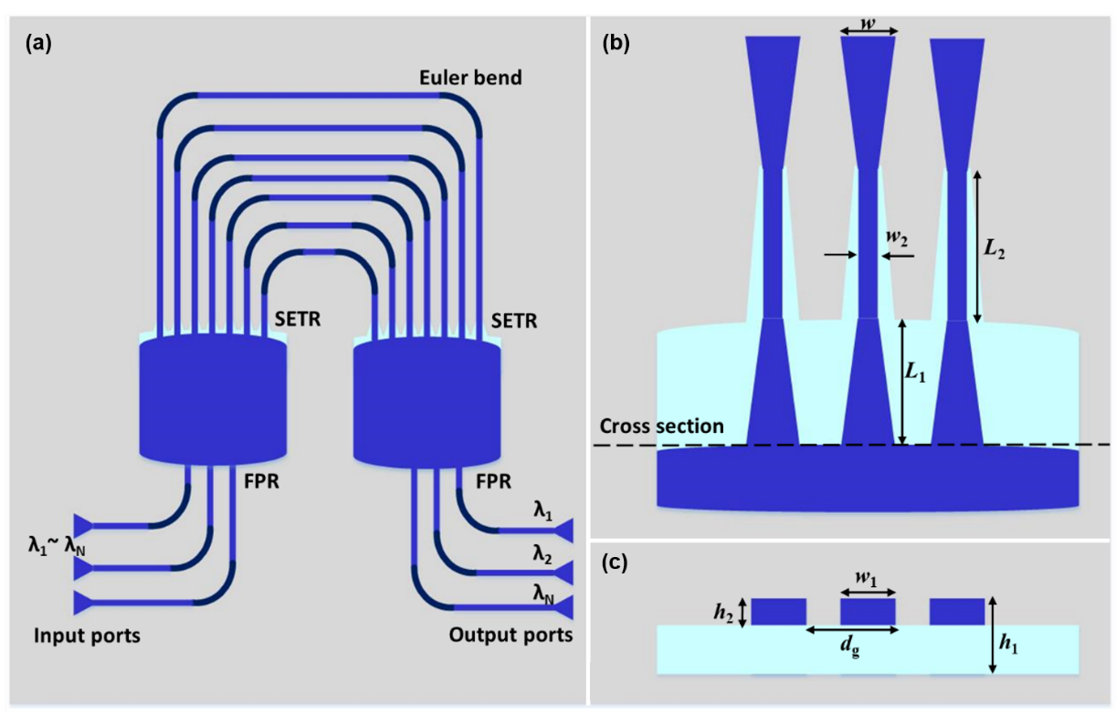
Fig. S3 | Schematic configuration of the proposed silicon multi-wavelength multi-path interference coupler with optimized Euler bends. (a)–(c) Structural layout of the device composed of input/output waveguides, dual FPRs with Rowland circle architecture, and widened array waveguides, showing the structural arrangement and key design parameters including fixed adjacent waveguide length difference, channel spacing, and geometric dimensions for multi-channel optical interference operation.

Fig. S3(a)–(c) illustrate the schematic configuration of the proposed silicon multi-wavelength multi-path interference coupler, which consists of input/output waveguides, FPRs, and widened array waveguides with optimized Euler bends. Two FPRs with identical Rowland circle layouts are interconnected via array waveguides, introducing a constant length difference ΔL between adjacent array waveguides. In this design, a channel spacing Δλ_{ch} of 0.4 nm is adopted, which is widely applied in dense wavelength division multiplexing systems. Key structural parameters of the proposed device are summarized in Table 1, including a channel number N of 32, a central wavelength λ₀ of 1550 nm, and an interference order m of 80. The corresponding length difference ΔL is 43.84 μm, the FPR length L_{FPR} is 200 μm, and the gap spacing d_{g} is 1.6 μm, yielding an output waveguide spacing do of 1.84 μm. The calculated free spectral range (FSR) is approximately 14.6 nm, which sufficiently covers all 32 operating channels.
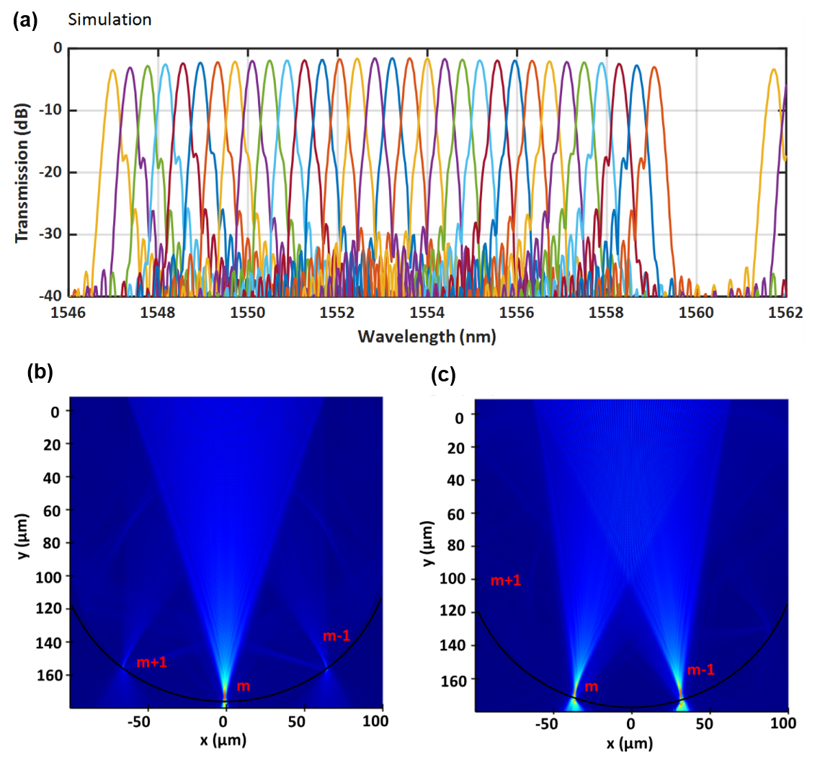
Fig. S4 | Simulated spectral responses and optical field propagation characteristics of the designed 32-channel coupler. (a) Simulated transmission spectra of all 32 operating channels, showing low excess loss, small channel non-uniformity, and accurate free spectral range. (b) Optical field distribution of the central channel at 1552 nm with distinct interference orders of m−1, m, and m+1. (c) Optical field distribution of the edge channel at 1560 nm, illustrating power dispersion across multiple interference orders that induces higher edge-channel excess loss.
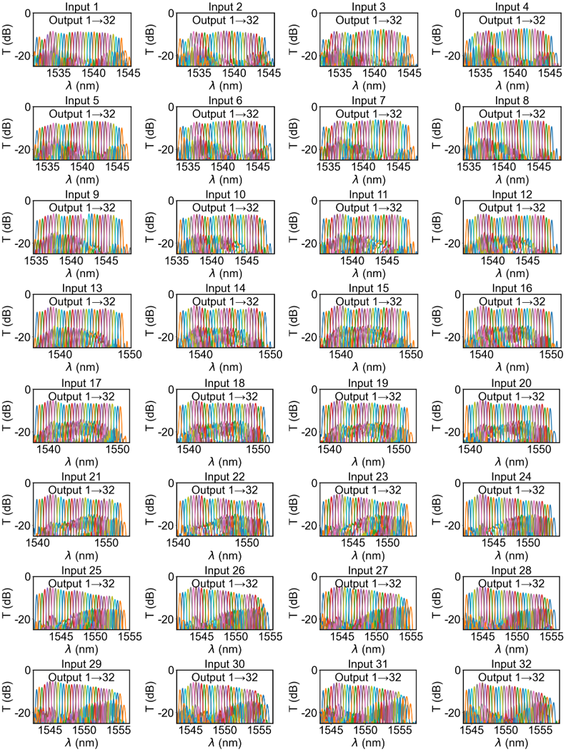
Fig. S5. Measured transmission performance of the fabricated 32×32 silicon multi-wavelength multi-path interference coupler. Normalized transmission spectra of all 32 output ports corresponding to each input port, verifying the practical channel spacing, wavelength shifting rule, channel non-uniformity, and excess loss characteristics of the fabricated device.
Fig. S4(a) presents the numerical simulated spectral responses of the 32 channels for the designed coupler. The central channel achieves a low excess loss of 0.69 dB with a channel non-uniformity of approximately 2.5 dB, and the obtained FSR of 14.6 nm is highly consistent with the theoretical calculation. For central channels, the crosstalk with adjacent and non-adjacent channels is lower than −25 dB and −30 dB, respectively, while the adjacent crosstalk degrades to approximately −20 dB for edge channels. Fig. S4(b) and Fig. S4(c) visualize the optical field propagation within the FPR for the central channel at 1.552 μm and the edge channel at 1.560 μm, respectively. Focused spots corresponding to the interference orders of m−1, m, and m+1 are clearly observed. Notably, the power of the edge channel distributes across the m−1 and m interference orders, which accounts for the higher excess loss of edge channels compared with central channels.
To verify the manufacturability and batch production feasibility of the proposed device, standard multi-project wafer (MPW) fabrication was conducted at the Institute of Microelectronics. Spectral characterization was performed on the fabricated device via test ports to validate its functional performance, and the corresponding measured results are illustrated in Fig. 5.
For transmission spectrum measurement of the fabricated 32×32 coupler, light from a broadband amplified spontaneous emission (ASE) source was coupled into the AWG input ports via TE grating couplers. The output optical signals were collected by single-mode fibers and measured using an optical spectrum analyzer (OSA). All measured results were normalized to the transmission of a 3 μm-wide straight waveguide integrated on the same chip with identical grating couplers. Fig. 5 summarizes the normalized transmission spectra of all 32 output ports corresponding to each input port (#1–#32). The measured channel spacing is 0.4 nm (50 GHz at 1550 nm), which is highly consistent with the theoretical design value. The overall device loss is relatively high due to the introduction of 3 dB couplers at the input terminals. In accordance with AWG operating principles, edge channels exhibit higher excess loss than central channels, which is determined by the far-field optical envelope distribution. The channel non-uniformity of the fabricated device is approximately 3 dB, which can be further optimized by adopting a larger FSR or refining the optical field distribution emitted from array waveguides. Uniform 0.4 nm channel spacing is observed between adjacent channels, and the central wavelength shifts regularly with different input port selections, which is consistent with the theoretical characteristics of the designed 32×32 silicon multi-wavelength multi-path interference coupler.

Section II: Analysis of Transmission Characteristics
In the main text, matrix left- and right-multiplication operations based on the conjugate transpose are adopted to quantitatively analyze and verify the unitary property of the transmission matrix of the proposed PQU device. To supplement the theoretical basis of the above evaluation method and to facilitate a comprehensive understanding of the unitary verification principle, this section further elaborates the mathematical definitions of matrix left multiplication and right multiplication, as well as the inherent physical correlation between these operations and the unitary constraints of photonic transmission matrices. As a core physical criterion for photonic computing matrix systems, the unitary property ensures strict energy conservation and error-free linear transformation of optical signals, and the dual verification of left- and right-multiplication results serves as a rigorous mathematical means to evaluate such characteristics. Here, the FPR transmission matrix is taken as the verification object. Its amplitude and phase distributions are shown in Fig. S6(a) and Fig. S6(b), respectively.
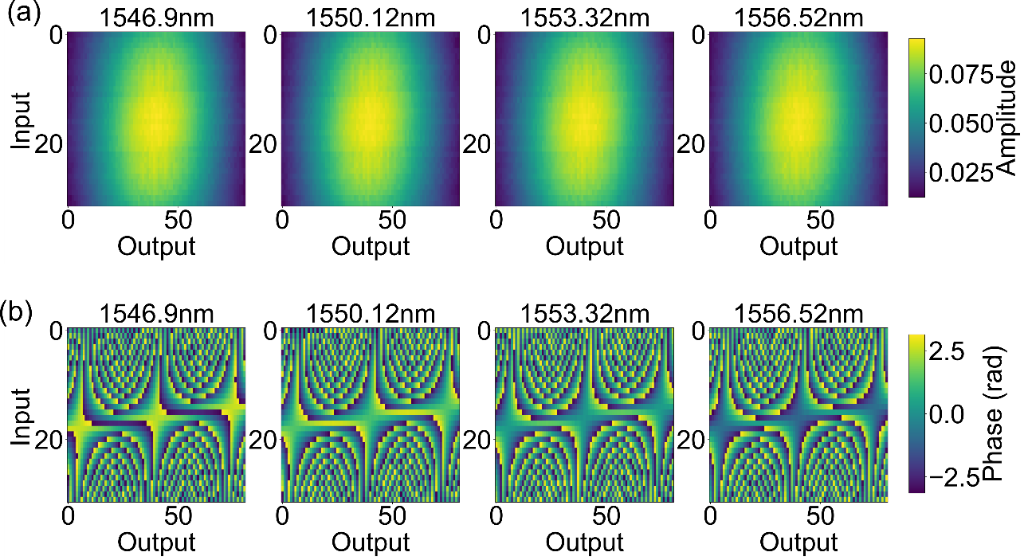
Fig. S6. Characterization of the FPR transmission matrix for unitary verification. (a) Amplitude distribution of the FPR transmission matrix. (b) Phase distribution of the FPR transmission matrix.
For an arbitrary complex transmission matrix T representing the FPR, T† is defined as its conjugate transpose matrix, where the superscript † denotes the conjugate transpose operation of matrix elements. Matrix left multiplication refers to the operation of multiplying the conjugate transpose matrix by the original matrix, expressed as T†T. Correspondingly, matrix right multiplication represents the operation of multiplying the original matrix by its conjugate transpose matrix, defined as TT†. The two operations characterize the inner-product correlations of the column and row vectors of the transmission matrix, respectively: T†T describes the orthogonality and normalization of the column vectors, whereas TT† describes those of the row vectors.
The essential criterion for judging a unitary matrix is that both left- and right-multiplication results are equal to the identity matrix, namely T†T=I and TT†=I. In numerical or experimental verification, this criterion is equivalently evaluated by the deviations from the identity matrix, T†T−I and TT†−I. Fig. S7 shows the distributions of these two deviations for the FPR transmission matrix. The near-zero residual distributions indicate that both T†T and TT† are approximately equal to the identity matrix, confirming that the row and column vectors of the FPR transmission matrix are mutually orthogonal and unit-normalized.
Fig. S7. Deviations from the identity matrix for the FPR transmission matrix. (a) Left-multiplication deviation (T†T−I). (b) Right-multiplication deviation (TT†−I).
For photonic computing devices such as the PQU, the unitary matrix determined by the left- and right-multiplication operations corresponds to the physical constraint of optical energy conservation. When the transmission matrix satisfies the unitary condition, the orthogonal matching of row and column vectors ensures negligible cross-coupling interference and no energy loss or gain during optical signal transmission and matrix transformation. The consistency verification of the left- and right-multiplication results can therefore quantitatively confirm the stable unitary transformation capability of the FPR/PQU device.

Section III : PQU Chip Test System
The PQU chip integrates multiple optical and electrical subsystems and contains numerous interconnections. A semi-automated test platform was therefore built for comprehensive and accurate characterization. As shown in Fig. S8, the platform consists of three main modules: a light source module, a photodetection module, and a power supply module. Fig. S8 (a) shows the light source and photodetection modules, and Fig. S8 (b) shows the power supply module.
Light source module. The light source module includes four programmable laser modules (each capable of two ITU-standard wavelengths), eight polarization controllers, an AWG, and optical attenuators. Although the source is multi-wavelength compatible, only one ITU-standard wavelength is used in the actual measurements. The programmable lasers have an output power range of 7–15.5 dBm and can be remotely controlled and centrally managed via Ethernet. Eight polarization controllers are used to precisely adjust the polarization state to meet the strict requirements of the devices. The commercial AWG used here features good thermal insensitivity and polarization independence, ensuring stable operation during testing. Since optical field modulation is performed inside the chip, high-speed control of the laser is not required, and a one-time parameter configuration is sufficient during testing. The input power can be controlled by programming the laser power or adjusting the polarization controllers.
Photodetection module. The photodetection module includes a rack-mounted 32-channel optical switch, a fiber-coupled photodetector, and a high-speed data acquisition card. Since the RAWG chip uses thermo-optic modulators, its operating speed is limited; considering cost and system complexity, a rack-mounted 32-channel optical switch is used for signal detection. A Ge-Si photodetector from Thorlabs receives the optical signal. It converts the input light into an electrical signal, amplifies it internally, and outputs it to the high-speed data acquisition card through a BNC interface. After digitization by the acquisition card, the signal is uploaded to the host computer via Ethernet for data analysis. The host computer runs Python for data acquisition and processing. Through the vendor-provided communication interface, Python can configure the sampling frequency and number of sampling points and read the 32-channel RAWG chip test data in real time. The acquired signals are processed and visualized as time-domain waveforms and error curves for chip performance evaluation. This scheme efficiently completes the entire workflow from data acquisition to result analysis.
Power supply module. A 128-channel current source is used to provide bias currents for the chip. It communicates with the test computer through a serial port and supports independent control of each channel. Its current resolution is 1 mA, which meets the driving-current requirements of multiple components in the 128-channel RAWG chip. The test computer sends commands through the serial port for remote setting and real-time monitoring of each channel output. Because thermo-optic electrodes have low resistance and high conductivity, they are easily damaged by electrostatic discharge or power-on/off transients during voltage loading. External ESD protection circuits and bypass capacitors are therefore required to reduce the risk of device failure. A dedicated 128-channel circuit board was designed to integrate these protection functions. In addition, because wire bonding must strictly follow the chip pad order, the large central common-ground pads of the chip must be routed through this board and connected uniformly to the system power ground. The 128-channel current source, the voltage-limiting board, and related circuits together form the power supply platform for the RAWG chip.
Fig. S8. Overview of the semi-automated test platform for the PQU chip. (a) The light source and photodetection modules. (b) The power supply module and optical switch.

Section IV : PQU-RNN System Architecture
The mathematical equivalence between the photonic system and a traditional RNN is defined by the following iteration formula:
$$u\left(t\right)=W_{xh}⋅x\left(t\right)$$
$$h\left(t\right)=f\left(W_{hh}⋅\left(u\left(t\right)+h\left(t-1\right)\right)\right)$$
$$y\left(t\right)=W_{hy}⋅h\left(t\right)$$
where $x\left(t\right)$ is the input vector at time $t$, $W_{xh}$ is the input matrix, $u\left(t\right)$ is the pre-processed input state, $W_{hh}$ is the recurrent weight matrix implemented by the PQU device, $h\left(t\right)$ is the hidden state, $f\left(⋅\right)$ is the activation function, $W_{hy}$ is the output matrix, and $y\left(t\right)$ is the predicted output.
In the hardware system, the PQU undertakes the function of $W_{hh}$. The optical response of the PQU, given the modulated input and the previous hidden state, produces the new hidden state $h\left(t\right)$. The final prediction is obtained by multiplying $h\left(t\right)$ with $W_{hy}$.
Gaussian normalization with clamping is defined as:
$$z=μ_{t}+\frac{σ_{t}}{σ}\left(x-μ\right)$$
$$x_{norm}=\max\left(μ_{t}-kσ_{t},\min\left(μ_{t}+kσ_{t},z\right)\right)$$
where $x$ is the raw data, $z$ is an intermediate variable, $x_{norm}$ is the normalized vector, $μ$ and $σ$ are the mean and variance respectively, the subscript $t$ represents the target mean and variance, and $k$ is the clamping coefficient (set to 3 in this study). Through the above normalization method, this study achieves scaling among computational variables, modulator inputs, and detector outputs. At the same time, different prediction effects can be achieved by adjusting relevant hyperparameters.
The test system is controlled by an upper computer in a closed loop. The workflow consists of the following steps:
- The upper computer encodes input data into voltage signals.
- Voltage signals are loaded onto the chip’s thermo‑optic modulators via current sources, realizing electro‑optic conversion.
- A 32‑channel optical switch sequentially switches each output channel to collect full‑port response data.
- Optical signals are converted to electrical signals by detectors, read by a data acquisition card, and sent back to the upper computer.
- The upper computer decodes the returned data, superimposes it with the next input, re‑encodes, and reloads it, forming a “encoding‑loading‑acquisition‑decoding” feedback loop for dynamic hidden state updates.

Section V : System Optimization Algorithm
The PQU device has complex internal optical field transmission, making it difficult to construct an exact analytical transfer matrix. Gradient‑based backpropagation is not applicable. Therefore, the Particle Swarm Optimization (PSO) algorithm is used to optimize the structural parameters of the PQU. PSO is a gradient‑free stochastic global optimization method suitable for black‑box problems.
The system iteration speed is limited by the closed‑loop hardware process. To reduce convergence time, PSO is integrated with ridge regression. The hybrid algorithm procedure is given in Algorithm 1. After each PSO iteration, ridge regression is performed on the hidden states from the previous period, yielding an error. The length of historical hidden state sequences used for fitting is set with a fixed upper bound to avoid unstable fitting caused by time‑varying system environments and hardware drift. This error is then used to update the PSO iteration.
In practice, PSO optimizing the output matrix usually converges faster than ridge regression. The typical implementation runs a certain number of PSO iterations first, fixes the weights after convergence, and then optimizes the ridge regression weights. This stepwise strategy reduces the overall training time. The complete implementation code of the combined algorithm is available from the authors upon request.

Algorithm 1: Online Reservoir Computing With PSO
Input: An input time series IN_SER, An output time series OUT_SER, number of time steps for initialization init, PSO object of the reconfigurable AWG PSO_{awg}
Output: Output Matrix Out_Matrix
n ← IN_SER.length; //Number of units in the series
PSO_{awg}.initialize(); //Initialize the AWG PSO object
PSO_count ← 0; //Calculate the steps PSO will use
while PSO_{awg}.repeat > 0 do
Clear Reservoir_PSO_output; //Clear data used for PSO update
for i = 1 to PSO_{awg}.Particle_number do
Chips_PSO[i].set_AWG(PSO_{awg}.particle_x); //Use particle’s location to update state of chip’s AWG
Chips_PSO[i].step(); //Update i^{th} particle’s reservoir
Reservoir_PSO_output[i] ← Chips_PSO[i].reservoir; //Collect particles’ reservoir for PSO update
end
PSO_{awg}.step(Reservoir_PSO_output); //Update PSO based on particles’ result
if PSO_{awg}.group_best unchanged do
PSO_{awg}.repeat ← PSO_{awg}.repeat – 1; //Subtract a count from PSO object’s max repeat number
end
PSO_count ← PSO_count+1; //Add a count to steps PSO used.
end
Chip ← Chips_PSO[1]; //Use the first particle’s reservoir state as the reservoir chip will continue
Collect_reservoirs ← n × reservoir_size matrix; //Define a matrix to record all the reservoir state
for i = 1 to n- PSO_count do
Chip.step(); // Execute an on-chip calculation
Collect_reservoirs[i] ← Chip. reservoir; //Record the reservoir at this time step
end
Out_Matrix ← Fit(Collect_reservoirs ,OUT_SER[PSO_count:n]); //Fit the record reservoir with the output series and get the output matrix in reservoir computing.
output Out_Matrix

Section VI: Reported on-chip photonic computing structures
Table 1. Summary of the reported coherent on-chip photonic computing
Types | Ref. | Footprint (μm × μm)  (Photonic structures only) | Matrix size | Number of phase shifters | Reconfigurability | Unitarity
MZI mesh | 1 | 1680×370 | 4×4 | 30 | Yes | Yes
MZI mesh | 2 | 1952×556 | 4×4 | 10 | Yes | Yes
Diffraction neural network | 3 | 2430×2150 | 20×20 | 20 | Yes | No
Diffraction neural network | 4 | 61×45 | 3×2 | 0 | No | No
Hybrid | 5 | 1100×850 | 10×10 | 40 | Yes | No
Hybrid | 6 | 1515×46 | 4×4 | 4 | Yes | Yes
Hybrid | 7 | 946×575 | 45×9 | 0 | No | Yes
Hybrid | Our work | 2150×650 | 32×32 | 81 | Yes | Yes

Table 1 summarizes representative reported coherent on-chip photonic computing architectures in terms of photonic footprint, matrix size, number of phase shifters, reconfigurability, and unitarity. To make the footprint comparison as meaningful as possible, we preferentially include works that implement a relatively complete, monolithic photonic computing structure. It should be noted that many reported systems are not single monolithic structures; instead, they consist of multiple assembled or cascaded photonic structures, or use time-domain extension, such as recirculation, or time multiplexing, to realize an equivalent larger matrix. In such cases, the overall physical footprint depends strongly on peripheral control, detection, packaging, I/O, and time-domain extension modules, and is therefore not directly comparable with that of a single monolithic structure. These works are thus not used as the main footprint comparison in this table. The footprint column counts only the photonic structures and excludes electrical controls, detectors, packaging, I/O, and peripheral circuits. Reconfigurability indicates whether the on-chip transfer function or matrix can be dynamically tuned; Unitarity indicates whether the implemented transformation is strictly unitary, as judged by whether the architecture can implement it with low-loss transmission.
Table 1 shows that MZI meshes generally provide both reconfigurability and unitarity, whereas diffractive neural networks and hybrid architectures often trade off one against the other depending on the design. Compared with the monolithic architectures listed, our work achieves a 32×32 matrix with 81 phase shifters while maintaining reconfigurability and unitarity, with a photonic footprint of 2150×650 μm². Within the comparable scope of monolithic coherent on-chip photonic computing architectures, our approach therefore offers a favorable combination of matrix scale, phase-shifter count, and unitary/reconfigurable operation.

References
- Shen Y, Harris NC, Skirlo S, et al. Deep learning with coherent nanophotonic circuits. Nature Photonics 2017, 11(7): 441-446.
- Wu B, Zhang W, Zhang S, et al. A monolithically integrated optical Ising machine. Nature Communications 2025, 16(1): 10841.
- Fu T, Zang Y, Huang Y, et al. Photonic machine learning with on-chip diffractive optics. Nature Communications 2023, 14: 70.
- Yan T, Yang R, Zheng Z, et al. All-optical graph representation learning using integrated diffractive photonic computing units. Science Advances 2022, 8(24): eabn7630.
- Zhu HH, Zou J, Zhang H, et al. Space-efficient optical computing with an integrated chip diffractive neural network. Nature Communications 2022, 13(1): 1044.
- Meng X, Zhang G, Shi N, et al. Compact optical convolution processing unit based on multimode interference. Nature Communications 2023, 14(1): 3000.
- Wang D, Nie Y, Hu G, et al. Ultrafast silicon photonic reservoir computing engine delivering over 200 TOPS. Nature Communications 2024, 15(1): 10841.

