Supplementary material

[¹⁸F]NaF PET Radiomics and Coronary Calcium Score Progression: Associations Beyond Baseline Calcium Score and TBR
Supplemental Methods
Radiomic Feature Interpretation
PyRadiomics groups features into six main classes:
- First-order statistics (18 features)
- Shape (3D/2D) (14 features, if shape included)
- GLCM (Gray Level Co-occurrence Matrix) (24 features)
- GLRLM (Gray Level Run Length Matrix) (16 features)
- GLSZM (Gray Level Size Zone Matrix) (16 features)
- GLDM (Gray Level Dependence Matrix) (14 features)
- NGTDM (Neighbouring Gray Tone Difference Matrix) (5 features)
The basic interpretation of each radiomic feature is in Supplementary Table S4.

PET normalisation
While normalisation of first-order features can conceptually follow the TBR_{max} approach by dividing the feature value by blood pool SUV_{mean}, no established method exists for normalising more complex texture-based features, such as those from GLCM or GLSZM, where such scaling may not be appropriate or meaningful. To address this, the voxel intensities of the PET image were normalised by dividing each voxel value by the SUV_{mean} of the blood pool prior to feature extraction.

Calcification progression interpretation
Each of the 91 patients had baseline and follow-up CCS measurements for each coronary artery, and the analysis was conducted at both patient and arterial level. We classified patients into progressors, and non-progressors, using the 'SQRT' method, which is calculated at the patient level using the following formula and predefined threshold values [1].:
$$\sqrt{{CCS}_{follow-up}}-\sqrt{{CCS}_{baseline}}>2.5$$
If the formula is satisfied, it indicates significant CCS progression beyond measurement error [2]. As this formula evaluates the total CCS at the patient level, derived from the sum of CCS values across all four coronary arteries, the corresponding threshold for each individual artery is adjusted to 1.25:
$$\sqrt{\frac{{CCS}_{follow-up}}{4}}-\sqrt{\frac{{CCS}_{baseline}}{4}}=\frac{\sqrt{{CCS}_{follow-up}}-\sqrt{{CCS}_{baseline}}}{2}>1.25$$
In a sensitivity analysis, we also utilised a threshold of 0.625 to define CCS progression.

Feature Extraction Configuration
Radiomic feature extraction was performed using PyRadiomics (Version 3.0.1) with default settings, except for the PET image discretization parameters. For PET images, a fixed bin width of 0.05 was applied, resulting in a bin count between 32 and 128 depending on the activity concentration range within the region of interest [3]. No image filtering or feature aggregation across filtered images was performed and only features derived from the original images were included in the analysis.

Multi-feature Prediction Model Configuration
pipeline = Pipeline([
('scaler', StandardScaler()),
('logreg', LogisticRegression(penalty='l1', solver='saga', random_state=42, max_iter=1000000))
])

# Define the regularization strength (C) grid
param_grid = {'logreg__C': np.logspace(-4, 1, 100)}

Feature Importance Method
Each bootstrap iteration yielded the optimal LASSO regularisation strength, cross-validation metrics (precision, recall, AUC, and F1 score), and feature importance rankings. LASSO assigns a coefficient to each feature, with non-zero coefficients indicating selected features contributing to the model for that iteration. The absolute magnitude of the coefficient represents the feature's contribution for that iteration. Feature importance scores were calculated as [4-6]:
$$Feature Importance Score=Selection Frequency×Mean Absolute Coefficient$$
Features were ranked by their importance scores, providing a consistent measure of their contribution to predicting calcification progression. High-ranking features were considered strong contributors, while low-ranking features indicated lesser influence on the model's predictions. This ranking method ensures a systematic assessment of feature contributions without relying solely on selection frequency or coefficient magnitude.

Voxel normalisation
This study employed a dual analysis approach, using radiomic features derived from both the original, non-normalised PET images and voxel-normalised PET images. By applying this dual approach consistently across patient- and artery-level analyses, the study evaluated the impact of normalisation on predictive performance and provides insights into how normalisation influences the predictive utility of various radiomic features.

Statins Analysis
To assess whether baseline statin therapy modified the discriminative performance of models for predicting CCS progression, we repeated the patient-level modelling after stratifying the cohort by baseline statin use (statin-treated vs statin-not-treated). All analyses were performed separately within each statin stratum.
Multi-feature models (Supplementary Figure S6):
We evaluated multi-feature logistic regression models using three feature sets: (i) clinical variables + baseline CCS, (ii) voxel-normalised PET radiomics features, and (iii) clinical variables + baseline CCS + voxel-normalised PET radiomics features.
For all models, discriminative performance was summarised using ROC-AUC. Uncertainty was quantified using bootstrap resampling to report the median AUC and 95% confidence interval within each statin group.

Supplemental Results
Prediction Results Comparing Non-normalised and Normalised Features
For the patient-level analysis without normalising PET features by mean blood pool activity, the most predictive features were first-order minimum (median AUC [95% CI]: 0.64 [0.42–0.78]), maximum (SUV_{max}, 0.63 [0.37–0.79]), total energy (0.63 [0.38–0.78]), and 10th percentile (0.62 [0.40–0.76]). However, these features did not exhibit a statistically significant differences in their predictive values when compared to each other (p ≫ 0.05) and lacked a substantial predictive advantage over subsequent features (e.g. Skewness AUC: 0.62 [0.38-0.74], p ≫ 0.05). After normalising the PET features by mean blood pool activity, 85 out of the 93 features demonstrated a statistically significant increase in their predictability (p < 0.05). The exceptions included first-order features Kurtosis and Skewness, GLCM features LMC1, LMC2, Cluster Shade, Correlation, and IDN, and GLRLM feature Run Variance. Importantly, the first-order maximum feature (TBR_{max}) demonstrated a significant improvement in predictability after normalisation (AUC 0.83, 25th-75th [0.73 – 0.92] vs AUC 0.63 [0.37–0.79], p < 0.01), making it the most predictive feature.
At the arterial level, only radiomic features and the baseline CCS feature were evaluated. Prior to normalisation by blood pool activity, the most predictive features were GLRLM Run Length Non-Uniformity (0.68 [0.63–0.74]), GLDM Dependence Non-Uniformity (0.68 [0.62–0.74]), GLRLM Long Run High Grey Level Emphasis (0.68 [0.62–0.73]), Run Entropy (0.67 [0.61–0.73]), and first-order Total Energy (0.66 [0.60–0.72]). However, the CIs of these features almost completely overlapped, indicating no single feature demonstrated a clear predictive advantage over each other. The first-order Maximum feature (SUV_{max}) prior to normalisation had a median AUC of 0.54 (0.41–0.62), which increased to 0.64 (0.58–0.70) after normalisation representing the TBR_{max}. After normalising all features by mean blood pool activity, 84 out of 93 features exhibited a statistically significant improvement in predictability (p < 0.05). The exceptions included first-order features Kurtosis and Skewness, GLCM features IDMN and Inverse Variance, GLDM features Large Dependence Emphasis and Dependence Variance, GLSZM features Grey Level Non-Uniformity and Zone Percentage, and the NGTDM feature Coarseness.

Logistic regression Odds Ratio Analyses
Sequential and separate univariable logistic regression models showed that TBR_{max} had the strongest association with calcification progression (OR: 20,163.51; 95% CI: 154.02–2,639,768.67; p < 0.0001), followed by SUV_{max} (OR: 5.27; 95% CI: 1.0 –27.71; p = 0.049) and HbA1c (%) (OR: 1.81; 95% CI: 1.04–3.15; p = 0.03). Other clinical variables, including BMI, CRP, EGFR, baseline CCS, and lipid profile measures, were not statistically significant (p > 0.05). Univariable logistic regression odds ratios for clinical variables, baseline CCS, TBRmax, and SUVmax are presented in supplementary Table S4 and supplementary Table S5.
Odds ratios for all normalised and non-normalised radiomic features, are presented in supplementary Table S6 and Table S7.
Multivariable logistic regression models including all clinical covariates and the TBRmax identified TBRmax as the strongest independent predictor of calcification progression (OR: 16.77; 95% CI: 3.55–79.11; p < 0.001). Other variables, including LDL cholesterol, HbA1c (%), BMI, HDL cholesterol, CRP, triglycerides, EGFR, total BA, and total cholesterol, showed positive but non-significant associations (p > 0.05).

Feature Importance Results
The most predictive clinical features identified in the multi-feature prediction model include HbA1c%, LDL cholesterol (mmol/L), baseline BMI, and total cholesterol (mmol/L). A clear trend is observed, where features with higher mean absolute coefficients tend to have higher selection frequencies (R² ≈ 0.80, p ≪ 0.05).
The feature importance results for models using only PET features at both the patient and arterial levels, with both normalised and non-normalised features.

Benchmark with Previous Threshold Result
Using predefined TBRmax thresholds [7], patients with no PET-positive arteries included 54.17% (13 patients) without CCS progression and 45.83% (11 patients) with progression. Among patients with one PET-positive artery, a significantly higher percentage, 74.36% (29 patients), exhibited CCS progression, while 25.64% (10 patients) did not. All patients with two, three, or four PET-positive arteries demonstrated progression. When analysing the number of PET-positive arteries for progressing and non-progressing patients as defined by the “SQRT” method [1], non-progressing patients had an medium of 0 ± 0.51 PET-positive arteries, while progressing patients had a higher average of 1 ± 1.04 PET-positive arteries.

Sensitivity analysis with alternative definition for CCS progression
Using an alternative definition of CCS progression on a per-artery basis (>0.625 AU), a similar pattern of predictive capabilities was observed, with increasing ROC-AUCs after inclusion of radiomics features (Supplementary Figure S1).

Statins Analysis
Across individual voxel-normalised radiomic features, single-feature discrimination varied by feature, but the overall pattern of performance was broadly comparable between statin-treated and non-treated participants. Several first-order and texture-derived features showed moderate-to-good AUCs in both strata, with overlapping bootstrapped 95% CIs across most features, suggesting no strong or systematic dependence of single-feature predictive performance on statin status. Details are presented in Supplementary Figure S6.
Multi-feature models using voxel-normalised radiomics features demonstrated similarly high discrimination in both statin strata. Median AUC (with interquartile range shown in the figure annotations) was: (i) Statin−: median AUC 0.88 (25th: 0.81, 75th: 0.94); and (ii) Statin+: median AUC 0.90 (25th: 0.86, 75th: 0.93)
Overall, the distributions overlapped substantially, indicating that multi-feature radiomics model performance was consistent regardless of statin treatment status in this cohort. Details are presented in Supplementary Figure S6.
Supplemental Discussions
In this study, the predictive capability of individual features for calcification progression was assessed, encompassing the current gold standard CCS from CT, the widely studied TBR_{max} from [¹⁸F]NaF PET, and the full spectrum of radiomic features from [¹⁸F]NaF PET. The aim was to explore whether alternative quantification methods for [¹⁸F]NaF could enhance the accuracy of risk stratification. At the patient level, regardless of blood pool normalisation, first-order PET features consistently demonstrated superior predictive performance. Several features, including first-order Maximum (SUV_{max}/TBR_{max}), 90th Percentile, Root Mean Squared, and Mean, outperformed baseline CCS. After normalisation, these features exhibited further enhancements in predictability, with TBR_{max} emerging as the most predictive feature, achieving a medium AUC of 0.83 (95% CI: 0.73–0.92).
Recognising that TBR_{max} represents the normalised first-order Maximum (SUV_{max}) by mean blood pool activity, it was hypothesised that other radiomic features might similarly benefit from correction for inter-patient metabolic variability. To test this, radiomic features were re-extracted after normalising voxel-level PET images by dividing each voxel intensity by the mean blood pool activity. This approach revealed that the majority of radiomic features showed statistically significant improvements in predictability following normalisation (p < 0.05). This finding is particularly noteworthy, as very few previous PET radiomic studies have applied voxel-level normalisation to address inter-patient metabolic differences. Studies on oropharyngeal squamous cell carcinomas employing similar voxel normalisation reported similar findings, with improved feature predictability for HPV status [2, 18]. These results highlight the potential importance of blood pool corrections in PET radiomic studies, paving the way for more accurate quantification and enhanced predictive utility of PET.
The multi-feature prediction model was investigated to evaluate whether combining multiple quantitative PET features enhances predictive accuracy compared to single feature alone. The analysis demonstrated that multi-feature models significantly improved the prediction of calcification progression (p < 0.05) than single-feature models, achieving a notably high median AUC of 0.90 (95% CI: 0.80–0.97). This underscores the potential benefits of leveraging more complex quantification methods of [¹⁸F]NaF PET imaging. Although direct comparisons are limited given the different populations and endpoints analysed, the AUC results from both single-feature models using TBR_{max} and multi-feature models exceed those reported in similar coronary [¹⁸F]NaF studies in the literature [13, 19, 20]. Furthermore, multi-feature models based on radiomic features outperformed those relying solely on clinical features (p < 0.05), and the addition of clinical features or baseline CCS to PET radiomic features did not further enhance predictive performance, suggesting that [¹⁸F]NaF PET imaging alone provides sufficient predictive capability. Aligned with the findings from single-feature analyses, multi-feature models using normalised radiomic features showed statistically significantly better performance (p < 0.05) compared to models using non-normalised features. In multi-feature prediction models, features complement one another, leveraging different data aspects to enhance performance. As a result, the most predictive features in single-feature models, such as TBR_{max}, were not always the most frequently selected in multi-feature models, though they remained among the top contributors. For patient-level models using normalised PET features, the most contributing features were first-order 10th Percentile, capturing the lower tail of voxel intensities; GLRLM Long Run Emphasis, reflecting textural homogeneity; first-order Interquartile Range, indicating intensity variability; and GLSZM Large Area High Grey Level Emphasis, identifying large regions of high metabolic activity, with TBRmax closely following. To our knowledge, no [¹⁸F]NaF PET coronary studies have examined the individual radiomics features, beyond TBR_{max}, to allow comparison with the current study. However, coronary CT radiomics studies have identified related radiomic patterns in clinically relevant coronary disease phenotypes, including rapid plaque progression and coronary artery disease classification, with features such as the 10th percentile, maximum intensity, gray level non-uniformity, energy, and gray level variance contributing to predictive models [21, 22].
Clinical decision-making traditionally relies on total CCS to guide preventative therapy allocation, with arterial-level CCS generally overlooked. The predictive accuracy at the arterial level was lower than that observed at the patient level, which is expected given the increased granularity of arterial-level analysis and the associated increase in uncertainty. Among the normalised PET features, TBR_{max} was not the most predictive in single-feature models. Instead, first-order Total Energy and Energy, which reflects the overall intensity distribution; GLRLM Long Run High Grey Level Emphasis, indicating textural patterns with long, high-intensity runs; and GLRLM Run Entropy, capturing the randomness of intensity distributions, outperformed TBR_{max} alongside 42 other PET features. Notably, arterial baseline CCS emerged as one of the top predictors, with no radiomic feature statistically significantly surpassing it (p > 0.5).
A voxel-level normalisation strategy for [¹⁸F]NaF PET was developed for this study to stabilise signal comparability across patients while preserving biologically meaningful contrast. Voxel intensities were divided by mean blood pool activity, analogous to TBR_{max}, to reduce inter patient variability in radiotracer biodistribution. Most radiomic features showed significantly better predictability (p < 0.05) after voxel-level normalisation.

Table S1. Image Biomarker Standardisation Initiative (IBSI) – Reporting guidelines: Patient

Topic | Modality | Description
Region of interest | PET, CT | Coronary arteries, thorax
Patient preparation | PET | Intravenous administration of 250 MBq of [¹⁸F]NaF and a 60-minute rest period
Patient preparation | PET | oral beta-blocker therapy or ivabradine therapy to obtain a target heart rate of ≤60 bpm
Radioactive tracer | PET | [¹⁸F]NaF
Radioactive tracer | PET | Intravenous
Radioactive tracer | PET | 250 MBq
Radioactive tracer | PET | 60-minute rest period
Contrast agent | PET, CT | None
Comorbidities | PET, CT | None

Table S2. Image Biomarker Standardisation Initiative (IBSI) – Reporting guidelines: Image Acquisition

Topic | Modality | Description
Acquisition protocol | PET, CT | Cardiac imaging protocol
Scanner type | CT | Philips iCT (128 detector rows, 256 slices, 120 kV, 40 mAs)  Siemens Definition AS+ (64 detector rows, 128 slices, 120 kV, 60 mAs
Scanner type | PET | Siemens mCT64 PET/CT scanner
Imaging modality |  | Calcium scoring computed tomography, position emission tomography
Dynamic scans | Dynamic scans | ECG gated
Dynamic scans | Dynamic scans | 0.1-0.2 seconds
Tube voltage mA | CT | 120
Tube current kVp | CT | 125
Time-of-flight | PET | TOF used
Philips iCT (128 detector rows, 256 slices, 120 kV, 40 mAs), Siemens Definition AS+ (64 detector rows, 128 slices, 120 kV, 60 mAs), and Siemens mCT64 PET/CT scanner manual.

Table S3. Image Biomarker Standardisation Initiative (IBSI) – Reporting guidelines: Image reconstruction.

Topic | Modality | Details
In-plane resolution | CT | 0.3 mm – 0.5 mm
In-plane resolution | PET | 4 mm – 6 mm
Image slice thickness | CT | 3 mm
 | PET | 5 mm
Image slice spacing | CT | 3 mm
Image slice spacing | PET | 5 mm
Convolution kernel | CT | I30f
Convolution kernel | PET | XYZ Gauss5.00
Reconstruction method | CT | SOMATOM Definition AS+ default
Reconstruction method | PET | PSF+TOF 2i21s
Image corrections | PET | Decay Correction: START
Image corrections | PET | Scatter Correction Method: Model-based
Image corrections | PET | Randoms Correction Method: DLYD
For more details please refer to Philips iCT (128 detector rows, 256 slices, 120 kV, 40 mAs), Siemens Definition AS+ (64 detector rows, 128 slices, 120 kV, 60 mAs), and Siemens mCT64 PET/CT scanner manual.

The main manuscript presents core metrics, including methods of image registration, Image processing, Segmentation, Image biomarker computation including texture feature bin width, extraction settings, image filtering methods, and other essential parameters as per radiomics reporting guidelines. Detailed feature values are presented in supplementary table 4. Detailed supplementary information is provided to support reproducibility and enable standardised comparison across studies.

Table S4. Radiomic Feature Interpretation
Feature Class | Feature | Description
First-order (18) | Energy | Sum of squared voxel intensities
First-order (18) | Entropy | Measure of randomness in intensity distribution
First-order (18) | Mean | Average intensity value within ROI
First-order (18) | Median | Median intensity value
First-order (18) | Variance | Variability of intensity values
First-order (18) | StandardDeviation | Standard deviation of intensities
First-order (18) | Skewness | Asymmetry of intensity distribution
First-order (18) | Kurtosis | Peakedness of intensity distribution
First-order (18) | Minimum | Lowest intensity value
First-order (18) | Maximum | Highest intensity value
First-order (18) | Range | Difference between maximum and minimum
First-order (18) | Uniformity | Sum of squared probabilities of each intensity
First-order (18) | MeanAbsoluteDeviation | Average absolute deviation from mean
First-order (18) | RobustMeanAbsoluteDeviation | Deviation from mean, robust to outliers
First-order (18) | RootMeanSquared | Square root of mean squared intensity
First-order (18) | TotalEnergy | Total voxel energy accounting for volume
First-order (18) | 90Percentile | 90th percentile of intensities
First-order (18) | 10Percentile | 10th percentile of intensities
Shape (14) | MeshVolume | Volume of mesh representing ROI
Shape (14) | VoxelVolume | Volume of voxels in ROI
Shape (14) | SurfaceArea | Surface area of ROI
Shape (14) | SurfaceVolumeRatio | Ratio of surface area to volume
Shape (14) | Sphericity | Roundness of ROI relative to sphere
Shape (14) | Compactness1 | Shape compactness measure 1
Shape (14) | Compactness2 | Shape compactness measure 2
Shape (14) | Maximum3DDiameter | Longest 3D distance in ROI
Shape (14) | Maximum2DDiameterSlice | Maximum 2D diameter in a slice
Shape (14) | Maximum2DDiameterRow | Maximum 2D diameter in a row
Shape (14) | Maximum2DDiameterColumn | Maximum 2D diameter in a column
Shape (14) | MajorAxisLength | Length of major axis of fitted ellipse
Shape (14) | MinorAxisLength | Length of minor axis of fitted ellipse
Shape (14) | Elongation | Ratio of major to minor axis lengths
GLCM (24) | Autocorrelation | Linear dependency of grey levels in GLCM
GLCM (24) | JointAverage | Mean grey level in GLCM
GLCM (24) | ClusterProminence | Asymmetry measure of GLCM clusters
GLCM (24) | ClusterShade | Skewness measure of GLCM clusters
GLCM (24) | ClusterTendency | Grouping tendency of grey levels
GLCM (24) | Contrast | Local intensity variation
GLCM (24) | Correlation | Linear dependency between grey levels
GLCM (24) | DifferenceEntropy | Entropy of grey level differences
GLCM (24) | Dissimilarity | Mean absolute grey level differences
GLCM (24) | Energy | Sum of squared GLCM elements
GLCM (24) | Entropy | Randomness of GLCM elements
GLCM (24) | Homogeneity1 | Closeness of distribution to GLCM diagonal
GLCM (24) | Homogeneity2 | Inverse difference moment
GLCM (24) | IMC1 | Informational measure of correlation 1
GLCM (24) | IMC2 | Informational measure of correlation 2
GLCM (24) | InverseVariance | Variance of inverse differences
GLCM (24) | MaximumProbability | Highest probability in GLCM
GLCM (24) | SumEntropy | Entropy of sum distribution
GLCM (24) | SumAverage | Mean of sum distribution
GLCM (24) | SumVariance | Variance of sum distribution
GLCM (24) | SumSquares | Variance of grey levels
GLCM (24) | Idmn | Inverse difference moment normalized
GLCM (24) | Idn | Inverse difference normalized
GLCM (24) | Id | Inverse difference
GLRLM (16) | ShortRunEmphasis | Distribution of short consecutive runs
GLRLM (16) | LongRunEmphasis | Distribution of long consecutive runs
GLRLM (16) | GrayLevelNonUniformity | Variability of grey levels
GLRLM (16) | RunLengthNonUniformity | Variability of run lengths
GLRLM (16) | RunPercentage | Proportion of runs in ROI
GLRLM (16) | LowGrayLevelRunEmphasis | Distribution of low grey-level runs
GLRLM (16) | HighGrayLevelRunEmphasis | Distribution of high grey-level runs
GLRLM (16) | ShortRunLowGrayLevelEmphasis | Short runs with low grey levels
GLRLM (16) | ShortRunHighGrayLevelEmphasis | Short runs with high grey levels
GLRLM (16) | LongRunLowGrayLevelEmphasis | Long runs with low grey levels
GLRLM (16) | LongRunHighGrayLevelEmphasis | Long runs with high grey levels
GLRLM (16) | RunEntropy | Randomness of run lengths
GLRLM (16) | RunVariance | Variance of run lengths
GLRLM (16) | RunMean | Average run length
GLRLM (16) | GrayLevelVariance | Variance in grey levels
GLRLM (16) | RunEntropy2 | Alternative entropy for runs
GLSZM (16) | SmallAreaEmphasis | Distribution of small homogeneous zones
GLSZM (16) | LargeAreaEmphasis | Distribution of large homogeneous zones
GLSZM (16) | GrayLevelNonUniformity | Variability of grey levels across zones
GLSZM (16) | SizeZoneNonUniformity | Variability of zone sizes
GLSZM (16) | ZonePercentage | Proportion of zones in ROI
GLSZM (16) | LowGrayLevelZoneEmphasis | Distribution of low grey-level zones
GLSZM (16) | HighGrayLevelZoneEmphasis | Distribution of high grey-level zones
GLSZM (16) | SmallAreaLowGrayLevelEmphasis | Small zones with low grey levels
GLSZM (16) | SmallAreaHighGrayLevelEmphasis | Small zones with high grey levels
GLSZM (16) | LargeAreaLowGrayLevelEmphasis | Large zones with low grey levels
GLSZM (16) | LargeAreaHighGrayLevelEmphasis | Large zones with high grey levels
GLSZM (16) | ZoneEntropy | Randomness of zone sizes
GLSZM (16) | ZoneVariance | Variance of zone sizes
GLSZM (16) | ZoneMean | Average zone size
GLSZM (16) | GrayLevelVariance | Variance in grey levels across zones
GLSZM (16) | ZoneEnergy | Energy of zone size distribution
GLDM (14) | SmallDependenceEmphasis | Distribution of small dependencies
GLDM (14) | LargeDependenceEmphasis | Distribution of large dependencies
GLDM (14) | GrayLevelNonUniformity | Variability of grey levels
GLDM (14) | DependenceNonUniformity | Variability of dependencies
GLDM (14) | DependenceEntropy | Entropy of dependencies
GLDM (14) | DependenceVariance | Variance of dependencies
GLDM (14) | DependenceMean | Average dependence size
GLDM (14) | LowGrayLevelEmphasis | Low grey-level dependencies
GLDM (14) | HighGrayLevelEmphasis | High grey-level dependencies
GLDM (14) | SmallDependenceLowGrayLevelEmphasis | Small low grey-level dependencies
GLDM (14) | SmallDependenceHighGrayLevelEmphasis | Small high grey-level dependencies
GLDM (14) | LargeDependenceLowGrayLevelEmphasis | Large low grey-level dependencies
GLDM (14) | LargeDependenceHighGrayLevelEmphasis | Large high grey-level dependencies
GLDM (14) | DependenceEnergy | Energy of dependencies distribution
NGTDM (5) | Coarseness | Rate of change of intensity values
NGTDM (5) | Contrast | Intensity difference compared with neighbours
NGTDM (5) | Busyness | Rapid changes in intensity
NGTDM (5) | Complexity | Intensity differences weighted by distance
NGTDM (5) | Strength | Strength of grey level primitives

Table S5. Univariable and Multivariable Odds Ratios for Clinical Variables, Baseline CCS, and TBR_{max} Between Progressing and Non-Progressing Patients
Feature | Odds Ratio | 95% CI Lower | 95% CI Upper | p-value
Univariable
TBR_{max} | 20163.51 | 154.02 | 2639768.67 | 6.74E-05
SUV_{max} | 5.27 | 1.00 | 27.71 | 0.05
HbA1c (%) | 1.81 | 1.04 | 3.15 | 0.03
BMI Baseline | 1.07 | 0.96 | 1.18 | 0.23
CRP (mg/L) | 1.06 | 0.91 | 1.23 | 0.45
eGFR mL/ (min·1.73 m2) | 1.03 | 0.99 | 1.07 | 0.19
Baseline CCS | 1.00 | 1.00 | 1.00 | 0.39
LDL cholesterol (mmol/L) | 0.91 | 0.50 | 1.64 | 0.74
Triglyceride (mmol/L) | 0.87 | 0.55 | 1.37 | 0.54
Cholesterol (mmol/L) | 0.82 | 0.50 | 1.35 | 0.44
HDL cholesterol (mmol/L) | 0.57 | 0.12 | 2.65 | 0.47
Multivariable
TBR_{max} | 16.77 | 3.55 | 79.11 | 0.00
LDL cholesterol (mmol/L) | 4.91 | 0.25 | 95.01 | 0.29
HbA1c (%) | 1.93 | 0.81 | 4.56 | 0.14
BMI Baseline | 1.85 | 0.85 | 4.05 | 0.12
HDL cholesterol (mmol/L) | 1.84 | 0.56 | 6.11 | 0.32
CRP (mg/L) | 1.45 | 0.56 | 3.76 | 0.44
Triglyceride (mmol/L) | 1.25 | 0.35 | 4.50 | 0.73
eGFR mL/ (min·1.73 m2) | 1.17 | 0.61 | 2.25 | 0.63
Baseline CCS | 0.58 | 0.23 | 1.43 | 0.23
Cholesterol (mmol/L) | 0.11 | 0.00 | 3.25 | 0.20
Odds ratios with 95% CIs from univariate and multivariate logistic regression analyses evaluating the association of clinical variables, baseline CCS, TBR_{max}, SUV_{max} with patient-level calcification progression. Statistically significant associations are displayed

Table S6. Univariate Odds Ratios with 95% CIs for Normalised Radiomic Features Between Progressing and Non-Progressing Patients
Feature | Odds Ratio | 95% CI Lower | 95% CI Upper | p-value
PET first-order Maximum (masked) | 2.02E+04 | 1.54E+02 | 2.64E+06 | 6.74E-05
PET first-order 10th percentile (masked) | 1.53E+05 | 2.12E+02 | 1.10E+08 | 3.78E-04
PET first-order 90th percentile (masked) | 3.76E+04 | 1.88E+02 | 7.51E+06 | 9.67E-05
PET first-order Energy (masked) | 1.00E+00 | 1.00E+00 | 1.00E+00 | 2.28E-03
PET first-order Entropy (masked) | 1.64E+01 | 2.41E+00 | 1.11E+02 | 4.23E-03
PET first-order Interquartile range (masked) | 9.29E+05 | 1.76E+02 | 4.90E+09 | 1.67E-03
PET first-order Kurtosis (masked) | 6.85E-01 | 2.56E-01 | 1.83E+00 | 4.51E-01
HDL cholesterol (mmol/L) | 5.67E-01 | 1.22E-01 | 2.65E+00 | 4.71E-01
PET first-order Mean absolute deviation (masked) | 1.57E+11 | 4.11E+03 | 6.00E+18 | 3.80E-03
PET first-order Mean (masked) | 1.79E+06 | 1.10E+03 | 2.89E+09 | 1.34E-04
PET first-order Median (masked) | 5.13E+04 | 9.77E+01 | 2.69E+07 | 6.89E-04
PET first-order Minimum (masked) | 1.32E+05 | 8.12E+01 | 2.14E+08 | 1.77E-03
PET first-order Range (masked) | 1.72E+02 | 5.29E+00 | 5.58E+03 | 3.75E-03
PET first-order Robust mean absolute deviation (masked) | 7.92E+14 | 2.18E+05 | 2.87E+24 | 2.25E-03
PET first-order Root mean squared (masked) | 1.66E+06 | 1.11E+03 | 2.48E+09 | 1.23E-04
PET first-order Skewness (masked) | 3.29E+00 | 8.89E-01 | 1.22E+01 | 7.44E-02
PET first-order Total energy (masked) | 1.00E+00 | 1.00E+00 | 1.00E+00 | 1.23E-03
PET first-order Uniformity (masked) | 1.01E-19 | 1.24E-32 | 8.14E-07 | 3.92E-03
PET first-order Variance (masked) | 8.60E+22 | 3.69E+05 | 2.01E+40 | 9.65E-03
PET GLCM Autocorrelation (masked) | 1.01E+00 | 1.00E+00 | 1.02E+00 | 5.89E-02
PET GLCM Cluster prominence (masked) | 1.00E+00 | 1.00E+00 | 1.00E+00 | 2.82E-02
PET GLCM Cluster shade (masked) | 1.00E+00 | 9.99E-01 | 1.00E+00 | 3.61E-01
PET GLCM Cluster tendency (masked) | 1.04E+00 | 1.01E+00 | 1.06E+00 | 6.39E-03
PET GLCM Contrast (masked) | 3.90E+00 | 1.40E+00 | 1.08E+01 | 9.01E-03
PET GLCM Correlation (masked) | 3.30E+01 | 9.42E-07 | 1.16E+09 | 6.93E-01
PET GLCM Difference average (masked) | 1.57E+02 | 4.92E+00 | 5.02E+03 | 4.22E-03
PET GLCM Difference entropy (masked) | 1.14E+02 | 4.32E+00 | 2.99E+03 | 4.54E-03
PET GLCM Difference variance (masked) | 1.85E+01 | 1.60E+00 | 2.14E+02 | 1.95E-02
PET GLCM Inverse difference (Id) (masked) | 2.94E-10 | 1.32E-16 | 6.51E-04 | 3.24E-03
PET GLCM Inverse difference moment (Idm) (masked) | 1.46E-08 | 9.97E-14 | 2.13E-03 | 2.94E-03
PET GLCM Inverse difference normalized (Idn) (masked) | 2.87E-31 | 1.48E-178 | 5.58E+116 | 6.84E-01
PET GLCM Inverse difference moment normalized (Idmn) (masked) | 9.76E-13 | 1.30E-45 | 7.31E+20 | 4.74E-01
PET GLCM Informational measure of correlation 1 (IMC1) (masked) | 1.32E+02 | 1.89E-03 | 9.25E+06 | 3.91E-01
PET GLCM Informational measure of correlation 2 (IMC2) (masked) | 2.01E+05 | 8.76E-12 | 4.59E+21 | 5.25E-01
PET GLCM Inverse variance (masked) | 1.31E-08 | 8.18E-17 | 2.10E+00 | 5.97E-02
PET GLCM Joint average (masked) | 1.23E+00 | 9.66E-01 | 1.55E+00 | 9.37E-02
PET GLCM Joint energy (masked) | 8.95E-35 | 1.18E-56 | 6.80E-13 | 2.29E-03
PET GLCM Joint entropy (masked) | 7.08E+00 | 2.10E+00 | 2.38E+01 | 1.58E-03
PET GLCM Max. probability (masked) | 7.30E-03 | 3.34E-11 | 1.59E+06 | 6.15E-01
PET GLCM Sum average (masked) | 1.07E-14 | 3.26E-24 | 3.49E-05 | 4.00E-03
PET GLCM Sum entropy (masked) | 1.11E+00 | 9.83E-01 | 1.25E+00 | 9.37E-02
PET GLCM Sum of squares (masked) | 1.23E+01 | 2.37E+00 | 6.34E+01 | 2.77E-03
PET GLRLM Gray-level non-uniformity (GLNU) (masked) | 1.15E+00 | 1.04E+00 | 1.27E+00 | 5.91E-03
PET GLRLM GLNU (normalized) (masked) | 9.99E-01 | 9.97E-01 | 1.00E+00 | 5.21E-01
PET GLRLM Gray-level variance (masked) | 1.76E-20 | 3.64E-34 | 8.46E-07 | 4.66E-03
PET GLRLM High gray-level run emphasis (HGLRE) (masked) | 1.14E+00 | 1.03E+00 | 1.26E+00 | 1.19E-02
PET GLRLM Long-run emphasis (LRE) (masked) | 1.01E+00 | 1.00E+00 | 1.03E+00 | 4.61E-02
PET GLRLM Long-run high gray-level emphasis (LRHGLE) (masked) | 9.19E-01 | 7.49E-01 | 1.13E+00 | 4.16E-01
PET GLRLM Long-run low gray-level emphasis (LRLGLE) (masked) | 1.00E+00 | 1.00E+00 | 1.00E+00 | 1.51E-01
PET GLRLM Low gray-level run emphasis (LGLRE) (masked) | 2.39E-01 | 2.57E-02 | 2.21E+00 | 2.07E-01
PET GLRLM Run entropy (masked) | 1.64E-13 | 7.61E-29 | 3.52E+02 | 1.02E-01
PET GLRLM Run-length non-uniformity (RLNU) (masked) | 1.58E+01 | 1.71E+00 | 1.46E+02 | 1.50E-02
PET GLRLM RLNU (normalized) (masked) | 1.00E+00 | 1.00E+00 | 1.00E+00 | 1.15E-01
PET GLRLM Run percentage (masked) | 1.95E+07 | 8.87E+00 | 4.28E+13 | 2.43E-02
PET GLRLM Run variance (masked) | 9.05E+10 | 1.46E+02 | 5.62E+19 | 1.46E-02
PET GLRLM Short-run emphasis (SRE) (masked) | 8.67E-01 | 5.05E-01 | 1.49E+00 | 6.06E-01
PET GLRLM Short-run high gray-level emphasis (SRHGLE) (masked) | 3.72E+11 | 8.26E+01 | 1.67E+21 | 1.88E-02
PET GLRLM Short-run low gray-level emphasis (SRLGLE) (masked) | 1.02E+00 | 1.00E+00 | 1.04E+00 | 3.41E-02
PET GLSZM Gray-level non-uniformity (GLNU) (masked) | 5.31E-18 | 1.06E-38 | 2.67E+03 | 1.02E-01
PET GLSZM GLNU (normalized) (masked) | 1.19E+00 | 9.39E-01 | 1.50E+00 | 1.52E-01
PET GLSZM Gray-level variance (masked) | 1.02E-16 | 1.41E-32 | 7.30E-01 | 4.81E-02
PET GLSZM High gray-level zone emphasis (HGLZE) (masked) | 1.11E+00 | 1.00E+00 | 1.22E+00 | 4.29E-02
PET GLSZM Large area emphasis (LAE) (masked) | 1.01E+00 | 1.00E+00 | 1.03E+00 | 5.09E-02
PET GLSZM Large area high gray-level emphasis (LAHGLE) (masked) | 1.00E+00 | 1.00E+00 | 1.00E+00 | 4.90E-02
PET GLSZM Large area low gray-level emphasis (LALGLE) (masked) | 1.00E+00 | 1.00E+00 | 1.00E+00 | 4.85E-01
PET GLSZM Low gray-level zone emphasis (LGLZE) (masked) | 1.00E+00 | 9.99E-01 | 1.00E+00 | 2.57E-01
PET GLSZM Size-zone non-uniformity (SZNU) (masked) | 9.67E-13 | 2.53E-24 | 3.70E-01 | 4.20E-02
PET GLSZM SZNU (normalized) (masked) | 2.00E+00 | 8.92E-01 | 4.47E+00 | 9.26E-02
PET GLSZM Small area emphasis (SAE) (masked) | 1.43E-26 | 4.94E-77 | 4.16E+24 | 3.15E-01
PET GLSZM Small area high gray-level emphasis (SAHGLE) (masked) | 1.73E-01 | 1.76E-09 | 1.70E+07 | 8.52E-01
PET GLSZM Small area low gray-level emphasis (SALGLE) (masked) | 1.06E+00 | 9.59E-01 | 1.16E+00 | 2.67E-01
PET GLSZM Zone entropy (masked) | 1.23E-17 | 1.67E-53 | 9.06E+18 | 3.55E-01
PET GLSZM Zone percentage (masked) | 6.96E+00 | 1.49E+00 | 3.26E+01 | 1.38E-02
PET GLSZM Zone variance (masked) | 6.40E+75 | 6.97E-33 | 5.88E+183 | 1.69E-01
PET GLDM Dependence entropy (masked) | 1.00E+00 | 1.00E+00 | 1.00E+00 | 3.01E-02
PET GLDM Dependence non-uniformity (DNU) (masked) | 4.91E+00 | 9.08E-01 | 2.65E+01 | 6.46E-02
PET GLDM DNU (normalized) (masked) | 1.00E+00 | 1.00E+00 | 1.00E+00 | 1.55E-01
PET GLDM Dependence variance (masked) | 2.18E+10 | 1.20E-03 | 3.96E+23 | 1.26E-01
PET GLDM Gray-level non-uniformity (GLNU) (masked) | 8.60E-01 | 7.46E-01 | 9.92E-01 | 3.83E-02
PET GLDM Gray-level variance (masked) | 9.99E-01 | 9.98E-01 | 1.00E+00 | 2.50E-01
PET GLDM High gray-level emphasis (HGLE) (masked) | 1.14E+00 | 1.03E+00 | 1.26E+00 | 9.50E-03
PET GLDM Large dependence emphasis (LDE) (masked) | 1.01E+00 | 1.00E+00 | 1.02E+00 | 5.12E-02
PET GLDM Large dependence high gray-level emphasis (LDHGLE) (masked) | 9.62E-01 | 9.32E-01 | 9.93E-01 | 1.67E-02
PET GLDM Large dependence low gray-level emphasis (LDLGLE) (masked) | 1.00E+00 | 1.00E+00 | 1.00E+00 | 3.35E-01
PET GLDM Low gray-level emphasis (LGLE) (masked) | 8.68E-01 | 6.50E-01 | 1.16E+00 | 3.38E-01
PET GLDM Small dependence emphasis (SDE) (masked) | 1.34E-11 | 7.42E-27 | 2.44E+04 | 1.63E-01
PET GLDM Small dependence high gray-level emphasis (SDHGLE) (masked) | 4.18E+115 | 1.09E+09 | 1.60E+222 | 3.35E-02
PET GLDM Small dependence low gray-level emphasis (SDLGLE) (masked) | 1.98E+00 | 1.08E+00 | 3.63E+00 | 2.70E-02
PET NGTDM Busyness (masked) | 0.00E+00 | 0.00E+00 | 1.18E+147 | 1.13E-01
PET NGTDM Coarseness (masked) | 9.02E-01 | 7.35E-01 | 1.11E+00 | 3.26E-01
PET NGTDM Complexity (masked) | 3.50E-182 | 0.00E+00 | 1.90E+165 | 3.05E-01
PET NGTDM Contrast (masked) | 1.03E+00 | 1.01E+00 | 1.05E+00 | 6.80E-03
PET NGTDM Strength (masked) | 7.06E+20 | 3.29E+01 | 1.51E+40 | 3.45E-02
PET first-order Maximum (masked) | 1.57E+02 | 7.57E-01 | 3.26E+04 | 6.32E-02
Odds ratios with 95% CIs from univariate logistic regression analyses evaluating the association of Normalised Radiomic Features with patient-level calcification progression. Statistically significant associations are displayed

Table S7. Univariate Odds Ratios with 95% CIs for Non-normalised Radiomic Features Between Progressing and Non-Progressing Patients
Feature | Odds Ratio | 95% CI Lower | 95% CI Upper | p-value
PET first-order 10th percentile (masked) | 5.48E+01 | 1.47E+00 | 2.04E+03 | 3.00E-02
PET first-order 90th percentile (masked) | 6.54E+00 | 8.65E-01 | 4.95E+01 | 6.88E-02
PET first-order Energy (masked) | 1.00E+00 | 1.00E+00 | 1.00E+00 | 1.21E-01
PET first-order Entropy (masked) | 2.53E+00 | 7.20E-01 | 8.89E+00 | 1.48E-01
PET first-order Interquartile range (masked) | 3.40E+02 | 1.48E+00 | 7.77E+04 | 3.55E-02
PET first-order Kurtosis (masked) | 6.85E-01 | 2.56E-01 | 1.83E+00 | 4.51E-01
PET first-order Mean absolute deviation (masked) | 3.08E+03 | 1.57E-01 | 6.05E+07 | 1.11E-01
PET first-order Mean (masked) | 1.57E+01 | 9.57E-01 | 2.56E+02 | 5.37E-02
PET first-order Median (masked) | 1.03E+01 | 6.84E-01 | 1.54E+02 | 9.20E-02
PET first-order Minimum (masked) | 2.26E+02 | 2.28E+00 | 2.25E+04 | 2.08E-02
PET first-order Range (masked) | 3.46E+00 | 5.75E-01 | 2.08E+01 | 1.75E-01
PET first-order Robust mean absolute deviation (masked) | 8.01E+05 | 1.15E+00 | 5.58E+11 | 4.77E-02
PET first-order Root mean squared (masked) | 1.41E+01 | 9.40E-01 | 2.13E+02 | 5.54E-02
PET first-order Skewness (masked) | 3.29E+00 | 8.89E-01 | 1.22E+01 | 7.44E-02
PET first-order Total energy (masked) | 1.00E+00 | 1.00E+00 | 1.00E+00 | 8.27E-02
PET first-order Uniformity (masked) | 6.12E-09 | 4.14E-19 | 9.04E+01 | 1.13E-01
PET first-order Variance (masked) | 8.06E+03 | 7.50E-04 | 8.67E+10 | 2.76E-01
PET GLCM Autocorrelation (masked) | 1.00E+00 | 9.96E-01 | 1.01E+00 | 6.07E-01
PET GLCM Cluster prominence (masked) | 1.00E+00 | 1.00E+00 | 1.00E+00 | 6.44E-01
PET GLCM Cluster shade (masked) | 1.00E+00 | 1.00E+00 | 1.00E+00 | 2.20E-01
PET GLCM Cluster tendency (masked) | 1.01E+00 | 9.96E-01 | 1.02E+00 | 1.94E-01
PET GLCM Contrast (masked) | 1.18E+00 | 8.52E-01 | 1.64E+00 | 3.15E-01
PET GLCM Correlation (masked) | 5.30E+00 | 8.06E-08 | 3.48E+08 | 8.56E-01
PET GLCM Difference average (masked) | 2.98E+00 | 6.23E-01 | 1.43E+01 | 1.71E-01
PET GLCM Difference entropy (masked) | 4.05E+00 | 6.52E-01 | 2.52E+01 | 1.33E-01
PET GLCM Difference variance (masked) | 1.43E+00 | 6.19E-01 | 3.32E+00 | 4.01E-01
PET GLCM Inverse difference (Id) (masked) | 1.49E-03 | 3.33E-07 | 6.62E+00 | 1.29E-01
PET GLCM Inverse difference moment (Idm) (masked) | 3.93E-03 | 4.17E-06 | 3.70E+00 | 1.13E-01
PET GLCM Inverse difference moment normalized (Idmn) (masked) | 1.60E-46 | 4.32E-197 | 5.93E+104 | 5.51E-01
PET GLCM Inverse difference normalized (Idn) (masked) | 2.92E-12 | 2.15E-44 | 3.96E+20 | 4.82E-01
PET GLCM Informational measure of correlation 1 (IMC1) (masked) | 3.35E+01 | 1.28E-03 | 8.80E+05 | 4.99E-01
PET GLCM Informational measure of correlation 2 (IMC2) (masked) | 2.37E+01 | 2.27E-17 | 2.48E+19 | 8.81E-01
PET GLCM Inverse variance (masked) | 2.16E-07 | 3.05E-14 | 1.53E+00 | 5.65E-02
PET GLCM Joint average (masked) | 1.04E+00 | 8.90E-01 | 1.22E+00 | 6.10E-01
PET GLCM Joint energy (masked) | 2.67E-15 | 6.61E-32 | 1.08E+02 | 8.54E-02
PET GLCM Joint entropy (masked) | 1.86E+00 | 9.03E-01 | 3.81E+00 | 9.24E-02
PET GLCM Maximum probability (masked) | 6.60E-05 | 7.89E-14 | 5.51E+04 | 3.58E-01
PET GLCM Sum average (masked) | 1.56E-07 | 3.19E-15 | 7.65E+00 | 8.28E-02
PET GLCM Sum entropy (masked) | 1.02E+00 | 9.43E-01 | 1.10E+00 | 6.10E-01
PET GLCM Sum of squares (masked) | 2.51E+00 | 8.21E-01 | 7.70E+00 | 1.06E-01
PET GLRLM Gray-level non-uniformity (GLNU) (masked) | 1.03E+00 | 9.86E-01 | 1.07E+00 | 1.94E-01
PET GLRLM GLNU (normalized) (masked) | 1.00E+00 | 9.98E-01 | 1.00E+00 | 9.05E-01
PET GLRLM Gray-level variance (masked) | 1.71E-09 | 2.19E-20 | 1.33E+02 | 1.15E-01
PET GLRLM High gray-level run emphasis (HGLRE) (masked) | 1.02E+00 | 9.81E-01 | 1.07E+00 | 2.96E-01
PET GLRLM Long-run emphasis (LRE) (masked) | 1.00E+00 | 9.96E-01 | 1.01E+00 | 5.78E-01
PET GLRLM Long-run high gray-level emphasis (LRHGLE) (masked) | 1.01E+00 | 8.53E-01 | 1.19E+00 | 9.22E-01
PET GLRLM Long-run low gray-level emphasis (LRLGLE) (masked) | 1.00E+00 | 9.99E-01 | 1.00E+00 | 4.06E-01
PET GLRLM Low gray-level run emphasis (LGLRE) (masked) | 5.95E-01 | 2.98E-02 | 1.19E+01 | 7.34E-01
PET GLRLM Run entropy (masked) | 3.38E-04 | 2.52E-22 | 4.53E+14 | 7.07E-01
PET GLRLM Run-length non-uniformity (RLNU) (masked) | 5.23E+00 | 8.04E-01 | 3.40E+01 | 8.34E-02
PET GLRLM RLNU (normalized) (masked) | 1.00E+00 | 1.00E+00 | 1.00E+00 | 2.21E-01
PET GLRLM Run percentage (masked) | 1.04E+02 | 7.23E-03 | 1.50E+06 | 3.42E-01
PET GLRLM Run variance (masked) | 3.74E+02 | 1.55E-03 | 9.04E+07 | 3.49E-01
PET GLRLM Short-run emphasis (SRE) (masked) | 1.03E+00 | 6.38E-01 | 1.65E+00 | 9.14E-01
PET GLRLM Short-run high gray-level emphasis (SRHGLE) (masked) | 1.06E+02 | 6.82E-04 | 1.65E+07 | 4.44E-01
PET GLRLM Short-run low gray-level emphasis (SRLGLE) (masked) | 1.00E+00 | 9.95E-01 | 1.01E+00 | 5.78E-01
PET GLSZM Gray-level non-uniformity (GLNU) (masked) | 1.78E-07 | 2.56E-32 | 1.24E+18 | 5.94E-01
PET GLSZM GLNU (normalized) (masked) | 1.07E+00 | 8.91E-01 | 1.28E+00 | 4.71E-01
PET GLSZM Gray-level variance (masked) | 2.60E-07 | 3.47E-21 | 1.95E+07 | 3.52E-01
PET GLSZM High gray-level zone emphasis (HGLZE) (masked) | 1.01E+00 | 9.70E-01 | 1.05E+00 | 6.01E-01
PET GLSZM Large area emphasis (LAE) (masked) | 1.00E+00 | 9.96E-01 | 1.01E+00 | 4.88E-01
PET GLSZM Large area high gray-level emphasis (LAHGLE) (masked) | 1.00E+00 | 1.00E+00 | 1.00E+00 | 7.34E-01
PET GLSZM Large area low gray-level emphasis (LALGLE) (masked) | 1.00E+00 | 1.00E+00 | 1.00E+00 | 6.82E-01
PET GLSZM Low gray-level zone emphasis (LGLZE) (masked) | 1.00E+00 | 9.99E-01 | 1.00E+00 | 9.24E-01
PET GLSZM Size-zone non-uniformity (SZNU) (masked) | 7.66E-06 | 2.25E-18 | 2.61E+07 | 4.24E-01
PET GLSZM SZNU (normalized) (masked) | 1.04E+00 | 7.80E-01 | 1.38E+00 | 7.96E-01
PET GLSZM Small area emphasis (SAE) (masked) | 2.71E-39 | 1.34E-81 | 5.50E+03 | 7.40E-02
PET GLSZM Small area high gray-level emphasis (SAHGLE) (masked) | 5.03E-07 | 1.23E-14 | 2.07E+01 | 1.05E-01
PET GLSZM Small area low gray-level emphasis (SALGLE) (masked) | 1.02E+00 | 9.66E-01 | 1.07E+00 | 5.18E-01
PET GLSZM Zone entropy (masked) | 9.55E-36 | 1.01E-77 | 9.03E+06 | 1.02E-01
PET GLSZM Zone percentage (masked) | 1.56E+00 | 6.16E-01 | 3.95E+00 | 3.49E-01
PET GLSZM Zone variance (masked) | 4.70E+06 | 1.29E-43 | 1.71E+56 | 7.92E-01
PET GLDM Dependence entropy (masked) | 1.00E+00 | 1.00E+00 | 1.00E+00 | 5.07E-01
PET GLDM Dependence non-uniformity (DNU) (masked) | 2.33E+00 | 5.17E-01 | 1.05E+01 | 2.71E-01
PET GLDM DNU (normalized) (masked) | 1.00E+00 | 1.00E+00 | 1.00E+00 | 1.48E-01
PET GLDM Dependence variance (masked) | 5.78E+12 | 1.11E-02 | 3.00E+27 | 8.92E-02
PET GLDM Gray-level non-uniformity (GLNU) (masked) | 9.44E-01 | 8.46E-01 | 1.05E+00 | 3.01E-01
PET GLDM Gray-level variance (masked) | 1.00E+00 | 9.99E-01 | 1.00E+00 | 6.84E-01
PET GLDM High gray-level emphasis (HGLE) (masked) | 1.02E+00 | 9.82E-01 | 1.07E+00 | 2.75E-01
PET GLDM Large dependence emphasis (LDE) (masked) | 1.00E+00 | 9.96E-01 | 1.01E+00 | 5.88E-01
PET GLDM Large dependence high gray-level emphasis (LDHGLE) (masked) | 9.90E-01 | 9.69E-01 | 1.01E+00 | 3.38E-01
PET GLDM Large dependence low gray-level emphasis (LDLGLE) (masked) | 1.00E+00 | 1.00E+00 | 1.00E+00 | 9.56E-01
PET GLDM Low gray-level emphasis (LGLE) (masked) | 1.03E+00 | 7.27E-01 | 1.47E+00 | 8.55E-01
PET GLDM Small dependence emphasis (SDE) (masked) | 4.14E-03 | 4.87E-21 | 3.51E+15 | 7.94E-01
PET GLDM Small dependence high gray-level emphasis (SDHGLE) (masked) | 6.16E+10 | 2.70E-29 | 1.40E+50 | 5.91E-01
PET GLDM Small dependence low gray-level emphasis (SDLGLE) (masked) | 1.04E+00 | 9.03E-01 | 1.21E+00 | 5.56E-01
PET NGTDM Busyness (masked) | 0.00E+00 | 0.00E+00 | inf | 3.35E-01
PET NGTDM Coarseness (masked) | 9.86E-01 | 7.60E-01 | 1.28E+00 | 9.18E-01
PET NGTDM Complexity (masked) | 2.79E-202 | 0.00E+00 | 1.32E+139 | 2.46E-01
PET NGTDM Contrast (masked) | 1.00E+00 | 9.98E-01 | 1.01E+00 | 3.48E-01
PET NGTDM Strength (masked) | 4.48E+06 | 5.30E-06 | 3.79E+18 | 2.74E-01
PET first-order Maximum (masked) | 3.81E+00 | 2.17E-01 | 6.70E+01 | 3.60E-01
PET first-order 10th percentile (masked) | 5.27E+00 | 1.00E+00 | 2.77E+01 | 4.97E-02
Odds ratios with 95% CIs from univariate logistic regression analyses evaluating the association of Non-Normalised Radiomic Features with patient-level calcification progression. Statistically significant associations are displayed

Figure S1. Multi-Feature Prediction Model Results for Progression in CCS a change in square root-transformed CCS greater than 0.625 for per-coronary analysis
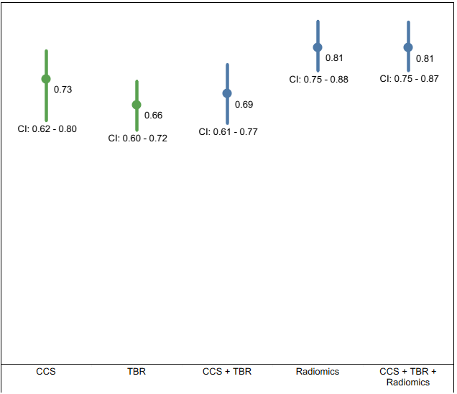
Median values and corresponding 95% confidence intervals calculated from bootstrapped results for multi-feature prediction models. Results are presented for the following models: clinical features only at the patient level, PET features only (normalised by mean blood pool activity and non-normalised) at the patient level, combined PET and clinical features at the patient level, and PET features only (normalised and non-normalised) at the arterial level. Subplots display performance metrics: a) AUC, b) Precision, c) F1 Score, and d) Recall.

Figure S2. Feature Importance Results for Normalised and Non-Normalised Radiomic-Only Multi-Feature Models
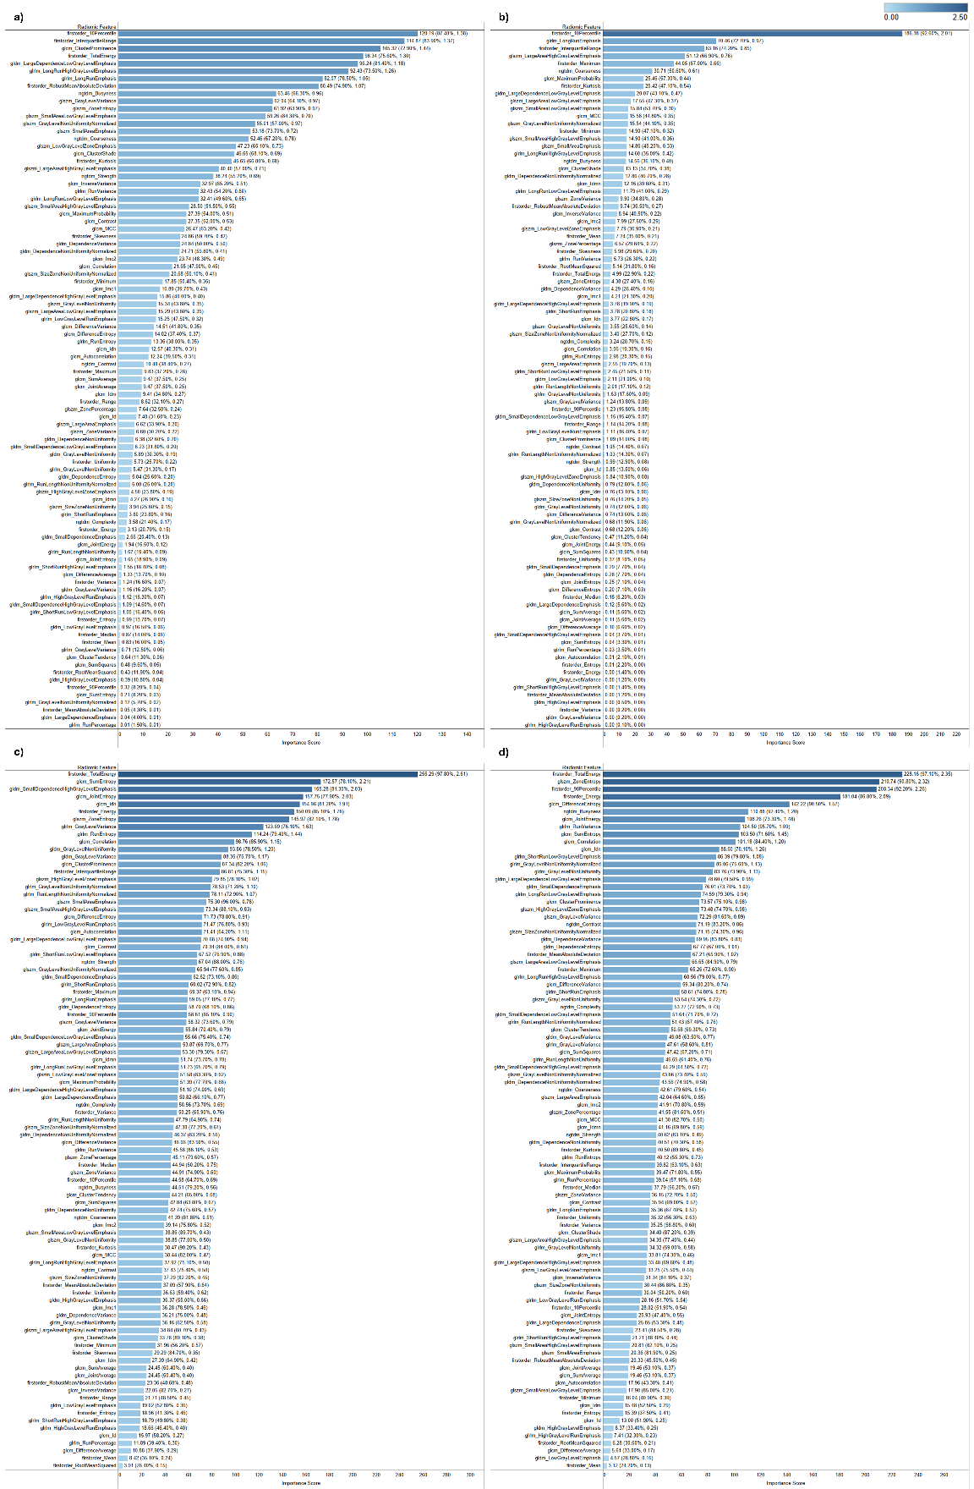
Bar plots depicting feature importance results for: a) non-normalised radiomic-only multi-feature model at the patient level, b) normalised radiomic-only multi-feature model at the patient level, c) non-normalised radiomic-only multi-feature model at the artery level, and d) normalised radiomic-only multi-feature model at the artery level. The x-axis represents the feature's importance score (bar length), calculated as the product of the mean absolute coefficient and the selection frequency. Bars are coloured based on the mean absolute coefficient, with feature labels next to each bar indicating the importance score, along with selection frequency and mean absolute coefficient in parentheses.
Figure S3. Single-Feature Prediction Model Results at the Patient Level for normalised and non-normalised radiomic features
Median AUC values and corresponding 95% confidence intervals calculated from bootstrapped results for single-feature prediction models. Results are shown for individual [¹⁸F]NaF PET radiomic features, both normalised by mean blood pool activity and non-normalised. Subplots represent different feature categories: a) First-order features, b) GLCM features, c) GLDM features, d) GLRLM features, e) GLSZM features, and f) NGTDM features.

Figure S4. Single-Feature Prediction Model Results at the Artery Level for normalised and non-normalised radiomic features
Median AUC values and corresponding 95% confidence intervals calculated from bootstrapped results for single-feature prediction models. Results are shown for individual [¹⁸F]NaF PET radiomic features, both normalised by mean blood pool activity and non-normalised. Subplots represent different feature categories: a) First-order features, b) GLCM features, c) GLDM features, d) GLRLM features, e) GLSZM features, and f) NGTDM features.

Figure S5. Multi-Feature Prediction Model Results for normalised and non-normalised features
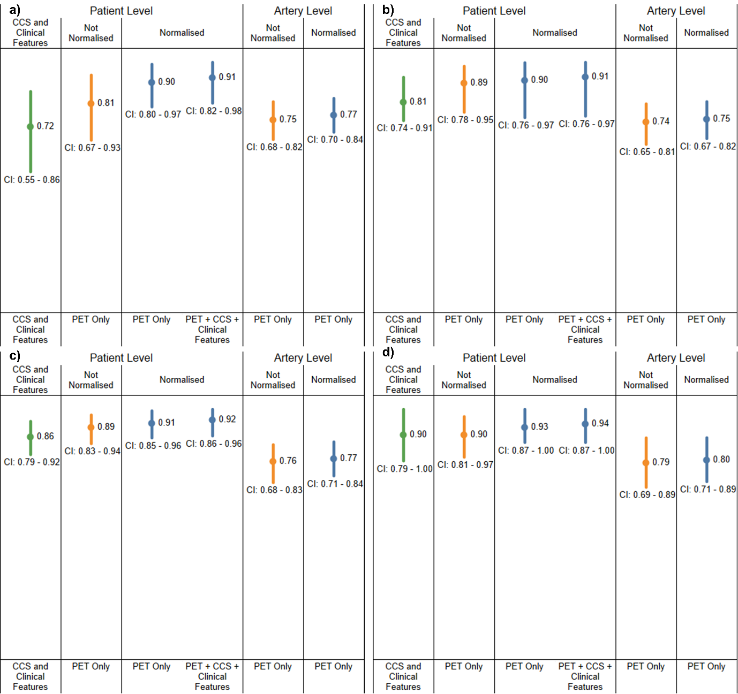
Median values and corresponding 95% confidence intervals calculated from bootstrapped results for multi-feature prediction models. Results are presented for the following models: clinical features only at the patient level, PET features only (normalised by mean blood pool activity and non-normalised) at the patient level, combined PET and clinical features at the patient level, and PET features only (normalised and non-normalised) at the arterial level. Subplots display performance metrics: a) AUC, b) Precision, c) F1 Score, and d) Recall.
Figure S6. Median AUC values and corresponding 95% confidence intervals calculated from bootstrapped results for multi-feature prediction models using i) clinical features + baseline CCS, ii) normalised radiomics features, and iii) all features combined, at the patient level for statins treatment usage groups.
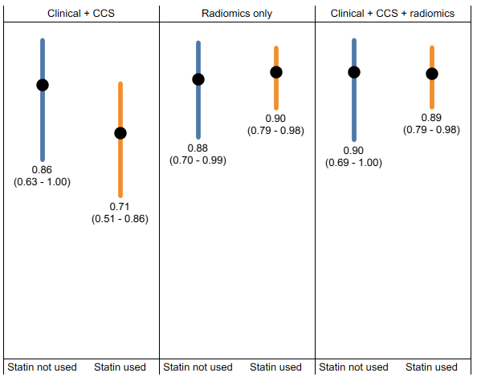
References
1. Budoff, M.J., et al., Progression of Coronary Artery Calcium Predicts All-Cause Mortality. Jacc-Cardiovascular Imaging, 2010. 3(12): p. 1229-1236.
2. Hokanson, J.E., et al., Evaluating changes in coronary artery calcium: an analytic method that accounts for interscan variability. AJR Am J Roentgenol, 2004. 182(5): p. 1327-32.
3. Leijenaar, R.T., et al., The effect of SUV discretization in quantitative FDG-PET Radiomics: the need for standardized methodology in tumor texture analysis. Sci Rep, 2015. 5: p. 11075.
4. Meinshausen, N. and P. Bühlmann, Stability selection. Journal of the Royal Statistical Society Series B-Statistical Methodology, 2010. 72: p. 417-473.
5. Yamada, M., et al., High-Dimensional Feature Selection by Feature-Wise Kernelized Lasso. Neural Computation, 2014. 26(1): p. 185-207.
6. Saarela, M. and S. Jauhiainen, Comparison of feature importance measures as explanations for classification models. Sn Applied Sciences, 2021. 3(2).
7. Bellinge, J.W., et al., <sup>18</sup>F-Sodium Fluoride Positron Emission Tomography Activity Predicts the Development of New Coronary Artery Calcifications. Arteriosclerosis, Thrombosis, and Vascular Biology, 2021. 41(1): p. 534-541.
8. Doris, M.K., et al., Coronary (18)F-Fluoride Uptake and Progression of Coronary Artery Calcification. Circ Cardiovasc Imaging, 2020. 13(12): p. e011438.
9. Dweck, M.R., et al., Coronary arterial 18F-sodium fluoride uptake: a novel marker of plaque biology. J Am Coll Cardiol, 2012. 59(17): p. 1539-48.
10. Ferencik, M., et al., Coronary Artery Calcium Distribution Is an Independent Predictor of Incident Major Coronary Heart Disease Events: Results From the Framingham Heart Study. Circ Cardiovasc Imaging, 2017. 10(10).
11. Kwiecinski, J., et al., Whole-vessel coronary F-sodium fluoride PET for assessment of the global coronary microcalcification burden. European Journal of Nuclear Medicine and Molecular Imaging, 2020. 47(7): p. 1736-1745.
12. Kwiecinski, J., et al., Predictors of 18F-Sodium fluoride uptake in patients with stable coronary artery disease and adverse plaque features on computed tomography angiography. Journal of Nuclear Medicine, 2019. 60.
13. Kwiecinski, J., et al., Coronary (18)F-Sodium Fluoride Uptake Predicts Outcomes in Patients With Coronary Artery Disease. J Am Coll Cardiol, 2020. 75(24): p. 3061-3074.
14. Li, L., et al., Sodium-fluoride PET-CT for the non-invasive evaluation of coronary plaques in symptomatic patients with coronary artery disease: a cross-correlation study with intravascular ultrasound. Eur J Nucl Med Mol Imaging, 2018. 45(12): p. 2181-2189.
15. Majeed, K., et al., Coronary 18F-sodium fluoride PET detects high-risk plaque features on optical coherence tomography and CT-angiography in patients with acute coronary syndrome. Atherosclerosis, 2021. 319: p. 142-148.
16. Wen, W., et al., In vivo coronary 18F-sodium fluoride activity: correlations with coronary plaque histological vulnerability and physiological environment. Cardiovascular Imaging, 2023. 16(4): p. 508-520.
17. Wen, W., et al., Associations between coronary/aortic 18F-sodium fluoride uptake and pro-atherosclerosis factors in patients with multivessel coronary artery disease. Journal of Nuclear Cardiology, 2022. 29(6): p. 3352-3365.
18. Otor, S.U., A Robust Feature Selection Framework for Effective Processing of Machine Learning Datasets.
19. Kitagawa, T., et al., Predictive Value of 18F‐Sodium Fluoride Positron Emission Tomography in Detecting High‐Risk Coronary Artery Disease in Combination With Computed Tomography. Journal of the American Heart Association, 2018. 7(20): p. e010224.
20. Kwiecinski, J., et al., Machine learning with 18F-sodium fluoride PET and quantitative plaque analysis on CT angiography for the future risk of myocardial infarction. Journal of Nuclear Medicine, 2022. 63(1): p. 158-165.
21. Li, Y., et al., Coronary CTA-based radiomic signature of pericoronary adipose tissue predict rapid plaque progression. Insights Imaging, 2024. 15(1): p. 151.
22. Militello, C., et al., CT radiomic features and clinical biomarkers for predicting coronary artery disease. Cognitive Computation, 2023. 15(1): p. 238-253.
23. Cilla, S., et al., CT angiography-based radiomics as a tool for carotid plaque characterization: a pilot study. Radiologia Medica, 2022. 127(7): p. 743-753.
24. Lin, A.D., et al., Radiomics-Based Precision Phenotyping Identifies Unstable Coronary Plaques From Computed Tomography Angiography. Jacc-Cardiovascular Imaging, 2022. 15(5): p. 859-871.
25. Lee, S.E., et al., Prediction of the development of new coronary atherosclerotic plaques with radiomics. Journal of Cardiovascular Computed Tomography, 2024. 18(3): p. 274-280.
26. Kolossvary, M., et al., Coronary Plaque Radiomic Phenotypes Predict Fatal or Nonfatal Myocardial Infarction: Analysis of the SCOT-HEART Trial. JACC Cardiovasc Imaging, 2025. 18(3): p. 308-319.
27. Eslami, P., et al., Radiomics of Coronary Artery Calcium in the Framingham Heart Study. Radiol Cardiothorac Imaging, 2020. 2(1): p. e190119.
28. Fahmy, A.S., et al., Radiomics and deep learning for myocardial scar screening in hypertrophic cardiomyopathy. Journal of Cardiovascular Magnetic Resonance, 2022. 24(1).
29. Ghanbari, F., et al., AI Cardiac MRI Scar Analysis Aids Prediction of Major Arrhythmic Events in the Multicenter DERIVATE Registry. Radiology, 2023. 307(3).
30. Amyar, A., et al., Radiomic Cardiac MRI Signatures for Predicting Ventricular Arrhythmias in Patients With Nonischemic Dilated Cardiomyopathy. Jacc-Advances, 2025. 4(4).
31. Duff, L.M., et al., An Automated Method for Artifical Intelligence Assisted Diagnosis of Active Aortitis Using Radiomic Analysis of FDG PET-CT Images. Biomolecules, 2023. 13(2).

