ChunkGuard: a user-space secure file storage system with chunk-level encryption and integrity protection

¹Biryomumeisho Joshua, Ocen Emmy Fred¹, Jjunju Fred Paul Mark*¹, Bbosa Denis²

¹Department of Computer Science, School of Technology and Computer Engineering, Uganda Technology and Management University (UTAMU), Kampala, Uganda.
²Department of Mechanical Engineering, Faculty of Applied Science and Technology, Mbarara University of Science and Technology (MUST), Mbarara, Uganda.

* Correspondence: Prof. Fred Paul Mark Jjunju; fpmjjunju@utamu.ac.ug

Supplementary Information

This file provides technical detail supporting the Research Note. It reports the same prototype and experiments as the main manuscript and does not introduce additional unreported experiments.

S1. Detailed threat model and logical architecture
ChunkGuard is designed for an attacker who obtains the storage medium or application files through device theft, copying, or direct filesystem access without valid user credentials, but who does not observe secrets in process memory during a legitimate session. The intended prototype properties are confidentiality of stored file contents against direct storage inspection, detection of unauthorised ciphertext modification, and enforcement of recorded file ownership through the application interface. The prototype does not claim protection against an attacker who already possesses valid credentials, can read process memory, can modify metadata and keys undetected, or can race concurrent metadata updates.
The application is organized into a graphical interface, authentication and file-operation APIs, a validation/chunk layer, cryptographic helpers, metadata/master-list management, and encrypted chunk files. Ownership checks occur before operations on an existing file are allowed to reach the chunk engine.
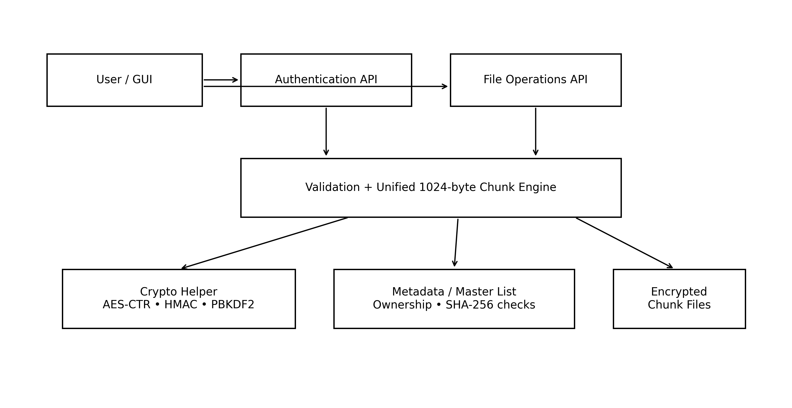
Figure S1. Logical architecture of the ChunkGuard prototype.

S2. Cryptographic and storage parameters
Table S1. Cryptographic design parameters
Parameter | Implementation value
Username/password validation | Username 6-31 alphanumeric characters; password 9-31 characters including symbols
Password salt | 32 random bytes per user
Password processing | PBKDF2-HMAC-SHA1; 20,000 iterations; 32-byte output
Chunk key / IV | 128-bit key / 128-bit IV; fresh per chunk per write
File encryption | AES-128 in CTR mode (PyCryptodome)
Chunk integrity | HMAC-SHA256 over ciphertext; current prototype uses the chunk AES key
Chunk capacity | 1024 bytes plaintext; partial final chunk padded with ASCII “0”
System-wide consistency | SHA-256 digest of each file metadata entry in the master list
Security-hardening note: using the same secret for AES-CTR and HMAC is a prototype limitation. A successor should derive separate subkeys or evaluate an authenticated-encryption construction.

S3. Unified chunk engine and extended functions
The implementation uses one chunking path for both small and large files. Files smaller than 1024 bytes still produce one independently protected chunk. Write operations recover the current plaintext in memory, apply the requested edit, and re-chunk the file into the theoretical minimum number of chunks (the smallest integer not less than file size divided by 1024).
The core API exposes create, encrypt, decrypt, positional read, positional write, size query, delete, per-file integrity checking, and system-wide health checking. The desktop application additionally provides real-file import, in-place encryption, and an independent recovery function. In-place encryption creates a plaintext JSON recovery sidecar containing key/IV/HMAC/size information required for standalone recovery. This feature is useful for testing recoverability but is not appropriate for production deployment because the sidecar itself contains sensitive recovery material.

S4. Automated functional and security-oriented test suite
Table S2. Automated self-test suite summary
Category | Cases | Result
Authentication and validation | 8 | 8/8 passed
Core file lifecycle | 12 | 12/12 passed
Access control | 2 | 2/2 passed
Tamper/integrity detection | 3 | 3/3 passed
System health and master list | 5 | 5/5 passed
Total | 30 | 30/30 passed (100%)

S5. Performance evaluation
Encryption, decryption, and integrity checking were measured over file sizes from 16 bytes to 1 MB, with five repetitions per file size. The main manuscript reports the 1 MB result; representative mean timings supplied in the source experiment are shown below.
Table S3. Representative mean timings by file size (five repetitions)
Size | Chunks | Encrypt (ms) | Decrypt (ms) | Integrity (ms)
1 KB | 1 | 0.756 | 0.206 | 0.105
10 KB | 10 | 1.043 | 0.564 | 0.245
100 KB | 100 | 6.404 | 3.925 | 1.765
500 KB | 500 | 35.009 | 24.448 | 7.863
1 MB | 1024 | 160.833 | 78.559 | 16.734
At 1 MB, the reported approximate throughput was 6.2 MB/s for encryption and 12.7 MB/s for decryption.

S6. Component-level profiling
A separate instrumented profiling run decomposed the 1 MB encryption path into four components. The profiling total differs from the separate end-to-end mean timing because the measurements were obtained under different instrumentation conditions; they should not be numerically substituted for one another.
Table S4. Component-level profile for encrypting a 1 MB file
Component | Time (ms) | Share
Key/IV generation | 1.91 | 1.0%
AES-128-CTR encryption | 31.78 | 17.2%
HMAC-SHA256 signing | 5.61 | 3.0%
Chunk-file disk write | 145.17 | 78.7%
Instrumented total | 184.47 | 100.0%

S7. Chunk-boundary validation
Chunking was tested at and around 1024-byte boundaries from 1 to 5000 bytes. The implementation produced exactly the theoretical minimum number of chunks for every tested size. Representative boundary cases are shown below.
Table S5. Representative chunk-boundary cases
Plaintext size (bytes) | Theoretical minimum | Observed
1 | 1 | 1
1023 | 1 | 1
1024 | 1 | 1
1025 | 2 | 2
2047 | 2 | 2
2048 | 2 | 2
2049 | 3 | 3
4096 | 4 | 4
4097 | 5 | 5
5000 | 5 | 5

S8. Security-validation scenarios
Table S6. Security-oriented validation scenarios
Scenario | Test action | Observed behavior
Ciphertext tampering | Flip one byte in an encrypted chunk after encryption | Per-file HMAC verification failed; corrupted plaintext was not silently returned
System health after tampering | Run system-wide health check after the one-byte modification | The modified file was flagged while unaffected files remained healthy
Cross-user size query | Second registered user queried a file owned by the first user | Access denied
Cross-user decryption | Second registered user attempted decryption of another user’s file | Access denied

S9. Additional limitations and next-step experiments
The unencrypted metadata store and plaintext recovery sidecar expose key material if an attacker obtains application metadata. Future key management should protect per-file or per-chunk secrets beneath a master key and address key wrapping, rotation, recovery, and protected storage.
The current 1024-byte physical chunk granularity should be treated as an experimental parameter rather than a recommended production value. Future evaluation should compare 4 KB, 16 KB, 64 KB, and larger logical units while measuring sequential and random throughput, metadata overhead, storage amplification, integrity cost, and the amount of data re-encrypted after small modifications.
Scalability testing should extend beyond 1 MB and include large file counts, tens to hundreds of megabytes, multi-gigabyte files, concurrent users, SSD and network storage, cloud-object storage, crash consistency, replay/rollback protection, secure deletion, chunk reordering/substitution, and interoperability with an independent implementation.
Cryptographic hardening should compare a key-separated encrypt-then-MAC design with an authenticated-encryption alternative such as AES-GCM and should evaluate a modernized password-protection configuration while holding workload and hardware conditions constant.

Supplementary references
S1. National Institute of Standards and Technology. Advanced Encryption Standard (AES). FIPS PUB 197-upd1. 2023. doi:10.6028/NIST.FIPS.197-upd1.
S2. Dworkin M. Recommendation for block cipher modes of operation: methods and techniques. NIST Special Publication 800-38A. 2001. doi:10.6028/NIST.SP.800-38A.
S3. National Institute of Standards and Technology. The Keyed-Hash Message Authentication Code (HMAC). FIPS PUB 198-1. 2008. doi:10.6028/NIST.FIPS.198-1.
S4. National Institute of Standards and Technology. Secure Hash Standard (SHS). FIPS PUB 180-4. 2015. doi:10.6028/NIST.FIPS.180-4.
S5. Moriarty K, Kaliski B, Rusch A. PKCS #5: password-based cryptography specification version 2.1. RFC 8018. 2017. doi:10.17487/RFC8018.
S6. Turan MS, Barker EB, Burr WE, Chen L. Recommendation for password-based key derivation: part 1: storage applications. NIST Special Publication 800-132. 2010. doi:10.6028/NIST.SP.800-132.
S7. Dworkin M. Recommendation for block cipher modes of operation: Galois/Counter Mode (GCM) and GMAC. NIST Special Publication 800-38D. 2007. doi:10.6028/NIST.SP.800-38D.

