Supplementary Material
Radiomics features extraction methodology

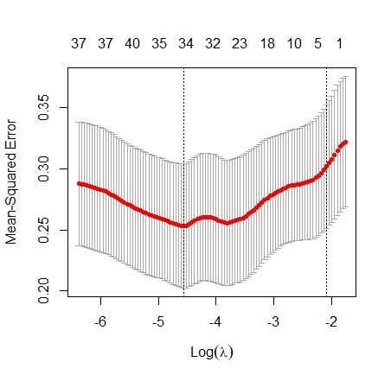
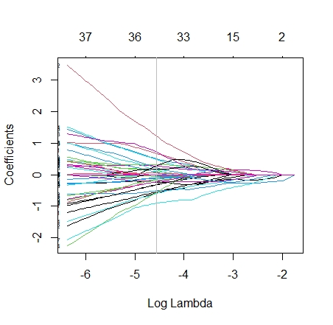

Fig. S1. The LASSO regression process of each phase radiomics signature building.

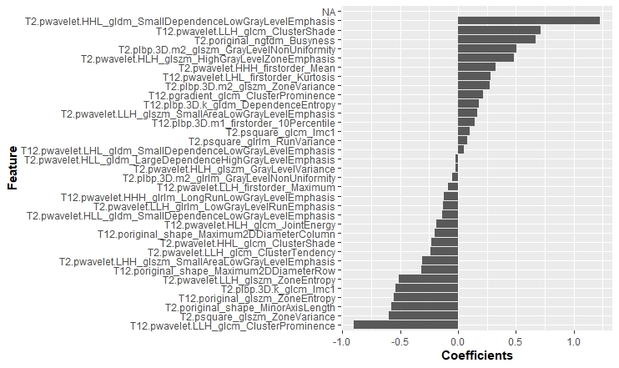
Fig. S2. Radiomics features selected for signature building.

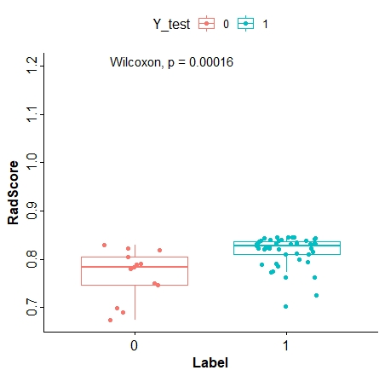
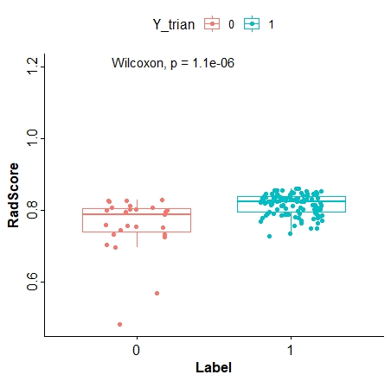
Fig. S2. Comparison of discrimination ability of radiomics model.

Fig. S3. Comparison of discrimination ability of radscore

Calculation Formula for the radiomics score (radscore)

Radscore= 3.71991719-0.57921648*T2.poriginal_shape_MinorAxisLength+
0.67238139*T2.poriginal_ngtdm_Busyness-0.04793204*T2.plbp.3D.m2_glrlm_GrayLevelNonUniformity+
0.50556266*T2.plbp.3D.m2_glszm_GrayLevelNonUniformity+
0.27462311*T2.plbp.3D.m2_glszm_ZoneVariance-0.54112958*T2.plbp.3D.k_glcm_Imc1+
0.10340045*T2.psquare_glcm_Imc1+
0.07880293*T2.psquare_glrlm_RunVariance -0.59888525*T2.psquare_glszm_ZoneVariance-0.23560016*T2.pwavelet.LLH_glcm_ClusterTendency-0.12986314*T2.pwavelet.LLH_glrlm_LowGrayLevelRunEmphasis+
0.16928221*T2.pwavelet.LLH_glszm_SmallAreaLowGrayLevelEmphasis-0.50936199*T2.pwavelet.LLH_glszm_ZoneEntropy-0.31120678*T2.pwavelet.LHH_glszm_SmallAreaLowGrayLevelEmphasis -0.01830680*T2.pwavelet.HLL_gldm_LargeDependenceHighGrayLevelEmphasis-0.13654648*T2.pwavelet.HLL_gldm_SmallDependenceLowGrayLevelEmphasis -0.02078512*T2.pwavelet.HLH_glszm_GrayLevelVariance+
0.48139543*T2.pwavelet.HLH_glszm_HighGrayLevelZoneEmphasis-0.22740391*T2.pwavelet.HHL_glcm_ClusterShade+
1.22936039*T2.pwavelet.HHL_gldm_SmallDependenceLowGrayLevelEmphasis+
0.32457340*T2.pwavelet.HHH_firstorder_Mean-0.20087666*T12.poriginal_shape_Maximum2DDiameterColumn-0.31885087*T12.poriginal_shape_Maximum2DDiameterRow-0.55701354*T12.poriginal_glszm_ZoneEntropy+
0.21696666*T12.pgradient_glcm_ClusterProminence+
0.14741778*T12.plbp.3D.m1_firstorder_10Percentile+
0.18229518*T12.plbp.3D.k_gldm_DependenceEntropy-0.08847515*T12.pwavelet.LLH_firstorder_Maximum-0.90141965*T12.pwavelet.LLH_glcm_ClusterProminence+
0.71783429*T12.pwavelet.LLH_glcm_ClusterShade+
0.28129354*T12.pwavelet.LHL_firstorder_Kurtosis+
0.05422788*T12.pwavelet.LHL_gldm_SmallDependenceLowGrayLevelEmphasis-0.18369517*T12.pwavelet.HLH_glcm_JointEnergy-0.12413782*T12.pwavelet.HHH_glrlm_LongRunLowGrayLevelEmphasis

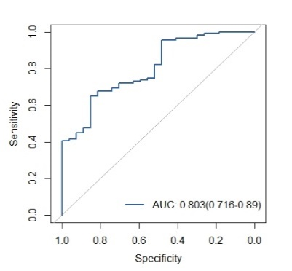
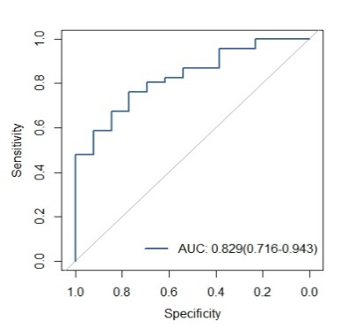
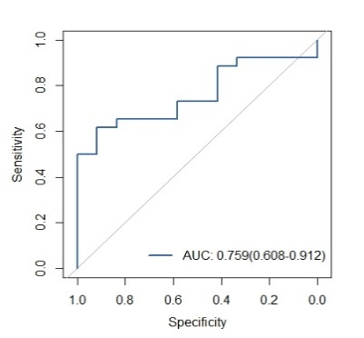

Fig. S4. The comparison of radscore in ROC curves in the construction cohort, internal validation and external cohort.

