Supplemental Figures
Supplemental Fig. 1. Agreement between the analytical variance-gamma null and Monte Carlo simulation under the continuous-rank model. Two, three and five omics layers were simulated with normalized ranks drawn as continuous Uniform (0,1) variables and random signs. P_VG is the analytical tail probability as implemented in ORBIT. P_MC was obtained by direct Monte Carlo simulation with 10¹⁰ draws per layer count and is shown with exact 95% Poisson confidence intervals. The dashed line marks a ratio of 1.
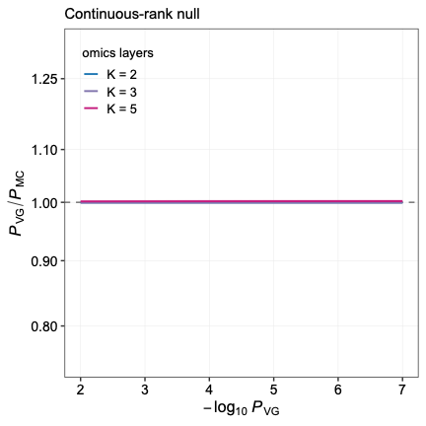

Supplemental Fig. 2. Conservative bias introduced by the discreteness of the rank transform. (A) Two omics layers with 5,000, 10,000 and 20,000 features per layer. The rank null is obtained by exact enumeration over all n² rank pairs and four sign combinations, so these curves carry no sampling error. (B) 10,000 features per layer, with two, three and five omics layers. The K = 2 curve is again exact; K = 3 and K = 5 were obtained by rank permutation 2 × 10⁸ and are shown with pointwise 95% confidence bands.
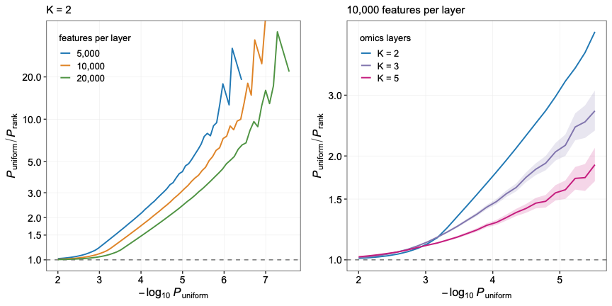

Supplemental Fig. 3 Power and false-positive rate of RankProd compared with ORBIT under identical simulations. (A-D) False-positive rate at four proportions of signals (0%, 10%, 20%, 50%) for no signals (solid line), independent signals (dashed line) and opposite signals (dotted line) scenarios. (A) Varying between-omics correlation. (B) Varying number of omics layers. (C) Varying proportions of missing values with median imputation. (D) Varying proportions of missing values when missing values were ignored (E) Per-feature P values from ORBIT and RankProd on the same simulated data as in Figure 2C of opposite-direction signal. (F) Power of RankProd and ORBIT to recover concordant signal as a function of the number of omics layers, at five proportions of signals (0%, 5%, 10%, 20%, 50%).
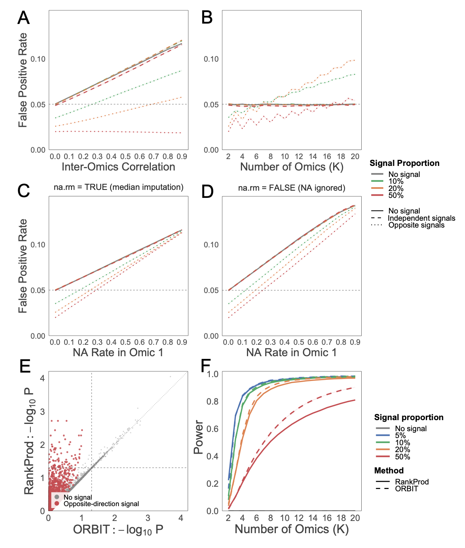

Supplemental Fig. 4. CKD gene prioritized by Fisher, Stouffer and DPM. (A) The top 10 most significant genes by Fisher's method. (B) The top 10 most significant genes by DPM. (C) The top 10 most significant genes by Stouffer’s method. Asterisks mark genes in A-C not among the top 10 under ORBIT.
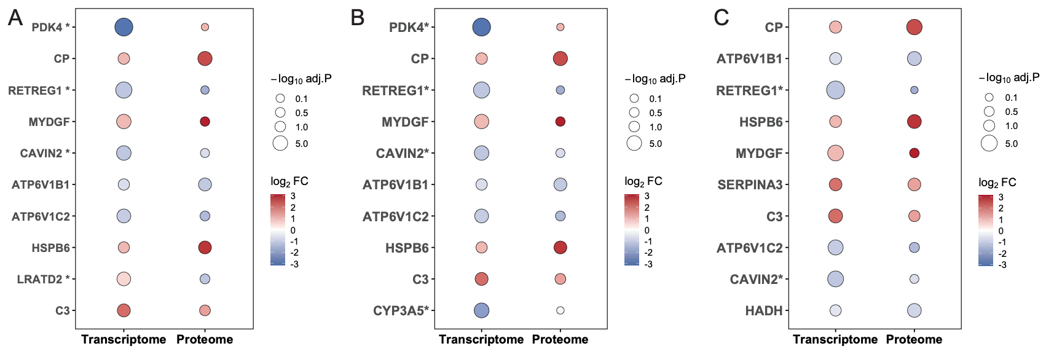

Supplemental Fig. 5. Comparison of ORBIT and RankProd for features with opposite directions of change across omics layers. (A) Signed significance, sign(log₂FC) × −log₁₀P, in the transcriptome versus the proteome for genes measured in both layers. Genes with opposite directions of change that rank within the top 20% by P-value in both layers are highlighted in purple. The dotted line indicates the line of identify (y = x). (B) Comparison of −log₁₀P from ORBIT and RankProd for the same genes, with opposite-direction genes highlighted as in (A). Dashed lines indicate P = 0.05 and the dotted line indicates the line of identity (y = x).
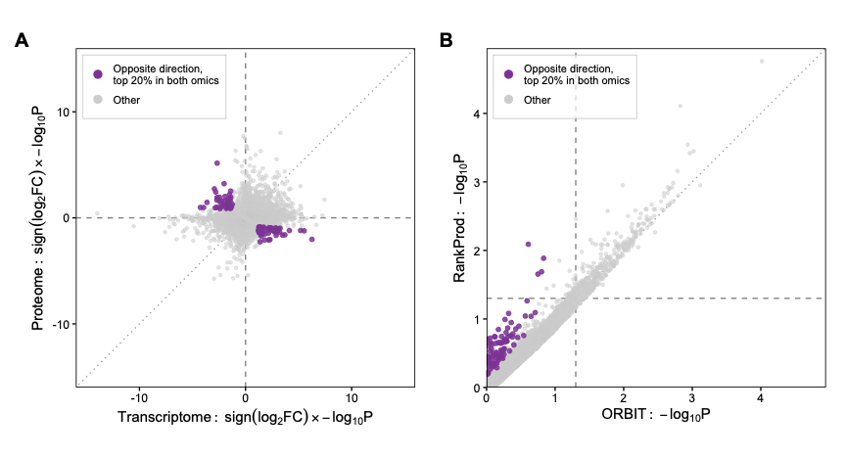

Supplemental Fig. 6. Comparison of pathway significance under GSEA and over-representation analysis using the integrated ORBIT transcriptome. Restricted to pathways significant (adjusted P value <0.05) in both methods. Each point is a gene set, positioned by its $-\log_{10}(adjusted P value)$ under each approach, colored by direction and sized by the number of member genes recovered in the ORA input set. The top 10 most significant pathways under GSEA are labeled.
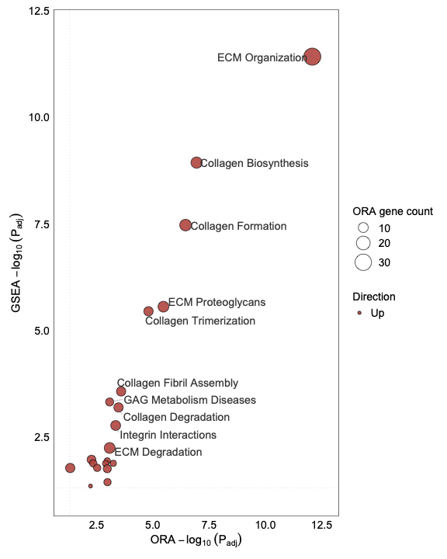

Supplemental Fig. 7. The top 10 most highly ranked proteins across the four contributing proteomic studies. Colour indicates $\log_{2}$(Fold Change) and point size indicates the per-omic $-\log_{10}(adjusted P value)$.
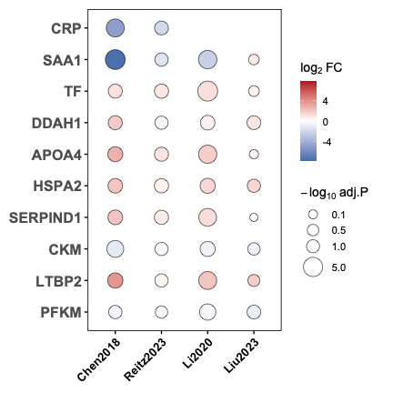

Supplemental Fig. 8. The false-positive rate control of ORBIT-P in simulation. (A-O) False-positive rate for no signals. (A, D, G, J, M) False-positive rate under varying between-omics correlation. (B, E, H, K, N) false -ositive rate under varying omics layers. (C, F, I, L, O) false-positive rate under varying proportion of missing values. (A-C) Fisher method. (D-F) Brown method. (G-I) Directional Stouffer method. (J-L) Directional P-value Merging (DPM). (M-O) ORBIT-P method. (P) Power of ORBIT-P (dashed line) and DPM (solid line) to recover concordant signal as a function of the number of omics layers, at five proportions of signals (0%, 5%, 10%, 20%, 50%).
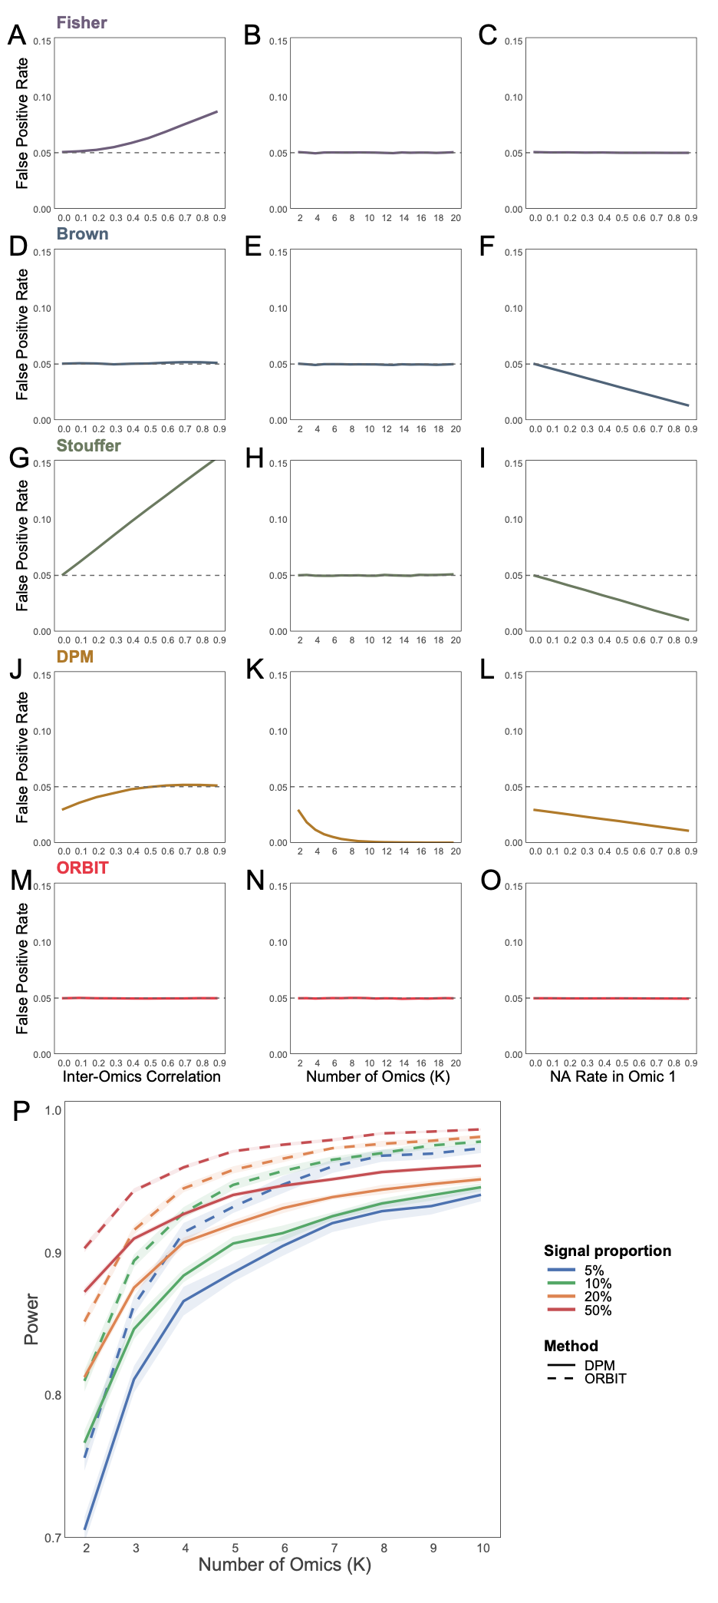

Supplemental Fig. 9. Monte Carlo validation of the ORBIT and Variance-Gamma Package [1]. (A) Computed against Monte Carlo tail probability, both on a −log₁₀ scale. The dashed line is the identity. Horizontal bars give the Monte Carlo 95% confidence interval. (B) The same comparison expressed as relative deviation from the Monte Carlo estimate. The grey band is the Monte Carlo 95% confidence interval.
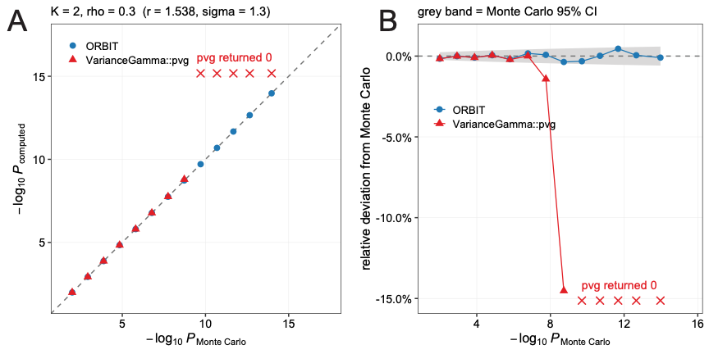
1. Scott, D. and C.Y. Dong, VarianceGamma: The Variance Gamma Distribution. 2023.

