Supporting Information
Residue-Conditioned In-Pocket Design for Paralogue Selectivity
Ahmed Amine SADOUK
Independent Researcher

Contents
Figure S1. The EGFR T790M over wild type EGFR trajectory, 8 rounds, 17 to 59 heavy atoms .
Figure S2. The KRAS G12C over wild type KRAS trajectory , 8 rounds, 65 to 94 heavy atoms .
Table S1. The 44 reference compounds with their case, approval status , InChIKey and PubChem CID .
Table S2. Per comparison shared core , decoy null median and exact p value .
Table S3. The drug to drug scale per target and the best of set recovery of each lead .
Data S1. The populations used by each figure , recomputed from the campaign records.

Figure S1. The EGFR T790M over wild type EGFR trajectory, 8 rounds, 17 to 59 heavy atoms .
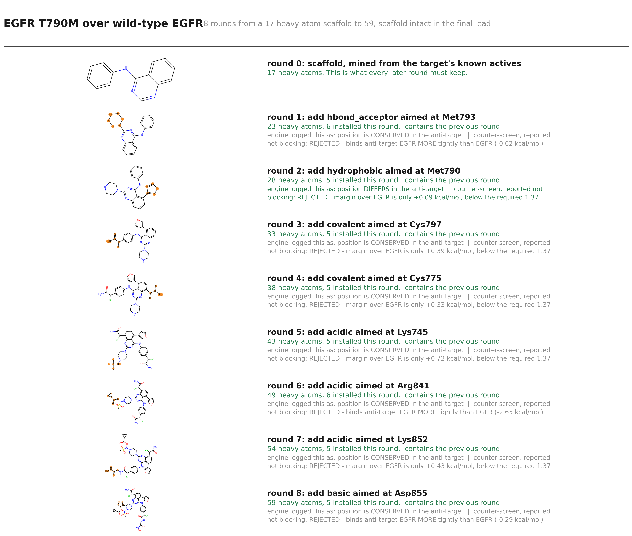

Figure S2. The KRAS G12C over wild type KRAS trajectory , 8 rounds, 65 to 94 heavy atoms .
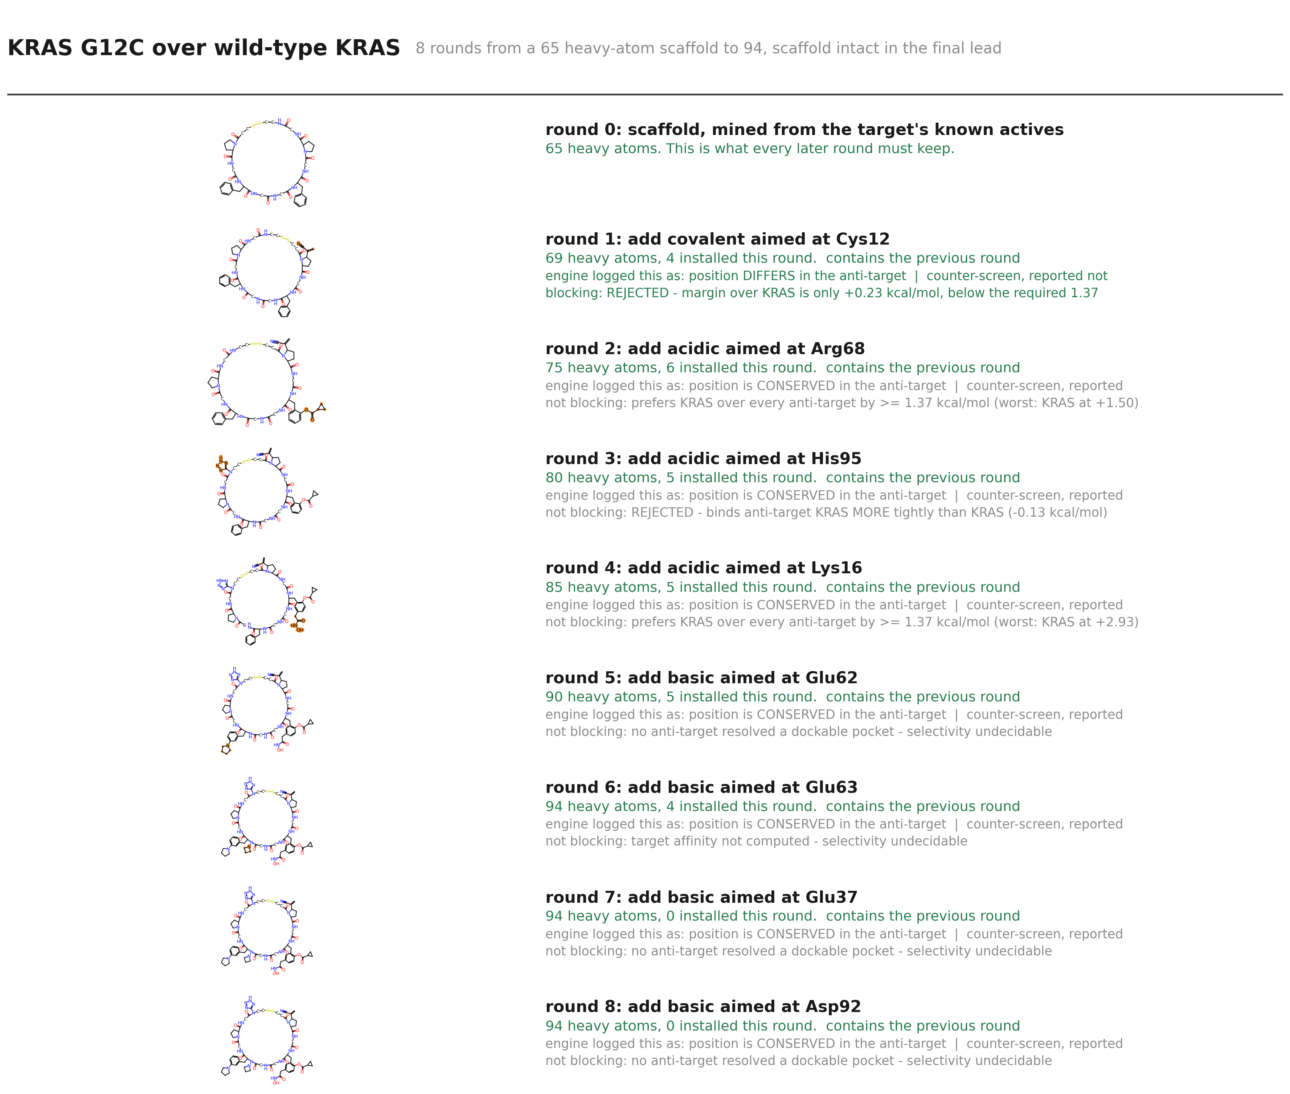

Table S1. The 44 reference compounds with their case, approval status , InChIKey and PubChem CID .
receptor pair | compound | approved | InChIKey | PubChem CID | heavy atoms
ABL1_SRC | imatinib | yes | KTUFNOKKBVMGRW-UHFFFAOYSA-N | 5291 | 37
ABL1_SRC | nilotinib | yes | HHZIURLSWUIHRB-UHFFFAOYSA-N | 644241 | 39
ABL1_SRC | dasatinib | yes | ZBNZXTGUTAYRHI-UHFFFAOYSA-N | 3062316 | 33
ABL1_SRC | ponatinib | yes | PHXJVRSECIGDHY-UHFFFAOYSA-N | 24826799 | 39
ABL1_SRC | bosutinib | yes | UBPYILGKFZZVDX-UHFFFAOYSA-N | 5328940 | 36
AKT1_AKT2 | capivasertib | yes | JDUBGYFRJFOXQC-KRWDZBQOSA-N | 25227436 | 30
AKT1_AKT2 | ipatasertib | no | GRZXWCHAXNAUHY-NSISKUIASA-N | 24788740 | 32
BRAF_V600E | vemurafenib | yes | GPXBXXGIAQBQNI-UHFFFAOYSA-N | 42611257 | 33
BRAF_V600E | dabrafenib | yes | BFSMGDJOXZAERB-UHFFFAOYSA-N | 44462760 | 35
BRAF_V600E | encorafenib | yes | CMJCXYNUCSMDBY-ZDUSSCGKSA-N | 50922675 | 36
BRAF_V600E_alt | vemurafenib | yes | GPXBXXGIAQBQNI-UHFFFAOYSA-N | 42611257 | 33
BRAF_V600E_alt | dabrafenib | yes | BFSMGDJOXZAERB-UHFFFAOYSA-N | 44462760 | 35
BRAF_V600E_alt | encorafenib | yes | CMJCXYNUCSMDBY-ZDUSSCGKSA-N | 50922675 | 36
CA2_CA1 | acetazolamide | yes | BZKPWHYZMXOIDC-UHFFFAOYSA-N | 1986 | 13
CA2_CA1 | methazolamide | yes | FLOSMHQXBMRNHR-UHFFFAOYSA-N | 4100 | 14
CA2_CA1 | dorzolamide | yes | IAVUPMFITXYVAF-XPUUQOCRSA-N | 5284549 | 19
CA2_CA1 | brinzolamide | yes | HCRKCZRJWPKOAR-JTQLQIEISA-N | 68844 | 23
CDK6_CDK2 | palbociclib | yes | AHJRHEGDXFFMBM-UHFFFAOYSA-N | 5330286 | 33
CDK6_CDK2 | ribociclib | yes | RHXHGRAEPCAFML-UHFFFAOYSA-N | 44631912 | 32
CDK6_CDK2 | abemaciclib | yes | UZWDCWONPYILKI-UHFFFAOYSA-N | 46220502 | 37
EGFR_T790M | gefitinib | yes | XGALLCVXEZPNRQ-UHFFFAOYSA-N | 123631 | 31
EGFR_T790M | erlotinib | yes | AAKJLRGGTJKAMG-UHFFFAOYSA-N | 176870 | 29
EGFR_T790M | afatinib | yes | ULXXDDBFHOBEHA-CWDCEQMOSA-N | 10184653 | 34
EGFR_T790M | osimertinib | yes | DUYJMQONPNNFPI-UHFFFAOYSA-N | 71496458 | 37
EGFR_T790M | dacomitinib | yes | LVXJQMNHJWSHET-AATRIKPKSA-N | 11511120 | 33
EGFR_T790M | neratinib | yes | JWNPDZNEKVCWMY-VQHVLOKHSA-N | 9915743 | 40
JAK2_JAK1 | ruxolitinib | yes | HFNKQEVNSGCOJV-OAHLLOKOSA-N | 25126798 | 23
JAK2_JAK1 | baricitinib | yes | XUZMWHLSFXCVMG-UHFFFAOYSA-N | 44205240 | 26
JAK2_JAK1 | fedratinib | yes | JOOXLOJCABQBSG-UHFFFAOYSA-N | 16722836 | 37
JAK2_JAK1 | tofacitinib | yes | UJLAWZDWDVHWOW-YPMHNXCESA-N | 9926791 | 23
KRAS_G12C | sotorasib | yes | NXQKSXLFSAEQCZ-SFHVURJKSA-N | 137278711 | 41
KRAS_G12C | adagrasib | yes | PEMUGDMSUDYLHU-ZEQRLZLVSA-N | 138611145 | 43
PARP1_PARP2 | olaparib | yes | FDLYAMZZIXQODN-UHFFFAOYSA-N | 23725625 | 32
PARP1_PARP2 | niraparib | yes | PCHKPVIQAHNQLW-CQSZACIVSA-N | 24958200 | 24
PARP1_PARP2 | rucaparib | yes | HMABYWSNWIZPAG-UHFFFAOYSA-N | 9931954 | 24
PARP1_PARP2 | talazoparib | yes | HWGQMRYQVZSGDQ-HZPDHXFCSA-N | 135565082 | 28
PIK3CA_PIK3CD | alpelisib | yes | STUWGJZDJHPWGZ-LBPRGKRZSA-N | 56649450 | 30
PIK3CA_PIK3CD | idelalisib | yes | IFSDAJWBUCMOAH-HNNXBMFYSA-N | 11625818 | 31
PIK3CA_PIK3CD | duvelisib | yes | SJVQHLPISAIATJ-ZDUSSCGKSA-N | 50905713 | 30
PIK3CA_PIK3CD | copanlisib | yes | MWYDSXOGIBMAET-UHFFFAOYSA-N | 135565596 | 35
PTGS2_PTGS1 | celecoxib | yes | RZEKVGVHFLEQIL-UHFFFAOYSA-N | 2662 | 26
PTGS2_PTGS1 | rofecoxib | no | RZJQGNCSTQAWON-UHFFFAOYSA-N | 5090 | 22
PTGS2_PTGS1 | etoricoxib | yes | MNJVRJDLRVPLFE-UHFFFAOYSA-N | 123619 | 24
PTGS2_PTGS1 | valdecoxib | no | LNPDTQAFDNKSHK-UHFFFAOYSA-N | 119607 | 22

Table S2. Per comparison shared core , decoy null median and exact p value .
receptor pair | compound | shared core, % | decoy null, % | p, exact
ABL1_SRC | imatinib | 78.37837837837837 | 21.62162162162162 | 0.01639344262295082
ABL1_SRC | nilotinib | 48.717948717948715 | 20.512820512820515 | 0.01639344262295082
ABL1_SRC | dasatinib | 30.303030303030305 | 21.21212121212121 | 0.03278688524590164
ABL1_SRC | ponatinib | 41.02564102564103 | 17.94871794871795 | 0.01639344262295082
ABL1_SRC | bosutinib | 36.111111111111114 | 19.444444444444443 | 0.03278688524590164
AKT1_AKT2 | capivasertib | 23.333333333333332 | 23.333333333333332 | 0.5901639344262295
AKT1_AKT2 | ipatasertib | 18.75 | 21.875 | 1.0
BRAF_V600E | vemurafenib | 21.21212121212121 | 21.21212121212121 | 0.8524590163934426
BRAF_V600E | dabrafenib | 20.0 | 20.0 | 0.9508196721311475
BRAF_V600E | encorafenib | 19.444444444444443 | 19.444444444444443 | 0.9508196721311475
BRAF_V600E_alt | vemurafenib | 21.21212121212121 | 21.21212121212121 | 0.9344262295081968
BRAF_V600E_alt | dabrafenib | 20.0 | 20.0 | 0.9180327868852459
BRAF_V600E_alt | encorafenib | 19.444444444444443 | 19.444444444444443 | 0.9508196721311475
CA2_CA1 | acetazolamide | 38.46153846153846 | 23.076923076923077 | 0.09836065573770492
CA2_CA1 | methazolamide | 35.714285714285715 | 21.428571428571427 | 0.04918032786885246
CA2_CA1 | dorzolamide | 26.31578947368421 | 15.789473684210526 | 0.09836065573770492
CA2_CA1 | brinzolamide | 21.73913043478261 | 13.043478260869565 | 0.09836065573770492
CDK6_CDK2 | palbociclib | 21.21212121212121 | 18.181818181818183 | 0.19672131147540983
CDK6_CDK2 | ribociclib | 21.875 | 18.75 | 0.36065573770491804
CDK6_CDK2 | abemaciclib | 18.91891891891892 | 18.91891891891892 | 0.7868852459016393
EGFR_T790M | gefitinib | 54.83870967741935 | 22.580645161290324 | 0.01639344262295082
EGFR_T790M | erlotinib | 58.62068965517241 | 24.137931034482758 | 0.01639344262295082
EGFR_T790M | afatinib | 50.0 | 20.58823529411765 | 0.01639344262295082
EGFR_T790M | osimertinib | 21.62162162162162 | 21.62162162162162 | 0.5245901639344263
EGFR_T790M | dacomitinib | 51.515151515151516 | 21.21212121212121 | 0.01639344262295082
EGFR_T790M | neratinib | 20.0 | 17.5 | 0.4262295081967213
JAK2_JAK1 | ruxolitinib | 30.434782608695652 | 21.73913043478261 | 0.29508196721311475
JAK2_JAK1 | baricitinib | 26.923076923076923 | 19.23076923076923 | 0.29508196721311475
JAK2_JAK1 | fedratinib | 18.91891891891892 | 24.324324324324323 | 0.8688524590163934
JAK2_JAK1 | tofacitinib | 34.78260869565217 | 26.08695652173913 | 0.29508196721311475
KRAS_G12C | sotorasib | 17.073170731707318 | 17.073170731707318 | 0.7377049180327869
KRAS_G12C | adagrasib | 16.27906976744186 | 13.953488372093023 | 0.47540983606557374
PARP1_PARP2 | olaparib | 25.0 | 21.875 | 0.16393442622950818
PARP1_PARP2 | niraparib | 25.0 | 29.166666666666668 | 1.0
PARP1_PARP2 | rucaparib | 16.666666666666668 | 29.166666666666668 | 1.0
PARP1_PARP2 | talazoparib | 21.428571428571427 | 25.0 | 1.0
PIK3CA_PIK3CD | alpelisib | 20.0 | 20.0 | 0.6229508196721312
PIK3CA_PIK3CD | idelalisib | 22.580645161290324 | 22.580645161290324 | 0.5737704918032787
PIK3CA_PIK3CD | duvelisib | 23.333333333333332 | 23.333333333333332 | 0.6229508196721312
PIK3CA_PIK3CD | copanlisib | 17.142857142857142 | 20.0 | 1.0
PTGS2_PTGS1 | celecoxib | 34.61538461538461 | 26.923076923076923 | 0.13114754098360656
PTGS2_PTGS1 | rofecoxib | 50.0 | 27.272727272727273 | 0.01639344262295082
PTGS2_PTGS1 | etoricoxib | 45.833333333333336 | 25.0 | 0.06557377049180328
PTGS2_PTGS1 | valdecoxib | 45.45454545454545 | 27.272727272727273 | 0.09836065573770492

Table S3. The drug to drug scale per target and the best of set recovery of each lead .
receptor pair | best shared core, % | nearest compound | decoy null, % | drug to drug median, % | p, exact
ABL1_SRC | 78.4 | imatinib | 22.2 | 30.3 | 0.0164
AKT1_AKT2 | 23.3 | capivasertib | 23.3 | 28.1 | 0.6066
BRAF_V600E | 21.2 | vemurafenib | 24.2 | 33.3 | 0.8525
BRAF_V600E_alt | 21.2 | vemurafenib | 24.2 | 33.3 | 0.9344
CA2_CA1 | 38.5 | acetazolamide | 23.1 | 26.3 | 0.0984
CDK6_CDK2 | 21.9 | ribociclib | 18.9 | 35.1 | 0.3934
EGFR_T790M | 58.6 | erlotinib | 24.1 | 35.0 | 0.0164
JAK2_JAK1 | 34.8 | tofacitinib | 26.1 | 39.1 | 0.3279
KRAS_G12C | 17.1 | sotorasib | 17.1 | 37.2 | 0.8361
PARP1_PARP2 | 25.0 | olaparib | 29.2 | 33.3 | 1.0
PIK3CA_PIK3CD | 23.3 | duvelisib | 23.3 | 26.7 | 0.6885
PTGS2_PTGS1 | 50.0 | rofecoxib | 27.3 | 45.5 | 0.082

Data S1. The populations used by each figure , recomputed from the campaign records.
POPULATIONS USED IN THIS STUDY
Every count below is recomputed from the files the figures read.

1 CAMPAIGNS
attempted 18 receptor pairs
produced a final lead 17
produced none 1 (SRC_LCK)
rounds per campaign ABL1_SRC 6, AKT1_AKT2 3, BRAF_V600E 8, BRAF_V600E_alt 8, CA2_CA1 8, CDK6_CDK2 8, CTSK_CTSS 6, EGFR_T790M 8, JAK2_JAK1 8, KRAS_G12C 8, MAPK14_MAPK1 2, MCL1_BCL2 8, MMP13_MMP1 5, PARP1_PARP2 8, PIK3CA_PIK3CD 8, PTGS2_PTGS1 8, ROCK1_ROCK2 3
USED BY: containment, trajectories, structure panel

2 MARKETED DRUG SET
compounds 44, of which 41 approved
receptor pairs covered 12 of 17 campaigns with leads
campaigns with NO marketed drug for their target: CTSK_CTSS, MAPK14_MAPK1, MCL1_BCL2, MMP13_MMP1, ROCK1_ROCK2
per pair ABL1_SRC 5, AKT1_AKT2 2, BRAF_V600E 3, BRAF_V600E_alt 3, CA2_CA1 4, CDK6_CDK2 3, EGFR_T790M 6, JAK2_JAK1 4, KRAS_G12C 2, PARP1_PARP2 4, PIK3CA_PIK3CD 4, PTGS2_PTGS1 4
USED BY: commercial comparison, chemotype scale, recovery and retention statistics

3 SBDD BENCHMARK POPULATION
molecules 43, screened and de-duplicated
heavy atoms median 40, range 21 to 60
with a strain value 43
with a pose-validity verdict 31
NOT the same population as 1: this is every generated molecule that passed the
chemistry screen, not one final lead per campaign.
USED BY: the generative-model comparison figure

4 COVALENT SUBSETS, WHICH ARE TWO DIFFERENT THINGS
campaigns setting a covalent goal 6 (ABL1_SRC, AKT1_AKT2, CA2_CA1, EGFR_T790M, KRAS_G12C, PARP1_PARP2)
final leads actually carrying a warhead 5 (ABL1_SRC: chloroacetamide, CA2_CA1: propiolamide, EGFR_T790M: chloroacetamide, KRAS_G12C: acrylonitrile, PIK3CA_PIK3CD: acrylamide)
Reporting the first number as though it were the second credits campaigns with
warheads their final molecules do not have.

5 GUI IN-POCKET VIEWS
one campaign, CA2_CA1, rounds [1, 2, 3] at [15, 21, 22] heavy atoms
These poses were REDOCKED for the figure; they are not the poses scored during
the campaign, and the docking values are not shown.

