Waveform inversion of the ultra-long-period seismic event associated with ground tilt motion during an eruption of Mount Kusatsu-Shirane, Japan, on January 23, 2018
Author#1: Ryohei Takahashi, Sakurajima Volcano Research Center, Disaster Prevention Research Institute, Kyoto University, 1722-19 Sakurajima-Yokoyama, Kagoshima 891-1419, Japan, takahashi.ryohei.55k@st.kyoto-u.ac.jp
Author#2: Yuta Maeda, Earthquake and Volcano Research Center, Graduate School of Environmental Studies, Nagoya University, D2-2 (510) Furo-cho, Chikusa-ku, Nagoya 464-8601, Japan, maeda@seis.nagoya-u.ac.jp
Author#3: Toshiki Watanabe, Earthquake and Volcano Research Center, Graduate School of Environmental Studies, Nagoya University, D2-2 (510) Furo-cho, Chikusa-ku, Nagoya 464-8601, Japan, watanabe@seis.nagoya-u.ac.jp
Corresponding author: Ryohei Takahashi (takahashi.ryohei.55k@st.kyoto-u.ac.jp)

Additional files
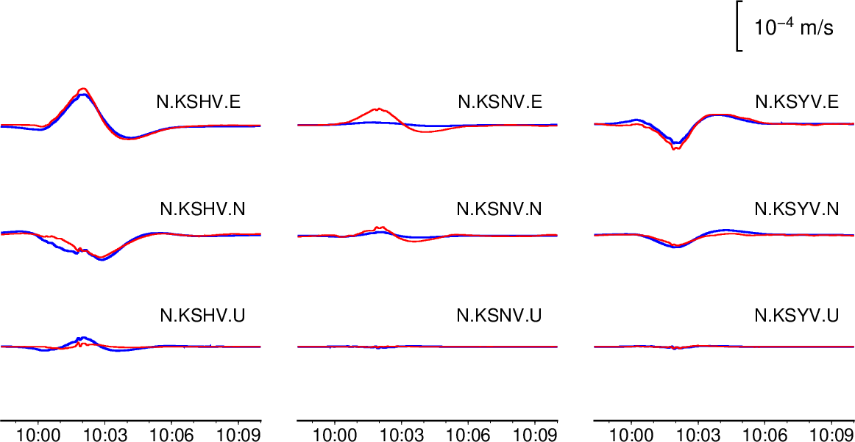
Fig. A1. Fitting between the observed (red) and synthetic (blue) waveforms for candidate (a).

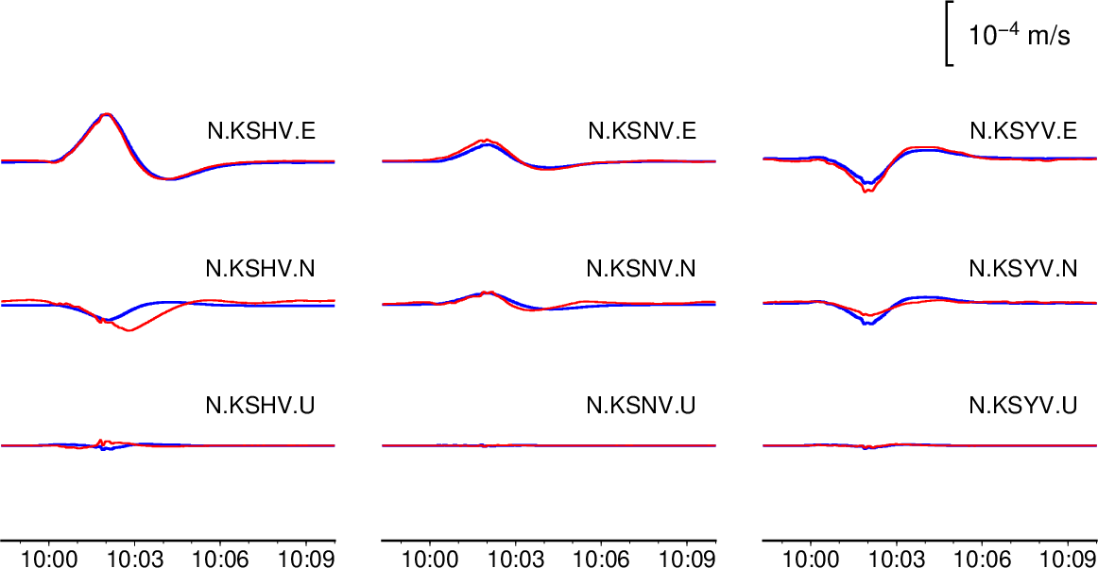
Fig. A2. Fitting between the observed (red) and synthetic (blue) waveforms for candidate (b).

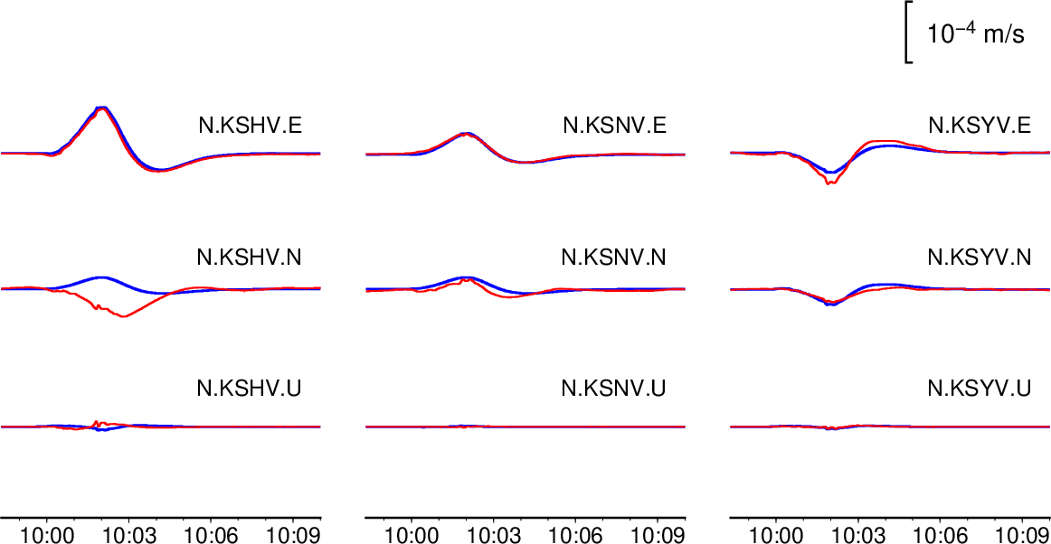
Fig. A3. Fitting between the observed (red) and synthetic (blue) waveforms for candidate (c).

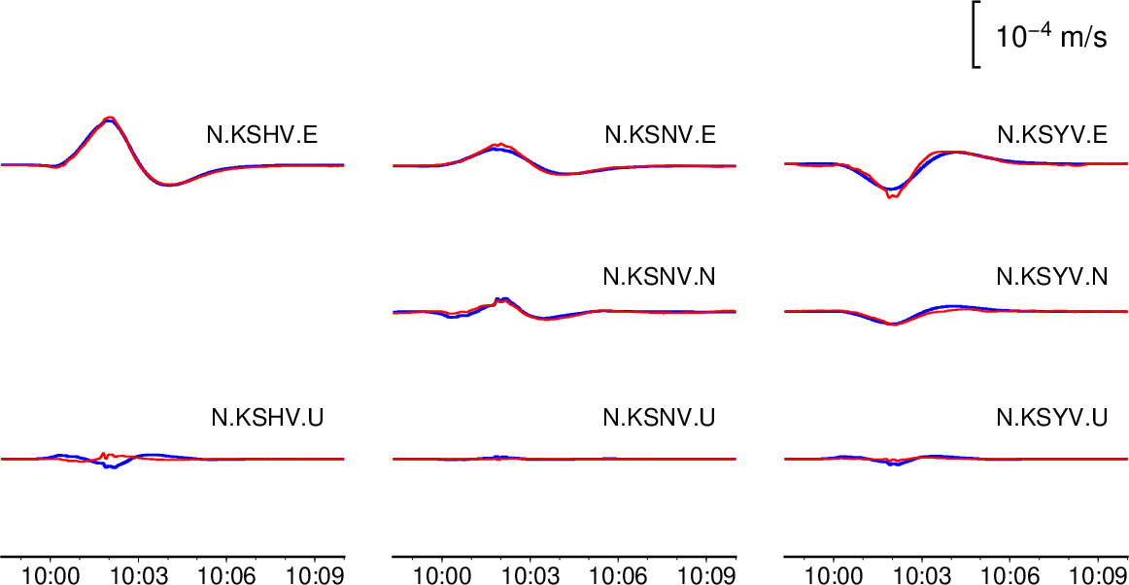
Fig. A4. Fitting between the observed (red) and synthetic (blue) waveforms for candidate (d).

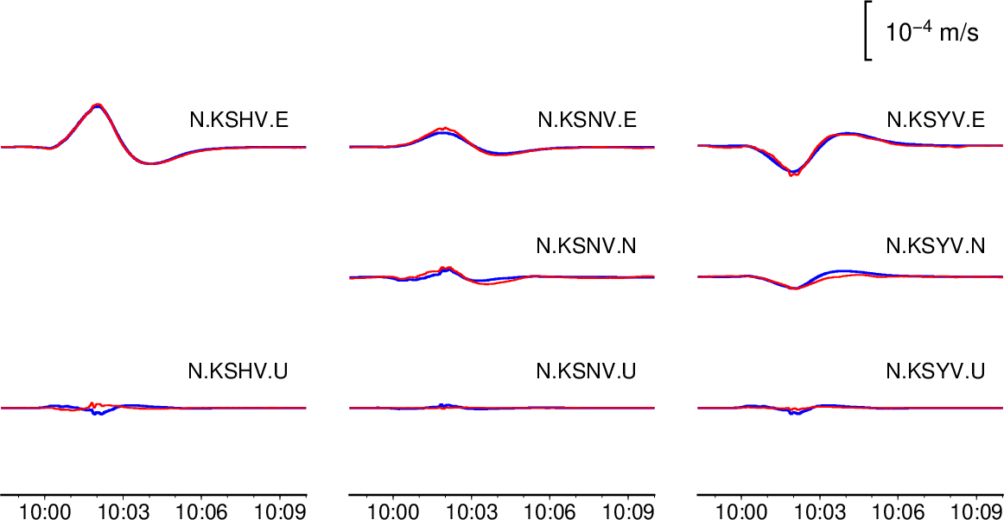
Fig. A5. Fitting between the observed (red) and synthetic (blue) waveforms for candidate (e).

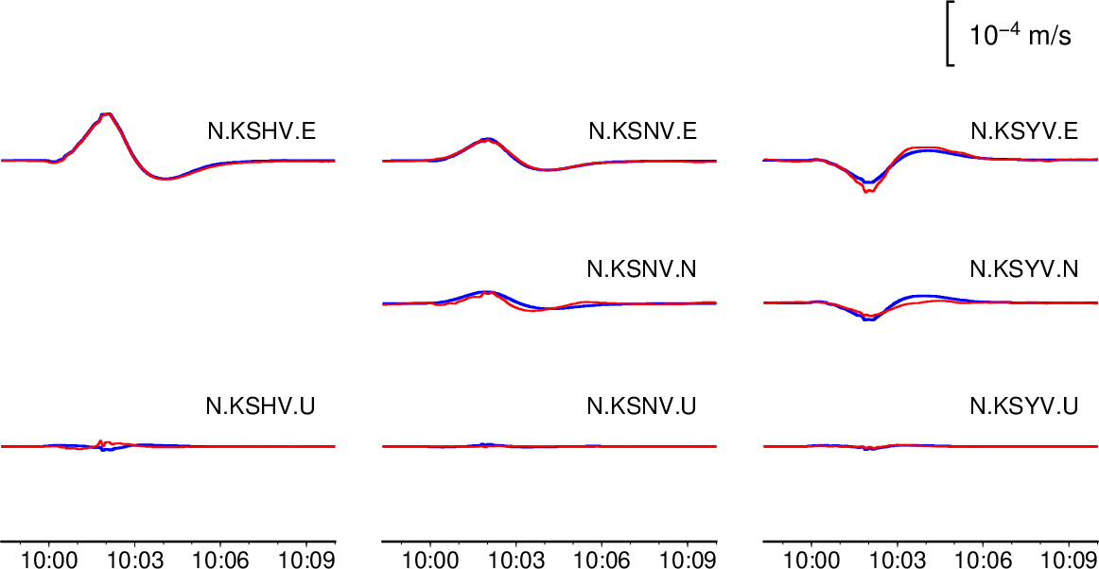
Fig. A6. Fitting between the observed (red) and synthetic (blue) waveforms for candidate (f).

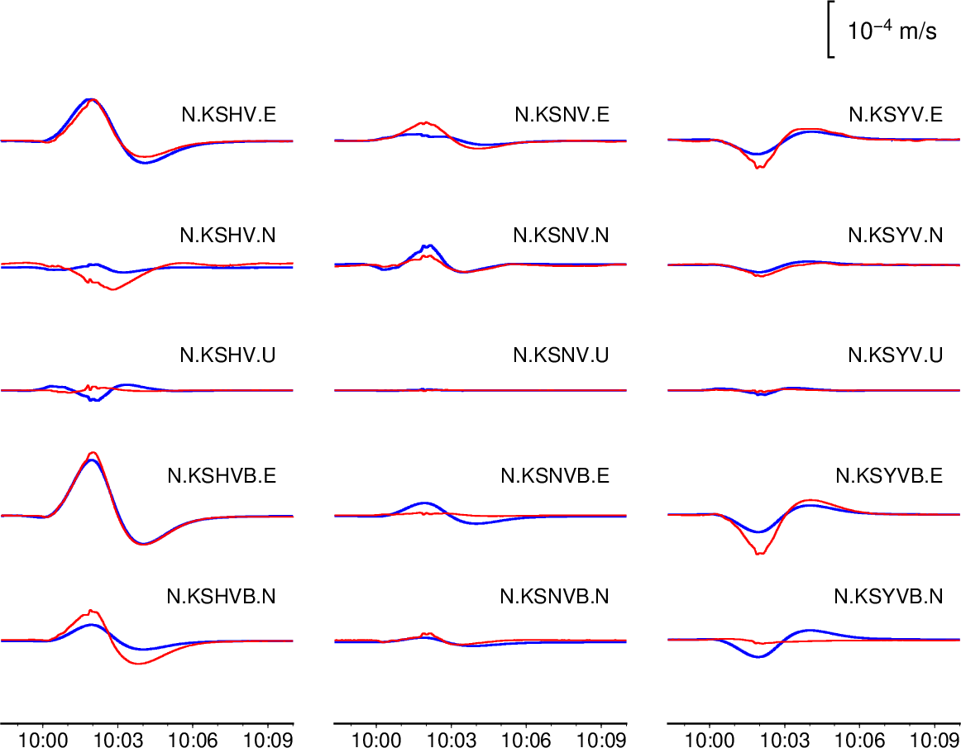
Fig. A7. Fitting between the observed (red) and synthetic (blue) waveforms for candidate (g). The notation is the same as that in Fig. 16.

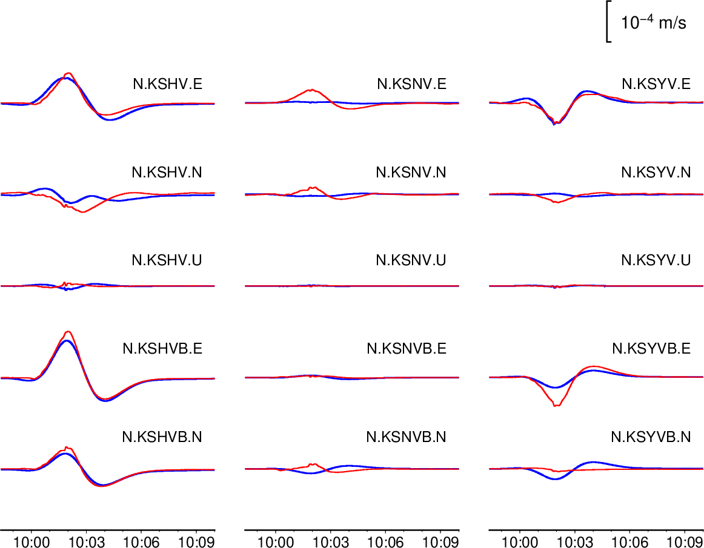
Fig. A8. Fitting between the observed (red) and synthetic (blue) waveforms for candidate (h). The notation is the same as that in Fig. 16.

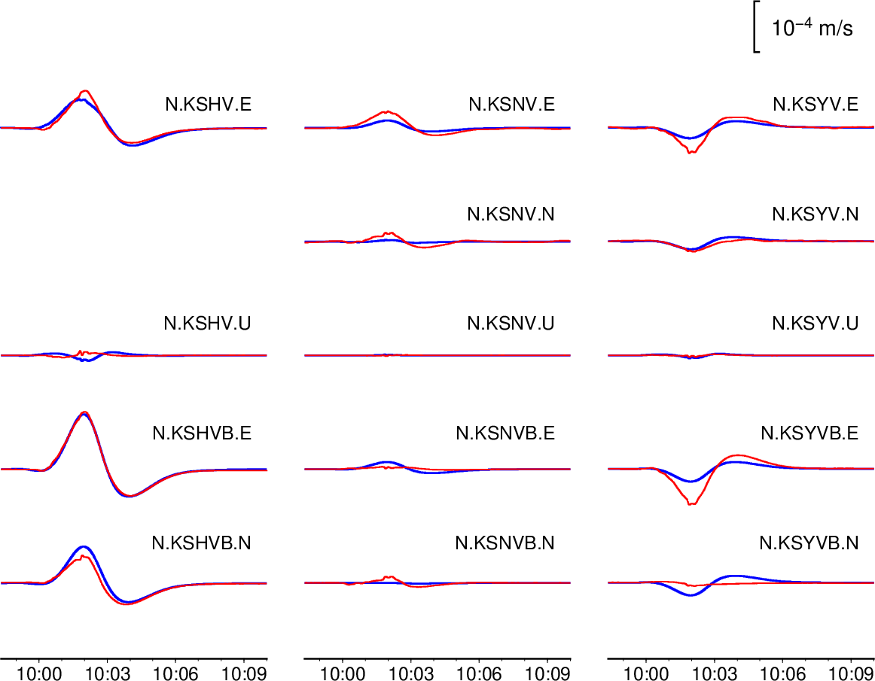
Fig. A9. Fitting between the observed (red) and synthetic (blue) waveforms for candidate (i). The notation is the same as that in Fig. 16.

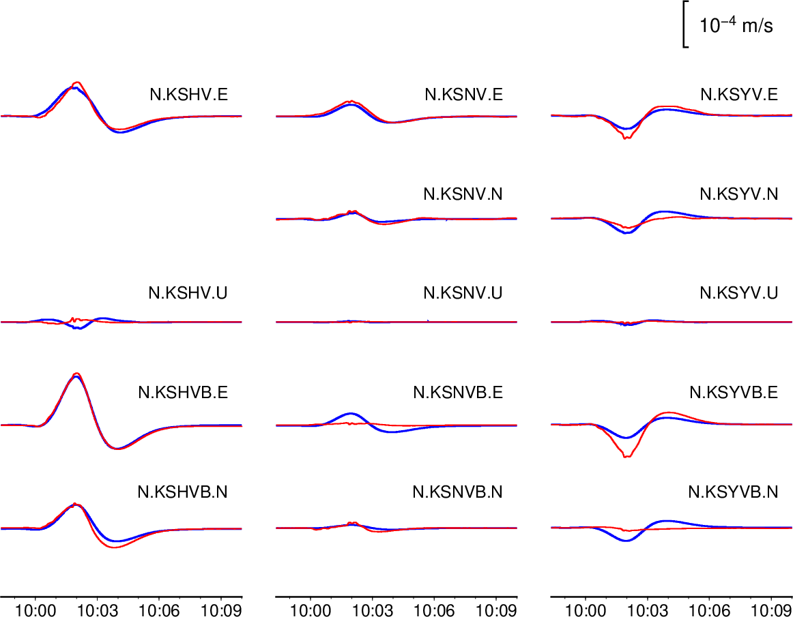
Fig. A10. Fitting between the observed (red) and synthetic (blue) waveforms for candidate (j). The notation is the same as that in Fig. 16.

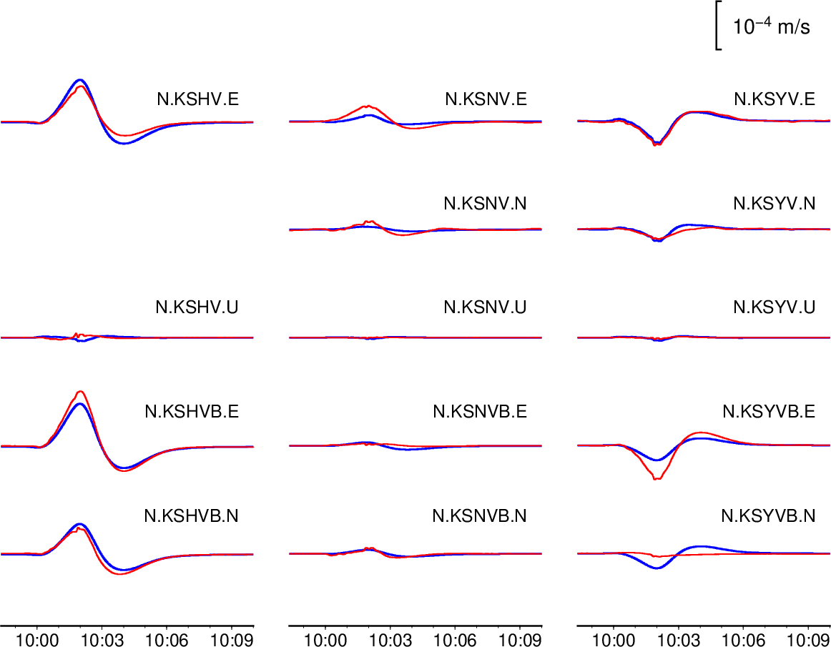
Fig. A11. Fitting between the observed (red) and synthetic (blue) waveforms for candidate (k). The notation is the same as that in Fig. 16.

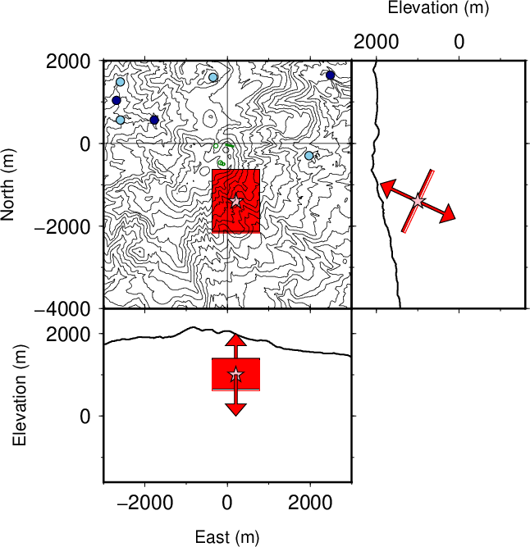

Fig. A12. Location and geometry of the tensile crack for candidate (e). The notation is the same as that in Fig. 12.

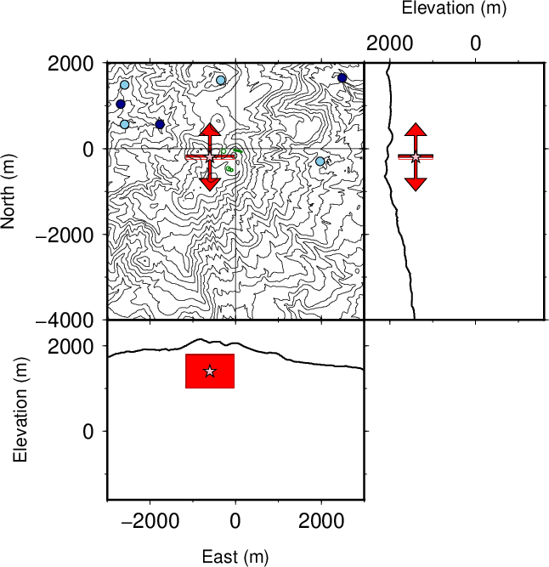
Fig. A13. Location and geometry of the tensile crack for candidate (d). The red arrows indicate the opening direction. The stars represent the centroid of candidate (d). The notation is the same as that in Fig. 12.

