Supplementary Material
Detection of ratHEV-specific IgG antibodies by dot blot assay.
Detection of ratHEV-specific IgG antibodies by dot blot assay.
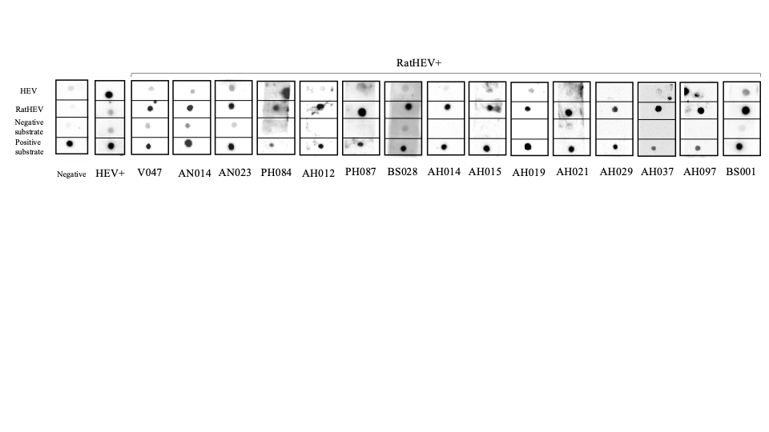
Figure S1. Detection of ratHEV-specific IgG antibodies by dot blot assay. Representative dot blot showing human serum reactivity against four immobilized antigens: hepatitis E virus (first spot), Rocahepevirus ratti (second spot), Puumala orthohantavirus (third spot, negative substrate), and Escherichia coli lysate (fourth spot, positive substrate control). Samples showing specific reactivity against the ratHEV antigen were considered seropositive.

