Appendix. The Language-Modelling Exposure Measure
The identifying variation in the between-field analysis is the differential AI exposure of academic fields, so the credibility of the exposure measure is central. We use the language-modelling variant of the AI Occupational Exposure index (Felten et al., 2023), which adapts to language models the framework of Felten et al. (2021). The methodology links documented applications of AI to the human abilities catalogued in the O*NET occupational database and aggregates ability-level exposure to the occupation level, indexed by Standard Occupational Classification code, and the language-modelling variant restricts the application set to language-model capability specifically, making it the appropriate construct for a study of generative-AI use on written and analytical assessment.
Each field is mapped to the occupation its terminal credential licenses, namely registered nurses (29-1141) and lawyers (23-1011), a one-to-one mapping that avoids aggregation ambiguity because each field exists to qualify graduates for a single, well-defined licensed occupation. The resulting scores place law at 1.454, near the top of the occupational distribution, and nursing at 0.272, near the bottom, consistent with the theoretical expectation of Section 2.3 that language-model exposure tracks the cognitive, language-based content of work and is low for occupations grounded in physical and interpersonal skill. Independent validation work reports strong rank agreement between this index family and separately constructed task-based exposure measures (Eloundou et al., 2024), indicating that the gradient reflects a real property of the work rather than an artifact of a single methodology. The measure’s principal limitation is that it is a field-level proxy for individual student behaviour, since it captures the potential for language-model substitution of the knowledge a credential certifies rather than observed AI use, which is unmeasured, and this is the central measurement caveat of the design.

Supplementary Figures
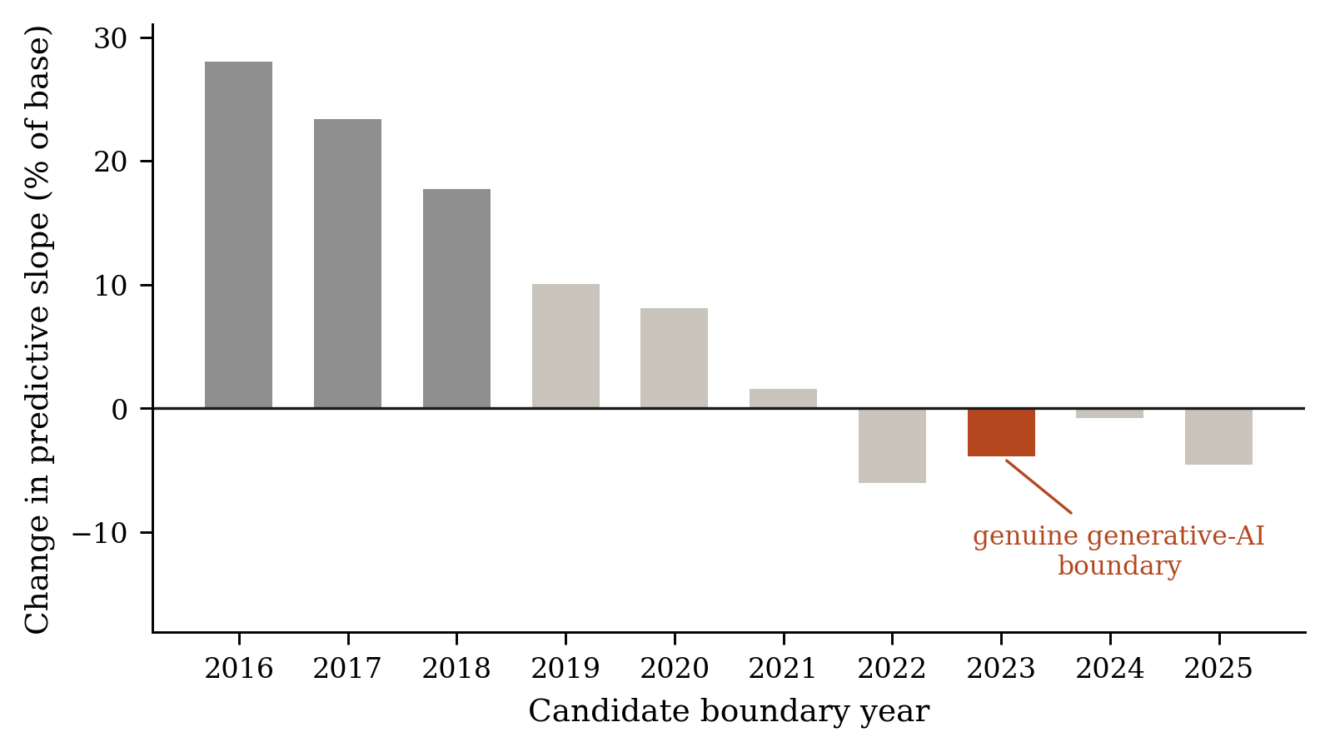
Figure S1. Change in the predictive slope, as a percentage of the base slope, re-estimated at every candidate boundary year from 2016 to 2025. Darker bars mark boundaries at which the change is statistically significant. The estimate at the genuine generative-AI boundary is highlighted and ranks eighth of ten in magnitude.
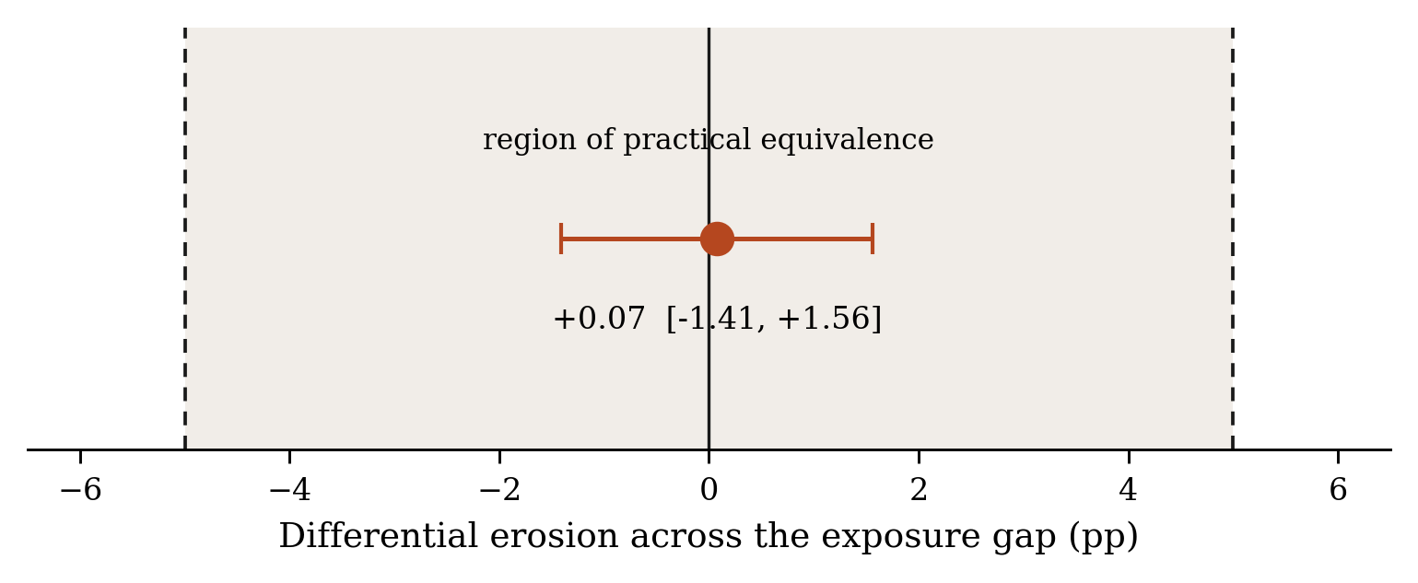
Figure S2. Equivalence test for the between-field contrast. The point estimate and its 95 per cent confidence interval lie entirely within the region of practical equivalence bounded at plus and minus five percentage points across the exposure gap.
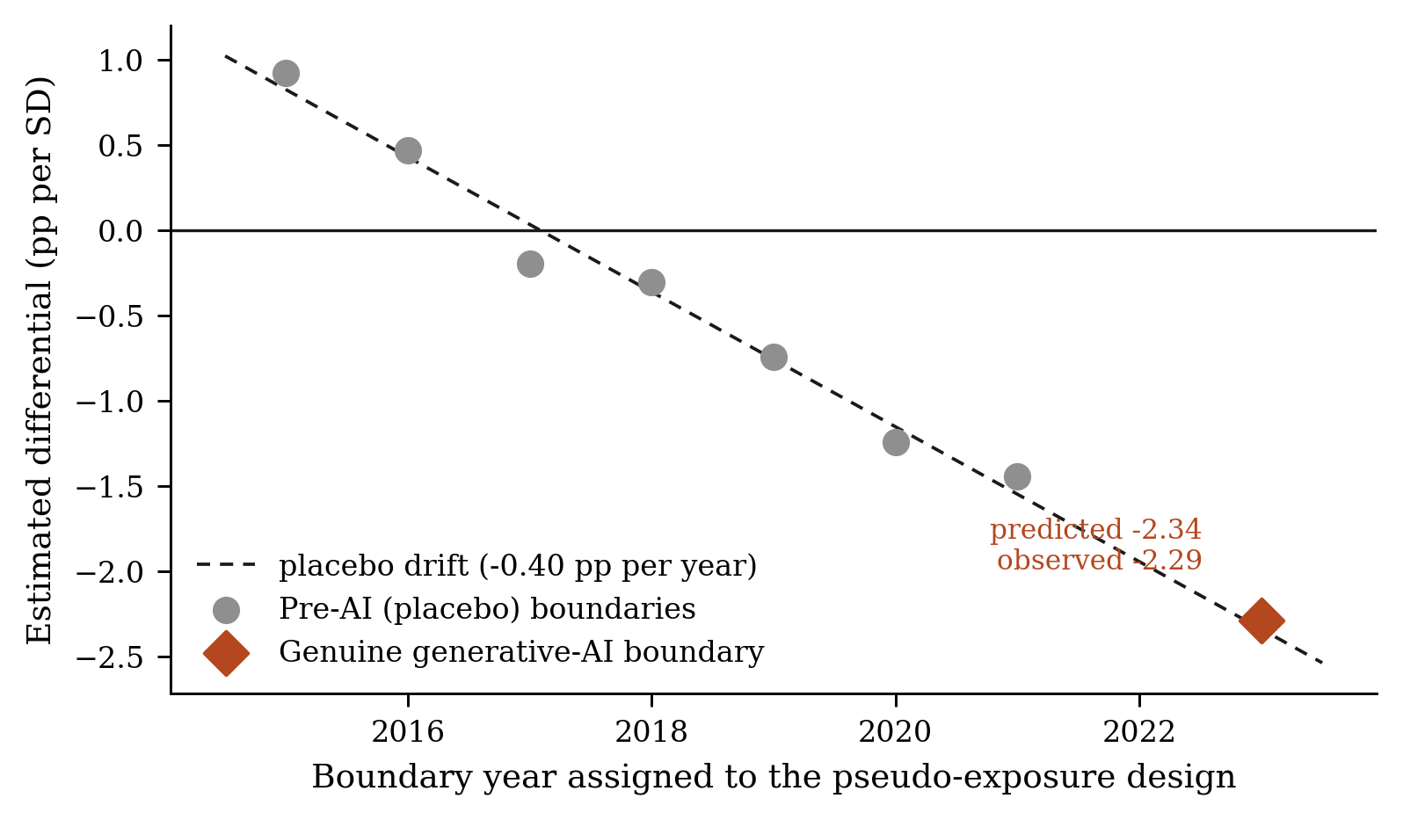
Figure S3. Placebo test within the long law panel. Grey points show estimates at pre-AI boundary years, where generative AI cannot by construction be responsible for any divergence, and the dashed line is the fitted drift produced by mean reversion in the pseudo-exposure measure. The estimate at the genuine generative-AI boundary departs from the extrapolated drift by 0.05 percentage points.
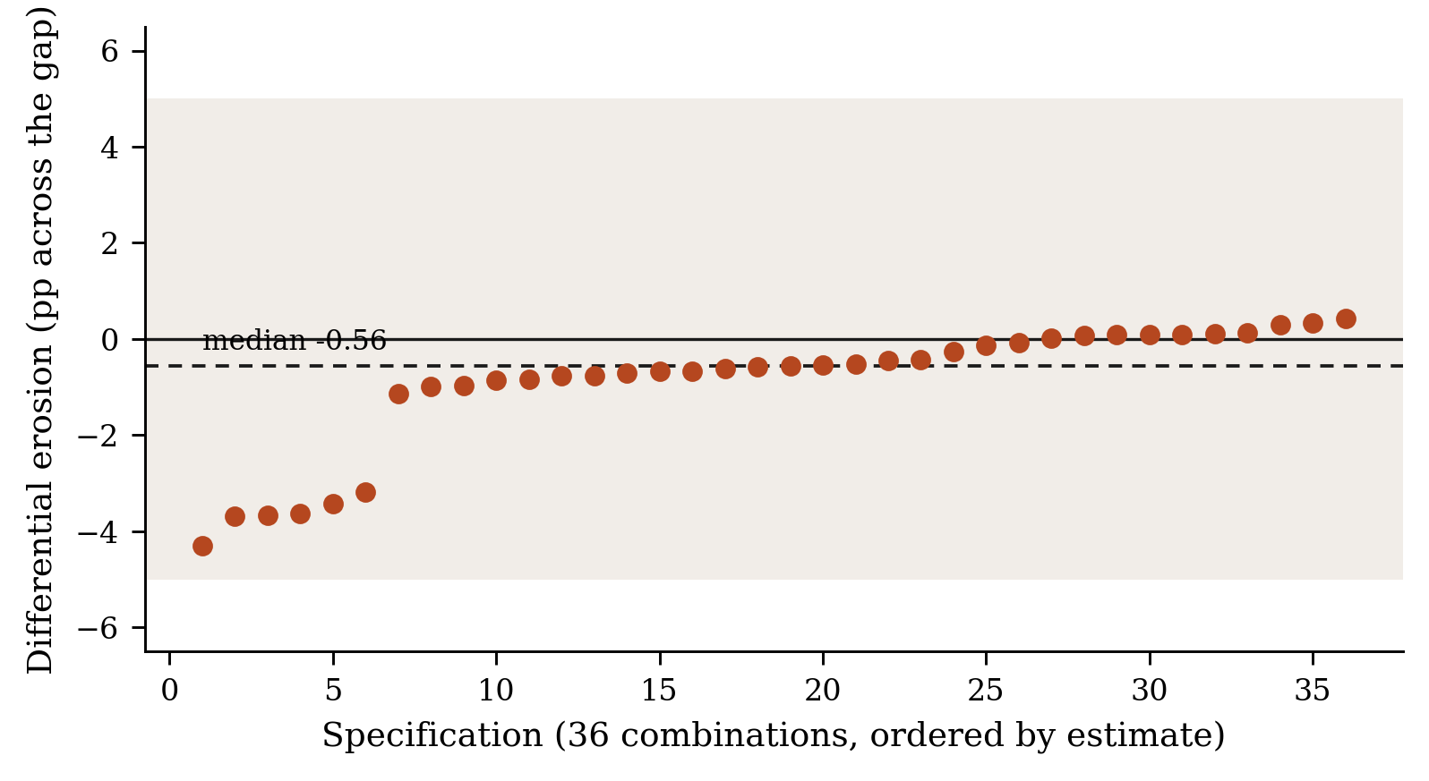
Figure S4. Specification curve showing the differential-erosion estimate across thirty-six combinations of boundary year, fixed-effects structure, cohort-size floor, and field-specific trends, ordered by magnitude. All thirty-six estimates lie within the region of practical equivalence and the median is -0.56 percentage points.

