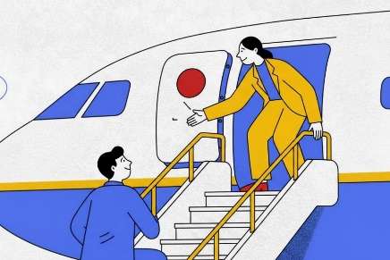
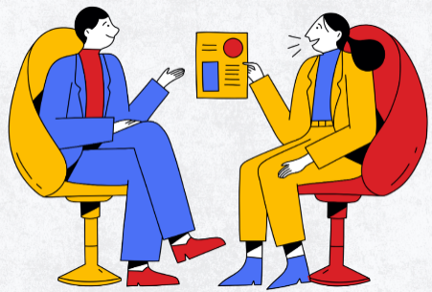

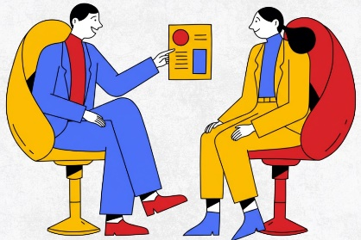
Figure 2. Pain point map, as presented during the brainstorming session. The longitudinal pain points below (“The doctor had too little time for me” and “The doctor had too little social skills” were added by the participants. The remaining pain points were inspired by the barriers as identified in our previous reviews.
“I did not know where to contribute as a patient.
(The doctor is the expert, isn’t he?)”
“”I did not know I had a choice.”
DECISION talk
PREFERENCE talk
OPTION talk
TEAM talk
“The doctor had too little social skills.”
“The doctor had too little time (for me).”
“I did not know why it was important that we decided together.”
“I did not understand the information of the doctor.”
“The doctor only explained me one option.”
“I could hear the preference of the doctor in his speaking.”
“The doctor did not take my opinion seriously.”
“The doctor did not ask me what is important to me.”
“The doctor did not seem to be interested in my life.”
“The doctor did ask what is important to me, yet did not take this into account (in the subsequent decision).”
“I did not receive enough opportunities to let my family be involved in the decision.”
“I did not receive enough time to reflect on my decision.”
“I was afraid of making a (wrong) decision.”
“Taking a decision? I didn’t believe I could.”
1
2
3
4
4

