Supplementary online material
Supplementary File A - STROBE statement
Supplementary File B - Theory of Change
Supplementary File C - Summary of statistical models
Supplementary File D - Costing details
Supplementary File E - Baseline characteristics for unmatched groups
Supplementary File F - Baseline characteristics for matched groups
Supplementary File G - Balance diagnostics
Supplementary File H - Sensitivity analysis

Supplementary File A - STROBE Statement
Checklist of items that should be included in reports of observational studies

 | Item No | Recommendation | Page  No
Title and abstract | 1 | (a) Indicate the study’s design with a commonly used term in the title or the abstract | 2
Title and abstract | 1 | (b) Provide in the abstract an informative and balanced summary of what was done and what was found | 2
Introduction
Background/rationale | 2 | Explain the scientific background and rationale for the investigation being reported | 3-5
Objectives | 3 | State specific objectives, including any prespecified hypotheses | 6
Methods
Study design | 4 | Present key elements of study design early in the paper | 6
Setting | 5 | Describe the setting, locations, and relevant dates, including periods of recruitment, exposure, follow-up, and data collection | 7-10
Participants | 6 | (a) Cohort study—Give the eligibility criteria, and the sources and methods of selection of participants. Describe methods of follow-up  Case-control study—Give the eligibility criteria, and the sources and methods of case ascertainment and control selection. Give the rationale for the choice of cases and controls  Cross-sectional study—Give the eligibility criteria, and the sources and methods of selection of participants | 7-10
Participants | 6 | (b) Cohort study—For matched studies, give matching criteria and number of exposed and unexposed  Case-control study—For matched studies, give matching criteria and the number of controls per case
Variables | 7 | Clearly define all outcomes, exposures, predictors, potential confounders, and effect modifiers. Give diagnostic criteria, if applicable | 11-12
Data sources/ measurement | 8* | For each variable of interest, give sources of data and details of methods of assessment (measurement). Describe comparability of assessment methods if there is more than one group | 11-12
Bias | 9 | Describe any efforts to address potential sources of bias | 11
Study size | 10 | Explain how the study size was arrived at | 15
Quantitative variables | 11 | Explain how quantitative variables were handled in the analyses. If applicable, describe which groupings were chosen and why | 11
Statistical methods | 12 | (a) Describe all statistical methods, including those used to control for confounding | 11
Statistical methods | 12 | (b) Describe any methods used to examine subgroups and interactions | NA
Statistical methods | 12 | (c) Explain how missing data were addressed | 13
Statistical methods | 12 | (d) Cohort study—If applicable, explain how loss to follow-up was addressed  Case-control study—If applicable, explain how matching of cases and controls was addressed  Cross-sectional study—If applicable, describe analytical methods taking account of sampling strategy | 13
Statistical methods | 12 | (e) Describe any sensitivity analyses | 13-14
Continued on next page
Results
Participants | 13* | (a) Report numbers of individuals at each stage of study—eg numbers potentially eligible, examined for eligibility, confirmed eligible, included in the study, completing follow-up, and analysed | 15
Participants | 13* | (b) Give reasons for non-participation at each stage | 15
Participants | 13* | (c) Consider use of a flow diagram | 15
Descriptive data | 14* | (a) Give characteristics of study participants (eg demographic, clinical, social) and information on exposures and potential confounders | Sup file E
Descriptive data | 14* | (b) Indicate number of participants with missing data for each variable of interest | 15, Sup file E
Descriptive data | 14* | (c) Cohort study—Summarise follow-up time (eg, average and total amount)
Outcome data | 15* | Cohort study—Report numbers of outcome events or summary measures over time | 15
Outcome data | 15* | Case-control study—Report numbers in each exposure category, or summary measures of exposure | 15
Outcome data | 15* | Cross-sectional study—Report numbers of outcome events or summary measures | NA
Main results | 16 | (a) Give unadjusted estimates and, if applicable, confounder-adjusted estimates and their precision (eg, 95% confidence interval). Make clear which confounders were adjusted for and why they were included | Table 1
Main results | 16 | (b) Report category boundaries when continuous variables were categorized | NA
Main results | 16 | (c) If relevant, consider translating estimates of relative risk into absolute risk for a meaningful time period | NA
Other analyses | 17 | Report other analyses done—eg analyses of subgroups and interactions, and sensitivity analyses | Sup file H
Discussion
Key results | 18 | Summarise key results with reference to study objectives | 19-22
Limitations | 19 | Discuss limitations of the study, taking into account sources of potential bias or imprecision. Discuss both direction and magnitude of any potential bias | 22-23
Interpretation | 20 | Give a cautious overall interpretation of results considering objectives, limitations, multiplicity of analyses, results from similar studies, and other relevant evidence | 19-23
Generalisability | 21 | Discuss the generalisability (external validity) of the study results | 23
Other information
Funding | 22 | Give the source of funding and the role of the funders for the present study and, if applicable, for the original study on which the present article is based | 25

*Give information separately for cases and controls in case-control studies and, if applicable, for exposed and unexposed groups in cohort and cross-sectional studies.

Supplementary File B - Theory of Change
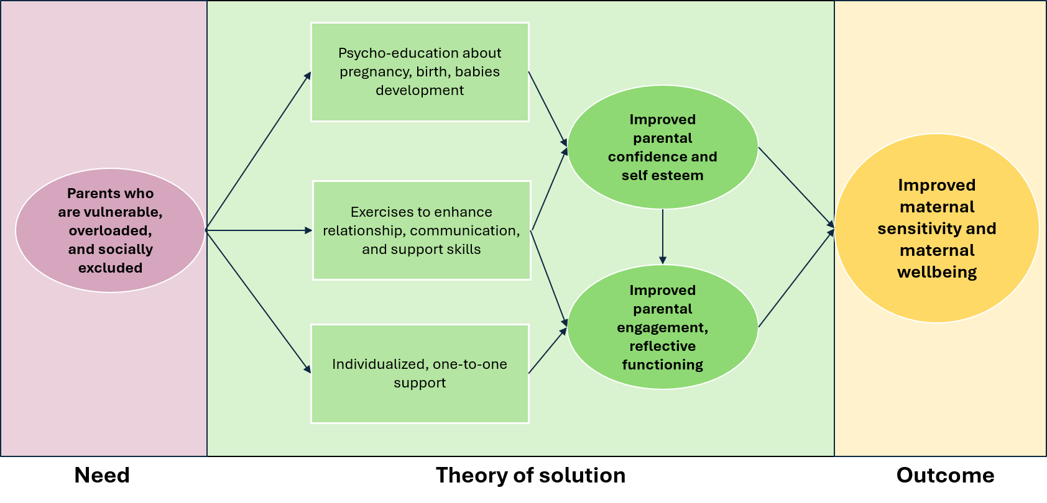
Figure B. Simplified Baby Steps Theory of Change as delivered by Action for Children in Better Start Bradford

Supplementary File C - Summary of statistical models
Model type | Outcome | Covariates | Primary analysis (complete data) | Sensitivity analysis (imputed data)
Linear models | Maternal child sensitivity (MORS warmth)* | BSB area, child age, and PAI scores at baseline | ✔ | ✔
Linear models | Maternal child sensitivity (MORS invasion)* | BSB area, child age, and PAI scores at baseline | ✔ | ✔
Linear models | Maternal depression (PHQ-8)* | BSB area, child age, and PHQ-8 scores at baseline | ✔ | ✔
Linear models | Maternal anxiety (GAD-7)* | BSB area, child age, and GAD-7 scores at baseline | ✔ | ✔
Logistic models | Maternal depression (PHQ-8) | BSB area, child age, and PHQ-8 scores at baseline | ✔ | ?
Logistic models | Maternal anxiety (GAD-7) | BSB area, child age, and GAD-7 scores at baseline | ✔ | ?
Logistic models | Delivery method  Categories coded as: 0=spontaneous vaginal delivery, 1=any other delivery | BSB area, child age | N/A as data complete.
Logistic models | - Gestation period  Categories coded as: 0=birth after 37 weeks gestation, 1=birth before 37 weeks gestation | BSB area, child age
Logistic models | - Baby birthweight  Categories coded as: 0=>2500 (healthy birthweight), 1 | BSB area, child age
Table C. Summary of all statistical models and sensitivity analyses
*=both ITT and per protocol analyses conducted on these outcomes

Supplementary File D - costing details
Table D. Unit costs applied to primary care (GP) contacts (2023/24 GBP)
Item | Unit cost (£)
Routine referral letter | £6.75
Nurse telephone appointment | £9.04
Nurse face-to-face contact | £14.20
Record/administrative note | £7.50
GP telephone consultation | £24.10
GP face-to-face consultation | £39.54
Fit note | £7.50
Did not attend (“DNA”) | £0.00

Notes: Unit costs were obtained from the Personal Social Services Research Unit (PSSRU), Unit Costs of Health and Social Care (2023/24) and applied according to consultation mode and staff type.
Figure D. Net difference in total NHS costs by service setting (GP, A&E, outpatient, inpatient): intervention vs matched control (12 weeks postpartum)
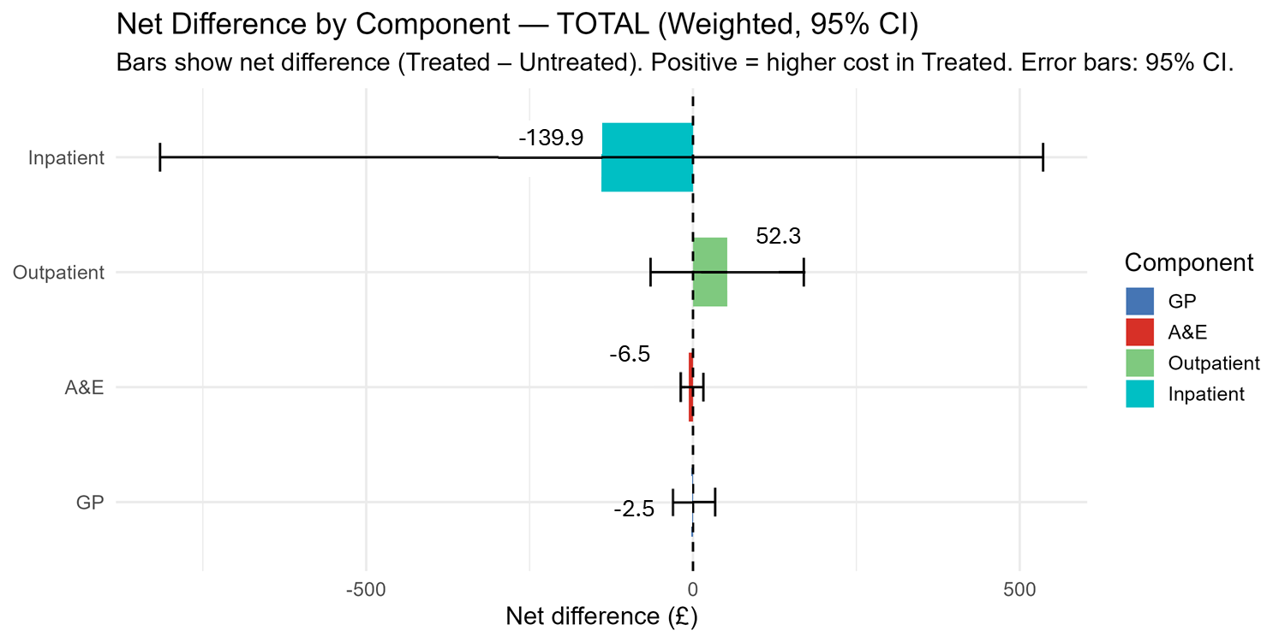

Supplementary File E - Baseline characteristics for unmatched groups

 | Non enrollees (n=430) | Enrollees (n=122) | Total (n=552)
Continuous variables | Mean (SD)
PHQ | 5.45 (4.73) | 5.56 (4.25) | 5.48 (4.62)
Missing N (%) |  |  | 16 (3)
GAD | 3.91 (4.22) | 4.53 (4.41) | 4.05 (4.26)
Missing N (%) |  |  | 19 (3)
PAI | 49.06 (9.81) | 50.22 (9.25) | 49.32 (9.69)
Missing N (%) |  |  | 117 (21)
Maternal age | 29.89 (5.51) | 29.66 (5.36) | 29.84 (5.47)
Missing N (%) |  |  | 1 (<1)
Categorical variables | N (%)
BSB area
Bowling and Barkerend | 133 (31) | 35 (29) | 168 (30)
Bradford Moor | 134 (31) | 51 (42) | 185 (34)
Little Horton | 160 (37) | 36 (30) | 196 (36)
Missing |  |  | 0 (0)
Ethnicity
Pakistani | 265 (62) | 59 (48) | 324 (59)
White British | 32 (7) | 6 (5) | 38 (7)
Other South Asian | 57 (13) | 28 (23) | 85 (15)
Other White/CEE | Redacted due to small cell counts
Black British/African/Caribbean | 40 (9) | 16 (13) | 56 (10)
Other | 18 (4) | 12 (10) | 30 (5)
Missing |  |  | 0 (0)
Country of birth
Not UK | 257 (60) | 90 (74) | 347 (63)
UK | 173 (40) | 32 (26) | 205 (37)
Missing |  |  | 0
First language
English | 247 (57) | 56 (46) | 303 (55)
Not English | 183 (43) | 66 (54) | 249 (45)
Missing |  |  | 0 (0)
English ability
Very well | 157 (37) | 41 (34) | 198 (36)
Quite well | 69 (16) | 33 (27) | 102 (18)
Some | 50 (12) | 12 (10) | 62 (11)
A little bit | 32 (7) | 15 (12) | 47 (9)
Not at all | 6 (1) | 0 (0) | 6(1)
Missing |  |  | 0 (0)
Financial security
Living comfortably | 106 (25) | 32 (26) | 138 (25)
Doing alright | 190 (44) | 47 (39) | 237 (43)
Just about getting by | 81 (19) | 25 (20) | 106 (19)
Finding it quite/very difficult | 37 (9) | 15 (12) | 52 (9)
Missing |  |  | 19 (3)
Parity
0 previous pregnancies | 38 (9) | 10 (8) | 48 (9)
1 previous | 91 (21) | 21 (17) | 112 (20)
2 or more previous | 118 (27) | 23 (18) | 141(26)
Missing |  |  | 251 (45)
Previous projects
None | 395 (92) | 95 (78) | 490 (89)
1 or more | 35 (8) | 27 (22) | 62 (11)
 |  |  | 0 (0)
Table E. Baseline characteristics for unmatched groups

Supplementary File F - baseline descriptives for matched groups
 | Control group (n=215) | Baby Steps group (n=120) | Standardized difference
Continuous variables | Mean (SD)
PHQ | 5.69 (5.11) | 5.517 (4.25) | 0.038
GAD | 4.45 (4.71) | 4.41 (4.41) | 0.008
Prenatal Attachment In | 49.6 (9.58) | 50.23 (9.56) | -0.065
Maternal age | 29.15 (5.60) | 29.52 (5.27) | -0.068
Categorical variables | N (%)
Bradford area of residence
Bowling and Barkerend | 62 (28.8) | 35 (29.2) | 0.078
Bradford Moor | 83 (38.6) | 50 (41.7)
Little Horton | 70 (32.6) | 35 (29.2)
Ethnicity
Pakistani | 113 (52.6) | 49 (42.2) | 0.220
White British | 17 (7.9) | 6 (5.0)
Other South Asian | 38 (17.7) | 28 (23.3)
Other White/Central Eastern European | Redacted due to small cell counts
Black British/African/ Caribbean | 27 (12.6) | 16 (13.3)
Other | 15 (7.0) | 10 (8.3)
First language
English | 118 (54.9) | 56 (46.7) | 0.164
Not English | 97 (45.1) | 64 (53.3)
Financial security
Living comfortably | 58 (27.0) | 32 (26.7) | 0.054
Doing alright | 85 (39.5) | 47 (39.2)
Just about getting by | 47 (21.9) | 25 (20.8)
Finding it quite/very difficult | 25 (11.6) | 16 (13.3)
Parity
0 previous pregnancies | 76 (35.3) | 42 (35.0)
1 previous | 76 (35.3) | 45 (37.5)
2 or more previous | 63 (29.3) | 33 (27.5)
Previous antenatal intervention participation
None | 186 (86.5) | 95 (79.2) | 0.196
1 or more | 29 (13.5) | 25 (20.8)
Table F. Baseline descriptives for propensity score matched control and treatment groups

Supplementary File G - Balance Diagnostics

Balance diagnostics are presented for the 12th multiply imputed dataset, and were broadly consistent across other datasets.
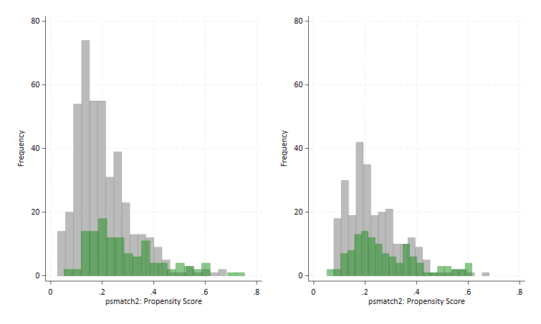
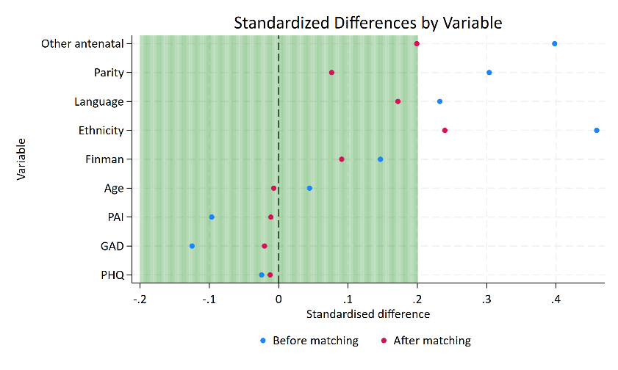
Figure G1. Propensity scores before and after matching

Figure G2. Standardised differences in matching variables before and after matching
Note: other antenatal = other interventions enrolled in, finman=financial security, PAI=Prenatal Attachment Inventory, GAD=Generalised Anxiety Disorder assessment, PHQ=Patient Health Questionnaire.

Table G. Means, %bias, t-test for equality of means, and variance ratios for all matching variables
Variable | Unmatched / Matched | Mean |  | %bias | %reduct  |bias| | t-test |  | V(T) /  V(C)
Variable | Unmatched / Matched | Treated | Control | %bias | %reduct  |bias| | t | p > |t| | V(T) /  V(C)
Ethnic group
Other | U | 0.09836 | 0.04215 | 22.1 |  | 2.42 | 0.016 | .
 | M | 0.08333 | 0.08889 | -2.2 | 90.1 | -0.15 | 0.879 | .
Other South Asian | U | 0.22951 | 0.13349 | 25.0 |  | 2.60 | 0.010 | .
 | M | 0.23333 | 0.20208 | 8.1 | 67.5 | 0.58 | 0.559 | .
Other White/CEE | U | 0.00820 | 0.04215 | -21.8 |  | -1.81 | 0.071 | .
 | M | 0.00833 | 0.01250 | -2.7 | 87.7 | -0.32 | 0.752 | .
Pakistani | U | 0.48361 | 0.61358 | -26.3 |  | -2.58 | 0.010 | .
 | M | 0.49167 | 0.51875 | -5.5 | 79.2 | -0.42 | 0.676 | .
White British | U | 0.04918 | 0.07494 | -10.7 |  | -0.99 | 0.324 | .
 | M | 0.05000 | 0.05000 | 0.0 | 100.0 | -0.00 | 1.000 | .
PHQ | U | 5.48360 | 5.42620 | 1.3 |  | 0.12 | 0.904 | 0.80
 | M | 5.51670 | 5.32640 | 4.2 | -231.6 | 0.32 | 0.748 | 0.75
GAD | U | 4.38520 | 3.79160 | 13.9 |  | 1.37 | 0.171 | 1.10
 | M | 4.40830 | 4.35210 | 1.3 | 90.5 | 0.10 | 0.924 | 0.87
Financial security | U | 1.21310 | 1.11940 | 10.0 |  | 1.00 | 0.318 | 1.21
 | M | 1.20830 | 1.17710 | 3.3 | 66.6 | 0.24 | 0.808 | 0.96
First language | U | 0.54098 | 0.42389 | 23.5 |  | 2.30 | 0.022 | .
 | M | 0.53333 | 0.54167 | -1.7 | 92.9 | -0.13 | 0.898 | .
PAI | U | 50.05700 | 49.32600 | 7.5 |  | 0.72 | 0.470 | 0.93
 | M | 50.22500 | 50.37100 | -1.5 | 80.1 | -0.12 | 0.906 | 1.02
Maternal age | U | 29.65600 | 29.89000 | -4.3 |  | -0.42 | 0.677 | 0.94
 | M | 29.52500 | 29.11800 | 7.5 | -73.8 | 0.59 | 0.555 | 0.96
Parity | U | 0.94262 | 1.14990 | -25.8 |  | -2.51 | 0.012 | 0.97
 | M | 0.92500 | 0.87222 | 6.6 | 74.5 | 0.52 | 0.602 | 1.03
Antenatal interventions | U | 0.22131 | 0.08197 | 39.5 |  | 4.35 | 0.000 | .
 | M | 0.20833 | 0.19236 | 4.5 | 88.5 | 0.31 | 0.758 | .
Area | U | 4.18850 | 4.56210 | -14.3 |  | -1.37 | 0.171 | 0.87
 | M | 4.16670 | 4.31460 | -5.7 | 60.4 | -0.46 | 0.649 | 0.98
Note: *T-test for equality of means: desirable outcome is insignificant test in the matched sample which is on the second rows.
*Standardised % bias: the % difference of the sample means in the treated and non-treated (full or matched) sub-samples as a percentage of the square root of the average of the sample variances in the treated and non-treated groups (formulae from Rosenbaum and Rubin, 1985).
*V(T)/V(C): the variance ratio of treated over non-treated. This ratio should equal 1 if there is perfect balance. An asterisk is displayed for variables that have variance ratios that exceed the 2.5th and 97.5th percentiles.

Supplementary File H - Sensitivity analysis
Table H1. Linear regression and binary logistic regression for all outcomes, including only enrollees who completed Baby Steps (per protocol analyses).
Continuous outcomes
Outcome [measure] | B [95% CI] | p
Maternal warmth [MORS-SF]*, ** | 0.50 [-1.12 to 2.13] | 0.541
Maternal invasion [MORS-SF]* | 0.80 [-0.64 to 2.26] | 0.273
Depression [PHQ-8]* | -0.71 [-1.65 to 0.23] | 0.139
Anxiety [GAD-7]* | -0.73 [1.64 to 0.17] | 0.111
Binary outcomes
Outcome [reference level] | Odds ratio [95% CI] | p
Depression categorized [reference=no depression]* | 0.51 [0.23 to 1.16] | 0.111
Anxiety categorized [reference=severe depression]* | 0.51 [0.22 to 1.20] | 0.126
Gestation [reference=after 37 weeks] | 0.46 [0.11 to 1.99] | 0.301
Birth type [reference=vaginal delivery] | 2.31 [1.41 to 3.79] | 0.001
Birth weight [reference=healthy birthweight] | 0.47 [0.14 to 1.55] | 0.214
*=models adjusted for child age in days at time of outcome, and baseline measure of the relevant outcome. Other models did not adjust for child age as period was not relevant, and no baseline measure of these outcomes existed e.g. of birthweight. **=a lower score/category is considered more desirable for all outcomes, except for maternal warmth (MORS-SF).

Table H2. Linear regression and binary logistic regression for maternal sensitivity and mental health outcomes, imputed outcome data sensitivity analysis.
Continuous outcomes
Outcome [measure] | B [95% CI] | p
Maternal warmth [MORS-SF]*, ** | 0.63 [-0.59 to 1.84] | 0.311
Maternal invasion [MORS-SF]* | 0.35 [-0.76 to 1.46] | 0.533
Depression [PHQ-8]* | -0.64 [-1.38 to 0.09] | 0.087
Anxiety [GAD-7]* | -0.42 [-1.14 to 0.29] | 0.242
*=models adjusted for child age in days at time of outcome, and baseline measure of the relevant outcome. **=a lower score/category is considered more desirable for all outcomes, except for maternal warmth (MORS-SF).

