Supplementary material
Habitat heterogeneity drives the community assembly of endemic shrimp in Lake Poso, Sulawesi, with implications for lake conservation

Diky Dwiyanto, Mihwan Sataral, Kurniawan P. Bandjolu, Daisy Wowor, Annawaty Annawaty, Achmad Farajallah, Dyah Perwitasari, Thomas von Rintelen, Kristina von Rintelen

Table S1 List of localities surveyed to record the occurence of Caridina (presence-absence), classification of species sampled in relation to chelae-type and environmental variables used in hmsc analysis.

Site | Site code | Species | Trait¹ | Habitat² | Temp. | pH | DO | Cond. | Value
Batu_Dua_Leboni | S1 | C_caerulea | generalist | rocks | 30 | 8,5 | 7,2 | 119 | 1
Dermaga_in_front_of_Dodoha | S2 | C_caerulea | generalist | submerged_roots | 29,3 | 8,3 | 7,3 | 120 | 0
Sulawesi_Rock | S3 | C_caerulea | generalist | submerged_roots | 29,9 | 8,3 | 6,9 | 118 | 0
Meko | S4 | C_caerulea | generalist | sand | 29 | 8,2 | 7,3 | 123 | 0
Tolambo1 | S5 | C_caerulea | generalist | peebles | 29,2 | 7,1 | 7,2 | 120 | 0
Tolambo2 | S6 | C_caerulea | generalist | sand | 29 | 8,4 | 6,8 | 118 | 1
Tokilo | S7 | C_caerulea | generalist | sand | 28,7 | 8,6 | 7,5 | 115 | 0
Dolidi_Ndano_Cottage1 | S8 | C_caerulea | generalist | shell_of_snails | 28,9 | 8,2 | 6,4 | 120 | 0
Dolidi_Ndano_Cottage2 | S9 | C_caerulea | generalist | wood | 29,3 | 7,63 | 8 | 114 | 1
Dulumai_near_village1 | S10 | C_caerulea | generalist | peebles | 30,4 | 8,6 | 7,1 | 116 | 0
Dulumai_near_village2 | S11 | C_caerulea | generalist | peebles | 27,7 | 8,1 | 7,7 | 142 | 0
Dolok | S12 | C_caerulea | generalist | submerged_roots | 28,2 | 8,4 | 6,6 | 128 | 0
Peura | S13 | C_caerulea | generalist | macrophytes | 29,6 | 8,4 | 6,8 | 122 | 0
Unnamed_place_near_Peura | S14 | C_caerulea | generalist | rocks | 28,9 | 8,3 | 7,9 | 122 | 0
Pantai_Saluopa_Indah | S15 | C_caerulea | generalist | macrophytes | 26,6 | 8,6 | 7,3 | 142 | 0
Pantai_Omboa_near_Taipa | S16 | C_caerulea | generalist | macrophytes | 26,4 | 7,5 | 7 | 146 | 0
Dumalanga_1 | S17 | C_caerulea | generalist | rocks | 29,3 | 8,4 | 6,9 | 125 | 1
Bancea1 | S18 | C_caerulea | generalist | rocks | 29,2 | 8 | 7,2 | 118 | 1
Bancea2 | S19 | C_caerulea | generalist | rocks | 29,2 | 8 | 7,2 | 118 | 1
Boe_near_Pendolo | S20 | C_caerulea | generalist | peebles | 28,8 | 7,8 | 7,15 | 93 | 0
Watu_Mpangasa | S21 | C_caerulea | generalist | peebles | 28,7 | 8,2 | 7,8 | 122 | 0
Small_cape_near_Watu_Mpangasa | S22 | C_caerulea | generalist | sand | 28,7 | 8,2 | 7,8 | 122 | 0
Beach_near_Torau_Resort | S23 | C_caerulea | generalist | rocks | 26 | 8,6 | 7,8 | 144 | 0
Pantai_near_Siuri | S24 | C_caerulea | generalist | rocks | 29 | 8 | 7,2 | 143 | 1
Beach_between_Dolidi_and_Peura | S25 | C_caerulea | generalist | macrophytes | 27,1 | 7,9 | 6,4 | 125 | 0
Inlet_mouth_near_Pantai_Saluopa_Indah | S26 | C_caerulea | generalist | macrophytes | 26,6 | 8,6 | 7,3 | 142 | 0
Dumalanga_2 | S27 | C_caerulea | generalist | wood | 29,2 | 8,1 | 6,9 | 123 | 1
Watu_Mpangasa_2_near_Dermaga | S28 | C_caerulea | generalist | macrophytes | 28,1 | 7,9 | 7,4 | 120 | 0
Pendolo | S29 | C_caerulea | generalist | wood | 29,1 | 7,8 | 7 | 115 | 1
Salukaia | S30 | C_caerulea | generalist | sand | 28,9 | 7,8 | 7,2 | 132 | 0
Tolambo3 | S31 | C_caerulea | generalist | sand | 27,6 | 8,2 | 7,4 | 116 | 1
Tindoli | S32 | C_caerulea | generalist | sand | 28,2 | 7,5 | 7,12 | 121 | 0
Batu_Dua_Leboni | S1 | C_ensifera | generalist | rocks | 30 | 8,5 | 7,2 | 119 | 0
Dermaga_in_front_of_Dodoha | S2 | C_ensifera | generalist | submerged_roots | 29,3 | 8,3 | 7,3 | 120 | 0
Sulawesi_Rock | S3 | C_ensifera | generalist | submerged_roots | 29,9 | 8,3 | 6,9 | 118 | 0
Meko | S4 | C_ensifera | generalist | sand | 29 | 8,2 | 7,3 | 123 | 0
Tolambo1 | S5 | C_ensifera | generalist | peebles | 29,2 | 7,1 | 7,2 | 120 | 1
Tolambo2 | S6 | C_ensifera | generalist | sand | 29 | 8,4 | 6,8 | 118 | 0
Tokilo | S7 | C_ensifera | generalist | sand | 28,7 | 8,6 | 7,5 | 115 | 0
Dolidi_Ndano_Cottage1 | S8 | C_ensifera | generalist | shell_of_snails | 28,9 | 8,2 | 6,4 | 120 | 0
Dolidi_Ndano_Cottage2 | S9 | C_ensifera | generalist | wood | 29,3 | 7,63 | 8 | 114 | 1
Dulumai_near_village1 | S10 | C_ensifera | generalist | peebles | 30,4 | 8,6 | 7,1 | 116 | 1
Dulumai_near_village2 | S11 | C_ensifera | generalist | peebles | 27,7 | 8,1 | 7,7 | 142 | 1
Dolok | S12 | C_ensifera | generalist | submerged_roots | 28,2 | 8,4 | 6,6 | 128 | 0
Peura | S13 | C_ensifera | generalist | macrophytes | 29,6 | 8,4 | 6,8 | 122 | 1
Unnamed_place_near_Peura | S14 | C_ensifera | generalist | rocks | 28,9 | 8,3 | 7,9 | 122 | 0
Pantai_Saluopa_Indah | S15 | C_ensifera | generalist | macrophytes | 26,6 | 8,6 | 7,3 | 142 | 1
Pantai_Omboa_near_Taipa | S16 | C_ensifera | generalist | macrophytes | 26,4 | 7,5 | 7 | 146 | 1
Dumalanga_1 | S17 | C_ensifera | generalist | sand | 29,3 | 8,4 | 6,9 | 125 | 1
Bancea1 | S18 | C_ensifera | generalist | sand | 29,2 | 8 | 7,2 | 118 | 1
Bancea2 | S19 | C_ensifera | generalist | rocks | 29,2 | 8 | 7,2 | 118 | 1
Boe_near_Pendolo | S20 | C_ensifera | generalist | peebles | 28,8 | 7,8 | 7,15 | 93 | 0
Watu_Mpangasa | S21 | C_ensifera | generalist | peebles | 28,7 | 8,2 | 7,8 | 122 | 1
Small_cape_near_Watu_Mpangasa | S22 | C_ensifera | generalist | sand | 28,7 | 8,2 | 7,8 | 122 | 0
Beach_near_Torau_Resort | S23 | C_ensifera | generalist | rocks | 26 | 8,6 | 7,8 | 144 | 1
Pantai_near_Siuri | S24 | C_ensifera | generalist | rocks | 29 | 8 | 7,2 | 143 | 1
Beach_between_Dolidi_and_Peura | S25 | C_ensifera | generalist | macrophytes | 27,1 | 7,9 | 6,4 | 125 | 0
Inlet_mouth_near_Pantai_Saluopa_Indah | S26 | C_ensifera | generalist | macrophytes | 26,6 | 8,6 | 7,3 | 142 | 1
Dumalanga_2 | S27 | C_ensifera | generalist | sand | 29,2 | 8,1 | 6,9 | 123 | 1
Watu_Mpangasa_2_near_Dermaga | S28 | C_ensifera | generalist | macrophytes | 28,1 | 7,9 | 7,4 | 120 | 0
Pendolo | S29 | C_ensifera | generalist | sand | 29,1 | 7,8 | 7 | 115 | 1
Salukaia | S30 | C_ensifera | generalist | sand | 28,9 | 7,8 | 7,2 | 132 | 1
Tolambo3 | S31 | C_ensifera | generalist | sand | 27,6 | 8,2 | 7,4 | 116 | 1
Tindoli | S32 | C_ensifera | generalist | sand | 28,2 | 7,5 | 7,12 | 121 | 1
Batu_Dua_Leboni | S1 | C_fusca | specialist | rocks | 30 | 8,5 | 7,2 | 119 | 0
Dermaga_in_front_of_Dodoha | S2 | C_fusca | specialist | rocks | 29,3 | 8,3 | 7,3 | 120 | 1
Sulawesi_Rock | S3 | C_fusca | specialist | submerged_roots | 29,9 | 8,3 | 6,9 | 118 | 0
Meko | S4 | C_fusca | specialist | sand | 29 | 8,2 | 7,3 | 123 | 0
Tolambo1 | S5 | C_fusca | specialist | peebles | 29,2 | 7,1 | 7,2 | 120 | 0
Tolambo2 | S6 | C_fusca | specialist | sand | 29 | 8,4 | 6,8 | 118 | 0
Tokilo | S7 | C_fusca | specialist | sand | 28,7 | 8,6 | 7,5 | 115 | 0
Dolidi_Ndano_Cottage1 | S8 | C_fusca | specialist | shell_of_snails | 28,9 | 8,2 | 6,4 | 120 | 0
Dolidi_Ndano_Cottage2 | S9 | C_fusca | specialist | wood | 29,3 | 7,63 | 8 | 114 | 0
Dulumai_near_village1 | S10 | C_fusca | specialist | peebles | 30,4 | 8,6 | 7,1 | 116 | 0
Dulumai_near_village2 | S11 | C_fusca | specialist | peebles | 27,7 | 8,1 | 7,7 | 142 | 1
Dolok | S12 | C_fusca | specialist | submerged_roots | 28,2 | 8,4 | 6,6 | 128 | 1
Peura | S13 | C_fusca | specialist | macrophytes | 29,6 | 8,4 | 6,8 | 122 | 0
Unnamed_place_near_Peura | S14 | C_fusca | specialist | rocks | 28,9 | 8,3 | 7,9 | 122 | 0
Pantai_Saluopa_Indah | S15 | C_fusca | specialist | macrophytes | 26,6 | 8,6 | 7,3 | 142 | 0
Pantai_Omboa_near_Taipa | S16 | C_fusca | specialist | macrophytes | 26,4 | 7,5 | 7 | 146 | 0
Dumalanga_1 | S17 | C_fusca | specialist | rocks | 29,3 | 8,4 | 6,9 | 125 | 0
Bancea1 | S18 | C_fusca | specialist | rocks | 29,2 | 8 | 7,2 | 118 | 0
Bancea2 | S19 | C_fusca | specialist | rocks | 29,2 | 8 | 7,2 | 118 | 0
Boe_near_Pendolo | S20 | C_fusca | specialist | peebles | 28,8 | 7,8 | 7,15 | 93 | 0
Watu_Mpangasa | S21 | C_fusca | specialist | peebles | 28,7 | 8,2 | 7,8 | 122 | 1
Small_cape_near_Watu_Mpangasa | S22 | C_fusca | specialist | sand | 28,7 | 8,2 | 7,8 | 122 | 1
Beach_near_Torau_Resort | S23 | C_fusca | specialist | rocks | 26 | 8,6 | 7,8 | 144 | 0
Pantai_near_Siuri | S24 | C_fusca | specialist | rocks | 29 | 8 | 7,2 | 143 | 0
Beach_between_Dolidi_and_Peura | S25 | C_fusca | specialist | macrophytes | 27,1 | 7,9 | 6,4 | 125 | 0
Inlet_mouth_near_Pantai_Saluopa_Indah | S26 | C_fusca | specialist | macrophytes | 26,6 | 8,6 | 7,3 | 142 | 0
Dumalanga_2 | S27 | C_fusca | specialist | wood | 29,2 | 8,1 | 6,9 | 123 | 0
Watu_Mpangasa_2_near_Dermaga | S28 | C_fusca | specialist | macrophytes | 28,1 | 7,9 | 7,4 | 120 | 0
Pendolo | S29 | C_fusca | specialist | sand | 29,1 | 7,8 | 7 | 115 | 0
Salukaia | S30 | C_fusca | specialist | sand | 28,9 | 7,8 | 7,2 | 132 | 0
Tolambo3 | S31 | C_fusca | specialist | sand | 27,6 | 8,2 | 7,4 | 116 | 0
Tindoli | S32 | C_fusca | specialist | sand | 28,2 | 7,5 | 7,12 | 121 | 0
Batu_Dua_Leboni | S1 | C_longidigita | hard-substrate | rocks | 30 | 8,5 | 7,2 | 119 | 1
Dermaga_in_front_of_Dodoha | S2 | C_longidigita | hard-substrate | submerged_roots | 29,3 | 8,3 | 7,3 | 120 | 1
Sulawesi_Rock | S3 | C_longidigita | hard-substrate | submerged_roots | 29,9 | 8,3 | 6,9 | 118 | 1
Meko | S4 | C_longidigita | hard-substrate | sand | 29 | 8,2 | 7,3 | 123 | 1
Tolambo1 | S5 | C_longidigita | hard-substrate | peebles | 29,2 | 7,1 | 7,2 | 120 | 0
Tolambo2 | S6 | C_longidigita | hard-substrate | rocks | 29 | 8,4 | 6,8 | 118 | 1
Tokilo | S7 | C_longidigita | hard-substrate | wood | 28,7 | 8,6 | 7,5 | 115 | 1
Dolidi_Ndano_Cottage1 | S8 | C_longidigita | hard-substrate | shell_of_snails | 28,9 | 8,2 | 6,4 | 120 | 0
Dolidi_Ndano_Cottage2 | S9 | C_longidigita | hard-substrate | wood | 29,3 | 7,63 | 8 | 114 | 1
Dulumai_near_village1 | S10 | C_longidigita | hard-substrate | peebles | 30,4 | 8,6 | 7,1 | 116 | 1
Dulumai_near_village2 | S11 | C_longidigita | hard-substrate | peebles | 27,7 | 8,1 | 7,7 | 142 | 1
Dolok | S12 | C_longidigita | hard-substrate | submerged_roots | 28,2 | 8,4 | 6,6 | 128 | 1
Peura | S13 | C_longidigita | hard-substrate | macrophytes | 29,6 | 8,4 | 6,8 | 122 | 0
Unnamed_place_near_Peura | S14 | C_longidigita | hard-substrate | rocks | 28,9 | 8,3 | 7,9 | 122 | 0
Pantai_Saluopa_Indah | S15 | C_longidigita | hard-substrate | macrophytes | 26,6 | 8,6 | 7,3 | 142 | 0
Pantai_Omboa_near_Taipa | S16 | C_longidigita | hard-substrate | macrophytes | 26,4 | 7,5 | 7 | 146 | 0
Dumalanga_1 | S17 | C_longidigita | hard-substrate | submerged_roots | 29,3 | 8,4 | 6,9 | 125 | 1
Bancea1 | S18 | C_longidigita | hard-substrate | submerged_roots | 29,2 | 8 | 7,2 | 118 | 1
Bancea2 | S19 | C_longidigita | hard-substrate | rocks | 29,2 | 8 | 7,2 | 118 | 0
Boe_near_Pendolo | S20 | C_longidigita | hard-substrate | peebles | 28,8 | 7,8 | 7,15 | 93 | 1
Watu_Mpangasa | S21 | C_longidigita | hard-substrate | peebles | 28,7 | 8,2 | 7,8 | 122 | 0
Small_cape_near_Watu_Mpangasa | S22 | C_longidigita | hard-substrate | sand | 28,7 | 8,2 | 7,8 | 122 | 0
Beach_near_Torau_Resort | S23 | C_longidigita | hard-substrate | rocks | 26 | 8,6 | 7,8 | 144 | 0
Pantai_near_Siuri | S24 | C_longidigita | hard-substrate | rocks | 29 | 8 | 7,2 | 143 | 0
Beach_between_Dolidi_and_Peura | S25 | C_longidigita | hard-substrate | macrophytes | 27,1 | 7,9 | 6,4 | 125 | 0
Inlet_mouth_near_Pantai_Saluopa_Indah | S26 | C_longidigita | hard-substrate | macrophytes | 26,6 | 8,6 | 7,3 | 142 | 0
Dumalanga_2 | S27 | C_longidigita | hard-substrate | wood | 29,2 | 8,1 | 6,9 | 123 | 0
Watu_Mpangasa_2_near_Dermaga | S28 | C_longidigita | hard-substrate | macrophytes | 28,1 | 7,9 | 7,4 | 120 | 0
Pendolo | S29 | C_longidigita | hard-substrate | sand | 29,1 | 7,8 | 7 | 115 | 0
Salukaia | S30 | C_longidigita | hard-substrate | sand | 28,9 | 7,8 | 7,2 | 132 | 0
Tolambo3 | S31 | C_longidigita | hard-substrate | submerged_roots | 27,6 | 8,2 | 7,4 | 116 | 1
Tindoli | S32 | C_longidigita | hard-substrate | sand | 28,2 | 7,5 | 7,12 | 121 | 0
Batu_Dua_Leboni | S1 | C_mayamareenae | specialist | rocks | 30 | 8,5 | 7,2 | 119 | 0
Dermaga_in_front_of_Dodoha | S2 | C_mayamareenae | specialist | submerged_roots | 29,3 | 8,3 | 7,3 | 120 | 0
Sulawesi_Rock | S3 | C_mayamareenae | specialist | submerged_roots | 29,9 | 8,3 | 6,9 | 118 | 0
Meko | S4 | C_mayamareenae | specialist | sand | 29 | 8,2 | 7,3 | 123 | 0
Tolambo1 | S5 | C_mayamareenae | specialist | peebles | 29,2 | 7,1 | 7,2 | 120 | 0
Tolambo2 | S6 | C_mayamareenae | specialist | sand | 29 | 8,4 | 6,8 | 118 | 0
Tokilo | S7 | C_mayamareenae | specialist | sand | 28,7 | 8,6 | 7,5 | 115 | 0
Dolidi_Ndano_Cottage1 | S8 | C_mayamareenae | specialist | shell_of_snails | 28,9 | 8,2 | 6,4 | 120 | 1
Dolidi_Ndano_Cottage2 | S9 | C_mayamareenae | specialist | wood | 29,3 | 7,63 | 8 | 114 | 0
Dulumai_near_village1 | S10 | C_mayamareenae | specialist | peebles | 30,4 | 8,6 | 7,1 | 116 | 0
Dulumai_near_village2 | S11 | C_mayamareenae | specialist | peebles | 27,7 | 8,1 | 7,7 | 142 | 0
Dolok | S12 | C_mayamareenae | specialist | submerged_roots | 28,2 | 8,4 | 6,6 | 128 | 0
Peura | S13 | C_mayamareenae | specialist | macrophytes | 29,6 | 8,4 | 6,8 | 122 | 0
Unnamed_place_near_Peura | S14 | C_mayamareenae | specialist | rocks | 28,9 | 8,3 | 7,9 | 122 | 0
Pantai_Saluopa_Indah | S15 | C_mayamareenae | specialist | macrophytes | 26,6 | 8,6 | 7,3 | 142 | 0
Pantai_Omboa_near_Taipa | S16 | C_mayamareenae | specialist | macrophytes | 26,4 | 7,5 | 7 | 146 | 0
Dumalanga_1 | S17 | C_mayamareenae | specialist | rocks | 29,3 | 8,4 | 6,9 | 125 | 0
Bancea1 | S18 | C_mayamareenae | specialist | shell_of_snails | 29,2 | 8 | 7,2 | 118 | 0
Bancea2 | S19 | C_mayamareenae | specialist | rocks | 29,2 | 8 | 7,2 | 118 | 0
Boe_near_Pendolo | S20 | C_mayamareenae | specialist | peebles | 28,8 | 7,8 | 7,15 | 93 | 0
Watu_Mpangasa | S21 | C_mayamareenae | specialist | peebles | 28,7 | 8,2 | 7,8 | 122 | 1
Small_cape_near_Watu_Mpangasa | S22 | C_mayamareenae | specialist | sand | 28,7 | 8,2 | 7,8 | 122 | 0
Beach_near_Torau_Resort | S23 | C_mayamareenae | specialist | rocks | 26 | 8,6 | 7,8 | 144 | 0
Pantai_near_Siuri | S24 | C_mayamareenae | specialist | rocks | 29 | 8 | 7,2 | 143 | 0
Beach_between_Dolidi_and_Peura | S25 | C_mayamareenae | specialist | macrophytes | 27,1 | 7,9 | 6,4 | 125 | 0
Inlet_mouth_near_Pantai_Saluopa_Indah | S26 | C_mayamareenae | specialist | macrophytes | 26,6 | 8,6 | 7,3 | 142 | 0
Dumalanga_2 | S27 | C_mayamareenae | specialist | wood | 29,2 | 8,1 | 6,9 | 123 | 0
Watu_Mpangasa_2_near_Dermaga | S28 | C_mayamareenae | specialist | macrophytes | 28,1 | 7,9 | 7,4 | 120 | 0
Pendolo | S29 | C_mayamareenae | specialist | wood | 29,1 | 7,8 | 7 | 115 | 0
Salukaia | S30 | C_mayamareenae | specialist | sand | 28,9 | 7,8 | 7,2 | 132 | 0
Tolambo3 | S31 | C_mayamareenae | specialist | sand | 27,6 | 8,2 | 7,4 | 116 | 0
Tindoli | S32 | C_mayamareenae | specialist | sand | 28,2 | 7,5 | 7,12 | 121 | 0
Batu_Dua_Leboni | S1 | C_poso | hard-substrate | rocks | 30 | 8,5 | 7,2 | 119 | 0
Dermaga_in_front_of_Dodoha | S2 | C_poso | hard-substrate | submerged_roots | 29,3 | 8,3 | 7,3 | 120 | 0
Sulawesi_Rock | S3 | C_poso | hard-substrate | rocks | 29,9 | 8,3 | 6,9 | 118 | 1
Meko | S4 | C_poso | hard-substrate | sand | 29 | 8,2 | 7,3 | 123 | 0
Tolambo1 | S5 | C_poso | hard-substrate | peebles | 29,2 | 7,1 | 7,2 | 120 | 1
Tolambo2 | S6 | C_poso | hard-substrate | sand | 29 | 8,4 | 6,8 | 118 | 0
Tokilo | S7 | C_poso | hard-substrate | sand | 28,7 | 8,6 | 7,5 | 115 | 0
Dolidi_Ndano_Cottage1 | S8 | C_poso | hard-substrate | shell_of_snails | 28,9 | 8,2 | 6,4 | 120 | 0
Dolidi_Ndano_Cottage2 | S9 | C_poso | hard-substrate | wood | 29,3 | 7,63 | 8 | 114 | 0
Dulumai_near_village1 | S10 | C_poso | hard-substrate | peebles | 30,4 | 8,6 | 7,1 | 116 | 0
Dulumai_near_village2 | S11 | C_poso | hard-substrate | peebles | 27,7 | 8,1 | 7,7 | 142 | 0
Dolok | S12 | C_poso | hard-substrate | submerged_roots | 28,2 | 8,4 | 6,6 | 128 | 0
Peura | S13 | C_poso | hard-substrate | macrophytes | 29,6 | 8,4 | 6,8 | 122 | 0
Unnamed_place_near_Peura | S14 | C_poso | hard-substrate | rocks | 28,9 | 8,3 | 7,9 | 122 | 0
Pantai_Saluopa_Indah | S15 | C_poso | hard-substrate | macrophytes | 26,6 | 8,6 | 7,3 | 142 | 0
Pantai_Omboa_near_Taipa | S16 | C_poso | hard-substrate | macrophytes | 26,4 | 7,5 | 7 | 146 | 0
Dumalanga_1 | S17 | C_poso | hard-substrate | rocks | 29,3 | 8,4 | 6,9 | 125 | 0
Bancea1 | S18 | C_poso | hard-substrate | rocks | 29,2 | 8 | 7,2 | 118 | 0
Bancea2 | S19 | C_poso | hard-substrate | rocks | 29,2 | 8 | 7,2 | 118 | 0
Boe_near_Pendolo | S20 | C_poso | hard-substrate | peebles | 28,8 | 7,8 | 7,15 | 93 | 0
Watu_Mpangasa | S21 | C_poso | hard-substrate | peebles | 28,7 | 8,2 | 7,8 | 122 | 0
Small_cape_near_Watu_Mpangasa | S22 | C_poso | hard-substrate | sand | 28,7 | 8,2 | 7,8 | 122 | 0
Beach_near_Torau_Resort | S23 | C_poso | hard-substrate | rocks | 26 | 8,6 | 7,8 | 144 | 0
Pantai_near_Siuri | S24 | C_poso | hard-substrate | rocks | 29 | 8 | 7,2 | 143 | 0
Beach_between_Dolidi_and_Peura | S25 | C_poso | hard-substrate | macrophytes | 27,1 | 7,9 | 6,4 | 125 | 0
Inlet_mouth_near_Pantai_Saluopa_Indah | S26 | C_poso | hard-substrate | macrophytes | 26,6 | 8,6 | 7,3 | 142 | 0
Dumalanga_2 | S27 | C_poso | hard-substrate | wood | 29,2 | 8,1 | 6,9 | 123 | 0
Watu_Mpangasa_2_near_Dermaga | S28 | C_poso | hard-substrate | macrophytes | 28,1 | 7,9 | 7,4 | 120 | 0
Pendolo | S29 | C_poso | hard-substrate | wood | 29,1 | 7,8 | 7 | 115 | 0
Salukaia | S30 | C_poso | hard-substrate | sand | 28,9 | 7,8 | 7,2 | 132 | 0
Tolambo3 | S31 | C_poso | hard-substrate | sand | 27,6 | 8,2 | 7,4 | 116 | 0
Tindoli | S32 | C_poso | hard-substrate | sand | 28,2 | 7,5 | 7,12 | 121 | 0
Batu_Dua_Leboni | S1 | C_sarasinorum | generalist | rocks | 30 | 8,5 | 7,2 | 119 | 0
Dermaga_in_front_of_Dodoha | S2 | C_sarasinorum | generalist | leaf_litter | 29,3 | 8,3 | 7,3 | 120 | 1
Sulawesi_Rock | S3 | C_sarasinorum | generalist | submerged_roots | 29,9 | 8,3 | 6,9 | 118 | 1
Meko | S4 | C_sarasinorum | generalist | sand | 29 | 8,2 | 7,3 | 123 | 0
Tolambo1 | S5 | C_sarasinorum | generalist | peebles | 29,2 | 7,1 | 7,2 | 120 | 1
Tolambo2 | S6 | C_sarasinorum | generalist | sand | 29 | 8,4 | 6,8 | 118 | 0
Tokilo | S7 | C_sarasinorum | generalist | sand | 28,7 | 8,6 | 7,5 | 115 | 0
Dolidi_Ndano_Cottage1 | S8 | C_sarasinorum | generalist | shell_of_snails | 28,9 | 8,2 | 6,4 | 120 | 0
Dolidi_Ndano_Cottage2 | S9 | C_sarasinorum | generalist | wood | 29,3 | 7,63 | 8 | 114 | 0
Dulumai_near_village1 | S10 | C_sarasinorum | generalist | peebles | 30,4 | 8,6 | 7,1 | 116 | 0
Dulumai_near_village2 | S11 | C_sarasinorum | generalist | peebles | 27,7 | 8,1 | 7,7 | 142 | 1
Dolok | S12 | C_sarasinorum | generalist | submerged_roots | 28,2 | 8,4 | 6,6 | 128 | 1
Peura | S13 | C_sarasinorum | generalist | macrophytes | 29,6 | 8,4 | 6,8 | 122 | 0
Unnamed_place_near_Peura | S14 | C_sarasinorum | generalist | rocks | 28,9 | 8,3 | 7,9 | 122 | 0
Pantai_Saluopa_Indah | S15 | C_sarasinorum | generalist | macrophytes | 26,6 | 8,6 | 7,3 | 142 | 1
Pantai_Omboa_near_Taipa | S16 | C_sarasinorum | generalist | macrophytes | 26,4 | 7,5 | 7 | 146 | 0
Dumalanga_1 | S17 | C_sarasinorum | generalist | submerged_roots | 29,3 | 8,4 | 6,9 | 125 | 1
Bancea1 | S18 | C_sarasinorum | generalist | submerged_roots | 29,2 | 8 | 7,2 | 118 | 0
Bancea2 | S19 | C_sarasinorum | generalist | rocks | 29,2 | 8 | 7,2 | 118 | 0
Boe_near_Pendolo | S20 | C_sarasinorum | generalist | peebles | 28,8 | 7,8 | 7,15 | 93 | 1
Watu_Mpangasa | S21 | C_sarasinorum | generalist | wood | 28,7 | 8,2 | 7,8 | 122 | 1
Small_cape_near_Watu_Mpangasa | S22 | C_sarasinorum | generalist | sand | 28,7 | 8,2 | 7,8 | 122 | 0
Beach_near_Torau_Resort | S23 | C_sarasinorum | generalist | rocks | 26 | 8,6 | 7,8 | 144 | 0
Pantai_near_Siuri | S24 | C_sarasinorum | generalist | rocks | 29 | 8 | 7,2 | 143 | 0
Beach_between_Dolidi_and_Peura | S25 | C_sarasinorum | generalist | macrophytes | 27,1 | 7,9 | 6,4 | 125 | 1
Inlet_mouth_near_Pantai_Saluopa_Indah | S26 | C_sarasinorum | generalist | macrophytes | 26,6 | 8,6 | 7,3 | 142 | 0
Dumalanga_2 | S27 | C_sarasinorum | generalist | wood | 29,2 | 8,1 | 6,9 | 123 | 1
Watu_Mpangasa_2_near_Dermaga | S28 | C_sarasinorum | generalist | macrophytes | 28,1 | 7,9 | 7,4 | 120 | 1
Pendolo | S29 | C_sarasinorum | generalist | wood | 29,1 | 7,8 | 7 | 115 | 1
Salukaia | S30 | C_sarasinorum | generalist | sand | 28,9 | 7,8 | 7,2 | 132 | 0
Tolambo3 | S31 | C_sarasinorum | generalist | sand | 27,6 | 8,2 | 7,4 | 116 | 0
Tindoli | S32 | C_sarasinorum | generalist | sand | 28,2 | 7,5 | 7,12 | 121 | 0
Batu_Dua_Leboni | S1 | C_marlenae | specialist | rocks | 30 | 8,5 | 7,2 | 119 | 0
Dermaga_in_front_of_Dodoha | S2 | C_marlenae | specialist | submerged_roots | 29,3 | 8,3 | 7,3 | 120 | 0
Sulawesi_Rock | S3 | C_marlenae | specialist | submerged_roots | 29,9 | 8,3 | 6,9 | 118 | 0
Meko | S4 | C_marlenae | specialist | sand | 29 | 8,2 | 7,3 | 123 | 0
Tolambo1 | S5 | C_marlenae | specialist | peebles | 29,2 | 7,1 | 7,2 | 120 | 0
Tolambo2 | S6 | C_marlenae | specialist | sand | 29 | 8,4 | 6,8 | 118 | 0
Tokilo | S7 | C_marlenae | specialist | sand | 28,7 | 8,6 | 7,5 | 115 | 0
Dolidi_Ndano_Cottage1 | S8 | C_marlenae | specialist | shell_of_snails | 28,9 | 8,2 | 6,4 | 120 | 0
Dolidi_Ndano_Cottage2 | S9 | C_marlenae | specialist | wood | 29,3 | 7,63 | 8 | 114 | 0
Dulumai_near_village1 | S10 | C_marlenae | specialist | peebles | 30,4 | 8,6 | 7,1 | 116 | 0
Dulumai_near_village2 | S11 | C_marlenae | specialist | peebles | 27,7 | 8,1 | 7,7 | 142 | 0
Dolok | S12 | C_marlenae | specialist | submerged_roots | 28,2 | 8,4 | 6,6 | 128 | 0
Peura | S13 | C_marlenae | specialist | macrophytes | 29,6 | 8,4 | 6,8 | 122 | 0
Unnamed_place_near_Peura | S14 | C_marlenae | specialist | rocks | 28,9 | 8,3 | 7,9 | 122 | 0
Pantai_Saluopa_Indah | S15 | C_marlenae | specialist | macrophytes | 26,6 | 8,6 | 7,3 | 142 | 0
Pantai_Omboa_near_Taipa | S16 | C_marlenae | specialist | macrophytes | 26,4 | 7,5 | 7 | 146 | 0
Dumalanga_1 | S17 | C_marlenae | specialist | rocks | 29,3 | 8,4 | 6,9 | 125 | 0
Bancea1 | S18 | C_marlenae | specialist | rocks | 29,2 | 8 | 7,2 | 118 | 0
Bancea2 | S19 | C_marlenae | specialist | rocks | 29,2 | 8 | 7,2 | 118 | 0
Boe_near_Pendolo | S20 | C_marlenae | specialist | peebles | 28,8 | 7,8 | 7,15 | 93 | 0
Watu_Mpangasa | S21 | C_marlenae | specialist | rocks | 28,7 | 8,2 | 7,8 | 122 | 1
Small_cape_near_Watu_Mpangasa | S22 | C_marlenae | specialist | sand | 28,7 | 8,2 | 7,8 | 122 | 0
Beach_near_Torau_Resort | S23 | C_marlenae | specialist | rocks | 26 | 8,6 | 7,8 | 144 | 0
Pantai_near_Siuri | S24 | C_marlenae | specialist | rocks | 29 | 8 | 7,2 | 143 | 0
Beach_between_Dolidi_and_Peura | S25 | C_marlenae | specialist | macrophytes | 27,1 | 7,9 | 6,4 | 125 | 0
Inlet_mouth_near_Pantai_Saluopa_Indah | S26 | C_marlenae | specialist | macrophytes | 26,6 | 8,6 | 7,3 | 142 | 0
Dumalanga_2 | S27 | C_marlenae | specialist | wood | 29,2 | 8,1 | 6,9 | 123 | 0
Watu_Mpangasa_2_near_Dermaga | S28 | C_marlenae | specialist | macrophytes | 28,1 | 7,9 | 7,4 | 120 | 0
Pendolo | S29 | C_marlenae | specialist | wood | 29,1 | 7,8 | 7 | 115 | 0
Salukaia | S30 | C_marlenae | specialist | sand | 28,9 | 7,8 | 7,2 | 132 | 0
Tolambo3 | S31 | C_marlenae | specialist | sand | 27,6 | 8,2 | 7,4 | 116 | 0
Tindoli | S32 | C_marlenae | specialist | sand | 28,2 | 7,5 | 7,12 | 121 | 0

¹According to von Rintelen et al. (2010), the type of cheliped in Caridina is linked to its substrate type. Since this appendages play a prominent role in feeding strategy, we considered it as functional traits (Gamma parameters) and followed von Rintelen et al. (2007), von Rintelen and Cai (2009), and Klotz et al. (2021).
²The habitat classification followed von Rintelen and Cai (2009) and Klotz et al. (2020)

Table S2: ﻿The source of COI gene sequence and its accession numbers used for phylogenetic tree.
Species | Source | Sequence accession numbers
Caridina caerulea | Klotz et al. 2021 | MT769195.1
Caridina ensifera | Klotz et al. 2021 | MT769200.1
Caridina fusca | Klotz et al. 2021 | MT769203.1
Caridina longidigita | Klotz et al. 2021 | MT769218.1
Caridina mayamareenae | Klotz et al. 2021 | MT769228.1
Caridina poso | Klotz et al. 2021 | MT769235.1
Caridina sarasinorum | von Rintelen et al. 2007 | AM747769.1
Caridina marlenae | Klotz et al. 2021 | MT769223.1

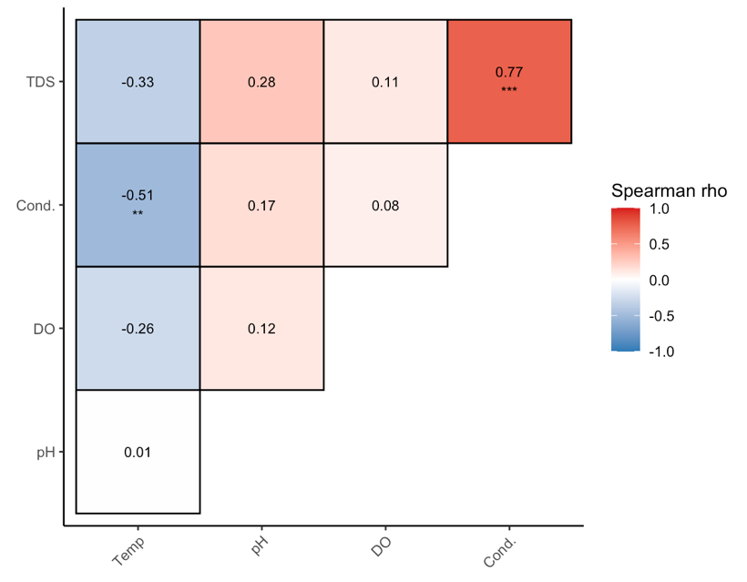
Fig. S1 Heatmap correlation matrix of water physicochemical variables in Lake Poso

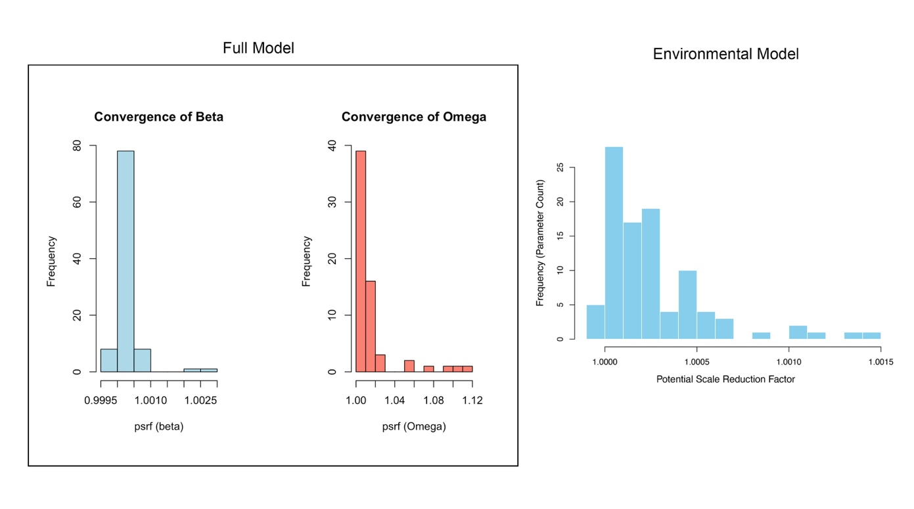
Fig. S2 The model convergence diagnostics based on potential scale of reduction factor (PSRF) of HMSC model's beta and omega parameters

Table S2 ﻿Explanatory power of the Full and Environmental models measured by calculating the area under the curve (AUC), the coefficient of discrimination (Tjur R²), and the widely applicable information criterion (WAIC) between the predicted and observed occurrences (average across species)
Model | AUC | Tjur R² | WAIC
Full model | 0.96 | 0,36 | 3.41
Environmental model | 0,95 | 0,35 | 3.42

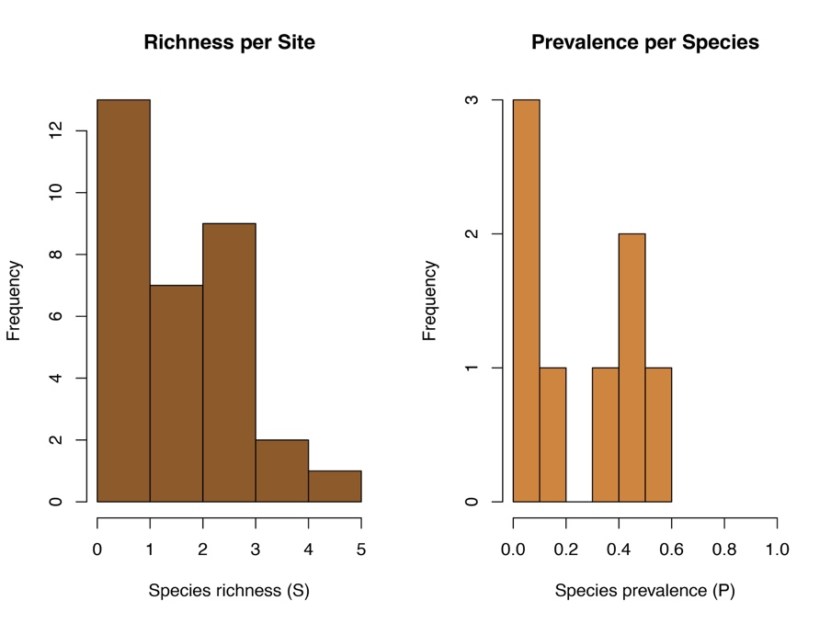
Fig. S3 ﻿The distribution of species richness (number of species) and species prevalence (frequency of species occurrence) of Caridina across sampling sites
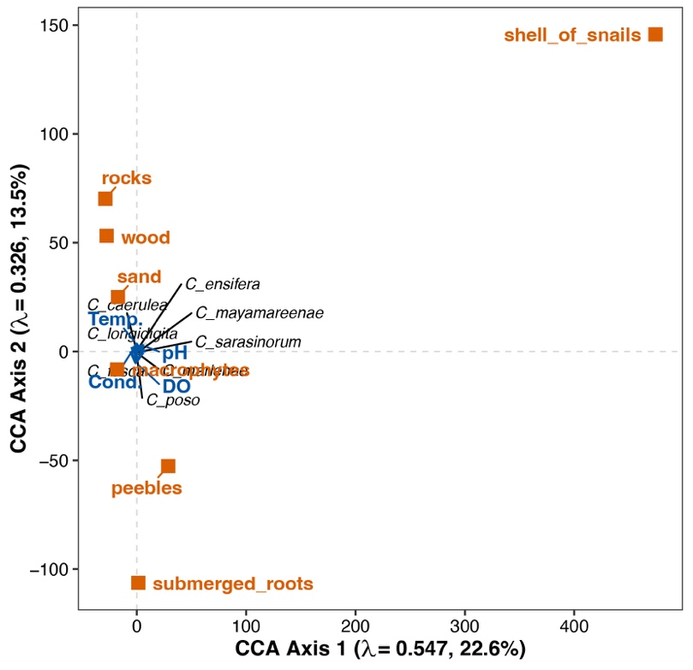
Fig. S4 Canonical Correspondence Analysis (CCA) biplot showing the relationships between environmental predictors (microhabitat = orange square and water physicochemical = blue arrow) and endemic Caridina species distributions in Lake Poso.

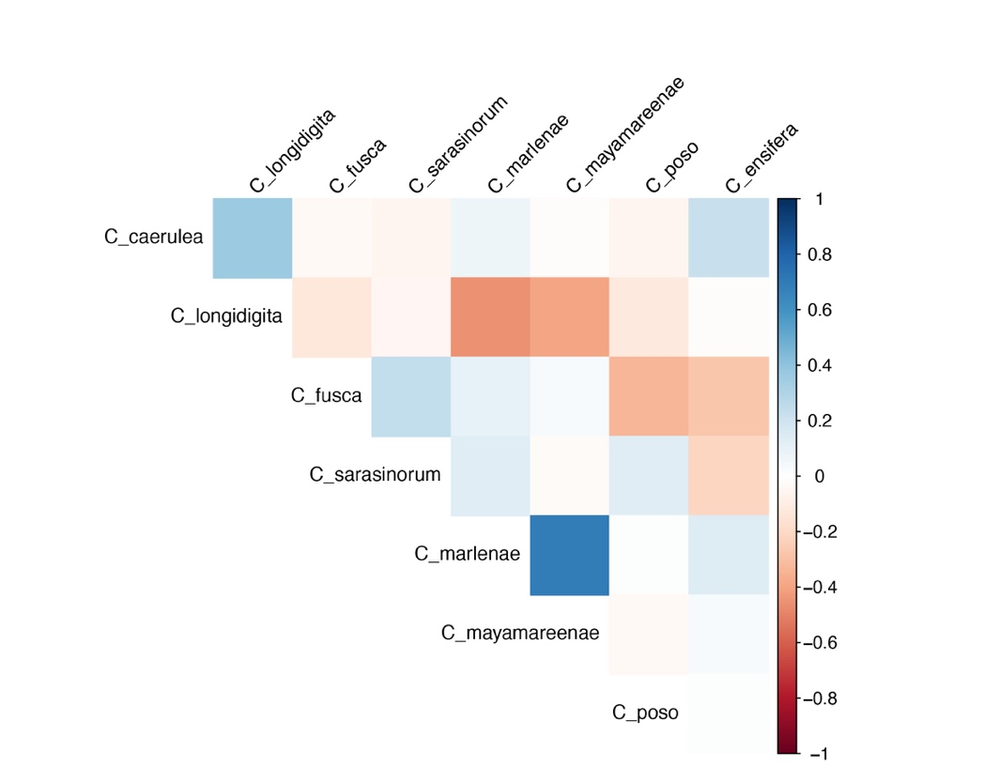
Fig. S5 The residual matrix of species-to-species associations for Caridina species pairs (support probability = 0) for either a positive or a negative association

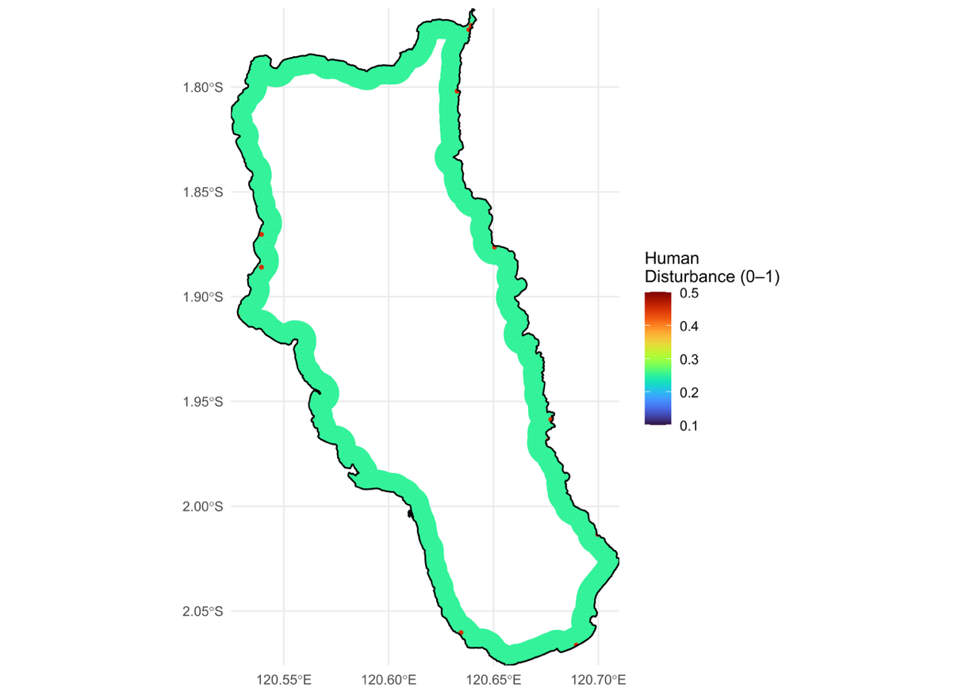

Fig. S6 Human disturbance level in Lake Poso

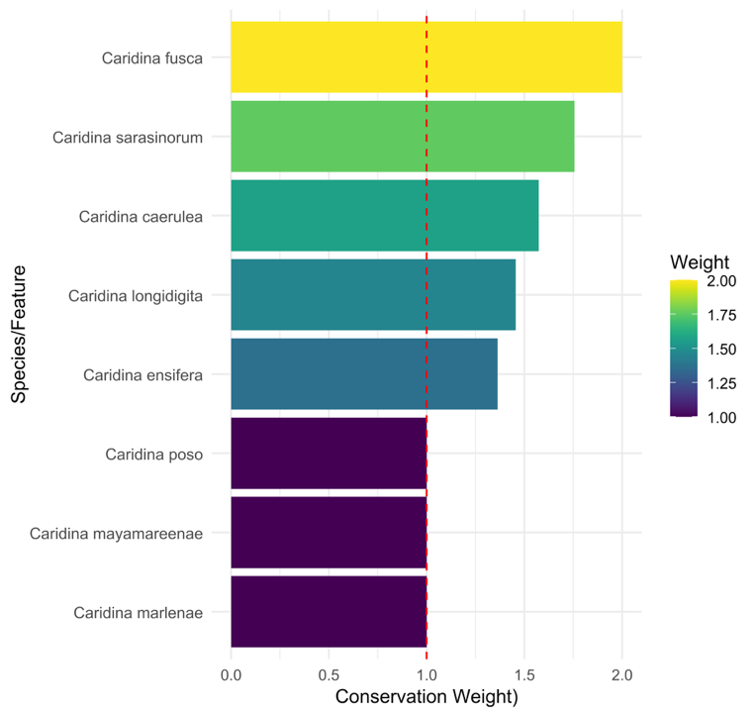

Fig. S7 Conservation feature weights based on indicator species analysis (IndVal) for Caridina species

References

Klotz, W., von Rintelen, T., Wowor, D., Lukhaup, C., von Rintelen, K., 2021. Lake Poso’s shrimp fauna revisited: the description of five new species of the genus Caridina (Crustacea, Decapoda, Atyidae) more than doubles the number of endemic lacustrine species. Zookeys. 1009, 81–122. https://doi.org/10.3897/zookeys.1009.54303.
von Rintelen K, Cai Y., 2009. Radiation of endemic species flocks in ancient lakes: Systematic revision of the freshwater shrimp Caridina H. Milne Edwards (Crustacea: Decapoda: Atyidae) from the ancient lakes of Sulawesi, Indonesia, with Description of Eight New Species. Raffles Bull. Zool. 57, 343–452.
von Rintelen, K., von Rintelen, T., Glaubrecht, M., 2007. Molecular phylogeny and diversification of freshwater shrimps (Decapoda, Atyidae, Caridina) from ancient Lake Poso (Sulawesi, Indonesia)—The importance of being colourful. Mol. Phylogenet. Evol. 45, 1033–1041. https://doi.org/10.1016/j.ympev.2007.07.002.
von Rintelen, K., Glaubrecht, M., Schubart, C.D., Wessel, A., von Rintelen, T., 2010. Adaptive radiation and ecological diversification of Sulawesi’s ancient lake shrimps. Evolution 64, 3287–3299. https://doi.org/10.1111/j.1558-5646.2010.01043.x.

