Supplementary Material to
“Metabarcoding reveals global variation in pollen‑collecting behavior of the invasive bee Megachile sculpturalis (Hymenoptera: Megachilidae)
.”

Authored by

Lanner J.*^{1, 2}, Mader S.^{2,3}, Rupprecht C.², Bila Dubaić J.⁴, Raičević J.⁴, Parys K., Tripodi A., Tien L., Orr M.C., Nikolić Petar, Fornoff F., Martini M., Hernandez-Castellano C. ⁶, Dötterl S. ¹, Meimberg H. ²

* corresponding author: julia.lanner@plus.ac.at

Supplementary Information A - Methods
Table S1 Palynologically analyzed pollen collected by M. sculpturalis published in former studies

Plant taxa | % pollen grain abundance | n provisioned pollen | n scopal pollen | Country | Source
Styphnolobium japonicum | 100% | 1 (1) |  | Germany | [1]
Styphnolobium japonicum | 100% |  | 1 | France | [2]
Styphnolobium japonicum | 97% |  | 1 | France | [2]
Styphnolobium japonicum | 100% | 27 |  | Simferopol | [3]
Styphnolobium japonicum | 99.99 ± 0.01% | 198 |  | Italy | [4]
Styphnolobium japonicum | 100% |  | 4 | Spain | [5]
Styphnolobium japonicum | 96% |  | 1 | Spain | [5]
Lagerstroemia | 3% |  |  |  | [5]
Ligustrum | 1% |  |  |  | [5]
Ligustrum | 81% | 1 (1) |  | Italy | [6]
Castanea | 12% |  |  |  | [6]

1.1 Laboratory processing of M. sculpturalis pollen samples
For the metabarcoding approach, we first extracted DNA of 5-50 mg aliquots of 242 pollen samples. As alcohol disrupts the extraction process, pollen stored in absolute Ethanol was air-dried for one hour prior to processing. For the extraction, 450 µL lysis buffer and 4 zirkonoxyd-beads were added to each sample, followed by homogenization for 5 minutes using a Collomix homogenizer (Type VIBA 330). Afterwards, the samples were centrifuged at 1000 rpm for one minute and 15 µL Proteinase K [1 mg/mL] was added. The samples were incubated at 56°C and 300 rpm for one hour. Next, 15 µL Rnase [10mg/mL] was added and the samples were incubated again at 37°C and 300 rpm for 30 minutes. Subsequently, 113 µL neutralization buffer was added and the samples were stored at -20°C overnight. After thawing, they were centrifuged sequentially at 1000, 2000, 4000 and 8000 rpm for one minute each, concluding with a final centrifugation step at 11000 rpm for 7 minutes. The resulting supernatant (500 µL) was mixed with 500 µL of binding buffer and transferred to a silica membrane (plate). The plate was centrifuged at 2000 rpm for 15 seconds and then at 4000 rpm for one minute. The flow-through was discarded, and the membrane was washed twice with 600 µL of 80% ethanol. Each washing step included centrifugation at 4000 rpm for one minute and at 6000 rpm for two minutes. To allow residual ethanol to evaporate, the samples were air-dried for one hour.
Finally, DNA was eluted by using 50µL of 65°C preheated elution buffer and centrifuged at 6000 rpm for five minutes. A second elution was performed using 80 µL of preheated elution buffer, with centrifugation at 6000 rpm for 5 minutes. To validate the quality of DNA extraction, gel electrophoresis was performed on 1.5% Agarose gel.
To amplify plant DNA from the pollen samples , we used the chloroplast primers trnL-F e & trnL-F f [7] and rbcLa-F & rbcLr506 [8] and the nuclear primers ITS2 F and ITS2 R [9]. Each marker was amplified in a separate PCR reaction. The reaction mix had a total volume of 10 µL, containing 5 µL Master Mix (QIAGEN Multiplex PCR Kit), 0.4 µL of each primer, 3.2 µL ddH₂O and 1 µL template DNA. The PCR cycle was initiated by a denaturation step at 95°C for 15 minutes, followed by 35 cycles of 95°C for 30 seconds, 52°C for one minute and 72°C for one minute, and a final extension step of 72°C for 10 minutes. Gel electrophoresis was performed on 1.8% Agarose Gel to validate the quality of the PCR products.
Subsequently, the amplicons were pooled by sample and purified using the Mag-naMedics’ Magsi-NGSᴾʳᵉᵖ Plus kit to remove excess primers, dNTPs or other PCR by-products according to the manufacturer’s instructions. To prepare the ampli
cons for sequencing we performed indexing as described by [10].

Table S2 Components of reagents used for DNA isolation of Megachile sculpturalis pollen.

Solution | Total volume (mL) | Components | Concentration | Component volume (mL) | Mass (g)
Lysis Buffer | 120 | H₂O |  | 71
 |  | NaCl | 250mM |  | 1.76
 |  | 1MTris-HCl pH8.0 | 200mM | 24
 |  | EDTA pH8.0 | 5mM | 1.2
 |  | PVP 40 | 2% (w/v) |  | 2.4
 |  | SDS [10%] | 2% (w/v) | 23.8
Neutralization buffer (3M Potassium Acetate) | 50 | H₂O |  | 15
 |  | Potassium Acetate(M_{Rel}=98.15) |  |  | 14.72
 |  | Glacial Acetic Acid |  | Add to a volume of 45mL
 |  | H₂O |  | Add to a final volume of 50 mL
Binding buffer (2M GuHCl in 95% EtOH) | 250 | EtOH abs. |  | 237.5
 |  | H₂O |  | 12.5
 |  | Guanidine Hydrochloride (M_{Rel}=95.53) |  |  | 47.765
Elution buffer (50mM Tris-HCl) pH8.3 | 250 | Tris-HCl(M_{Rel}=157.59) |  |  | 0.766
 |  | Tris-base(M_{Rel}=121.14) |  |  | 0.925
 |  | H₂O |  | Add to final volume of 250mL

1.2 Bioinformatic processing and taxonomic assignment
Pollen metabarcoding was performed on Megachile sculpturalis pollen samples, distributed across two Illumina MiSeq sequencing runs. Each sample was processed for three markers: ITS2, rbcL, and trnL. Additionally, three pollen provision samples from confirmed M. sculpturalis nest cells collected at a field site in Jiangxi Province, China (29.12°N, 117.91°E; June–July 2024) were processed separately, targeting the ITS2 region only (see below).
Raw paired-end sequences (2×300 bp, Illumina MiSeq) were demultiplexed by marker using the marker-specific primer sequences. We analyzed the sequencing results for rbcL on family level due to the relative conservatism of the primer region. Families assigned to Pinaceae, Salicaceae, Juglandaceae were most likely nest substrate (wood or resin sources) and excluded from further analysis. For trnL, we used the e-f primer pair targeting the longer trnL-trnF intergenic spacer (approximately 150-700 bp) rather than the shorter P6 loop (g-h primers), providing higher taxonomic resolution while maintaining broad amplification success [11,12].
From this step onwards, the bioinformatic processing was performed within the QIIME2 2024.10 framework [13]. Sequences were quality-trimmed using cutadapt v4.4 [14] as implemented in QIIME2, after which paired-end reads were merged using vsearch [15] with minimum merged lengths set according to expected amplicon sizes for each marker. As 3' quality was generally low needing extensive trimming, and some markers such as trnL can produce fragment sizes too long to merge reliably, we additionally retained unmerged forward reads (R1) and processed them separately. This dual-processing strategy (merged + R1-only) has been demonstrated to improve taxonomic resolution, particularly for markers with variable amplicon lengths [16]. Both merged and R1-only sequences were denoised independently using DADA2 v1.20 [17] to infer exact amplicon sequence variants (ASVs). As DADA2 requires independent error rate estimation for each sequencing run, the sequencing runs were processed separately. Finally, chimeric sequences were removed using DADA2's consensus method resulting in the final ASV tables.
For the Chinese samples, bioinformatic processing followed the same pipeline with minor adaptations to account for the shorter ITS2 amplicon produced by the primer combination ITS-S2F and ITS4 [18].
Taxonomic reference databases were obtained or constructed for each marker. For rbcL and ITS2, we used the pre-formatted QIIME2-ready databases from the DB4Q2 workflow [19], which provide curated reference sequences derived from NCBI. For trnL, we constructed a custom database as no comprehensive QIIME2-ready trnL database was available using QIIME2 RESCRIPt [20]. The database was built from two NCBI sources: (1) complete chloroplast/plastid genome sequences from Viridiplantae, and (2) explicitly annotated trnL and trnF gene sequences. For the chloroplast genomes, we performed in-silico PCR using the trnL e-f primers [7] to extract the target intergenic spacer region. However, many explicitly annotated trnL sequences deposited in NCBI do not include the primer binding sites, making direct in-silico PCR impossible. To recover these sequences, we employed the qiime rescript extract-seq-segments function: the sequences successfully extracted via in-silico PCR served as "baits" to identify and extract the homologous target region from sequences lacking primer sites. Both sequence sets underwent quality filtering following the DB4Q2 workflow, with the exception that the homopolymer filter was removed, as the trnL region naturally contains poly-T stretches. The database was then supplemented with 536 unpublished trnL sequences generated for the Austrian Barcode of Life (ABOL) initiative by the Institute for Integrative Nature Conservation Research, BOKU. All databases underwent additional curation beyond the standard DB4Q2 workflow to maximize species-level identification: (1) removal of environmental and uncultured sample sequences, (2) removal of sequences with ambiguous taxonomic annotations (sp., cf., aff., numeric suffixes), (3) removal of overly detailed taxonomic designations (e.g., subspecies, varieties) while retaining the sequence itself to avoid consensus classification failures due to minor taxonomic distinctions. All three databases were finalised using the rescript dereplication.
For the taxonomic assignment, we employed a custom approach designed to balance specificity and accuracy. Common approaches in metabarcoding include best-hit methods and consensus methods. Recent cross-validation studies of different methods have shown that best-hit approaches generally outperform consensus-based methods, though both remain error-prone with around one-fifth of sequences misidentified [21]. We adopted a conservative hybrid approach combining elements of both strategies to prioritize accuracy over identification rates. First the retrieved ASVs for each marker were blasted against the respective reference databases with a minimum identity threshold of 84.5% and 70% minimum query coverage. For each ASV, we extracted two key metrics from the BLAST results: (1) the best-hit taxonomy, defined as the taxonomic assignment of the hit(s) with the highest bitscore, and (2) a filtered consensus taxonomy, calculated from the top-10 hits by bitscore after filtering to retain only hits within 0.5% identity of the best hit. All assignments required a ≥40% agreement at each taxonomic rank. Taxonomy was then assigned using a two-rule decision system. If three or more hits shared the highest bitscore, the best-hit taxonomy was assigned directly, as multiple identical top matches indicate high confidence. If fewer than three best-hits, the filtered consensus taxonomy was assigned instead, providing a more conservative assignment. This hierarchical approach addresses the challenge that single best-hit assignments can be unreliable when database coverage is incomplete or when closely related species share similar sequences [22].
To prevent over-confident taxonomic assignments, results were capped at appropriate ranks based on maximum sequence identity thresholds. Standard thresholds commonly applied in metabarcoding studies use 97% for species and 90% for genus level assignments. However, given the documented high error rates, we applied more conservative thresholds. For rbcL, which is highly conserved, species level required ≥99.5% identity, genus ≥99%, family ≥95%, and order ≥85%. For trnL and ITS2, species level required ≥98% identity, genus ≥97%, family ≥95%, and order ≥85%. These thresholds represent conservative estimates that may under-assign some taxa but reduce false-positive species identifications.
After taxonomic assignment, ASVs with identical taxonomic classifications were aggregated by summing their read counts.
Three sequential filtering steps were applied to remove false-positive detections. First, tag-jumping was corrected using a 1% threshold per sequencing run following [23]: for each ASV, 1% of the total run-wide read count was subtracted from each sample's count. Samples from a concurrent pollen project (n=288) sequenced on the same flow cell were included in this calculation, as tag-jumping affects all samples regardless of project origin. This correction was applied at the ASV level before taxonomic aggregation.
Second, laboratory contamination detected in negative control samples (n=4) was addressed using a maximum-subtraction approach. For each taxon, the maximum read count observed across all negative controls was subtracted from all biological samples in the same sequencing run.
For the Chinese samples, no tag-jumping correction was applied, and no negative controls were included, as no other sequences from the same sequencing run were made available
After quality filtering, paired-end merging, and DADA2 denoising of the main pollen samples, we obtained 557,305 high-quality reads distributed across 725 amplicon sequence variants (ASVs): 193 ASVs for rbcL (203,890 reads), 296 ASVs for ITS2 (107,090 reads), and 236 ASVs for trnL (246,325 reads). The dual-processing strategy combining merged and R1-only reads proved effective: for rbcL, the majority of ASVs (72.5%; n=140) were derived from successfully merged paired-end reads, with 27.5% (n=53) recovered from R1-only processing. Regarding read abundance, R1-only reads accounted for 15,128 reads (7.4% of total rbcL reads). Similarly, trnL showed predominantly merged ASVs (77.5%; n=183) with 22.5% (n=53) from R1-only reads, representing 32,933 reads (13.4% of total trnL reads). In contrast, ITS2 showed a reversed pattern at the ASV level, with more ASVs derived from R1-only processing (54.1%; n=160) than from merged reads (45.9%; n=136). However, in terms of read abundance, merged reads still dominated, with 94,073 reads (87.9%) compared to only 13,017 reads (12.2%) from R1-only processing, representing mostly artifacts of the abundant taxon Styphnolobium japonicum.
For the three Chinese samples, a total of 112,980 raw reads were obtained, of which 110,662 (97.9%) were successfully merged and 102,954 (91.1%) passed quality filtering and chimera removal (101,272 reads from merged processing; 1,682 reads from R1-only processing). Denoising yielded 158 ITS2 ASVs.
Regarding the reference databases, after curation, the rbcL database comprised 173,991 sequences representing 72,496 taxa, and the ITS2 database comprised 349,217 sequences representing 115,000 taxa. For trnL the final database comprised 99,473 sequences representing 61,966 taxa.
The BLAST approach against the respective reference databases achieved high classification rates across all markers. For rbcL, 188 of 193 ASVs (97.4%) were successfully assigned taxonomy. Classification rates were slightly lower for ITS2 (275 of 296 ASVs; 92.9%) and trnL (220 of 236 ASVs; 93.2%). After the identity-based rank capping and aggregation of ASVs with identical taxonomic assignments, the initial ASV counts were reduced to 77 taxa for rbcL, 73 taxa for ITS2, and 116 taxa for trnL.
Tag-jumping correction and negative control subtraction together removed 3.2% of reads for rbcL (6,466 reads), 4.1% for ITS2 (4,412 reads), and 4.4% for trnL (10,774 reads).
Third, low-abundance filtering removed taxa with <1% relative abundance or <5 absolute reads per sample. Subsequent low-abundance filtering had minimal impact on total read counts, removing only 0.35% of rbcL reads (691 reads), 0.43% of ITS2 reads (443 reads), and 0.62% of trnL reads (1,453 reads). However, this filtering step substantially reduced the number of taxa: 21 taxa were removed from rbcL (27.3% of pre-filter taxa), 17 from ITS2 (23.3%), and 49 from trnL (42.2%).
For the European and USA dataset, we yealded 725 Amplicon Sequence Variantes (ASVs) (rbcL: 203,890 reads, 193 ASVs; trnL: 246,325 reads, 236 ASVs; ITS2: 107,090 reads, 296 ASVs) after quality filtering, paired-end merging, and DADA2 denoising. For all three markers, the majority of reads originated from successfully merged paired-end reads; were retained, For the three Chinese samples we yealded 158 ASVs.
Four families were exclusively detected with ITS2: Anacardiaceae, Boraginaceae, Crassulaceae, and Rutaceae (Fig. S4). Eight families were exclusively detected with rbcL: Actinidiaceae, Asparagaceae, Asphodelaceae, Orchidaceae, Papaveraceae, Scrophulariaceae, Simaroubaceae, and Verbenaceae.

References
1. Westrich, P., Knapp, A. & Berney, I. Megachile sculpturalis Smith 1853 (Hymenoptera, Apidae), a new species for the bee fauna of Germany, now north of the Alps. Eucera 9, 3–10 (2015).
2. Andrieu-Ponel, V., Ponel, P., Le Féon, V., Geslin, B. & Duvallet, G. À propos du comportement de butinage de Megachile sculpturalis Smith, 1853, en France méditerranéenne (Nîmes et Montpellier) (Hymenoptera, Megachilidae). Bulletin de la Société entomologique de France 123, 49–54 (2018).
3. Ivanov, S. P., Fateryga, A. V., Zhidkov, V. Y. & Pivovarenko, N. A. Giant resin bee Megachile (Callomegachile) sculpturalis Smith, 1853 (Hymenoptera, Apoidea, Megachilidae), an invasive species in the Crimea (notes on its biology). Ekosistemy 28, 122–128 (2021).
4. Bogo, G. et al. Nesting biology and nest structure of the exotic bee Megachile sculpturalis. Bulletin of Entomological Research 1–10 (2024) doi:10.1017/S0007485323000627.
5. Aguado, O. et al. Megachile (Callomegachile) sculpturalis Smith, 1853 (Apoidea: Megachilidae): a new exotic species in the Iberian Peninsula, and some notes about its biology. Butlletí de laInstitució Catalana d’Història Natural 82, 157–162 (2018).
6. Quaranta, M., Sommaruga, A., Balzarini, P. & Felicioli, A. A new species for the bee fauna of Italy: Megachile sculpturalis continues its colonization of Europe. Bulletin of Insectology 67, 287–293 (2014).
7. Taberlet, P., Gielly, L., Pautou, G. & Bouvet, J. Universal primers for amplification of three non-coding regions of chloroplast DNA. Plant Mol Biol 17, 1105–1109 (1991).
8. CBOL Plant Working Group1 et al. A DNA barcode for land plants. Proc. Natl. Acad. Sci. U.S.A. 106, 12794–12797 (2009).
9. Chen, I. C., Hill, J. K., Ohlemuller, R., Roy, D. B., & C. D. Thomas. Rapid Range Shifts of Species Associated with High Levels of Climate Warming. Science 333, 1024–1026 (2011).
10. Tibihika, P. D. et al. Application of microsatellite genotyping by sequencing (SSR-GBS) to measure genetic diversity of the East African Oreochromis niloticus. Conserv Genet 20, 357–372 (2019).
11. Taberlet, P., Coissac, E., Pompanon, F., Brochmann, C. & Willerslev, E. Towards next‐generation biodiversity assessment using DNA metabarcoding. Molecular Ecology 21, 2045–2050 (2012).
12. Kraaijeveld, K. et al. Efficient and sensitive identification and quantification of airborne pollen using next‐generation DNA sequencing. Molecular Ecology Resources 15, 8–16 (2015).
13. Bolyen, E. et al. Reproducible, interactive, scalable and extensible microbiome data science using QIIME 2. Nat Biotechnol 37, 852–857 (2019).
14. Martin, M. Cutadapt removes adapter seqeunces from high-throughput sequencing reads. Technical Notes 17, 10–13 (2011).
15. Rognes, T., Flouri, T., Nichols, B., Quince, C. & Mahé, F. VSEARCH: a versatile open source tool for metagenomics. PeerJ 4, e2584 (2016).
16. Dacey, D. P. & Chain, F. J. J. Concatenation of paired-end reads improves taxonomic classification of amplicons for profiling microbial communities. BMC Bioinformatics 22, 493 (2021).
17. Callahan, B. J. et al. DADA2: High-resolution sample inference from Illumina amplicon data. Nat Methods 13, 581–583 (2016).
18. Chen, S. et al. Validation of the ITS2 Region as a Novel DNA Barcode for Identifying Medicinal Plant Species. PLoS ONE 5, e8613 (2010).
19. Dubois, B. et al. A detailed workflow to develop QIIME2-formatted reference databases for taxonomic analysis of DNA metabarcoding data. BMC Genom Data 23, 53 (2022).
20. Robeson, M. S. et al. RESCRIPt: Reproducible sequence taxonomy reference database management. PLoS Comput Biol 17, e1009581 (2021).
21. San Martin, G., Hautier, L., Mingeot, D. & Dubois, B. How reliable is metabarcoding for pollen identification? An evaluation of different taxonomic assignment strategies by cross-validation. PeerJ 12, e16567 (2024).
22. Pappalardo, P. et al. Taxon‐specific BLAST percent identity thresholds for identification of unknown sequences using metabarcoding. Methods Ecol Evol 16, 2380–2394 (2025).
23. Cirtwill, A. R. & Hambäck, P. Building food networks from molecular data: Bayesian or fixed-number thresholds for including links. Basic and Applied Ecology 50, 67–76 (2021).

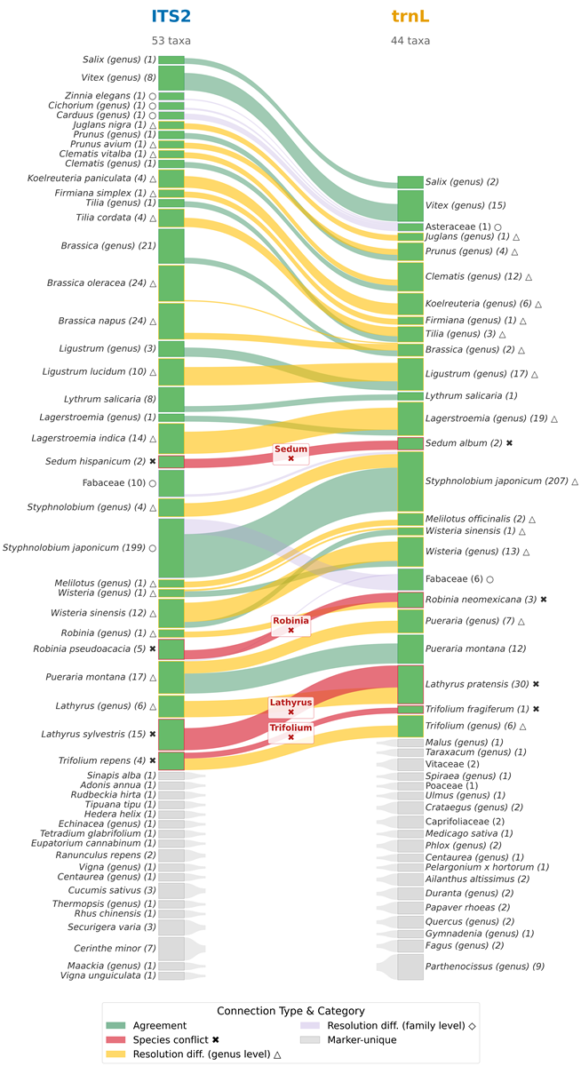

Figure S3 Species-level marker comparison (ITS2 vs. trnL): Alluvial diagram comparing taxa detected by ITS2 (left) and trnL (right) at species level. Bar height is proportional (log₂) to the number of samples in which each taxon was detected. Flows connect taxa co-occurring in at least one shared sample whose taxonomic assignments are congruent at genus or family level. Connection colour indicates the nature of the match: identical species in both markers (agreement; green), different species within the same genus detected in the same samples (conflict; red), species-level assignment in one marker but only genus-level in the other (resolution difference, genus level; amber), or family-level assignment in at least one marker (resolution difference, family level; lavender). Taxa without a congruent counterpart in the other marker are shown as unconnected bars. Taxa resolved only to order level and all non-angiosperm taxa were excluded prior to plotting.

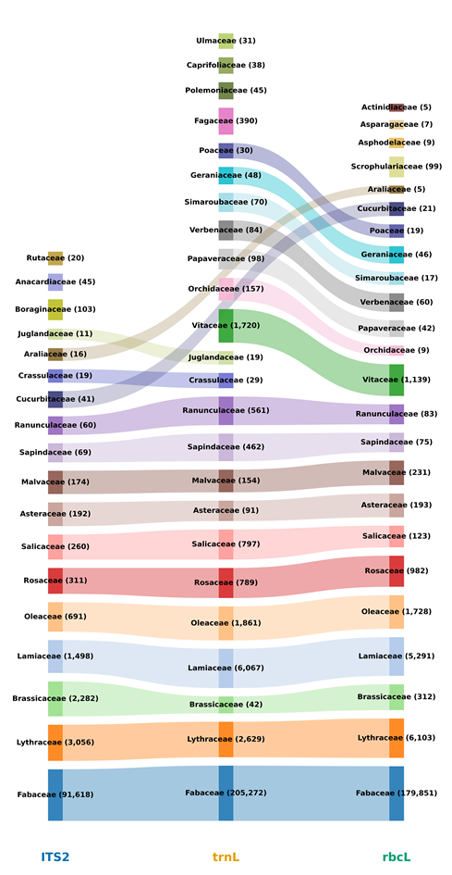

Figure S4 Family-level marker comparison (ITS2, trnL, rbcL) Alluvial diagram comparing families detected across three metabarcoding markers (ITS2, trnL, rbcL). All assignments resolved to genus or species level were aggregated to family level while taxa resolved only to order level were excluded. Read counts are indicated in each bar and bar height is proportional to the read counts (log₁₀) Flows connect families co-detected across markers. Families detected by only one marker are shown as unconnected bars. Taxa assigned to non-angiosperm classes and taxa resolved only to order level were excluded.

Supplementary information C – Results

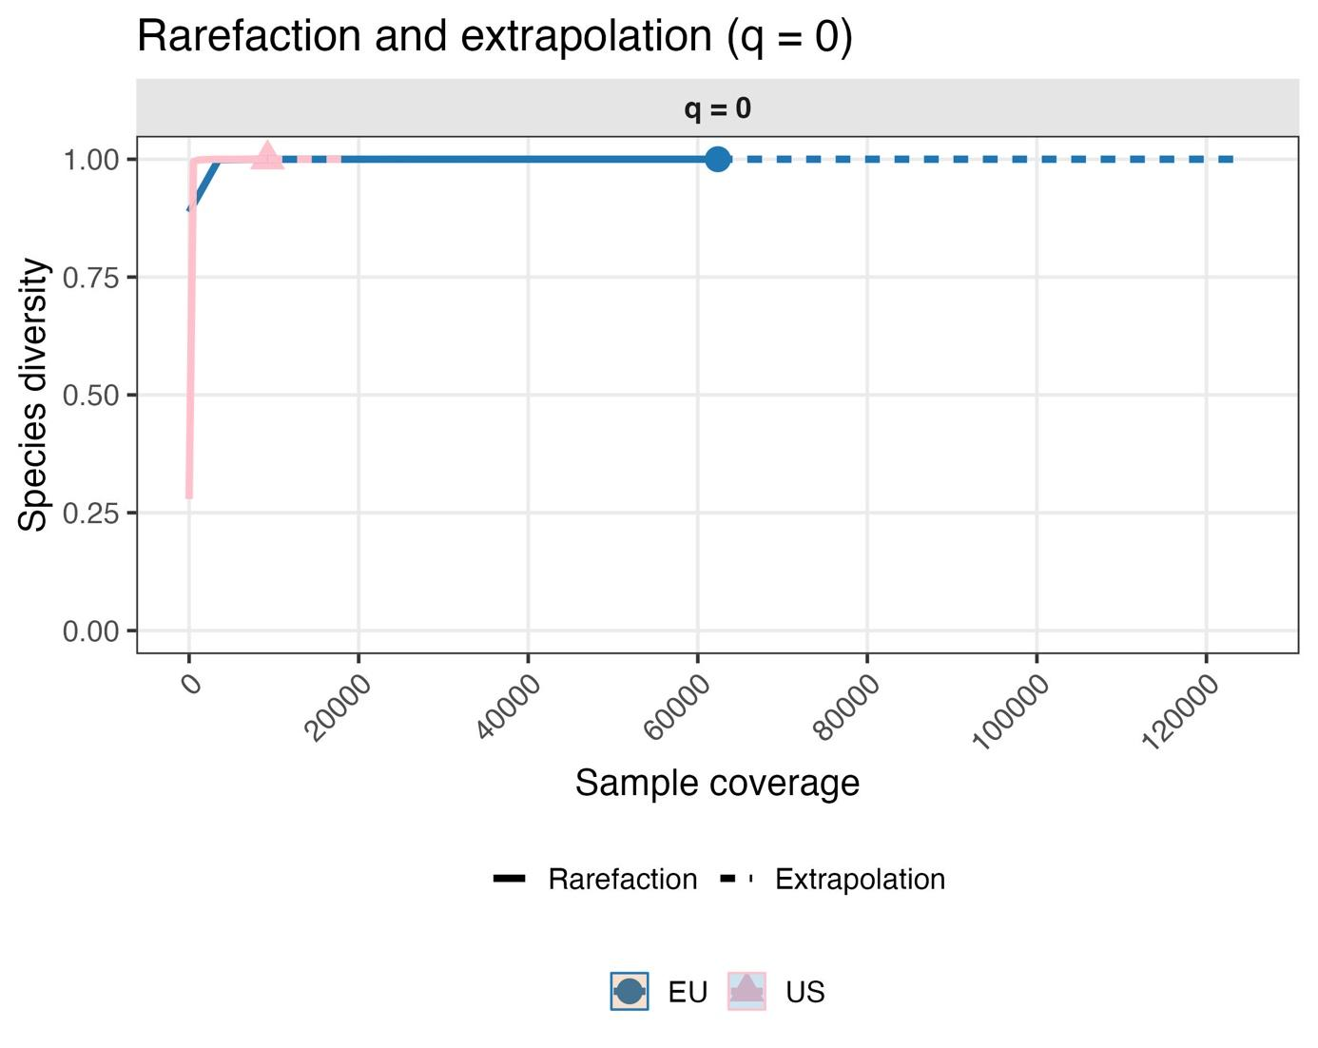
Figure S1 The coverage-based rarefaction curves for diversity order q = 0 show that both assemblages (EU, blue; US, pink) rapidly approach an asymptote at high sample coverage (≈1.0). The USA curve lies slightly above the EU curve across the covered range, suggesting higher species richness in USA after standardization by coverage. Confidence ribbons are narrow and the extrapolated portions (dashed) add little beyond the observed curves, supporting that additional sequencing would not substantially increase the richness estimates.

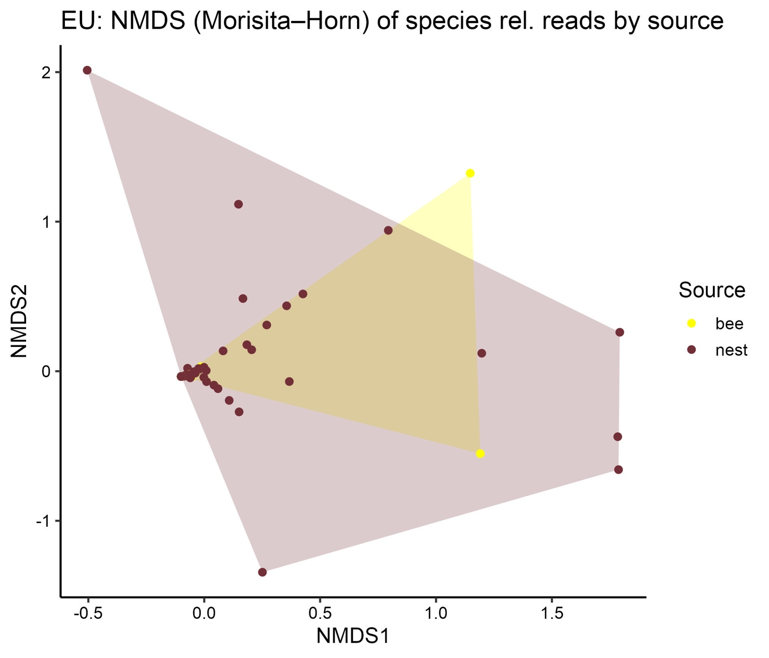
Figure S2 European samples contained pollen from nest provisions and collected from the bee’s scopa. Species composition did not differ significantly according to a Permanova (R2 = 0.0, F = 0.49, p = 0.67). NMDS plot shows overlapping species compositions with only one scopal sample differing from the provisioned pollen composition (Stress = 0.04). Provisioned pollen samples contained on average 1.75 (± 1.44; 20 species) plant species from 1.4 (± 0.82) taxonomic families, whereas scopal pollen contained 1.24 (± 0.66; five species) plant species from 1.1 (± 0.3) families. The Wilcoxon rank sum test presented a significant difference (p = 0.03) between the species richness of provisioned and scopal pollen samples.

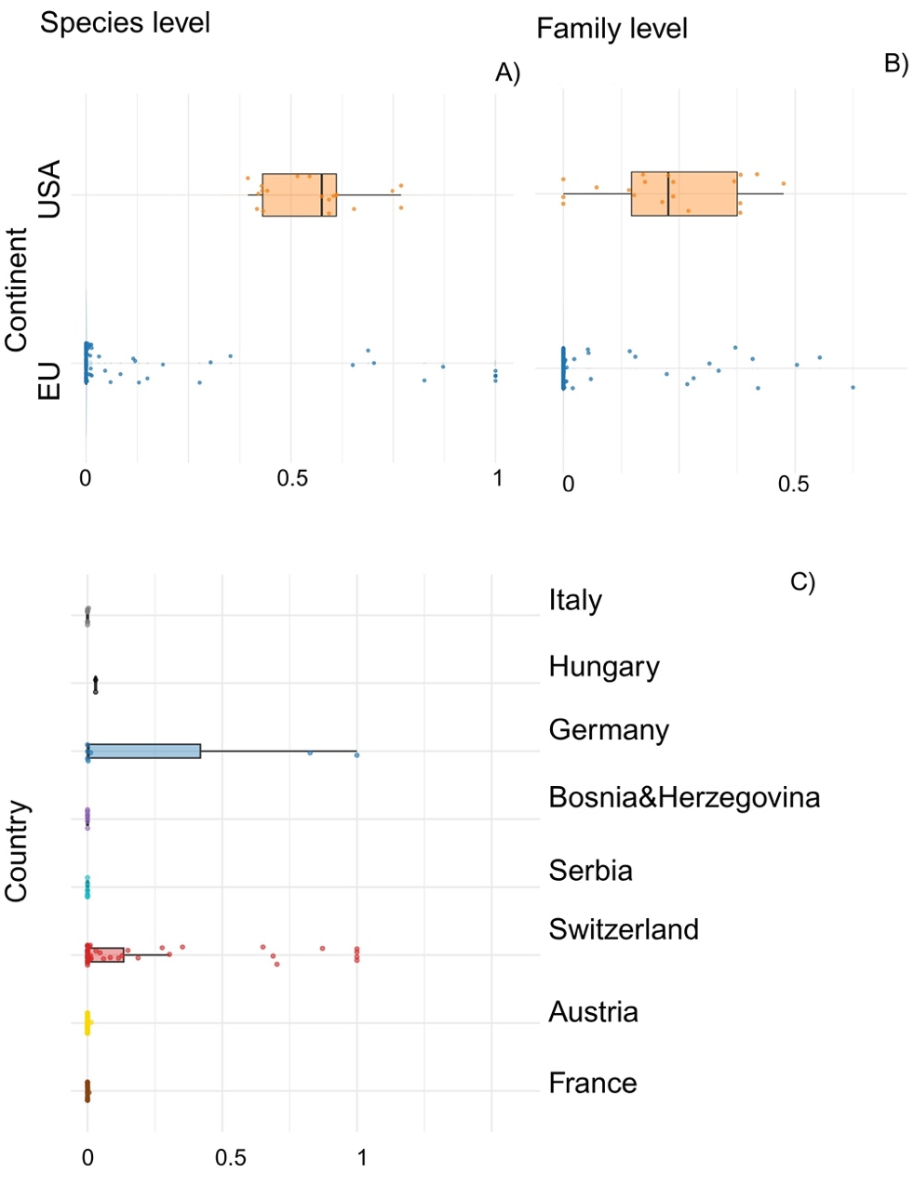
Figure S3: Differences to centroid in pollen-sample composition of M. sculpturalis between continents A) species + B) family level and C) between European countries based on the relative abundance of reads per sample sper species. Multivariate dispersion test on species and family level between continents was significant( p <1).

Table S4 Native origin and growth type of plant species identified in European pollen samples collected from M. sculpturalis.
Species | Origin | Growth type
Adonis annua | non-Asian | herb
Brassica napus | non-Asian | herb
Brassica oleracea | non-Asian | herb
Cerinthe minor | non-Asian | herb
Cucumis sativus | Asian | climber
Eupatorium cannabinum | non-Asian | herb
Hedera helix | non-Asian | climber
Koelreuteria paniculata | Asian | tree
Lagerstroemia indica | Asian | tree
Lathyrus sylvestris | non-Asian | climber
Ligustrum lucidum | Asian | shrub
Pueraria montana | Asian | climber
Ranunculus repens | Asian | herb
Robinia pseudoacacia | non-Asian | tree
Sedum hispanicum | non-Asian | herb
Sinapis alba | non-Asian | herb
Styphnolobium japonicum | Asian | tree
Tetradium glabrifolium | Asian | tree
Trifolium repens | non-Asian | herb
Wisteria sinensis | Asian | climber

Table S5 Plant species detected in USA pollen samples collected from M. sculpturalis including native origin and growth type.
Species | Origin | Growth type
Clematis vitalba | non-Asian | climber
Cucumis sativus | Asian | climber
Firmiana simplex | Asian | tree
Koelreuteria paniculata | Asian | tree
Lagerstroemia indica | Asian | tree
Lathyrus sylvestris | non-Asian | climber
Ligustrum lucidum | Asian | shrub
Lythrum salicaria | Asian | herb
Pueraria montana | Asian | climber
Rhus chinensis | Asian | shrub
Robinia pseudoacacia | non-Asian | tree
Rudbeckia hirta | non-Asian | herb
Securigera varia | non-Asian | herb
Tipuana tipu | non-Asian | tree
Trifolium repens | non-Asian | herb
Vigna unguiculata | non-Asian | climber
Wisteria sinensis | Asian | climber

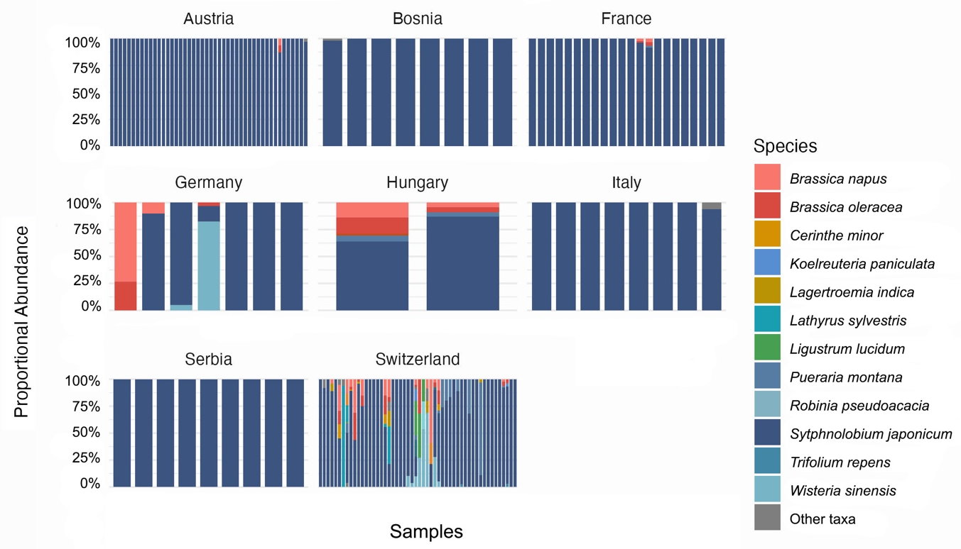
Figure S6 The graph shows on the y axis the proportional abundance of reads per plant taxa separated per country. Scopal pollen samples from Serbia contained a single species – S. japonicum. Most samples were collected in Switzerland which also showed the highest species diversity.
Table S7 Summary of investigated pollen samples collected by Megachile sculpturalis per country applying the ITS2 barcoding markers (p = provisions, s = scopa, sd = standard deviation) on species level including plant traits.
country | sample size | species richness | average species ± sd | % East-Asian origin | % tree | % shrub | % herb | % climber
Austria | p = 29 | 4 | 1.07 ± 0.33 | 50 | 25 | / | 75 | /
Austria | s = 17
Bosnia and Herzegovina | p = 8 | 2 | 1.12 ± 0.35 | 50 | 50 | / | 50 | /
France | p = 16 | 4 | 1.23 ± 0.75 | 50 | 25 | / | 50 | 25
France | s = 6
Germany | p = 3 | 4 | 1.71 ± 0.76 | 50 | 25 | / | 50 | 25
Germany | s = 4
Hungary | p = 2 | 5 | 4.5 ± 0.71 | 40 | 20 | / | 60 | 20
Italy | p = 2 | 2 | 1.12 ± 0.35 | 100 | 50 | / | 50 | /
Italy | s = 6
Serbia | p = 5 | 1 | 1 | 100 | 100 | / | / | /
Serbia | s = 4
Switzerland | p = 48 | 18 | 2.4 ± 1.79 | 44.4 | 27.8 | 5.6 | 38.9 | 27.8
Switzerland | s = 4

Tab S8 Pairwise differences in dispersion calculated based on the relative abundance of reads per species and sample by applying the Tukey HSD test. Significant differences between country pairs are bold (95% confidence level).
pairwise country comparison | diff | lwr | upr | p adjusted
Bosnia-Austria | -2.86E-04 | -0.2447438 | 0.24417275 | 1
France-Austria | -2.25E-05 | -0.1654455 | 0.16540051 | 1
Germany-Austria | 2.63E-01 | 0.00361199 | 0.52142357 | 0.044332
Hungary-Austria | 2.97E-02 | -0.4312406 | 0.49066931 | 0.9999994
Italy-Austria | 1.54E-04 | -0.2443048 | 0.24461178 | 1
Serbia-Austria | -3.21E-04 | -0.2329232 | 0.2322803 | 1
Switzerland-Austria | 1.67E-01 | 0.03817257 | 0.29651409 | 0.0026375
France-Bosnia | 2.63E-04 | -0.26321 | 0.26373596 | 1
Germany-Bosnia | 2.63E-01 | -0.0674775 | 0.59308413 | 0.2270848
Hungary-Bosnia | 3.00E-02 | -0.4745124 | 0.5345122 | 0.9999996
Italy-Bosnia | 4.39E-04 | -0.3186426 | 0.31952063 | 1
Serbia-Bosnia | -3.59E-05 | -0.3101275 | 0.31005567 | 1
Switzerland-Bosnia | 1.68E-01 | -0.074731 | 0.40998872 | 0.4026691
Germany-France | 2.63E-01 | -0.01439 | 0.53947055 | 0.0768624
Hungary-France | 2.97E-02 | -0.4415779 | 0.50105166 | 0.9999995
Italy-France | 1.76E-04 | -0.2632969 | 0.26364899 | 1
Serbia-France | -2.99E-04 | -0.2528097 | 0.25221192 | 1
Switzerland-France | 1.67E-01 | 0.00505984 | 0.32967186 | 0.038107
Hungary-Germany | -2.33E-01 | -0.7444723 | 0.27886547 | 0.8563202
Italy-Germany | -2.62E-01 | -0.5926451 | 0.06791657 | 0.2289568
Serbia-Germany | -2.63E-01 | -0.5844432 | 0.05876481 | 0.1981277
Switzerland-Germany | -9.52E-02 | -0.3520999 | 0.16175097 | 0.9469756
Italy-Hungary | -2.96E-02 | -0.5340732 | 0.47495144 | 0.9999997
Serbia-Hungary | -3.00E-02 | -0.5289109 | 0.46883931 | 0.9999996
Switzerland-Hungary | 1.38E-01 | -0.3222166 | 0.59747448 | 0.9836559
Serbia-Italy | -4.75E-04 | -0.3105665 | 0.30961664 | 1
Switzerland-Italy | 1.67E-01 | -0.0751701 | 0.40954969 | 0.4061833
Switzerland-Serbia | 1.68E-01 | -0.0627306 | 0.39806013 | 0.3355596

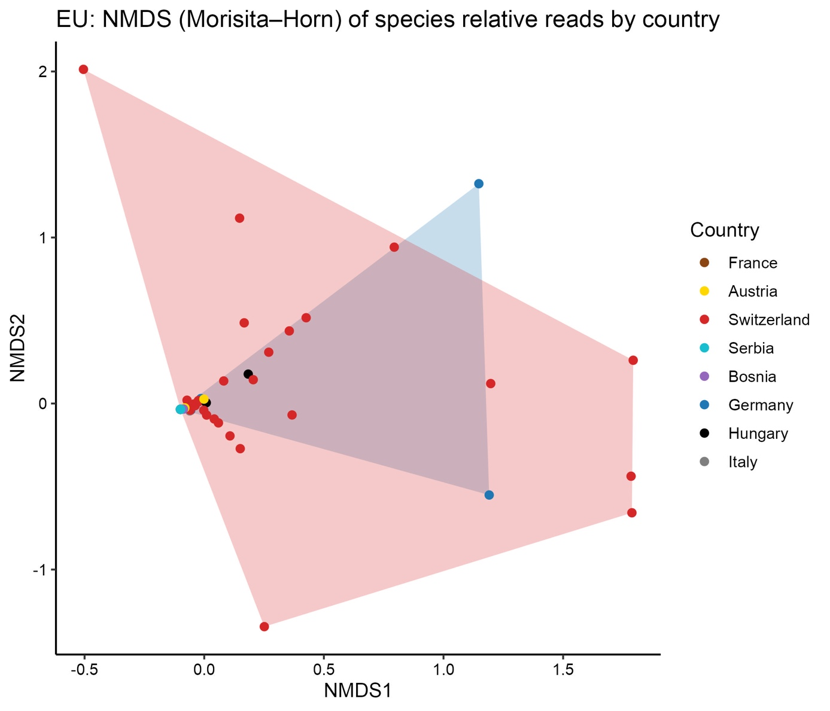
Figure S9 NMDS (Stress = 0.04) plot based on the relative abundance of reads per species and sample to compare the plant taxa composition between European countries. Pollen composition is for many countries almost identical with a more heterogenous composition detected in Switzerland, Germany and Hungary.

Table S10 Unique plant species by country in Megachile sculpturalis pollen samples.
Plant species | Country
Adonis annua | Switzerland
Cucumis sativus | Switzerland
Eupatorium cannabinum | Switzerland
Hedera helix | Switzerland
Koelreuteria paniculata | Switzerland
Lagerstroemia indica | Switzerland
Lathyrus sylvestris | Switzerland
Ligustrum lucidum | Switzerland
Robinia pseudoacacia | Switzerland
Sedum hispanicum | Bosnia
Sinapis alba | Switzerland
Tetradium glabrifolium | Switzerland
Trifolium repens | Switzerland

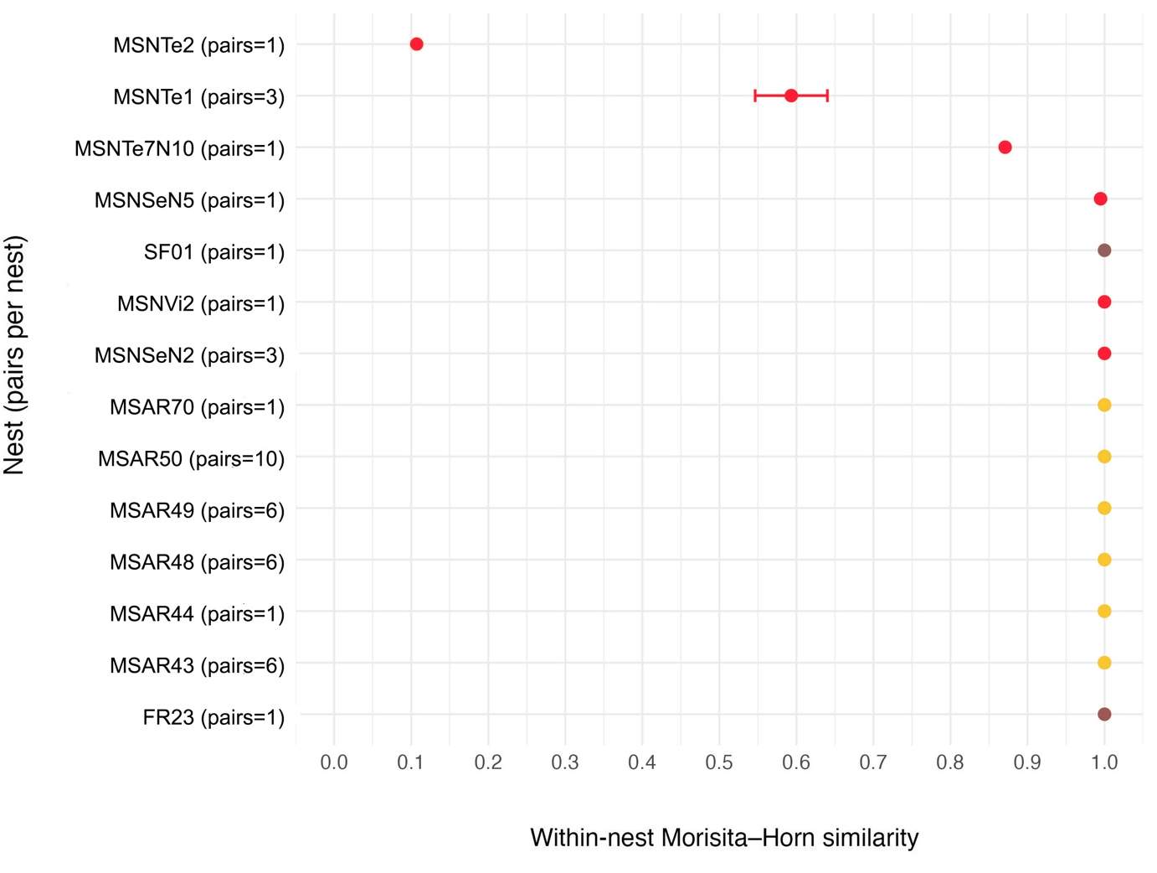
Figure S11 Mean Morisita-Horn dissimilarity to analyse the provisioned pollen consistency within nests of Megachile sculpturalis. Switzerland with the highest sample size had the highest species richness and was most dissimilar compared to other countries. Dissimilarity ranges (± SD) are color coded according to countries where the samples were collected (Austria = yellow, Bosnia = purple, France = brown, Germany = blue, Hungary = black, Italy = grey, Serbia = turquoise, Switzerland = red).

Supplementary information D – rbcL marker results

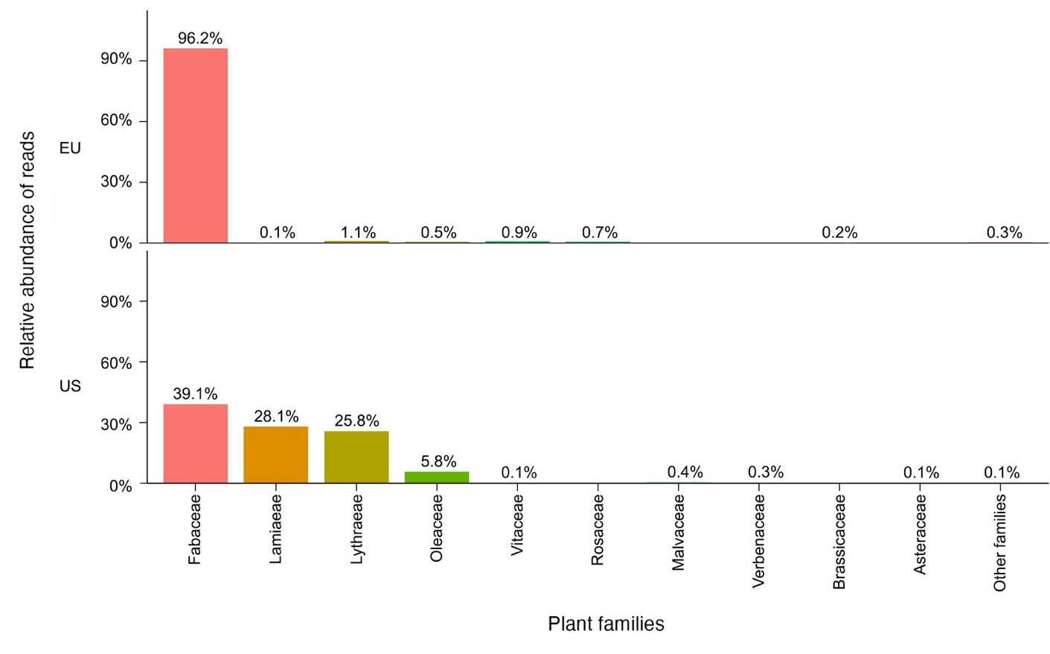
Figure S1 Relative abundance of read counts per plant family of pollen samples collected by M. sculpturalis sequenced with the rbcL marker. The barplots present samples collected in Europe (top) and the USA (below). We detected 22 families, ranging from one to six different families in a single sample (MSCO14, Switzerland). Fabaceae was again most frequently occurring in 164 samples.

Table S2: Summary of investigated pollen samples collected by Megachile sculpturalis per country applying the ITS2 and rbcL barcoding markers (p = provisions, s = scopa,) on family level.
country | sample size | average families
Austria | p = 29 | ITS2 = 3
Austria | s = 17 | rbcL = 2
Bosnia and Herzegovina | p = 8 | ITS2 = 2
Bosnia and Herzegovina | p = 8 | rbcL = 2
France | p = 16 | ITS2 = 2
France | s = 6 | rbcL = 1
Germany | p = 3 | ITS2 = 2
Germany | s = 4 | rbcL = 2
Hungary | p = 2 | ITS2 = 3
Hungary | p = 2 | rbcL = 3
Italy | p = 2 | ITS2 = 2
Italy | s = 6 | rbcL = 2
Serbia | p = 5 | ITS2 = 1
Serbia | s = 4 | rbcL = 1
Switzerland | p = 48 | ITS2 = 14
Switzerland | s = 4 | rbcL = 17

Supplementary information E – TrnL marker results
We excluded seven Bryozoan taxa and three taxa (Pseudotsuga menziesii and Taxus baccata, Malus sp.), which were probably nest material. 35 taxa were only resolved to genus level and seven to family level. We detected an overall number of twelve taxa across all samples applying the TrnL primer pair. We detected in 141 samples only a single plant taxon, in 122 samples this species was Styphnolobium japonicum. Two samples of provisioned pollen collected in southern Switzerland (Gerra) contained three taxa, which was the most for the TrnL primer: MSNTe1P1 contained Styphnolobium japonicum, Pueraria montana and Robinia neomexicana and MSNTe2P1 contained Styphnolobium japonicum, Pueraria montana and Trifolium striatum.
We detected eleven taxa in European samples and three in USA samples, two taxa were found on both continents: Lathyrus pratensis and Pueraria montana. Lythrum salicaria was exclusively found in USA samples.
We detected ten taxa in provisioned pollen samples and six in scopal samples.

Table S1 Summary of the twelve detected plant species, total abundance of reads and number of containing pollen samples of M. sculpturalis. The plant species were identified with the trnL-trnF intergenic spacer.
Plant taxa | Total abundance of reads | Number of samples present
Styphnolobium japonicum | 117978 | 148
Lathyrus pratensis | 30641 | 26
Pueraria montana | 1400 | 12
Papaver rhoeas | 98 | 2
Lythrum salicaria | 97 | 1
Ailanthus altissimus | 70 | 2
Wisteria sinensis | 60 | 1
Melilotus officinalis | 59 | 2
Medicago sativa | 43 | 1
Robinia neomexicana | 40 | 1
Sedum album | 17 | 1
Trifolium fragiferum | 11 | 1

Table S2 Species richness of pollen samples collected from M. sculpturalis split per country/ USA states.
Country/USA states | Species richness
Austria | 4
Bosnia | 3
Florida | 1
France | 2
Germany | 3
Hungary | 1
Italy | 1
Michigan | 2
Mississippi | 1
North Carolina | 2
Serbia | 1
Switzerland | 7

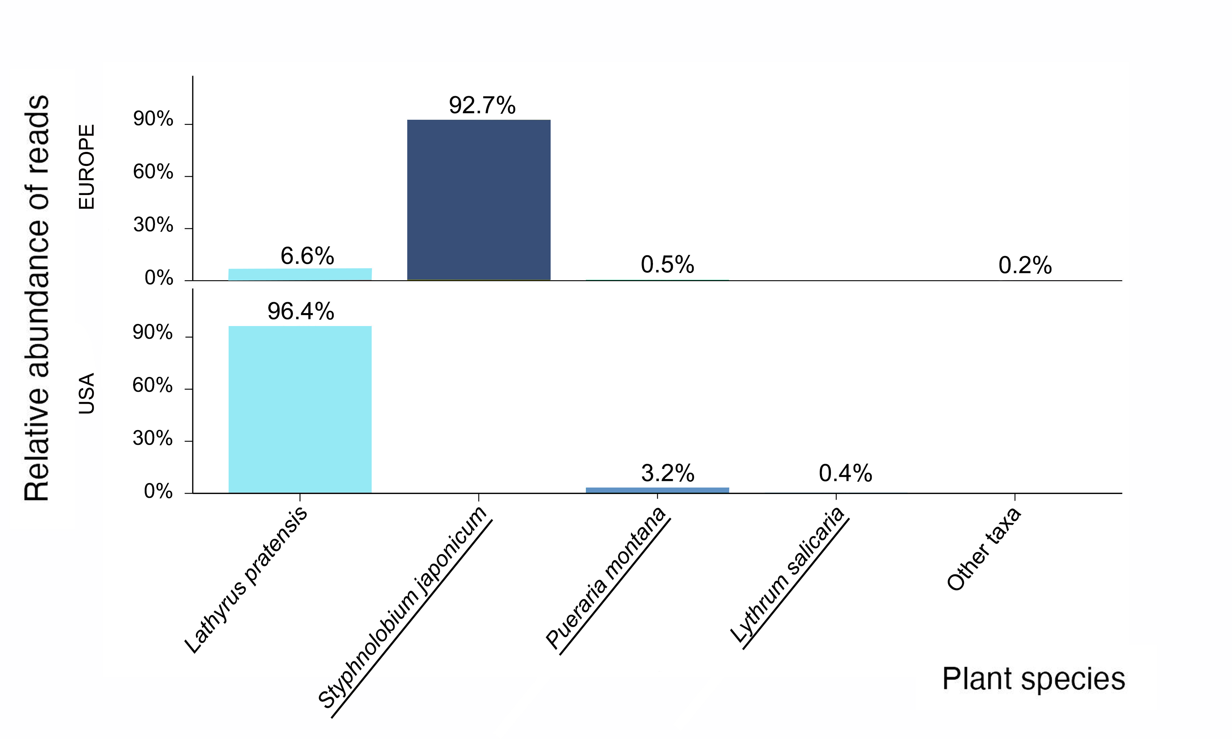
Figure S3 Relative abundance of read counts per plant family of pollen samples collected by M. sculpturalis sequenced with the TrnL marker. The barplots present samples collected in Europe (top) and the USA (below).

