Supplementary Information
Accounting for the nutritional risks of calorie restriction yields protein-adequate personalised diet plans
Tazayun Shakeel^{1*}, Afaq Alam Khan¹ & Shagufta Khan²
¹Department of Information Technology, School of Engineering & Technology, Central University of Kashmir, Ganderbal 191131, Jammu and Kashmir, India. ²Children's Hospital, Bemina, Srinagar 190018, Jammu and Kashmir, India. *email: tazayunbhat2020@cukashmir.edu.in
Supplementary Table S1. Summary of related work in diet and menu optimisation. Reference numbers refer to the main-text reference list.
Year | Study | Objectives | Constraints | Decision variables | Algorithm(s)
2021 | Turkmenoğlu et al. [14] | Cost; preference; preparation time | Two-sided bounds on 23 nutrients from USDA DRI; energy split | Binary over 356 dishes | NSGA-III
2005 | Gaál et al. [13] | Match personalised nutrient targets from medical data | Nutrient bounds at meal, day and week levels | Dish and food selections over a weekly menu | Multi-level GA (MenuGene)
2018 | Moreira et al. [12] | Cost of a five-day school menu | Age and school category; variety; per-meal macronutrients | Dish selections over a five-day menu | GA, greedy construction
2023 | Ahourag et al. [15] | Total glycaemic load; cost | Nutrient and food-group limits for patients with diabetes | Food quantities in four food groups | Multi-objective GA
2024 | Sahin & Aytekin-Sahin [16] | Energy and nutrient adequacy; colour, consistency, variety | Adequacy validated against dietitian scoring | Binary over 332 dishes | AGE-MOEA, SMS-EMOA, NSGA-II/III
2024 | Babalola et al. [17] | Energy; cost; preference; seasonal availability | Adequacy; user-specific needs | Selections from 200 foods | NSGA-II
2025 | Zhao (ACMO-Diet) [18] | Caloric adherence; macronutrient balance; taste; variety | WHO-based limits; ultra-sparse structures | Ultra-sparse binary (<0.1% density) | U-NSGA-III with sparse mask operators

Supplementary Table S2. Terms removed by the evidence audit, with the finding that removed each one.
Score | Term | Reason
Mood | Complex carbohydrate | Mechanistic hypothesis that fails in mixed meals
Mood | Folate | Cited analysis null; significant terms were not dietary
Hair | Vitamin A | Source reports that excess causes hair loss
Hair | Complex carbohydrate | Citation does not cover it
Hair | Biotin | No benefit reported when not deficient
Hair | Selenium | No relationship detected in telogen effluvium
Hair | Omega-3 | Multi-ingredient trial; contribution cannot be isolated
Muscle | Vitamin C | Citation concerns collagen after injury, not muscle
Muscle | Vitamin D | Ten RCTs: lean mass and handgrip null, performance worse
Satiety | Healthy fats | Opposed the energy-density term ranked above it
Satiety | Glycaemic carbohydrate | Glycaemic index invalid for mixed meals and nearly absent from the data
Satiety | Magnesium | Evidence concerns insulin sensitivity, not appetite
Satiety | Vitamin D | Rodent hypothalamic study
Satiety | Iron | Establishes only that severe deficiency causes pica

Supplementary Table S3. Profile and configuration for the primary run (P1).
Setting | Value
Sex, age, weight, height | Male, 27 y, 74 kg, 171 cm
Activity category | Active (PAL 1.70)
Maintenance energy | 2,854 kcal/day
Deficit / energy target | 801 / 2,053 kcal/day
Active objectives | 6
Hard micronutrient upper limits | 16 (applied at 90% of the published UL)
Soft minimums | 35
Candidate foods | 2,307
Population, generations, seeds | 210, 12,000, 21
Serving grid | 5 g
Wall-clock cost | 13,222 s per seed; 20.5 h for the profile

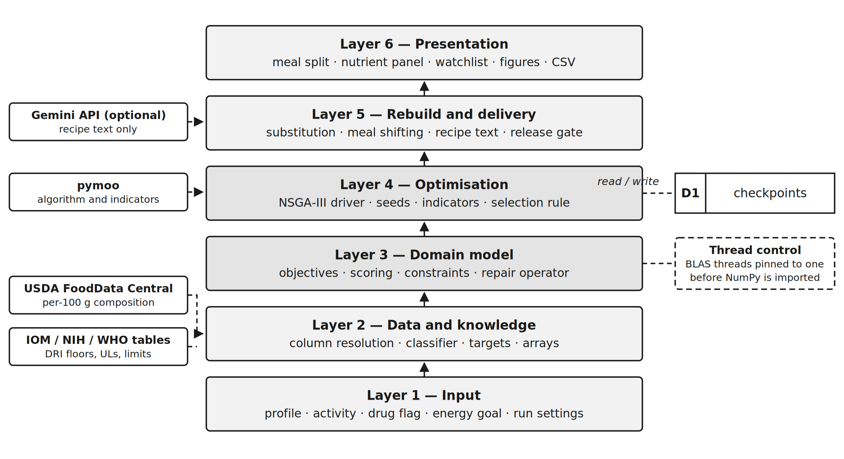
Supplementary Figure S1. Layered system architecture. The six layers run from the input layer, which collects the user profile, to the delivery layer, which issues the client document.

